Evaluation

The aim for this project was to produce a poster about … For this I chose to do base my poster on body positivity/ the effects the media has on the way we look as this is a subject I feel strongly about. I have used both female and male features in the poster as both male and female bodies look a certain way on social media.

Research

For this project I decided to look at multiple photographs from Cindy Sherman; as throughout her career she has looked at the stereotypical female roles in films but also, she has created photos where she has exaggerated facial features to look like what the idea modern day women should look like.

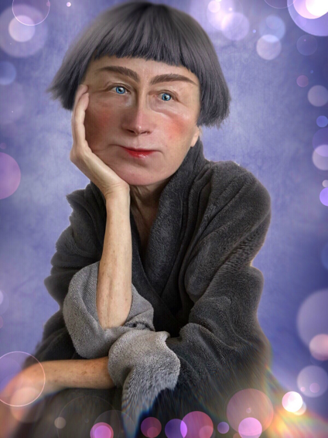
For the past couple of years, she has been posting highly edited self-portraits onto her Instagram. With these photos she has been making herself look like a different person each time with various similarities that are seen throughout photos/selfies/portraits on Instagram.

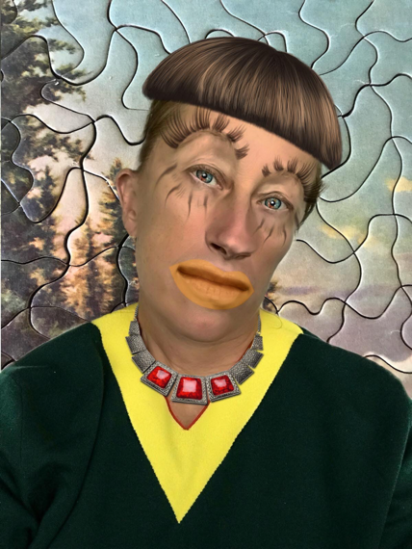
With these two photos she has edited them to make herself look like someone else completely. A reoccurring element to all of the portraits is bright eyes. Sherman edits the eyes to be a different, brighter colour; which makes them standout. But one thing that she does with the eyes that goes against the ideal looks is that most of the time she makes them smaller; going against the idea that having big eyes is attractive. What she does to counteract this is that she will make the lips bigger, which goes with the ideal look.

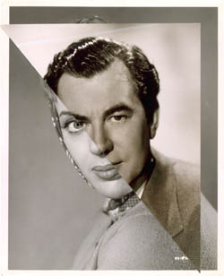
Style wise, I went with something like John Stezaker. John Stezaker is a conceptual artist who takes old photos; mainly portraits, and cuts then into each other to make one image.

These two images are from his series called ‘Marriage’. To make these he took portraits from celebs that where in Hollywood’s ‘golden era’ and collages them together to make a life of its own.

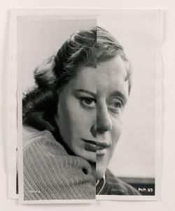
With these two I like how Stezaker has tried to be acerate with the placement of the two images but is slightly of which gives the sense that these people are not perfect. I also like how he has kept at least one eye from each portrait as it’s said that the eye is the window to our soul.

Planning

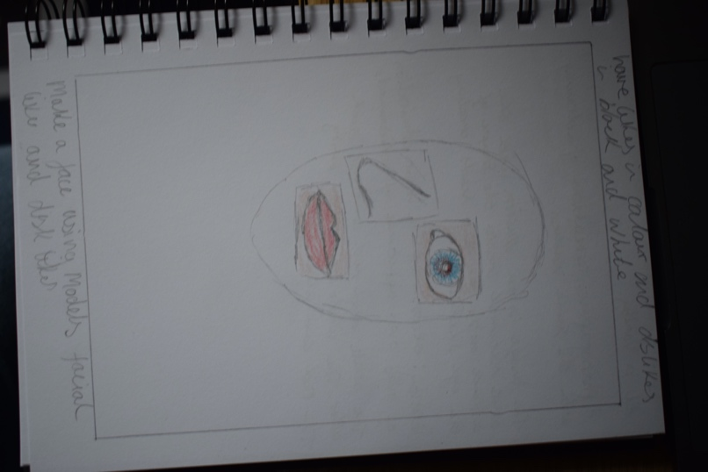
I started of with planning the layout of the poster first so then I had an idea of what the final outcome of the project would look like. I wanted to have either the shape of a face as the base or a photo as the base which I would then place parts of other portraits on top to create a new face. I wasn’t too sure on what the witing on the poster would be or where I would have put it so I decided that when I was creating it.

Making of the Poster

First, I chose the images I wanted to use.

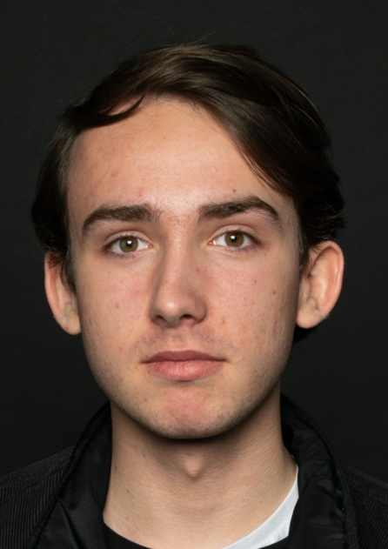
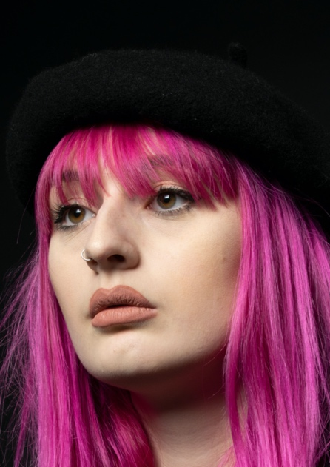

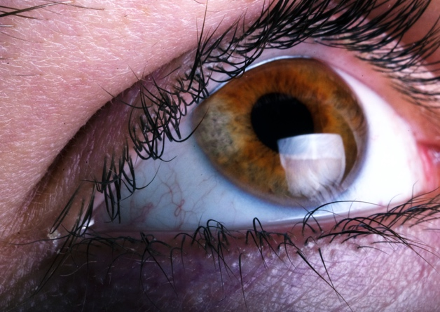
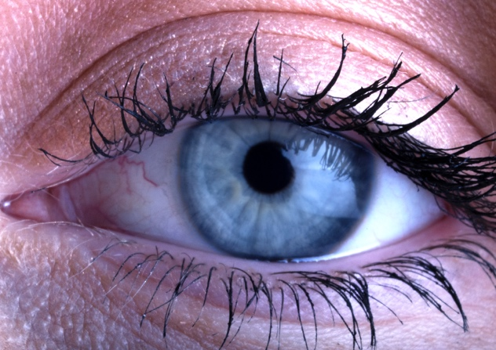

I chose photos that I had previously taken. The first two are from a project that also involved body positivity and the last two are from a project about hidden beauties.

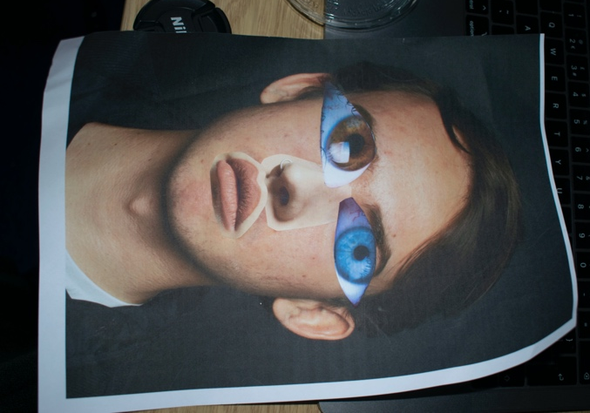
I printed them of and decided to use the male portrait as the backdrop for the others to go on top. Then I cut out the eyes from both macro shots and the nose and mouth from the female portrait and stuck them over the male portrait on the correct area. I then scanned in image which gave the image a grainy effect to it which I liked.

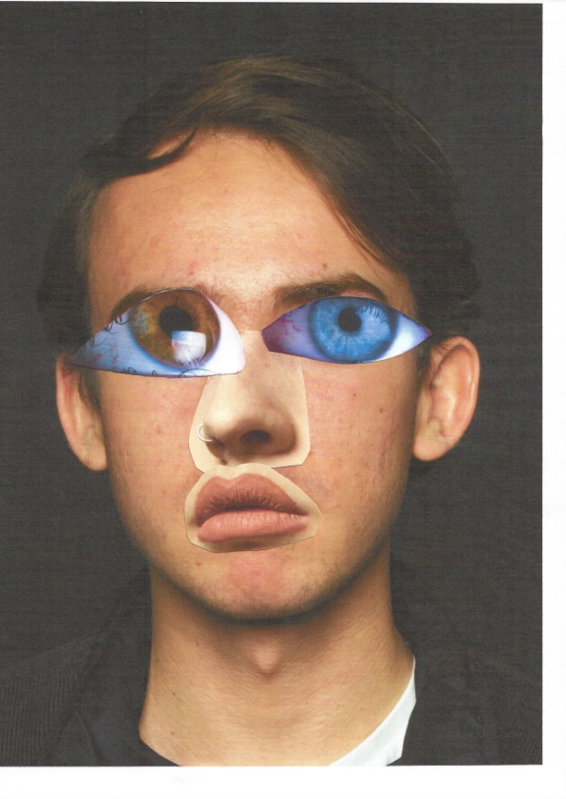
I then went into Photoshop, upped the contrast to add dimension to the photo; as when I scanned it the image lost most of its dimension, and altered the colour balance to give the image more of a cool tone look as I prefer that for images.

For the writing over top, I decided to use ‘Don’t let the media change your appearance’ as I felt like it was a strong message and is something I believe in. I also decided that this would be my interactive part of the photo. To make it a gif I had to make multiple frames of just the writing, then change the opacity of that layer by 20 each time e.g 100%, 80%, 60% etc. Time wise I had the layers on for 0.1 second so then it would then flow easily.

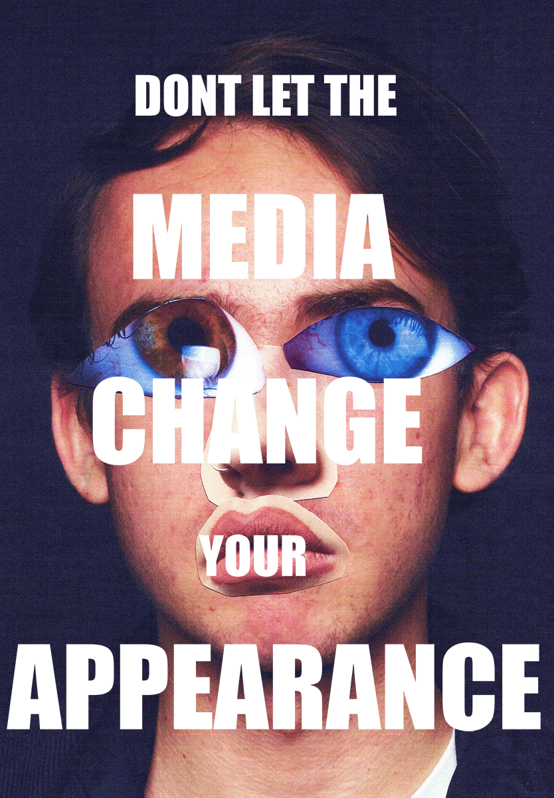
Final Product

I’m pleased with how the poster came out as I don’t think it’s too busy and doesn’t have too much writing that it just confuses you when you see it. I do think I could have exaggerated the feature a bit more; mainly with the nose and the lips, but I feel like then it would have become a bit busy and wouldn’t be able to see the male face behind them.

Bibliography
Cindy Sherman
https://www.nytimes.com/interactive/2018/10/05/magazine/instagram-cindy-sherman-ugly-beauty.html

John Stezaker
https://www.saatchigallery.com/artists/john_stezaker.htm

