Report:
Planning for Innovative Customer Service
[The Purchase of Arcadia Brand Topshop, Topman and Miss Selfridge by Online Retailer ASOS]

Shelina Monoara Begum (1704954)
University of Wales Trinity Saint David

Module: Marketing Management (BMMB7012)
MBA – Level 7
Submission Date: 13th June 2021
Lecturers: Jayne Williams & Davina Wyn Evans

Executive Summary

This report discusses the development and launch of a new innovative customer care programme with a view to improve the overall customer journey through value creating activities and experiences. The report continued from the completed marketing audit presentation which enabled help in planning and reviewing the market’s overall strategy which determines whether the existing strategy requires changing along with determining the goal of the company and where it is likely to go in future. For this report, the company that is opted is ASOS Plc, where ASOS is an online retail fashion store. ASOS’s objectives were identified to enhance customer experience and introduce 24 hours customer service; promote products through different social media platforms; focus on offering reasonable prices to customers in order to increase sales; ensure that the products are easily available so that it can reach each individual easily. The strategies identified to achieve the objectives are enhancing AI, adopting Digital Twin Technology, simplifying shopping by optimising the supply chain, training employees in communication, social media to engage with customers and diversification strategy to offer customers reasonable prices. The report highlights the strategic approaches that can be implemented by ASOS. Besides, the implementation of the strategy was performed along with various key tactics that are required to be integrated. Lastly, it provides effective and appropriate recommendations in the form of resources required and how the performance can be monitored.

Contents
Executive Summary 2
1.0 Introduction 4
2.0 Findings 5
2.1 Environmental Marketing Audit (Information from Presentation) 5
2.2 Marketing Objectives 6
2.3 Strategic Options 7
2.3.1 Enhancing customer experience 7
2.3.2 Ensuring the products availability and reachable to customers 7
2.3.3 Simplifying shopping 8
2.3.4 Promoting products through social media 9
2.3.5 Offering reasonable prices to customers 9
2.3.6 24 hour customer service 10
2.4 Implementing Strategic Options 10
2.4.1 Artificial Intelligence (AI) strategy to enhance customer experience 10
2.4.2 Digital Twin technology strategy to ensure that the products are available and reachable to customers 11
2.4.3 Optimisation supply chain strategy to simplify shopping 11
2.4.4 Social media strategy to promote products 11
2.4.5 Cost effective diversification strategy to offer reasonable prices to customers 12
2.4.6 Social media and AI strategies for 24 hour customer service 12
3.0 Conclusion 14
4.0 Recommendations 15
4.1 Resources Required 15
4.2 Recommendations for the monitoring of performance 15
5.0 Appendices 18
5.1 Appendix A – Organisation Summary of ASOS Plc 18
5.2 Appendix B – Presentation Slides, Marketing Audit 19
5.3 Appendix C – Marketing Audit of ASOS Plc 29
6.0 References 34

Introduction

This report continues from the team presentation (see Appendix B) of a marketing audit plan (see Appendix B and C) which reviewed the market’s overall strategy to establish whether the existing strategy requires changes along with defining the goal of the company where it is likely to go in future. The marketing audit plan has already been submitted to the Senior Management Team. This report will discuss the establishment and a new innovative customer care programme. The organisation in discussion for the report continues from the presentation which is the online retailer ASOS Plc who have purchased the Arcadia brands Topshop, Topman and Miss Selfridge. ASOS is an online retail fashion store that has one of the largest e-commerce markets in the world, based in the United Kingdom (ASOS, 2021) (please see Appendix A for the organisation summary). This report further intends to highlight the strategic approaches that can be implemented by the company, along with various key tactics that will be required to be integrated. Lastly, it will provide effective and appropriate recommendations in the form of resources required and how the performance can be monitored.

Currently, the biggest challenges for the fashion industry, as stated by the McKinsey Report of ‘The State of Fashion 2021’, are as follows: “7% stated physical retail and store footfall; 18% stated the changing consumer demand and behaviour; 45% stated Covid-19 and the economic crisis”. Furthermore, the report also included the biggest opportunity for the fashion industry are as follows: 8% stated market share gain; 10% stated sustainability; 30% stated the digital (Amed et al., 2020).

Findings

This section analyses the findings from the presentation (see Appendix B). Thus, it will review the strategic options and discuss the implementations.

2.1 Environmental Marketing Audit (Information from Presentation)
The presentation has analysed the external and internal environment; PESTEL; SWOT; future challenges; target audience and their needs; competitive intelligence; the marketing mix by employing the 4Ps. The internal and external audits were undertaken by utilising the marketing audit from the CIM Marketing Expert (CIM, 2021). The marketing audit is characterised as a competent, impartial, periodic and all-encompassing investigation of basic components of the external and internal environment, as well as the organisation's goals, strategies, and marketing activity, with the goal of early detection of problems and undiscovered potential, as well as the implementation of an appropriate marketing plan (Derev’yanchenko and Benivska, 2018).

The results demonstrated that the main potential risks are due to Brexit, the foremost political aspect of the UK government, that has affected the retail industry. As 10 billion GBP worth of goods are imported from EU countries into the UK, a no plan Brexit has led to additional costs by almost a billion-pound increase (Bramall, 2020). Apart from this, the recent Covid-19 pandemic has affected political systems as well, which affects retail. The economic impact of Covid-19 on the UK economy has declined GDP growth rate by approximately 6%, leading to lesser consumer purchasing ability for retail (ONS, 2021). Thus, one of the major threats is that the larger retailers, existing in both digital and physical form, may have more brand recognition than ASOS, as they gain consumers through foot traffic as well as their online platform.

Furthermore, the foremost change expected within the retail industry is the shift of consumers from traditional luxury brands and fast-fashion retail to more ethically sourced materials (Ren, Chan and Siqin, 2020). This environmental change will considerably change the retail market. However, the study of Zhao and Kim (2021) has added that an unforeseeable change has been brought by the pandemic, which has changed retail forever. These changes are the exclusion of physically buying in retail stores, as well as preferences for comfort clothing over formal wear. In this way, the retail market is set to experience a change of consumer demand about what they expect ASOS to produce.

2.2 Marketing Objectives
In the modern world it has become very essential for the organisations to work on their business operations effectively by utilising different strategies (Soltanizadeh et al., 2016). Additionally, in order to compete with competitors in the market it is necessary to adopt appropriate strategies. Moreover, these strategies greatly contribute to the success of the organisation. According to Baker (2014), marketing strategy refers to the game plan which is implemented by an organisation in order to reach its desired goals and objectives. Strategy also acts as a general direction for the organisations which contribute to achieving the future desired state.

The following marketing objectives have been identified by completing the environmental audit:
- Enhance customer experience and introducing 24 hours customer service
- Promote products through different social media platforms
- Focus on offering reasonable prices to customers in order to increase sales
- Ensure that the products are easily available so that they can reach each individual easily.

2.3 Strategic Options
There are a number of strategic options that are going to be reviewed in order to achieve the marketing objectives. However, it is crucial for ASOS to adopt certain strategies in order to produce a new product or service in the market. The selection of appropriate strategic options is the key element in order to be successful.

2.3.1 Enhancing customer experience
ASOS should focus on enhancing assortment planning with Artificial Intelligence (AI), where the retailers have immense knowledge of what and when their customers want something (Schwarzl, and Grabowska, 2015). In this regard, the AI strategy will help in minimising the marketing and inventory management, which therefore, permits ASOS to invest in an engaging shopping experience. The use of AI-driven business analytics will enable ASOS to understand what exactly their customer wants. This AI-driven business strategy will help ASOS to ‘right-size’ their operations that involves directing ASOS to focus on establishing smarter product inventories which leads retailers to reap higher return on investment (ROI) (Zhu and Gao, 2019). However, there are some risks involved in using the AI strategy that could impact the customer experience, as machines can only accomplish the tasks for which they have been created or programmed for; anything outside of this remit may cause them to fail or provide irrelevant outputs, which may be disastrous (Kumar, 2019).

2.3.2 Ensuring the products availability and reachable to customers
ASOS can enable customers by giving them greater connection to products. For this, ASOS requires the adoption of Digital Twin technology that places virtual copies of products in consumer’s hands and that involves virtual changing rooms and 360- degree product shots (Purcarea, 2018). This strategy will help in bringing online shoppers closer to the products which will lead the customers to feel secure, regarding online purchases. However, customisation is also one of the best strategies that involves customers in developing the product which creates a great relationship between customers and products. However, the customers could be connected with the process through drop-shipping and 3D printing. This will enable ASOS to get closer to offering customers their perfect product through customisation where the customers can create and obtain the best product that they want (Svobodová, and Rajchlová, 2020). The limitation of Digital Twin technology is that the idea is based on 3D CAD models and rather than 2D drawings. Furthermore, Digital Twin technology will be necessary throughout all supply chains (Adamenko et al., 2020).

2.3.3 Simplifying shopping
It is crucial for ASOS to simplify shopping at every stage, as the world today is very complicated, customers are in search of simplicity. Therefore, it is crucial that ASOS can provide simpler and smarter access for the customers, for their products and services (Baubonienė and Gulevičiūtė, 2015). With the help of supply chain optimisation, ASOS can offer the customers simple yet same day delivery that encourages the customers to make more purchases. In this regard, it is essential that with the help of conversational AI, retailers can permit the customers to order products easily. This determines that embracing simplicity helps in letting the retailers to grow their sales and in generating higher revenues (Bashir, Mehboob, and Bhatti, 2015). This illustrates that there are five keys to success within retailing which includes social media, the use of SEO, public relations, collaborations and advertising. An enhanced efficient supply chain strategy may speed up ASOS’s procedures while also delighting their consumers (Allen, 2021). However, if the supply chain management is not correctly executed, there will be wasted labour, service redundancy, and missed deadlines, all of which will result in large expenses for the company (Carter Logistics, 2021).

2.3.4 Promoting products through social media
ASOS should emphasise more on managing social media with the help of effective marketing strategies and tactics. Social media is one of the growing marketing strategies that helps in catering and reaching to the target audiences easily and effectively (Bucko, Kakalejčík and Ferencová, 2018). Being an online fashion retailer, the company should concentrate using social media platforms such as Instagram, Facebook, YouTube and Snapchat from where ASOS can engage with the customers more efficiently. However, leveraging YouTube and Facebook to target customers would benefit ASOS due to high usage, according to Khoros (2021) research. Tritama and Tarigan, (2016) stated social media plays a vital role in promoting product awareness and producing effective content. However, the disadvantage of social media is that the competitors could analyse ASOS’s tactics through the social media platform. This would put ASOS at danger of being ‘outdone’ (BlogBusiness, 2018). Furthermore, there will be a need to employ staff and train them to utilise the social media activities (NI Business Info, 2021).

2.3.5 Offering reasonable prices to customers
Diversified strategy enables the business to provide different products with regards to those which are already in market competition (Bowen, Baker and Powell, 2015). In other words, diversified strategies are implemented within business operations by adding products, services into business (Oladimeji and Udosen, 2019). Furthermore, the diversified strategy would enable ASOS to create value towards the audience. Similarly, the digitalised marketing strategies adoption may enable retail businesses to reach out to larger audiences and increase their market share or market growth. The digitalised marketing tactics enable businesses to increase their reach by providing and showing target customers products and offerings (Westerman, 2018). The drawback of diversification strategy is that it is seen as high risk when a company lacks experience operating in a new market. (Lighter Capital, 2020).

2.3.6 24 hour customer service
ASOS should utilise the AI digital assistant and Facebook to provide 24 hour customer service. Furthermore, employees would be required to be trained in communication. Co-creation can be triggered by educating personnel to be helpful, polite, responsive and empathic to online visitors. Customer approval and satisfaction should be boosted via better communication between businesses and their customers (Zhang et al, 2018). Employees without a good knowledge of how to communicate to customers will impact the business as there would be poor relationships with customers. Therefore, there could be a reduction in customers.

2.4 Implementing Strategic Options
Several strategies have been suggested and this scetion will look at how each one will be executed.

2.4.1 Artificial Intelligence (AI) strategy to enhance customer experience
ASOS will require a plan for recruiting, assessing, acquiring and developing talent or constructing an ecosystem to supplement internal resources, to achieve this approach. As a result, software development skills, as well as a mix of programming, data analytics and business development, will be required. As businesses create more complicated, interactive applications, software architecture, project management and user experience (UX) skills become more important (Davenport, 2018). Therefore, to implement this strategy ASOS would require highly skilled workers.

2.4.2 Digital Twin technology strategy to ensure that the products are available and reachable to customers
ASOS must identify anticipated results, scope the solution by setting the physical system of interest as well as layers of abstraction. ASOS should construct the virtual representation and appropriate data links in order to deploy the Digital Twin technology (VamDerHorn and Mahadevan, 2021). Therefore, ASOS would need skilled workers to implement this.

2.4.3 Optimisation supply chain strategy to simplify shopping
It is critical for ASOS to optimise the supply-chain in order to offer competitive prices, improve sales, and guarantee that items are conveniently available so that they can reach consumers. Supply chain interruptions are common, as many organisations have discovered. As a result, achieving a productive supply chain will enhance effectiveness and enhance productivity for ASOS. To execute this, it is critical to develop comprehensive demand-planning to help in the reduction of expedited fees and other logistical costs that drive up ASOS’s end-to-end supply chain cost.

2.4.4 Social media strategy to promote products
ASOS would need access to Facebook and YouTube in order to implement its social media plan. As a result, ASOS would need an employee with understanding of social media channels as well as marketing experience to promote and advertise ASOS's products. Implementing this will considerably contribute to increasing product awareness. ASOS will have to ensure that consumers have clarity and are not confused about the information that has been published on social media networks. According to Barger, Peltier, and Schultz (2016), social media content shapes customer views and fosters comprehension of the brand's product. Hence, if the consumers have doubts or confusion in regard to the products of ASOS, then it may fail to satisfy the consumers. Another key tactic for ASOS to obtain marketplace insights, which will aid in understanding the views, opinions and interest of customers in the brand's products. According to Kjeldgaard et al, (2021), if a company does not have a social media presence, it may miss out on knowing its customers' requirements and preferences.

2.4.5 Cost effective diversification strategy to offer reasonable prices to customers
In order to give customers fair pricing, ASOS must employ a diversification strategy in which each product line is treated as a separate business. ASOS would need a large investment in both people and financial resources to accomplish this plan.

2.4.6 Social media and AI strategies for 24 hour customer service
Establishing a 24 hour customer service communication channel through Facebook and YouTube, would benefit consumers and the company. These platforms are useful as ASOS can put ads on these platforms that can drive the traffic to the products. Therefore, the use of effective marketing strategies is the core for raising a company's profitability and increasing its sales (Lockett, 2018). Another key tactic will be to ensure producing consistent and engaging content. As per the research conducted by Akram and Kumar (2017), consumers get negatively influenced by the inconsistent and boring content. Thereby, it will be necessary to continuously produce captivating, engaging and interesting content for the customers.

As a result, the aforementioned main techniques will greatly contribute to the selection and execution of social media platforms as a source of creating awareness and engaging customers through 24 hour customer care. However, in order to properly execute this, ASOS would need to hire and educate employees. Furthermore, employees would need to be trained in communication. In order to execute this, employees would be required to attend classes where they could be instructed on how to properly interact with customers. This might be done both internally and externally. This will allow employees to keep customers up to date on the goods and what the brand has to offer.

Conclusion

It has been identified that to enhance or produce a service or product it is essential for organisations to work effectively. In addition, through this report it has been identified that adopting appropriate marketing strategies holds significant value for ASOS. Moreover, it is necessary for ASOS to carefully work on each and every element, tools and tactics or else they may fail to achieve their desired targets. The objectives from the environmental audit were identified to enhance customer experience and introduce 24 hours customer service; promote products through different social media platforms; focus on offering reasonable prices to customers in order to increase sales; ensure that the products are easily available so that it can reach each individual easily. The strategies identified to achieve the objectives are enhancing AI, adopting Digital Twin Technology, simplifying shopping by optimising the supply chain, training employees in communication, social media to engage with customers and diversification strategy to offer customers reasonable prices. Furthermore, ASOS needs to monitor if the strategies were successful.

Recommendations

4.1 Resources Required

In order to attain successful performance and outcomes, certain marketing techniques and methods must be implemented. It is crucial that ASOS focus on obtaining the necessary and essential technology that will assist them in attracting customers and meeting their requests and needs on time. However, the advice for ASOS that they should acquire for the advantage of their company as well as their customer benefits. The following resources are required:
- AI-driven business analytics
- Access to each social media platform
- Effective and well-designed website
- Computer System
- Digital Twin technology
- String Internet Connection
- Effective Telecommunication System
- Technically qualified and expert workforce.
- Robust demand-plan
- Human and Financial resources

4.2 Recommendations for the monitoring of performance

Monitoring performance indicates whether or not the strategy, approach, tools and procedures that were applied were effective (Lind, 2019). The following are recommended:

- ASOS should monitor and evaluate overall performance as it is crucial. The most important guideline for evaluating performance is that ASOS should do a thorough examination of what has been completed and what has not been completed. This could be accomplished by tracking the results of customer experiences, analysing data and sales.

- Questionnaires should be distributed to consumers in order to learn about their experiences and how the service quality is. According to Hopp and Greene (2018), it is critical to determine if the marketing plan established meets the business's objectives and intended goals. This will assist ASOS in understanding their position and where they are in terms of performance.

- Performance may be assessed by analysing consumer reactions to a new product development or service. According to Lang and Rettenmeier (2017), it is critical to understand the customers' wants and preferences. As a result, if the consumer response to the product concept and service is favourable, then the strategy's goal appears to have been met. However, a negative response reflects poor performance and shows that the desired objectives have not been met. Hence, in this way ASOS will be able to know the behaviour, attitude and feedback of their customers towards the product.

- ASOS should monitor how many potential customers have been attracted as a result of new items. The AI-driven analytical system would be utilised to collect this data and monitor it. Furthermore, just as it is important to satisfy and maintain existing customers, it is essential to attract and grow new customers (Martinelli and Vergura, 2020). This will allow ASOS to determine how effective they have been in both maintaining and acquiring new customers. As a result, customers should be the company's main focus. In addition to the above remark, customer satisfaction and motivation would reveal ASOS's market position.

- ASOS should use the performance indicators to efficiently measure corporate performance. According to Kelley and Simmons (2019), performance indicators indicate whether or not an organisation has met its key business objectives. ASOS can use performance metrics such as net sales and the number of new contracts signed every period to analyse its success. As a result, ASOS can efficiently monitor and assess company performance by implementing the aforementioned guidelines.

- Collect feedback through social media platforms to monitor the service provided to customers in order to track the 24 hour customer service delivered.

Appendices

5.1 Appendix A – Organisation Summary of ASOS Plc

ASOS is an online retail fashion store which was established in 2000 in London whose main emphasis was towards young adults (ASOS, 2021). It encompasses the largest e-commerce market in the world that sells over 850 brands that sells to around 196 countries with its own exclusive range of clothing and accessories. The company has the largest customer base in Europe that has more than 23 million customers as of August 2020 (Statista. 2021). At ASOS, there is a large place for everyone and its clothes are designed for celebrating the individuality and uniqueness of everyone. The goal of the company is to offer the trendiest clothes that are designed by the in-house team by offering great variety to the customers. Retailers in the UK are digitally transforming, as the customer’s purchasing behaviour has changed and has reshaped the high street as a result. Online shopping was launched and pioneered by Michael Aldrich in 1979 (Doherty, and Ellis‐Chadwick, 2010). The purpose of online shopping is to understand people’s feasibility and fulfill all their needs by letting them be at home. Although ASOS has been in business for 20 years, the company continues to strive for innovation and distinctiveness in its offerings. ASOS Plc's major competitor is Boohoo who has recently bought Debenhams which caters for all age groups.

5.2 Appendix B – Presentation Slides, Marketing Audit

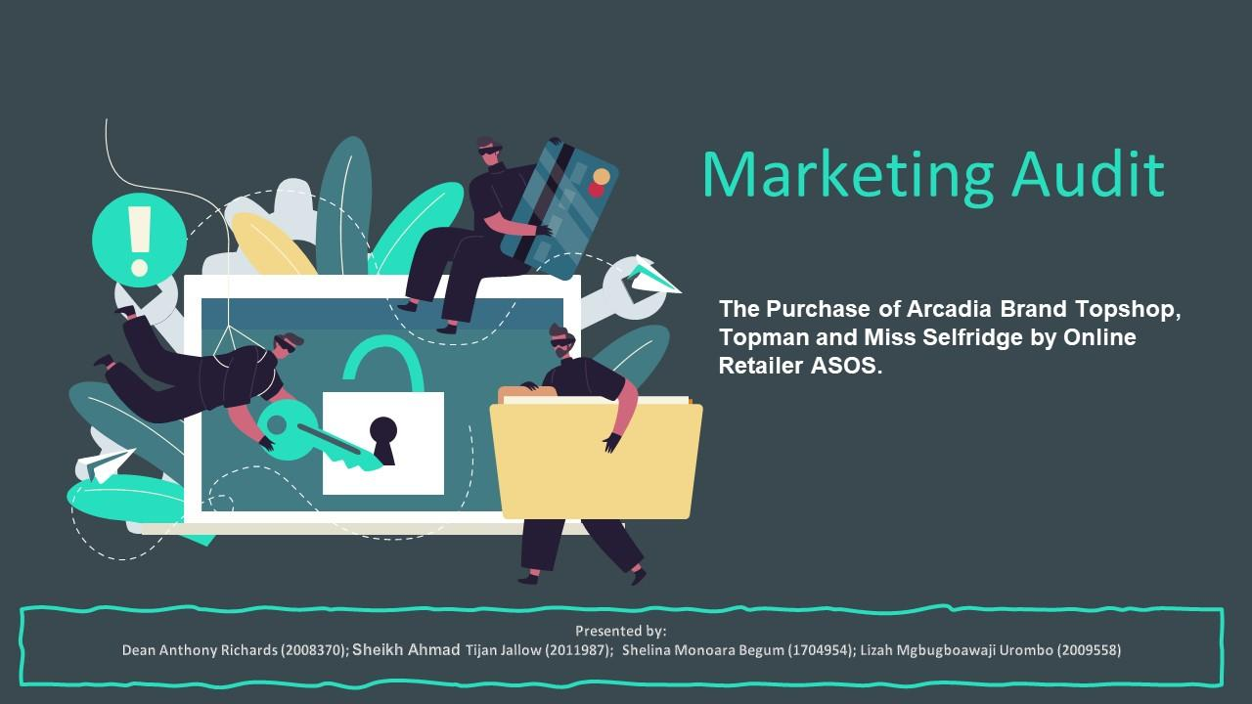

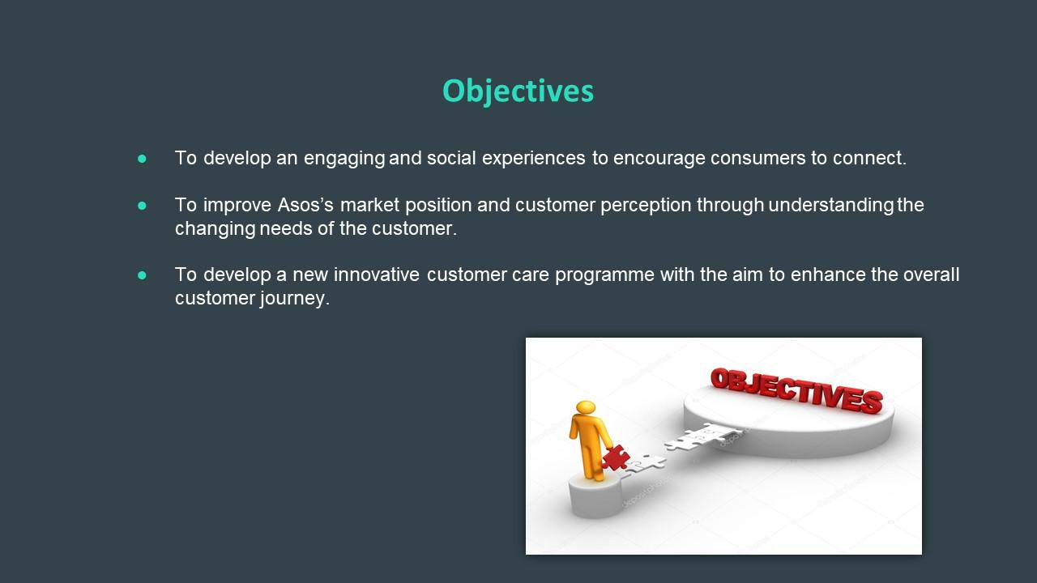
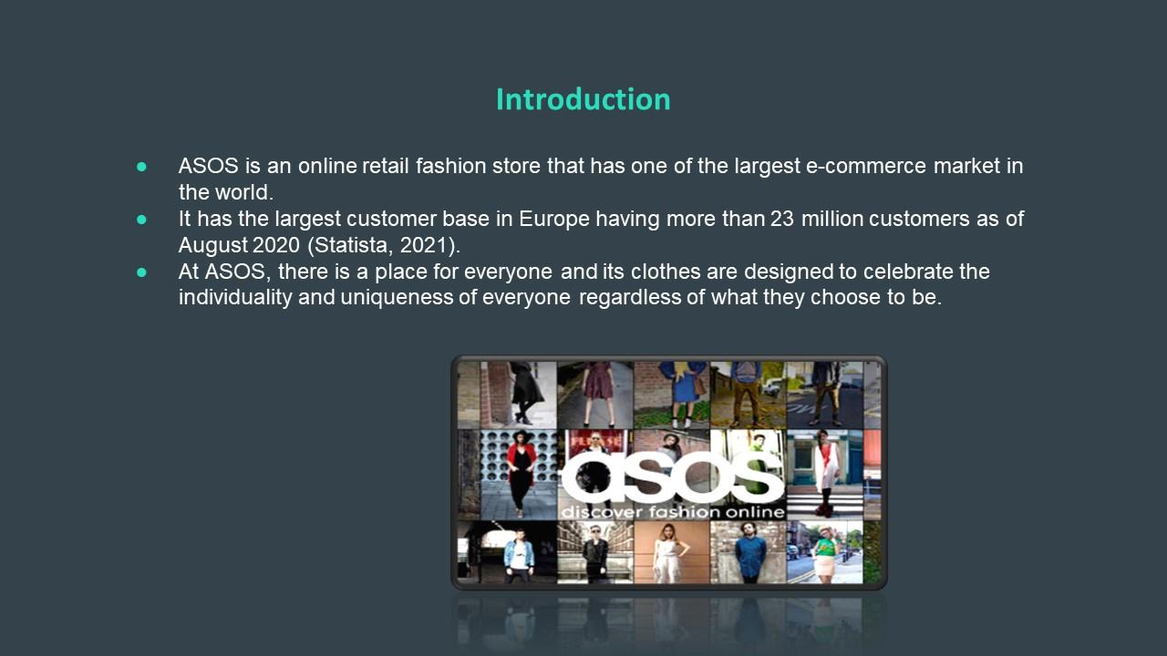


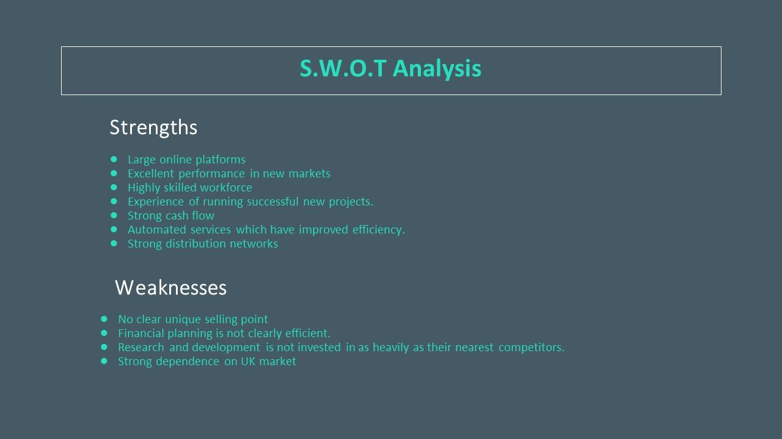

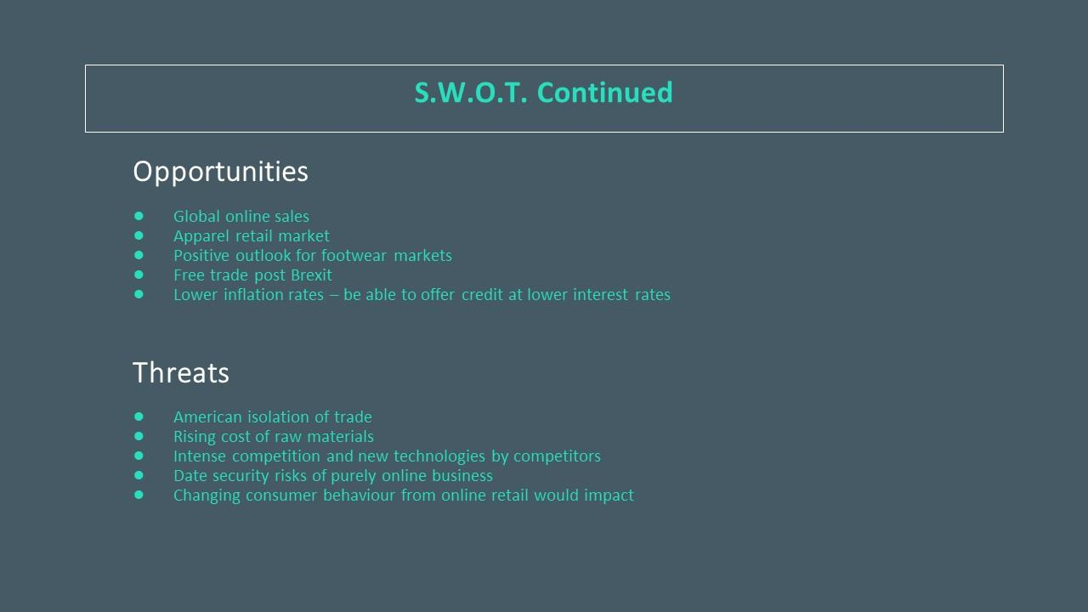
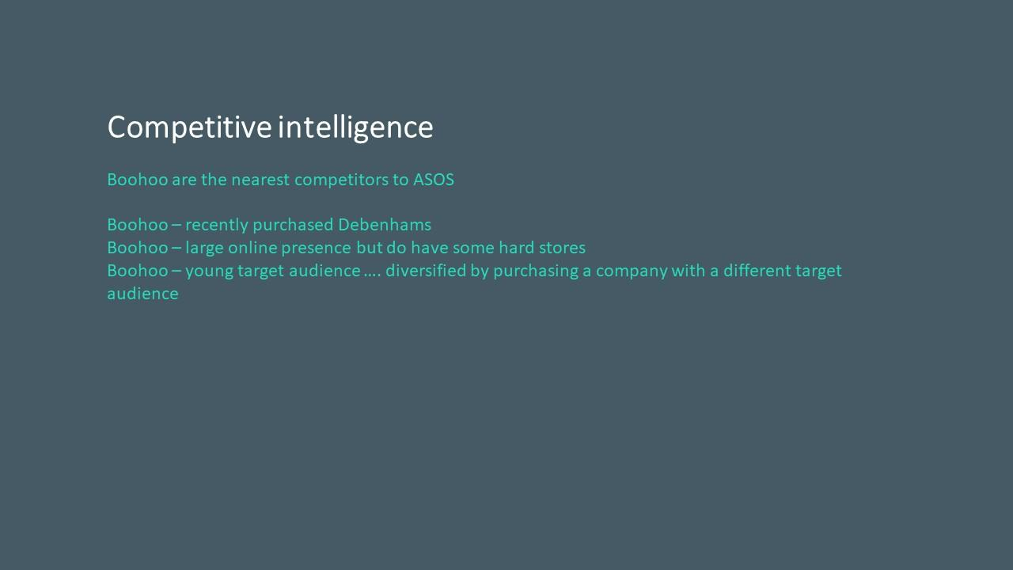

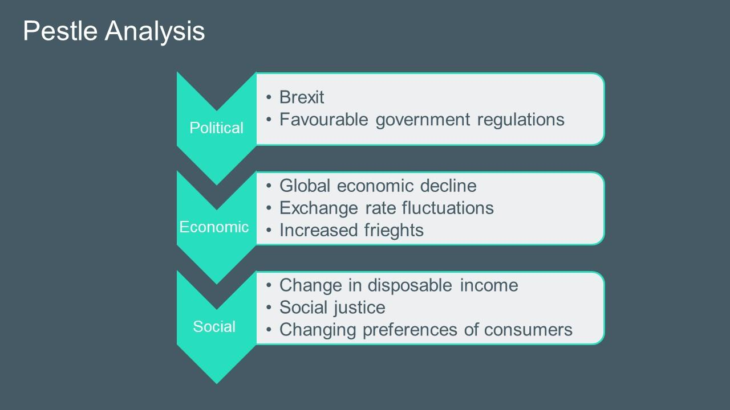
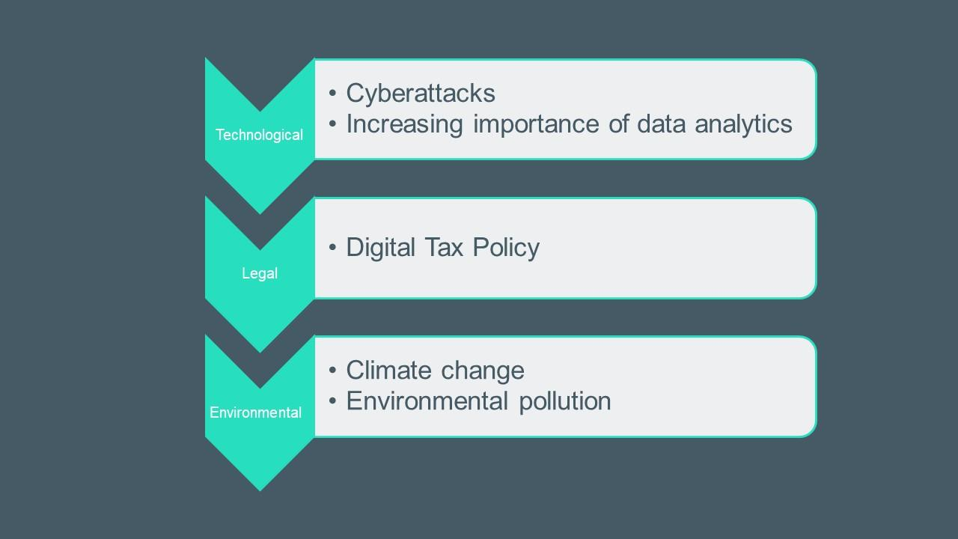



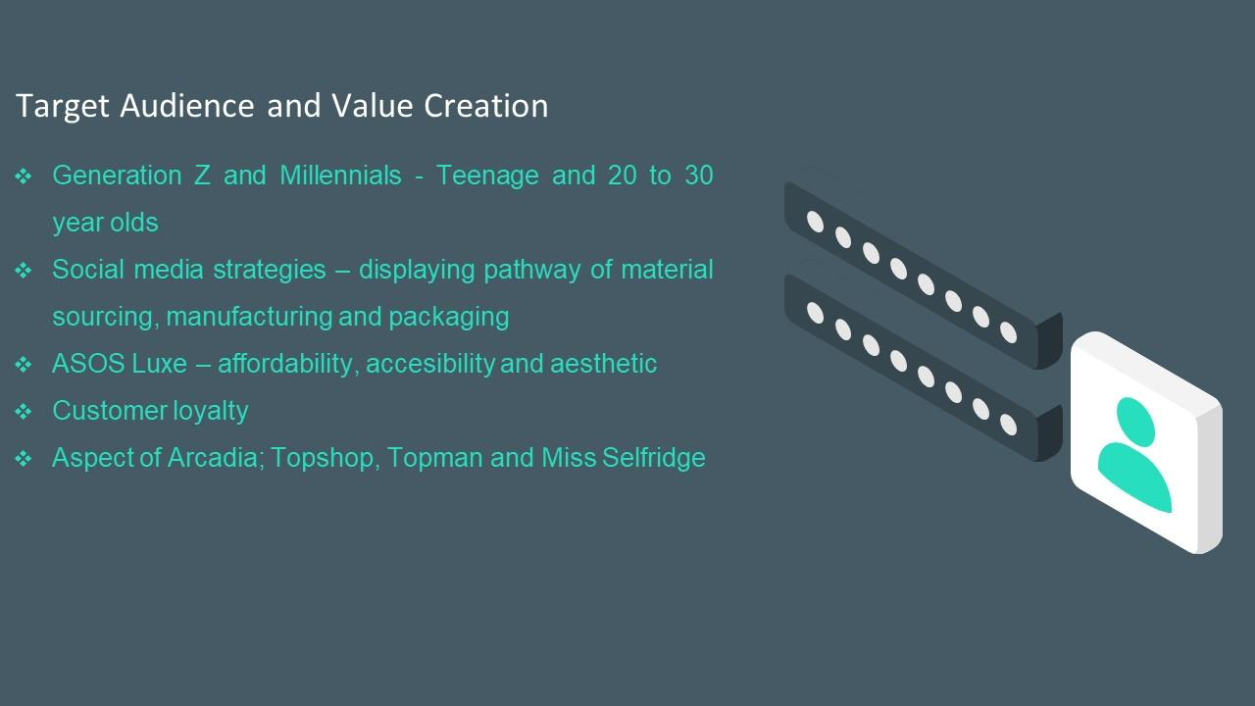

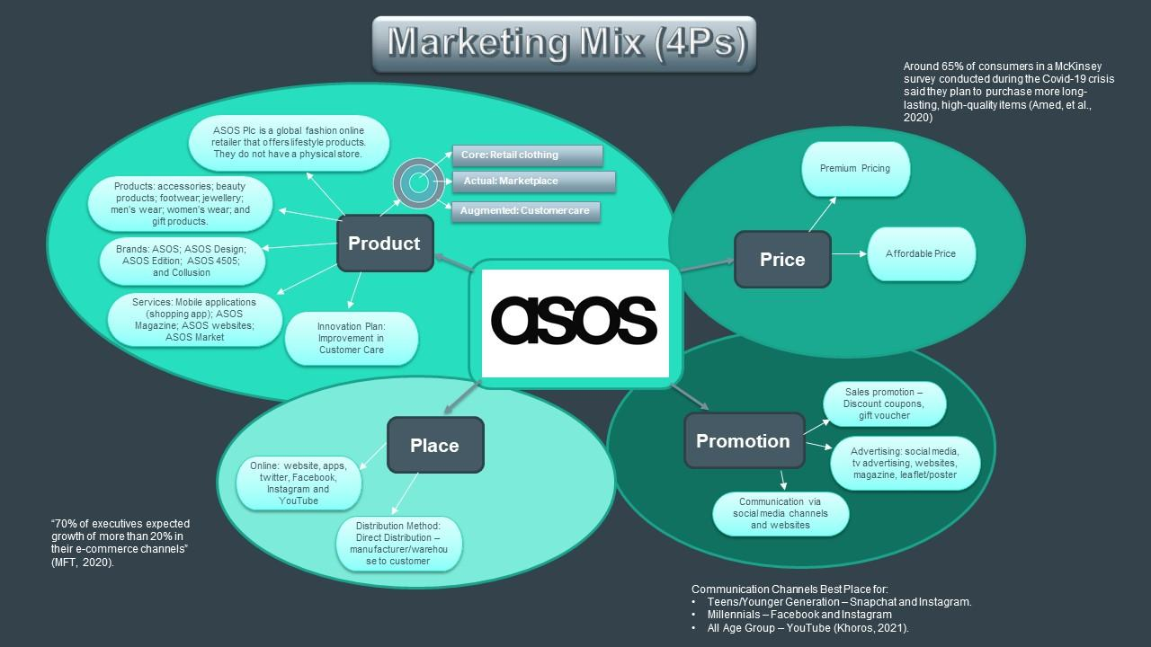
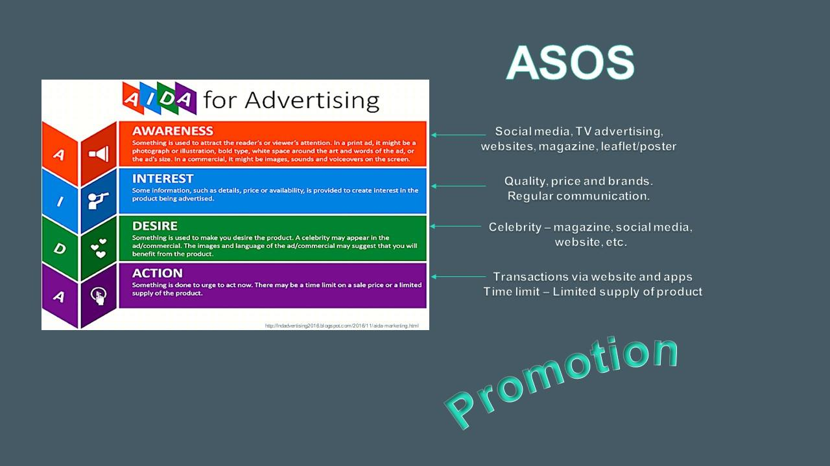


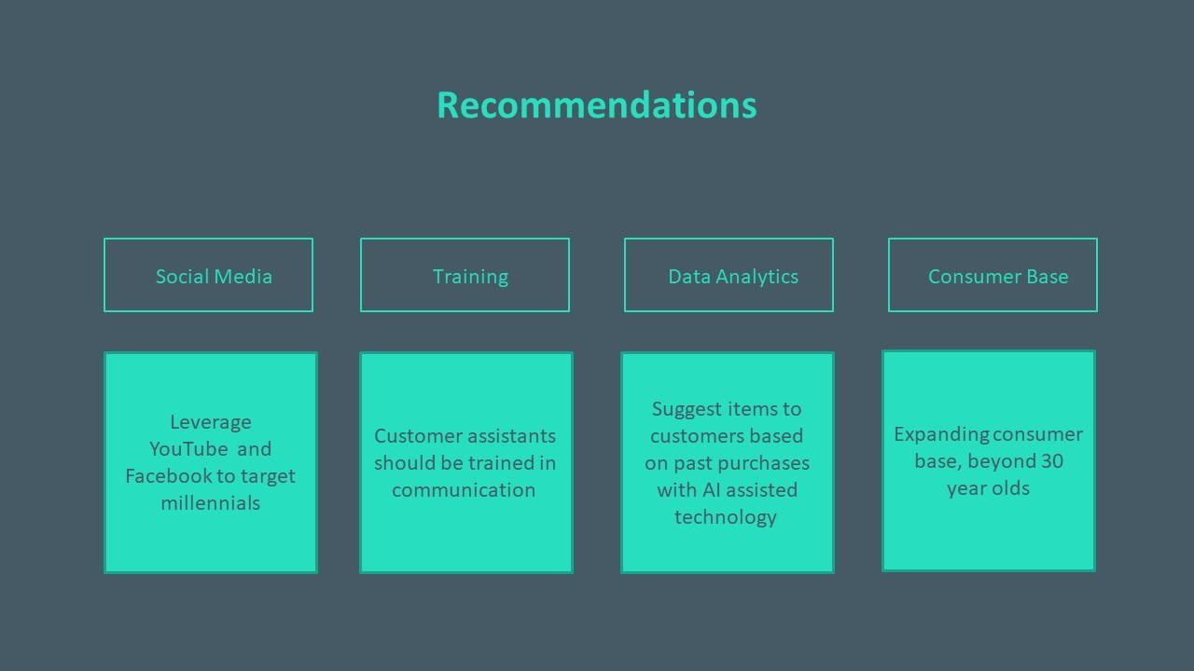

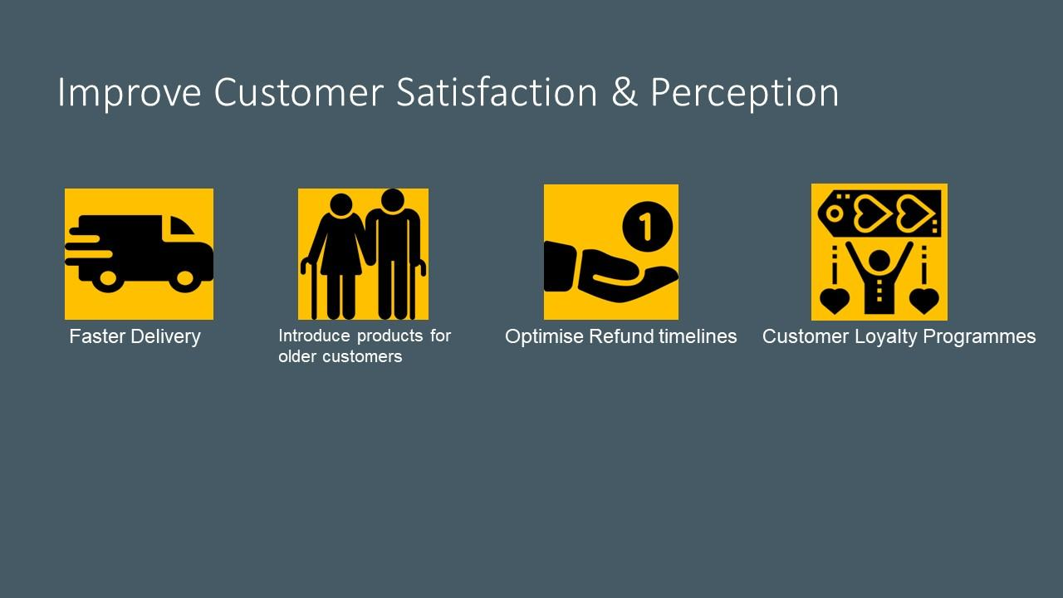
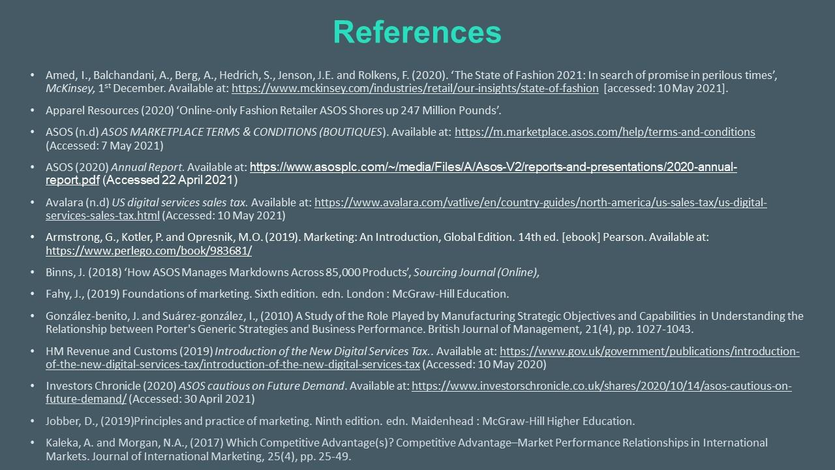

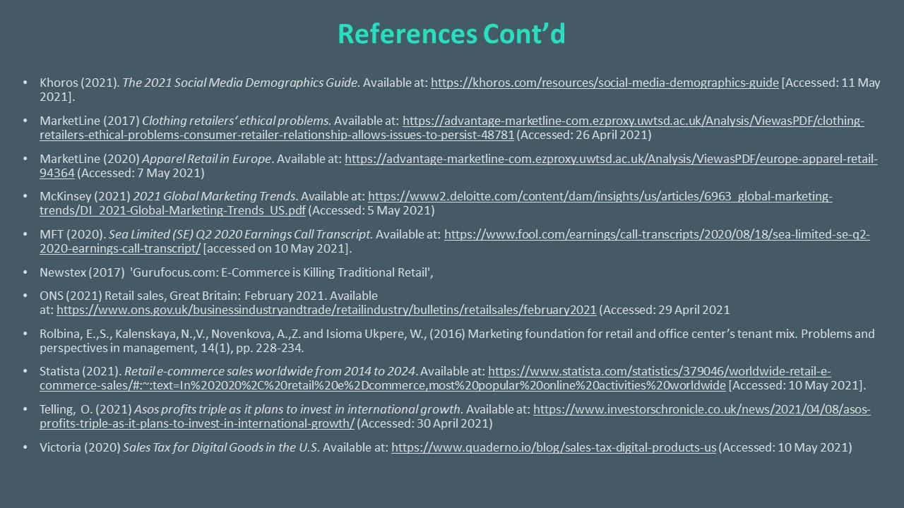
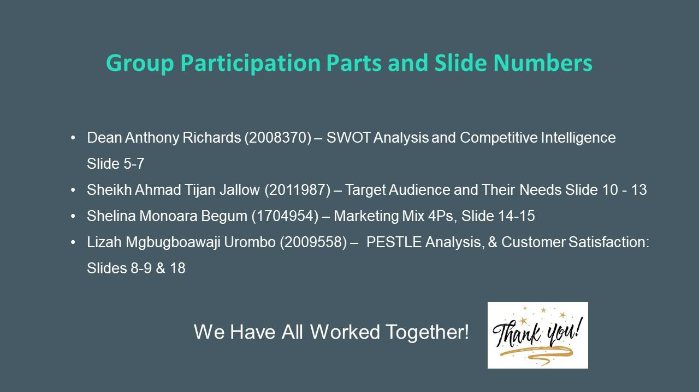

5.3 Appendix C – Marketing Audit of ASOS Plc

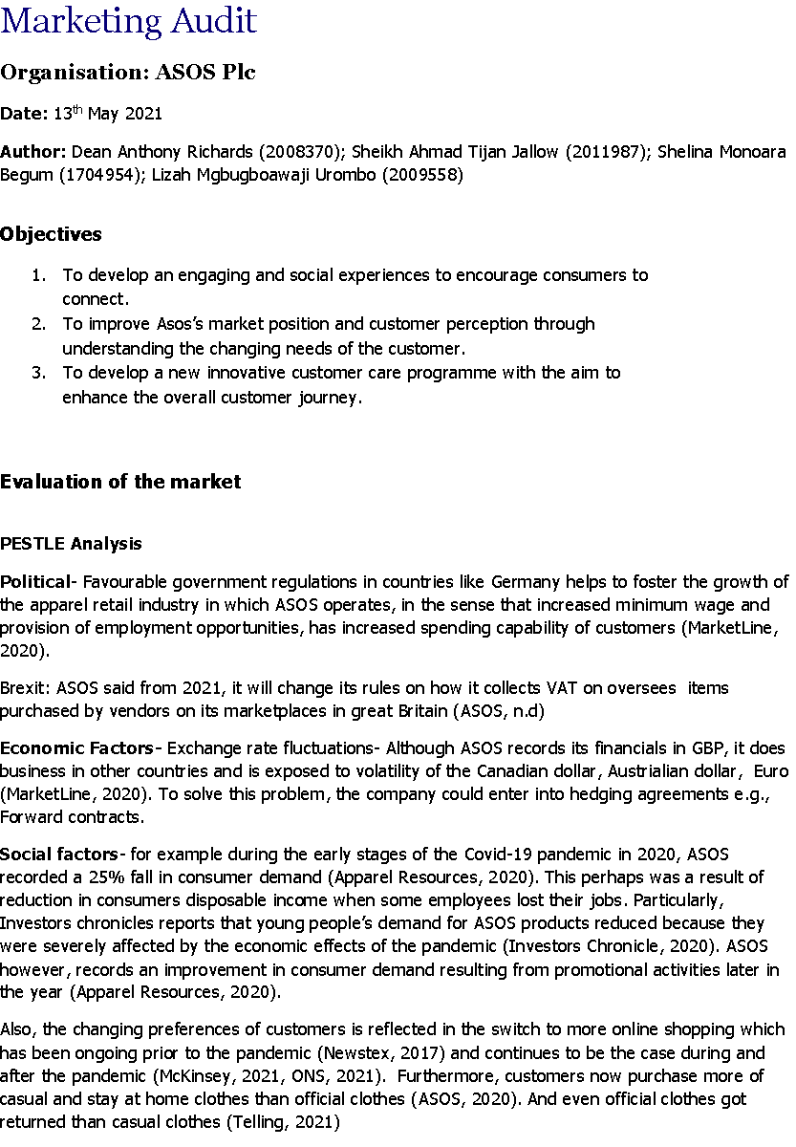
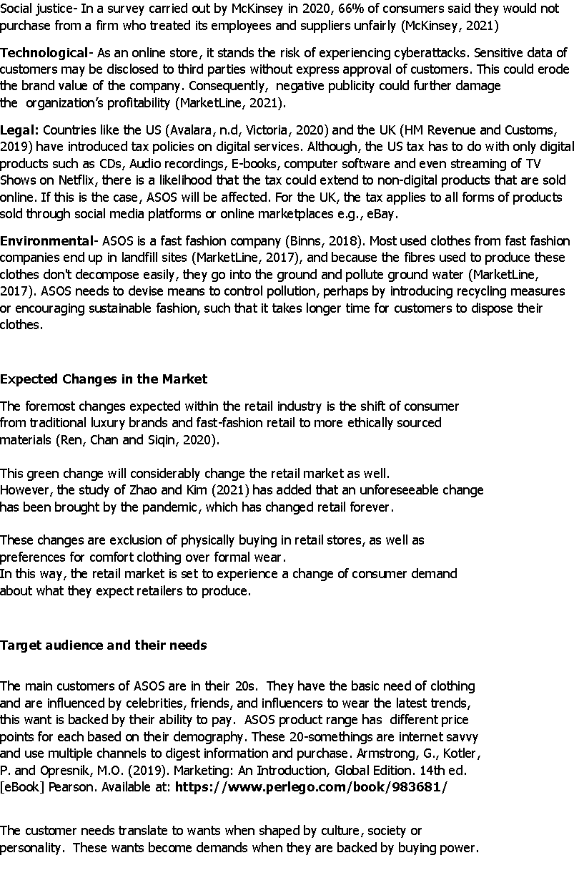
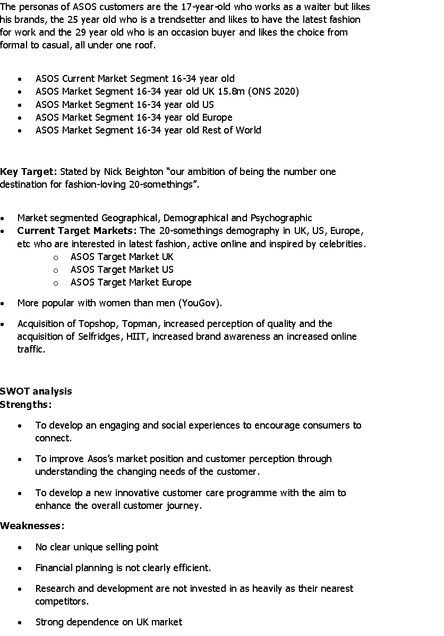

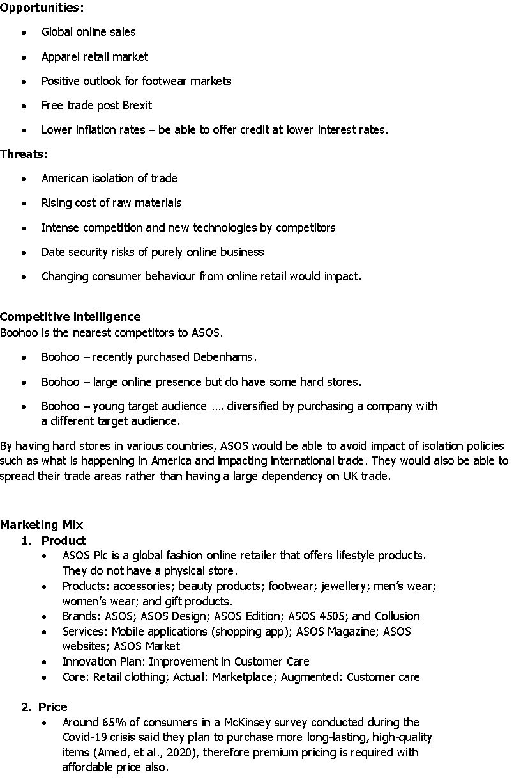
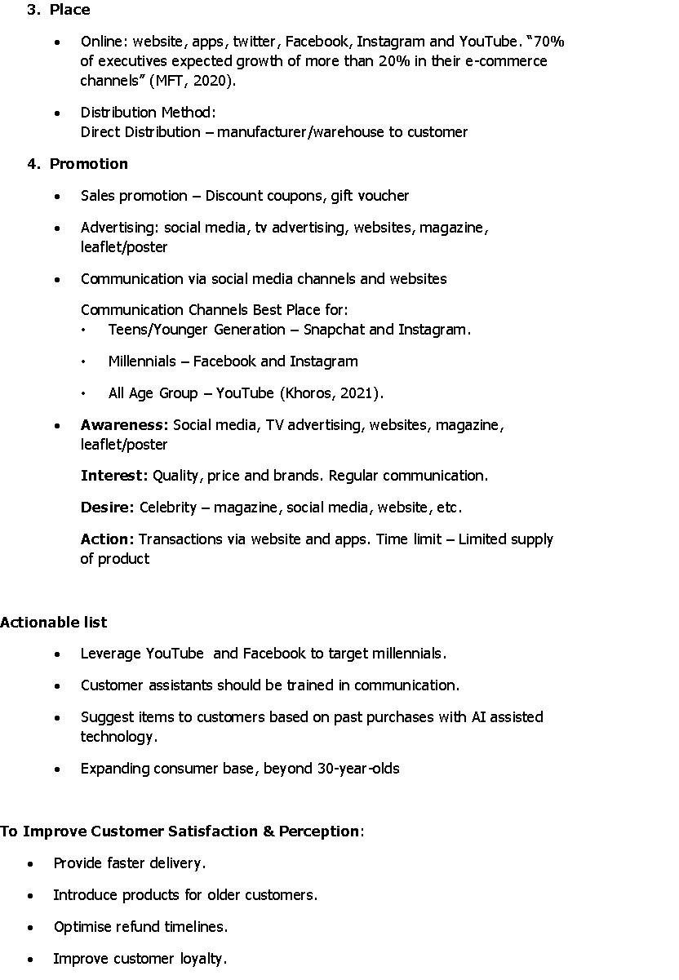

References
- Adamenko, D., Kunnen, S., Pluhnau, R., Loibl, A. and Nagarajah, A. (2020). ‘Review and comparison of the methods of designing the Digital Twin’, Procedia CIRP. 91, 27-32. DOI: https://doi.org/10.1016/j.procir.2020.02.146.
- Akram, W. and Kumar, R. (2017). ‘A study on positive and negative effects of social media on society’. International Journal of Computer Sciences and Engineering, 5(10), 347-354. DOI:10.26438/IJCSE/V5I10.351354.
- Allen, J. (2021). How to Improve E-Commerce Through Efficient Supply Chain Strategies. Business 2 Community [online] available at: https://www.business2community.com/product-management/how-to-improve-e-commerce-through-efficient-supply-chain-strategies-02375392 [accessed on 4 June 2021].
- Amed, I., Balchandani, A., Berg, A., Hedrich, S., Jenson, J.E. and Rolkens, F. (2020). ‘The State of Fashion 2021: In search of promise in perilous times’, McKinsey, 1st December. Available at: https://www.mckinsey.com/industries/retail/our-insights/state-of-fashion [accessed: 10th May 2021].
- ASOS (2021). Who We Are | Body Positivity & Supporting Talent | ASOS. [online] Available at: https://www.asos.com/about/who-we-are/?ctaref=aboutus|whoweare [accessed on 5th May 2021].
- Baker, M.J. (2014). Marketing strategy and management. 5th Ed. London: Palgrave.
- Barger, V., Peltier, J.W. and Schultz, D.E. (2016). ‘Social media and consumer engagement: a review and research agenda’. Journal of Research in Interactive Marketing. 10(4), 268-287. https://doi.org/10.1108/JRIM-06-2016-0065.
- Bashir, R., Mehboob, I. and Bhatti, W.K. (2015). ‘Effects of Online Shopping Trends on Consumer-Buying Behaviour: An Empirical Study of Pakistan’. Journal of Management and Research, 2(2), 1-24. DOI: https://doi.org/10.29145/jmr/22/0202001.
- Baubonienė, Ž. and Gulevičiūtė, G. (2015). ‘E-commerce factors influencing consumers ‘online shopping decision’, Social Technologies. DOI: https://doi.org/10.13165/ST-15-5-1-06.
- Bowen, H.P., Baker, H.K. and Powell, G.E. (2015). Globalization and diversification strategy: A managerial perspective. Scandinavian Journal of Management, 31(1), 25-39.
- Bramall, R. (2020). A Nation of Shopkeepers? The Idealised High Street in Brexit Britain. In: Imagined Economies - Real Fictions, New Perspectives on Economic Thinking in Great Britain. Culture & Theory. Verlag, Bielefeld, 119-138. ISBN 978-3-8376-4881-2.
- Bucko, J., Kakalejčík, L. and Ferencová, M. (2018). ‘Online shopping: Factors that affect consumer purchasing behaviour’. Cogent Business & Management, 5(1), 1535751. DOI: 10.1080/23311975.2018.1535751.
- BusinessBlogs (2018). Top 5 Advantages and Disadvantages of Social Media Marketing. Business Blogs Hub [online] available at: https://www.businessblogshub.com/2018/06/top-5-advantages-and-disadvantages-of-social-media-marketing/ [accessed on 5 June 2021].
- Carter Logistics (2021). Disadvantages of Poor Supply Chain Management.[Online] available at: https://tinyurl.com/y59u9223 [accessed on 4 June 2021].
- CIM (2021). Templates. [online]. Available at: https://marketingexpert.cim.co.uk/templates/#3293 [accessed on 3 May 2021].
- Davenport, T.H. (2018). ‘From analytics to artificial intelligence’, Journal of Business Analytics. 1(2), 73-80. DOI:10.1080/2573234X.2018.15435
- Derev’yanchenko, T. and Benivska, I. (2018). ‘MARKETING AUDIT AS THE INSTRUMENT OF MARKETING INCREASE EFFICIENCY WITHIN THE CONDITIONS OF ECONOMIC INSTABILITY’. Scientific Journal of Polonia University, 28(3), 43-48. DOI: https://doi.org/10.23856/2805.
- Doherty, N.F. and Ellis‐Chadwick, F. (2010). ‘Internet retailing: the past, the present and the future’. International Journal of Retail & Distribution Management. 38 (11/12), 943-965. https://doi.org/10.1108/09590551011086000.
- Hopp, C. and Greene, F.J. (2018). ‘In pursuit of time: Business plan sequencing, duration and intra entrainment effects on new venture viability’, Journal of Management Studies, 55(2), 320-351. https://doi.org/10.1111/joms.12251.
- Huang, MH. and Rust, R.T. (2021). ‘A strategic framework for artificial intelligence in marketing’. Journal of the Academy of Marketing Science, 49(1), 30–50. DOI: https://doi.org/10.1007/s11747-020-00749-9.
- Kelley, J.G. and Simmons, B.A. (2019). ‘Introduction: The power of global performance indicators’, International Organization, 73(3), 491-510. DOI: 10.1017/S0020818319000146.
- Khoros (2021). The 2021 Social Media Demographics Guide. Available at: https://khoros.com/resources/social-media-demographics-guide [Accessed: 11 May 2021].
- Kjeldgaard, D., Nøjgaard, M., Hartmann, B.J., Bode, M., Lindberg, F., Mossberg, L. and Östberg, J. (2021). ‘Failure: Perspectives and prospects in marketing and consumption theory’. Marketing Theory, 1470593121992539. https://doi.org/10.1177/1470593121992539.
- Kumar, S. (2019). Advantages and Disadvantages of Artificial Intelligence. Towards Data Science [online] available at: https://towardsdatascience.com/advantages-and-disadvantages-of-artificial-intelligence-182a5ef6588c [accessed on 4 June 2021].
- Lighter Capital (2020). What is Diversification Strategy? (Definition and Examples) [online] available at: https://www.lightercapital.com/blog/what-is-diversification-strategy-definition-examples/ [accessed on 9 June 2021].
- Lang, T. and Rettenmeier, M. (2017). ‘Understanding consumer behavior with recurrent neural networks’. In Workshop on Machine Learning Methods for Recommender Systems. [PDF] available at: https://doogkong.github.io/2017/papers/paper2.pdf.
- Lind, P. (2019). Monitoring Business Performance: Models, Methods, and Tools. London: Routledge.
- Lockett, A.R. (2018). ‘Online Marketing Strategies for Increasing Sales Revenues of Small Retail Businesses’. Walden Dissertations and Doctoral Studies. 5896. https://scholarworks.waldenu.edu/dissertations/5896
- Martinelli, E. and Vergura, D.T. (2020). ‘Satisfying Customers Through Premium Private Labels: Identifying Drivers of Customer Loyalty to the Retailer’. In Handbook of Research on Retailing Techniques for Optimal Consumer Engagement and Experiences (33-56). IGI Global. http://dx.doi.org/10.4018/978-1-7998-1412-2.ch003.
- NI Business Info (2021). Social media best practice for business. Advantages and disadvantages of using social media. [Online] available at: https://www.nibusinessinfo.co.uk/content/advantages-and-disadvantages-using-social-media [accessed on 4 June 2021].
- Oladimeji, M.S. and Udosen, I. (2019). ‘The Effect of diversification strategy on organizational performance’. Journal of Competitiveness, 11(4), 120. https://doi.org/10.7441/joc.2019.04.08.
- ONS (2021). ‘Coronavirus and the impact on output in the UK economy: December 2020’. Office for National Statistics. [Online]. Available at: https://www.ons.gov.uk/economy/grossdomesticproductgdp/articles/coronavirusandtheimpactonoutputintheukeconomy/december2020 [accessed on 5th May 2021].
- Purcarea, T. (2018). Retail digital marketing strategies. Available at: https://ideas.repec.org/a/rdc/journl/v9y2018i2p30-40.html [accessed on 17 May 2021].
- Ren, S., Chan, H.L. and Siqin, T.2 (020). ‘Demand forecasting in retail operations for fashionable products: methods, practices, and real case study’. Annals of Operations Research, 291(1), 761-777. DOI: 10.1007/s10479-019-03148-8.
- Schwarzl, S. and Grabowska, M. (2015). ‘Online marketing strategies: the future is here’. Journal of International Studies, 8(2), 187-196. DOI: 10.14254/2071-8330.2015/8-2/16.
- Soltanizadeh, S., Rasid, S.Z.A., Golshan, N.M. and Ismail, W.K.W. (2016). ‘Business strategy, enterprise risk management and organizational performance’. Management Research Review. 39(9), 1016-1033. https://doi.org/10.1108/MRR-05-2015-0107.
- Statista (2021). ‘Retail e-commerce sales worldwide from 2014 to 2024’. Statista.com, [online] available at: https://www.statista.com/statistics/379046/worldwide-retail-e-commerce-sales/ [accessed on 5 May 2021].
- Svobodová, Z. and Rajchlová, J. (2020). ‘Strategic Behavior of E-Commerce Businesses in Online Industry of Electronics from a Customer Perspective. Administrative Sciences, 10(4), 78. Available: https://EconPapers.repec.org/RePEc:gam:jadmsc:v:10:y:2020:i:4:p:78-:d:426006.
- TheGuardian (2021). Asos buys Topshop and Miss Selfridge brands for £330m. [online]. Available at: Asos buys Topshop and Miss Selfridge brands for £330m | Asos | The Guardian [accessed on 7th May 2021].
- Tritama, H.B. and Tarigan, R.E. (2016). ‘The effect of social media on the brand awareness of a product of a company’. CommIT (Communication and Information Technology) Journal, 10(1), 9-14. DOI: https://doi.org/10.21512/commit.v10i1.1667.
- VanDerHorn, E. and Mahadevan, S. (2021). ‘Digital Twin: Generalization, characterization and implementation’, Decision Support Systems. 145, 113524. DOI: https://doi.org/10.1016/j.dss.2021.113524.
- Westerman, G. (2018). ‘Your company doesn't need a digital strategy’. MIT Sloan Management Review, 59(3), 1-5. Available: https://sloanreview.mit.edu/article/your-company-doesnt-need-a-digital-strategy/.
- Zhang, T., Lu, C., Torres, E. and Chen, P.J. (2018), ‘Engaging customers in value co-creation or co-destruction online’, Journal of Services Marketing, 32 (1), 57-69. DOI: https://doi.org/10.1108/JSM-01-2017-0027.
- Zhao, L. and Kim, K. (2021). ‘Responding to the COVID-19 Pandemic: Practices and strategies of the global clothing and Textile value chain’. Clothing and Textiles Research Journal, 39(2), 157-172. DOI: https://doi.org/10.1177/0887302X21994207.
- Zhu, G. and Gao, X. (2019). ‘Precision retail marketing strategy based on digital marketing model’. Science Journal of Business and Management, 7(1), 33-37. DOI: 10.11648/j.sjbm.20190701.15.

