Academic and Employability Skills

REFLECTIVE ESSAY

University of Wales Trinity Saint David
Amandia Almeida
Student: 1816183
LECTURER: TIM HOPKINS

Page 1
INTRODUCTION

With a background in Beauty Therapy, I am seeking to develop myself as a professional. My aim doing Higher Education in Skills for the Workplace is to prepare myself for the professional world. With the objective to work as Spa Manager, I need to achieve the right skills that will project me to the employment world.
My reflective essay starts from understand: “what are my goals? How can I achieve them? What skills do I need?”
Focused on these questions, on the following sentences I will portrait myself answering these questions and explaining my development based on my in-class learning from the Module Academic and Employability Skills.

……………………………………………………………………………………………………………………………………………….

WHAT ARE SKILLS and WHAT ACADEMIC SKILLS I NEED
As a Beauty Therapist I still seek to improve my experiments but the main point is to know how to develop my academic skills so I can reach the job statute I want.
My process starts from understand the meaning of skills - Skills are the ability to use knowledge effectively when executing tasks.
Prior to be a Spa manager and regarding to career progression I need to define a structured base focus on academic skills.
As Morgan (2017) said: “University is about preparing you for the start of your career and the rest of your life – extending your knowledge, your skills and view of `how the world works`.
Balancing the in-class learning and my home research I found that I need a good academic foundation to automatically growth professionally. Academic Skills involve “a collection of study habits, learning strategies, and time management tools that help students learn and absorb school lessons” - Upson, (2003).

SKILLS EMPLOYERS SEEK
My career aim is to work as manager in a Spa and during this stage I want to get more experience and growth professionally.
Prior to my job analyse I realised the concept of employability skills and how they influence professional careers. Employability skills are defined as soft and transferable skills, these are the main point to get employed and to develop tasks required.
Morgan, (2017) described: “A job analysis is the process of identifying what tasks the job will involve. This is useful for you, so that you know whether you might like the job, and useful to employer who can use it to identify the kinds of qualities they are looking for.”
I started from identify, analyse, and understand Spa manager role and which employability skills are relevant to get this job. As examples I collected some newspaper that shows how direct employers are when looking to recruit people, (find homework exercise in the Appendix 1), the information I collected talks about soft skills, ability to relate, empathise and find common ground, which are all vital to progress professional.
During this research I noticed that due to the big competition in Beauty sector, employers are not only looking for certificated or graduated people, but they are focus on their employability skills, so in this way they can overtake their competitors.

Page 2

SWOT ANALYSIS and EISHENHOVER METHOD
After identify the skills I need to work as a Spa manager I prepared my SWOT analyse, so I could also identify my strengths, weaknesses, opportunities and threats, - as you can see in the Appendix 2 - I describe my analyse so it can help me to planning and focus on my objectives.
The Eishenhover Method also gave me more perspective of planning by organize duties and tasks defining priorities. This method uses the criteria IMPORTANT-NOT IMPORTANT, giving me the chance of manipulate the most relevant tasks. Find my Eishenhover Method in the appendix 2.

PERSONAL DEVELOPMENT PLAN
The in-class learnings encouraged me to develop researches, these researches brought to me different perspectives. I stopped thinking only about my final goal, so I thought that the best way was to create a solid structure to achieve my job. I was wondering about the skills I own at this stage, - what will make me different from another professionals so companies will contract me!
With the course of the lessons I learned the main steps:
1-I focus on define my goals: I want to manage a Spa and open my own business;
2- Evaluate my current position, evaluate my skills and achievements;
3- I need to structure my personal plan to achieve it;
During this phase I started my Personal Development Plan, as you can see in the in-class exercises (Appendix 3).
I structured 6 sections, from goals projection to the completion divided in three stages: short, mid and long terms.
This evaluation took me back to the last topic, about “what skills employers are looking for?” and then to realize what skills I need.

SKILLS I NEED
To meet Spa manager responsibilities I need the following skills: verbal and written communication to handle with different responsibilities; leadership skills to know how to work as a team; time management skills to get the ability of anticipation in certain situations; customer service; problems solving and decisions making when interacting with the team or customers to resolve issues insuring work flows healthy and customers are satisfied; interpersonal skills are important because of customers interaction, colleagues and vendors.
Adding to the above skills, due the vast range of competitors and different standards, employers look for Spa managers capable to execute the following specific skills:
Health and Anatomy skills; Products and treatments knowledge as a Spa manager this skill is essential to present products benefits and when recommending services to customers and closing sales; Time keeping: learning this skill the Spa manager will be able to create and keep deadlines, project management, manage appointments, make service decisions, etc…
The ability to work under pressure is also required to managers, so they know how to deal with stressful situations, how to react and manage them and how to deal with complains and busy days.

Page 3

SKILLS I HAVE and HOW DO I DEMONSTRATE THEM
With my background in Beauty Therapy level 3 and keep working in the Beauty sector for 3 years, some of the skills are already part of my curriculum although I am still learning and improving my knowledge, particularly the academic skills. At this stage I own the following Soft Skills:
Verbal and writing communication (academic skills) - I demonstrate these skills daily, by promoting ideas, resolving problems, communicating face to face with different people in assertive way, e.g. the in-class presentations or group discussions;
Leadership – I practice discipline daily by dealing with different responsibilities, I demonstrate this skill during group works by using effective communication.

Time management – I use time management daily when defining and planning tasks, defining priorities and fulfilling deadlines;
Customer service – I demonstrate this skill when carrying out treatments, giving assistance to customers during all the treatment process.
Problem solving and decision making – when I find a problem my first action is to fix it and provide a way that will avoid the same problem again.
Interpersonal skills – I practice this skill at home, work, in-class, every time I interact with someone. Interpersonal skills demonstrate qualities and behaviour we use to interact effectively with others.
Soft Skills contribute to execute any career, even in personal life. These are considered transferable skills, the ability to understand and give instructions.
I also own the hard skills:
Health and anatomy skills, products and treatments knowledge – I demonstrate them during client treatments, e.g. during body treatments, massage or facials.
Hard Skills are very pertinent to specific roles and work we are doing. I consider these skills the technical skills, they show how we should do the work.

SKILLS TO DEVELOP and HOW TO DEVELOP THEM
I think the best way to improve my skills is to keep focus on my objectives, keep practicing exercises to cover my difficulties, bringing together the academic learnings and implementing them on a daily basis.
Verbal and writing communication (academic skills) – dealing with customers, completing in-class exercises and homework, making researches and taking notes. These skills are a challenge for me because English is not my first language and I struggle to understand the meaning of some words or sentences. As you can see in the Appendix 4, I provide in-class exercises that shows my evolution using paraphrasing and summarizing.
Paraphrasing and Summarizing are great ways to avoid plagiarism and different ways to show comprehension and interpretation. Paraphrasing is when I put the ideas/texts of another person in my own words keeping the same context. Summarising is when I put others/texts ideas into my words but only including the main points – it is shorter than paraphrasing.
In the Appendix 5 I present my “reference” exercises. I am quiet confuse about how to refer, (I know that I need to focus more on this topic). These exercises also help me to develop academic writing, essays or reports, avoiding plagiarism and covering the real importance of academic integrity. To develop skills, I also implement them into my current life when socialising. Language is very important for me, making me feel more confident with others.

Page 4

Leadership – I want to develop this potential skill because will be important when managing group of people. I can develop this skill by offering me as group work responsible (for example: making part of community or university activities), making decisions and solving problems.
Time keeping and work under pressure – to develop these skills I will practice at my work university and personal life, providing different ways to control my schedules, meeting deadlines.
Health and anatomy skills, products and treatments knowledge – making sure I improve my knowledge by having regular training that will cover my professional update.

……………………………………………………………………………………………………………………………………………………

CONCLUSION
My learning evaluation makes me conclude that Academic Skills are fundamental as a starting point, they represent an open door to employment but they need to work side by side with employability skills.
As Morgan, (2017), says on page 177: “University tries to prepare you to workplace, … on enabling to behave in a way that will also help you succeed in the workplace.” So, graduation need to be balanced with employability skills. Employees with these two capabilities are easily hired to work in successful companies.
Companies want employees that can help them grow so they can win competitors.
With this process I feel able to define my goals and outline the best way to achieve them.
Through my researches I found important skills employers are looking for, and these will be present during my academic and professional evolution. Skills are the main thing employers are looking for, a mix of soft and hard skills.
To get the job I want, and considering that I am still developing the academic stage, I`ll work hard to develop my skills by committing myself to put what I have learned into practice. As I developed my Personal Plan I will be focus on it, for sure it will help me managing my academic and professional life, and hopefully I will find the job I am looking for.

Page 5

REFERENCES

- Morgan, P. (2017) “The Business Student`s Guide to Study and Employability”
- https://www.merriam-webster.com/dictionary/skills
- Bania, Ashok. Director of Product Management, Headspace. https://productplan.com/hard-skills-product-management/
- https://www.thebalancecareers.com
- https://www.businessdictionary.com
- https://www.google.co.uk/amps/spamanager-jobdescription.com

Page 6

APPENDIX 1

Qualifications are the easy bit: how to build your job skills
What skills do you need to make a career in finance
by JAMES FITZGERALD
Posted 16 AUGUST, 2019
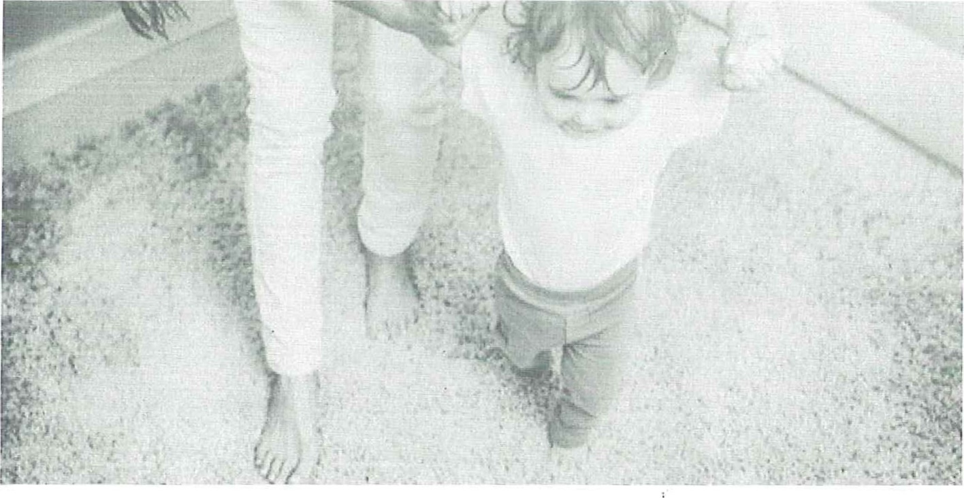
Almost two decades of schooling and higher education may all lead inexorably to the workplace, the actual realties of work may all too often remain abstract when taking the first steps into employment.
At our Next Generation forum in London earlier this year, more than 50 young delegates listened to our guest speakers talk about industry myths, 'important modern skills and why there is a taste for change in regard to career progression within financial services.
Speakers agreed there are some basic questions industry hopefuls need to think through as they begin to think ahead. Where do I want to go? How do I get there? What skills do I need? And is there a better way 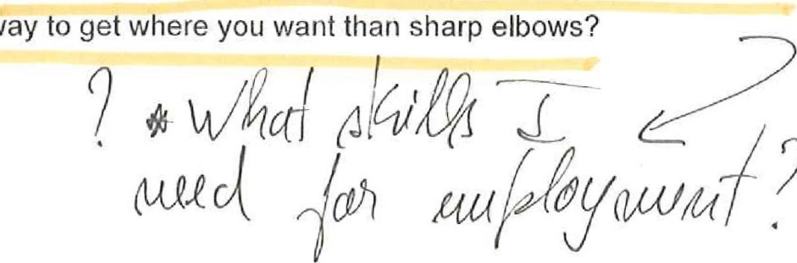to get where you want than sharp elbows?

Bev Shah, chief executive of professional network City Hive, said that financial services
focus too much on academia and qualifications and not enough on soft-skills such as the ability to relate, empathise and find common ground, which are all vital 'if you want to progress in your professional career.'
ADVERTISEMENT
SCROLL TO CONTINUE WITH CONTENT
She said this meant 'bringing your whole self to the work place' and said that when working in a client focused, relationship-led industry, young professionals shouldn't 'hide who they are'.
'I'm a big believe of bringing yourself to work, she said. 'l struggle with this personal and personal persona. I think if you are dealing with people on a daily basis then you have to interact with people, the industry is opening up to the idea of bringing your whole self to the work place, you don't need to hide who you are.
'When I changed companies, I didn't have to change who I was, the people came with me because they knew me. We are all people at the end of the day.' Said Shah.
Karis Stander, managing director of sector recruiter Investment 20/20 agreed, and said that a narrow regulatory focus on qualifications led too many to believe that studying was the primary route to success.
'Exposure within a company means more than what you are doing in just work impact,' he said. 'What you are doing is networking, letting people know who you are and what you are doing, It is about exposure to colleagues and clients. Work with different people, vertically above you or horizontally, get that exposure and that then helps your development.'
Michal Freeman-Shor, senior associate at law firm Shoosmiths, added that qualifications are just one pathway to success and that in this new, truly global world the younger generation of professionals needed to 'keep up with subject matter and soft-skills' otherwise they will 'fall behind.'
As well as this, Freeman-Shor said 'leadership is not just about being a CEO' and that being confident and ensuring both senior and junior colleagues 'want to work with you' is a huge piece of the corporate puzzle.
'To succeed, you need subject matter and soft skills, otherwise you won't keep up in the global world, it is not just qualifications. Most importantly, you need to be confident in yourself, leadership is not just being a CEO.
'Everyone can be a leader. You have to be able to ensure that those people who are

working with you, whether they are senior or junior colleagues, that they want to work with
you.'

magazine,ik/?
Strategic HR v Operational Efficiency v Personal Development v
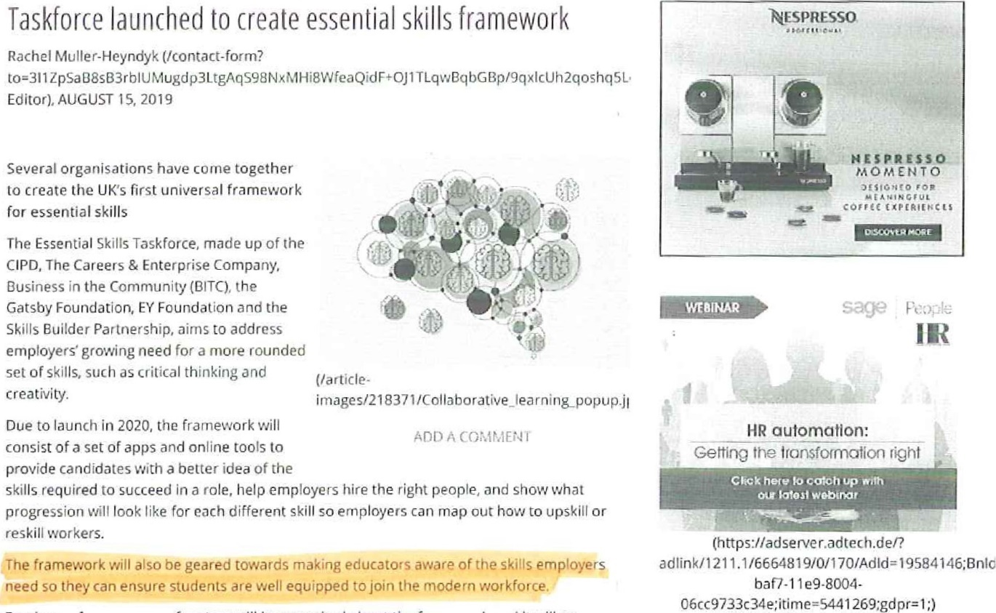
Employers from a range of sectors will be consulted about the framework and il will go through several development stages. The final version is expected to be published in Spring 2020.
Chief executive of the Royal Society for the Encouragement of Arts, Manufactures and Commerce (RSA) Matthew Taylor (https://wwvv.hrmagazine.co.uk/hr-mostinfluential/profile/matthew•taylor) called for a universal skills framework in his review of modern working practices (https://hrmagazine.co.uk/article•details/two-years-since-the-taylorreview-what-next) in 2017.
He welcomed the creation of a new Essential Skills Taskforce: 'With the nature of work continuing to evolve, it is challenging to predict exactly what technical abilities and skills will be needed in years to come. However, there's growing recognition that the core skills, which are essentially hu man and behavioural (https://www.hrmagazine.co.uk/article-details/whatautomation-means-for-hr), will be vital in almost all jobs and roles."
He added: '"The work of the taskforce is an important step towards achieving a common understanding of these essential skills from education right through to our workplaces. Establishing a framework and a common language for these skills is vital
(https://hrmagazine.co.uk/article-details/matth eel-lay t or-in-conversation-with-cary-cooper) in creating the clarity we need to achieve more productive, high-performing workplaces that enable people whatever their backgrounds to feel engaged and empowered in their jobs."
John Holman, Emeritus professor of chemistry at the University of York and former STEM skills adviser to the government, will chair the Essential Skills Taskforce. He commented that despite the rise of automation at work, employees will still need specific skills that can't be replicated by technology.
^{E}lf you ask employers what they are rooking for in the people they hirer "they increasingly specify essential skills like communication and teamwork, They take for granted that employees must have sound educational qualifications, and what makes the difference is the higher order essential skills which a machine cannot offer," he said.
producing a universal framework of essential skills that are clear. measurable and authoritative, we will give employers a toolkit that they can use to select and train the employees they need to succeed in tomorroWs workplace. Equally importa ntiy, it will be a toolkit that schools, colleges and universities can use to hetp the students develop these skills."
News of the framework comes as students receive their A-level results today (1 5 August). Rachael Saunders, education director at BITC, said that some of the skills needed at work are frequentty overlooked by the education system.
"While the knowledge that young people will gain through their studies is vital, essential skills such as teamwork, creativity, leadership and problem solving are in danger of being forgotten. These skills are valuable now and will remain vital in the future as a balanced focus between know:edge and skills directly links to the LJKs economic development and productivity," she said,
Employees and students must be supported to build the skills they need now for our changing world of work, and given access to learning that will equip them to develop the skills they need for the future (https'.//Www.h rmagazine.co.uk/article-details/case-study-unitedutilities-removes-the-stigma-of-reskilling)."
Saunders called on employers and educators to work together to address the skills chal lenge in the UK. "If businesses are looking for specific essential skills. they need to work with educators using a curriculum that's relevant to modern life. This will ensure that businesses benefit from the workforce of the future having the skills they need while leading the way in providing good and fair employment opportunities to all, regardless of background," she said.
COMMENTS
Name Email
Comment
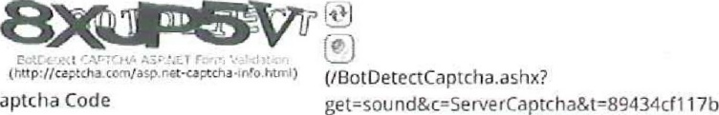145ffbt
Captcha
All comments are moderated and may take a while to appear.
POST COMMENT
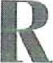
About us (fabout.us) I Contact Us(/contact-us) I Privacy Policy (httpswprivacypolicy.markallengroup.com)
Terms & Conditions (httpt//assets.markallengroup.com/compänvgenericjlegatfterrns-conditions.pdf)
Cookie policy (http://assets.markallengcoup.ccm/cornpany/genericnegal/cookie-policy.pdf) I Advertising ('advertising) I Accessibility (laccessibility)
Registered in England and Wales. No, 06779864 | Registered Office: StJude's Church DUIWlch Road London • SE24 OPB
O copyright Mark Allen Group 2019 (http://vxvw.markallengroup.com/)
(https://wwvalinkedin.cor magazine. 1k/?
vie
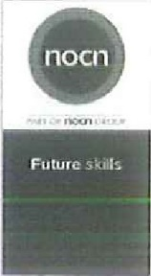
Matthew Taylor, the RSAs chief executive and champion of this project, called for a framework like this to be introduced in his review of Modern Working Practices_
Employers from a range of dfferent sectors will be consulted about the framework and it will go through several development stages. The final version Is expected to be published in spring
2020
Sir John Holman, Chair Of the Essential Skills Task Force, said:
you ask employers what they are looking for in the peop!e they hire. they increasingly specify essental skills "ke communrcaton and teamwork They take for granted that employees must
have sound educational qualJf1catjons. -and what makes the d'fterence is the order essential skills whith a macnne cannot otter | ('componenUbanners/clicW473)
What
do you think
about workplace learning?.
'By producing a universal framework of essential skills that are deer, measurable and authoritative, we will give emp!oyers a toolkit that they can use to select and train the emp!oyees they need to succeed in tomorrow's workp!ace. Equally importantly, it be a toolkit that schoo:s, colleges and universities can use to help the students develop these skil's.'
Matthew Taylor, Chief Executive of the RSA, said:
•With the nature of work continuing to evolve, it is challenging to predict exactly What technical abi%ties and skit's be needed in years to come. However there's growhg recognition that the core ski]s, which are essentially human and behavioural, will be vital in almost all jobs and ro!es
'The work of the task force is an important step towards achieving a common understanding Of these essential skiffs from education right through to our workplaces. Establishing a framework | (IcomponentJbanners/click/4GO)
(/componentjbanners/clicW466)  we want make sure skills in the | (IcomponentJbanners/click'307)
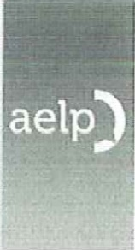
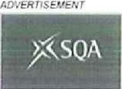

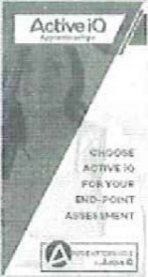
and a common language for these skit's is vital in creating the c;arity we need to achieve more productiVe, high-performing workplaces that enab'.e people whatever their backgrounds to feel engaged and empowered in their jobs'"
Christine Hodgson, Chairman Of Capgemini in the UK, Chairman Of The Careers & Enterprise Company and a trustee of Business in the Community, said:
'As an employer, to we're recruit;ng people with the right to thrive
21st century workplace. But without a common language and shared understanding, it can be d'ffjcult for empbyers to identify easily or communicate what they're looking for. And it'S harder for schools to make sure they're focusing on developing the right ski]s_ By helping schools, young peop!e and employers all pull in the same direction, this work Vi'iAl help us prepare young people for the fast-changing world of work '
(b Commcnt$ Newest
Adr.l a comment. (IcomponenUbanners/clicW437)
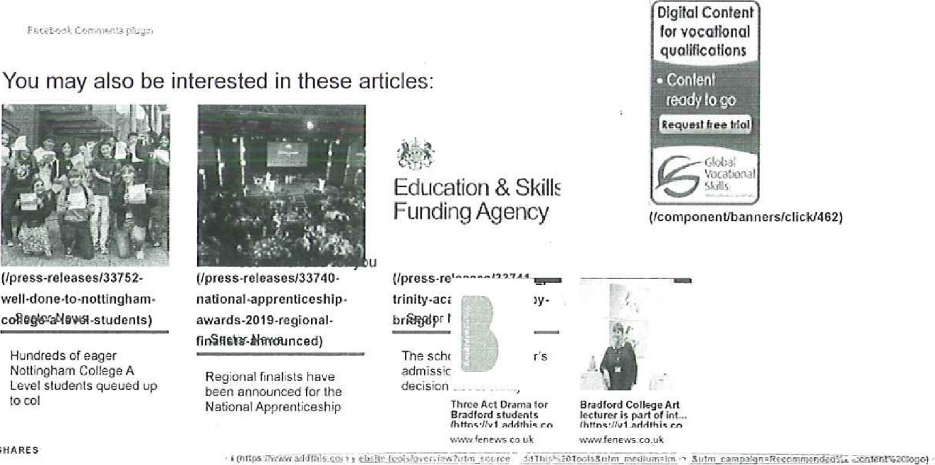
SHARES
new1113ire.35
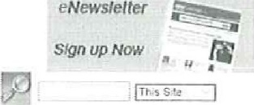
eNews!etter

APPENDIX 2

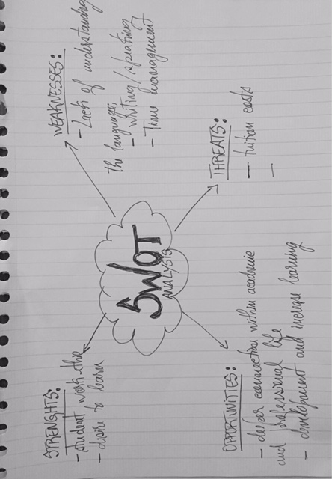

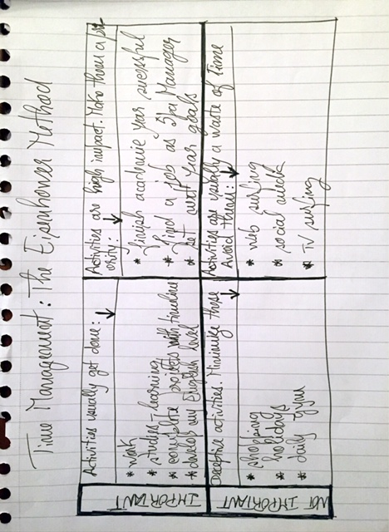

APPENDIX 3

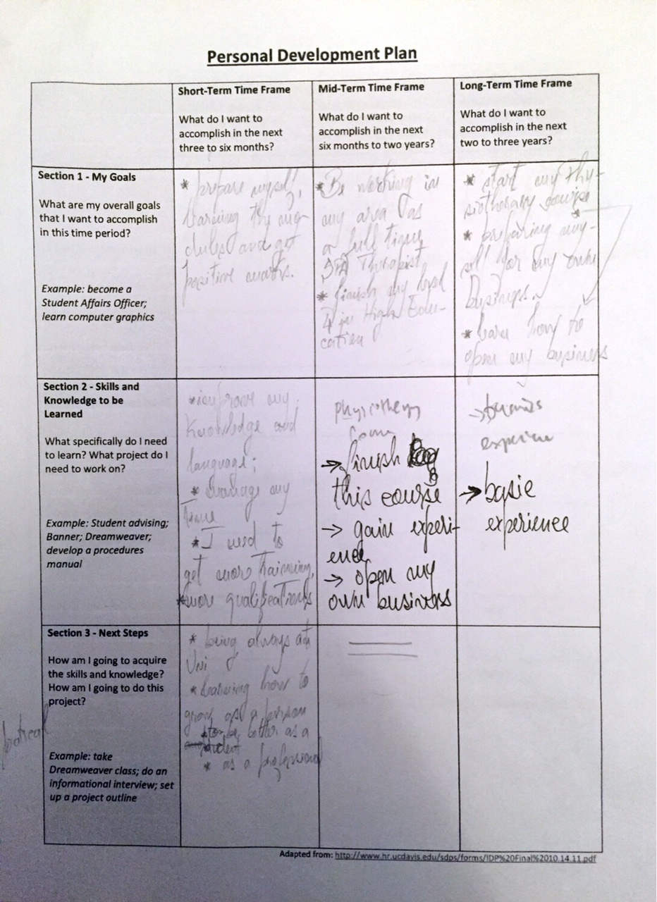

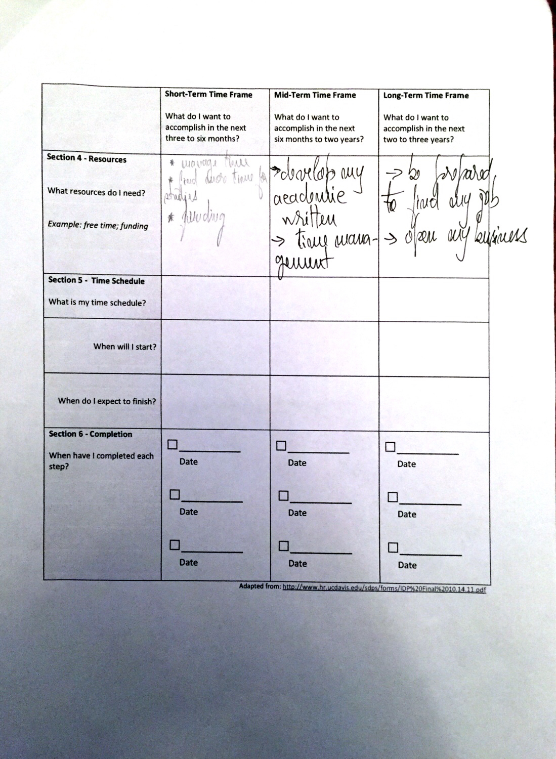

APPENDIX 4

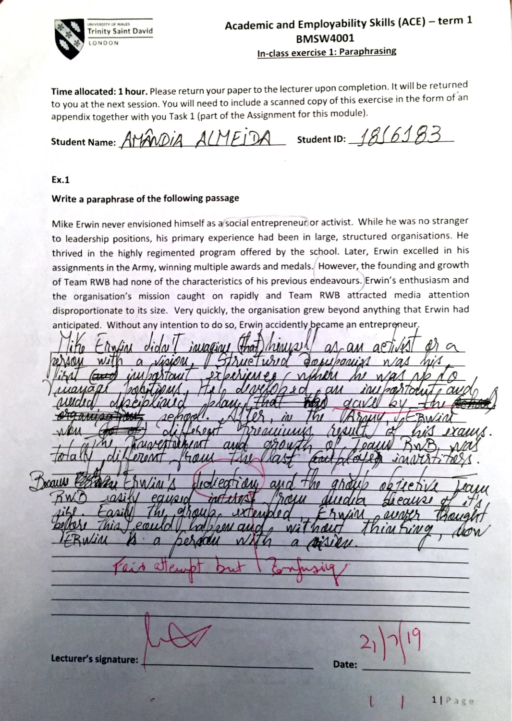

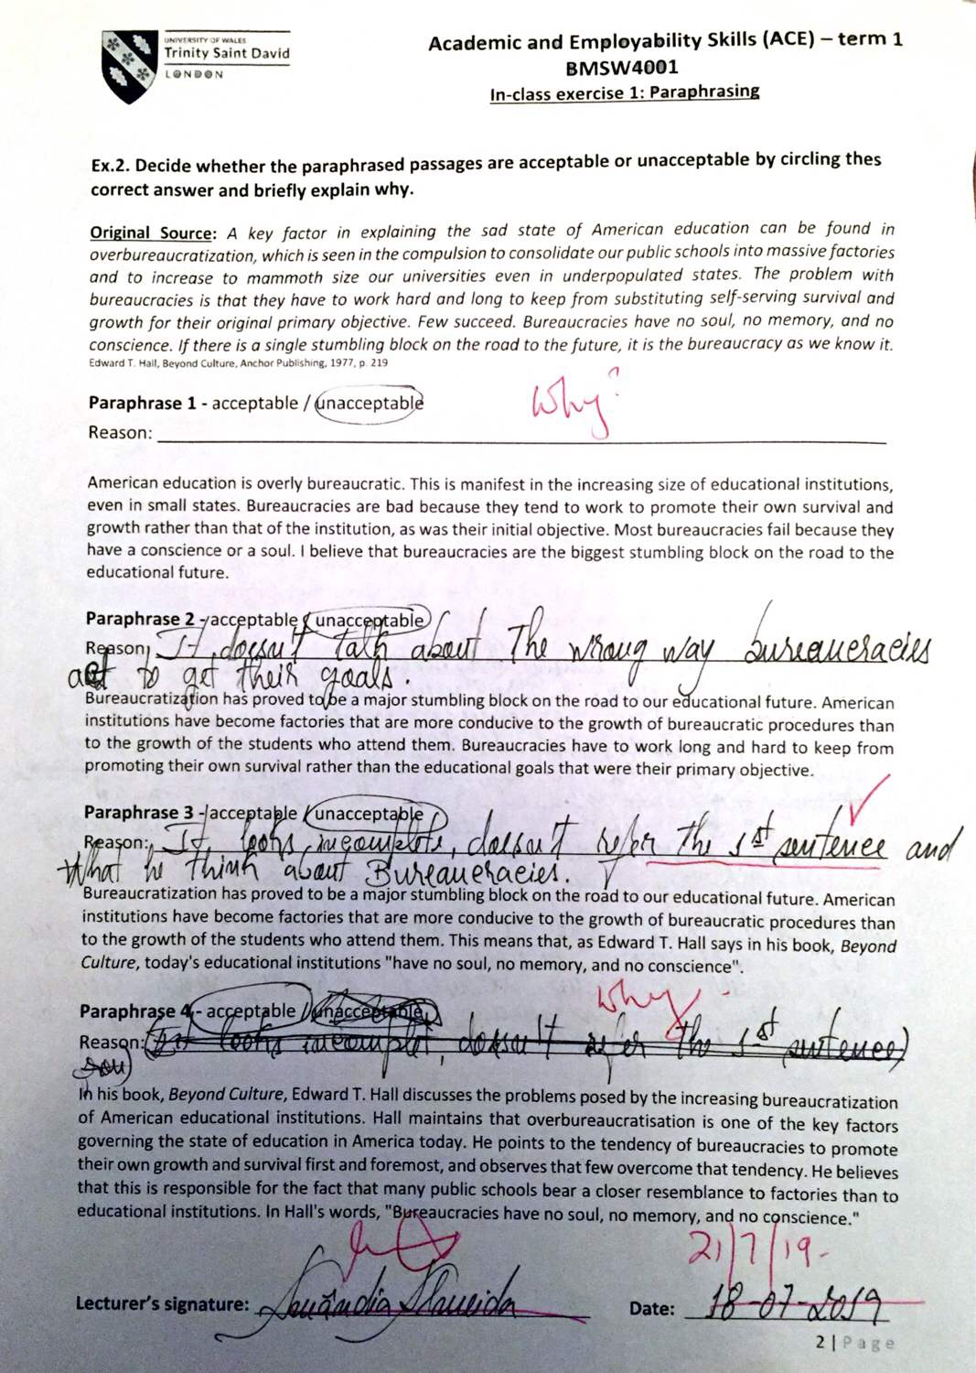

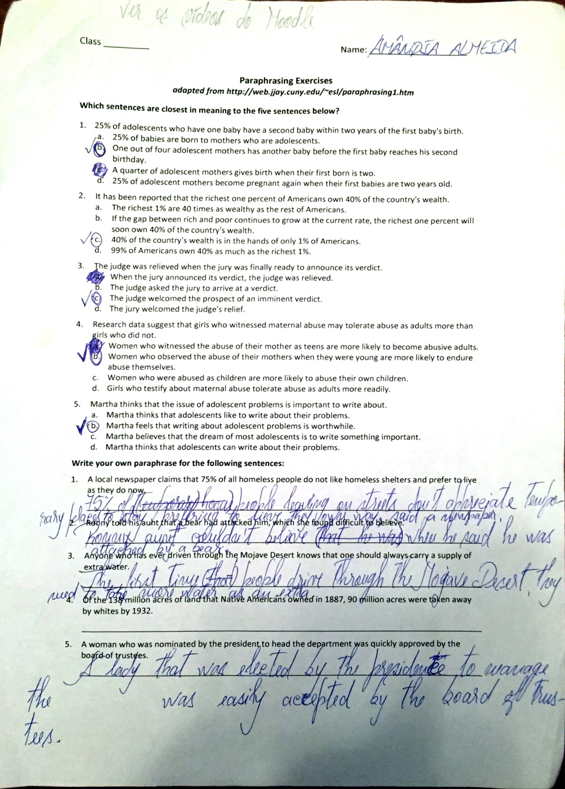

APPENDIX 5



