

Assignment Title: Assessment 1
Human Resource Management

Name: Nidhi arpitkumar patel
ID:2210476
Word Count: 2589

Table of Contents
Introduction 2
Assessing the present state of the labour market within UK 2
Analysing the effects of the Brexit on the labour market in the UK 4
Evaluating the emerging changes in human resourcing strategies in the post COVID-19 period 6
Evaluating the emerging changes in human resourcing strategies in the post Brexit external environment 9
Conclusion 11
References 12

Introduction
The assessment shall be effective in observing effects of both the Brexit and the COVID-19 induced pandemic that generates a shortage of critical talents to a certain extent. The paper has elucidated on the necessity of filling the skill gaps efficiently that has widen the range of human resourcing strategies considered as the inclusive part of the UK based organisations strategic planning initiatives. Thus, for effectively assessing the human resourcing strategies in post Brexit and the post pandemic period, the paper has initially involved insights on the present situation of the labour market within the territorial jurisdiction of the UK with a special focus on the influence of Brexit on the labour market.

Assessing the present state of the labour market within UK
Acquiring a job in addition to getting on board at work happens to be one of the essential means through which households can enhance their circumstances. As recognised from the reports of British Chambers of Commerce (2022), that the UK has come across stringent labour market related issues in the present years and the labour shortages have been prohibiting the propensity of several organisations and businesses to provide efficient service to the pre- existing clients and consumers while restricting their opportunities to continue expanding. It requires to be stated that despite a further decline within amount of job vacancies, which has amounted to just under 1.25m the entire level remains very high. It requires to be mentioned in this context that the businesses are presently encountering numerous external shocks that is related to the global supply chain disruption along with expanding inflation in addition to higher interest rates. The reports of Leaker (2022), suggest that the UK employment rate for the months that is particularly from July until September 2022 was 75.5%. That widely unaltered on the previous quarter and 1.1 percentage points that is lower than before the COVID-19-induced pandemic. Labour shortages happen to be yet another challenge reducing the business confidence.
The assessment has aided in the revelation that the unemployment rate of approximately 3.5% that is recorded to be at the lowest level since the year 1974 where the evidence of increasing and expanding economic inaction rate happens to be standing at approximately 21.7%. This has become a reason for concern where the average weekly earnings falls behind for the workers owing to the inflation. The amount of people recruited in job fields reduced by 825,000 individuals between January to end of March 2020 as well as October to the December 2020 besides unemployment happens to rise by approximately 400,000 and the amount of individuals who was economically frozen rose by 327,000. However, the redundancies attained record highs while the working hours happened to have dropped to the lowest since the year 1994 besides the number of people arguing for unemployment profits, which was doubled in between the months March to May 2020 (House of Commons Library, 2022). The youngest and the oldest employees had lost their jobs and furloughed at the unexpected emergence of the COVID-19. However, youth employment returned to the pre-pandemic standards by January to March 2022.
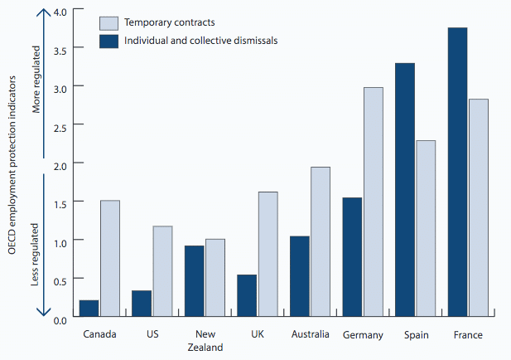
Figure 1: Increase in the labour market flexibility
(Source: Pettinger, 2022)
Two years later the beginning of the unexpected pandemic, the employment standards happen to be around 350,000 lower in comparison to before it began. Claims of 1.3 million were directly generated to the Self-Employment Income Support Scheme (SEISS) that ended by 30 September 2021. Pettinger (2022), has aided in the evaluation that the number of fixed work contracts have changed owing to the influence of the pandemic. There happens to be a major attention paid on flexible work opportunities that include limited contracts along with short-term and zero hour contracts as the UK market has a lightly regulated labour market in comparison to other European nations. Moreover, it requires to be mentioned that the government has been aiming to make serious modification, which can be attained through more job creation prospects. Some key reforms can aid in easing the concurrent labour market situation, which comprises supporting enhanced trade investment in the human capital training while focusing on adopting flexible working practices along with expanding usage of apprenticeship where a inclusive reform of the Shortage Occupation List to permit industries encountering urgent demand for skills to fulfil their demands.

Analysing the effects of the Brexit on the labour market in the UK
As stated by Wadsworth (2018), immigration remains being a highly aggressive issue while its purported effects in the labour market are still contestable. However, the author has stated that there happens to be little evidence that immigration has had an influence either positive or negative on the employment remunerations of the UK born workers. Furthermore, as assessed that restrictions on EU employees are evident in terms of the flow rather than the stock while the flow happens to be much smaller. Sectors with high turnover and low pay are able to notice the changes. The Bank of England has warned that Brexit could result in the financial instability, which involves damaging macroeconomic effects owing to the fiscal prospects of the UK (Begg and Mushövel, 2022). In the view of Wadsworth (2018), there happened to be a sustained fall in real wages that has been unprecedented in the present history of the UK where the changes have been evident since 2010 in the duration of rising immigration that is both total and EU based. However, average (median) real wages of the UK born seem to grow during the duration when immigration was rising. Moreover, the literary article has aided in the analysis that the reduction of sterling against the euro and other European currencies particularly diminishes the magnetism of the provided hourly wage towards the prospective migrant from other European nations.
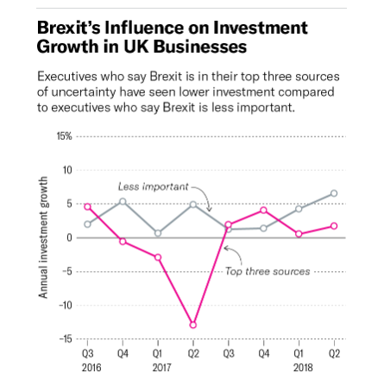
Figure 2: Influence of Brexit on the investment growth in the UK Businesses
(Source: Bloom et al., 2021)
Additionally, the evaluation of The Migration Observatory (2022), has aided in the realisation that post Brexit many other policies affect the demand and supply for workers comprising tax and reimbursement, minimum wages, training and education as well as decisions made with reference to the public services that include health and social care which mainly rely on the migrant workers. On the contrary, it is difficult to assume that Brexit vote in tandem with these additional developments had nothing to contribute to the modifications in flows especially when the flows from outside the EU may be moving in the contradictory direction. In the opinion of Bloom et al. (2021) provided in the reports of Harvard Business Review that Brexit uncertainties has had an effect on the growth of investment along with employment by firms. Depending on this it was estimated that Brexit uncertainties was linked with approximately 6% inferior investment in the initial year later to the Brexit referendum. As analysed that post Brexit most of the prevailing EU workforce happens to be entitled for the British citizenship or comprise the necessary for years of residence within the UK (Wadsworth, 2018). Emphasis has been paid on the job with the largest workforce shares of EU. The EU migrants consist of a higher than average share of scientific researchers well as higher education professionals. It requires to be mentioned that on the procedure reply to the temporary consequence of Brexit it was a mistake to assume that the employers are about to loses their employees immediately and the adjustments have been evident in terms of the flow and not the stock of the migrants.

Evaluating the emerging changes in human resourcing strategies in the post COVID-19 period
The COVID-19 pandemic has certainly highlighted the significance of the role of human resources in the UK based businesses. HR units have been focusing on diversity agenda in the post pandemic era to ascertain that the companies are attracting, interviewing and hiring diverse people. It has been analysed that human resource strategies in the post pandemic period emphasises on inclusion which is vital to add value in order to ascertain that every employee get a sense of belonging. According to Yawson (2020) that the governments along with the intergovernmental organisations while the non-profits and corporations are simultaneously aware that the disruptions through natural bio disasters and crisis such as the COVID-19 pandemic can occur any moment. In the view of Przytuła et al. (2020), reskilling happened to be pointed by 75% employers as one of the most vital HR trend in 2020 as per the reports of Deloitte. It has been observed that in response employees happen to be eager to reskill while 1,500 full time employees across the globe happen to be most motivated to boost their professional and technical skills because of the COVID-19-induced pandemic. In addition to this, the HR teams are introducing reward programmes to reduce the employee attrition rate.
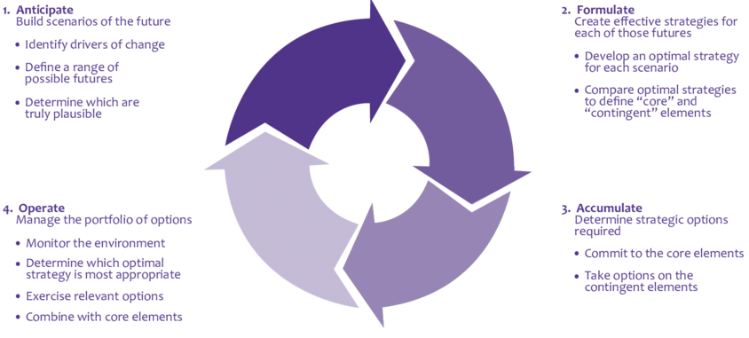
Figure 3: The Strategic Flexibility Framework
(Source: Yawson, 2022)
As a result, the human resource units are focusing on an increased application of the Strategic Flexibility Framework. In accordance with which a range of possible future outcomes are anticipated followed by the development of an optimal strategy for each scenario besides relevant options are exercised and options from the contingent elements are taken into consideration (Yawson, 2022). It requires to be mentioned that the providing employees hybrid work opportunities has become a part of the human resourcing strategies and the newly appointed staff are elucidated about the same during the time of the recruitment. The human resource departments are concentrating on the human-centric model for the hybrid environment by structuring work around the employee driven flexibility, culture connectedness and human leadership.
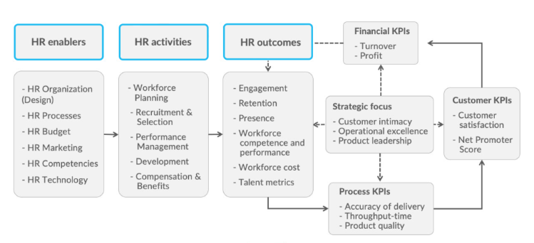
Figure 4: The HR Value Chain Advanced
(Source: Vulpen, 2022)
Rather than emphasising on records management along with compliance related issues for instance the strong HR units spend their time emphasising on improving the employee engagement developing an even stronger and attractive company culture. The HR Value Chain Advanced model has aided in the realisation that the balance scorecard happens to contain the key performance indicator from a financial perspective along with consumer perspective as well as process perspective. The COVID-19 affected the UK where the country has encountered its longest recession while the reports of (Gilchrist, 2022), suggest that the economic downturn is expected to extend into 2024. The companies are aiming to enhance their financial prospects for which an integrated HR Value chain becomes considerably necessary. The HR enablers include the HR systems and a substantiated budget so that the value chain of the UK based companies operates effectively. A low budget in the post pandemic era has a negative effect on innovation generating non-beneficial HR outcomes. The post pandemic human resourcing strategies happen to focus on technological assistance that aids in workforce planning and performance management, which supports in the formulation of appropriate talent metrics (Vulpen, 2022). That imparts long-term positive influence on the financial turnover of the company leading towards operational excellence and client satisfaction. Data collection obtained through virtual clocking along with tracking the work computer usage and supervising employees through internal communications and emails are deployed to comprehend the employee experience as well as health and safety data making responsible usage of employee analytics in the post pandemic period.

Evaluating the emerging changes in human resourcing strategies in the post Brexit external environment
HR Directors have been inspiring the teams to accumulate the right kind of data sets for undertaking the scenario-planning while provides the teams the appropriate tools to attract, retain and contrive the talent in the more competitive post-Brexit landscape. As analysed from the reports of Kerridge (2022), that the recruitment units have already evidenced a decrease in the application from EU nations while talent seems to be in shorter supply. The Institutional theory of human resource management has aided in the realisation that organisations make certain decisions based on the combined politics, legislations, public administration, psychology and economical policies to lead towards a positive outcome in the organisations (Das, 2022). However, applying control on a single individual comprises the potential to lead towards liberty of the others resulting in enhanced gains. As an analysis, it requires to be stated that Brexit indicates that certain employment legislations might be relaxed or removed and human resourcing strategies includes comprehending the laws at risk and the scenario planning within the organisational set up. Thus, the human resourcing strategies include focusing on the work time regulations and abiding by the agency workers regulations the HR department requires ascertaining that in continuous employment for almost 12 weeks and more regardless of the official contact length, which can be reviewed to provide employers’ enhanced access to more flexible workforce.
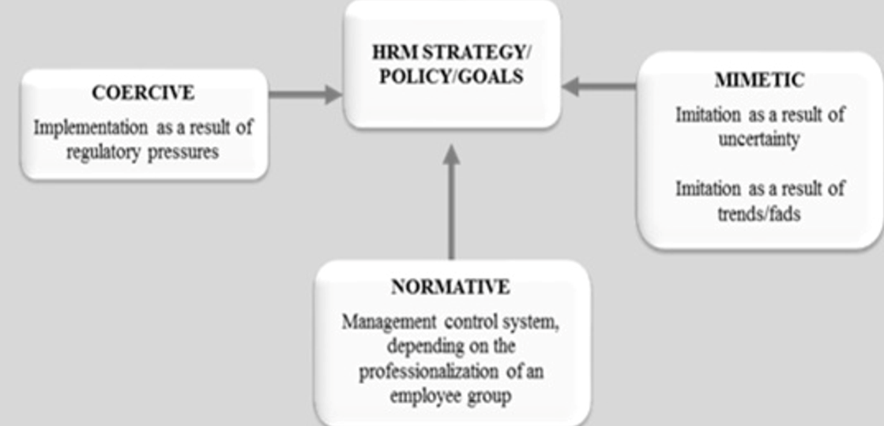
Figure 5: Institutional theory of Human Resource Management
(Source: Najeeb, 2022)
Companies and the HR teams happen to ensure during hiring employees that they are elucidated on the factor that the organisation shall be paying them social security contributions (Kerridge, 2022). According to Ridgway (2019), the global financial catastrophe present a useful contrast to the uncertainties caused by the Brexit and the author has recognised in the literary article that the employer reaction to the financial disaster was evident in terms of labour hoardings that then contributed to the notion of a jobless recovery from increased issues associated with unemployment. Moreover, the author states the human resource strategies of the companies operating in the stiff competitive market sphere of the UK happens to include the flexible working arrangements which has the capacity to produce an improved resilient as well as an agile workforce that is considerably inclined to adjust to the economic changes.
Brexit has generated an uncertainty in terms of the talent movement within the EU forcing organisations to reformulate their human resourcing strategies. Performance evaluation by the human resource departments determine that EU has not unfavourably influenced the employment standards, public services and remuneration but the migrants from the EU contribute more towards taxation and welfare. Ridgway (2019), states from an extensive research work in the literary article that Brexit generated a detrimental impact on the flexible functioning practices of the UK that is no longer governed by the EU provisions for paternity, maternity and annual leave when compared to the minimum EU standard policies. The strategies of the HR departments are to create employment protection. Concerns have been expressed in human resourcing department of the nursing and construction sector, which currently hold a reduced representation of the non-EU employees owing to the complications in the security permits (Kerridge, 2022). However, the public sector as part of their HRM strategy is likely to employ non EU migrant labours besides it requires to be stated that amount of EU migrants that are already hired is unlikely to alter. As part of the human resourcing strategy the focus has been on the idea of super-diversity necessitates that has the potential to channelise the modern day organisations towards market expansion.

Conclusion
In conclusion, it can be stated that there happens to be a major attention paid on flexible work opportunities that include limited contracts along with short-term and zero hour contracts as the UK market has a lightly regulated labour market in comparison to other European nations. Global financial crisis present a useful comparison to the uncertainties caused by Brexit where the employer reaction to the financial crisis was evident in terms of labour hoardings that then contributed to the notion of a jobless recovery from increased issues associated with unemployment. The post pandemic human resourcing strategies happen to focus on technological assistance that aids in workforce planning and performance management, which supports in the formulation of appropriate talent metrics.

References
Begg , I. and Mushövel, F. (2022) The economic impact of Brexit: Jobs, growth and the public finances. Available at: https://eprints.lse.ac.uk/67008/1/Hearing-11---The-impact-of-Brexit-on-jobs-and-economic-growth-sumary.pdf (Accessed: December 14, 2022).
Bloom, N., Bunn, P. and Chen, S., Mizen, P., Smietanka , P. and Thwaites, G. (2021) Brexit is already affecting UK businesses - here's how, Harvard Business Review. Available at: https://hbr.org/2019/03/brexit-is-already-affecting-uk-businesses-heres-how (Accessed: December 14, 2022).
British Chambers of Commerce (2022) Relentlessly tight labour market stifling business growth, British Chambers of Commerce. Available at: https://www.britishchambers.org.uk/news/2022/10/relentlessly-tight-labour-market-stifling-business-growth (Accessed: December 14, 2022).
Das, N. (2022) Guide to theories in Human Resource Management, ilearnlot. Available at: https://www.ilearnlot.com/guide-to-theories-in-human-resource-management/54689/ (Accessed: December 14, 2022).
Gilchrist, K. (2022) UK faces longest recession since records began, Bank of England says, CNBC. CNBC. Available at: https://www.cnbc.com/2022/11/03/bank-of-england-uk-faces-longest-ever-recession.html (Accessed: December 14, 2022).
House of Commons Library (2022) Coronavirus: Impact on the labour market - house of commons library. Available at: https://commonslibrary.parliament.uk/research-briefings/cbp-8898/ (Accessed: December 14, 2022).
Kerridge, C. (2022) How Brexit will change the game for HR, MHR. Available at: https://mhrglobal.com/uk/en/blog/how-brexit-will-affect-hr (Accessed: December 14, 2022).
Leaker, D. (2022) Labour market overview, UK: November 2022, Labour market overview, UK - Office for National Statistics. Office for National Statistics. Available at: https://www.ons.gov.uk/employmentandlabourmarket/peopleinwork/employmentandemployeetypes/bulletins/uklabourmarket/november2022 (Accessed: December 14, 2022).
Najeeb, A. (2022) Institutional theory and human resource management, Semantic Scholar. Available at: https://www.semanticscholar.org/paper/Institutional-theory-and-human-resource-management-Najeeb/c650d2f07c0092d317e548a2eb30ef4da191de56 (Accessed: December 14, 2022).
Pettinger, T. (2022) Recent changes in UK labour markets, Economics Help. Available at: https://www.economicshelp.org/labour-markets/changes-uk-labour-markets/ (Accessed: December 14, 2022).
Przytuła, S., Strzelec, G. and Krysińska-Kościańska, K., (2020). Re-vision of future trends in human resource management (HRM) after COVID-19. Journal of Intercultural Management, 12(4).
Ridgway, M., (2019). Brexit: human resourcing implications. Employee Relations: The International Journal.
The Migration Observatory (2022) Brexit exacerbated labour shortages in the UK, but is not the only cause, Migration Observatory. Available at: https://migrationobservatory.ox.ac.uk/press/brexit-exacerbated-labour-shortages-in-the-uk-but-is-not-the-only-cause/ (Accessed: December 14, 2022).
Vulpen, E.V. (2022) 5 human resources models every HR practitioner should know, AIHR. Available at: https://www.aihr.com/blog/human-resources-models/ (Accessed: December 14, 2022).
Wadsworth, J., (2018). Off EU go? Brexit, the UK labour market and immigration. Fiscal Studies, 39(4), pp.625-649.
Yawson, R., (2020). Strategic flexibility analysis of HRD research and practice post COVID-19 pandemic. Human Resource Development International, 23(4), pp.406-417.
Yawson, R.M. (2022) The strategic flexibility framework | download scientific diagram. Available at: https://www.researchgate.net/figure/The-Strategic-Flexibility-Framework_fig3_256001914 (Accessed: December 14, 2022).

