Personal trainer case study

A.
The client is a 51-year-old male who works in student services and leads an active life with good health. He does not smoke, consumes alcohol occasionally, and reports maintaining a balanced diet. His current physical activity includes swimming 3 to 5 times each week while he swims approximately 2 kilometres during every session and walks at least 10 miles every week. He has only limited experience with structured resistance training because he has only visited the gym on occasional days.
The client wants to achieve two main objectives which involve improving his core strength and cardiovascular fitness while he stays healthy and maintains his functional abilities. Health measurements show his blood pressure at 96/64 mmHg and his height at 183 cm and his body weight at 84.8 kg which indicates a healthy body composition. The client preferred machine-based resistance training and cycling-based cardiovascular exercise while he showed a dislike for running and burpees and free weight areas.
Through speaking to the client, I learned that he has one arm shorter than the other which is an asymmetry that would have to be monitored throughout the sessions. The exercise selection process used this information to maintain balanced movement patterns while decreasing the need for compensatory strategies. The client showed his willingness to start a formal training program.
The assessment techniques employed included a consultation, lifestyle questionnaire, PAR-Q test, and simple body measurements. The assessment techniques used are suitable because they offer subjective and objective information for designing an efficient and effective programme (American College of Sports Medicine, 2021). The use of the PAR-Q test was necessary since it helped identify any risk factors that would contraindicate exercising. Consultation helped tailor the programme to fit the client's needs.
In summary, the client possesses a solid foundation in terms of aerobic activity but lacks any form of planned strength training exercises. In that regard, the workout concentrated on enhancing muscle strength and core stability while retaining cardiovascular fitness.
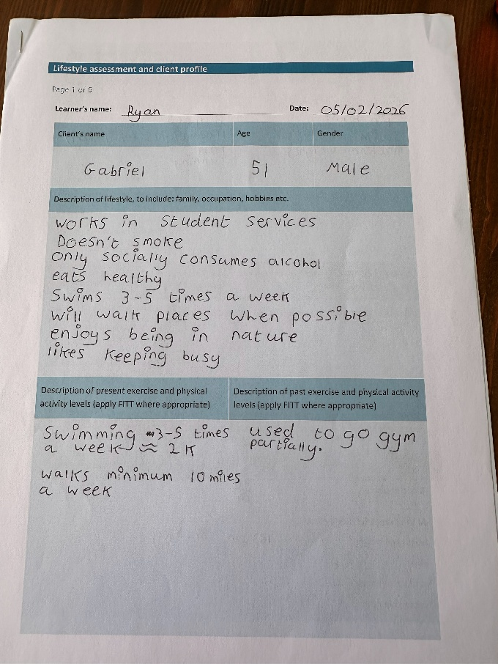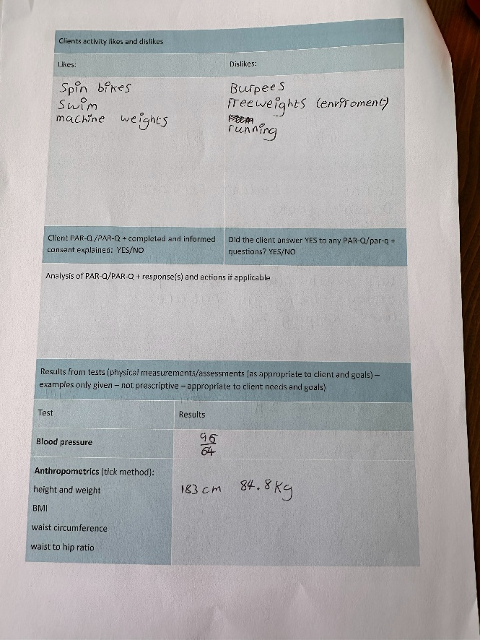
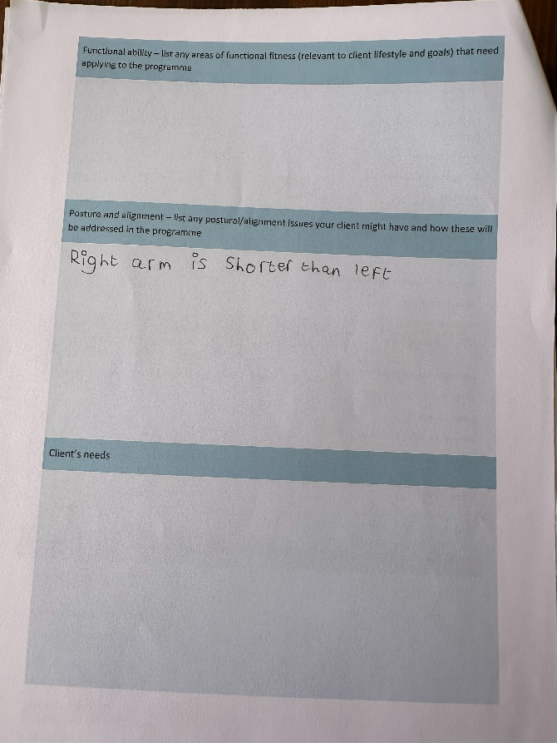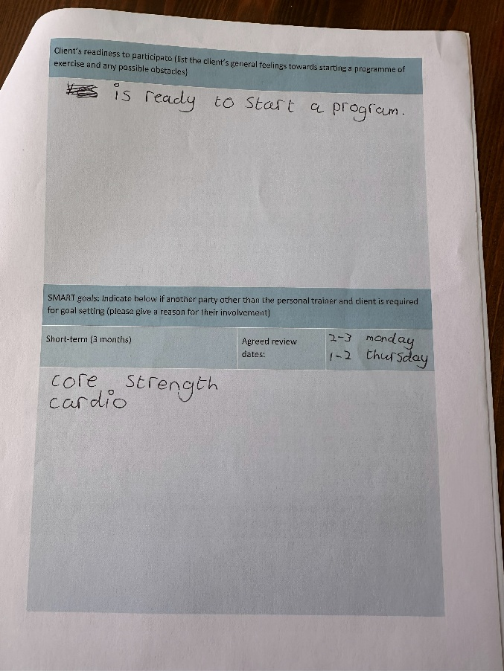

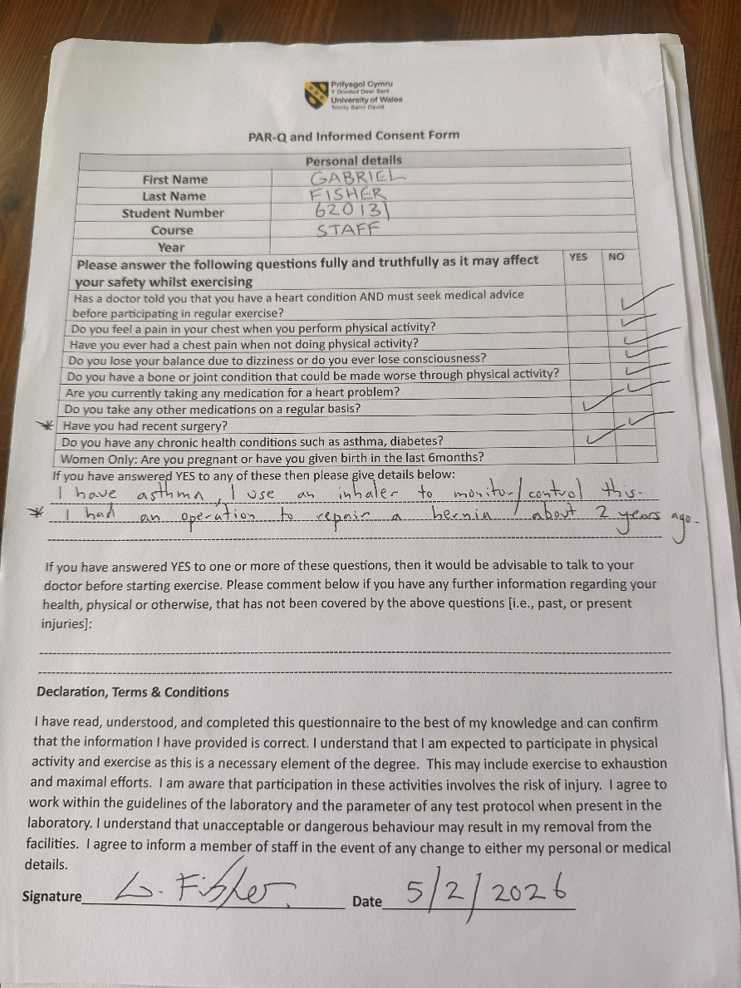
B.
A progressive training program was provided for ten weeks, which comprised one session weekly, with the intention of increasing the core stability and cardiorespiratory fitness of the client. Because of the reduced training frequency, the importance of gradually building up the program, consistency, and proper exercise technique was prioritized. This took into account the FITT principle (frequency, intensity, time, and type) in addition to progressive overload (American College of Sports Medicine, 2021).

Programme Overview Table
Component | Details
Programme Duration | 10 weeks
Session Frequency | 1 session per week
Session Length | ~45–60 minutes
Primary Goals | Improve core strength and cardiovascular fitness
Warm-Up | 5 mins cross trainer + dynamic mobility exercises
Cardio Training | Watt bike intervals (10 mins)  Weeks 1–3: Resistance 1 & 6  Weeks 4–10: Progression to 2 & 8
Resistance Training | Machine-based exercises (e.g., chest press, lat pulldown)  3 sets x 10 reps  Progression up to ~35 kg
Functional Training | Step-ups (6 kg), goblet squats (10 kg)
Core Training | Dead bug, bird dog (alternating)  Planks (30–45 sec, progressing to 1:13)
Cool-Down | Treadmill walk + static stretching
Progression Methods | Increased resistance, improved technique, longer plank duration, higher bike intensity
Adaptations | Machine focus (client preference), posture monitoring, exercise variation
Outcomes | Improved core endurance, strength, technique, and cardiovascular fitness

Programme Rationale

Each session consisted of:
- Warm-up: 5 minutes cross trainer and mobility work
- Cardiovascular training: 10-minute interval training on watt bike
- Resistance training: machine-based and functional exercises
- Core training: stability and endurance exercises
- Cool-down: treadmill walk and static stretching

The program was run once a week, requiring good planning in order to make use of the benefits offered by the sessions effectively. Although more sessions are normally advised due to better results in adaptation, the activities already being performed by the client, such as swimming and walking, ensured his general fitness.
The watt bike was chosen because of the client’s desire to learn how to cycle, since his previous exposure to the piece of equipment had been minimal. This also offered the chance for him to try a different method of training without losing interest. Furthermore, he preferred exercises that involved cycling rather than running.
An interval training method was utilized to build on cardiovascular fitness. Starting off from resistance levels 1 and 6, the client graduated to resistance levels 2 and 8 to accommodate increased fitness levels. This shows that progressive overload was achieved. According to Gibala et al. (2012), interval training is an effective way of enhancing aerobic capacity.
Machine exercises like chest press and lat pull down were chosen based on the preferences of the client and to have stable exercises. In the early stages, emphasis was put on learning proper form with lighter weights before working up to around 35 kg per set of 10 repetitions for 3 sets. Exercises such as step-ups with 6 kg and goblet squats with 10 kg were used for functional training.
Core strength training played an integral part in the exercise program. The dead bug exercise and the bird dog exercise were used to train stability through a varied program. This would ensure that the program did not become monotonous for the participant. Planks were done to train core stability endurance.
Progressive overload was achieved through:
- Increasing resistance in strength exercises
- Increasing watt bike intensity
- Improving control, technique, and endurance (e.g. plank duration)

The client’s preference for not using free weights was accommodated by concentrating mainly on machine work and functional exercises with controlled movements. The postural imbalance necessitated careful attention to form to avoid uneven loading and compensate.
There was a warm-up period conducted before each training session to get the body ready for exercise and prevent injuries.
overall, the program was designed according to the objectives, tastes, and training schedule of the client.

C.
Over the ten sessions, there were various reflections made concerning the effectiveness of the programme and the involvement of the client in each session.
One of the positive aspects of the programme was the level of attendance and participation by the client throughout. This happened since the client maintained involvement in all the sessions throughout. This could be linked to the nature of the programme, which had been tailored to suit the personal likes of the client. With the inclusion of resistance through the watt bike intervals and use of machines in resistance training, the client was satisfied.
Other positive outcomes included the gradual enhancement of strength and quality of movements. The beginning of the training regimen saw the client needing instructions during exercises like the goblet squat and step-up. With time, the client’s technique became proficient enough to safely increase weight usage, even reaching a point where he could use up to 35 kg in machine workouts.
Core exercises formed an integral part of the programme, and there was significant evidence of progress here. The ‘dead bug’ and ‘bird dog’ exercises were alternated during the course of the programme, although not because of the level of difficulty involved, but simply to ensure variety in the workout routines.
Improved Performance in Plank Indicated Core Endurance Improvement The client did a number of plank variations including 2×45 seconds for some sessions and, 2×30 seconds, and one until failure in others alternating each week. On his first go at a plank to failure, the client achieved 49 seconds. By the last sessions, this improved further to 1 minute and 13 seconds. The steady progress serves as a testament to the efficacy of consistent training and progressive overload even when often done once a week.
One challenge in the programme was the low frequency of training, which affected the pace of adaptation. Improvements were thus more gradual than those obtained from high-frequency training programmes. The solution was to ensure that each training session was conducted optimally, while ensuring that the client continued with his own physical exercises like swimming and walking.
Also, the client’s distaste for free weights affected the exercise programming decisions. Free weights have their advantages, but, in this case, using machines and functional exercises made more sense. Slowly introducing exercises like goblet squats was important because it did not compromise motivation.
Communication and coaching were important throughout. Through effective demonstrations and cues, the client is developing the right technique and gaining confidence with supportive feedback. One example includes plank duration improvement which we can show as evidence.
The asymmetry of the client’s arms had to be closely observed while exercising, especially when doing movements involving the upper body. Stress was put on executing the movements symmetrically to prevent any compensations from occurring.
Some changes to the programme were done based on client feedback and performance during sessions. Such changes involved altering the length of rest periods, mixing different exercises to keep things interesting, and changing the intensity level whenever necessary.
To conclude, the programme was very successful in increasing the core strength and cardiovascular health. It helped me understand the need for a client-centred approach in training, especially under limited training frequency. Some important lessons from the experience are the importance of varied exercises, good communication and adaptability in training clients.

Wordcount: 1501

Reference list
American College of Sports Medicine (2021) ACSM’s guidelines for exercise testing and prescription. 11th edn. Philadelphia: Wolters Kluwer.
Gibala, M.J., Little, J.P., Macdonald, M.J. and Hawley, J.A. (2012) ‘Physiological adaptations to low-volume, high-intensity interval training in health and disease’, The Journal of Physiology, 590(5), pp. 1077–1084.
Grgic, J., Schoenfeld, B.J., Skrepnik, M., Davies, T.B. and Mikulic, P. (2018) ‘Effects of resistance training frequency on measures of muscle hypertrophy: A systematic review and meta-analysis’, Sports Medicine, 48(5), pp. 1207–1220.
Huxel Bliven, K.C. and Anderson, B.E. (2013) ‘Core stability training for injury prevention’, Sports Health, 5(6), pp. 514–522.
Schoenfeld, B.J., Ogborn, D. and Krieger, J.W. (2017) ‘Dose-response relationship between weekly resistance training volume and increases in muscle mass’, Journal of Sports Sciences, 35(11), pp. 1073–1082.
Steib, S., Schoene, D. and Pfeifer, K. (2010) ‘Dose-response relationship of resistance training in older adults: A meta-analysis’, Medicine & Science in Sports & Exercise, 42(5), pp. 902–914.
Teixeira, C.V.L.S., Evangelista, A.L., Pereira, P.E.A. and Bocalini, D.S. (2019) ‘Ten important facts about core training’, ACSM’s Health & Fitness Journal, 23(1), pp. 1–7.

