Thomas Westley
HPEN5004
Peter Mitchell
Due: 26.09.24.

Written Analysis of Christopher Marlowe’s Doctor Faustus, earliest

Transcription of the earliest edition of ‘Doctor Faustus’ by Christopher Marlowe, 1604.

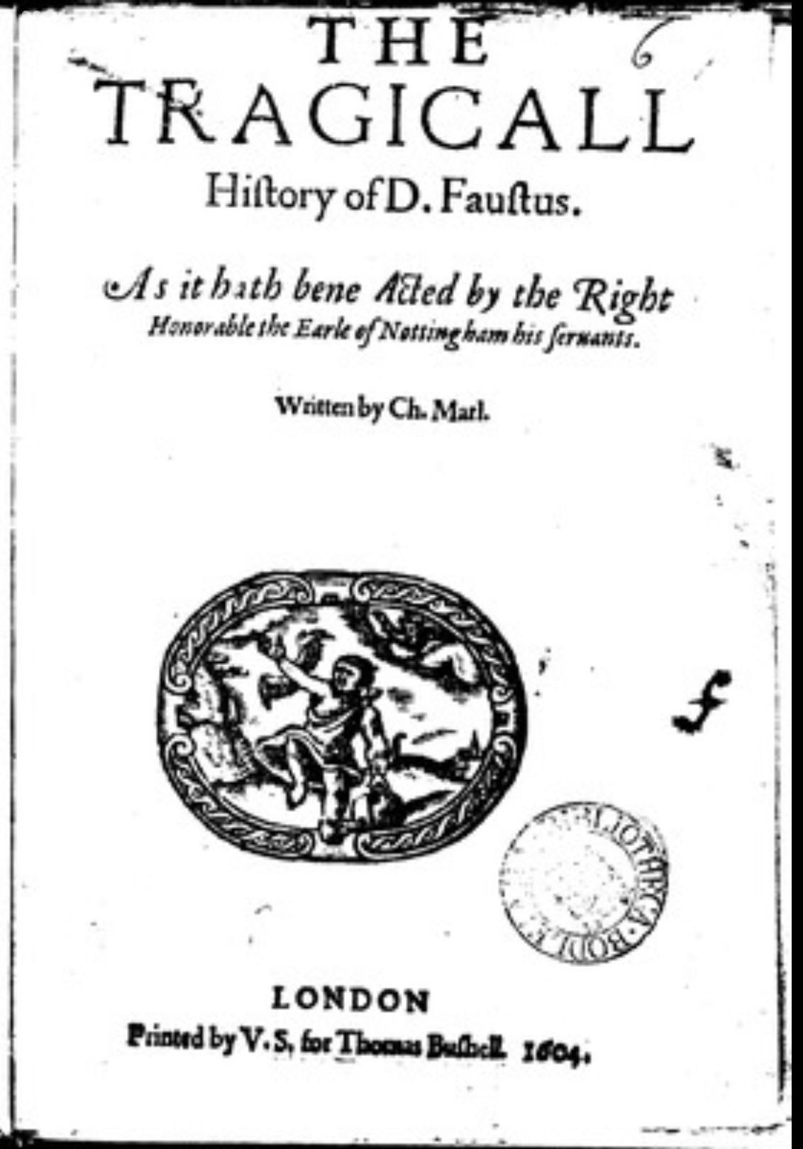

THE | TRAGICALL | Hiſtory of D. Fauſtus.| As it hath been Acted by the Right | Honorable the Earle of Nottingham his ſervants. | Written by Ch. Marl. | [Printer’s device] | LONDON | Printed by V.S, for Thomas Buſbell. 1604.

Format.
The first edition of Doctor Faustus was published in the Quarto format in 1604, marking an important moment in the early history of English drama. This format, often abbreviated as Qto, 4to, or 4º, was a popular method of book production during the early modern period. The process involves printing eight pages of text on a single, large sheet of paper, with four pages on each side. Once printed, the sheet is folded twice, creating a compact packet of eight pages that are then trimmed along the folds. The Quarto format was commonly used for plays, pamphlets, and other shorter works due to its economical use of paper and manageable size for readers. Despite being smaller and less prestigious than the larger Folio format (which was often reserved for longer or more formal publications like the collected works of Shakespeare), Quarto editions were highly significant for circulating early printed literature. The 1604 edition of Doctor Faustus offers a window into how texts were shared with audiences of the time and remains a crucial artefact for scholars studying the history of English literature.
Printers, Booksellers and Performers

The earliest recorded publication of Doctor Faustus, often referred to as the "A text," was released in 1604. Prior to this, in 1592, a court ordered that the book would remain property of A. Jeffes unless it was found to be registered with R. Oliff before Jeffes’ claim. The “A text” was first officially recorded on January 7th, 1601. It contained only one thousand four hundred eighty-five lines, which is considered short for an English Renaissance play. The publication was commissioned by Thomas Bushell and printed by Valentine Simmes. Bushell had spent eight years apprenticing to Nicholas Ling before eventually opening his own bookshop, where he credited Ling for granting him his ‘freedom’, which meant that he was no longer an apprentice. He would then go on to be a bookseller for 18 years, 1599-1617 with December 13th, 1617 being his last book entry. It is stated that Bushell’s bookshop was situated at the north door of St. Paul’s, however its name is never mentioned. Simmes, meanwhile, had been apprenticed to Henry Sutton. Sutton was a bookseller who sent Simmes, by his own request, to work for the printer Henry Bynneman. After Bynneman's death in the 1580s, Simmes returned to the bookselling trade. Though Sutton had passed away by then, his widow, Joane, granted Simmes his ‘freedom’. From there, Simmes would build a controversial career. From printing books that he had no rights to, to books that were ‘obnoxious to the authorities’. Until 1595, his printing press was taken from him, as well as some equipment melted and his apprentice sent to someone else, for printing an copyrighted text. In1599, Simmes was on the list of fourteen printers that were not allowed to print epigraphs or satires, a fine of a shilling if he did. In 1619, Simmes gave several of his copyrights to Edward Griffin.
As written on the title page of the “A text”, the company. that owned the rights to perform it was the “Earle of Nottingham's Servants”, or rather the “Admiral’s men’. And as the name suggests, the company’s patron was Charles Howard, Nottingham’s Earl at the time of publication. The company would perform Doctor Faustus a total of 12 times, with Edward Alleyn cast as lead each time. Alleyn was also married to the daughter of Phillip Henslowe, the impresario of the “Admiral’s Men”. The impresario was usually the one who organises and even often funds and manages the finances of the plays.Henslowe is also credited for the construction of the Rose Theatre, which would serve as the home of the Admiral’s Men for many years.
Henslowe also kept a diary, which is the earliest surviving reference to Doctor Faustus in recorded history.It shows that Henslowe acquired the rights to the play on September 30th, 1594, for three pounds and twelve shillings.
The “Admiral’s Men” performances of Faustus received great praise, especially a tale that actual devils appeared on stage during one of their performances “to the great amazement of both actors and spectators”. Some audience members were alleged to have been driven mad by “that fearful sight”. Another tale came from the first, which stated that Alleyn’s later devotion towards charitable endeavours were a direct response to witnessing devils.
There was also a slight controversy within the company. Richard Jones and Thomas Downton briefly left the company for the “Pembroke’s Men”, their patron being Henry Hebert, the Earl of Pembroke at the time, but returned after a disastrous production of Jonson’s and Nash’s ‘The Isle of Dogs’. The two would return to the Rose Theatre and the “Admiral’s Men” to avoid prosecution.
The next publication of Doctor Faustus came in 1609. This was a direct reprint of the 1604 text and underwent no further edits or additions from other playwrights. It was printed by George Eld for John Wright. Whilst very little can be found about Wright, Eld was a printer at ‘The Printer’s Press’ on Fleet Lane, London, from 1604 to 1624 when he died of the plague. He had apprenticed under Robert Bolton for 8 eights until finally establishing his own publishing business. He did this by marrying the widow of two passed publishers, Gabriel Simpson and Richard Reade, and acquired two printing presses from it.
The version eventually referred to as the "B text" was published in 1616 and reprinted several times, in 1619, 1620, 1624, 1631, and as late as 1663. The publisher was John Wright, with alterations by Samuel Rowley and William Borne (also sometimes listed as William Birde, though most sources refer to him as Borne, which I will follow). The printer of this edition, however, remains unknown. Wright would buy the rights to Doctor Faustus in 1610 from Bushell, a year after Wright first published the ‘B text’. Both Rowley and Borne were paid four pounds for their contributions. These changes removed thirty-five words and added six hundred seventy-six. There was also a change to the name of the devil, which had previously been “Mephistopheles”, yet in this edition, it was “Mephistophilis”. Several quotes were also subtly rephrased, likely by others, though these contributors and their alterations were not recorded.
There was also a third iteration of Doctor Faustus that came about after the British civil wars, between the public, parliament and the monarchy. This edition dramatically changed the messages of both the A and the B texts so that they would comply with the recently changed, post-war stance.

Greg, A Bibliography of the English Printed Drama to the Restoration, Vol. 1. (London: Oxford University Press, 1939). Pp. 327.
Ibid. Pp. 327.
McKerrow ed., A Dictionary of Printers and Booksellers in England, Scotland and Ireland, and of Foreign Printers of English Books 1557-1640. (London: Blades, East and Blades, 1910). Pp. 58.
McKerrow, 1910. Pp. 245.
Ibid. Pp. 17.
Greg, 1939. Pp. 328.
McKerrow, 1910. Pp. 98.
Ibid, Pp. 328.
Greg, 1939. Pp. 327-331.
Pinkerton, Cut is the Branch: Faustus’ C Text. (Kent: University of Kent, 2024).
Gurr, The Shakespearean Stage 1574-1642. 3rd ed. (Cambridge: Cambridge University Press, 1992). Pop. 103-4.
Chambers, The Elizabethan Stage 1574-1642, Vol. 4. (Oxford: Clarendon Press, 1923). Pp. 423-4.
Henslowe, Henslowe’s Diary. (London: A. H. Bullen, 1904). Pp. 74.
McKerrow, An Introduction to Bibliography for Literary Students. (Oxford: Oxford University Press, 1927). Pp. 164-174.

