Healthcare Facility Renovation and Upgrade Project Charter

Table of Contents
1. Project Purpose and Justification 5
2. Project Objectives 5
3. Project Scope 5
4. Key Stakeholders 6
5. Deliverables 7
6. Timeline / Milestones 9
7. Budget Estimate 10
8. Risks and Mitigation 13
9. Assumptions 16
10. Approval Signatures 16
11. References 17

List of Tables
Table 1: Stakeholder Table 5
Table 2: Budget Table 9
Table 3: Risk Mitigation 10
Table 4 : Approval Signatures 11
List of Figures
Figure 1 : Equipment Installation Plan 8
Figure 2 : WBS 9
Figure 3: Schedule Table 9
Figure 4: Gantt Chart 10
Figure 5: Network Diagram 10
Figure 6 : Budget Breakdown 11
Figure 7 : Energy Efficiency Improvement Before and After Renovation 12
Figure 8 : Compliance and Inspection Process 13
Figure 9 : Risk Matrix 15

1. Project Purpose and Justification
The objective of the project is to repair and modernize Greenfield Medical Center, increase its capacities, improve patient care, and meet the standards of health and safety. Such major renovations involve modernization of medical supply, updating of patient and staff facilities and enhancing energy efficiency. These changes solve the aging infrastructure and growing need of advanced healthcare services, which eventually enhance the clinical outcome, patient satisfaction, and performance (Li, Cui and Feng, 2023). This upgrade is essential towards the sustainability of high-quality healthcare in the fast-changing medical environment and thus the facility is a future ready healthcare provider.

2. Project Objectives
- Be able to finish renovating 30 patient rooms and other shared areas by 01/07/2025.
- By 01/06/ 2025, have in place new medical equipment, such as MRI, X- ray and ultrasound equipment.
- Attain 90 percent satisfactory levels in patient and staff surveys in 3 months after the project.
- Cut energy costs by one-fifth in half a year of the facility upgrade.
- Make sure that by the end of the project, all the current rules and standards of healthcare are adhered to.
These goals will make sure that the renovation will not only increase the infrastructure of the facility but will also upgrade its operational efficiency, the quality of patient care and compliance with the regulatory standards, which is consistent with the long-term strategic aims of the healthcare center.

3. Project Scope
In Scope
- Thirty Patient Rooms, Waiting Areas, and Administrative Offices Incorporation: Refinement of the areas of patient care and administration, to improve functionality and comfort.
- Medical Equipment (MRI, X-ray, Ultrasound): To enhance the quality of patient care and diagnostic abilities, installation of the latest medical equipment should be carried out (Gambo and Shehu, 2024).
- Increasing HVAC and Electrical Systems to be more energy efficient: Upgrade HVAC and electrical systems to lower energy use and sustainability in the environment.
- Facility Exterior Restructuring to Improve Access and Patient Movement: It is desirable to improve the exterior layout of the facility to guarantee easier access among the patients, families, and staff and enhanced movement within the facility.
- Staff training on the operation of new equipment and the functioning of the new facility: The training programs will be comprehensive so that the staff can properly use the newly installed equipment and work with the updated facility.
- Inspections regarding Health and Safety standards: Carrying out of inspections to ascertain that the facility is up to all regulations and safety requirements in the care of patients and the safety of employees.
Out of Scope
- Construction of New Facilities or addition of Space: There is no new structure or substantial addition of space to the existing structure in this project.
- Introduction of new services or Specializations: The renovation will not cause new services or medical specializations that do not exist at present to be offered.
- Improvement of Non-Patient and Cafeteria Areas: Cafeteria and staff lounge will not be included in the upgrades of this project.

4. Key Stakeholders
Table 1: Stakeholder Table
Role | Name | Responsibility
Executive Sponsor | Sarah Smith | Provides funding, oversight, and approvals
Project Manager | John Doe | Coordinates all aspects of the renovation
Operations Manager | Lisa Green | Oversees day-to-day construction and upgrades
Medical Staff Lead | Dr. Mark James | Ensures medical needs are met during renovation
Facilities Manager | Michael Brown | Manages infrastructure and equipment needs
Design & Engineering | Helen White | Responsible for layout and design planning
Marketing Lead | Emily Turner | Manages internal and external communication during the renovation

Key Stakeholders section is used to emphasise the important roles that are needed to make the Healthcare Facility Renovation and Upgrade project successful.
- Executive Sponsor (Sarah Smith) offers financing, controls, and approvals, making sure that everything fits the organization objectives and that there is an external support.
- Project Manager: John Doe is the and he is in charge of all the project affairs including schedules, budgets, and milestones. He maintains constant contact with the stakeholders so that the project is on schedule.
- Operations Manager (Lisa Green) takes the day-to-day tasks of the construction and renovation work, dealing with contractors, logistics and ensuring that operations are hardly disturbed.
- Medical Staff Lead (Dr. Mark James) is the person who makes sure that medical needs are addressed during the renovation process, keeping in touch with the project team to discuss the need of medical personnel and patients.
- Facilities Manager (Michael Brown) deals with the infrastructure and equipment requirements so that the building systems are updated and the operation of the building is not compromised by the renovation process.
- Design & Engineering (Helen White) will take care of the design and layout of the facility, making sure it is based on the healthcare standards and patient/staff flow is maximized.
- Marketing Lead (Emily Turner) will be dealing with the internal and external communication, selling the renovation and keeping all stakeholders updated on the project.
Collectively, these stakeholders guarantee effective end of the renovation to enhance patient care and efficiency in the operations.

5. Deliverables
- The new healthcare center is a complete remodel of a healthcare facility whose patient rooms and common areas have been updated.
- New medical equipment, such as MRI, X-ray machines, and ultrasound machines, were installed (Hussain, 2022).
- HVAC and electrical systems installed which are energy- efficient.
- CE Staff training on new systems and equipment.
- Compliance certificates that make sure that health and safety standards are adhered to.
- An end-of-project report on the success of the renovation.
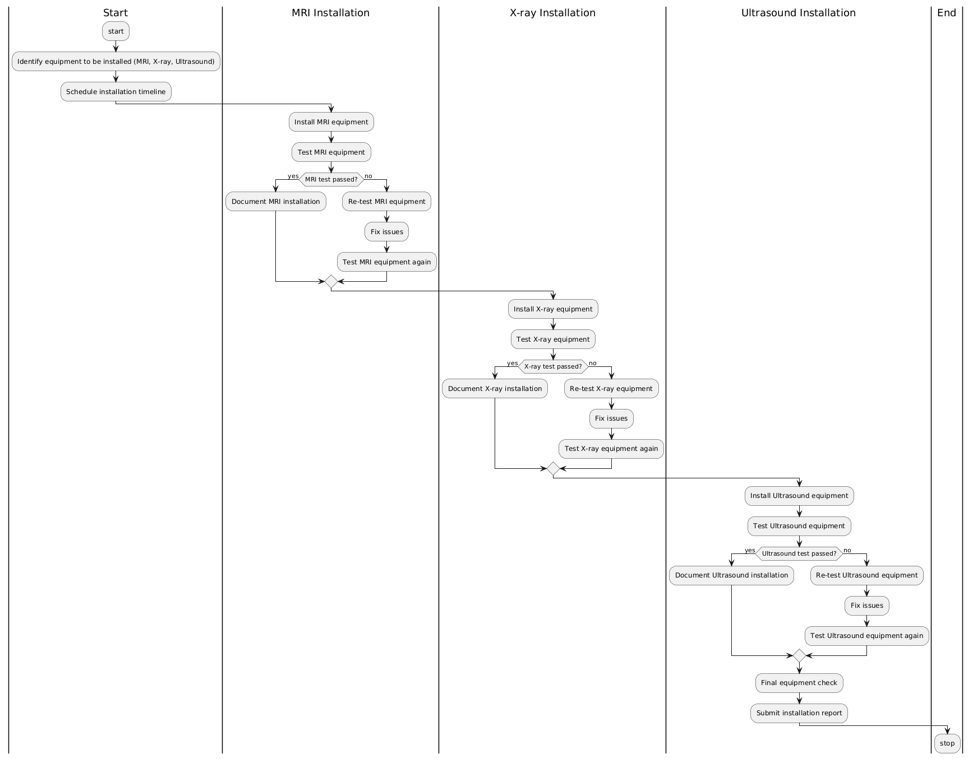
Figure 1 : Equipment Installation Plan
These deliverables guarantee that the updated facility is based on modern healthcare standards, patient care, and efficient operation in addition to meeting regulatory standards and better performance of the staff.

6. Timeline / Milestones
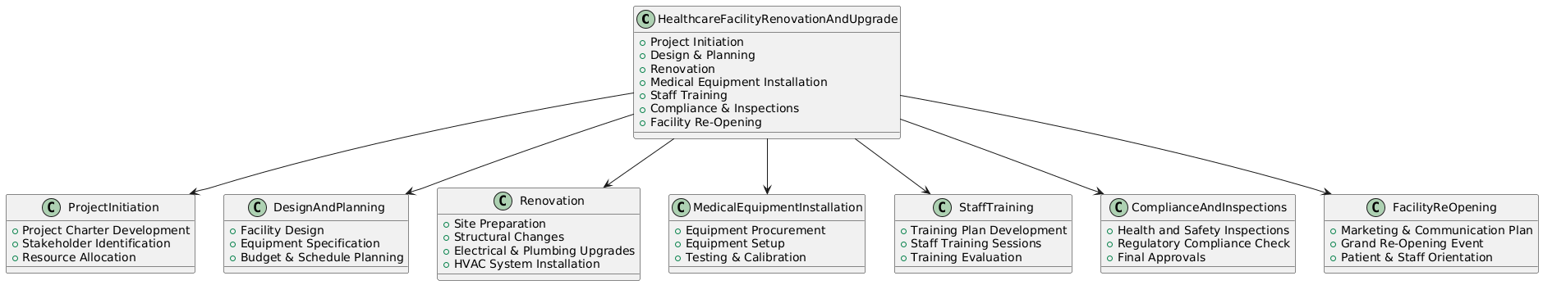
Figure 2 : WBS
The Healthcare Facility Renovation and Upgrade project has a timeline that indicates the major milestones and their timeframes. The project begins with Design Approval that will take 28 days (2/1/25 to 3/11/25), then proceeds to Procurement of Medical Equipment taking 31 days, starting 3/12/25 and ending 4/23/25. Renovation and Construction is a 30-day period between 4/24/25 and 6/4/25 then a 61-day Construction and Renovation period. Training of staff on New Systems: 15 days between 8/29/ 25 and 9/18/25. Then, the completion of the renovation will be a one-day operation on 9/19/25. The last compliance inspections and Facility Re-Opening Ceremony will be done by 9/26/25, and the whole project will end during 9/29/25. This timetable will make sure that every key deliverable is achieved within a strict and systematic period.
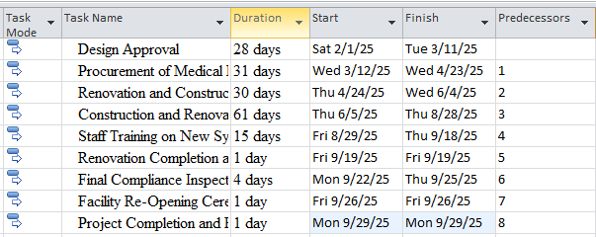
Figure 3: Schedule Table
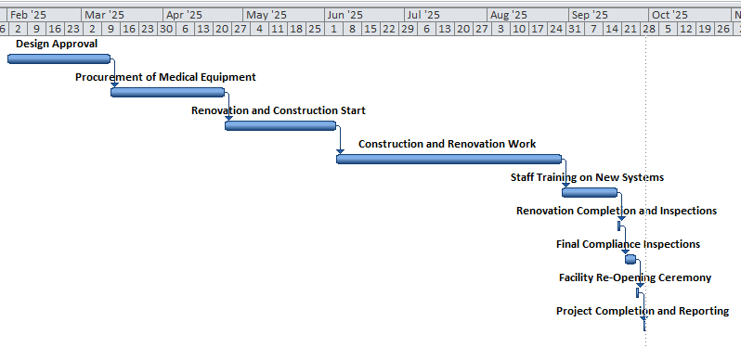
Figure 4: Gantt Chart
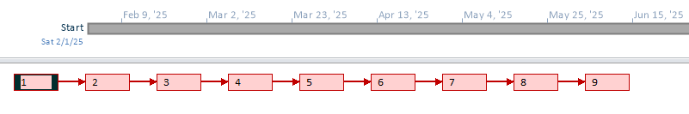
Figure 5: Network Diagram

7. Budget Estimate
The Healthcare Facility Renovation and Upgrade project has been estimated to be budgeted in a number of important areas. The highest amount, which is a half million, is used in medical equipment upgrades and this includes purchase of MRI and X-ray machines (Oturu et al., 2021).
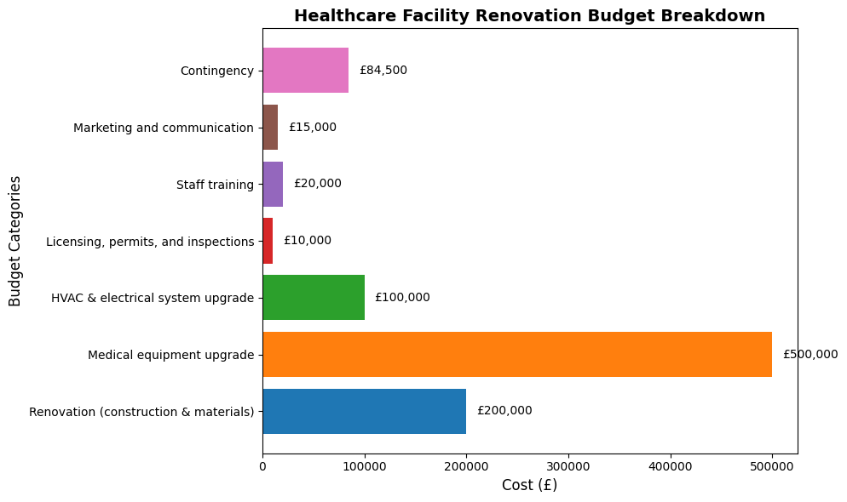
Figure 6 : Budget Breakdown
The renovation (construction and materials) project will be priced at 200,000 pounds, which includes structural changes, and the materials required at the facility. The electrical upgrade and HVAC is expected to cost 100,000 pounds to enhance energy efficiency and modernize the key systems (Hernandez, 2025). The cost of licensing, permits and inspection is estimated at 10,000 pounds which guarantees that the facility is within regulations. The cost of training of the staff is estimated at 20,000 as the staff are needed to be equipped with the skills required to run the improved systems.
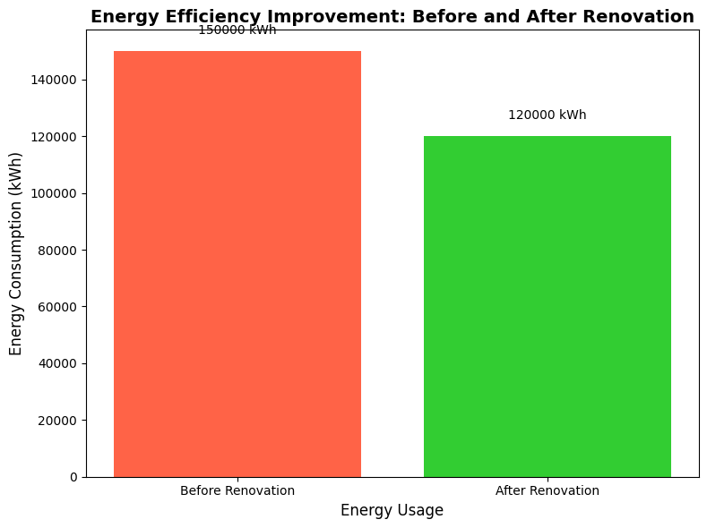
Figure 7 : Energy Efficiency Improvement Before and After Renovation
The marketing and communication budget will be 15000 pounds to market the refurbished facility. Lastly, there is the contingency of 10% amounting to £84,500 to meet any unforeseen expenses. The overall project cost is estimated to be at 929,500.
Table 2: Budget Table
Category | Estimated Cost (£)
Renovation (construction & materials) | 200,000
Medical equipment upgrade (MRI, X-ray) | 500,000
HVAC & electrical system upgrade | 100,000
Licensing, permits, and inspections | 10,000
Staff training (initial 3 months) | 20,000
Marketing and communication | 15,000
Contingency (10%) | 84,500
Total Estimated Budget | £929,500

8. Risks and Mitigation
Risk Management section determines the possible challenges and suggests ways to overcome them during the project of Healthcare Facility Renovation and Upgrade.
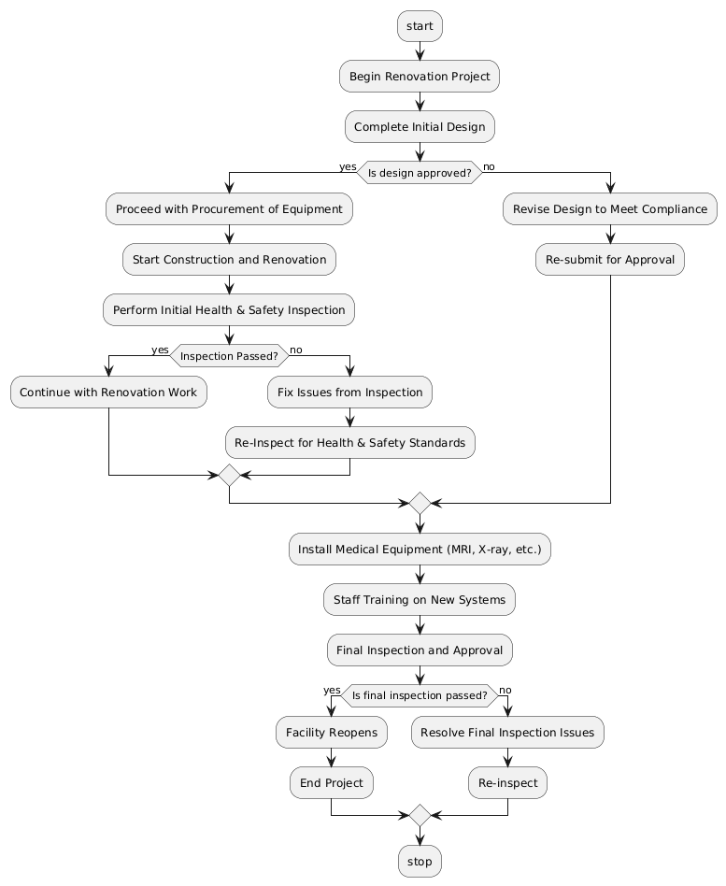
Figure 8 : Compliance and Inspection Process
- Postponement in the delivery of Medical Equipment (High Impact): In case of the delay of the medical equipment including MRI and X-ray machines, they may have a large result to the project schedule and also to the entire functionality of the project (Garg, 2023). To contain this, the secondary suppliers will be secured, and a staggering of deliveries will be undertaken to prevent delays that will impact the project development.
- Construction Delays (High Impact): Construction delays may cause project overruns and project disruption. The experience of the contractors and provision of buffer time in the schedule will minimize this risk, and it will be guaranteed that possible delays are considered and addressed (Latif, 2023).
- Failure to comply with the Health regulations (Medium Impact): In the case of failure to adhere to health and safety standards during the renovation, the approval of the project and its operations may be delayed. Audiological inspection and consultation with health authorities will also be done regularly to ascertain that all the requirements are met during the renovation process (Fogle, 2023).
- Interruption in Patient Care (High Impact): Construction activities may interfere with the work processes and patient care. Planning the renovation in stages will reduce the degree of disruption, and the necessary services will still be provided to the patients.
- Staff Resistance to New Systems (Medium Impact): Staff resistance to new system can slow the development. In order to alleviate this, early involvement and specific training will be done to facilitate the transition and facilitate the process of smooth integration of the new systems.
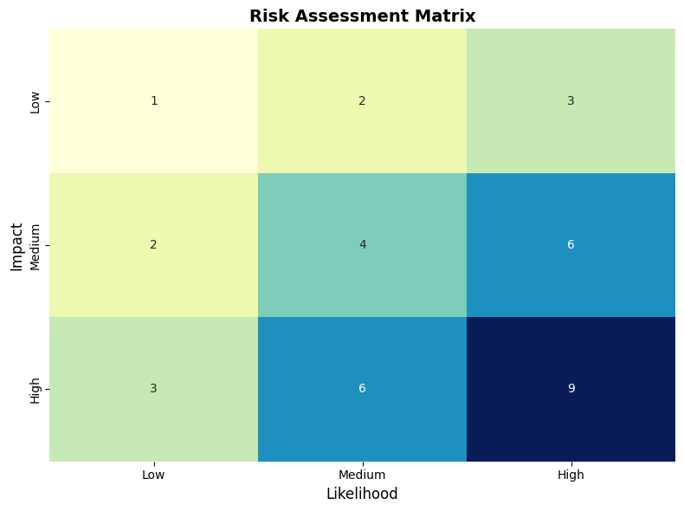
Figure 9 : Risk Matrix
Table 3: Risk Mitigation
Risk | Impact | Mitigation Strategy
Delay in medical equipment delivery | High | Secure secondary suppliers, staggered deliveries
Construction delays | High | Hire experienced contractors, set buffer time
Non-compliance with health regulations | Medium | Regular audits, consult health authorities early
Disruption to patient care | High | Schedule renovation in phases to minimize impact
Staff resistance to new systems | Medium | Early engagement and training sessions

9. Assumptions
The Assumptions section reveals significant conditions that should be true in the successful implementation of the project on Healthcare Facility Renovation and Upgrade.
- Operational Continuity: It is assumed that the facility will keep running its full operations throughout the renovations, which will not majorly impact on the current care of the patients. Construction works will be planned well to ensure that there is limited or no interference with essential healthcare services (Ndekugri, Ankrah and Adaku, 2023). The aspect of this assumption is that the service delivery and patient safety will not be compromised in the project.
- Timely Permits and Inspections: It is assumed that all the necessary permits and health inspections will be received on time. This encompasses zoning approvals, building permits as well as health and safety examination (Seiß et al., 2025) . The regulatory authorities should be given their consent in good time to make sure that the renovation process remains within the timeframe and that all the legal conditions are met.
- Access to Medical Equipment: It is assumed that the medical equipment required like MRI machines, X-ray machines and other important systems will be supplied by approved suppliers (Murali et al., 2023). The delays in the equipment acquisition would also impede the project, and thus the source suppliers and the backup plans in case of delays should be considered reliable.
- Stakeholder Agreement on Schedule: It is presumed that all the key stakeholders such as the medical staff will agree on the timeline of the renovation to ensure that the patients will not be disturbed (Bingham et al., 2022). The correct communication and planning are necessary to make the renovation consistent with the operational requirements and minimize possible controversies in the process.

10. Approval Signatures
The Approval Signatures section is a guarantee of formal approval of the project Healthcare Facility Renovation and Upgrade. The project charter is signed by Sarah Smith the Chief Executive Officer and Maria the Project Manager who is affirming their commitment and authority to do the planned renovation, with a start date of 01/02/2025.
Table 4 : Approval Signatures
Name | Title | Signature | Date
Sarah Smith | Chief Executive Officer | [Signature] | 01/02/2025
Maria | Project Manager | [Signature] | 01/02/2025

11. References
Bingham, E., Whitaker, D., Farnsworth, C. and Smith, J. (2022). Evidence-Based Design in Hospital Renovation Projects: Design Implementation for Patient Privacy and Comfort. Journal of Architectural Engineering, 28(2). doi:https://doi.org/10.1061/(asce)ae.1943-5568.0000530.
Fogle, P.T. (2023). Essentials of communication sciences & disorders. Burlington, Massachusetts: Jones & Bartlett Learning.
Gambo, N. and Shehu, M. (2024). The Role of Diagnostic Medical Physics in Medicine: An Overview. Sahel Journal of Life Sciences FUDMA, [online] 2(1), pp.103–109. doi:https://doi.org/10.33003/sajols-2024-0201-012.
Garg, A. (2023). Equipment Planning, Procurement, Installation and Management. pp.307–356. doi:https://doi.org/10.1007/978-981-99-6203-7_14.
Hernandez, I.M. (2025). IMPROVING ENERGY EFFICIENCY IN SEMICONDUCTOR HVAC SYSTEMS. Arizona.edu. [online] doi:http://hdl.handle.net/10150/677809.
Hussain, S. (2022). Modern Diagnostic Imaging Technique Applications and Risk Factors in the Medical Field: A Review. BioMed Research International, [online] 2022(5164970), pp.1–19. doi:https://doi.org/10.1155/2022/5164970.
Latif, M.Z. (2023). Analyzing the Key Factors Contributing to Project Delays in the Construction Industry: A Comprehensive Study. Journal of development and social sciences, 4(III). doi:https://doi.org/10.47205/jdss.2023(4-iii)85.
Li, L., Cui, X. and Feng, W. (2023). Enhancing Patient Satisfaction in Cross-Regional Healthcare: a Cross-Sectional Study in the Knowledge-Based Healthcare Landscape. Journal of the Knowledge Economy, 15. doi:https://doi.org/10.1007/s13132-023-01685-z.
Murali, S., Ding, H., Adedeji, F.A., Qin, C., Obungoloch, J., Asllani, I., Anazodo, U., Ntusi, N., Mammen, R., Niendorf, T. and Adeleke, S. (2023). Bringing MRI to low‐ and middle‐income countries: Directions, challenges and potential solutions. NMR in Biomedicine, 37(7). doi:https://doi.org/10.1002/nbm.4992.
Ndekugri, I., Ankrah, N.A. and Adaku, E. (2023). Performance Barriers for Coordination of Health and Safety during the Preconstruction Phase of Construction Projects. Journal of Construction Engineering and Management, 149(7). doi:https://doi.org/10.1061/jcemd4.coeng-12073.
Oturu, K., Ijomah, W., Broeksmit, A., Reig, D.H., Millar, M., Peacock, C. and Rodger, J. (2021). Investigation of remanufacturing technologies for medical equipment in the UK and context in which technology can be exported in the developing world. Journal of Remanufacturing, 11(3), pp.227–242. doi:https://doi.org/10.1007/s13243-021-00102-5.
Seiß, S., Fauth, J., Zheng, Y. and Poetz, A. (2025). Understanding and conceptualizing inspections in the context of building permits. Smart and Sustainable Built Environment. doi:https://doi.org/10.1108/sasbe-11-2024-0492.

