Programme: BA (Hons) International Hotel Management
Module: Managing Guest Service Operations
Module Code: BMIH6003
Assignment Title: Student Learning Log
Student ID Number: 2120533
Chosen Department: Front Office
Model of Reflection: Gibbs Reflective
The Gibbs Reflective Cycle, another six-fold cycle devised by Graham Gibbs, is aimed at helping people learn from an experience. Then, it provides a description of a given situation and reflects the emotions which one might experience in that particular situation. Then, you get to recognize the strengths and weaknesses of your application. This means that Analysis examines further with the conception of essential causal factors and theories that are applicable (Wain, 2017). Last, kindred points synthesis and their implications are accomplished and an improvement strategy to foster further effectiveness is discussed. Through the consideration of these stages, the cycle can assist in the enhancement of the individual and the job position on the continual basis.
Placement Learning Objectives:
- The person should closely monitor the activities of the front office department for better understanding.
- To complete this task, Ihave observed a supervisor at work and document the tasks in order to understand the scope of the supervisor’s role.
- Discussed the type of skills and know-how needed for the guest service activities as performed in the place of work.
- When considering the process of meeting the guests’ needs assessment, it is possible to determine that communication, collaboration, and organizational skills are critical success factors.
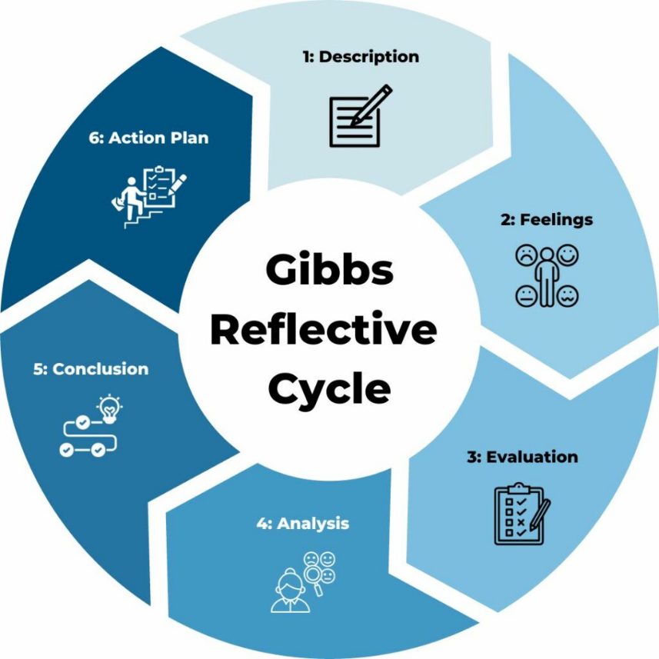
Gibbs Reflection

Figure 1: Gibbs Reflective Cycle
Source: (Channell, 2023)

Description:
Thus, the placement offered me the practical opportunity of accompanying a front office supervisor. Through this experience, I could observe the difficulties and interactions of the organizational structure involving the guest services. As part of my day, I had to stay and watch how the check-in and check-out formalities are carried out, queries that are handled, minor complaints that are solved, and monitoring of the front office employees (Nurlatifah, 2023).
Feelings:
I happened to be under great pressure due to high levels of client traffic at this post. But, as I moved into implementation of tasks within the position, I found the supervisor to be quite rational in their resolutions. I also received satisfaction from seeing the fight after embodying the principle of excellent guest service (Brown, 2022).
Evaluation:
I learned so much about the demands of the front office supervisory role and the myriads of skills and competencies needed for the position (Brown, 2022).
Work-based Skills:
Communication: The supervisor was brief in terms of interacting with the guests, both in response to complaints and in relaying information. They also led to often communication within the team so that everyone was informed of the developments within the team. This is consistent with the idea of the three-leg model of team effectiveness as postulated by Hackman & Wageman (2005), where communication is key in the achievement of goals as well as fostering a common outlook or perception (Salihovic, 2021).
Teamwork: Cooperation was particularly key to most practices in the front office. One of the major and positive managerial actions is the use of effective delegation methodology where the supervisor/manager made sure that members of the team are exercised on their areas of strength while at the same time strengthening the teamwork culture in the organization. This supports Belbin’s team role theory, whereby certain people in a group have a specific character that allows him or her to effectively support the other party (Belbin, 2022).
Task Management: In this work we identified several key issues suitable for presentation of the supervisor’s experience: Prioritization and, possibly, time management were important. These workers were able to perform several tasks at the same time in order to meet the operational demands. As per time management, introduced by Covey (2020), there is identification of prior Sherman important guests’ requirements were responded to immediately, whereas future duties were organized.
Technical Knowledge: As for interpersonal skills, they are invaluable but the supervisor had a complete knowledge of the operations of the hotel and the reservations systems of the hotel and its billing structures. This technical knowledge helped them to be quite comfortable with the occurrence of any complications and to be able to guide the guests (Yağmur, 2023).
Personal Skills:
Problem-Solving: Concerning the conflict-solving competency, the supervisor employed best knowledge and skills in addressing guests’ complaints concerning the hotel. Instead, they did their best to remain relaxed, serious, and kind, trying to listen to the problem carefully and then offering the possible ways out. This follows problem solving strategy which fits in Dewey’s model of reflective thinking (1933) of which the essence involves identifying effective solutions from a problem situation (Sümen, 2023).
Decision-Making: In another instance, the supervisor had to make a decision regarding the guests throughout the day and he was able to do it in a timely manner. This could be explained by the fact that critical thinking skills are developed together with the ability to consider the implications of certain decisions in the process of decision making known as decisional balance.
Analysis:
My period of service made me understand the importance of communicating with other employees, working in a team and managing the tasks in order to meet the expectations of guests. By providing key skills that helped him/her to perform efficiently in these areas, the supervisor was instrumental in ensuring a good experience for the guests. In particular, the candidates’ personal attributes, including the problem-solving abilities and decision making, facilitated issue solving and guests’ satisfaction.
Conclusion:
Serving as a front office supervisor gave the opportunity to observe the work and duties of the employee closely and understand its work with guests better. It not only made me strengthened my interest on this field but also increased my awareness on Personal and Professional Development
Action Plan:
Based on this experience, I have formulated an action plan for future development:
Develop public speaking skills: I shall ensure that I attend all class sessions, and where there are chances to make presentations or otherwise engage in-discussion, I shall ensure I do so in order to enhance my skills in communication and public speaking.
Enhance teamwork capabilities: I will personally participate in team projects and activities that require leadership, in order to enhance my capacity for co-operation.
Gain industry knowledge: Thus, in the context of learning and enhancing my technical writing as well as theological and educational knowledge, I will aspire to gain hospitality industry certifications to broaden my understanding of the industry.
Refine conflict resolution skills: In that light, I will endeavor to seek further information regarding on line resources and workshop on conflict prevention or management skills that I can use the next time a guest complains (Brown, 2022).
Specific Situation Analysis:
Encounter: In this observation, a guest used the complaints section of the Rhode Island hotel’s comment form, describing discomfort due to a noisy air conditioning system in their room. A careless response would have been something like: “Well, that’s just how it is here sir/ma’am sorry for the inconvenience” Instead, the supervisor looked the guest in the eyes, apologized for the inconvenience, and took the guest at their word by immediately calling maintenance to get the problem corrected. When the client has to wait for a tech, they made sure to compensate the guest by providing a free meal token in the hotel’s restaurant.

Alternative Solutions:
Provide immediate solutions: Presumably, the supervisor could have provided the guest with a chance to switch to another room without a broken air conditioning system.
Temporary noise reduction: They could suggest using ear plugs or getting a white noise machine which may act as a temporary remedy until the maintenance team gets there (Sicora, 2024).
Follow-up: The supervisor could have followed up the guest by him or herself in order to confirm his or her satisfaction with the repair done by the maintenance.
Conclusion:
I was able to develop understanding on how to effectively deal with guest complaints from this particular interaction of guest service. The chosen approach responded to the need for increasing guest satisfaction and depicted a concern with service recovery. The other methods help me expand my knowledge of the various approaches that can be taken with regard to time and resources available.
Reference
Brown, N. (2022) Reflective model according to Gibbs, Dr Nicole Brown. Available at: https://www.nicole-brown.co.uk/reflective-model-according-to-gibbs/.
Wain, A. (2017). Learning through reflection. British Journal of Midwifery, 25(10), 662-666.
Sicora, A. (2024). Learning from ‘difficult’experiences in field practice. The Routledge International Handbook of Social Work Teaching, 294.
Salihovic, K. (2021). Team coaching in the workplace. A literature review on team coaching and solving performance deficiency in the workplace, 10.
Belbin, R. M., & Brown, V. (2022). Team roles at work. Routledge.
Covey, S. R. (2020). The 7 habits of highly effective people. Simon & Schuster.
Nurlatifah, L., Purnawarman, P., & Sukyadi, D. (2023, December). The implementation of reflective assessment using Gibbs’ reflective cycle in assessing students’ writing skill. In AIP Conference Proceedings (Vol. 2621, No. 1). AIP Publishing.
Yağmur, Y., Demirel, A., & Kılıç, G. D. (2023). Top quality hotel managers' perspectives on smart technologies: an exploratory study. Journal of Hospitality and Tourism Insights.
Sümen, Ö. Ö. (2023). Reflective Thinking in The Problem-Solving Process: A Model Proposal. Sakarya University Journal of Education, 13(1), 6-23.
Channell, M. (2023) Gibbs reflective cycle – A practical guide, TSW Training. Available at: https://www.tsw.co.uk/blog/leadership-and-management/gibbs-reflective-cycle/ (Accessed: 02 June 2024).

