MARKETING FUNDAMENTALS

Student Name: Gheorghe Bogatii
Student ID:2020309
Module Name: Marketing Fundamentals
Contents
Introduction: 3
Blogs as a part of communication activities 3
Blog 1: The Brand-new winter collection 3
Blog 2: Product market of ZARA 4
Blog 3: Marketing strategy and environment of ZARA 6
Blog 4: The pricing policy of ZARA 8
Blog 5: Promotional/customer engagement strategies of ZARA 9
Blog 6: Organization suppliers and distribution channel engagement strategies of ZARA 12
Conclusion: 13
References 14

Introduction:
Here the chosen company is Zara. Zara is a clothing retailer company that was established by Amancio Ortega and his wife Rosalia Mera in Spain in the year 1963. This retail company made its specializations in fast fashion and products like clothing, jewellery, shoes, swimwear, perfumes, fashion materials, accessories and apparel for women, men, children and even newborns etc. Zara has around 2,270 stores all around the globe. In the year 2015, Zara was given the rank of 30th on Interbrand's list of best global brands.
In this assignment, the considered well-known company is ZARA for which blogs will be provided as the communication activity between the target audience and the company. Via those blogs, the company will be notifying the targeted audience about their new launches and collection and will be increasing their awareness for the company in turn intending to increase the customer base for the company.

Blogs as a part of communication activities

Blog 1: The Brand-new winter collection
This winter, Zara launched its brand new winter collection, which has products of utmost perfection. The collection is too good to build one complete autumn or winter wardrobe. The collection probably possesses everything one needs for having a perfect and cozy winter season (Kotler and Armstrong, 2013). The varieties come in such a huge number that it almost becomes too hard to choose from. Like each and every time, Zara has just beaten its own previous collections. This collection of Zara gives almost a million reasons to not have a plain, basic and bland winter season. Zara tops the trends rising in the market all at once. Zara this year, decks up everyone with all the glamorous, gorgeous and glittery yet warm clothes. Parties in winter do not sound like a problem with Zara round in the corner. So, no chances of boring and gloomy attires this season.
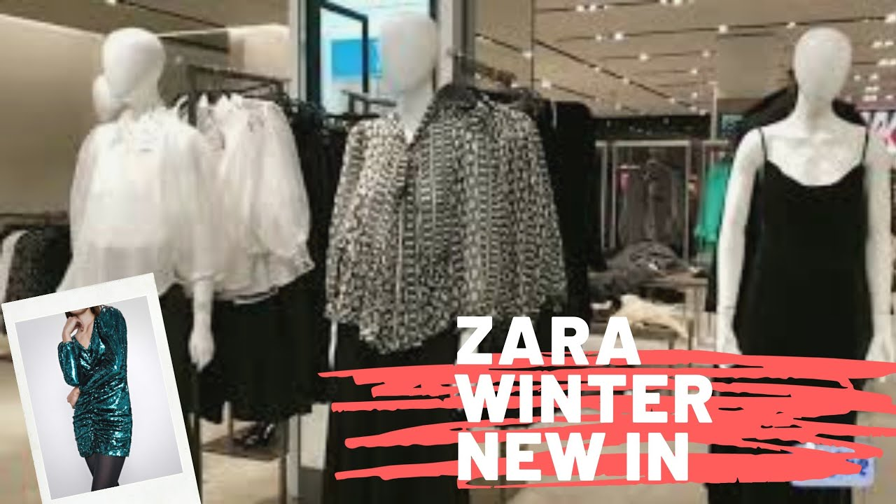
Figure 1: Brand-new winter collection of Zara
(Source: Piedrahita Orozco et al., 2021)
The party section of Zara covers up all the draped metallics, sequined minis, colourful fringe etc., all of which are literally enough to win hearts. The collections are a treat to the eyes and give a blast of holiday spirit to the hearts (Piedrahita Orozco et al., 2021). Winters and fall seasons have probably never been this bright, glossy and full of colours. The list also contains – Mid waist straight jeans, Faux leather oversized shirts, Kassel coated long coat (limited edition), Poplin shirt, Tailored blazer, full-length Faux the 90's leather pants etc. and so much more. So, no duller and drier fall season. Reach to the nearest Zara showroom as soon as possible to build an all-new winter special wardrobe.

Blog 2: Product market of ZARA
ZARA made its specializations in fast fashion and products like clothing, jewellery, shoes, swimwear, perfumes, fashion materials, accessories and apparel for women, men, children and even newborns etc. Most products in the stores of Zara are newly designed (Koivulehto, 2017). Zara may be termed as an 'instant fashion' brand which implies that they identify the latest and ongoing fashion trends and brings them to the market as quick as possible. The popular designs in Zara are quickly sold out. The products of Zara are unique compared to the mass-produced. The new and latest designs of Zara stay in huge demand and is sold off pretty fast. Zara aims to position its products at a minimum and at affordable prices to its customers (Dueeas and Carmona, 2022). Zara provides its fashion items at a much lower price in almost all of its stores all around the world as compared to the other international brands.
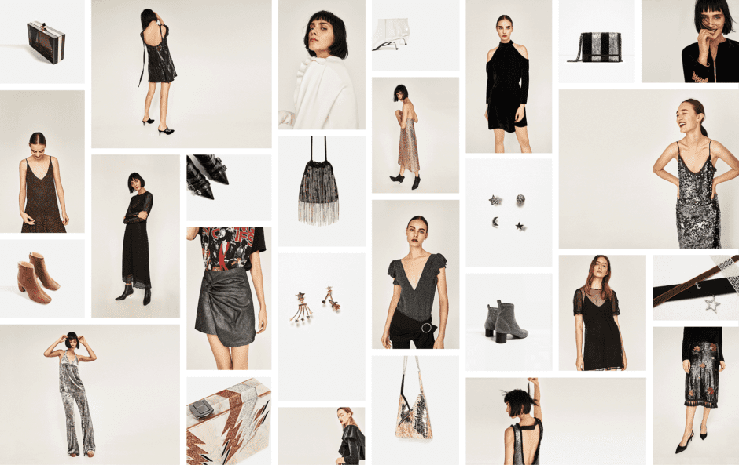
Figure 2: Product market of ZARA
(Source: Li, 2021)
Zara determines a market-based pricing strategy that puts up the aimed price at a level at which, the customers will be able to pay. Zara also provides a 50% sale on its products twice a year to attract customers. Zara introduces new fashion and trendy items in almost every season and for every occasion and festival (Li, 2021). Their products are eye-catching and very impressive. In the hurry of producing trendy items, they do not and never compromise with the quality of the product. Zara purchases its raw materials or raw fabrics and bulk fibres from suppliers staying in Italy, Spain, Portugal and Greece. A large amount of capital cost is involved in the transportation of materials and finished goods and products (Li and Ukhova, 2021). Thus, Zara produces quality as well as trendy products at the correct time a never fails to drive the public's attention towards itself.

Blog 3: Marketing strategy and environment of ZARA
The basic target market of Zara ranges from 18 years old to 35 years old. Zara keeps its price range affordable to the standard of middle classes as they have a customer base of which most of the people are middle-class individuals of the society (Chunling, 2020). Their products range for both men and women and come in all sorts of varieties. They make segments of their product line by women up to 60 percent, men up to 25 percent and also children up to 15 percent. In the United Kingdom, Zara has a huge business base. The business there is constantly growing. However, the constantly rising population of the United Kingdom can have a considerable effect on the growth of this business brand. Since the year 2016, there has been a population growth of 392,000 in the United Kingdom. The constant increase in population would mean that Zara would also have to make a rise in its supply to cope up with the rise of demand.
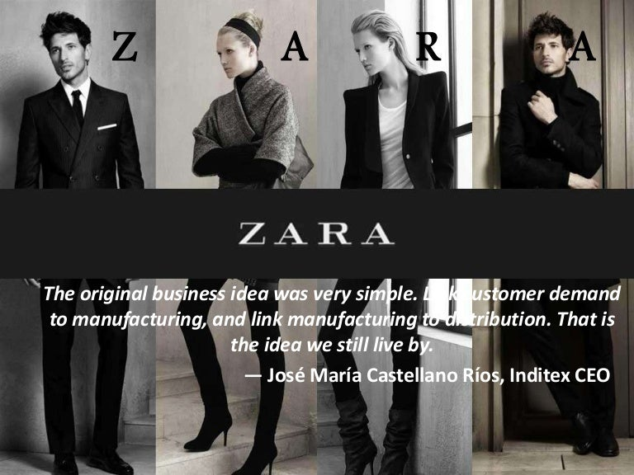
Figure 3: Marketing strategy of Zara
(Source: Cameron et al., 2021)
Zara has open trade agreements with Europe and hence it enjoys all the benefits of running a business in the European Union. The free trade policies of the European Union are a huge benefit for the company. Being a Spanish company, Zara has a relatively lower cost of labour, which permits them to minimize their cost (Cameron et al., 2021). It provides its clothes and accessories at an affordable rate. People usually associate the trend of fast fashion with wastefulness. Since Zara is a fast-fashion brand, this may have a negative impact on its reputation. Zara also follows popular online shopping trends to analyze customer demands. Zara has around 2,270 stores all around the globe. In the year 2015, Zara was given the rank of 30th on Interbrand's list of best global brands. Still, after all these, Zara has to compete with strong competitors such as H&M and Forever21 who rule almost at the same strata.

Blog 4: The pricing policy of ZARA
Zara mainly uses a pricing policy that is value-based. This particular policy of pricing considers the customer's perception of the product's value rather than the goals of the company, which has been prior, set from before. Zara sets the price at which the middle-class people of the society can also afford trendy and stylish products (Valero López, 2020). Zara provides its fashion items at a much lower price in almost all of its stores all around the world as compared to the other international brands. Zara determines a market-based pricing strategy that puts up the aimed price at a level at which, the customers will be able to pay. They budget their cost of production according to the price level, which in turn fixes the profit margin of each product. Zara uses a number of different schemes for promotional purposes of its products. Zara provides a 50% sale on its products twice a year to attract customers. Zara keeps its price range affordable to the standard of middle classes as they have a customer base of which most of the people are middle-class individuals of the society.
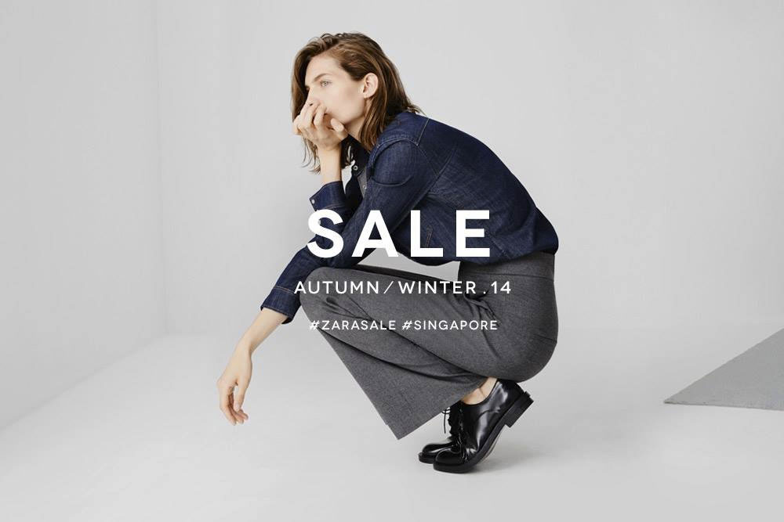
Figure 4: Pricing strategy of Zara
(Source: Segran, 2019)
Zara has cheap labour and comparatively higher faster production schedules than other companies. This factor helps the brand to keep the prices low as much as they can. The price ranges of Zara are almost one-fourth of the prices of other popular brands in the market (Segran, 2019). Unlike other popular and luxury fashion brands, Zara never opted for the high pricing policy based on the name and fame of the big brand. This one factor provides Zara with a competitive advantage over the other high-rise companies like Gucci, Channel and Louise Vuitton. This is one of the other major reasons why Zara has such huge dominance over the global market and has a good customer base in almost all the countries of the world.

Blog 5: Promotional/customer engagement strategies of ZARA
The customer research strategy has been a great treasure for Zara's success. Zara constantly uses its accounts on different social media platforms to communicate or interact with its customers. Zara has profiles on different platforms like - Facebook, Twitter, Instagram, YouTube, Pinterest, LinkedIn, blogs etc. Zara shares promotional pictures and videos of their products and accessories to let people know about the current stocks at their stores (Wierciak, 2020). This constant interaction of the brand with the customers has helped to retain a belief of brand loyalty among the customers. Zara keeps on updating the people and their target audience about their current stocks, ongoing trends and new launches by posting – pictures, videos, blog posts etc. they post on different social media handles where they have accounts.

Figure 5: Brand loyalty
(Source: Dueñas and Carmona, 2022)
Zara has a huge number of followers on all the social media handles including Instagram, where they have a follower base of 47.7 million. Since most part of the social media promotions depends on visual elements' consistency, Zara is very particular about the visual content they post. They have a photo-oriented synchronized layout on which they post their pictures on every social media platform (Dueñas and Carmona, 2022). This helps to keep up the identity of the brand. Zara also posts consistently and not at a gap of a very long time which maintains the brand's consistency. They try posting at least once a day on both Facebook and Instagram.
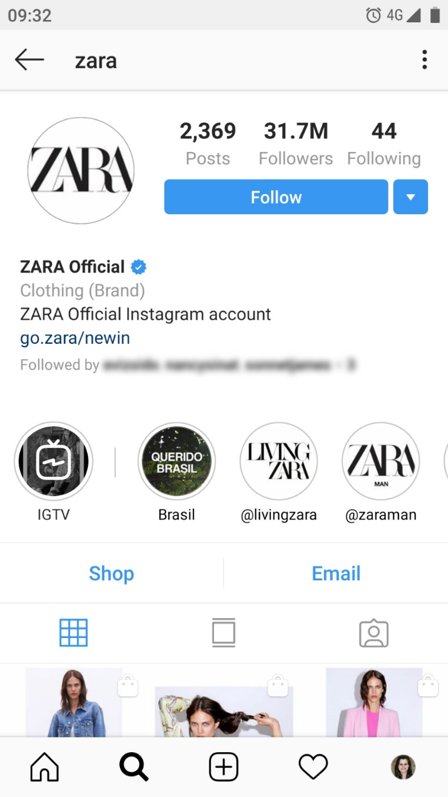
Figure 6: Followers of Zara on social media (Instagram)
(Source: Filimonova et al., 2019)
Zara consistently and constantly uses social media platforms to have conversations with the public and that is how Zara manages to maintain brand loyalty with the people (Filimonova et al., 2019). Zara also uses YouTube for promotional purposes and also posts videos there to notify the public about their new launches, collection and currently available products.

Blog 6: Organization suppliers and distribution channel engagement strategies of ZARA
Zara has a very organized and well-maintained supply chain. The distribution channel of the brand has a lot of intermediates un between - wholesalers, retailers, resellers, agents and franchisees. Zara purchases its raw materials or raw fabrics and bulk fibres from suppliers staying in Italy, Spain, Portugal and Greece. A large amount of capital cost is involved in the transportation of materials and finished goods and products (Angkie, 2019). Zara sells its finished products and goods to almost in77 countries in among 2,000 stores. Zara also retails through their company's main website, Twitter, Facebook, Instagram, Pinterest and LinkedIn. Zara has its manufacturing units in three different places. 50 percent of Zara’s production is done is in Spain, 26 percent of the production takes place in Europe and in Asia, 24 percent of the production takes place. After production, the products are carefully transferred to the headquarters of Zara, which is in Spain and from there; the products are carefully moved and transferred to the other parts and Zara units across the globe.
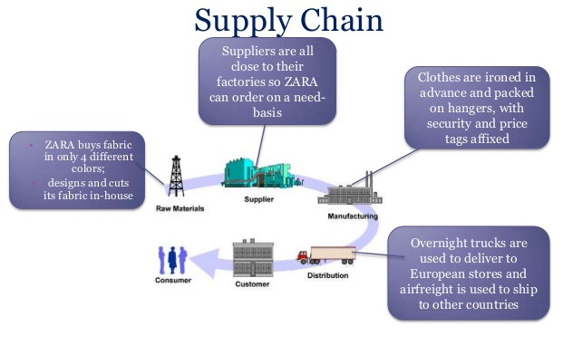
Figure 7: Distribution channel of Zara
(Source: Duoyan, 2021)
The distribution of the products to all across the globe is well controlled and managed by the headquarters itself. The products are transferred in the minimum possible time and are always found in good condition (Duoyan, 2021). The creativity and the hard work of the staff at Zara range so much that it produces almost 1200 units of products of the design per batch and these designs are available in the stores within 2 weeks of production. The brand has almost more than 200 staff for the purpose of production. They have a strong market analysis the reason of which, they can make the distribution of the produced items so fast.

Conclusion:
This assignment has considered the well-known company is ZARA and has provided blogs for the communication activity between the target audience and the company. Via those blogs, the company had notified the targeted audience about their new launches and collection and has tried to increase their awareness for the company with the intending of increasing the customer base for the company.

References
Angkie, N.S., (2019). Pengaruh Social Media Marketing terhadap Brand Equity pada Brand Fashion ZARA, H&M, PULL&BEAR, dan STRADIVARIUS di Surabaya. Agora, 7(1).
Cameron, K., Al-moukadem, S., Boutilier, M., Hamilton, M., Jeffcoat, A., Lee, M., Martina, M. and Price, M., (2021). Zara in China: Fashionably Fast.
Chunling, L., (2020). Analysis on the Marketing Strategy of Fast Fashion Brand Zara Based on 4c Theory.
Dueeas, P.P.M. and Carmona, D.G., (2022). APLICACIÓN DE LAS TÉCNICAS DE MARKETING SENSORIAL EN LOS ESTABLECIMIENTOS DE MODA: EL CASO DE ZARA Y STRADIVARIUS/Application of sensory marketing techniques in fashion shops: the case of Zara and Stradivarius/APLICAÇÃO DAS TÉCNICAS DE MARKETING SENSORIAL NAS LOJAS DE MODA: O CASO ZARA E STRADIVARIUS. Vivat Academia, (155), pp.17-33.
Dueñas, P.P.M. and Carmona, D.G., (2022). Aplicación de las técnicas de marketing sensorial en los establecimientos de moda: el caso de Zara y Stradivarius. Vivat Academia, pp.17-32.
Duoyan, H., (2021), April. Research on ZARA Strategy from the Perspective of SWOT Analysis Method. In (2021) 6th International Conference on Social Sciences and Economic Development (ICSSED (2021)) (pp. 201-205). Atlantis Press.
Filimonova, S.E., Shakinko, M.I. and Mehta, R.A., (2019). DIGITAL MARKETING AS NEW ERA OF ADVERTISING. In Неделя науки СПбПУ (pp. 326-328).
Koivulehto, E.I., (2017). Do social media marketing activities enhance customer equity? A case study of fast-fashion brand Zara.
Kotler, P. and Armstrong, G., (2013). Principles of Marketing (16th Global Edition).
Li, C. and Ukhova, A.I., (2021). THE POSITIVE INFLUENCE OF ZARA BRAND MARKET STRATEGY MANAGEMENT USAGE IN THE CHINESE MARKET. In BREAKTHROUGH SCIENTIFIC RESEARCH AS AN ENGINE OF SCIENCE (pp. 36-38).
Li, Y., (2021), September. How Should Zara Optimize Its Marketing Strategies to Cater to the Needs of New Generations–Gen Z and Millennials. In (2021) International Conference on Financial Management and Economic Transition (FMET (2021)) (pp. 305-311). Atlantis Press.
Piedrahita Orozco, S., Ochoa-Zezzatti, A. and Delgado Lechuga, G., (2021). Using Machine Learning to Predict Online Buying Behaviour, Wholesale and Fashion Marketing at Zara, an Analysis Including Z Generation. In Technological and Industrial Applications Associated with Intelligent Logistics (pp. 357-403). Springer, Cham.
Segran, E.L.I.Z.A.B.E.T.H., (2019). H & M, Zara, and other fashion brands are tricking shoppers with vague sustainability claims. Fast Company, 8.
Valero López, S., (2020). Zara Home en Puerto Rico: camino hacia el éxito.
Wierciak, A., (2020). STRATEGIA MARKETINGOWA W BRANŻY FASHION NA PRZYKŁADZIE MARKI ZARA.

