Easter exercises

Future proofing cities is the greatest challenge facing 21st century humanity (Wilkins, 2018)

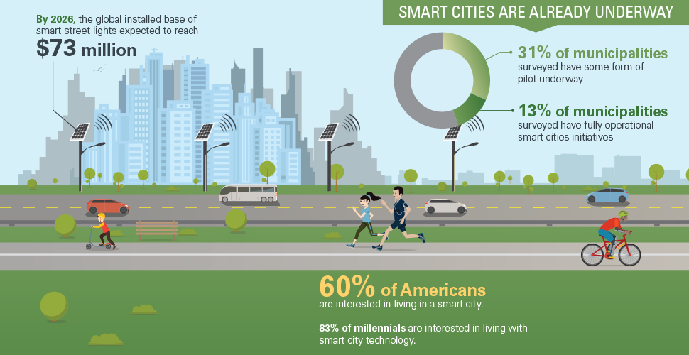
What factors need to be considered in future proof our cities?

Find examples and references for each of the following factors (also presented in the future cities lecture). Send your answers to me before the end of Easter

Future proofing cities can be based on the following factors
• Urbanisation Strategy and design
• Resilient water supply
• Managing climate impacts
• Sustainable transport
• Protecting ecosystems
• Efficient waste management
• Sustainable urban finance
• Resilient buildings and green spaces
• Clean energy
• Resilient coastlines
• Various examples to exemplify these points

