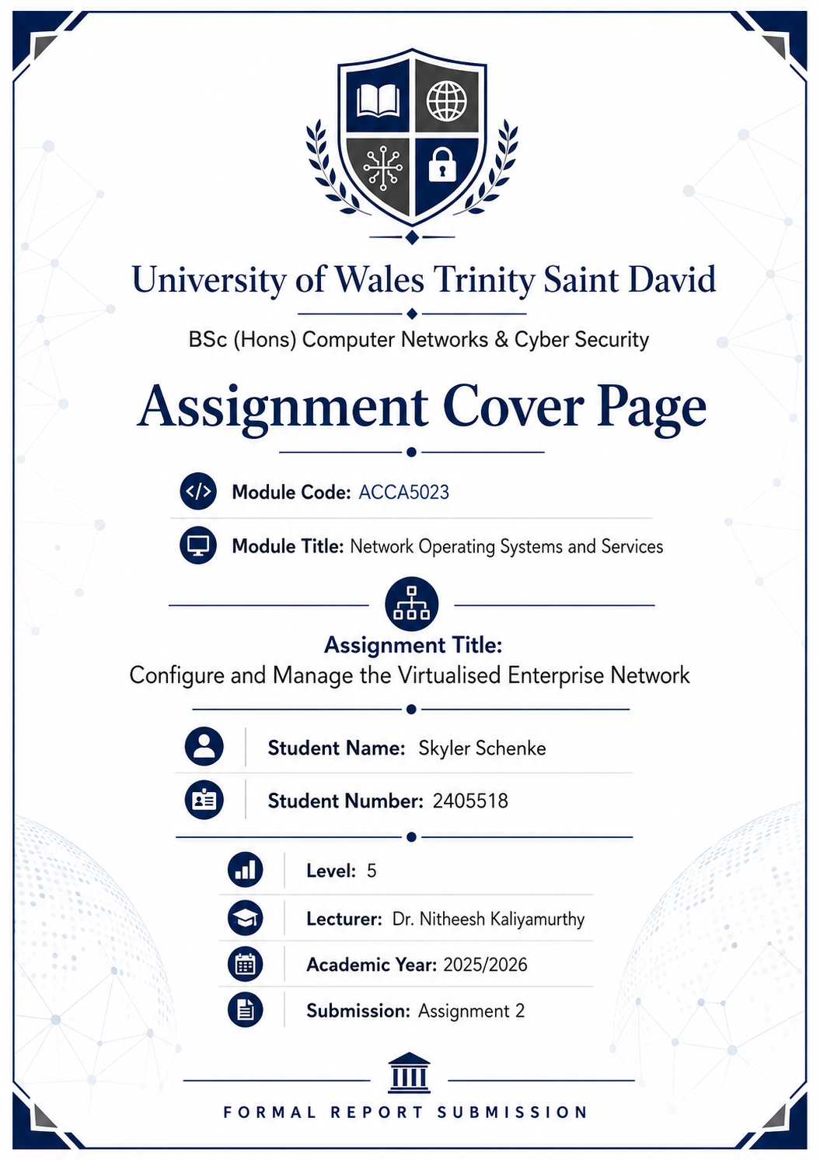

Contents

ACCA5023 Network Operating Systems and Services 1
Configure and Manage the Virtualised Enterprise Network 1
1. Introduction 1
2. Network Addressing and Topology 2
3. Active Directory Domain Services 5
4. DNS Configuration 8
5. DHCP Configuration 10
6. Routing and Site-to-Site VPN 12
7. File Sharing and Permissions 17
8. IIS Website Configuration 19
9. Remote Desktop Services 21
10. Testing and Verification 24
11. Conclusion 26
References 26

ACCA5023 Network Operating Systems and Services

Configure and Manage the Virtualised Enterprise Network

1. Introduction
This report documents the configuration of a virtualised enterprise network containing two sites: Swansea and London. The Swansea site contains the main Windows Server domain controller, S-DC, and the Swansea client, ClientS1. The London site contains L-DC and ClientL1. The network was configured to provide centralised authentication, DNS, DHCP, secure routing, file sharing, IIS web access, Remote Desktop Services, and a site-to-site VPN.
The final domain used for the environment is skyler.acca. The design follows a typical enterprise model where core services are centralised on a Windows Server domain controller, while branch-site connectivity is provided through routing and VPN services.
[Screenshot 1: Full network topology showing S-DC, ClientS1, L-DC, ClientL1, Swansea network, London network, and transit network]
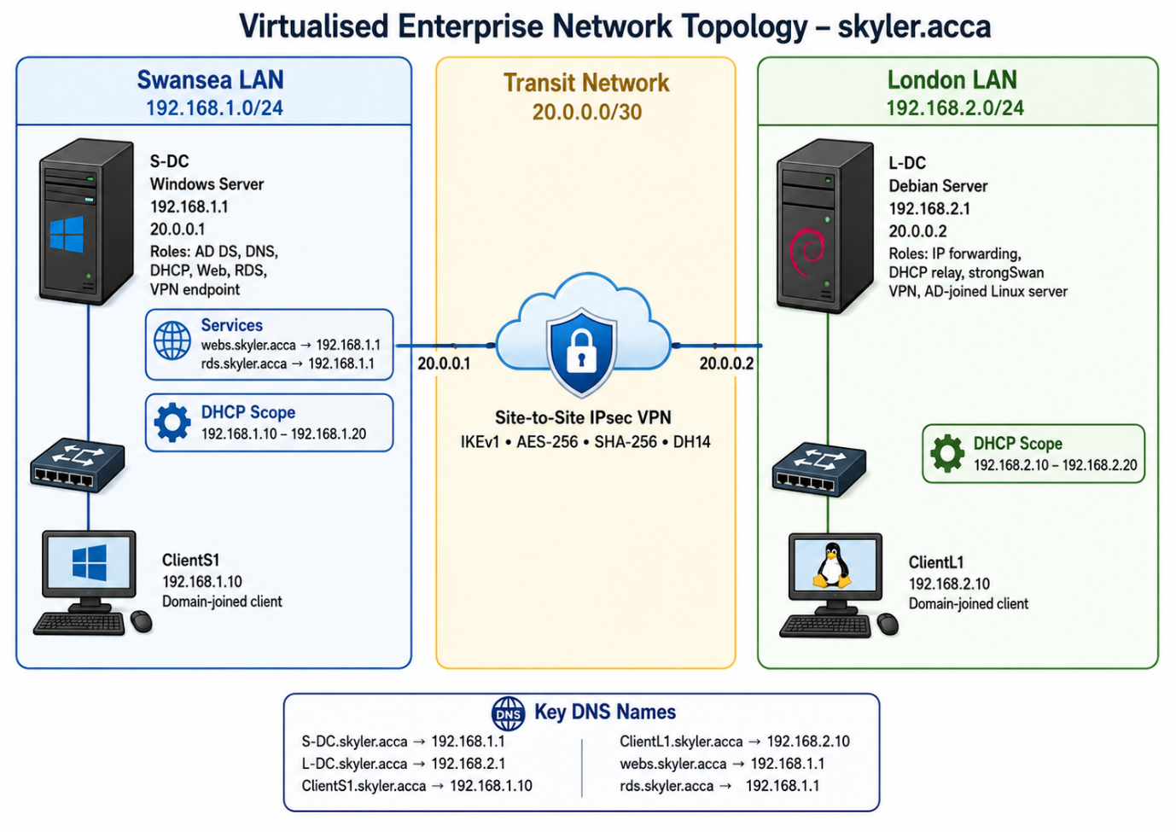
This screenshot shows the final enterprise network topology. The Swansea site contains S-DC and ClientS1 on the 192.168.1.0/24 network. The London site contains L-DC and ClientL1 on the 192.168.2.0/24 network. The two sites are connected using a transit network between S-DC and L-DC, allowing routing and IPsec VPN communication between Swansea and London.

2. Network Addressing and Topology
The Swansea network was configured as 192.168.1.0/24, with S-DC using 192.168.1.1. The London network was configured as 192.168.2.0/24, with L-DC using 192.168.2.1 and ClientL1 using 192.168.2.10. A transit network was used between the two sites, with S-DC using 20.0.0.1 and L-DC using 20.0.0.2.
Static IP addressing was used for the server and routing devices because these systems provide infrastructure services and must remain reachable using predictable addresses. This is especially important for DNS, DHCP, routing, and VPN configuration.
[Screenshot 2: S-DC ipconfig /all showing 192.168.1.1 and 20.0.0.1]
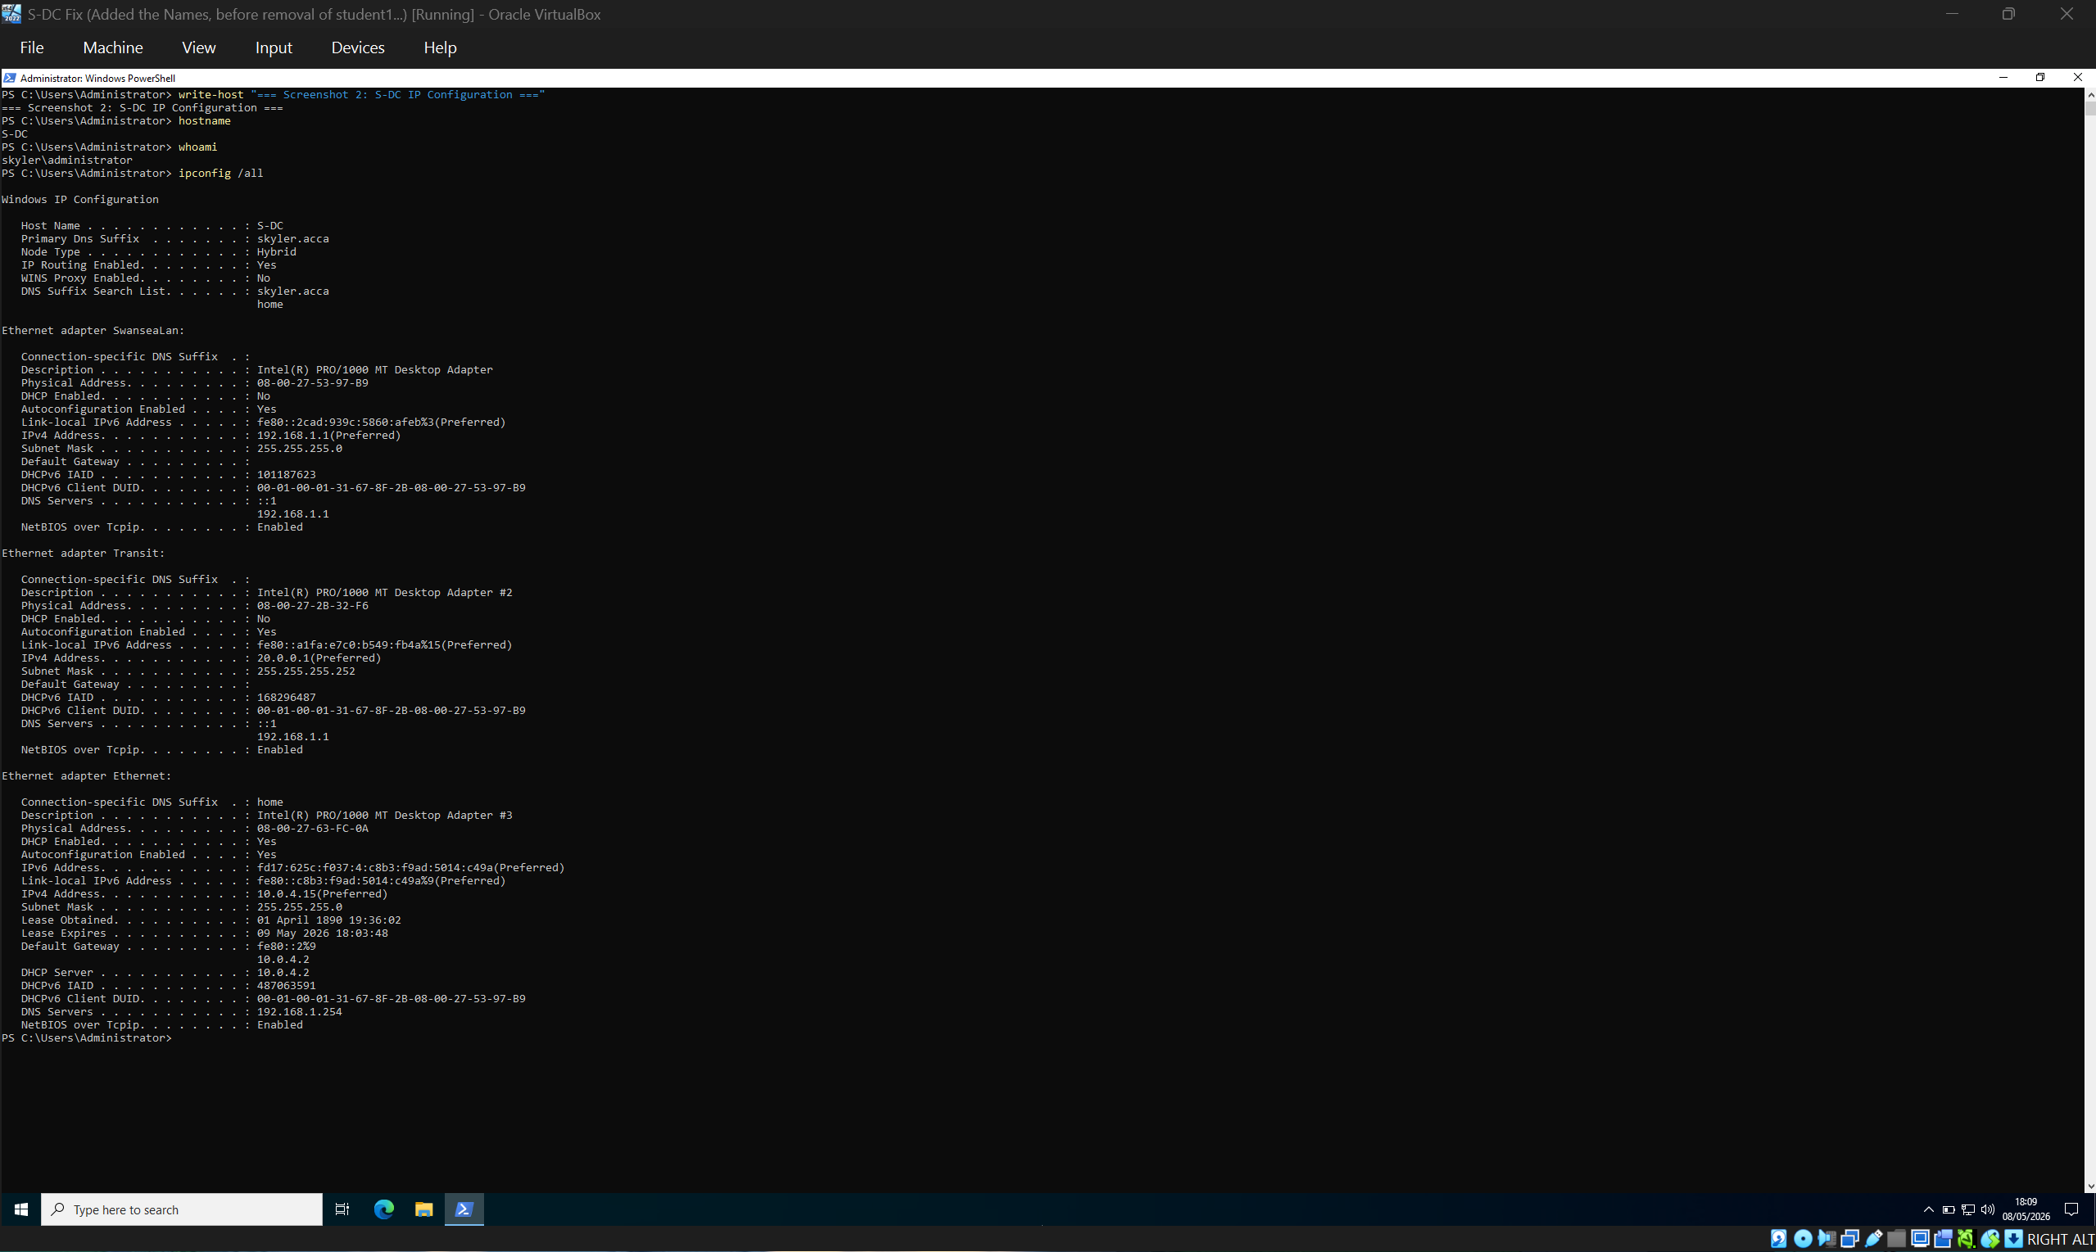
This screenshot shows the IP configuration of S-DC. The server has one interface on the Swansea LAN using 192.168.1.1 and one transit interface using 20.0.0.1. IP routing is enabled, allowing S-DC to route traffic between the Swansea network and the London network through the VPN/transit connection.
[Screenshot 3: L-DC ip addr / ip route showing 192.168.2.1, 20.0.0.2, and route to Swansea]
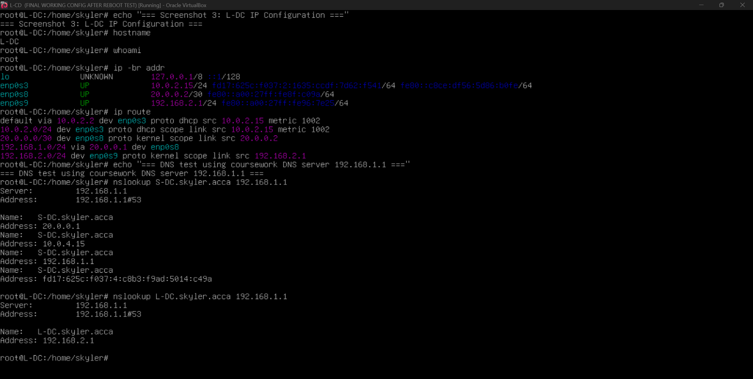
This screenshot shows the network configuration of L-DC. The server has an interface on the London LAN using 192.168.2.1 and a transit interface using 20.0.0.2. The routing table shows that traffic for the Swansea network 192.168.1.0/24 is routed through the transit/VPN connection.
[Screenshot 4: ClientS1 and ClientL1 IP configuration showing correct IP, gateway, and DNS]
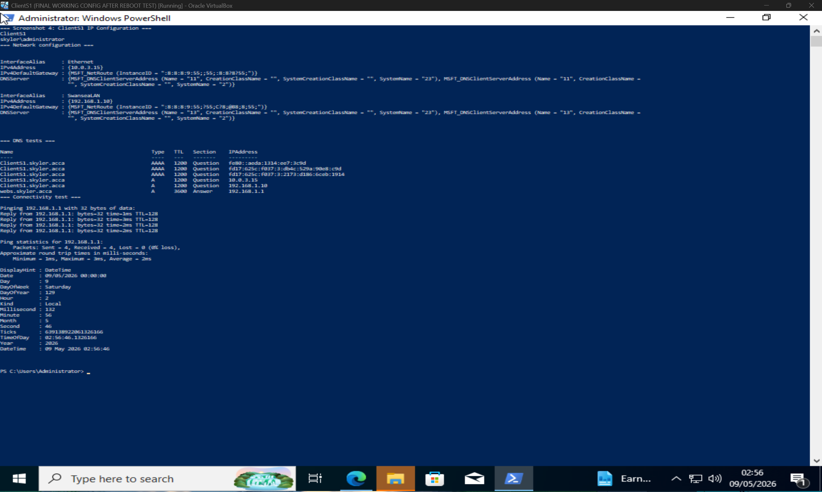
ClientS1 IP configuration showing Swansea LAN addressing, DNS resolution, and connectivity to S-DC.3. Active Directory Domain Services
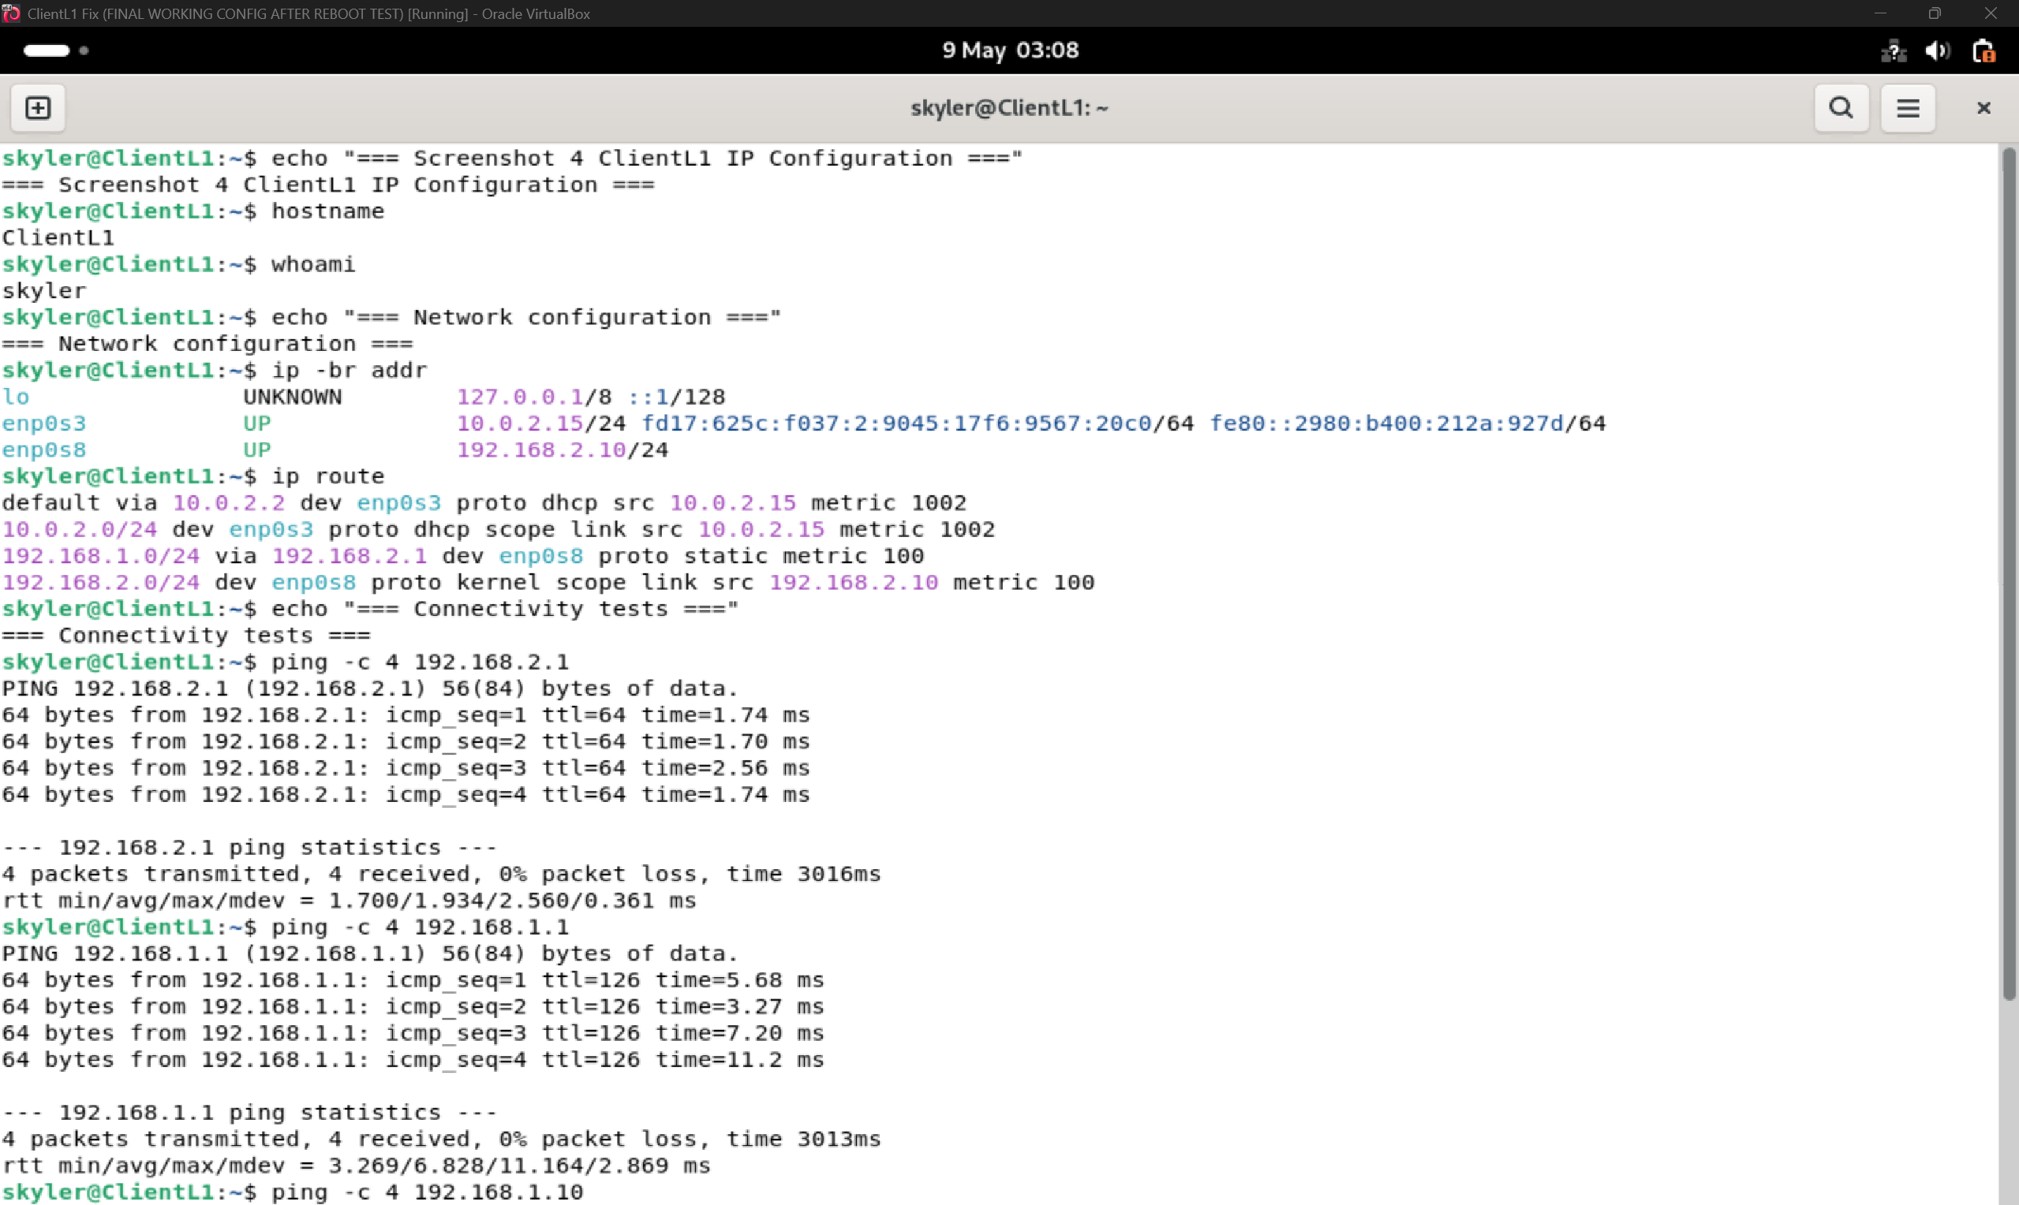
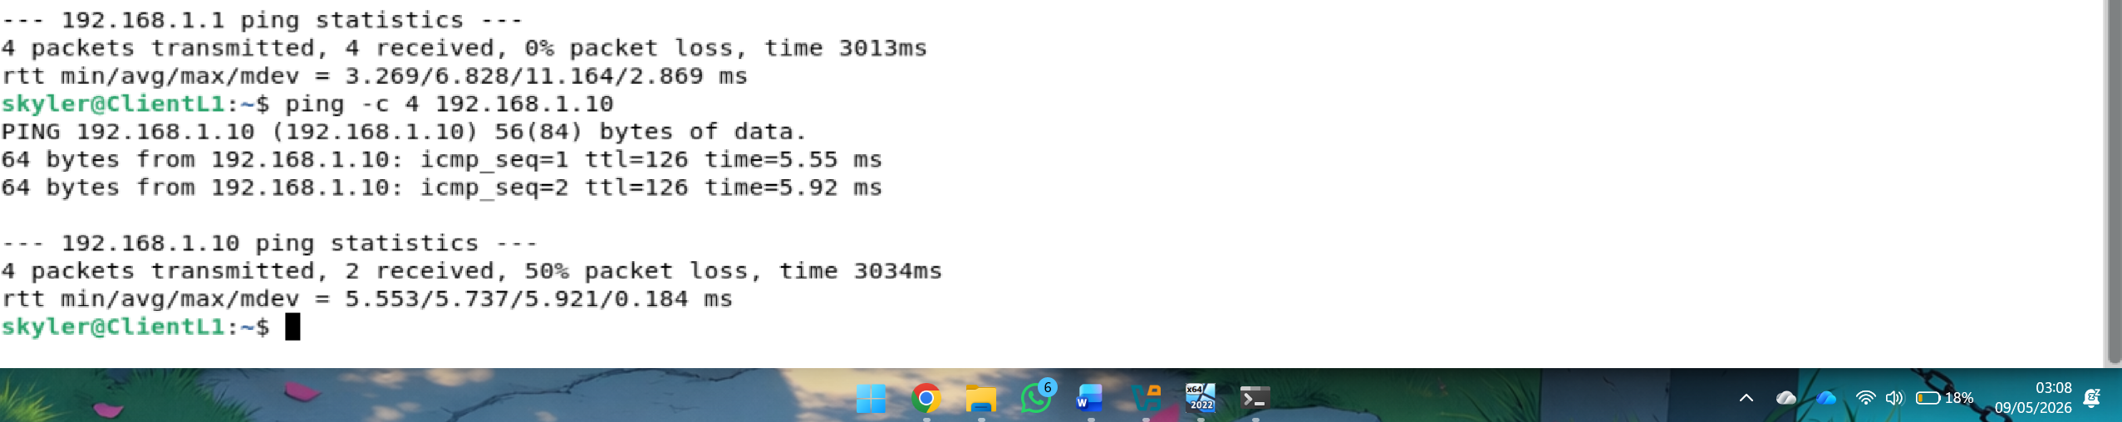
ClientL1 IP configuration showing London LAN addressing, route to Swansea, DNS resolution, and cross-site connectivity.

3. Active Directory Domain Services
Active Directory Domain Services was installed on S-DC and configured with the domain skyler.acca. AD DS provides centralised storage and management of network objects such as users, computers, passwords, and security information, allowing users and administrators to access network resources through a single domain identity system [1].
The domain controller was verified using PowerShell commands such as Get-ADDomain and Get-ADComputer -Filter *. The final domain computer objects shown were S-DC, ClientS1, L-DC, and ClientL1, confirming that the required machines were joined to the domain.
User accounts were created from the provided user list. The required naming format was applied using the first initial, followed by a dot, followed by the surname, such as b.white, l.terry, and s.jackson. These accounts were also added to the SwanseaUsers group so that access permissions could be managed through group membership rather than individual users.
[Screenshot 5: Get-ADDomain showing skyler.acca]
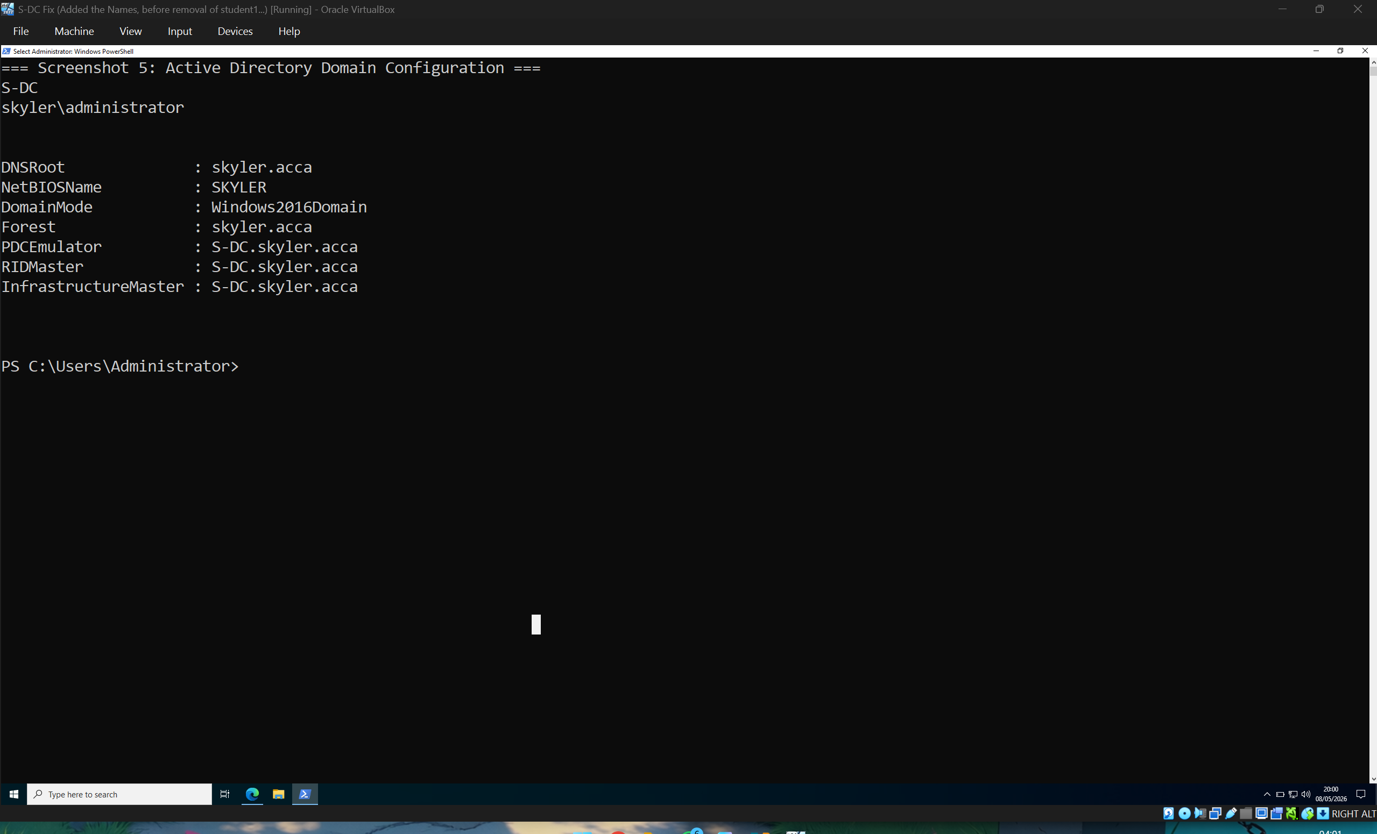
This screenshot verifies the Active Directory domain configuration. The domain DNS root is skyler.acca, the NetBIOS name is SKYLER, and S-DC is shown as the domain controller holding the main domain roles. This confirms that AD DS was successfully installed and configured.
[Screenshot 6: Get-ADComputer -Filter * showing S-DC, ClientS1, L-DC, ClientL1]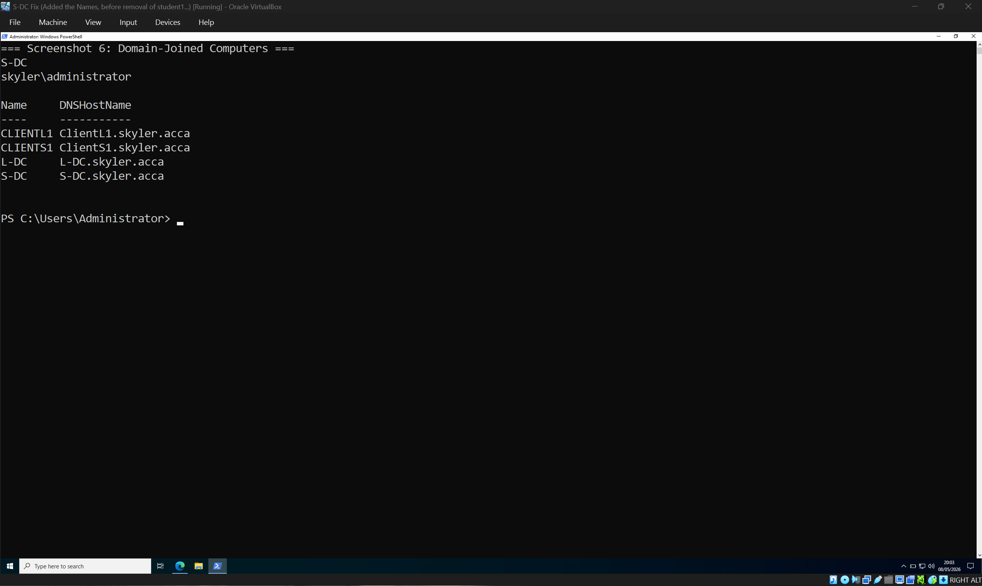
This screenshot shows the domain-joined computer objects in Active Directory. The presence of S-DC, ClientS1, L-DC, and ClientL1 confirms that the required machines have been added to the domain and can be centrally managed through AD DS.
[Screenshot 7: Get-ADUser b.white, l.terry, and s.jackson]
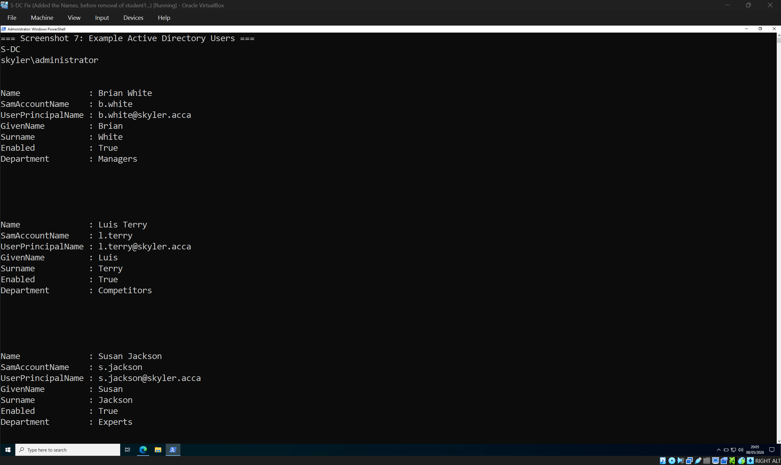
This screenshot shows example imported user accounts, including b.white, l.terry, and s.jackson. The accounts follow the required naming format and include valid user principal names in the skyler.acca domain. This confirms that the CSV user import was successful.
[Screenshot 8: Total ACCA users count and SwanseaUsers group count]
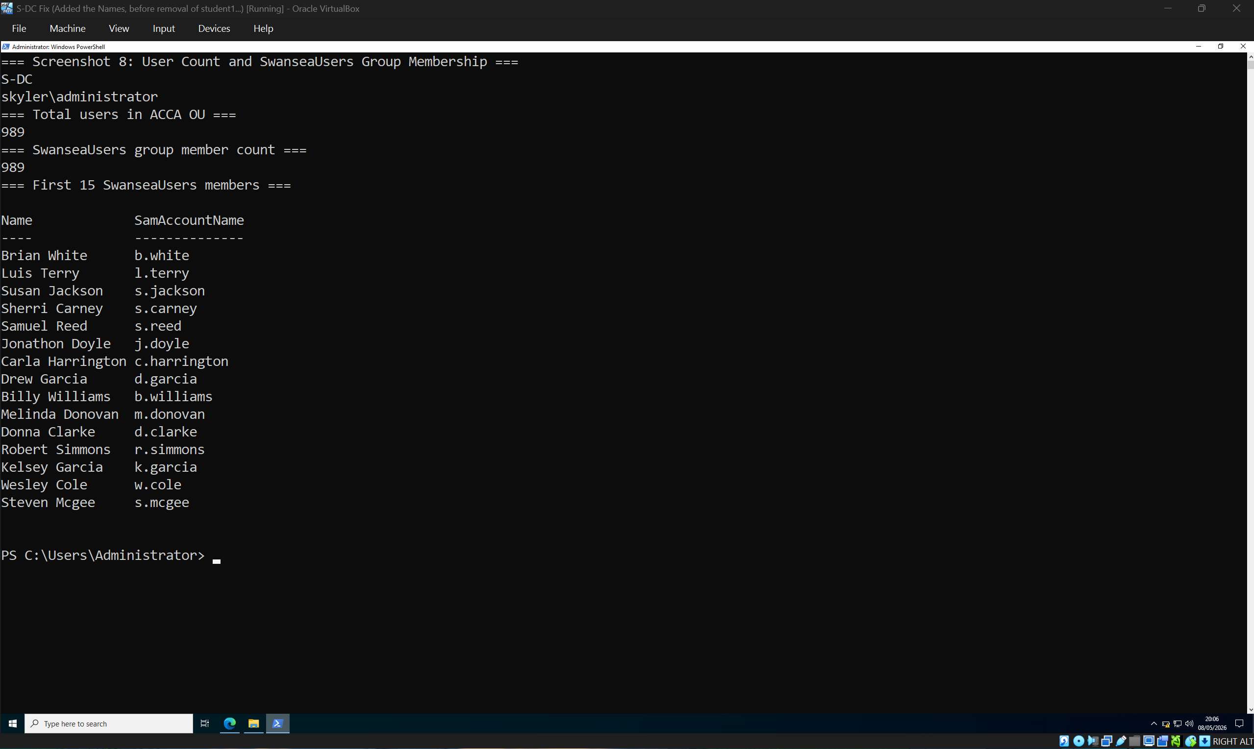
This screenshot shows the total number of users in the ACCA organisational unit and the number of members in the SwanseaUsers group. The matching counts confirm that the imported users were created successfully and added to the correct security group for permissions management.

4. DNS Configuration
DNS was configured on S-DC for the skyler.acca domain. DNS is a critical service in an Active Directory environment because AD DS uses DNS name resolution to allow clients to locate domain controllers and allow domain controllers to communicate with each other [2].
Forward lookup records were configured for the required devices and services, including S-DC, ClientS1, L-DC, ClientL1, webs.skyler.acca, and rds.skyler.acca. This allows users and systems to access resources by hostname rather than IP address. DNS testing was completed using Resolve-DnsName, confirming that the correct records resolved to the correct IP addresses.

[Screenshot 9: DNS Manager showing skyler.acca forward lookup zone]
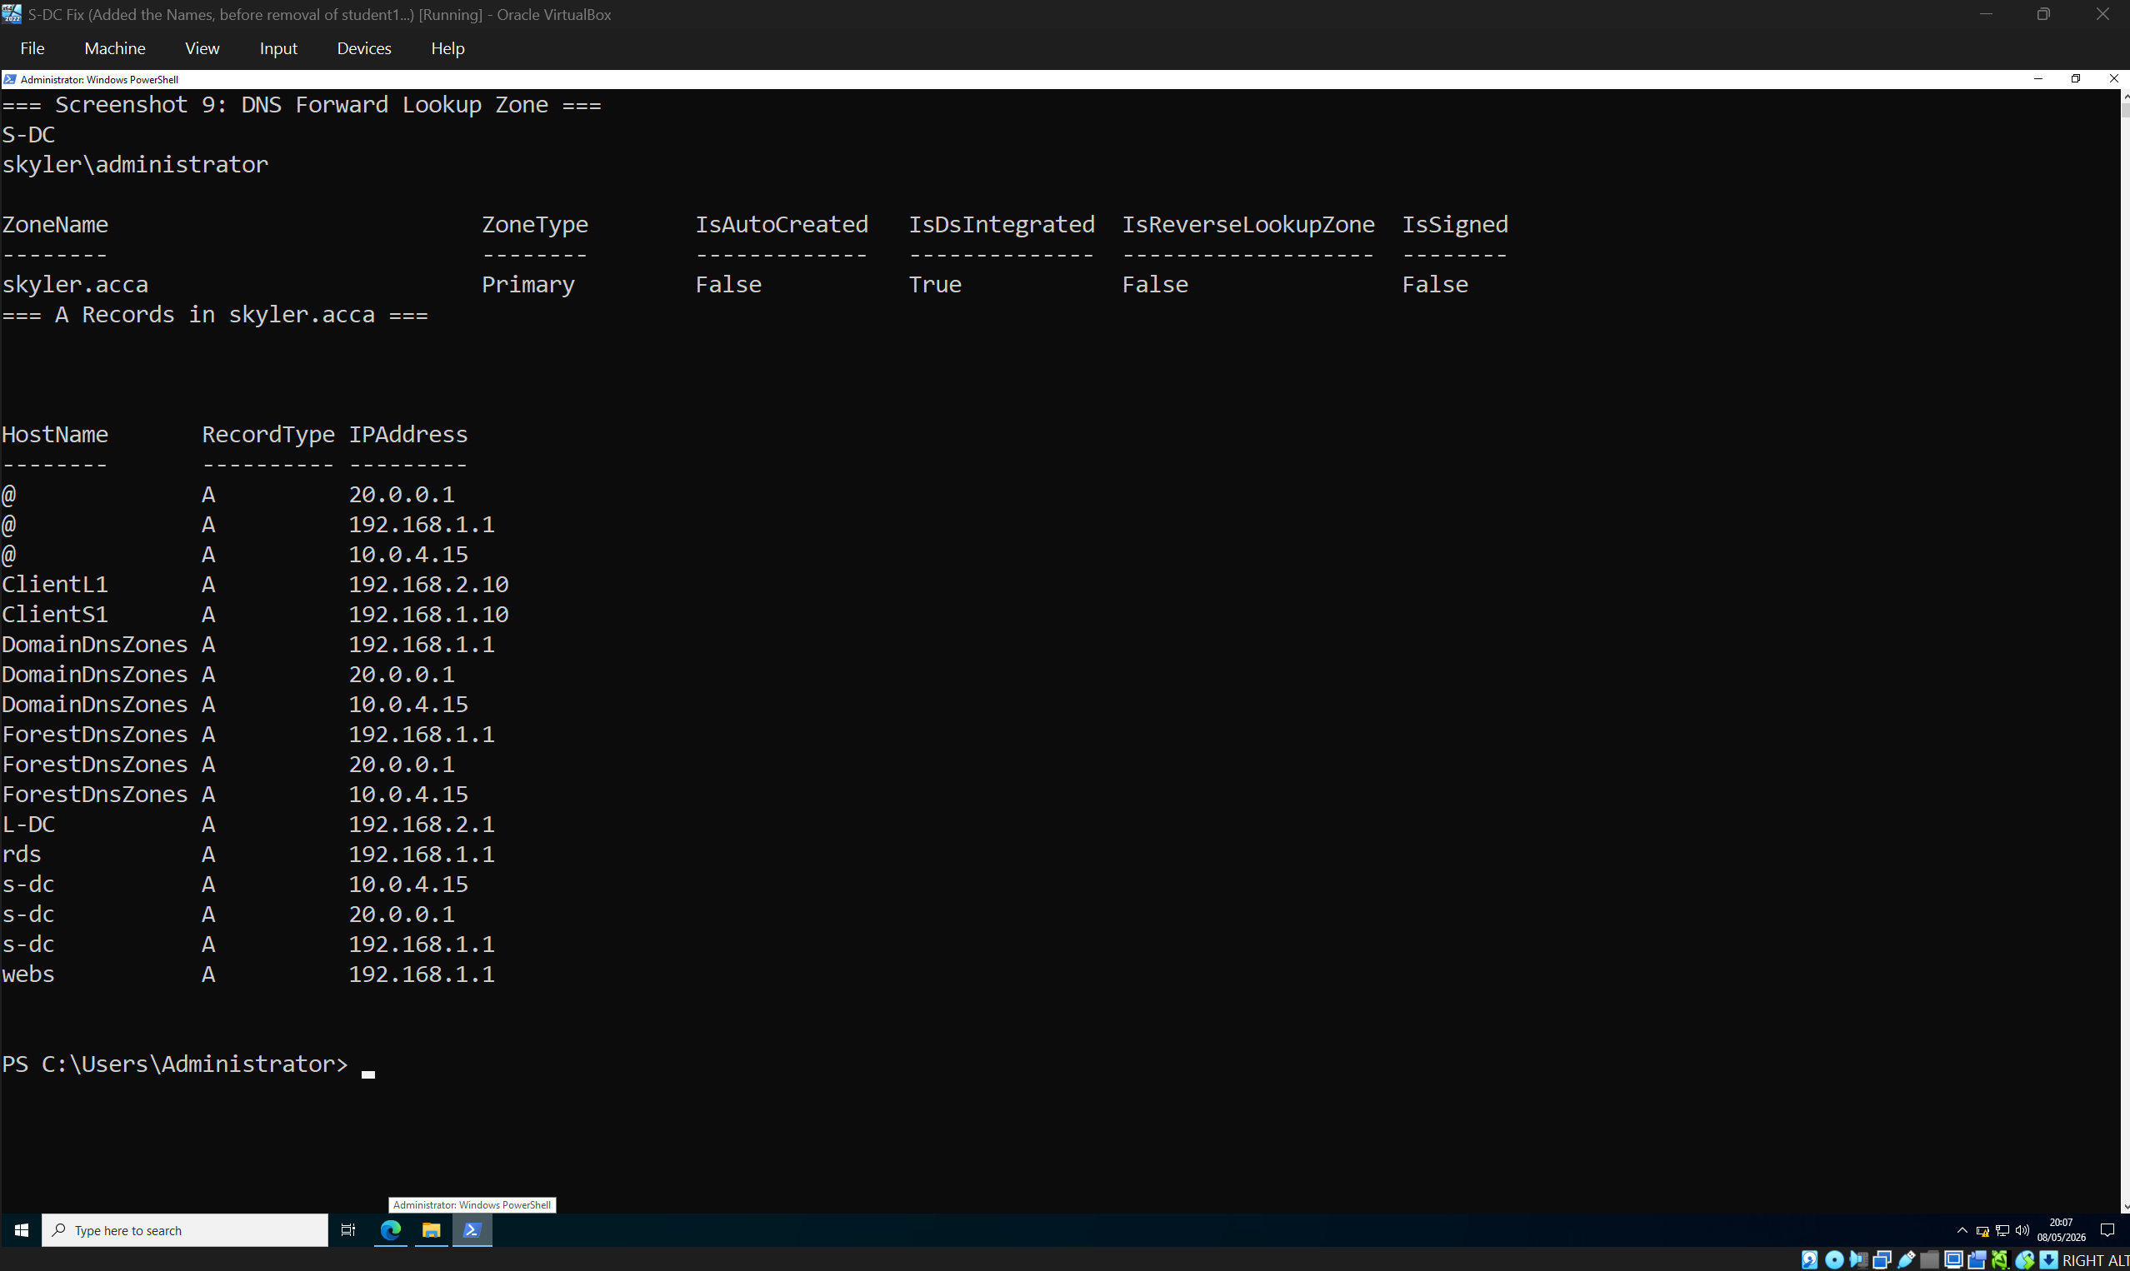
This screenshot shows the DNS forward lookup zone for skyler.acca. It includes A records for the required hosts and services, including S-DC, ClientS1, L-DC, ClientL1, webs.skyler.acca, and rds.skyler.acca. This allows systems and users to access resources by hostname instead of IP address.
[Screenshot 10: Resolve-DnsName results for S-DC, L-DC, ClientS1, ClientL1, webs, and rds]
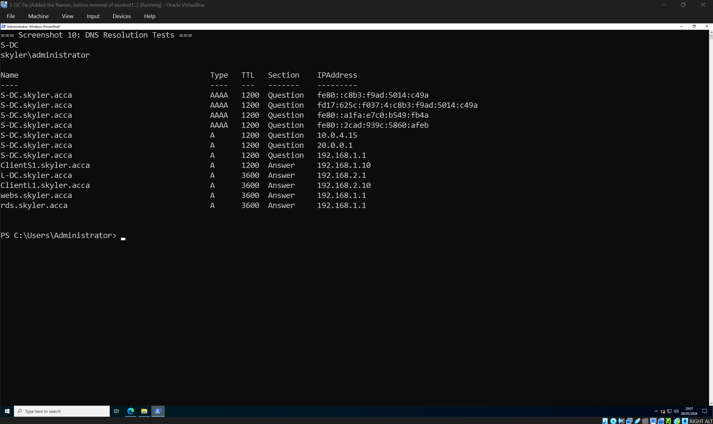
This screenshot verifies DNS resolution using PowerShell. The Resolve-DnsName results confirm that hostnames such as ClientS1, L-DC, ClientL1, webs, and rds resolve successfully. This proves that DNS is working for both infrastructure devices and user-facing services.
[Screenshot 11: Reverse lookup zone / PTR records if configured]
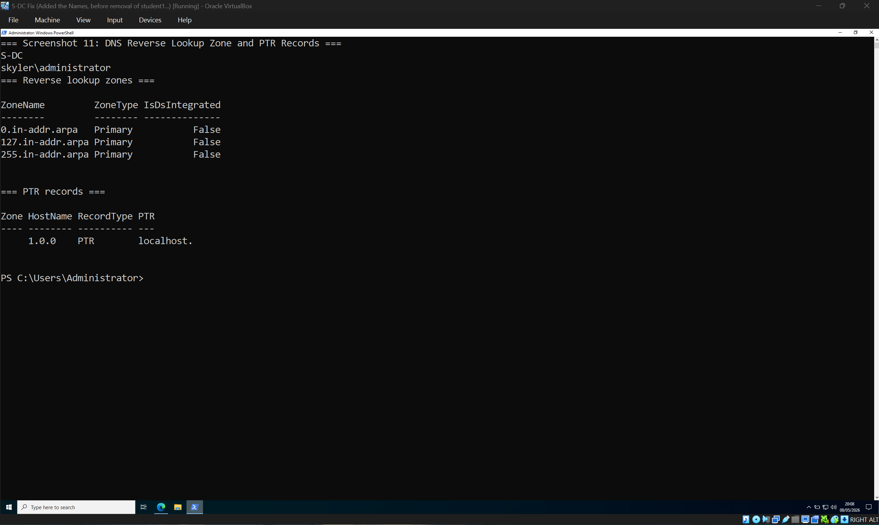
This screenshot shows the DNS reverse lookup configuration. Reverse lookup records allow IP addresses to be resolved back into hostnames, which supports troubleshooting, auditing, and service validation in the domain environment.

5. DHCP Configuration
DHCP was configured to automatically provide IP address settings to client machines. DHCP is used to pass configuration information to hosts on a TCP/IP network, including reusable IP addresses and additional network options [3], [4].
Two DHCP scopes were configured. The Swansea scope uses 192.168.1.10 to 192.168.1.20, and the London scope uses 192.168.2.10 to 192.168.2.20. Scope options were configured for the default gateway, DNS server, and DNS domain name. Microsoft’s Windows Server DHCP guidance also identifies scope configuration, DHCP server authorisation, and IPv4 client options as core parts of DHCP server deployment [3].

[Screenshot 12: Get-DhcpServerv4Scope showing SwanseaScope and LondonScope]
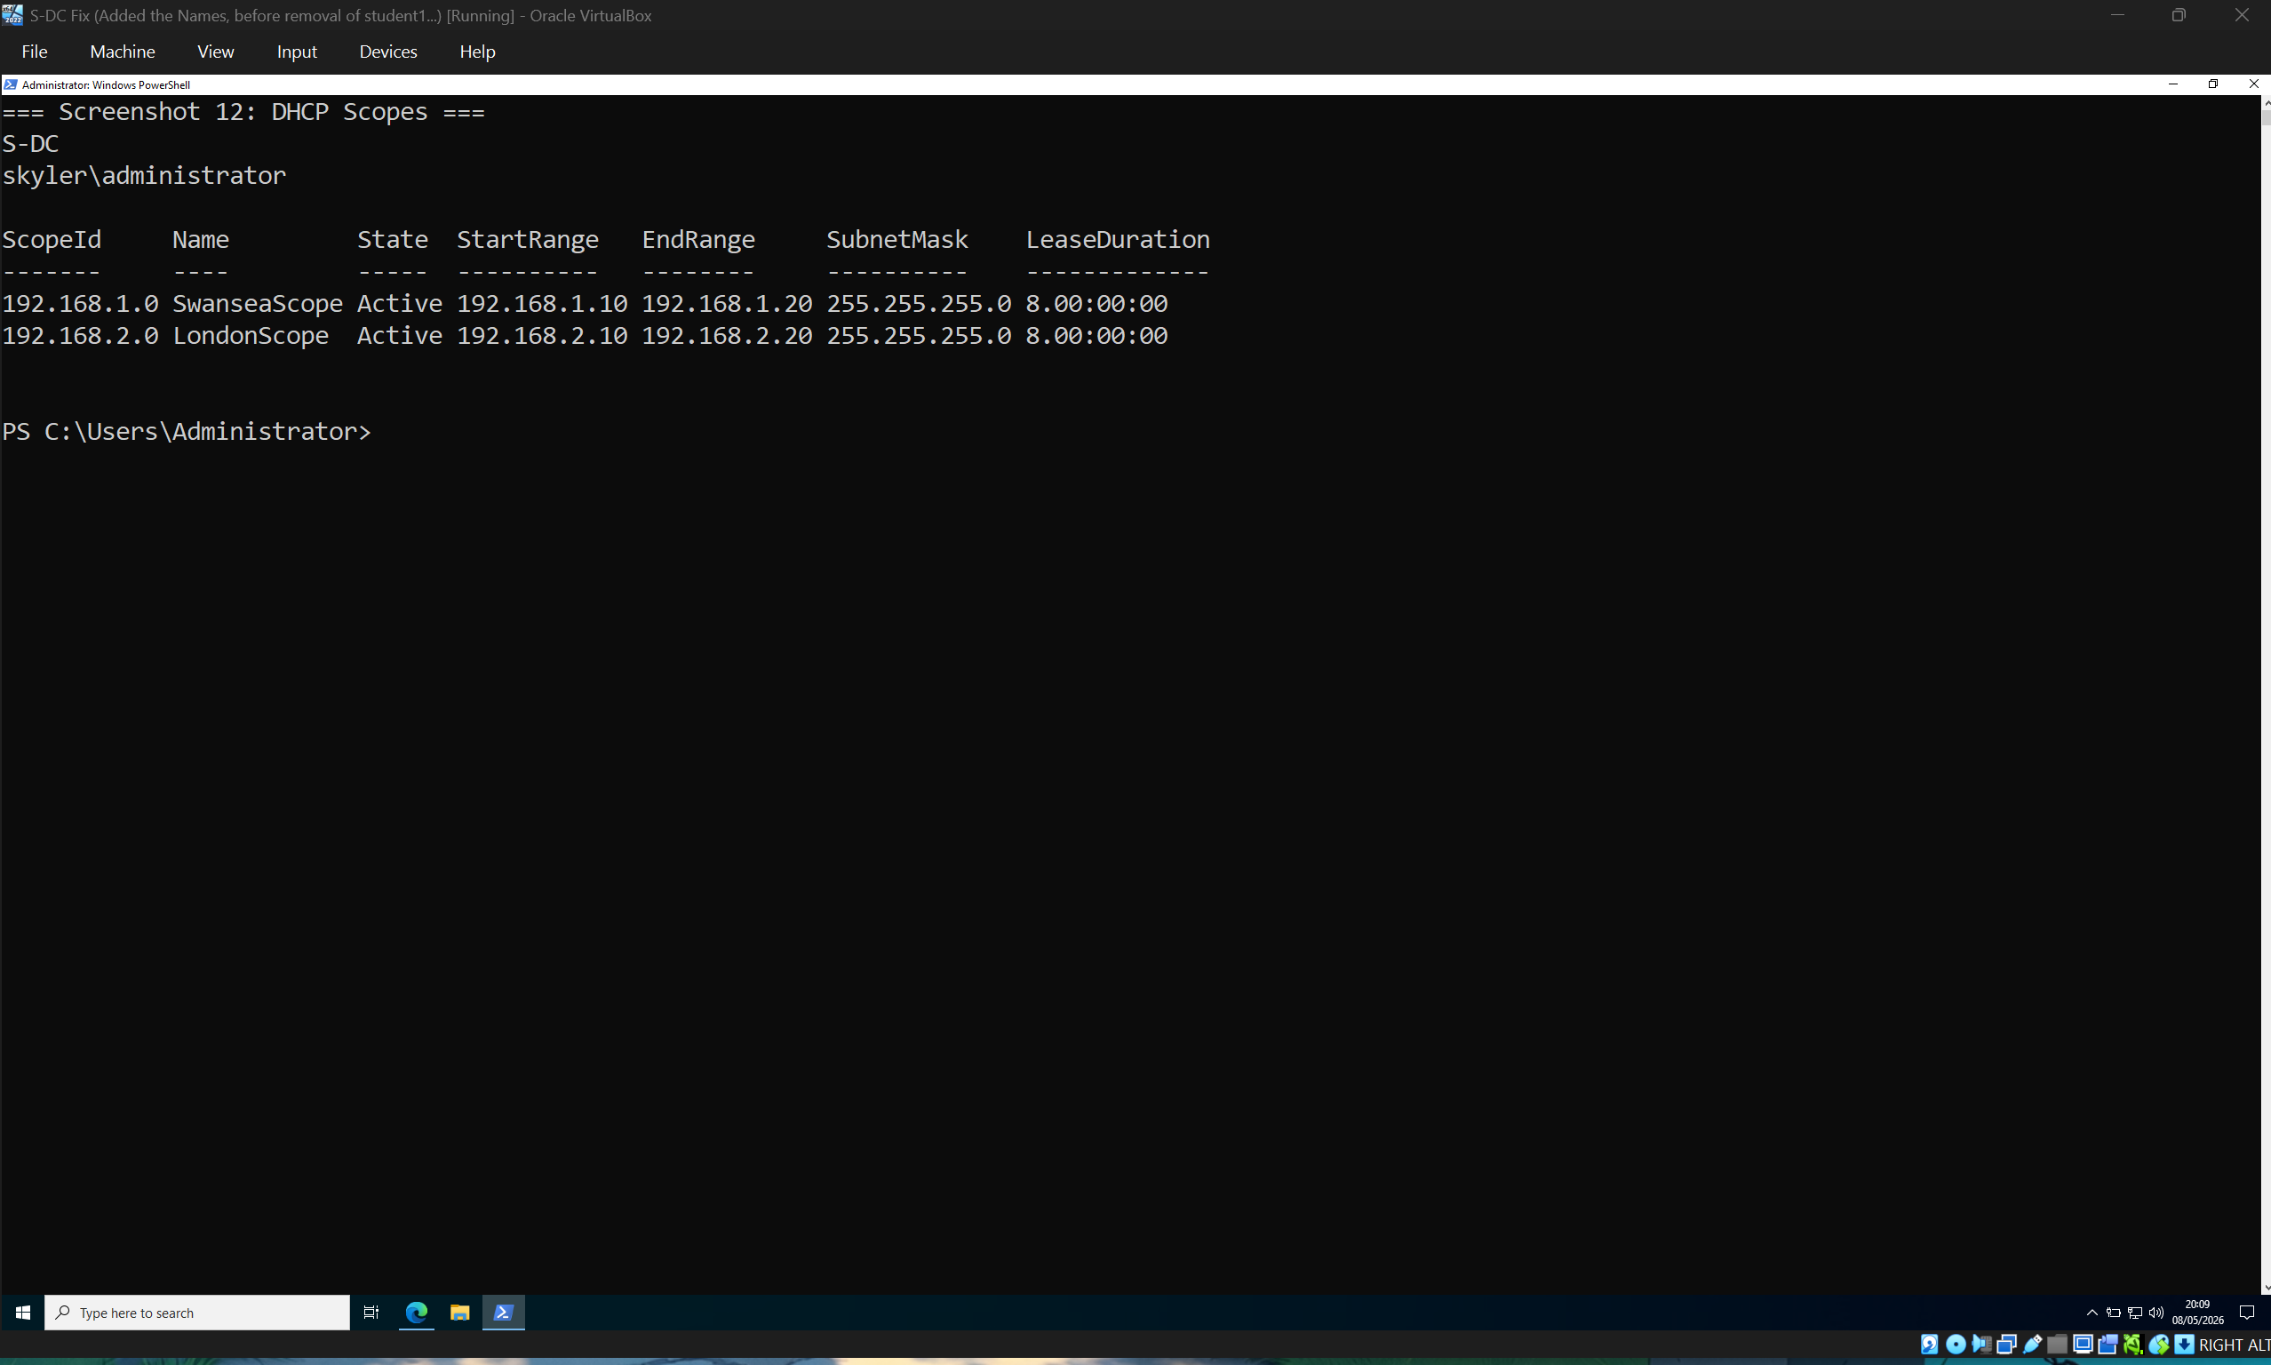
This screenshot shows the configured DHCP scopes. The Swansea scope provides addresses from 192.168.1.10 to 192.168.1.20, and the London scope provides addresses from 192.168.2.10 to 192.168.2.20. Both scopes are active, confirming that DHCP is ready to provide client addressing.
[Screenshot 13: DHCP options showing router, DNS server, and DNS domain name]
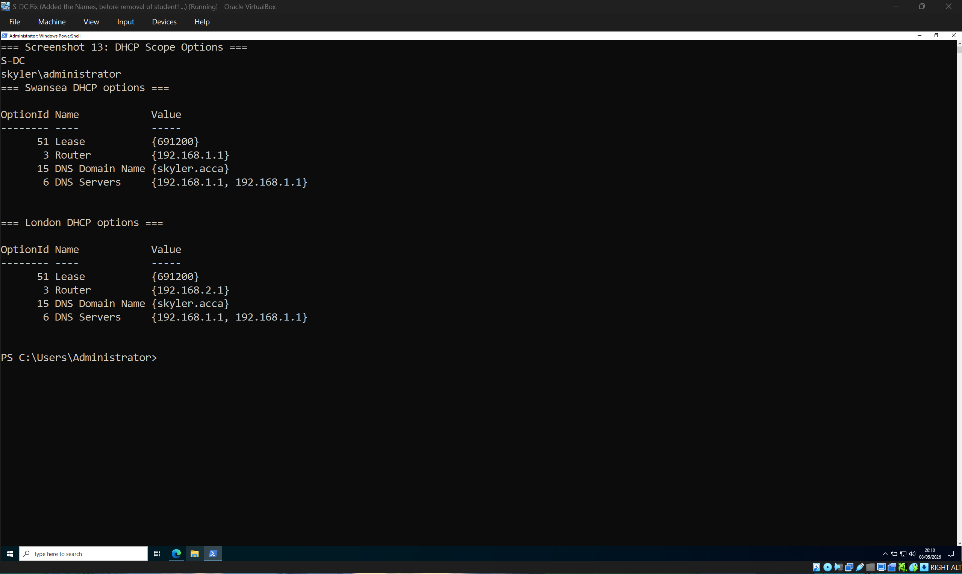
This screenshot shows the DHCP options configured for the Swansea and London scopes. The options include the correct router/default gateway, DNS server, and DNS domain name. These settings ensure that clients receive the correct network configuration automatically.
[Screenshot 14: Client showing correct network configuration from DHCP or configured address]
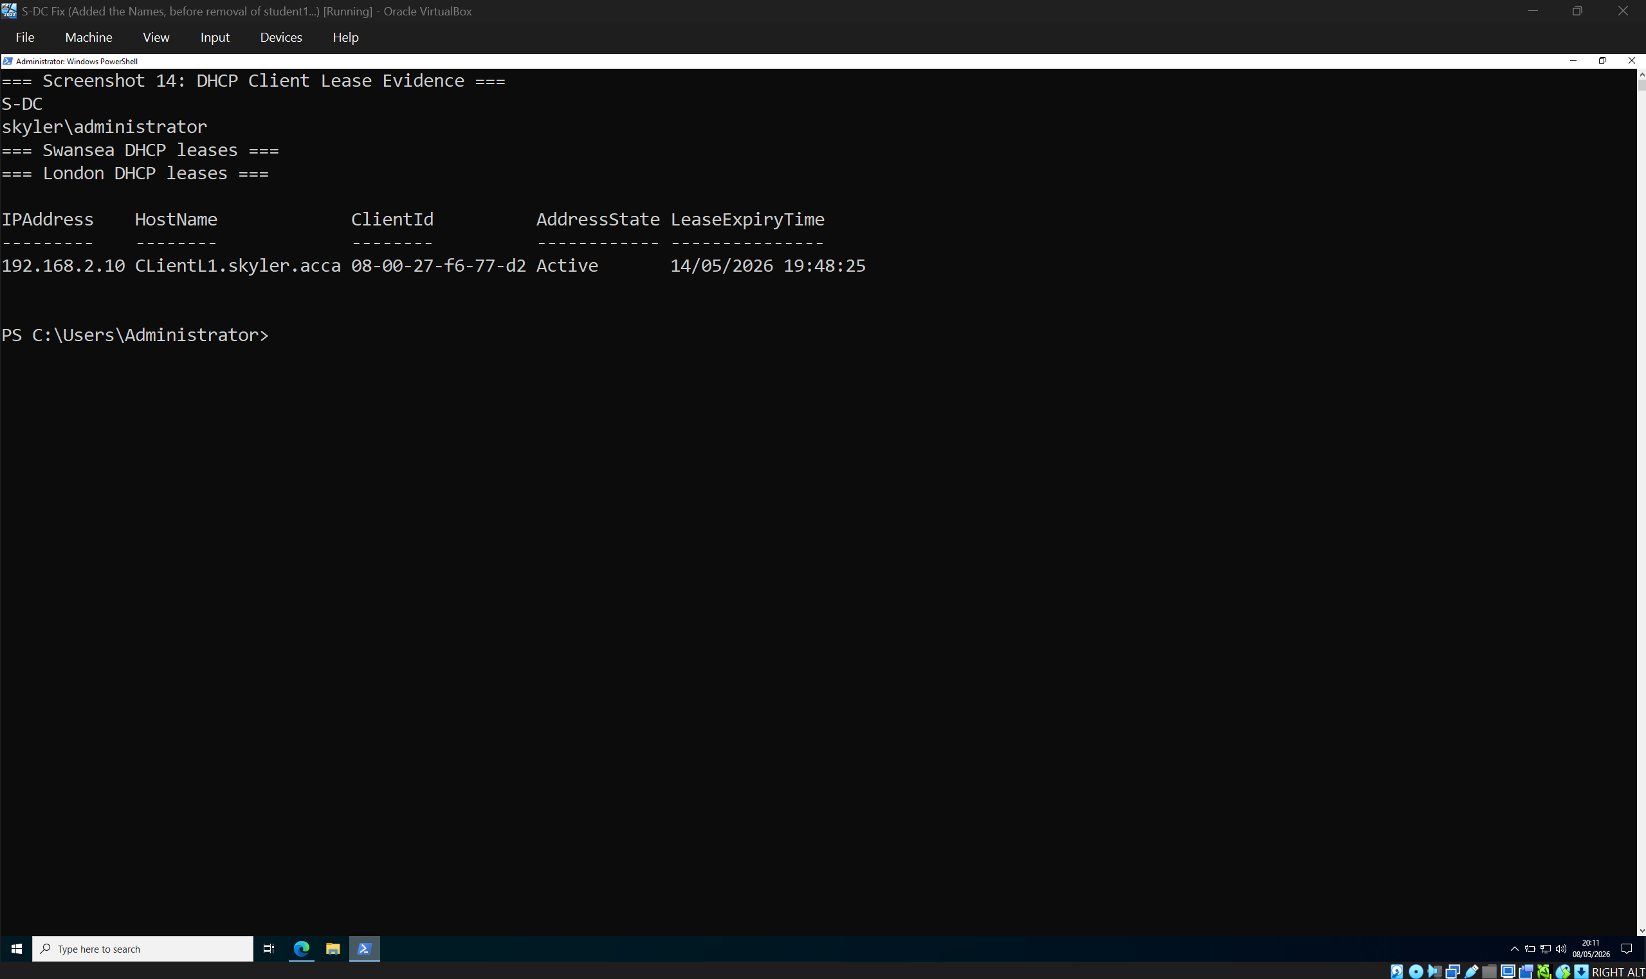
This screenshot provides evidence that client devices are using the correct addressing for their network. It supports the DHCP configuration by showing that the client addressing matches the planned Swansea and London IP ranges.

6. Routing and Site-to-Site VPN
Routing was configured so the Swansea and London networks could communicate. On S-DC, a persistent route sends traffic for 192.168.2.0/24 through 20.0.0.2. On L-DC, traffic for 192.168.1.0/24 routes back through the transit link. Successful ping tests confirmed communication between Swansea and London.
A site-to-site VPN was configured using IPsec. IPsec is designed to provide security services for traffic at the IP layer, making it suitable for protecting traffic between two routed networks [5]. strongSwan was used on the Linux side because it is a comprehensive open-source implementation of IKE protocols for securing IP traffic in policy-based and route-based IPsec VPN scenarios [6], [7].
The VPN used strong security settings including AES-256, SHA-256, and DH14. The IPsec tunnel was verified using Get-NetIPsecMainModeSA, Get-NetIPsecQuickModeSA, and swanctl --list-sas. These commands confirmed that the tunnel was established between 20.0.0.1 and 20.0.0.2, with traffic selectors for 192.168.1.0/24 and 192.168.2.0/24.
[Screenshot 15: route print on S-DC showing persistent route to 192.168.2.0/24]
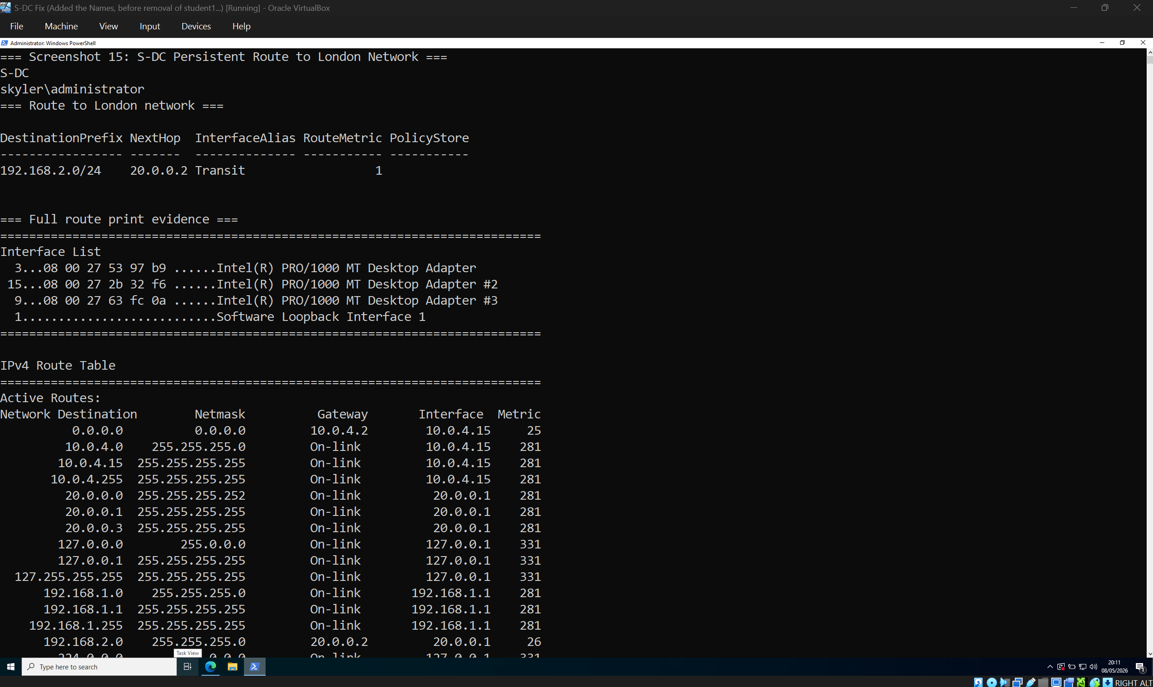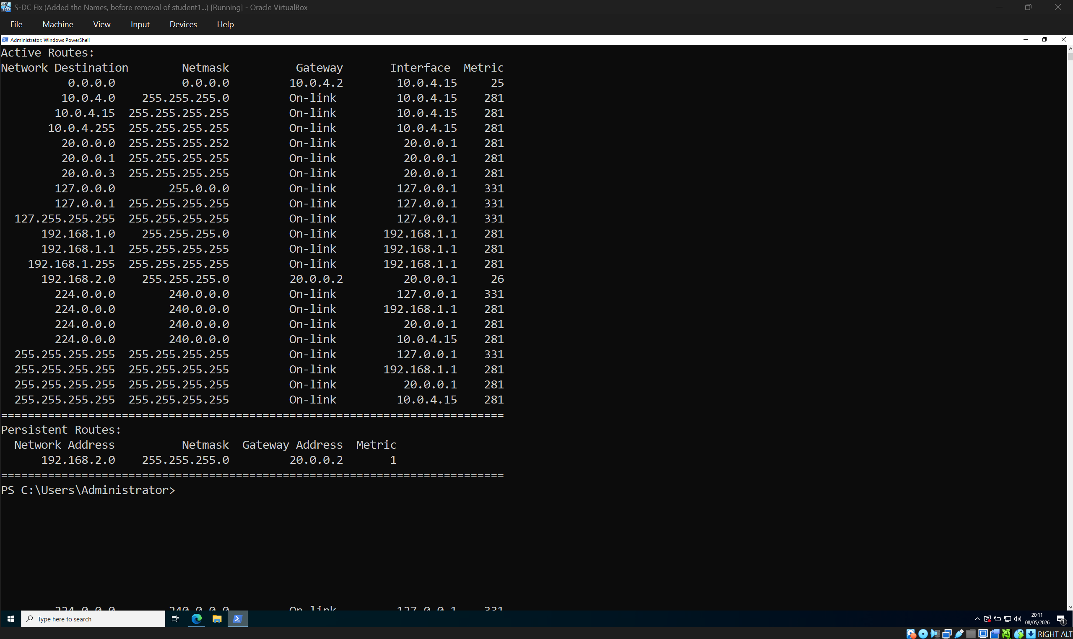
This screenshot shows the persistent route on S-DC for the London network. Traffic destined for 192.168.2.0/24 is sent to 20.0.0.2, which is the transit interface on L-DC. This route is required for Swansea devices to reach the London network.

[Screenshot 16: L-DC ip route showing route to 192.168.1.0/24]
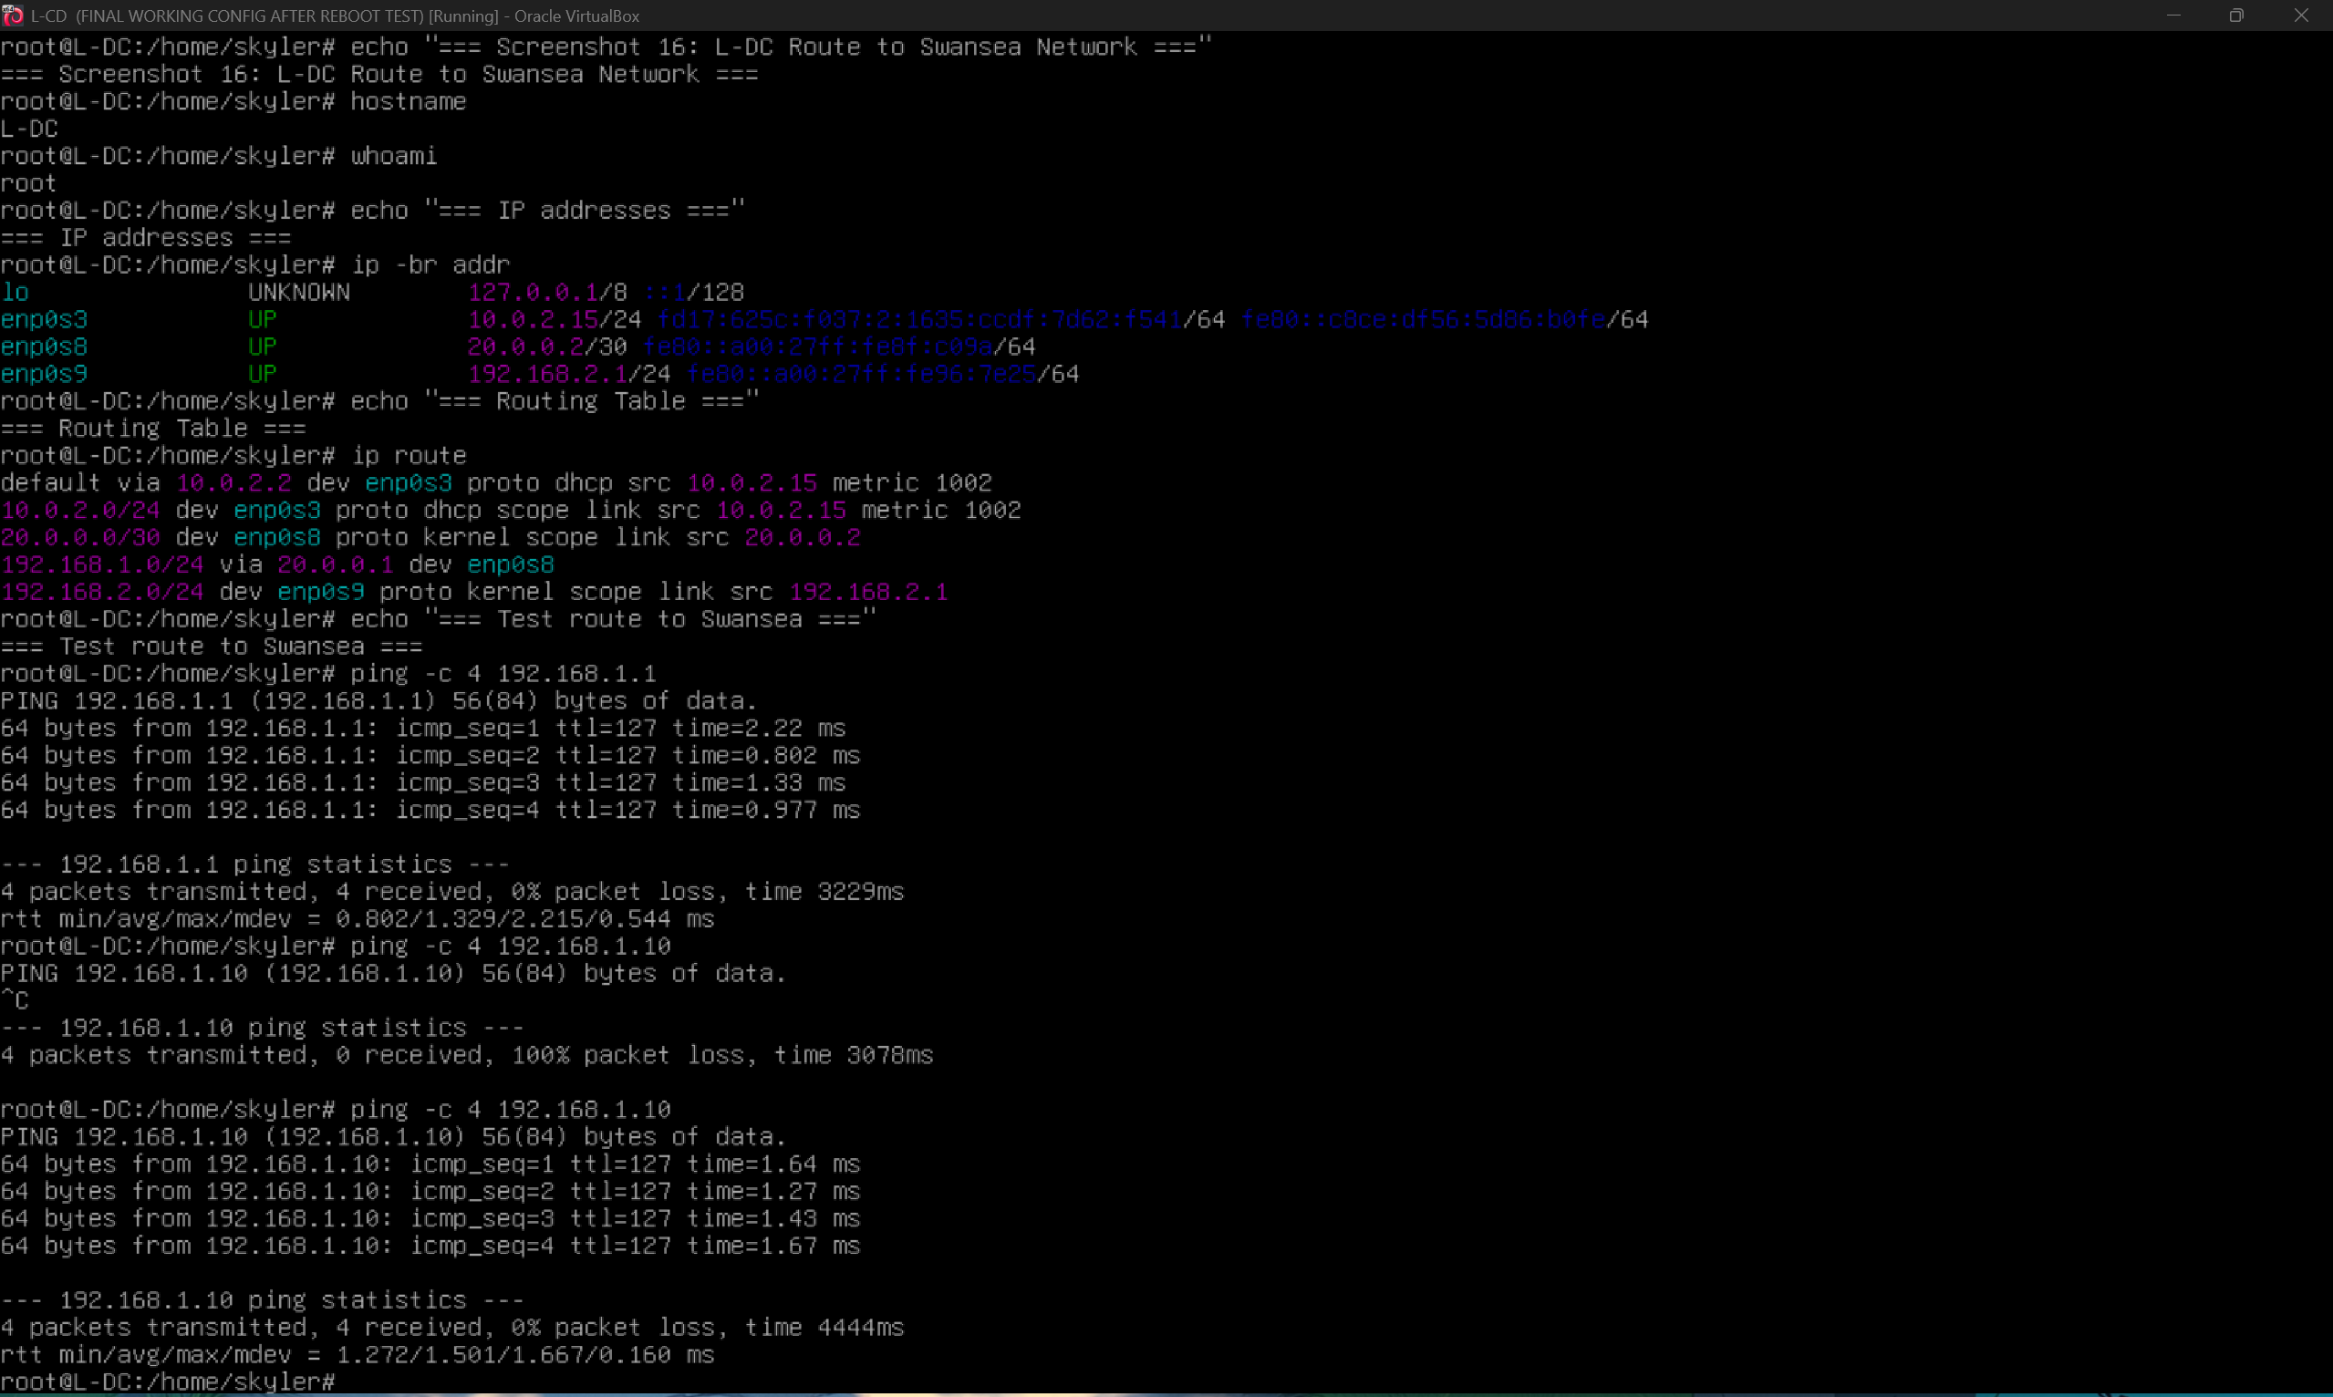
This screenshot shows the routing table on L-DC. Traffic for the Swansea network 192.168.1.0/24 is routed through 20.0.0.1. This confirms that return routing from London to Swansea is configured correctly.
[Screenshot 17: Get-NetIPsecMainModeSA showing AES256, SHA256, DH14]
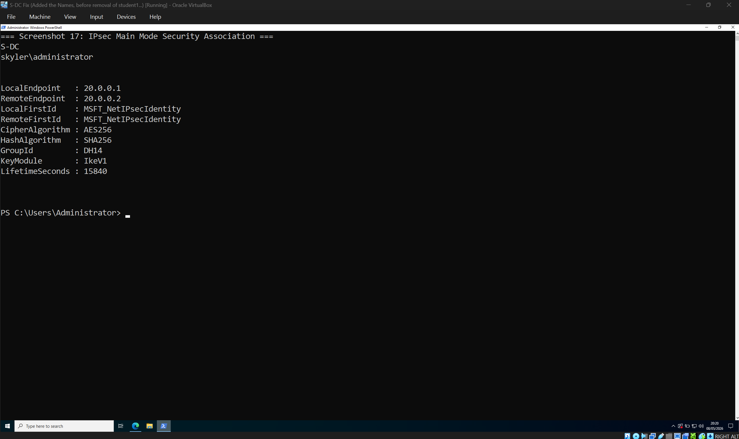
This screenshot shows the Windows IPsec Main Mode security association. The VPN tunnel is established between 20.0.0.1 and 20.0.0.2 using AES-256, SHA-256, and DH14. This confirms that strong encryption settings were used for the site-to-site VPN.
[Screenshot 18: swanctl --list-sas showing established tunnel]
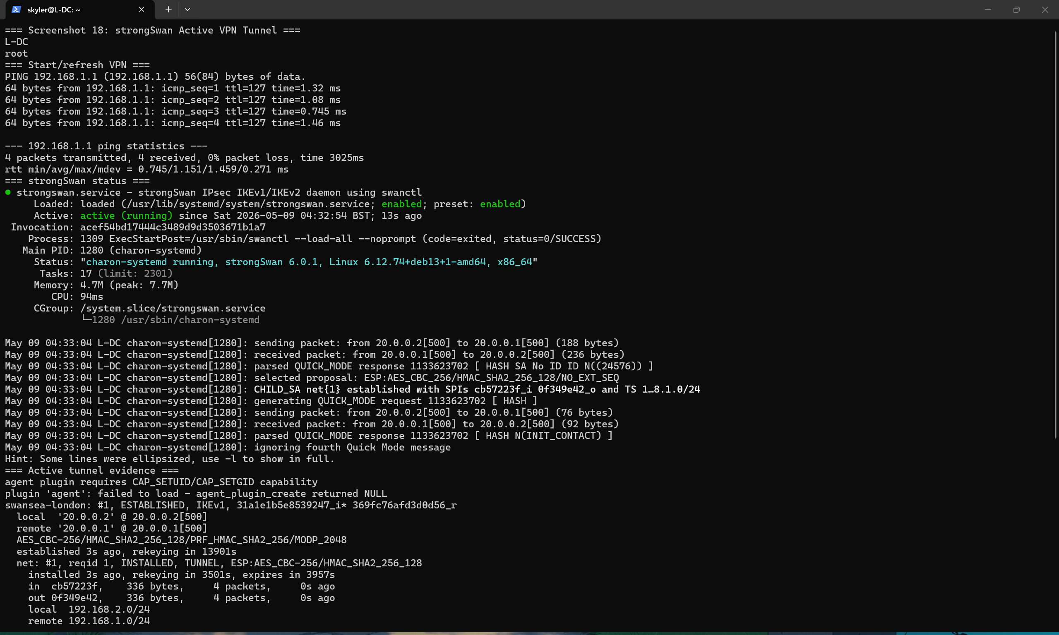
This screenshot shows the strongSwan VPN status on L-DC. The tunnel is established between the London and Swansea transit addresses, with traffic selectors for 192.168.2.0/24 and 192.168.1.0/24. This confirms that the Linux side of the VPN is active and passing traffic.

[Screenshot 19: Ping tests between Swansea and London networks]
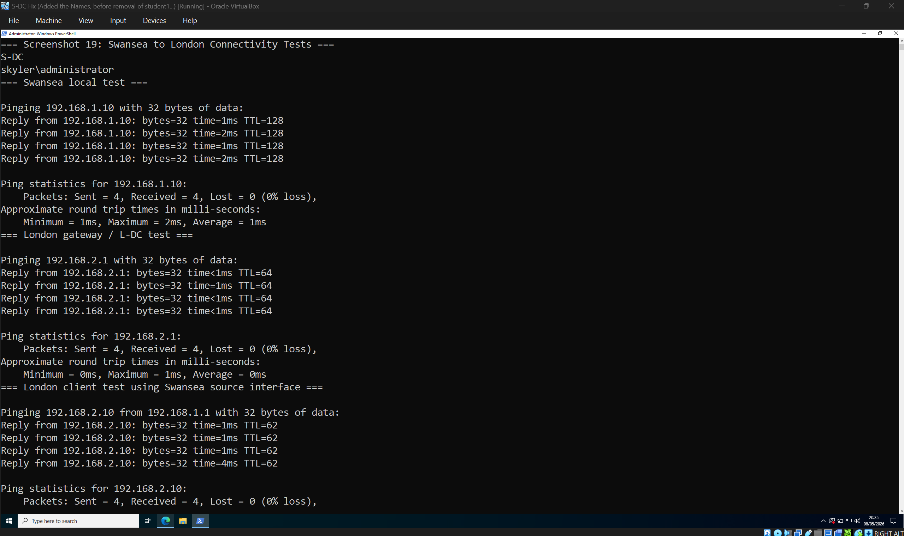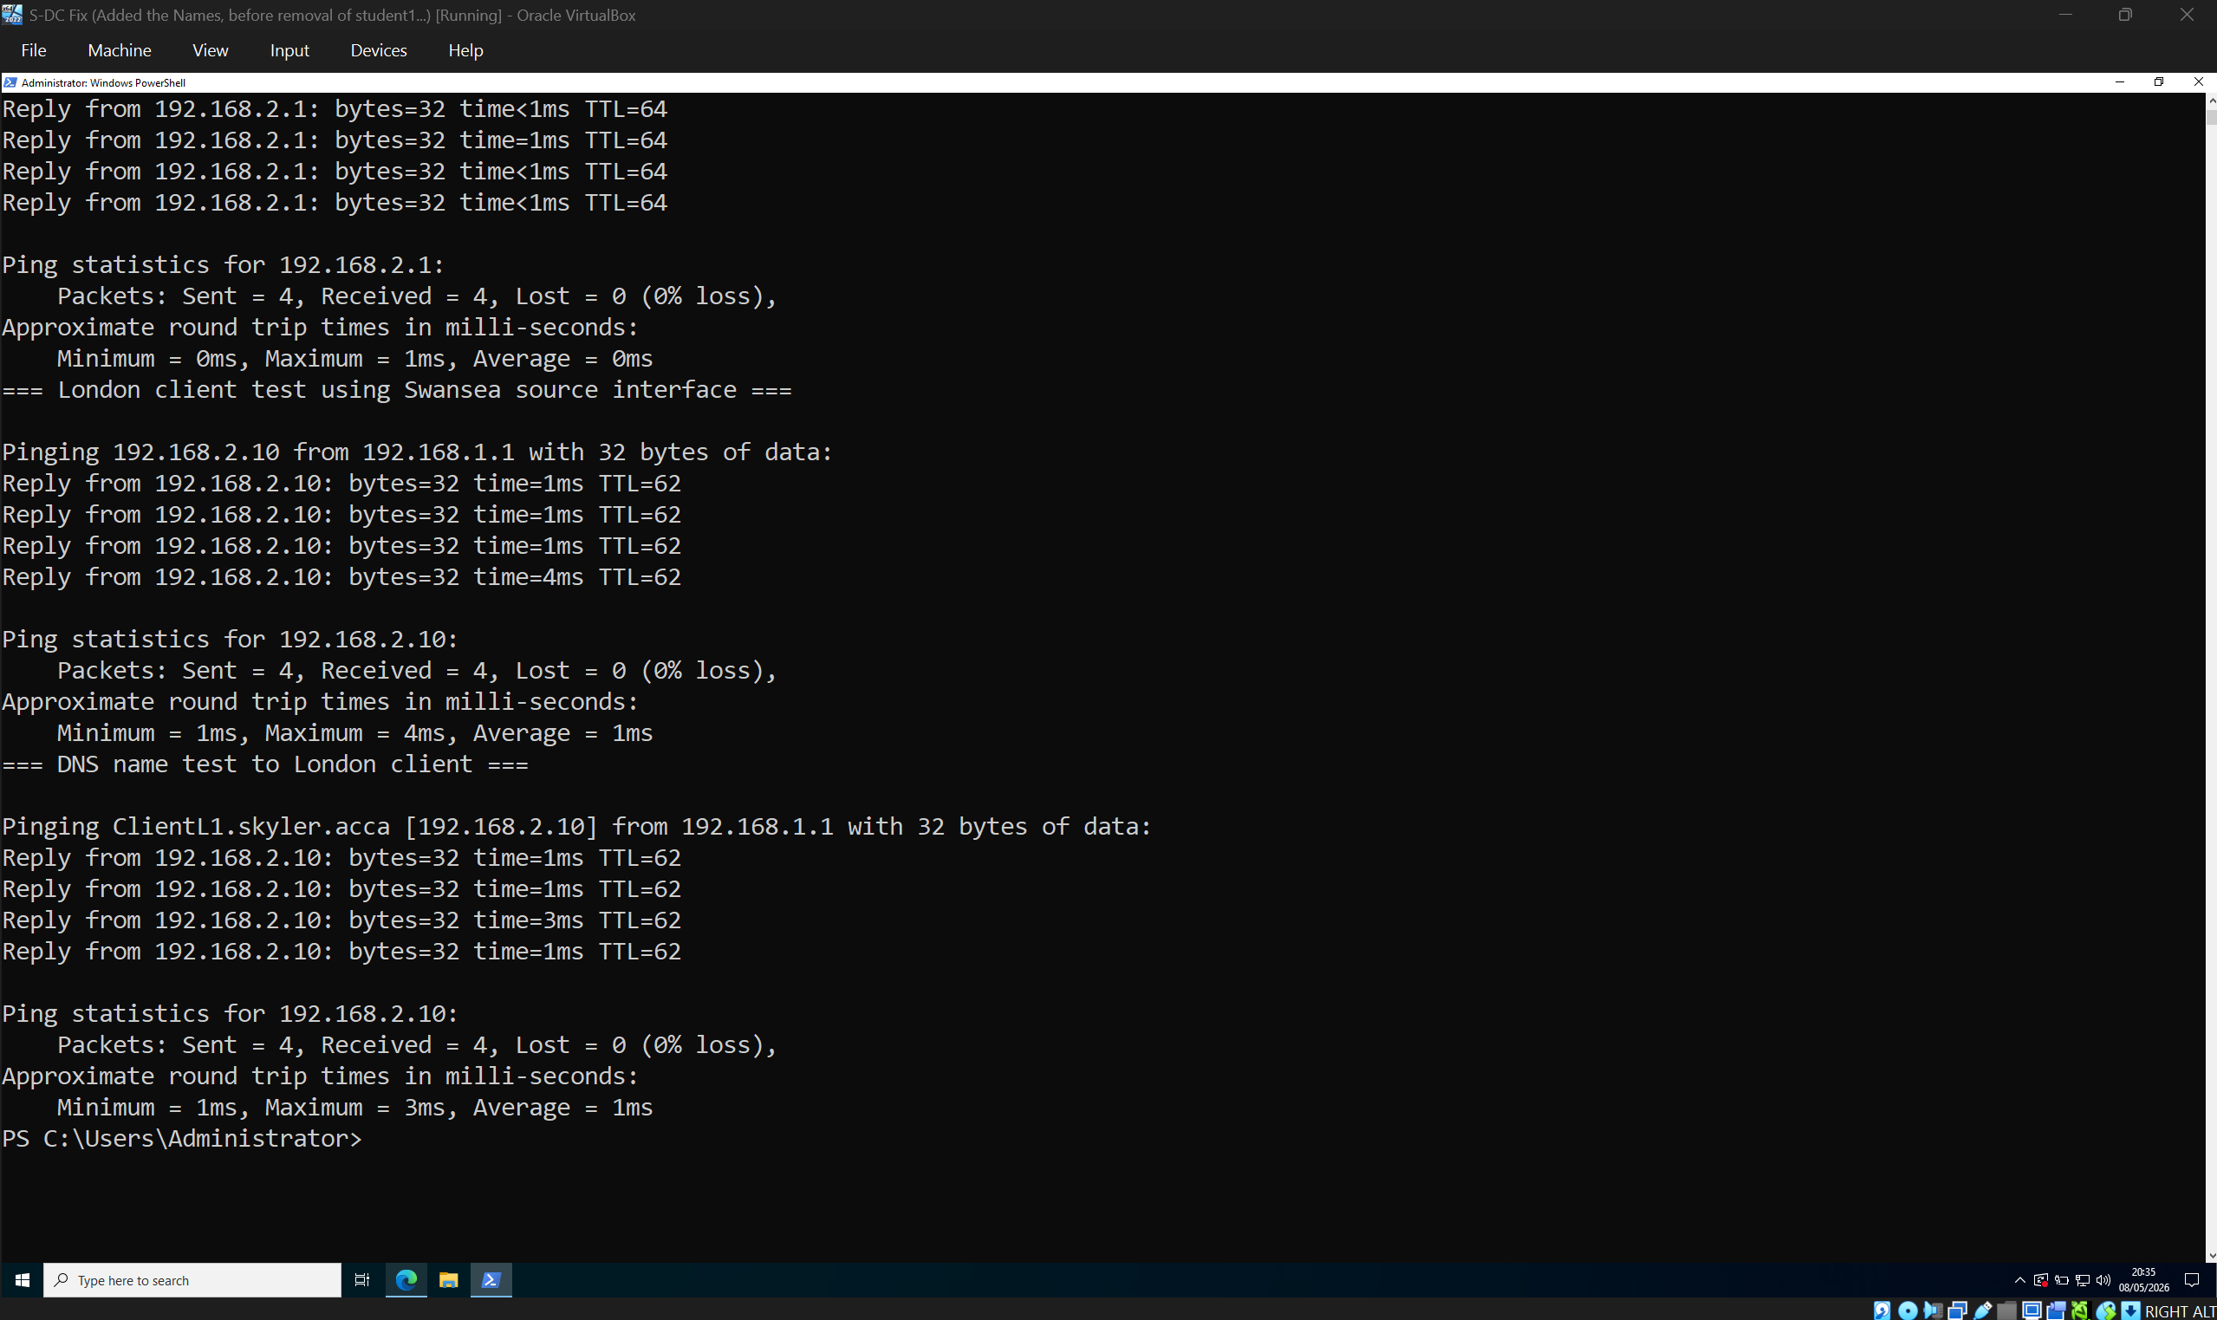
This screenshot shows successful ping tests between the Swansea and London networks. The results confirm that local Swansea connectivity, London gateway connectivity, and cross-site communication to ClientL1 are working through the configured routing and VPN tunnel.

7. File Sharing and Permissions
A second disk was mounted as E: and the shared folder E:\SwanseaFiles was created. The folder was shared as SwanseaFiles. Server Message Block is the Windows file sharing protocol used to allow remote clients to access shared folders and files [8].
Permissions were configured so that Domain Users have full control and other users have read-only access. This supports the assignment requirement by allowing authorised domain users to access shared files while limiting unnecessary access for other users.
[Screenshot 20: Disk Management or Get-Volume showing E: drive]
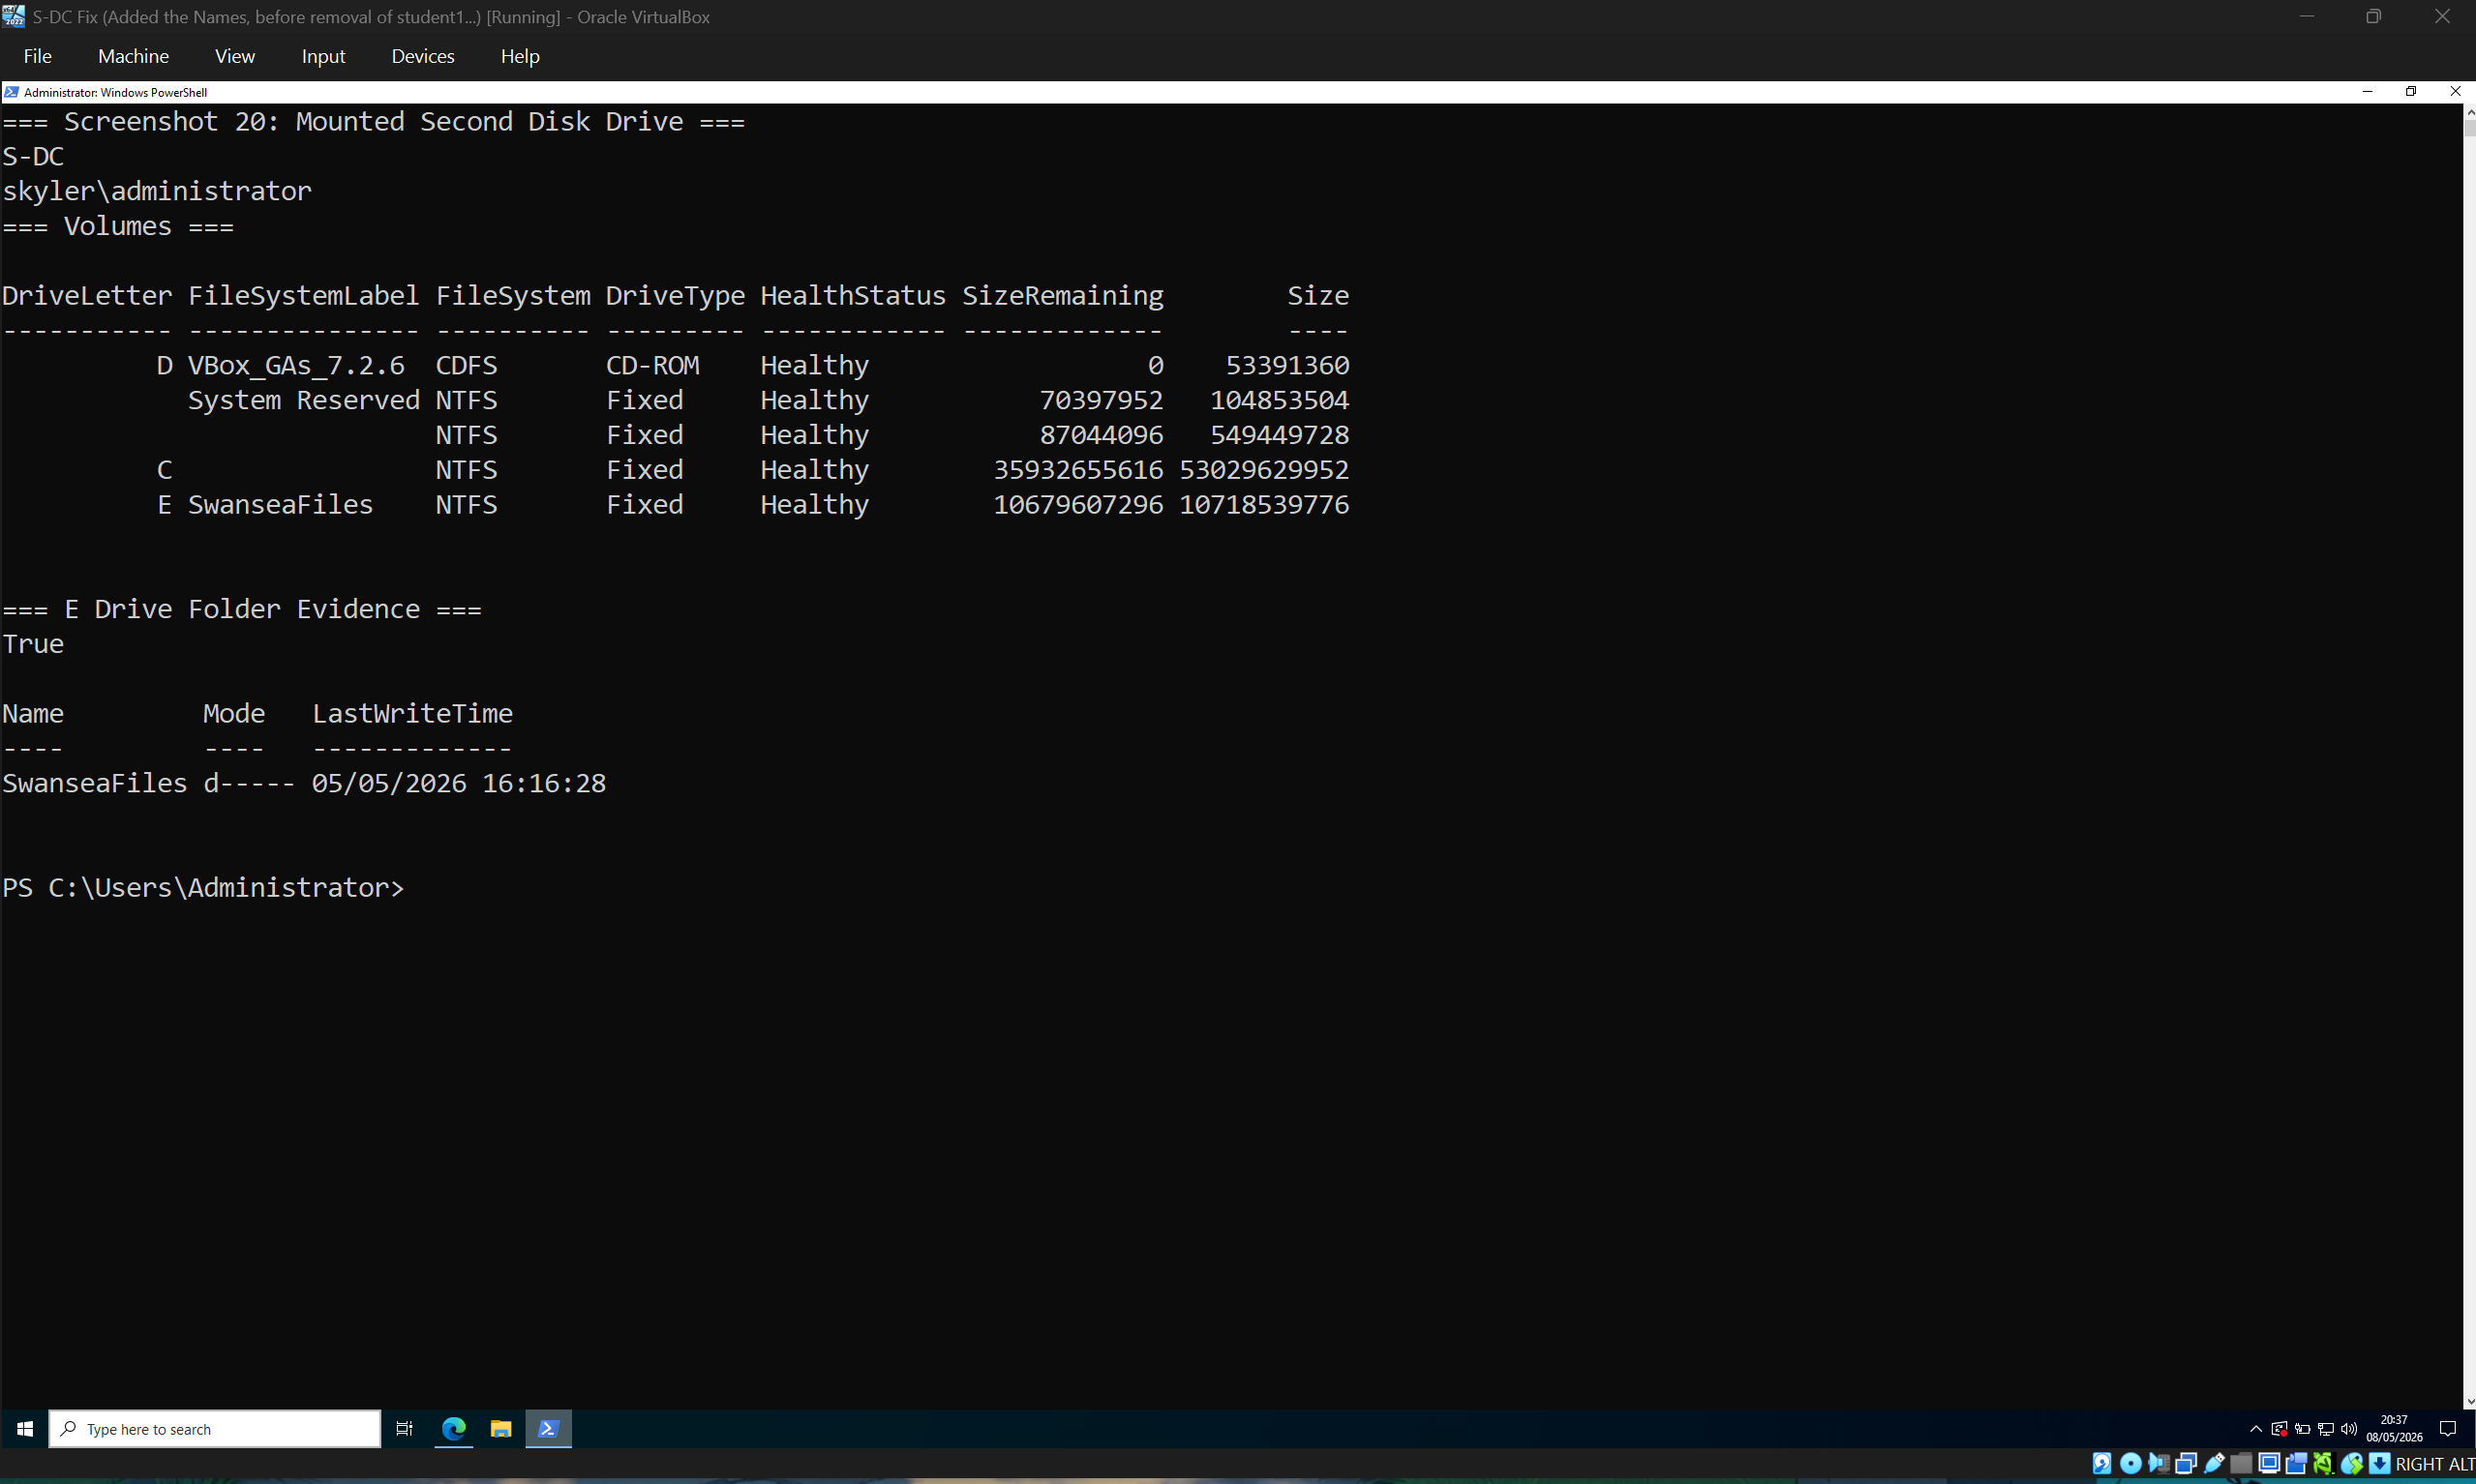
This screenshot shows the mounted E: drive on S-DC. The E: drive is used to store the SwanseaFiles shared folder, separating shared data from the system drive and matching the required file share configuration.

[Screenshot 21: Get-SmbShare -Name SwanseaFiles]
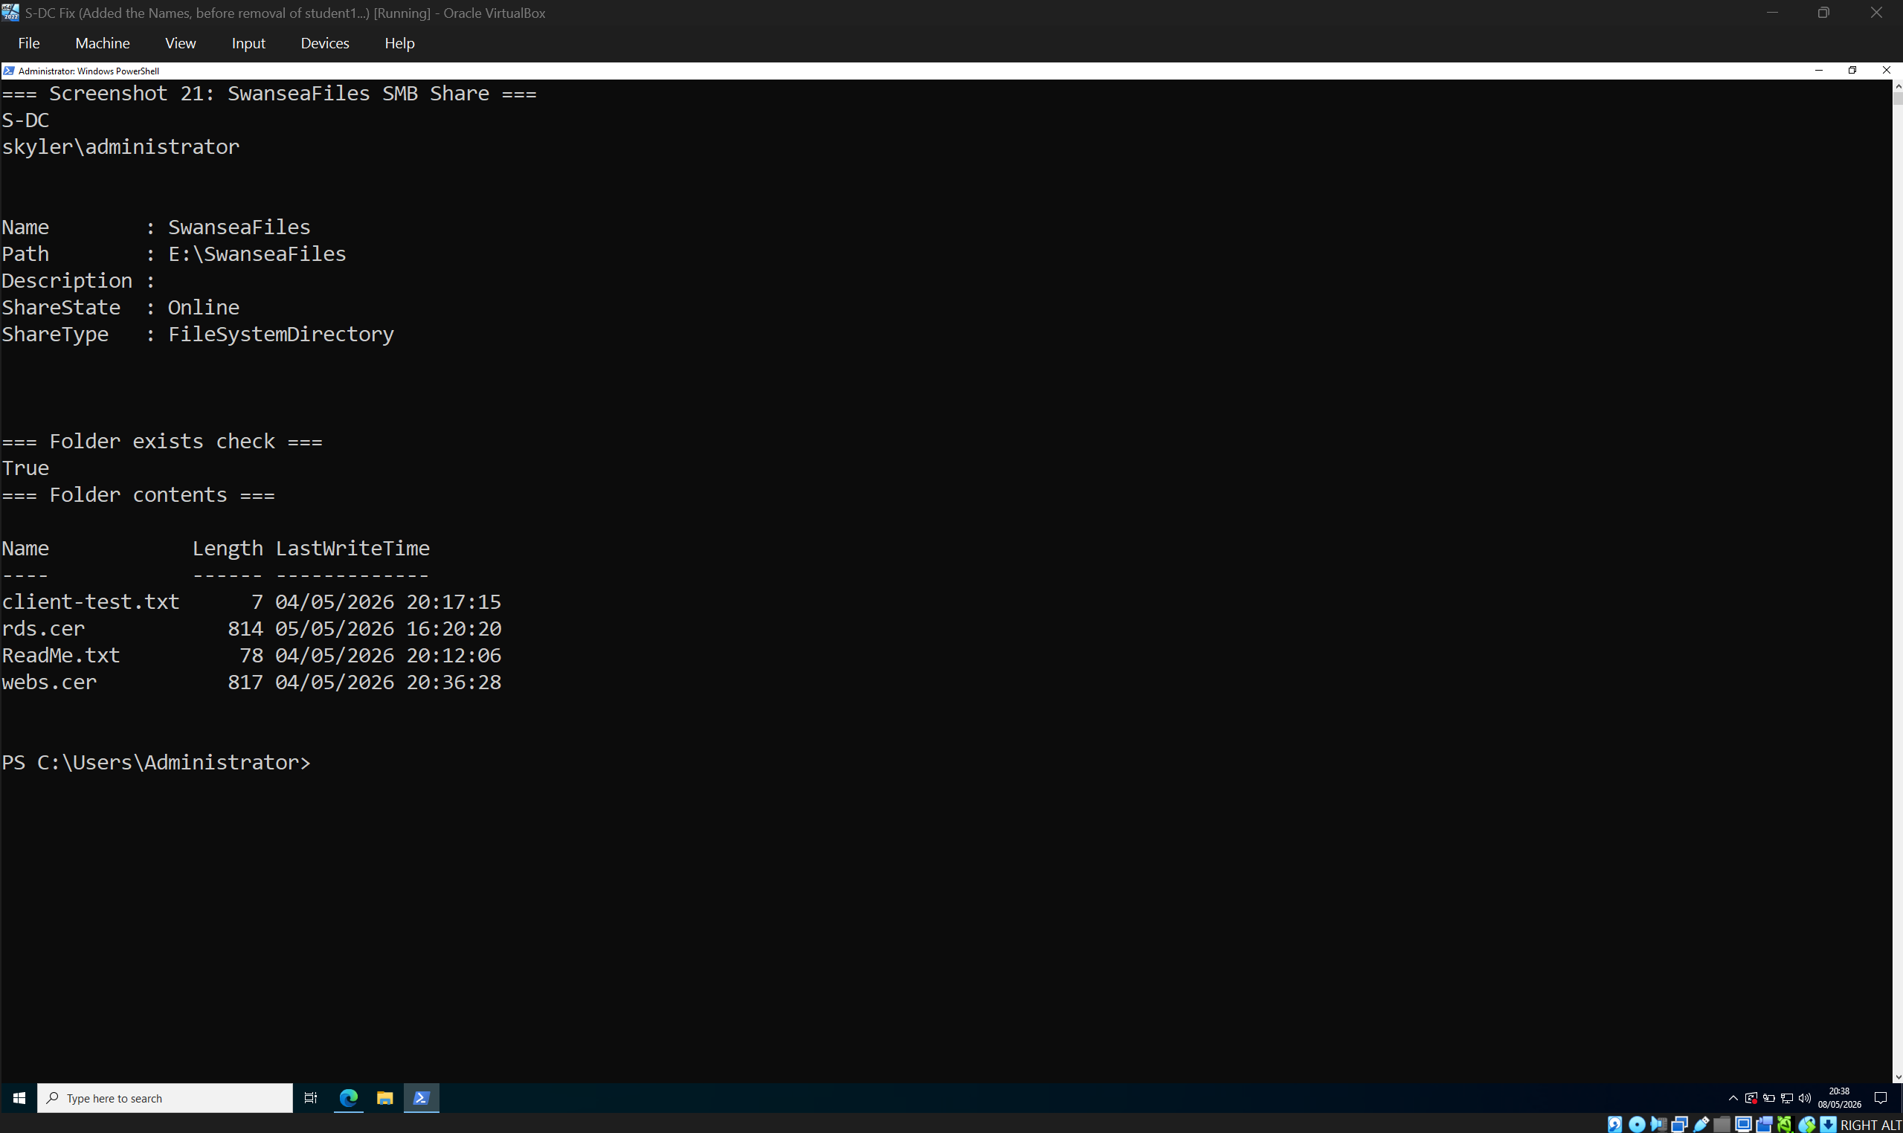
This screenshot shows the SwanseaFiles SMB share. The share path is E:\SwanseaFiles and the share is online, confirming that the folder has been successfully published as a network share for domain users.
[Screenshot 22: Get-SmbShareAccess -Name SwanseaFiles showing Domain Users Full and Everyone Read]
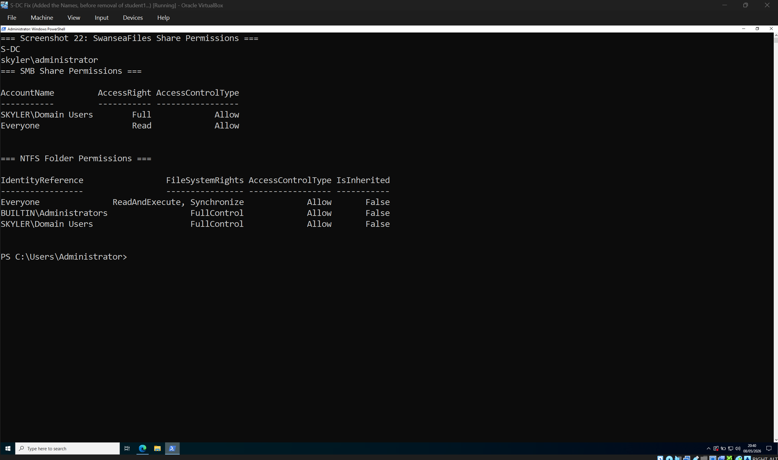
This screenshot shows the configured share and NTFS permissions for SwanseaFiles. Domain Users have full access, while Everyone has read-only access. This demonstrates group-based access control and limits unnecessary permissions.
[Screenshot 23: Client access test to \s-dc.skyler.acca\SwanseaFiles]
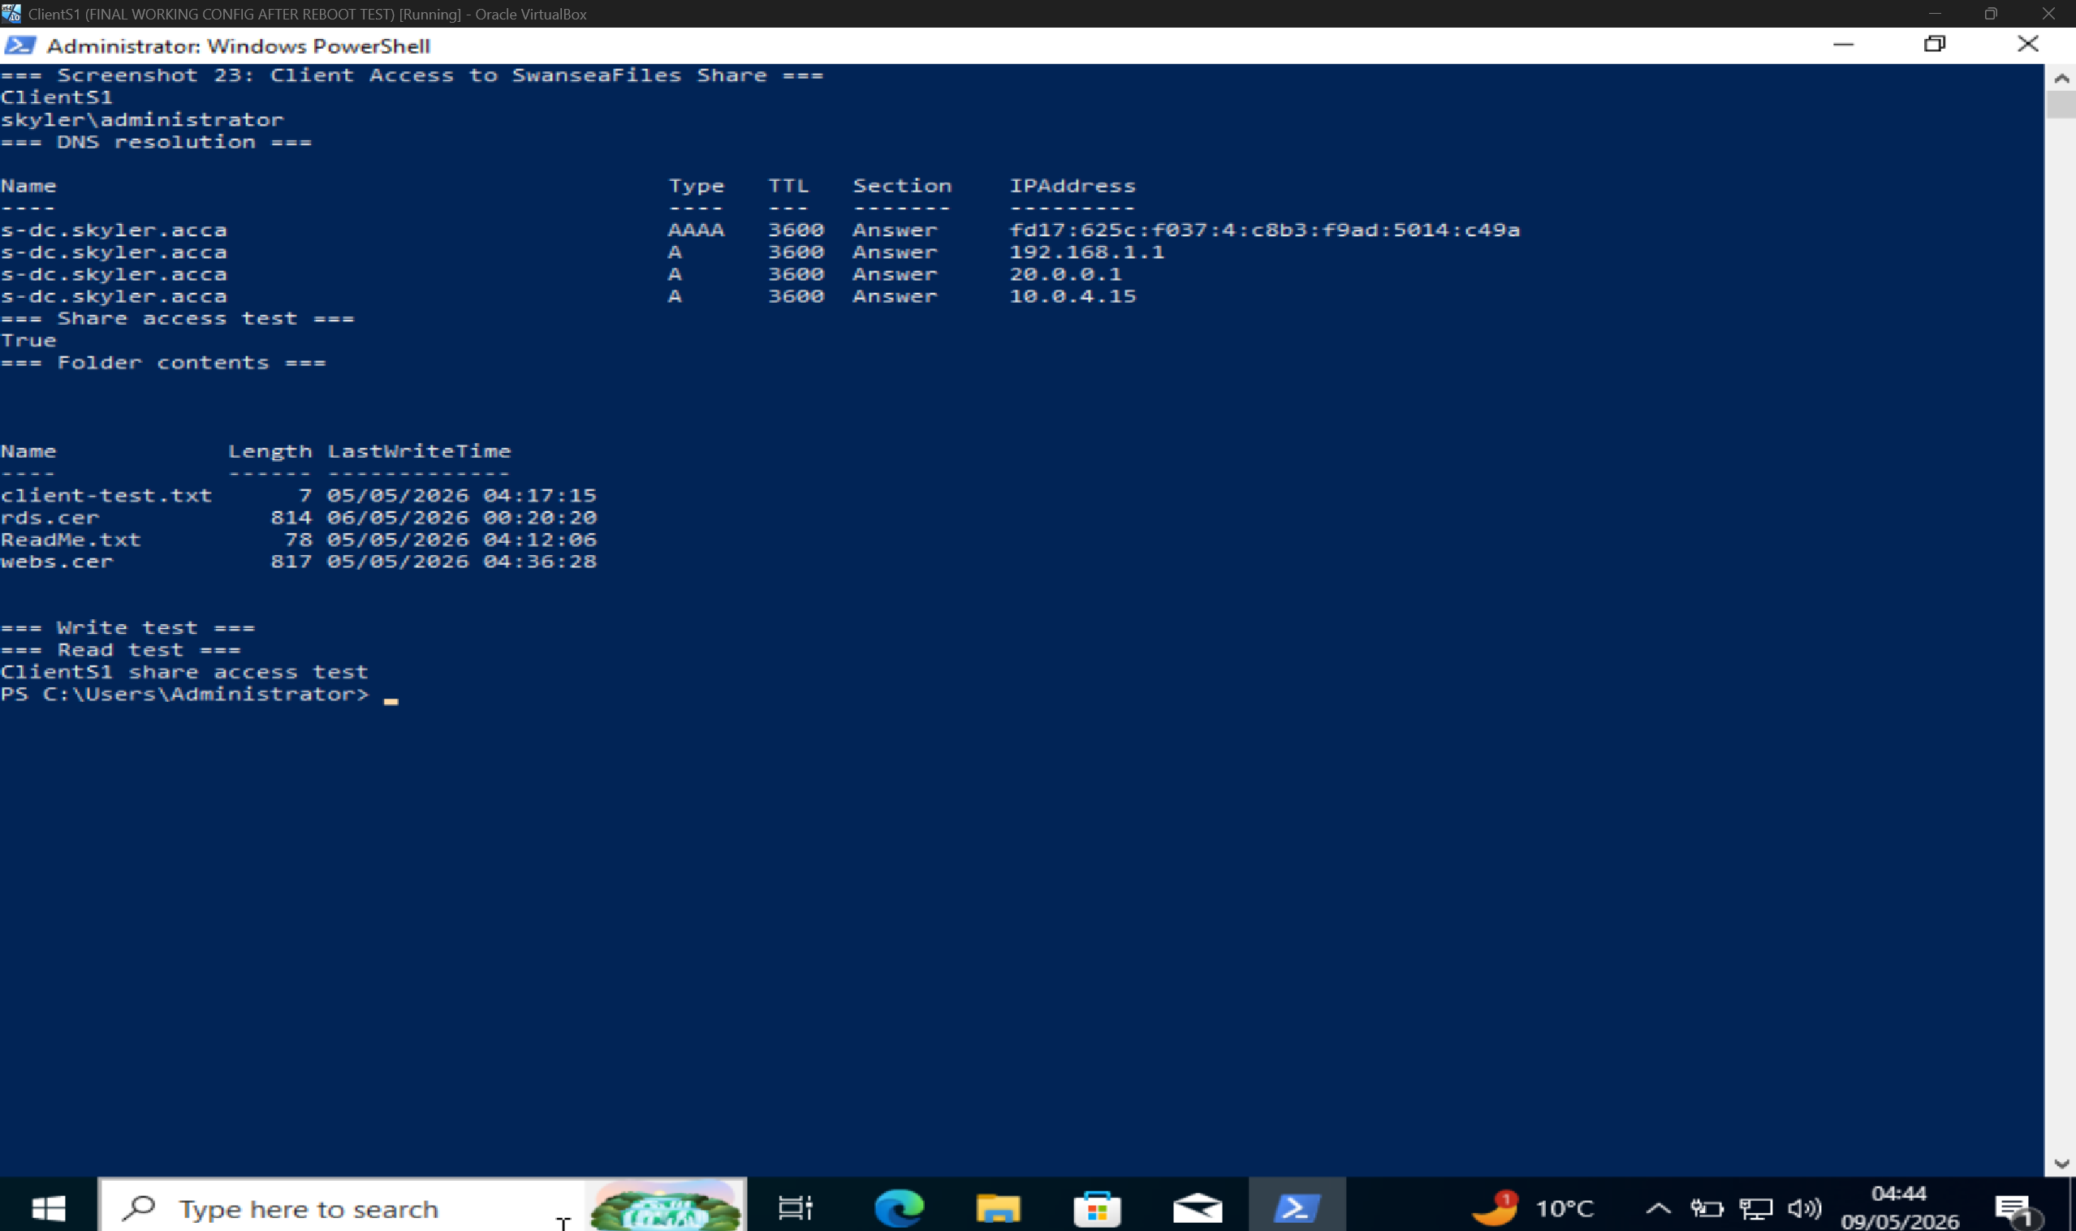
This screenshot shows a client accessing the \s-dc.skyler.acca\SwanseaFiles share. The successful folder listing and access test confirm that the SMB share is reachable from a domain client and that the permissions allow authorised access.

8. IIS Website Configuration
IIS was installed on S-DC and a website was created for webs.skyler.acca. The website was configured with Windows Integrated Authentication so that users authenticate with domain credentials rather than anonymous access. This supports centralised access control because website access is linked to Active Directory identity.
The website was tested using DNS resolution and web access. The successful response from https://webs.skyler.acca confirms that the site was available and responding correctly.

[Screenshot 24: IIS Manager showing webs.skyler.acca site]
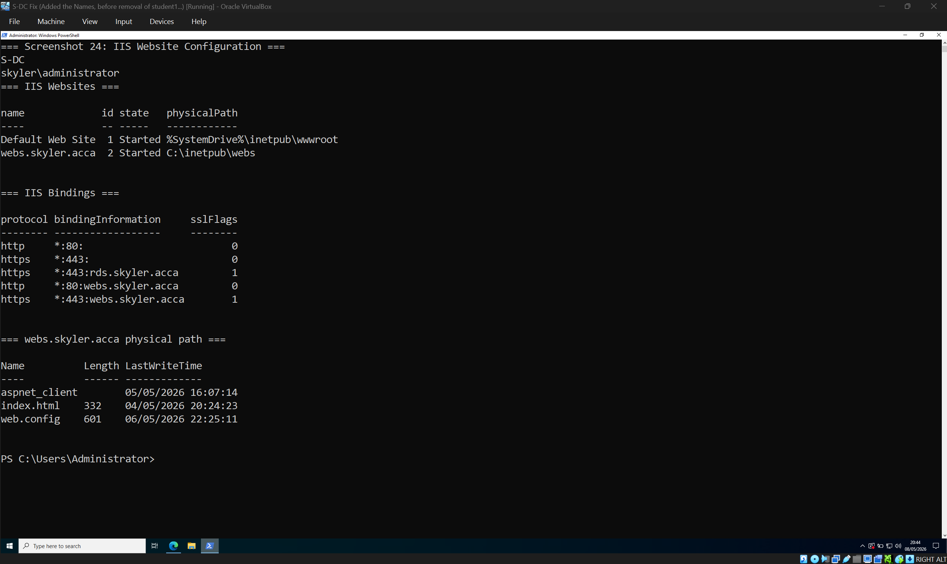
This screenshot shows the IIS website configuration for webs.skyler.acca. The site is started, uses the configured physical path, and has the correct HTTP/HTTPS bindings. This confirms that the internal website has been created and hosted successfully.
[Screenshot 25: IIS authentication settings showing Windows Authentication enabled and Anonymous disabled]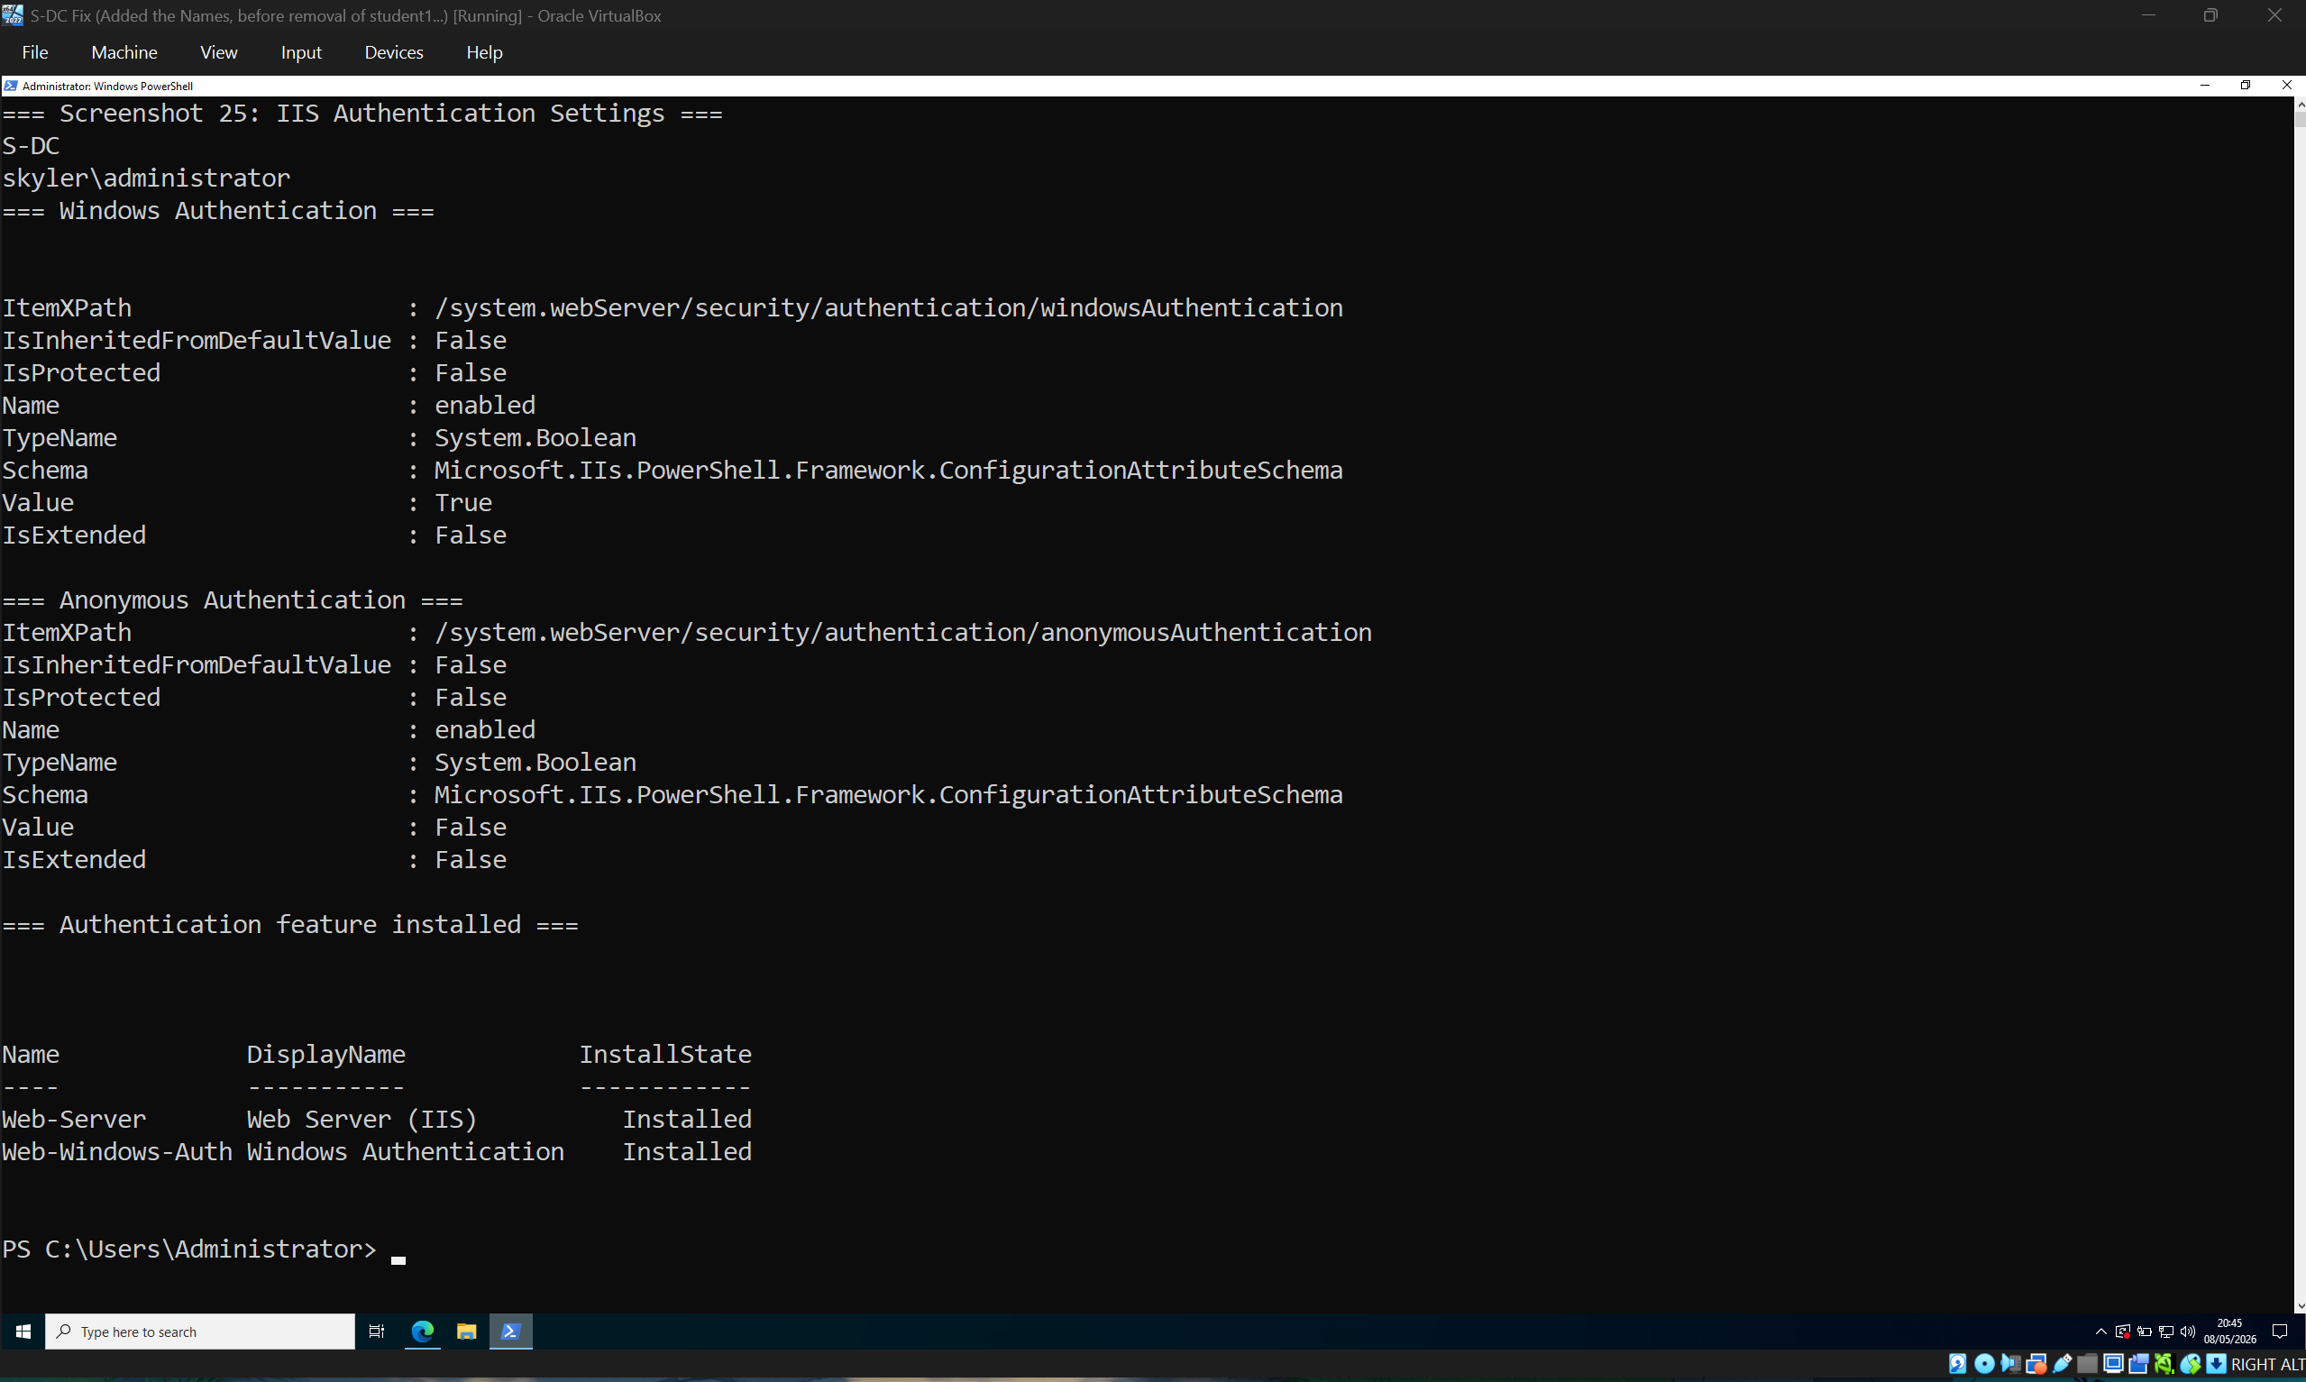
This screenshot shows the authentication configuration for webs.skyler.acca. Windows Authentication is enabled and Anonymous Authentication is disabled, meaning users must authenticate using domain credentials. This supports centralised access control through Active Directory.
[Screenshot 26: Browser or Invoke-WebRequest showing webs.skyler.acca responding]
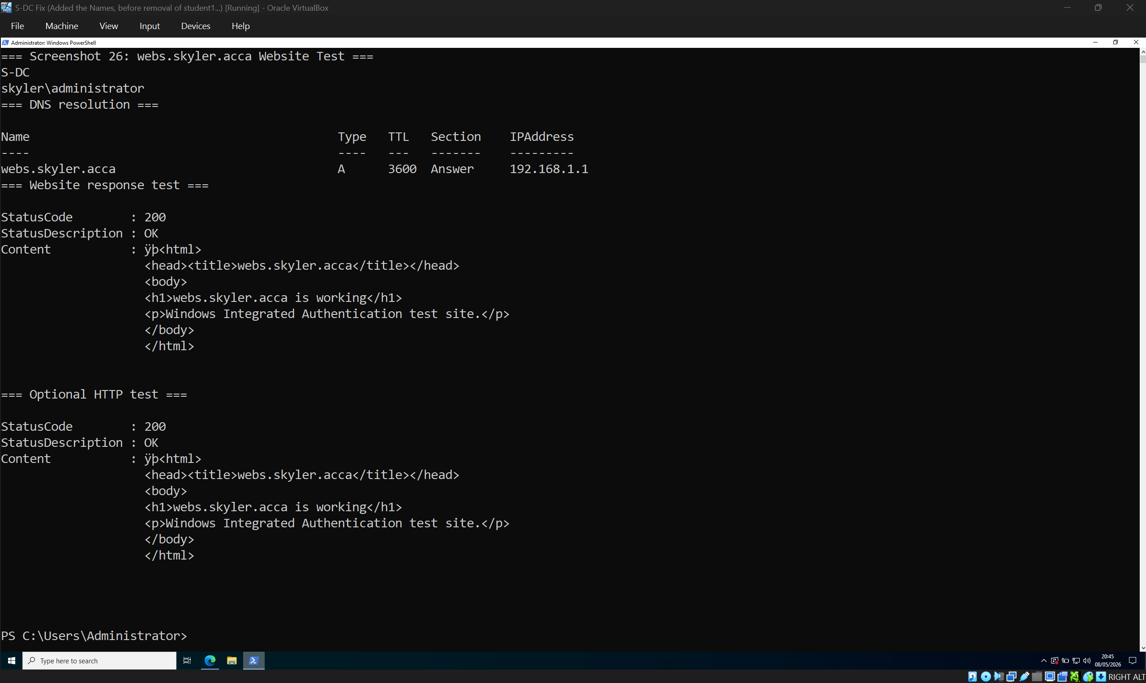
This screenshot verifies that webs.skyler.acca is reachable. DNS resolution points the hostname to the correct server, and the web request returns a successful response. This confirms that the IIS website is operational.

9. Remote Desktop Services
Remote Desktop Services was configured to provide remote access through rds.skyler.acca. RDS in Windows Server is used to securely deliver managed desktops and applications to users, supporting centralised access and management [9].
The RDS web portal was tested using https://rds.skyler.acca/RDWeb. DNS resolution and HTTPS access confirmed that the RDS service was reachable using the expected hostname.

[Screenshot 27: Get-WindowsFeature showing RDS-RD-Server and RDS-Web-Access installed]
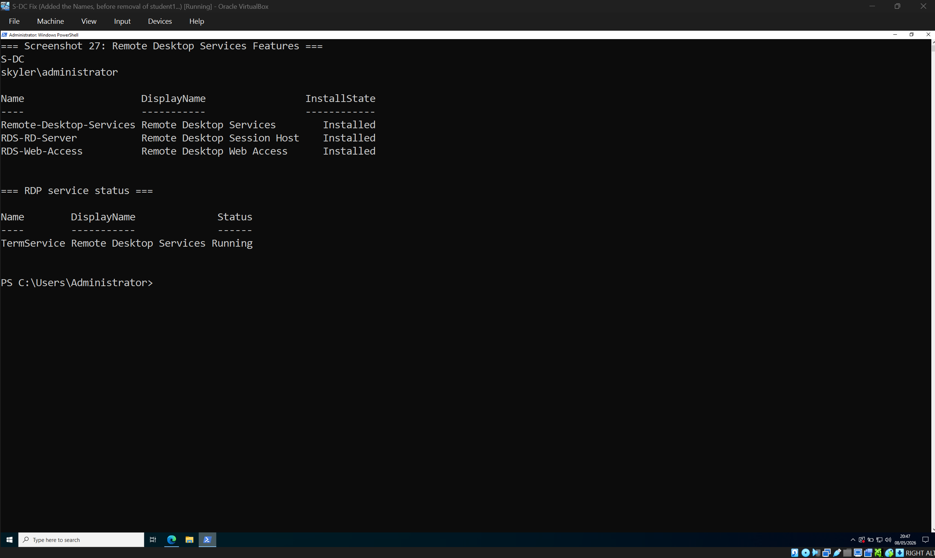
This screenshot shows that the required Remote Desktop Services components are installed. RD Session Host and RD Web Access are present, and the Remote Desktop service is running, confirming that RDS has been configured on the server.
[Screenshot 28: Browser showing https://rds.skyler.acca/RDWeb login page]
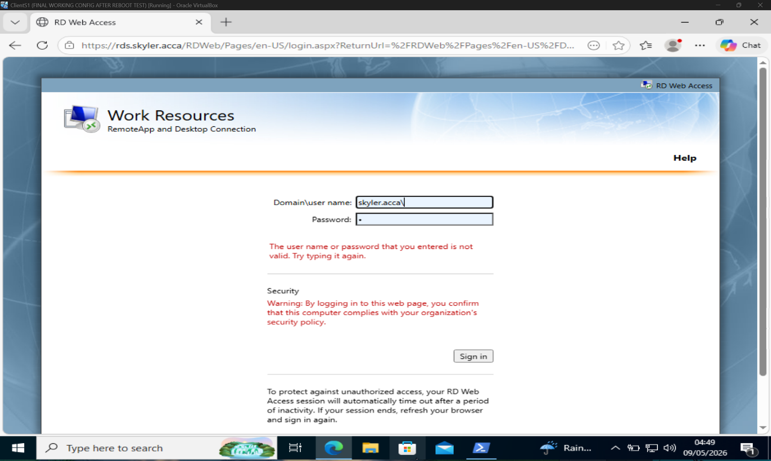
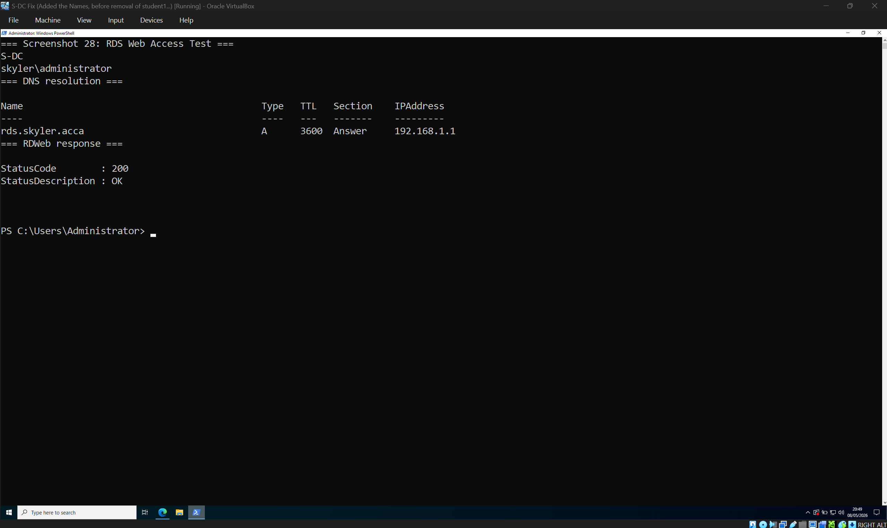
This screenshot shows the RD Web Access portal using the rds.skyler.acca hostname. The successful page load confirms that the RDS web interface is reachable using DNS and HTTPS.
[Screenshot 29: Certificate or HTTPS binding evidence for rds.skyler.acca]
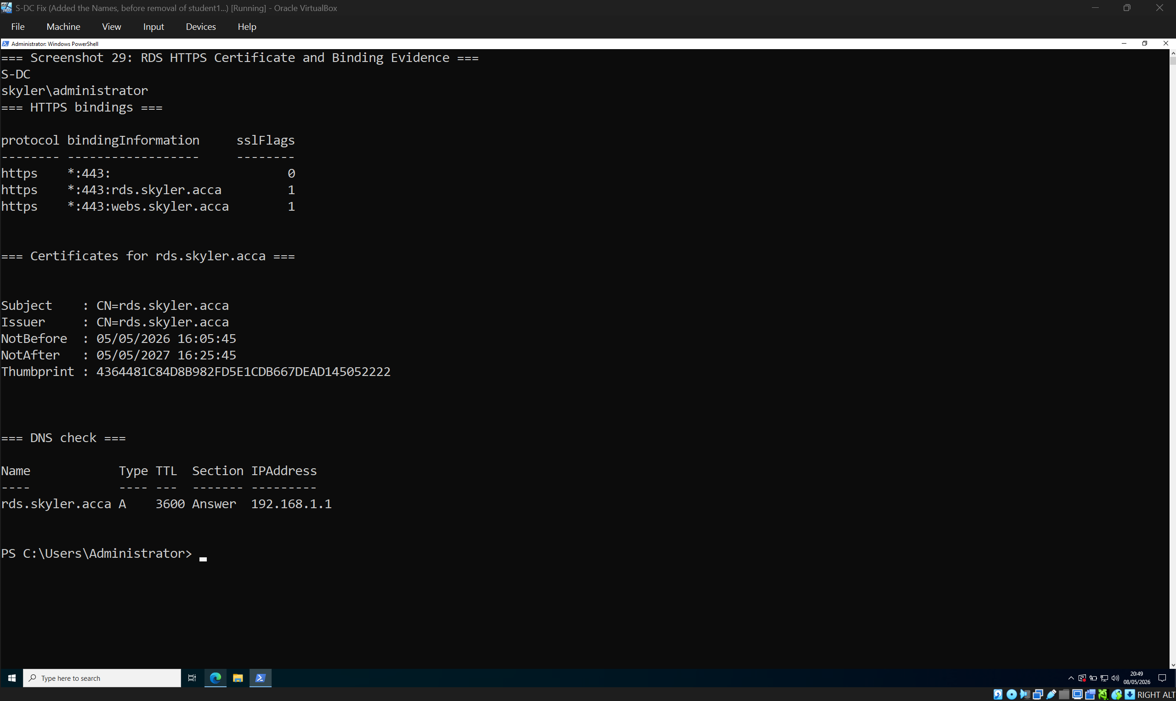
This screenshot shows the HTTPS binding and certificate evidence for rds.skyler.acca. This confirms that the RDS web portal has been configured to use HTTPS, supporting secure browser access to the remote desktop service.

10. Testing and Verification
Testing was completed using PowerShell, Linux terminal commands, DNS queries, ping tests, and service checks. The final tests confirmed that DNS records resolved correctly, DHCP scopes existed, Active Directory users and computers were present, the file share existed, IIS responded, RDS was reachable, and the IPsec VPN was established.
The most important evidence is that ClientL1 could communicate with Swansea resources across the VPN and S-DC could reach ClientL1 using the correct source interface command:
ping -S 192.168.1.1 192.168.2.10
This confirms that the traffic was tested from the Swansea network interface rather than from another adapter.
[Screenshot 30 ping -S 192.168.1.1 ClientL1.skyler.acca showing 0% loss]
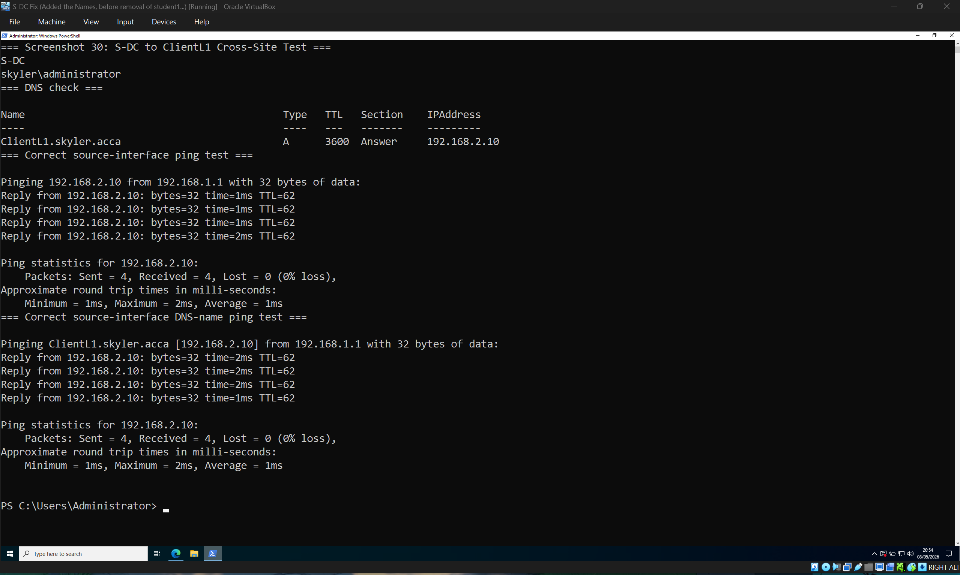
This screenshot shows the command ping -S 192.168.1.1 ClientL1.skyler.acca. This proves that S-DC can reach the London client across the VPN using the Swansea LAN interface as the source. This is important because it confirms that cross-site routing is working correctly, not just local or NAT-based connectivity.

[Screenshot 31: L-DC showing AD login as b.white@skyler.acca]
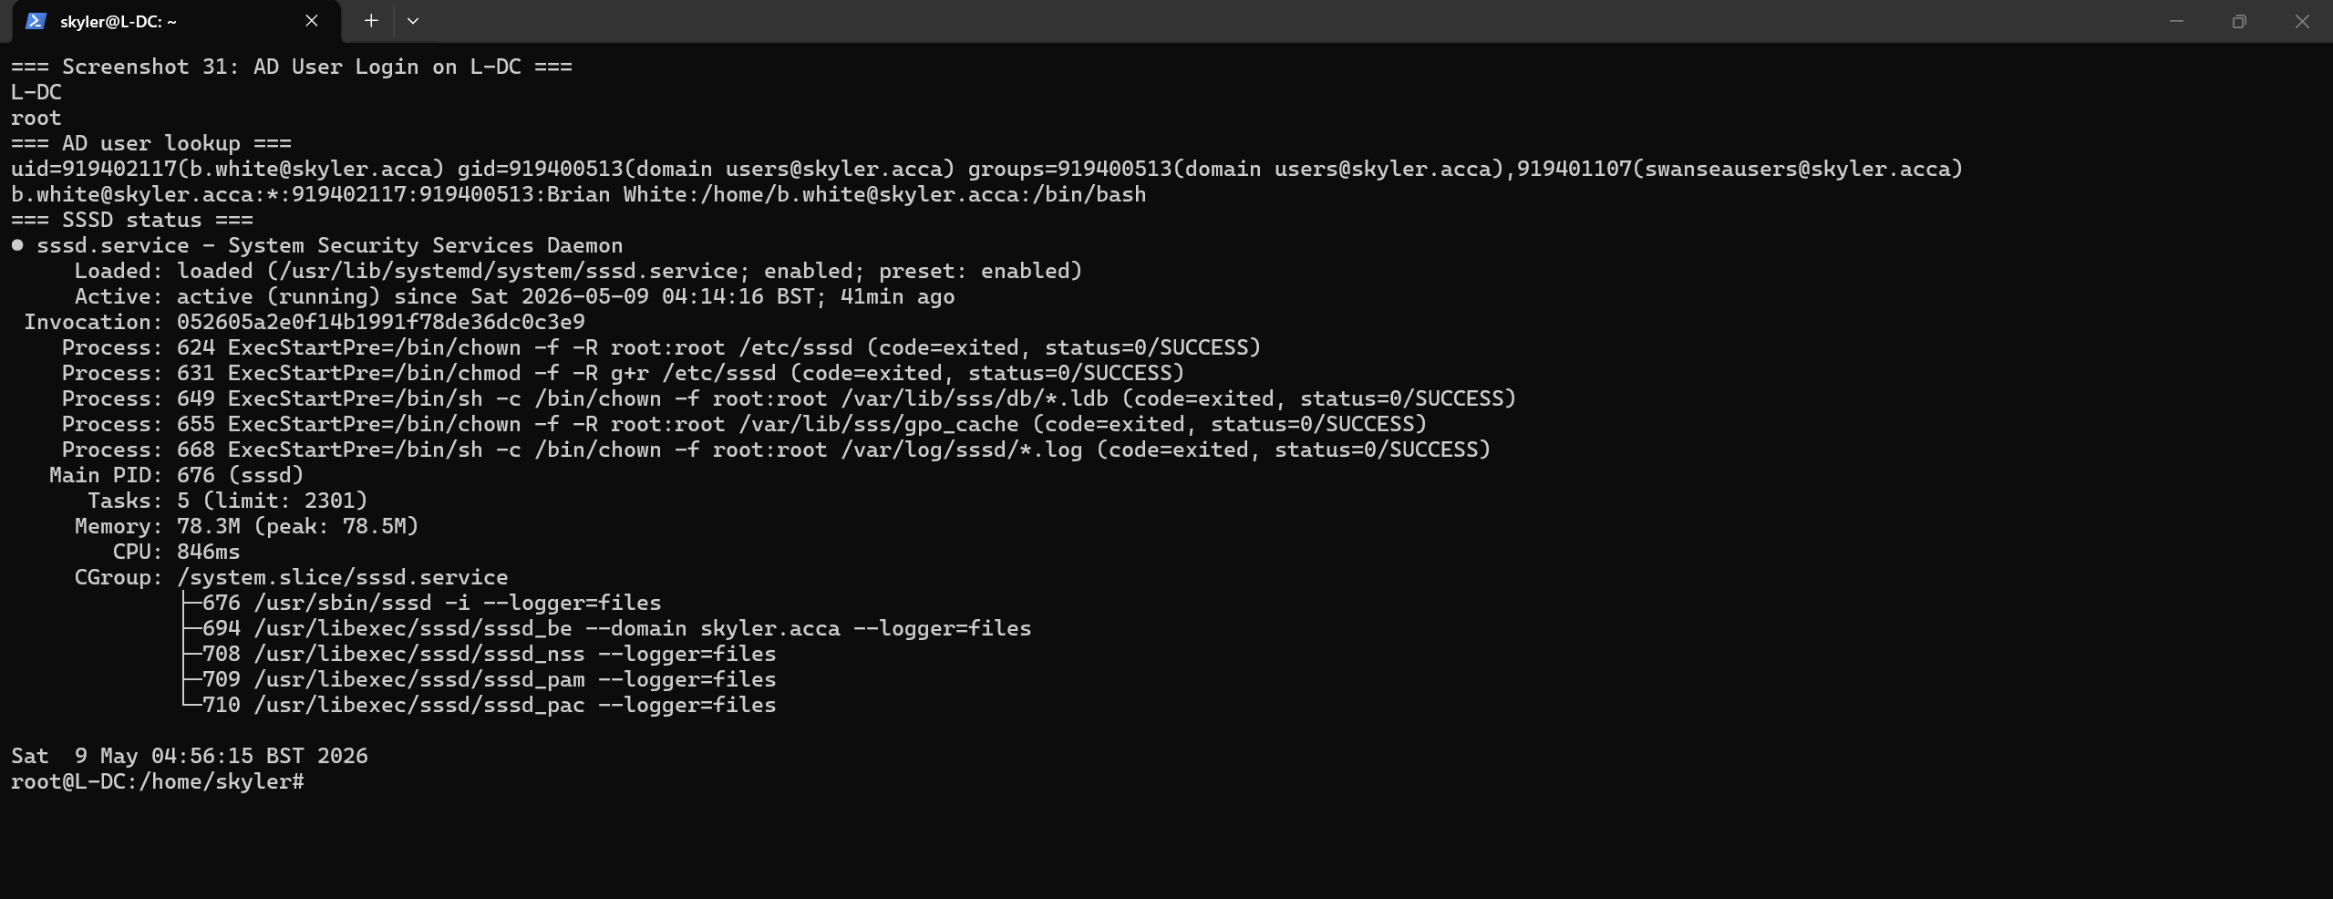
This screenshot shows L-DC recognising the Active Directory user b.white@skyler.acca. The id and getent results confirm that SSSD is communicating with Active Directory and that the user is recognised as a domain user and member of the SwanseaUsers group. This proves that Linux-side domain integration is working.

11. Conclusion
The virtualised enterprise network was successfully configured to meet the assessment requirements. The environment includes a working Active Directory domain, DNS records, DHCP scopes, domain users, domain-joined computers, file sharing, IIS, RDS, routing, and a secure IPsec site-to-site VPN between Swansea and London.
The configuration demonstrates both technical implementation and professional verification. The use of PowerShell and Linux command-line testing provides clear evidence that the services are not only installed but functioning correctly across both networks. The final result is a manageable enterprise-style network where authentication, addressing, name resolution, file access, web access, remote access, and secure inter-site communication are all operational.

References
[1] Microsoft, “Active Directory Domain Services overview,” Microsoft Learn, Mar. 11, 2025. [Online]. Available: https://learn.microsoft.com/en-us/windows-server/identity/ad-ds/get-started/virtual-dc/active-directory-domain-services-overview. [Accessed: May 10, 2026].
[2] Microsoft, “DNS and AD DS,” Microsoft Learn, May 12, 2025. [Online]. Available: https://learn.microsoft.com/en-us/windows-server/identity/ad-ds/plan/dns-and-ad-ds. [Accessed: May 10, 2026].
[3] Microsoft, “Quickstart: Install and configure DHCP Server,” Microsoft Learn, Apr. 21, 2025. [Online]. Available: https://learn.microsoft.com/en-us/windows-server/networking/technologies/dhcp/quickstart-install-configure-dhcp-server. [Accessed: May 10, 2026].
[4] R. Droms, “Dynamic Host Configuration Protocol,” RFC 2131, Internet Engineering Task Force, Mar. 1997. [Online]. Available: https://datatracker.ietf.org/doc/html/rfc2131. [Accessed: May 10, 2026].
[5] S. Kent and K. Seo, “Security Architecture for the Internet Protocol,” RFC 4301, Internet Engineering Task Force, Dec. 2005. [Online]. Available: https://datatracker.ietf.org/doc/html/rfc4301. [Accessed: May 10, 2026].
[6] C. Kaufman, P. Hoffman, Y. Nir, P. Eronen, and T. Kivinen, “Internet Key Exchange Protocol Version 2 (IKEv2),” RFC 7296, Internet Engineering Task Force, Oct. 2014. [Online]. Available: https://datatracker.ietf.org/doc/html/rfc7296. [Accessed: May 10, 2026].
[7] strongSwan Project, “strongSwan - IPsec VPN for Linux, Android, FreeBSD, macOS, Windows,” 2026. [Online]. Available: https://www.strongswan.org/. [Accessed: May 10, 2026].
[8] Microsoft, “What is SMB File Sharing for Windows and Windows Server?,” Microsoft Learn, Nov. 27, 2025. [Online]. Available: https://learn.microsoft.com/en-us/windows-server/storage/file-server/file-server-smb-overview. [Accessed: May 10, 2026].
[9] Microsoft, “Remote Desktop Services overview in Windows Server,” Microsoft Learn, Oct. 30, 2025. [Online]. Available: https://learn.microsoft.com/en-us/windows-server/remote/remote-desktop-services/overview. [Accessed: May 10, 2026].

