
Marketing Environment Analysis and Strategic Growth: SSAB’s Transition to Lower-Carbon Steel

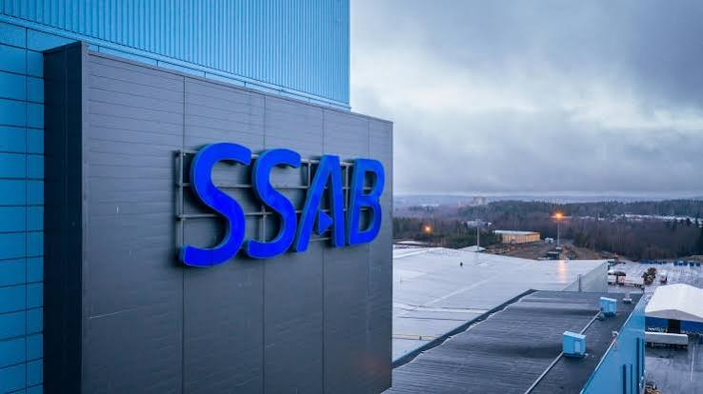

Programme: Master of Business Administration

Module: Marketing Management

Module code: LCMB7024

Student name: Hiren Nathabhai Timba

Student ID: 2611854

Word count:2656

Lecturer’s Name: Taonga Kaonpcga Sobere-Snithers(Birmingham)

Submission date:22 October 2026

Table of Contents
1 Task 1: Critical Analysis of the External Marketing Environment 3
1.1 Organisational Context and Selection of Environmental Factors 3
1.2 Environmental Factors 4
1.2.1 Decarbonisation Pressure and Carbon Lock-In 4
1.2.2 Environmental Claims and Measurement Boundaries 5
1.2.3 Circularity and the Limits of Environmental Advantage 5
1.3 Economic Factors 6
1.3.1 Energy Costs and International Competition 6
1.3.2 Financial Capacity and Pricing Discipline 6
1.4 Technological Factors 7
1.4.1 Infrastructure Dependencies and Delivery Credibility 7
1.4.2 Artificial Intelligence and Marketing Capability 8
2 Task 2: Ansoff Growth Strategy and Competitive Advantage 9
2.1 Selection of Market Penetration 9
2.2 Building Competitive Advantage Through Porter’s Generic Strategies 10
2.2.1 Evaluating Cost Leadership, Differentiation and Focus 10
2.2.2 Marketing’s Coordinating Contribution 13
2.3 Implementation, Measurement and Strategic Limits 14
3 Task 3: Managerial and Professional Reflection 15
3.1 Development of Analytical Judgement 15
3.2 Implications for Managerial Practice 16
3.3 Professional Development Priorities 17
4 References 18

Task 1: Critical Analysis of the External Marketing Environment

Organisational Context and Selection of Environmental Factors
The reduction of carbon steel is an example of the environmental innovation that has generated business opportunities, along with the need for credible marketing by SSAB. It differentiates with its existing product SSAB Zero, which is produced based on recycled steel and fossil-free energy. But environmental performance must be seen in the customer acceptance, the supply and returns to be considered commercially viable. In the context of business-to-business greenwashing, the analysis of literature shows that positioning on the environment cannot be limited to the use of promotional language, but must also be backed up by evidence in the organisation (Vangeli et al., 2023). The research on Sustainable Business models also highlights the importance of value creation, delivery and capture (Sinkovics et al., 2021; Geissdoerfer et al., 2020).
Three PESTLE dimensions will be chosen for this analysis: environmental, economic and technological factors. The relevance and credibility of the offering is dependent upon the environmental pressures, economic conditions impact the production cost and purchases, and technological developments dictate what the company can offer. These dimensions are not independent, but work together. Even when decarbonisation is technically possible, it might not be economically viable if electricity prices are high, and even if the environment benefit is great, it may not be when the measurement boundaries are not clear (Devlin et al., 2023; Neumann et al., 2025; Vangeli et al., 2023).
Figure 1 has confirmed that there are already commercial sales of SSAB Zero. Of the approximately 100,000 tonnes target delivery, around 90% (approximately 90,000 tonnes) was completed in 2025 (SSAB, 2026). This helps to consider the product as an existing product, but volumes delivered do not constitute profitability.
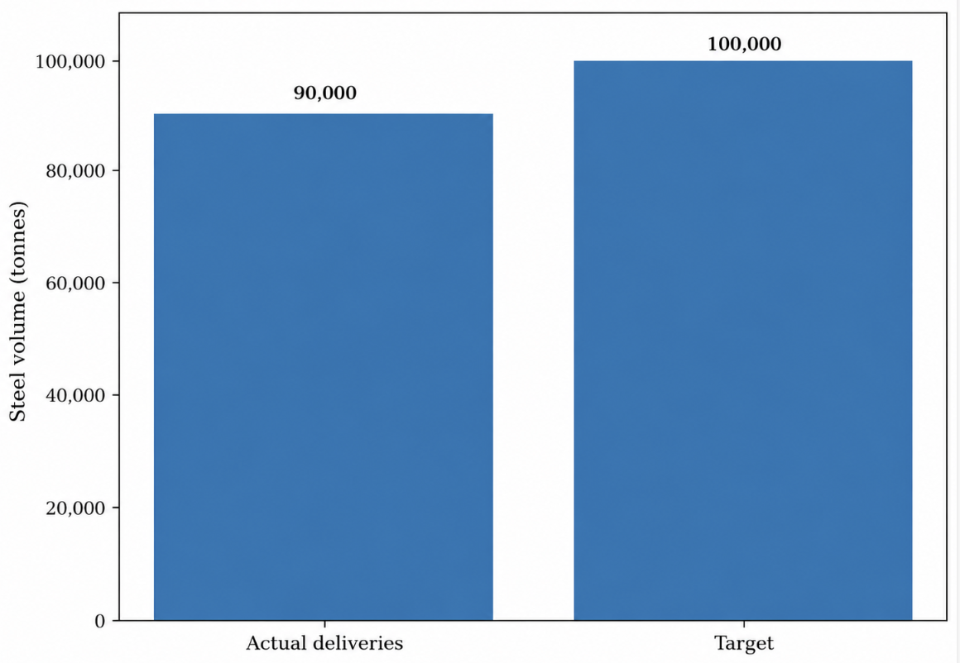
Figure 1. SSAB Zero deliveries compared with the 2025 target, Source: Author’s own work based on SSAB (2026).
Figure 1 has confirmed that there are already commercial sales of SSAB Zero. Of the approximately 100,000 tonnes target delivery, around 90% (approximately 90,000 tonnes) was completed in 2025 (SSAB, 2026). This helps to consider the product as an existing product, but volumes delivered do not constitute profitability.

Environmental Factors

Decarbonisation Pressure and Carbon Lock-In
Decarbonising steel is a strategic opportunity, as the need for customers to understand emissions across their supply chains increase. However, the magnitude and pace of industrial transformation is important. Bachorz et al. (2026) estimate that the committed emissions from continued operation and development of conventional steelmaking assets could be significant, hence illustrating the impact of carbon intensive investments. Plant-level studies also suggest a large dispersion in the decarbonisation pathway costs and feasibility (Wu et al., 2025). As such, the opportunity of SSAB comes in a mix of industries, not a monolithic conversion.
Lower-carbon steel should be marketed around customer value – procurement requirements and emissions reporting – they are demonstrable to the customer. The superiority in terms of the environment cannot be inferred from a production technology. Outcomes vary depending on the location, type of electricity system and material inputs, and implementation is restricted by infrastructure barriers (Keramidas et al., 2024; Wang et al., 2025). The link between the environmental claims and the products and verified evidence should therefore be established by SSAB.

Environmental Claims and Measurement Boundaries
One of the main challenges is the separation of the operative emissions from the product emissions. SSAB defines SSAB Zero as emissions below a certain threshold of 0.05 kg of CO₂e per kg of steel (SSAB, n.d.-b). This is not to be interpreted as a full life cycle footprint. Product environmental declarations use established boundaries for the assessment and use a different basis of comparison (SSAB, n.d.-a).
This distinction is in the commercial sense. Greenwashing is detected by research when companies' messages about the environment are greater than the evidence that they have at all levels of their supply chains (Pizzetti et al., 2021). Additionally, the disclosure does not necessarily lead to better decision-making, if the information is not comparable and helpful enough (Christensen et al., 2021). Therefore, it is vital for the SSAB to specify the product, assessment boundary and verification basis in the marketing so that the procurement team can make defensible comparisons (Vangeli et al., 2023).

Circularity and the Limits of Environmental Advantage
A circular value proposition can be achieved by using recycled inputs, but circularity does not necessarily equal sustainability. The availability of materials is a prerequisite for circular business models, as well as supporting organisations and functioning ecosystems (Geissdoerfer et al., 2020; Kanda et al., 2021). The commercial strength of recycled steel is thus partly dependent on other systems of materials for SSAB.
Other research opportunities exist such as lab work on the recovery of iron from red mud, but this would not necessarily mean that the technology is commercially ready for SSAB. There is also critical research questioning whether the national green-steel narratives are sufficient to consider the broader resource and territorial impacts (de Leeuw & Vogl, 2024). Therefore, marketing needs to acknowledge environmental improvements and not to suggest that producing more steel is "environmentally consequence-free.

Economic Factors

Energy Costs and International Competition
Reduced carbon production is a matter of competition in an international cost structure. Devlin et al. (2023) show that renewable energy conditions have a significant impact on the economics of using hydrogen to make steel. While this route of production is not the same as that of SSAB Zero the results demonstrate why energy cost cannot be de-coupled from the assessment of decarbonisation. The studies of green-energy and steel imports also suggest that international trade can shift degrees of attractiveness of domestic production pathways (Neumann et al., 2025).
For marketing management, the conclusion is that an extra price for the environment can compensate only for a limited time for a commercial offer which is not competitive. Technical requirements, purchasing costs and supply continuity are examined by the customer in conjunction with each other. There are several factors that have been identified in consumer-oriented studies that affect consumers' willingness to pay for green steel, but they are not necessarily applicable to industrial consumers. An account level interview and commercial trial is thus required.

Financial Capacity and Pricing Discipline
As illustrated in figure 2, the group operating profit of SSAB has decreased from SEK 7.860 billion in 2024 to SEK 6.116 billion in 2025, about 22.2% (SSAB, 2026). While the consolidated results don't show individual profit of SSAB Zero they do show the value of disciplined investment and pricing.
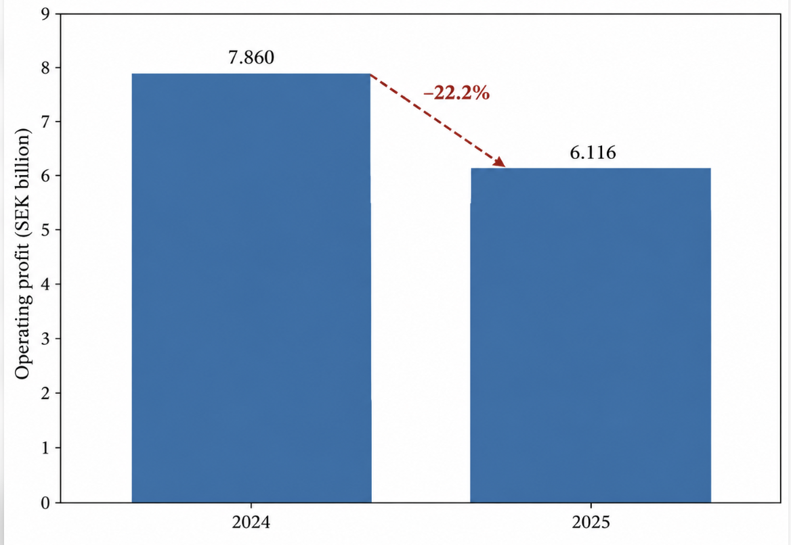
Figure 2. SSAB group operating profit, 2024–2025, Source: Author’s own work based on SSAB (2026).
It is important for SSAB not to equate sales growth with commercial success. In order to be innovative in the sustainable business model, it is necessary that the organisation is able to capture enough value to sustain itself (Sinkovics et al., 2021; Alonso-Martínez et al., 2021). Pricing should thus take into consideration customer benefits and account economics that are validated and consider uncertainty in future energy prices and competitor response.

Technological Factors

Infrastructure Dependencies and Delivery Credibility
It is the supporting infrastructure, along with the steelmaking equipment, which is essential for the technological transition. The commissioning of the Luleå steel mill was postponed by one year from the end of 2028 to the end of 2029 by SSAB (2025b). The milestones identified in figure 3 are those that have been announced and not future planned operations. Renewable electricity supply and broader integration of the power system are also found to be limitations for decarbonising steel production (Kazmi et al., 2023; Wang et al., 2025).
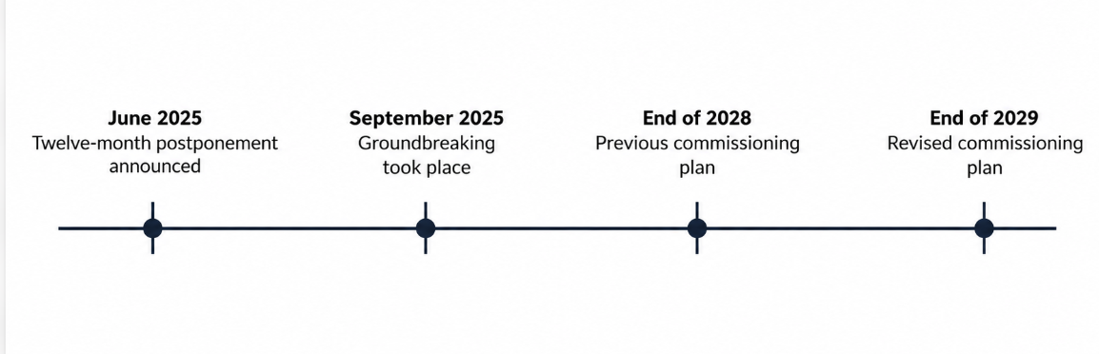
Figure 3. Revised commissioning timetable for SSAB’s Luleå steel mill, Source: Author’s own work based on SSAB (2025a, 2025b).
A distinction needs to be made between current capacity and the potential capacity. Industrial transitions can be coordinated through intermediaries and wider innovation networks but this does not reduce implementation risk (Kanda et al., 2020). Thus, sales commitments need to be based on proven operational abilities.

Artificial Intelligence and Marketing Capability
AI can be used to assist in opportunity prioritisation, demand forecasting and account analysis. But organisational capability is not just software acquisition, it relies on data, skills and management practices too (Mikalef & Gupta, 2021). Marketing research indicates opportunities for AI-assisted decision making, and management research indicates tensions between automated and human decision making (Davenport et al., 2020; Raisch & Krakowski, 2021).
SSAB should use AI to help commercial teams to analyse the customer requirements and provide information. Environmental / engineering claims should be validated by technical specialists prior to publication. Human–AI collaboration is best when there is a clear division of labor and the employees can check with AI's recommendations (Chowdhury et al., 2022).
Table 1. External influences and marketing implications
Dimension | Opportunity | Main constraint | Marketing response
Environmental | Differentiate through documented emissions performance | Unclear boundaries and exaggerated claims | Provide product-specific evidence and explain assessment boundaries
Economic | Develop repeat demand among customers valuing emissions reductions | Energy costs and uncertain price premiums | Test account profitability and contractual arrangements
Technological | Improve production and customer-information capabilities | Infrastructure delays and unreliable automated outputs | Align commitments with confirmed capacity and specialist validation
Source: Author’s own work based on Devlin et al. (2023), Vangeli et al. (2023), Wang et al. (2025), and SSAB (2025b).

Task 2: Ansoff Growth Strategy and Competitive Advantage

Selection of Market Penetration
Market penetration is the most defensible immediate strategy for SSAB Zero as it engages with an existing product in existing markets of customers. The goal is not to think that any environmental improvement is product development, but to drive repeat purchases and account share. Under Ansoff's matrix, these strategic moves can be differentiated based on the newness of the product and market (Whittington et al., 2023).
Table 2. Application of Ansoff’s growth matrix
Strategy | Product–market relationship | Application to SSAB | Assessment
Market penetration | Existing product; existing market | Increase SSAB Zero purchases within established accounts | Immediate priority
Market development | Existing product; new market | Enter additional locations or customer segments | Requires demand and channel evidence
Product development | New product; existing market | Develop genuinely new grades or capabilities | Requires development and qualification
Diversification | New product; new market | Enter unfamiliar offerings and markets | Highest additional capability requirements
Source: Author’s own work based on Whittington et al. (2023).
Table 2 is a comparison of the alternatives. Market development and product development are still available but these have an added qualification or market-learning need. Sustainable business model research helps to assess growth potential based on capabilities that are required to create and seize value and not based on novelty alone, as it is not always commercially ready (Alonso-Martínez et al., 2021; Sinkovics et al., 2021).
However, there are risks associated with market penetration. Older customers might be hesitant to alter specifications or pay more, and other competitors could offer other means of emissions cuts. The strategy should thus focus on the accounts that can be seen to have a need for procurement and not look at every existing customer as an equal. While evidence from green-consumption research can help answer questions, the assumptions in industrial purchasing should be tested directly, as indicated in the research by Testa et al., (2021), Kumari et al., (2022), and Vangeli et al., (2023).

Building Competitive Advantage Through Porter’s Generic Strategies

Evaluating Cost Leadership, Differentiation and Focus
Porter's generic strategies are constructed by the combination of low cost vs high cost, broad market vs narrow market. Ansoff's matrix defines the direction of growth, while Porter's framework provides an explanation on how the business is going to compete. Therefore, to be a complementary competitor to SSAB, a market penetration strategy is required. Differentiation becomes the most defensible method used in SSAB Zero, if the customers have the perception of enough value from the environment and functional features (Whittington et al., 2023; Vangeli et al., 2023).
Cost leadership would involve having a cost advantage over the competition that is difficult for others to match and still achieve an acceptable performance in the product. No evidence was found to indicate that SSAB Zero is the least expensive production. Studies have shown that the economic viability of LCS production is heavily affected by energy costs and location (Devlin et al., 2023; Neumann et al., 2025), although the results of studies focusing on hydrogen-based production should not be assumed to apply to SSAB Zero. Thus, SSAB should adhere to cost discipline, while at the same time not claiming cost leadership as a proven competitive advantage.
Differentiation provides a more solid foundation for the recommendation as SSAB can integrate emissions data, technical qualification, engineering support and reliable supply. These attributes may assist customers to meet procurement and reporting requirements while still holding the proper performance of steel. But environmental claims need to state the boundaries of their assessment, and company sustainability ratings cannot be used in place of product-specific evidence (Christensen et al., 2021; Berg et al., 2022). What matters for commercial application of differentiation is the moment in which customers appreciate these benefits, and the moment in which the purchasing revenues overcome the costs of the differentiation (Vangeli et al., 2023).
One approach to a focus strategy would be to target a specific niche, such as customers who have specific emissions-documentation and qualification needs. If SSAB narrows its range of products/services and its marketing efforts and resources are targeted toward that niche, focused differentiation may be appropriate. However, having several developed industries with a concentration on the best prospects does not, in itself, represent a focus approach. The current recommendation, therefore, is that differentiation be supported by selective account targeting, and not on the unsupported assertion that SSAB already practices focused differentiation (Whittington et al., 2023).
The proposed differentiation can be used to enter the market, as shown in Figure 4. It's major drawback is that it can be copied - other competitors can get similar environmental qualifications. Therefore, the total value of credible documentation, technical support and delivery performance would need to be maintained by SSAB. A sustainable competitive advantage is not possible through environmental positioning and repeat purchasing is not guaranteed (Pizzetti et al., 2021; Vangeli et al., 2023).

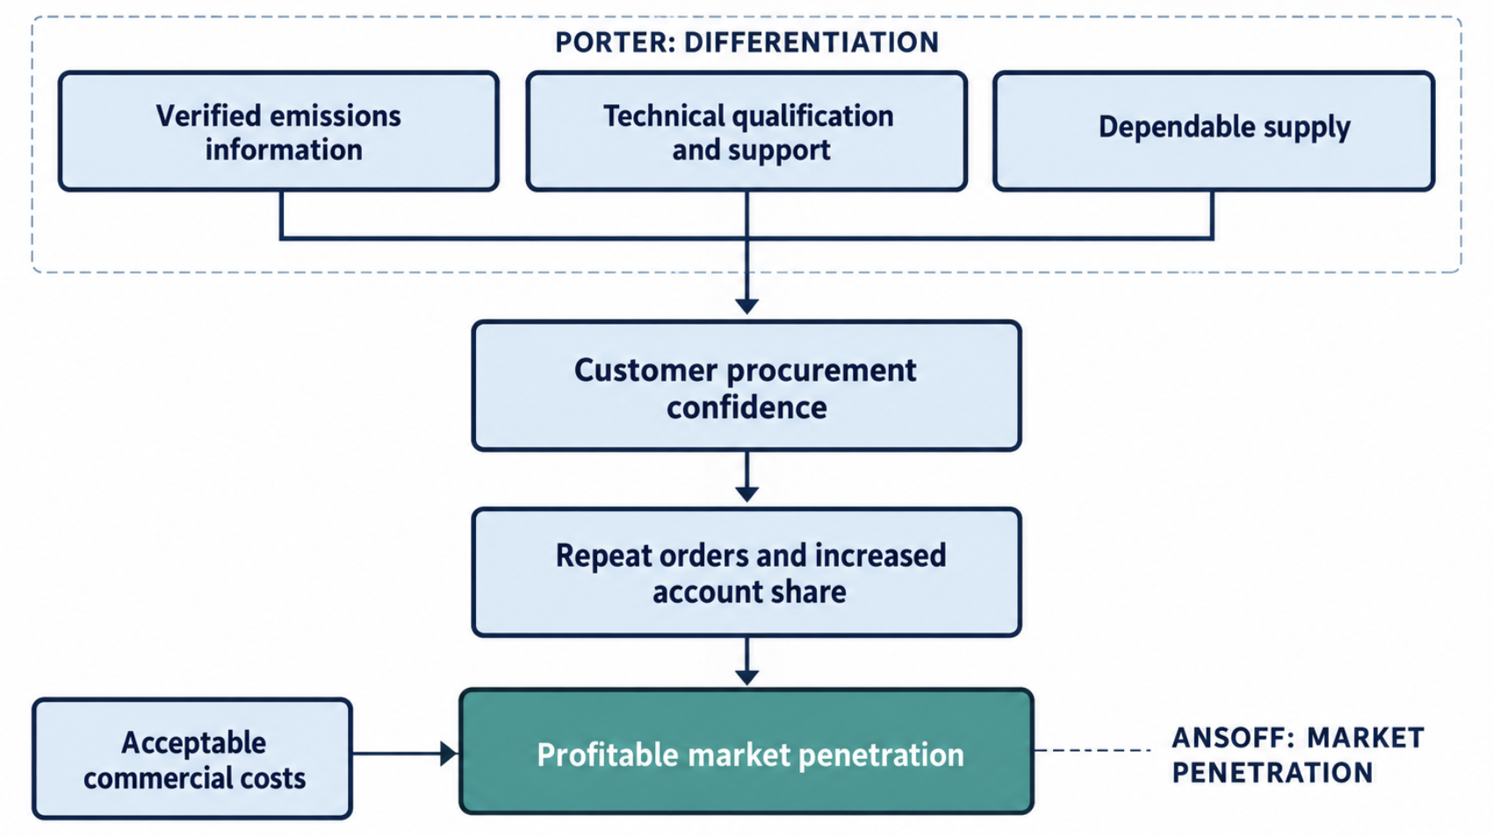
Figure 4. Proposed differentiation mechanism supporting SSAB Zero market penetration , Source: Author’s own work based on Christensen et al. (2021), Kanda et al. (2021), and Vangeli et al. (2023).
Environmental credibility is achieved through product level evidence. Such information can't be replaced by corporate sustainability ratings, as ratings can vary significantly between providers (Berg et al., 2022). In a similar way, when a claim is made in the supply chain, supplier practices must be addressed in addition to only corporate communications (Pizzetti et al., 2021). Therefore it is important that SSAB obtain evidence that procurement teams can use in their own assessment.

Marketing’s Coordinating Contribution
Marketing is contributing by transforming external requirements into decisions with regard to customer selection, service and positioning. It is not just a function of promotion – it is also a function of coordinating technical and evidence, production commitments, and commercial expectations. Research on circular business models reiterates the role of inter-organisational relationships (Geissdoerfer et al., 2020; Kanda et al., 2021).
AI can help with this coordination by pinpointing patterns in accounts and gaps in information. But, automated recommendations should not be without a commercial and technical examination. AI capability and collaboration research shows that the performance is not necessarily reliant on AI but also on complementary organizational resources and human involvement (Mikalef & Gupta, 2021; Chowdhury et al., 2022). This deals with marketing's strategic role as well as the implications of marketing technologies in the future.

Implementation, Measurement and Strategic Limits
The recommendation is converted to the proposed decision process presented in Figure 5. Expansion of the account should only happen when the evidence, technical acceptance and supply feasibility and commercial returns are adequate. This helps stop for example ‘green' interest being interpreted as confirmed demand.
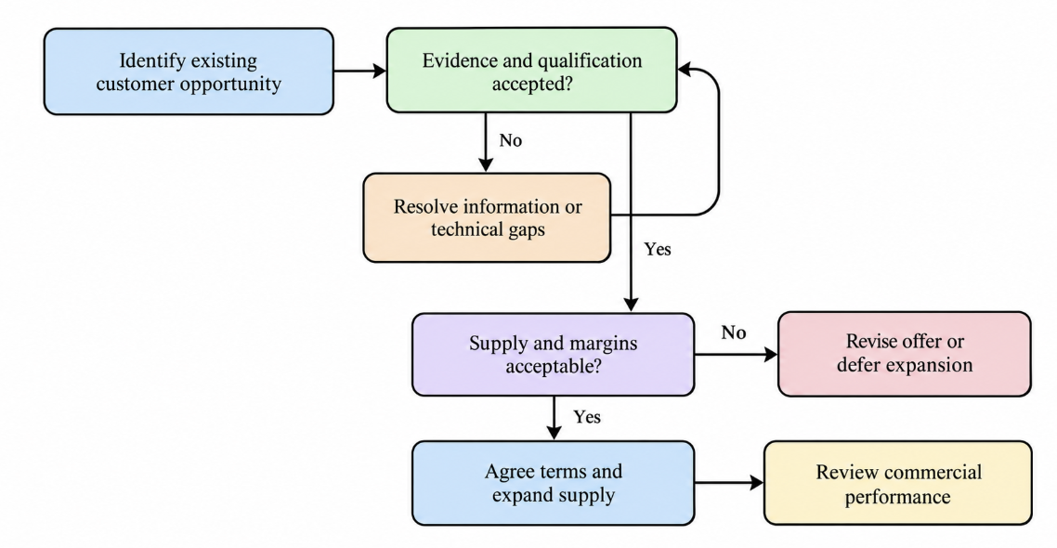
Figure 5. Proposed account-expansion decision process, Source: Author’s own work based on Devlin et al. (2023), Vangeli et al. (2023), and Whittington et al. (2023).
Measures to assess implementation are included in Table 3. The use of numerical targets must be based on an analysis of the school's own baseline, and not simply be plucked from a public source.
Table 3. Proposed implementation measures
Measure | Definition | Decision supported
Repeat-order rate | Eligible customers placing subsequent orders | Whether adoption becomes continuing demand
Account share | SSAB Zero volume relative to relevant customer steel purchases | Whether penetration increases
Qualification conversion | Opportunities completing qualification relative to those entering it | Where technical barriers arise
Contribution margin | Revenue less attributable variable costs | Whether expansion produces commercial value
On-time, in-full delivery | Deliveries meeting agreed timing and quantity | Whether supply commitments are reliable
Documentation completeness | Relevant orders supplied with valid required emissions information | Whether environmental evidence supports purchasing
Source: Author’s own work, informed by Christensen et al. (2021), Vangeli et al. (2023), and Whittington et al. (2023).
Lastly, growth needs to be measured not just by tonnes sold. The question of critical sustainability marketing is whether growth in consumption automatically leads to an improvement in the environment (Lloveras et al., 2022). SSAB should account for profitable customer adoption, as well as credible product level environmental performance, and realise that efficiency gains do not make for sustainable growth.

Task 3: Managerial and Professional Reflection

Development of Analytical Judgement
This analysis reinforced my views on marketing being a strategic process that is linked to the external change and organisational decisions. At first this product with an ‘environmental dividend' seemed to be a simple means for differentiation. But, a review of the evidence revealed that questions of environmental relevance, technical feasibility and commercial attractiveness are distinct. During the research process, I learned that an appealing offer must be delivered in a credible manner and value capture is essential (Vangeli et al., 2023; Sinkovics et al., 2021).
I believe that I'm better able to relate stakeholder behaviour with wider external influences following this approach using PESTLE. Under social factors, I identified when customer expectations are being analysed, as they are related to the changing of society values, sustainability expectations or attitude of customers towards responsible business. Customer behaviour can also be indicative of economic pressures and technological requirements; this classification will be based on the influence investigated. Environmental, economic and technological factors were chosen for this assignment as a coherent basis to explore the pressures, economics and infrastructure availability on emissions. This selection does not (intentionally) bar customers from PESTLE analysis. Rather, it needs to be explained how their purchasing expectations are linked to the selected external influences. Analysis also helped to cement my understanding that these dimensions are intertwined: an environmentally appealing offering must be technically feasible and commercially acceptable (Devlin et al., 2023; Vangeli et al., 2023; Wang et al., 2025).
The additional public-web search yielded 36 records. After removing 16 duplicate entries, 20 records were available to screen for title, abstract, or document-summary. 12 reports were sought to be retrieved and eight records were excluded. Seven complete reports were not retrieved and five remained for use in the eligibility assessment. One descriptive scheduling brief was removed from the review due to a lack of retention or employee-outcome analysis. 4 reports were kept: 2 academic studies and 2 Tesco reports. These counts refer to the supplementary search and are not necessarily representative of the selection for the full bibliography of 34 publications.
A subsequent lesson focused on evidence boundaries. An individual product's profitability cannot be determined from the corporate level operating profit and the operational emissions cannot be substituted for the LCA emissions. Likewise, studies on consumer purchase can not directly show the willingness to pay of industries. Identifying these limitations enhanced the defensibility of my suggestions and helped to clarify the relevance of similar disclosures (Christensen et al., 2021; Testa et al., 2021).

Implications for Managerial Practice
Market penetration would be a conditional recommendation by me as a manager with a staged commercial proof. I will ask for customer interviews, results of technical qualification and margin analysis at the account level prior to setting expansion targets. These will help to determine if the customers see enough value for the proposition to warrant repeat purchases. This is a method that allows linking strategic ambition with the skills needed for its realization (Whittington et al., 2023; Alonso-Martínez et al., 2021).
I would also differentiate between things that I can do and things that I cannot. Marketing will make documentation, communication and opportunity selection better, but will not solve an electricity infrastructure limitation. Luleå postponement illustrates a need for careful communication of future capacity, in addition to communicating existing supply (SSAB, 2025b). My one big takeaway would then be explicit qualification, capacity and commercial returns.
In regard to technology, I would consider using AI to assist with account analysis with the human still accountable for technical and environmental statements. The literature questioned the notion that automation necessarily results in better decision-making. The success of its use is based on the organizational capacity, employee participation, and suitable judgment (Mikalef & Gupta, 2021; Raisch & Krakowski, 2021; Chowdhury et al., 2022).

Professional Development Priorities
I want to focus on development on the issues of greater literacy in life cycle assessment, financial evaluation and customer investigations. These would assist me in making a more thorough judgment about conflicting claims, margins and exploring purchase needs. I would also look for any evidence that goes against the recommendation, such as failed qualification trials and customer rejections of proposed terms.
In general, the analysis helped me to learn how to link the marketing theory with industrial decisions and explicitly handle the uncertainty. Advice must be responsible, which means that they should tell the manager what is known based on the available evidence, and what is unknown and how the manager can fill in the missing information before sending in the resources.

References
Alonso-Martínez, D., De Marchi, V., & Di Maria, E. (2021). Sustainability performance and the role of inter-organizational R&D cooperation. Journal of Cleaner Production, 323, Article 129145. https://www.sciencedirect.com/science/article/pii/S0959652621033321
Bachorz, C., Dürrwächter, J., Gong, C. C., Odenweller, A., Pehl, M., Schreyer, F., Verpoort, P. C., Luderer, G., & Ueckerdt, F. (2026). Averting steel carbon lock-in. Nature Climate Change, 16, 681–689. https://www.nature.com/articles/s41558-026-02635-8
Berg, F., Kölbel, J. F., & Rigobon, R. (2022). Aggregate confusion: The divergence of ESG ratings. Review of Finance, 26(6), 1315–1344. https://academic.oup.com/rof/issue/26/6
Chowdhury, S., Budhwar, P., Dey, P. K., Joel-Edgar, S., & Abadie, A. (2022). AI-employee collaboration and business performance: Integrating knowledge-based view, socio-technical systems and organisational socialisation framework. Journal of Business Research, 144, 31–49. https://www.sciencedirect.com/science/article/pii/S0148296322000819
Christensen, H. B., Hail, L., & Leuz, C. (2021). Mandatory CSR and sustainability reporting: Economic analysis and literature review. Review of Accounting Studies, 26, 1176–1248. https://link.springer.com/article/10.1007/s11142-021-09609-5
Davenport, T., Guha, A., Grewal, D., & Bressgott, T. (2020). How artificial intelligence will change the future of marketing. Journal of the Academy of Marketing Science, 48, 24–42. https://link.springer.com/article/10.1007/s11747-019-00696-0
de Leeuw, G., & Vogl, V. (2024). Scrutinising commodity hype in the Swedish green steel transition. Environment and Planning E: Nature and Space, 7(4), 1844–1867. https://journals.sagepub.com/doi/10.1177/25148486241238398
Devlin, A., Kossen, J., Goldie-Jones, H., & Yang, A. (2023). Global green hydrogen-based steel opportunities surrounding high quality renewable energy and iron ore deposits. Nature Communications, 14, Article 2578. https://www.nature.com/articles/s41467-023-38123-2
Geissdoerfer, M., Pieroni, M. P. P., Pigosso, D. C. A., & Soufani, K. (2020). Circular business models: A review. Journal of Cleaner Production, 277, Article 123741. https://www.sciencedirect.com/science/article/pii/S0959652620337860
Jovičević-Klug, M., Souza Filho, I. R., Springer, H., Adam, C., & Raabe, D. (2024). Green steel from red mud through climate-neutral hydrogen plasma reduction. Nature, 625, 703–709. https://www.nature.com/articles/s41586-023-06901-z
Kanda, W., Geissdoerfer, M., & Hjelm, O. (2021). From circular business models to circular business ecosystems. Business Strategy and the Environment, 30(6), 2814–2829. https://onlinelibrary.wiley.com/doi/full/10.1002/bse.2895
Kanda, W., Kuisma, M., Kivimaa, P., & Hjelm, O. (2020). Conceptualising the systemic activities of intermediaries in sustainability transitions. Environmental Innovation and Societal Transitions, 36, 449–465. https://www.sciencedirect.com/science/article/pii/S2210422420300125
Kazmi, B., Taqvi, S. A. A., & Juchelková, D. (2023). State-of-the-art review on the steel decarbonization technologies based on process system engineering perspective. Fuel, 347, Article 128459. https://www.sciencedirect.com/science/article/pii/S0016236123010724
Keramidas, K., Mima, S., & Bidaud, A. (2024). Opportunities and roadblocks in the decarbonisation of the global steel sector. Energy and Climate Change, 5, Article 100121. https://www.sciencedirect.com/science/article/pii/S2666278723000284
Kumari, R., Verma, R., Debata, B. R., & Ting, H. (2022). Enablers of green marketing: A comprehensive approach for sustainable development. Journal of Cleaner Production, 366, Article 132852. https://www.sciencedirect.com/science/article/pii/S0959652622024465
Lloveras, J., Marshall, A. P., Vandeventer, J. S., & Pansera, M. (2022). Sustainability marketing beyond sustainable development: Towards a degrowth agenda. Journal of Marketing Management, 38(17–18), 2055–2077. https://www.tandfonline.com/doi/full/10.1080/0267257X.2022.2084443
Mikalef, P., & Gupta, M. (2021). Artificial intelligence capability: Conceptualization, measurement calibration, and empirical study on its impact on organizational creativity and firm performance. Information & Management, 58(3), Article 103434. https://www.sciencedirect.com/science/article/pii/S0378720621000082
Neumann, F., Hampp, J., & Brown, T. (2025). Green energy and steel imports. Nature Communications, 16, Article 5302. https://www.nature.com/articles/s41467-025-60652-1
Pizzetti, M., Gatti, L., & Seele, P. (2021). Firms talk, suppliers walk: Analyzing the locus of greenwashing in the blame game and introducing “vicarious greenwashing.” Journal of Business Ethics, 170, 21–38. https://link.springer.com/article/10.1007/s10551-019-04406-2
Raisch, S., & Krakowski, S. (2021). Artificial intelligence and management: The automation–augmentation paradox. Academy of Management Review, 46(1), 192–210. https://journals.aom.org/doi/10.5465/amr.2018.0072
Sinkovics, N., Gunaratne, D., Sinkovics, R. R., & Molina-Castillo, F. J. (2021). Sustainable business model innovation: An umbrella review. Sustainability, 13(13), Article 7266. https://www.mdpi.com/2071-1050/13/13/7266
SSAB. (n.d.-a). Environmental product declarations for SSAB Zero. https://chinafyorigin.ssab.com/en/fossil-free-steel/ssab-zero/epd
SSAB. (n.d.-b). SSAB Zero. https://www.ssab.com/en-us/fossil-free-steel/ssab-zero
SSAB. (2025a, September 17). The deputy prime minister and SSAB’s CEO broke ground on a new steel mill in Luleå. https://www.ssab.com/en/news/2025/09/the-deputy-prime-minister-and-ssabs-ceo-broke-ground-on-a-new-steel-mill-in-lule
SSAB. (2025b, June 19). SSAB postpones commissioning of new steel mill in Luleå by 12 months. https://www.ssab.com/en/news/2025/06/ssab-postpones-commissioning-of-new-steel-mill-in-lule-by-12-months
SSAB. (2026). Annual report 2025. https://www.ssab.com/-/media/files/company/investors/annual-reports/2025/ssab-annual-report-2025.pdf
Testa, F., Pretner, G., Iovino, R., Bianchi, G., Tessitore, S., & Iraldo, F. (2021). Drivers to green consumption: A systematic review. Environment, Development and Sustainability, 23, 4826–4880. https://link.springer.com/article/10.1007/s10668-020-00844-5
Vangeli, A., Małecka, A., Mitręga, M., & Pfajfar, G. (2023). From greenwashing to green B2B marketing: A systematic literature review. Industrial Marketing Management, 115, 281–299. https://www.sciencedirect.com/science/article/pii/S001985012300192X
Wang, Y., Chen, C., Tao, Y., & Wen, Z. (2025). Uneven renewable energy availability and the decarbonization of direct reduced iron production. Nature Communications, 16, Article 4916. https://www.nature.com/articles/s41467-025-59730-1
Whittington, R., Regnér, P., Angwin, D., Johnson, G., & Scholes, K. (2023). Exploring strategy (13th ed.). Pearson. https://eu.pearson.com/exploring-strategy/9781292428819R365
Wu, X., Meng, J., Liang, X., Sun, L., Coffman, D., Kontoleon, A., & Guan, D. (2025). Technological pathways for cost-effective steel decarbonization. Nature, 647, 93–101. https://www.nature.com/articles/s41586-025-09658-9

