Table of Contents
Executive summary 2
Introduction 3
Waste 3
Scarcity of resources 3
Linear economy 3
Circular economy 4
Main body 5
Renault and the circular economy 5
The Future is NEUTRAL 6
The Refactory 7
Challenges 8
SWOT analysis 8
Strengths and Opportunities 8
Weaknesses and Threats 9
Conclusion 9
Bibliography 11

Executive summary
This report provides an analysis of the linear and circular economies as well as a critical analysis of the Renault Group (RG) and its position within the circular economy. The report identifies Renault as a pioneer within the circular economy, using a SWOT analysis to identify areas of improvement.

Introduction

Waste
Humanity is facing both a waste and resource crisis. According to Kaza et al. (2018), global waste was estimated to be 2.01 billion tonnes in 2016 and is expected to reach 3.40 billion tonnes by 2050 if human consumption continues at the current rate. Waste management also requires a significant expenditure to be dealt with. In low-income countries, waste disposal can consume 20% of their municipal budgets; in middle-income countries, this decreases to 10%; in high-income countries, this decreases further to 4%. Waste costs range from $35 per tonne in low-income countries to upwards of $100 per tonne in high-income countries. Waste management also contributes to 5% of greenhouse gas emissions globally; however, implementing suitable systems can reduce these emissions by 25% (Kaza et al., 2018).

Scarcity of resources
Another increasing issue humanity faces is the resource crisis we are in the midst of. A concept known as Earth Overshoot Day was created to track the usage of natural resources. Earth Overshoot Day identifies the day of the year whereby the amount of resources the Earth generates in a year no longer suffices the needs of humanity for that year (Earth Overshoot Day, 2022). In 2022, Earth Overshoot Day fell on the 28th of July; thus, the resources from the equivalent of 1.75 Earths would be required to replenish the resources consumed by humans in 2022; this is the most significant consumption of natural resources since 1971 (Earth Overshoot Day, 2022).

Linear economy
Waste and overconsumption of natural resources are primarily down to the linear economy model. The linear economy, also called the take-make-waste economy, is a model whereby resources are used to create products used by consumers and then discarded as waste (Ellen MacArthur Foundation (EMF), n.d; Santander, 2021). The linear economy is “an economy in which finite resources are extracted to make products that are used - generally not to their full potential and then thrown away” (EMF, n.d). According to Sariatli (2017), one of the main factors that contributed to the adoption of the linear economy was cheap materials and expensive labour, which led to a lack of recycling and upcycling and put an emphasis on waste. The linear economy is seen as a traditional model focusing primarily on profits rather than sustainability (Santander, n.d). The linear economy and thinking have dominated since the beginning of the third industrial revolution, leading to financial growth, albeit at the expense of sustainability (Jørgensen & Pedersen, 2018). According to the EMF (n.d), the linear economy did have its benefits; for example, it enabled the production of goods on a mass scale, which led to greater economic growth and created more industrialised countries, allowing millions of people to be removed from poverty. This economic growth came at the expense of natural capital, slowly degrading the Earth's resources (EMF, n.d). Earth's resources are finite, and many are on course to be depleted (Jørgensen & Pedersen, 2018); therefore, a change to a more circular economy is needed.

Circular economy
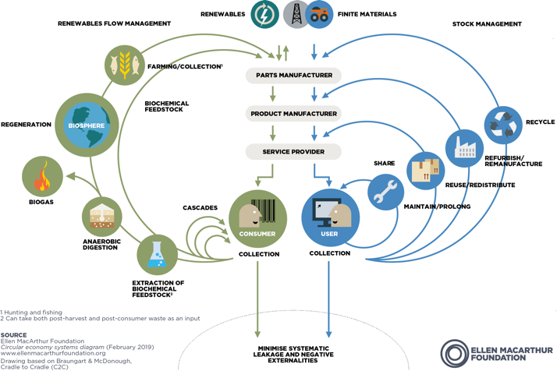
Boulding (1966) first conceptualised the circular economy, stating that “man must find his place in a cyclical ecological system which is capable of continuous reproduction of material” (p. 7-8). Today the circular economy is based on three principles, to “eliminate waste and pollution, circulate products and materials, and regenerate nature” (EMF, n.d-a). The circular economy consists of two cycles: the technical and biological cycles. The technical cycle represents products kept in a cycle through processes such as reuse, repair, remanufacture and recycling, contrary to the linear cycle (EMF, 2019). The biological cycle refers to biodegradable materials that return to the Earth after use (EMF, 2019). Studies show that switching to a circular economy can reduce greenhouse gas emissions by 70% and increase employment by 4% (EMF, 2015).
(EMF, 2019)
The sharing economy is seen as a subset of the circular economy; however, its approach is different, focusing on a bottom-up, peer-to-peer approach rather than a top-down business-to-business approach (Henry et al., 2021). The sharing economy is “a suite of emerging software platforms acting as an intermediary between private buyers and private sellers, allowing them to share their existing resources” (Allen, 2015, p. 25). The sharing economy is linked to the circular economy as it promotes using services rather than owning products. This can help to reduce the number of natural resources consumed, minimise costs and produce less waste (Arup, 2017). An example of the connection between sharing and circular economies is evident in peer-to-peer clothing rental services. This involves renting out clothing items, which helps consumers reduce their expenditures and waste (Waite-Taylor, 2022). With £140 million worth of closed thrown away each year in the UK, 92 million tonnes of textiles discarded as waste globally and the demand for raw materials expected to triple by 2050 (Waite-Taylor, 2022), the sharing economy certainly has a role to play within the circular economy.

Main body

Renault and the circular economy
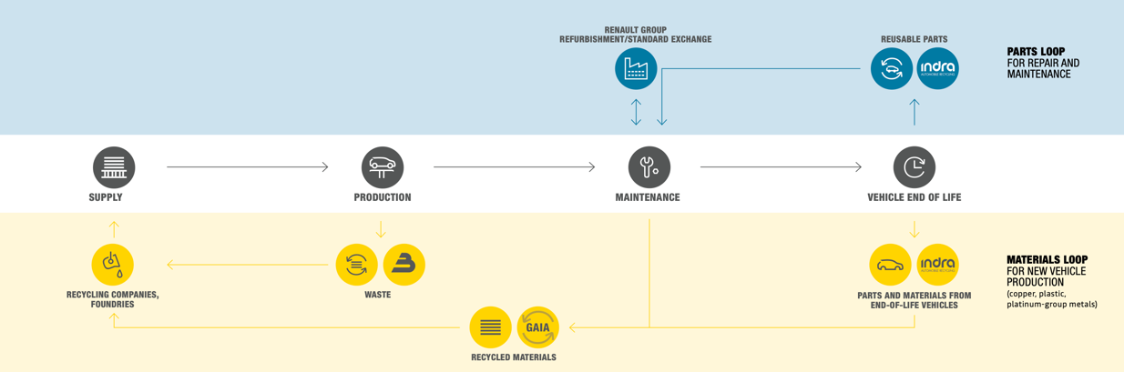
Renault is a French automotive manufacturer founded in 1898 by brothers Fernand, Louis, and Marcel Renault (Renault Group (RG), 2022). Renault is undoubtedly one of the leading global automotive manufacturers, with a market share of 4% (Sigal, 2023). Renault currently produces ten vehicles, consisting of five cars, all of which are available as either hybrid, plug-in hybrids or fully electric, and five vans, two of which are fully electric (Renault, n.d). Renault also has two subsidiary automotive companies, Dacia and Alpine; these three companies all fall under the Renault Group (Renault, 2022). The Renault Group sales amounted to 2,044,112 vehicles in 2022, with Renault accounting for 1,466,729, Dacia for 573,837 and Alpine for 3,546 (RG, 2023). The RG’s success has carried into 2023; in January, three of the top six best-selling cars in Europe were part of the Renault Group, with the Dacia Sandero at number one, Renault Clio at number five and the Dacia Duster at number six (Autocar, 2023).
(Renault Group, 2021)
At the forefront of Renault’s commitment to the circular economy is its ‘Renaulution’ strategic plan, released in January 2021 (RG, 2022a). According to RG (2022a), the ‘Renaulution’ consists of three stages: resurrection, renovation, and revolution. The RG (2022a) states that the resurrection stage focused on becoming more competitive by reducing costs and generating a profit, which was achieved ahead of schedule. The renovation stage focused on renewing their product line-ups which have been achieved. Finally, there is the revolution phase, which lays out RG’s ambition to become a Next Gen automotive company (RG, 2022b).
RG (2021) has been a founding member of the EMF for ten years and is working together to shift from a linear to a circular model. RG is a pioneer and leader in the circular economy, being the first carmaker to incorporate it into its value chain, which it did in 2005. RG also has three subsidiaries dedicated to the circular economy, generating €500 million collectively between 2018 and 2021, with the aim of achieving €1 billion in revenue by 2030 from circular economy activities alone (RG, 2021). These subsidiaries each play a role in Renault's circular economy; firstly, there is Indra, which is owned 50/50 between RG and SUEZ, it dismantles vehicles for parts, batteries, and materials to be recycled (RG, 2021; RG, 2022c). Next is GAIA, which RG fully controls; it repairs vehicle batteries, refurbishes end-of-series parts to be recycled and recycles materials from automotive deconstruction (GAIA, 2022; RG, 2021). The final subsidiary is Boone Comenor, RG owns 33% and shares the remaining percentage with SUEZ (RG, 2021). Boone Comenor helps customers transition from a linear economy to a circular economy by recycling scrap metal, which increases the amount of recycled steel with manufactured cars (RG, 2022c).

The Future is NEUTRAL
To further demonstrate their commitment to the circular economy, according to RG (2022a), the RG founded The Future Is Neutral business, which is a new standalone holding enterprise and the ‘first 360 degrees circular economy business in the automotive industry’. The business accumulates the expertise of the entire RG and its partners, enabling them to create a closed-loop recycling solution for their vehicles, from supplying materials at the beginning of the vehicle’s life to recycling the vehicle at the end of its life. Currently, ‘The Future is NEUTRAL’ covers 50% of the value chain, with the intention of increasing this to 90% by 2030, and with this, it is set to become the leading automotive business with a closed-loop circular economy, not only working with Renault but the entire automotive industry (RG, 2022a).
‘The Future is NEUTRAL’ also aims to become the global leader in closed-loop battery recycling (RG, 2022e). The aim for battery recycling is to recycle as close to 100% of batteries as possible (Trinkwon, 2021), and with the ban on internal combustion-powered cars set to be introduced in 2030, the recycling of batteries from electric vehicles (EV) will be essential for the circular automotive economy (Brand et al., 2020). The primary reason for the creation of the ‘The Future is NEUTRAL’ is because, currently, vehicles are made from 85% recyclable materials; however, just 20-30 % of materials used in the construction of new cars are recycled materials, and the RG see these materials as an underused resource (RG, 2022e). In 2021, ‘The future is NEUTRAL’ generated €750 million worth of profit (The future is NEUTRAL, n.d), showcasing that sustainability is both environmentally friendly and profitable.
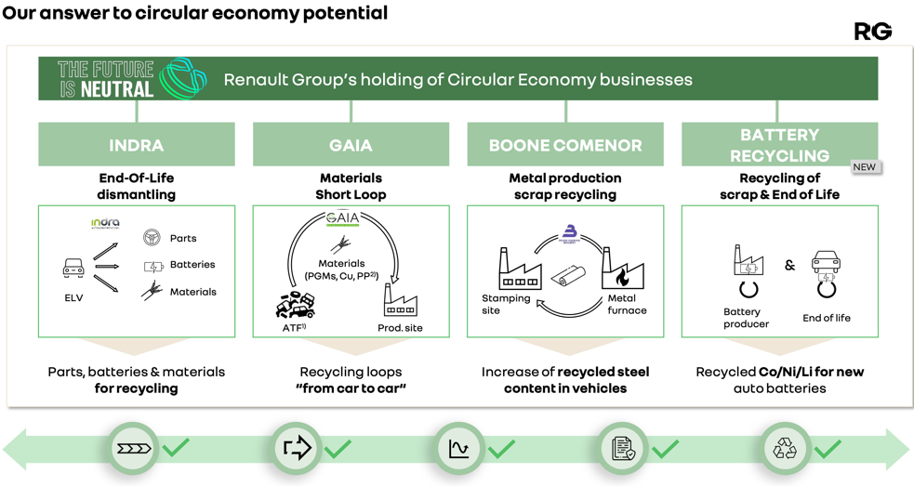
(RG, 2022d)

The Refactory
At the heart of the RG’s circular economy is their Flins plant, the Refactory. The Refactory is Europe’s first dedicated circular economy automotive factory, launched in 2020 in Flins, France (EMF, n.d.-b). The Refactory aims to refurbish 120,000 vehicles, repair 20,000 batteries and use 80% of recycled battery minerals in new batteries by 2030 while achieving €1 billion in revenue (RG, 2022c). The recycling of batteries is crucial, as battery recycling expert Aceleron suggest that in the next 20 years, up to 20 million tonnes of battery waste could be produced (Page, 2020). Another aim for the Refactory is to achieve a negative CO2 balance and provide employment for over 3000 people by 2030 (EMF, n.d.-b).
The plant has four key activity areas; the first two are, Re-trofit, which involves the reconditioning of vehicles and Re-energy, which involves optimising the use of batteries, recycling end-of-life batteries and exploring alternative energy sources (EMF, 2020). The third activity is Re-cycle, which involves dismantling vehicles and reusing or recycling their parts. Finally, Re-start involves educating others about the circular economy, which they will achieve with their ReKnow university (EMF, 2020; RG, n.d.). This university aims to train and educate 20,000 people by 2025, focusing on the circular economy (RG, n.d.).
Remanufacturing is vital in the circular economy, with manufactured parts consuming 80% less energy, 88% less water, using 92% fewer chemicals and generating 70% less waste (EMF, 2020). Remanufactured parts are also 40% less expensive than new parts but are often very similar in quality; RG has remanufactured 112,000 gearboxes, 73,000 engines, 50,000 turbos and 94,000 injectors (EMF, 2020). RG has also launched a similar plant in Spain and has plans to launch plants in Turkey, South America, and Portugal (Economist Intelligence, 2023). By 2030, RG will only produce EVs (Calloch, 2020), aiming to be carbon neutral in Europe by 2040 and globally by 2050 (RG, 2022c). Overall, RG is undoubtedly the pioneer in the automotive industry and must continue leading the way in the circular automotive economy.

Challenges

SWOT analysis
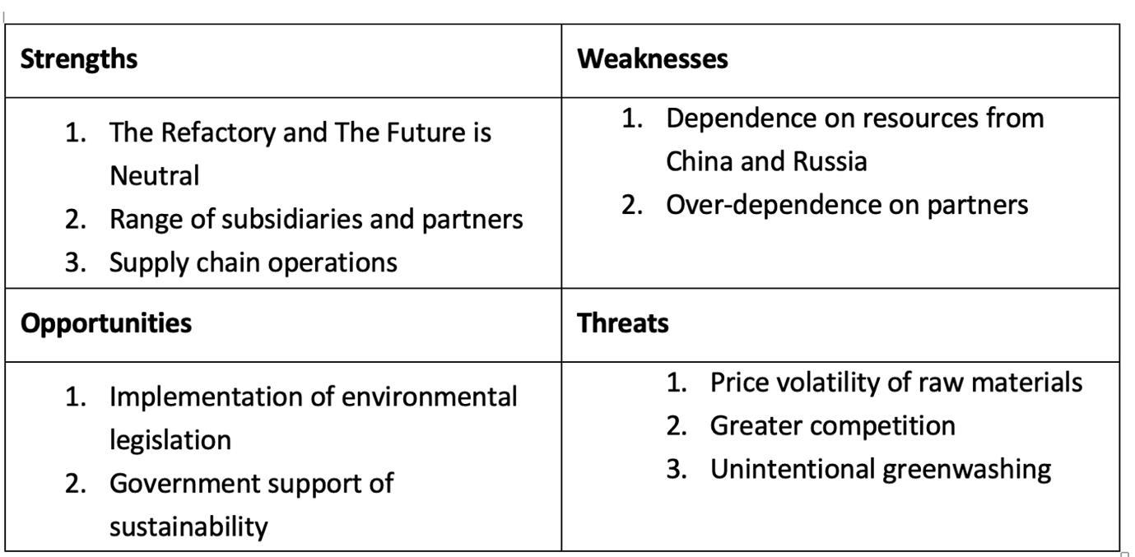

Strengths and Opportunities
One of RG's significant strengths is its innovative approach to the circular economy within the automotive industry. The creation of the Refactory and The Future is NEUTRAL has cemented RG’s position at the heart of the automotive industry. One of its main strengths is its ability to work alongside a network of subsidiaries and partners, enabling them to implement a circular economy (RG, 2022e). These subsidiaries and partners aid with the collection of parts, materials, and batteries for the entirety of the automotive lifecycle (RG, 2022e). Mobilize is RG’s attempt at entering the electric mobility market, not only with vehicles but with its own charging stations and subscription packages (Page, 2022). Horizontal integration has allowed RG to venture into different markets, gain greater market share and diversify its product range, the benefit of this is that it will allow them to have a greater impact on the circular automotive economy. Another strength of RG is its supply chain; RG supports their suppliers in four key areas, human rights and working conditions, regulatory and ethical compliance, and the environment, implementing these values across the entire supply chain (RG, 2021a).
The implementation of legislation such as the End-of-Life Vehicles Directive could prove beneficial to the RG (Department of Agriculture, Environment and Rural Affairs, n.d.). As a market leader, they are a step ahead of all of their competitors regarding sustainability and thus are in the best position should new legislation be enforced. Governments around the world are implementing sustainability strategies, the United Kingdom’s government have already pledged £2.5 billion to EV infrastructure (Department for Transport, 2022); this highlights the potential for procurement opportunities for automotive manufacturers such as RG in the future.

Weaknesses and Threats
One weakness I have identified is RG’s reliance upon its partners. As previously mentioned, RG relies upon its partners and subsidiaries to create its circular economy. This is detrimental as business partnerships can fail due to differing goals and disagreements which could affect RG's circular economy in the future. RG is also reliant on materials from China and Russia. For example, 65% of RG’s cobalt is sourced from China, while 63% of primary aluminium is sourced from both China and Russia (RG, 2022c), and due to the current regulations and geopolitical uncertainty, other sources of these materials will need to be found.
A threat facing RG is the price volatility of raw materials. For example, the cost of lithium has been multiplied by seven in just one year, while the price of steel has been multiplied by one and a half times in the past two years (RG, 2022c). In order to mitigate these risks, RG must have supply chain resilience, this means having multiple sources of materials, which could include recycling and using data and analytics to predict shortages of raw materials and replicate the effects (Juliano et al., 2022).
Another threat I have identified is unintentional greenwashing, the primary source of unintentional greenwashing due to the emissions created by the value chain, known as scope three emissions; these are all indirect emissions across the value chain (Hertwich & Wood, 2018). Scope three emissions account for 75% of organisations' greenhouse gas emissions; however, they can account for 100%, depending on the sector (Lloyd et al., 2022). According to the Boston Consulting Group (2021), just 9% of organisations can measure their greenhouse gases effectively. To avoid unintentional greenwashing, RG must ensure they have comprehensive carbon accounting. A recommendation would be to use AI-supported tools to improve reporting accuracy by 30-50% and reduce emissions by 30-40% (Packaging Europe, 2022). Alongside these threats, RG must be mindful of greater competition from automotive manufacturers entering the circular economy from the likes of Skoda.

Conclusion
The circular economy is crucial for the sustainable development of the entire globe. According to the EMF (2019), the circular economy consists of two cycles, technical and biological, and the RG is associated with the technical cycle within the circular economy. RG aims to extend the lives of vehicles and their components by reusing, repairing, remanufacturing, and recycling as many materials as possible, reducing the number of raw materials they use (EMF, 2020). From my research, I found that RG is a pioneer in the circular automotive economy and is very much the market leader. To combat its threats, RG must have a resilient supply chain, continue establishing itself as a market leader and ensure they complete vigorous reporting of its greenhouse gas emissions. RG’s strategy and impact on the circular economy are undeniable, and customers, fellow automotive manufacturers, and the environment stem to benefit from the standard that RG has set.

Bibliography
About Earth Overshoot Day. (2022). Overshoot Day. Retrieved February 28, 2023, from https://www.overshootday.org/about-earth-overshoot-day/
Allen, D. (2015). The sharing economy. Review., 67(3). https://doi.org/10.3316/informit.546266948792380
Arup. (2017). Circular and Sharing Economy Study. In www.London.go.uk. Ove Arup & Partners Ltd. Retrieved March 2, 2023, from https://www.london.gov.uk/sites/default/files/9._circular_and_sharing_economy_study_0.pdf
Autocar. (2023, February 23). Best-selling cars in Europe so far in 2023. https://www.autocar.co.uk/car-news/new-cars/best-selling-cars-europe-2022
Boston Consulting Group. (2021, October 13). New BCG GAMMA Survey Reveals That Only 9% of Organizations Are Able to Measure Their Total Greenhouse Gas Emissions Comprehensively [Press release]. https://www.bcg.com/press/13october2021-only-nine-percent-of-organizations-measure-emissions-comprehensively
Boulding, K. E. (1966). The economics of the coming spaceship earth. In Environmental quality in a growing economy (pp. 3-14). Retrieved from http://arachnid.biosci.utexas.edu/courses/THOC/Readings/Boulding_SpaceshipEarth.pdf
Brand, C., Anable, J., Ketsopoulou, I., & Watson, J. (2020). Road to zero or road to nowhere? Disrupting transport and energy in a zero carbon world. Energy Policy, 139, 111334. https://doi.org/10.1016/j.enpol.2020.111334
Calloch, V. (2020, June 7). Industry decarbonization: the path is set. Renault Group. https://www.renaultgroup.com/en/news-on-air/news/industry-decarbonization-the-path-is-set/
Department for Transport. (2022, March 25). Electric vehicle charging infrastructure: help for local authorities. GOV.UK. https://www.gov.uk/guidance/electric-vehicle-charging-infrastructure-help-for-local-authorities
Department of Agriculture, Environment and Rural Affairs. (n.d.). End of Life Vehicles. Department of Agriculture, Environment and Rural Affairs (DAERA). Retrieved March 7, 2023, from https://www.daera-ni.gov.uk/articles/end-life-vehicles-0
Ecological Footprint: Advancing the Science of Sustainability. (n.d.). Global Footprint Network. Retrieved February 28, 2023, from https://www.footprintnetwork.org/our-work/ecological-footprint/
Economist Intelligence. (2023, February 17). Automakers move to adopt a circular economy. Economist Intelligence Unit. https://www.eiu.com/n/automakers-move-to-adopt-a-circular-economy/
Ellen MacArthur Foundation. (2020). Europe’s first circular economy factory for vehicles: Renault. https://ellenmacarthurfoundation.org/circular-examples/groupe-renault
EMF. (2015). Growth within: A circular economy vision for a competitive Europe. Cowes, UK: EMF, retrieved from EMF. (2015). Growth within: A circular economy vision for a competitive Europe. Cowes, UK: EMF.
EMF. (2019). The butterfly diagram: visualising the circular economy. Retrieved March 2, 2023, from https://ellenmacarthurfoundation.org/circular-economy-diagram
EMF. (n.d.-a). How does the circular economy create value? Retrieved March 2, 2023, from https://ellenmacarthurfoundation.org/how-does-the-circular-economy-create-value
EMF. (n.d.). What is the linear economy? Retrieved March 2, 2023, from https://ellenmacarthurfoundation.org/what-is-the-linear-economy
European Environment Agency (EAA). Resource efficiency and waste. (2019). Retrieved February 28, 2023, from https://www.eea.europa.eu/themes/waste/intro
GAIA. (2022). About us. GAIA Eco Recyclage Automobile. https://www.gaiaautorecycling.com/en/about-us/
Global trends and the resource scarcity crisis. Let's Do It Foundation. (2021). Retrieved February 28, 2023, from https://letsdoitfoundation.org/waste-info/global-trends-and-the-resource-scarcity/
Henry, M., Schraven, D., Bocken, N., Frenken, K., Hekkert, M., & Kirchherr, J. (2021). The battle of the buzzwords: A comparative review of the circular economy and the sharing economy concepts. Environmental Innovation and Societal Transitions, 38, 1–21. https://doi.org/10.1016/j.eist.2020.10.008
Hertwich, E. G., & Wood, R. (2018). The growing importance of scope 3 greenhouse gas emissions from industry. Environmental Research Letters, 13(10), 104013. https://doi.org/10.1088/1748-9326/aae19a
Jørgensen, S., & Pedersen, L. J. T. (2018). The Circular Rather than the Linear Economy. Palgrave Studies in Sustainable Business in Association With Future Earth, 103–120. https://doi.org/10.1007/978-3-319-91971-3_8
Juliano, L., Bender, J. P., Russell, R., & Hughes, D. (2022, October 14). Gauging the Risks of Raw-Material Volatility. BCG Global. https://www.bcg.com/publications/2022/gauging-risks-of-raw-material-price-volatility
Kaza, S., Yao, L., Bhada-Tata, P., & Van Woerden, F. (2018). What a Waste 2.0: A Global Snapshot of Solid Waste Management to 2050. World Bank Publications. https://doi.org/10.1596/978-1-4648-1329-0
Lloyd, S. M., Hadziosmanovic, Rahimi, K., & Bhatia, P. (2022, June 22). Trends Show Companies Are Ready for Scope 3 Reporting with US Climate Disclosure Rule. World Resources Institute. Retrieved March 7, 2023, from https://www.wri.org/update/trends-show-companies-are-ready-scope-3-reporting-us-climate-disclosure-rule
Packaging Europe. (2022, August 18). Finalist interview: An AI-powered tool for measuring carbon emissions. https://packagingeurope.com/comment/finalist-interview-an-ai-powered-tool-for-measuring-carbon-emissions/8602.article
Page, F. (2020, March 26). Battery technology firm warns of looming EV waste problem. Autocar. https://www.autocar.co.uk/car-news/industry/battery-technology-firm-warns-looming-ev-waste-problem
Page, F. (2022, October 10). Mobilize Duo leads new Renault brand’s electric mobility push. Autocar. https://www.autocar.co.uk/car-news/new-cars/mobilize-duo-leads-new-renault-brands-electric-mobility-push
Renault Group. (2021). On the road to carbon neutrality: Climate report 2021. https://smarttransportpub.blob.core.windows.net/web/1/root/climate-report-renault-group.pdf
Renault Group. (2021a). Responsible purchasing: Renault Group’s commitment. https://www.renaultgroup.com/en/our-commitments/for-a-shared-ethics/sustainable-purchasing/
Renault Group. (2022). The Heritage of Renault Group. Renault Groupe. Retrieved March 3, 2023, from https://www.renaultgroup.com/en/our-company/heritage/
Renault Group. (2022a). Renaulution: everything about our strategic plan. Retrieved March 3, 2023, from https://www.renaultgroup.com/en/our-company/strategic-plan/
Renault Group. (2022b, November 8). Renaulution, now Revolution [Press release]. https://www.renaultgroup.com/wp-content/uploads/2022/11/renault-group-cmd-release-renaulution-now-revolution.pdf
Renault Group. (2022c, October 14). Investor Meeting - ReFactory [Press release]. https://www.renaultgroup.com/wp-content/uploads/2022/10/20221014_investors-rg_flins_-1.pdf
Renault Group. (2022d, October 14). Our answer to circular economy potential. https://www.renaultgroup.com/wp-content/uploads/2022/10/20221014_investors-rg_flins_-1.pdf
Renault Group. (2022e, October 13). The Future is NEUTRAL: The circular economy is stepping into a new era [Press release]. https://www.press.renault.co.uk/en-gb/releases/3012
Renault Group. (2023, January 18). Renault Group 2022 sales results: continued growth in value-creating segments. Media Website. Retrieved March 3, 2023, from https://media.renaultgroup.com/renault-group-2022-sales-results-continued-growth-in-value-creating-segments/?lang=eng
Renault Group. (n.d.-a). Our brands. Renault Groupe. Retrieved March 7, 2023, from https://www.renaultgroup.com/en/our-brands/
Renault Group. (n.d.). ReKnow University. Renault Groupe. https://www.renaultgroup.com/en/talent/reknow-university/
Renault. (2021, June 10). Renault enjoys big success at the CarBuyer Best Card Awards 2022. https://www.renault.co.uk/renault-news/awards-news/renault-enjoys-big-success-at-the-carbuyer-best-card-awards-2022.html
Renault. (2022, October 21). 2022 third quarter: 20.5% increase in revenue & success of new launches [Press release]. https://media.renaultgroup.com/2022-third-quarter-205-increase-in-revenue-success-of-new-launches/?lang=eng
Renault. (n.d.). Vehicle Range - Renault Cars & Vans - Renault UK. Retrieved March 3, 2023, from https://www.renault.co.uk/vehicles.html
Santander. (2021, September 15). Linear and circular economies: What are they and what’s the difference? Retrieved March 2, 2023, from https://www.santander.com/en/stories/linear-and-circular-economies-what-are-they-and-whats-the-difference
Sariatli, F. (2017). Linear Economy Versus Circular Economy: A Comparative and Analyzer Study for Optimization of Economy for Sustainability. Visegrad Journal on Bioeconomy and Sustainable Development, 6(1), 31–34. https://doi.org/10.1515/vjbsd-2017-0005
Sigal, P. (2023, January 17). Renault gains in high-margin compact segment as overall sales slump. Automotive News Europe. https://europe.autonews.com/automakers/renault-gains-compact-segment-overall-sales-slump
Stahel, W. R. (2016). The circular economy. Nature, 531 (7595), 435 – 438. http://doi.org/10.1038/531435a
The Future is NEUTRAL. (n.d.). Who we are. The Future Is Neutral. Retrieved March 4, 2023, from https://www.thefutureisneutral.com/who-we-are/
Trinkwon, W. (2021, March 18). Renault joins project to develop EV battery recycling loop. Autocar. https://www.autocar.co.uk/car-news/industry-news-tech,-development-and-manufacturing/renault-joins-project-develop-ev-battery
Waite-Taylor, E. (2022, May 5). 8 best clothes rental services for every type of occasion. The Independent. https://www.independent.co.uk/extras/indybest/fashion-beauty/womens-clothing/best-fashion-rental-service-womens-wardrobe-online-subscription-dress-designer-a9586991.html

