Week 4 – Profitability, Efficiency and Leverage Ratios
  - Reference
Atrill, P., & McLaney, E. (2018). Chapter 6. Accounting and finance for non-specialists (10th ed., pp. 194–244). Pearson Education, Limited.
  - Exercise 1
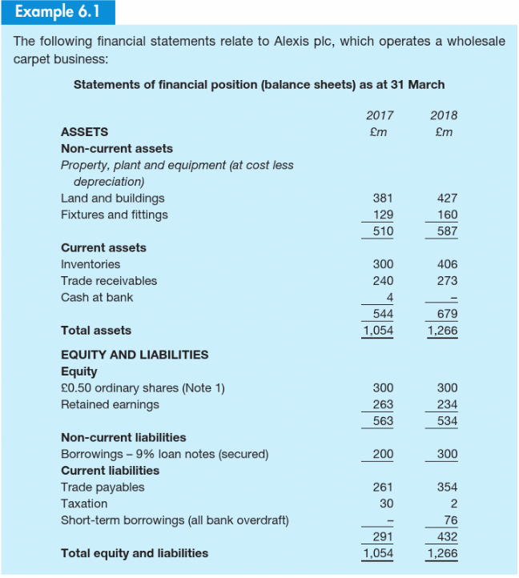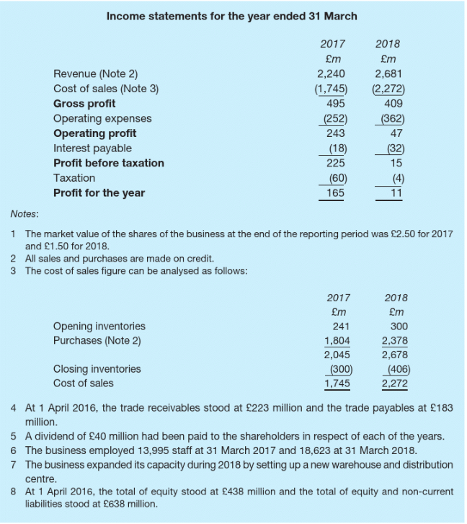
Profitability Ratio:
- Calculate the gross profit margin for Alexis plc for the year 2018.
- Calculate the operating profit margin for Alexis plc for the year 2018.
- Calculate the gross profit margin and the operating profit margin for Alexis plc for the year 2017. What do you deduce from a comparison of the changes (increases or declines) in the gross profit margin and the operating profit margin ratios?
- What do you deduce from a comparison of the changes (increases or declines) in the operating profit margin and the net profit margin ratios?
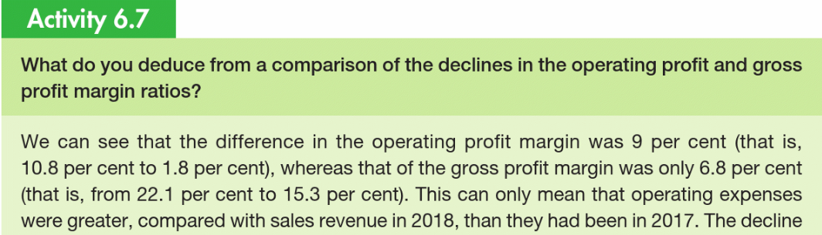

  - Exercise 2
Liquidity Ratio:
- Calculate the current ratio for Alexis plc for the year 2018.
- Calculate the quick ratio (or acid test ratio) for Alexis plc for the year 2018.
- Calculate the current ratio and the quick ratio for Alexis plc for the year 2017. What do you deduce from a comparison of the changes (increases or declines) in the current and quick ratios?
- What do you deduce from a comparison of the changes (increases or declines) in the quick and the cash ratios?
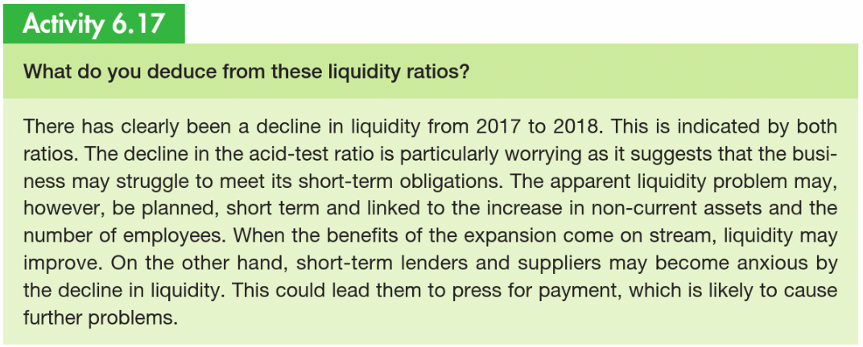

  - Exercise 3
Leverage ratio (financial gearing):
- Calculate the interest coverage ratio for Alexis plc for the year 2018.
- Calculate the debt-to-capital ratio for Alexis plc for the year 2018.
- Calculate the current ratio and the quick ratio for Alexis plc for the year 2017. What do you deduce from a comparison of the changes (increases or declines) in the current and quick ratios? Can you provide some potential reasons of these changes?


