O'Brien, Patrick (P139647)

Major Project
The Golden Bench

Table of Contents
1. Table of Contents 1
2. Introduction 3
1.2. Company A Swansea Site 3
3. Aims and Objectives. 5
4. Reasons for undertaking the project. 7
5. Project Timing Plan 8
6. Literature Review. 9
4.1 Manual handling. 9
a. Good and Bad practices of ergonomics. 11
7. Main Body 12
4.1. Current Situation 12
4.2 Safety and Ergonomics. 14
4.2.1 Assessing Work stations and MSD Risks. 18
6. Progress to date 25
7. Next Steps 29
8. Bibliography 30

Figure 1 - Factors to consider in designing a work station. 18
Figure 2 - Suitable working parameters. 20
Figure 3 - Gesuite Data showing Primary Reasons for accidents at a Pack Station. 22
Figure 4 - Gensuite Data showing Secondary reasons for accidents at a Pack station. 22
Figure 5 - Gensuite data showing tertiary reasons for accidents at a PackStation. 23
Figure 6 - multi pack station corrugate design 24
Figure 7 - Sweet spot drawing of multis pack station. 25
Figure 8 - Single Medium Pack station design. 25
Figure 9- Single Large Pack Station Design. 26
Figure 10 - Single Large Pack station design. 26
Figure 11 - Asset register 27

Introduction

Company A worldwide has over 175 fully operational Fulfilment centers (FC’s) also has over 150 million square feet where associates carryout work within the following departments: Receive, Stowe, Cross Dock, Pick, Pack, and Ship. Company A customers are fulfilled by these associates to over 100 million of them a year are performed in these departments. Company A invests millions of pounds into its operations which in total has come to over 9.3 billion pounds since 2010 and prides itself on its highly skilled and qualified workforce who are constantly thinking and working on innovations to ensure that customer priority is number 1 stating that customer obsession is the way to think. This proves that company A and its work force are always ensuring the best standard and quality is going out to its customers.
Associates are employed in a wide range of positions in Company A’s fulfilment centers, from operations managers to engineers, HR and IT roles to employees who handle customer orders. (Bezos, 2019) States “We strive to have a positive impact on customers, employees, small businesses, the economy, and communities where we’re located. Amazonians are smart, passionate builders with different backgrounds and goals, who share a common desire to always be learning and inventing on behalf of our customers”.
Company A’s European Network is consisting of over 40 FC’s (Fulfilment Centers) and in the United Kingdom there are 18. The European Network however means that Company A’s customers in the United Kingdom can choose between a wide and vast range of products that are able to be internally shipped between FC’s throughout the network, yes this process means it will take a few more days to get to the customer however the products are available to the customers and they will not go without or miss out on the opportunity of a purchase.

Company A Swansea Site

The Swansea FC employs more than 3000 people across multiple departments, Swansea’s center consists mainly of shoes and apparel with a whole department dedicated to only shoes. The Swansea FC consist of 6 different departments:
- Receive – Receive is the department when the items of stock first come into the building, these items are scanned in onto the system which then places the products on the website. This then shows customers the availability and depending on where you live what the delivery times and dates that the items will get to them. They are also sorted in category of where they will be stored.
- Stow – after the products are scanned and received into the building they then go into Stow. Stow is a simple process of scanning an item and then scanning an inventory location to place the products into so there is a virtual and physical trace on the system. The items that are stowed then become customer orders.
- Pick – Once items are stowed and they become customer orders the Picking department is the exact opposite of the Stowe department so the customer orders come up on scanners to highlight where an associate must collect the item, the associate scans the inventory location and then the product to physically and virtually move the item into a container called a black tote which is essentially a temporary inventory location.
- VNA (Very Narrow Aisle) – this department is high racking where associates stow and pick in the same department on PPT’s this department consists of only shoes in boxes and the associates are required to stow and pick whatever customers demand.
- Pack – Packing is where the items go after the picking process, the items are transported via conveyors and are scanned on conveyors to ensure they end up at the right process path, there are several processes in the packing department.
- Ship – once the products have been packed they are placed on a conveyor where there is a shipping label applied to the customer for manifesting. This is then sorted by region and then
Placed on the back of a truck to go to a sort center for delivery to the customers.

Aims and Objectives.

The Aim of this project is to redesign and configure work stations for manual working associates within the pack department. The reason is Company A’s current 177 pack stations have physically reached their End of Life (EOL), are fully depreciated on the asset register, are creating an associate engagement issue, and can’t be upgraded safely due to length of use and number of upgrades and these are now classed as EOL by Engineering. The proposed solution is to replace the majority of these stations with the benchmark pack benches. This department consists of 7 different process paths:
- Wrangle – this process is where the black totes meet on conveyors, associates scan the totes and then place them into batches which will then be sent to various parts of the department to pack.
- Rebin – once the batch has been completed on wrangle there is a multis process path, but before they can be packed the multis process path is on customer which has ordered multiple items, these items have to be packed in the same box or bag packaging. These are then sorted and placed into a rebin wall together which is essentially a bookshelf on wheels and customer orders are placed in the same section to be packed.
- Pack Multis & pack multi XL – this process is consisting of packaging items out of the rebin wall sots and depending on item size an amounts will determine the size of the package to put the customer orders into, these are then put on a conveyor and sent down a SLAM (a SLAM machine stands for Scan Label Apply Manifest) which will then punch the customer details onto the item so it can be scanned by delivery companies in the sort centres to determine deliver route.
- Pack Singles – This process path is packaging items for single orders, the items are in a tote but there are multiple. These items are packed one at a time so the amount in a tote can very and it doesn’t require any other processing.
- Giftwrap – these items are arranged at wrangle and sorted into priorities, these are items that have been paid a premium for and there is a specific process path to handle the gift wrapping for customers, there is a spike in this process around holidays and birthdays etc.
- TBYB (Try Before You Buy) – This is also a separate process path as customers are able to try on items and return them within seven days, if the item is not returned within 7 days they will have to pay for it but if they do it is free of charge.
- Autobag – this is a process within the department which focuses purely on shoes, the shoes are scanned by associates and placed onto a conveyor which then proceeds to the SLAM, once scanned and applied with a manifest label the package in then automatically wrapped in a bag ready for shipping to the customer.
(H.M., 1989) States “The architecture of a design workstation that has the capability of performing concurrent design functions is described. The architecture of a larger system, a Manufacturing Commodity Exchange System, is also defined to illustrate the concept of unified life-cycle engineering. Various research thrusts into design technologies, manufacturing related applications, and information technologies are outlined. When designing new stations the lifecycle and use must be taken into consideration, this must be a long term use and to withstand constant production within the company. These benches and stations will require to take weight up to 50kg at one time consistently.
The objectives are to re design work stations, have them fabricated and fitted in order to increase associate working ergonomics. Improve efficiency within the department and upgrade all equipment to meet current required demand.

The objectives will be laid out in the main body as followed:
- To review the Current Situation
- To fully investigate the Safety and Ergonomics of making modifications.
- Proposed Solution – to assess and design a new station based on the first two objectives.
- To draw conclusions and make recommendations on the work obtained.

Reasons for undertaking the project.

Work base projects are initiated or assigned to help upgrade areas of concern within businesses. (Gulec, 2014) States “As a professional, we participate in several projects through our professional career. Most of the time, we are assigned to a project with a given scope and it is expected to finish the project on time and on budget”. There are 3 reasons the project is undertaken within Company A:

- Safety and Legal background
Within company A these work benches are at end of life and with associates working on them every day across 2 shifts they are in 20 hours use a day. Two shifts working 07:30 – 18:00 and 18:35 – 05:05 with one hour of breaks taken out. These benches are subject to work place injuries whether it be due to fatigue or poor manual handling techniques. (Lyndsey, 2002) States “Due to the complex nature of workers compensation and workplace injury, many legal issues present themselves. 1 out of every 5 people under the age of 40 will have some sort of disability, so it is important to be prepared in the event of a serious accident. There are many legal issues that can arise from a workplace injury, and workers comp claims can be complicated for an employee to navigate. Employees often need the assistance of an attorney experienced in workers compensation to help them assert their right to benefits for loss of wages, medical benefits, rehabilitation and compensation for permanent injuries”.
On average the Swansea site will have 10 claims a year made against them due to work place injuries, these injuries that take place will need to be recorded at the time they happen and passed onto the legal team who will then take it to court to represent the company. If the company are at fault the average claim cost in the last 5 years have been the sum of £40,000.

- Work stations being at End Of Life (EOL)
Due to these current stations having been in operation at company A’s site for 15 years these have fully depreciated and are beyond physical upgrade. With current manual station having to withhold items weighing up to 25kg at a time they will need to be completely replaced in order to withstand this work. (Warner, 2020) States “End of Life (EoL), in the context of manufacturing and electrical product lifecycles, is the final stage of a product’s existence. For product users, EoL also concerns the responsible disposal of the existing product, transitioning to a different product and ensuring that disruption will be minimal. Experts can manage all of these critical tasks in a secured and efficient way, from the diagnostic phase through to the eventual recycling phase”.

- Work stations beneficial for Associates
With these stations being old and at EOL they are creating an associate engagement issue, with complaints being made to local management about the standards of the workstations. In order to prevent any MSD injuries and to raise morale these will be replaced. It will be beneficial if the height is adjustable to suit a wider range of people not to cause discomfort.

Project Timing Plan

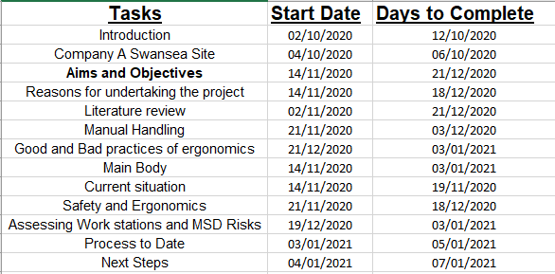

Literature Review.

4.1 Manual handling.

Manual handling in a work place is used in a broad range of activities, it includes pulling, pushing, lifting, and holding, carrying, restraining and throwing. These are usually repetitive and carried out by workers on a daily routine, such as assembly line workers they will pack items, type reports, do quality checks, tighten bolts, fix parts, fit parts, clean areas, pack items, use hand tools and sort parts. Manual handling in a work place if not carried out correctly can lead to injuries in the work place, it is vital that these risks are assessed and made as safe as possible to avoid injuries.
(Morrison, 1991) States "Manufacturing" covers a wide range of industries including: textiles, clothing, footwear, motor vehicle assembly, food processing, pulp and paper, wood products and metal products. The most common manual handling injuries that occur in manufacturing industries are: sprains and strains, back injuries, foot injuries and abdominal hernias. Back pain is a common experience. It can be caused or aggravated by manual handling activities at work, and body postures that are adopted during work”.
As previously stated manual jobs can range from stacking shelves, to computer work, to working on a conveyor line, most jobs require manual work or some sort of manual handling task. If these tasks are not assessed and designed efficiently these can become a hazard. The risks of these tasks can be life changing if accidents are to happen, that is why these must be assessed often with risks being minimized and constant observations of workers daily to ensure all tasks are preformed safely.
(Jefferson, 2018) States
“Identifying hazardous manual tasks
A hazardous manual task is where you have to lift, lower, push, pull, carry, hold or restrain something. It can include:
- repetitive movement
- repetitive or sustained force
- high or sudden force
- sustained or awkward postures
- Exposure to vibration.
These factors stress the body and can lead to a wide range of MSD.

Risk assessment of hazardous manual tasks
You should carry out a risk assessment for any manual tasks that have the potential of being hazardous or you have identified as being hazardous. The only time this may not be necessary is when the risk is well known and you are already aware of how to effectively control it.

A risk assessment of manual tasks will help you identify:
Postures, movements and forces that pose a risk and at what point they may become dangerous.
Why they are happening and what needs to done for it to be fixed.
Don’t forget to also identify and manage the psychosocial risks that can increase the risk of musculoskeletal disorders.
A well-designed work area, work procedures, ergonomically designed tools and equipment will help eliminate or reduce risk factors associated with hazardous manual tasks.
Failure to appropriately manage hazardous manual tasks may result in a breach of WHS laws.
General guidance is available in the model Code of Practice: How to Manage Work Health and Safety Risks and specific advice can be found in the model Code of Practice: Hazardous Manual Tasks and Identify, assess and control hazards.
Designing problems out
The best and most cost effective way to eliminate or minimize the risk of an MSD is to consider manual task hazards and risks during the design and planning stage of a workplace or a job. During this stage, hazards and risks can be ‘designed out’ before they are introduced into a workplace.
Designers, manufacturers, importers and suppliers of plant and structures have duties under the model WHS Act to make sure, so far as is reasonably practicable, that products don’t pose risks to health and safety when they’re used for the purpose they were designed or manufactured for. This includes ensuring they will not result in MSD risks”.

Musculoskeletal disorders
MSD refer to an injury or disease of the musculoskeletal system. The musculoskeletal system supports and protects the body and is made up of the bones of the skeleton, muscles, cartilage, tendons, ligaments, joints and other connective tissues that supports and binds tissues and organs together.
MSD may include:
Sprains and strains of muscles, ligaments and tendons.
Back injuries including damage to the muscles, tendons, ligaments, spinal discs, nerves, joints and bones.
Joint and bone injuries or degeneration, including injuries to the shoulder, elbow, wrist, hip, knee, ankle, hands and feet.
Nerve injuries or compression (for example carpal tunnel syndrome).
Muscular and vascular disorders as a result of hand-arm vibration.
Soft tissue injuries such as hernias.
Chronic pain (pain that lasts longer than three months).
Acute pain (pain that lasts less than three months).
MSD can occur:
Slowly through gradual wear and tear caused by repeated or continuous use of the same body parts, including static body positions.
Suddenly through strenuous activity or unexpected movements such as when loads being handled move or change position suddenly”.

Good and Bad practices of ergonomics.

Working life ranging from an office to a factory floor, if you practice good ergonomics it can help the workforce stay healthy and work safely. If left to own devices they may not realize damage that can be done to bodies and if left untreated after it could progress to have disorders or muscle and joint injuries. Working duties that can lead to these and have poor ergonomics are such as working in awkward positions, poorly set up workstations without correct assessments or surveys and overexerting when lifting, pulling pushing or siting at a station.
Whether sitting in an office all day or moving material in a warehouse, practicing good ergonomics can help workers stay healthy. If left untreated, ergonomic problems can result in muscle and joint injuries. According to the National Safety Council, factors that contribute to poor ergonomics include working in awkward positions; having a poorly set-up workstation; overexerting yourself when lifting, pushing or pulling; and sitting for too long in one position.
(Yafa Levanon, 2012) “States We have known for a number of years that too much time sitting or standing, poor posture, poor ergonomics and task design can have a negative effect on the musculoskeletal system. Research tells us that a sedentary working environment, that is inactivity like sitting for long periods of time, can have a negative impact on your body. In recent years, sitting has had a bad time in the press, and this is likely to continue as more research is done into what is often referred to as ‘the new smoking’.
Often characterized as discomfort and pain in joints, muscles and soft tissues, musculoskeletal disorders (MSDs) are one of the most commonly reported work related illness. The Bureau of Labor Statistics reported that work related MSDs had an incidence rate of 29.8 per 10,000 full-time workers in 2015. This applies to all industries, from sedentary office-based workers through to manual industrial roles. Ergonomists, both practitioners and academics, continue working to increase awareness and reduce the prevalence of MSDs”.

Main Body

4.1. Current Situation

In Company A there are 177 pack stations that have reached End of Life (EOL) these station can’t be upgraded or improved any more as they have surpassed the working life. (Minjung, 2015) States” considering a manufacturer that produces new products and also remanufactured versions of the new products that become available at the end of their life cycle. For such a manufacturer, design decisions at the initial design stage determine both the current profit from manufacturing and future profit from remanufacturing. To maximize the total profit, design decisions must carefully consider both ends of product life cycle, i.e. manufacturing and end-of-life stages”. This unfortunately is not the case, so new designs will have to be sought and researched in order to earn maximum efficiency and throughput with regards to production.
The current layout of stations is in 10 lines with conveyance, 9 of the lines have 17 stations parallel to the conveyor and one line has 18. The conveyance leads to a SLAM (Scan Label Apply Manifest) which is where the shipment label is printed with the customer delivery address on. Once the labels are applied they get automatically sorted on the shipping sorter and then sent out to the various delivery centers for customer delivery. Every station is configured so associates can pack items into packaging where some are heavy and some are small but then after packing are able to push the boxes onto the conveyor while maintaining good manual handling techniques. (R.S.BridgeraS.S.Freidbergb, 1999) States “Manual handling occurs in almost all working environments, though workers in construction, agriculture, hotels and restaurants are most likely to be exposed to heavy loads. Manual handling of loads may cause cumulative disorders due to gradual and cumulative deterioration of the musculoskeletal system through continuous lifting / handling activities, e.g. low back pain. It can also cause acute trauma such as cuts or fractures due to accidents”.
The health and safety department along with Engineering have deemed these stations unfit for future modifications, to meet new customer demand. These will have to be replaced as they are past the life span of this equipment and therefore pose a safety risk to the associates using them.
It is seen that the 177 pack stations have been in continuous use for 15 years that the site have been opened, they have been subjected to many changes and modifications but this has now stretched them beyond the working life of these work stations. These benches have been used through various inventory changes at the site ranging from dog food bulk to hard line goods (HUDSON, 2019) States “A store department or product line primarily consisting of merchandise such as hardware, housewares, automotive, electronics, sporting goods, health and beauty aids or toys would be considered hardline goods”.
Most companies in industry use conveyor belts and conveyor machinery and systems to transport goods over to departments and machines. They are used for raw materials, parts and finished products. They will go through several stages or a process or in and out of a storage facility. It is often to create efficient work stations also.
A worker might move parts or material off the moving belts or place on, or the belts may deliver spares or additional required parts to add to products. This may also be used to create a buffer storage area to be used at a later date. Once a worker has created and finished a certain process of the stage they work on they will place the tem back to the machinery for the next part or next department.
(HSE, Conveyor belt workstation design) States “Conveyor systems can improve efficiency and help to reduce repetitive lifting and carrying, which are causes of MSDs. But unless workstations associated with conveyors are properly designed, with the tasks and the users in mind, work may be done less efficiently and workers may be at increased risk of developing MSDs.
Designing workstations so they can be used safely and comfortably (including providing seats where the work can be done sitting) and reducing the risks of MSDs are requirements of:
The Workplace (Health, Safety and Welfare) Regulations 1992;■■1
The Manual Handling Operations Regulations 1992.■■2”
This is where we are
This is what’s happening
Figures and data of employees being off work.

4.2 Safety and Ergonomics.

When re designing new work stations there are a lot of considerations to take into account. The safety of the structure, the manual handling of workers and overall structure, design and layout. In this instance the workstations have to maintain the current format of being parallel to the conveyance. (HilaryMcDermott1CherylHaslam1StacyClemes1ClaireWilliams2RogerHaslam3, 2012) States “Manual handling activities at work can result in a wide range of musculoskeletal disorders (MSDs). In Europe, the European Union Directive 90/269/EEC – Manual Handling of Loads sets out a hierarchy of measures aimed at reducing the risks of manual handling and training is one of the obligations on employers”.
The initial ergonomic assessment has been undertaken using guidance from the HSE Conveyor belt workstation design guidance document. (HSE, Conveyor belt workstation design) States “This guidance is aimed at conveyor belt workstation designers and suppliers and at the employers of workers using them.
It explains how inadequately designed conveyor workstations can increase the risks of people working at them developing musculoskeletal disorders (MSDs), and the minimum action the law requires”. The optimum height for a standing workstation is specified as 1075mm. This has been tailored to taller employees with the guidance stating that step ups or work platforms should be provided for shorter associates. The current EOL benches at Company A have a work surface height of 900mm.

Task analysis was undertook by the Safety department to see in person and to paint a snapshot in time of how the associates currently work on the current EOL stations to observe and see what can be improved. The documentation is set out as:
(D.Weller, 2020) States “The Job Hazard Analysis tool is used to identify how to perform task step-by-step, any hazards associated with the task and controls to mitigate the hazards.

Purpose

A Job Hazard Analysis (JHA) is an analysis of the hazards and risk associated which focus on identifying and controlling hazards. Utilizing the JHA will provide a process for analyzing the work activities that will identify the tools, materials and equipment needed to develop work methods and procedures for accomplishing the task. The process will identify existing and potential hazards and assessing the risk and identify methods to eliminate or protect against the hazard.

Definitions

Controls: This is how to eliminate or minimize the hazards. There are three types of controls Engineering controls eliminate or reduce exposure to a chemical or physical hazard through the use or substitution of engineered machinery or equipment. This is the preferred control
Administrative controls are changes in work procedures such as written safety policies, rules, supervision, schedules, and training with the goal of reducing the duration, frequency, and severity of exposure to hazardous chemicals or situations.
Personal Protective Equipment (PPE) – Personal protective equipment, commonly referred to as “PPE”, is equipment worn to minimize exposure to hazards that cause serious workplace injuries and illnesses.

Exposure – When an employee enters a “danger zone” by virtue of their proximity to the hazard
Hazard – An unsafe condition or practice that could cause injury, illness, or property damage and is preventable. Examples of hazards include: working at heights, slippery surfaces, exposed moving machinery parts, fire, explosion, noise, electricity, toxic emission, corrosive chemicals, low oxygen, repetitive tasks, heavy lifting, infectious Blood borne pathogens, and assault
Job Hazard Analysis– A process that focus on job task as a way to identify hazards before they result in injury. It focuses on the relationship between the worker, the task, the tools and equipment, and the environment and identifies control to reduce or eliminate the hazard.
Task – Any activity (mental or physical or both) that has been assigned to an employee as a responsibility and carries with it both positive and/or negative consequences based on the performance of that job.

Steps to an Effective JHA (See Appendix A Job Hazard Analysis Form)

Define the scope or the work to be analyzed and watch the work being done.
Involve the employee performing the work Break the job down into small tasks or steps.
Each task or step should be written on the worksheet one by one. Avoid creating steps that are too small, as the analysis may become too long and cumbersome.
Watch the employee performing the work
Ask other employees who have performed the task what the steps to perform the work are
In the Hazard column identify and write down the hazards associated with each task. See Appendix B Common Hazards and Descriptions for types of hazards. Consider every possible thing that could go wrong. Questions you can ask are:
What could go wrong?
What could cause things to go wrong?
What other factors could contribute to an incident or injury to the worker?
How could equipment be damaged?
Next the Control Measure should be developed (See Appendix C Hazard Control Measures). Write down all the possible controls for each of the hazards identified in each of the task. There may be several controls that can be used for each hazard. This may include procedures, practices, and personal protective equipment (PPE)
Controls include and should be implemented in the following sequence:
Engineering – eliminate of the hazard or reduced exposure to the hazard.
Administrative – Reducing the exposure by changing conditions or the way that the work is done.
Personal Protective Equipment – When exposure to hazards cannot be engineered completely out and administrative control cannot provide sufficient additional protection. PPE is the last line of defense.

After finishing listing the tasks, hazards and controls, write down any training that is required to address the hazards, operate equipment or needed to perform the task.
Write down the types of Personal Protective (PPE) that may have to be used to control the hazards.
Review JHA with employees performing the work.
The JHA can always be reviewed and upgraded when new information is needed to be added”.

The report carried out shows the risks in several process paths and it is broken down by path:

- Multi Medium – In this process path there are rebin walls which are essentially a book shelf on wheels that associates use called a rebin wall. These rebin walls are set so multiple items go to the same customer, these items are segregated by slots so there are slide able shelves to increase or decrease space required. These items are then taken out of a rebin wall which is behind the associate and packed on the station.
This process path requires a lot of movement from the associate, the items are placed in a rebin wall so they are physical placing items in and then adjusting shelf space to fit size requirements. The associate then have to turn to take the items out of the all behind them and then in urn turn back to the station to begin packaging. Safe manual handling techniques are critical for this role to ensure no muscular damage is done.

- Single Medium – this process of which an item is packaging items from a black tote and they are singular smaller items for individual customers. The single medium process means that a customer has only ordered 1 item and they are under the weight of 15kg. Therefore the associates that work on the process have to take an item out of the tote and then turn to pack on the station so correct manual handling techniques and ergonomics is a must.

- Single Large – This process is very similar to the single medium process path however the items are over 15kg and are physically large items. It requires the associate to make a box to suit the product, place the product in the box and add dunnage (paper packaging to help protect the item from moving around too much in the box) then seal the box. The safety requirements will be more clinical as the associates are taking heavy items out of totes so there is risk of hurting lower back and muscles to strain or sprain. Then the items are packed on the station so the associates will be lifting and turning with heavy items it is critical that the ergonomics in this path are spot on to avoid any injuries.

- Autobag – This process is shoes so they come in all size and are manually packed from cages. The items are then placed in a bag or a box depending on product and size. The cages are tall and deep so associates are sometimes required to stretch to reach items within and then turn to pack on the stations. Ergonomics is critical and manual handling posture to help not pick up any injuries.

- Gift Wrap – this process requires rebin walls and totes, customers can upgrade the item or items they purchase to receive them gift wrap packed. The associates will be taking any items that can appear in the other processes so heave, light 1 to how ever many ordered so therefore it is crucial to maintain good manual handling techniques as well as being aware of personal limit and turning not twisting to use pack station and equipment.

(HSE, Conveyor belt workstation design) States “Many industries use conveyor systems to transport raw materials and products through the stages of a process and/or to and from storage. It is often efficient to create workstations along the way.
A worker might pick parts or materials from the moving belt, or the belt might deliver a product to a buffer area next to the workstation and then stop until the person activates it again. Once a worker has completed their stage of the process, they might put the product back on the conveyor. Even employees who don’t normally access a conveyor may help to clear blockages, do maintenance or fix breakdowns.
Conveyor systems can improve efficiency and help to reduce repetitive lifting and carrying, which are causes of MSDs. But unless workstations associated with conveyors are properly designed, with the tasks and the users in mind, work may be done less efficiently and workers may be at increased risk of developing MSDs.
Designing workstations so they can be used safely and comfortably (including providing seats where the work can be done sitting) and reducing the risks of MSDs are requirements of:
The Workplace (Health, Safety and Welfare) Regulations 1992.
The Manual Handling Operations Regulations 1992.

Associates are required to move along their work stations and are often collecting inventory from a cart or rebin wall. Providing a step up or work platform increases the risk of a trip or fall and they take up valuable floor space when not in use. For these reasons having a fixed height workstation with additional work platforms for shorter associates is not an optimal solution. Once approval has been achieved, a detailed ergonomic assessment using the MAC Manual Handling Assessment Charts will be conducted to optimize the shelf height and final workstation design before approving the final design drawings. (Smith, 2020) States “The biggest issue with standing desks and sit-to-stand desk risers is that they do not work ergonomically for most people. There are two category of users that most sit stand solutions miss; that's the shorter user or the very tall user.

Be careful that the desk or desk riser meets your height. Important considerations for making the proper choice:

1. Typing or working Position: Make sure that you can type in an L-shape in both the seated and standing position (Keyboard should be below your elbow when typing). This is your most relaxed typing position, shorter people have to slump forward and do chicken wings to type on a standard 29" tall desk. If you are 5' tall you should be typing close to 22" off the floor. Make sure your standing desk meets HFES 100-2007. If you are 6'3" or taller you need to be careful when standing, that the table or desk riser travels tall enough to type in an L-shape as well. If you are typing closer to you’re to your pants waistband then you are most likely extending your wrist which puts stress on your tendons and ligaments.

2. Eye Height: Rule of thumb is that you want your eyes to line up with the top two to three inches of your monitor. That means in both the seated and standing position. For shorter users (5' to 5'5") be careful that the desk riser allows the monitor to adjust properly when seated. Most desk-on-desk will not line up properly, potentially causing head extension. If you are too tall when standing the other possible issue is head and neck flexion. Every inch you move your chin to your chest looking down adds 10 lbs. of additional pressure to your neck and spine. If your chin is touching your chest you are adding close to 40lbs of additional pressure.

If you already have a standing desk and it does not meet your height properly. The easy fix is adding a trackless keyboard tray (perfect for standing desks with a crossbar) and/or a monitor arm.

We've enclosed three sub categories by height (Petite/Smaller User 4'11" to 5'7", Standard User (5'8" to 6'2" and Tall User 6'3" to 6'6").

Perching stools were introduced across site in Q4 2019. Associates are required to adjust the height of the perching stool so that they can rest their buttocks against the stool whilst keeping their feet off the floor. The project has reduced the amount of lower back issues and facilitated an improvement in health of associates with existing lower back issues. Due to the fixed height of our current workstations some AA’s who require a perching stool have been observed bending forward whilst on process which undermines the impact of the stool. As the proposed benches feature a height adjustment alterations can be made by each user to ensure the stool and bench are aligned and provide the maximum level of comfort whilst working.

This helps associates with Temporary Working Adjustments (TWA’s) to be able to work on process even with setbacks and injuries which will allow the workers to still maintain the current climate of work and that the company and still offer the same conditions to take into account. This will also have to be aculates as some will be standing and others will be perching while carrying out working duties. Associates must be able to maintain good standard working practices and manual handling techniques to be able to carry out the role.

4.2.1 Assessing Work stations and MSD Risks.

Conveyor workstations or any workstation with access or a job role that requires to work near a conveyor system must be assessed, designed and installed and maintained to be suitable for the workers who are using them. This will then prove to be safe and secure and minimize MSD risk factors.
With assessing the MSD risks and then in turn designing a station to minimize and mitigate these risks there must be assessments made and variants to take into account such as-
Main risk factors to consider in regards to workstations:
- Height and build of the workers who will be working there.
- What operations or stages of operations will be carried out there?
- What type of objects will staff be working with so size, weight, shape and variety.
- Will the workers be standing, sitting or both?
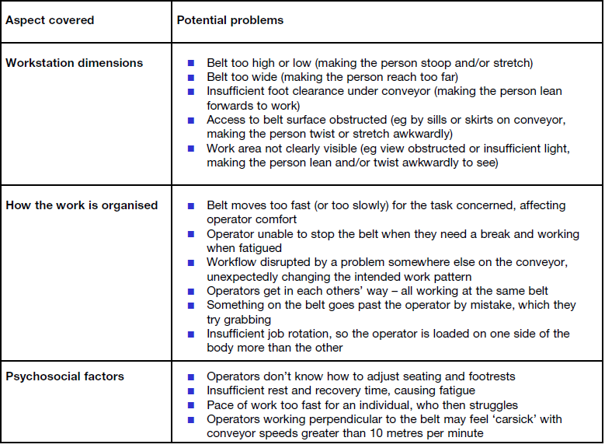
Figure 1 - Factors to consider in designing a work station.

Standing or sitting
Performing any task standing or seated will affect the nature of any task that you perform, they can be performed comfortably or if you aren’t careful it will not be comfortable for the worker. Suitable seating requirements must be met in order for those workers who are sitting to be able to complete the tasks assigned without any discomfort. So if there are sitting workers the heights of individuals will need to be assessed.
Working while sitting down is good to help prevent the risk of fatigue, this can help contribute towards a muscular skeletal injury. A person can also exert a lot less strength while sitting and this has to be considered. A sitting workstation must not require workers to be lifting heavy items so workers must be subjected to low force tasks such as assembling small items on a production line. However heavier tasks that are required to be performed on a large structure are easier to perform lower down and higher objects with smaller task are easier to be performed at height.

Working height
When redesigning workstations there are certain aspects as to the workers needs to be considered in this task, one is the working height of the individual. The preferred working height for an individual depends on:
- The workers stature
- The tasks the worker needs to perform, so what aspect of what process and what they need to be able to see and do.
- The objects they are working with, what are the sizes and the weights.
- The height of the workstation and conveyor around them.
Heavier work which are carried out on larger objects are a lot easier at lower heights to minimize stress and exertion. Higher precision tasks are easy to do at height. For most people standing while working the preferred height is elbow height in order to carry out these tasks.
Because seated tasks and jobs are usually lighter work, the working height of individuals can be closer to elbow height although for not all jobs can be, it is subject to the task in hand.
Working on objects that can differ in size, weight and shape often change considerably at different stages in a process –
Certain steps that are suitable for the requirements should be taken in order to verify what is needed and at what steps of the process with the working height of the conveyor system:
- Nature of the tasks performed.
- Size and weight of working object.
- Whether seating is required.
- Range of structures and statures of people.
The fixed work surface or conveyor height at a work station obviously can’t be provided as a working height suitable for one may not be for another so there must be a standard that can be made to make working height comfortable.

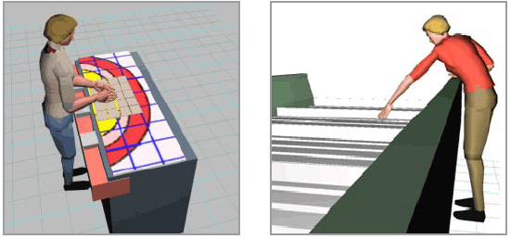
Figure 2 - Suitable working parameters.
In order to clarify point further there have to be specific measures to place in order to create a culture of safety and ergonomics. (HSE, Conveyor belt workstation design) States -
“Suitable methods for achieving each worker’s preferred working height include:
Fixing the belt height above the floor to suit the tallest worker and, so shorter workers can achieve a comfortable working posture, supplying:
An operator-adjustable, variable-height working platform (or chair ––where the job should be done seated), or
A range of suitable interchangeable working platforms to stand on; ––
Providing operator-adjustable, variable belt height to suit the full range of worker statures (although this can present technical and other difficulties);
Providing inclined conveyors to allow workers to find spots at just the right height for them (although this can introduce problems as only a small length of the conveyor is at the right working height – the rest of the conveyor is either too high or too low).
For standing tasks where the arms need to move freely, such as belt picking, or light assembly tasks, the working height assessment should take account of the following:
A fixed work surface height of 1075 mm from floor level is generally suitable as it fits taller members of the adult working population.
This height should be reduced if the worker has to hold their hands above elbow height while working on objects on the conveyor belt.
Shorter conveyor operatives may require platforms up to 265 mm high to stand on to achieve a comfortable working posture.3
Platforms should:
Be stable and have enough room for operators to move their feet, not ––create tripping or slipping hazards;
Have edges clearly marked; ––
Have surfaces contrasting in colour with the floor they are on.––
For seated tasks, which are usually lighter, the working height assessment should take the following factors into account:
The working height can be nearer elbow height.
A working surface height of 750 mm would allow enough space for a
30 mm thick work surface and leave 720 mm from floor level, which is enough for the legs of a large operator.4
Shorter workers may need their seats raised to achieve comfortable postures.
Shorter workers may also need to be provided with a footrest that can adjust up to 165 mm high to provide adequate foot support”.
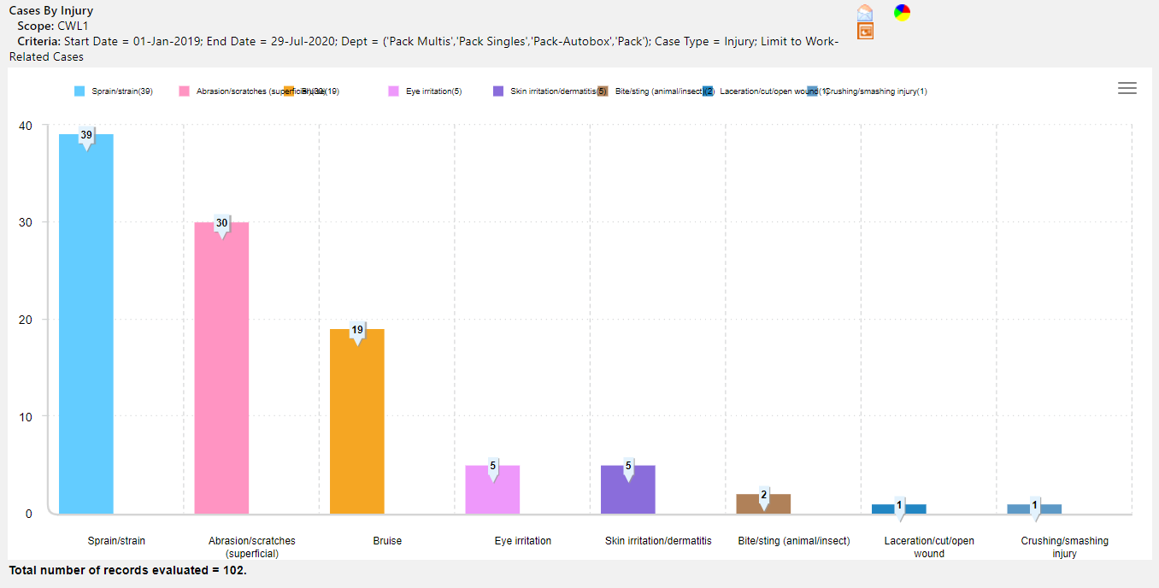
Figure 3 - Gesuite Data showing Primary Reasons for accidents at a Pack Station.
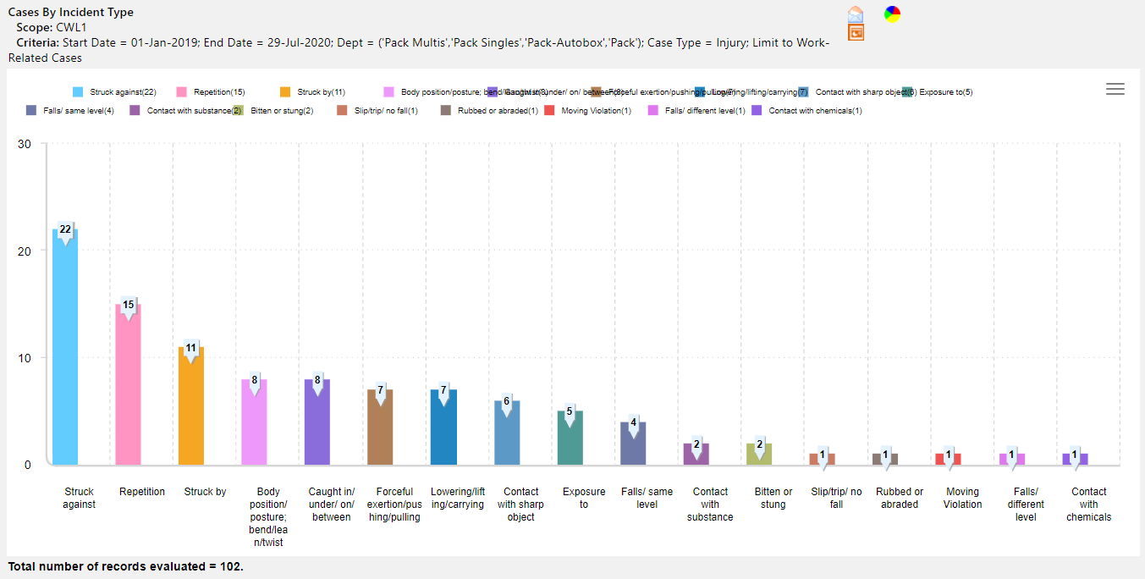
Figure 4 - Gensuite Data showing Secondary reasons for accidents at a Pack station.

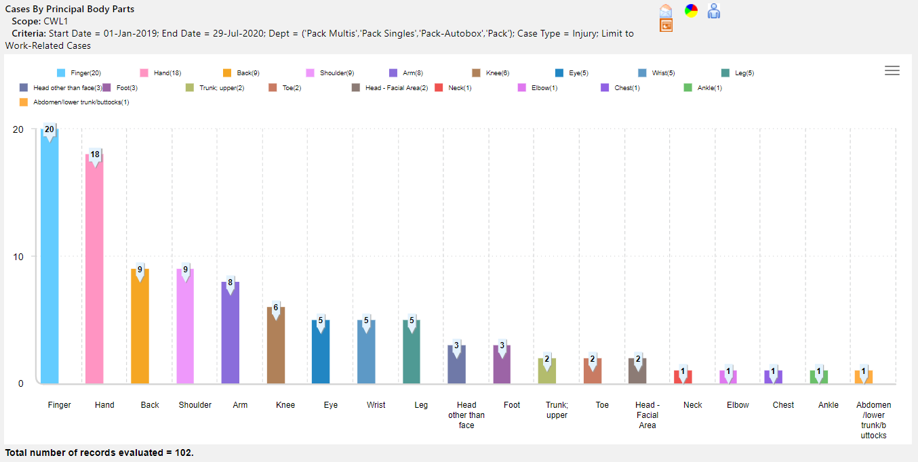
Figure 5 - Gensuite data showing tertiary reasons for accidents at a Pack Station.
Based on gensuite data pulled over the last year the majority of cases have been sprain and strains shown in figure 8. The second majority can be shown as ergonomics errors or issues working in the packing department as shown in figure 9. Lastly these issues have been upper body and therefore with improving the ergonomic of the working duties carried out there should be a decrease in these accidents and injuries.

Progress to date

Within the project so far and to replace the benches at the Swansea fulfiment center there have to be clear standards and expectations drawn up from current inventory usage and corrugate to ensure that all measurements and designs are true and precise.
To get an accurate representation there must be a report run over a year to ensure what is the most used and the most used packaging is to be directly in front of packers to be easily accessible and to help with one piece flow.
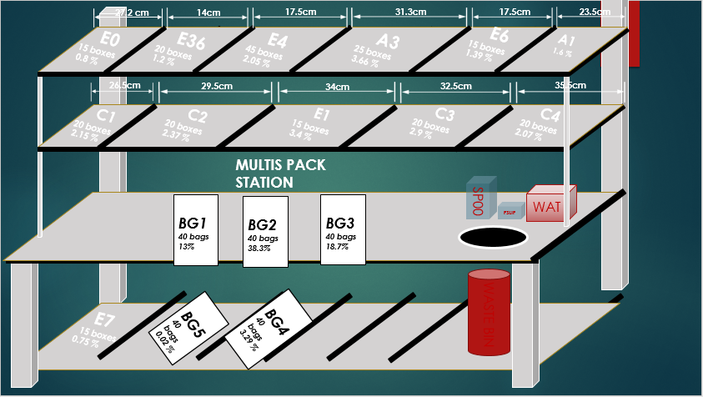
Figure 6 - multi pack station corrugate design
The corrugate shelving has been pulled from data over the year and this sweet spot ensures that the most used are the most accessible for the associates in order for ergonomics to be correct and ensure the easiest process is easily within reach.

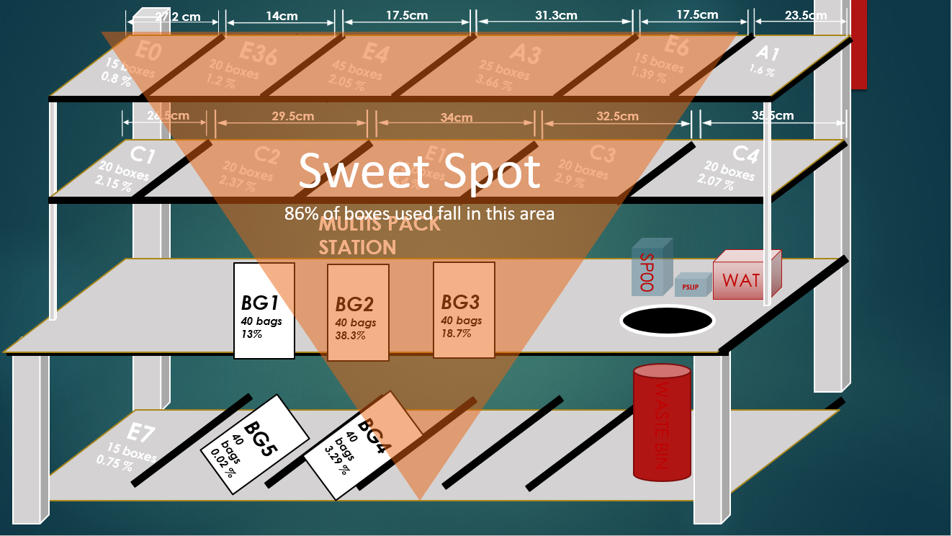
Figure 7 - Sweet spot drawing of multis pack station.
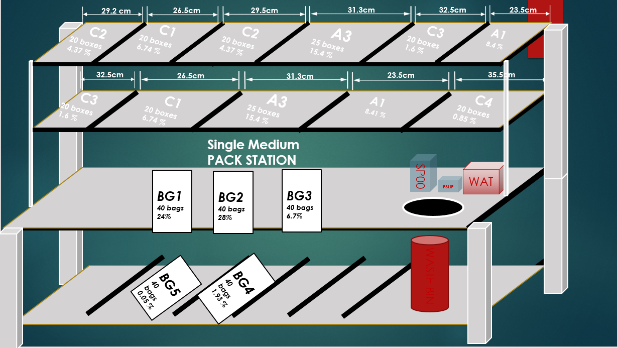
Figure 8 - Single Medium Pack station design.
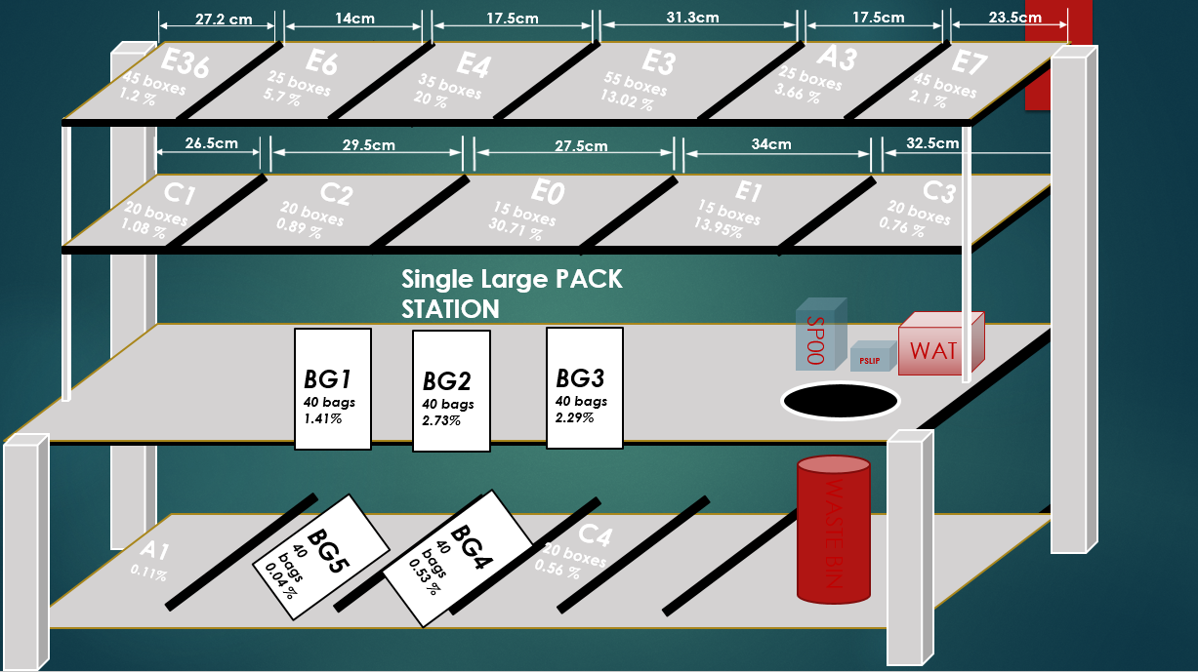
Figure 9- Single Large Pack Station Design.
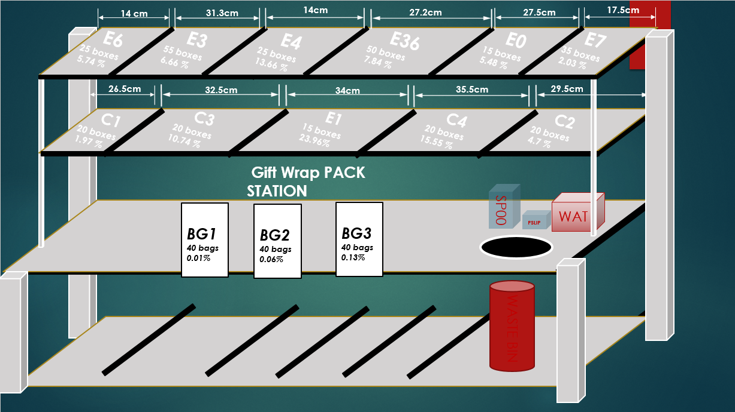
Figure 10 - Single Large Pack station design.
These are the station design layouts to go forward with to ensure all process is lean and to ensure one piece flow within the department.
Figure 11 - Asset register
Figure 12 shows what the Swansea site currently have and what will need to be replaced in order to ensure the EOL benches are fully fit for operational purpose.

Next Steps

In order to ensure this project is successful the next steps to carry out are as follows:
- Work with safety to ensure a true ergonomic test is carried out to benefit associates.
- Benchmark the equipment to ensure it meets company A standards.
- Verify design with engineering and IT to ensure work is true, complete and a true representation of operations.
- Source quotations for the manufacture of the benches and attachments.
- Vendor strategy
- Sourcing and labor costing with procurement.

Bibliography
Bezos, J. (2019, november 3rd). Amazon Fulfilment. Retrieved from About Amazon: https://www.aboutamazon.com/our-company/about-amazon
D.Weller. (2020). Job Hazard Analysis (JHA). Raleigh: env-health-occ-safety.
Gulec, R. (2014). Why are projects Initiated? Project Management, 7-8.
H.M., B. (1989). Design for Manufacturing and the Life Cycle. Theory 88, 302-312.
HilaryMcDermott1CherylHaslam1StacyClemes1ClaireWilliams2RogerHaslam3. (2012). Investigation of manual handling training practices in organisations and beliefs regarding effectiveness. International Journal of Industrial Ergonomics, 206-211.
HSE. (Conveyor belt workstation design). Ergnomics. London: 2020.
HUDSON, M. (2019, June 06). Retail goods. Retrieved from Retail, Small business: https://www.thebalancesmb.com/hardline-and-softline-goods-in-retail-2890191#:~:text=A%20store%20department%20or%20product,would%20be%20examples%20of%20softlines.
J.Foss, T. (2017). What Drives Business Model Adaptation? The Impact of Opportunities, Threats and Strategic Orientation. Long Range Planing, 567-581.
Jefferson, H. (2018, 07 15). Lifting, pushing and pulling (manual handling). Retrieved from Safe Work Australia: https://www.safeworkaustralia.gov.au/manual-handling
Lyndsey, D. J. (2002). Legal Issues and Workplace Injuries. Orlando: 209 south ave howard and tampa FL 33608.
Minjung, K. H. (2015). Design for life-cycle profit with simultaneous consideration of initial manufacturing and end-of-life remanufacturing. Engineering Optimization, 18-35.
Morrison, J. T. (1991). Assessing Manual Handling tasks. Manual Handling in the Manufacturing industry, 3-5.
R.S.BridgeraS.S.Freidbergb. (1999). Managers' estimates of safe loads for manual handling: evidence for risk compensation? Safety Science, 103-111.
Smith, J. (2020, November 12). Standing Ergonomics. Retrieved from Ergoprise Ergonomic : https://www.ergoprise.com/standing-desk-by-height-of-user/
SriIndrawatiMuhammadRidwansyah. (2015). Methodology. Manufacturing Continuous Improvement Using Lean Six Sigma: An Iron Ores Industry Case Application, 528-534.
Warner, D. (2020, November 3). End-of-life management for electrical equipment. Retrieved from Socomec : https://www.socomec.com/end-of-life-management_en.html
Yafa Levanon, A. G. (2012). Ergonomics. Reducing musculoskeletal disorders among computer operators: comparison between ergonomics interventions at the workplace,, 55:12, 1571-1585.

