

Student name: Rosy Kanyiki

Student ID: 2427696

Module name: Introduction to Physiology

Module code: BMHP5023

Lecturer name: Dr Soban Sadiq

Assessment: Component 1: Written Assignment (Case Study Report)

Table of Contents
1. Introduction 3
2. Blood Sugar Regulation 3
3. Cellular Metabolism 5
4. Recording and tracking blood sugar levels for type 2 diabetes 8
5. Recommendations 9
6. Conclusion 10
Reference list 11

1. Introduction
Diabetes mellitus is a chronic metabolic disorder characterised by the sustained increase in the level of blood glucose. Diabetes can be classified into two broad types, namely Type 1 diabetes, which is caused by the autoimmune destruction of pancreatic beta cells, thus causing minimal or no insulin to be produced in the body, and Type 2 diabetes, where the insulin resistance occurs within the body or the pancreas is unable to produce the required insulin. There are 4.3 million diabetes patients in the UK, most of whom have Type 2 diabetes (Diabetes UK, 2023).
Several risk factors lead to the occurrence of Type 2 diabetes, obesity, sedentary lifestyle, unhealthy eating habits, ageing and genetic predisposition are included. Some of the ethnic groups in the UK, especially the South Asian groups and the African Caribbean, also exhibit a greater vulnerability to developing the condition. Diabetes has a close relationship with the endocrine system, where the pancreas is an endocrine gland that produces hormones like insulin and glucagon that help to balance the level of glucose within the blood.
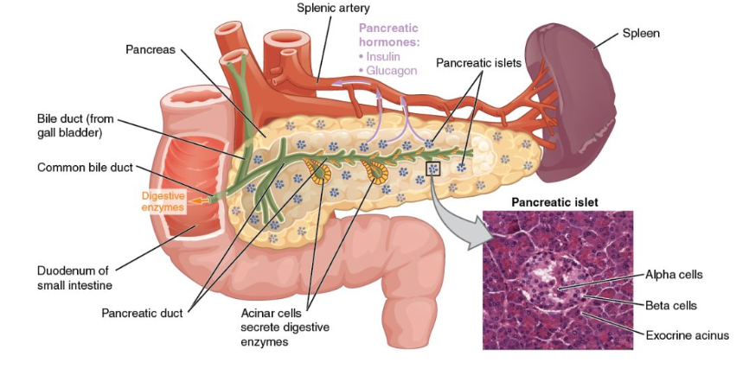
Figure 1: Pancreas and insulin production within the endocrine system
(Source: Hutchins et al., 2025)

2. Blood Sugar Regulation
Importance of Blood Glucose Regulation
Blood glucose regulation is an essential process that helps in maintaining a normal amount of energy supply in the body and eliminating any undesired changes in the amount of glucose (Prendin et al., 2023). Most body cells, especially the brain, depend on glucose as the main energy source. The close physiological range of blood glucose is vital to meeting metabolic stability and survival necessities. Normal patients have a normal range of fasting blood glucose of 4-7 mmol/L (Prendin et al., 2023). Any deviation outside this limit can lead to hyperglycaemia, which can affect the functioning of the body. Blood sugar levels are maintained through the hormonal action of insulin and glucagon.
Role of the Endocrine System in Blood Glucose Control
The pancreas dominates the endocrine system, which largely regulates the level of blood glucose in the body. The pancreas has special clusters of endocrine cells, and these groups are called the Islets of Langerhans (Liu et al., 2022). They produce hormones involved in the metabolism of glucose. The two important hormones in this process include insulin, secreted by beta cells, and glucagon, secreted by alpha cells. The workings of these hormones are based on a negative response in which they are used to create glucose homeostasis. The process regulates the levels of glucose within a secure physiological range.
- Insulin in Lowering Blood Glucose: Insulin enhances the absorption of glucose into body cells, especially the skeletal muscle, the liver and adipose tissue. However, when blood sugar levels rise on consumption of food, especially after taking carbohydrates, the beta cells of the pancreas sense this elevation, and it causes the release of insulin into the blood (Yuan et al., 2022). The glucose can be used directly by these cells to generate energy by cellular respiration or stored as glycogen by the glycogenesis cellular process. This process minimises the level of blood sugar by normalising blood glucose levels. Insulin also suppresses the manufacture of glucose in the liver, which also helps prevent excessive blood sugar levels.
- Glucagon in Increasing Blood Glucose: The blood sugar levels decrease during the fasting periods, during the intervals between meals or during severe exercises, the pancreas produces glucagon (Hædersdal et al., 2023). This hormone works predominantly on the liver by increasing the degradation of glycogen in the liver to glucose by glycogenolysis. Also, glucagon enhances gluconeogenesis, which involves the production of glucose from non-carbohydrate sources like amino acids. These mechanisms make glucagon raise the level of sugar in the blood so that body organs like the brain do not encounter a shortage of energy.
The mechanism of regulation fails in Type 2 diabetes patients because the body cells fail to react efficiently to the insulin signals of insulin resistance. This leads to poor absorption of glucose into cells, leading to further hyperglycaemia. Moreover, chronic and repeated elevation of blood glucose can cause blood vessels and organs to rupture, creating complications such as cardiovascular disease, kidney failure and neuropathy.
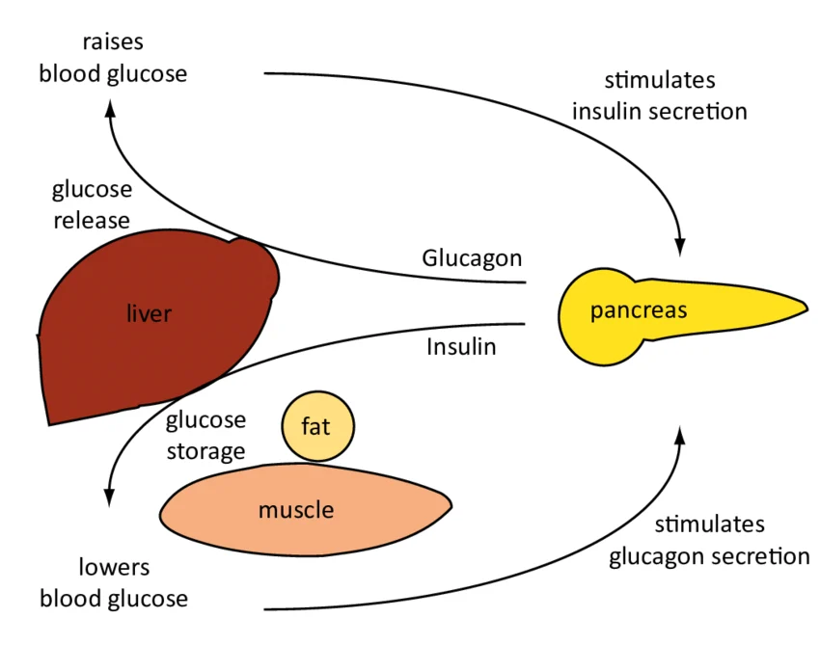
Figure 2: Hormonal regulation of blood sugar by insulin and glucagon
(Source: Hædersdal et al., 2023)

3. Cellular Metabolism
Overview of Cellular Metabolism
The cellular metabolism is described as the chain of biochemical reactions that transform nutrients into energy needed for physiological activities (González et al., 2023). Cellular respiration is one of the most vital metabolic processes in the body of a human being. Glucose and oxygen are used to generate adenosine triphosphate (ATP), which is the major energy currency in the cell. This is necessary to assist other crucial biological functions like muscle contraction, transmission of nerve impulses, repair, and growth of cells.
The carbohydrates in the food are converted into glucose and transported to the body cells through the bloodstream. Insulin is an essential aspect in the metabolism for the absorption of glucose by the cells, particularly in muscle and fat tissues (Yuan et al., 2022). This process is known as a metabolic reaction when glucose enters the cell. This process generates ATP, which is utilised to supply energy in the cell processes.
Role of Oxygen and Glucose in Energy Production
Production of energy in cells takes place in the form of aerobic respiration, and it demands glucose and oxygen (Feng et al., 2023). It is a metabolic pathway that takes place mainly in the mitochondria and is composed of 3 major stages, including glycolysis, the Krebs cycle and the electron transport chain.
Glycolysis is a process that takes place in the cytoplasm, and the molecules of glucose are disaggregated into a product known as pyruvate (Bauer et al., 2022). The result of the process generates a low amount of ATP and electron carriers like NADH. Even though the process of glycolysis does not involve the direct use of oxygen, it is regarded as the first step that prepares glucose to be converted to additional energy. The pyruvate molecules are then transported to the mitochondria, where they are subjected to the Krebs cycle. Electron carriers are further synthesised in this step, and these transfer the high-energy electrons to the last step of cell respiration.
The electron transport chain happens in the inner part of the mitochondrial membrane, and it is also the one that produces most of the ATP. Oxygen is important in this step since it plays the role of the ultimate electron acceptor, which enables the metabolic process to take place effectively (Bauer et al., 2022). Oxidative phosphorylation leads to the production of large quantities of ATP that are sufficient to survive in the cell. In the absence of oxygen, such a process cannot go on efficiently. In this way, cells resort to anaerobic respiration, which generates very low ATP.
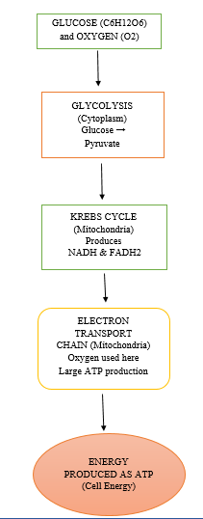
Figure 3: Role of oxygen and glucose in producing energy
(Source: Author)
Cellular Metabolism and Type 2 Diabetes
The insulin sensitivity is lowered in the cellular metabolism of Type 2 diabetes patients. Insulin resistance fails to enable glucose to get into the cells effectively, resulting in elevated levels of blood glucose with a shortage of the cells' primary energy supply (Berbudi et al., 2025). The energy imbalance can result in energy loss, reduction of cell productivity and irreversible damage to tissues. Furthermore, chronic hyperglycaemia is among the factors of oxidative stress and inflammation that are leading to the major causes of diabetic complications such as cardiovascular disease, neuropathy and renal impairment.

4. Recording and tracking blood sugar levels for type 2 diabetes
Importance of Monitoring Blood Glucose Levels
Blood glucose control is essential for Type 2 diabetes patients. Monitoring blood glucose level allows diabetic patients and their medical teams to evaluate the extent of blood sugar control. Frequent monitoring assists in obtaining valuable data regarding the bodily response to the consumption of food, physical exercises, changes in medicine and lifestyle (Hina and Saadeh, 2022). This helps in keeping blood glucose levels in a safe physiological range to reduce short and long-term diabetes complications.
Self-monitoring of blood glucose energy can be performed by patients with Type 2 diabetes. The devices are used to check the glucose levels in the blood and give instant feedback on whether the glucose levels are within the recommended range or not (Hina and Saadeh, 2022). Moreover, tracking of blood glucose levels allows patients to learn the trends of their glucose swings and make opportunities to choose the dietary intake, medication, and physical activity.
Benefits of Recording Blood Glucose Data
Monitoring the blood glucose levels at different times helps an individual and medical personnel to determine patterns and trends in the blood glucose level. Monitoring blood sugar post-meal would enable people to know the influence of certain foods on their glucose level and thus make healthier food-related choices. Besides that, documented information can help medical professionals determine whether the existing interventions are effective or when changes may be made (Kieu et al., 2022). It is especially critical for those who use drugs like metformin or insulin, and their doses might have to be changed to ensure the best glycaemic control. Structured glucose monitoring is proposed as a component of comprehensive diabetes management by the National Institute for Health and Care Excellence.
Consequences of Not Monitoring Blood Glucose
Individuals with Type 2 Diabetes may face the threat of acute and chronic complications if the level of blood glucose is not constantly monitored. In the long run, hyperglycaemia may cause damage to blood vessels and organs that cause severe complications, which include heart diseases, kidney diseases, nerve damage and loss of sight (Schleicher et al., 2022).
Moreover, uncontrolled diabetes is essentially a large healthcare burden in the UK. It was observed that over 100 lower-limb amputations per week in the UK are due to diabetes-related complications, which in turn can be avoided through proper management and monitoring of the disease (Mottolini, 2023). Hence, frequent monitoring and recording changes related to the levels of blood glucose are essential to facilitate effective management of the condition in the case of people with Type 2 diabetes.

5. Recommendations
- Dietary Modification: Low glycaemic index food is very useful for reducing constant blood sugar levels and reducing insulin resistance (Młynarska et al., 2025). Additionally, dietary modification is also necessary to minimise the use of refined carbohydrates and sweet foods because they elicit abrupt spikes in the blood sugar level. Therefore, to prevent the high risk factors of diabetes, patients should consume a healthy diet.
- Regular physical activity: Maintaining moderate intensity exercise at least 150 minutes per week, Such as riding and swimming. Exercise enhances insulin sensitivity to allow the body cells to use glucose better (Rietz et al., 2022). Exercise is also able to decrease body weight, decrease blood pressure and improve cardiovascular health, which are significant in controlling diabetes.
- Weight management: Type 2 diabetes can be maintained through a 5-10% reduction in body mass, as it helps in the management of blood glucose (Hutchins et al., 2025). Weight management can be executed successfully through a proper dietary plan.
- Medication Adherence and Medical Monitoring: Patients need to take prescribed medicine, such as metformin treatment or insulin treatment. It is proposed to perform constant medical check-ups, blood work and glucose tests to determine the efficiency of the treatment. Along with that, diabetes patients must follow all the guidance given by the healthcare practitioner to avoid the risk of medication errors.
- Health Promotion and Education: Promotion of health in society can focus on how to raise more awareness on how to prevent diabetes, healthy eating and exercise. Sustainable lifestyle behaviours can be adopted by individuals through the provision of healthcare services and community services.

6. Conclusion
In conclusion, it can be stated that Type 2 diabetes should be controlled through appropriate regulation and monitoring of blood glucose. The knowledge of physiology, including the functioning of insulin and cellular metabolism, helps to control the disease better. Health behaviour change and observational and evidence-based healthcare practises are significant to prevent complications and enhance the general well-being and health of patients.

Reference list
Bauer, J.A., Zámocká, M., Majtán, J. and Bauerová-Hlinková, V. (2022) ‘Glucose Oxidase, an Enzyme “Ferrari”: Its Structure, Function, Production and Properties in the Light of Various Industrial and Biotechnological Applications’, Biomolecules, 12(3), pp. 46–72. Available at: https://doi.org/10.3390/biom12030472.
Berbudi, A., Khairani, S. and Tjahjadi, A. (2025) ‘Interplay Between Insulin Resistance and Immune Dysregulation in Type 2 Diabetes Mellitus: Implications for Therapeutic Interventions’, ImmunoTargets and Therapy, 14(6), pp. 359–382. Available at: https://doi.org/10.2147/itt.s499605.
Diabetes UK (2023) How Many People in the UK Have diabetes?, Diabetes UK. Available at: https://www.diabetes.org.uk/about-us/about-the-charity/our-strategy/statistics (Accessed: 11 March 2026).
Feng, Y., Chen, Y., Wu, X., Chen, J., Zhou, Q., Liu, B., Zhang, L. and Yi, C. (2023) ‘Interplay of energy metabolism and autophagy’, Autophagy, 20(1), pp. 4–14. Available at: https://doi.org/10.1080/15548627.2023.2247300.
González, P., Lozano, P., Ros, G. and Solano, F. (2023) ‘Hyperglycemia and Oxidative Stress: An Integral, Updated and Critical Overview of Their Metabolic Interconnections’, Hyperglycemia and Oxidative Stress: An Integral, Updated and Critical Overview of Their Metabolic Interconnections, 24(11), pp. 9352–9352. Available at: https://doi.org/10.3390/ijms24119352.
Hædersdal, S., Andersen, A., Knop, F.K. and Vilsbøll, T. (2023) ‘Revisiting the role of glucagon in health, diabetes mellitus and other metabolic diseases’, Nature Reviews Endocrinology, 19(6), pp. 321–335. Available at: https://doi.org/10.1038/s41574-023-00817-4.
Hina, A. and Saadeh, W. (2022) ‘Noninvasive Blood Glucose Monitoring Systems Using Near-Infrared Technology—A Review’, Sensors, 22(13), pp. 48–55. Available at: https://doi.org/10.3390/s22134855.
Hutchins, J., Price, T., Burr, J., Johnston, M., Silberman, P., Speth, J., West, J., Allen, M. and Rebarchik, E. (2025) The Pancreas and Pancreatic Hormones, Integrated Human Anatomy and Physiology. Weber State University. Available at: https://uen.pressbooks.pub/anatomyphysiology/chapter/the-pancreas-pancreatic-hormones/ (Accessed: 11 March 2026).
Kieu, A., King, J., Govender, R.D. and Östlundh, L. (2022) 'The Benefits of Utilising Continuous Glucose Monitoring of Diabetes Mellitus in Primary Care: A Systematic Review', Journal of Diabetes Science and Technology, 17(3), pp. 193–229. Available at: https://doi.org/10.1177/19322968211070855.
Liu, W., Wu, Z., Sun, M., Zhang, S., Yuan, J., Zhu, D., Yan, G. and Hou, K. (2022) ‘Association between fasting blood glucose and thyroid stimulating hormones and suicidal tendency and disease severity in patients with major depressive disorder’, Bosnian Journal of Basic Medical Sciences, 6(7), pp. 23–76. Available at: https://doi.org/10.17305/bjbms.2021.6754.
Młynarska, E., Czarnik, W., Dzieża, N., Jędraszak, W., Majchrowicz, G., Prusinowski, F., Stabrawa, M., Rysz, J. and Franczyk, B. (2025) ‘Type 2 Diabetes Mellitus: New Pathogenetic Mechanisms, Treatment and the Most Important Complications’, International Journal of Molecular Sciences, 26(3), pp. 10–94. Available at: https://doi.org/10.3390/ijms26031094.
Mottolini, N. (2023) Diabetes and lower limb complications A thematic review of clinical negligence claims. Available at: https://resolution.nhs.uk/wp-content/uploads/2022/06/Diabetes_and_Lower_Limb_Complications.pdf (Accessed: 12 March 2026).
Prendin, F., Pavan, J., Cappon, G., Del Favero, S., Sparacino, G. and Facchinetti, A. (2023) ‘The importance of interpreting machine learning models for blood glucose prediction in diabetes: an analysis using SHAP’, Scientific Reports, 13(1), pp. 16–65. Available at: https://doi.org/10.1038/s41598-023-44155-x.
Rietz, M., Lehr, A., Mino, E., Lang, A., Szczerba, E., Schiemann, T., Herder, C., Saatmann, N., Geidl, W., Barbaresko, J., Neuenschwander, M. and Schlesinger, S. (2022) ‘Physical Activity and Risk of Major Diabetes-Related Complications in Individuals With Diabetes: A Systematic Review and Meta-Analysis of Observational Studies’, Diabetes Care, 45(12), pp. 3101–3111. Available at: https://doi.org/10.2337/dc22-0886.
Schleicher, E., Gerdes, C., Petersmann, A., Müller-Wieland, D., Müller, U.A., Freckmann, G., Heinemann, L., Nauck, M. and Landgraf, R. (2022) ‘Definition, Classification and Diagnosis of Diabetes Mellitus’, Experimental and Clinical Endocrinology & Diabetes, 130(6), pp. 1–8. Available at: https://doi.org/10.1055/a-1624-2897.
Yuan, X., Wang, J., Yang, S., Gao, M., Cao, L., Li, X., Hong, D., Tian, S. and Sun, C. (2022) ‘Effect of Intermittent Fasting Diet on Glucose and Lipid Metabolism and Insulin Resistance in Patients with Impaired Glucose and Lipid Metabolism: A Systematic Review and Meta-Analysis’, International Journal of Endocrinology. Edited by H.D. Zhou, 20(6), pp. 1–9. Available at: https://doi.org/10.1155/2022/6999907.

