
FuelHaus
SHOHOR BANU 2522073

lclm4006 – COMPONENT 1
Enterprise and entrepreneurship
DR. Doreen Dai
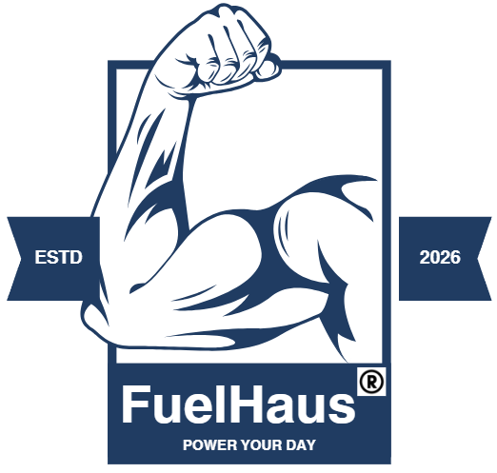

Executive Summary

FuelHaus is a mobile food enterprise specialising in high-protein, health-focused meals delivered through a fully equipped mobile food truck. The business operates within the street-food and healthy-eating sector, responding to increasing consumer demand for convenient, nutritious, and fitness aligned meal options. As a mobile unit, FuelHaus benefits from operational flexibility, enabling the business to position itself strategically in high traffic areas such as gym districts, university campuses, business centres, and community events across Birmingham.

FuelHaus will collaborate with high-footfall gyms in Birmingham to access fitness-focused consumers who value high-protein nutrition. Target gyms include PureGym, The Gym Group, and the University of Birmingham Sport & Fitness, as they all have strong member demographics, accessible locations, and alignment with FuelHaus’s performance-driven brand.

Partnership activities will include member discounts, post-workout food truck service, co-branded social media content on Instagram and TikTok, nutrition workshops, and sponsored fitness challenges. These collaborations boost gym member experience during which providing FuelHaus with consistent footfall, increasing brand visibility, and a direct link to its core target market.

This strategy is cost-effective, scalable, and supports FuelHaus’s long-term growth by affiliating the brand within Birmingham’s fitness community.

Table of Contents

OVERVIEW OF THE BUSINESS 3
1. What the Business Is 3
2. What the Business Is Offering 4
3. Legal Format 5
4. Management Structure 7
5. Environmental Sustainability and Community Support 8
MARKET RESEARCH 9
1. PESTEL Analysis 9
2. Competition Analysis 11
MARKETING COMMUNICATIONS 14
1. Brand Positioning 14
2. Digital Marketing Strategy 14
3. Community Engagement 16
4. Sustainability Messaging 17
FINANCIALS 18
1.Funding Requirements 18
2. Startup Expenses (First Month) 19
CONCLUSION 23
1. Unique Selliing proposition 23
2. Critical explanation of why this is a good entrepreneurial idea 24
REFERENCE LISTS 25
GLOSSARY 27

Overview of the business

What the Business Is

FuelHaus is a protein-focused mobile food truck that provides convenient, nutritious, high-protein meals for consumers pursuing a healthy lifestyle. Its mobility enables the business to operate across multiple locations in Birmingham, including gym districts, university campuses, and community events. The concept integrates the accessibility and flexibility of street-food vendors with the nutritional value of organic, locally sourced whole foods, positioning FuelHaus as a modern alternative to traditional fast-food trucks by offering meals that actively support wellbeing. Although FuelHaus operates within the broader street-food sector, it differentiates itself from conventional food trucks, typically associated with fast food and sweet treats, by responding to growing consumer demand for protein-rich diets and aligning with current market trends centred on fitness-oriented living.

Statista (2024) reported that the UK street-food sector continues to expand, driven by accessibility and affordability. It indicates consumer demand and market space for FuelHaus in the food truck industry.


Stock image

What the Business Is Offering

FuelHaus prepares all meals fresh and offers additional options tailored to low-carbohydrate, vegan, and gluten-free dietary requirements. The business prioritises nutritional transparency by clearly displaying protein content and calorie information, enabling customers to make informed choices and align their selections with individual macro goals. Its menu is built around high-protein dishes formulated to support muscle recovery, sustained energy, and balanced daily nutrition. The offering includes:

- Protein bowls (chicken, tofu, beef, tuna) for customers wanting a quick, balanced lunch.
- Organic Protein smoothies and shakes (from raw milk directly sourced from the farm).
- Organic soup of the day (will vary as the produce will be sourced organically from the farm - seasonal).

According to Mintel (2023), high-protein product demands are increasing in response to rising consumer interest in nutrition for health and wellness.

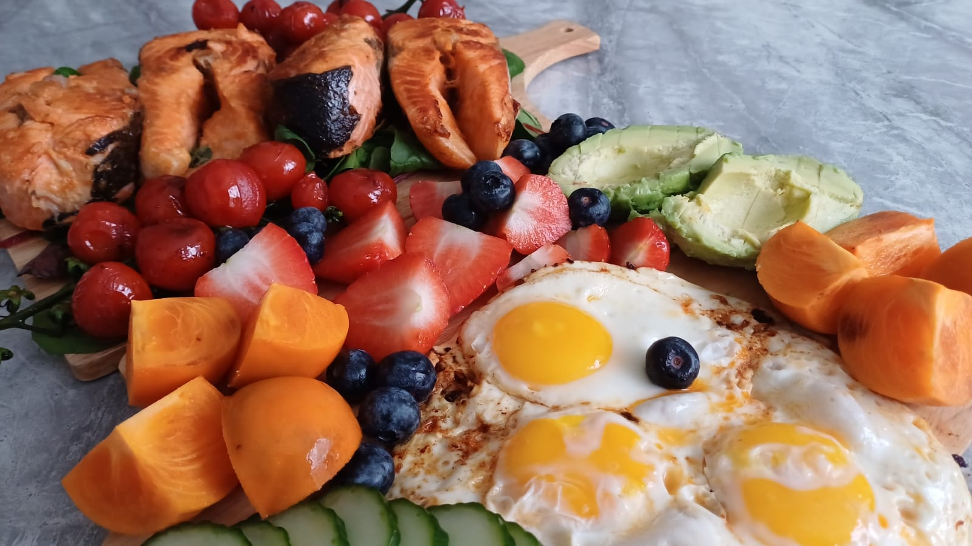
Image(s) taken and owned by Shohor Banu.

Legal Format

FuelHaus will operate as a Private Limited Company (Ltd), providing limited liability protection, enhancing credibility with suppliers and investors, and supporting long-term growth. Registering FuelHaus Ltd with Companies House also allows the business to market itself professionally, benefit from tax efficiency, and create a scalable formation suitable for future franchising.

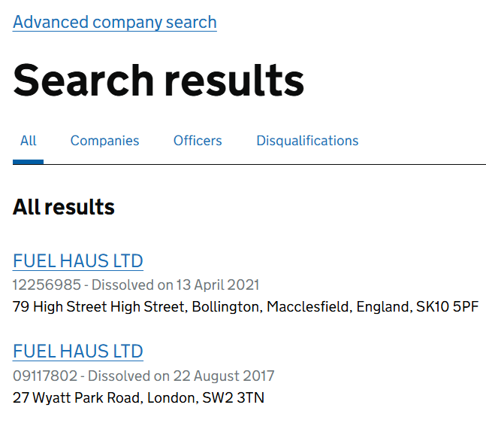

FuelHaus will use the ® symbol once its trademark is officially registered, as using an unregistered mark is a criminal offence under the Trade Marks Act 1994. Securing a registered trademark provides legal protection, increases brand credibility, prevents imitation, ensures compliance and brand visibility, and secures the trust of the consumer market.

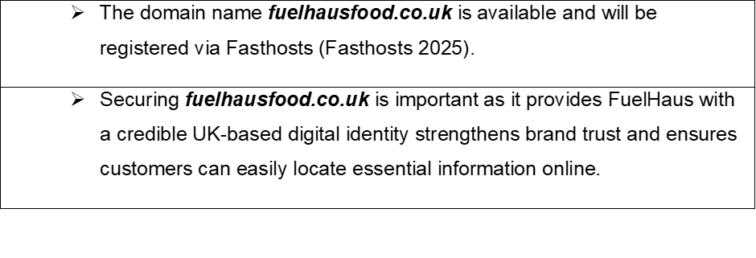

Management Structure

FuelHaus will operate as a small owner-managed enterprise, with the founder acting as Managing Director. The initial team formation will include:

This lean structure lowers labour costs while maintaining proficiency, and the mobility of the food truck additionally reduces overheads and enables variable, strategically targeted operations for FuelHaus, which wants to proceed as a Private Limited Company.

Johnson, Whittington and Scholes (2020, p. 3) state that “strategy is the long-term direction of an organisation”.

5. Environmental Sustainability and Community Support

FuelHaus incorporates sustainability and community support to meet investor expectations while building a strong Birmingham-based supply chain through local food suppliers, eco-friendly packaging providers, and regional sustainability partners. FuelHaus will implement:

Biodegradable and compostable packaging.
Reusable container scheme (offering discounts for customers who bring their own boxes).
Local sourcing (vegetables, fruits, protein and milk to reduce carbon emissions and support local suppliers/farmers).
Community employment (hiring local young people).
Food-waste reduction (including discounted end-of-day bowls and donating vegetable scraps for composting back to local suppliers/farmers).

WRAP highlights that reducing food waste is increasingly crucial, stating that “the ethical, environmental and economic case for reducing food waste has become ever more critical” (WRAP, 2022).

Market Research

PESTEL Analysis

According to Johnson, Whittington, and Scholes (2020), a PESTEL analysis helps review the external factors influencing a business such as FuelHaus and identifies aspects that may affect its operations, allowing strategic decision-making.

PESTEL Factor | Impact on FuelHaus
Political | UK food businesses must comply with Food Standards Agency (FSA, 2024) regulations. Local councils control street-trading licences, influencing where FuelHaus can operate (Birmingham City Council). Government support for small businesses and sustainability initiatives benefits FuelHaus, particularly as the business incorporates environmentally responsible practices (biodegradable packaging).
Economic | The UK’s rising living costs influence consumer spending behaviour; however, the demand for affordable yet nutritious meals has surged. The food truck model reduces overheads compared to restaurants, improving FuelHaus’s financial resilience. Local sourcing can reduce transportation costs and support regional suppliers. CBI (2022) indicates local sourcing strengthens regional economies and reduces supply chain emissions.
Social | Current social trends facilitate FuelHaus’s value proposition, as consumers' interest in healthier eating habits, fitness culture, and protein-focused, nutrient-dense diets is on the rise. Social media food culture enhances FuelHaus’s visibility, attracting customer engagement.  Protein and fibre-rich foods have seen “considerable growth” in the UK, with protein up 9.6% (NielsenIQ, 2026).
Technological | FuelHaus will use Digital tools such as mobile payments, QR-code menus, and social media marketing, enhancing customer experience and brand reach.  "Technological factors, such as innovation, automation, and digital transformation, play a crucial role in influencing business efficiency and competitiveness". (Belsare, 2025).
Environmental | FuelHaus’s biodegradable packaging, reusable container scheme, and local sourcing align with rising consumer concern for sustainability. Waste reduction processes such as discounted end-of-day bowls and a composting scrap scheme support environmental positioning.  According to DEFRA, the 2023 regulations highlight accountability within industry, stating that they “require businesses to adopt practices that prevent pollution and promote sustainable resource use” (DEFRA, 2023).
Legal | Compliance with food safety laws, allergen regulations, waste-management rules, and employment legislation is essential. (Food Standards Agency - GOV.UK). “Meet legal duties, file reports and manage risk.” — GOV.UK, Business and self-employed (2024).  As a Private Limited Company, FuelHaus must meet Companies House reporting requirements (Companies House - GOV.UK). Legal compliance protects reputation and reduces operational risk.

FuelHaus operates within a predominantly favourable PESTEL environment, with social, economic, environmental, and technological trends offering strong external support for its business model. Although political and legal factors introduce mandatory compliance obligations, these regulatory requirements ultimately reinforce organisational credibility, strengthen stakeholder trust, and support long-term strategic resilience, therefore favouring the business model for FuelHaus’s launch and long-term growth.

According to DEFRA, the 2023 regulations aim to strengthen national sustainability outcomes by “setting clear legal duties for organisations to reduce waste and protect the environment” (DEFRA, 2023).

Competition Analysis

FuelHaus operates in a competitive market that includes direct and indirect competition.

FuelHaus differentiates itself from its Birmingham City Centre competitors through:

These elements collectively give FuelHaus a clear USP, positioning it as a modern and socially responsible alternative to traditional fast-food street vendors. Strengthened further by its strategic collaborations with gyms and fitness partners.

This map shows direct competition for FuelHaus, around gyms in central Birmingham.

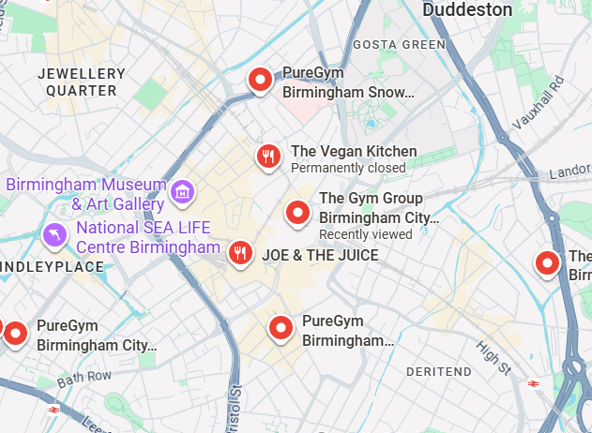
This map shows indirect competition for FuelHaus, around gyms in central Birmingham.

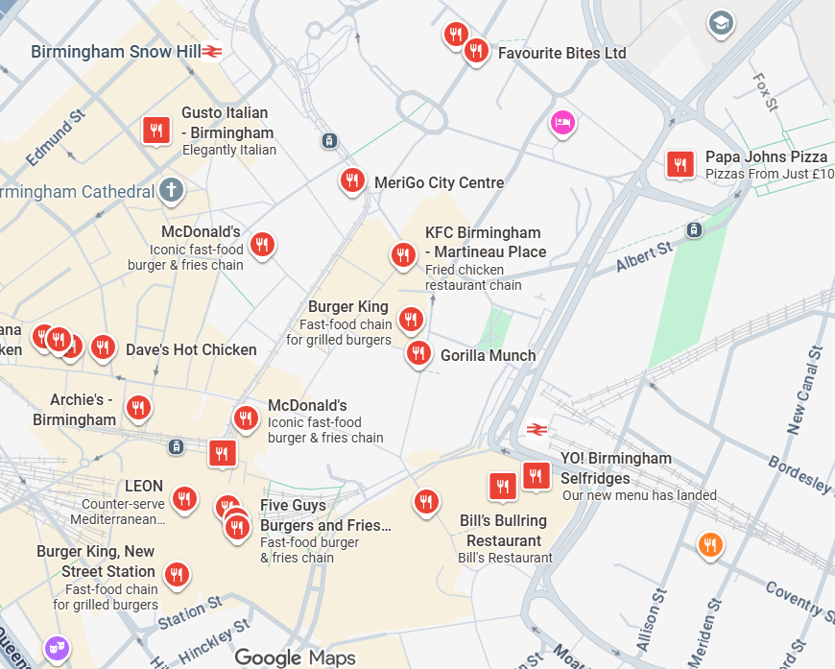

Marketing Communications

1. Brand Positioning

FuelHaus positions itself as a healthy, protein-focused, environmentally responsible street vendor that operates from a mobile food truck, offering convenient, healthy meal options to suit consumers' lifestyle choices. The brand identity emphasises nutrition, sustainability, and community support.

2. Digital Marketing Strategy

FuelHaus will use Instagram and TikTok to strengthen brand visibility, promote high-protein meals, and deliver real-time food-truck updates through Stories + Reels, with visually engaging content.

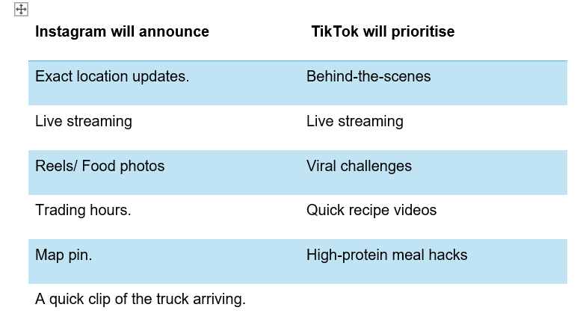
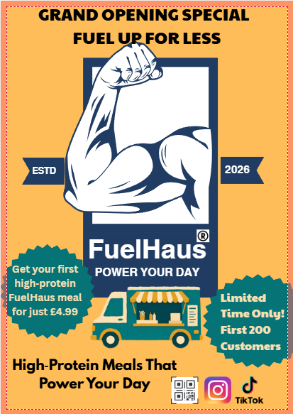 | 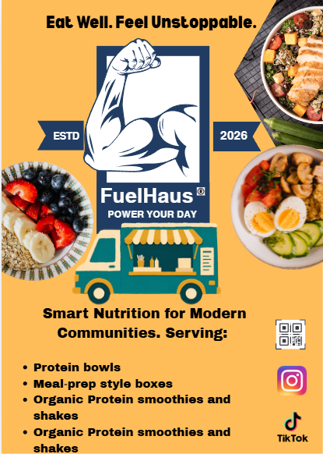

3. Community Engagement

Potential collaboration partner(s) for market segmentation and demographic | Best Birmingham geographics for FuelHaus:
Gyms with high footfall (PureGym, The Gym Group). Thousands of potential customers. Large car park, easy food truck placement. | PureGym and The Gym Group Birmingham City Centre  Birmingham, is covered by B4, B15 and B16 postcodes
University area/University gyms | Edgbaston (University area)  Primarily covered by the B15
Business district - Surrounded by offices and lunchtime traffic. | City Centre (Snow Hill or Central)  Birmingham, is covered by B3 and B4 postcodes
Independent gyms with strong community vibes and active social media. With repeat daily footfall

Why it’s a win-win partnership and best psychographic:

These initiatives reinforce FuelHaus’s presence and strengthen its dedication to local communities.

WRAP emphasises the importance of collaboration, stating that “whole chain collaboration is essential to tackling food waste effectively across the supply chain” (WRAP, 2022).

FuelHaus will implement community engagement into its core purpose, by working closely with commercial gyms as well as independent gyms to promote protein-focused meals, healthy lifestyle, and sustainable energy practices. By encouraging participation and shared responsibility, the brand strengthens community trust and visibility, while achieving its environmental goals.

4. Sustainability Messaging

FuelHaus will emphasise its eco-friendly packaging, reusable container scheme, and local sourcing practices in all marketing communications, as well as social media posts. This attracts environmentally conscious consumers and aligns with investor expectations.

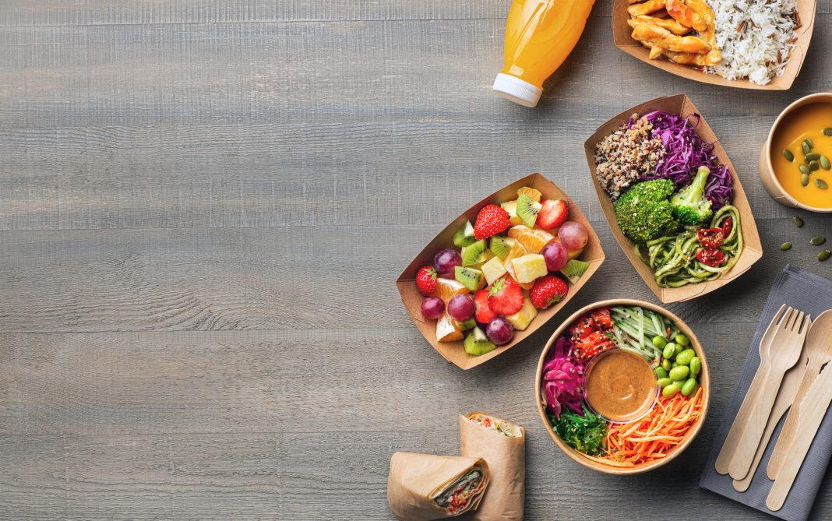
This Photo by Unknown Author is licensed under CC BY

Picture URL: https://www.openaccessgovernment.org/wp-content/uploads/2024/03/iStock-1353785314-1068x669.jpg

Financials

1.Funding Requirements
FuelHaus requires £35,000 in initial funding to launch operations as a start-up enterprise. Funding will be spent to purchase and convert a food truck, buy equipment, secure initial inventory, and cover early marketing and operational costs.
FuelHaus will seek funding from:
Funding Source:

2. Startup Expenses (First Month)

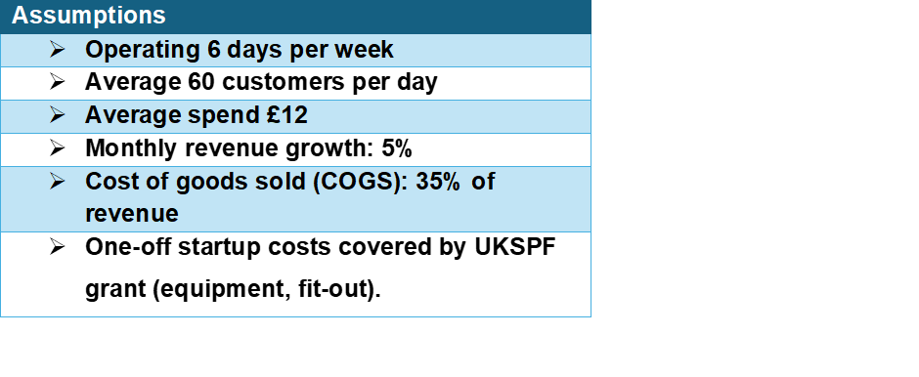
These are the local Birmingham Options for FuelHaus to consider when purchasing a food truck:

Buy a used van (Auto Trader / Facebook Marketplace Birmingham)  £5,000 Vans ideal for conversion: | Convert the van (Birmingham Van Conversions / Midlands Catering Trailers). Converts vans into custom food trucks.  £10,000 depending on equipment Includes:
Ford Transit | Branding wrap
Mercedes Sprinter | Electrical setup
Peugeot Boxer | Serving hatch
Citroën Relay | Worktops
Renault Master | Grill / hot plate
 | Refrigeration



Stock image

CONCLUSION

1. Unique Selliing proposition

FuelHaus’s unique selling proposition is its provision of fast, affordable, and customisable protein-based nutrition supported by eco-friendly, sustainable practices as a modern health-focused brand. By offering convenience and nutritional transparency in a streamlined service environment, FuelHaus differentiates itself from traditional fast-food vendors and positions itself as an accessible wellness-oriented alternative for urban Birmingham.

FuelHaus demonstrates strong entrepreneurial potential because its USP corresponds with analytically observed market growth, including rising demand for health-focused convenience and high-protein nutrition. The alignment between FuelHaus’s value proposition and documented consumer trends enhances its competitive advantage and supports its feasibility within a growing UK market.

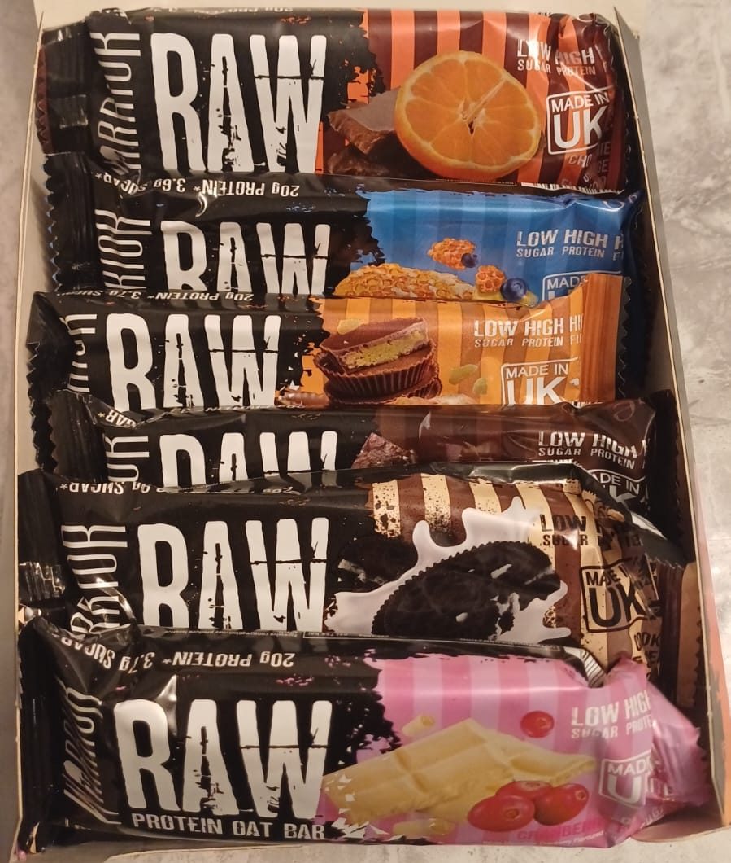
Image(s) taken and owned by Shohor Banu

2. Critical explanation of why this is a good entrepreneurial idea

FuelHaus is supported by a low-risk funding structure combining personal investment with the UKSPF Business Support Grant (Birmingham City Council), ensuring strong financial foundation and immediate operational capability. The business model focuses on affordability, rapid service, and a distinctive health-focused brand identity, positioned strategically near high-footfall fitness centres. Market analysis indicates favourable conditions, driven by rising demand for wellness and high-protein whole foods. Statistics from GOV.UK indicate that there is space in the market for FuelHaus, as SME growth has increased according to the Business Population Estimates for the UK and Regions 2024 statistical release. FuelHaus differentiates itself through transparent nutritional information, a community driven brand identity and meet current consumer market trends for a healthy lifestyle. Financial forecasts indicate stable revenue growth, controlled costs, and positive cashflow from launch, with the UKSPF Business Support Grant (Birmingham City Council) reducing early stage financial risk. Overall, FuelHaus is well positioned to become a leading provider of fast, nutritious, and affordable protein-based meals in Birmingham’s food truck industry, supported by strong branding, social-media engagement, and partnerships with local gyms, establishing a loyal customer base.
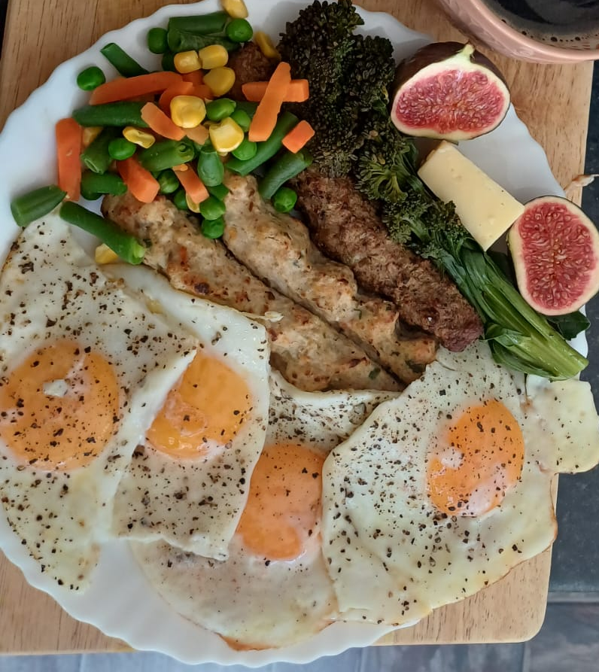
Image(s) taken and owned by Shohor Banu.

Reference Lists
Belsare, H.V. (2025) ‘PESTLE analysis’, International Journal of Advanced Research, 13(2), pp. 608–612.
Birmingham City Council (2025) Birmingham City Council. Available at: https://www.birmingham.gov.uk (Accessed: 01 October 2026).
Birmingham City Council (2024) UK Shared Prosperity Fund (UKSPF) annual update to Cabinet. Available at: https://birmingham.cmis.uk.com/ (Accessed: 10 October 2026).
Canva, Inc. (2025) Canva. Available at: https://www.canva.com/ (Accessed: 10 October 2026).
CBI (2022) Confederation of British Industry (CBI). Available at: https://www.cbi.org.uk/ (Accessed: 15 October 2026).
Companies House (2025) Companies House. Available at: https://www.gov.uk/government/organisations/companies-house (Accessed: 01 October 2026).
Department for Business and Trade (2024) Business population estimates for the UK and regions 2024: Statistical release. Available at: [https://www.gov.uk/government/statistics/business-population-estimates-2024/business-population-estimates-for-the-uk-and-regions-2024-statistical-release] (Accessed: 20 October 2026).
Department for Environment, Food and Rural Affairs (DEFRA) (2023) Environmental Improvement Plan 2023. London: DEFRA. Available at: https://www.gov.uk/government/publications/environmental-improvement-plan (Accessed: 15 October 2026).
Fasthosts (2025) Fasthosts. Available at: https://www.fasthosts.co.uk/ (Accessed: 15 October 2026).
Food Standards Agency (FSA) (2024) Food Standards Agency. Available at: https://www.food.gov.uk/ (Accessed: 30 September 2026).
Google Maps (2025) Google Maps. Available at: https://maps.google.com/ (Accessed: 18 October 2026).
GOV.UK (2024) Business and self-employed. Available at: https://www.gov.uk/browse/business (Accessed: 01 October 2026).
GOV.UK (2025) GOV.UK. Available at: https://www.gov.uk/ (Accessed: 01 October 2026).
https://www.openaccessgovernment.org/wp-content/uploads/2024/03/iStock-1353785314-1068x669.jpg (Accessed: 20 October 2026).
Johnson, G., Whittington, R. and Scholes, K. (2020) Exploring Strategy: Text and Cases. 12th edn. Harlow: Pearson.
Mintel (2023) Plant-based proteins on the rise. Available at: https://www.mintel.com/insights/food-and-drink/plant-based-proteins-on-the-rise/ (Accessed: 08 October 2026).
NielsenIQ (2026) NielsenIQ. Available at: https://nielseniq.com/ (Accessed: 01 October 2026).
Simply Business (2025) Simply Business. Available at: https://www.simplybusiness.co.uk/ (Accessed: 5 October 2026).
Statista (2024) Statista. Available at: https://www.statista.com/ (Accessed: 2 October 2026).
Trade Marks Act 1994, c. 26. Available at: https://www.legislation.gov.uk/ukpga/1994/26/contents (Accessed: 5 October 2026).
WRAP (2022) WRAP. Available at: https://wrap.org.uk/ (Accessed: 2 October 2026).

GLOSSARY

Biodegradable: A substances that can break down naturally over time through bacteria, fungi, or other biological processes, returning to the environment safely.
Demographic: Is a measurable characteristic of a population, such as age, gender, income, or location, used to describe and analyse groups of people.
Geographics: Are location-based traits describing where people live, such as region, climate, or city size.
Health-focused meals: Meals constructed to support wellbeing, usually made with nutritious ingredients, balanced portions, and practices healthier cooking processes.
High-protein: Foods or meals that contain a large amount of protein relative to their total nutritional content, supporting muscle growth, repair, and sustained energy.
Influencer partnerships : Collaborations between a brand and a social media influencer to promote products or services to the influencer’s audience, aiming to increase visibility, brand trust, and bridging engagement between the audience and product.
Nutritional value: The amount of vital nutrients a food provides, such as vitamins, minerals, protein, fats, and carbohydrates, and how it contributes to overall health.
Private Limited Company (Ltd): A privately owned business where shareholders have limited liability and shares cannot be sold to the public.
Psychographic: Is a psychological trait describing a person’s values, attitudes, interests, lifestyle, or personality.
Seasonal specials: Limited-time menu items or products offered only during a specific season to match seasonal demand and attract customers.
Small owner-managed enterprise: A business that is independently owned and run by its owner, usually with a small number of employees and limited resources.
Street food: Ready-to-eat food sold by vendors in public places, normally served quickly and eaten on the go.
Sustainability: The practice of using resources responsibly so that environmental, social, and economic systems can be maintained over the long term without causing harm to future generations.

Brand name FuelHaus LTD is available to register at Companies House - GOV.UK. (See screenshot above). Also see PESTEL Legal factors.
Canva, Inc. (2025) was used to design the FuelHaus logo.
See Environmental Factors on the Pestel analysis table.
See Economic Factors on the Pestel analysis table.
The map shows there are not many healthy eating options around this geographics, reducing direct competition for FuelHaus.
The map shows all indirect competition FuelHaus faces in this same geographic area. Evident that the market is overcrowded with fast food and low-protein options, giving FuelHaus a greater advantage.
Canva, Inc. (2025) was used to design social media posters for FuelHaus.
See PESTEL, Environmental Factor.
Demonstrates how FuelHaus are purchasing equipment from local sources in order to reinforce community support.
These are reliable, easy to convert, and cheap to maintain.
See page 4 (Mintel).
See Competition Analysis.
See Start-up expenses, second page, purchase of a van and conversion cost eligible to be covered by UKSPF Grant.
See Community Engagement.

