University of Wales Trinity Saint David
School of Engineering

Engineering Technical Report

  - Tomos Cole
  - 205508

Motorsport Engineering
Workshop and Practice ACHA4011

03/12/2023



(Word Count – 1984)

Contents Page

Contents Page 1
1. Introduction 2
2. Chapter 1 – Health & Safety with Risk Assessments 3
2.1 Health & Safety 3
2.2 Risk Assessment Matrix 5
2.2.1What risks could appear when taking apart an engine? 5
3. Engineers Role in Society 6
4. Problem Solving 7
4.1 An issue found during development. 8
4.2 An issue found once on the market. 8
4.3 A supplier issue in the production process 9
5. Chapter 4 – Team Structure 10
5.1 When I worked in a team. 10
5.2 What team structure did we use. 10
5.3 Different team structure we could have used instead. 11
6. Chapter 5 – Personal Development Plan 12
7. Conclusion 14
8. Reference List 15

Introduction

This report discusses the importance of the Health and Safety Legislation and how it is implemented into real world tasks. This report discusses the role engineers play today, focusing in on the responsibilities engineers have for topics such as sustainability and environmental issues. While also discussing the common issues engineers face on a regular basis and how they use their problem-solving skills to produce a solution. This report will include the authors own experience and some added research.

The aim of this report is to understand the day-to-day responsibilities engineers have, looking specifically at the health & safety laws they must follow, their role in society and how they solve each problem they face.

2. Chapter 1 – Health & Safety with Risk Assessments

2.1 Health & Safety

The Health & Safety Legislation is there to ensure a safe working environment for everybody. Whether it is an engine being taken apart or whether parts are being made on a CNC machine, the number of risks involved is aplenty.

What is the Health & Safety Legislation all about and why is it still so important?
The two main Health and Safety legislations are the Health and Safety at Work Act 1974 and the Management of Health and Safety at Work Regulations 1999.
According to White (2014) the well-known Health & Safety at Work Act (HWSA) 1974 ‘was an enactment that consolidated a lot of existing and rather piecemeal legislation’.

Despite the obvious success of this legislation not everyone was a fan of it because, according to Norman (1975, p.1), this legislation ‘has been fulsomely embraced by some and scathingly rejected by others’, later describing it as a ‘demonstrably weak legislation was about to be further weakened’.
The Personal Protective Equipment Regulations under the Health & Safety at Work Act 1974 legislation goes on to talk about the distinct types of PPE that must be provided by employers to make the workplace a safe environment for employees. The list includes, “Hard hats, High-visibility Jackets, protective eyewear, safety harnesses, steel toe cap boots, respiratory equipment.”
However, obviously not everything from that list will be needed for every task. For example, when stripping an engine realistically the only PPE needed for that task is the steel toe cap boots and potentially the protective eyewear.

According to Putri and Tjahjono (2022, p.7) the average accident rate in the Dinoyo Welding Workshop Malang before and after counselling and assistance over how to use PPE has decreased by ’69.44%’.
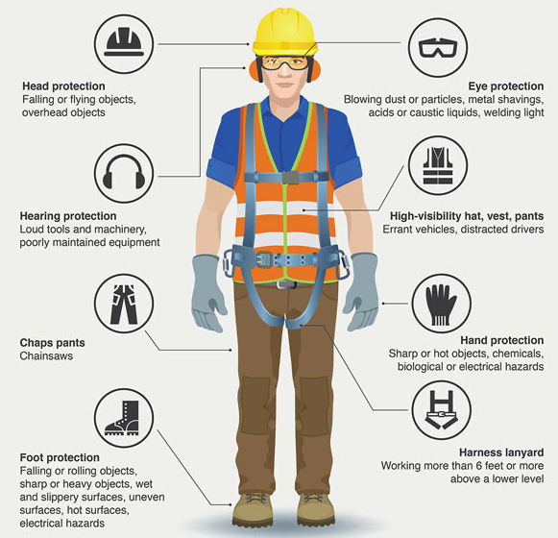
Figure 1- Head to toe PPE photo

2.2 Risk Assessment Matrix.
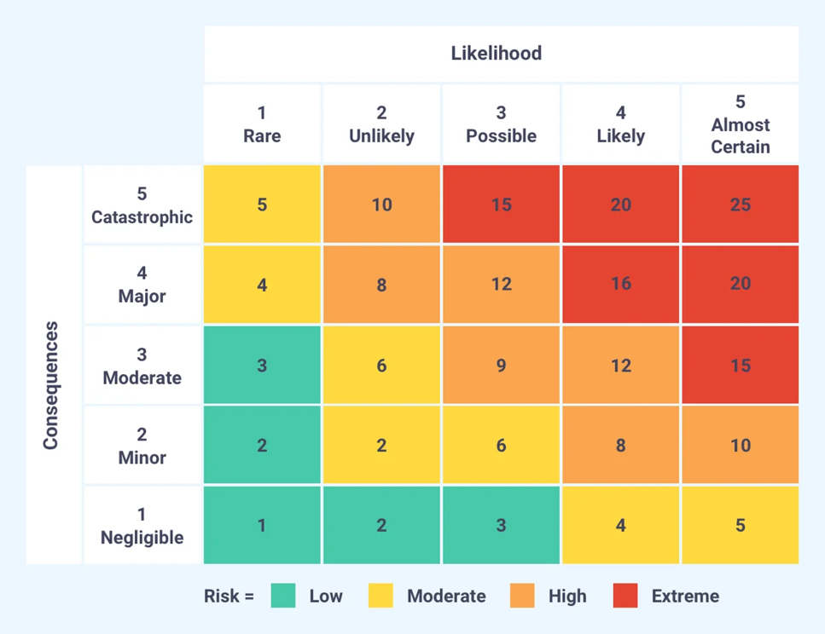
Figure 2 - Risk Assessment Matrix

2.2.1 Risks when taking apart an engine.

Risk 1 – Steel toe cap boots
Heavy parts on an engine could fall off/through the middle of the engine and land on somebody’s foot. The consequence of this could be moderate or major obviously depending on how heavy the part is and what part of someone's foot/leg it lands on. The likelihood is possible, can never rule it out. Risk would be moderate to high.
Giving it a rating of 6-9.
The scenario that would be unlikely but also catastrophic would be if the engine stand were not put together correctly and then dropped the engine onto somebody’s foot.

Risk 2 – Protective eyewear
Bolts or other metal parts may snap and be flung towards someone’s eyes. The consequence of this would be major, leaning more towards being catastrophic. The likelihood of this happening is unlikely, but also possible. The risk of this is high.
Giving it a rating of 8-10. Most likely a 10.

3. Engineers Role in Society

Engineers have a lot of laws and regulations to follow, but one topic they have had to pay attention to increasingly in more recent years are the rules adhering to sustainability and environmental issues that are listed in several code of conducts.
According to the Engineering Council, (2023), ‘engineers and technicians are required to carry out their work in a way that contributes to sustainable development’. They also discuss ‘the six principles’ they have for engineers to contribute to sustainable development which includes, ‘Use resources efficiently and effectively.’
Proof of this principle being listened to in motorsport has come in Formula 1 with one of them coming in recently which is to do with the amount of Pirelli tyres being taken to these events. At the Hungarian Grand Prix 2023, weekend of July 21st-23rd, Formula 1 tweaked rules for qualifying where the number of tyres available has decreased from 13 to 11 set of tyres. According to Matt Kew (2023) ‘This alternative tyre allocation has been ostensibly devised to improve the championship’s sustainability credentials.
According to the Royal Charter, (2022), ‘All members shall show due regard for the environmental and for the sustainable management of natural resources.’
Many changes have happened and many more are going to be happening in a couple of years with a big one coming within Formula 1. According to Underwood, (2023), ‘By 2026, F1 intends for all cars to run on 100 percent sustainable fuels. These e-fuels will use a carbon capture scheme or municipal waste to achieve greenhouse gas saving.’ This is just one of the many changes they plan to introduce to the sport.

4. Problem Solving

Engineers face problems daily and no matter at which stage of the process said issue arises, they always find a solution and it is often the best solution.

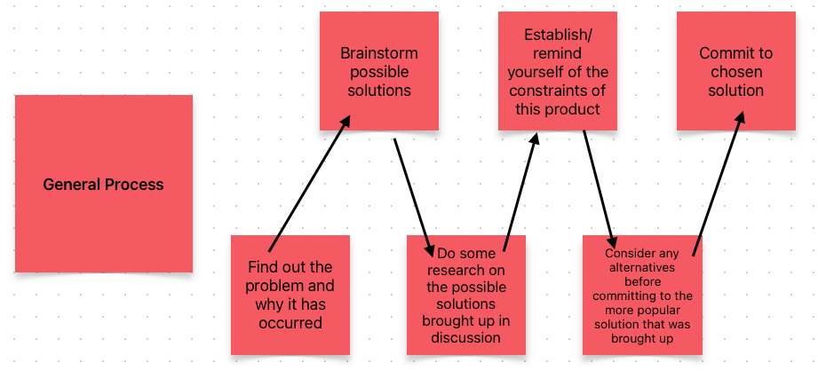
Figure 3 - General Process Flow Diagram (own image, 2023)

But what would the thinking look like when producing a solution when the issue is at a particular stage?

4.1 An issue found during development.

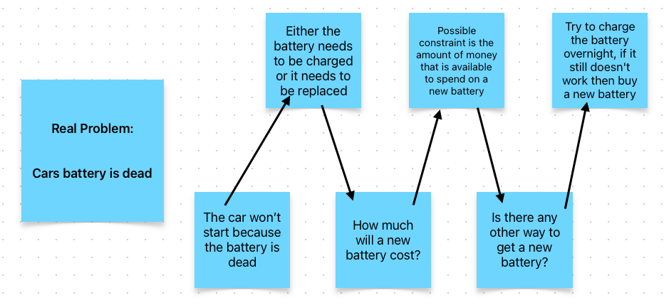
Figure 4 - Issue During Development Flow Diagram (own image, 2023)

The problem shown above in figure 4 is a rough thought process of what would go through someone's mind if their car would not start and the solution in this case would be to buy a new battery. Of course, there are more reasons as to why a car has problems starting.

4.2 An issue found once on the market.

This is the final stage of the engineering design process, where ‘with a refined prototype, it’s time to implement your solution and evaluate its performance.’ Many things can go wrong at this stage, it could be that the feedback given from users will bring an issue to the forefront or it could be to do with insufficient funds or resources.
A scenario being that a company is suffering financially resulting in a lack of funds and/or resources, this may be due to the marketing team for example overestimating the success of their marketing campaign for this product.
And according to Indeed, (2022), to solve this ‘one effective strategy is tracking and reporting on valuable performance metric’, for example, ‘customer acquisition cost, customer lifetime value, conversion rate and return on investment’.
Further scenario in figure 5 below:
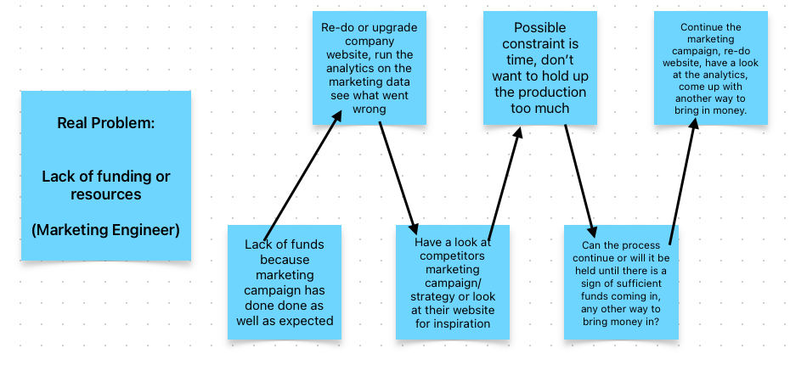
Figure 5 - Issue During Marketing Flow Diagram (own image, 2023)

4.3 A supplier issue in the production process

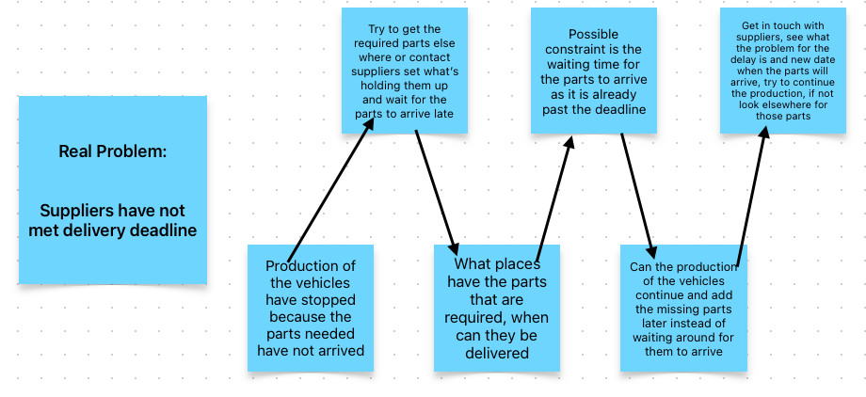
Figure 6 - Supplier Issue in Production Flow Diagram (own image, 2023)
The problem shown in figure 6 is a rough thought process is there was a problem with the suppliers not meeting the deadline to deliver specific parts. With various workable solutions to a big problem.

5. Chapter 4 – Team Structure

5.1 When I worked in a team.

One time that I worked in a team was last year, in the foundation year, when we were put into groups to complete a group project. We had to design a soapbox car to go down a hill. The only problem was that we could not build it because it would be expensive.

5.2 What team structure did we use.

There was not a set team structure that we followed, instead what we did was we elected a sort of leader who would organise team meetings, takes the minutes of each meeting, tell others what their roles are, sets deadlines for others to send their work and then drafts the final report.
This team structure overall was good because despite the occasional slowness it terms of getting the work done from all parties, everyone did what they were asked to do, and it was done in the time limit given.

5.3 Different team structure we could have used instead.

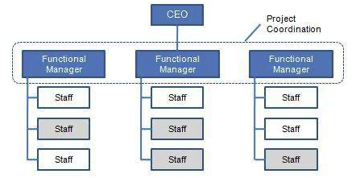
Figure 7 -Functional Team Structure
If I were to go back and do the group project again, I think a functional team structure like the one shown above in figure 7. Although we only had 6 members ,I think having a structure like this would set clear objectives and it would mean that each member is in their own area of expertise, considering the fact that I was just chucked into whatever they needed me to do as I was added to the group after they had already decided each other's roles.
A change that I would make if I were to do this again would be having more in person meetings. I feel like this would have helped speed things up so that we could look at different things because in these meeting we would have been able to see how everyone else is getting on with their work and it may have pushed others to complete their area. Although it would be tricky with other schedules.

6. Chapter 5 – Personal Development Plan

Degree – Motorsport Engineering

Previous Qualifications – EAL Level 3 Subsidiary Diploma in Engineering Technologies (Mechanical Engineering Technologies), EAL Level 3 Extended Diploma in Engineering Technologies.

Previous Experience – Just the 2-year course I did in college on Mechanical Engineering

Long Term Goals (5-10 years):
My aim is to be working in Formula 1. I would also like to be financially stable and to start getting into the real estate world as an extra source of income.

Short Term Goals (0-5 years):
I would like to have graduated this course, to have had a successful year in work in-between now and graduating. Hopefully get a job using my degree (priority is Formula 1). I would like to be in a good spot financially before I graduate.

Goal | Objective | Resources Required | Measurement | Target Date
Get a part-time job before graduating. | Comfortable financially before graduating. | Make a good CV. | Receiving first payment. | Early or mid 2024.
Have a year of working in the industry. | Make a good impression incase they want me back after graduating. | Good CV, use resources/service around to apply for Formula 1 teams. | Acceptance letter. | 2025.
Graduate. | Complete the course with as best results as possible. | Time, effort. | Receive a certificate. Have a graduation. | 2026 – 2027 depending on whether I complete a full year of work in between.
Get a job in Formula 1. | Get a job in Formula 1 as a strategy or race engineer. | Graduate, have an updated CV. | Job application acceptance notice. | 2027 onwards.
Get more than one source of income. | Get into the real estate business.  (Investing, flipping houses etc.) | Comfortable financially, resources to educate myself on the real estate business. | Get good deals on investments or houses, seeing profit after flipping a house. | 2030 onwards.
Table 1 - Personal Development Plan (own table, 2023)

7. Conclusion

The importance of PPE and the regulations in place cannot go unnoticed, especially when there is data to prove the impression it has had on the rate at which accidents occur, for example at the Dinoyo Welding Workshop Malang.
Engineers are constantly thinking of solutions to the many problems they run into, whether it is in the first stages of a project or whether it is at the back end of the project. And in recent times, big organisations have started to divert some of their attention to issues the entire world is facing diving into potential solutions to help with the environment which requires engineers' attention.
Interesting to see in forthcoming years, what other changes are made that contribute to a positive change in the sustainability and environmental issues that are going on.

8. Reference List

White, J. (2014). One small step. The Safety & Health Practitioner, 32(1), 34-.

Lewis, N. (1975) ‘Health and Safety at Work Act 1974’, Modern law review, 38(4), pp. 442–448.

HSE Network (2019) Health and Safety at Work Act 1974 Explained. Available at: https://www.hse-network.com/health-and-safety-at-work-act-1974-explained/ (Accessed: 2nd December 2023).

Putri, C.F. and Tjahjono, N. (2022) ‘Counselling and application of personal protective equipment to reduce work accidents in welding workshops’, Abdimas (Online), 7(3), pp. 460–470. Available at: https://doi.org/10.26905/abdimas.v7i3.7016.

Wang (2022) Personal Protective Equipment List with Pictures and Function. Available at: https://www.anbusafety.com/personal-protective-equipment-list-with-pictures-and-function/ (Accessed: 2nd December 2023).

Safran (2019) What’s the Difference Between Qualitative and Quantitative Risk Analysis? Available at: https://www.safran.com/blog/whats-the-difference-between-qualitative-and-quantitative-risk-analysis (Accessed: 2nd December 2023).

Engineering Council (2023) Statement of Ethical Principles. Available at: https://www.engc.org.uk/ethics (Accessed: 2nd December 2023).

Kew (2023) Why drivers aren’t convinced by F1’s qualifying tyre experiment. Available at: https://www.autosport.com/f1/news/why-drivers-arent-convinced-by-f1s-qualifying-tyre-experiment-/10497982/#:~:text=This%20Alternative%20Tyre%20Allocation%20has,a%20race%20will%20decrease%20accordingly. (Accessed: 2nd December 2023).

Royal Charter (2023) Code of Professional Conduct. Available at: https://www.ice.org.uk/download-centre/code-of-conduct (Accessed: 2nd December 2023).

Underwood (2023) Formula One’s Environmental Impact: Will F1’s Net-Zero Goals Make a Difference? Available at: https://www.greenmatters.com/climate-action/is-f1-bad-for-the-environment#:~:text=By%202026%2C%20F1%20intends%20for,as%20compared%20to%20fossil%20fuels. (Accessed: 2nd December 2023).

Utilities One (2023) The Importance of Understanding the 5 Steps of Engineering Design Process for a Successful Project. Available at: https://utilitiesone.com/the-importance-of-understanding-the-5-steps-of-engineering-design-process-for-a-successful-project# (Accessed: 2nd December 2023).

Indeed (2022) 10 Challenges in Marketing and How to Overcome Them. (Available at: https://www.indeed.com/career-advice/career-development/marketing-challenges#:~:text=One%20common%20challenge%20marketers%20may,or%20slow%20a%20company%27s%20growth. (Accessed: 2nd December 2023).

Toppr (2019) Formal Organization – Functional Organization. Available at: https://www.toppr.com/guides/business-management-and-entrepreneurship/organizing/formal-organization-functional-organization/ (Accessed: 2nd December 2023).

