What does the artwork commissioned by the normans tell us about how they wished to be perceived?

In this essay I am going to be describing and discuss a number of different depictions of the Normans, from throughout the Norman world, from Britain to France to Italy and Sicily. I will be commenting on the various pictures, and then drawing upon those commentaries to describe and explain how the Normans wished to be perceived.

First up we have the Bayeux Tapestry, this is possibly one of if not the most famous surviving pieces of Norman artwork. Thought to have been created shortly after the Norman invasion of England, in roughly the 1070’s by Bishop Odo of Bayeux and created at Canturbury Catherdral by English women. (Bayeux Tapestry, ND)
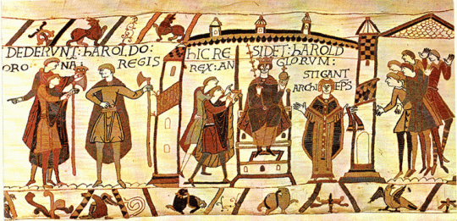
Picture of Harold Godwinson being crowned King of England. Heraldic times, 2009.
In the above picture you can see Harold Godwinson sat upon the throne, to his right is Archbishop Stigant who appears to be administering the coronation. This is historically incorrect, in actual fact Harald was crowned by Aldred, Abbot of Tavistock, Bishop of Worcester and Archbishop of York with Stigant at the event. (Anglefire, ND) Had the correct information been given it would have given the coronation more legitimacy than if Stigant was depicted. You can also see that those in attendance (to the right of Stigant) are all cleanshaven, that is rather than the mustached Anglo Saxons depicted elsewhere, this could be that these clean shaven onlookers are actually Normans. This could be backed up with the body language they have, the clean shaven men appear to have their shoulders shrugged and have their hands in the air as if saying or gesticulating ‘what’s going on here? Duke William has the right to the throne from the agreement with Edward in 1051.’ The clean shaven men also appear to have a slightly shorter court tunic, than those of the Anglo-Saxons this was a stylistic and fashion difference between the Normans and the Anglo-Saxons.

Below is an image of William, Odo and Robert, along with a scene showing a group of people including Odo dining.
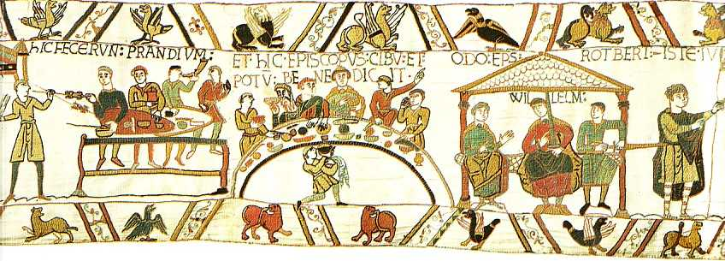
Bayeux Tapestry scene showing Odo feasting, and Odo, William and Robert discussing something. Anglefire, ND.
In this image you have two main scenes, the first is slaves dishing food out to who are possibly common soldiers, this assumption is due to the shields being used, and slaves taking food to the table of Bishop Odo and friends. As well as a scene with Bishop Odo, Duke William and Robert? Sat under a canopy discussing something.
The part of the scene with Bishop Odo and his table is very reminiscent of medieval depictions of the ‘Last Supper’, this could be a way of the Normans trying to show themselves as being pious and that they are close to God. Also in this scene you have Bishop Odo in the centre, and unlike Harald in his coronation scene Bishop Odo is dressed in the highest finery of the time. Also the men surrounding Bishop Odo are shown as though they are from the higher echelons of society.
The gentleman two from Bishop Odos right looks very different from the men around him. He is shown as being bearded and also of more advanced age. It is not clear who this man is, however it is possible that he is an Anglo-Saxon who has risen to prominence in the Norman court.
Looking at Bishop Odo, Duke William and Robert they may be discussing possible war. This is because Duke William has his sword already drawn, a very big symbol of aggression, as well as Robert appears to be drawing his sword. They do not appear to be armed in armour.
Bishop Odo, Duke William and Robert are all dressed in the much finer clothes of the elite than those of the Anglo-Saxon elite. This could be to show that the Normans were just better dressed and had better materials to hand. On a similar topic you can see at the feet of Bishop Odo, Duke William and Robert are some foot stools, in depictions these do seem to be a symbol of wealth and importance as they has the extra money to purchase these items, especially when in a war situation.

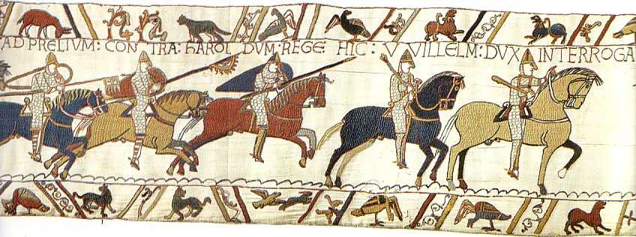
Bayeux Tapestry scene showing Norman knights going into battle lead by Duke William. Angelfire, ND.
The two knights on the left of the image have pennons on their spears, this shows a degree of ranks and wealth amongst the Normans. The left hand pennoned knight has a Christian cross on his pennon, this shows his piety and his religious prowess. The right hand pennoned knight has what looks like a raven or bird on his pennon. This is possibly reminiscent of the Scandinavian hero Ragnar Lothbrok and Rollo. The importance here is of course Rollo being the possible first Norman. If a Norman knight could invoke the power of Rollo he may excel himself in battle, it also is a pointer to the origins of the Normans in depictions.
The Norman knights and soldiers are consistently shown as being better prepared and better equipped, alongside the Norman forces having cavalry.
Duke William is the knight on the far right, you can see that he is more heavily armoured with chausses. Duke William is also carrying a bacculum, a ceremonial mace used by a leader.
Throughout the Bayeux Tapestry the Normans are shown as having the upper hand. This is understandable as the Normans were the victors, despite the Bayeux tapestry being likely created by English people the Normans are shown in good light with the Anglo-Saxons not put down as such but not shown as they possibly were. This is a good example of the victor of war telling the history.

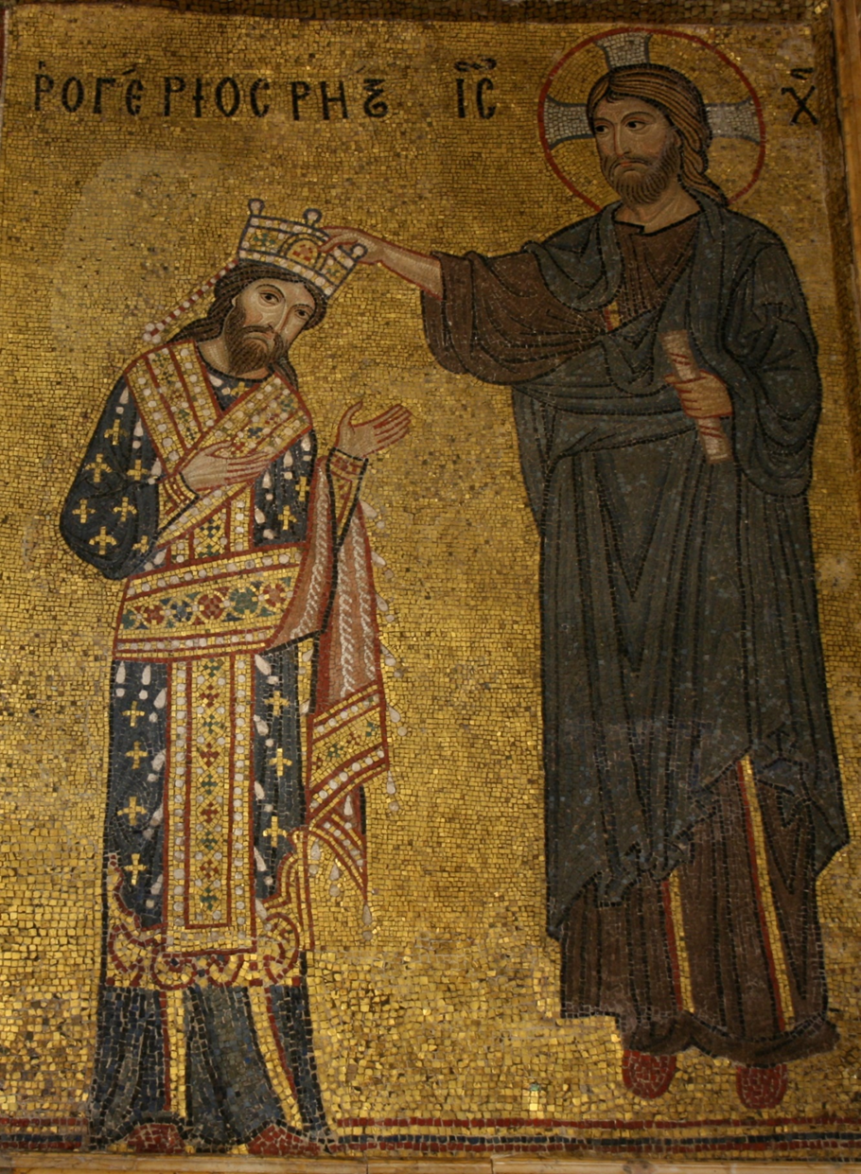
mosaic with Roger II receiving the crown from Christ, Martorana, Palermo. Wikipedia, 2018.

In the above image we have two figures: King Roger II and Jesus Christ. Christs head is flanked by the words “IC” and “X”, the later word was probably “XC” which would fall in line with the Greek Christogram “IC XC” for Christ.
You can see that Christ is looking at King Roger II, and with an outstretched hand is crowning the monarch. To be shown as being crowned by the King of Kings Jesus Christ gives King Roger II the legitimacy to claim the Kingship as well as the divine right to rule.
King Roger II is looking out at the audience, as though to include them in the ceremony taking place. King Roger II’s clothes are not those of a typical Norman Lord or King, however they are very reminiscent and befitting of a Byzantine Emperor. This could be a statement that the King is making to say that he is more important and more influential than even a Byzantine Emperor.
Above King Rogers head is says “ΡΟΓΕΡΙΟC ΡΗΣ”. These are Latin words using Greek characters, in Latin it says “Rogerius Rex” or “King Roger” very clearly identifying who it is.
There is also a very distinct similarity between the faces of both King Roger II and the face of Christ. King Roger II has almost identical facial features to Christ, he also has the long hair that Christ has. However King Roger II does not have a halo as Christ does.
Something that does appear here that doesn’t appear a lot in other Byzantine style artwork is the Fleur-de-lis, this is a piece of iconography that is gaining favour in the up and coming French populous. But is very rarely depicted in the typical Byzantine art.
The crown and loros (scarf type thing hanging around Rogers neck) are outdated to the Byzantine style, the reason for this in the mosaic in unknown.

Bibliography:
Wikipedia. 2018. Roger II of Sicily. Available from: https://en.wikipedia.org/wiki/Roger_II_of_Sicily. [Accessed 19/01/2018]
Anglefire. ND. Bayeux Tapestry. Available from: http://www.angelfire.com/rnb/bayeux_tapestry/sect22_24.html. [Accessed 19/01/2018]
Anglefire. ND. Bayeux Tapestry. Available from: http://www.angelfire.com/rnb/bayeux_tapestry/sect31_33.html. [Accessed 19/01/2018]
Heraldic Times. 2009. The Plot of the Bayeux Tapestry, Part II – Godwinson is Crowned King of England. Available from: https://heraldictimes.wordpress.com/2009/02/27/the-plot-of-the-bayeux-tapestry-part-ii-godwinson-is-crowned-king-of-england/ [Accessed 19/01/2018]

