
ALICE JOHNSON
1921008

The Underlining Issue Mental Health Calls Have on Response Time and Workload
BSc (Hons) Professional Policing Practice

Declaration

This work has not previously been accepted in substance for any degree and is not being concurrently submitted in candidature for any degree.
Signed:
Date: 09/01/2023

Statement 1 - This dissertation is being submitted in partial fulfilment of the requirements for the degree of BSc.
Signed:
Date: 09/01/2023

Statement 2 - This dissertation is the result of my own independent work/investigation, except where otherwise stated. Other sources are acknowledged by footnotes giving explicit references. A bibliography is appended.
Signed:
Date: 09/01/2023

Statement 3 - I hereby give consent for my dissertation, if accepted, to be available for photocopying and for interlibrary loan, and for the title and summary to be made available to outside organisations.
Signed:
Date: 09/01/2023

Statement 4 - I hereby give consent for my dissertation, if accepted, to be available on the university’s IT system to those who have consent to use the system.
Signed:
Date: 09/01/2023

Acknowledgements
I would like to thank the University of Trinity Saint David and more specifically my Supervisor Jonathan Edwards for his support and guidance throughout my dissertation process.

My shift, you know who you are, the 7 of you. Words will never be enough, thank you for always answering questions, providing guidance, support, reading my work and never complaining.

I would also like to thank my family and close friends for picking me back up at every hurdle and providing the endless support I required to push me to submission.

Finally, my partner Morgan Jenkins. You have pushed me continually, supported me endlessly and listened to my never-ending self-doubt. You have given me your time and your knowledge, and this is something I will forever be thankful for.

.
Abstract
The aim of this dissertation is to understand why Police must attend Mental Health calls and how attending these calls can have detrimental effects on individual Police Officers workloads and response time to emergency calls with a criminality aspect.
The Police Service, more specifically Police Officers have become the first responders to Mental Health crisis calls in the UK. The continuing question of who should be attending these calls and which service is better trained for these situations is an ongoing one, with valid arguments from both responding services (Police and Ambulance).
To be able to understand the effect attending these calls have had on Police Officers, an online questionnaire was produced to help understand the mindset of the Officers who would be in attendance at the Mental Health calls and if they feel adequately trained to be attending and if they believe that they should be attending in the first instance, the analysis of the findings from the literature review provided the foundation for the questionnaire to be produced.
The gathered information was analysed and concluded that Police Officers do not feel adequately trained to attend these incidents and would feel more confident either attending with a Mental Health Practitioner or someone from the Ambulance / NHS service.
Police Officers also noted that if they had not attended the specific Mental Health call, they would have been able to work on one of their current workloads, thus providing efficient service to victims of criminal incidents.

TABLE OF CONTENTS
1.1 - Introduction 7
1.2 – Background and Rationale 7
1.3 – Aim 8
1.4 – Objectives 8
1.5 – Research Structure 9
1.6 – Conclusion 9
Chapter 2 - Literature Review 10
2.1 - Introduction 10
2.2 – Legally Obligated 11
2.3 - Training 12
2.4 – Triage Teams 16
2.5 - Conclusion 22
Chapter 3 - Methodology 23
3.1 - Introduction 23
3.2 – What is research? 23
3.2.1 - Primary Research 23
3.2.2 - Secondary Research 24
3.3 – Qualitative Methods 24
3.4 – Quantitative Methods 25
3.5 - Questionnaires / Online Survey 25
3.5.1 - Benefits of questionnaires 25
3.5.2 - Negatives of questionnaires 26
3.6 – Choice of method 27
3.7 – Data Analysis 28
3.8 - Limitations and Potential Problems 28
3.9 - Conclusion 29
Chapter 4 - Analysis of Results 30
4.1 – Introduction 30
4.2 – Findings 31
4.2.1 – Question 1 31
4.2.2 – Question 2 32
4.2.3 – Question 3 33
4.2.4 – Question 4 34
4.2.5 – Question 5 35
4.2.6 – Question 6 36
4.2.7 – Question 7 37
4.2.8 – Question 8 38
4.2.9 – Question 9 39
4.2.10 – Question 10 40
4.2.11 – Question 11 41
4.2.12 – Question 12 44
4.2.13 – Question 13 44
4.2.14 – Question 14 45
Chapter 5 – Conclusion 49
5.1 – Introduction 49
5.2 – Objectives of dissertation 49
5.3 – Relating to literature 51
Chapter 6 – Recommendations 54
6.1 - Introduction 54
6.2 - Questionnaire 54
6.3 – Partnership working 55
6.4 – Improved training for police officers 55
6.5 – Implementation of triage teams 56
Chapter 7 – Bibliography 57
Chapter 8 – Appendices 59
8.1 - Appendix One: Ethics Form 59
8.2 – Appendix Two: Proposal Form 75
‌8.3 – Appendix Three; Blank Questionnaire 78

Chapter 1 - Introduction

1.1 - Introduction
This chapter is designed to provide an explanation of the overall study for this dissertation. It will outline the aims and objectives for the research to be conducted.
This dissertation will look at why the Police Service in general are attending Mental Health calls and if their officers are adequately trained in doing so based on previous experiences and the training they receive during their initial training.

1.2 – Background and Rationale
Research suggests that there is a legal obligation for the Police Service to attend, this will be noted and analysed as to why this is necessary and when this came into practice.
This subject was chosen by the researcher due to being in a Police Service which is currently sending Police Officers to Mental Health calls and has not adopted that of a Mental Health Triage Team as other forces have done so, therefore being on the frontline and responding to these calls – seeing the call demand rise and unable to attend calls that have a criminal aspect to them, rather than a health aspect that realistically should be attended by the National Health Service.

1.3 – Aim
The aim of this dissertation is to research and discover why Police Officers are required to attend Mental Health calls and if the attendance of Officers at these calls is having a detrimental effect on the individual’s workload and the overall response time to criminally motivated emergency calls.

1.4 – Objectives
Objective 1: To research all current available literature regarding attendance at Mental Health incidents, police training and support and response timings.
Objective 2: To gather all research methods available and understand their meaning and relevance, to choose the most applicable which will collect the relevant data required for this dissertation.
Objective 3: To analyse the data collected to understand if Police Officers feel they should be the persons attending Mental Health calls, if they feel trained to attend these calls, and if they feel anything can be done to aid them with these incidents.
Objective 4: From my findings, if applicable, provide recommendations which could aid Police Officers regarding Mental Health incidents.

1.5 – Research Structure
This dissertation will be structured over 5 chapters.
Chapter one has introduced the dissertation topic and stated the aims and objectives for the research to be conducted.
Chapter two is based on the literature review which is thorough research of documentation published to help provide a background and history to develop an understanding of their meaning and relevance to Mental Health, Police Services, and response timing.
Chapter three is based on the research methods which will be used to conduct the research and collect the relevant data required for analysis.
Chapter four will present the findings in analysis form which has been collected via the research methods chosen in the previous chapter.
Chapter five will review the aims and objectives of this dissertation project to ensure that they have been met.
There will be a conclusion to the dissertation and recommendations will be presented if they are applicable.

1.6 – Conclusion
This chapter has introduced the aims and objectives to the reader and has outlined why this project has been chosen by the researcher. The next chapter will be the literature review based on previous work and findings.

Chapter 2 - Literature Review

2.1 - Introduction
“Mental health calls are stopping police officers detecting and preventing crime.” Dyfed-Powys Chief Constable Mark Collins (BBC News, 2017).
The BBC News (2017) article goes on to report that unlike other services the police are the forefront of most mental health related incidents. This is down to the fact that the Police have legal obligations to attend calls and are continuously providing a service 24/7. The article continues to say, this in turn limits people to the right support, so they feel their only option is to call 999 as stated by Mark Collins himself “situation is exacerbated by the fact out-of-hours options for people are limited. This means dialling 999 is often the only choice for people”.
This is then having a drastic impact on the effectiveness of the police, due to them having to attend more mental health related incidents than performing their other duties. Statistics have shown that there has been a substantial increase in mental health related calls for a various number of forces in the UK. More specifically:
“South Wales Police have seen an increase of 223% in the last 5 years. With figures ranging from 10,279 in 2012-2013 to 33,252 in 2016-2017”
“Dyfed-Powys experienced a 29% increase ranging from 4,195 to 5,428” (BBC News, 2017).

2.2 – Legally Obligated
The legal obligations that Police must follow regarding mental health calls are the Mental Health Act, Police and Criminal Evidence Act and Common Law principles.
The Mental Health Act 1983 is the main piece of legislation that covers the assessment, treatment, and rights of people with a mental health disorder (NHS.UK, 2019). An individual can be detained (sectioned) under the Mental Health Act and treated without their agreement, these people need urgent treatment for a mental health disorder and are at risk of harm to themselves or others (NHS.UK, 2019).
Sheffield Health and Social Care (2022) state that a Police Officer has two powers granted by the Mental Health Act these are a Section 135 and a Section 136. A Section 135 allows the Police to gain entry to an individual’s home when an assessment under the act is considered and the individual will not attend voluntarily. The 135 is usually pre-arranged as it requires a warrant that is authorised by a Magistrate.
A Section 136 however, is done by an officer in a public place and is due to the individual being at risk of harm to themselves or other persons. The individual is then taken to a place of safety for 24 Hours for a mental health assessment carried out by a medical practitioner or an Approved Mental Health Professional (AMHP) (Sheffield Health and Social Care, 2022). The core duty of the police is to protect the public and prevent crime from occurring, the police have Common Law and Legislative Powers to execute to it. Common Law allows Police to use force (reasonable force only to detain and assist a lawful arrest – in relation to Mental Health) and powers of entry to protect persons from harm. Section 17 PACE (Police and Criminal Evidence Act) relates to entry of private property without warrant to ‘Save life or limb’ which is usually the case when attending a Mental Health call regarding a person threatening self-harm or suicide (Brown, J. 2021).

2.3 - Training
When an individual joins a police service, they have to go through the initial training period where they are taught the role of a police constable which is based on the curriculum developed by the College of Policing (Gwent Police, 2022) and includes a thorough understanding of the legal obligations in which are carried and have to be followed by Police Officers. Although officers aren’t given any specific in-depth Mental Health training on the level that specialist Mental Health professionals are given, they are taught and provided information regarding the Mental Health Act 2007, Mental Health illnesses, how people may act (signs and symptoms), capacity and the systems in place such as crisis teams or Mental Health facilities, but is this information enough to prevent or act on a Mental Health Crisis?
“There are always frequent calls for better mental health training across forces in England and Wales” Mark Collins, Dyfed-Powys Chief Constable (NPCC. 2018), especially when incidents have taken place that involve Mental Health that could have possibly been avoided.
For example, Gwent Police attended a call in Abergavenny where a female had killed her young baby. Mental Health experts have stated that she was suffering with paranoid schizophrenia, which was clear to Dr. Williams who is a consultant at the Clinic where she was assessed after arrest. She has responded well to treatment but will remain under observation indefinitely. The officers that attended observed the female in an ‘agitated state’. The female stated she had smoked cannabis, but this could not be confirmed by officers. When the female had calmed down, they left her with her child to return to the station and file the appropriate paperwork for this incident. However, in less than one hour after they had left, the female had killed her child. The female had made multiple calls in the days prior to the incident but no one could understand how to help her. If someone was able to identify the signs of a paranoid schizophrenic or just the fact that she was having a mental health episode, then there is a possibility this incident could have been avoided and treatment sought for the female (Abergavenny Chronicle. 2011).
However, an opposing article written by BBC Radio 5 Live (BBC News, 2019) states that a female, Emma (false identity) aged 39 has a mental health condition and has suffered with this long term. Emma has stated that “the police were the only ones who couldn’t say no” “The police saved my life when I was unwell, and I wouldn’t be here now if it wasn’t for the work police do in mental health”. Emma has also stated that she was arrested by officers and put in a cell for her own safety one time. This had a personal and professional effect on Emma as she was prosecuted on one occasion when suffering with a mental health episode.
The article continued to say that Watchdog in 2018 said it had grave concerns about the extent to which officers were involved in mental health incidents. Also pointing out that police officers often lacked the skills needed to deal with such complex issues.

A female from the Powys Area has told BBC News (2017) that she suffered with Mental Health problems and regularly relied on Police for help stating that “I was really not safe, struggling with suicidal thoughts on a regular basis… calling three to four times a week and sometimes days back-to-back because the crisis I was having the day before wasn’t resolved properly so I was in the same situation again the next day.” She also states that ‘Police are a part of the reason that I’m still here today’. This article shows a for and against attendance of officers at a mental health incident, because if they were adequately trained and able to access the correct services for the female then her crisis should have been resolved to a degree before re-entering the community. But they still were in attendance due to their legal obligations and prevented the female from suicide multiple times.

2.4 – Triage Teams
Dr. Andrew Mayers (date unknown) quotes a ‘tweet’ from an Inspector Michael Brown from Twitter (@mentalHealthCop) which states ‘The best mental health training on this planet for UK police officers will not solve our problems unless there are accessible mental health services’.
In response to an increasing demand, several regions (around 20) across the UK have been piloting mental health street triages. The street triages have been working differently, dependent on the force that has been trialling it, but they have all been working with the basis of reducing the amount of Mental Health detainments and providing alternative options to custody cells being used as a safe place (when hospitals aren’t available) by the use of an Approved Mental Health Professional working alongside a Police Officer in attendance to Mental Health incidents (Dr. Andrew Mayers, date unknown).
BBC News (2019) states that the triage service is designed to deliver fast and effective care and avoid unnecessary police detention for people suffering a mental health crisis.
The article further reports that Essex Police’s Mental Health Street Triage Team dealt with 2,374 incidents in the year from 2018 to 2019 – this is 2,374 less incidents that response officers had to attend.
BBC News, 2016, reported that Dyfed-Powys Police Service launched their pilot project in 2015 regarding a triage van being sent to mental health incidents. The van carried a Dyfed-Powys police officer and a Hywel Da University Health Board mental health worker, they worked together from 1600 hours to 0000 hours and visited the homes of any person calling 999 with a Mental Health concern. When it first piloted it ran for four nights a week but based on demand that could change.
The piloted triage service prevented more than 100 people being kept in cells under the Mental Health Act and assisted 180 other persons in West Wales. The Dyfed-Powys Triage service was the first of its kind in Wales.
Mental Health Today (2013) have stated that there are already integrated working initiatives in place, such as the pilot launched in June that see’s street triage teams patrolling with police officers in Derbyshire, Devon and Cornwall, North Yorkshire, and Sussex force areas.
Sara Moseley director of Mind Cymru told BBC News (2016) when you are in crisis you may be psychotic or have an overwhelming desire to end your own life. People in that circumstance need a real concerted effort to support and help them. Sara also expressed her disgrace that person’s under-18 in a mental health crisis were being locked up, stating that this ‘should never happen’.
Dr. Andrew Mayers states in his report on Mental Health and the Police (date unknown) that the initial findings from the street triage are showing promising outcomes with reductions in mental health detainment and fewer 136 detainments being used by officers.
Gwent Police responded to a Freedom of Information Request in 2022 in which they stated that they are developing the expertise of officers in the next 6 months who have expressed an interest in mental health training to receive an enhanced level of training on this topic. They also went on to state that they do not have ‘Street Triage’ model, but they do have a telephone triage system in place. This triage system consisted of 5 mental health professionals and a manager who provide a service from 0800hrs to 0200hrs, 7 days a week. These persons provide information and advice to officers dealing with Mental Health incident. This team are Approved Mental Health Professionals with red-only access to the database to provide a background to the officers about the individual that they are dealing with. The AMPH can also speak to officers on the phone, liaise with partner agencies, secure support for the person and sometimes speak to the individual to establish what support they may require.
Although, Gwent Police have the Telephone Triage in place, the strain is still placed on the officers attending the incident often having to take the individual to a mental health facility to be assessed as officers aren’t able to do this – thus meaning they are then with this person for multiple hours until safe or an assessment is conducted meaning less hours to investigate, detect and prevent crime.
A report by BBC News (2021) ‘Deaths of people treated under the Mental Health Act rose during pandemic’ the article explains why it has been, that Police have become the forefront on attending calls and what we can expect to happen within the next few years.
Former Conservative Health Secretary Jeremy Hunt had warned that there were staff shortages in every part of the NHS, and these were now compromising patient safety and called the figures on deaths in psychiatric detention ‘very concerning’. A radical overhaul was required of the training system to ensure the influx of Doctors and Nurses in the coming decades.
Jeremy Hunt, now Chairman for the Commons Health and Social Care Committee told BBC News (2021) that deaths in psychiatric units have illustrated the need for community-based alternatives to hospital detentions and that we still put far too many people into secure accommodation when they haven’t committed any crime, just because it’s the only option left.
Paul Farmer, Chief Executive for the mental health charity ‘MIND’ stated to BBC News (2021) we must learn lessons and ensure that services are ‘fully staffed to be able to provide the help and care for some of the most vulnerable in our society’. He followed with stating that some of their next three-yearly budget should be for mental health services to make sure that people are “safely treated”.
The report ended with a spokesperson for the Department of Health and Social Care declaring “We are on track to deliver 50,000 more nurses … We are also investing £2.3bn a year by 2023/2024 to transform mental health care and our plans to reform the mental health act shortly, to ensure that anyone in a mental health crisis is treated with dignity and respect.
Chief Constable Mark Collins, who is the lead for mental health and policing at the National police Chiefs Council spoke with Laura Jones for BBC Radio 5 Live (BBC News, 2019) reports “Police are not dealing with crime and investigations when we are called out to mental health incidents. The public would rather we spent our time on crime. If there is a crisis in the community it should be dealt with by the NHS specialist staff and not the police.

On writing this review, Express and Star News (2022) has reported that West Midlands Police have now become the first force within the country to allow live streaming technology for Body Worn Cameras. This allows supervisory officers to see incidents live time which in turn can provide advice, protection, and support to those officers.
This implementation could be vital when dealing with Mental Health Calls and could be as useful as the Steet Triage Teams with the AMPH being able to see the individual in real time / how they are acting to give the correct advice to the officers dealing.

2.5 - Conclusion
So would it be beneficial if we continued with the Triage Street Teams and implemented these in each force or piloted them in forces in which they haven’t been used to see if they may be beneficial. Especially within the smaller forces who may see more of a benefit due to a lower number of officers but still a vast area to police force wide or implanting the use of live streaming Body Worn cameras to support and protect officers at Mental Health incidents.
As HM Chief Inspector of Constabulary, Sir Thomas Winsor said in his 2017 State of Policing report: “Blue lights should not have to flash for someone to get the help they need in time”.

Chapter 3 - Methodology

3.1 - Introduction
This chapter will explain the research methods that will be used in this dissertation to effectively undertake background research to gather information from Police Officers regarding their experiences, knowledge and training about Mental Health calls and the benefits of implementing Mental Health procedures.

3.2 – What is research?
‘Research is the careful consideration of study regarding a particular concern or problem using scientific methods. According to the American sociologist Earl Robert Babbie, “research is a systematic inquiry to describe, explain, predict, and control the observed phenomenon. It involves inductive and deductive methods.”’
(Question Pro, 2022).

3.2.1 - Primary Research
‘Primary data is data that a researcher has collected for a specific purpose (Mooi & Sarstedt, 2011)’, i.e., collecting their own data from their own conducted research. Primary data is recent, proprietary and is specific to the researching purpose. However, primary data usually requires longer periods of time to collect the data which in turn can be more expensive to conduct in the long run.
Primary research examples are student thesis, market research and first-person accounts of trauma.

3.2.2 - Secondary Research
‘Secondary data is data that has already been collected by another researcher’ (Mooi & Sarstedt, 2011) and then quoted within their own work. Secondary data tends to reach a higher sample size of persons, they can be more accurate as they have already been researched and are easier to compare to other research of the same nature. However, due to being already researched they may be outdated, they may not fit completely into the research problem or there maybe errors in the data.
Secondary research examples include newspapers, books, academic journals, and magazines.
Research methods are broadly classified as Qualitative and Quantitative, and both have their distinctive properties and data collection methods.

3.3 – Qualitative Methods

Qualitative research is expressed in words and is used to understand experience, thoughts, or concepts.
‘Qualitative research is an approach that allows you to examine people’s experiences in detail by using specific set of research methods, such as in-depth interviews, focus group discussions, observations and life histories or biographies’ (Hennick, et al. 2020).

3.4 – Quantitative Methods

Quantitative research is expressed in numbers and graphs. It is more commonly used to confirm theories or assumptions. Quantitative methods of research include experiments, numerical observations, and closed-ended surveys / questionnaires.
‘Some of the techniques involved in content analysis, experimental designs, archival analysis and in-depth interviewing use quantitative approaches. Structuring questions for interview and counting responses are just some of these techniques.’ (Nardi, P. 2015).

3.5 - Questionnaires / Online Survey
A questionnaire is designed primarily to collect data from individuals, an online questionnaire also has the same basis, however, is conducted solely electronically via email or an internet-based platform. Questionnaires can be used to reach a wide number of respondents in a short space of time and can be adapted to suit the required response needed.
However, there are both positives and negatives of using a questionnaire to gather data.

3.5.1 - Benefits of questionnaires
The creator of the questionnaire can tailor the questions so that they are based around the criteria required which in turn makes the data collected more reliable. Questionnaires provide flexibility for the creator in both design and content, ensuring that what is put within the questionnaire will keep the respondent focused – using closed-ended questions is usually beneficial as this can make the respondent want to keep answering, but also putting a few open-ended questions to allow them to explain their answers allows the respondent to become creative and explorative but keeping them focused on the topic.
Questionnaires are cost effective when being online only. Most websites do not require a signup fee or a fee for making a questionnaire which is under a specified amount of questions (usually 15 or 20, dependent on the website).
Questionnaires also put less pressure on the respondent to provide an answer instantly, they can read each question at their own pace and decide upon their chosen answer. They also reach a wider audience base, which is useful for this research project as it shows not only the Police Service locally, but on a more national level.

3.5.2 - Negatives of questionnaires
Questionnaires, as explained above, tend to be kept short to keep the respondent interested. This might mean that more closed-ended questions are used by the creator, which doesn’t allow flexibility in the response from the respondent. The creator is unable to probe answers from the respondent either or able to ask them to clarify an answer they have given unless they provide an open-ended question to follow – however, some people may not wish to answer these questions as it can become tedious to repeatedly have to explain answers.

3.6 – Choice of method
The production and dissemination of an online questionnaire has been decided as the chosen method to collect data over any other methods thought of, such as individual interviews, paper questionnaires or focus groups.
This is mainly due to specific factors that each of the disregarded methods share:
Timing: timing is a huge factor when deciding the data collection method, and there does not appear to be enough time to organise and speak with enough persons, book, and conduct interviews and gather data. This then follows on with location, to conduct interviews, there would be a requirement for a location to be used (a private room) of which are rarely available unless paid for.
This then explains the next factor of costing, this project is being conducted by the researcher with their own funding and a cost factor for private interviewing rooms, possibly over several days, is unavailable. Cost for printing individual questionnaires locally is also a factor. There is printing available at the University, but the campus is a fair distance from the researcher’s own location.

3.7 – Data Analysis
The data obtained from the research gathered by the online questionnaire is going to be analysed using Google Docs, this document allows pie charts and bar charts to compare answers, thus being able to explain the findings and present them clearly.

3.8 - Limitations and Potential Problems
There is the factor of an ongoing pandemic, which although has reduced significantly since this project was first thought of 12 months ago, it is still very much a factor in limiting where the researcher can attend or who the researcher may be able to come in to contact with – thus using an online survey to keep any infection rates low.
The researcher does not see any further problems with their research, that being that there is a wide range of research available in both the role of a Police Officer (and first-hand experience) and that of Mental Health. However, there may be an issue with reaching the specific pool of persons in which the researcher wishes to complete the research as feedback of Police Officers is what is required. The force intranet, sports groups, and that of other policing groups, mainly located on social media, will be used to disseminate the online survey.

3.9 - Conclusion
This chapter has discussed which research method will be used to collect the required data. The next chapter will analyse the findings collected.

Chapter 4 - Analysis of Results

4.1 – Introduction
This chapter is primarily based on the findings which have been collected from the online questionnaire.
All questions on the questionnaire have been answered at least once, but as explained in chapter 3.5.2; most persons may wish to skip over an open-ended question without providing their honest response to their closed-ended question; it was not mandatory to provide a response due to time constraints when the survey was conducting and the need for respondents to answer.
Therefore, the questionnaire was kept short with 14 questions in total, with only 2 requiring a longer, non-mandatory response. There were 18 respondents in total.
Analysing the data provided in the questionnaire enables the researcher to understand the link between the theories mentioned and the respondents’ answers and noting if the literature review agrees or disagrees with the data collected.

4.2 – Findings

4.2.1 – Question 1
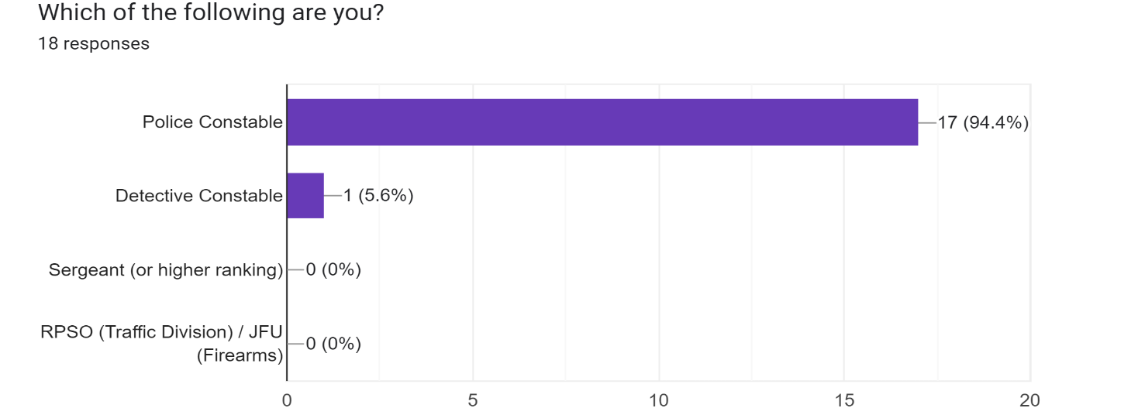
Figure 1

Results in figure 1 show that out of 18 respondents, 17 (94.4%) are in the role of Police Constable and only 1 (5.6%) is in the role of Detective Constable.
A Detective Constable may not respond directly to a Mental Health incident however, so the 94.4% of persons responding in the response policing role may provide a better insight into how they would respond and police the incident. It is also worth noting that no persons of a high ranking or specialist department has undertaken this questionnaire, thus keeping the response relevant to responding officers only.

4.2.2 – Question 2
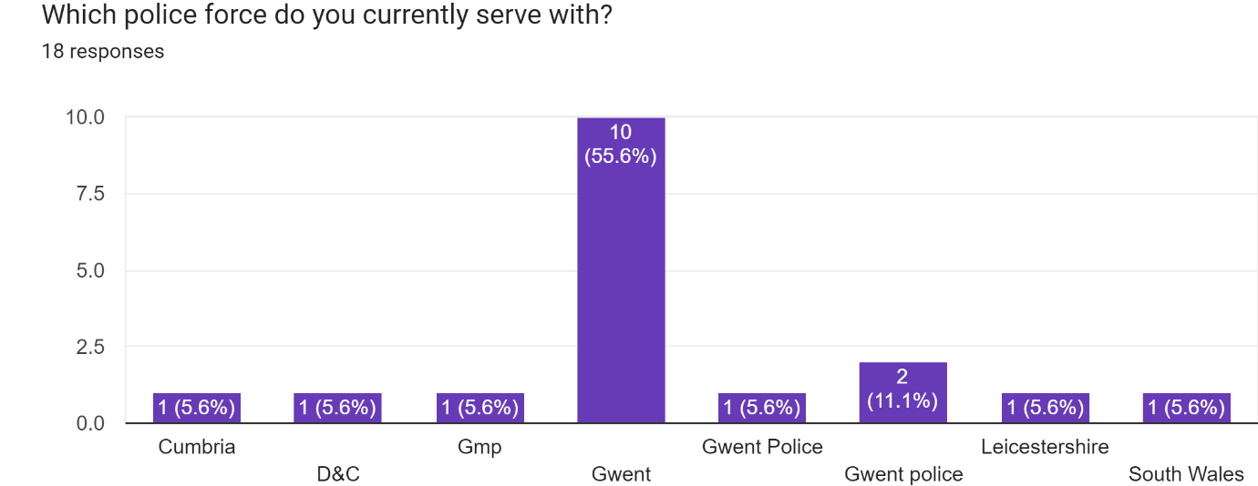
Figure 2

In figure 2, this question allowed the participants to answer openly as to not group them in any type of group, such as Welsh Police Forces / English Police Forces etc.
Due to persons being able to answer with their own choice, 13 persons answered that they were a part of Gwent Police Force. There were also 1 participant from Leicestershire Force, South Wales Police Force, Greater Manchester Police Force, Devon and Cornwall Police Force and Cumbria Police Force.
The questionnaire was given via a social media in-force police service group, commonly used for promotion boards and other generalised Policing speak. Therefore, I had a wider range of participants reply and not just specifically from the force that I work within, which should provide a wider range of opinions and experiences.

4.2.3 – Question 3
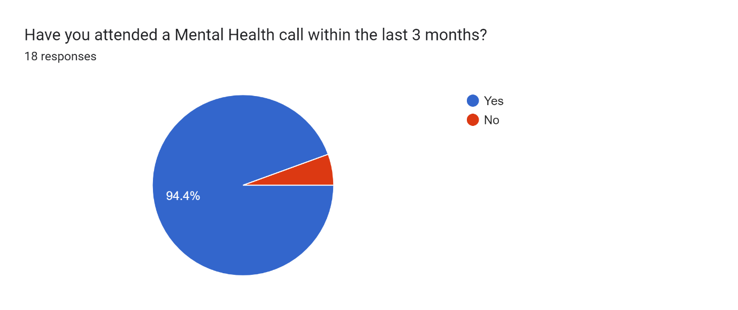
Figure 3
Results in figure 3 showed that most participants had attended a mental health call within the last three months, 94.4% - 17 participants. With only 1 participant 5.6% not having attended a mental health call within the last 3 months – this could be due to working in another department, as noted in figure 1 (Detective Constable).

4.2.4 – Question 4
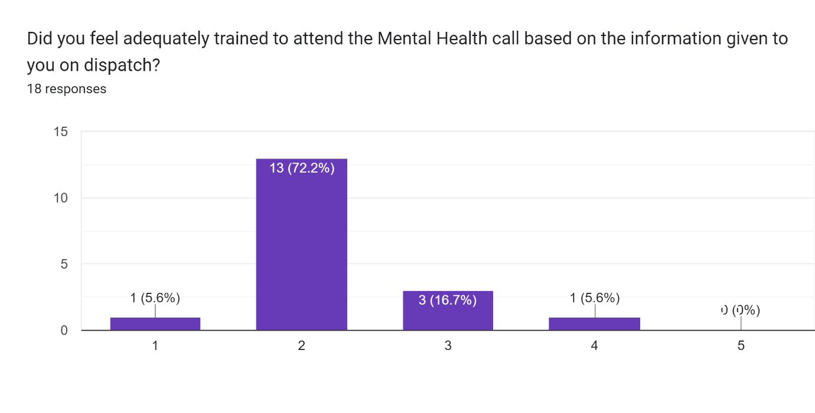
Figure 4
Not at all Fully Trained

Figure 4 shows the responses for Question 4. Participants were asked if they felt adequately trained to attend the mental health call based on the dispatch information they were originally given – from not at all trained to fully trained.
1 person felt as if they were not trained at all to attend the call, with a further 13 persons also picking below average of how trained they felt.
3 persons picked the middle number – average amount of training, not undertrained but not adequately trained to attend.
With only 1 person picking above average – but again, not fully trained to attend the call based on the initial dispatcher’s information passed.

4.2.5 – Question 5
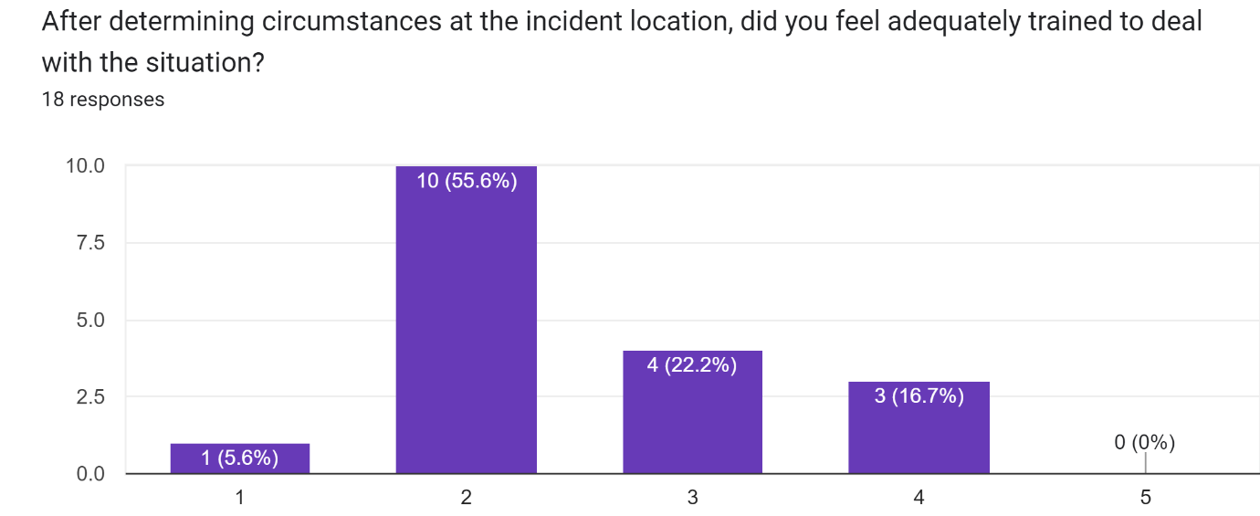
Figure 5
Not at all Fully Trained

Figure 5 shows the responses to question 5, with participants again being asked if they felt adequately trained to deal with the mental health call but this time after they had arrived and determined the circumstances for themselves (as instances aren’t always as they appear on dispatch) – from not at all trained to fully trained.
1 participant felt as if they were trained at all to attend the call, with a further 10 persons also picking below average of how trained they felt.
However, 4 persons now felt that they were neither undertrained nor adequately trained, which was more than the previous question.
3 persons picked above average, which is also more than the previous question, but still no persons felt fully trained enough to deal with the mental health incident that they had attended.

4.2.6 – Question 6
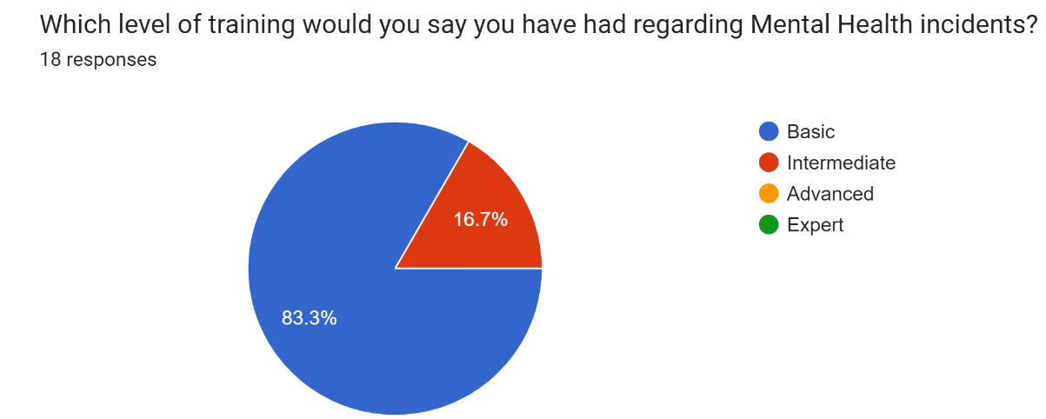
Figure 6
The results in figure 6 show that out of the 18 participants for this survey, 15 of those, 83.3% felt that they had received a basic level of training regarding mental health incidents.
3 participants, 16.7% felt that they had an intermediate level of training regarding mental health incidents.
No persons who answered the survey felt as if they had an advanced or an expert level of training regarding mental health incidents.

4.2.7 – Question 7
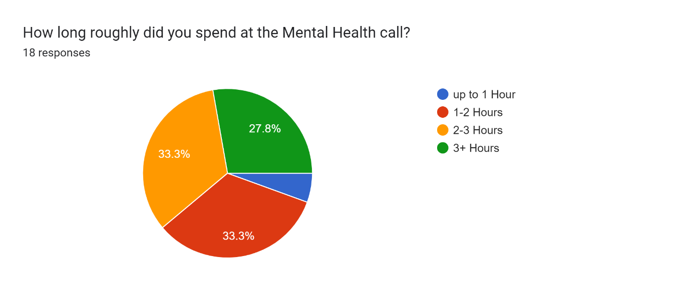
Figure 7

The results in figure 7 show that only 1 participant (5.6%) had been at their mental health call for 1 hour or less.
6 participants responded that they had been at their mental health call for 1-2 hours with another 6 participants stating that they had been at their call for 2-3 hours.
5 participants had spent longer than 3 hours at a mental health incident. The average shift is around 9 hours in the Police Service, over a third of their shift spent on one incident which is not crime related and falling into the category of a health-related call.

4.2.8 – Question 8
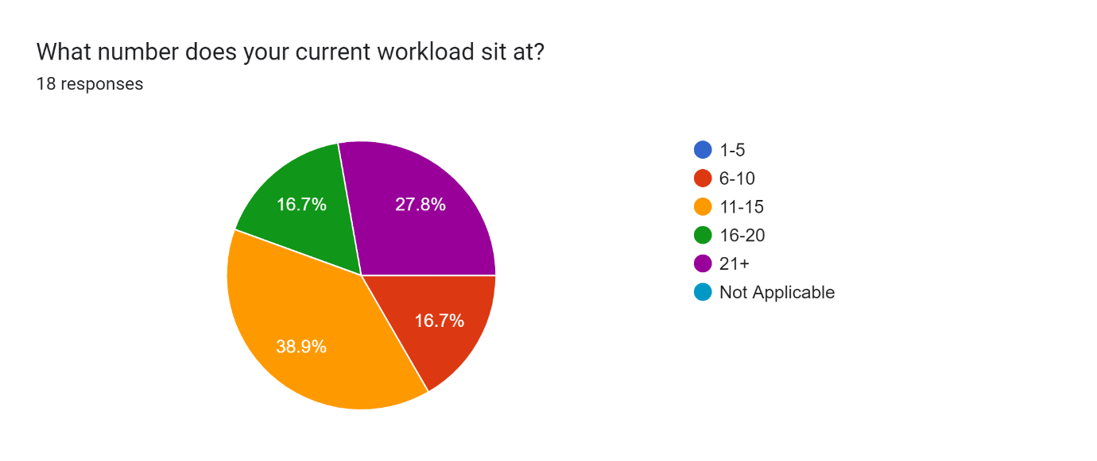
Figure 8

Question 8 within the survey allowed participants to answer ‘Not Applicable’ as it is known that some police forces have investigatory teams and this survey was inclusive, showing real data from participants.
However, figure 8 showed that all participants are carrying a workload at present.
No persons have a workload of 5 or under, 3 persons having a workload of between 6 and 10 crimes. 7 participants stating their workload is sat between 11 and 15. 3 participants stating their workload is sat between 16 and 20 crimes and 5 persons having a workload of over 21+ crimes.

4.2.9 – Question 9
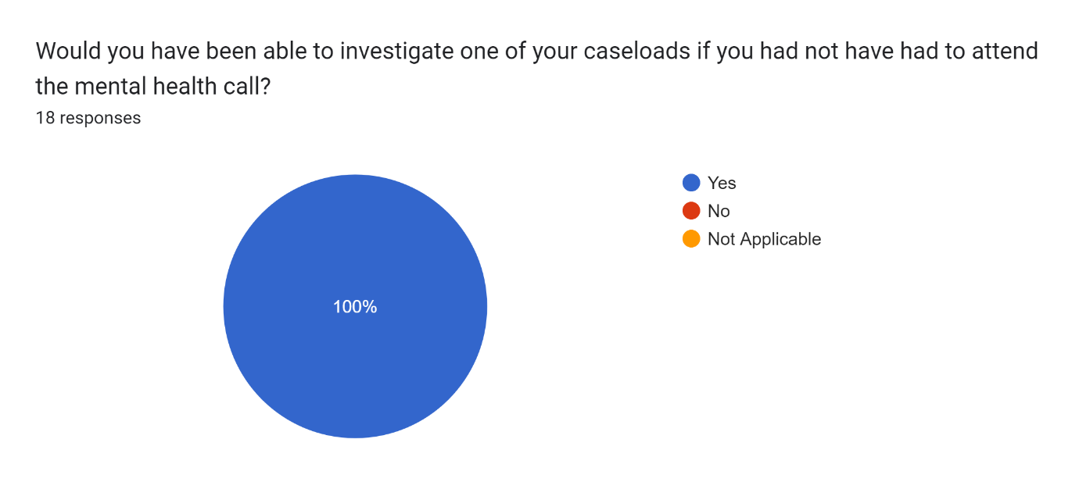
Figure 9

Participants of the survey were asked if they would have been able to investigate one of their incidents on their workload if they did not have to attend the mental health call.
Figure 9 shows that all 18 persons who responded stated that they would have been able to work on one of their own workloads.

4.2.10 – Question 10
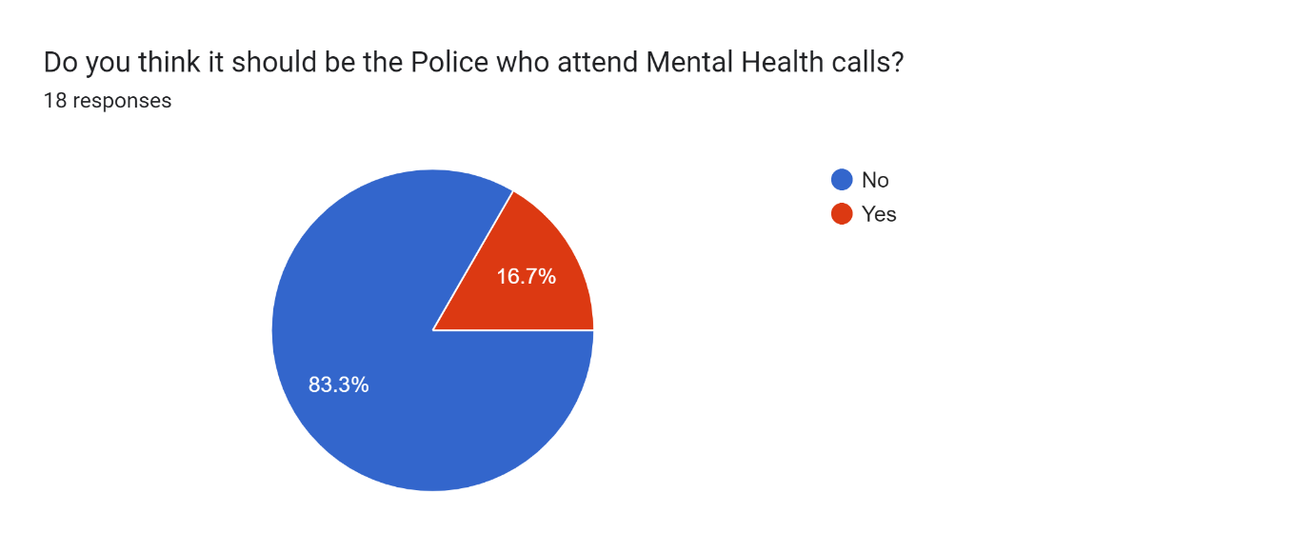
Figure 10
Figure 10 shows that 18 persons responded to the question above. With 15 persons believing that it should not be the police who attend mental health calls.
3 persons who answered this believed that it should be police who attend, they have been asked to explain their answer in the next question.

4.2.11 – Question 11
Figure 11

15 responses
I believe there should be a specific emergency response unit whose sole purpose is to attend mental health calls as the demand is definitely there.
Not suitably trained, haven’t got the resources to assist in gaining ongoing support/treatment. 136 gets over used as often difficult to get referrals.
Medical staff or ambulance would be better suited to this
Ambulance should deal with mental health related calls as police can assist. Paramedics are more suitably trained to deal with mental health than Police.
Not proportionate for police to be attending for medical emergencies
I'm on the fence of yes and no. Some MH jobs involve weapons where ambulance crews aren't trained or equipped with the equipment to resolve the issue. So yes and no.
medical emergency
we are not medically trained to deal with mental health incidents
It’s a medical issue thus should fall with the nhs, the most appropriate agency.
Police have a role to play in attending MH calls, without a MH triage team being three or four times the current size with 24/7 working we have no choice but to attend. MH jobs along with domestic incidents are the two types of jobs that can turn very quickly into horrendously dangerous situations for attending officers/professionals. Police have powers to deal with violence and are training to recognise danger cues, 100% we need mental health professionals dealing with MH, even better MH services should be funded enough so that it doesn’t come down to that 999 call and the requirement for any police to attend but unfortunately we aren’t at that point and I don’t see us reaching that point anytime in the near future.
We are not adequately trained for one point, secondly it is not our responsibility, we are here to keep the kings peace and prevent crime. Mental health calls should be attended to by paramedics or AMHPS who have sufficient powers to section more than a 136 and also they can refer easier
We are not the best trained to deal with calls of this nature, there is no crime committed and I believe a person with medical training would be able to assist with the situation better and have better resources.
Not adequately trained and cannot help the person enough
Do not have enough training/understanding of how to deal with persons who are mentally ill.
Feel other emergency services are better trained to deal with this type of call

Question 11 asked the participants of question 10 who answered ‘No’ to explain their answer. 15 persons responded ‘No’, 15 persons answered this question. The responses are best broken down into groups of how the participants have responded.
8 responses were mainly regarding being not suitably trained to attend, with all persons mentioning not being adequately trained in some aspect of their response and that the 136 method is often the best way but is overused by police as this is all that we have available.
- We are not adequately trained for one point, secondly it is not our responsibility, we are here to keep the king’s peace and prevent crime. Mental health calls should be attended to by paramedics or AMHPS who have sufficient powers to section more than a 136 and also, they can refer easier
- We are not the best trained to deal with calls of this nature, there is no crime committed and I believe a person with medical training would be able to assist with the situation better and have better resources.
- Ambulance should deal with mental health related calls as police can assist. Paramedics are more suitably trained to deal with mental health than Police.
- Not suitably trained, haven’t got the resources to assist in gaining ongoing support/treatment. 136 gets overused as often difficult to get referrals.
- Do not have enough training/understanding of how to deal with persons who are mentally ill.
- Feel other emergency services are better trained to deal with this type of call
- we are not medically trained to deal with mental health incidents
- Not adequately trained and cannot help the person enough

5 responses were mainly stating that they believe mental health is a medical issue and should fall to the NHS to be in attendance as they are the most appropriate agency who can deal with this type of incident and the demand for them to deal with this is present. One person within this response also stated that there should be a specific emergency response unit in place whose sole purpose is to attend these types of calls.
- medical emergency
- It’s a medical issue thus should fall with the nhs, the most appropriate agency.
- Not proportionate for police to be attending for medical emergencies
- Medical staff or ambulance would be better suited to this
- I believe there should be a specific emergency response unit whose sole purpose is to attend mental health calls as the demand is definitely there.
One response stated that they were unsure of their answer, mainly due to how some people with mental health can present and this can then become dangerous for paramedics to attend and aren’t attending with the correct protective equipment to aid with this type of incident.
- I'm on the fence of yes and no. Some MH jobs involve weapons where ambulance crews aren't trained or equipped with the equipment to resolve the issue. So yes and no.
The final response states that they believe that police have a role to play in attended mental health calls as there is not a 24/7 mental health triage team big enough (believe that it needs to be 3 or 4 times the size) to deal with the mental health crisis. The police have the powers and training to deal with the violence, but it should be mental health professionals dealing with mental health – they do not believe that the UK will reach that point anytime in the near future, however.
- Police have a role to play in attending MH calls, without a MH triage team being three or four times the current size with 24/7 working we have no choice but to attend. MH jobs along with domestic incidents are the two types of jobs that can turn very quickly into horrendously dangerous situations for attending officers/professionals. Police have powers to deal with violence and are training to recognise danger cues, 100% we need mental health professionals dealing with MH, even better MH services should be funded enough so that it doesn’t come down to that 999 call and the requirement for any police to attend but unfortunately we aren’t at that point and I don’t see us reaching that point anytime in the near future.

4.2.12 – Question 12
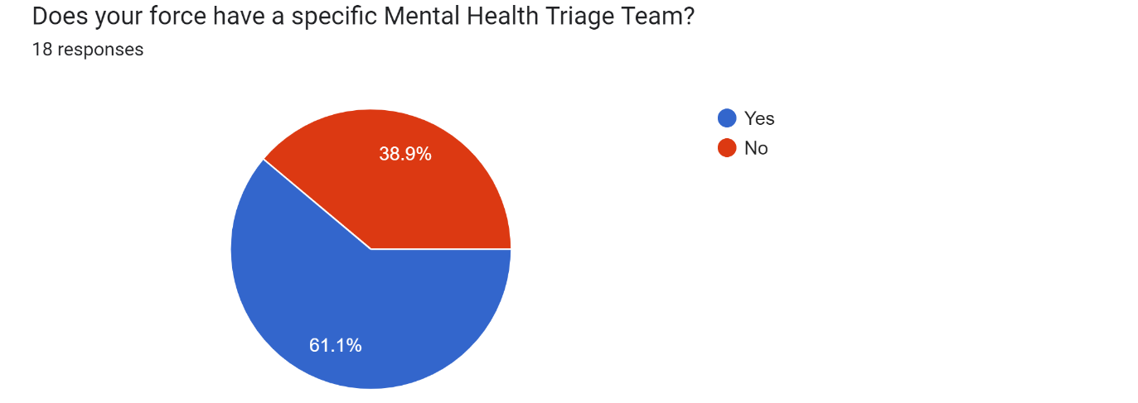
Figure 12
Figure 12 shows that 18 persons responded to the question above. With 11 persons stating that the police force that they work within has a specific mental health triage team.
7 persons stated that their force does not have a specific mental health triage team.

4.2.13 – Question 13
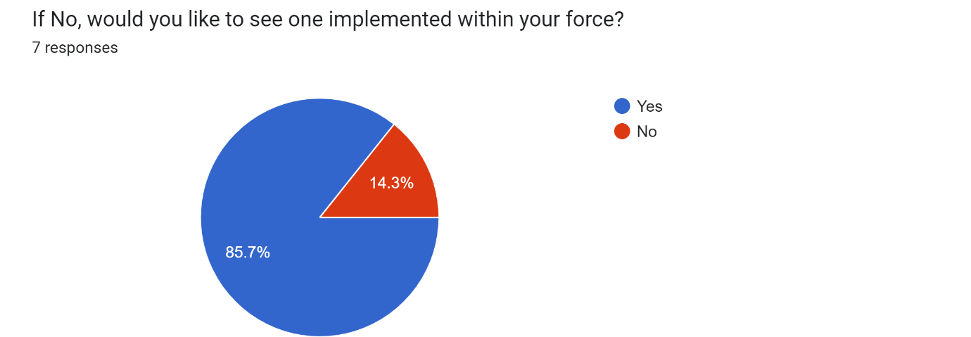
Figure 13

Figure 13 shows that 7 persons responded to the question above and 11 persons providing no answer.
Of the 7 persons who responded, 6 persons stated that they would like to see one implemented within their force.
1 person stated they would not like to see one implemented within their force.

4.2.14 – Question 14
Figure 14

10 responses
It would drastically affect the level of calls front line officers have to deal with. Providing them more time to focus on progressing their own workloads.
We have a joint mental health car nurse/pc- however only on lates and due to be taken to be joint with ambulance, having a mental health nurse on shift has been amazing, can access records, make referrals, find beds if needed etc. can get prescriptions if required. Worked far better when we had them on every shift but funding recently reduced. Invaluable to my district and had reduced 136 to virtually none, in the long term saving a lot of resources and money whilst also getting appropriate care and treatment for those in crisis.
Having a dedicated triage team would reduce response officers time at such calls. MH calls require knowledge from the Force AMHP who advises the best course of action however Gwent’s AMHP isn’t always available. This then results in officers having to contact 111, OOH GPs and MH Hospitals to obtain advice. This is very time consuming for officers and not practical in some situations - eg when the attending officer is single crewed at the call. This does not provide an adequate service to the person in need nor does it allow the officer to have full control of the situation at hand. Having a dedicated Triage Team brings both improved knowledge to the call as well as an improved service to those in need.
We have a mental health professional within the control room. Brilliant bit of kit
Medication emergency, hospitals should be taking the strain off police
to help us deal with mental health incidents
Triage triage triage, if the call sounds like a 136, send ambulance! If someone is in potential danger or threat to life or risk of crime we can attend *Alongside*
AMP

Question 14 asked the participants of question 13 to explain why they would or would not like to see a mental health triage team implemented within their police force.
There were 10 responses to this question (more than anticipated as only 7 answered the previous question and were asked to explain their answer).
The responses are best broken down into groups of how the participants have responded.
3 of the responses are based around lifting the strain off police officers allowing us to concentrate on response policing and crime and for hospitals to take on the medical emergency.
- It would drastically affect the level of calls front line officers have to deal with. Providing them more time to focus on progressing their own workloads.
- Medication emergency, hospitals should be taking the strain off police
- to help us deal with mental health incidents

One response is solely about how we take the call, triaging the person on the other side of the line and if it is a mental health call then Ambulance should attend, if the call is dangerous then police can attend but alongside rather than solely taking the call on.
- Triage triage triage, if the call sounds like a 136, send ambulance! If someone is in potential danger or threat to life or risk of crime we can attend *Alongside*

A further 3 responses are regarding what is already in place within their force, but more specifically a mental health professional within the control room (Approved Mental Health Professional, AMPH or AMP). With one person responding in length about Gwent Police in specific, as their AMPH goes off duty and is not always available which then leaves the officer seeking their own health professional to aid with the call such as Out of Hours GP’s or direct contact with mental health hospital facilities.
- Having a dedicated triage team would reduce response officers time at such calls. MH calls require knowledge from the Force AMHP who advises the best course of action however Gwent’s AMHP isn’t always available. This then results in officers having to contact 111, OOH GPs and MH Hospitals to obtain advice. This is very time consuming for officers and not practical in some situations - eg when the attending officer is single crewed at the call. This does not provide an adequate service to the person in need, nor does it allow the officer to have full control of the situation at hand. Having a dedicated Triage Team brings both improved knowledge to the call as well as an improved service to those in need.
- We have a mental health professional within the control room. Brilliant bit of kit
- AMP

The final response talks about how their force has already implemented the Mental Health Triage Team by having a joint response vehicle which has a mental health nurse and a police officer present. This is not on all shifts however, but they have seen a dramatic decrease in 136 sectioning and saving resources and money whilst providing appropriate care and treatment.
- We have a joint mental health car nurse/pc- however only on lates and due to be taken to be joint with ambulance, having a mental health nurse on shift has been amazing, can access records, make referrals, find beds if needed etc. can get prescriptions if required. Worked far better when we had them on every shift, but funding recently reduced. Invaluable to my district and had reduced 136 to virtually none, in the long-term saving a lot of resources and money whilst also getting appropriate care and treatment for those in crisis.

Chapter 5 – Conclusion

5.1 – Introduction
To conclude, the previous chapters of this dissertation provided by the researcher have introduced the dissertation, provided previous research, and have shown how further research and analysis of that research was to be carried out.
This chapter will now relate to the conducted previous research and note that if it was correct in what it stated or if any new findings have emerged. This chapter will also take note of the objectives created within this research project and if the researcher has been successful in achieving those objectives.

5.2 – Objectives of dissertation

As previously noted within the Introduction to this dissertation that there were objectives that the researcher wished to achieve throughout this research project.
Objective 1: To research all current available literature regarding attendance at Mental Health incidents, police training and support and response timings. Objectives 1 was based around the research that required to be conducted for this research project to be carried out effectively. From the literature review, it has identified that not all current literature was sourced, and this was due to wanting specific data and being unable to identify key pieces which would aid the researcher in concluding, whether that be for or against the topic.
Objective 2: To gather all research methods available and understand their meaning and relevance, to choose the most applicable which will collect the relevant data required for this dissertation. Objective two was completed however as research was conducted with what methods would be able to be used effectively within the time constraints and current COVID-19 pandemic. The meaning and relevance of the chosen research method was shown, with positives and negatives also provided.
Objective 3: To analyse the data collected to understand if Police Officers feel they should be the persons attending Mental Health calls, if they feel trained to attend these calls, and if they feel anything can be done to aid them with these incidents. The data was collected over a short period using social media and social groups to disseminate the questionnaire in hopes that it would get quite a few respondents almost immediately and that it would reach a wider audience – which both worked, and I was able to close the survey after a few days with 18 participants having completed it and provided me with enough data to analyse. A full analysis was carried out with most participants stating that they do not feel adequately trained as response officers to be attending mental health calls without a qualified mental health practitioner with them.
Objective 4: From my findings, if applicable, provide recommendations which could aid Police Officers regarding Mental Health incidents.
The researcher has noted points from the data collected and analysed that there would be numerous recommendations which would aid officers in attending mental health incidents; these will be listed in the recommendations chapter (Chapter 6).

5.3 – Relating to literature
A focus for mental health training for police, published by Thomas and Watson, 2017 states that their paper was written to propose a focus for mental health training efforts to better equip officers to provide intervention and support – this in turn will then have improved outcome for people experiencing mental health problems.
This survey has produced answers that correspond with Thomas and Watson, stating that there should be specialised mental health training programmes provided to police, but these should be reserved for specialist officers who wish to partake in these, but only after a period of sufficient operational experience has lapsed.
Meaning not all Police Officers should be attending the mental health calls, and whilst everyone has a basic training of mental health behind them, there may be officers who have vast experience and knowledge in their force and wish to undergo further mental health training, specialising in attending specifically mental health calls.
Lamb, et al. 2014 state that law enforcement agencies have played an increasingly important role in the management of persons who are experiencing psychiatric crisis. The Police are often the first to be called to deal with the persons with mental health emergencies. This is down to the legal powers as mentioned in 2.2. There is a need for better training, the article goes on to say, in how to identify and meet the needs of a person with mental illness and how to use the appropriate resources. A key part of the training should be to distinguish when a person with mental illness can be managed more appropriately by the health services or by the criminal justice system.
The article concludes that police and mental health departments should work closely and collaborate to create mobile crisis teams, so that there are more readily available resources to attend mental health incidents.
The research conducted for this article produced the same answers to the topic, that more training will always be required for police officers when attending a call which is specifically classed as a health-related call and not one crime related. Officers have limited training, and although they have life-saving training, very few come from specialised backgrounds that can aid an individual suffering with a mental health crisis.
Marsden, et al. 2020 conducted a study to examine UK police officers views and experiences of their involvement in mental healthcare. Their findings backing the results of the survey and previous research that police officers believed they had duty of care to protect the persons in mental health emergencies (PACE S17 save life and limb), they actually lacked the relevant knowledge in how to do so, the skills in doing so and due to this – the confidence in making the final decision which is in the best interests of the individual suffering with the mental health crisis.
The study stated that their findings showed that by strengthening multi-agency work and improving training, this might positively influence officers views of their role and maximise their contribution to improving emergency mental healthcare.

Chapter 6 – Recommendations

6.1 - Introduction
This chapter will show the recommendations that the researcher has deemed appropriate from conducting this research paper. Whilst conducting this research, some elements of the research project became evident that there could be some changes made that would improve services for a lot of people, not just the attending officers but for the National Health Service and the persons suffering with their mental health.

6.2 - Questionnaire
One part that could be amended would be the questionnaire that was produced to collect the data required for this research project. This questionnaire was only made via only routes due to time constraints, where I believe if I had gone and handed this out within stations to response officers on my days off (which would not have taken long), I would have gotten more responses and thus a wider range of data to go towards my analysis and findings chapter. There could have also been direct questions asked and a better way of answering some rather than a 1-5 scale, as this does not allow people to explain how much training they felt they had.

6.3 – Partnership working
To be able to get a more rounded answer regarding mental health, a second questionnaire could have been made and aimed at the National Health Service to grasp their side of the current mental health crisis, how we could overcome this and how we could work together in partnership to provide a more overall effective approach to mental health incidents.
It would have been handy also to speak to mental health nurses / health are assistants who deal with mental health specifically to allow their views on how we could adapt to work together and which service they believe should be in immediate response and why, this would have allowed for a broader feedback and overall research dissertation.

6.4 – Improved training for police officers
As shown within the survey and research, training appears to be lacking with regards to the police service and mental health. It is quite simple that officers are not trained appropriately and in-depth enough to attend the mental health incidents that they are attending. Providing specialist training to specific officers and allowing them to work with the National Health Service will provide a better service to those suffering with their mental health.

6.5 – Implementation of triage teams
One thing that is clear, and even from an American and UK policing point of view, is that there is demand there for the National Health Service and the Police Service to work together. As mental health increases the demand increases too, which provides the drive to pull the services together. As mentioned within the survey by an active police officer, their implementation within their service of a triage team has already dramatically reduced the number of 136 sectioning by sending a qualified person who can provide appointments, support and medication instantly; this is helping the growing instant demand when officers require appointments or sit for hours in hope that a mental health specialist will provide an assessment on your patient.

Chapter 7 – Bibliography

- Abergavenny Chronicle, 2011. 'I hope you find closure' Judge tells Jade Ruck. [Online]
Available at: https://www.abergavennychronicle.com/news/i-hope-you-find-closure-judge-tells-jade-ruck-68872

- BBC News, 2016. Van to stop mental health patients being locked up. [Online]
Available at: https://www.bbc.co.uk/news/uk-wales-35300815
[Accessed 17 July 2022].

- BBC News, 2017. Mental Health Calls 'Stopping police preventing crime'. [Online]
Available at: https://www.bbc.co.uk/news/uk-wales-41998104
[Accessed 22 June 2022].

- BBC News, 2021. Deaths of people treated under the Mental Health Act rose during pandemic. [Online]
Available at: https://www.bbc.co.uk/news/uk-politics-59336579
[Accessed 21 July 2022].

- Booth, A., Scantlebury, A., Hughes-Morley, A., Mitchell, N., Wright, K., Scott, W. and McDaid, C. (2017). Mental health training programmes for non-mental health trained professionals coming into contact with people with mental ill health: a systematic review of effectiveness. BMC Psychiatry, 17(1). doi:10.1186/s12888-017-1356-5.
[Accessed 18 July 2022].

- Brown, J., 2021. Police Powers: An Introduction. [Online]
Available at: https://commonslibrary.parliament.uk/research-briefings/cbp-8637/
[Accessed 18 July 2022].

- Express and Star, 2022. West Midlands Police first to live stream body camera footage. [Online]
Available at: https://www.expressandstar.com/news/crime/2022/07/18/regions-police-force-first-to-live-stream-body-camera-footage/
[Accessed 25 July 2022].

- Gwent Police, 2022. Join Us - Police Officers. [Online]
Available at: https://www.gwent.police.uk/police-forces/gwent-police/areas/careers/join-us/police-officers2/police-officers/
[Accessed 20 July 2022].

- Hennink, M.M., Hutter, I. and Bailey, A. (2020). Qualitative research methods. Los Angeles: Sage.

- Jones, L., 2019. Police 'dealing with more mental health incidents'. [Online]
Available at: https://www.bbc.co.uk/news/uk-49317060
[Accessed 18 July 2022].

- Lamb, H.R., Weinberger, L.E. and Decuir, W.J. (2002). The Police and Mental Health. Psychiatric Services, [online] 53(10), pp.1266-1271. https://doi:10.1176/appi.ps.53.10.1266.

- Marsden, M., Nigam, J., Lemetyinen, H. and Edge, D. (2020). Investigating police officers’ perceptions of their role in pathways to mental healthcare. Health & Social Care in the Community. doi:10.1111/hsc.12922.

- Mayers, D. A., n.d. Mental health and the police. [Online]
Available at: https://andrewmayers.uk/mental-health-and-the-police
[Accessed 20 July 2022].

- Mental Health Today, 2013. Police need more mental health training. [Online]
Available at: https://www.mentalhealthtoday.co.uk/police-need-more-mental-health-training
[Accessed 20 July 2022].

- Mooi, E. and Sarstedt, M. (2011) A concise guide to market research the process, data, and methods using IBM SPSS statistics. Berlin: Springer

- Nardi, P.M. (2016). Doing survey research: a guide to quantitative methods. London: Routledge.

- National Police Chiefs' Council, 2018. National Strategy on Policing and Mental Health. [Online]
Available at: https://www.npcc.police.uk/Mental%20Health/Nat%20Strat%20Final%20v2%2026%20Feb%202020.pdf
[Accessed 25 July 2022].

- NHS Sheffield Health and Social Care, 2022. Commonly used sections of the Mental Health Act 1983. [Online]
Available at: https://www.shsc.nhs.uk/service-users-and-carers/commonly-used-sections-mental-health-act-1983
[Accessed 20 July 2022].

- NHS, 2019. Mental Health Act. [Online]
Available at: https://www.nhs.uk/mental-health/social-care-and-your-rights/mental-health-and-the-law/mental-health-act/
[Accessed 28 June 2022].

- Streefkerk, R. (2019). Qualitative vs. quantitative research | definitions, differences & methods. [online] Scribbr. Available at: https://www.scribbr.com/methodology/qualitative-quantitative-research/.

- Scantlebury, A., Fairhurst, C., Booth, A., McDaid, C., Moran, N., Parker, A., Payne, R., Scott, W.J., Torgerson, D., Webber, M. and Hewitt, C. (2017). Effectiveness of a training program for police officers who come into contact with people with mental health problems: A pragmatic randomised controlled trial. PLOS ONE, 12(9), p.e0184377. doi:10.1371/journal.pone.0184377.

- Thomas, S. and Watson, A. (2017), "A focus for mental health training for police", Journal of Criminological Research, Policy and Practice, Vol. 3 No. 2, pp. 93-104. https://doi.org/10.1108/JCRPP-01-2017-0005

Chapter 8 – Appendices

8.1 - Appendix One: Ethics Form

APPLICATION FOR ETHICAL APPROVAL
In order for research to result in benefit and minimise risk of harm, it must be conducted ethically. A researcher may not be covered by the University’s insurance if ethical approval has not been obtained prior to commencement.
The University follows the OECD Frascati manual definition of research activity: “creative work undertaken on a systematic basis in order to increase the stock of knowledge, including knowledge of man, culture and society, and the use of this stock of knowledge to devise new applications”. As such this covers activities undertaken by members of staff, postgraduate research students, and both taught postgraduate and undergraduate students working on dissertations/projects.
The individual undertaking the research activity is known as the “principal researcher”.
Ethical approval is not required for routine audits, performance reviews, quality assurance studies, testing within normal educational requirements, and literary or artistic criticism.
Please read the notes for guidance before completing ALL sections of the form.
This form must be completed and approved prior to undertaking any research activity. Please see Checklist for details of process for different categories of application.
Delete the Guidance Notes at the end of the form BEFORE submitting your application
SECTION A: About You (Principal Researcher)
Full Name: |  | Alice Elizabeth Johnson
Tick all boxes which apply: |  | Member of staff: | ☐ | Honorary research fellow: | ☐
Undergraduate Student | ☒ | Taught Postgraduate Student | ☐ | Postgraduate Research Student | ☐
Institute/Academic Discipline/Centre: |  | IMH
Campus: |  | Swansea
E-mail address: |  | 1921008@student.uwtsd.ac.uk
Contact Telephone Number:
For students:
Student Number: |  | 1921008
Programme of Study: |  | BSc (Hons) Professional Policing Practice
Director of Studies/Supervisor: |  | Jane Thomas

SECTION B: Approval for Research Activity
Has the research activity received approval in principle?  (please check the Guidance Notes as to the appropriate approval process for different levels of research by different categories of individual) |  | YES | ☒ | NO | ☐
 |  |  |  | Date
If Yes, please indicate source of approval (and date where known): Approval in principle must be obtained from the relevant source prior to seeking ethical approval | Research Degrees Committee |  | ☐
 | Institute Research Committee |  | ☐
 | Other (write in) |  | ☒ | Jane Thomas

SECTION C: Internal and External Ethical Guidance Materials
Please list the core ethical guidance documents that have been referred to during the completion of this form (including any discipline-specific codes of research ethics, and also any specific ethical guidance relating to the proposed methodology). Please tick to confirm that your research proposal adheres to these codes and guidelines.
UWTSD Research Ethics & Integrity Code of Practice | ☒
UWTSD Research Data Management Policy | ☒
 | ☐

SECTION D: External Collaborative Research Activity
Does the research activity involve collaborators outside of the University? |  | YES | ☐ | NO | ☒
If Yes, please provide the name of the external organisation and name and contact details for the main contact person and confirmation this person has consented to their personal data being shared.as part of this collaboration.
Institution
Contact person name
Contact person e-mail address

Has this individual consented to sharing their details on this form? |  | YES | ☐ | NO |  |  | ☐
Are you in receipt of a KESS scholarship? |  | YES | ☐ | NO |  |  | ☐
Is your research externally funded |  | YES | ☐ | NO |  |  | ☐
Are you specifically employed to undertake this research in either a paid or voluntary capacity? | Voluntary | YES | ☐ | NO |  | ☐
 | Employed | YES | ☐ | NO |  | ☐
Is the research being undertaken within an existing UWTSD Athrofa Professional Learning Partnership (APLP) | If YES then the permission question below does not need to be answered. | YES | ☐ | NO |  |  | ☐
Permission to undertake the research has been provided by the partner organisation | (If YES attach copy)  If NO the application cannot continue | YES | ☐ | NO |  |  | ☐

Where research activity is carried out in collaboration with an external organisation
Does this organisation have its own ethics approval system? | YES | ☐ | NO | ☐
If Yes, please attach a copy of any final approval (or interim approval) from the organisation

SECTION E: Details of Research Activity
Indicative title: | The underlining issue mental health calls have on response time and workload
Proposed start date: | 23 March 2022 | Proposed end date: | 16 January 2023
Introduction to the Research (maximum 300 words)
Ensure that you write for a Non-Specialist Audience when outlining your response to the three points below:
- Purpose of Research Activity
- Proposed Research Question
- Aims of Research Activity
- Objectives of Research Activity
Demonstrate, briefly, how Existing Research has informed the proposed activity and explain
- What the research activity will add to the body of knowledge
- How it addresses an area of importance.
Purpose of Research Activity
To understand why Police Officers need to attend Mental Health calls and how this has a negative effect on their constantly increasing workloads and time restraints to work on these and investigate crimes effectively.
As a response officer I am able to relate to the increasing workloads and the stress and hardship this has, whilst also having to attend numerous Mental Health calls per set of shifts.
(this box should expand as you type)
Research Question
Why are Police Officers the first to respond to these incidents? Could there be a unit implemented by both services working together to provide immediate mental health response to incidents?
(this box should expand as you type)
Aims of Research Activity
To see if the implementation of a unit created by both services would be beneficial to response police officers and their workloads / time to investigate crime.
(this box should expand as you type)
Objectives of Research Activity
The information I wish to collect on this research topic is:
- The real-life views from response officers that attend mental health calls and how they feel regarding attending these
- If the response officers attending feel as though they have enough training to deal with the mental health calls that they are attending
- If the mental health officers feel they would benefit from a unit within the Police and Ambulance service that could respond to mental health calls
- If the response officers feel that attending mental health calls repeatedly is having an effect on their workload and how they respond to emergency calls.
(this box should expand as you type)
Proposed methods (maximum 600 words)
Provide a brief summary of all the methods that may be used in the research activity, making it clear what specific techniques may be used. If methods other than those listed in this section are deemed appropriate later, additional ethical approval for those methods will be needed.
For research methods I will be using quantitative methods, specifically a questionnaire.
I feel this would be best suited as it can reach a wider range of persons throughout the force area.
I do not wish to use interviews or directly ask individuals as I plan to keep each persons answers anonymous to be able to accurately and factual gather information – not based on relationships with individuals in the force.
(this box should expand as you type)

Location of research activity
Identify all locations where research activity will take place.
Gwent Police Force geographical area.
Cwmbran / Blackwood.

(this box should expand as you type)
Research activity outside of the UK
If research activity will take place overseas, you are responsible for ensuring that local ethical considerations are complied with and that the relevant permissions are sought. Specify any local guidelines (e.g. from local professional associations/learned societies/universities) that exist and whether these involve any ethical stipulations beyond those usual in the UK (provide details of any licenses or permissions required). Also specify whether there are any specific ethical issues raised by the local context in which the research activity is taking place, for example, particular cultural and/or legal sensitivities or vulnerabilities of participants.
Not applicable

(this box should expand as you type)
Use of documentation not in the public domain: Are any documents NOT publicly available? | NO | ☒
 | YES | ☐
If Yes, please provide details here of how you will gain access to specific documentation that is not in the public domain and that this is in accordance with prevailing data protection law of the country in question and England and Wales.

(this box should expand as you type)

SECTION F: Scope of Research Activity
Will the research activity include: | YES | NO
Use of a questionnaire or similar research instrument? | ☒ | ☐
Use of interviews? | ☐ | ☒
Use of diaries? | ☐ | ☒
Participant observation with their knowledge? | ☐ | ☒
Participant observation without their knowledge? | ☐ | ☒
Use of video or audio recording? | ☐ | ☒
Access to personal or confidential information without the participants’ specific consent? | ☐ | ☒
Administration of any questions, test stimuli, presentation that may be experienced as physically, mentally or emotionally harmful / offensive? | ☐ | ☒
Performance of any acts which may cause embarrassment or affect self-esteem? | ☐ | ☒
Investigation of participants involved in illegal activities? | ☐ | ☒
Use of procedures that involve deception? | ☐ | ☒
Administration of any substance, agent or placebo? | ☐ | ☒
Working with live vertebrate animals? | ☐ | ☒
Other primary data collection methods, please explain in this box  For example, ‘focus groups’. Please indicate the type of data collection method(s) in this box and tick the accompany box. | ☐ | ☒
Details of any other primary data collection method:  (this box should expand as you type) | ☐ | ☒
If NO to every question, then the research activity is (ethically) low risk and may be exempt from some of the following sections (please refer to Guidance Notes).

If YES to any question, then no research activity should be undertaken until full ethical approval has been obtained.

SECTION G: Intended Participants
Who are the intended participants: | YES | NO
Students or staff at the University? | ☒ | ☐
Adults (over the age of 18 and competent to give consent)? | ☒ | ☐
Vulnerable adults? | ☐ | ☒
Children and Young People under the age of 18? (Consent from Parent, Carer or Guardian will be required) | ☐ | ☒
Prisoners? | ☐ | ☒
Young offenders? | ☐ | ☒
Those who could be considered to have a particularly dependent relationship with the investigator or a gatekeeper? | ☐ | ☒
People engaged in illegal activities? | ☐ | ☒
Others (please identify specifically any group who may be unable to give consent) please indicate here and tick the appropriate box. | ☐ | ☒
Other – please indicate here:  (this box should expand as you type) | ☐ | ☒

Participant numbers and source
Provide an estimate of the expected number of participants. How will you identify participants and how will they be recruited?
How many participants are expected? | As many as can complete the survey in the given time. The number of persons is not relevant, but preferably more than 20 to gather a good number of evidential opinions.  (this box should expand as you type)
Who will the participants be? | Response police officers currently employed by Gwent Police Service or recently departed Response Police Officers who were employed by Gwent Police.  (this box should expand as you type)
How will you identify the participants? | Colleagues and other persons working within the Police Service.  (this box should expand as you type)

Information for participants: | YES | NO | N/A
Will you describe the main research procedures to participants in advance, so that they are informed about what to expect? | ☒ | ☐ | ☐
Will you tell participants that their participation is voluntary? | ☒ | ☐ | ☐
Will you obtain written consent for participation? | ☒ | ☐ | ☐
Will you explain to participants that refusal to participate in the research will not affect their treatment or education (if relevant)? | ☒ | ☐ | ☐
If the research is observational, will you ask participants for their consent to being observed? | ☒ | ☐ | ☐
Will you tell participants that they may withdraw from the research at any time and for any reason? | ☒ | ☐ | ☐
With questionnaires, will you give participants the option of omitting questions they do not want to answer? | ☒ | ☐ | ☐
Will you tell participants that their data will be treated with full confidentiality and that, if published, it will not be identifiable as theirs? | ☒ | ☐ | ☐
Will you debrief participants at the end of their participation, in a way appropriate to the type of research undertaken? | ☒ | ☐ | ☐
If NO to any of above questions, please give an explanation
(this box should expand as you type)

Information for participants: | YES | NO | N/A
Will participants be paid? | ☐ | ☒ | ☐
Is specialist electrical or other equipment to be used with participants? | ☐ | ☒ | ☐
Are there any financial or other interests to the investigator or University arising from this study? | ☐ | ☒ | ☐
Will the research activity involve deliberately misleading participants in any way, or the partial or full concealment of the specific study aims? | ☐ | ☒ | ☐
If YES to any question, please provide full details
(this box should expand as you type)

SECTION H: Anticipated Risks
Outline any anticipated risks that may adversely affect any of the participants, the researchers and/or the University, and the steps that will be taken to address them.

If you have completed a full risk assessment (for example as required by a laboratory, or external research collaborator) you may append that to this form.
Full risk assessment completed and appended? |  | Yes | ☒
 |  | No | ☒
Risks to participants
For example: emotional distress, financial disclosure, physical harm, transfer of personal data, sensitive organisational information
Risk to Participant:  No Risk.  (this box should expand as you type) | How will you mitigate the Risk to Participant  (this box should expand as you type)
If research activity may include sensitive, embarrassing or upsetting topics (e.g. sexual activity, drug use) or issues likely to disclose information requiring further action (e.g. criminal activity), give details of the procedures to deal with these issues, including any support/advice (e.g. helpline numbers) to be offered to participants. Note that where applicable, consent procedures should make it clear that if something potentially or actually illegal is discovered in the course of a project, it may need to be disclosed to the proper authorities
(this box should expand as you type)
Risks to investigator
For example: personal safety, physical harm, emotional distress, risk of accusation of harm/impropriety, conflict of interest
Risk to Investigator:  No Risk  (this box should expand as you type) | How will you mitigate the Risk to Investigator:  (this box should expand as you type)
University/institutional risks
For example: adverse publicity, financial loss, data protection
Risk to University:  No Risk  (this box should expand as you type) | How will you mitigate the Risk to University:  (this box should expand as you type)

Disclosure and Barring Service
If the research activity involves children or vulnerable adults, a Disclosure and Barring Service (DBS) certificate must be obtained before any contact with such participants. | YES | NO | N/A
Does your research require you to hold a current DBS Certificate? | ☐ | ☐ | ☒

SECTION I: Feedback, Consent and Confidentiality
Feedback
What de-briefing and feedback will be provided to participants, how will this be done and when?
It will be known what will happen to the research prior to the questionnaire taking place and if anyone would like a copy of the research they are able to request this.

(this box should expand as you type)
Informed consent
Describe the arrangements to inform potential participants, before providing consent, of what is involved in participating. Describe the arrangements for participants to provide full consent before data collection begins. If gaining consent in this way is inappropriate, explain how consent will be obtained and recorded in accordance with prevailing data protection legislation.
There will be a consent part of the questionnaire before the questionnaire begins which asks the persons for consent.
If they do not consent – the questionnaire MUST NOT be completed.

(this box should expand as you type)
Confidentiality / Anonymity
Set out how anonymity of participants and confidentiality will be ensured in any outputs. If anonymity is not being offered, explain why this is the case.
Anonymity is being offered.
I am taking no personal information which can identify any persons.

(this box should expand as you type)

SECTION J: Data Protection and Storage
In completing this section refer to the University’s Research Data Management Policy and the extensive resources on the University’s Research Data Management web pages (http://uwtsd.ac.uk/library/research-data-management/).
Does the research activity involve personal data (as defined by the General Data Protection Regulation 2016 “GDPR” and the Data Protection Act 2018 “DPA”)? | YES | NO
“Personal data” means any information relating to an identified or identifiable natural person (‘data subject’). An identifiable natural person is one who can be identified, directly or indirectly, in particular by reference to an identifier such as a name, an identification number, location data, an online identifier or to one or more factors specific to the physical, physiological, genetic, mental, economic, cultural or social identity of that natural person. | ☐ | x
If YES, provide a description of the data and explain why this data needs to be collected:
(this box should expand as you type)
Does it involve special category data (as defined by the GDPR)? | YES | NO
“Special category data” means sensitive personal data consisting of information as to the data subjects’ –  (a) racial or ethnic origin,  (b) political opinions,  (c ) religious beliefs or other beliefs of a similar nature,  (d) membership of a trade union (within the meaning of the Trade Union and Labour Relations (Consolidation) Act 1992),  (e) physical or mental health or condition,  (f) sexual life,  (g) genetics,  (h) biometric data (as used for ID purposes), | ☐ | x
If YES, provide a description of the special category data and explain why this data needs to be collected:
(this box should expand as you type)
Will the research activity involve storing personal data and/or special category data on one of the following: | YES | NO
Manual files (i.e. in paper form)? | ☐ | ☒
University computers? | ☐ | ☒
Private company computers? | ☒ | ☐
Home or other personal computers? | ☐ | ☒
Laptop computers/ CDs/ Portable disk-drives/ memory sticks? | ☐ | ☒
“Cloud” storage or websites? | ☐ | ☒
Other – specify: | ☐ | ☒
For all stored data, explain the measures in place to ensure the security of the data collected, data confidentiality, including details of password protection, encryption, anonymisation and pseudonymisation:
(this box should expand as you type)
All Data Storage
Will the research activity involve any of the following activities: | YES | NO
Electronic transfer of data in any form? | ☐ | ☒
Sharing of data with others at the University? | ☐ | ☒
Sharing of data with other organisations? | ☐ | ☒
Export of data outside the European Union or importing of data from outside the UK? | ☐ | ☒
Use of personal addresses, postcodes, faxes, emails or telephone numbers? | ☐ | ☒
Publication of data that might allow identification of individuals? | ☐ | ☒
Use of data management system? | ☐ | ☒
Data archiving? | ☐ | ☒
If YES to any question, please provide full details, explaining how this will be conducted in accordance with the GDPR and DPA (and/or any international equivalent):
(this box should expand as you type)
List all who will have access to the data generated by the research activity:
(this box should expand as you type)
List who will have control of, and act as custodian(s) for, data generated by the research activity:
(this box should expand as you type)
Give details of data storage arrangements, including security measures in place to protect the data, where data will be stored, how long for, and in what form. Will data be archived – if so how and if not why not.
(this box should expand as you type)
Please indicate if your data will be stored in the UWTSD Research Data Repository (see https://researchdata.uwtsd.ac.uk/ ). If so please explain. (Most relevant to academic staff)
(this box should expand as you type)
Confirm that you have read the UWTSD guidance on data management (see https://www.uwtsd.ac.uk/library/research-data-management/) | YES | ☒
 | NO | ☐
Confirm that you are aware that you need to keep all data until after your research has completed or the end of your funding | YES | ☒
 | NO | ☐

SECTION K: Declaration
The information which I have provided is correct and complete to the best of my knowledge. I have attempted to identify any risks and issues related to the research activity and acknowledge my obligations and the rights of the participants.

In submitting this application I hereby confirm that I undertake to ensure that the above named research activity will meet the University’s Research Ethics and Integrity Code of Practice which is published on the website: https://www.uwtsd.ac.uk/research/research-ethics/
Signature of applicant: |  | Date:  16/05/2022

For STUDENT Submissions:
Director of Studies/Supervisor: |  | Date:
Signature: |  | Date:

For STAFF Submissions:
Academic Director/ Assistant Dean: |  | Date:
Signature: |  | Date:

Checklist: Please complete the checklist below to ensure that you have completed the form according to the guidelines and attached any required documentation:
☒ | I have read the guidance notes supplied before completing the form.
☒ | I have completed ALL RELEVANT sections of the form in full.
☒ | I confirm that the research activity has received approval in principle
☐ | I have attached a copy of final/interim approval from external organisation (where appropriate)
☐ | I have attached a full risk assessment (and have NOT completed Section H of this form) (where appropriate) ONLY TICK IF YOU HAVE ATTACHED A FULL RISK ASSESSMENT
☒ | I understand that it is my responsibility to ensure that the above named research activity will meet the University’s Research Ethics and Integrity Code of Practice.
☒ | I understand that before commencing data collection all documents aimed at respondents (including information sheets, consent forms, questionnaires, interview schedules etc.) must be confirmed by the DoS/Supervisor, module tutor or Academic Director.
☒ | I have deleted the guidance notes before submitting the PG2 for consideration

RESEARCH STUDENTS AND STAFF ONLY
All communications relating to this application during its processing must be in writing and emailed to pgresearch@uwtsd.ac.uk , with the title ‘Ethical Approval’ followed by your name.
You will be informed of the outcome of your claim by email; therefore it is important that you check your University and personal email accounts regularly.

STUDENTS ON UNDERGRADUATE OR TAUGHT MASTERS PROGRAMMES should submit this form (and receive the outcome) via systems explained to you by the supervisor/module leader.

This form is available electronically from the Academic Office web pages: https://www.uwtsd.ac.uk/academic-office/appendices-and-forms/

Application Process

All staff research projects and all research students must submit the Ethical Approval Form to the University Research Ethics Committee via the Academic Office (pgresearch@uwtsd.ac.uk). Staff research directly in relation to personal study for taught undergraduate or Masters programmes should be submitted via the Institute procedures explained below.

Taught masters and taught undergraduate research Ethical Approval Forms are considered within Institutes. Institutes will provide details of the specific processes for this. Where the Ethical issues within any single ethical application are of particular concern the Institute will refer these to the University Research Ethics Committee. Any student activity that involves the collection of primary data needs to undergo Ethical approval, this includes assignment work as well as dissertations.

8.2 – Appendix Two: Proposal Form


UNDERGRADUATE DISSERTATION
RESEARCH PROPOSAL FORM

NAME: Alice Johnson | STUDENT ID No.: 1921008
DRAFT RESEARCH TITLE QUESTION: The underlining issue mental health calls have on response time and workload.

INTRODUCTION: (220 words)
To understand why Police Officers need to attend Mental Health calls and how this has a negative effect on their constantly increasing workloads and time restraints to work on these and investigate crimes effectively.
As a response officer I am able to relate to the increasing workloads and the stress and hardship this has, whilst also having to attend numerous Mental Health calls per set of shifts.
Police Officers have acts and laws to follow as part of their role. Common Law and Police and Criminal Evidence Act (PACE) state that Police Officers are able to enter a property without warrant to ‘save life and limb’ this allows officers to be contacted more frequently to attend properties in which Ambulance are unable to enter due to their lack of Power of Entry policies that they have.
Mental Health Act had legal changes introduced in 2017. These changes were intended to improve service responses to people who require urgent help with their Mental Health, however, it states that Police Officers are usually the first to respond.
Mental Health cases have increased dramatically due to illnesses becoming more well known and identified, and due to the ongoing pandemic, which has enclosed persons within their households, limited their contact with other persons and some have lost jobs and have now had financial issues.
SUMMARY OF RESEARCH OBJECTIVES: (106words)
The information I wish to collect on this research topic is:
- The real-life views from response officers that attend mental health calls and how they feel regarding attending these
- If the response officers attending feel as though they have enough training to deal with the mental health calls that they are attending
- If the mental health officers feel they would benefit from a unit within the Police and Ambulance service that could respond to mental health calls
- If the response officers feel that attending mental health calls repeatedly is having an effect on their workload and how they respond to emergency calls.

LITERATURE REVIEW: (68 words)
The key literature to be used within this research project would come from current legislation which is in place that states that Police should be attending mental health calls and why, Google Scholar – which looks at previous journals created by individuals which can have some input on the research and information and relevant textbooks or online websites which can also provide information and factual statistics regarding the question.
SUMMARY OF RESEARCH –SURVEY METHOD:
For research methods I will be using quantitative methods, specifically a questionnaire.
I feel this would be best suited as it can reach a wider range of persons throughout the force area.
I do not wish to use interviews or directly ask individuals as I plan to keep each persons answers anonymous to be able to accurately and factual gather information – not based on relationships with individuals in the force.
SUMMARY OF SAMPLING FRAMEWORK: (146 words)
For this research project, I intend on using current response officers within Gwent Police to participate in my research.
These professionals work within the given field and can provide direct feedback from the calls they attend and their current workloads.
These professionals, like myself, attend mental health calls repeatedly and I believe these are the best persons to provide feedback and statistical data for this research project.
A questionnaire will be provided and shared to different shifts, stations and geographical areas within the Gwent Police Force in order to have a varied sample of persons completing and varied incidents attended.
There is also a possibility of recently disposed officers to complete, however I would require these to be within the last year to keep the information current and show how mental health calls are affecting workloads at present, rather than using any person(s) from the past.
ETHICAL ISSUES: (89 words)
The questionnaire provided will remain completely anonymous, only asking persons to disclose geographical area in which they work in order to see how many mental health calls persons are going to in specific areas.
No other personal information will be taken from these individuals and they will not be asked to disclose any other information which may be able to identify themselves.
I do not wish to work with any outside agencies and therefore do not believe that I will have any multi-agency ethical issues regarding my research project.
TIME SCALE: (268 words)
Time is limited due to full time employment and family commitments, it is essential to implement a structure of work and completion dates in order to be able to successfully complete research, data collection, analysing of said data and conclude the dissertation entirely.
Making a list of dates in which each part should be completed by, ensuring that each stage can be completed in full detail and allowing enough time to compile the questionnaire and for person(s) who are busy with their working day to complete said questionnaire.
The literature review has been given two months to complete, this allows enough time to ensure I am able to fully prove the thesis of my dissertation and provide valuable examples for this. It also gives me time to compile a questionnaire based on the information and research that I am able to find.
A further two months has then been given for completion of the questionnaire in order to be able to discuss how and why it has been compiled in this set way, the research design and implementation and how I am going to analyse the data.
Time has then been set to analyse the results and relate these to the objectives that I hoped to achieve with this research project, using a range of analytical tools – specifically tables and spreadsheets where I am able to present data clearly.
Findings and conclusions where I can critically discuss my findings and compare and contrast these with my literature review.
This specific and realistic timetable has ensured that the research project is achievable within the time frame provided.

REFERENCE LIST:
Department of Health. 2017. Guidance for the implementation of changed to police powers and places of safety provisions in the mental health act 1983. Available at: Guidance for the implementation of changes to police powers and places of safety provisions in the mental health act 1983 (publishing.service.gov.uk)

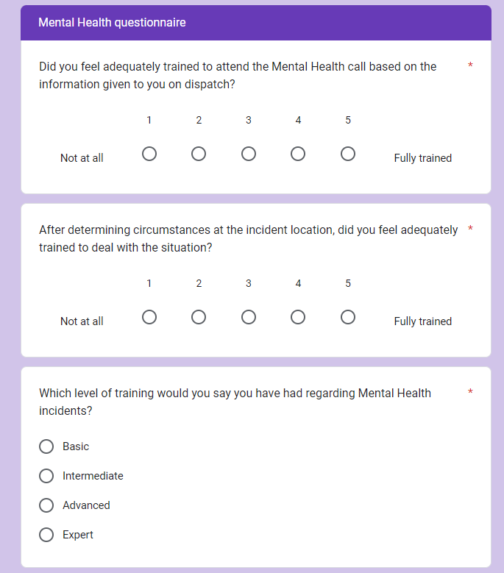
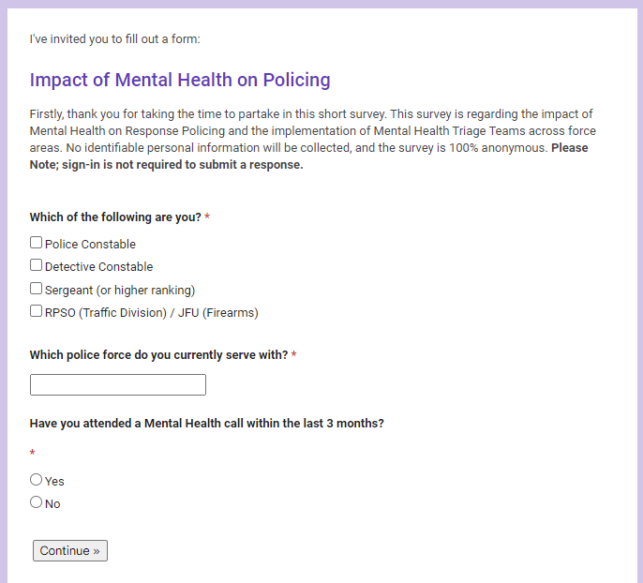
‌8.3 – Appendix Three; Blank Questionnaire


