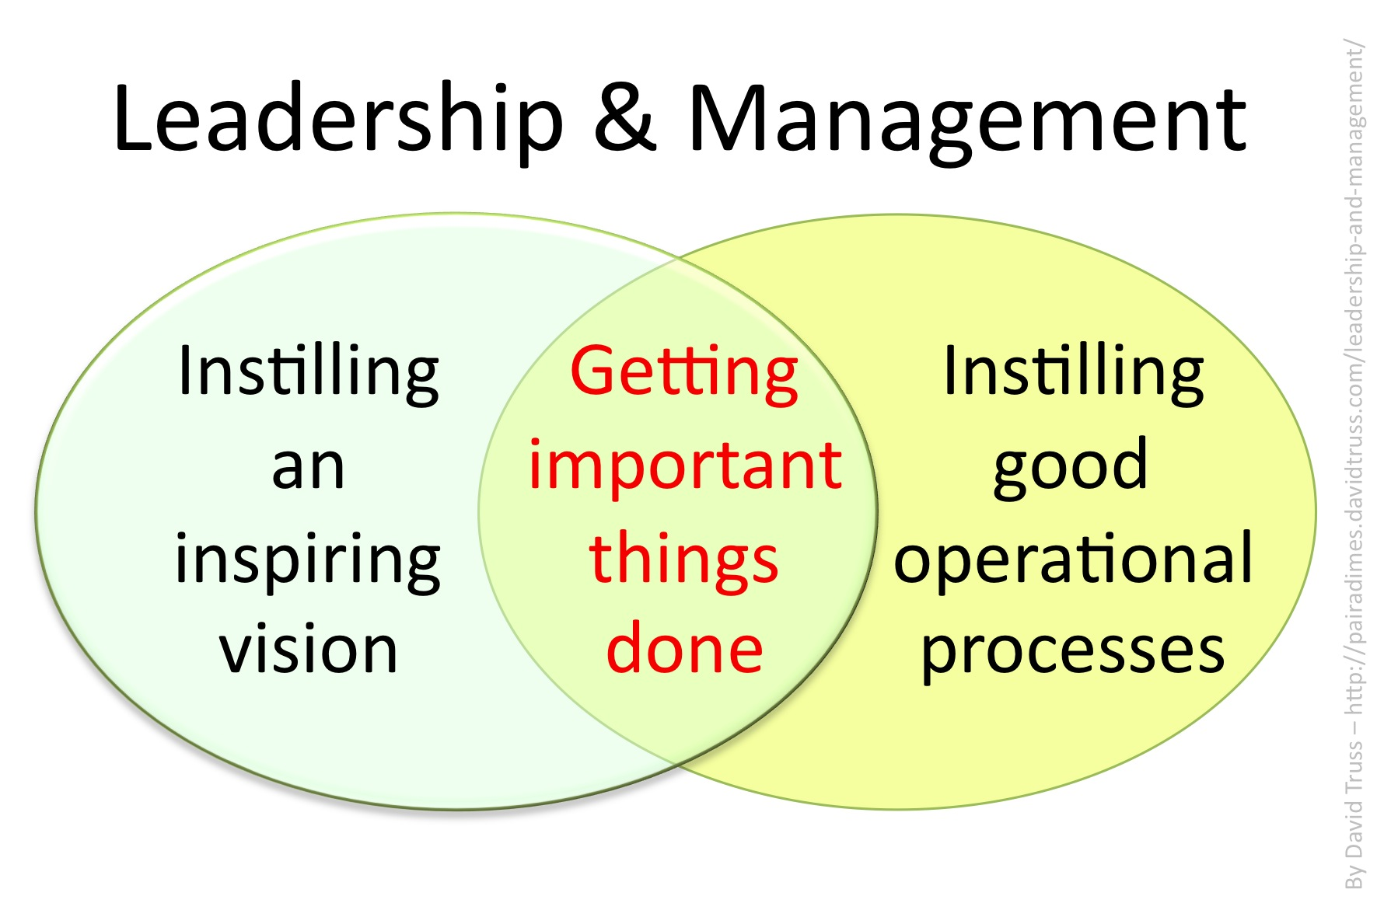  A Research Report. | Motivational Leadership and Management  By Mandy Morgan (2019)

Contents

Content page………………Page 1
Abstract ……………………Page 1
Introduction………………...Page 2
Main body …….................. Page 2-7
Conclusions ……………… Page 7-8
Recommendations………. Page 8
References ……………… Page 8-10

Abstract
This report will identify the significance of effective leadership and management within the National Health Service. Many management theories have been put into practice over the years, an insight in to the various managerial and leadership styles will be given (Mullins, 2016).

Introduction
Efficient leadership is vital as health care sectors endures persistent restructuring in sculpting organisational culture and motivating the insertion of change, whether it be from the interchange of issues within the organisations grasp or outside it’s governance (National Health Service (NHS), 2019).

Main body
(Ayeleke et al, 2019) informs that he necessary alterations in the health care sector are due to an increase in population, economy, capital expansion, an alteration in policies, medical advancement and progression in technology Ayeleke et al, (2018) also mentions that essential Management and leadership capabilities requires skill, knowledge and attitude. The (NHS, 2019) agrees and adds that managers within the health care sector also need to schedule, organise, regulate, budget, attach and evaluate to ensure control over organisational goal, ensuring company policies, structures and cultural values are instigated.
Storey and Holti (2013) suggests that Management and leaders are chosen based on their relevant knowledge, skills and attitudes, depending on what category they fall under will differentiate whom is who. Mullins (2016) concurs that self-sufficiency and the ability a to be decisive is just as important. There are many approaches to management, the customary being in control and command of workers providing clear management configuration. Roy (2015) tell us that this theory is known as ‘The Trait Leadership’ and is dependent on one individual to take sole control as the leader. This type of leader has good organisational skills, disciplinary skills and initiative. This falls in line with Fayol (1841-1925) and Mintzberg (1939) theories.
Russell and Cohen (2012) introduce the House (1996) path goal theory. This book reveals that if an employee puts hard work and effort into his role then this will build a positive atmosphere in the working environment and build a healthy relationship between himself and his employer and appraisal and rewards can be gained. House theory also implies negative attitude and lack of hard work will in turn produce a miserable out come for employee and employer and discipline and punishment will take place. In retro respect, conduct and performance influence leadership and managements actions.
Mullins (2016) recalls Pavlov classic conditioning theory it implies that instinctiveness can be a learnt response, but there is a questionable weakness as not all men are dependable, established managers. This theory can be viewed as outdated and unreliable (Team Building Company, TBC, 2019).
Another approach of management is regarded as the human relations approach to management. This approach requires coherence from the workers and managers motivation and promoting a quality of self - worth to his employees, whilst handling any conflict that arises. This type of manager has vision, notions, direction and motivation (Ayeleke et al, 2018).
John Adair (1934) used the human relations approach, his action centred leadership made him one of Britain’s most renowned influential leaders in organisations. Adair’s theory is seen as a practical structure of management, involving a team of people who can work together to undertake tasks. Adair ensured that the team of workers requirements where met, thus ensuring the completion of work. Adair believed that fifty percent of the work done relied on the employees and fifty percent depended on the working environment. The approach provides obvious trait between the leaders and management (TBC, 2019). Ayeleke et al (2018) agrees and quotes “Managers do things right, leaders do the right thing.”
The BBC (2014) revealed that July 1948 saw the birth of the NHS. It was funded by tax payer’s money. Twelve managerial roles were given. The NHS was known to be regimentally strict as the matrons took over leadership of the wards. The matron’s authoritarian style of management did work for a long period. Everybody had defined duties to carry out. This type of leadership was respected, but workers did not feel appreciated by their hierarchy (Koteyko, N. Nerlich, B).
It can be argued that when the managers decided to use the influential and cooperative style of management and leadership, commitment from some workers did take place, whilst other workers had no self -direction and took advantage of this new style of management. Some staff began to avoid their duties. This outcome falls under Mc Gregor theory ‘y’. Mc Gregor perceived that some people would see work as a normal part of life and enjoyed being committed to their job as it fulfilled their potentials and self-worth. Whilst Mc Gregor’s theory ‘X’ recognised that other people avoided responsibilities and lacked motivation.
Schyns and Hansbrough (2010) reads that the laissez faire management style first took place in the early 20th century. It allowed people to work on their own merit, with a hands-off approach from management. The workers had to become an organised team and reach any decision making and deadlines with little input from their superior. A Scottish hospital was governed in the laissez style of leadership and it backed fired and caused a negative effect on staff and patient. An investigation took place (Kings fund, 2014). Staff were inundated with an overload of jobs to do whilst feeling, exhausted and undermined. This caused low morale in the workplace that directly impacted on the patients care. A video was released where West (2018) instils the notion “Compassionate leadership for a compassionate health service”. Adair theory was put in place, enabling a happier work force who were governed by support, encouragement, motivation and guidance. Staff were informed on any changes taking place. They were involved in tasks that develop them as a valued individual. Moral picked up and patient care improved. The National Health Service (NHS) principal ideal is working together for patients and putting Patient before institutional interests. The NHS regards the Involvement of staff, patient, carers and the local community with high esteem. The NHS beliefs are formed from their cultural ethos “Care from cradle to grave.” (NHS, 2019).
External factors such as government policies, increase in population and the development of medical and technical advancement took place and had a direct impact on managements planning, organisation and budgeting strategies (NHS, 2019). Many internal factors also, had impacted on the NHS as an organisation, which included clarity, liability and political matters. Then the private sectors took an interest in health care sector. Most workers stayed in their roles up until retirement, when the professionals reached retirement age it had a direct hit on the NHS, who faced a shortage of qualified staff. The National Health Service has had to transform its customary management structure as it was centred around a chain of superiors who authorised and ruled the workforce to achieve the organisations goals. With so many people in executive positions the NHS
philosophy was affected and therefore alterations had to be made (NHS, 2019). The managerial and leadership side of the NHS concentrated on the business side of the organisation, this led to a communication clause between leaders and their managers that in turn put more pressure on the leadership roles, causing tension and lack of communication between leaders and employees. The energy and optimism of the work force deflated. Management and leaders had to improve and develop a better strategy to gain back positive attitudes, beliefs and values of the NHS. A lesson was taught, and positive developments were made, boosting trust, confidence and moral amongst patient, service users and hierarchy once again (NHS, 2019).
The NHS management, leaders and all internal employees now face other ongoing issues.
The (BBC, 2018) reported a significant rise in verbal and aggressive behaviour towards nurses from patients. This has a direct impact on patient and staff welfare, waiting times and resources. Staff are given training in relation to violent and aggressive situations. zero tolerance is what management aim for with offenders being prosecuted faster and for longer. Care inspectors are being reinforced after the NHS protect scheme was thrown out of government a year ago. Nurses have now asked for an easier way to report any incident that occurs during working hours.
The Royal college of Nursing (2019) revealed that a meeting regarding new measures to protect staff has been put in place by the health secretary. It seems the lack of security and authority on the accident and emergency waiting area has caused mayhem. Members of the public are having to wait for long periods at a time as minimum staff attend, investigate, treat and care for a growing population. Prioritisations must take place especially organisation were of importance. Mintzberg (1990) theory involved communication and monitoring, if this theory was carried out theory could, precautionary prevention would have stopped the NHS current situation from occurring. Fayol (1841-1925) theory involves command, organisational, planning and control. This style of management needed to take place (Fayol, 2016).
(NHS, 2018) reads that life expectancy is on the rise the population are living longer but some do suffer from long term health conditions, these conditions are treatable but not yet preventable. Medical problems such as arthritis, mental health illness, dementia, heart disease and diabetes. The NHS is holding an exhibition to introduce their long- term leadership plan in September this year. One focus is based on how the management of the mental health crisis team is now working alongside the police, ambulance professionals and social services in preparations need for patients to receive an improved quality of life alongside better patient care results. The changes have occurred as the people of communities are insisting on having more input with regards to what, why and how the care is given to them. The new management scheme follows Mann’s (1796- 1859) theory of developing influential skills, provides the care givers with self-confidence and nurturing abilities, this in turn will involve the return of trust and respect from their patients. The leaders have chosen a democratic form of management to obtain ruling. The changes have occurred as the people of communities are insisting on having more input with regards to what, why and how the care is given to them. The new management scheme follows Mann’s (1796- 1859) theory of developing influential skills, provides the care givers with self-confidence and nurturing abilities, this in turn will involve the return of trust and respect from their patients.

Conclusion
Change is inevitable and forever occurring in the health care sector. The practice of health needs to adopt forever changing coping strategies. Managers and leaders constantly need to update and modernise their strategies to carry out any risk stratifications. New medicines will always need to evolve along with societies needs, but most importantly a team of social support networks, hospitals and doctors need to collaborate efficiently for the health service to continue survival.

Recommendations
• Restructuring organisational culture
• Motivational change for internal and external factors
• Expansion of people and technology
• Managerial skills and leadership styles
• NHS ethos affected
• Consequences of poor communication

1828 Words.

References
Ayeleke, R, O. Dunham, A. North, N. Wallis, K. (2018). The Concept of Leadership in the Health Care Sector. Available at: https://www.intechopen.com/books/leadership/the-concept-of-leadership-in-the-health-care-sector Accessed 11th March 2019.
BBC (2014) Birth of the National Health Service. Available at: www.bbc.co.uk/archives/nhs/ Accessed on 22nd March 2019.
BBC (2018) Clampdown on Violence Against NHS Staff. Available at: https://www.bbc.co.uk/news/health-46029884 Accessed on 21st March 2019.
Fayol, H. (2016) General and Industrial Management. Ravenio books.
Koteyko, N. Nerlich, B. (2008) Modern Matrons and Infection Control Practice: Aspirations and Reality. Available at: http://doi.org/10.1177/1469044607087601. Accessed on: 23rd March 2019.
Mintzberg, H. (2015) Rebalancing Society: Radical Renewal Beyond Left, Right, and Centre. Berret-Koehler Publishing Company.
Mullins, L, J and Christie, G (2016). Management & Organisational Behaviour 11th Ed. Pearson Copyright.

NHS (2018) Take Part in a Large International Exhibition. Available at: https://www.england.nhs.uk/expo/support/. Accessed on 23rd March 2019.
(National Health Service, 2019) The Handbook to The NHS Constitution. England NHS.
Nursing Times (2013) Available at: https://moodle.uwtsd.ac.uk/pluginfile.php/145877/mod_resource/content/1/Why-management-skills-are-a-priority-for-nurses-050313.pdf Accessed on: 11th March 2019.
Roy, S, R (2015) Promoting Trait Emotional Intelligence in Leadership and Education. Information Reference Science. United States of America.
Royal College of Nursing (2019) Available at: https://www.rcn.org.uk/news-and-events/news/government-clamps-down-on-violence-against-nhs-staff-following-rcn-campaigning. Accessed on 21st March 2019.
Russell, J. and Cohn, R. (2012) Path Goal Theory. Waterstone.
Schyns, B. Hansbrough, T. (2010) When Leadership Goes Wrong: Destructive, Leadership, Mistakes, and Ethical Failures. Information Age Publishing Inc. North Carolina.
Storey, J, and Holti, R. (2013). Towards A New Model of Leadership for the NHS. Open University.
(Team Building Company, 2019) John Adair- Action Centred- Leadership. Available at: https://www.teambuilding.co.uk/theory/john-adair-team-theory.html Accessed 16th March 2019
The Kings Fund (2014) Growing Concern About Staff Morale as NHS Performance slips. Available at: https://www.kingsfund.org.uk/press/press- releases/growing-concern-about-staff-morale-nhs-performance-slips. Accessed on 21st March 2019.

