Method Section
Participants
The participants who took part in this study were five undergraduate university students, who were enrolled into a psychology course. They were recruited through the use of the University of Wales Trinity St David’s (UWTSD) Psychology Experiment Management System (EMS). A convenience sample was used for the study, with participants ages ranged between ???. There were no intended exclusions/restrictions against those who wished to take part.
Design
Focus groups were utilised for data collection within the study, which followed a qualitative approach. The collected data will be analysed using the thematic analysis method, which will allow the researcher to identify, analyse and report patterns, more commonly referred to as themes, in the data (Braun & Clarke, 2006)
Materials
A number of materials were created for use within this study. An information sheet (see Appendix A) was used to provide participants with a brief summary of the study and an outline of what the study involves them doing. A warning was included due to the nature of the study, and the contents potential to cause distress to the participants, as well as, informing participants they were allowed to take a break from the discussion and return, if they became distressed or uncomfortable at any point, or withdraw their data completely. The contact information of the researcher and the research supervisor were also included if the participants needed to contact either for any reason. An informed consent form (see Appendix B was used to provide the participants with detailed information about the purpose of the study, the duration of time the study is expected to take and their right to withdraw from the study within 2 weeks of participation. Another warning was included due to the content of the study and potential of distress being caused to the participant, as well as the contact information of the researcher and research supervisor in case they felt the need to contact them at all after participation in the study. The participants were also informed through the consent form that any and all data collected during the study about themselves, and other participants will be completely confidential, and anonymity must be maintained by all those who are involved. A demographics form (see Appendix C) was used to gather information of the participants age and gender to aid the researcher during the analysis. A set of questions (see Appendix D) were created to prompt the participants to discuss schizophrenia and their views of its portrayal in the UK media. These questions were worded in a way to encourage discussion between participants. Questions were also asked in relation to the articles (see Appendix E) provided by the researcher, about schizophrenia in the UK. A debrief sheet (see Appendix F) was supplied to participants after completion of participation in the focus groups, which contained contact information of the researcher and the research supervisor, and thanked participant for taking part in the study. The aim of the study was included on the debrief sheet to help participants understand the reason the study was created, and also another reminder of their right to withdraw from the study for up to 2 weeks after the date participation was completed. A digital voice recorder was used to record the focus group discussion and a pc was used to store and transcribe the data that was collected during the study.
Procedure
The study was uploaded to the UWTSD EMS for student to sign up for. The researcher arrived at the allocated room 15 minutes before the starting time of the focus group session to set up ready for when participants arrived. Laid out on the table in front of each chair was an information sheet, consent form, and a set of articles. A piece of paper with a number written on it was also on the table, for participants to read out once recording had begun to aid the researcher when transcribing the data collected. At the time specified, the researcher greeted the participants and welcomed them to the study. The participants were shown to the table where the researcher then talked through the information sheet and consent form with them. After reading the information sheet and completing the consent for the participants were pointed to the set of articles in front of them where they were instructed to read through them in preparation for the discussion and informed by the researcher that they will be available throughout the whole discussion to refer back to at any point. Once every participant had read through the articles, the researcher then explained how the process of the focus group would work. It was explained that when the recording began each participant was to read out the number off the paper in front of them, after this the researcher would ask the first question and the participants would then answer the question and discuss between themselves. The participants were then told that any contribution they made to the study would be greatly appreciated and the recording began. After all the questions had be asked and the discussion had ended, the researcher ceased the recording and thanked the participants for taking part in the study. They were then handed a debrief sheet by the researcher, who talked through it with them and asked if they had any questions to ask about the study. The participants were then thanked for their time and participation in the study before leaving.

References
Braun, V. and Clarke, V. (2006) ‘Using thematic analysis in psychology’, Qualitative Research in Psychology, 3(2), pp. 77–101. doi:10.1191/1478088706qp063oa.

Appendices
Appendix A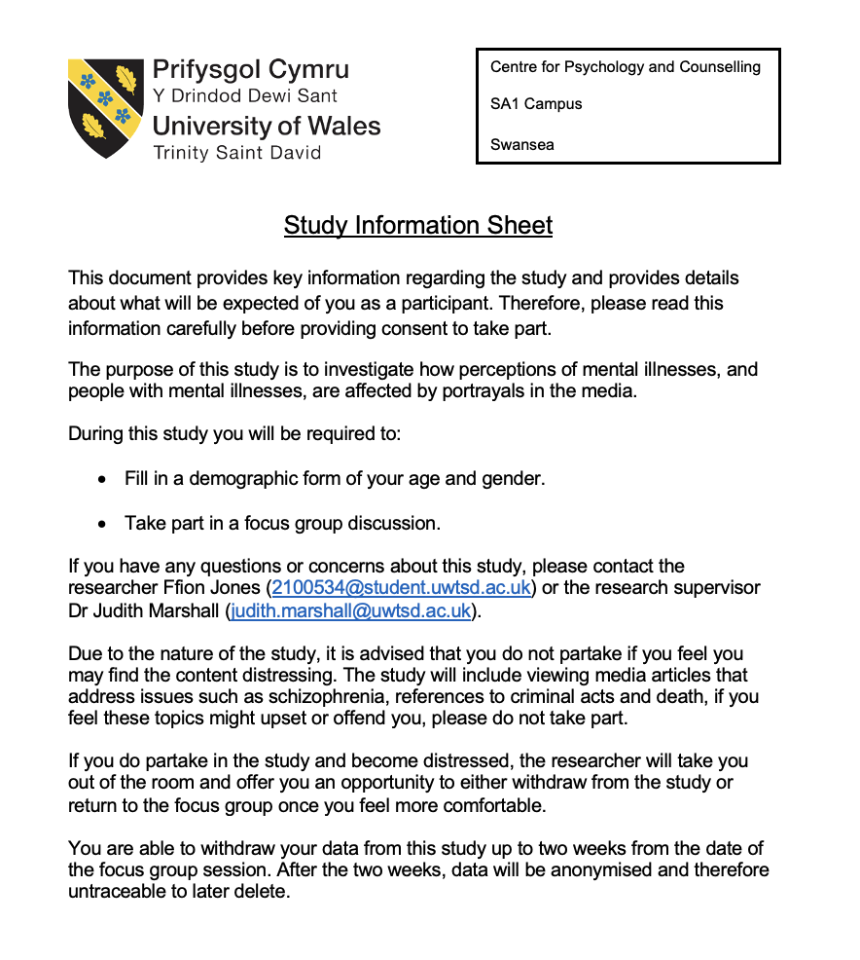

Appendix B
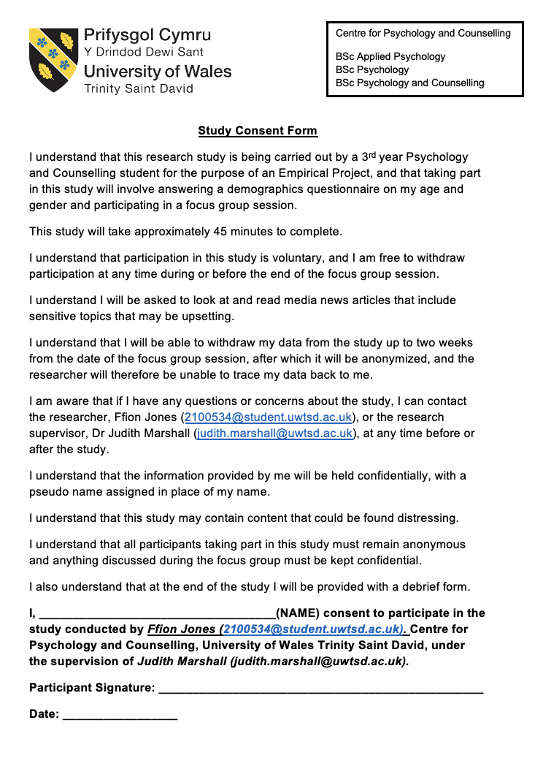

Appendix C
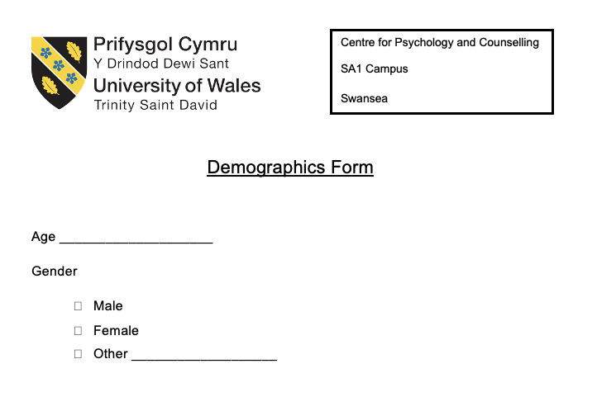
Appendix D
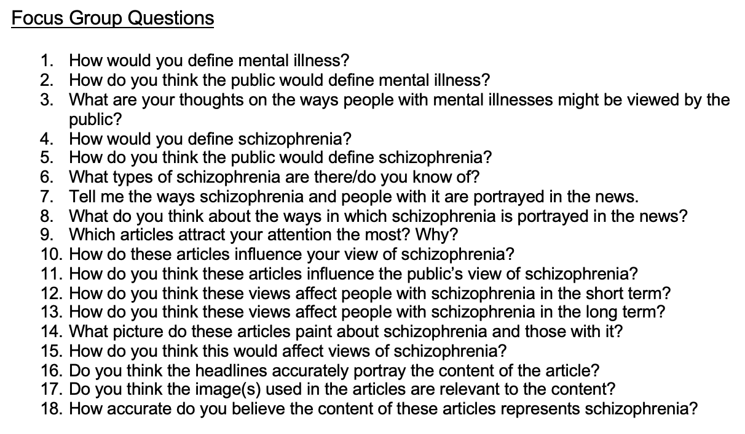
Appendix E
!ADD ARTICLES!

Appendix F


