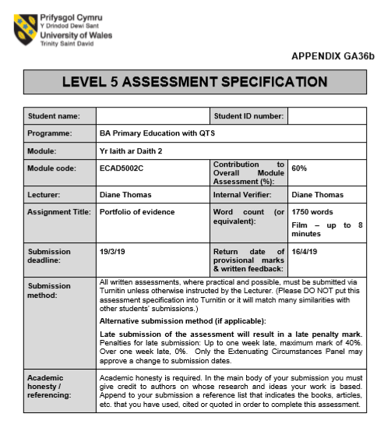
1701348
Shannon McCann

Portfolio of evidence
Task One
The chosen story for this portfolio of evidence will be ‘Dillad Tedi Twt’ as it complements the current strand of learning within the class, with regards to learning knowledge on clothes and the weather, such that Browne (2007) and the Welsh Government (2015) emphasise that learners learn effectively through activating prior knowledge. This story will be presented to a Year one and two class, of mixed levels of Welsh, allowing them to develop their linguistical skills through each strand of the curriculum in terms of speaking, reading, writing and listening. According to the Welsh Government (2013), it is essential that everyone has fair learning opportunities within oracy in order to allow acquiring a language to be meaningful and engaging. Furthermore, the objective of the Welsh lesson would be to ensure they “follow stories read to them and respond as appropriate” (Welsh Government, 2015, p. 38). Following on from the story, the focus activity for this portfolio will be a written task whereby it will offer opportunities for learners to reach their potentials to communicate in Welsh whist increasing their confidence and fluency in writing in Welsh (Welsh Government, 2015). Therefore, in accordance to Donaldson (2015), Welsh language, particularly in the Foundation Phase, requires to be taught through thriving and holistic approaches.

Task Two – link
https://youtu.be/tA360kO8vow

Task Three
This section of the portfolio highlights the personal experience I had teaching Welsh second language in the Foundation Phase and reflecting on the methods and strategies used both through the story and the written activity. According to Garcia (2012) and the Welsh Government (2017), in order to teach Welsh effectively, there needs to be a variety of strategies and linguistical experiences within a classroom activity. Therefore, through reading a story and providing a follow-on task, also allows the learning to be engaging and provides support for exploring language inclusively enhancing their communication skills (Brock, 2008). Whitehead (2010) and William and Thomas (2017) synthesise with this such that story telling is considered the most dynamic technique of introducing a language which may cause a lot of hesitancy to portray language in this format. However, if language is not expressed through the early years, it limits the creativity and dialogue teaching that each learner is entitled to (Whitehead, 2010). Furthermore, reading a story in an additional language may be considered as a ‘Context and Language Integrated Learning’ (CLIL) approach as Coyle et al (2010) emphasises the complementation of subject knowledge and language.
Firstly, when reading the story, it was essential that it had to be engaging, therefore, I ensured that the use of repetition was used throughout as Brock (2008) and Whitehead (2010) convey that repetition is a prudent tool to allow the learners to focus on the language used. Thus, I ensured I had completed a Welsh Language Development Plan prior to the lesson (see appendix one) to ensure I promoted the phrases. Therefore, using repetitive statements and questions such as ‘Beth ydy..?’ , ‘Mae hi’n’ and phrases relating to the story, engaged the learners to use more flexible responses and emphasises the understanding of the story and the terminology within it as Koluci and Lemish (2011) connote that repetition stimulates development physically. Additionally, the use of repetition as an audio-lingual approach to teaching language was effective, particularly when the story progressed, as the learners were able to increase their listening and speaking skills to respond back in Welsh. Estyn (2013) emphasises that those who do not consistently repeat new phrases learnt in Welsh, do not allow effective practice. However, Cook (2016) criticises the behaviourist view in which audio-lingual is not always inclusive in engaging every learner as there is no further intellectual knowledge to benefit them in communicating in an out of school environment. Alternatively, Graham and Kelly (2008) emphasise that repetition in story telling is beneficial as learners will begin to recognise the phonetic structures and phrases in order to read the word themselves. Reflecting on the approach used, this strategy was effective as many of the children recognised the language heard when following the story and as a result, were able to use these skills to read a page of the story themselves complementing the aim of the task.
Furthermore, even though repetition was used continuously throughout my lesson, this could have been portrayed in an additional engaging way through rhymes or song such that Whitehead (2010) and the Welsh Government (2015) state that learners need to experience learning a language through an aspect of rhyme or song to aid them to remember grammar and structure. In similarity with this, another creative element needing improving that was presented on many occasions, was the use of actions and gestures for different weather patterns and clothes for a prompt for the children. The learners responded well to this as Browne (2007) states that young learners learn more efficiently using social interaction to which Whitehead (2010) later acknowledges Piaget’s theory that thinking, and learning is based on a variety of understanding and tools i.e. different resources and actions (Whitehead, 2010, p 65). According to Barton (2013), actions and gestures can highlight important phrases but can also increase the control on behaviour such that the use of gestures in Welsh was used to control the class. However, in the future, behaviour management will be an aspect to develop when teaching a language, implying that different approaches need to be experimented. Therefore, enhancing this method in the future will be of tremendous benefit to engage learners and to become more confident in teaching Welsh. On the other hand, Fox-Eades (2006) implies that effective teaching of language does not need gestures and can be expressed through words only.
Despite this, the learners had a good knowledge of vocabulary and grammar within the activities using questioning and explanation strategies demonstrated in both the story-telling and the written activity such that the Welsh Government (2015) emphasises that learners need to be able to respond and ask their own questions based on the task. According to Richards and Rodgers (2014), usage of a direct method can be successful through learning vocabulary through teacher-led instruction. For instance, during my experience, ensuring most commands and questions were translated into either Welsh or English, shown in the Welsh Language Development Plan, was needed in order to consolidate their understanding. This allowed learners the opportunity to demonstrate their listening when instructions were given and were able to confidently respond (Welsh Government, 2015). Additionally, Estyn (2013) states that if there is limited consistency within teaching Welsh, this prevents the learners’ development of speaking and reading abilities emphasising the necessity that learners need to listen to a practitioner’s grammar and diction to develop. Moreover, Gruffudd (2000) and Wragg (2002) complement this such that to succeed at a language, there is a need for practitioners to teach correct, fluent Welsh to which occasionally, my structure with prepositions after commands was not precise thereby making it a target for teaching Welsh in the future.
However, at times, translating led to the confusion for many pupils to follow the story due to the mixed ability of Welsh, therefore, differentiation within the variety of questions asked was needed as Johnston et al (2007) and Estyn (2013) synthesises that modifying teaching to complement each learner’s needs and understanding aids them to progress further. Hence, altering a question structure to ‘Pa fath …?’ for a child who knew more Welsh to increase the skills. Hood and Tobutt (2015) and Estyn (2016) connote that the speed in how you teach language also affects their opportunities to develop their oracy skills such that practitioners need to ensure the pace of learning is reasonable to understand in order to enjoy the learning. During questioning, Hood (2015) and Gross (2018) emphasises that if a learner is finding it difficult to respond, supporting the individual further through altering the questions or using gestures as prompts may be considered a better alternative than moving on to another individual as it allows them the thinking time to develop their language. Thus, I had to use this approach to encourage thinking through actions and gestures which helped many learners grasp understanding.
Subsequently, according to the Welsh Government (2015), it is essential that learners experience increasing their written abilities. Therefore, to complement the story, the children had a worksheet on ‘Dillad Tedi Twt’ that they had to label (see appendix Two) in which, the learners who were most comfortable with Welsh, had to further develop their writing through an example of the writing structure shown. According to Estyn (2013), the level of written Welsh work is reliant on the speaking skills of the learner thereby making it essential to ensure Welsh is consistent. Fox-Eades (2006) and Barton (2013) synthesises that modelling writing and oracy is effective to achieve the learning objective as it demonstrates the structure and patterns making it meaningful and memorable. Supporting this, Brock (2008) and Curtis (2017) states that meaningful teaching of language needs Visual aids and first-hand experiences which the children had to identify the correct vocabulary and phrases for their sentences and labelling. Reflecting on the written task, independent working and group work was allowed after explaining the task which supports Vygotsky’s (1978) Zone of Proximal Development which emphasises that learners need that independence within language in order to enhance their knowledge and understanding (1978, cited in Brock, 2008, p. 36).
In the future, I will enable that during activities, I am visibly working with the children, as although I was present helping them if needed, I felt that I need to be more involved. However, due to lack of time and other school priorities, there was a limited amount of staff implying that I had to film without being visible. As a result of lack of time, a game of snap was played to consolidate understanding (see appendix three) of vocabulary as this ‘CLT’ approach enables learners to become confident learners, working together to develop their social skills and motivation (Welsh Government, 2013; Donaldson, 2015; Curtis, 2017). Therefore, Whitehead (2010) states that to progress language acquisition and accuracy through writing, learners should be able to acquire social interaction with both the practitioner and their peers as language cannot be understood just within the teacher-led learning. Hence, in the video shown, the opportunity for learners to socialise with peers in Welsh, as well as encouraging each other to using the templates to which was modelled by myself.
To conclude, the use of story-telling and additional activities was beneficial when learning a language as the Welsh Government (2015) states that learners need engaging opportunities to develop their speaking, reading and listening skills. Donaldson (2015) states that in order to have competence within learning a language, methods such as repetition need to be reinforced throughout the whole day to which occurred within Professional Teaching Practice when using terminology such as ‘dw i’n gwisgo…’ enabled the learners to practice their speaking and listening skills. The development of the learners’ linguistical abilities were enhanced by the end of this session, as most learners were able to pronounce and write sentence structures accurately, in order to collaborate with peers. Additionally, learning a language needs to be inductive to the curriculum and, similarly, with the current LNF skills, need to be implementing social interaction within groups or as a class, to develop their language skills (Curtis, 2017; Donaldson, 2015). Moreover, it is essential that all practitioners use the learners’ first language to support the learning as Brock (2008) states we must modify our strategies to complement the knowledge and skills of the learners.

Reference List
- Barton, G. (2013) Don’t call it Literacy: what every teacher needs to know about speaking, listening, reading and writing. London: Routledge.
- Brock, A. (2008) Communication, Language and Literacy from birth to five. London: SAGE Publications Ltd.
- Browne, A. (2007) Teaching and Learning Communication, Language and Literacy. London: SAGE Publications Ltd.
- Cook, V. (2016) Second Language Learning and Language Teaching. 5edn. Oxon: Routledge.
- Coyle, D. (2010) Content and Language Integrated Learning. Cambridge: Cambridge University Press 2010.
- Curtis, A. (2017) Methods and Methodologies for Language Teaching. London: PALGRAVE.
- Donaldson, G (2015) Successful Futures. Cardiff: Crown. Available at: https://gov.wales/docs/dcells/publications/150225-successful-futures-en.pdf
[Accessed: 17th March 2019]
- Estyn (2013) Welsh Language Development in the Foundation Phase. Cardiff: Crown. Available at:
https://www.estyn.gov.wales/sites/default/files/documents/Welsh%20Language%20Development%20in%20the%20Foundation%20Phase%20-%20January%202013.pdf
[Accessed: 14th March 2019]
- Fox-Eades, J.M. (2006) Classroom Tales. London: Jessica Kingsley.
- Garcia, O (2012) Bilingual Community Education and Multilingualism. Bristol; Buffalo: Multilingual Matters 2012.
- Gross, J (2018). Time to Talk : Implementing outstanding practice in Speech, Language and Communication. 2nd edn. Oxon: Routledge.
- Hood, P. and Tobutt, K. (2015) Teaching Languages in the Primary School. 2nd edn. London: SAGE Productions Ltd.
- Johnston, J. et al (2007) Developing Skills in the Primary School. Maidenhead: McGraw-Hill Education.
- Kolchi, B. and Lemish, D. (2011) UNICEF; Communicating with Children. Available at: https://www.unicef.org/cwc/files/CwC_Final_Nov-2011(1).pdf [ Accessed: 18th March 2019]
- Welsh Government. (2013) One Language For All. Crown: Cardiff. Available at: https://beta.gov.wales/sites/default/files/publications/2018-05/review-of-welsh-second-language-at-key-stages-3-and-4.pdf [Accessed: 18th March 2019 ]
- Welsh Government. (2015) Curriculum for Wales: Foundation Phase Framework 2015. Crown: Cardiff.
Available at: https://beta.gov.wales/sites/default/files/publications/2018-02/foundation-phase-framework-revised-2015.pdf [Accessed:18th March 2019 ]
- Welsh Government (2017) 1 million Welsh speakers by 2050. Cardiff: Crown. Available at: https://gov.wales/docs/dcells/publications/170711-welsh-language-strategy-eng.pdf [Accessed: 18th March 2019]
- Whitehead, M. (2010) Language and Literacy in the Early Years. 4edn. London: SAGE Productions Ltd.
- Wragg, E.C. (2002) Questioning in the Primary School. 2nd edn. London: New York: Routledge Falmer 2002.
- Williams, N. and Thomas, E.M, (2017). ‘Exploring Minority language input sources as means of supporting the early development of second language vocabulary and grammar.’ Vol. 38(4) pp850-880. DOI:10.1017/S0142716416000473

Appendix One

Name of learner: Shannon McCann
Promoting Welsh Planning Sheet
Aim: To follow stories and respond to them as appropriate.
To communicate in Welsh writing with confidence, fluency and accuracy.
Date/ Dyddiad: 8/2/19 | Welsh I will use | Welsh the pupils will use
Achieved – Green  Nearly- yellow  Not Achieved – Red | Gorchmynion –  Gwrandewch ar ,  Un dau tri… edrychwch arnaf i, Dewiswch  Dwylo fyny/ lawr | Mae hi’n  Dw i’n / rydw i’n  gwisgo
Achieved – Green  Nearly- yellow  Not Achieved – Red | Cyestiynau –  Beth ydy’r teitl?  Beth ydy … ?  Beth mae Tedi Twt yn gwisgo?  Pwy sy’n barod?  Sut mae tywydd?  Beth ydych chi/ wyt ti’n meddwl …. Tedi Twt yn gwisgo/ y tywydd… ar y tudalen nesaf?  Pa fath o tywydd wyt ti’n/ ydych chi’n hoffi? | Yn ystod y gweithgaredd ysgrifennu;  Ga I … rwber/ pensil os gwelwch yn dda?  Tywydd –  bwrw glaw  braf  heulog  questions in Welsh
Stori Dillad Tedi Twt | Geirfa-  Mae hi’n…  Bwrw glaw  Heulog  Bwrw eira  Gymylog  Wyntog  Braf  Gweithgareddau / gweithgaredd ysgrifennu  Gemau | Geirfa  Mae hi’n / dw I’n / mae tedi twt yn gwisgo  Dillad= crys-t, siorts, esgidiau, côt, menig  Dillad tedi twt  Lliwiau

Appendix Two
Mae hi’n bwrw eira.
Beth mae Tedi Twt yn gwisgo?
Mae Tedi Twt yn gwisgo



Mae hi’n bwrw glaw.
Beth mae Teddi Twt yn gwisgo?

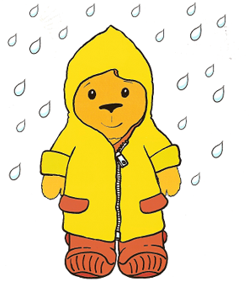

Mae hi’n heulog.
Beth mae Teddi Twt yn gwisgo?
Mae Teddi Twt yn gwisgo



Mae hi’n braf.
Beth mae Teddi Twt yn gwisgo?

Mae Teddi Twt yn gwisgo

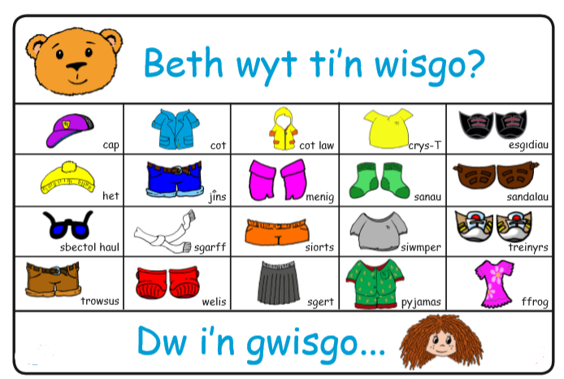
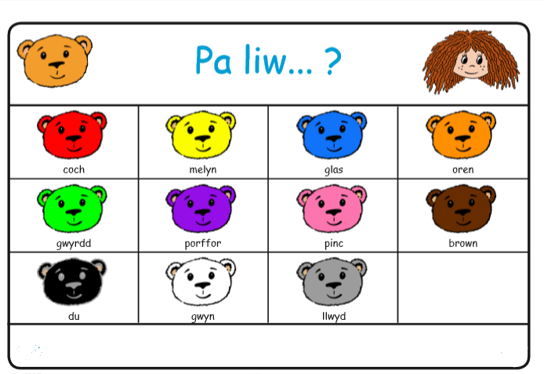

WJEC (2014) Llyfr Cwestiwn ac Atebion Tedi Twt a Doli Glwt. Available at: http://resource.download.wjec.co.uk.s3.amazonaws.com/tcg/tedi_twt/Tedi%20Twt%20a%20Doli%20Glwt.pdf [Accessed: 14th March 2019]

Appendix Three – games to consolidate understanding
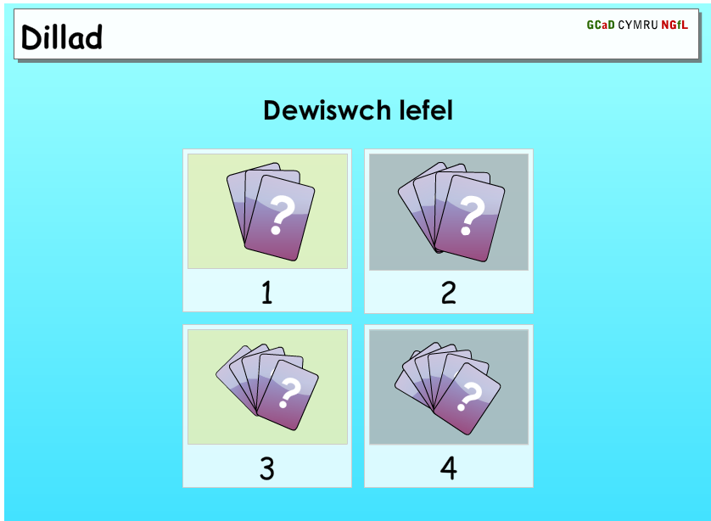

Hwb (2008) Dillad. Available at: https://resources.hwb.wales.gov.uk/VTC/2008-09/wsl/irf08_13/english/clothes/index.html [Accessed: 14th March 2019].


