  Organisational PERFORMANCE | Exexutive Summary  This Work outlines the importance of structure, leadership and culture upon organizational performance. However, the work will briefly define Organisation Performance and Organisation in order to give a clear picture of the key points mentioned above in terms of Organisational performance.  An Organisation’s Culture develops values, beliefs, assumptions and behaviors shared on a daily basis that will become the basic character of the firm, therefore, what the company is recognised for, from an employee’s perspective.  success is never final; therefore, there is always a margin of improvement available or a gap in the market to fill a need. A Leader is an individual that has a Vision to either implement or develop a product or service and is able to involve other people and motivate them towards accomplishment of their objectives. Lastly the work will outline the impact of macroeconomic factors currently affecting the economy.
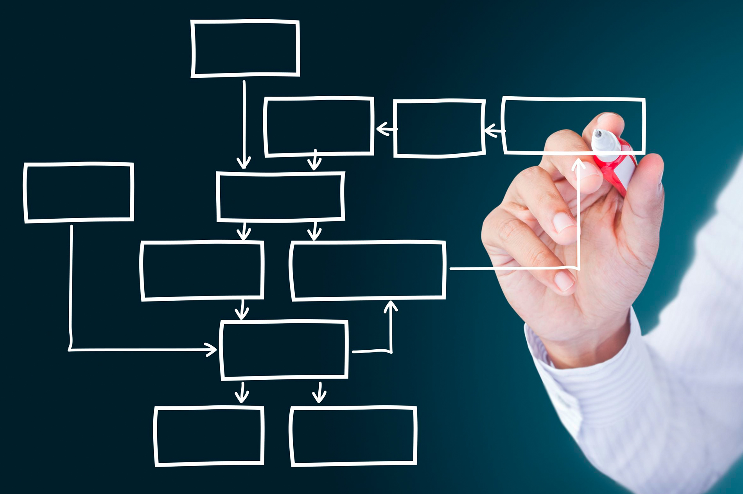

Table of Contents
Exexutive Summary 0
Introduction 2
Organisation behaviour 2
Organisation Structure 3
Functional Structure 3
Divisional Structure 3
Matrix Structure 3
Impact upon Organisation Performance 4
Leadership 4
Democratic Leadership 4
Authoritarian Leadership 4
Laissez-faire Leadership 5
Coaching Leadership 5
Leadership impact on Organisation performance 5
Culture 5
Impact of Culture on Organisation Performance 6
Macro economical implication to Organisation Performance 6
PESTLE 6
Conclusion 6
Recommendation 6
Reference 7

Introduction
Organisation performance defines the objectives of a business and establishes the actual position of the company in regards to its goals in order to have a clear picture of possible measures to be taken to achieve such objectives.
Strategic management is an important part of performance management that takes advantage of a process of strategy implementation inclusive of the formulation, implementation and control of a set of activities a company will undertake in order to achieve major goals, activities and customer satisfaction. (Adler, 2018)
It is a concept broadly analysed and discussed as of vital importance for organisation, therefore there are many different opinions amongst authors.
Either way it is important to clarify the final objective of the company and develop a strategy that focuses on the resources necessary to achieve organisational goals.
Continuous monitoring and analysis of performance might highlight underperformance; therefore, management may undertake further actions (i.e. introduction of performance management tools such as KPI, balanced scorecard etc) to identify possible issues that determine lack of efficiency.
Recently updated Organisation Performance Frameworks, outline that Accounting must be separated into Profitability and Liquidity in order to achieve accuracy of information, while stock market performance and growth are established as separate dimensions. (Hamann, Schiemann, Bellora and Guenther, 2013)
Organisational Performance evaluates and outlines three areas related to Organisational Outcome: Financial Performance (that incorporates profit, return on assets, return on investment, asset turnover, operating expense etc), Product Market Performance (analyses areas like Sales, Market share, efficiency of production, marketing channels etc) and Shareholder Return (Share Price Appreciation, Dividends Paid, Economic Value etc). (Richard, Devinney, Yip and Johnson, 2009)

Organisation behaviour
Organisational Behaviour involves the study of how people, as individuals and as a part of larger groups (Teams), perform their work tasks. It is essential psychology applied to work environments. It examines human behaviour and assets the effects of structure, motivation and leadership and communication in terms of Organisational Performance. (Adler, 2018-2)
Knowledge of Organisation Behaviour should enable Professionals to understand Organisational Problems with some insight and expertise. In addition to that, following the diagnosis, professionals must be able to solve a problem, evaluate different approaches to deal with organisation’s resources and develop procedures in order to avoid some problems in the first place. (Brooks, 2009)
People are essential in order to accomplish organisation success, consequently the main duty of Manager switches from control and structure operations or action to fully support teams on performing their work, therefore, outline lacking areas and develop trainings. (Perkins and Arvinen-Muondo, 2013)
Furthermore, the role of Managers in a more strategic organisational perspective may be subject to further adjustments according to the process framework utilised by the company (e.g. Scrum, RUP etc).

Organisation Structure
The structure of an organisation defines how activities are coordinated, directed and managed aiming to achieve objectives. It is essential for an organisation as it establishes roles and responsibilities, creates different levels of hierarchy focused to evaluate career progression and define duties. Besides, an outlined company structure allows management to identify new areas that may be implemented within a particular department; which ultimately may encourage employees to develop different capabilities.
Furthermore, organisation structure is particularly important to define roles and tasks (e.g. Job description), expectations; avoiding overlapping of duties etc.
Companies may develop a structure according to three main types: Functional structure, Divisional structure and Matrix structure. (Daft, Murphy and Willmott, 2010)

Functional Structure
In a functional structure the company is divided in departments, that rely on the knowledge of each individual. This system is usually implemented in small companies. In addition, coordinating activities within departments may be challenging as departments tend to work separately one another. Thus, organisational goals may be restricted, and the response time to environmental changes and possible challenges may be too slow. Nevertheless, important opportunities might be missed.

Divisional Structure
Departments are organised according to products, services, major projects or programmes, profit centres and divisions. In addition, every department has its own section for accounting, marketing, finance etc. Divisional Structure is more flexible as each unit is smaller and decision making is decentralised (each department makes decision according to organisation goals only).

Matrix Structure
The matrix structure is a functional structure horizontally implemented with a division that allows better coordination within departments. Coordination may be improved developing information systems, project managers or direct contact within departments. Also, matrix structures challenge Managers to always develop and design structures, teams and systems in order to face organisational and operational challenges.

Impact upon Organisation Performance
It is stated that the structure of an Organisation is crucial in terms of performance. Organisational structure may also affect employee engagement and performance. The Management team may wish to implement performance management tools that will enable employees to set personal and professional goals, career development, PDP and also to receive periodic performance reviews that may encourage them to undertake further development.
Achieve and sustain competitive advantage requires from organisation to learn better and faster from both successes and failures. Therefore, individuals, groups and teams must engage continuously in order to acquire, store and utilise knowledge multiple times. (Gorelick, Milton and April, 2012)

Leadership
Leadership is difficult and demanding, it is a task that requires a huge amount of time, effort, and sacrifice, nevertheless, focus on customer offer, satisfaction and employee engagement. It requires high levels of commitment, passion, creativity and desire to make a contribution to a firm or to the society. (Hancott, 2017)
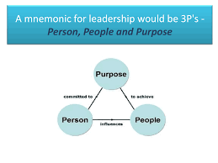
According to Sadler, leadership is a powerful concept that cannot be contained within few words and capable of telling many different things to different audiences depending on the contest. Despite public opinion, leaders are made, not born as many competencies and capacities can be learned. (Sadler, 2003)
Leadership is subject to individual styles and experiences; as such, there are many possible variants. However, there are 4 main types of leadership.
Democratic Leadership: the leader shares his vision with the team and makes decisions evaluating and considering their opinion, therefore, teams feel involved instead of merely executing orders.
Authoritarian Leadership: it is exactly the opposite of a democratic leadership. Decisions are dictated by managers so, the absence of the leader may result in a direct impact on performances, problem-solving and time-management.
Laissez-faire Leadership: leader let the teams work without much interference, empowering them with decision making. This results in a creative and motivated team. On the other hand, the lack of self-sufficiency can result in confusion.
Coaching Leadership: the leader is very empathetic and particularly attentive to the employees’ needs; he acts like a Mentor and provides effective training, development and career progression for its team, nevertheless, daily motivation. His ultimate goal is to develop other leaders within the company.

Leadership impact on Organisation performance
It is stated that the type of leadership adopted has an important impact upon organisation performance. Despite the limitation that any style may encounter the common value achieved through participatory leaderships is that employees feel empowered so they tend to be more productive and creative. On the downside, types of leadership that tend to blend in characteristic of the authoritarian style may result in employee’s unhappiness and ultimately in a drastic drop of performance. According to the current workforce available, leaders may wish to inspire their employees, give them important knowledge and giving flexibility and no limitation in terms of learning and acquiring both new and transferable skills. This will allow the company to increase productivity as transferable skills may result applicable to other departments or tasks. Therefore, leaders must inspire, allow to develop and share creative thinking as a way to increase productivity.

Culture
The culture of a Firm can be defined as the accumulated learning of a group of employees as a method to solve problems of external adaptation and internal integration that has worked well, therefore, it must be shared with other employees and other venues of the company as the correct way of perceive, think, feel and behave towards particular situations the company may occur. (Schein, 2017)
According to the author, this definition outlines that the common assumptions behave toward how we perceive, think and feel about things.
Organisational culture may be defined as the leading way accepted and implemented by the company to sustain employees and reduce to minimum levels Labour Turnover. In addition, the “Culture” of the company is often a key factor to engage employees and, as a result, maximize performance. The “Culture” may vary depending on the sector the company operates in. For Instance, hospitality will develop values completely different from Finance or Fashion.
The predominant values and standards of employees, over time develop an organisation culture that refers on organisation standards. The form and culture developed is affected by external factors such as environment and technology. (Cole, 2005)
Martin suggests that companies may wish to develop a culture based on the mixture of all three perspectives (Integration, Differentiation and Fragmentation). (Martin, 1992)

Impact of Culture on Organisation Performance
According to the study undertaken, leaders, managers and company may need to develop a strong company culture as it has an important impact on employees’ performance, therefore organisation goals. Furthermore, it is important to apply the same culture to any venue or area of the business as it may have a disorientation impact for employee that may be subject to transfers.

Macro economical implication to Organisation Performance

PESTLE
A PESTLE analysis evaluates factors in the macro environment that are not controllable by the company. It is developed in order to assess threats and opportunities related to external factors.
External factors may have a tremendous impact upon organisation as they may imply a foreseeable future closure. For instance, the viral infection named Covid-19 that has spread throughout the globe in about two months, has had a tremendous impact on the economy of each and every country. In this particular case, companies may receive financial help from the government according to Country Regulation. However, most European countries are currently in lockdown, some companies may face closures and employees have been dismissed.
As a counter-tendency to the general landscape, other companies may take advantage of the crisis to develop a successful product.

Conclusion
The success of a company is influenced either positively or negatively depending on entrepreneurial choices. The structure of a company may result crucial to face challenges and achieve results.
Important goals may be achieved only if an individual leads a company by focusing on a vision, either implementing or creating a new scalable service. Scalability of a product may define the success or failure of a company. For instance, businesses that solve a scalable problem may reach a global extent according to local regulations in terms of service delivery (e.g. Amazon, Uber, Air B&B). The culture of a company communicates what the management believes and how their employees behave, having an impact on their sales. However, a culture is commonly developed to attract and inspire talent and deliver a better customer service aiming at establishing customer loyalty.

Recommendation
According to the current issue represented by the Covid-19, companies may wish to be flexible. A restaurant in Chelsea, switched the classic business model of a restaurant by offering a “supermarket” service in order to avoid a “temporary closure” that has affected most businesses within the Hospitality Sector. They receive food and essential goods from their suppliers and sell it back with their own label if applicable. The service offered may allow the company to acquire further future customers and to keep employees working instead of dismiss them as most hospitality companies have done.

Reference

Adler, R., 2018. Strategic Performance Management: Accounting For Organizational Contro. New York: Routledge.
Brooks, I., 2009. Organisational Behaviour Individuals, Groups And Organisation. 4th ed. Harlow, England: Prentice Hall/Financial Times.
Cole, G., 2005. Organisational Behaviour: Theory And Practice. London: Thomson.
Daft, R., Murphy, J. and Willmott, H., 2010. Organization Theory & Design. Andover Hampshire: Cengage Learning.
Gorelick, C., Milton, N. and April, K., 2012. Performance Through Learning. Oxford: Elsevier Butterworth Heinemann.
Hamann, P., Schiemann, F., Bellora, L. and Guenther, T., 2013. Exploring the Dimensions of Organizational Performance: a construct validity study. Organizational Research Methods, [online] 16(1), pp.67-87. Available at: <https://journals.sagepub.com/doi/abs/10.1177/1094428112470007?journalCode=orma> [Accessed 19 March 2020].
Hancott, D., 2017. Leadership Is What?: The Importance Of Vision, Integrity, And Developing Others. Morrisville, US: Lulu Publishing Services.
Martin, J., 1992. Cultures In Organizations. New York: Oxford University Press.
Perkins, S. and Arvinen-Muondo, R., 2013. Organizational Behaviour: People, Process, Work And Human Resources Management. London: Kogan Page.
Richard, P., Devinney, T., Yip, G. and Johnson, G., 2009. Measuring Organizational Performance: Towards Methodological Best Practice. Journal of Management, [online] 35(3), pp.718-804. Available at: <https://businessmanagementphd.files.wordpress.com/2014/11/richard-et-al-2009-measuring-organizational-performance-jm.pdf> [Accessed 19 March 2020].
Sadler, P., 2003. Leadership. MBA Masterclass. 2nd ed. London: Kogan Page.
Schein, E., 2017. Organization Culture And Leadership. 5th ed. Hoboken: Wiley.

