

School of Engineering

Reduction of Harmful NOx Emissions from a Petrol Engine Using a Water Injection System

Mateusz Dabrosz
P146086

BSc Automotive Engineering

23/04/2018

Research Methods & Project M3X9486

1. Table of Contents

1. Table of Contents i
2. List of Figures iii
3. List of Equations iv
4. List of Tables v
5. Acknowledgements vi
6. Abstract vii
6.1 Abstract Keywords vii
7. Symbols Used viii
8. Introduction 1
8.1 First Project Aim 2
8.2 Second Project Aim 2
9. Literature Review 3
9.1 Tested Vehicle Specifications 3
9.2 Four Stroke Cycle Emissions 4
9.3 Medical and Environmental Issues Caused by Nitrogen Oxide 5
9.4 Nitrogen Oxide Sources & Formation 6
9.5 Current Emissions Regulations 9
9.6 New WLTP Drive Cycle 10
9.7 Possible Means to Reducing Automotive Emissions 12
9.7.1 EGR Enhancement 12
9.7.2 Selective Catalytic Reduction (SCR) 12
9.7.3 Hybrid Assist (IMA) 12
9.7.4 Pulsed Air System (SAI) 13
9.7.5 Discussing the Technologies Used by Manufacturers to Reduce Emissions 13
9.8 Water Injection Technology 14
9.8.1 Principles of Water Injection on NOx Reduction 16
10. Methodology 17
10.1 Analytical Calculations 18
10.2 After Live Testing Calculations 27
10.3 Live Testing Simulation 36
10.3.1 Factors Which Cause Validation Issues 37
11. Results & Analysis 39
11.1 First Test Session Results 40
11.2 Second Test Session Results 41
11.3 Third Test Session Results 45
12. Discussion 49
13. Conclusion 51
13.1 Future Recommendations 52
14. References 53
15. Bibliography 58
16. Appendices 60

2. List of Figures

Figure 1-Emission Regulation Trends (GOV.UK, 2016) 2
Figure 2-Volkswagen Lupo 2003 (carsnitch.co.uk) 3
Figure 3-Four Stroke Cycle Emission Threats (M. Dabrosz, 2018)/ (US EPA, 2018). 4
Figure 4-Thermal NOx Formation vs Temperature (Fluid.wme.pwr.wroc.pl, 2018) 6
Figure 5-Fuel Nitrogen in Heating Oils (Fluid.wme.pwr.wroc.pl, 2018) 7
Figure 6-Nitrogen Fuel vs NOx emissions (Fluid.wme.pwr.wroc.pl, 2018) 7
Figure 7-Prompt NOx Formation (Fluent Incorporated, 2003) 8
Figure 8-Prompt NOx vs Temperature (TFTEI, 2018) 8
Figure 9-NOx Emission from Euro 3 to Euro 6 (Hybrid Cars, 2018) 9
Figure 10-WLTP vs NEDC Drive Cycles (SMMT, 2018) 10
Figure 11-Water Injection Test on NOx Reduction (Bruce D & Stebar, SAE 1976) 14
Figure 12-Latent Heat of Vaporisation (Spalding & Cole, 1961) 16
Figure 13-First Session NOx Emissions With & Without Water Graph (M. Dabrosz, 2018) 40
Figure 14-Second Test Session NOx Emissions With & Without Water Graph (M. Dabrosz, 2018) 41
Figure 15-Second Test Session HC Emissions With & Without Water Graph (M. Dabrosz, 2018) 42
Figure 16-Second Test Session CO2 Emissions With & Without Water Graph (M. Dabrosz, 2018) 43
Figure 17-Second Test Session CO Emissions With & Without Water Graph (M. Dabrosz, 2018) 44
Figure 18-Third Testing Session NOx Emissions with Water vs Without Graph (M. Dabrosz, 2018) 45
Figure 19-Third Test Session HC Emissions With & Without Water Graph (M. Dabrosz, 2018) 46
Figure 20-Third Test Session CO2 Emissions With & Without Water Graph (M. Dabrosz, 2018) 47
Figure 21-Third Test Session CO Emissions With & Without Water Graph (M. Dabrosz, 2018) 48
Figure 22-EGR vs Water Injection on NOx Reduction (Nazha, M, Rajakaruna, H & Wagstaff, S, 2001) 49
Figure 23-EGR vs Water Injection on NOx Reduction (Hountalas, 2007) 50
Figure 24-Euro 6 Emission Standards (AA, 2018) 60
Figure 25-Nitrogen Oxide Sources (ico-pal.co.uk) 61
Figure 26-EGR Valve on NOx Emissions (http://article.sciencepublishinggroup.com/journal/164/1641091/image030.gif) 61
Figure 27-SCR Operating Principles (https://saemobilus-sae-org.ezproxy.uwtsd.ac.uk/htmlimage/1000368433/2016-01-0972_fig0002.jpg) 62
Figure 28-Emissions Advantage of an IMA System (CalCars.org) 62
Figure 29-SAI System Reducing NOx (http://ars.els-cdn.com/content/image/1-s2.0-S0016236108004808-gr7.jpg) 63
Figure 30-Triger Atomiser (M. Dabrosz, 2018) 63
Figure 31-Water Injection Effectiveness on NOx Reduction (Tesfa, 2018) 64
Figure 32-Types of Secondary Data (UWTSD Slides, 2017) 64
Figure 33-Secondary Data Source Evaluation (Saunders, 2009) 65
Figure 34-Injector Testing (M. Dabrosz, 2017) 65
Figure 35-Injector Pattern Selection (TheBoostLab.com) 66
Figure 36-Fuel Consumption Benefits with Water Injection (tsijournals.com) 74
Figure 37-Thermocouple Design (hotrod.com) 75
Figure 38-BOSCH Water Delivery System (Webike.net) 75

3. List of Equations

Equation 1-Engine Displacement Calculations (Ipfs.io, 2018) 19
Equation 2-Thermal Efficiency Calculations (Energyeducation.ca, 2018) 19
Equation 3-Maximum Water Amounts at Different Powers Calculation (M. McDonald, 2018) 20
Equation 4-Mass of Fuel User Per Second Calculation (M. McDonald, 2018) 20
Equation 5-Maximum Water Flow at Different Power Calculation (M. McDonald, 2018) 21
Equation 6-Aerodynamic Forces at Four Testing Speeds Calculation (Heywood J, 1989) 22
Equation 7-Work Done at Four Different Testing Speeds Calculation (Heywood J, 1989) 23
Equation 8-Power at Wheels at Different Testing Speeds (Heywood J, 1989) 23
Equation 9-Maximum Water Flow at Four Testing Speeds Calculation (McDonald, M 2018) 24
Equation 10-Tyre Radius Calculation (X-engineer.org, 2018) 24
Equation 11-Wheel Revolutions per Second Calculation (McDonald, M 2018) 25
Equation 12-Correct Gear Selection for Each Testing Speed (Technologystudent.com, 2018) 26
Equations 13-3.3Kw Test, Water Supply (McDonald, M 2018) 27
Equation 14-3.3Kw Test, Fuel Flow (M. Dabrosz, 2018) 27
Equation 15-3.3Kw Test, Stoichiometric Combustion Equations (Merker, G, 2006) 27
Equation 16-3.3Kw Test, Product Mass Equations (Merker G. 2006) 28
Equation 17-3.3Kw Test, Mass Increase Factor Calculation (McDonald M, 2018) 28
Equation 18-3.3 Kw Test, Theoretical Combustion Temperature Drop (M. Dabrosz, 2018) 28
Equation 19-3.3Kw Test, Rate of NOx production Calculation (Merker, G. 2006) 28
Equation 20-6.74Kw Test, Water Supply (McDonald, M 2018) 30
Equation 21-6.74Kw Test, Fuel Flow (McDonald, M 2018)) 30
Equation 22-6.74Kw Test, Product Mass Equations (Merker, G, 2006) 30
Equation 23-6.74Kw Test, Stoichiometric Combustion (Merker, G, 2006) 30
Equation 24-6.74Kw Test, Product Mass (Merker, G, 2006) 30
Equation 25-6.74Kw Test, Theoretical Combustion Temperature Drop (M. Dabrosz, 2018) 31
Equation 26-6.74Kw Test, Rate of NOx production (Merker, G, 2006) 31
Equations 27-8.89Kw Test, Water Supply (McDonald, M 2018) 32
Equation 28-8.89Kw Test, Fuel Flow (McDonald, M 2018) 32
Equation 29-8.89Kw Test, Product Mass Equations (M. Dabrosz, 2018) 32
Equation 30-8.89Kw Test, Stoichiometric Combustion (Merker, G, 2006) 32
Equation 31-8.89Kw Test, Product Mass (Merker, G, 2006) 32
Equation 32-8.89Kw Test, Theoretical Combustion Temperature Drop (M. Dabrosz, 2018) 33
Equation 33-8.89Kw Test, Rate of NOx production (Merker, G, 2006) 33
Equation 34-21.79Kw Test, Water Supply (McDonald, M 2018) 34
Equation 35-21.79Kw Test, Fuel Flow (McDonald, M 2018) 34
Equation 36-21.79Kw Test, Product Mass (M. Dabrosz, 2018) 34
Equation 37-21.79Kw Test, Stoichiometric Combustion (Merker, G, 2006) 34
Equation 38-21.79Kw Test, Product Mass (Merker, G, 2006) 34
Equation 39-21.79Kw Test, Theoretical Combustion Temperature Drop (M. Dabrosz, 2018) 35
Equation 40-21.79Kw Test, Rate of NOx production (Merker, G, 2006) 35

4. List of Tables

Table 1-First Session Testing Results Table (M. Dabrosz, 2018 40
Table 2-Second Test Session NOx Testing Results Table (M. Dabrosz, 2018) 41
Table 3-Second Test Session HC Testing Results Table (M. Dabrosz, 2018) 42
Table 4-Second Test Session CO2 Testing Results Table (M. Dabrosz, 2018) 43
Table 5-Second Test Session CO Testing Results Table (M. Dabrosz, 2018) 44
Table 6-Third Test Session NOx Testing Results Table (M. Dabrosz, 2018) 45
Table 7-Third Test Session HC Testing Results Table (M. Dabrosz, 2018) 46
Table 8-Third Test Session CO2 Testing Results Table (M. Dabrosz, 2018)- 47
Table 9-Third Test Session CO Testing Results Table (M. Dabrosz, 2018) 48
Table 10-Temperature Drops with Water Injection (M. Dabrosz, 2018) 51
Table 11-Euro Standards for Cars (SMMT, 2018) 60
Table 12-First Test Session Full NOx Results (M. Dabrosz, 2018) 66
Table 13-Second Test Session Full NOx Results (M. Dabrosz, 2018) 67
Table 14-Second Test Session Full HC Results (M. Dabrosz, 2018) 68
Table 15-Second Test Session Full CO2 Results (M. Dabrosz, 2018) 69
Table 16-Second Test Session Full CO Results (M. Dabrosz, 2018) 70
Table 17-Third Test Session Full NOx Results (M. Dabrosz, 2018) 71
Table 18-Third Test Session Full HC Results (M. Dabrosz, 2018) 72
Table 19-Third Test Session Full CO2 Results (M. Dabrosz, 2018) 73
Table 20-Third Test Session Full CO Results (M. Dabrosz, 2018) 74

5. Acknowledgements

After some very intensive eight months, today is the day: writing this acknowledgment of thanks is the final touch on my dissertation. Those eight months have been a period of intense learning for me, not only on technical and scientific areas but also on a personal growth level. Writing this final year project has had a big impact on me. I would especially like to reflect on the people who have guided and supported me throughout those challenging periods.
I would first like to thank two of my brilliant personal tutors, Andrew Gibson and Malcolm McDonald who have both provided me with excellent consultations, knowledge and support throughout my final year project. My gratitude is also extended to all lecturers and technicians at UWTSD who have sacrificed their time to assist me with my project. You have all provided me with the needed tools to choose the right direction and complete my dissertation successfully.
I would like to thank my parents and my grandmother for their kind and loving support throughout my whole degree, of which I am fortunate to receive.
Finally, there are my friends. We did not only support each other by deliberating over our problems and research, but also by talking happily about other things rather than just our project.
Thank you very much, everyone!

6. Abstract

The change in our climate and poor human health has rapidly become a very important issue which must be addressed as quickly and effectively as possible to prevent even more environmental issues and health diseases. 26% of greenhouse gases are formed by the transportation sector, greatly contributing to global warming. Studies show about 5000 premature deaths are caused by excess vehicle emissions. The importance of this project is to evaluate a possible method to reducing the harmful nitrogen oxide emissions.
The investigation undertook the attempt to solve the problem of nitrogen oxide emissions, which is what the automotive industry has been trying for decades. The scope of the work focused on investigating the effectiveness of water injection during the newly introduced WLTP drive cycle, thus making this work very applicable to the industry.
The approach undertaken to reduce the nitrogen oxide emissions was through two methodologies, analytical calculations and live testing simulation. Analytical calculations helped distinguish the accuracy of the obtained results from the controlled simulation, thus enhancing accuracy. The same test was carried out three times to help eliminate anomalies. The circumstances which were controlled and which were kept constant were; engine temperature, test cell temperature and driver.
The results prove the effectiveness of water injection at reducing nitrogen oxide emissions. During the best results the combustion temperature was lowered by 251.39 k resulting in a decrease of NOx emissions of 76%.
The implications of such results can be significant to the automotive industry and might potentially open many eyes of influential people onto different NOx reduction technologies, such as water injection. This improvement is an important step to not only improving the quality of life but also saving our environment.

6.1 Abstract Keywords
- Emission Reduction
- Air Pollution
- Internal Combustion Engines
- Water Injection
- Nitrogen Oxide (NOx)

7. Symbols Used

Symbol | Typical Units | Description
D | Meter | Diameter
L | Meter | Length
A | Meter² | Area
V | Meter³ or M/S | Volume or Velocity
M | KG | Mass
$$ρ$$ | KG/M³ | Pressure
T | °C or °K | Temperature
H | J/K.mol | Enthalpy
V.E | % | Volumetric Efficiency
T.E | % | Thermal Efficiency
F | N | Force
HP | BHP | Brake Horse Power
X | M | Distance Moved
G | M/S | Gravity
NOx | PPM | Nitrogen Oxide
CO² | PPM | Carbon Dioxide
CO | % | Carbon Monoxide
HC | PPM | Hydro Carbon
PM | PMM | Particulate Matter
WLTP | N/A | Worldwide harmonized Light Vehicles Test Procedure
NEDC | N/A | New European Drive Cycle
EGR | N/A | Exhaust Gas Recirculation
W.I | N/A | Water Injection
SAI | N/A | Secondary Air Injection
SCR | N/A | Selective Catalytic Reduction
RDE | N/A | Real Driving Emissions
L4 | N/A | In Line Four 4 Cylinder
KM/H | N/A | Kilometres Per Hour
MPH | N/A | Miles Per Hour
MAF | N/A | Mass Air Flow
TPS | N/A | Throttle Position Sensor
IMA | N/A | Integrated Motor Assist
PWM | N/A | Pulse Width Modulator
TDC | N/A | Top Dead Centre
BDC | N/A | Bottom Dead Centre

8. Introduction

Choosing to focus on a project regarding the reduction of NOx emissions from a petrol engine was not a hard decision. The automotive industry is currently facing the toughest emission regulations, leaving them with having to make tougher decisions to overcome these problems, this includes more time and effort in the research and development departments resulting in greater spending’s (SMMT, 2018). Figure 1, towards the end of section 8 shows how the emission regulations have got more stringent since 1970 to 2014. Table 11 of the appendices shows the regulation changes in a much more precise manner.
The decision for undertaking this project was helped by the research carried out into the automotive emissions and how harmful they are. Therefore, considering all those factors it was very suitable and applicable to try and focus on a project which could potentially help automotive manufacturers with regards to reducing vehicle emission.
Considering that a four-stroke petrol engine produces other emission which are explained under section 9.2 of this report, the main focus of this report was the reduction on nitrogen oxide (NOx). NOx emissions pose the biggest threat to the human health and the environment (Fasching, P., Sprenger, F., and Eichlseder, H, SAE Technical Paper, 2016). Therefore, considering the above reference, reducing NOx emissions from a combustion engine would show great improvements on the quality of life of today’s society by reducing the risk of health problems which are consequences of NOx.
When there is a reaction between NOx particles they form smog and acid rain as well as negatively contributing to forming the central ozone layer. At high levels NOx gas has a vast impact on the respiratory system and effects the breathing capabilities of humans. During a long exposure NOx can have negative effects such as; decreasing lung function, increase the risk of respiratory conditions and increases allergy response (Icopal-noxite.co.uk, 2017).
In September 2015 the (EPA) United States environmental policy agency alleged that diesel engine cars manufactured by Volkswagen had been fitted with emission cheat devices. Following the disclosure, the car producer announced 1.2 million vehicles in the UK were affected and 1.2 million worldwide (Vehicle Emissions Testing Programme, 2018). Considering this scandal, it was estimated that 1,200 people will die earlier than speculated, results convey each person affected will lose about one decade of their life (Office, 2017).
The report will analyse the studies of reducing NOx emissions on a petrol vehicle Volkswagen Lupo, its specification can be found under section 9 of this report. The undertaken method of NOx reduction is using a water injection system or otherwise known as (ADI) anti-detonate injection. Over the last couple of decades automotive manufacturers spent a lot of time on research in development sectors and have started to experiment with water injection systems (Kim, J. Park, H. Bae, C., Choi, M. and Kwak, Y., 2016). According to Tsao and Wang they observed a 30% decrease in NOx emissions when carrying out this experiment, they injected water directly into the intake manifold for enhanced accuracy (Tsao and Wang, 1984). From this statement the first aim was derived, it is suitable to check if similar results can be obtained with this investigation. Considering results of other academics, it is predicted to expect the similar trends of results within this experiment.
The derivation of the second project aim has been helped by carrying out a literature review on what the industry is doing to accurately measure vehicle emissions. As stated by John Anderson in the book ‘Evaluation of emissions from two euro 6 engines’ the most accurate way to measure emissions is to use both analytical and simulation approaches. This method is accurate as one can confirm the other. If both the predicted (analytical) and live simulation show similar results therefore these can be deemed as accurate. This approach is favoured within the industry as it enhances the overall accuracy and precision of the obtained results (Anderson, SAE international, 2014). This is why the second project aim was derived.
In 2017 Channel 4 has carried out calculations regarding the number of deaths caused by NOx poisoning. The results were frightening, they showed NOx emissions caused 11,000 deaths in 2016, these results are from both petrol and diesel engines combined (Energy Matters, 2017). From the above statistics it is noticed that NOx is still a big problem in the industry and needs to be investigated and suggestions for possible improvements must be engineered.
Below are project aims which link into helping the industry reduce vehicle emission problems:

8.1 First Project Aim
- How effective is the application of water injection during the combustion process in reducing combustion temperatures, resulting in lowered levels NOx in a petrol engine?

8.2 Second Project Aim
- Using analytical calculations as well as control measured live testing simulation within a workshop to validate the overall findings.

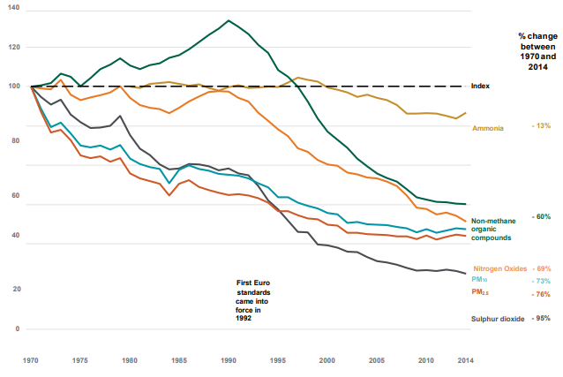
Figure 1-Emission Regulation Trends (GOV.UK, 2016)

9. Literature Review

9.1 Tested Vehicle Specifications
The vehicle which is being tested in this investigation and its specification can be seen below:

Figure 2-Volkswagen Lupo 2003 (carsnitch.co.uk)

Engine
Dimensions
Engine Size | 999cc
Cylinders | 4
Valves | 8
Fuel Type | Petrol
Transmission | Manual
Gearbox | 5 Speed
Drivetrain | Front wheel drive
Fuel Capacity | 34 litres
Weight | 946kg
Length | 3527mm
Width | 1860mm
Height | 1459mm
Wheelbase | 2323mm
Turning Circle | 10m
Performance
Power | 49 bhp
Top Speed | 94 mph
0-60 mph | 17.1 secs
Torque | 86 Nm, 63 ft-lb
CO₂ Emissions | 139 g/km
Euro Emissions Standard | 3
Miles Per Tank | 359 miles

Vehicles specification have been obtained from: https://www.parkers.co.uk/volkswagen/lupo/hatchback-1999/10-e-3d/specs/

9.2 Four Stroke Cycle Emissions
As previously mentioned under section 8 the main focus will be on nitrogen oxide emissions, however there are other harmful emissions which will also be looked at and are formed during a four-stroke cycle engine combustion. Emissions caused during combustion are gases which cannot be reused and are therefore referred to as waste products. Main emissions formed from a petrol engine are; carbon monoxide (CO), Hydro Carbon (HC), Oxides of Nitrogen (NOx) and particulate matter (PM), the later one is only formed in petrol engines with direct fuel injection (Dft.gov.uk, 2018). Figure 3 below shows the threats of the mentioned emission. NOx being the main focus point of this investigation therefore its threats have been explained under section 9.3.
Figure 3-Four Stroke Cycle Emission Threats (M. Dabrosz, 2018)/ (US EPA, 2018).
Emission | Threat to Health | Threat to Environment
Particulate Matter | - Premature death in people with heart or lung disease  - Nonfatal heart attacks  - Irregular heartbeat  - Aggravated asthma  - Decreased lung function | - Making lakes and streams acidic  - Changing the nutrient balance in coastal waters and large river basins  - Depleting the nutrients in soil  - Damaging sensitive forests and farm crops
Hydro Carbon | - Respiratory tract irritation  - Eye irritation | - Causes plant damage
Carbon Dioxide | - Death  - Unconsciousness  - Convulsions | - Global warming  - Intoxicating sea creatures
Carbon Monoxide | - Headache  - Dizziness  - Vomiting  - Death  - Heart Disease | - Increase greenhouse effects  - Increase temperature  - Increasing storm activity  - Causing extreme weather conditions

9.3 Medical and Environmental Issues Caused by Nitrogen Oxide
Nitrogen dioxide is a very irritant gas, if it finds itself in human lungs at high concentrations is causes inflammation of the airways. When nitrogen oxides are released during the combustion of fuel it combines with the oxygen atoms to form nitrogen dioxide (NO²). Nitric acid on its own is not considered as a big risk to human health, however nitrogen oxide is very harmful. Once nitrogen dioxide and nitrogen dioxide combine they are referred to as nitrogen oxide (NOx), (Icopal-noxite.co.uk, 2018). Statistics shown in figure 25 of the appendices shows that transportation sector is the biggest sources of NOx production.
NOx emissions mainly impact a human’s respiratory system and usually causes inflammation of the respiratory system. If a human is exposed to these harmful gases long term it will decrease the lung functions, increase the risk of respiratory conditions and increase one’s responses to allergens. NOx contributes to forming the fine particles (PM) and ground level ozone, both are associated with adverse human effects (Icopal-noxite.co.uk, 2018). These factors have also been confirmed by Graham J in his SAE Technical Paper concerning the health effects of automotive emissions, therefore can be deemed as accurate.
NOx at high concentrations also has a big negative effect on vegetation, this means it damages leafs and reduces crops growth. It makes the plants more susceptible to frost damage and diseases (pathology). A study which was carried out in the Epping Forest has shown how its habitat is affected by nitrogen dioxide and ammonia (NH³). The study’s results show that the pollution is significantly influencing the forests ecosystem health. The local traffic around the forest is the source of such pollution causing the critical levels to exceed safe limits substantially (Local Air Quality Management, 2016).
When there is a reaction between hydrocarbons and nitrogen oxide in the presence of sunlight, photochemical oxidants line ozone (O³) are formed in the lower atmosphere. Ozone formed in the lower atmosphere is highly toxic and causes lung tissue damage not only to humans but also other mammals (Ferris, 2018).
NOx which reacts with moisture in the atmosphere form Nitric Acid. Like ozone, nitric acid is efficient at damaging lung tissue and it’s linked to many respiratory diseases (Chemistry.wustl.edu, 2018).
Acid rain is primarily caused by nitric acid. When the containing acidic compound atmospheric moisture condenses and precipitates into rain, snow, fog or dew it has a harmful effect upon the natural environment. Acid rain harms the vegetation, causes eutrophication of lakes and seas which is harmful to its flora and fauna, corroding steel structures and weathers stone building (Ferris, 2018).

9.4 Nitrogen Oxide Sources & Formation
Nitrogen oxide is produced from a reaction between nitrogen and oxygen gases in the air during combustion, especially at high temperatures. This is the reason why NOx levels are significantly high in areas with a high level if motor vehicle traffic, in large cities for example (Ferris, 2018). Other sources of NOx emissions can be seen in figure 25 of the appendices.
NOx emissions from combustion are primarily in the NO form. As stated in the Zeldovich equation NO is generated to the limit of available oxygen which is about 200,000ppm in the air at temperatures higher than 1350°c (1623K). At temperatures below 760°c (1033K), NO is either generated in much lower quantities or not at all. NO in a combustion is generated as a function of the air to fuel ration and it is more visible when the mixture is on the lean side of the stoichiometric ratio, which is 14.7:1 (EPA, 1999). The Zeldovich equations for NOx formation are:
$$1) N_{2} + O≫ NO + N$$
$$2) N + O_{2} ≫NO + O$$
$$3) N + OH NO + H$$
The Zeldocich equations show the chemical mechanism which conveys the oxidation of nitrogen and NOx formation (Zeldovich, Y. A, D. 1947).
During combustion there are three circumstances in which NOx can be formed, they are;
- Thermal NOx- The concentration of thermal NOx is controlled by the nitrogen and oxygen concentrations and the combustions temperature. Combustion at temperatures below 1250°c form smaller thermal NOx concentrations (EPA, 1999). The image below shows rate of NOx formation by thermal mechanism:
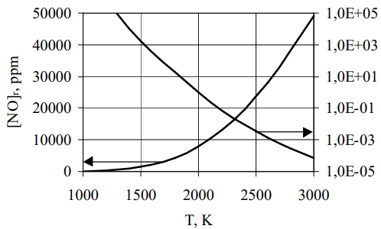
Figure 4-Thermal NOx Formation vs Temperature (Fluid.wme.pwr.wroc.pl, 2018)

Figure 4 clearly shows that Zeldovich’s theory mechanisms become important when the temperature reaches the 1600K-1800K range, because at this temperature the NO begins to oxidise and creates NOx (Spindt, SAE Paper, 1956).

- Fuel NOx-Fuels such as coal contain nitrogen and when combusted they create fuel NOx which results from oxidation of the already-ionized nitrogen which the fuel contains (EPA, 1999). The image below shows fuel nitrogen in different heating oil:
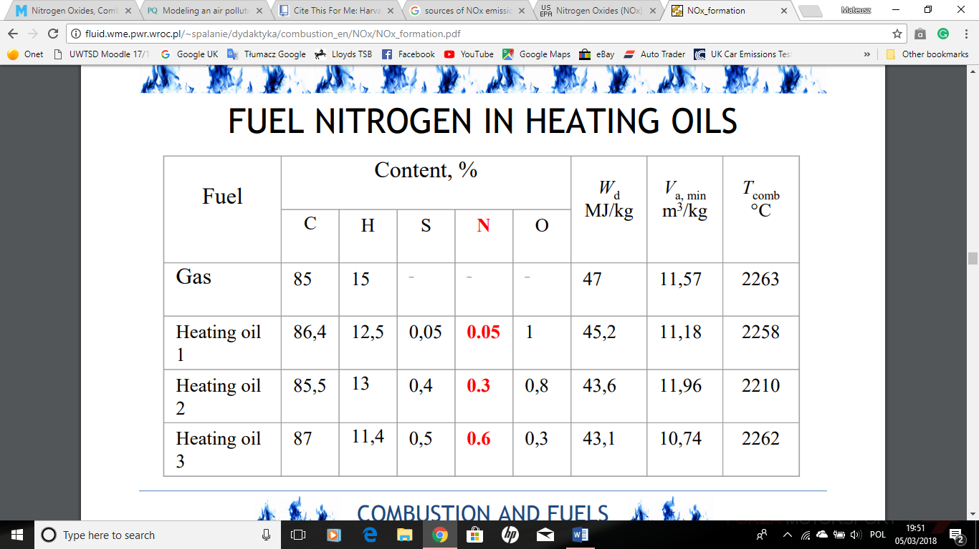
Figure 5-Fuel Nitrogen in Heating Oils (Fluid.wme.pwr.wroc.pl, 2018)
To relate the nitrogen fuel (NF) to NOx emissions the bellow image was generated, it conveys the influence of (NF) content on NOx emissions.
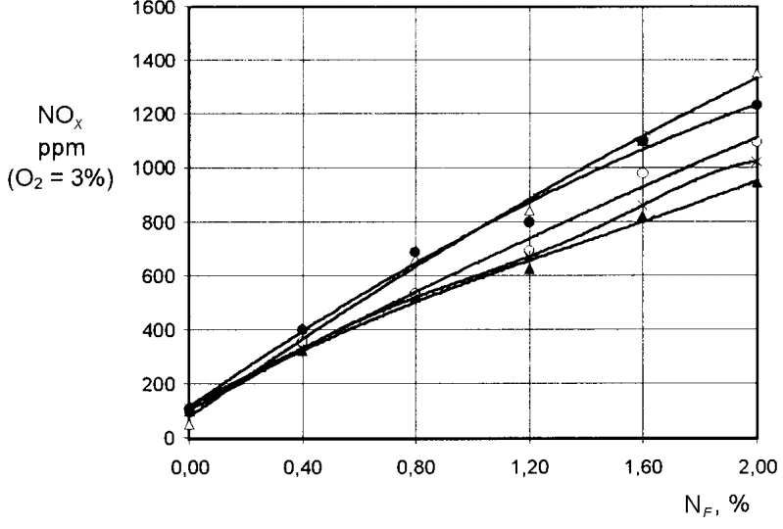
Figure 6-Nitrogen Fuel vs NOx emissions (Fluid.wme.pwr.wroc.pl, 2018)

- Prompt NOx- This if formed from molecular nitrogen in the air combining with the fuel in a fuel rich circumstances which exist in nearly all combustions. The nitrogen oxidizes with the fuel and become NOx during combustion, like fuel NOx (EPA, 1999). Many writers in their reports write about disputing the abundance of prompt NOx because they are probably considering fuels in a specific way containing very large or very small nitrogen amounts, or they are considering burners which have or not have any fuel rich regions within the flame.
The formation involves a complicated series of reactions, the route now accepted is as follows:
Figure 7-Prompt NOx Formation (Fluent Incorporated, 2003)
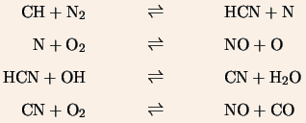

Figure 8 below shows the prompt NOx compared to the two other NOx formation conditions against combustion temperature:
Figure 8-Prompt NOx vs Temperature (TFTEI, 2018)
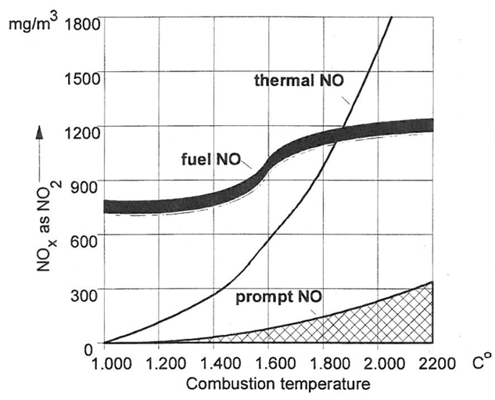

In circumstances which have the mentioned rich air-fuel ratio meaning less oxygen is available to react with the N² in the combustion air and fuel bound nitrogen. Considering that, both fuel NO and thermal NO are reduced. However, the amount of prompt NOx can be expected to rise. The effect of injection to detection (retention) time very much depends on the air-fuel ratio. A greater retention time can reduce emissions due to the NOx starting to decompose. In lean air-fuel ratios and great temperatures new thermal NOx will be formed (TFTEI, 2018).

9.5 Current Emissions Regulations
The current emission standards in the automotive industry are Euro 6 standards, these regulations can be seen in table 24 of the appendices. European emission standards are set to improve the air quality which as a result will improve human health by decreasing the levels of human poising. To focus once again on the intensity of the emission regulation reduction euro 6 reduces some pollutants by up to 95% compared to Euro 1, set in 1992 (AA, 2018).
Euro 6 emission legislation became mandatory in September 2015, meaning average CO2 emissions need to fall below 130 g/km across the entire range of a car company. Euro 6’s biggest restrictions are mostly effecting NOx, HC and PM. Figure 9 shows how NOx emissions have changed between Euro 3 to Euro 6 legislations.
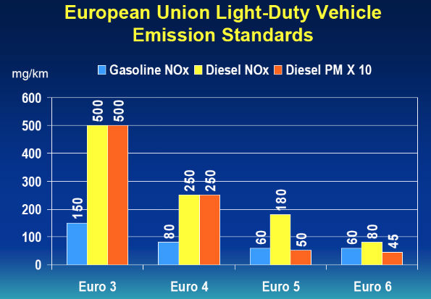
Figure 9-NOx Emission from Euro 3 to Euro 6 (Hybrid Cars, 2018)

From figure 9 it can be noted that the NOx emissions did not change as drastically for petrol engines as they did for diesel engines, this however does not mean they are any less harmful (Parkers.co.uk, 2018). The difference between petrol and diesel NOx regulations is caused by different methods of combustion. A petrol engines fuel and air mixture is ignited by a spark plug, in a diesel engine the mixture is compression, therefore in a diesel engine the combustion temperatures are much greater than on petrol engines to allow better compression (Reif and Dietsche, 2014). As stated by Maurer the hotter the combustion temperature the larger the formation of NOx, therefore it is harder for automotive manufacturers to reduce NOx emission on diesel engine than compared to a petrol engine due to the different operating circumstances, hence why diesel engines are given a slightly lower NOx formation legislation (Maurer, M., Holler, P., Zarl, S., Fortner, SAE Technical Paper, 2017).
According to Matt Dyer the managing director of LeasePlan UK, the next Euro 7 emission legislation should be expected before 2021, he predicts that the new legislations will pose new requirements on the manufactures of diesel engines. He also adds that the current drive cycle will be updated to add even more accuracy to measuring real world NO² emissions (Fleetnews.co.uk, 2018). This has also been confirmed by Thierry Bollore the chief of Renault’s competitiveness officer.

9.6 New WLTP Drive Cycle
To aid with the credibility and suitability to the automotive industry the live testing simulation will be carried out according to the new WLTP (Worldwide Light Vehicle Testing Procedure) drive cycle, introduced in 2017.
The new drive cycle test must be carried out in a controlled temperature and environment, and the car must be representative of the vehicle as it is produced. All components of the vehicle must be present and cannot be tempered with. As an example, the alternator belt must be intact and the brakes must function fully to pass the test. It is crucial to make sure the vehicle is checked to ensure it has the same tyre pressures, fluid levels and components as it would have on the road, these factors make the test more accurate (SMMT, 2018)
For the first time the new drive cycle includes and on-road test scenarios (RDE), however for this project testing only a laboratory simulation will be carried out due to the resource limitations. The new WLTP testing is longer lasting 30 minutes, includes faster speeds and more dynamic driving methods compared to the NEDC, therefore these new testing procedures can replicate modern driving simulation by enhancing the accuracy and realism of the obtained results (SMMT, 2018)/ (M. Dabrosz, 2018).
The new drive cycle includes four testing speeds which are carried out on after the other, the speeds are: low (51 km/h), medium (74.7 km/h), high (85 km/h) and extra high (123 km/h). Figure 10 below represents the major differences between the old NEDC drive cycle and the new WLTP:
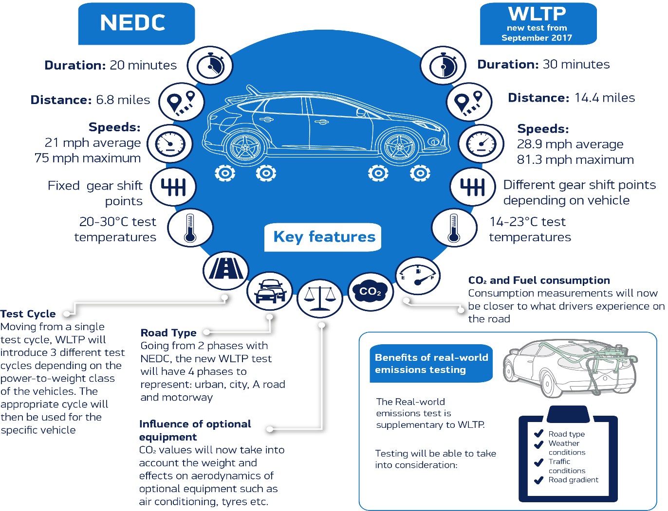
Figure 10-WLTP vs NEDC Drive Cycles (SMMT, 2018)
WLTP uses three different vehicle testing categories, this is determined by the power-weight ratio of the vehicle which is being tested, the testing category for the VW Lupo is class 2 due to the P:W ratio being 24.11kg/kw, therefore it fits within the 22 to 34 kg/kw, class 2 category (Transportpolicy.net, 2017).
The reason behind changing the drive cycles is because the NEDC had become outdated, being first introduced in 1970 and being updated in 1992 to include urban traffic testing. Most importantly the test could not simulate and accurately present what happened in real driving circumstances. As presented by Mercedes Benz some CO² reduction technologies performed better on the dynamometer than on the road, such as the start-stop system. The manufacturers are constantly advancing the used technologies and therefore the drive cycles must also be updated to keep up with the trends. Also, another advantage of WLTP is its results will be globally valid and therefore can be compared on a global scale (Mercedes-Benz.com, 2017).
Another less talked of reason for the new drive cycle is the recent VW emission scandal, which fitted a cheat device into their vehicles so they performed better on the dynamometer than on the road. The vehicles detected when they were being tested and adjusted their performance accordingly to improve the results. Because of these illegal changes the engines produced up to 40 times above the legal NOx limits, therefore a change of drive cycles was introduced to stop manufacturers doing something like this again (House of Commons, Transport Committee, 2017).

9.7 Possible Means to Reducing Automotive Emissions
The tested vehicle has been manufacturer to the euro 3 emissions standard regulations. Biggest changes which came with the introduction of euro 3 meant a modification of the testing methods, the warm up phase was eliminated and a further reduction in CO emissions (Dieselnet.com, 2018). This section will focus on technologies which are being used by the automotive manufacturers to try and reduce the harmful vehicle emissions, these technologies could also be introduced onto the vehicle to enhance it to a higher emission standard.

9.7.1 EGR Enhancement
Possible the most common technology to reduce NOx emissions is an EGR valve. It operates by introduction a fraction of the engine exhaust back into the intake manifold to dilute the charge entering the combustion chamber. This process is called ‘Exhaust Gas Recirculation’. The thermodynamics behind an EGR operation explain how it aids the reduction of NOx. Introducing EGR into the intake charge of stoichiometric engines increases the mass of the intake charge, therefore lowering the combustion temperature since for the same heat addition, a greater mass of intake charge will result in a lower combustion temperature. In addition, the exhaust gases have a greater specific heat capacity than air, therefore this aid the reduction of flame temperature, which has a positive effect on reducing NOx, this can be backed up Zeldovich theory, found in section 9.4 (Bhargava, S., Clark, N., and Hildebrand, M, SAE Technical Paper, 1998). Figure 26 of the appendices shows the effectiveness of EGR valve operation on reducing NOx emissions. The tested engine has a downstream EGR fitted, this system is inaccurate as it only functions according to the throttle position information. To enhance this, an electric EGR could be fitted which uses data from throttle position, exhaust gas temperatures, mass air flow sensor and engine RPM thus making the whole system more accurate and credible (Yang, Z., Winward, E., O'Brien, G., Stobart, R, SAE Technical Paper, 2016).

9.7.2 Selective Catalytic Reduction (SCR)
The sole purpose of an SCR system is to reduce nitrogen oxides (NOx) to harmless nitrogen and water. An SCR system requires a reducing agent in the form of a urea based additive ammonia (NH³). Figure 27 which can be found on the appendices shows the operating principles of an SCR system. From the image it’s clear that when the NOx enters the SCR system it reacts with the ammonia based additive, because of such reaction harmless water and nitrogen are formed (Figura, J., Kihas, D., Pekar, J., Uchanski, M, SAE Technical Paper, 2016).

9.7.3 Hybrid Assist (IMA)
The main advantage of a hybrid assist system on a vehicle is it assist the engine during accelerating, because of this it offsets a need for a larger engine which would potentially be less fuel efficient. Vehicles with an IMA system also uses it instead of the engine in circumstances such as parking, idling, slow driving speeds and when the vehicle is stationary the IMA system helps to get the vehicle moving. The reason this system is so efficient is due to the fact it uses deceleration as a charging factor for its batteries, it recovers the heat energy to charge its batteries. The motor becomes a generator and can store energy for later use. This system improved efficiency, lowers fuel consumption and helps to lower emissions (Vallur, A., Khairate, Y., and Awate, C, SAE Technical Paper, 2015). Figure 28 in the appendices shows the advantage of an IMA system at reducing CO² emissions.

9.7.4 Pulsed Air System (SAI)
A SAI (secondary air injection) system uses an air injection pump providing the exhaust system with air by injection into each exhaust port, this is usually done at cold starts to help the catalytic converter oxide the hydrocarbons and carbon monoxide into water and carbon dioxide, the reason for oxidising emissions is to make them less harmful (GmGH, 2007). Figure 29 shows the effectiveness of an SAI system on reducing NOx emissions.

9.7.5 Discussing the Technologies Used by Manufacturers to Reduce Emissions
From the literature review around the hazardous pollutants formed during the four-stroke cycle combustion, NOx has become very prominent within the last couple of decades (Cybulski, 2005). Reason for NOx emissions becoming such a prominent problem is because of the negative effects it has on human health, which have been described in section 9.3 of this report.
Automotive manufacturers are using downsizing methods which consist of providing a similar power output on a smaller engine like a larger engine, constructors provide information which show smaller engines with the power of larger engine are more efficient and form less emissions, however, as backed up by many professional papers this is not entirely accurate. Downsized engines produce more NOx emissions and contribute greatly to forming this harmful pollutant (Bassett, M., Vogler, C., Hall, J., Taylor, J, SAE Technical Paper, 2018). A typical downsized engine consists of 3 cylinders with a turbocharger system fitted, according to Timothy V Johnson in his SAE paper which states that turbochargers are a good solution for lowering NOx (Johnson, 2015). However, there are other aspects of the engine which will form more NOx even with the turbocharger fitted. According to Diess from Volkswagen the era of downsizing engines will come to a halt as recent tests carried out by Reuters show that as the engine sizes decrease the amount of formed NOx increases (Reuter, 2017). Also stated by Diess is the fact that downsized engines will perform worse during the new RDE and WLTP drive cycles because of the downsized engines. This is because the smaller engines are expected to produce a power output similar to that of a larger engine, conveying the smaller engine will need to work twice as hard to produce those power figures, and as a result increasing the combustion temperature and as mentioned in section 9.3 this will result in increased NOx emissions (Hybrid Cars, 2016). Also from the Reuters test downsized engines exceed NOx limits by 15 times at maximum and also significantly increasing the fuel consumption and as the test progressed the downsized engines started forming large amounts of CO² (Reuter, 2017).
Also, as proved in the article ‘Simulating the effects of turbocharging on the emission levels of a gasoline engine’ it was found that NOx, CO and CO² emissions were higher in terms of their concentrations in the exhaust fumes of a turbocharged engine compared to a naturally aspirated one (Mahmoudi, Khazaee and Ghazikhani, 2018).
Furthermore, another technology adopted by car manufacturers which isn’t performing as expected is the high compression ratio engines. According to El Kassaby and and Nemit Allah when the compression ratio changed from 14psi to 18psi the engines produced 36% more NOx emissions, thus proving that higher compression ratios negatively contribute to forming NOX emissions, hence this technology is slowly being abandoned by manufacturers (EL Kassaby and Nemit Allah, 2013).

9.8 Water Injection Technology
Water injection technology will be the emission reduction technology which will investigated in this project. The testing will be done according to WLTP the new drive cycle procedures, more on this under section 10 of this report, please refer. Assessing the literature review in all cases water is an effective system to reduce the levels of NOx emissions, as the water is injected into the cylinder the combustion temperatures decreases, thus decreasing the levels of formed NOx (Fu, L., Wu, Z., Li, L., and Yu, X, SAE Technical Paper, 2014).
In addition, water injection does not only improve the NOx emissions however it also gives the engine an advantage of increasing engine performance and lowering fuel economy by up to 8%, this was tested by BMW on the 1 series engine. Water injection also improves the longevity of components such as piston, dudgeon pin, valves and connect rods. This happens due to the decrease in temperature resulting in lower cylinder pressures therefore there is less stress and strain acting on the components. This can be backed up by Gay-Lussac’s ideal gas law which explains how gasses change when volume is held constant. As temperature decreases the gas molecules move slower, impacting the gas’s container less frequently and exerting a lower force (Littleshop.physics.colostate.edu, 2018). Because of lower combustion temperatures car manufacturers can programme engines with lower compression ratios allowing for the ignition timing adjustments hence increase in boost. According to new atlas engines with water injection systems can produce up to 10% more power and torque compared to standard engines (Newatlas.com, 2017). These statements show other good benefits of water injection however the reduction of NOx is the prime focus of this project.
According to Peters and Stebar peak NOx levels were lowered by up to 40% with 40 weigh (mass) percent water addition to petrol. They convey that both methods they used (direct injection into manifold and emulsified fuel water mixture) were both effective in lowering NOx emissions (Peters, Bruce D. and Stebar, Russel F. SAE Paper, 1976). This can be seen in figure 11 below:
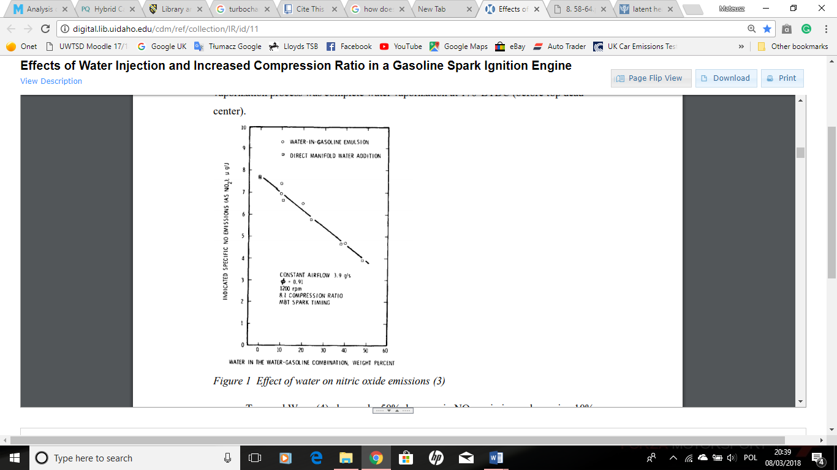
Figure 11-Water Injection Test on NOx Reduction (Bruce D & Stebar, SAE 1976)

Furthermore, they convey that at 170°BTDC they saw the most effective complete vaporization process.
According to Nicholls in ‘Inlet manifold water injection for control of nitrogen oxide’ the injection of water on a water/fuel mass ratio of 1:1 can lower NOx emissions by as much as 90%, this however is dependant in the used equivalence ratio (Nicholls, J. E., El-Messiri, I. A. and Newhall, H. K. 1969. SAE Paper 690018).
As shown by Harrington in his data plots where he showed NOx across a wide range of equivalence ratios and 3 showed NOx emissions can be lowered by up to 93%, depending on the amount of water and equivalence ratios (Harrington, J. A. SAE Paper 820314).
Lastly, as stated by Lestz in his SAE paper concerning the ‘emissions from a direct cylinder water injections’ as 90% in NOx drop is possible however this would result in a sacrifice of power, on the other hand a 50% reduction in NOx emissions is possible without making any sacrifices in power (Letz S.S., Meyer W.E and Colony C.M, SAE Paper, 1972). This statement is important to consider once the results from this investigation are obtained. Considering these studies, they all agree that water injection into the combustion chamber is effective at reduction NOx emissions.

9.8.1 Principles of Water Injection on NOx Reduction
The principles of how water injection causes a reduction of NOx is in two methods. One of them is the addition of overall mass to the combustion mixture. As backed up by (Merker, Schwarz and Stiesch, 2006) in their ‘Simulating Combustion’ book the product mass at 2000K combustion temperature the product mass without water is 1830kg, with water injection the product mass is 1886.9 kg.
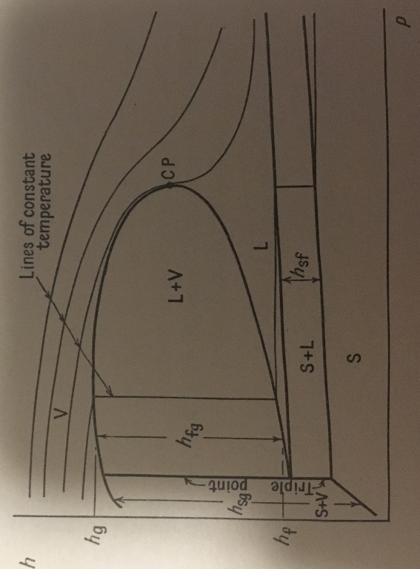
The second principle of water injection on NOx reduction is by evaporation, this is explained by the latent heat of vaporisation theorem, and the explanation of this will be helped by figure 12 below:
Figure 12-Latent Heat of Vaporisation (Spalding & Cole, 1961)

The way the water evaporates is by latent heat of vaporisation, it removes heat from the combustion gases by evaporating therefore reducing the overall combustion temperature thus reducing NOx emission (McDonald, 2018). Hence in the calculation under 10.2 there are two parts, one part is how much energy is needed to vaporise it and the other one lowering combustion temperature.
Referring to figure 12 the vertical height of a two-phase region (S+V, L+V or S+L) represents the enthalpy increase of the fluid when it changes from one phase to the other. This enthalpy increase is known as ‘latent heat of vaporisation’. The higher the temperatures correspond to the higher enthalpies. Particularly at high temperatures it is noted that the isotherms become closely horizontal, signifying that the enthalpy at given temperature is only dependant on pressure. This links to the fact that reduction of temperature results in a reduction of pressure (Spalding and Cole, 1961).

10. Methodology

The main research approach undertaken in this project is the use of secondary data. Figure 32 in the appendices shows the types of this data. The advantage of using secondary data means that fewer resources are required, it provides comparative data such as the data collected above, and it is easily accessible thus using it is much more time efficient (UWTSD, 2017). There were two stages to finding secondary data, first was establishing that the required secondary data is available and secondly locating only the precise data which was required. However, there are multiple disadvantages of using secondary data. The purpose of collection may not match the research needs, access to some sites and books may be difficult and costly, there is no real control over the quality of the data and initial purpose might affect the data presentation (UWTSD, 2017). Therefore, it is crucial that the obtained data is collected from good, and checked sources which have been assessed by professionals before publishing, such as SAE International. The stages which were used to evaluate the secondary sources can be seen in figure 33 of the appendices. In summary of secondary data, its evaluation includes reliability and all measurement bias, the costs and benefits of using secondary data is evaluated and compared with alternative sources and although secondary data may contain some bias most of the information found in it can help to solve the research equation (Sounders, 2009).

10.1 Analytical Calculations
This section will cover the analytical equations which were derived for this final year project. They have been derived from different books and internet sources as well as during meetings with the project supervisor and meetings with different academics form the university. Analytical equations in this instance were created to enhance the accuracy of the methodology section of this project, more specifically to enhance the live testing simulation section. The reason behind choosing analytical equation methodology alongside live testing simulation is because it gives the latter section a more enhanced accuracy, analytical methods can predict the results which will be obtained from the simulation and when both sets of results are similar it can be deemed that the testing was done correctly. If, however the results are different there is a room for explanation and identifying the reasons why the results are different, thus mathematical equations also enhance the comparison factor between the two sets of results (Marion, 2008).
Without the analytical equations live testing simulation would be dangerous, it could potentially damage the vehicles engine but more importantly it wouldn’t make the project results as accurate. The calculations allowed for a development of more knowledge of how the live testing should be carried out, for example, equations were used to calculate exactly how much water the engine can physically take before is misfires and potentially hydro locks. The equations written in section 10.1 are in the order in which they were developed and used for the live testing simulation.
Section 10.2 covers the equations which were derived after the live testing simulation. These equations were created to help analyse and comparing the results to the theoretical predictions.

Equation 1-Engine Displacement Calculations (Ipfs.io, 2018)
Bore = 67.1mm/2.64in
Stroke = 70.6mm/2.78in
Number of Cylinder = 4
$$\frac{π}{4} x Bore^{2} \left(inches\right)x Stroke (inches) x Number of Cylinders$$

$\frac{π}{4} x$2.64² x 2.78² x 4
= 60.87 Cubic Inches
=0.987182 Litres
=897 CC’s

Equation 2-Thermal Efficiency Calculations (Energyeducation.ca, 2018)
P = Power (Kw)
M = Mass of Fuel Used Per Second (kg/s)
CV = Calorific Fuel Value (Kj/kg)

$$ƞt=\frac{P}{M x CV}$$

$$ƞt= \frac{36.50}{2.793 x {10}^{-3} x 44000}$$

$ƞt$= 0.2934
$ƞt$ = 29%

Equation 3-Maximum Water Amounts at Different Powers Calculation (M. McDonald, 2018)

Water in combustion chamber = 25% of fuel amount

Power at 10 BHP = 10 x 0.746 = 7.46 Kw= 7.46x${10}^{3}$ Joules/Second
Calorific Value (1kg) = 44${x10}^{6}$ Joules
Calorific Value = 44 000 000 Joules
Calorific Fuel Value = 44 000 Kilo-Joule
Thermal Efficiency = 29%
Engine Output Used = 7.46x${10}^{3} Joules/Second$
$$Fuel Energy Used=\frac{7.46x{10}^{3}}{0.29}$$
Fuel Power @ 10 BHP = 25.7 $x{10}^{3}Joules/Second$
Fuel Power @ 20 BHP = 51.7x${10}^{3}Joules/Second$
Fuel Power @ 30 BHP = 77.2x${10}^{3}Joules/Second$
Fuel Power @ 40 BHP = 102.7x${10}^{3}Joules/Second$
Fuel Power @ 49 BHP = 125.9$x{10}^{3} Joules/Second$

Equation 4-Mass of Fuel User Per Second Calculation (M. McDonald, 2018)

$$M=44x{10}^{6}=25.7x{10}^{3}$$
$$M= \frac{25.7x{10}^{3}}{44x{10}^{6}}$$
Fuel Used/Second @ 10 BHP = 0.58$x{10}^{-3} kg/second$
Fuel Used/Second @ 20 BHP = $1.18x{10}^{-3} kg/second$
Fuel Used/Second @ 30 BHP = $1.75x{10}^{-3} kg/second$
Fuel Used/Second @ 40 BHP = $2.33x{10}^{-3} kg/second$
Fuel Used/Second @ 49 BHP = $2.86x{10}^{-3} kg/second$

Equation 5-Maximum Water Flow at Different Power Calculation (M. McDonald, 2018)
$$Maximum water per second is a multiplying constant x mass of fuel used per second$$

Maximum Water @ 10 BHP = 0.25 x 0.58 = 0.15 grams/second
Maximum Water @ 20 BHP = 0.51 x 1.18 = 0.62 grams/second
Maximum Water @ 30 BHP = 0.77 x 1.75 = 1.35 grams/second
Maximum Water @ 40 BHP = 1.03 x 2.33 = 2.40 grams/second
Maximum Water @ 49 BHP = 1.26 x 2.86 = 3.60 grams/second

Water = 1g = 1cc
Maximum Water Flow:
@ 10 BHP/7.46 kW = 0.145 cc/second = 8.7 cc/minute
@ 20 BHP/14.9 kW = 0.62 cc/second = 37.2 cc/minute
@ 30 BHP/22.4 kW = 1.35 cc/second = 81.0 cc/minute
@ 40 BHP/29.8 kW = 2.40cc/second = 144.0 cc/minute
@ 49 BHP/36.5 kW = 3.60cc/second = 216.0 cc/minute

Equation 6-Aerodynamic Forces at Four Testing Speeds Calculation (Heywood J, 1989)

$$Force At The Wheel=Rolling Resistance+Aero Force+Maximum Acceleration$$

$$Rolling Resistance Force= Rolling Resistance Coefficient x Mass x Gravity$$
Rolling Resistance = 0.015 N
Mass = 825 kg
Gravity = 9.81 m/s$²$
$$Rolling Resistance Force=0.015 x 825 x 9.81$$

Rolling Resistance Force = 121.4 N

$$Areodynamic Force \left(N\right)=\frac{1}{2} x P x Cd x A x v²$$

P = Air Density (kg/m³)
Cd = Drag Coefficient
A = Frontal Area (m)
V = Speed (m/s)

$$Areodynamic Force @ 51.4 kph \left(N\right)=\frac{1}{2} x 1.2 x 0.3 x 2 x 14.3²$$

$Areodynamic Force @ 51.4 kph=$73.6 N
$Areodynamic Force @ 74.7 kph=$155 N
$Areodynamic Force @ 23.66 kph=$201.5 N
$Areodynamic Force @ 123.1 kph=$420.82 N

$$Total Aerodynamic Force (N) = Rolling Resistance + Aerodynamic Force$$

$Total Aerodynamic Force \left(N\right) @ 14.3m/s$ $=121.4 + 73.6 =195 N$

$Total Aerodynamic Force \left(N\right) @ 20.75m/s$ $=121.4+ 155 =276 N$

$Total Aerodynamic Force \left(N\right) @ 23.66m/s$ $=121.4+ 201.5 =323 N$

$Total Aerodynamic Force \left(N\right) @ 34.19m/s$ $=121.4+ 420.82 =542 N$
Equation 7-Work Done at Four Different Testing Speeds Calculation (Heywood J, 1989)
$$Power=Work Done/second=Aerodynamic Force x Distance/second$$
$$Work Done @14.3m/s=195 x 14.3$$
=2788.5 Watts/2.79 Kw/3.74 BHP
$$Work Done @20.75m/s=276 x 20.75$$
=5727 Watts/5.73 Kw/7.68 BHP
$$Work Done @23.66m/s=323 x 23.66$$
=7642.18 Watts/7.64 Kw/10.24 BHP
$$Work Done @34.19m/s=542 x 34.19$$
=18530 Watts/18.53 Kw/24.84 BHP

Equation 8-Power at Wheels at Different Testing Speeds (Heywood J, 1989)

To accurately calculate power at the wheels we need to use the transmission efficiency which is 85 %.
$$Engine Power=\frac{BHP}{Transmission Efficiency }$$
$$Engine Power @14.3m/s=\frac{3.74}{0.85}$$
=4.41 BHP/3.30 kW
$$Engine Power @20.75m/s=\frac{7.68}{0.85}$$
=9.04 BHP/6.74 kW
$$Engine Power @23.66m/s=\frac{10.24}{0.85}$$
=12.05 BHP/8.89 kW
$$Engine Power @34.19m/s=\frac{24.84}{0.85}$$
=29.22 BHP/ 21.79 kW

Equation 9-Maximum Water Flow at Four Testing Speeds Calculation (McDonald, M 2018)
Maximum Water Flow:
@ 51kph, 14.3m/s, 3.30Kw = 37.62 ml for 9.81 minutes
@ 74.7kph, 20.753m/s, 6.74Kw = 76.84 ml for 7.21 minutes
@ 85.2kph, 23.66m/s, 8.89Kw = 101.35 ml for 7.58 minutes
@ 123.1kph, 34.19m/s, 21.79Kw = 248.41 ml 5.38 minutes
Total water required for test = 464.22 ml / 0.464 L for 30 minutes

Equation 10-Tyre Radius Calculation (X-engineer.org, 2018)
The size of the tyre on VW Polo is 185.55.14
$$Wall Thickness=0.55 x 185$$
Wall Thickness = 101.75 mm
$$14 "=14 x 25.4 = 355.6 mm$$
$$Wheel Radius= \frac{355.6}{2}$$
Wheel Radius = 178.3 mm
$$Tyre Radius=178.2+101.75$$
= 280.05mm
= 0.28m

Equation 11-Wheel Revolutions per Second Calculation (McDonald, M 2018)
$Circumference=2πR$
$$Wheel Revolution/sec @ 14.3m/s=\frac{14.3}{2π x 0.28}$$
$Wheel Revolution/sec @ 14.3m/s=8.13 Revs/Sec$/ 484 RPM.
$$Wheel Revolution/sec @20.75m/s=\frac{20.75}{2π x 0.28}$$
$Wheel Revolution/sec @ 20.75m/s=11.79 Revs/Sec$/ 707 RPM.
$$Wheel Revolution/sec @23.66m/s=\frac{23.66}{2π x 0.28}$$
$Wheel Revolution/sec @ 23.66m/s=13.44 Revs/Sec$/ 806.92 RPM.
$$Wheel Revolution/sec @34.19m/s=\frac{34.19}{2π x 0.28}$$
$Wheel Revolution/sec @ 34.19m/s=19.43 Revs/Sec$/ 1166 RPM.

Equation 12-Correct Gear Selection for Each Testing Speed (Technologystudent.com, 2018)

Gear | Gear Ratio
1st | 3.46:1
2nd | 1.96:1
3rd | 1.25:1
4th | 0.93:1
5th | 0.74:1
Final Drive Ratio | 3.88:1

$$Engine RPM=Gear Ratio x Final Drive Ratio x Wheel RPM$$
$$@ 51.4kph = 0.93 x 3.88 x 484$$
=1760 RPM
= 4th gear
$$@ 74.7kph = 0.93 x 3.88 x 707$$
=2251.02 RPM
= 5th gear
$$@ 85.2kph = 0.93 x 3.88 x 806.92$$
=2912 RPM
= 5th gear
$$@ 123.1kph = 0.93 x 3.88 x 1166$$
=4207.39 RPM
= 5th gear

10.2 After Live Testing Calculations
To get the approximate temperature in combustion chamber with and without water the stoichiometric combustion was assumed and the flame temperature calculated. Enthalpy of formation was found in Haywood (table 2) of enthalpy equations (Haywood R. W, 1992). The first testing speed calculations have been done in detail to give the reader a good understanding, the following speeds have not been extended as such however the procedure remains the same, if any problems please refer to the 3.3 Kw test. The tests will be referred to as ‘Kw’ power, this represents the power figures which the vehicle creates at the four testing speeds; 51.4km/h (3.3Kw), 74.7km/h (6.74Kw), 85.2km/h (8.89Kw) and 123km/h (21.79).
- 3.3 Kw Test
Equations 13-3.3Kw Test, Water Supply (McDonald, M 2018)
Water supply = 37.62 ML in 9.91 minutes.
$$Water Supply=\frac{37.62}{9.91 x 60}$$
=0.063 g/second
Equation 14-3.3Kw Test, Fuel Flow (M. Dabrosz, 2018)
$$Fuel Flow=4 x 0.063$$
=0.25 g/second
Equation 15-3.3Kw Test, Stoichiometric Combustion Equations (Merker, G, 2006)
Without water:
Stoichiometric combustion equation:
$$C_{8}H_{18}+{12}^{\frac{1}{2}}\left(O_{2}+3.76{ N}_{2}\right)>8{ CO}_{2}+9{ H}_{2}O+47N_{2}$$
Using enthalpy of formation values and the above equation:
Enthalpy needed to reach zero level= 224 MJ
$$Enthalpy Released=8 x 393+9 x 242=5098 MJ$$
With Water Injection:
$$\frac{Mass of Water }{Mass of Fuel }=0.25$$
Therefore: $\frac{Water Mass}{Fuel Mass}=0.25x\frac{114}{18}=1.58$

Combustion Equation:
$${1.58{ H}_{2}O+C}_{8}H_{18}+{12}^{\frac{1}{2}}\left(O_{2}+3.76{ N}_{2}\right)>8{ CO}_{2}+10.58+47N_{2}$$
Using enthalpy of formation values enthalpy needed to get zero level:
$$=1.58 x 282 \left(water as liuid\right)+224=670MJ$$
Enthalpy Released $=8 x 393+10.58+242 \left(water as gass\right)=5704$
Net enthalpy released $=5704-670=5034 MJ$
Therefore, because of the energy needed to vaporise the water, the net heat energy or enthalpy released is reduced by a factor of$\frac{5098}{5034}=1.013$.
Equation 16-3.3Kw Test, Product Mass Equations (Merker G. 2006)
In addition, the product mass has increased due to the injection of water.
$$Product mass without water=8x44+9x18+47x28=1830kg$$
$$Product mass with water=8x44+10.58x18+47x28=1858.44kg$$
Equation 17-3.3Kw Test, Mass Increase Factor Calculation (McDonald M, 2018)
Therefore, considering the above equations the theoretical factor of mass increase of the combustion products:
$$=\frac{1858}{1830}=1.016$$
Equation 18-3.3 Kw Test, Theoretical Combustion Temperature Drop (M. Dabrosz, 2018)
Assuming the stoichiometric flame temperature without water injection is 2400K.
Flame temperature with water injection is reduced approximately by factor of:
$$1.013 x 1.016=1.029$$
Therefore: $\frac{2400}{1.029}=2332K$
We can see a drop in combustion temperature of 68 degrees.
Equation 19-3.3Kw Test, Rate of NOx production Calculation (Merker, G. 2006)
The rate of NOx production equation has been obtained from page 138 of ‘Simulating Combustion’ (Merker, Schwarz and Stiesch, 2006), and it is:
$$Exponent (\frac{-67837}{Temperature})$$
If, temperature is 2400K (without water), the rate of NOx production $=5.33x{10}^{-13}$
If, temperature is 2332K (with water), the rate of NOx production $=2.33x{10}^{-13}$
Thus, the theoretical NOx reduction factor $=\frac{5.33x{10}^{-13}}{2.33x{10}^{-13}}=2.29$
The measured NOx reduction factor from the live testing simulation results $=\frac{3307}{2562}=1.29$
Therefore, considering the theoretical and actual reduction factors for the 3.3Kw test it can be assumed that the testing was done accurately and the predicted results are within a close range of the actual results. As stated in the book ‘Qualitative data analysis’ if the predicted and actual results are within a reasonable limit of each other they can be deemed as accurate (Miles, Huberman and Saldaña, n.d.).

- 6.74 Kw Test
Equation 20-6.74Kw Test, Water Supply (McDonald, M 2018)
Water supply = 76.48 ML in 7.21 minutes.
$$Water Supply=\frac{76.48}{7.21 x 60}$$
=0.177 g/second
Equation 21-6.74Kw Test, Fuel Flow (McDonald, M 2018))
$$Fuel Flow=4 x 0.177$$
=0.71 g/second
Equation 22-6.74Kw Test, Product Mass Equations (Merker, G, 2006)
Product mass:
$$\frac{Mass of Water }{Mass of Fuel }=0.51$$
Therefore: $\frac{Water Mass}{Fuel Mass}=0.51x\frac{114}{18}=3.23$
Equation 23-6.74Kw Test, Stoichiometric Combustion (Merker, G, 2006)
Combustion Equation with water injection:
$${3.23{ H}_{2}O+C}_{8}H_{8}+{12}^{\frac{1}{2}}\left(O_{2}+3.76{ N}_{2}\right)>8{ CO}_{2}+12.23H_{2}O+47N_{2}$$

Considering the first part of the equation: $3.23 x 282+224=1134.86 MJ$
Considering the second part of the equation: $8 x 393+12.33 x 242=6103.66 MJ$
Net enthalpy released $=6103.66-1134.86=4969 MJ$
Reduced by a factor of: $\frac{5098}{4969}=1.026$
Equation 24-6.74Kw Test, Product Mass (Merker, G, 2006)
In addition, the product mass has increased due to the injection of water.
$$Product mass without water=8x44+9x18+47x28=1830kg$$
$$Product mass with water=8x44+12.23x18+47x28=1888kg$$
Therefore, considering the above equations the theoretical factor of mass increase of the combustion products:
$$=\frac{1888}{1830}=1.032$$

Assuming the stoichiometric flame temperature without water injection is 2400K.
Equation 25-6.74Kw Test, Theoretical Combustion Temperature Drop (M. Dabrosz, 2018)
Flame temperature with water injection is reduced approximately by:
$$=1.026 x 1.032=1.059$$
Temperature drop with the addition of water:
$$=\frac{2400}{1.059}=2266$$
$$=2400-2266=134 degrees$$
Equation 26-6.74Kw Test, Rate of NOx production (Merker, G, 2006)
Rate of NOx production:$$Exp (\frac{-67837}{Temperature})$$
When combustion temperature is 2400K the rate of NOx production $=5.31x{10}^{-13}$
When combustion temperature is 2266K the rate of NOx production $=9.96x{10}^{-14}$
Therefore, the theoretical reduction factor is:
$$\frac{5.31x{10}^{-13}}{9.96x{10}^{-14}}=5.33$$
The actual reduction factor from the obtained results:
$$=\frac{2648}{1086}=2.44$$

- 8.89 Kw Test
Equations 27-8.89Kw Test, Water Supply (McDonald, M 2018)
Water supply = 76.48 ML in 7.21 minutes.
$$Water Supply=\frac{101.35}{7.58 x 60}$$
=0.223 g/second
Equation 28-8.89Kw Test, Fuel Flow (McDonald, M 2018)
$$Fuel Flow=4 x 0.223$$
=0.892 g/second
Equation 29-8.89Kw Test, Product Mass Equations (M. Dabrosz, 2018)
Product mass:
$$\frac{Mass of Water }{Mass of Fuel }=0.77$$
Therefore: $\frac{Water Mass}{Fuel Mass}=0.77x\frac{114}{18}=4.88$
Equation 30-8.89Kw Test, Stoichiometric Combustion (Merker, G, 2006)
Combustion Equation with water injection:
$${4.48{ H}_{2}O+C}_{8}H_{8}+{12}^{\frac{1}{2}}\left(O_{2}+3.76{ N}_{2}\right)>8{ CO}_{2}+13.88H_{2}O+47N_{2}$$

Considering the first part of the equation: $4.88 x 282+224=1600.20 MJ$
Considering the second part of the equation: $8 x 393+13.88 x 242=6502.96 MJ$
Net enthalpy released $=6502.96-1600.20=4902.76 MJ$
Reduced by a factor of: $\frac{5098}{4903}=1.04$
Equation 31-8.89Kw Test, Product Mass (Merker, G, 2006)
In addition, the product mass has increased due to the injection of water.
$$Product mass without water=8x44+9x18+47x28=1830kg$$
$$Product mass with water=8x44+13.88x18+47x28=1917.84kg$$
Therefore, considering the above equations the theoretical factor of mass increase of the combustion products:
$$=\frac{1918}{1830}=1.048$$

Assuming the stoichiometric flame temperature without water injection is 2400K.
Equation 32-8.89Kw Test, Theoretical Combustion Temperature Drop (M. Dabrosz, 2018)
Flame temperature with water injection is reduced approximately by:
$$=1.04 x 1.048=1.089$$
Temperature drop with the addition of water:
$$=\frac{2400}{1.089}=2203.84$$
$$=2400-2203.84=196 degrees$$
Equation 33-8.89Kw Test, Rate of NOx production (Merker, G, 2006)
Rate of NOx production:$$Exp (\frac{-67837}{Temperature})$$
When combustion temperature is 2400K the rate of NOx production $=5.31x{10}^{-13}$
When combustion temperature is 2203K the rate of NOx production $=4.23x{10}^{-14}$
Therefore, the theoretical reduction factor is:
$$\frac{5.31x{10}^{-13}}{4.23x{10}^{-14}}=12.55$$
The actual reduction factor from the obtained results:
$$=\frac{2229}{880}=2.53$$

- 21.79 Kw Test
Equation 34-21.79Kw Test, Water Supply (McDonald, M 2018)
Water supply = 248.81 ML in 5.38 minutes.
$$Water Supply=\frac{248.81}{5.38 x 60}$$
=0.771 g/second
Equation 35-21.79Kw Test, Fuel Flow (McDonald, M 2018)
$$Fuel Flow=4 x 0.771$$
=3.08 g/second
Equation 36-21.79Kw Test, Product Mass (M. Dabrosz, 2018)
Product mass:
$$\frac{Mass of Water }{Mass of Fuel }=1.03$$
Therefore: $\frac{Water Mass}{Fuel Mass}=1.03x\frac{114}{18}=6.52$
Equation 37-21.79Kw Test, Stoichiometric Combustion (Merker, G, 2006)
Combustion Equation with water injection:
$${6.52{ H}_{2}O+C}_{8}H_{8}+{12}^{\frac{1}{2}}\left(O_{2}+3.76{ N}_{2}\right)>8{ CO}_{2}+15.52H_{2}O+47N_{2}$$

Considering the first part of the equation: $6.52 x 282+224=2062.64 MJ$
Considering the second part of the equation: $8 x 393+15.52 x 242=6899.84 MJ$
Net enthalpy released $=6899.84-2062.64=4837.2 MJ$
Reduced by a factor of: $\frac{5098}{4831}=1.05$
Equation 38-21.79Kw Test, Product Mass (Merker, G, 2006)
In addition, the product mass has increased due to the injection of water.
$$Product mass without water=8x44+9x18+47x28=1830kg$$
$$Product mass with water=8x44+15.52x18+47x28=1947.36kg$$
Therefore, considering the above equations the theoretical factor of mass increase of the combustion products:
$$=\frac{1947.36}{1830}=1.06$$

Assuming the stoichiometric flame temperature without water injection is 2400K.
Equation 39-21.79Kw Test, Theoretical Combustion Temperature Drop (M. Dabrosz, 2018)
Flame temperature with water injection is reduced approximately by:
$$=1.05 x 1.064=1.117$$
Temperature drop with the addition of water:
$$=\frac{2400}{1.117}=2148.61$$
$$=2400-2148.61=251.39 degrees$$
Equation 40-21.79Kw Test, Rate of NOx production (Merker, G, 2006)
Rate of NOx production:$$Exp (\frac{-67837}{Temperature})$$
When combustion temperature is 2400K the rate of NOx production $=5.31x{10}^{-13}$
When combustion temperature is 2149K the rate of NOx production $=1.95x{10}^{-14}$
Therefore, the theoretical reduction factor is:
$$\frac{5.31x{10}^{-13}}{1.95x{10}^{-14}}=27.23$$
The actual reduction factor from the obtained results:
$$=\frac{2864}{1768}=1.62$$

10.3 Live Testing Simulation
Following the initial analytical calculations method, the next stage was the live testing simulation. The live testing simulation procedures will be carried out in a way which will test the vehicle over different dyno loads and speeds, the speeds which are being have been taken from the new WLTP drive cycle. The reason why the author chosen to carry out the investigation following the same procedures as the new drive cycle is because of its relevance to the automotive industry. The car manufacturers are now testing their vehicles using the new procedures therefore this was deemed as an appropriate method of carrying out the live testing simulation. Therefore, the skill of industry awareness is very helpful here. Carrying out the methodology in the same way as the industry gives the results more accuracy and suitability to the real world, gives the project a greater meaning and gives more opportunities with the results analysis, as these can be compared with the global database which is now a compulsorily factor to all manufactures (MDA, 2018).
The testing procedures of the WLTP drive cycle can be seen in figure 10 under section 9.6 of this report. As the vehicle is being tested the water injection system will be engaged, this thus allows to determine the effectiveness water introduction on the reduction on NOx emissions. The government has set up the WLTP drive cycle on four different speeds, low, medium, high and extra high, they are, 51.3 km/h, 74.7km/h, 85.2pm/h and 123km/h respectively. The equations in section 10.1 include those speeds however they have been converted into m/s to give accurate figures. Each of the four speeds have different testing periods, they are: 9.81, 7.21, 7.58 and 5.38 minutes respectively (SMMT, 2017).
From the analytical methodology the maximum amounts of water which have been calculated for each testing speeds are as follows: 37.62ml, 76.48ml, 101.35ml and 248.41ml respectively, the total amount of water needed is 464.22ml. The water will be applied into the induction system just before the throttle butterfly using a trigger atomiser, seen in figure 30 of the appendices. The amount of water in one full spray of the trigger atomiser has been calculated by the author, the bottle was filled with 100ml of water, the amount of sprays required to empty the atomiser was 80, therefore to calculate how much water is emitted within one spray: 100ml/80=1.25ml per one spray. Using this system will replicate a water injector system which is like the one adopted by manufacturers, this will simulate realistic operation. The tests will be carried out three times, using this approach will enhance accuracy of the results and potentially exclude any anomalies from the data, this a good practice which allows for more trustworthy data (Andersson, 1999).
From the background research around the effectiveness of water injection on NOx emissions reduction it was seen from different sources that this approach will be effective and will successfully meet the set objectives. B.C Tefsa, a student at UoH carried out a very similar testing to the one in this project. He tested the effects of water injection on emissions characteristics and saw positive results. His results can be seen in figure 31 of the appendices. Although, his testing was carried out throughout an RPM range not actual vehicle speed the results still prove the principle that water injection is effective on reducing NOx.
Considering Tefsa’s results one of purposes of the investigation will be to determine if those sets of results are correct by comparing the principle of NOx reduction from the results obtained in this project. His results will be used to validate these results, if the two sets of results are similar this will be crucial as it will mean the data obtained is clean, useful and accurate (McCulloch, 2017).

10.3.1 Factors Which Cause Validation Issues
Firstly, the tested vehicle was not used for significant amount of time prior to the beginning of the testing. The potentially effected the obtained results, and explains why the results got slightly better towards the end of the testing procedures. The dangers of allowing a car to be unused for a long period of time and then suddenly using it are this will significantly affect the obtained results. When the engine is not run for a long time these factors come into play: engine fluids start to develop unwanted substances, fuel pump will start to malfunction due to the lack of fluids passing through it, the rust which is developed in a fuel tank will affect the operation of the engine once it is restarted, it can also developed leaks when unused, engine oil which is left still for prolonged periods of time loses its lubrication capabilities and effects the performance of moving parts (Jerseycash4cars.com, 2018). However, the most crucial effect of not using the vehicle which might potential create anomalies in the results is that changes to the exhaust system. If the engine is not run for a long period of time the exhaust system is not cleaned out, this leads to exhaust damage and rust and leads to a multitude of problems including sensor damage, catalytic converter blockage, both of these effecting the obtained results and the system can become so eroded until a point where holes form in the exhaust, this will lead to some of the exhaust gases escaping into the atmosphere without being recorded by the Bosch gas analyser, this could potentially affect the results (R, King 2018). To make sure the above factors do not significantly change the results, the vehicle was run for a couple of hours prior to the start of the test with an attempt to clean all the mentioned systems out, however, some of these aspects could have remained and effected the emission results.
Secondly, another important factor was the lack of a second catalytic converter. As explained under section 9.7.2 a catalytic converter is one of the most important components of an exhaust system, its operation reduces the harmful pollutants by converting them into harmless gases by a series of chemical reactions (Whelan, I., Samuel, S., and Hassaneen, A SAE, 2010). The catalytic converter was removed because the vehicle was modified to a rally spec, however, the after-engine catalyst remained. This factor will not play a major part in the analysis because the objective of this investigation was to analyse the effectiveness of water injection on NOx reduction, to show if the water injection system is clearly effective two tests were carried out, one without water and one with water, these results were then compared. The two tests were carried out in the same circumstances and environment therefore the lack of the converter will not affect the results as it can still prove whether the water injection reduced NOx emissions or not. This will however affect the comparison of the obtained results to the ones saved in the WLTP database and ones that are produced by the manufacturers, as the tested vehicle does not meet the emission regulations due to the lack of catalyst. This must be considered when comparing.
Thirdly, the factor of changing the nozzle size on the trigger atomiser might affect the validation capabilities. The nozzle size of the atomiser was adjusted to match the spray patter of an injector which was tested. The change in nozzle size adjusted the pressure with which the water was being forced out of the nozzle, this meant that if the adjustments were done incorrectly and the pressure was not high enough it could potentially have a negative effect on the water not reaching the intake tube. Also, if the spray patter was too large the water would be sprayed around the intake butterfly and not actually into it. This would once again cause anomalies within the results as the actual water amount in the combustion chamber might vary from the amount of water which was expected to be in there. Figure 35 of the appendices shows a picture of the injectors being tested, the nozzle was adjusted to replicate a similar pattern shown by the ‘good’ label. The reason why nozzle adjustments are important is because it plays a very big part in atomising the water and delivering into the air charge of the engine. The nozzle spray pattern is not demined by judging at what happens with the patter 1 or 2 feet away, the point to focus on is what happens with the patter within the first half inch after the orifice, the spray pattern must be adjusted in such a way that the separation into smaller droplets begins within 1-2 inches after the orifice, this will result in better atomisation (Gilles-Birth, I. Bernhardt, SAE 2005).
Lastly, during the testing a problem which was encountered often was blockage of the five-gas analyser emission probe. As stated by the manufacture the machine is only specified to operate for short periods of times, such as during MOT testing (BOSCH, 2018). If the machine is used for prolonged period’s problems such as melting of the probe end and blockage occurred, the blockage occurred due to the water being injected not getting vaporised and flowing out through the exhaust and thus blocking the pipe. Melting of the probe end occurred due to the excessively high temperatures which were caused by long engine operation, and the material on the probe was not designed to withstand such high temperatures. When these two problems occurred, the test had to be stopped as the machine would bring up an error code and would stop analysing the emission. When the melting problem occurred, the tests were stopped for 10-15 minutes allowing the probe to cool down, and were restarted again from the point where they were stopped. When the water blockage problem occurred, the probe had to be disconnected and air flushed to get rid of the excessive water build up, this took significant amounts of time as the machine needed to be calibrated every time the tests were stopped. The reason for mentioning these two problems is because every time the tests were stopped half way through, the vehicle was left to cool down, this thus meaning when the tests were restarted again the results were different due to the lower combustion temperatures, especially seen in the NOx emissions, which as shown in figure 8 is dependent on temperature. Care was taken to restart the test in the similar conditions, however this might not have always been accurate and therefore might cause validation problems.

11. Results & Analysis
Before the results from the testing sessions are presented a couple of important statements and assumptions must be made to enable the reader to develop a better understanding of the presented results and why they are happening. As the analysis progresses these points will be referred to.
In practice when the combustion temperature drops the concentration of $O_{2}$ also drops due to less dissociation of ${CO}_{2}$ and $H_{2}O$ (Merker, G., Schwarz, C. and Stiesch, G. 2006). Shown by the below chemical reactions:
$${CO}_{2}≫CO+ \frac{1}{2}O_{2}$$
$$H_{2}O≫H_{2}+ \frac{1}{2}O_{2}$$
Therefore, real nitrogen oxide depends on $O_{2}$ as well as the temperature. As the engine power increases the air and fuel mixture will be richer due to the greater demand, this mixture although richer will have less $O_{2}$ in the combustion (Addepalli, S. Saw, O. and Mallikarjuna, J. SAE 2017). Therefore, the difference with and without water injection may be less than actually expected from the simple calculations. Furthermore, as the combustion temperature drops there is less dissociation of ${CO}_{2}$ thus CO also decreases.
The reason why in some of the presented results we see a better NOx reduction at lower speeds is due to the lower RPM, at low engine speeds the piston is moving slower, thus the water can keep up with the air, as the air is passing through the intake is sucks the water along with it, at low speeds they can both keep pace with one another. As the RPM increases the air is coming in at much higher speeds and the water potentially cannot keep up with it and is left behind, hence the NOx reduction is lower at higher speeds. As the air speed increases, due to the water being injected from outside the engine it was furthest away from the injectors, therefore it could not keep pace with the air. To conclude these statements, at some lower RPM’s the method of water injection is accurate, however at higher RPM’s it is not, a much better method which was mentioned previously would be an injector straight into the cylinder, this would deliver all the water directly into the combustion chamber providing a continuous and more accurate flow. Due to this being only an experiment there was bound to be encountered mistakes, however if any future testing occurs these will be rectified. Even though considering all of the negative factors encountered the results shown still prove the positive effect of water injection on NOx reduction.

11.1 First Test Session Results

V_Max (km/h) | NOx (PPM) Without Water Injection | NOx (PPM) With Water Injection
51.4 | 2962 | 1422
74.7 | 3457 | 1139
85.2 | 3597 | 863
123.1 | 3262 | 2032
Table 1-First Session Testing Results Table (M. Dabrosz, 2018
Table 15 above shows the results table which contains the averages for the first testing speed of both NOx with and without water injection. Due to the abundance of data obtained the most accurate and clear way to present it was by calculating averages, this method is the most efficient and it is useful as no result are lost within the process of making the data smaller, thus being the most accurate method (Miles, M., Huberman, A. and Saldaña, J. (n.d.)). The full results from the testing session can be found in table 12 of the appendices.
Figure 13-First Session NOx Emissions With & Without Water Graph (M. Dabrosz, 2018)
Figure 13 illustrates the NOx reduction factors for the four different speeds of the WLTP drive cycle. The overall trend and correlation of the bar chart shows that the NOx is significantly reduced after the injection of the water. The NOx reduction in percentages are as follows; 51.4km/h (50.88%), 74.7km/h (67.05%), 85.2 (76.01%) and 123.1km/h (37.98%). From these statistics we can see the greatest NOx reduction benefits occurred at the third testing speed and the lowest reduction occurred at the fourth speed. The overall NOx reduction percentage for the first testing session was 57.98%. When injecting an accurate amount of water into the combustion chamber there should be approximately 60% to 70% reduction from uncontrolled levels (EPA, GOV 2018). From the above quote it can be assumed that this testing showed good reduction factors when compared to the government statistics. The reason why we see the lowest reduction factors at the fourth speed is because not all the water which was injected entered the combustion chamber, please refer to paragraph 3 under section 10.3.1 for a more detailed explanation.

11.2 Second Test Session Results
For the following test sessions, it was recognised that there is a need to not only monitor NOx emissions but also to monitor other pollutants to recognise if water injection has any negative effects. Therefore, from now on results will also be presented for NOx, HC, ${CO}_{2}$ and CO. The full results from the testing session can be found in table 13 of the appendices.
Table 2-Second Test Session NOx Testing Results Table (M. Dabrosz, 2018)
V_Max (km/h) | NOx (PPM) Without Water Injection | NOx (PPM) With Water Injection
51.4 | 3308 | 2563
74.7 | 2649 | 1086
85.2 | 2229 | 879
123.1 | 2864 | 1768

Figure 14-Second Test Session NOx Emissions With & Without Water Graph (M. Dabrosz, 2018)
Figure 14 represents the NOx emission results from the second testing session, the x-axis shows the four testing speeds and the y-axis represents the NOx emissions in PPM. The “parts per million” units can also be expressed as milligrams per litre (mg/l), it is a measure of the chemical mass per unit volume of water, it is an accurate way to measure emissions (Adelaide.edu.au, 2018). The NOx reduction factors in percentages for each speed are: 51.4km/h (22.52%), 74.7km/h (59%), 85.2km/h (60.57%) and 123km/h (38.27%). The greatest NOx reduction occurred at the third speed, the lowest occurred at the first speed. The overall NOx percentage decrease was 45.09%. The reason why water injection did not have as great impact on NOx reduction at the first speed is because the gas analyser probe begun clogging up, this caused the tests to stop causing anomalies in the obtained results, please refer to paragraph six under section 10.3.1 for more information.

Table 3-Second Test Session HC Testing Results Table (M. Dabrosz, 2018)
V_Max (km/h) | Hydrocarbon (HC) (PPM) Without Water Injection | Hydrocarbon (HC) (PPM) With Water Injection
51.4 | 277 | 271
74.7 | 296 | 352
85.2 | 270 | 293
123.1 | 164 | 162
*For full results please refer to table 14 of the appendices.

Figure 15-Second Test Session HC Emissions With & Without Water Graph (M. Dabrosz, 2018)

Figure 15 presents how the hydrocarbon emissions are affected by the addition of water into the combustion chamber. Hydrocarbon plays a very important role in vehicle emissions, it is a measure of hydrogen and carbon compounds which are created during an incomplete combustion process, or from vaporisation of gasoline. Basically, hydrocarbons are unburnt fuels, therefore the lower the emission reading the better. Hydrocarbons contribute to forming the ground ozone layer (Spalding, D. and Cole, E. 1961). From figure 15 on second and third speeds the addition of water increased the hydrocarbon emissions by 18.92% and 8.52% respectively. Increased hydrocarbon emissions are caused by poor fuel ignition due to the addition of the water, this is due to the quenching which is a result of diluting the combustion charge and the reduction in combustion temperatures (F. Hoppe, M. Thewes, H. Baumgarten, J. Dohmen, 2015). Except from the fourth testing speed the other hydrocarbon emissions are too high to meet the legislation, as stated by the DVSA the hydrocarbon emissions should be at or less than 200 ppm, however the increased emissions are caused by the lack of the second catalyst. In such instance the vehicle would undergo a “non-catalyst emission check requirement” test to meet the regulations (Driver & Vehicle Standards Agency, 2017).
Table 4-Second Test Session CO2 Testing Results Table (M. Dabrosz, 2018)
V_Max (km/h) | Carbon Dioxide (CO2) Without Water Injection | Carbon Dioxide (CO2) With Water Injection
51.4 | 14.08 | 14.1
74.7 | 13.71 | 13.82
85.2 | 12.94 | 13.4
123.1 | 13.78 | 14.3
*For full results please refer to table 15 of the appendices.
Figure 16-Second Test Session CO2 Emissions With & Without Water Graph (M. Dabrosz, 2018)

Figure 16 presents how the carbon dioxide emissions are affected by the addition of water into the combustion chamber. Gasoline contains carbon and hydrogen atoms, when combusted the carbon from the fuel react with oxygen from the air, because of this reaction ${CO}_{2}$ is formed (Nrcan.gc.ca, 2018). From figure 18, the addition of water increases the carbon dioxide. The percentages of those increases are: 51.4km/h (0.14%), 74.7km/h (0.8%), 85.2km/h (3.55%) and 123.1km/h (3.77%). The increased carbon dioxide emissions are linked to the increased hydrocarbon emissions, the reason for increased carbon dioxide emissions is the fuel and air ration is incorrect and there is evidence of incomplete combustion, when the water is added into the combustion chamber the combustion is not as efficient, this is shown by the increased hydrocarbons in figure 15, this leads to incomplete combustion and thus as a result increase the carbon dioxide emissions (Salem, 2000). The reason why the highest carbon dioxide increase is at the fourth speed is that at this speed the highest amount of water was injected, causing an incomplete combustion.

Table 5-Second Test Session CO Testing Results Table (M. Dabrosz, 2018)
V_Max (km/h) | CO (%) Without Water Injection | CO (%) With Water Injection
51.4 | 0.359 | 0.441
74.7 | 0.541 | 0.299
85.2 | 0.472 | 0.324
123.1 | 2.127 | 0.708
*For full results please refer to table 16 of the appendices.
Figure 17-Second Test Session CO Emissions With & Without Water Graph (M. Dabrosz, 2018)

Figure 17 presents how the carbon monoxide emissions are affected by the addition of water into the combustion chamber. Carbon monoxide is a product formed by an incomplete combustion. It is formed by partial oxidation of carbon compounds. Typically, in a combustion process carbon dioxide is formed after combustion, but as soon as there is not enough oxygen for the combustion required carbon monoxide begins forming, this is incomplete combustion (Valério, M. Raggi, K. and Sodré, J. SAE, 2003). The results in the graph are not consistent and show some anomalies, at the first speed the carbon monoxide emissions are increased, as stated by P.P.Patnaik, the addition of water into a combustion chamber will at some stage increase the carbon monoxide emissions due to the depression of thermal dissociation (P.P.Patnaik, 2016). The percentages of those changes are: 51.4km/h (+22.84%), 74.7km/h (-44.73%), 85.2km/h (-31.21%) and 123.1km/h (-68.06%). However, on the other hand, as stated by the EPA and other sources, an accurate water injection system should not cause any increases in CO emissions, there should be a small improvement in fact, due to the cooler combustion temperature and better burn (Nepis.epa.gov, 2018). Considering this statement, that’s exactly what we are seeing at speeds two and three, thus these results can be deemed as accurate. The fourth test shows an anomaly, the CO emissions are significantly increased. This anomaly has been caused by taken the reading at an inaccurate time frame.

11.3 Third Test Session Results

Table 6-Third Test Session NOx Testing Results Table (M. Dabrosz, 2018)
V_Max (km/h) | NOx (PPM) Without Water Injection | NOx (PPM) With Water Injection
51.4 | 3050 | 1458
74.7 | 2652 | 819
85.2 | 2212 | 827
123.1 | 2548 | 1288
*For full results please refer to table 17 of the appendices.
Figure 18-Third Testing Session NOx Emissions with Water vs Without Graph (M. Dabrosz, 2018)

Figure 18 illustrates the NOx reduction factors for the four different speeds of the WLTP drive cycle, during the third testing session. The overall trend and correlation of the bar chart shows that the NOx is significantly reduced after the injection of the water, this is the same trend as the results shown in figures 15 and 16. The NOx reduction in percentages are as follows: 51.4km/h (52.2%), 74.7km/h (69.12%), 85.2km/h (62.61%) and 123.1km/h (49.45%). The trends of the graph can be backed up by the equations under section 10.2. The equations show that from the obtained results we see a reduction factor of 1.62. The equation for the predicted reduction factor shows we should see a much greater reduction factor of 27.23, this is because this equation considers the amount of water which should have entered the combustion chamber, and not the amount of water which entered. This has been explained in paragraph 3 under section 10.3.1. Therefore, considering that, if the amount of water which was expected to enter the combustion chamber, entered, we would see an even more significant NOx reduction, however the results obtained are still good and successfully meet the projects objectives. The lowest NOx reduction occurs at the fourth speed, as mentioned on page 37, when the vehicles RPM is high the air is coming in at much higher speeds, as a result the injected water cannot keep up with the air and therefore some of it is left behind, this suggests why the NOx reduction factor is lower when the RPM is increased. This theory has also been backed up by (Nyenyep Sriwardani, 2016).

Table 7-Third Test Session HC Testing Results Table (M. Dabrosz, 2018)
V_Max (km/h) | Hydrocarbon (HC) (PPM) Without Water Injection | Hydrocarbon (HC) (PPM) With Water Injection
51.4 | 320 | 302
74.7 | 353 | 451
85.2 | 289 | 321
123.1 | 184 | 257
*For full results please refer to table 18 of the appendices.
Figure 19-Third Test Session HC Emissions With & Without Water Graph (M. Dabrosz, 2018)

Figure 19 presents how the hydrocarbon emissions are affected by the addition of water into the combustion chamber. The principle of why and how hydrocarbon emission increase after adding water into the combustion chamber have been explained under figure 15, please refer. Excluding the results from the first speed the remainder show a clear correlation that the addition of water increases the levels of hydrocarbons. These results are similar to the ones obtained in test session 1 and 2. The percentage differences between the testing speeds are: 51.4km/h (-5.62%), 74.7 km/h (27.76%), 85.2km/h (11.07%) and 123.1km/h (39.67%).
The reason why during the first speed the HC emissions are not negatively affected by water injection is due to its amounts. As the water injected at the first speed is fairly low it does not affect the combustion process enough to increase the HC emissions. However, as the water amount increases for the next speeds, the HC are increased, which shows in figure 19. The theory about the level of the injection water and the changes in hydrocarbon emissions has also been backed up by (Frank, R. and Heywood, J, SAE, 1991).

Table 8-Third Test Session CO2 Testing Results Table (M. Dabrosz, 2018)-
V_Max (km/h) | Carbon Dioxide (CO2) Without Water Injection | Carbon Dioxide (CO2) With Water Injection
51.4 | 13.77 | 13.75
74.7 | 13.45 | 13.65
85.2 | 13.42 | 14.87
123.1 | 13.35 | 14.23
*For full results please refer to table 19 of the appendices.
Figure 20-Third Test Session CO2 Emissions With & Without Water Graph (M. Dabrosz, 2018)

Figure 20 presents how the carbon dioxide emissions are affected by the addition of water into the combustion chamber. The percentage differences between the four testing speeds are: 51.4km/h (-0.15%), 74.7km/h (1.49%), 85.2km/h (10.8%) and 123km/h (6.59%). As previously explained under figure 16, the hydrocarbons are responsible for the increase in carbon dioxide emissions, as the hydrocarbons increase the combustion becomes incomplete due to the poor air to fuel ratio, this is the potential cause of increased carbon dioxide (Gruden, D, SAE, 2006). The overall trend of the graph shows the addition of water causes an increase in carbon dioxide emissions, similar also shown by figure 16. As suggested by Busuttil and Farrugia the addition of water into a spark ignition engine could cause an enrichment in the fuel mixture, this is caused by too little air entering the combustion chamber due to the water being injected together with the air (Busuttil and Farrugia, 2015). As also backed by a different source a rich fuel mixture could have a negative effect on increasing the carbon dioxide emissions (Crypton.co.za, 2018). This statement explains why ${CO}_{2}$ has increased when adding water.

Table 9-Third Test Session CO Testing Results Table (M. Dabrosz, 2018)
V_Max (km/h) | CO (%) Without Water Injection | CO (%) With Water Injection
51.4 | 0.392 | 0.424
74.7 | 0.456 | 0.314
85.2 | 0.472 | 0.344
123.1 | 1.172 | 0.541
*For full results please refer to table 20 of the appendices.
Figure 21-Third Test Session CO Emissions With & Without Water Graph (M. Dabrosz, 2018)

Figure 21 presents how the carbon monoxide emissions are affected by the addition of water into the combustion chamber. From the graph it can be seen that the third session results are very similar to the second test session results regarding the effects of water injection on carbon monoxide emissions. The percentage changes for the testing speeds are as follows: 51.4km/h (8.16%), 74.7km/h (-31.14%), 85.2km/h (-27.12%) and 123.1km/h (-53.95%). As mentioned under figure 17 CO is a product formed by an incomplete combustion, as seen in the results the CO is increased at the first testing speed but for the remainder of the speeds the carbon monoxide is lowered. This would explain that at the first speed the combustion was incomplete, however at speeds 2, 3 and 4 the combustion was correct. From different sources it can be assumed that the first testing speed shows an anomaly. As mentioned by Tauzia, Maiboom and Shah the injection of water changes the dilution rate, resulting in an increase of carbon monoxide flow, this may affect the final CO emissions (Science Direct, 2018). This is the potential cause of why there is a rise in the carbon monoxide emissions during the first test. The remainder of the results seems accurate, as stated by EPA government paper CO emissions should be decreased when introducing water injection, due to lowered combustion temperatures and more efficient burn.

12. Discussion

Considering such positive effects of water injection system on the reducing of NOx emissions, one thought comes to mind, why is this system not adopted on every vehicle out on the road if it shows such positive benefits?
As suggested by Nzham, Rajakaruna and Wagstaff in their SAE Paper concerning ‘the use of emulsion, water induction and EGR for controlling emissions’ water addition to combustion comes with its problems. Direct water injection into the cylinder was always seen as too costly due to the need to inject it at high pressures for enhanced accuracy. On the other hand, water emulsion poses the problem of emulsion stability, it also come with the possible corrosive effects on the fuel supply system. A possible enhancement is the use of using both EGR and water addition to maximise the effects and hopefully minimise adverse effects mentioned above (Nazha, M., Rajakaruna, H., and Wagstaff, S, SAE Paper, 2001).
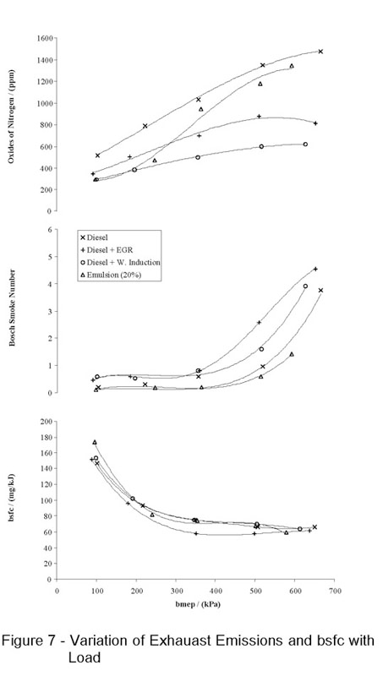
Figure 22-EGR vs Water Injection on NOx Reduction (Nazha, M, Rajakaruna, H & Wagstaff, S, 2001)

Figure 22 shows how effective EGR and water injection systems are on NOx reduction, it shows that both water injection and EGR are good with reducing NOx emissions. However, water induction is slightly more effective than EGR throughout the BMEP range, this can especially be seen at 400-700 BMEP range, this is because as the fuel requirement increases the water injection amounts increase and the ratio of water to fuel is more accurate and therefore effective, whereas the EGR inputs are not as accurate (Shah, S., Maiboom, A., Tauzia, X., and Hétet, J, SAE Technical Paper, 2009).
Considering the results shown in figure 22 water injection and EGR techniques show very similarly trends in reducing NOx emissions, even though water injection is slightly more effective, EGR is the technique most commonly adopted on everyday cars.
Reaching another source written by Hountalas, D., Mavropoulos, G., and Zannis, T it shows that EGR operation is slightly more effective than water injection, which is opposite to what was seen in figure 22, however, the test carried out by Hountalas was at a different application. Therefore, now we can see the two systems outperforming each other when used at different applications, this just shows their effectiveness. Figure 23 below shows the results of the mentioned above testing:
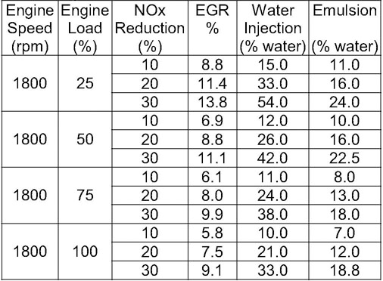
Figure 23-EGR vs Water Injection on NOx Reduction (Hountalas, 2007)

Figure 23 shows the values of water injection percentage relative to fuel and EGR required to reduce the formation of NOx, by 10%, 20% and 30%. Showing results in such format allows for a direct comparison of water injection and EGR addition (Hountalas, D., Mavropoulos, G., and Zannis, SAE Paper, 2001). From these sets of results, the required EGR % is lower than the required water injection % to reach the same NOx reduction. For example, to achieve a 30% NOx reduction at 50% load, 11.1% EGR is required compared to 42.0% water injection.
EGR is the technology that’s mostly adopted in today’s vehicles to help NOx reduction. In the authors opinion the reason for this is since today’s society lives in a fast-paced environment and does not have time to maintain the water injection system, on the other hand once an EGR valve is fitted it does not require maintenance and is therefore more ‘user friendly’. A water injection system would require maintenance such as filling up the water tank and this would have to be done more often than filling up the petrol tank due to the water tank being smaller, this could potentially result in vehicle owners forgetting to fill up the tank and risk the system running dry, thus damaging the systems components. As mentioned above the water injection system is complex and therefore costs much more compared to an EGR valve which is cheaper and which shows similar reduction benefits.
Water injections systems have been around for decades, although initially it was only used in military vehicles and aircrafts. The automotive society and its customers are afraid of water in combustion engines due to many stories regarding hydro lock. However, vehicle users should not be worried, water injected at small and accurate amounts does no harm to the engine, it will only result in more power especially at high end, improve the longevity of components by operating at lower pressures due to lower combustion temperatures and it will lower emissions levels, especially NOx, which has been proved by the results.
Todays advanced petrol engines waste roughly a fifth of the supplied fuel, this can be seen especially at high engine speeds, and this is because some of the petrol is used for cooling instead of powering the engine. Bosch has engineered a precise water injection system and shows that particular at harsh acceleration the injection of water makes it possible to reduce the fuel consumption by nearly 13%. As stated by Dr. Rolf Bulander, “the water injection system offered by Bosch shows that the combustion engine still has some tricks up its sleeve”. Refer to figure 36 of appendices.

13. Conclusion

To conclude the dissertation, the aims which were specified within the introduction section of this report have been successfully met. The first project aim was to evaluate the effectiveness of a water injection system at reducing combustion temperatures resulting in lowered level of NOx emissions. From the analytical calculations done in section 10.2 of this report the equations regarding the drop-in combustion temperature show the following results:
Table 10-Temperature Drops with Water Injection (M. Dabrosz, 2018)
Test | Combustion Temperature Drop (K)
51.4 km/h | 68
74.7 km/h | 134
85.2 km/h | 196
123.1 km/h | 251.39

As we can see from table 10 the first part of the first aim to show the effectiveness of water injection at reducing combustion temperatures has been met. Also, as shows in the result graphs presented under section 11 of this report, the NOx emissions have been lowered by significant amounts, these results have also been replicated by other academics including Mr Tefsa, therefore can be deemed as accurate. To give the reader a more detailed understanding of the NOx reduction values, percentages of each change have been calculated. The lowest and highest NOx reduction values which were seen during the testing were 22.52% and 76% respectively. Thus, these statistics and results show the first aim has been fully met.
The second aim set out for this investigation was to use analytical calculations together with a controlled live testing simulation within a workshop environment to validate the overall findings. It can be said with confidence that both parts to the second aim have been met. Equations in section 10.1 were equations completed to aid carrying out the live testing simulations, these were done to make sure the live testing simulation can be as accurate as possible and to show truthful results. The equations in section 10.2 were carried out after the live testing simulations, these equations help to define the accuracy of the live testing simulation. For example, they showed that if the water which was injected actually reached the combustion chamber the results would be far more superior and would show much greater NOx reduction factors. However, without these equations it would be impossible to distinguish the differences and realise that actually there were some anomalies in the testing, therefore giving room for improvement for future investigations.
Overall, this was a successful investigation which could potentially open many eyes onto different emission reduction technologies, such as the water injection system. The automotive manufactures must engineer new more effective systems to save people’s lives and the environment which we live in.

13.1 Future Recommendations
If a similar investigation was to be completed in the future the following changes would be made:
- Thermocouples in exhaust
The reason why thermocouples have been chosen as one system which could be added is due to its accurate temperature measuring capabilities. Without this system the temperature drops could only be predicted by analytical calculations. However, with a thermocouple system it would be possible to measure the exhaust gases temperature and provide an important input into systems to improve the efficiency, reduce emissions and extend the engine life (Peak Sensors, 2018). A potential thermocouple design can be seen in figure 37 of the appendices. This system would prove much more accurate temperature drops which would prove the effectiveness of water injection much more.
- More accurate water injection delivery system
A critical factor which caused validation issues and should be an improvement for the future was the fact that not all the water was entering the combustion chamber due to the locations from which it was delivered. As the water was injected pre- air intake butterfly the diameter of the component was big enough to let all the water flow past the initial phase, however, as observed during the testing just after the intake butterfly there is a much smaller diameter intake tube through which the air is sucked in. As observed some of the water was not sucked into the air intake and remained around the smaller intake tube even though it went past the initial butterfly. Therefore, the water which was injected into the combustion chamber might not have been the same amount which was sprayed into the inlet. This factor will significantly affect the results as the exact amount of injected water is unknown. This is the reason why at higher RPM’s the NOx reduction factor is greater due to the larger opening of the butterfly allowing for a greater amount of water to be sucked in by the intake tube.
This problem could be fixed by engineering a different, more accurate delivery system to make sure that all of the water which is injected is reaching the desired destination combustion chamber. At the beginning of the project the initial idea was to engineer a whole injection system with an injector positioned within the intake manifold, this delivery method would ensure all of the injected water is sprayed directly into the chamber. The system which was initially being designed as a method of water delivery included these component: 5v battery, 3 BAR water pump, 5L water tank, signal generator and a pulse width modulator. There was already testing carried out to determine the safe water injection pressure to give most accuracy. Figures 26 of the appendices shows the injector testing. This testing was also used to determine the most effective spray pattern considering the diameter of the intake manifold to make sure no one of the water was wasted. However, due to the limitations in resources, lack of budget and complexity of the system for the project this method had to be condemned, and a more cost-effective method of using a hand trigger atomiser was selected. Figure 38 of the appendices shows the injector positioning for future investigations.

14. References

- SMMT. (2018). UK Car Emissions Testing - SMMT. [online] Available at: https://www.smmt.co.uk/industry-topics/emissions/testing/ [Accessed 2 Mar. 2018].
- Fasching, P., Sprenger, F., and Eichlseder, H., "Experimental Optimization of a Small Bore Natural Gas-Diesel Dual Fuel Engine with Direct Fuel Injection," SAE Int. J. Engines 9(2):1072-1086, 2016, https://doi-org.ezproxy.uwtsd.ac.uk/10.4271/2016-01-0783.
- Vehicle Emissions Testing Programme. (2018). [PDF] London: William Lea Group. Available at:https://www.gov.uk/government/uploads/system/uploads/attachment_data/file/552439/vehicle-emissions-testing-programme-print.pdf [Accessed 2 Mar. 2018].
- Office, J. (2017). Study: Volkswagen’s excess emissions will lead to 1,200 premature deaths in Europe. [online] MIT News. Available at: http://news.mit.edu/2017/volkswagen-emissions-premature-deaths-europe-0303 [Accessed 2 Mar. 2018].
- KIM, J., PARK, H., BAE, C., CHOI, M. and KWAK, Y., 2016. Effects of water direct injection on the torque enhancement and fuel consumption reduction of a gasoline engine under high-load conditions. International Journal of Engine Research, 17(7), pp. 795.
- “Performance of Gasoline-Water Fuel in a Modified SI Engine. Tsao, K. C. and Wang, C. L. 1984. SAE Paper 841399”.
- “Energy Matters. (2017). Mortality from Diesel Car Pollution in the UK. [online] Available at: http://euanmearns.com/mortality-from-diesel-car-pollution-in-the-uk/ [Accessed 2 Mar. 2018]”
- Dft.gov.uk. (2018). Cars and air pollution. [online] Available at: http://www.dft.gov.uk/vca/fcb/cars-and-air-pollution.asp [Accessed 2 Mar. 2018].
- Parkers.co.uk. (2018). Euro 6 emissions regulations – the facts | Parkers. [online] Available at: https://www.parkers.co.uk/what-is/what-is-euro6-emissions-standards/ [Accessed 2 Mar. 2018].
- Reif, K. and Dietsche, K. (2014). Automotive handbook. Karlsruhe: Robert Bosch GmbH.
- Maurer, M., Holler, P., Zarl, S., Fortner, T. et al., "Investigations of Lean NOx Trap (LNT) Regeneration Strategies for Diesel Engines," SAE Technical Paper 2017-24-0124, 2017.
- Fleetnews.co.uk. (2018). NOx emissions from Euro 6 diesel cars more than double modern diesel trucks, according to new study. [online] Available at: https://www.fleetnews.co.uk/news/fleet-industry-news/2017/01/09/nox-emissions-from-euro-6-diesel-cars-more-than-double-modern-diesel-trucks-according-to-new-study [Accessed 2 Mar. 2018].
- Transportpolicy.net. (2017). International: Light-duty: Worldwide Harmonized Light Vehicles Test Procedure (WLTP) | Transport Policy. [online] Available at: http://www.transportpolicy.net/standard/international-light-duty-worldwide-harmonized-light-vehicles-test-procedure-wltp/ [Accessed 2 Mar. 2018].
- Mercedes-Benz.com. (2017). What are NEDC and WLTP? And how do they differ? [online] Available at: https://www.mercedes-benz.com/en/mercedes-benz/vehicles/wltp/wltp-vs-nedc/ [Accessed 2 Mar. 2018].
- House of Commons Transport Committee (2017). Volkswagen emissions scandal and vehicle type approval. Third Report of Session 2016–17. London: House of Commons, pp.5-10.
- Icopal-noxite.co.uk. (2018). Nitrogen Oxide (NOx) Pollution - Health Issues - Icopal. [online] Available at: http://www.icopal-noxite.co.uk/nox-problem/nox-pollution.aspx [Accessed 5 Mar. 2018].
- Graham, J., Claxton, L., O'Neil, J., Otto, D. et al., "Automobile Emissions: Primary Health Effects Concerns," SAE Technical Paper 840908, 1984, https://doi-org.ezproxy.uwtsd.ac.uk/10.4271/840908.
- In fulfilment of Part IV of the Environment Act 1995 Local Air Quality Management. (2016). [ebook] Essex: Epping Forest District Council. Available at: http://www.essexair.org.uk/Reports/Epping%20Forest_DC_Air_Quality_Annual_Status_Report_2016.pdf [Accessed 5 Mar. 2018].
- Chemistry.wustl.edu. (2018). Acid Rain. [online] Available at: http://www.chemistry.wustl.edu/~edudev/LabTutorials/Water/FreshWater/acidrain.html [Accessed 5 Mar. 2018].
- Nitrogen Oxides (NOx), Why and How They Are Controlled. (1999). [ebook] North Carolina: Clean Air Technology Centre. Available at: https://www3.epa.gov/ttncatc1/dir1/fnoxdoc.pdf [Accessed 5 Mar. 2018].
- Zeldovich, Y. A., D. Frank-Kamenetskii, and P. Sadovnikov. Oxidation of nitrogen in combustion. Publishing House of the Acad of Sciences of USSR, 1947.
- Spindt, R., Wolfe, C., and Stevens, D., "Nitrogen Oxides, Combustion, and Engine Deposits," SAE Technical Paper 560068, 1956, https://doi-org.ezproxy.uwtsd.ac.uk/10.4271/560068.
- Tftei.citepa.org. (2018). Reduction of NOx emissions - TFTEI. [online] Available at: http://tftei.citepa.org/en/industrial-sources/reduction-of-nox-emissions#formation-process-in-combustion [Accessed 5 Mar. 2018].
- Dieselnet.com. (2018). Emission Standards: Europe: Nonroad Engines. [online] Available at: https://www.dieselnet.com/standards/eu/nonroad.php#s3 [Accessed 5 Mar. 2018].
- Bhargava, S., Clark, N., and Hildebrand, M., "Exhaust Gas Recirculation in a Lean-Burn Natural Gas Engine," SAE Technical Paper 981395, 1998, https://doi-org.ezproxy.uwtsd.ac.uk/10.4271/981395.
- Yang, Z., Winward, E., O'Brien, G., Stobart, R. et al., "Modelling the Exhaust Gas Recirculation Mass Flow Rate in Modern Diesel Engines," SAE Technical Paper 2016-01-0550, 2016, https://doi-org.ezproxy.uwtsd.ac.uk/10.4271/2016-01-0550.
- Figura, J., Kihas, D., Pekar, J., Uchanski, M. et al., "Automotive Selective Catalytic Reduction System Model-Based Estimators for On-ECU Implementation: A Brief Overview," SAE Technical Paper 2016-01-0972, 2016, https://doi-org.ezproxy.uwtsd.ac.uk/10.4271/2016-01-0972.
- Vallur, A., Khairate, Y., and Awate, C., "Prescriptive Modeling, Simulation and Performance Analysis of Mild Hybrid Vehicle and Component Optimization," SAE Technical Paper 2015-26-0010, 2015, https://doi-org.ezproxy.uwtsd.ac.uk/10.4271/2015-26-0010.
- GmbH, S.D. (2007) Bosch automotive handbook (Bosch handbooks (REP)). Edited by Robert Bosch GmbH. 7th edn. Chichester, United Kingdom: Wiley-Blackwell (an imprint of John Wiley & Sons Ltd).
- Cybulski, A. (2005). Structured catalysts and reactors. Boca Raton, FL: Taylor & Francis.
- Bassett, M., Vogler, C., Hall, J., Taylor, J. et al., "Analysis of the Hardware Requirements for a Heavily Downsized Gasoline Engine Capable of Whole Map Lambda 1 Operation," SAE Technical Paper 2018-01-0975, 2018.
- Reuters. (2017). Exclusive: Carmakers forced back to bigger engines in new emissions era. [online] Available at: https://www.reuters.com/article/us-autoshow-paris-engines-exclusive/exclusive-carmakers-forced-back-to-bigger-engines-in-new-emissions-era-idUSKBN12E11K [Accessed 08/03/2018].
- Hybrid Cars: Tougher European Emissions Tests Forcing Automakers to Reverse Course on Downsized Engines. 2016. Chatham: Newstex.
- Mahmoudi, A., Khazaee, I. and Ghazikhani, M. (2018). Simulating the effects of turbocharging on the emission levels of a gasoline engine.
- EL_Kassaby, M. and Nemit_allah, M. (2013). Studying the effect of compression ratio on an engine fueled with waste oil produced biodiesel/diesel fuel. Alexandria Engineering Journal, 52(1), pp.1-11.
- Fu, L., Wu, Z., Li, L., and Yu, X., "Effect of Water Injection Temperature on Characteristics of Combustion and Emissions for Internal Combustion Rankine Cycle Engine," SAE Technical Paper 2014-01-2600, 2014, https://doi-org.ezproxy.uwtsd.ac.uk/10.4271/2014-01-2600.
- Littleshop.physics.colostate.edu. (2018). How are temperature and pressure related. [online] Available at: http://littleshop.physics.colostate.edu/activities/atmos2/TempPressureRelated.pdf [Accessed 8 Mar. 2018].
- Merker, G., Schwarz, C. and Stiesch, G. (2006). Simulating combustion. Heidelberg: Springer.
- Spalding, D. and Cole, E. (1961). Engineering thermodynamics. London: Arnold.
- Water-Gasoline Fuels - Their Effect on Spark Igntion Engine Emissions and Performance. Peters, Bruce D. and Stebar, Russel F. 1976. Trans. SAE 760547
- Inlet Manifold Water Injection for Control of Nitrogen Oxides - Theory and Experiment. Nicholls, J. E., El-Messiri, I. A. and Newhall, H. K. 1969. SAE Paper 690018.
- Water Addition to Gasoline - Effect on Combustion, Emissions, Performance and Knock. Harrington, J. A. 1982. SAE Paper 820314.
- Lestz S.S., Meyer W.E. and Colony C.M.; “Emissions from a Direct-Cylinder Water-Injected Spark-Ignition Engine ”; SAE Paper No. 720113, Presented at Automotive Engineering Congress, Detroit, Jan. 1972
- Nazha, M., Rajakaruna, H., and Wagstaff, S., "The Use of Emulsion, Water Induction and EGR for Controlling Diesel Engine Emissions," SAE Technical Paper 2001-01-1941, 2001, https://doi-org.ezproxy.uwtsd.ac.uk/10.4271/2001-01-1941.
- Shah, S., Maiboom, A., Tauzia, X., and Hétet, J., "Experimental Study of Inlet Manifold Water Injection on a Common Rail HSDI Automobile Diesel Engine, Compared to EGR with Respect to PM and Nox Emissions and Specific Consumption," SAE Technical Paper 2009-01-1439, 2009, https://doi-org.ezproxy.uwtsd.ac.uk/10.4271/2009-01-1439.
- Hountalas, D., Mavropoulos, G., and Zannis, T., "Comparative Evaluation of EGR, Intake Water Injection and Fuel/Water Emulsion as NOx Reduction Techniques for Heavy Duty Diesel Engines," SAE Technical Paper 2007-01-0120, 2007, https://doi-org.ezproxy.uwtsd.ac.uk/10.4271/2007-01-0120.
- G Marion (2008). [online] Available at: https://people.maths.bris.ac.uk/~madjl/course_text.pdf [Accessed 3 Apr. 2018].
- Haywood R. W. (1992). Equilibrium thermodynamics. [Place of publication not identified]: Krieger Publishing Company.
- Miles, M., Huberman, A. and Saldaña, J. (n.d.). Qualitative data analysis.
- MDA. (2018). Importance of commercial skills awareness | MDA Training. [online] Available at: https://mdatraining.com/blog/2017/07/18/important-commercial-awareness-commercial-skills-training/ [Accessed 3 Apr. 2018].
- Andersson, U. (1999). Humanware. Victoria, B.C.: Trafford.
- McCulloch, L. (2017). The importance of data validation - deltadna.com. [Online] deltadna.com. Available at: https://deltadna.com/blog/importance-data-validation/ [Accessed 11 Nov. 2017].
- Jerseycash4cars.com. (2018). The Dangers of Letting Your Car Sit Unused | Jersey Cash For Cars. [online] Available at: http://www.jerseycash4cars.com/cash-4-cars-info/the-dangers-of-letting-your-car-sit-unused/ [Accessed 3 Apr. 2018].
- Rob King (2018). Car Exhaust Guide and Common Problems. [online] Available at: https://www.micksgarage.com/blog/exhaust-system-guide-common-problems/ [Accessed 3 Apr. 2018].
- Whelan, I., Samuel, S., and Hassaneen, A., "Investigation into the Role of Catalytic Converters on Tailpipe-out Nano-Scale Particulate Matter from Gasoline Direct Injection Engine," SAE Technical Paper 2010-01-1572, 2010, https://doi-org.ezproxy.uwtsd.ac.uk/10.4271/2010-01-1572.
- Gilles-Birth, I., Bernhardt, S., Spicher, U., and Rechs, M., "A Study of the In-Nozzle Flow Characteristic of Valve Covered Orifice Nozzles for Gasoline Direct Injection," SAE Technical Paper 2005-01-3684, 2005, https://doi-org.ezproxy.uwtsd.ac.uk/10.4271/2005-01-3684.
- Addepalli, S., Saw, O., and Mallikarjuna, J., "Effect of Mixture Distribution on Combustion and Emission Characteristics in a GDI Engine - A CFD Analysis," SAE Technical Paper 2017-24-0036, 2017, https://doi-org.ezproxy.uwtsd.ac.uk/10.4271/2017-24-0036.
- Www3.epa.gov. (2018). [online] Available at: https://www3.epa.gov/ttnchie1/mkb/documents/B_17a.pdf [Accessed 16 Apr. 2018].
- Adelaide.edu.au. (2018). ppm. [online] Available at: https://www.adelaide.edu.au/arcpoh/dperu/fluoride/ppm.html [Accessed 16 Apr. 2018].
- Water injection for gasoline engines: Potentials, challenges, and solutions. (2015). International Journal of Engine Research, 17(1), pp.86-96.
- Assets.publishing.service.gov.uk. (2017). In Service Exhaust Emission Standards for Road Vehicles. [online] Available at: https://assets.publishing.service.gov.uk/government/uploads/system/uploads/attachment_data/file/676700/in-service-exhaust-emission-standards-for-road-vehicles-19th-edition.pdf [Accessed 16 Apr. 2018].
- Nrcan.gc.ca. (2018). Fuel consumption and CO2. [online] Available at: http://www.nrcan.gc.ca/sites/www.nrcan.gc.ca/files/oee/pdf/transportation/fuel-efficient-technologies/autosmart_factsheet_6_e.pdf [Accessed 16 Apr. 2018].
- Mark Salem (2000). Emission testing, emission failures and repairs. [online] Available at: http://www.salemboysauto.com/faqs/faq-20.htm [Accessed 17 Apr. 2018].
- P.P.Patnaik. S.K.Acharya. D.PadhiU. K.Mohanty, (2016) Experimental investigation on CI engine performance using steam injection and ferric chloride as catalyst. (PDF). Available at: https://www.sciencedirect.com/science/article/pii/S2215098616303408#bb0080 [Accessed 17 Apr. 2018].
- Nepis.epa.gov. (2018). Document Display | NEPIS | US EPA. [online] Available at: https://nepis.epa.gov/Exe/ZyNET.exe/9100X5ZN.txt?ZyActionD=ZyDocument&Client=EPA&Index=Prior%20to%201976&Docs [Accessed 17 Apr. 2018].
- Sriwardani, N. (2016). Improving engine performance with distillated water-methanol. [online] AIP Conference Proceedings. Available at: https://aip.scitation.org/doi/pdf/10.1063/1.4965737 [Accessed 17 Apr. 2018].

- Frank, R. and Heywood, J., "The Effect of Piston Temperature on Hydrocarbon Emissions from a Spark-Ignited Direct-Injection Engine," SAE Technical Paper 910558, 1991, https://doi-org.ezproxy.uwtsd.ac.uk/10.4271/910558.
- Gruden, D., "Technical Measures To Reduce Carbon Dioxide Emissions On The Road Traffic," SAE Technical Paper 2006-01-3005, 2006, https://doi-org.ezproxy.uwtsd.ac.uk/10.4271/2006-01-3005.
- Crypton.co.za. (2018). Understanding Engine Exhaust Emissions. [online] Available at: http://www.crypton.co.za/Tto%20know/Emissions/exhaust%20emissions.html [Accessed 19 Apr. 2018].
- Sciencedirect.com. (2018). Experimental study of inlet manifold water injection on combustion and emissions of an automotive direct injection Diesel engine. [online] Available at: https://www.sciencedirect.com/science/article/pii/S0360544210002707 [Accessed 19 Apr. 2018].
- Peak Sensors. (2018). Exhaust Thermocouple Manufacture - Peak Sensors. [online] Available at: https://www.peaksensors.co.uk/blog/exhaust-thermocouple/ [Accessed 19 Apr. 2018].

15. Bibliography

- Graves, H. and Graves, R. (2006). Writing centres, writing dissertations, writing culture. Winnipeg: Inkshed Pub.
- Somervill, B. (2009). Writing reports. Harlow, Essex [England]: Heinemann Library.
- Budinski, K. (2001). Engineers' guide to technical writing. Materials Park, OH: ASM International.
- Fred, A. (n.d.). Knowledge discovery, knowledge engineering and knowledge management.
- Noto, T., Murayama, T., Tosaka, S., and Fujiwara, Y., "Mechanism of NOx Reduction by Ethanol on a Silver-Base Catalyst," SAE Technical Paper 2001-01-1935, 2001.
- Lee, R., "SI Engine Combustion Chamber Deposits and Their Effects upon Emissions," SAE Technical Paper 1999-01-3583, 1999.
- Duret, P. and Moreau, J., "Reduction of Pollutant Emissions of the IAPAC Two-Stroke Engine with Compressed Air Assisted Fuel Injection," SAE Technical Paper 900801, 1990.
- Merkisz, J., Pielecha, J., Bielaczyc, P., and Woodburn, J., "Analysis of Emission Factors in RDE Tests as well as in NEDC and WLTC Chassis Dynamometer Tests," SAE Technical Paper 2016-01-0980, 2016.
- Schoenhaber, J., Kuehn, N., Bradler, B., Richter, J. et al., "Impact of European Real-Driving-Emissions Legislation on Exhaust Gas Aftertreatment Systems of Turbocharged Direct Injected Gasoline Vehicles," SAE Technical Paper 2017-01-0924, 2017.
- Pavlovic, J., Tansini, A., Fontaras, G., Ciuffo, B. et al., "The Impact of WLTP on the Official Fuel Consumption and Electric Range of Plug-in Hybrid Electric Vehicles in Europe," SAE Technical Paper 2017-24-0133, 2017.
- Anonymous 2015, Sep 21. Executive Analysis for European Emission Standards and Testing Procedures 2015-2020. M2 Presswire.
- BRYANT, C. and FOY, H., 2014, Apr 22. Carmakers put foot down over emission limits. Financial Times, 16. ISSN 03071766.
- Rohit, A., Satpathy, S., Choi, J., Hoard, J. et al., "Literature Survey of Water Injection Benefits on Boosted Spark Ignited Engines," SAE Technical Paper 2017-01-0658, 2017.
- Department for Transport (2016) Vehicle emissions testing Programme presented to parliament by the secretary of state for transport by command of her majesty. Available at: https://www.gov.uk/government/uploads/system/uploads/attachment_data/file/552439/vehicle-emissions-testing-programme-print.pdf (Accessed: 1 March 2018).
- EPA, U. and OTAQ (2016) Final rule for control of air pollution from motor vehicles: Tier 3 motor vehicle emission and fuel standards. Available at: https://www.epa.gov/regulations-emissions-vehicles-and-engines/final-rule-control-air-pollution-motor-vehicles-tier-3 (Accessed: 1 March 2018).
- Gov.uk. (2017). Government publishes findings of diesel emissions testing programme - GOV.UK. [online] Available at: https://www.gov.uk/government/news/government-publishes-findings-of-diesel-emissions-testing-programme [Accessed 1 Mar. 2018].
- Le Treut, H., R. Somerville, U. Cubasch, Y. Ding, C. Mauritzen, A. Mokssit, T. Peterson and M. Prather. Historical Overview of Climate Change. In: Climate Change 2007: The Physical Science Basis. Contribution of Working Group I to the Fourth Assessment Report of the Intergovernmental Panel on Climate Change. Cambridge University Press, Cambridge, United Kingdom and New York, NY, USA, 2007.
- International Energy Agency. CO2 Emissions from Fuel Combustion 2012. Paris: Organisation for Economic Co-operation and Development, 2012.
- Department for Transport, (2017). Renewable Transport Fuel Obligation statistics: period 9 2016/17, report 2. [online] Gov.uk. Available at: http://Renewable Transport Fuel Obligation statistics: period 9 2016/17, report 2 [Accessed 4 March 2018].
- Department for Transport (2016) Vehicle emissions testing Programme - data. Available at: https://www.gov.uk/government/uploads/system/uploads/attachment_data/file/534716/vehicle-emissions-testing-programme-data-report-final-report.pdf (Accessed: 4 March 2018).
- (No Date) Available at: http://ec.europa.eu/environment/archives/greenweek2013/sites/default/files/content/presentations/5-4_walsh.pdf (Accessed: 4 March 2018).
- (2012) Available at: http://eur-lex.europa.eu/legal-content/EN/TXT/PDF/?uri=CELEX:52012PC0393&from=EN (Accessed: 4 March 2018).
- Publications Office (2014) Uri=CELEX: 02009R0443 20140408&from=EN. Available at: http://eur-lex.europa.eu/legal-content/EN/TXT/PDF/?uri=CELEX:02009R0443-20140408&from=EN (Accessed: 5 March 2018).
- Hoppe, F., Thewes, M., Seibel, J., Balazs, A. et al., "Evaluation of the Potential of Water Injection for Gasoline Engines," SAE Int. J. Engines 10(5):2500-2512, 2017.
- Ahern, B., Djutrisno, I., Donahue, K., Haldeman, C. et al., "Dramatic Emissions Reductions with a Direct Injection Diesel Engine Burning Supercritical Fuel/Water Mixtures," SAE Technical Paper 2001-01-3526, 2001, https://doi-org.ezproxy.uwtsd.ac.uk/10.4271/2001-01-3526.

16. Appendices

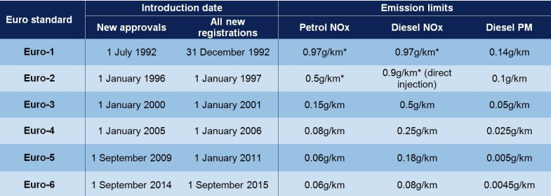
Table 11-Euro Standards for Cars (SMMT, 2018)

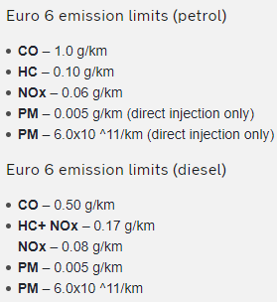
Figure 24-Euro 6 Emission Standards (AA, 2018)

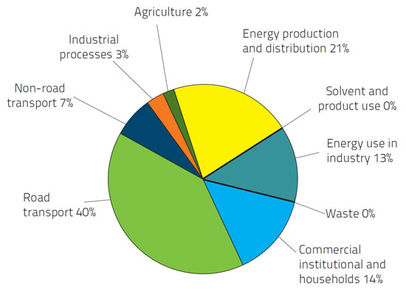
Figure 25-Nitrogen Oxide Sources (ico-pal.co.uk)

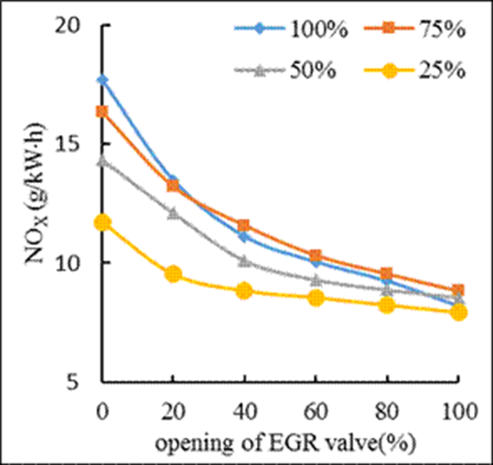
Figure 26-EGR Valve on NOx Emissions (http://article.sciencepublishinggroup.com/journal/164/1641091/image030.gif)

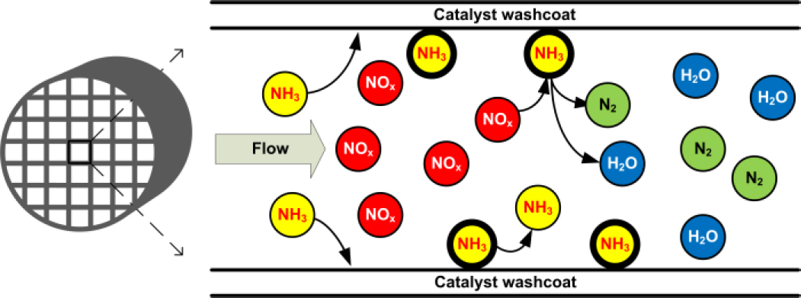
Figure 27-SCR Operating Principles (https://saemobilus-sae-org.ezproxy.uwtsd.ac.uk/htmlimage/1000368433/2016-01-0972_fig0002.jpg)

Figure 28-Emissions Advantage of an IMA System (CalCars.org)
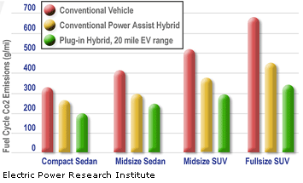

Figure 29-SAI System Reducing NOx (http://ars.els-cdn.com/content/image/1-s2.0-S0016236108004808-gr7.jpg)
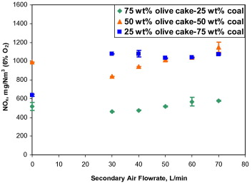

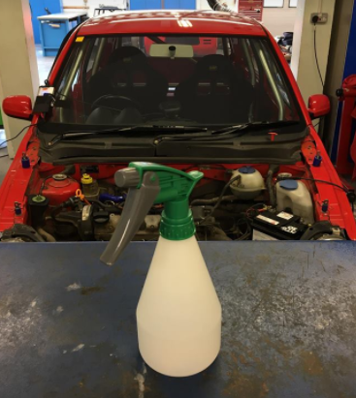
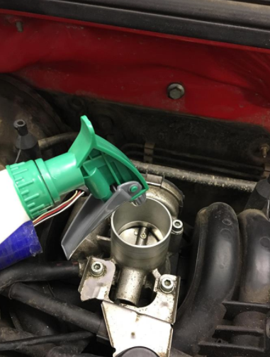
Figure 30-Triger Atomiser (M. Dabrosz, 2018)

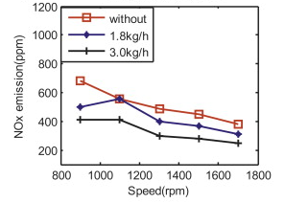
Figure 31-Water Injection Effectiveness on NOx Reduction (Tesfa, 2018)

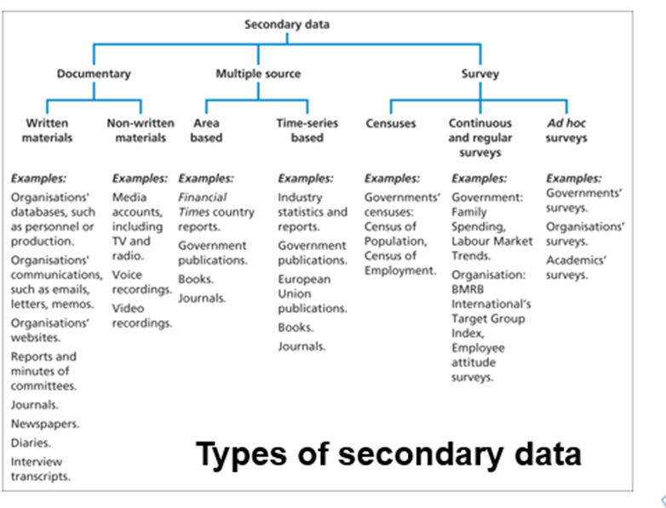
Figure 32-Types of Secondary Data (UWTSD Slides, 2017)

Figure 33-Secondary Data Source Evaluation (Saunders, 2009)


Figure 34-Injector Testing (M. Dabrosz, 2017)
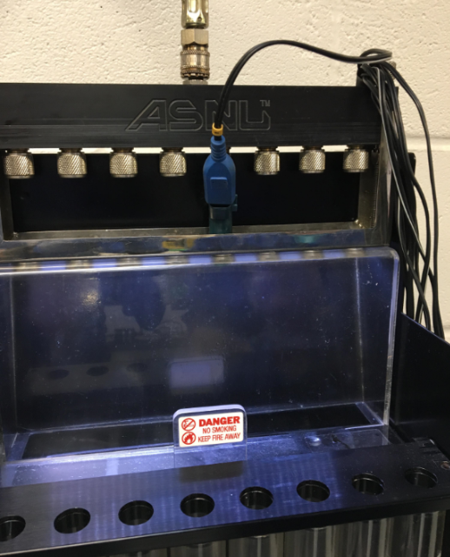
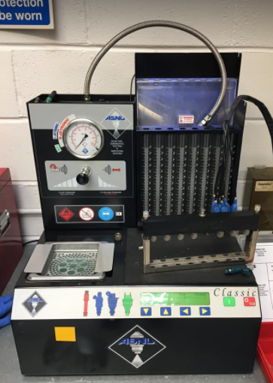

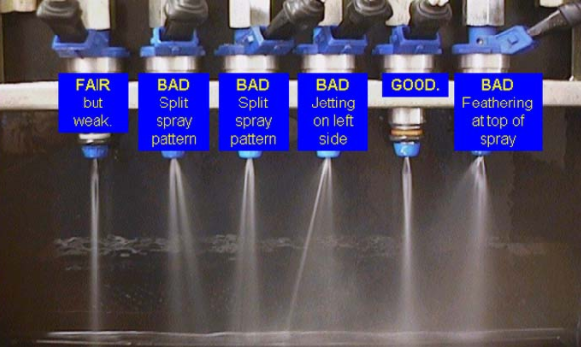
Figure 35-Injector Pattern Selection (TheBoostLab.com)

Table 12-First Test Session Full NOx Results (M. Dabrosz, 2018)
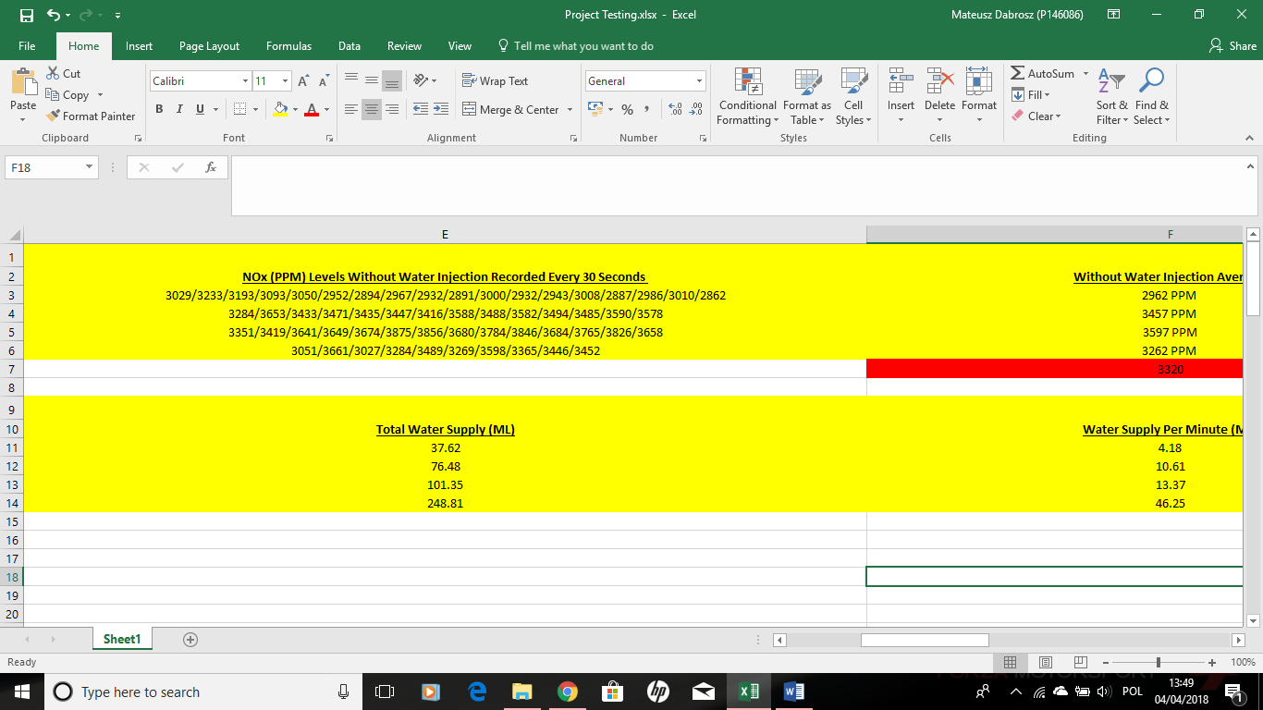
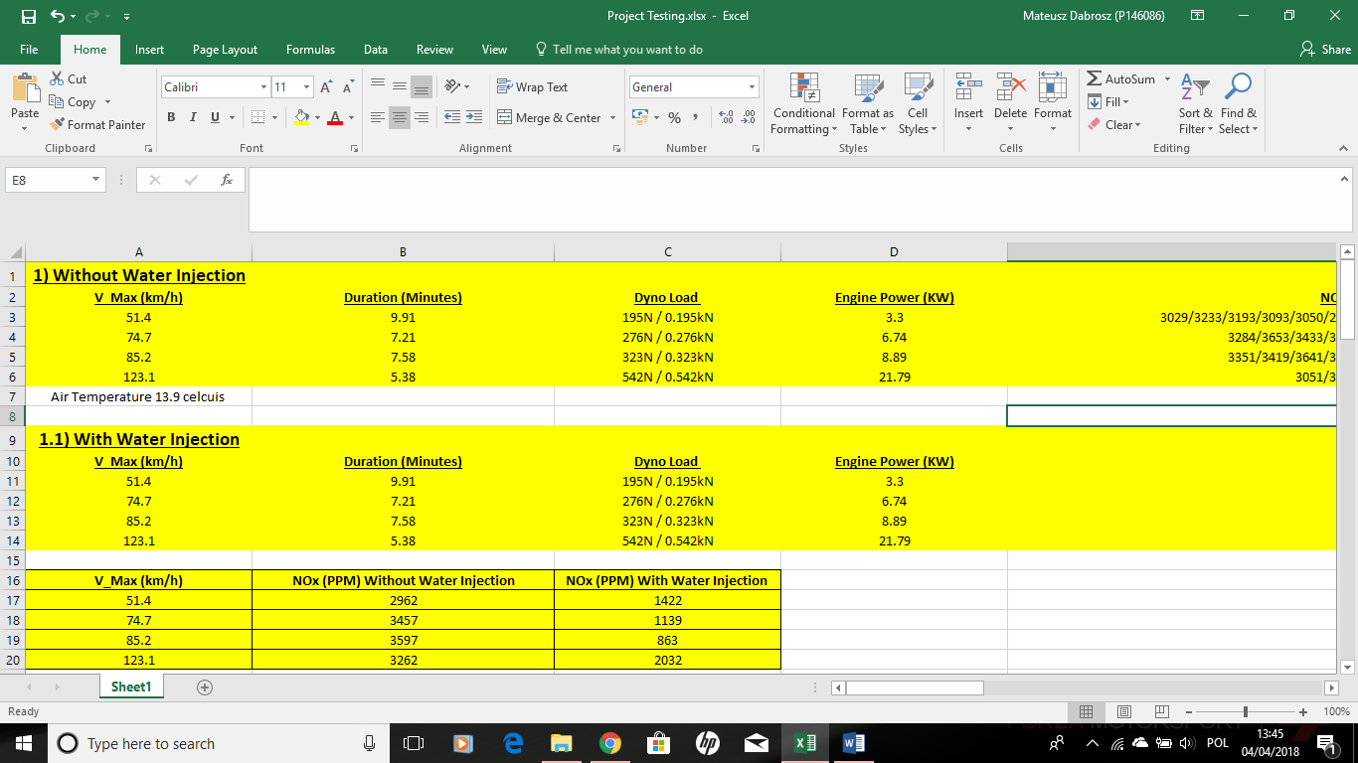
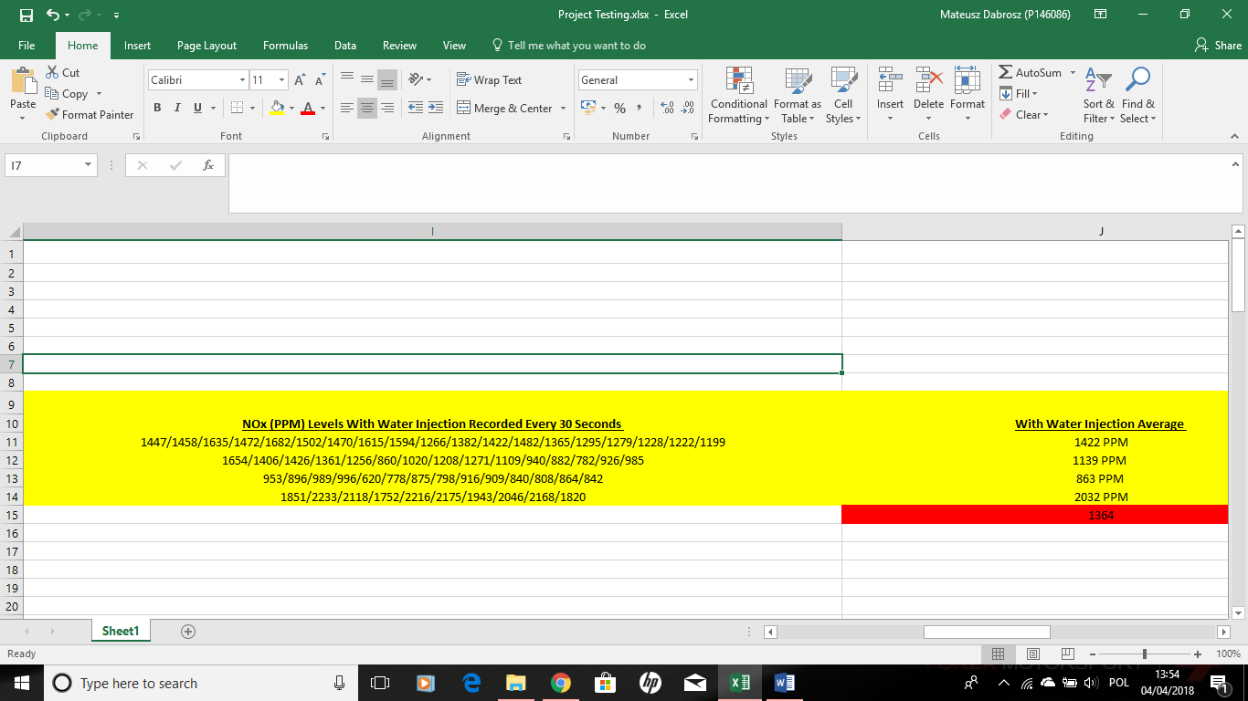
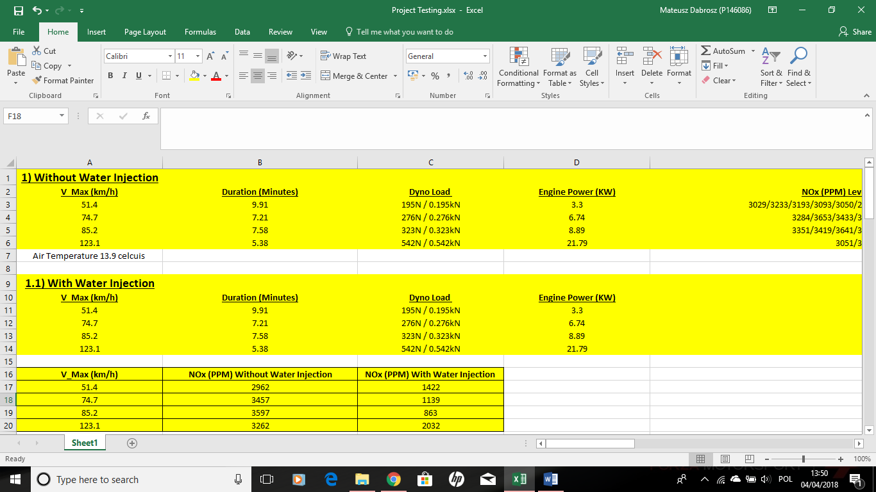

Table 13-Second Test Session Full NOx Results (M. Dabrosz, 2018)
NOx Levels (PPM) Recorded Every 30 Seconds
3208/2959/3014/3315/3308/3236/3289/3359/3516/3442/3499/3594/3486/3234/3364/3389/3465/2909
2788/2667/2580/2679/2503/2520/2589/2461/2499/2689/2710/2560/2942/2896
2372/2405/2339/2356/2250/2084/2184/2248/2180/2053/2155/2201/2180/2199
3613/2561/2871/2842/2994/2876/2815/2813/2574/2682


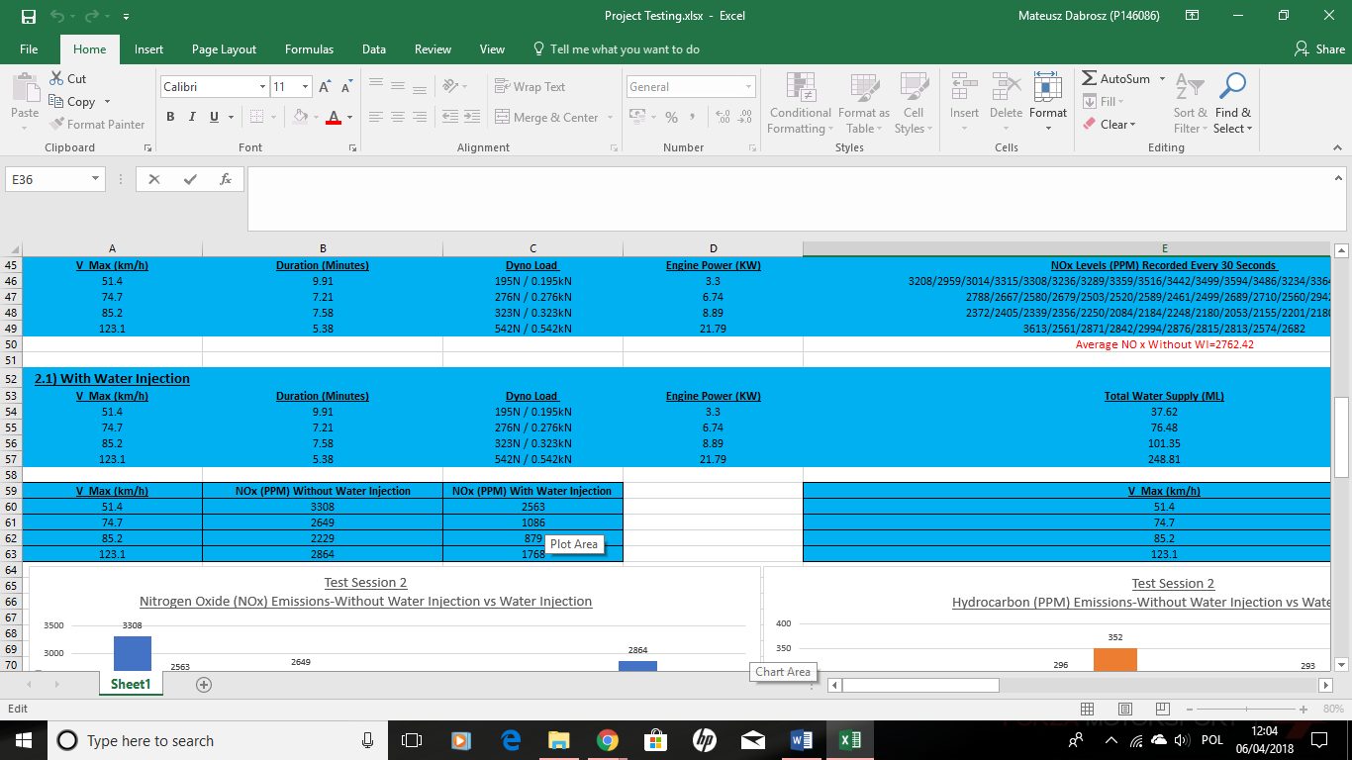
NOx Levels (PPM) Recorded Every 30 Seconds
3345/3290/3265/3175/3129/2938/2820/2447/2166/2359/2118/2220/2129/2166/2176/2016/2199/2164
1745/1241/1005/1106/1054/1036/1058/1007/1080/1006/874/880/1009/1101
1095/963/623/665/822/795/801/872/898/1114/850/836/805/1174
1569/2080/2100/2220/1555/1511/1696/1552/1339/2065

Table 14-Second Test Session Full HC Results (M. Dabrosz, 2018)

Hydrocarbon (HC) (PPM)
288/270/272/275/275/279/275/277/289/280/280/279/285/264/282/263/272/274
233/240/211/261/332/333/334/338/310/303/319/309/301/312
212/298/274/270/260/254/251/290/263/258/275/286/292/301
184/159/181/170/164/164/159/161/146/156


Hydrocarbon (HC) (PPM)
262/266/245/264/261/266/271/274/275/276/278/270/276/282/280/274/276/273
356/292/350/361/346/359/349/352/373/376/358/356/351/356
238/233/217/299/305/315/320/330/305/306/305/303/317/315
168/157/156/172/169/168/161/150/153/170

Table 15-Second Test Session Full CO2 Results (M. Dabrosz, 2018)
Carbon Dioxide (CO2)
13.97/14.07/14.07/14.06/14.15/14.13/14.12/13.89/14.09/14.09/14.12/14.02/14.16/14.11/14.16/14.14/14.06
14.20/14.01/14.08/13.88/13.46/13.52/13.42/13.41/13.59/13.49/13.57/13.48/13.36/13.40
12.64/12.12/12.61/12.88/13.07/12.88/13.01/12.82/13.14/13.44/13.14/13.21/13.19/13.04
13.16/14.03/13.86/13.77/14.00/13.86/13.85/13.60/13.88/13.74
Carbon Dioxide (CO2)
14.00/14.07/14.09/14.11/14.10/14.07/14.11/14.12/14.08/14.09/14.11/14.13/14.10/14.09/14.12/14.16/14.08/14.21
14.00/14.20/13.85/13.78/13.76/13.74/13.79/13.80/13.77/13.66/13.83/13.84/13.71/13.80
14.03/13.24/11.93/12.73/13.04/13.21/13.36/13.58/13.65/13.69/13.79/13.82/13.76/13.77
13.80/14.00/14.07/14.34/14.44/14.45/14.47/14.46/14.50/14.25

Table 16-Second Test Session Full CO Results (M. Dabrosz, 2018)
CO Carbon Monoxide (%)
0.35/0.335/0.336/0.377/0.359/0.364/0.359/0.301/0.364/0.355/0.367/0.370/0.365/0.388/0.348/0.361/0.359/0.349
0.681/0.371/0.404/0.453/0.595/0.564/0.609/0.613/0.577/0.558/0.523/0.542/0.539/0.540
0.422/0.491/0.500/0.487/0.405/0.585/0.376/0.481/0.539/0.431/0.434/0.468/0.488/0.501
3.099/1.732/1.676/1.900/1.657/1.805/3.024/1.851/2.723/1.888

CO Carbon Monoxide
0.483/0.460/0.457/0.466/0.469/0.477/0.458/0.436/0.419/0.439/0.415/0.418/0.405/0.412/0.432/0.428/0.414/0.444
0.403/0.357/0.294/0.3130/0.138/0.312/0.309/0.305/0.300/0.302/0.284/0.286/0.290/0.301
0.471/0.436/0.295/0.288/0.295/0.302/0.314/0.321/0.303/0.297/0.308/0.305/0.298/0.301
1.144/1.076/1.131/0.486/0.461/0.470/0.476/0.480/0.811/0.549

Table 17-Third Test Session Full NOx Results (M. Dabrosz, 2018)


NOx Levels (g/km) Recorded Every 30 Seconds
2054/2928/2606/3052/3000/2945/3204/3257/3380/3231/3249/3300/3289/3198/2705/3200/3131/3178
2626/2554/2508/2625/2452/2985/2510/2998/2895/2981/2814/2379/2457/2349
2862/2179/1993/2177/2336/2169/2398/2151/2075/2098/2296/2085/2137/2014
1956/2531/2629/3348/3118/2680/2398/2687/2077/2052

NOx Levels (PPM) Recorded Every 30 Seconds
2920/1251/1154/1348/1668/1487/1461/1446/1550/1470/1440/1438/1311/1222/1411/1015/1291/1352
1377/1261/747/641/687/604/671/708/699/559/672/942/933/960
1206/1160/521/833/772/710/740/745/776/760/792/789/859/926
1192/1154/1442/1304/1245/1306/1308/1077/1470/1389

Table 18-Third Test Session Full HC Results (M. Dabrosz, 2018)
Hydrocarbon (PPM)
306/314/336/326/313/317/314/314/315/315/320/324/323/335/323/311/336
281/332/351/351/370/370/364/366/360/362/360/358/352/358
257/289/292/268/272/305/291/297/296/308/297/284/299/296
210/167/163/187/195/195/186/176/177/182

Hydrocarbon (PPM)
295/290/268/271/280/283/306/301/290/326/329/318/313/317/308/311/312/326
323/316/373/417/455/507/484/491/565/671/501/400/411/409
229/259/362/315/330/345/349/335/333/346/329/324/323/327
288/282/289/278/219/191/191/253/296/282

Table 19-Third Test Session Full CO2 Results (M. Dabrosz, 2018)
Carbon Dioxide CO2
13.90/13.85/13.78/13.82/13.86/13.86/13.86/13.83/13.82/13.85/13.86/13.88/13.85/13.86/13.40/13.78/13.81/13.79
13.90/13.65/13.53/13.50/13.41/13.40/13.44/13.44/13.23/13.36/13.35/13.34/13.40/13.37
13.83/13.73/13.51/13.49/13.50/13.32/13.36/13.36/13.38/13.26/13.14/13.44/13.27/13.33
12.10/13.85/13.88/13.89/13.08/13.25/13.52/13.59/13.27/13.06

Carbon Dioxide CO2
13.40/13.47/13.97/13.96/13.95/13.92/13.87/13.94/13.89/13.58/13.56/13.66/13.71/13.68/13.75/13.73/13.88/13.67
13.84/13.85/13.82/13.71/13.61/13.61/13.60/13.56/13.46/13.30/13.68/13.69/13.69/13.64
13.73/13.88/13.60/14.03/13.91/13.88/13.88/13.93/13.86/13.90/13.95/13.92/13.95/13.99
14.09/14.14/14.25/14.30/14.15/14.24/14.30/14.32/14.28/14.22

Table 20-Third Test Session Full CO Results (M. Dabrosz, 2018)
Carbon Monoxide CO
0.495/0.474/0.309/0.390/0.395/0.390/0.390/0.391/0.417/0.387/0.381/0.389/0.377/0.374/0.423/0.365/0.359/0.356
0.372/0.412/0.426/0.416/0.434/0.444/0.482/0.455/0.514/0.499/0.479/0.490/0.423/0.539
0.533/0.529/0.457/0.474/0.404/0.427/0.459/0.493/0.435/0.558/0.401/0.425/0.505/0.509
1.133/0.930/1.083/0.961/1.394/1.125/1.147/1.448/1.357/1.150

Carbon Monoxide CO
0.553/0.567/0.428/0.400/0.417/0.419/0.421/0.407/0.482/0.478/0.441/0.407/0.365/0.394/0.376/0.356/0.363/0.329
0.363/0.404/0.330/0.315/0.301/0.281/0.299/0.304/0.290/0.289/0.307/0.317/0.319/0.311
0.499/0.472/0.338/0.344/0.327/0.329/0.321/0.311/0.303/0.310/0.322/0.314/0.311/0.309
0.717/0.613/0.537/0.514/0.646/0.505/0.490/0.470/0.462/0.458

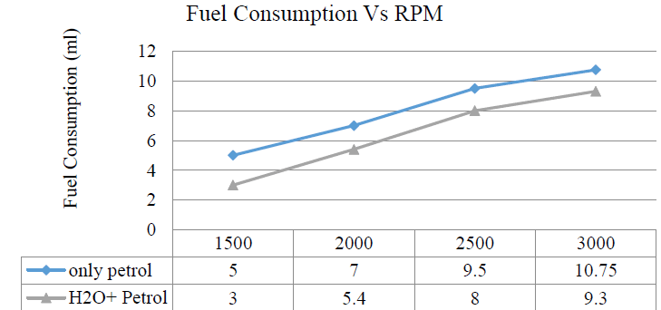
Figure 36-Fuel Consumption Benefits with Water Injection (tsijournals.com)

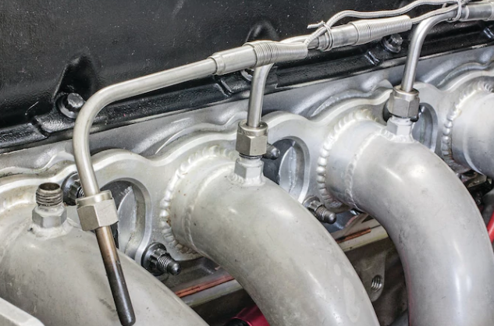
Figure 37-Thermocouple Design (hotrod.com)

Figure 38-BOSCH Water Delivery System (Webike.net)


