

Next Plc's strategic plan and capabilities

Teodora Georgieva

Student ID: 2111818

Date of submission: ……..

Word Count: …… words

Tutor’s Name: Piyumika Gamage

Strategic Management and Sustainability
LCBB6004

ASSIGNMENT 1

Student Name: Miroslava Georgieva
Student ID: 2111818
Date of submition:24/04/24
Tutor’s Name: Dr Piyumika Gamage

University of Wales Trinity Saint David-LONDON

Table of contents:

1. Introduction: 4
1.1 Company Background: 4
2. Key Business and Corporate Strategies ( Strategic Choice)…5
3. Resources and Capabilities …..9
➢ 3.1 Inbound Logistics:…… 9
3.2 Operations:……… 9
3.3 VRIO Analysis:…….. 11
➢ Value:……………. 11
➢ Rareness:…………. 11
➢ Imitability:………… 11
➢ Organisation:…….. 11
SAF Framework/Strategy in Action……… 12
Situational Analysis:……………………….. 12
➢ Strategic Objectives:……………….. 13
➢ Strategic Initiatives:…………………. 13
➢ Monitoring and Control:…………… 14
4. Conclusion…………………………… 15
Reference List:……………………………… 16

Introduction:
Prioritising sustainability is not just essential, it's a prerequisite for any business that wants to ensure a future of success and growth. The ability of a company to adapt and effectively respond to competition, changing consumer preferences, and technological advancements determines its success. The ability to proactively and quickly react to external changes sets apart a prosperous and stable business. Companies must confidently adopt a proactive and agile approach to outperform the competition. The implementation of this strategy will provide them with a competitive advantage, which will enable them to lead their industry. To ensure long-term success, companies must foster a culture of innovation and continuous improvement, allowing them to keep on top of ever-changing market trends, consumer demand trends, and consumer demands.
This report provides a comprehensive evaluation of NEXT Plc.’s strategic plan and business strategies. It thoroughly reviews the company's business and corporate strategies, focusing on their success in decision-making and execution.

Company Background:

Next plc is a highly regarded and widely recognised retail brand with a prominent position in the industry. Its extensive reach spans Europe, Asia, and the Middle East, boasting an impressive 500 stores in the United Kingdom. As a result of its remarkable sales, Next has emerged as a top contender in the clothing retail industry, surpassing even its rival, Marks & Spencer. The brand's success continues to grow, and it remains committed to expanding its operations across different regions to enhance its effectiveness and profitability.

2. Key Business and Corporate Strategies ( Strategic Choice)
To succeed a company in a highly competitive business environment, it is essential to identify the key strategies that will promote growth and ensure continued success. As a result, it becomes crucial to identify appropriate corporate and business strategies. An organisation's strategic decisions aligned with its vision and goals can help it outperform its competitors and establish itself as a thriving entity. Therefore, it is a wise and fruitful investment to dedicate time to thoughtfully identifying and implementing the most suitable business strategies.
Porter's ideas (Porter, 2008) emphasise the importance of competition, strategy, geographical location, and societal advancement. Businesses should focus on establishing a unique competitive position, improving efficiency, and achieving prosperity through strategic placement.
Next, Plc's strategic choices have not just been successful; they have been a masterstroke, positioning the company to thrive despite economic uncertainty. This adaptability is crucial, especially when consumers are more cautious with their spending and opt for cheaper products. Despite recessions, Next has consistently remained profitable, thanks to its digital business that appeals to customers who prefer online shopping. Next has always remained ahead of retail trends. Thanks to its investments in digital delivery, marketing, consumer credit, international expansion, LABEL, Lipsey, and supply chain evolution, it will continue to do so. The company's strategic investments and affordable yet stylish clothing make it a formidable competitor in the industry and will continue to be so (NEXT, 2022).

2.1 Porter's Generic Strategies
Businesses can differentiate themselves from competitors by adopting one of Pareto's three fundamental tactics: cost leadership, differentiation, or focus. These are known as Porter's Generic Strategies. To determine the most suitable strategy for their market, companies should conduct a thorough analysis of their strengths and capabilities. Each approach has benefits and challenges, so firms must determine which tactic best aligns with their resources and abilities. Remember, the three fundamental tactics are cost leadership, differentiation, and focus (Harvard Business Review et al., 2011, p.18)
As Pareto observed, cost leadership, differentiation, and focus are established business strategies that can improve a company's standing in the marketplace (Porter, 1996).
Cost Leadership emphasises simplicity, bulk purchasing, and reduced expenses to become the most affordable producer. Differentiation requires research, marketing, or service investment to offer unique or high-quality products. Focus targets a specific market segment to tailor offerings and enhance profitability and customer loyalty. These tried-and-tested strategies can help companies thrive in today's competitive marketplace (Ike, 2017).
Next Plc's retail industry transformation has implemented the Cost Leadership strategy. This strategy highlights the significance of online presence and the abundance of consumer choices. The emphasis is on online aggregation, which means that new brands can gain scale rapidly. Leveraging online platforms is crucial to reaching a broader audience and achieving cost efficiency.
Next Plc can optimise its online infrastructure and technology to pursue cost leadership. This will enable them to offer a wide range of products at competitive prices, attracting price-conscious consumers seeking value in a highly competitive market (NEXT, 2022).
Next Plc intends to broaden its range of brands and establish an aggregation enterprise that caters to the fashion, homeware, and beauty customers in the UK and Ireland.
The company's unique differentiation strategy is a testament to its commitment to offering a wide range of customised products, thereby establishing a distinctive brand identity among consumers. This strategy is further enhanced by Next's openness to physical retail space, which allows for many options for customers (NEXT, 2022).
Next Plc has strategically adopted a focused approach to building an aggregation business that targets customers in the fashion, homeware, and beauty sectors in the UK and Ireland. By concentrating on specific product categories and geographic markets, Next Plc is advantageous, as it tailors its offerings to meet its target audience's unique needs and preferences. The company remains flexible and adaptable to the evolving retail landscape while focusing on multiple opportunities and initiatives( NEXT,2022)
In summary, Next Plc incorporates elements of all three generic strategies, but its primary focus is differentiation. It leverages the power of online aggregation to create value for its customers in an ever-changing industry landscape.
2.2 Ansoff Matrix for NEXT Plc and company's strategic directions
The Ansoff matrix is a tool for businesses to make strategic growth decisions. It offers four options: market penetration, market development, product development, and diversification (H Igor Ansoff et al., 2019).
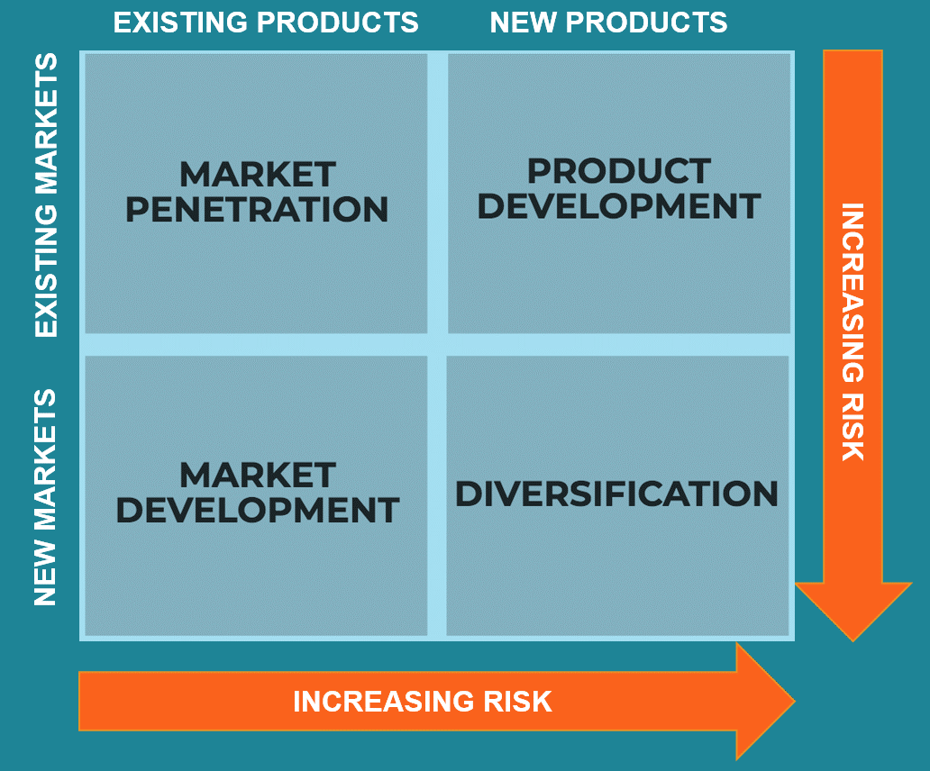
The strategy chosen depends on internal and external factors, such as political stability, economic conditions, talent management, and resource capacity. Organisations analyse these factors to select a growth strategy under the Ansoff matrix (Loredana, 2017)
Next Plc has shown remarkable market penetration capabilities by achieving outstanding brand full-price sales performance over the past 12 months. The company has tapped into existing markets and captured a significant share of consumer spending, resulting in noteworthy growth of 12.8% compared to pre-pandemic levels in 2019/20. Additionally, Next Plc's profitability has witnessed a remarkable growth of 10% compared to 2019/20 and a remarkable 140% against 2020/21. The increase in earnings per share (EPS) by 12% compared to 2019/20 and 138% against 2020/21 demonstrates the company's ability to convert revenue growth and profitability into higher earnings for its shareholders. Furthermore, Next Plc has reduced its year-end net debt (excluding lease debt) by 46% compared to 2019/20, strengthening its financial position (Next plc, 2021)
Next Plc will expand its market share by utilising the NEXT Platform to sell its merchandise and third-party brands. The company seeks to position itself as the premier destination for customers seeking clothing and homeware by leveraging its vital infrastructure, which includes physical stores, warehouses, delivery networks, and digital platforms. By implementing this strategy, Next Plc can significantly enhance its foothold in domestic and international markets.
In market development, companies research and enter new market schemes with existing products (Whittington et al., 2020).
Thanks to its comprehensive product development and diversification strategy, Next plc maintains a strong position in the retail market. The company prioritises responsible production of its NEXT-branded products and is dedicated to promoting sustainability and innovation. In addition to its leading brand, Next plc has expanded its business with LABEL, which offers third-party brands, Lipsy, catering to a younger demographic, and credit financing, which provides customers with flexible financing options.

Resources and Capabilities

3.1 Inbound Logistics:

Next Plc sources a wide range of well-designed, high-quality clothing and homeware products globally, including [specific examples of products]. This involves managing supplier relationships, ensuring timely deliveries, and maintaining quality standards. The company's value proposition focuses on offering diverse product assortments to attract and retain customers.

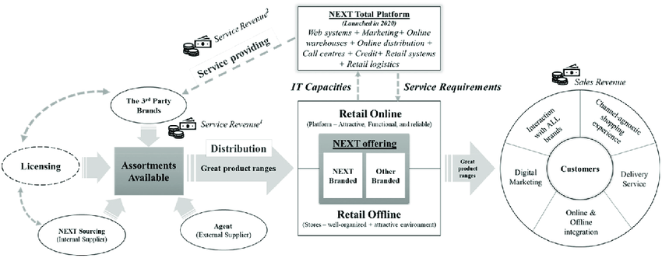

Operations:

Next Plc's approach is centered around the customer and effectively blends online and offline channels. This approach positively impacts the overall customer experience and presents an encouraging opportunity for investors( Figure 4. An overview of Next’s value proposition).
Additionally, Next Plc has implemented key initiatives such as Label, Licensing, and Total Platform to optimise operational efficiency. Label consolidates third-party brands, Licensing introduces licensed products, and Total Platform provides convenient pay-as-you-go services(Zhang et al., 2021Figure 4. An overview of Next’s value proposition).
Outbound Logistics:
Next Plc's distribution network includes warehouses, depots, and international hubs to facilitate customer product delivery.
The company's value proposition emphasises broader product assortments and 'one-stop' shopping experiences through initiatives like Label and Total Platform.
Marketing and Sales:
Next Plc is driven by a commitment to growth and innovation, utilising digital marketing strategies to achieve these goals. By effectively promoting its products, the company can reach a wider audience. Next Plc has launched initiatives such as Label, Licensing, and Total Platform to strengthen its value proposition further. These efforts provide customers with a broader range of products and services, increasing revenue streams and a more extensive customer base. Next Plc remains dedicated to delivering top-notch service to its customers online and offline, with initiatives like Label, Licensing, and Total Platform serving to enhance customer value through expanded offerings (Relation, 2011).
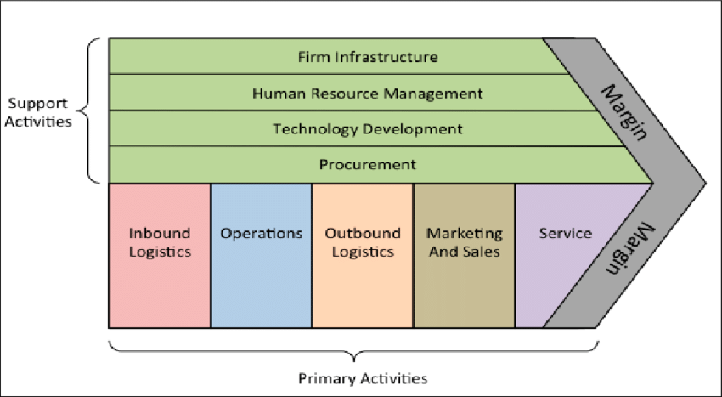
Figure 1 (Gate, n.d.)

3.3 VRIO Analysis:

Value:
Next Plc is reliable for diverse, high-quality products at reasonable prices. The company's strategic initiatives, such as Label, Licensing, and Total Platform, enhance the product range and provide extra services to customers and brand partners, increasing the overall value.

Rareness:
Next Plc's global sourcing capabilities and integration of online and offline channels are rare in the retail industry, giving the company a unique edge. Initiatives like Label, Licensing, and Total Platform leverage the company's expertise to provide customers and brand partners with exclusive services that are hard to find elsewhere.

Imitability:
While competitors can imitate Next Plc's operational model and value proposition, the company's extensive network and established brand reputation provide a competitive advantage that is difficult to replicate. Initiatives such as Labels, Licensing, and Total Platforms require significant expertise and resources, making them less susceptible to imitation (Research, 2021)

Organisation:
Next Plc skillfully organises resources and capabilities to deliver value to customers and brand partners. Initiatives like Label, Licensing, and Total Platform demonstrate strategic alignment with the company's core objectives, enhancing its competitive position.
Next Plc's value chain analysis demonstrates strategic initiatives that deliver value to customers and brand partners through diverse product assortments, integrated channels, and additional services. The VRIO analysis highlights the importance of unique resources and capabilities in maintaining a competitive edge in the retail industry (Research, 2021).

Next Plc has an extensive network of 500 stores, 7 UK depots, 8 UK warehouses, and two international hubs, which enable efficient distribution and fulfilment. To support its omnichannel retail strategy, the company invests in advanced technology for its online platforms, digital marketing, and distribution systems, including websites, logistics, and information systems(Johnson, 2019).

Next Plc operates online and offline sales channels, including its e-commerce platform, mobile app, and physical stores, providing customers with multiple purchase options. The company recruits and trains employees, focuses on employee engagement initiatives, and implements HR policies and practices to support employee well-being and productivity( NEXT, 2022).

These support functions enable Next Plc to effectively manage its operations, promote its products, and engage with customers, driving sustainable growth and success in the retail industry (NEXT, 2022a).

SAF Framework/Strategy in Action

Situational Analysis:

Next, Plc competes in the highly competitive retail industry, characterised by rapidly changing consumer preferences, technological advancements, and evolving market dynamics. However, the company has several strengths that enable it to stay ahead of the competition, such as a strong brand reputation, a diverse product portfolio, an integrated omnichannel strategy, and a robust distribution network. Notwithstanding, Next Plc is aware of its challenges, including intense competition, shifting consumer behaviours, economic uncertainties, and regulatory changes, but remains resolute in its determination to succeed. To achieve this, the company has identified several growth opportunities, such as expanding online sales, international markets, strategic partnerships, and innovative product offerings.

Strategic Objectives:

Next, Plc's strategic objectives are clear and focused on achieving its vision of being a leader in the retail industry. The company aims to:
- Increase market share and revenue growth through online and offline channels.
- Enhance customer engagement and loyalty through personalised experiences and value-added services.
- Expand internationally to tap into new markets and diversify revenue streams.
- Drive operational efficiency and cost optimisation through technological innovation and process improvements.
- Maintain financial stability and profitability while pursuing sustainable growth initiatives.

Strategic Initiatives:
Next, Plc is taking bold steps to achieve its strategic objectives. The company has implemented several initiatives, including:
Online- integration: Next Plc's online and offline channels are now seamlessly integrated, providing customers an enhanced shopping experience. The company has also launched initiatives such as Label, Licensing, and Total Platform to improve its online offerings further.
Product Innovation: Next Plc continuously introduces new products and collections to meet its customers' ever-changing needs. The company leverages its design capabilities and global sourcing network to stay ahead of the competition.
- International Expansion: Next Plc has expanded into global markets, tapping into growth opportunities outside the UK through online sales and physical stores.
- Operational Excellence: Next Plc invests heavily in technology and process improvements to enhance operational efficiency, optimise inventory management, and streamline logistics operations.
- Customer-Centric Approach: Next Plc prioritises customer satisfaction and loyalty by providing personalised services, efficient delivery options, and flexible payment solutions.

Monitoring and Control:
To ensure it stays on track, Next Plc regularly monitors key performance indicators (KPIs) such as sales growth, market share, customer satisfaction, and financial metrics. The company conducts regular reviews and evaluations to identify areas for improvement and make necessary adjustments to its strategy. Next, Plc maintains a flexible and adaptive approach to strategy implementation, allowing it to respond quickly to changes in the competitive landscape and market conditions(Walten, 2020)

Conclusion
Next, Plc's strategic initiatives demonstrate its comprehensive understanding of the competitive retail landscape. By setting clear objectives, implementing targeted initiatives, and monitoring progress, the company is committed to driving sustainable growth.
Next, Plc's ability to adapt to changing consumer preferences and market dynamics gives it a competitive edge. The company's focus on online integration, product innovation, international expansion, and operational excellence aims to enhance customer engagement, drive revenue growth, and expand its market reach.
Despite intense competition, economic uncertainties, and regulatory changes, Next Plc aims to maintain its competitive edge by addressing emerging threats and capitalising on new opportunities.
Maintaining a customer-centric approach is the cornerstone of Next Plc's success. By delivering value-added experiences across its online and offline channels, the company strengthens its competitive position and fosters long-term customer relationships.
In essence, Next Plc's strategic initiatives demonstrate its proactive and forward-thinking approach to navigating the complexities of the retail industry. By fostering a culture of innovation, agility, and customer-centricity, the company aims to achieve its strategic objectives and sustain its growth trajectory in the years to come.

Reference List:

Charles, Jones, G.R. and Schilling, M.A. (2014). Strategic Management: Theory & Cases: An Integrated Approach. Cengage Learning.
H Igor Ansoff, Kipley, D., Lewis, A.O., Helm-Stevens, R., Ansoff, R. and Springerlink (Online Service (2019). Implanting Strategic Management. Cham: Springer International Publishing.
Harvard Business Review, Porter, M.E., W Chan Kim and Mauborgne, R.A. (2011). HBR’s 10 Must Reads on Strategy (including featured article What Is Strategy? by Michael E. Porter). Boston Harvard Business Review Press, p.18.
Ike, L. (2017). Business Strategy. Xlibris Corporation. Chapter 5.
Johnson, G. (2019). Exploring Strategy, Text and Cases, 12th Edition. Pearson UK.
Loredana, M.E. (2017). THE USE OF ANSOFF MATRIX IN THE FIELD OF BUSINESS. p.144.
Lynch, R. (2018). Strategic Management. Pearson UK.
Murray, A.I. (1988). A Contingency View of Porter’s ‘Generic Strategies’. Academy of Management Review, Available at: https://journals.aom.org/doi/abs/10.5465/amr.1988.4306951 [Accessed 23 Apr. 2024].
NEXT (2022a). Annual Report. https://www.nextplc.co.uk/~/media/Files/N/Next-PLC-V2/documents/2022/annual-reports-and-account-jan-2022.pdf, p.256.
NEXT (2022b). ANNUAL REPORT & ACCOUNTS JANUARY 2022. [online] p.256. Available at: https://www.nextplc.co.uk/~/media/Files/N/Next-PLC-V2/documents/2022/annual-reports-and-account-jan-2022.pdf [Accessed 23 Apr. 2024].
Next plc (2021). Business Model. [online] Available at: https://www.nextplc.co.uk/~/media/Files/N/Next-PLC-V2/documents/company-meetings/business-model-2021.pdf.
Porter, M. (1996). What Is Strategy? [online] Harvard Business Review • November–december 1996. Available at: https://cdn.paynevesht.ir/assets/2_9e51a63409.pdf [Accessed 23 Apr. 2024].
Porter, M.E. (2008). On competition. Boston, Massachusetts: Harvard Business School Press.
Read, R. and Luffman, G.A. (1986). Diversification: the Growing confusion. Strategic Management Journal, 7(1), pp.29--35.
Relation, R.I. (2011). December 9, 2011 - S-1/A: General Form of Registration Statement for All Companies Including face-amount Certificate Companies | RH (RH). [online] https://ir.rh.com/. Available at: https://ir.rh.com/financials-filings/sec-filings/content/0001193125-11-335426/d70987ds1a.htm [Accessed 24 Apr. 2024].
Research, G. (2021). Figure 1. Michael Porter’s Value Chain [6]. [online] ResearchGate. Available at: https://www.researchgate.net/figure/Michael-Porters-value-chain-6_fig1_316889653 [Accessed 24 Apr. 2024].
Schlegelmilch, B.B. (2022). Global Marketing Strategy : an Executive Digest. Cham: Springer.
Walten, C. (2020). Next Secures £107 Million Warehouse Sale and Leaseback. [online] Logistics Manager. Available at: https://www.logisticsmanager.com/next-secures-107-million-warehouse-sale-and-leaseback/.
Whittington, R., Regner, P., Angwin, D., Johnson, G. and Scholes, K. (2020). Exploring Strategy. 12th ed. Hoboken: Pearson.
Zhang, L., Wu, L., Huang, L. and Zhang, Y. (2021). Wield the Power of Omni-channel Retailing Strategy: a Capability and Supply Chain Resilience Perspective. Journal of Strategic Marketing, [online] 77, pp.1–25. doi https://doi.org/10.1080/0965254x.2021.1972440.

