

BA BUSINESS MANAGEMENT

Assignment 1

A BRITISH AIRWAYS BLOG

Module: MARKETING FUNDAMENTALS

Code: LCBB4004

Lecturer: MD SADEQUE IMAM SHAIKH

Student name: MARICELA BROASCA

Student ID: 2125147

Submitted on: 02/09/2022

BRITISH AIRWAYS IS PARTNERING WITH HIDDEN DISABILITIES SUNFLOWER

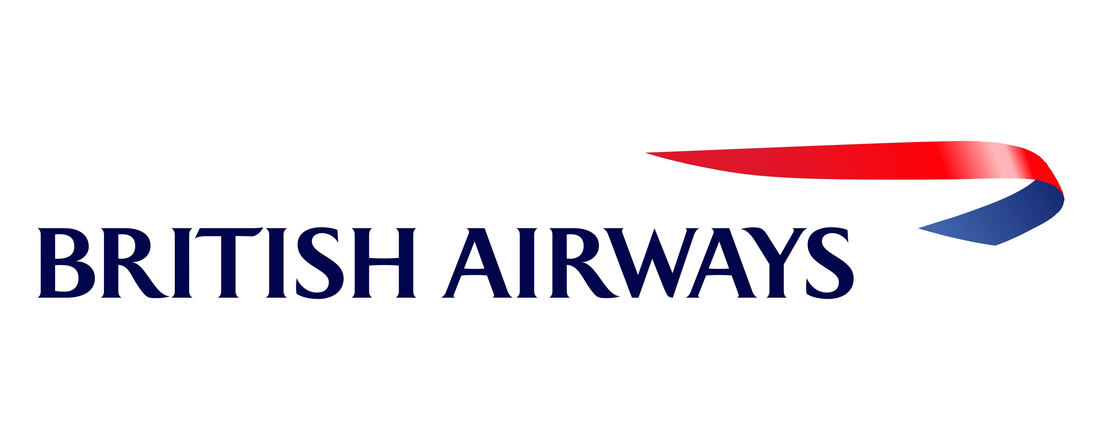
Figure 1. British Airways logo

British Airways is thrilled to announce partnership with Hidden Disabilities Sunflower and are proud to be the first airline that will recognize this type of badge. Moreover, every year almost half a million British Airways passengers require additional support whilst travelling. We have actively listened to your concerns and suggestions, and we understood that our customers with accessibility needs are traveling more and more, and our aim is to make everyone’s journey as smooth as possible. (British Airways, 2022)
“Our clients – the heart of our work”
B
R
I
T
I
S
H

A
I
R
W
A
Y
S

N
E
W
S

B
L
O
G

Whether wearing the lanyard because you require more time during your travels or just requiring our assistance and support, the Hidden Disabilities Sunflower lanyard is accessible to anyone that needs it. This is the airline’s promise to customers to make travelling more effortless and take away the hassle that some people experience with their journey. (British Airways, 2022)

Weather travelling for leisure or business, we are looking forward to meeting all our customers wearing the Sunflower lanyard, on board. Find out how to get yours or a loved one’s the Hidden Disabilities Sunflower by accessing https://hiddendisabilitiesstore.com/.
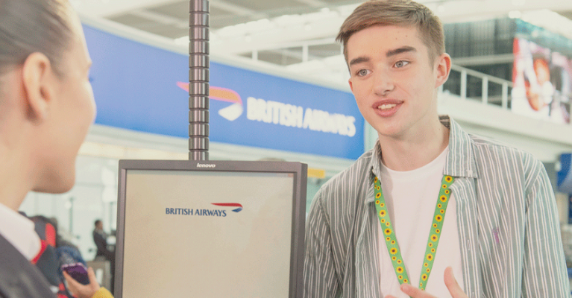
Figure 2. British Airways agent helping a sunflower lanyard user

IN NEED OF A NAP? TRY BRITISH AIRWAYS POWER NAPS AT HEATHROW AIRPORT


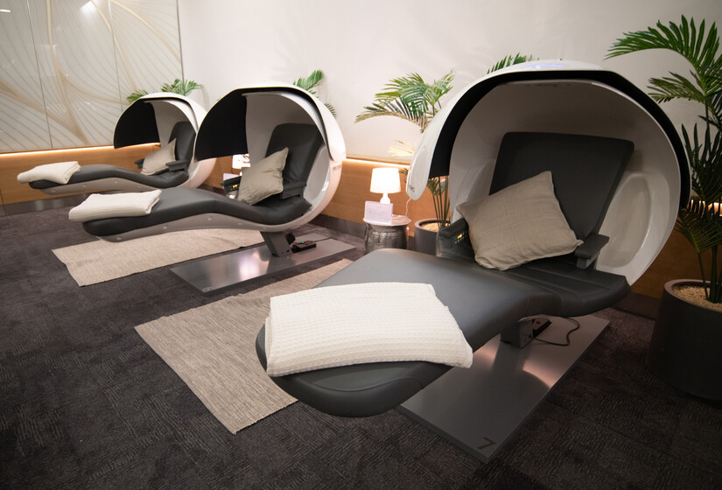
B
R
I
T
I
S
H

A
I
R
W
A
Y
S

N
E
W
S

B
L
O
G

https://www.britishairways.com
Book your flight today!

Figure 4. PowerNap Pods in the British Airways lounge at Heathrow Airport, UK

Aren’t the airport seats, uncomfortable? It’s impossible to lay flat on one and there has been many of us obligated to take an early or a late flight that would overwhelm us with tiredness and make our journey rather bitter.
Based at Heathrow Airport, the British Airways First Lounge is now benefiting from these power nap pods that are ready to make tired passengers feel rested and help restore their energy for the rest of their trip. (British Airways, 2021).

The airline is planning to introduce these pods in the Concorde Room that is based at London Heathrow Terminal 5 but as well, in the famous JFK Airport Terminal 7 in New York City.
The power nap pods, called as well, “the EnergyPods” were designed exclusively for people in need of a quick nap – these are built combining gravitational neutral positioning and a much-needed privacy visor. (British Airways, 2021).

Furthermore, this service comes as a fantastic addition to our complementary lounge to allow passengers to enjoy the full travelling experience without the overwhelming feeling of tiredness. (British Airways, 2021).

How do you feel about this BA new lounge addition? Do you feel that a nap is needed before your flight? Send us your opinions and suggestions in the comment section.

OUR BRITISH AIRWAYS NEW MEMBERS – BOEING 777

British Airways is proud to announce the acquisition for 3 Boeing 777-300ER aircrafts; These airplanes are built with a three-class configuration and can transport 386 passengers at once. (British Airways, 2018).

Part of the International Airlines Group, British Airways is one of the largest UK and international carrier; with its base at the well know UK airport – London Heathrow, the airline flies to over 200 destinations based in o75 different countries located on the entire globe. (British Airways, 2018).
B
R
I
T
I
S
H

A
I
R
W
A
Y
S

N
E
W
S

B
L
O
G

Fly with us and get to enjoy the full British Airways experience.
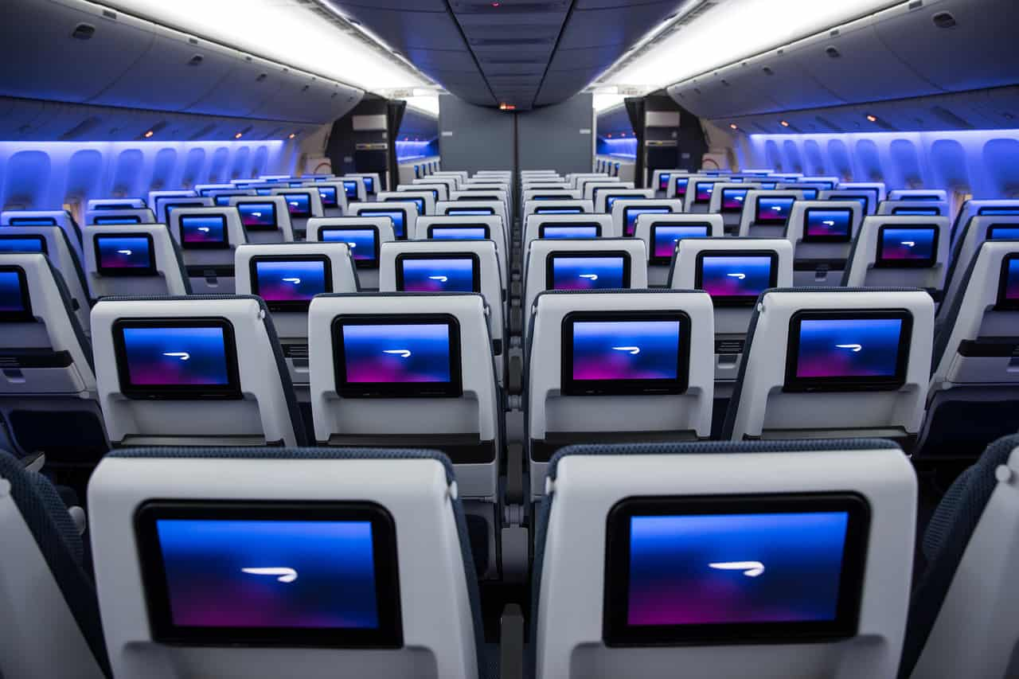
Figure 5. Inside the Boeing 777 aircraft

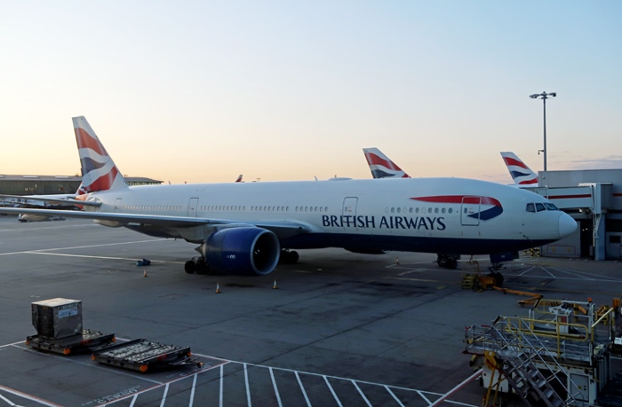
Figure 6. British Airways Boeing 777 aircraft at Heathrow Airport

TOGETHER WITH BRITISH AIRWAYS FOR A CLEANER PLANET

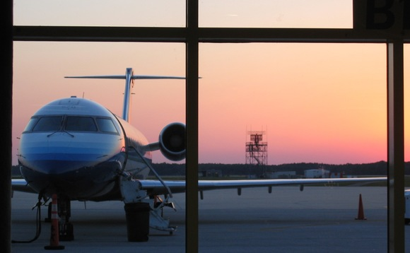
B
R
I
T
I
S
H

A
I
R
W
A
Y
S

N
E
W
S

B
L
O
G

Figure 7. Parked aircraft

As a busy airline we understand the importance of using cleaner fuels when flying our aircrafts – British Airways is proud to announce its collaboration with Solena Group Inc. to help develop a 16 M gallon/y waste-to-jet fuel plant based in East London, UK. (Biomass Magazine, 2010)

The new plant will be developed on the Solena’s plasma gasification process, and it will involve technology developed by Fischer Tropsch. The aim is to convert over 500,000 tone/y of municipal solid waste into jet fuel. The operations and build of the plant will be funded by Solena and the project costs are up to $280 millions. (Biomass Magazine, 2010)
With this plan in mind, British Airways intends to reduce its carbon footprint by 50% until 2050 and help protect the earth. (Biomass Magazine, 2010)

FLY BRITISH AIRWAYS
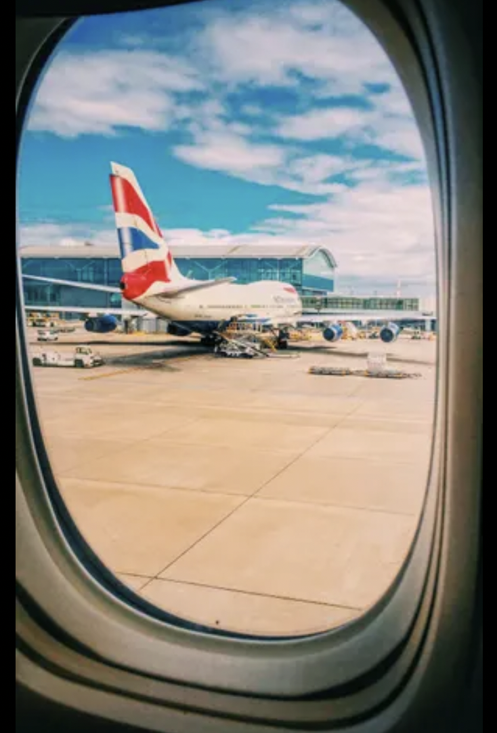
Figure 8. BA Boeing 737


BRITISH AIRWAYS IS INCREASING THE EXECUTIVE CLUB BENEFITS FOR GOLD MEMBERS
B
R
I
T
I
S
H

A
I
R
W
A
Y
S

N
E
W
S

B
L
O
G

Figure 9. British Airways Executive Club GOLD logo

British Airways is delighted to announce a new series of benefits for the Executive Club members that hold a gold card. Upon the completion of the 5000 tier loyalty points collected, you can now choose a family member or a friend to obtain a gold card. Moreover, if you want to make two of your friends happy, you can choose to nominate them to receive each a silver partner card. (Business Traveller, 2014)
If you would like to join our exclusive membership, access our website www.britishairways.com, create an account and start collecting loyalty points. All the members that attain 1,500 tier points in a year, will automatically obtain the “gold member” status; once this status is in place, you can choose “Executive Club partner card” option on our website, that is located in the “Manage my account” section and nominate your friends and family to enjoy the exclusive British Airways benefits. Gold card holders enjoy complimentary access to all BA First lounges, first class check-in, priority gate boarding, choose your seat for free – option and extra baggage allowance. (Business Traveller, 2014)

Have we convinced you to fly with us? If yes, do not hesitate to access our website, book your holidays with us, and start collecting loyalty points. The more points you attain, the quicker you get to enjoy the British Airways benefits.

BRITISH AIRWAYS IS INVESTING IN CATERING FOR WORLD TRAVELLER CUSTOMERS
B
R
I
T
I
S
H

A
I
R
W
A
Y
S

N
E
W
S

B
L
O
G


Enjoying your time during your flight should not be optional but a definite must; British Airways is happy to announce a multi-million-pound investment in its World Traveller (long-haul economy cabin) catering, by introducing a new menu, enriching some of the existing menus and supply more quantity and a better quality for the on-flight meals and snacking options. (Contify Aviation News, 2018)
Figure 10. On board passenger enjoying a meal

The new selections now include pretzels with your welcome drink, a four-course meal made of the starter, the main, a delicious dessert and a fine selection of cheese and biscuits together with our fluffiest bread roll and a bottle of fresh water. Moreover, we will introduce regional meals in accordance with your destination, Magnum ice-creams to satisfy one’s sweet tooth, Graze snack box, hot breakfast for long or overnight flights and complimentary drinks in our on-board bar. (Contify Aviation News, 2018)

British Airways director of branding and customer experience, Carolina Martinoli has declared that adjusting and improving the on-flight menus are a huge driver of customer service and taking all passengers suggestions on board has helped develop these new menus. Each passenger will be served with pretzels and a drink at the beginning of the flight, followed by a four-course meal containing a light couscous salad, followed by a delicious chicken casserole with white sauce, seasonal vegetables. Pots & Co salted caramel will be served as dessert, or you can choose a sweet chocolate mousse – we will then after serve you our fine selection of cheese and crackers. (Contify Aviation News, 2018)

Have we tempted you yet? All our passengers can access our website and choose the “manage my booking” option where you can communicate us if you have any dietary requirements or any allergies, or any food intolerance. (Contify Aviation News, 2018)

British Airways plans to invest a staggering £4.5 billion for its customers in the next 5 years in its attempt to improve and deliver the best quality Wi-Fi on board, developing 128 long-haul flights and improve their interiors; Furthermore, a plan in place states that another 72 new aircrafts will be purchased. In addition, £600 million will be invested in the Club World membership, that includes exceptional catering and high-end White Company bedding. (Contify Aviation News, 2018)

What do you like to see in our BA food menus? Leave us your opinions and suggestions in the comment section below.

B
R
I
T
I
S
H

A
I
R
W
A
Y
S

N
E
W
S

B
L
O
G

WITH BRITISH AIRWAYS YOU CAN CHECK-IN YOUR LUGGAGE DIRECTLY FROM THE COMFORT OF YOUR HOME

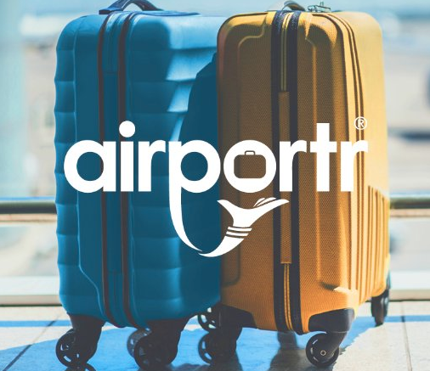
Have we made your curious? You have read it right! You can now check-in your luggage directly from your home without the need to travel to the airport.

How convenient, isn’t it? (Airportr.com)
British Airways proudly partnered up with AirPortr to help ease your travel even more – AirPortr is a service which you can use by accessing our BA website www.britishairways.com and choose conveniently the pickup slot to match your needs and our AirPortr team will collect it for your, directly from your house, office or a hotel based within our service area and take it directly to the airport. This way, you’ll save a lot of time in the airport and maybe use it to enjoy our BA First Lounge and its amazing benefits. (Airportr.com)
Figure 11. A blue and a yellow luggage

Furthermore, you can track the location of your pick-up driver directly on the AirPortr application that is available for both Android and iOS users; once your luggage is collected, you will be able to see the digital baggage receipts and the date and time of the arrival of your luggage at the airport. This service is available for our UK and Switzerland customers, it is approved and safe for all our passengers and if your plans have changed, you are entitled to free cancellations or changes. (Airportr.com)

Ever since the implementation of this service, we have checked-in over 160,000 bags for more than 350 destinations. You don’t believe us? Check our Trusted User reviews. (Airportr.com)

References
Airportr, n.d. Airportr. [Online]
Available at: https://airportr.com/en/ba/?utm_source=British%20Airways&utm_campaign=BA.com&utm_medium=airline&utm_term=Business%20Club%20World&utm_content=Business%20Club%20World&redirected=true
[Accessed 26 August 2022].

Airways, B., n.d. British Airways. [Online]
Available at: https://www.britishairways.com/en-gb/information/about-ba
[Accessed 26 August 2022].

Direct, S., 2010. British Airways, Solena Group, team up for waste-to-jet fuel plant. Focus on Catalysts, 2010(6), p. 3.
Edition), B. T. (., 2014. EBSCO host. [Online]
Available at: https://content.ebscohost.com/ContentServer.asp?T=P&P=AN&K=94483563&S=R&D=bth&EbscoContent=dGJyMMTo50SeqLQ4v%2BvlOLCmsEqeqK5Sr6i4SLGWxWXS&ContentCustomer=dGJyMPGqtVGxp7FRuePfgeyx44Dt6fIA
[Accessed 26 August 2022].

Information, A. I., 2018. Trade Journal. [Online]
Available at: https://www.proquest.com/docview/2076086575?accountid=130472&parentSessionId=CQyiYp%2FfQ%2FQRghP3IUbOjCv2%2BVmxhiMlQQ9yXj51k%2FY%3D&pq-origsite=primo
[Accessed 25 August 2022].

Information, A. I., 2021. Trade Journal. [Online]
Available at: https://www.proquest.com/docview/2572516684?parentSessionId=XQPZHAZiEwclqY8hUCIViCoHXpESoDszQy6bAaAPLTQ%3D&pq-origsite=primo&accountid=130472
[Accessed 25 August 2022].

Information, A. I., 2022. Trade Journal. [Online]
Available at: https://www.proquest.com/docview/2630916699/fulltext/51731EB843E54710PQ/1?accountid=130472
[Accessed 25 August 2022].

News, C. A., 2022. British Airways Invests in Substantial New Catering for World Traveller Customers. New Delhi: Athena Information Solutions Pvt. Ltd. .
Spottergva, M., 2018. CASHILL. [Online]
Available at: https://www.gotravelyourway.com/2018/08/11/review-10-british-airways-facts-you-should-know/
[Accessed 26 August 2022].

Photos collected

Fig. 1 - https://hiddendisabilitiesstore.com/insights/post/british-airways-become-the-first-uk-airline-to-recognise-the-sunflower
Fig. 2 - https://mediacentre.britishairways.com/pressrelease/details/86/0/13113
Fig. 3 - https://londonairtravel.com/2019/05/12/british-airways-10-abreast-economy-boeing-777-may-2019/
Fig. 4 - https://www.businessgreen.com/news/3078969/velocys-raises-gbp28m-from-shell-and-ba-for-waste-based-jet-fuel-plant
Fig. 5 - https://travelingformiles.com/quick-look-british-airways-club-world-boeing-777-cabin/
Fig. 6 - https://www.theguardian.com/business/gallery/2020/jul/17/british-airways-retiresboeing-747-fleet-in-pictures - photo by Af8images/Stockimo/Alamy
Fig. 7 – photo by Amanda Kelso
Fig. 8 - https://www.britishairways.com/en-us/executive-club/tiers-and-benefits - photo by British Airways
Fig. 9 - https://www.vogue.in/wellness/content/diet-tips-what-you-should-eat-and-avoid-before-during-and-after-a-long-flight - photo by Apparna Gupta in Vogue Italia
Fig. 10 - https://www.turningleftforless.com/airportr-review-solution-luggage-issues-ex-eu-trips/ - photo by Turning Left for Less
Fig. 11 – https://1000logos.net/british-airways-logo/ - BA Logo

