
Skills for the Workplace
Module Assignment Submission
Student Name: | Emma Jayne Evans
Student Number: | 1910917
Module No: | BMSK4002
Module Title: | Effective Team Working and Communication  Part 2

Statement of Confirmation of Authenticity
By the act of making this submission, the student declares that this is the work of the student named above. The work has not, in whole or in part, been knowingly presented elsewhere for assessment, or where assessment has been built on a previous assessment, this has been identified. Where materials have been used from other sources it has been properly acknowledged. If this statement is untrue, the student acknowledges that an assessment offence has been committed.
Attention is drawn to the plagiarism and unfair practice policies of both the University and of ILM.

Table of Contents

INTRODUCTION

- Explanation of Communication
- Communication Models Shannon and Weaver and Watzawick and Barnlund
- The importance of verbal and non verbal communication
- Explanation of a range of verbal and written communication used in my work place
- My communication skills
- My communication SWOT Analysis
- Gap Analysis
- Personal Development plan

CONCLUSION
REFERENCES

Introduction

My main purpose as a manager is to be able to communicate with my team so they are highly effective and successful. Also to be able to communicate with customers to increase store profits and productivity. This report will talk about different communication models and also analyze my own communication skills and weaknesses. It will also include a PDP which will help me achieve my goals.

What is Communication.

Communication in Latin is ‘Communicare’ which means to share or to make something common. Communication is the process by which people transmit information, share verbal and non verbal messages and create meaning with each other.
To be a good leader or Manager you need to be a good communicator. Managers and leaders must be good at getting their message across and at the same time, take on board what their team members are saying, bringing out the best in them.

- Communication Models.

There are many different communication models. In 1948, Shannon and Weaver created a model which explained the ‘transmitting message’.

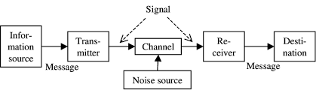
This model shows that communication happens when an information source ( a sender) has a message and transmits that message in the form of a signal through a channel. Then that signal is received by the receiver at its final destination. A long the way, there maybe some noise that can affect the message. Shannon and Weaver were interested in communication systems such as the telephone, radio, and their model reflects that.It is a linear, one- way model.
So in this model there is one sender and one receiver, it is simple, it is about the message being sent and the message being received. However, whats missing from this model is non verbal communication, which is a large part of life. It also doesn’t account for any feedback. This model provides an understanding of how information is transferred and helps us understand how messages get sent and received, but it doesn’t account for face to face dynamics.

Many years later, Paul Watzawick and Dean Barnlund came up with a transactional model of communication.

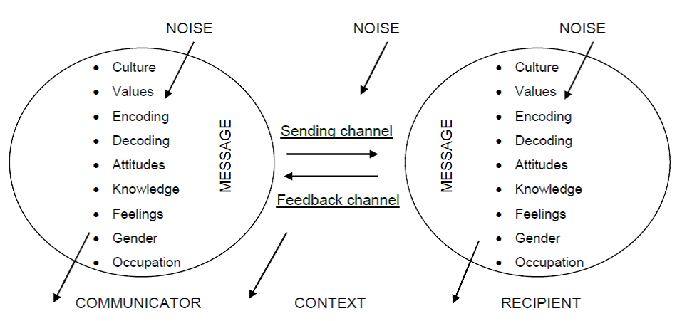

This is the most helpful models for understanding face to face communication and interaction. It is different to the Shannon and Weaver model as in this model both are senders and receivers simultaneously, always giving each other feedback, verbal and non verbal.

Paul Watzawick states, “you cannot not communicate” you are sending and receiving messages all the time whether you are aware of it or not. This model also explains the context, which is where the communication takes place. Foe example (my workplace) and that the context can also shape and affect how you communicate.
Another aspect of this model is the field of experience, which is where our values and beliefs will interpret how we send and receive messages. This is something that the Shannon and Weaver also doesn’t include. Barnland shows that communication isn’t linear, that is is in fact circular, as an on going back and forth exchange and that the meaning of the message exists in the people.

- Verbal and non verbal communication.
There are two types of communication, verbal and non verbal. Verbal communication refers to ou use of words and other utterences we use to express ourselves. Where as non verbal communication refers to communication that occurs through means other than words such as body language, gestures and silence. Both verbal and non verbal communication can be spoken and written. We can experience verbal and non verbal communication at the same time, they can either compliment one another or they can also contradict one another.
When looking at non verbal communication, it is how you look, your gestures, how you sound, your tone pace. A gesture can mean one thing in one society and something completely different in another. The meaning can vary from culture to culture, therefore it is very important to be mindful because these gestures help us paint a picture that our words are expressing
Both verbal and non verbal communication interact with each other by;
- Repeating - when the non verbal behaviour reinforces a verbal message
- Substituting - when using a gesture or other non verbal cue in place of a word
- Turn taking - relying on non verbal communication to signal turn taking
- Complementing - enhancing a verbal message with non verbal communication
- Emphasising - to accentuate a verbal message especially in a speech presentation or meeting.
- Contradicting - when your non verbals contradict your spoken words.

4 Explanation of a range of verbal and written communication used in my workplace.

Flemming (2004) argues that;
“even when good systems for communications exist… people still find ways of getting round them… line managers… have an important role in ensuring that downward messages are accurately conveyed and upward feedback is also communicated.”
As a manager it is important to be a good communicator, but is is also equally important that the listener (my team, a customer) understands and conveys the message the same as I intended it to be. It is an ongoing challenge where if communication is not interpreted correctly, it can have consequences for the beliefs and attitudes of my team affecting their emotions and behaviour.
Verbal communication (face to face) is the most complex form of communication. It is not always the best approach in the workplace, it depends on what as a manager I am trying to accomplish. This communication creates relationships in real time, therefore it is good for, customer service, problem solving, Team training and team building and Meetings, where I can see as a manager if my message has been communicated well by having instant feedback from my team.With face to face communication with my team I am able to create solutions, problem solve, have brain storming sessions.
Flemming states;
“training may not always be considered to be part of the communications system, but it doubtless provides opportunities to open discussion- and anything that does that, helps towards improving communication in the organisation”
Verbal and non verbal communication is extremely important for customer service in my workplace. It is used to
- Eye contact, you need to establish eye contact as soon as the customer walks in the store
- Body language, look interested and be open for communication, the way you stand has a lot to do with it, do not fold your arms and lean in towards the customer rather than away.
- A smiling face and a friendly manner, always be approachable, smile and look friendly
- Listening and silence, you have to know how to listen effectively without interrupting so you can hear what the customer wants. Active listening just as important as effective speaking.
- Summarising what has been said and paraphrasing, this helps the customer and I understand what is being said and what is required as the next step..
Written communication such as email is really good for transmitting large amounts of data very quickly. It is good for sending detailed instructions in writing, for sending invites and appointments because dates and times are very specific. It is good for sending information that doesn’t require a lot of interpretation, to do this face to face would be really time consuming.However written communication, when used wrong can lead to misunderstanding. If the person receiving and reading the email is in a bad mood, then are likely to read the email in a bad mood and take the message the wrong way. If this happens, then face to face communication needs to take place immediately to sort the misunderstanding out. Written communication through Social media is great for advertising and marketing, with videos, images, audio and text. However it can lack authenticity and gives the customer the only options of liking or disliking, agreeing or disagreeing, with no real compromise.

My communication skills.

John Adair ( 2002) asks;
“am I a good communicator? What do others think? Do I bother to find out by communicating with them?”
Recently I carried out a presentation about effective teamwork. I did this by using the Microsoft Team software, however when doing my presentation, my communication was interrupted by the technology that I was using. I had technical issues with my laptop and this then affected how I communicated my presentation to my team. From the feedback that I received, it was obvious that although the content of my presentation was good and it was informative, my team were unable to see any eye contact and advice for future presentations was to sort out any technical issues. I feel it is extremely important to always have feedback from my team so I can improve my own communication skills to become a better more successful manager.
I have come to realise the importance of communication skills as a manager and that feedback from my team will help me enhance these skills.

My communicaton SWOT Analysis.
STRENGTHS | WEAKNESSES
- I am a good listener and I take an interest in my teams ideas. | - Technical issues, not having enough technical abilities and knowledge.
- I am good at listening to what customers want, therefore my sales are high. | 2.I talk quietly, I can come across as nervous with not alot of confidence in what I am saying.
- I am friendly, smiley and approachable, good at communicating with customers. | - I can be a people pleaser and find it hard to say ‘no’.
OPPORTUNITIES | THREATS
- To become good at communicating through presentations and meetings at work. | - Not having support from family and friends through my progress.
- Career progression through bettering my communication skills. | 2 illness, I suffer with a chronic illness.
- Developing better social and leadership skills. | 3 Both illness and lack of support effecting my confidence and abilities as a manager.

7 Gap Analysis.

OBJECTIVE  What do I want to achieve? | CURRENT POSITION  What can I do already? | DEFICIENCY  What am I lacking? | ACTION  How do I fix this?
To be able to give effective and successful presentations. | I already have good content and very informative. | I am lacking full technical ability and technical knowledge | By learning more about the technology I am using and completing a course.
To be a good public speaker | I already have the knowledge of how to talk to people having the right words to say. | I lack confidence and volume in my voice coming across as nervous. | Practice makes perfect. I feel I need to do more public speaking and get more feedback, to become better at it.

My Personal Development Plan

I understand that there is a gap between my current communication skills and and desired communication skill level. To be able to achieve my future goals, I need to recognize the steps that will get me there and my five year PDP will ensure this happens.

What do I want to learn? | What do I have to do? | What support and resources will I need? | How will I measure success? | Target date for review?
To be the most effective and successful at presentations and meetings | Do more presentations, listen and take on board feedback to improve. | My team  Resources  Tecnical ability  Confidence  Communication skills | Through my team feedback  And also having an effective successful team | 2 years
Career progression having my own business | Have a business plan | Family  Craetivity  Communication skills  Motivation  Money  Time management | By having my own successful business | 5 years

Personal objectives

My short term goal is to become successful at giving presentations (next 1-2 years) and my long term goal (3-5 years) is to have all the communication skills and confidence to have my own business.

Conclusion

Throughout this report I have learned a lot about my communication skills. I have learned the importance of effective communication in my workplace and what I need to do to improve these skills to be able to succeed and progress in my career and I will thrive to do this.

References

- Flemming, P (2004) ‘Retail Management’, Gloucestershire
- Adair, J (2002) ‘100 greatest ideas for effective leadership and management’, West Sussex
- Hind, D and Moss, S (2005) ‘Employability Skills’, Sunderland
- Morgan, P (2017) ‘The business students guide to study and employability’, London

