
Title page
Student name: Nusrat Yasmin Shitara
Student number: 1712117
Module name: workplace culture and its impact on organisational efficiency
Module code: BMSW5005
Assignment title: Individual project report with practical (oral) performance
Tutor name: Dr Eric Osei

.

Executive summary

This research study emphasizes on organisational culture and how the culture impacts organisational efficiency. To do this there is a PESTLE analysis for the external environment, McKinsey’s 7S framework for the internal analysis and an organisation’s ethical stance is explained in detail. There is also a comparison between Riya Fashion (the chosen organisation) and Ela Exclusive (a competitor). Finally there is a recommendation to improve the chosen organisation.

Table of Contents

Introduction………………………………………………………………….3

Organisation background…………………………………………………3

External analysis by using PESTLE…………………………………….3,4,5,6,7

Internal analysis by using Makensey’s 7S framework……................8,9,10,11

An analysis of the organisation’s ethical stance.……………………11

A comparison by using seven elements of culture………………….12,13,14

Recommendation………………………………………………………….14

Conclusion………………………………………………………...............15

Reference list……………………………………………………...............16,17

Introduction
As part of this paper, the different types of organisational culture and the impact on organisational efficiency will be explored.
When individuals come together for a common purpose, an organisation is created. An organisational culture is where employees come together to provide a service under a common environment. The culture of the organisation comprises a set of beliefs; values; and standards which binds the employees together, providing a sense of common direction.. (Juneja, 2015)
The term ‘organisational culture’ refers to the principles, values and rules of the particular organisation. Most organisations have some fundamentals forming part of their ‘culture’, with huge differences which mark the cultures apart, meaning every organisation has a unique culture. (Juneja 2015)
We will consider the retail industry and compare two different retail organisation.

Organisation background
Riya fashion is an independent retailers specialising in South Asian wear which was established in 2003. It operates from local high streets in Birmingham and attracts the same demographic. Due to the organisations privacy policy, the organisation will be referred to as Riya Fashion. Having firsthand experience of working in the retail sector, we will analyse the workplace culture, including the internal and external factors, of the organisation and the impact it had on organisational efficiency.

External analysis of Riya Fashion by using PESTLE
PESTLE analysis – It is a tool used to analyse and monitor the external environmental factors that may have a significant impact on an organisation’s performance. When starting a new business, this tool poses to be quite useful. PESTLE is an acronym, standing for Political, Economic, Social, Technological, Legal and Environmental factors.
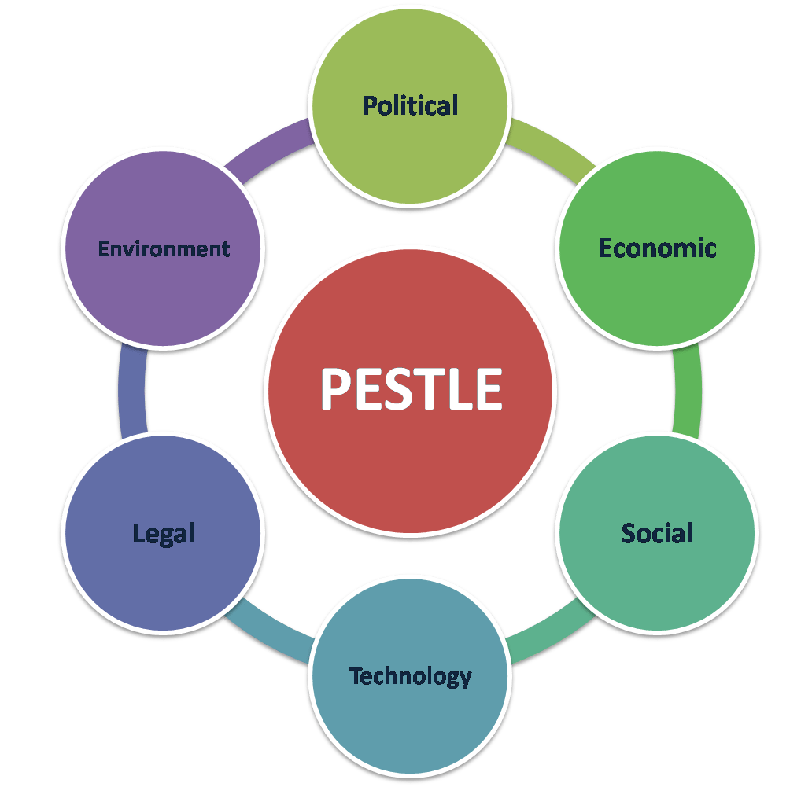

Figure 2: PESTLE analysis
Source: Waiz 2019
Political – Political factors are how far a government’s involvement in the economy is and how they are involved. E.g. overseas markets, trade restrictions, government, tax and foreign trade policy and political stability.
The retail industry must comply with the rules and regulations it operates within the UK and the political factors can create uncertainty or upheaval in the sector.
Shifts in the political arena in other parts of the world can have an impact on the retail sector in the UK. Working in the Asian retail industry most of the clothing sold are made in factories based in South Asia with poor working conditions and treatment of workers in ‘sweat shops’.
There have been media reports of clothing factories in Bangladesh and India which brought attention to the plight of workers who were working in hazardous factories, being mistreated. Riya imported clothes from Bangladesh and India to sell in their stores.
Such headlines made consumers more conscious about where they buying their clothes from and the ethical impact of such organisations.
Riya addressed the issue, scheduling staff meetings and identified if Riya had business relationships with any of those factories. Riya acknowledged that the Eastern economy played a huge role in driving the ‘sweat shop’ factories in South Asia and would analyse its supply chain, taking active steps in making changes. This line of communication was also repeated to customers by both management and employees, holding the same values and beliefs instead of being profit driven.
Brexit is another good example of how politics can affect organisational culture. Although politics can be heated and should be kept out of an organisation, it cannot be denied that some politics will directly affect what the organisation itself does and cannot be ignored. (Frue, 2018)
Economical – External economical factors deal with the management of demand in any given economy and are the determinants of an economy’s performance. Taxation policy and government expenditure are used by governments to improve an economy’s performance.
Economical factors deeply affect the retail industry. The spending behaviour of consumers is determined by the economy. Factors such as Brexit; a drop in the value of sterling; uncertainty around job certainty, has all impacted on the retail industry.
When there is uncertainty in the economy, one of the first things consumers cut back on is retail spending. (Frue, 2018)
Riya has broadened its offering to customers. It now offers everyday casual wear to occasional wear. By doing so, it has ensured a constant source of customers.
Social – social factors are the areas that share the same beliefs and attitudes as a population. Determinants such as demographics, cultural trends, career attitudes, and health consciousness and population analytics scrutinise the social environment of the market.
Consumers are now much more aware and care where their fashion comes from. This closely ties in with politics. (Frue, 2018)
Riya has a charity of the year which it supports. The charities chosen are related to the retail industry and all help in some way the South Asian countries. This way, Riya is playing an active role in changing the supply chain and is doing its part in making a difference. The charity is advertised in the shop all year round and customers are encouraged to make a donation. The owners of Riya are originally from India and, in recent times, they have returned to India and handed out clothes from their shop to factory workers. All of these kind gestures are advertised in the shop and through social media platforms.
Technological – technological factors are related to innovations in technology that may have a favourable or unfavourable effect on operations. This includes the production and distribution of goods and services and communication with target markets.
With the advances in technology making on-line shopping very accessible, this has impacted on retail in a positive and negative way.
Having an on-line presence has allowed retail shops to have access to worldwide consumers. However, those retail shops with physical stores have suffered. Fewer consumers are visiting shops, and smaller retailers cannot compete with the bigger retailers with more money and expertise. (Frue, 2018)
Riya is an independent high street shop. Riya has invested in technology and created a website from which customers can make online orders. This has broadened its customer base to the whole of UK. Management are considering expanding their website so that others around the world can make purchases. Within Riya, online sales have surpassed shop sales. Riya is able to display more items without having to increase its retail space and the costs. In Riya, the workforce felt it was forward thinking and relevant in the market place.
Legal – legal factors are laws that affect the business environment in certain countries and policies that companies adhere to themselves. These include consumer rights and laws, health and safety standards, equal opportunity and labour laws. Global trade makes this difficult as different countries have different laws and regulations to adhere to.
Legal issues such as health and safety training, employee pension rights and welfare impact on both large and small businesses. (Frue, 2018)
Riya had a detailed induction programme for its new employees including matters such as health and safety, career progression etc. Despite being a small family run business, Riya had set up a framework similar to larger organisations. Employees consequently had the structure of working in a larger organisation within the environment of a family run business.
Environmental – environmental factors are determined by the surrounding environment. These factors include weather, climate, global changes, climate change, geographical location and pollution. They have become important due to carbon footprints, scarcity of raw materials, the demand for ethical and sustainable companies and polluted areas.
Environmental and sustainability are just as important in the fashion industry. Consumers take a keen interest in carbon footprint and will choose who they shop with. (Frue, 2018)
Riya engaged with the values and beliefs of its employees and customers which made it more relatable and attractive.
As mentioned previously, the management in Riya in recent years have travelled to India, where most of its clothes are imported from, to visit villages where the majority of factory workers come from and hand out clothes. As part of this, Riya has a drop off point for customers to drop off unwanted clothing which is still wearable.
Ref: internal interview was taken with the owner of Riya Fashion (26.10.19)

Internal analysis by using McKinsey’s 7s framework
.McKinsey’s model is based on the principle that all seven factors: structure, system, style, staff, skills, strategy and shared value, are connected and need to be aligned to create the optimal organisational performance.
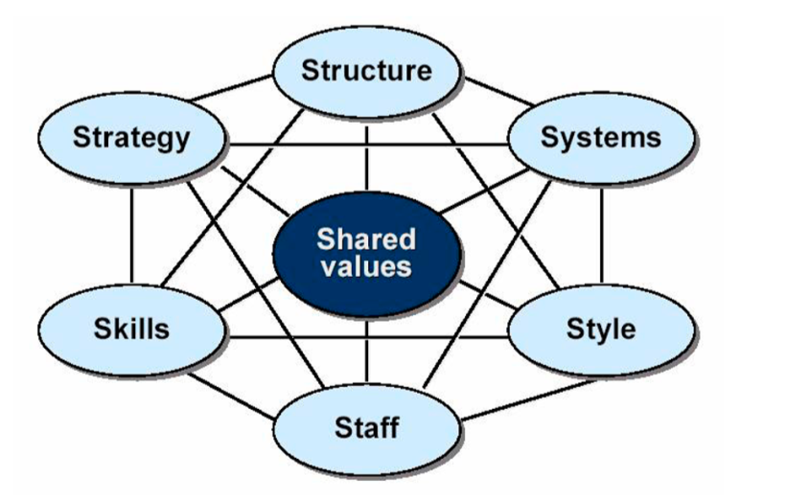
Figure 3: Mckensey’s 7S framework
Source: Rasiel et al. 2019
Structure - refers to the division of responsibility and work tasks within an organisation. In an organisation there is a hierarchy of power.
Riya is a family run independent businesses. Management consists of family members. Staffs are employed as retail assistants. Within the retail assistants there is a level of seniority, with some taking the role of shop floor managers.

Figure 4: Structure of organisation Riya Fashion
Source: own construct

The shop floor managers are retail assistants but have the additional responsibility of being the first port of call on the shop floor and will manage the workflow of retail assistants. Retail assistants will report to the shop floor managers with all matters concerning customer complaints/queries, taking lunch breaks etc. The shop floor managers ensure the smooth running of the shop floor on a day to day basis.
In Riya, although there are no departments, all individuals play a collaborative role in the development of the organisation. The small number of fixed term employees means strong relationships are built between the staff.
System - refers to the mechanics used to organise the information, process and procedures of the organisation. Having such a system in the workplace helps manage the work of the organisation’s teams/employees. (Story, 2019)
Systems have been put in place at Riya to help its strategy. As an example, this is family run business with family at the centre of how this business operates. Hiring of staff is usually done by recommendation of current employees and there is no formal, structured interviewing process. Instead, recruitment is based on individual’s passion for Asian wear and whether they have an interest in working within the community. Potential employees will be given a trial run and, if successful, will be taken on board.
There is a system of record keeping which helps to identify certain trends, popularity of certain items in the store. Sales are manually recorded within a ‘sales book’. In addition, to customer feedback and employee insight, the ‘sales book’ is used to identify trends to ensure that the shop order more of these stock so that it has the supply to meet the demand.
Riya has a CCTV system in the store to ensure the internal culture is safe, and is protected from theft or damage. The CCTV footage is backed up and saved an additional two times every 72 hours to make sure that no footage is lost.
Style - refers to the brand and culture of the organisation. (Story, 2019)
The leadership style is top-down, meaning it is autocratic, with management having a clear vision of their brand and what Riya stands for in the marketplace.
This is filtered through the culture of the organisation. Although there is no designated uniform to wear to work, employees are encouraged to wear clothing brought from Riya. Staffs are eligible for staff discount on items. Employees, regardless of whether the clothing is brought from Riya or not, primarily wears south Asian clothing. This is in line with what the business sells, the community it represents and the demographic it wants to target.
Staffs - refer to the individuals who are employed by the organisation to carry out various tasks within the organisation. (Story ,2019)
The core strengths of staff employed plays a very important role in the success of any organisation. A big advantage in Riya is that each employee works together to help each other in completing their jobs and in creating a smooth running organisation. The staff feel more like family than just co-workers. Given the size of the organisation, all employees are involved in the decision making and direction of the organisation is heading in
Skills - refer to the universal competencies of the organisation’s staff which are used in the business. (Story, 2019)
A primary skill of a sales assistant is the ability to connect and communicate with customers in order to make a sale. Riya sells Asian wear and its primary customers are from this community. Having sales staff that can relate and communicate with the demographic is important.
Sales assistant are also required to have IT skills to operate the cash registers and the online services, CCTV camera services. In Organisation A, these skills are developed over time and informal training sessions are provided.
Strategy - refers to the agenda of the organisations – what it plans to do and how. (Story, 2019)
Riya aims to deliver a retail service for the south Asian community. In order for it to have a wider reach, Riya has ventured into the online market. It has also created a haute couture line, featuring in several magazines and runways.
The advancement into online selling and having its very own haute couture line, makes Riya stand out from its competitors who tend to just have a physical shop and specialise in a certain type of wear (evening wear, bridal wear, everyday wear etc).
The future goal is to have distinct sections in the shop – one which sells everyday wear; another section which sells evening wear; and another section for haute couture.
The presence in magazines and runways has resulted in an increase in direct sales, in particular online. Customers mentioned that they had only heard of Riya after reading a certain magazine/runway, bringing them to the website.
Shared values - refers to the values, beliefs, goals and objectives held in common between the organisation, its employees and customers and, these shared values are at the centre of the organisation. (Story, 2019)
The shared values of Riya are its vision and its culture.
Its vision is to be a leading name in the retail industry of south Asian wear, wanting to break away from the usual mould where such businesses tend to only have a local establishment. Riya wants to have national reach and have a recognised brand name.
The culture of Riya is its family set-up. It was started by a husband and wife who involved family members at the very beginning and then employed employees, who became part of the ‘family’. That culture has stayed with the business and Riya is keen to maintain this.
Ref: internal interview was taken with the owner of Riya Fashion (26.10.19)

- An analysis of the organisation’s ethical stance.
Ethical stance - Companies that take an ethical stance and adopt altruistic and ethical policies can gain more in terms of an increase in sales, more customers and supporters and maintain a good corporate image. Stakeholders feel proud to be associated with a company trusted by so many. (Teik, 2014)
Riya as an organisation is striving to be more ethical, doing so through many ethical and environmentally friendly actions. For example, they now have different bins at the back of the store, separating recyclable materials from general waste. They have also started to recycle or reuse cardboard boxes and other useful materials and items.
Ref: internal interview was taken with the owner of Riya Fashion (26.10.19)
To make the organisation more ethical, Riya could switch the use of plastic bags for recycled paper bags or reusable bags.

A comparison between Riya Fashion with Ela Exclusive in detail by using the seven elements of culture
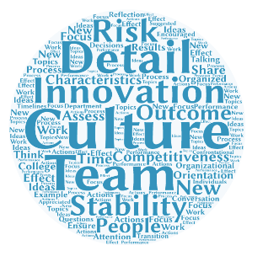

Figure 5: seven elements of culture
Source: google.com (2019)

Element | Riya Fashion | Ela Exclusive
Innovation and risk taking | Everyone from management to sales assistant play a key role in the success of the business. All are involved in the direction of the business. The launch of the website was done in consultation with all staff and everyone is excited about the growth of the business. | Ela has not ventured into the online world.. This has meant that its customer base is restricted to those in and around Birmingham. Its main customers and its regular customers but, given that it is high end, purchases are not made that often. In recent years, Ela is making arrangements to enter online sales. Employees often had slow days at the shop, creating a lethargic environment.
Outcome orientation | Although the aim is to make its brand presence known and increase sales, the organisation is not outcome driven, meaning there is a open dialogue where employees feel they can engage with new ideas. | Ela was more outcomes driven than process driven. Its concern was the end result but there was a reluctance to do things differently to see if this would yield a better outcome.
Team orientation | Riya is set up as a ‘family’ and this culture is driven from top-down. Everyone works collaboratively in achieving the same goal. There are no sales targets and salary is not based on commission. | Ela has no structured programme for employees. Employees didn’t feel like they were working part of an organisation but rather felt like they were working for the family.
Attention to detail | Customer and staff feedback is taken seriously, where these will directly lead to change. | Ela did not directly address the issue with employees and customers and chose not to have an open discussion. Employees raised questions and management were very vague in their response, being told to refer customers to management if they had any questions regarding this matter.
People orientation | Staffs are encouraged to build strong relationships within work and customers. The rota system allows staff to work with each other to create a flexible rota. | Apart from selling clothes, Ela did not engage in any wider issues that were impacting the retail industry and its customers. Ela was very insular.
Aggressiveness | Staff are encouraged to work together. In trying to do this, Riya has never had sakes targets or commission based salary. | Although there was no sales target for employees, there was a culture of competition created amongst staff as to who could bring the most sales. This was driven by management.
Stability | The business was started in 2003. Since then it has moved premises twice within the same area to accommodate its growth. Along the way the size of its staff has tripled in size and continues to grow. | Ela has remained a high end boutique retailer. This has its advantages especially when it comes to maintaining a reputation in this marketplace. However, it does mean its sales are primarily seasonal.
Source :( Management-transitions.com, 2019)
Ref: internal interview was taken with the owner of Riya Fashion and Ela Exclusive (29.10.19)

Recommendation
It is observed from the above report that, an organised and structured interviewing process is required when looking to hire employees. People applying for a role in the store need to fill in an application, send it to the store and wait to be contacted about an interview. The interview includes a 10 minute discussion. Every candidate will be asked the same questions during the interview, which can be changed depending on the specific role.
A customer toilet is needed as many customers come into the store, spend a long time and require this facility. This can help keep customers as they do not have to leave the store in search of a toilet.

Conclusion
Organisational performance is dependent on many factors. The culture of an organisation does impact the performance of employees. Generally speaking, employees are more motivated and work harder towards the organisational goals if they truly feel they are a part of the organisation.
By creating a culture of inclusion within your organisation, employees feel more fulfilled, which in turn increases productivity and performance. This also extends out to the market place where customers/clients are more likely to want the services of such organisation.

Reference list

Academy, P. (2019). Marketing Theories - PESTEL Analysis. [online] Professionalacademy.com. Available at: https://www.professionalacademy.com/blogs-and-advice/marketing-theories---pestel-analysis [Accessed 27OCT.2019].
Educational Business Articles. (2019). Using the 7s model to increase the chance of successful change. [online] Available at: https://www.educational-business-articles.com/7s-model/ [Accessed 23 OCT. 2019].
Frue, K. (2019). PESTEL/PESTLE Analysis of The Retail Industry. [online] PESTLE Analysis. Available at: https://pestleanalysis.com/pestel-analysis-of-retail-industry/ [Accessed 20 OCT.2019].
Google.com. (2019). innovation and risk taking organizational culture - Google Search. [online] Available at: https://www.google.com/search?q=innovation+and+risk+taking+organizational+culture&rlz=1C1AVFC_enGB870GB870&source=lnms&tbm=isch&sa=X&ved=0ahUKEwifvYPlntjlAhUYilwKHSQOCr4Q_AUIE [Accessed 24 OCT.2019].
Juneja, P. (2015). Understanding Organization and Organization Culture. [online] Managementstudyguide.com. Available at: https://www.managementstudyguide.com/organization-culture.htm [Accessed 20 OCT.2019].
Juneja, P. (2015). Understanding Organization and Organization Culture. [online] Managementstudyguide.com. Available at: https://www.managementstudyguide.com/organization-culture.htm [Accessed 3 NOV 2019].
Jurevicius, O. (2019). Conquer the Challenge of Expansion with McKinsey 7s. [online] Strategic Management Insight. Available at: https://www.strategicmanagementinsight.com/tools/mckinsey-7s-model-framework.html [Accessed 25 OCT. 2019].
Management-transitions.com. (2019). Management Transitions. [online] Available at: http://www.management-transitions.com/article-what-is-organizational-culture [Accessed 24 OCT. 2019].
STORY, j. (2019). How to use the McKinsey 7S model in marketing | Smart Insights. [online] Smart Insights. Available at: https://www.smartinsights.com/marketing-planning/marketing-models/mckinsey-7s-model/ [Accessed 25 OCT.2019].
sugimoto, A. (2019). pestle analysis pictures - Google Search. [online] Google.com. Available at: https://www.google.com/search?q=pestle+analysis+pictures&rlz=1C1AVFC_enGB870GB870&tbm=isch&source=iu&ictx=1&fir=10woVW2 [Accessed 20 OCT. 2019].
t info
Teik, T. (2014). Taking an Ethical Stance in Business. [online] M360.sim.edu.sg. Available at: https://m360.sim.edu.sg/article/pages/Taking-an-Ethical-Stance-in-Business.aspx [Accessed 21 OCT. 2019].
Waiz, S., Waiz, S. and Staff, A. (2019). Pestle Analysis Examples to Unlock Business Growth. [online] Advergize. Available at: https://advergize.com/insights/pestle-analysis-examples-to-unlock-business-growth/ [Accessed 19 OCT.2019].
Wookey, W. (2019). Organisational Culture and Employee Performance - BusinessBalls.com. [online] Businessballs.com. Available at: https://www.businessballs.com/organisational-culture/organisational-culture-and-employee-performance/ [Accessed 20 OCT.2019].

