Databases and Application Development
(ACCA5026)
Component 2 Report
Name: Eden Grace Sissons
Student ID: 2329831
Course: BSc Applied Computing
Module code: ACCA5026
Lecturer: Mohd Syafiq Bin Zolkeply


Contents
LibraryLink Database Structure 1
SQL Injection Overview 8
Examples of SQL Injection 8
Potentially Vulnerable Areas 8
Implemented Defences 9
Attempted Injection and Results 17
Limitations and Recommendations 18
IEEE References 18

LibraryLink Database Structure
The LibraryLink website uses a relational MySQL database containing six tables: Administrator, Book, Borrower, Loan, BorrowApplication and ReturnRequest. The tables store the website’s book, borrower, loan, application, return and administrator information. Related tables use primary and foreign keys to support an appropriately normalised database structure.
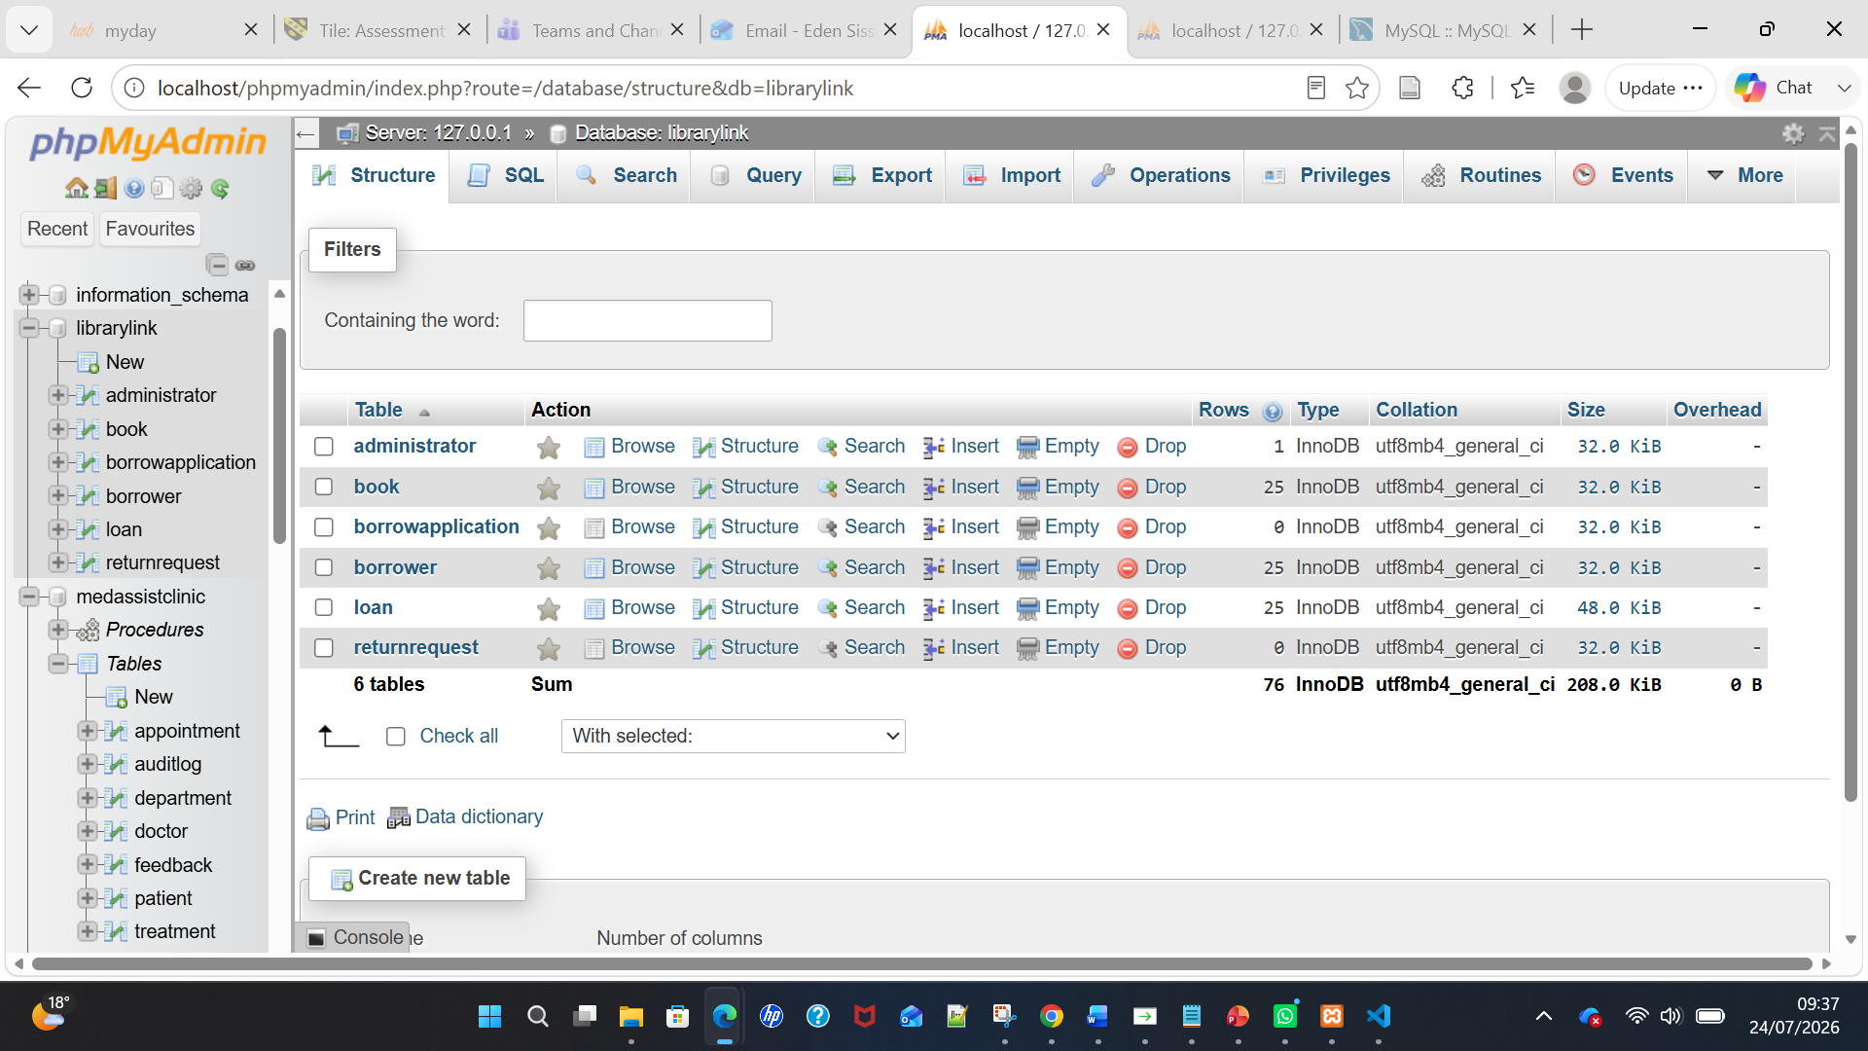
Figure 1(a): Structure of the LibraryLink database showing the six database tables in phpMyAdmin.
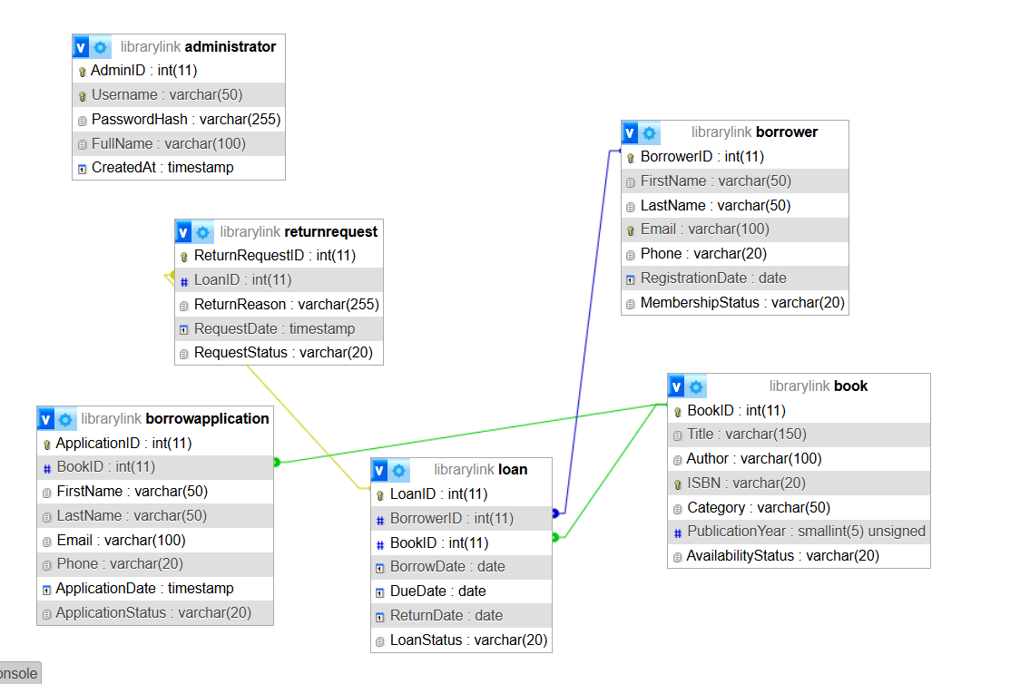
Figure 1(a): Entity-relationship diagram showing the six LibraryLink tables and the foreign-key relationships between Book, Borrower, Loan, BorrowApplication and ReturnRequest.

Administrator Test Login details
Username: admin
Password: Library@2026

Public Book Inventory 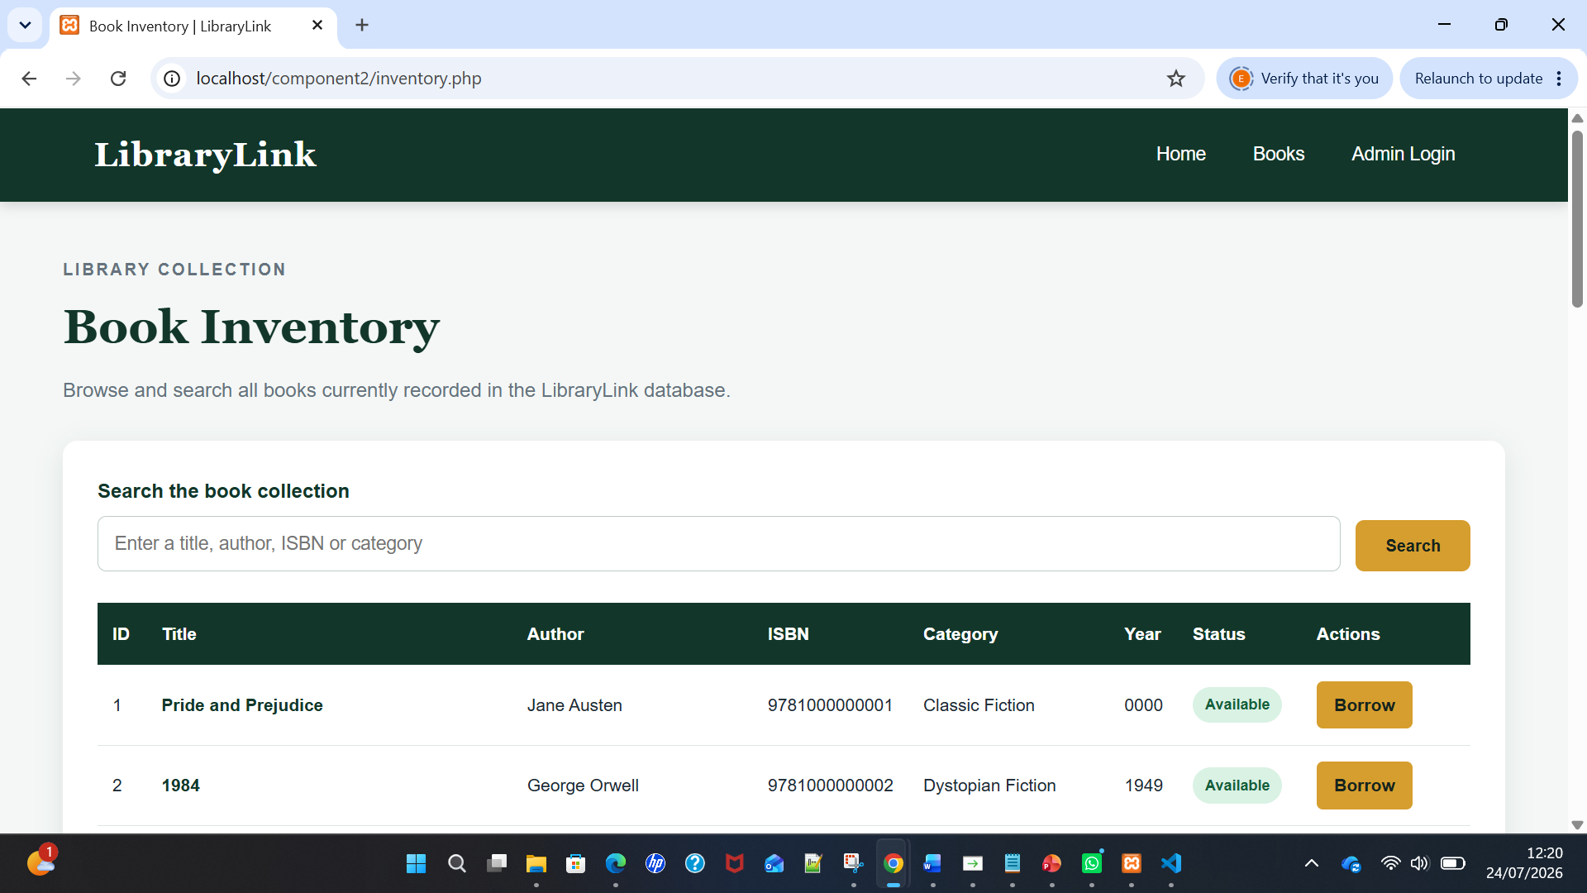 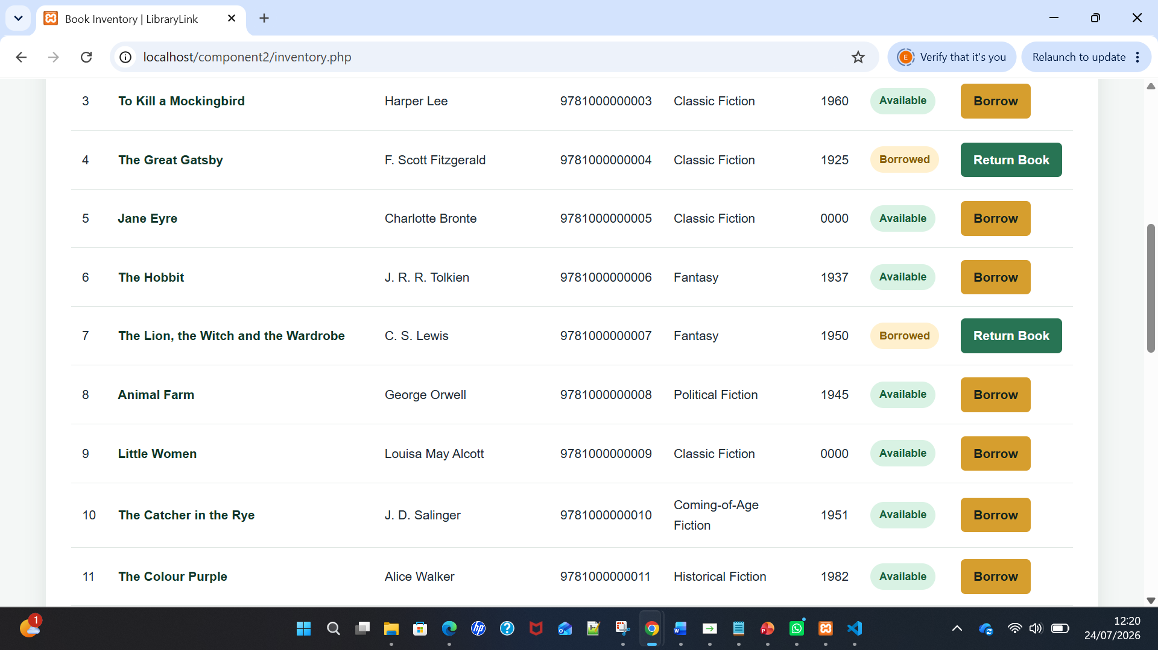 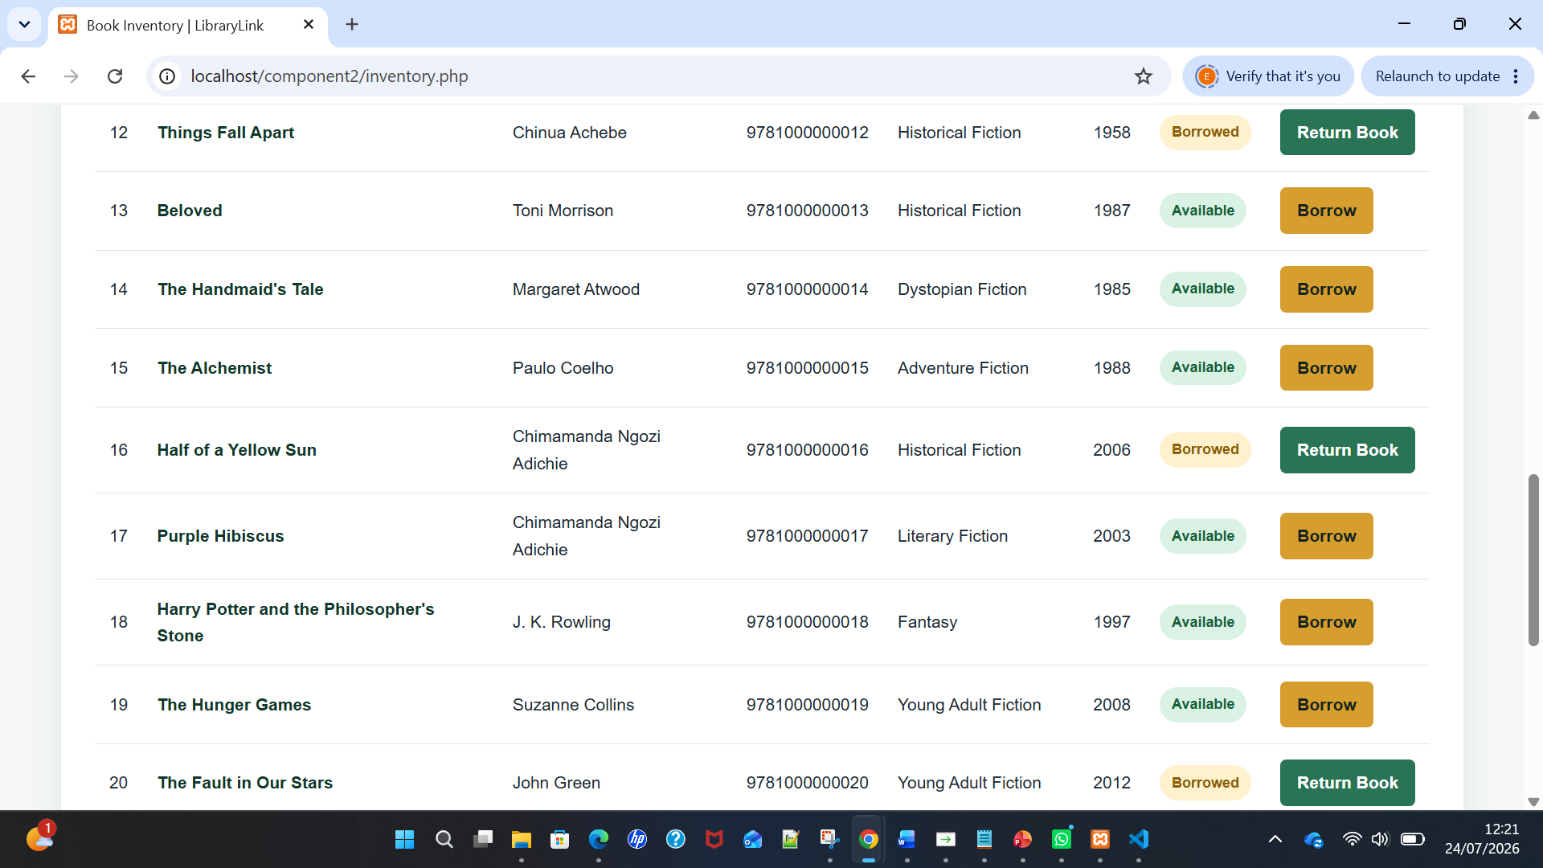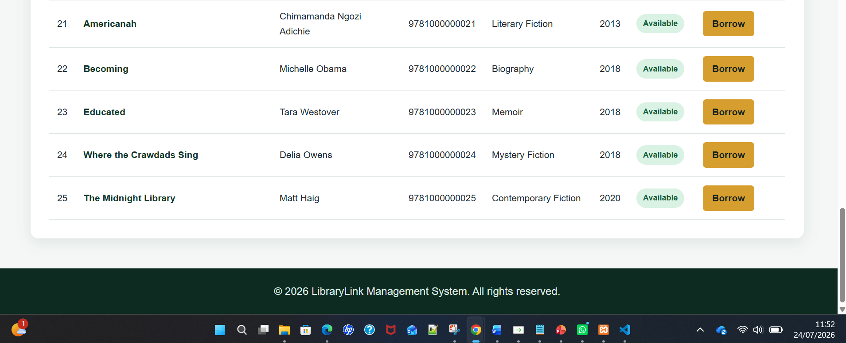
Figure 2: Public LibraryLink book inventory showing the search facility, availability status and borrowing option.

Search Facility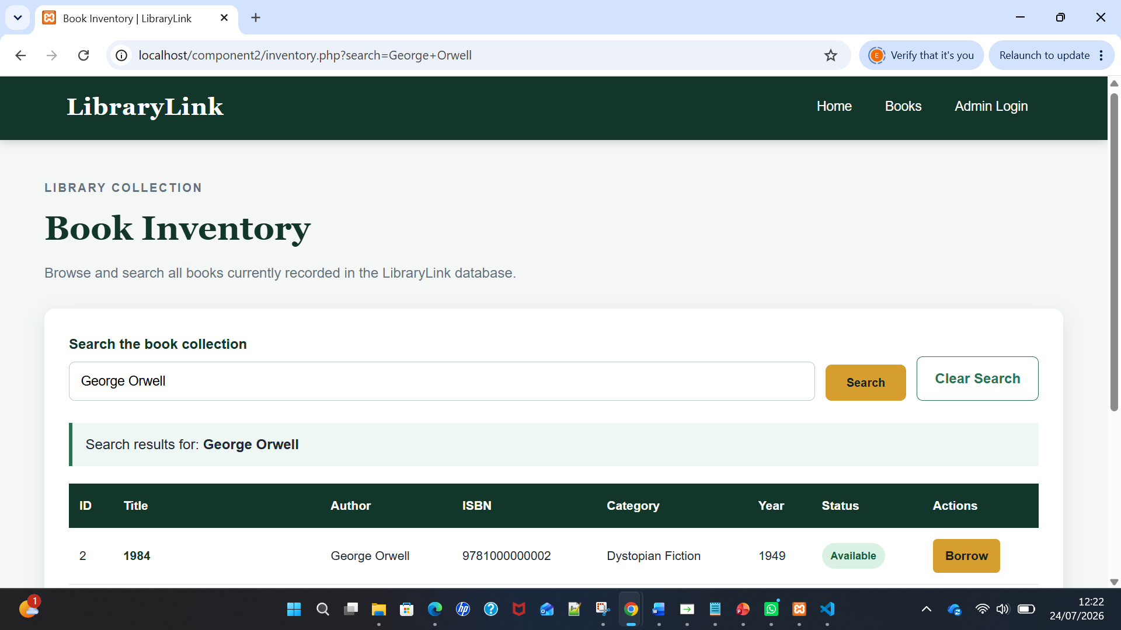 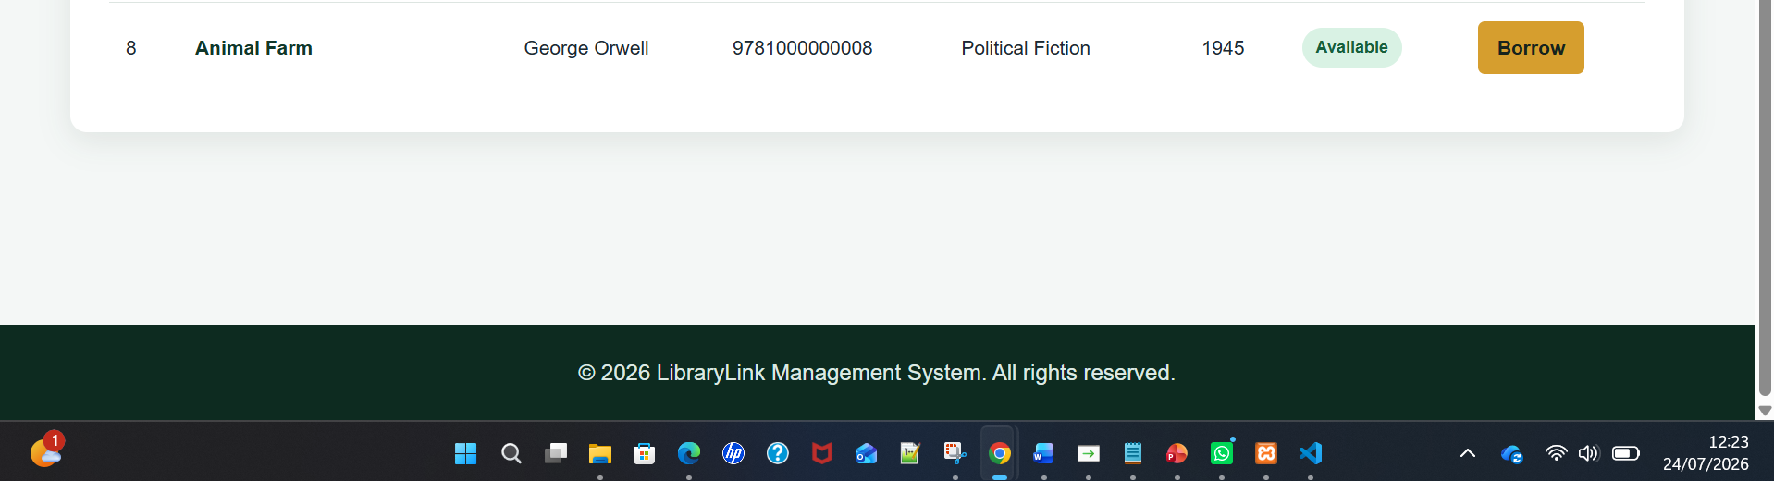
Figure 3: LibraryLink search facility displaying book records filtered by author.

Administrator Login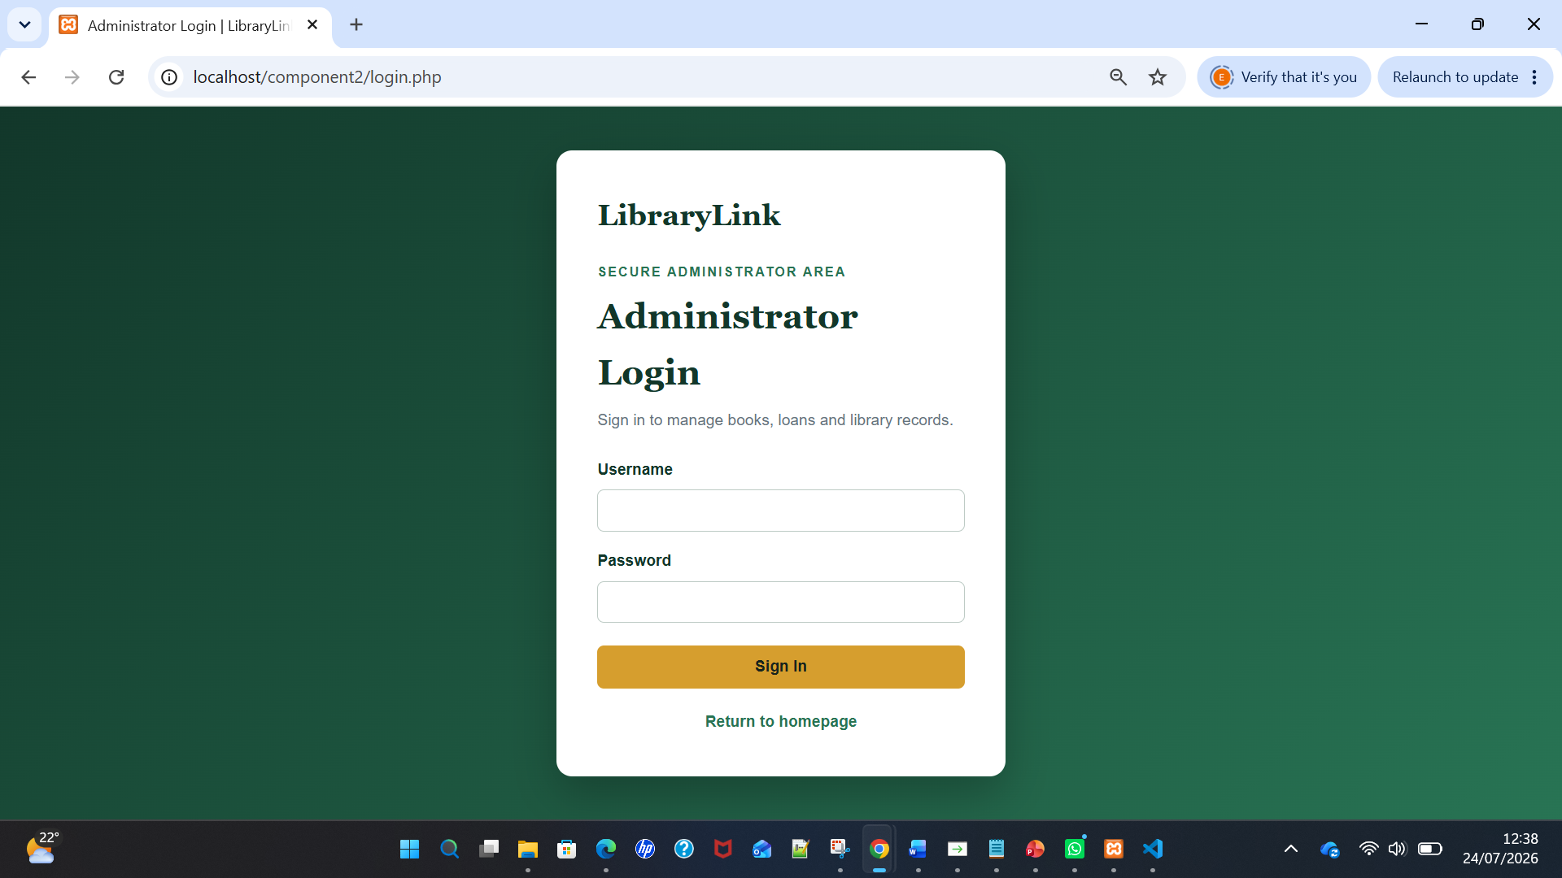
Figure 4: LibraryLink administrator login page providing access to protected management functions.

SQL Injection Login Test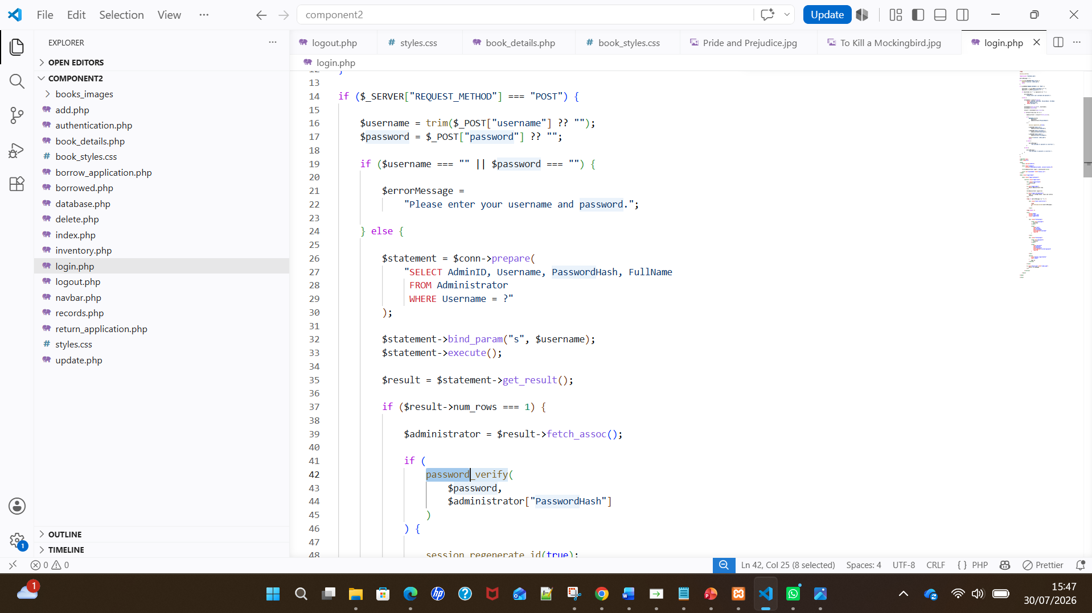
Figure 5(a): Administrator login code using a prepared statement, bind_param() and password_verify() to protect credentials and prevent SQL injection.
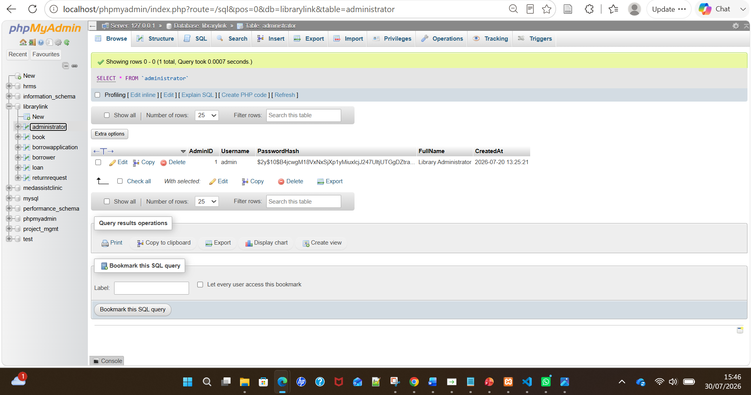
Figure 5(b): Administrator table showing that the password is stored securely as a hash rather than in plain text.
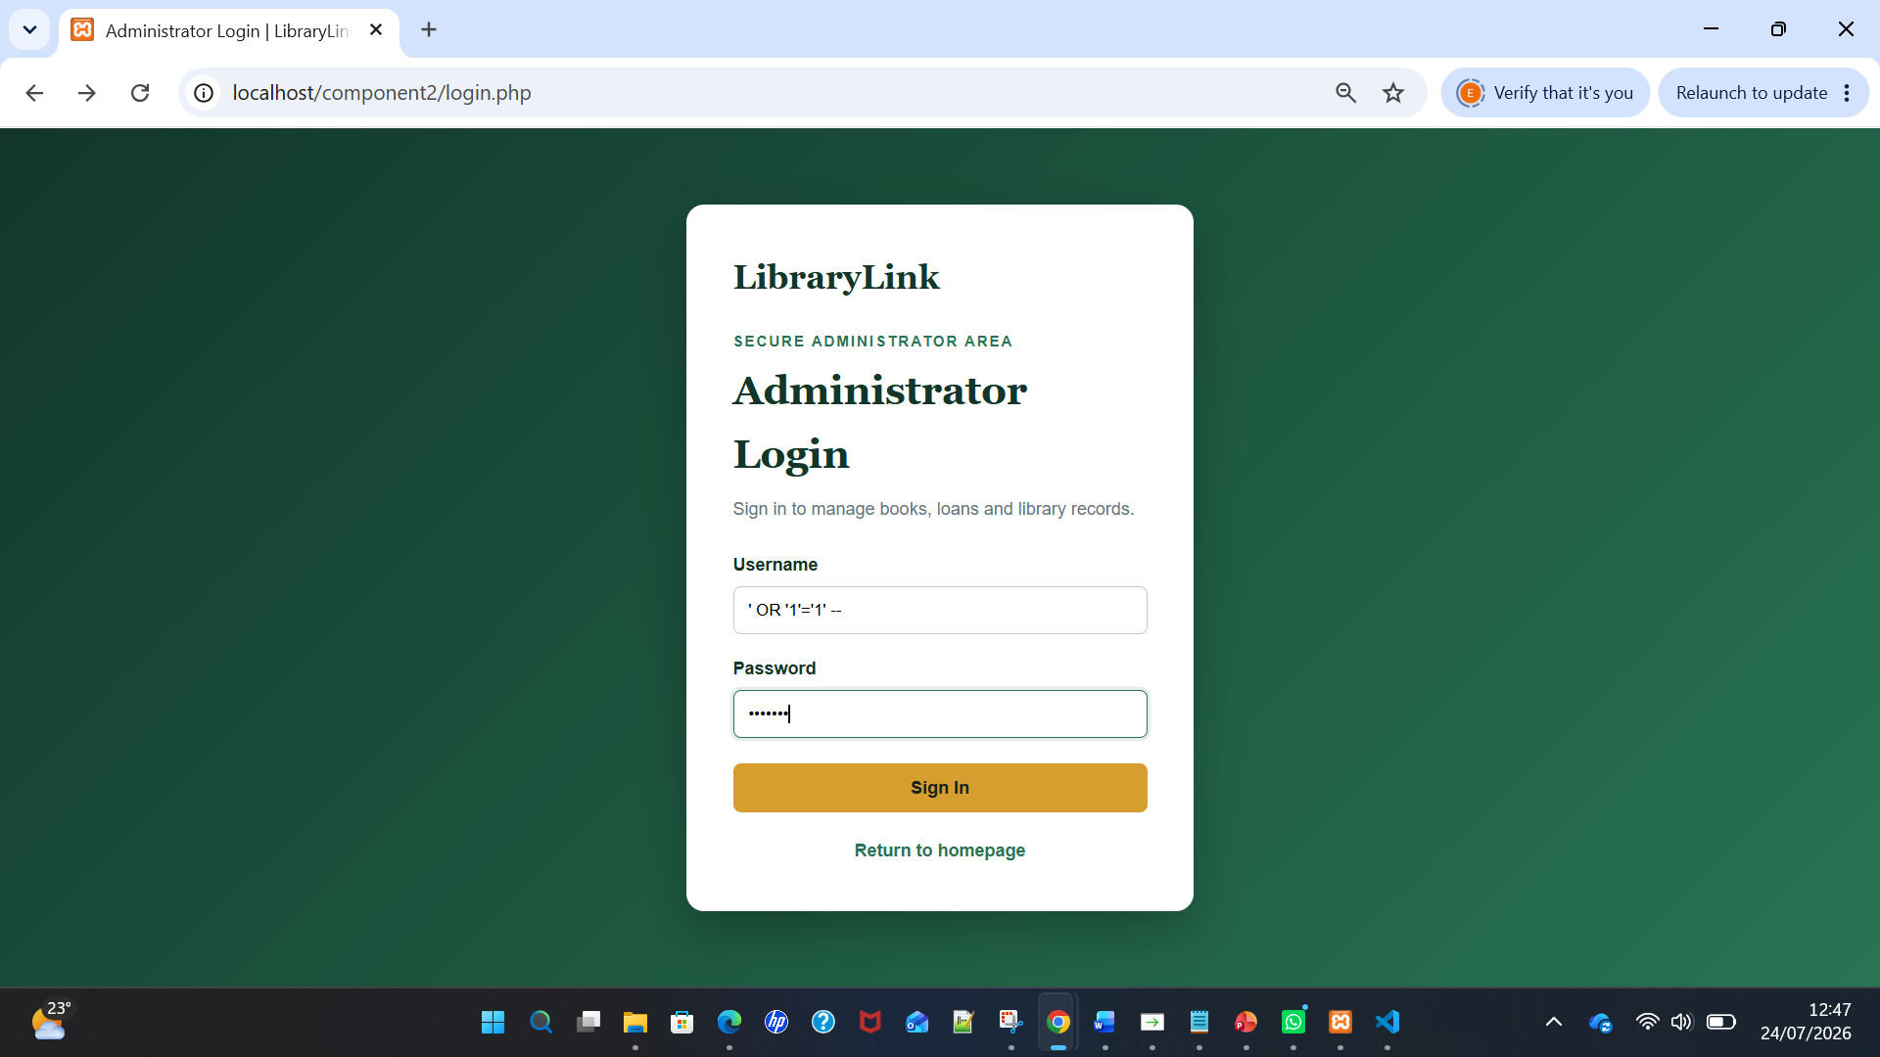
Figure 5(c): SQL injection payload entered into the administrator username field.
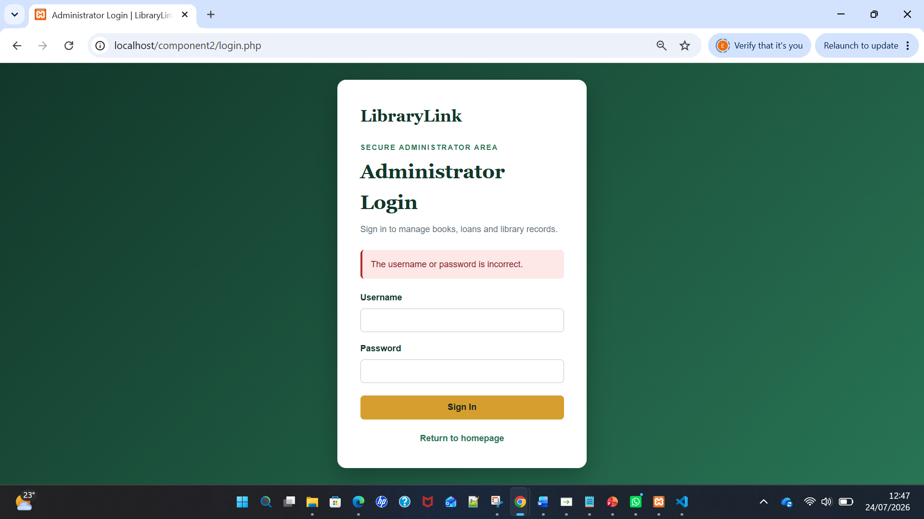
Figure 5(d): LibraryLink rejecting the attempted SQL injection and preventing administrator access.

Figure 5(d):

SQL Injection Overview
SQL injection is a security vulnerability that occurs when untrusted input is combined with an SQL command without adequate separation or validation [1]. Attackers can submit constructed characters through forms, search boxes, URL parameters or login fields, causing databases to interpret the input as executable commands. Consequences may include unauthorised access, disclosure of personal information, alteration or deletion of records and authentication bypass [2]. In LibraryLink, an attack could reveal borrower details, manipulate availability, create false loans or delete inventory records. Therefore, SQL injection threatens the confidentiality, integrity and availability of information held by database-driven websites [3], [4].

Examples of SQL Injection
A vulnerable login query might be written as:
SELECT * FROM Administrator
WHERE Username = '$username'
AND Password = '$password';
A vulnerable login query directly inserts the submitted username and password into SQL text. If an attacker enters ' OR '1'='1' -- as the username, the resulting condition may become true for every record, while the comment marker can remove the password comparison [5], [6]. A manipulated search can also use UNION SELECT to request information from an unrelated table. Where a database permits multiple statements, destructive input may attempt DELETE or DROP operations. These attacks are commonly described as tautology-based, union-based, error-based, stacked-query or authentication-bypass attacks [7], [8]. They demonstrate why external input must remain separate from executable SQL instructions.

Potentially Vulnerable Areas
LibraryLink receives data through the login, search, Add Book form, Update Book form, borrowing form, return form and identifiers contained in URLs. Every point where data reaches a database query is a potential attack surface [9]. Search terms influence SELECT operations, whereas administration forms perform INSERT, UPDATE and DELETE operations [10]. Book and loan identifiers are processed when records are edited, borrowed, returned or removed. Without secure handling, an attacker could alter an identifier, enter SQL syntax into a field or attempt authentication bypass. Administration pages present greater risk because they can modify information, not merely display it [11], [12].

Implemented Defences
LibraryLink uses MySQLi prepared statements with question-mark placeholders and bind_param(). This keeps SQL structure separate from supplied values, so malicious characters are processed as data rather than executable instructions [13]. Server-side validation checks fields, integer identifiers, dates, publication years, email addresses and thirteen-digit ISBN values. htmlspecialchars() encodes output before display, reducing cross-site scripting risk [14]. Administrator passwords are stored with password_hash() and verified using password_verify(), rather than being saved as text. PHP sessions and authentication.php restrict Add, Update and Delete functions to authenticated administrators. Together, parameterisation, validation, output encoding, password hashing and access control provide security layers [15], [16].
Prepared statement defence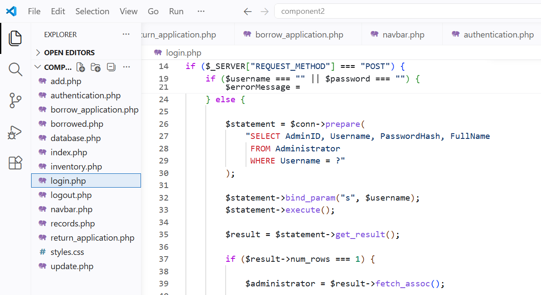
Figure 6: MySQLi prepared statement and parameter binding used to protect the administrator login against SQL injection.

Search prepared statement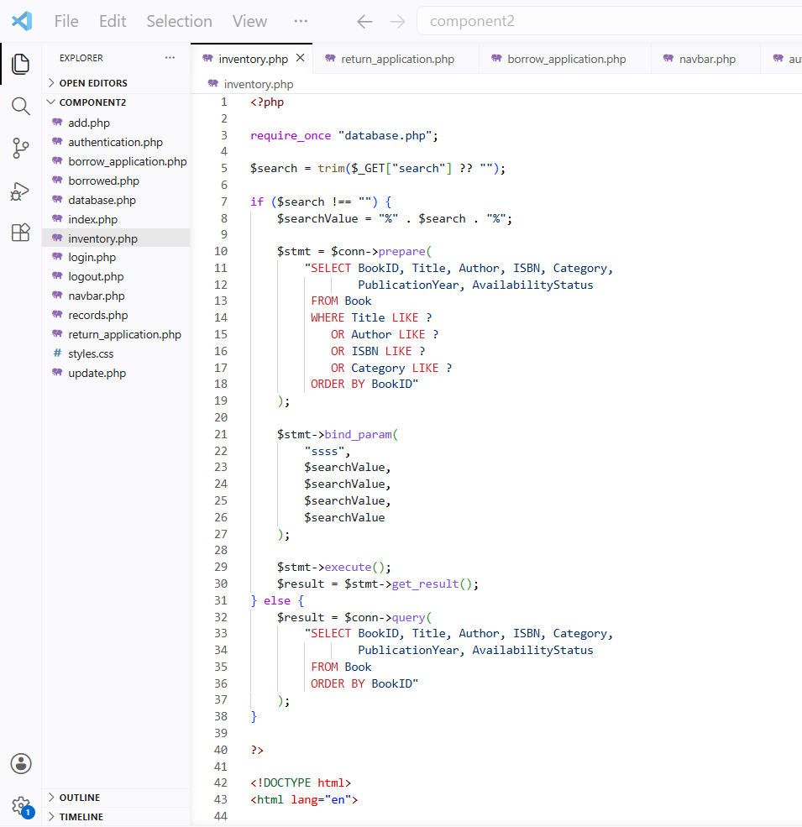
Figure 7: Prepared statement used to protect the public book-search facility against SQL injection.

Search injection test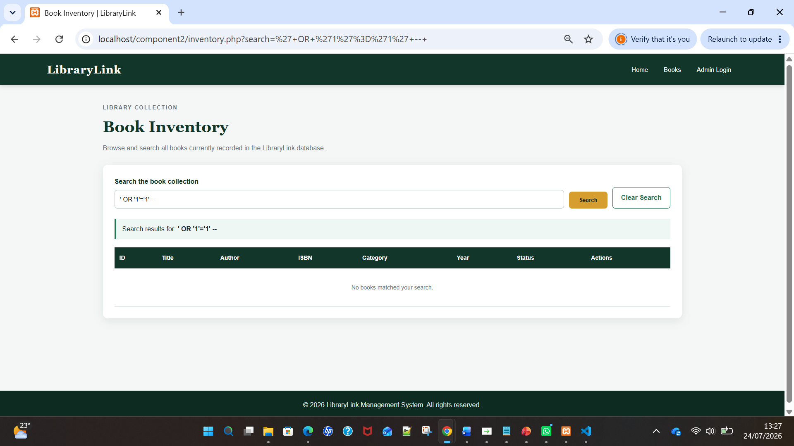
Figure 8: SQL injection payload treated as ordinary search data and returning no matching records.

Successful administrator access
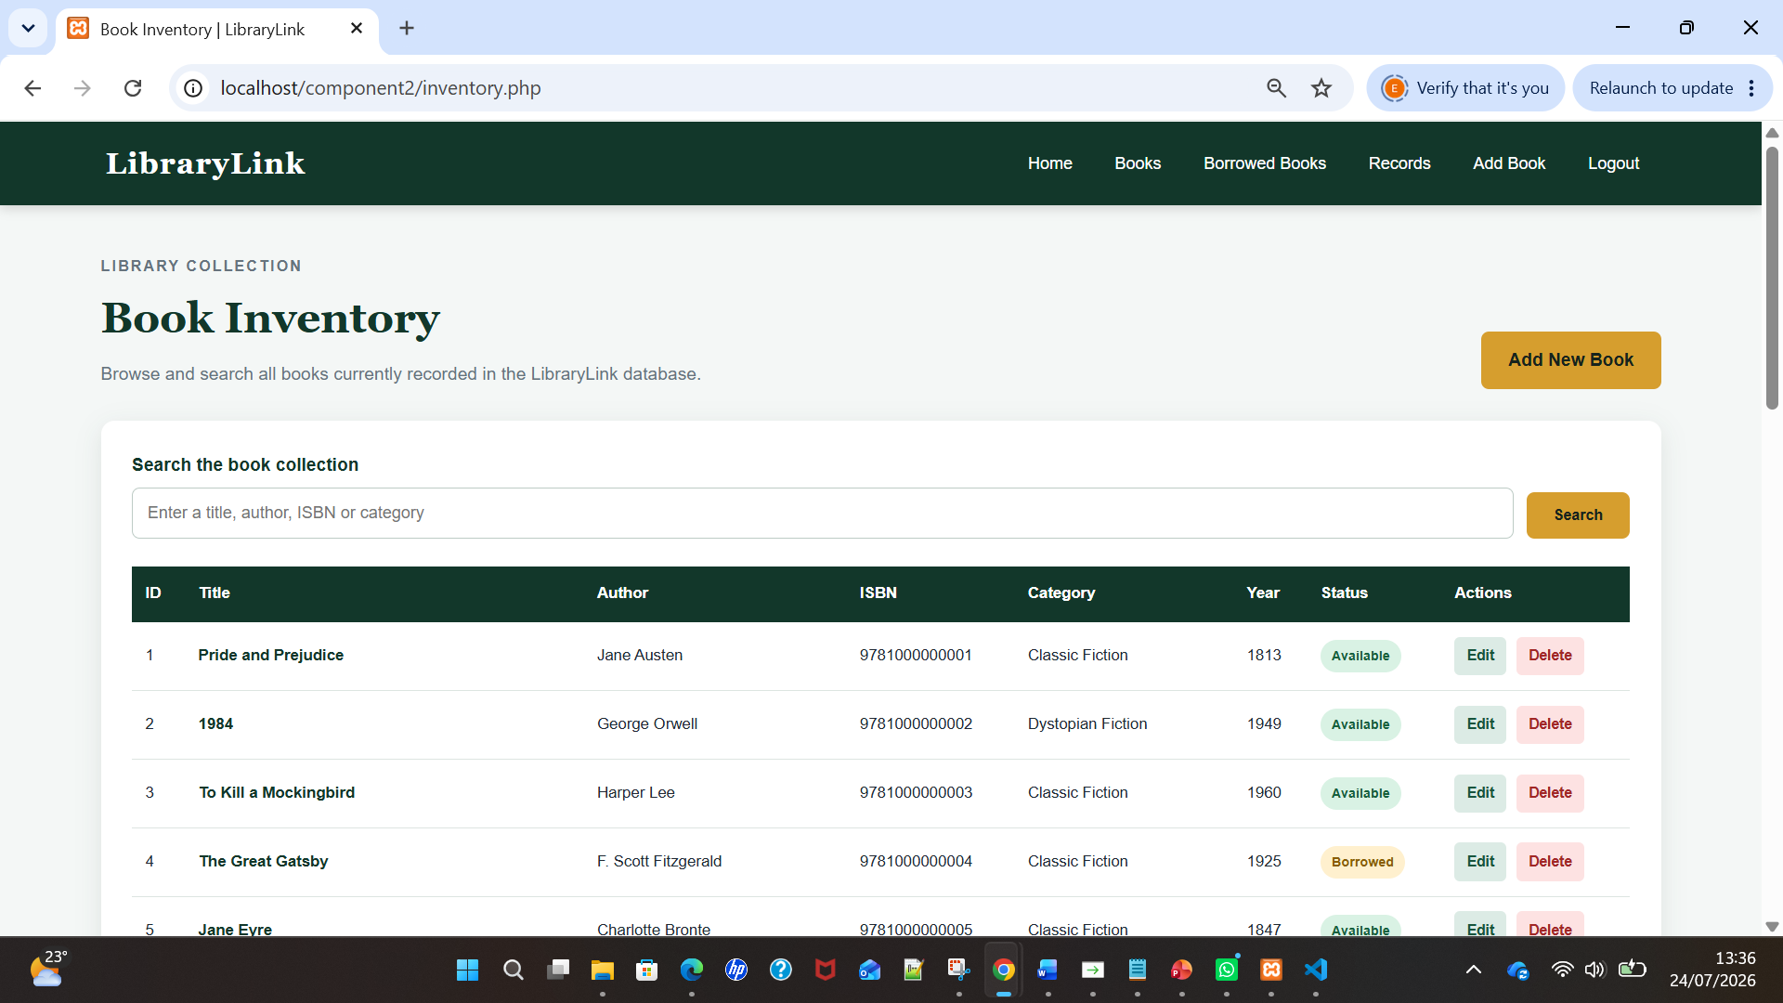
Figure 9: Protected administrator inventory displaying authorised Add, Edit and Delete controls after successful login.
Authentication protection code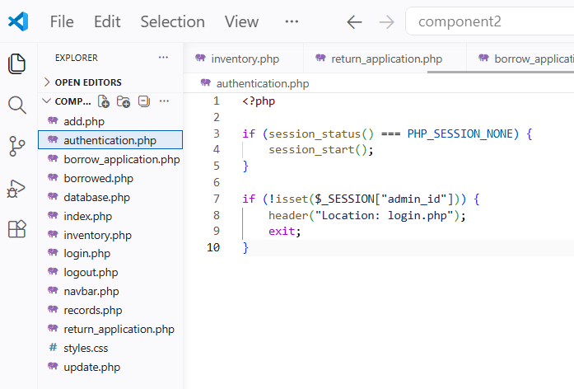
Figure 10: PHP session validation used to redirect unauthenticated users away from protected administrator pages.

Protected-page test 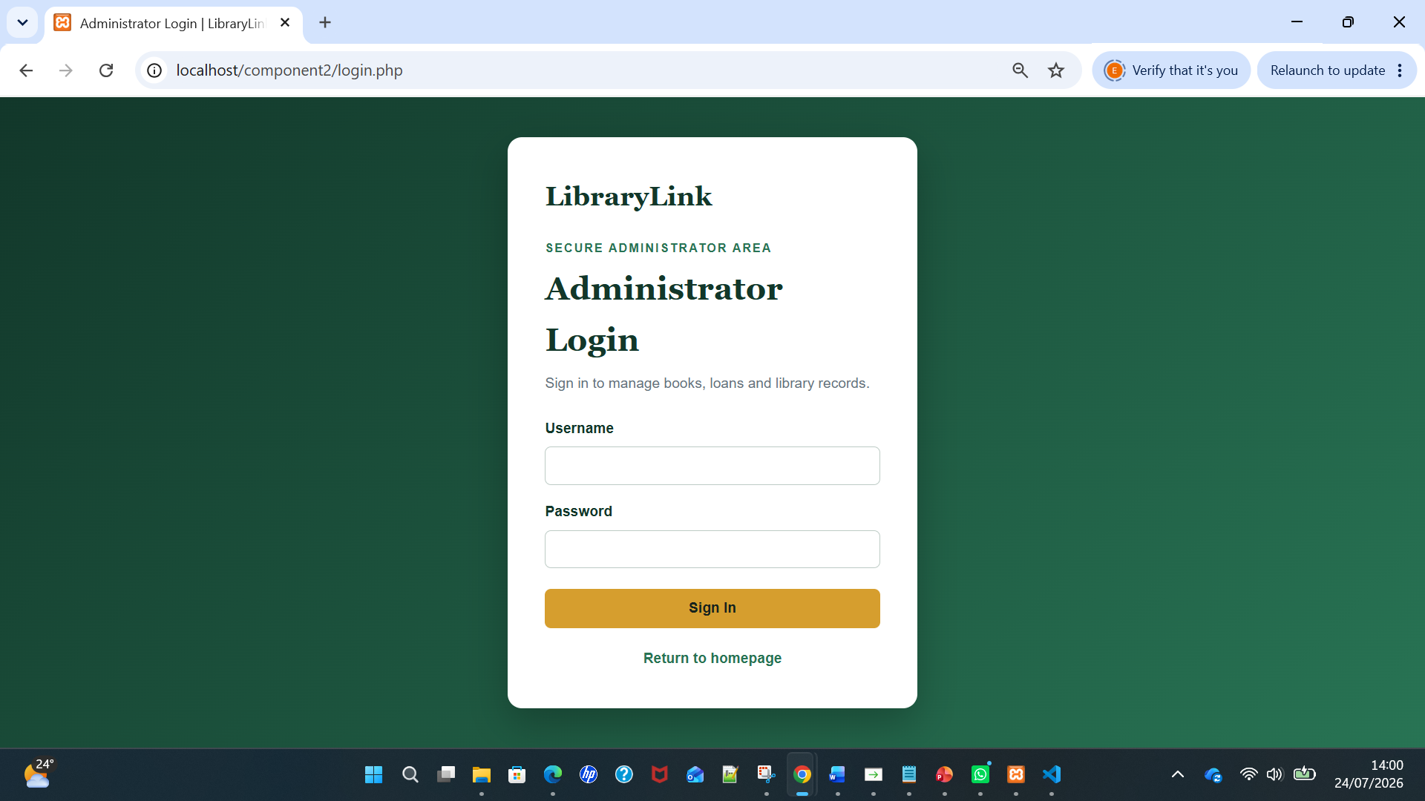
Figure 11: Unauthenticated attempt to access the protected Add Book page redirected to the administrator login.

Add Book function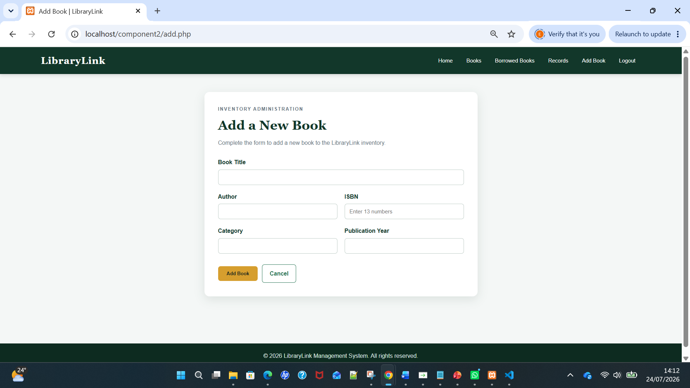
Figure 12(a): Protected administrator form completed with details for adding a new book.
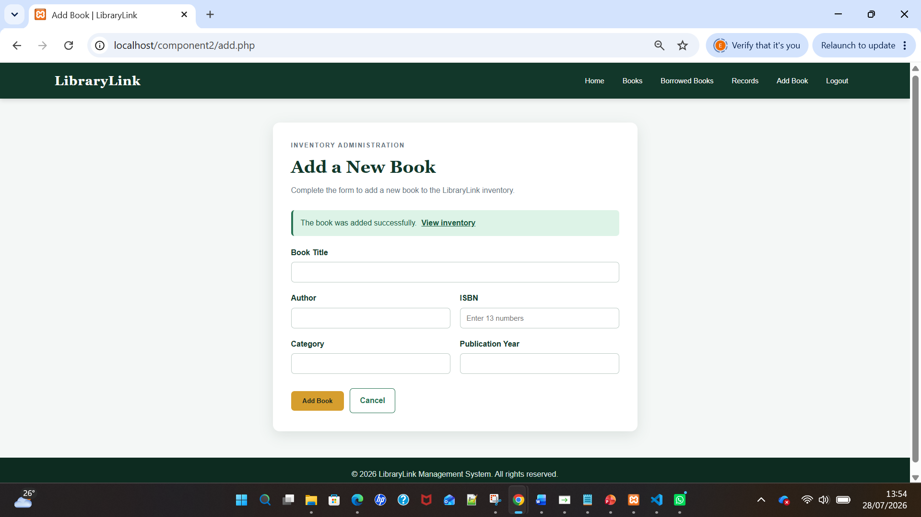
Figure 12(b): New book successfully inserted into the LibraryLink inventory with the default Available status.

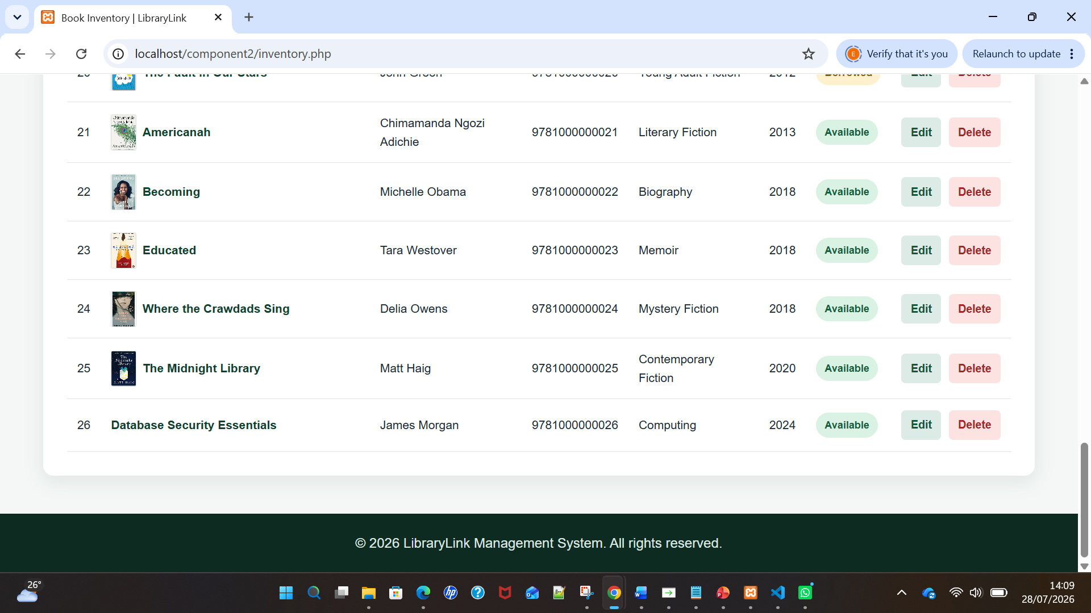
Figure 12(c): Newly added book displayed in the LibraryLink inventory with the default Available status.

Update Book Function
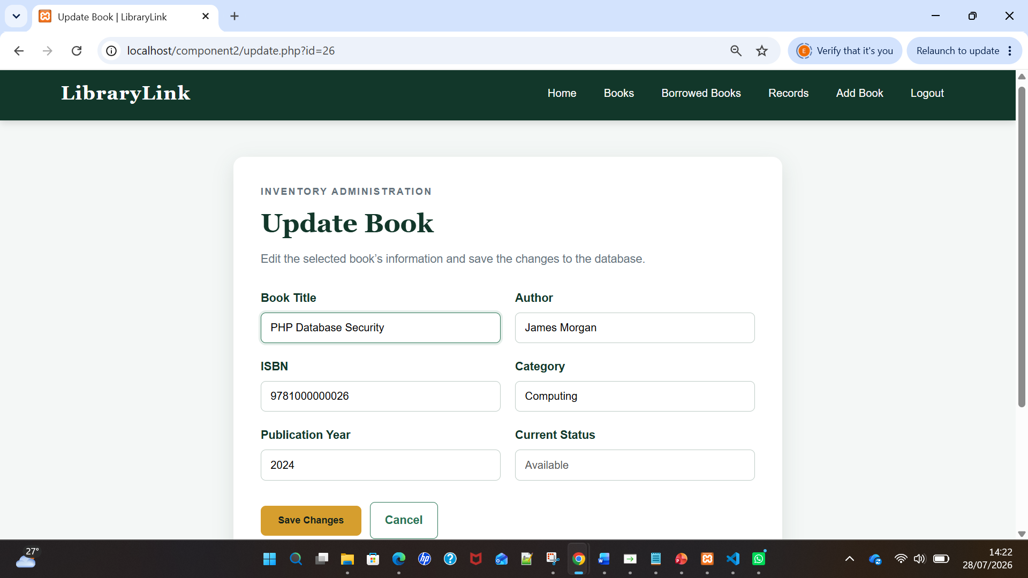
Figure 13(a): Protected Update Book form containing the amended book title before submission.

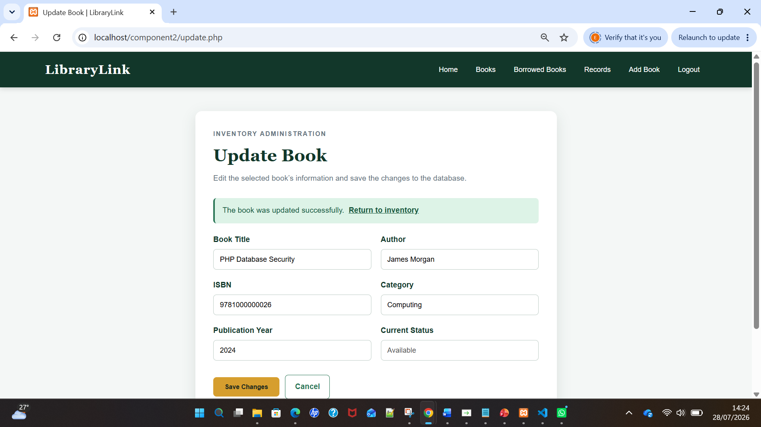
Figure 13(b): LibraryLink confirming that the book title was successfully updated to PHP Database Security.

Delete Book Function
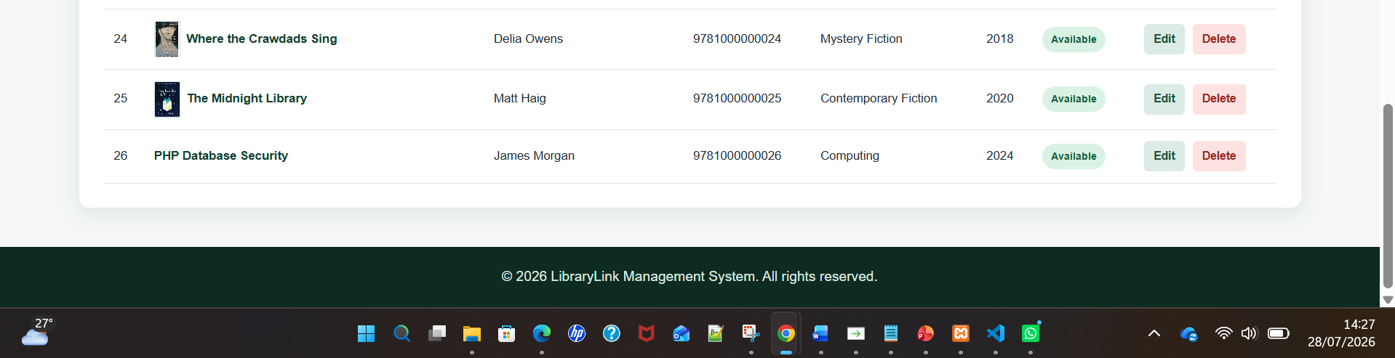
Figure 14(a): Updated temporary book record selected for deletion by the administrator.

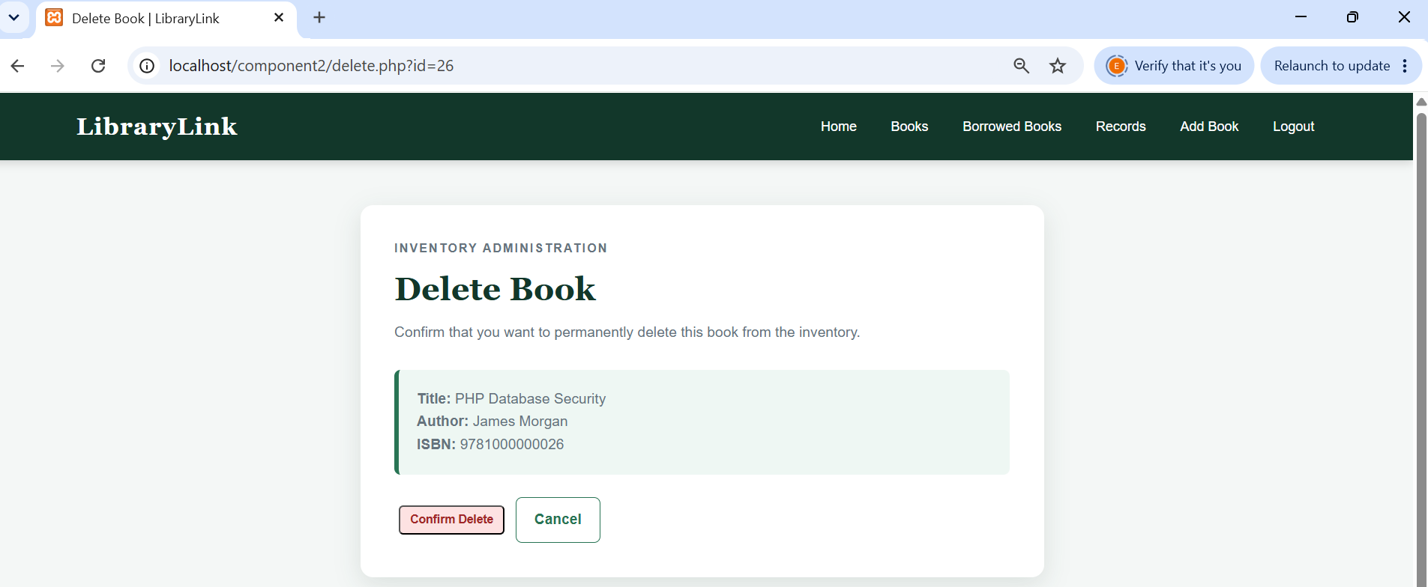
Figure 14(b): Administrator confirmation page for securely deleting the selected temporary book record.
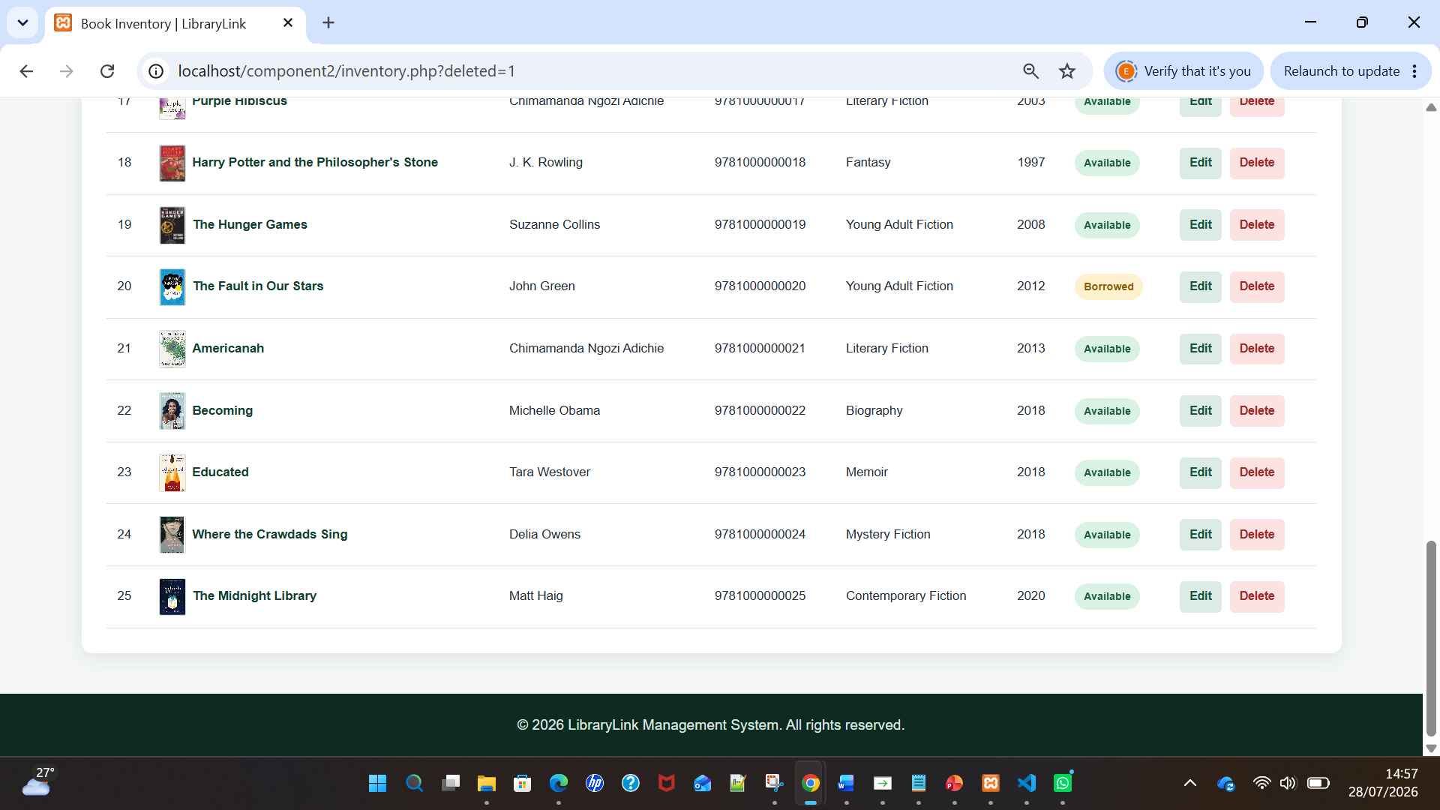
Figure 14(c): Temporary test record successfully deleted, restoring the LibraryLink inventory to its original 25 books.

Attempted Injection and Results
Testing involved entering ' OR '1'='1' -- into the LibraryLink search field and administrator login. Screenshots record the submitted payload and the website’s complete response. Controlled payload testing determines whether input can alter a query’s intended structure or behaviour [17], [18]. The search treated the payload as an ordinary phrase and returned no matching books. The login treated it as a username value, rejected authentication and displayed “The username or password is incorrect”. No database error, additional record or unauthorised page appeared. These results provide practical evidence that prepared statements prevented the tested payload from changing either SQL command [19], [20].

Limitations and Recommendations
Prepared statements do not address every security risk. LibraryLink must retain server-side validation because browser-side HTML controls can be changed or bypassed [21]. Production deployment should use HTTPS, secure session-cookie settings, CSRF tokens for state-changing requests, login rate limiting and generic error messages. The database account should receive only permissions needed for its functions, limiting damage if another vulnerability is discovered [22]. Regular patching, encrypted backups, monitoring, testing and code review are also required [23], [24]. The localhost implementation provides assignment evidence, but it should not be described as completely secure because protection depends on layered controls and continuing maintenance.

IEEE References
[1] M. Alghawazi, D. Alghazzawi, and S. Alarifi, “Detection of SQL injection attack using machine learning techniques: A systematic literature review,” Journal of Cybersecurity and Privacy, vol. 2, no. 4, pp. 764–777, 2022, doi: 10.3390/jcp2040039.
[2] A. Paul, V. Sharma, and O. Olukoya, “SQL injection attack: Detection, prioritization and prevention,” Journal of Information Security and Applications, vol. 85, Art. no. 103871, 2024, doi: 10.1016/j.jisa.2024.103871.
[3] S. Chowdhury, A. Nandi, M. Ahmad, A. Jain, and M. Pawar, “A comprehensive survey for detection and prevention of SQL injection,” in Proc. 7th International Conference on Advanced Computing and Communication Systems (ICACCS), Coimbatore, India, 2021, pp. 434–437, doi: 10.1109/ICACCS51430.2021.9442012.
[4] N. Cahyadi, S. N. Yutia, and P. Dorand, “Enhancing SQL injection attack prevention: A framework for detection, secure development, and intelligent techniques,” Journal of Informatics and Communication Technology, vol. 5, no. 2, pp. 138–148, 2023, doi: 10.52661/j_ict.v5i2.233.
[5] L. Erdődi, Å. Å. Sommervoll, and F. M. Zennaro, “Simulating SQL injection vulnerability exploitation using Q-learning reinforcement learning agents,” Journal of Information Security and Applications, vol. 61, Art. no. 102903, 2021, doi: 10.1016/j.jisa.2021.102903.
[6] Å. Å. Sommervoll and L. Erdődi, “Simulating all archetypes of SQL injection vulnerability using reinforcement learning,” International Journal of Information Security, vol. 23, pp. 1329–1350, 2024, doi: 10.1007/s10207-023-00738-3.
[7] J. Irungu, S. Graham, A. Girma, and T. Kacem, “Artificial intelligence techniques for SQL injection attack detection,” in Proc. 8th International Conference on Intelligent Information Technology (ICIIT ’23), Da Nang, Vietnam, 2023, pp. 38–45, doi: 10.1145/3591569.3591576.
[8] N. D. Bobade, N. V. Dharwadkar, and A. S. Rajput, “A diligent survey of SQL injection attacks, detection and prevention techniques,” in Proc. 2024 IEEE International Conference on Contemporary Computing and Communications (InC4), Bangalore, India, 2024, pp. 1–6.
[9] D. Parashar, L. M. Sanagavarapu, and Y. R. Reddy, “SQL injection vulnerability identification from text,” in Proc. 14th Innovations in Software Engineering Conference (ISEC 2021), Bhubaneswar, India, 2021, pp. 1–5, doi: 10.1145/3452383.3452405.
[10] J. Xu, K. Zhang, and Y. Wang, “Overview of SQL injection attack detection techniques,” in Proc. International Conference on Computer Science and Artificial Intelligence, 2023, pp. 281–287, doi: 10.1145/3640912.3640956.
[11] M. C. Wijaya, “Security analysis of SQL injection attacks on multimedia and journal-services sites using concatenated input validation and parsing method,” Ingénierie des Systèmes d’Information, vol. 29, no. 5, pp. 1841–1848, 2024, doi: 10.18280/isi.290523.
[12] A. G. Kakisim, “A deep learning approach based on multi-view consensus for SQL injection detection,” International Journal of Information Security, vol. 23, no. 2, pp. 1541–1556, 2024, doi: 10.1007/s10207-023-00791-y.
[13] J. Duckett, PHP & MySQL: Server-Side Web Development. Hoboken, NJ, USA: Wiley, 2022.
[14] R. Nixon, Learning PHP, MySQL & JavaScript, 7th ed. Sebastopol, CA, USA: O’Reilly Media, 2025.
[15] A. Sajadi, B. Le, A. Nguyen, K. Damevski, and P. Chatterjee, “Do LLMs consider security? An empirical study on responses to programming questions,” Empirical Software Engineering, vol. 30, no. 4, Art. no. 101, 2025, doi: 10.1007/s10664-025-10658-6.
[16] M. Jamdade and Y. Liu, “A pilot study on secure code generation with ChatGPT for web applications,” in Proc. 2024 ACM Southeast Conference (ACMSE ’24), Marietta, GA, USA, 2024, pp. 229–234, doi: 10.1145/3603287.3651194.
[17] M. Alghawazi, D. Alghazzawi, and S. Alarifi, “Detection of SQL injection attack using machine learning techniques: A systematic literature review,” Journal of Cybersecurity and Privacy, vol. 2, no. 4, pp. 764–777, 2022, doi: 10.3390/jcp2040039.
[18] Å. Å. Sommervoll and L. Erdődi, “Simulating all archetypes of SQL injection vulnerability using reinforcement learning,” International Journal of Information Security, vol. 23, pp. 1329–1350, 2024, doi: 10.1007/s10207-023-00738-3.
[19] N. Gandhi, J. Patel, R. Sisodiya, N. Doshi, and S. Mishra, “A CNN-BiLSTM based approach for detection of SQL injection attacks,” in Proc. 2021 International Conference on Computational Intelligence and Knowledge Economy (ICCIKE), Dubai, United Arab Emirates, 2021, pp. 378–383, doi: 10.1109/ICCIKE51210.2021.9410675.
[20] Y. Zhang, Z. Jiang, X. Cheng, H. Wu, S. Lou, and Y. Wang, “A method of SQL injection attack detection based on large language models,” in Proc. 2024 2nd International Conference on Computer Network Technology and Electronic and Information Engineering (CNTEIE), 2024, pp. 154–158, doi: 10.1109/CNTEIE66268.2024.00035.
[21] D. Muduli, S. Shookdeb, A. T. Zamani, S. Saxena, A. S. Kanade, N. Parveen, and M. Shameem, “SIDNet: A SQL injection detection network for enhancing cybersecurity,” IEEE Access, vol. 12, pp. 176511–176526, 2024, doi: 10.1109/ACCESS.2024.3502293.
[22] Y. Guan, W. Zhou, H. Wang, and L. Lin, “Feature fusion-based detection of SQL injection and XSS attacks,” in Proc. 2024 5th International Conference on Information Science, Parallel and Distributed Systems (ISPDS), Guangzhou, China, 2024, pp. 351–355, doi: 10.1109/ISPDS62779.2024.10667632.
[23] A. Paul, V. Sharma, and O. Olukoya, “SQL injection attack: Detection, prioritization and prevention,” Journal of Information Security and Applications, vol. 85, Art. no. 103871, 2024, doi: 10.1016/j.jisa.2024.103871.
[24] A. G. Kakisim, “A deep learning approach based on multi-view consensus for SQL injection detection,” International Journal of Information Security, vol. 23, no. 2, pp. 1541–1556, 2024, doi: 10.1007/s10207-023-00791-y.

Appendices



