

Assignment Title: Managing Projects in the Organisation
Programme: BA Leadership and Management Skills for the Workplace

Student Name: Mahmuder Rahaman
Student ID: 1605850
MODULE: BMSK 5004
Lecturer name: DR Rexon Nting

Table of Contents
Introduction 3
A critical assessment of the usefulness of project management tools and techniques. 4
Project management tools and techniques and their usefulness for managing a project within my organisation. 4
How projects are carried out in my workplace accepted methodology. 5
Development of a table of criteria which allows me to assess several project management approaches for my organisation. 7
Demonstrating my understanding of PM tools and techniques by explaining why each tool and technique may be appropriate (a good fit) or not for my workplace 8
Looking to draw upon some recognised project tools/techniques 12
Critically evaluation of my ability to manage a project 18
Personal strengths and weaknesses of mine to manage a project 19
Creating a self-development plan to improve my performance in managing projects supported through questionnaires. 20
Conclusion 22
Reference 23

Introduction
Project Management is not regular activities of any organisation, but things are not like that to manage a project, the organisation need a separate type of manager. The project is any irregular activists of an organisation that needs to perform for financial or any other gain of the organisation. Project management needs various tools, techniques and planning tools to make the project more successful. The manager who is to manage a project needs to have propjet management skill with many other managerial skills. However, in reality, certain projects are successful not all the project, and in those successful projects, the project manager has specific characteristics which are very much helpful and needed for any project. Church’s is a high-end English footwear producer which always invest in research and development program to bring innovation on their product. So, not this company is trying in launce new shoe which will be called as summer shoe and special feature of this shoe will be it will reduce the effect of hit in summer. To reduce the effect of hot in summer this shoe will be very helpful.

A critical assessment of the usefulness of project management tools and techniques.
In every organisation and every project like launching of new summer shoe use, various kinds of project management tools and techniques here are some use of those tools and techniques …
Estimating, Planning and Tracking: Various project management tools like Gantt charts, bar charts, Work Breakdown Structure, project budgets helps the project manager to estimate and to plan efficiently which is very much helpful for allocating resources in the project.
Assigning and Scheduling Resources: Like for example project management tools and techniques like grant chart, task assignments, project plans, linear programming help organisation like Church’s to identify and manage the critical path of the project and schedule the available resources of an organisation to work with those critical paths. Moreover, if the management of the project can assign and schedule resources, they can use those to bring success (Leach, 2004).
Break down the project: Various tools like WBS, project life cycle Metrix, Stakeholder analysis, PERT Chart, Program evaluation and review help the project manager to break down all the work and to continue many tasks at the same time and to assemble those when needed.

Project management tools and techniques and their usefulness for managing a project within my organisation.
Like for example as a project manager of Church’s I need to use various tools and techniques, and I use them because these tools and techniques bring the following benefit for my organisation and me.
Gantt charts: This tool of project management help my organisation to make a project schedule and to bring all of the activities on a single page. Moreover, this enables me to identify the critical path and to manage those critical paths to make the project more reliable and error free.
PERT Chart: I use this tool greatly for my project, and this tool helps me to schedule, organise, and coordinate tasks within my project and this tools also help me to estimate the time necessary to complete the project.
Linear programming: This is a statistical tool used to evaluate the benefit from the specific project so, almost in all the project I use this technique to budget and cost-benefit analysis. Moreover, this technique converts all the business problem into a mathematical program which brings quantitative result (Roberts, 2011).
Work Breakdown Structure: This enables me to break most of the critical activities into the parts, and I can reschedule any work if needed. So, I use these tools to schedule and run separate job altogether which enable me to maximise the use of our resources.
Prince2: In this technique, the total project is divided into multiple levels and stages as this is a quite a well-put methodology and enable the project manager to take necessity steeps to complete all the work related with the project.

How projects are carried out in my workplace accepted methodology.
According to Heerkens, (2015) project in any organisation can be defined as the unique process of activities with particular time frame undertake to achieve particular objective where there are various constraints like constraints of time, cost, quality and resources. However, to carry out any project we need to follow certain procedures.
Project Set-up: In this steep management of the organisation feels the need for the project and define the scope and objectives of the project. Moreover, in this stage Project Management Plan by evaluating risk, cost and required resources are also done by the project manager.
Work Breakdown Structure: Leach (2004) define it like as WBS is a hierarchical, from general to specific tree structure of deliverables and tasks that need to be performed to complete a project. Moreover, by using it, we divide all job of the new project of Church’s into a work package, and we can create a separate plan for those packages.
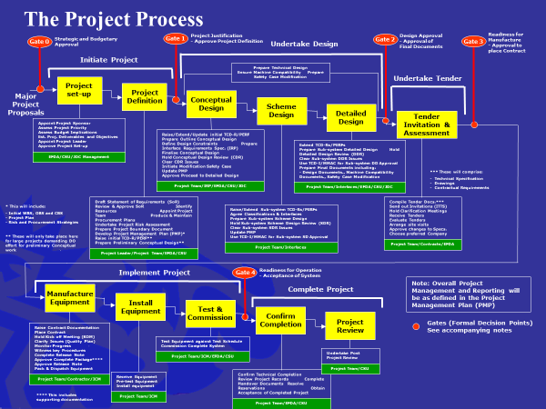
Figure- Process of Project Management
Design: In this stage, we conceptualise our project design, and after analysing from a different perspective we invade tender and assessment. We use various tools and techniques to analyse the project like grant chart, part chart and so on (Roberts, 2011).
Manufacture equipment: Like for example to produce new summer shoe Church’s may need to introduce new production equipment or it may happen that a may need to redesign the manufacturing activities.
Install equipment: In this stage, we try to install all our equipment in our core production side, and that equipment is used in our desired project. For example, to produce new summer shoe we need to install new production equipment in the production activity.
Confirm complication and project review: After all the elements are fully operational, we measure the progress of our project like for example we measure how work is doing in respect to the projected plane. If we find any big desperation in the critical path of our project, we take steps to reduce it. We also review the progress against schedule, cost against budget using WBS and arrange regular meetings with contractors to see progress reports and inspections overall activities ( Heerkens, 2015).

Development of a table of criteria which allows me to assess several project management approaches for my organisation.
Project management approaches | Criteria | Organisational culture
Phased Approach | The project must be breakable into a series of stages, and use of good planning and control techniques is required in this approach. | This approach is best for a small organisation and applicable for well-defined projects. As this approach is very challenging needs to run many works together, the project manager needs to have the high skill of project management.
Lean Project Management | This approach fallows the principles of lean manufacturing like Six Sigma. As this system fallow, A3 Problem Solving method project manager needs to be highly skilful in those areas. However, generally, this approach is applicable in a big company like in Tata, Ford’s where robotic production system exists (Roberts, 2011). | An organisational culture which wants to decrease and to minimise waste and reduce the time of production use this approach. Moreover, this approach allows an organisation to produce high value by reducing non-value-added activities.
Critical Chain Project Management | In this approach project constraints and uncertainties are taken seriously by the management of the project, and some of the activities are valued as a critical path. This approach uses the latest statistical measurement tools and linear programming model to finish the project, and Dr Goldratt’s Theory of Constraints is fallowed in this approach. | An organisation which wants to use their maximum amount of resources to finish the project using this approach.
Process-Based Management | In this overall approach, the project is considered a single task and project manager try to finish the project like as day-to-day operations. PRINCE2 is a good example of a process-based approach (Buttrick, 2009). | An organisation which wants to only invest in productive project use this approach. As in this approach, only those project are taken which can add value to the company’s general goals and objectives.

Demonstrating my understanding of PM tools and techniques by explaining why each tool and technique may be appropriate (a good fit) or not for my workplace
PM tools and techniques are needed to execute a project success for any organisation so, in my organisation, we use various tools and techniques which add value for our project. Here are some of those tools and techniques used in my organisation.
Widely-used Project management techniques
Agile: Most of the people know this technique as sprint approach where the project of my organisation is a break in the format of sprints or cycles. In my workplace, this technique is very much appropriate as it enables me to bring flexibility and collaboration all over the activities. However, this technique needs frequent communication and team-work to be more responsive to changes.
Waterfall: This method works like a sequential so, in this method, the next task gets started only when the previous one is done. Like for example in the Software Development Life Cycle, all the development activities need to be done sequentially (Wheelock and Dahandeh, 2016).
Prince2: In my organisation, we use this technique where we divide all the task from multiple levels and stages, and all of the levels need a certain set of steps for execution. In this technique, all the activities related to the project are kept on a controlled environment.

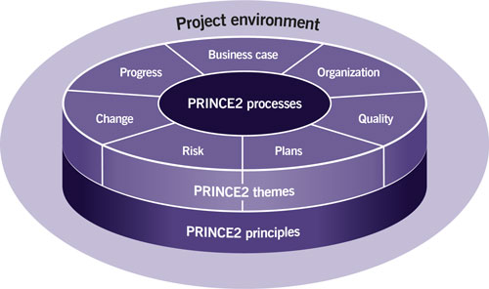
Figure- PRINCE2
Critical Chain Methodology: This methodology ensures that the project plan is feasible enough and completed on time by keeping all the resources level. So, in my organisation, we use this technique to complete the task in time by using all the resources allocated in the project.
Project Management Tools
ProofHub: This is a computerised project management tools used by many famous organisations like NASA, Disney, Taco Bell which enable the project manager to use Gantt charts and mobile application and something like that with limited cost.
Zoho Projects: This is a free online project management tool used by my organisation as it enables us to plan, track, and collaborate in an easy manner. This application enables us to reduce human error so, besides traditional tool we use it as a helper.
Gantt chart: This tool is very useful for my organisation as it enables us to break a large project into a sequence of minor tasks. So, these tools also enable us to run separate work together by managing the critical path. We use this tool as it also enables us to identify the subtask and time management of each task by presenting a visual overview of the project.
WBS Chart: My organisation has a good competency to run separate small work of a project so, we use this chart which helps us to divide the task into many subtasks and by evaluating critical path we manage the allocation of our resources.
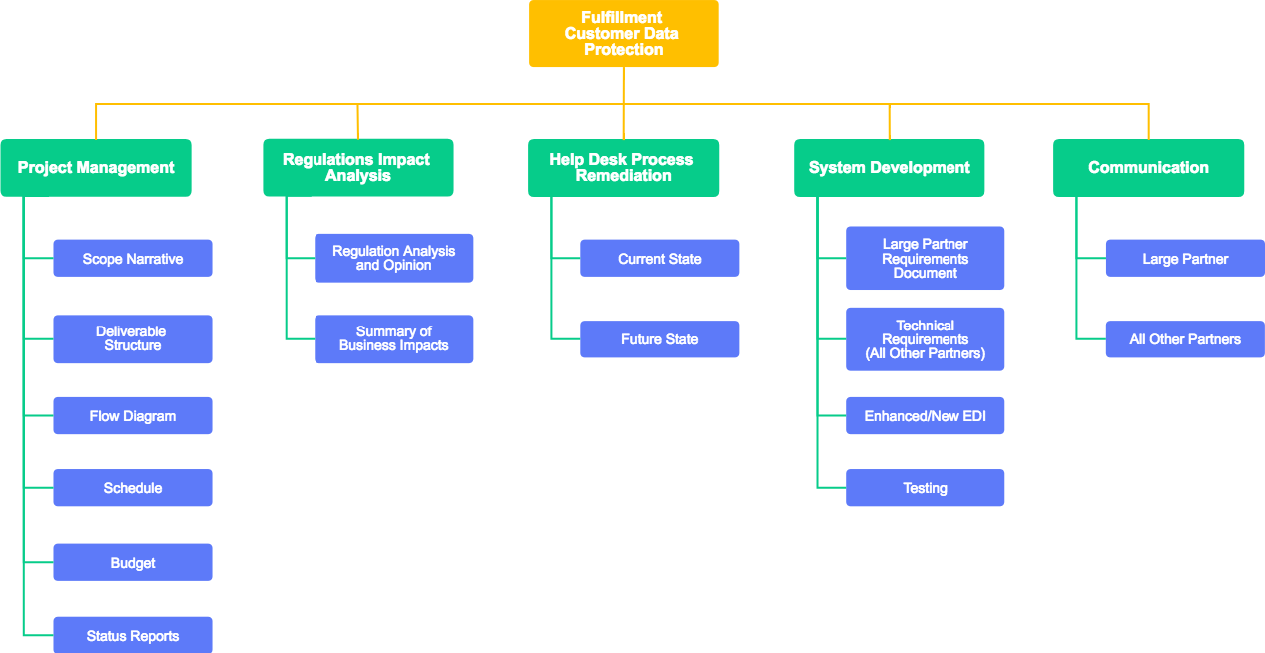
Figure- WBS Chart
Plan the implementation of a project within the workplace.
To Implement any project the project manager of the organisation needs to follow certain steps and rules and procedure. Project implementation starts with project selection and approval. Moreover, the project manager needs to evaluate many things like risk, resource constant and many other elements associated with the project. So, it will be better to start with project selection and approval (Buttrick, 2009).
Project selection
Strategic planning: The Desired project need to be aligned with the strategy, goals and objectives of the organisation; otherwise the project may fail or less productive. Like for example project of the retail organisation need to be anyhow related to the retail activities (Amiri, 2010).
Business area analysis: The existing business process of my organisation need to be supported and associated with the outcome of the project. Like for example project of improving manufacturing activities may increase sales and manufacturing.
Project planning: The overall project plane needs to address the organisational strategies of the parent organisation like for example the strategy of the organisation and strategy of the project need to achieve the same objective.
Resource allocation: Organisation needs to have all the resources need to execute the project like for example if an organisation implant to send a rocket in the moon then it must need to have resources for it.
Selection Methods
To select a project from the alternatives, an organisation can use various selection methods that will help them to evaluate the effectiveness of the project.
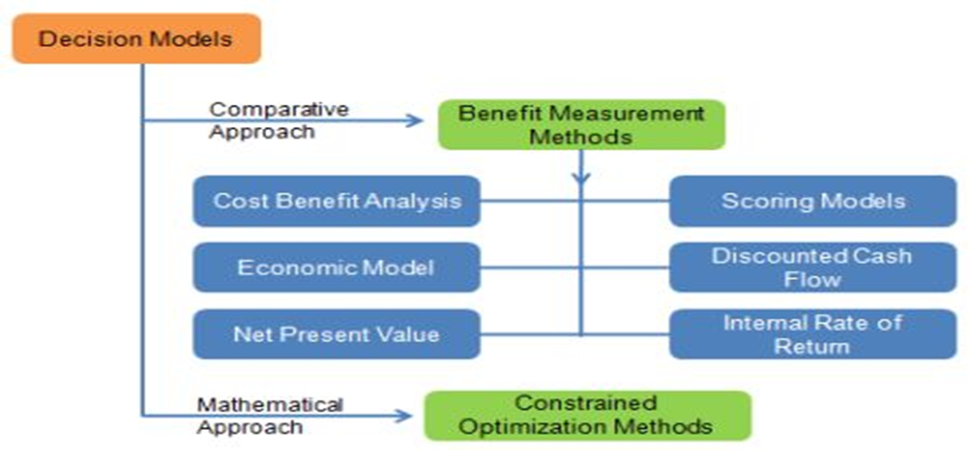
Figure- Selection Methods used by the organisation (Vinodh, Ramiya and Gautham, 2011).
Benefit Measurement: To select a project organisation try to evaluate the financial and non-financial gain of them for which they use various measurement tools like cost-benefit analysis, net present value, return on investment and many other financial measurement tools.
Constrained Optimization methods: As stared earlier that every project has some constant but organisation try to optimist those constant related to the project. To allocate resources in the project of the organisation, this method is very helpful for my organisation (Amiri, 2010).
Project Communications Management
It is the strategy of my organisation to establish good communication with all stakeholders of this organisation (Pritchard, 2013). Moreover, to manage communication with all we use some strategy which is like…
Communications planning: In this stage, the project manager feels the communications needs and collect the information to communicate with all. Here in this project information may be the objective, scoop and benefit of the project.
Information distribution: Our communication strategy always ensures that all the information need to supply promptly so, all the project data need to be provided promptly to all the stakeholder.
Performance reporting: Performance information is very important so, project manager collect and disseminate performance of all the related in the project (Pritchard, 2013).
Administrative closure: To formalise phase or project completion project manager need to frequently generate, gather and distribute project related data.

Looking to draw upon some recognised project tools/techniques
Planning
Like for example Church’s want to undertake a new project to launch their new product summer shoe. So, the objective of this project is to increase the product line of this organisation. This new product will bring comfort to the user because this shoe is designed in this way. As there is no same product like this show this will help Church’s to create competitive advantages.

Project plan milestones
Lientz and Rea (2007) stated that a project milestone is a management tool that is used to delineate a point in a project schedule. With the help of project milestone, we can manage the constant related with the time of the project of Church’s.
Key milestones | Start date | End date
Market analyses to see the requirement | 01-April-2019 | 15-April-2019
Report exhibition | 17-April-2019 | 20-April-2019
Selecting Available raw-materials | 21-April-2019 | 30-April-2019
Communicating with vendors for raw-materials | 01-May-2019 | 20-May-2019
Deal with the vendors | 21-May-2019 | 25-May-2019
Constricting Resources for the project | 26-May-2019 | 28-May-2019
Implementing resources | 01-June-2019 | 10-Jun-2019
Start the project | 15-Jun-2019 | Continue

Project appraisal techniques
Now to evaluate the profitability of the project this organisation can use various techniques they will enable it to bring quantitative measurement of IT project (Harris, 2017).
Payback period: Like for example, the overall project has the initial cost of £200000 and the life cycle of the project is six years. There is some variables expense related to this new production system this also need to concede while decision making.
Year | Return (In £) | Cumulative Return (In £)
1 | 20000 | 20000
2 | 50000 | 70000
3 | 100000 | 170000
4 | 85000 | 255000
5 | 55000 | 310000
6 | 40000 | 350000
So, from this table we see in year four all the initial investment come back so, year 4 is the payback year for this project.

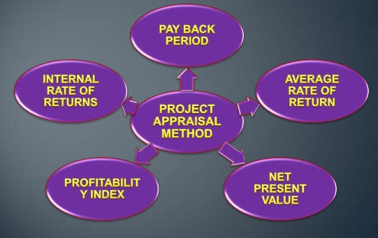
Figure- Project appraisal techniques
Profitability Index: This show us how much profit is gained in respect to the cost of the project and here is a profitability index for this project of my organisation (Battisti and Campo, 2019).
Return
Year | Return (In £)
1 | 20000
2 | 50000
3 | 100000
4 | 85000
5 | 55000
6 | 40000
Cost
Initial Cost | £200000
Maintenance Cost | £10000
Other Cost | £20000
Benefit | £120000

Risk analysis
Meredith and Mantel (2009) stated that project risk management is the art and science of identifying, analysing and responding to risk throughout the life of a project and in the best interests of meeting project objectives.
Quantitative risk analysis: This type of risk is accosted with the quantitative risk presenting or measuring in numerically data like for example in our project we have a potentiality to lose our initial investment which is £200000, and this is the maximum risk in this method.
Planning risk responses: This type of risk is like the reduction of the opportunity of related with the project like for our project we have a potentiality to be unable to income as planned like in year one we may fail to generate £20000.
Stakeholder Analysis
Stakeholder of our project is anyone who has an interest in the outcome of our project that may be affected by it positively or negatively.
High importance /low influence: Like for example shareholder, the credit provider is this type of stakeholder for Church’s and from the project, we must need to generate a certain amount of income to meet their interest.
High importance/high influence: Like for example the staff of this organisation are this type of stakeholder so, the project manager needs to develop a good working relationship with them as they can significantly influence the project (Eskerod and Jepsen, 2016).

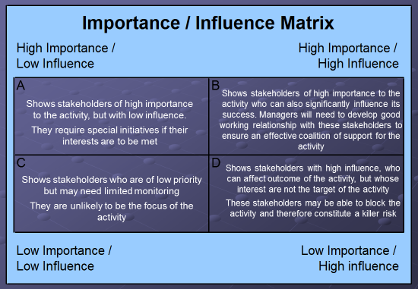
Figure-Influence Matrix of Stakeholder Analysis (Eskerod and Jepsen, 2016).
Low importance /low influence: Like for example external auditor, the competitor is this type of stakeholder, and as a manager of this organisation, I need to monitor them although they have a limited influence on the project.
Low importance /high influence: Like for example government, local authority, policy and procedure, the regulatory authority is part of this stakeholder, and all of these parties can affect the outcome of the project.
Gantt chart
This chart will work as evidence of implementing the project plan and monitoring progress and agreed on targets of my project. Here is a Gantt chart for my project.
Key milestones | April |  |  | May |  |  | June
Market analyses to see the requirement
Report exhibition
Selecting Available raw-materials
Communicating with vendors for raw-materials
Deal with the vendors
Constricting Resources for the project
Implementing resources
Start the project
From this Gantt chart, we see that our project starts from the 1^{st of} April and end on 10th June of this year.
Work breakdown structure (WBS)
Harrison and Lock (2017) said about Work breakdown structure that it is to make a large project more manageable by breaking it down into smaller chunks means work can be done simultaneously by a different team.

Project execution
Project plan
Project initiation
Start

End
Project closure

Figure- Work breakdown structure for IT project

Now, our project is successfully executed with the help of various tools and techniques so; it is the responsibility of the manager to communicate with the other parties of the organisation.
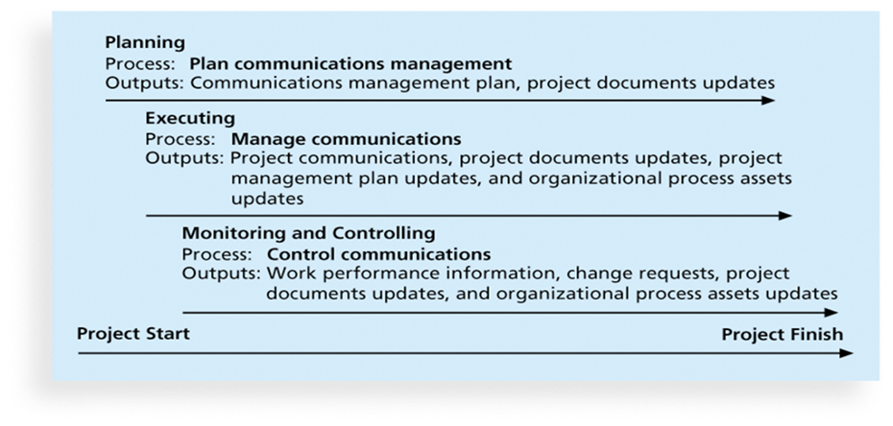
Manage Communication: After successful execution of the project now manager needs to communicate with a project update, update on the plan and if any update is bringing in the overall process of the business activity of Church’s.
Control Communication: This communication is needed in monitoring and controlling of the project so, here in our project we need to make all the parties in Church’s, update about the work performance of the project with a change request and project documents update (Binder, 2016).

Critically evaluation of my ability to manage a project
As I want to be an effective project manager, I have developed some skills in different areas which I think greatly help me to become a successful project manager.
Leadership Skill: I am with the same opinion with Darsø (2016) that as a leader, I need to be able to clearly and succinctly explain to my employees everything from organisational goals to specific tasks. I have developed this skill from the beginning of my student life. I think this skill will able me to motivate, understand my employees and welly communicate with them.
Communication: This skill is needed in every phase of the project to make everyone known about the progress of the project, and I think my communication skill will enable me to understand all the activities related with my project.
Planning Skills: This skill will enable me to use appropriate tools and techniques to plan for my project and as I can use various planning tools like Gantt chart, Pert chart to plan for any project.
Time Management: In most of the case time in the project is constant so, as a project manager I need to use time effectively and efficiently. Proper time management skill is needed to use available time more effectively.
Risk Management: There is various kind of risk associated with any project, and I need to use good tools and techniques to measure those risk and to take corrective action to minimise those risk.
Negotiation Skills: To me, project management is like politics, where competing interests exist, and one party need to lose where another gain. So, I think excellent negotiator will be able to gain from any negotiation process (Shirley, 2016).

Personal strengths and weaknesses of mine to manage a project
Here are some of my strengths and weaknesses which will affect my career as a project manager...
Personal Strengths
The creativity of my will able me to innovate a new way to manage my job as a project manager.
Flexibility in all of my activities will allow me to be more responsive to changes and as I am focused on my duty, I will be able to manage all the task in timely (Cameron and Green, 2015).
Honesty and self-control will make me more acceptable to all so, I think I will able to influence others more.
Continuous learning will able me to cope with the changing issues related to project management, and my dedication will accelerate this process.
Personal weaknesses
Self-criticism of mine prevents me from to look at my successes objectively and celebrate my wins.
Too much sensitive work negatively on me like while public speaking I feel shame and my presentation skill is not good enough.
I always fail to bring creativity on writings as I am often detail oriented.

Creating a self-development plan to improve my performance in managing projects supported through questionnaires.
Step 1:
Important goals that I want to achieve for my performance in managing project:
- Increase my time management skill,
- Control on my emotion
- Increase my competency to use the latest technological equipment
- Increase my presentation skill
- Goal power activities
- To bring creativity in all parts of life

Step 2:
Out of all goals, I think to increase my competency to use the latest technological equipment in project management is very important.
Step 3:
How long time I will take to reach this goal? 3 Month
Do I commit 100% to achieve this goal: ☒YES ☐NO
The reward I want to offer myself once I successful to achieve this goal: I will go for a world tour.
Step 4:
Strengths in my eye I have that will help me to attain this goal of my life:
- I am open to new learning.
- I am very much committed to achieving this goal.
- I can use various technology now even most of those can be used in project management.
Step 5:
Things I select to start doing and stop doing that will greatly help me to attain my goal:
START DOING | STOP DOING
1. Reading It related journals regularly.  2. More open on information technology.  3. I need to try the use of ERP software for my organisation.  4. I need to use a smartphone for my daily use. | 1. I must not averse from to use IT in my daily activities.  2. I must not protest on the implementation of IT in our office activities.  3. I must not rely only on the traditional file system for my project management.
Step 6:
Which new skills/knowledge will assist me in attaining my goal?
1. Knowledge of ERP and enterprise system software.
2. Time management skill will help me to invest my time to achieve this goal.
3.Open to new and continuous professional development.
4. I need to be more realistic, results-based, time-sensitive, motivating, sensible in my personal and professional life.
Step 7:
Which activities do I need to take to attain this goal?
Action 1: Attending an IT related seminar regularly.
Action 2: Reading IT journal regularly.
Action 3: Trying to learn new technology and use of those in my activities.
Step 8:
Who can I make all of those faster to achieve this goal?
I need to be more dedicated and hopeful to achieve that goal and more realistic will make to understand the requirement of this goal in my life.
Step 9:
My development:
The development should be monitored over the period of such development and any corrective measure should be taken into account regarding the facts that which things are working well and which things are not along with the appropriate reasons.

Conclusion
Managing project needs some dedicated and skilful project manager who will love project management and do their best to bring excellence in the project. In every year many projects fail because of poor management and poor management is for an unskilled manager in most of the cases. But now we see there are various types of IT-based project management software for helping to manage any project. But most of those tools are paid software platform for which project implementation cost may rise and if manager fails to use the software it will accelerate the overall failure of the project.

Reference
Amiri, M. P. (2010). Project selection for oil-fields development by using the AHP and fuzzy TOPSIS methods. Expert systems with applications, 37(9), 6218-6224.
Battisti, F., and Campo, O. (2019). A Methodology for Determining the Profitability Index of Real Estate Initiatives Involving Public–Private Partnerships. A Case Study: The Integrated Intervention Programs in Rome. Sustainability, 11(5), 1371.
Berkun, S (2008) Making Things Happen: Mastering Project Management (Theory in Practice) O'Reilly
Binder, J. (2016). Global project management: communication, collaboration and management across borders. Routledge.
Buttrick, R. (2009). The Project Workout: The Ultimate Handbook of Project and Programme Management. 4th ed. Harlow, England: Financial Times/Prentice Hall.
Cameron, E., and Green, M. (2015). Making sense of change management: A complete guide to the models, tools and techniques of organizational change. Kogan Page Publishers.
Darsø, L. (2016). Artful inquiry as a leadership skill. The Art of Management and Organisation.
Eskerod, P., and Jepsen, A. L. (2016). Project stakeholder management. Routledge.
Harris, E. (2017). Strategic project risk appraisal and management. Routledge.
Harrison, F., and Lock, D. (2017). Advanced project management: a structured approach. Routledge.
Heerkens, G. (2015). Project management (A briefcase book). New York: McGraw-Hill.
Leach, L. (2004). Critical chain project management. Artech House effective project management series. Boston, Mass. ; London: Artech House.
Lientz, B., and Rea, K. (2007). Project management for the 21st century. Routledge.
Meredith, J. and Mantel, S. (2009) Project Management: A Managerial Approach, Asia: John Wiley and Sons
Pritchard, C. (2013). The project management communications toolkit. Artech House.
Roberts, P. (2011). Effective project management. London, UK Philadelphia, PA: Kogan Page. <http://www.tsd.ac.uk/en/lrc/onlineresources/e-books/> (Accessed 21March 2013)
Shirley, D. (2016). Project management for healthcare. CRC Press.
Vinodh, S., Ramiya, R. A., and Gautham, S. G. (2011). Application of fuzzy analytic network process for supplier selection in a manufacturing organisation. Expert Systems with Applications, 38(1), 272-280.
Wheelock, D. W., and Dahandeh, S. (2016). U.S. Patent No. 9,251,844. Washington, DC: U.S. Patent and Trademark Office.

