Police perception
Why are so many officers leaving the police and what roles lead to police attrition rates
By student Iestyn Roderick
Student Id: 2236342

Declaration
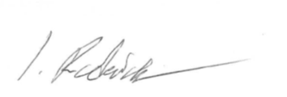
This work has not previously been accepted in substance for any degree and is not being concurrently submitted in candidature for any degree.
Signed:
Date: 18/11/25

Statement 1:
This dissertation is being submitted in partial fulfilment of the requirements for the degree of BSc Policing and Criminology.
Signed:
Date: 18/11/25

Statement 2:
This dissertation is the result of my own independent work/investigation, except where otherwise stated.
Other sources are acknowledged by footnotes giving explicit references. A bibliography is appended.
Signed:
Date: 18/11/25

Statement 3:
I hereby give consent for my dissertation, if accepted, to be available for photocopying and for interlibrary loan, and for the title and summary to be made available to outside organisations.
Signed:
Date: 18/11/25

Statement 4:
I hereby give consent for my dissertation, if accepted, to be available on the university’s IT system to those who have consent to use the system.
Signed:
Date: 18/11/25

Acknowledgements
I would first like to thank the staff of the university of Wales Trinity of St Davids in particular Jane Davies in regard to her assistance in giving me the guidance needed to submit this paper. I would also like to thank those that participated in the research I conducted and give thanks to my supervisor Richard Coulthart for constantly supporting me and endeavouring to show me the best of my abilities.

Lastly, I would like to thank my Mother Nia and my father Philip and my fellow colleagues who were nothing but supportive of this endeavour and the work I have conducted. I am thankful to you all beyond measure.

Abstract
The aim of this dissertation was to identify and determine the main factors associated with the increasing rates of officer attrition Uk wide. The research gathered was analysed critically and added to this piece of literature due to the relevance it provides in regard to that of factors that lead to officers choosing to resign and contributing to officer attrition rates in the Uk.
The result of this study supports the factors identified by supporting literature in the research stage but goes into greater depth as to how officers grade the listed factors in the study conducted from serving officer within South Wales Police. The factors that officers have graded have been identified as relevant factors for officer attrition and these include mental health, poor work life balance, pay and financial struggles, public perception and career advancement.

At the conclusion of the research this study has conducted it has aided in identifying and categorising the importance of the identified factors that lead to police attrition and the main causes officers have chosen to leave the police service.

Table of contents

CHAPTER 1 – Introduction
  - Background
  - Research Rationale
  - Aims & objectives
  - Structure
  - Conclusion

Chapter 2 – Literature Review
2.1 Introduction
2.2 Mental Health of officers
2.3 Pay & financial concern
2.4 Work life balance
2.5Public perception
2.6 Conclusion

Chapter 3 Methodology
3.1 Study Form
3.2 Study structure
3.3 Ethical consideration
3.4 Limitations
3.5 Conclusion

Chapter 4 Results
4.1 Introduction
4.2 Age demographic of Respondents
4.3 Gender Demographic
4.4 Officer satisfaction
4.5 Those who considered leaving
4.6 Factors for considering resignation
4.7 Rating listed factors for reasons of officer retention
4.8 Conclusion

Chapter 5 Conclusion & recommendations
5.1 Introduction
5.2 Achieving the Aims
5.3 Main findings
5.4 Recommendations
5.5 Limitations
5.6 Future research
5.7 Conclusion

Bibliography

- INTRODUCTION
The goal of this dissertation is to inquire into the rates of officer attrition Uk wide and to determine what factors are causing the increased attrition rates amongst the police service. The introduction of this dissertation will focus on the background behind this research topic and aid in answering what factors lead to an increased officer attrition rate in recent years.
1.1 Background
The (Uk Home Office,2024) shows in 2024 police attrition was 9,080 officers and indicates the second largest number of officers to have left the police to date. In addition, The Home Office (2023) reports 9,192 officers left the 43 respective police forces in the Uk during 2023. This rate is the highest rate of officer leaving the police since comparable records began.
The Police federation, (2024) survey conducted on pay and morale identified several causes for officer dissatisfaction such as pay dissatisfaction, work life balance and mental health. The National crime agency, (2023) has identified reasons for officer attrition were due to low pay and treatment by the organisation and shows reasons for the rate of officer attrition contributing to the original points raised by the police federation. Regarding public perception towards police Hoogesteyn et al, (2025) Identifies negative public perception is propelled by media coverage of high-profile incidents such as the George Floyd and the Chris Kaba shooting.

1.2 Research Rationale
Whilst several sources have been stated to be linked to public perception there is lack of understanding on how deeply these identified factors play in officers minds. The links of attrition rates are believed to be caused by one or more of these identified factors by other research parties but there is still an unknown degree to how these factors are effecting current serving officer.

1.3 Aims & Objectives
The aim of this dissertation is to identify how these factors identified by other research parties effect serving officers and the and to what degree rather than just identifying an issue this paper looks to determine the level at which officers are concerned.

- To conduct research from various recent and relevant sources and critically analyse them to understand the factors identified to be linked to attrition rates.
- To identify a clear form of independent research that can be conducted and the structure to identify the concern of officer’s have regarding identified factors.
- To then conduct research with serving South Wales police officer to identify how these factors identified affect them and how they would grade them.
- Lastly to highlight the correlation with secondary research sources and supporting literature and offer recommendations to improve this concern.
1.4 Structure
The dissertation follows the structure of an introduction providing background, reason for study and how this dissertation will be structured. The literature Review will analyse other research conducted by others into the same topic and the gaps in their research. The methodology will show the form of primary research conducted and the ethical considerations and limitation in this research. The Result will answer the exact degree identified factors affect officer and the conclusion will show the findings and offer recommendations best suited to improve areas of concern.

1.5 Conclusion
This introduction has provided the reason why this research is being conducted and has explained clearly the aims and objectives of the research that will be undertaken and highlights the way in which this dissertation will be structured. All amounting to an answer to “why is police attrition so high and what factors are to play”.

Literature Review
Introduction
This chapter of the dissertation will focus on aim 2 which is to analyse research conducted by other sources and critically analyse how they may support the reason officer attrition rate is so high. This chapter will provide literature from various sources from government bodies to open-source searches on the internet. The research will cover the factors identified by officers which would be mental health, Pay and financial difficulty, workloads and work life balance and lastly public perception. The research conducted in this chapter will then highlight the main factors plaguing officers and set a clear understand for the above-mentioned objective.

2.2 Mental Health
The first factor identified will be regarding mental health in the workplace (Bell and Eski, 2022) highlights key mental health struggles amongst officers from increased anxiety, sleep disruption and some officers suffering from post-traumatic stress. Stevelink, (2020) shows from a sample of 40,000 officers and staff found a probable PTSD prevalence of 3.9% and found that 14.5% of the sample had attending or been witness to a traumatic event in the last 6 months by the time the study was conducted. Stevelink didn’t measure officer attrition but that poor mental health amongst officers could act as an indirect factor of officer attrition. It is said that 14,500 officers have been signed off on sick for the year of 2023-2024 (Police Federation of England and Wales, 2024). Furthermore, to this a study by Brewin et al, (2020) highlights that it found at least 20% of officers across the Uk were suffering from mental health but does not highlight if these officers left or were signed off sick. When reviewing these 2 sources it’s clear to see that mental health may play a role in officer attrition. Metropolitan police federation, (2024) further helps segment that mental health and officer attrition rates are linked as a survey conducted by them indicated that mental health and work-related stresses play a major factor. Whilst Charman & Bennet, (2021) further supports this by stating occupational stresses can affect officers’ commitment to their duties. This lack or lower commitment from officers is also believed to be linked to the increased attrition rates amongst the police.

2.3 Pay & Financial concern
The next factor is that of pay and how rising financial concerns are causing officers to consider leaving the police Standen, (2025) highlights that around 24% of officers with less than 5 years of service are struggling with financial stress. They also believe that as their career continuous that their financial situation would worsen, and this is leading them to consider resigning from their respective police force. Ayad, (2024) further highlights pay concerns as their work states that out of a survey of 5,000 police staff that one in five are considering leaving the police in the next few years. When looking further into this they have found that more than half of these 5,000 respondents are not satisfied in their current role. Nanda, (2023) Indicates that 76% of officers are not happy with their pay whilst 92% of officers feel that the pay, they are given by the police doesn’t reflect the risk they face in their roles as officers. This is a clear idea that pay plays a large part in officer attrition and Police Federation, (2025) makes note to the Social market foundations finding and looks to address concern this report has raised and one key point was the restoration of police pay and to conduct and independent pay review to identify their own officers concerns over pay. This shows that Dyfed Powys police’s main findings are the concern that pay may be the driving factor for officers’ attrition.

2.4 Work life balance
A third factor identified is that of workloads and a real work life balance for police officers, the concerns of workload and the increasing amount of said workload being forced onto the average officer plays a great deal on their overall morale. Ugwu & Idemudia, (2024) Found that officers are under significant stress due to the irregular shift pattern and the last-minute shifts changes to their rota. Its also highlighted how officers feel that these shift patterns disrupt the quality of a work life balance and how this pattern interferes with family time and periods of rest and sleep cycles. Police federation, (2024) underpins the work life balance as a survey from 2,654 officers its says that 63% of officers that chose to leave cited an impact on their family. It continues by saying that officers that face irregular work hours and a lack of a work life balance in the police and this was one of the main reasons for choosing to resign. Graham et al, (2025) found that 25% of officers were considering resigning within the next year and a work-life balance was one of the main points officers provided regarding their consideration for resignation. The findings of the published report underscored the key role a good work life balance can have on officers but also how a negative work life balance can cause officers to consider resignation.

2.4 Public perception
The last them is that of public perception amongst officers Low & Evans, (2024) is an article which indicates that in England less than half the population has faith in their police for with the actual number standing at 40% of people lacked trust in their police forces. It also found that in the case of the Metropolitan police force that women were found to trust the police far less than men and this was mainly due to several scandals they were shown through the media. This is also highlighted in another demographic where Duffy & Morini, (2024) indicated that in the Gen z community those born between 1997 & 2012 had a significantly lower trust level in the police forces of the Uk than those of the Gen z community from other countries. The research conducted graded 20 countries and found that the trust and confidence these individuals have is amongst the lower third of the 20 countries.

2.5 Conclusion
In conclusion to this chapter, it has completed the first objective to gain insight into factors plaguing officer’s and to critically analyse the findings from various sources regarding police attrition rates. The chapter dictates several key factors found such as mental health, pay and financial concerns, work life balance and public perception. The analysis shows that whilst independent studies have been conducted on these factors there hasn’t been a gauging of how these factors effect officers alongside one another and to what degree officers would rate these factors when asked about them all in conjunction with one another.

3.0 Methodology
3.1 Study Form
This study has used a quantitative and qualitative research methods using a survey that would gather responses & data from officers in South Wales police. This survey is designed to gauge what officers feel are the biggest concerns in the job between the themes of pay, work life balance, mental health and public perception. The sample for this study is from active serving officers from south Wales police and was conducted anonymously to gain a random sample from the officers that have contributed to the study and revolved around me inviting 300 officers to participate on this study. Whilst 300 officers were invited to participate there were only 22 respondents assisting in the study. This survey was entirely anonymous, and the officers invited to participate come from various areas of the south Wales Police area from Rural towns to the major cities in south Wales. This way it will allow for the finding to have the perspective from different officers from different work environments due to the cities receiving a higher number of calls this could lead to find that a work life balance or mental health strain is higher amongst officers in urban areas as apposed to rural areas.

3.2 Study structure
The study has made use of both closed ended questions and gives opportunities for officers to answer how they wish to some questions. The questions have been standardised so certain trends can be seen and identified, the survey remained identical in terms of structure for officers that chose to participate. The survey is to identify and gauge factors such as work life balance, pay satisfaction & mental health & public perception. The quality review of the data received has focused on finding trends and areas that seem to connect to one another and these themes that have trends will collaborate into the overall finding and allows for identification of key areas that officers deem are important for their retention in the police. The analysis of the findings has followed that of (Braun & Clarke’s, 2006) which focuses on core aspects of data review. These points being of familiarisation, Coding, generating initial theme, reviewing the theme, defining and naming themes identified and producing the final narrative of the data analysis

3.3 Ethical considerations
The Ethical considerations for this study aimed to keep the anonymity of those that participated and limited their identity only to Rank, age and gender. This meant that officer didn’t require to provide their name and as such provides the anonymity to the study to protect officers’ individual identities. The survey was open for any person to withdraw at any time, and the result were stored in line with ethical standards and government regulations. This would also safeguard officers that participated as several of the question regarding mental health and work stresses can be deeply personal to answer and as such their anonymity allows them to not be concerned as to if this survey would be passed forward to other groups such as occupational health.

3.4 Limitation identified
The limitations of this survey were that the sourcing was from a pool of officers that work in south Wales police and no other forces across the Uk. Therefore, the results of these finding will only show how factors of police attrition are rated amongst officers of South Wales police but doesn’t give a picture of how the overall grading for serving officers across the Uk. One concern is that of a self report lead survey which could bring forms of bias to the findings from certain officers due to individual perspectives of the questions posed. However, the standardised, closed ended questions cannot be biased due to the responses they have available are identical to each participant involved in this study.

3.5 Conclusion
This fulfils the second objective to find a structure to conduct independent research on the factors behind officer attrition rates. This structure will be used in the research conducted and the limitations and ethical considerations that have been considered will aid in avoiding bias or misinformation.

4.0 Results
4.1 Introduction
The findings of this study will show that whilst public perception does play a role it is not the most pressing concern amongst officers and will show that the greatest concerns from the findings see that officer deem that a work life balance is considered amongst their main reason for electing to leave South Wales Police. This will show that whilst public perception does play a part it was not as large a role in officer attrition as first thought and that focus on the areas deemed to be of greater concern such as the work life balance for officers would need to be addressed first to affect attrition rates.

4.2 Age demographic of Respondents
The first part of the findings was for age demographics of the respondents, and this is quantified into several age categories from those that are 18 to 24 years of age to 25 - 29, 30 – 34 and lastly those age 35 years and above. This graph shows that the highest number of respondents were aged in the 25-29 years demographic with the lowest level of respondents being those in the bracket of 30-34 years of age. This shows that the study will be contributed mainly by the demographic age of officers between 25 years of age and 29 years of age. The results of this finding therefor will consider that a quarter of the respondents will be in the aforementioned age demographic, and this study reflects that. 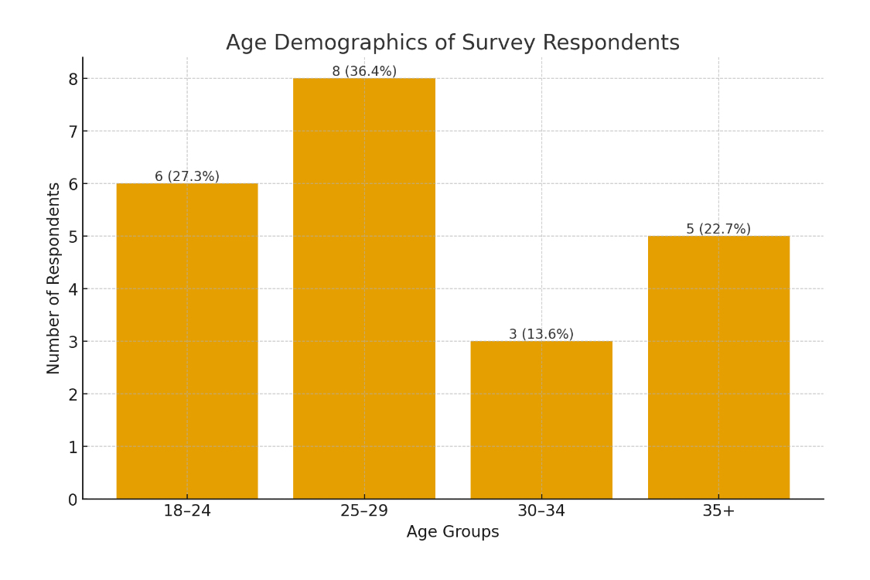

4.3 Gender Demographic
The study found the main gender contributing to the study was males with a contribution of 59.09% and Females contributing to 40.91% and those listed as other showing 0% participation. This indicates the study will mainly be contributed by a younger demographic that being those in their mid to late 20s and the main respondents are male.
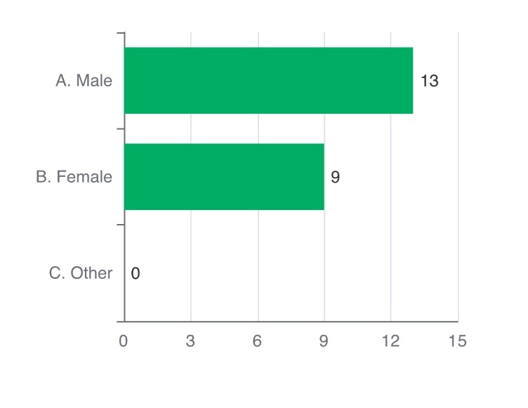

4.4 Officer satisfaction
The next question was to gauge officer’s levels of satisfaction in their role and if officers were very satisfied, satisfied, neutral, dissatisfied or very dissatisfied. The question put to respondents was “How satisfied are you with your current role” with the above-mentioned answers being the only way to respond. The finding saw 0% of officers were very dissatisfied in their role but then that 9.52% have as being dissatisfied. The greatest response was those that have answered neutral to the question put and this was recorded at 33.33% or a quarter of all respondents. Finally, 38.1% answered that they are satisfied with 19.05% saying they are very satisfied, and this makes up the larger proportion of responses overall to this question and highlights that officers are mainly either satisfied or very satisfied.

4.5 Those who considered leaving
This question asks if officers considered leaving the police service within the last year and highlights the responses below as yes or no. The responses showed that 59.1% haven’t considered leaving the police within the last year but 40.9% had considered leaving. This was to gauge whether officers were considering leaving and not to show the reasons behind that choice as that is shown in the next question put to respondents.
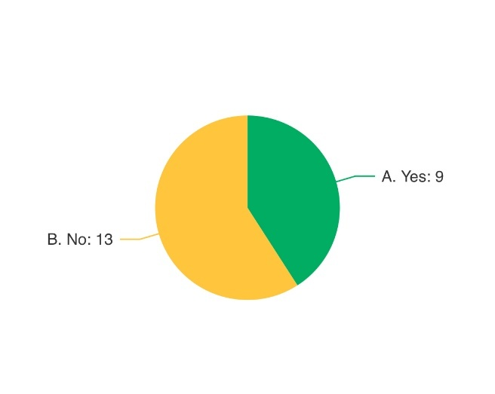
4.6 Factors for considering resignation
When asked on why officers wish to leave and what theme leads to this reason to leave the two greatest responses were officers saying that a work life balance was the main cause and the second largest response was officers haven’t considered leaving. Both answers resulted in a 55.2% response for each factor given. Pay and mental health then fall close behind with 18.4% & 13.2% respectively and public perception being 7.9% of responses. Lastly it shows career advancement is one of the lowest reason officers choose to leave with 2.6% and the field “other” had the same percentage.
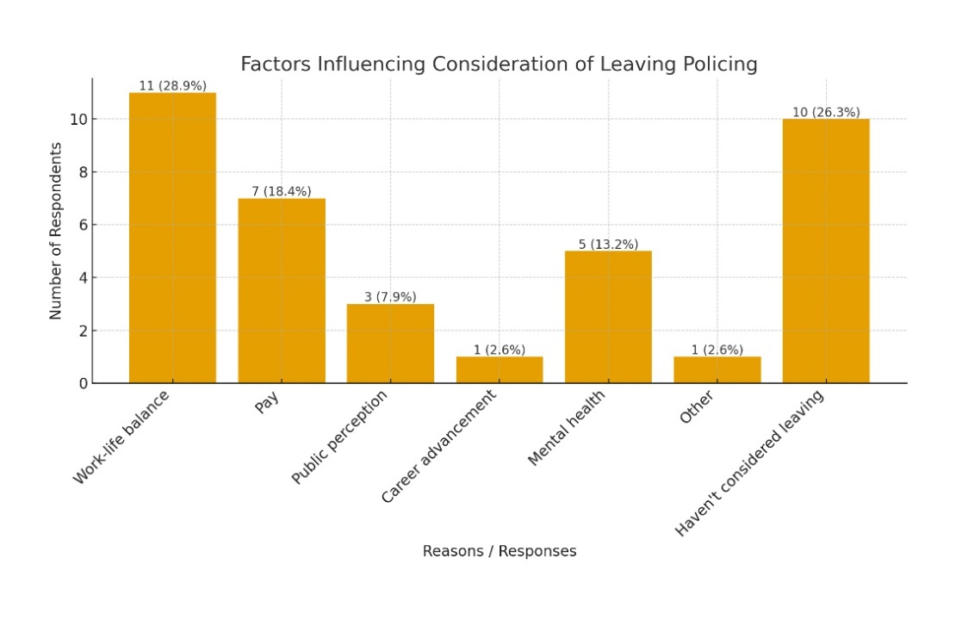

4.7 Rating listed factors for reasons of officer retention
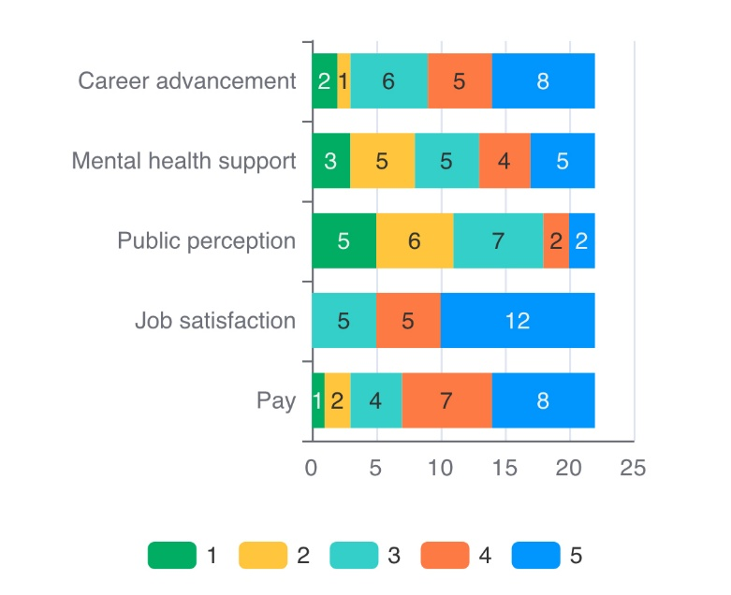
The next field that officers were questioned on was asking them to rate from a score of 1 to 5 regarding several factors for their importance of remaining as a police officer. The scores identify 1 being the lowest in terms of importance and 5 being the highest in importance and the results regarding this question were that 54.55% of officers regarded job satisfaction as their most important reason for remaining in the police. The next highest responded reason for officers’ importance in remaining in the police was that of career advancement and pay with both shown as 36.4%. The next subject officers felt was their main reason for remaining in the police was mental health support at 22.73% and lastly officers gauged public perception as the least important reason for remaining in the police with responses standing at 9.09%.
4.8 Conclusion
This section has shown the findings of the research conducted into identified factors that plague officers and may lead to officer attrition rates amongst the police. The research conducted was from qualitative surveys conducted anonymously by serving officers and highlights how officers gauge factors identified to play a part in officer attrition rates.
The last chapter of this dissertation will be the conclusion of this paper and the findings and recommendations posed along with what further research could be conducted and the limitations this research found.

5.0 Conclusion & Recommendations
5.1 Introduction
The past chapters have shown the purpose of this dissertation the supporting literature that was researched into factors of police attrition. The structure that independent research would be conducted and the findings of the research that was conducted with serving officers of South Wales police and throughout each chapter and objective has been met that was first stated during the introduction of this piece of writing. This last chapter will be that of the findings of the research conducted and how it compares and either support or undermines external literature that was gathered. This chapter will lastly highlight the limitations found and recommendations posed to address the key findings of the research conducted on police attrition rates and the factors that affect those rates.

5.2 Achieving the Aims
- To conduct research from various recent and relevant sources and critically analyse them to understand the factors identified to be linked to attrition rates.
Shown in chapter 2 regarding research from various sources on the factors that plague serving officers and staff.
- To identify a clear form of independent research that can be conducted and the structure to identify the concern of officer’s have regarding identified factors.
Identified in Chapter 3 regarding how the research conducted by this paper would be carried out along with limitations and ethical considerations identified.
- To then conduct research with serving South Wales police officer to identify how these factors identified affect them and how they would grade them.
Revealed in chapter 4 regarding the research carried out with the aid of serving South Wales police officers and how they gauge and grade the factors identified.
- Lastly to highlight the correlation with secondary research sources and supporting literature and offer recommendations to improve this concern.
This objective will be met during this chapter in findings and recommendation subheadings.

5.3 Main findings
The results of the findings do correlate with previous research conducted by other sources and the results from this finding can be linked to some of those studies conducted by others such as the reasons officer have considered leaving the police. police federation, (2024) identified numerous reasons officers choose to leave the police and this study helps to gauge how important those reasons are with most officers feeling a good work life balance, pay and mental health would be the main three reasons for leaving the police.
The study also shows the degree of officer satisfaction in the role they perform in the police force and the findings a reflective of the findings of Charman & Bennet, (2021) where occupational stressors can lead to and increase in officer attrition. These stressors such as high workload, negative public views and lack of recognition can produce the numbers for officer attrition seen by (Home Office, 2024) & this study shows that that 9.52% of officers were dissatisfied by their role and a third of respondents at 33.33% said they were neutral in their satisfaction.
The findings show 40.91% had considered resignation from South Wales police and the main reason behind this decision was that of work life balance, pay and mental health being the three most predominant factors identified from those that answered that they had considered leaving. This supports the findings seen by Police federation, (2024) where 63% of officers that left the job cited impacts on their family life. The research also highlights Brewin et al, (2020) where at least 20% of officers across the Uk were suffering from mental health as the findings found mental health was graded at 13.2% of reasons officers have considered resigning.

5.4 Recommendations
Firstly, considerations need to be made regarding a real work life balance for officers as highlighted in the research it is the most prevalent reason for officers considering resignation. The research identified that varied shift patterns and officers required to stay late has a severe impact on their family life and some form of action is required to address this facet of policing.

Secondly mental health needs to be addressed on a wider factor officers are suffering with clear signs of PTSD and CPTSD with a large majority regularly attending traumatic incidents. A framework needs to be put in place for officers to seek mental health support on a wider scale and this needs to be easily accessible and not brushed aside.

Lastly considerations must be made into police pay and the salary that officers get is highlights as the second largest reason for officers considering resignation alongside mental health. Officers have highlighted the financial stresses, and future financial concerns are a factor in officers seeking a more beneficial source of income that allows for quality of life. The police federation has highlighted this, but little is being said on a path to improving officers financial concerns.

5.5 Limitation
Due to the scope of the question posed and the word count this research has not been fully explored and there are various routes of further study that could be conducted to identify root causes of factors identified. Another limitation was regarding the timeframe of the research, and this subject cannot be fully explored in the timeframe of the dissertation itself.

5.6 Future Research
If future research was conducted, then the next step would be to increase the pool of respondents from the original or just 22 the study would be to examine these factors from the perspective of a 1000 officers to see if the findings of this research remain accurate or if they change with the wider pool of results. Another form of research would be to compare this result to those of neighbouring police forces as many forces are structured differently and may address some factors whilst ignoring other and the use of applicants from neighbouring police forces would show a greater image of results for officers Uk wide.
Lastly it would be beneficial to conduct interviews with respondent of this research to further examine the answers they gave and to understand why they listed answers in the way that they did providing greater clarity to the reasons officers are considering resignation.
5.7 Conclusion
This dissertation has achieved the aim and objectives of identifying factors that lead to officers’ attrition and has highlighted the key struggles that officers face in policing. The dissertation has shown the research of other forms of literature and has shown findings into the factors that affect officers’ attrition rates.

Throughout this paper the objectives have been addressed and stated in each chapter to contribute to the aim which was determining the factors for police attrition. The objectives have allowed for clear understanding on why this subject is important, the critical analysis of other forms of literature, the structure of this research and its limitations and ethical considerations and its findings from the research that was conducted with serving member of South Wales police. Concluding this paper shows that the three main factors officers consider resignation are that of work life balance, pay and mental health and these would be identified as leading causes that influence officer attrition rates.

Bibliography

Ayad, F. (2024). Police staff at breaking point over low pay, soaring workloads and high stress | News, Press release | News | UNISON National. [online] UNISON National. Available at: https://www.unison.org.uk/news/press-release/2024/10/police-staff-at-breaking-point-over-low-pay-soaring-workloads-and-high-stress/.
Bobby Duffy and Morini, P. (2024). The police have a problem with Gen Z. [online] The Police Foundation. Available at: https://www.police-foundation.org.uk/2024/06/the-police-have-a-problem-with-gen-z/.
Brewin, C.R., Miller, J.K., Soffia, M., Peart, A. and Burchell, B. (2020). Posttraumatic Stress Disorder and Complex Posttraumatic Stress Disorder in UK Police Officers. Psychological Medicine, [online] 52(7), pp.1–9. doi:https://doi.org/10.1017/s0033291720003025.
Charman, S. and Bennett, S. (2021). Voluntary resignations from the police service: the impact of organisational and occupational stressors on organisational commitment. Policing and Society, [online] 32(2), pp.1–20. Available at: https://www.tandfonline.com/doi/full/10.1080/10439463.2021.1891234.
Graham, L., Plater, M. and Brown, N. (2025). Summary of Policing: Key Issues and Common Themes. [online] Oscarkilo.org.uk. Available at: https://www.oscarkilo.org.uk/media/7016/download?inline [Accessed 24 Nov. 2025].
Home Office (2023). Police workforce, England and Wales: 31 March 2023. [online] GOV.UK. Available at: https://www.gov.uk/government/statistics/police-workforce-england-and-wales-31-march-2023/police-workforce-england-and-wales-31-march-2023.
Home Office (2024). Police workforce, England and Wales: 31 March 2024. [online] GOV.UK. Available at: https://www.gov.uk/government/statistics/police-workforce-england-and-wales-31-march-2024/police-workforce-england-and-wales-31-march-2024.
Hoogesteyn, K., Meijer, E.H. and Vrij, A. (2020). Detainee and layperson’s expectations and preferences regarding police interview rooms. PLOS ONE, 15(11), p.e0241683. doi:https://doi.org/10.1371/journal.pone.0241683.
Low, N. and Owen-Evans, R. (2024). Public Trust and Confidence in the Police. [online] UK Parliament . Available at: https://post.parliament.uk/public-trust-and-confidence-in-the-police/.
NANDA, S. (2023). Caught out: Trends in police pay in the UK. [online] Social Market Foundation. Available at: https://www.smf.co.uk/commentary_podcasts/caught-out-trends-in-police-pay/.
National Crime Agency (2023). National Crime Agency annual report and accounts: 2023 to 2024 (accessible). [online] GOV.UK. Available at: https://www.gov.uk/government/publications/national-crime-agency-annual-report-and-accounts-2023-to-2024/national-crime-agency-annual-report-and-accounts-2023-to-2024-accessible.
Police federation (2024). Pay and Morale Survey 2024 – Headline Report January 2025. [online] polfed.org. Available at: https://polfed.org/media/19812/pay-and-morale-survey-report-2024-final-v10.pdf.
Police federation (2025a). Federation: We don’t have enough police officers. [online] Polfed.org. Available at: https://polfed.org/surrey/news/2024/federation-we-don-t-have-enough-police-officers/ [Accessed 24 Nov. 2025].
Police federation (2025b). Mental Health. [online] Polfed.org. Available at: https://polfed.org/mentalhealth [Accessed 24 Nov. 2025].
Police federation (2025c). Officers are being pushed beyond their limits and given no choice’. [online] Polfed.org. Available at: https://polfed.org/dyfedpowys/news/2025/officers-are-being-pushed-beyond-their-limits-and-given-no-choice/ [Accessed 24 Nov. 2025].
Police federation (2025d). Record 14,508 officers were signed off with poor mental health in the past year. [online] Polfed.org. Available at: https://polfed.org/news/latest-news/2024/record-14-508-officers-signed-off-with-poor-mental-health-in-past-year/.
Standen, N. (2025). Metfriendly Police Family Finance Index Report - Spring 2025 - Metfriendly. [online] Metfriendly. Available at: https://www.metfriendly.org.uk/metfriendly-police-family-finance-index-report-spring-2025/.
Stevelink, S.A.M., Opie, E., Pernet, D., Gao, H., Elliott, P., Wessely, S., Fear, N.T., Hotopf, M. and Greenberg, N. (2020). Probable PTSD, Depression and Anxiety in 40,299 UK Police Officers and staff: Prevalence, Risk Factors and Associations with Blood Pressure. PLOS One, [online] 15(11), pp.1–16. doi:https://doi.org/10.1371/journal.pone.0240902.
Ugwu, L.E. and Idemudia, E.S. (2024). Burnout and post-traumatic stress disorders in police officers: Systematic review and meta-analysis. Journal of Police and Criminal Psychology, 40(3). doi:https://doi.org/10.1007/s11896-024-09713-7.

