

WORKPLACE CULTURE AND ITS IMPACT ON ORGANISATIONAL EFFICIENCY
WRITTEN REPORT

Student name: Adriana Trifu
Student No.: 1812538
Module Code: BMSW5105
Module Tutor: Janet Green

Table of Contents
INTRODUCTION 3
MAIN BODY 3
WORKPLACE CULTURE OF THE ORGANISATION 3
Theoretical overview of organizational culture 3
The “WAGAMAMA WAY” 4
Wagamama behaviours 4
Classical management theory 4
Organizational structure at Wagamama Watford branch 5
Behavioural theory 6
Contingency theory 6
MBO (Management by objective) 6
Suggestions for improvement 7
Critical evaluation of the broader environment in which Wagamama operates and its impact on the organisation culture and performance. 8
PESTLE analysis 8
Evaluation of Wagamama present cultural and ethical standards and the personal values and beliefs of most employees and how sustainability can help the organisation achieve its corporate objectives and social responsibilities. 13
Everyday benefits at Wagamama 13
CONCLUSION 14
REFERENCES 15

INTRODUCTION
The report below indicates the workplace culture and its impact on organisational efficiency of the restaurant Wagamama, Watford Brach, UK. It also depicts the theoretical views of organisational culture in terms of classical management theories, behavioural theories, contingency theory followed by MBO theory, together with areas for improvement. The assignment below has been analysed on the basis of environmental scanning tool such as PESTEL analysis. The PESTEL analysis below represents the cultural and performance parameters of the organisation. It also represents the cultural and ethical standards of the organisation including the values and beliefs of the employees’ sustainability and occurrences of achieving the corporate values and social responsibilities.

MAIN BODY

WORKPLACE CULTURE OF THE ORGANISATION
As per the findings of Wagamama.com (2020), Wagamama Watford is a British restaurant, part of a big chain of restaurants in the UK and the US, having 138 directly-operated restaurants in the UK and the US and 58 franchised restaurants in Europe, the Middle East and New Zealand, serving Asian foods purely based on Japanese cuisine, “spreading positivity from bowl to soul”- one of their mottos, and feeding the “mind, body and soul”, meaning the food must both “look and taste beautiful”, represents the centre of its focus. Wagamama Watford branch it’s a small-sized enterprise, having fewer than 50 employees and an average turnover of 50.000 £ weekly.
In conformity with Wagamama.com/our-menu (2020), they are serving a big variety of big plates, sides, desserts, drinks and vegan and vegetarian dishes. Different famous products that can be expected from Wagamama restaurant include: ramens - Chilli Chicken Ramen, teppanyaki – Yaki Soba, Donburies – Duck Donburi, kokoro bowls –Naked Katsu, salads - chicken harusame glass noodle, their vegan Yasai Nikko Curry, the most wanted dessert – Banana Katsu and also a big variety of fresh juices. It is located in Watford town centre, offering the possibilities of bookings, take-out and delivery orders, disabled access, and many facilities as: free Wi-Fi, baby facilities, braille menus, induction loops and magnifying sheets.

Theoretical overview of organizational culture

The “WAGAMAMA WAY”
Wagamama’s culture is based on “kaizen”, meaning “good change”, “the philosophy that sits right at our heart. It shapes every dish we create, and pushes us to find better ways in all that we do. we’re restless spirits. forever creating and making things better”, as stated at (https://www.wagamama.com/about-us, 2020)

Wagamama behaviours
At Wagamama, delivering great ad amazing results, it is very important. According to https://jobs.wagamama.uk/the-wagamama-way/, (2020), their food is fantastic and their people are brilliant. With the help of their behaviors, they create a positive environment.
The 5 behaviors at Wagamama:
WE OWN IT | WE EMBRACE CHANGE | WE CARE | WE COMMUNICATE | WE LEAD
Wagamama owns what they are doing, and is taking responsibility for it, in a positive manner. | Doing their best every day, in order to be better than the day before. This is the ‘kaizen’ way. | Wagamama cares about people, and it is obvious judging by the way they treat each other. | They have a brilliant communication between them and customers. | Always connected and part of something special. Wagamama choose to lead in a way that makes a difference.

Classical management theory
According to the classical management theory, workers only have a subsequent level of economic as well as physical needs, and it does not take account of different job satisfaction and social needs of different employees who are being working in organisations like Wagamama. Instead, it has been observed that classical management theory has the ability of making centralised leadership style alongside with adequate decision-making factors while maximising profit generation level (indeed.co.uk, 2020).
In Wagamama restaurant, proper application of classical management theory can be helpful in order to put more emphasis towards enhancing the certain organisation rather than the overall existing employees inside of the organisation. A hierarchical structure can be made inside of the organisation while applying classical management theory.

Organizational structure at Wagamama Watford branch
ORGANISATIONAL STRUCTURE OF WAGAMAMA WATFORD BRANCH
April, 2020

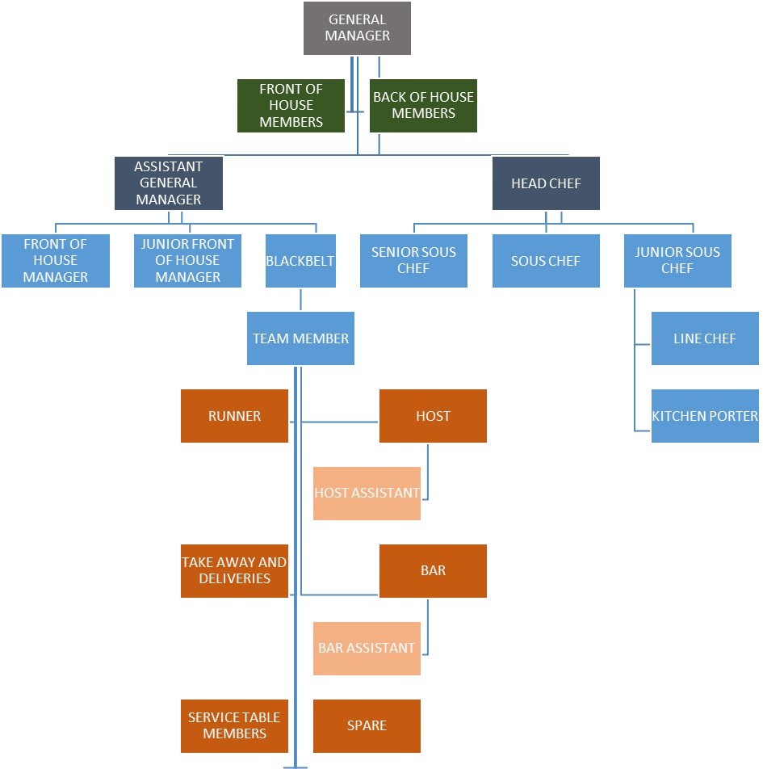
Wagamama made some changes to the organizational structure, and simplified the leadership into senior and junior managers. Not everyone can be a junior manager, only those interested in becoming restaurant GMs should be junior managers.
Wagamama also introduced a new “black belt” role, someone who is in charge of training new starters on-site.

Behavioural theory

Behavioural theory, which is also known as the behavioural psychology, can be demonstrated as such a theory where learning is actually based into an idea that every form of behaviour can only be acquired via the help of effective conditioning (Elsmore, 2017). According to the behavioural theory, it has been observed that the response towards a certain environmental aspect, has the ability of responding to some specific stimuli that can shape the action of different individuals inside the organisation. Moreover, while applying behavioural theory in context of organisations like Wagamama, it has been observed that different actions lead by their employees, can actually lead towards formulating diverse aspects inside of organisational context.

Contingency theory

Contingency theory is such an organisational theory that describes that there is not any actual way of running a specific organisation, as everything runs according to the internal and external course of the actions that has been conducted in some specific situational context. While applying contingency theory upon the current aspects of organisations like Wagamama, it has been observed that the organisation needed to make some predictable and unpredictable analysis of diverse functions in order to identify the best practice of maintaining certain organisational culture.

MBO (Management by objective)

MBO can easily be documented as the strategic management model that contains the primary aim of improving overall performance of a certain organisation while clearly and effectively define diverse objectives that has been agreed through both the employees as well as the managers and leaders inside of the organisation. While applying MBO theory in respect to organisations like Wagamama, it will be possible for the leaders and managers to take mutual decision that will be effective in making certain aspects of organisational culture.

Suggestions for improvement

Despite the fact that Wagamama restaurant has quite an effective as well as efficient organisational culture, it has been observed that there are certain aspects in their entire organisational culture that need continuous improvement at the most parts. As an instance, it has been observed that the organisational communication procedure inside of different branches of Wagamama restaurant is not adequate and it represents a bunch of different problems for the entire organisation as a whole. Therefore, the leaders as well as the managers from the entire organisation needed to look after for managing the entire communication related aspects inside of the organisation. In addition to that, it has been suggested towards the organisation to make some basic improvements in their organisational flexibility. They are needed to do that, so that they can make more employees happy as well as satisfied in current context of high competitive aspect (Crane, 2017). Moreover, the employees belonging from the entire organisation are needed to be informed regarding the active as well as passive values as well as believes of the organisation so that they can manage their working capabilities according to this. Furthermore, it has also been suggested to the organisation to maintain and promote trust inside of their actual organisational context for managing basic integrity and affectivity.
It is also being suggested towards the particular organisation to establish a strong and effective relationship among different members of groups, which will obviously lead towards having a more effective and integrated organisational culture for an entire employee base. Their perception of delivering high quality works can be improved quite significantly while improving the cultural norms and values of the entire organisation. Furthermore, in order to improve the cultural aspects of Wagamama restaurant, it is being highly suggested towards the leadership as well as the management department of the organisation to listen regarding the preferences of different employees in order to maintain a strong relationship with them (Laforet, 2016). By doing so, the organisation will be able to maintain a strong and empathetic organisational workforce that will be helpful towards maintaining a steady organisational growth.

Critical evaluation of the broader environment in which Wagamama operates and its impact on the organisation culture and performance.

PESTLE analysis
The PESTEL framework has been developed to provide a “wide overview” (Johnson, Whittington and Scholes, 2011) of the macro environment. This scanning tool “is used for marketing and business development assessment and for decision-making” (Wisconsin, 2004). As Johnson states, “PESTEL (PEST or PESTLE) framework can be used to identify how future trends on the following environments might impose on organizations”. (Johnson, G. & Scholes, K. 2002).
The environmental scanning tool used below has the purpose to examine the Wagamama Restaurant Watford Branch and it allows the restaurant to look over the significant changes over the terms of political, economic, social, technological, environmental and legal for the owners of the organisation. It opens the gate for the organisation to expand the business in terms of productivity and profitability as well. The scanning tool used below supports the organisation to have clear identification on cost-effectiveness, deeper analysis, alertness and its development followed by exploiting the opportunities. The results of this analysis can be used to “mark opportunity and also to make contingence strategy for threats when planning strategy for the business” (Cooper, 2000)

Factors | Analysis
Political | The political factors which affects organisation in terms of customer satisfaction, profits, payrolls followed by the menu. As when the political climate rolls out, the economical budget of the people around tightens which ends up spending less during the dine-out or put a complete stop over it. These factors affect the restaurant vigorously in terms of productivity and profitability (Atkins and Bowler, 2016). The political climate also affects the minimum hike wages for the staff, which ends up incurring expenses to comply with the change of laws. The health and safety guidelines are highly implemented over the United Kingdom.
Economical | As the restaurant is working in geographic of United Kingdom, where the economic factors plays an extensive role to drive the profits and productivity of the organisation such as if the inflation rate goes high affects the cost of ingredients. This results in behaviour changes of the people avoiding going out and ordering food from the restaurant. The economic factors also affect in terms of disposable income such as the people having more disposable amount will allow them to go out and dine (Ramanathan et al., 2016).
Social | The social factors affecting the restaurant business and its profits concludes about the behavioural changes such as people now a days are mostly health conscious preferring organic food instead of junk food. The restaurants must make proper implementations in serving food to both the customers such as organic and junkie’s results increasing the customer base. The other factors include people of having the busy routine life in their offices ending up being dependent on fast food, coffee and carbonated drinks (Murcott, 2018). The way of making each customer happy is a difficult task as it also includes vegans, pet lovers and transgender.
Technological | The technological factors include about keeping a close check on the staff behaviour and customer’s satisfaction. There are various new software implementations made to increase the productivity and profitability of the customer such as using of CCTV cameras around the restaurant to keep close eye on the behaviour of staff and workers working in the kitchen. It allows the restaurant business to have proper checks in terms of growing the customer satisfaction meters. Some of the businesses still rely on the doing manual checks in terms of accounting and other related operations (Eldridge et al., 2019). There is various accounting software released in to the market such as Quick books online and Toast POS ends up increasing good profit numbers for the restaurant.
Environmental | The factors defining the environmental conditions of the restaurant such as both internal and external, the internal factors such as to take care of the cleanliness terms of the restaurants for the customers to have hygienic experience and must be able to reach the restaurant hassle less. The external factors defining the environmental factors such as a restaurant must use the food charity concept for the people in need and use the concept of recyclable material to have a proper food waste management policy (Filimonau et al., 2019). The environmental factors play a crucial role in terms of expanding business and making loyal customer base.
Legal | There are local and legal bodies by the administration, whose prime work is to visit the restaurants and kitchens to examine the food quality, date of expiry, staffs and hygienic conditions of the restaurant (Davies, 2019). The reason behind assigning the legal bodies to examine the working culture of the restaurant is to maintain the quality standards to prevent any epidemic.
Table 1: PESTEL analysis
The PESTEL analysis above drives two elements based on culture and performance parameters is described below:
Cultural: The cultural aspects being widely followed by the Wagamama Restaurant Watford Branch such as driving the change of goodness followed by the creativity to innovate better being restless spirits. As per the social factors assigned in the geographic it comprises of two types of people such people going out to dine in and other comprise of the busy people in their routine life. The restaurant has all for both of them such as it has the facility of dine-in as well as takeout along with delivery. It helps the organisation to build up proper customer for both the customer profits driving productivity and profitability. The other cultural aspects of the restaurant also include food dishes from low range to high range, which fulfils the criteria during the political and economic rollouts. It helps the customers to avail food at lower prices with the same quality and quantity resulting maintenance of proper relationship between customers and restaurant. As per the legal matter is concerned, the organisation maintains the gender pay act well in terms of employee operations. It has qualified the parameters significantly positive in numbers, which makes the well establishment of working culture among the female employees. The legal formalities being maintained by the organisation tends to highlight the legal gender status for each working (De Groof et al., 2019).
The environmental factors, which restaurant widely uses in its operation to make it sustainable in terms of environment such as it has made European chicken commitment following new set of standards in terms of improvement of welfare standards and living environments for the chickens farmed for meat. It also commits that this European chicken commitment will follow the guidelines in the whole Europe in the near future. As per findings at Wagamama sustainability + environment, (2020), they are committed to high welfare; “we’re proud to have made the European chicken commitment, a new set of standards improving the welfare + living environment of chickens farmed for meat. these standards will be achieved throughout our Europe supply chain by 2026.”
The restaurant has also implemented the rule of changing the colour of take-out bowls from black to grey. According to Wagamama sustainability + environment, (2020), “grey is the new black”. As per the council, black bowls are not eligible for recycling so the restaurant implemented the colour-changing rule ensures that plastic bowls reach the right place of recycling and ends up making great lunch boxes, storage containers and plant pots. As the egg is the staple food for Japanese cuisines, the organisation proudly says that being committed to European chicken the eggs are available from high welfare chickens and are of free range. The organisation strives to have better understanding in terms of recycling material and using it to have sustainable working conditions beneficial for the environment. As stated at Wagamama sustainability + environment, (2020), in 2019 Wagamama Watford transformed 1 million litres of used oil into bio-diesel fuel, and besides producing green energy, Wagamama runs on it, being powered by renewable electricity. The food wastes are sent to anaerobic digester, which turns everything into powder and results preventing the use of fuel. It acts as a fuel for the kitchen operations (Requena-Méndez et al., 2019). As per the technological factor is concerned with, the organisation has implemented various technologies, which has reduced the use of electricity. It has invested amount on the lightning purpose, which regulates the use and amount of electricity being used by the extractors depending on the level of cooking activity.
Performance: The restaurant has maintained the performance metrics in an outstanding manner throughout the United Kingdom and Europe. The surveys being conducted by the customers shows that the customer experience being provided by them excels among the competitors. The people on the high streets have mentioned that the organisation has gained the criteria of recommendations from the customers all through. The performance metrics of the organisation is based on the few factors being analysed such as good food, well-behaved staffs, value for money followed by being friendly and faster service compared to the other competitors (Schmidt, 2019). The table below shows about the performance metrics on various parameters such as friendly service, value for money, cleanliness, menu varieties, sensitivity of food allergies and good special promotions. The table below is based on the competitive matrix with the other competitors on the same geographic and the scores achieved by Wag mama, UK.
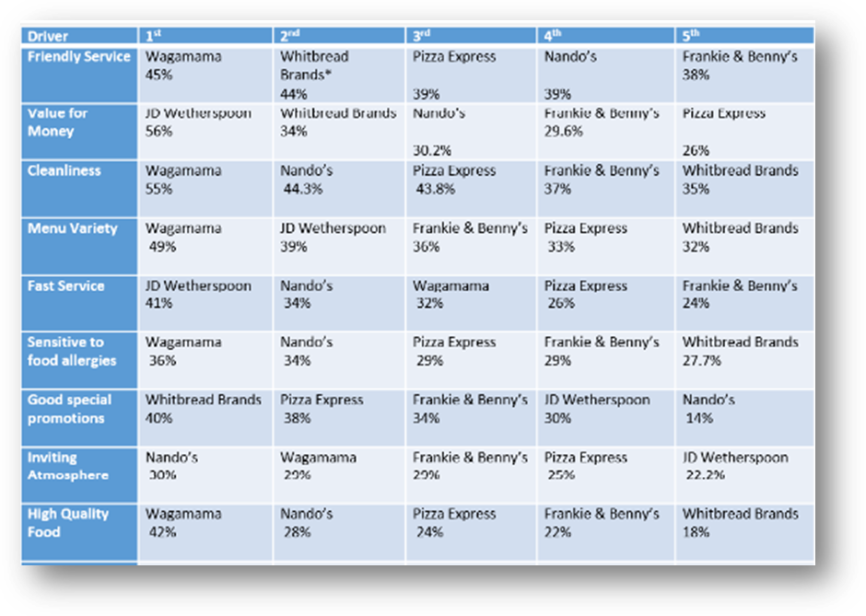Figure 1: Scoreboard for WAGAMAMA, UK
As per the findings of the Wagamama, (2019), it is seen that the organisations immense rise in the terms of like for like sales growth and continued to expand the portfolio. It also concludes about the figures that like for like sales grew about 6.3% and it mentions about the achievement being outperformed in the UK market by 5.1%, results the WAGMAMA restaurant traded ahead the competition of more than five years. It also highlights that the EBITDA adjusted grew by 27.2% in quarter two results to £16.7 million compared to £13.2 million in quarter two of 2018/2019. The group turnover of the organisation showed immense rise by 15.3% resulting to £300.6 million as opening of new thirteen franchises restaurants across the Middle East, Europe followed by two US openings. The group holding organisation has almost more than two hundred clients operating multi location business including restaurants at major retailers, grocery stores, petrol stations followed by banking and entertainment brands. It has huge customer base all over the United Kingdom and Europe due its brand value and good food followed by its highlighted feature of value for money.
The organisation has always strived to keep the customers close to their hearts to gain the trust and proportionally increase the productivity and profitability of the food business. It has introduced the new way of accessing the customer insights and scope of opportunities to work for the betterment of the services provided. According to the UK customer satisfaction index, the customers of the restaurant are happy about the services being provided to them. The organisation also tries to give complete focus on the customer demands to reduce the compliant numbers and drive them towards one of the leading restaurant chains among the competitors of UK and Europe. The organisation has launched its spin-off restaurant given brand name as MAMAGO in the city of London. They have introduced various other dishes, which include breakfast porridges, rice bowls followed with turmeric and pumpkin wraps with a choice of fillings as per the consumer. There are also various modifications done on the former dishes such as katsu chicken curry, followed by vegan cauliflower and naked chicken katsu salad. The new drinks in the menu include smoothest, various types of coffees, rose wine and sauvignon blanc (Sveum and Sykuta, 2019).
Apart from such modifications and launch of new restaurants, the organisation also keeps a close eye over the training and selection of the employees to add up more benefit over the organisational profits. It has designed the online learning toolkit for the new joiners offering new ways to learn about the ingredients and their makings. It helps the employees of Wagamama to gain real life experience and achieves them to have a recognised qualification over twelve months of apprenticeship. The organisational firmly believes in making things better in terms of market requirements and comparative performance in terms of competitors.

Evaluation of Wagamama present cultural and ethical standards and the personal values and beliefs of most employees and how sustainability can help the organisation achieve its corporate objectives and social responsibilities.

Wagamama is facing one big problem, and that’s why they adopted this new role- black belt, within the company. Getting people through their first 90 days it represents a challenge. As soon as one new potential employee enters the restaurant, the team is acting like it is already a team member, starting to insinuate the values and beliefs of Wagamama. Cultural and ethical standards together with sustainability, represents a very important factor within this company.
Wagamama adopted kintsugi + mental health
According to wagamama.com/mentalhealthmates, (2020), “kintsugi is the Japanese art of mending broken pottery. this year to raise awareness for mental health we are encouraging people to ‘share and repair’”. Wagamama committed to donate £60,000 to mental health mates, in order to the number of walks across the UK. Those walks represent a possibility for more people to open up and talk about mental health.
Wagamama sra and proud
Wagamama is a member of the sustainable restaurant association, focusing on three areas: source, society, and environment. The purpose is to become a more sustainable business, and sra helps them become greener day by day. Wagamama also wants its customers to help them grow, and encourages them to get involved by sharing their thoughts and ideas in order to become a more ecologically organization.

Everyday benefits at Wagamama
Food and Friendships – They are inspired to grow by the relationships among them, and Wagamama offers food benefits to its employees. One free meal on every shift, plus discounts when eating with family or friends.
Life and living well – Wagamama is offering great pay, regular breaks and paid holiday, together with amazing staff parties. Front of house teams are paid weekly, all employees have uniform allowance, and back of house team benefits from clean chef whites every day.
Rewards and recognition – Wagamama runs weekly competitions for its employees, offering amazing prizes for the winners and pensions for all its people.

CONCLUSION
The study above indicates about the restaurant Wagamama, Watford Brach and its workplace culture. It mainly acts into Japanese cuisine serving big plates such as: curry, ramen, teppanyaki, donburi, kokoro bowls, and salads; sides, desserts, drinks, vegan, non-gluten dishes, and kids meals. There have been various depictions made on the theoretical views of organisational culture in terms of classical management theory, behavioural theory, contingency theory followed by MBO theory. The work above has been analysed based on environmental scanning tool such as PESTEL analysis. The PESTEL analysis used represents the cultural and performance parameters of the organisation. It also forecasts about the use of PESTEL analysis in terms of achieving the organisational profits and goals all over. It helps the organisation to have close eyes over the cultural and performance parameters. The assignment also shows the organisational structure of the restaurant, Watford Branch, in April, 2020. It also represents the cultural and ethical standards of the organisation including the values and beliefs of the employees’ sustainability and occurrences of achieving the corporate values and social responsibilities.

REFERENCES

Atkins, P. and Bowler, I., 2016. Food in society: economy, culture, geography. Routledge.
Cooper, L., 2000. Strategic marketing planning for radically new products, Journal of Marketing, Vol. 64
Ramanathan, R., Di, Y. and Ramanathan, U., 2016. Moderating roles of customer characteristics on the link between service factors and satisfaction in a buffet restaurant. Benchmarking: An International Journal.
Davies, J., 2019. From severe to routine labour exploitation: The case of migrant workers in the UK food industry. Criminology & Criminal Justice, 19(3), pp.294-310.
De Groof, V., Coma, M., Arnot, T., Leak, D.J. and Lanham, A.B., 2019. Medium chain carboxylic acids from complex organic feedstock’s by mixed culture fermentation. Molecules, 24(3), p.398
Eldridge, A.L., Piernas, C., Illner, A.K., Gibney, M.J., Gurinović, M.A., De Vries, J.H. and Cade, J.E., 2019. Evaluation of new technology-based tools for dietary intake assessment—An ILSI Europe dietary intake and exposure task force evaluation. Nutrients, 11(1), p.55.

Filimonau, V., Krivcova, M. and Pettit, F., 2019. An exploratory study of managerial approaches to food waste mitigation in coffee shops. International Journal of Hospitality Management, 76, pp.48-57.
Johnson, G. and Scholes, K. (1993) “Exploring Corporate Strategy” Text and Cases, Hemel Hempstead: Prentice-Hall.
Johnson G, Whittington R and Scholes K, (2011), Exploring Strategy 9th Edition, London, Prentice Hall
Murcott, A., 2018. The nation's diet: The social science of food choice. Routledge.
Requena-Méndez, A., Davies, G., Waterhouse, D., Ardrey, A., Jave, O., López-Romero, S.L., Ward, S.A. and Moore, D.A., 2019. Intra-individual effects of food upon the pharmacokinetics of rifampicin and isoniazid. Journal of Antimicrobial Chemotherapy, 74(2), pp.416-424.
Schmidt, M., Zannini, E. and Arendt, E.K., 2019. Screening of post-harvest decontamination methods for cereal grains and their impact on grain quality and technological performance. European Food Research and Technology, 245(5), pp.1061-1074.
Sveum, M. and Sykuta, M., 2019. The effect of franchising on establishment performance in the US restaurant industry. Cornell Hospitality Quarterly, 60(2), pp.104-115
Wisconsin. (2004, May). State Bar of Wisconsin. p. Vol 77.
ANALYSIS: New management and leadership structure explained - Foodservice Equipment Journal., 2018. Available at: https://www.foodserviceequipmentjournal.com/trg-buys-Wagamama-new-management-and-leadership-structure-explained/ (Accessed: 7 April 2020).
Wagamama | Case Study | Savanta: Make Better Decisions., 2020. Available at: https://savanta.com/case-studies/Wagamama-2/#.XowmOeozbIU (Accessed: 7 April 2020).
Wagamama Mission, Benefits, and Work Culture., 2020. Available at: https://www.indeed.co.uk/cmp/Wagamama/about (Accessed: 7 April 2020).
Wagamama workers, 2018. Available at: theguardian.com/business/2018/dec/20/Wagamama-workers-to-share-4m-christmas-bonus-after-chain-sale-restaurant-group (Accessed: 7 April 2020).
Wagamama, 2019. Available at: bighospitality.co.uk/Article/2019/11/25/Wagamama-continues-to-see-sales-climb (Accessed: 7 April 2020).
The wagamama way, 2019. Available at: https://www.wagamama.com/about-us (Accessed: 20 April 2020).
Wagamama our menu, 2020. Available at: https://www.wagamama.com/our-menu (Accessed: 01 May 2020).
Wagamama sustainability + environment, 2020. Available at: https://www.wagamama.com/sourcing-sustainability-environment (Accessed: 01 May 2020)
Wagamama mental health mates, 2020. Available at: https://www.wagamama.com/mentalhealthmates (Accessed: 17 May 2020)

