

LOCATION: Swansea | LLEOLIAD: abertawe
LEVEL 6 | LEFEL 6
EXAMINATION PERIOD | CYFNOD ARHOLIADAU
January 2025 | IONAWR 2025
MODULE CODE: ACDA 6008
SCIENTIFIC PRINCIPLES OF OME DESIGN
TIME: 2 HOURS

answer all of section A

answer 2 out of 3 QUESTIONS in section B

Equipment or materials required. Please select from the following:
Adnoddau neu ddefnyddiau sydd eu hangen.

Cyfrifiannell/Calculator
Llyfr Agored/Open Book.
Arall/Other Nodwch/Please Note ……………………….

BEGIN EXAM QUESTIONS HERE!

SECTION A

ANSWER ALL 6 QUESTIONS IN THIS SECTION

- Using the ZND model for one-dimensional detonation wave propagation, describe the difference between an ideal and non-ideal detonation
[5 marks]

- a) Using the diagram below, explain the significance of the point highlighted on the lethality curve for a 70 kg male in the free field

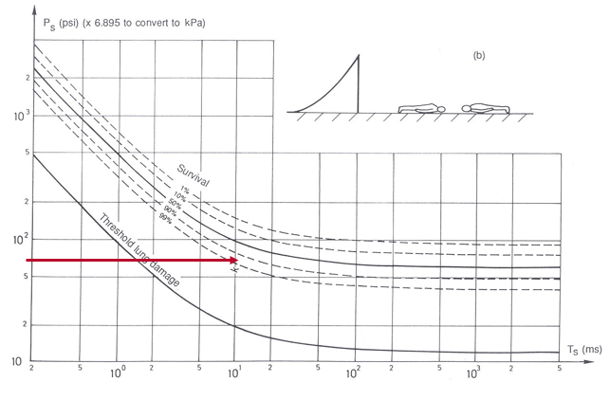
[3 marks].

b) If the individual were standing next to a reflecting surface, would you expect survivability to be better or worse, and why?

[2 marks]

- Describe 5 different shock waves that a surface vessel may experience from an underwater explosion. Assume the detonation is of sufficient strength to generate reflection from the sea floor and water surface.
[5 marks]

- a) An explosive comprises 80% TNT and 20% aluminium. Given the parameters described in the table below, and the equation provided, what is the theoretical detonation velocity of the mixture in km s⁻¹?

D_{i} TNT | 6.970 km s⁻¹
Di Al | 6.850 km s⁻¹
V_{i} | The volume fraction of component

$$D_{mix}=\sum{D_{i}V_{i}}$$
[3 marks]

b) If the theoretical density (ρ) of the composition is 1.77 g cm⁻¹, calculate the detonation pressure (P_{cj}) in GPa

$P_{cj}≅$ $\frac{ρD_{mix}^{2}}{4}$
[2 marks]

- The infantry user requires a rapidly deployable capability that shall penetrate the side armour of a main battle tank from engagement distances between 20 and 100 m. Using the diagram below for directed energy weapons, explain whether you think a shaped charge or EFP would be more suitable for this side-armour task.
[5 marks]
- Describe the mechanical properties required of a cased munition and its explosive to produce small natural fragmentation. What would be an appropriate mathematical relationship to demonstrate the relationship between charge mass (C) and case mass (M) for a moderate to heavy-cased munition?

[5 marks]

SECTION B
ANSWER 2 OUT OF 3 QUESTONS IN THIS SECTION

- From the diagram and data below, calculate the initial fragmentation velocity (V_{o}) and beam angle for a static cylindrical warhead detonated from the rear.

$ρ=\frac{m}{v}$ Relationship between density, mass and volume

$π\frac{d^{2}}{4}l$ Equation to describe the volume of a cylinder
$V_{o}=\sqrt{2E}{\left(\frac{M}{C}+0.5\right)}^{-0.5}$Gurney Equation for a Cylinder

$θ=\sin^{-1}\left\{\left(V_{o}\cos{∝}\right)/2D\right\}$ Equation to determine Taylor Angle

Case material density | 7830 kg m⁻³
Explosive density | 1770 kg m⁻³
Gurney Constant $\sqrt{2E}$ | 2460 ms⁻¹
Initial fragment velocity V_{o} | What you must calculate in ms⁻¹
Mass of case material M | What you must calculate in kg
Mass of explosive material C | What you must calculate in kg
Velocity of detonation of explosive D | 7840 ms⁻¹

Tip:

You will need to work out the Taylor angles at Point A (the point of initiation) and Point B to determine the beam angle (θ_{A} + θ_{B}).

[35 marks]

- a) In relation to a kinetic energy projectile (such as a bullet or a long rod penetrator), describe the following velocity regimes that would apply to their use. Your answer should include the primary mode of penetration in both case

- Sub-hydrodynamic
- Hydrodynamic
[6 marks]

b) Draw a graphical representation of Penetration vs Velocity for these regimes, explaining why velocities between 800 ms⁻¹ and 1200 ms⁻¹ should be avoided by the designer for a long rod penetrator.

[6 marks]

c) Explain the optimum criteria that should apply in the design of a long rod penetrator. Your answer should demonstrate an understanding of the role of purpose of the discarding sabot, target material properties, penetrator material properties, adiabatic shear, strain rate, angle of attack, the effects of yaw, the shape of the penetrator’s nose and types of material would afford the best design.

[20 marks]

d) For an armoured platform, what could the designer consider in terms of countermeasures against a long rod penetrator?
[3 marks]

- a) Discuss the most suitable type of propellant for the following applications, justifying your choices:
(i) Air to air missile fired from a fixed wing aircraft
(ii) Surface to surface man portable missile
(iii) Air to surface missile on a rotary wing aircraft
[23 marks]

(b) Discuss how the following properties of solid rocket propellants can influence the total impulse of a rocket motor. Use examples of different types of solid propellants to illustrate your answers:

(i) Oxygen balance and calorific values [3 marks]
(ii) Mechanical properties (strain capability) [3 marks]
(iii) Linear burning rate. [3 marks]
(iv) Density [3 marks]

End

