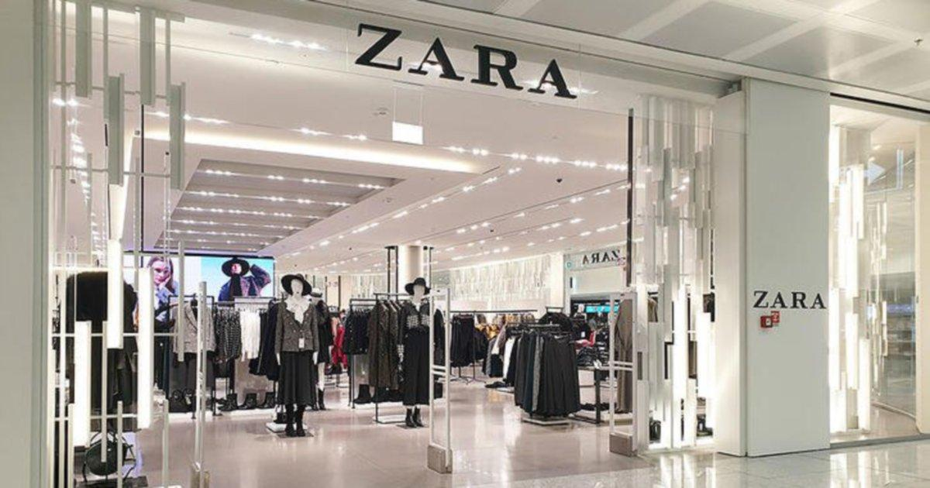

LCBB4004: Marketing Fundamentals – Assessment 2 Marketing Fundamentals Analysis and Evaluation (Individual Essay – Zara)

Kristina Spasova ID: 2014059

BUSINESS MANAGEMENT
LECTURER: ZE ZOOK
UWTSD
LONDON
28/04/2021

Table of Contents
Introduction 1
Overview 1
Background of the Company 2
Role of Marketing in Creating Value for Customers 3
Impact of Stakeholder Engagement on the Marketing Activities 6
Conclusion 8
References 9

Introduction
The following essay has been prepared to conduct a critical evaluation and analysis of the role that marketing plays in creating value for the customers. In this regard, the case of Zara (which is a renowned fashion and clothing brand) has also been used in this essay to comprehend the marketing activities that this company has utilised for creating customer value and understand how these activities have enabled Zara to increase its sales successfully. In addition to this, the essay has also analysed the role and impact of stakeholder engagement on the marketing activities that are conducted by companies like Zara to promote their products, engage their customers, and increase their sales. Based on these analyses, a detailed conclusion has also been provided at the end of this essay.

Overview
Marketing can be described as a process of developing and communicating a message about a company’s product or service in an effective format to create awareness of the brand, engage customers, and encourage them to make purchases (Porral and Stanton, 2017). It can take many forms that include (but not limited to) advertisement, press releases, as well as direct communication with the customers. Today, managing marketing activities has become one of the utmost priorities of almost every organisation around the world primarily due to the increased competition that the companies are facing within their respective industries (Payne et al., 2017). In this regard, the common marketing goal for every company in most cases is based on creating value for the customers in such a way that also enables them to increase their sales and profits and create brand loyalty among their target customers (Sánchez-Gutiérrez et al., 2019). One such industry where creating customer value has become significantly important is related to the global fashion and apparel industry.
The reason why companies in the fashion industry are continuously improving their marketing strategies in order to capture the attention of their target customers is again related to the fact that today this industry has become increasingly competitive and customers have many options in terms of deciding what type of clothing products they want to purchase (Gardetti and Torres, 2017). Moreover, customers are also becoming more demanding when it comes to purchasing clothing products as they are increasingly seeking new designs, high-quality and affordable prices while making their purchases (Linden, 2016).
Thus, creating value for these customers has become a challenge for most fashion and apparel companies but one such company that has been found to become successful in terms of providing value to the customers through its effective marketing strategies is Zara (Danziger, 2018). Thus, before proceeding towards explaining the role of marketing activities in creating customer value and how Zara has managed its marketing activities (in this regard) effectively, a brief background of the company has been provided in the below section.

Background of the Company
Founded in 1975 by Rosalía Mera and Amancio Ortega, Zara is considered as one of the renowned Spanish fashion and apparel companies, which is selling its products globally. The company is known for specializing in fast fashion and products that mainly include clothing, perfumes, beauty products, swimwear, shoes, accessories, and so forth (Sitaro, 2020). The parent company of Zara is Inditex group, which itself is the largest apparel retailer in the world. As of 2017, Zara was found to manage up to twenty collections per year. Moreover, currently, the company is providing its products all over the world from more than 2,118 stores (Inditex, 2021). The reason why Zara has been selected for this essay is related to the fact that this famous fashion company is currently leading the entire Inditex Group in terms of making high sales and profitability.
This is because as per the last recorded statistics on sales share in 2019, Zara was found to generate the highest number of sales for the Inditex Group in comparison to its other subsidiaries since the company was noted to capture a sales share of around 69% of the total sales of the Inditex Group (Blázquez, 2020). The sales share of Zara and other subsidiaries of Inditex has also been depicted in the below figure. Again, Zara would have not been able to generate such a high level of sales without devising and using an effective marketing strategy to meet the needs of its customers and create value for them (Danziger, 2018). Thus, by considering these points, the following section has provided a detailed analysis of the role of marketing in creating customer value by also referring to the case of Zara.

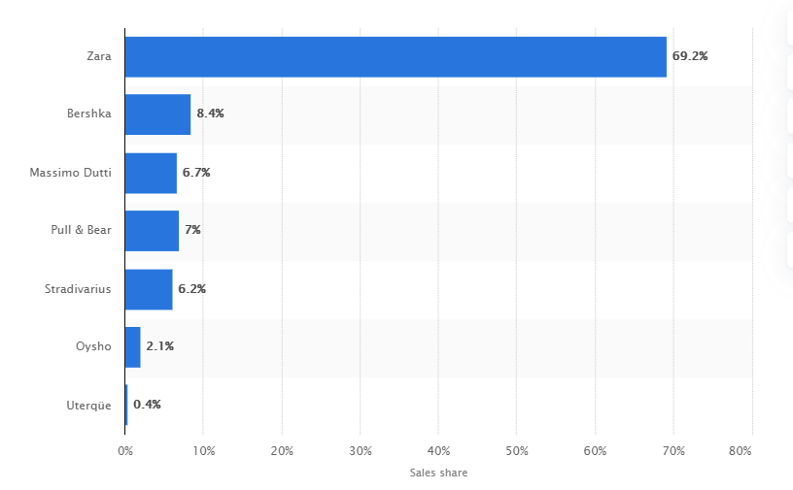
Role of Marketing in Creating Value for Customers
Figure SEQ Figure \* ARABIC 1: Sales share of the Inditex Group worldwide in 2019, by format – Source: Blázquez (2020)
As stated earlier, one important role that marketing plays for organisations like Zara is related to creating value for the customers through the products and services. According to Kumar and Reinartz (2016), customer value can be described as a perception that customers have regarding the worth of a particular product or service in comparison to other possible alternatives. This worth is typically determined by the customers by looking at the potential advantages of the product that can be related to its high quality, price, service, and even experience of the brand (Mahmoud et al., 2018). Thus, marketing plays an important role in terms of delivering value to the customers by providing these advantages for which organisations are often required to first identify and satisfy the needs of their customers and then retain them in the long run (Kusumadewi, 2019).
In this regard, authors like Zhang et al. (2016), have also stated that before deciding the type of value that the company wants to provide through its products or services, it should first focus on identifying the needs or wants of its target customers. As stated earlier, within the fashion and apparel industry, most companies like Zara are increasingly innovating their products and services due to the changing needs and preferences of the customers (Yang et al., 2017). In other words, customers in this industry have been noted to constantly talk about the newest trends in fashion, which in turn motivates them to develop a longing related to having the latest fashion collection. However, many of these fashion and apparel products become costly for the customers to afford, which as a result, cause them to purchase cheaper clothes or poor-quality apparel products (Santini et al., 2018; Mustafid et al., 2018).
Thus, identifying and satisfying this need of the customers to have the latest fashion collection at affordable prices can be considered as one of the initial tasks for companies like Zara if they want to create value for the customers. In this regard, to satisfied the identified need of the customers, Sayil et al. (2019) have stated that the goal of the companies while devising the marketing strategy of the product should always be based on increasing the total customer benefit of the product or reduce the total customer cost related to attaining the product (or a combination of both). Yen et al. (2020) have also stated that even though creating the right product or service becomes extremely important for organisations while providing value, they are also required to ensure that everyone feels the benefit from the exchange of the product/service. This means that an organisation has to ensure that its target customers feel happy with the value which they get for what they pay for the product and the company also feels satisfied with the payment it receives in exchange for providing that product (Kotler, 2017).
In this regard, Zara is satisfying the needs of its customer by creating value for everyone by utilizing the mass customisation technique. This technique is allowing the company to provide different types of apparel and fashion products in large volumes to its target customers in order to meet their distinctive tastes and preferences for fashion products (Hoen, 2018). However, at the same time, the company is also reducing the unit cost of producing these apparel products through utilizing the mass customisation technique, which is helping it to charge affordable and even low prices for its fashion and apparel products (Semple, 2019). From this strategy, one can infer that Zara is utilizing the best-cost provider strategy (i.e., the combination of both the product differentiation and low-cost leadership) to create value for its customers as per the academic theory of Porter’s generic strategies (Islami et al., 2020).
However, the role of marketing is not only confined to identifying and satisfying the needs of the customers, since it also requires companies to retain their target customers in the long run. For this purpose, organisations typically try to create novel opportunities to win the loyalty of the customers (Wu and Li, 2018). Again, in the case of Zara, the company has created loyalty among its customers to retain them in the long run by constantly delivering the branded value of trend-right clothing and apparel products at appealing prices (Danziger, 2018).
In this regard, by making the product exchange valuable and the overall brand experience meaningful for the customers, Zara has created loyalty among its customers by tapping into their potential in order to evangelise its brand (Danziger, 2018). In other words, rather than utilizing push marketing strategies, Zara focuses on pulling its customers after which it cultivates them as the brand influencers of the company to enhance its products, services, and operations. This has also enabled Zara to spread positive word of mouth about its brand. These marketing strategies of Zara are also the reason why the shopper frequency at its stores is higher than the traditional women’s clothing and apparel stores (Kohan, 2018).
Again, in creating loyal customers and then transforming them into brand evangelists, the marketing activities of Zara typically focus on increasing customer engagement (besides providing high-quality and unique clothing products to them at affordable prices) (Payton, 2020). An example of this can be taken from the two-way communication that Zara conducts with its young customers on its social media pages like Facebook (where it has more than 25 million followers) to understand their needs, address their concerns and launch new (or improve its existing) apparel and fashion products (Ravi, 2018). By considering these points, it can also be inferred that Zara utilises the "marketing concept" while devising its customer value-driven marketing strategy by understanding the wants and needs of its target customers, and then delivering the desired value better than its close competitors (Lumen, 2021). The above-explained role of marketing has also been summarised in the below figure.

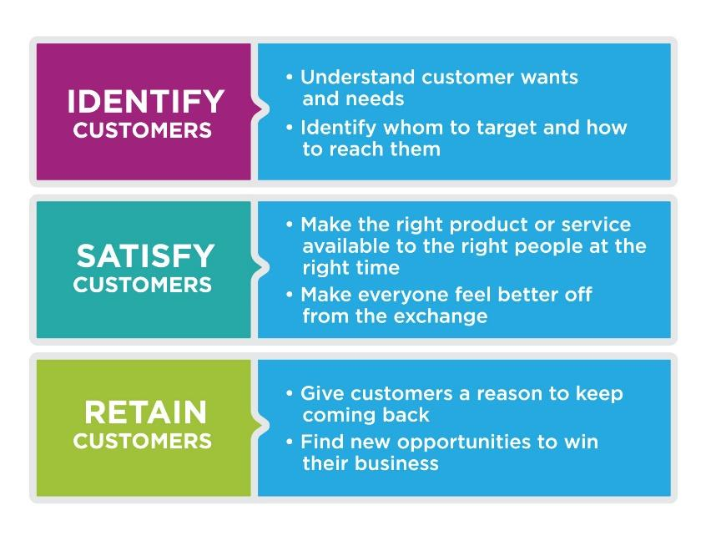

Figure SEQ Figure \* ARABIC 2: Role of Marketing in Creating Value for the Customers – Source: Lumen (2021)

Impact of Stakeholder Engagement on the Marketing Activities
Stakeholder engagement can be described as a process that enables organisations to communicate and understand their key stakeholders. In other words, this process allows an organisation to comprehend the needs and varying interests of its stakeholders and the extent of their engagement with the firm (Bowen et al., 2017). By gaining this understanding of the individual needs and involvement of each stakeholder in the business, organisations are better able to devise appropriate plans and actions that also allow them to impact the goals of their firms, as well as their stakeholders (Ray and Miller, 2017).
Today, engaging with the key stakeholders of the business has also become significantly important for the success of the organisations within their respective industries (Jakhar, 2017). In this regard, authors like Bourne (2016) have contended that if organisations want to become successful, they should have a clear vision that can be derived from a robust or effective strategic planning process. This also includes the marketing plan of the business that can help to make the organisation successful by fostering stakeholder engagement. In this regard, the stakeholder theory has also contended that organisations should always try to devote their effort by creating value not just for their shareholders but also for their stakeholders (Jones et al., 2017). Again, this value cannot be created without engaging the stakeholders that also tend to impact the organisation’s overall marketing activities (Caputo, 2016).
However, before understanding this impact of stakeholder engagement, it is also important to comprehend the type of stakeholders that impact or are impacted by the decisions or actions of an organisation. Usually, stakeholders for any company (such as Zara) are grouped into two categories that include internal and external stakeholders. In the case of Zara, its internal stakeholders can include its shareholders, board of directors, employees, and managers. While the external stakeholders of the company can include its customers, suppliers, government, and society (Cardwell et al., 2017).
Engaging with all these stakeholders can be considered a highly important task for companies like Zara since such an engagement can help organisations to develop meaningful relationships with all their important stakeholders, which in turn, can help in adding value to the operations of their firms (Boesso and Kumar, 2016). In addition to this, engaging with the stakeholders also allows organisations to minimise potential risks, create appropriate plans for the future, and enhance opportunities for growth by better comprehending the fast-changing environmental, political, technological, social, and economic context of their industries (Mitchell et al., 2020).
This importance of addressing the concerns and meeting the needs of each stakeholder can also be considered as the prime reason behind the impact of stakeholder engagement on the marketing activities of the organisations (Loureiro et al., 2020). Again, an example of this can be taken from the case of Zara which devices its marketing strategies by engaging with its key stakeholders. For instance, one of the reasons behind the success of Zara is related to its increased efforts in terms of training and empowering its managers and employees (i.e., internal stakeholders) at its retail stores to be particularly sensitive to the wants and needs of the customers (Martin Roll, 2020).
For this purpose, Zara has been known for empowering its store managers and sales associates to be at the forefront of customer research. In this regard, the company has trained its employees and managers to listen and note down the comments or ideas of the customers intently related to the fabrics, cuts, or a new line of clothing product (Uberoi, 2017). This also includes training the employees and managers to keenly observe the new styles that customers are found to be wearing while visiting the company’s stores to identify the potential of converting those styles into unique Zara styles (Martin Roll, 2020). Whereas, in return for providing exceptional customer service which is the important goal of its marketing activities, Inditex (i.e., the parent company of Zara) also offer different types of monetary and non-monetary rewards to its employees (including growth opportunities) to increase their motivation, job satisfaction, as well as the intention to work for the company in the long-run (Akass, 2019).
On the other hand, the engagement of Zara with its customers (i.e., external stakeholders) can be better understood by referring to the company's basic rules related to giving customers what they want and providing their desired products faster than anyone else (Koivulehto, 2017). As stated earlier, Zara communicates with its customers on its website and social media pages like Facebook to understand their needs or address their queries in order to provide them with optimal customer service. In this regard, asking for feedback from the customer is more than lip service at Zara. This is because when customers give positive or negative feedback on its clothing product, Zara reports this back to its headquarters and communicates these reviews or feedback of the customers to its in-house designers who apply them in their future work (Danziger, 2018).
Similarly, Zara also focuses on producing and promoting toxic-free merchandise under its marketing activities and it has also implemented different recycling programs under its retail stores to positively engage with the local communities or society where it is conducting its operations. For instance, to promote sustainability, Zara has launched a recycling donation program, as well as an eco-friendly clothing collection named “Join Life” under which it has made all its clothing products from animal-friendly and forest-friendly materials. This again has helped Zara in improving its image in the eyes of its stakeholders (Holgate, 2019).

Conclusion
From the above-conducted analyses within this essay, it can be concluded that marketing indeed plays an important role in terms of creating value for the customers by ensuring that they are provided with the right product, at the right place, at the right price, and on a right time. However, the analysis under this essay has also shown that the marketing activities which are conducted by organisations for promoting their brands are significantly impacted by their stakeholder’s engagement. Thus, it can also be concluded from this essay that to improve both their strategic and financial performance, companies like Zara should always try to understand the needs and wants of their stakeholders. This, in turn, can help them to develop the right marketing strategies for promoting their products and create value for their key stakeholders successfully.

References
Akass, E., 2019. Inditex: How structured career progression boosts morale and reduces turnover. [online] Engageemployee.com. Available at: <https://engageemployee.com/how-structured-career-progression-boosts-morale-and-reduces-turnover/> [Accessed 31 March 2021].
Blázquez, A., 2020. Sales share of the Inditex Group by format worldwide 2019. [online] Statista. Available at: <https://www.statista.com/statistics/268825/contribution-of-sales-of-the-inditex-group-worldwide-by-format/> [Accessed 31 March 2021].
Boesso, G. and Kumar, K., 2016. Examining the association between stakeholder culture, stakeholder salience and stakeholder engagement activities. Management Decision.
Bourne, L., 2016. Targeted communication: the key to effective stakeholder engagement. Procedia-Social and Behavioral Sciences, 226, pp.431-438.
Bowen, D.J., Hyams, T., Goodman, M., West, K.M., Harris‐Wai, J. and Yu, J.H., 2017. Systematic review of quantitative measures of stakeholder engagement. Clinical and translational science, 10(5), p.314.
Caputo, F., 2016, September. A focus on company-stakeholder relationships in the light of the Stakeholder Engagement framework. In 9th Annual Conference of the EuroMed Academy of Business.
Cardwell, L.A., Williams, S. and Pyle, A., 2017. Corporate public relations dynamics: Internal vs. external stakeholders and the role of the practitioner. Public Relations Review, 43(1), pp.152-162.
Danziger, P., 2018. Why Zara Succeeds: It Focuses On Pulling People In, Not Pushing Product Out. [online] Forbes. Available at: <https://www.forbes.com/sites/pamdanziger/2018/04/23/zaras-difference-pull-people-in-not-push-product-out/?sh=4ee5056023cb> [Accessed 31 March 2021].
Gardetti, M.A. and Torres, A.L. eds., 2017. Sustainability in fashion and textiles: values, design, production and consumption. Routledge.
Hoen, V., 2018. Staying Ahead in the Fashion Race: Who Will Be the Mass Customization Winners?. [online] Guidehouseinsights.com. Available at: <https://guidehouseinsights.com/news-and-views/staying-ahead-in-the-fashion-race-who-will-be-the-mass-customization-winners> [Accessed 31 March 2021].
Holgate, M., 2019. As Zara Announces Its Latest Sustainability Goals, Three of Its Design Team Weigh In on Going Slower and Creating Responsibly. [online] Vogue. Available at: <https://www.vogue.com/article/zara-sustainable-initiatives> [Accessed 31 March 2021].
Inditex, 2021. Inditex around the world - About Us. [online] Inditex.com. Available at: <https://www.inditex.com/about-us/inditex-around-the-world#continent/000> [Accessed 31 March 2021].
Islami, X., Mustafa, N. and Latkovikj, M.T., 2020. Linking Porter’s generic strategies to firm performance. Future Business Journal, 6(1), pp.1-15.
Jakhar, S.K., 2017. Stakeholder engagement and environmental practice adoption: The mediating role of process management practices. Sustainable Development, 25(1), pp.92-110.
Jones, T.M., Wicks, A.C. and Freeman, R.E., 2017. Stakeholder theory: The state of the art. The Blackwell guide to business ethics, pp.17-37.
Kohan, S., 2018. Why Zara Wins, H&M Loses in Fast Fashion. [online] The Robin Report. Available at: <https://www.therobinreport.com/why-zara-wins-hm-loses-in-fast-fashion/> [Accessed 31 March 2021].
Koivulehto, E.I., 2017. Do social media marketing activities enhance customer equity? A case study of fast-fashion brand Zara.
Kotler, P., 2017. Customer value management. Journal of creating value, 3(2), pp.170-172.
Kumar, V. and Reinartz, W., 2016. Creating enduring customer value. Journal of Marketing, 80(6), pp.36-68.
Kusumadewi, R., 2019. The Role of Marketing and Individual Environment Association in Elevating the Customer Value. Budapest International Research and Critics Institute (BIRCI-Journal), pp.451-460.
Linden, A.R., 2016. An analysis of the fast fashion industry. Senior Projects Fall 2016, 30.
Loureiro, S.M.C., Romero, J. and Bilro, R.G., 2020. Stakeholder engagement in co-creation processes for innovation: a systematic literature review and case study. Journal of Business Research, 119, pp.388-409.
Lumen, 2021. The Role of Customers in Marketing | Introduction to Business. [online] Courses.lumenlearning.com. Available at: <https://courses.lumenlearning.com/wmopen-introbusiness/chapter/the-role-of-customers-in-marketing/> [Accessed 31 March 2021].
Mahmoud, M.A., Hinson, R.E. and Anim, P.A., 2018. Service innovation and customer satisfaction: the role of customer value creation. European Journal of Innovation Management.
Martin Roll, 2020. The Secret of Zara’s Success: A Culture of Customer Co-creation. [online] Martin Roll. Available at: <https://martinroll.com/resources/articles/strategy/the-secret-of-zaras-success-a-culture-of-customer-co-creation/> [Accessed 31 March 2021].
Mitchell, J.R., Mitchell, R.K., Hunt, R.A., Townsend, D.M. and Lee, J.H., 2020. Stakeholder Engagement, Knowledge Problems and Ethical Challenges. Journal of Business Ethics, pp.1-20.
Mustafid, Karimariza, S.A. and Jie, F., 2018. Supply chain agility information systems with key factors for fashion industry competitiveness. International Journal of Agile Systems and Management, 11(1), pp.1-22.
Payne, A., Frow, P. and Eggert, A., 2017. The customer value proposition: evolution, development, and application in marketing. Journal of the Academy of Marketing Science, 45(4), pp.467-489.
Payton, S., 2020. How The Zara Marketing Strategy Makes Billions And Spends $0. [online] Word-of-Mouth and Referral Marketing Blog. Available at: <https://www.referralcandy.com/blog/zara-marketing-strategy/> [Accessed 31 March 2021].
Porral, C.C. and Stanton, J.L., 2017. Principles of marketing. ESIC Editorial.
Ravi, K., 2018. Zara's Social Media Strategy - How They Delight Their Customers. [online] Unmetric Social Media Analytics Blog. Available at: <https://blog.unmetric.com/social-media-strategy-zara> [Accessed 31 March 2021].
Ray, K.N. and Miller, E., 2017. Strengthening stakeholder-engaged research and research on stakeholder engagement. Journal of comparative effectiveness research, 6(4), pp.375-389.
Sánchez-Gutiérrez, J., Cabanelas, P., Lampón, J.F. and González-Alvarado, T.E., 2019. The impact on competitiveness of customer value creation through relationship capabilities and marketing innovation. Journal of Business & Industrial Marketing.
Santini, F.D.O., Ladeira, W.J. and Sampaio, C.H., 2018. The role of satisfaction in fashion marketing: a meta-analysis. Journal of Global Fashion Marketing, 9(4), pp.305-321.
Sayil, E.M., Akyol, A. and Golbasi Simsek, G., 2019. An integrative approach to relationship marketing, customer value, and customer outcomes in the retail banking industry: a customer-based perspective from Turkey. The Service Industries Journal, 39(5-6), pp.420-461.
Semple, S., 2019. Zara's Custom Embroidery Line Shows Consumers Want Personalization. [online] Promo Marketing. Available at: <https://magazine.promomarketing.com/article/zara-collection-reveals-apparel-with-custom-embroidery/> [Accessed 31 March 2021].
Sitaro, T.D., 2020. Fast Fashion and Sustainability-The Case of Inditex-Zara.
Uberoi, R., 2017. ZARA: Achieving the “Fast” in Fast Fashion through Analytics. [online] Digital Innovation and Transformation. Available at: <https://digital.hbs.edu/platform-digit/submission/zara-achieving-the-fast-in-fast-fashion-through-analytics/> [Accessed 31 March 2021].
Wu, Y.L. and Li, E.Y., 2018. Marketing mix, customer value, and customer loyalty in social commerce: A stimulus-organism-response perspective. Internet Research.
Yang, S., Song, Y. and Tong, S., 2017. Sustainable retailing in the fashion industry: A systematic literature review. Sustainability, 9(7), p.1266.
Yen, C.H., Teng, H.Y. and Tzeng, J.C., 2020. Innovativeness and customer value co-creation behaviors: Mediating role of customer engagement. International Journal of Hospitality Management, 88, p.102514.
Zhang, H., Liang, X. and Wang, S., 2016. Customer value anticipation, product innovativeness, and customer lifetime value: The moderating role of advertising strategy. Journal of Business Research, 69(9), pp.3725-3730.

