
International Meetings Management for the Hotel Industry
Event Strategic Planning and Delivery Considerations for an
International Meeting

Module code: BMIH6007
LEVEL 6
Winter Term 2025
Lecturer name: Kathryn Flynn

Student name: Elena-Gabriela David

Student ID: 2212249



Acknowledgement of the use of AI

I confirm that I have not used any AI tools in the research and creation of this assignment. I confirm that I have not presented any AI generated materials as my own work. I confirm I have copies of my drafts, notes, and other resources I used, which I may be asked to provide in evidence.

Executive Summary
The “Crossroads of Culture” is an event to encourage the celebration of cultural differences, unity and cultural exchange in the community. Held in one of London’s more popular locations, Hyde Park, this five-day programme entails live music performance, traditional dances, artwork exhibitions, and cultural stations that foster cultural sensitivity among the participants. This is because the event objectives encompass issues of enhanced cultural diversity, partnership and sponsors, as well as the subject of engagement in cultural learning. It also focuses on equality and openness, proximity and distance events, as well as work on ecologically friendly concepts. The event is designed to act as an ambassador of the principles of tolerance and anti-discrimination promoted by EU countries and have a positive impact on the development of local tourism and society in general terms.

Table of Contents
1 Introduction 2
2 The Event Cycle 2
2.1 Definition of the Event Cycle 2
2.2 Application to the Event 3
3 Event Concept 3
3.1 Delegate Experience 3
3.2 Itinerary 4
3.3 Event Design 4
3.4 Sensory Engagement 4
4 Aim and Objectives of the Meeting/Event 4
5 Event Management 5
5.1 Required Skills and Resources 5
5.2 Resource Allocation and Team Structure 6
6 Event Budget 6
6.1 Expenditure Breakdown 6
6.2 Income Generation 6
6.3 Financial Discussion 7
7 Industry Trends/Issues/Impacts 7
7.1 Current Trends in Event Management 7
7.2 Industry Impacts on Multicultural Event Planning 8
7.3 Event Adaptation to Trends 8
8 Situational and Cultural Considerations 8
8.1 Situational Factors 8
8.2 Cultural Considerations 9
8.3 Application of Business Analysis Tools 9
8.3.1 SWOT Analysis 9
8.3.2 PESTLE Analysis 10
8.3.3 SOAR Model 10
9 Conclusion 11
10 Reference List 11

Introduction
Crossroads of Culture, a Fusion of Diversity is a multicultural event that seeks to promote thepromotion of cultural diversity. It enhances cross cultural understanding, embraces diversity and strengthens community harmony with an element of empathy on culture (Ziakas, 2020). The event has been selected because it aligns with the three concepts of equality, diversity, and inclusion as vital values within today’s society. Hyde Park London serves as a suitable culturally, diverse background that should accommodate internationals comfortably and easily (Askitas, Tatsiramos and Verheyden, 2021). Multicultural event programmes have overtime have made positive contribution towards cultural exchange, cultural integration and promotion of local tourism as well as social cohesion (Wong et al., 2022).
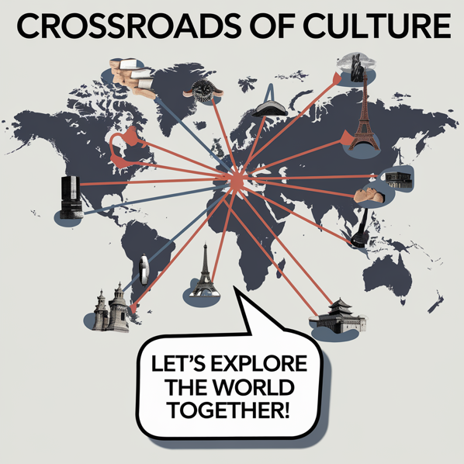
Figure 1 Crossroads of Culture event posters

The Event Cycle

Definition of the Event Cycle
The Event Cycle can be defined as a systematic approach that systematically outlines the planning, implementation and assessment of an event. The management process is usually categorised into three phases, namely planning the event, the actual convening of the event and prospectively, evaluating the event. During the planning phase, they have to make preparations in one or several aspects of the family event, including the choice of the venue, the organisation of logistics, financial issues, and staff (Wolff, Jarodzka and Boshuizen, 2020). The implementation stage is the actual happening of the event in which all activities, resources and people involved must be well coordinated and monitored. Lastly, the assessment is the evaluation of the event outcome, collecting the feedbacks, and finding out the areas that need improvement for future events.
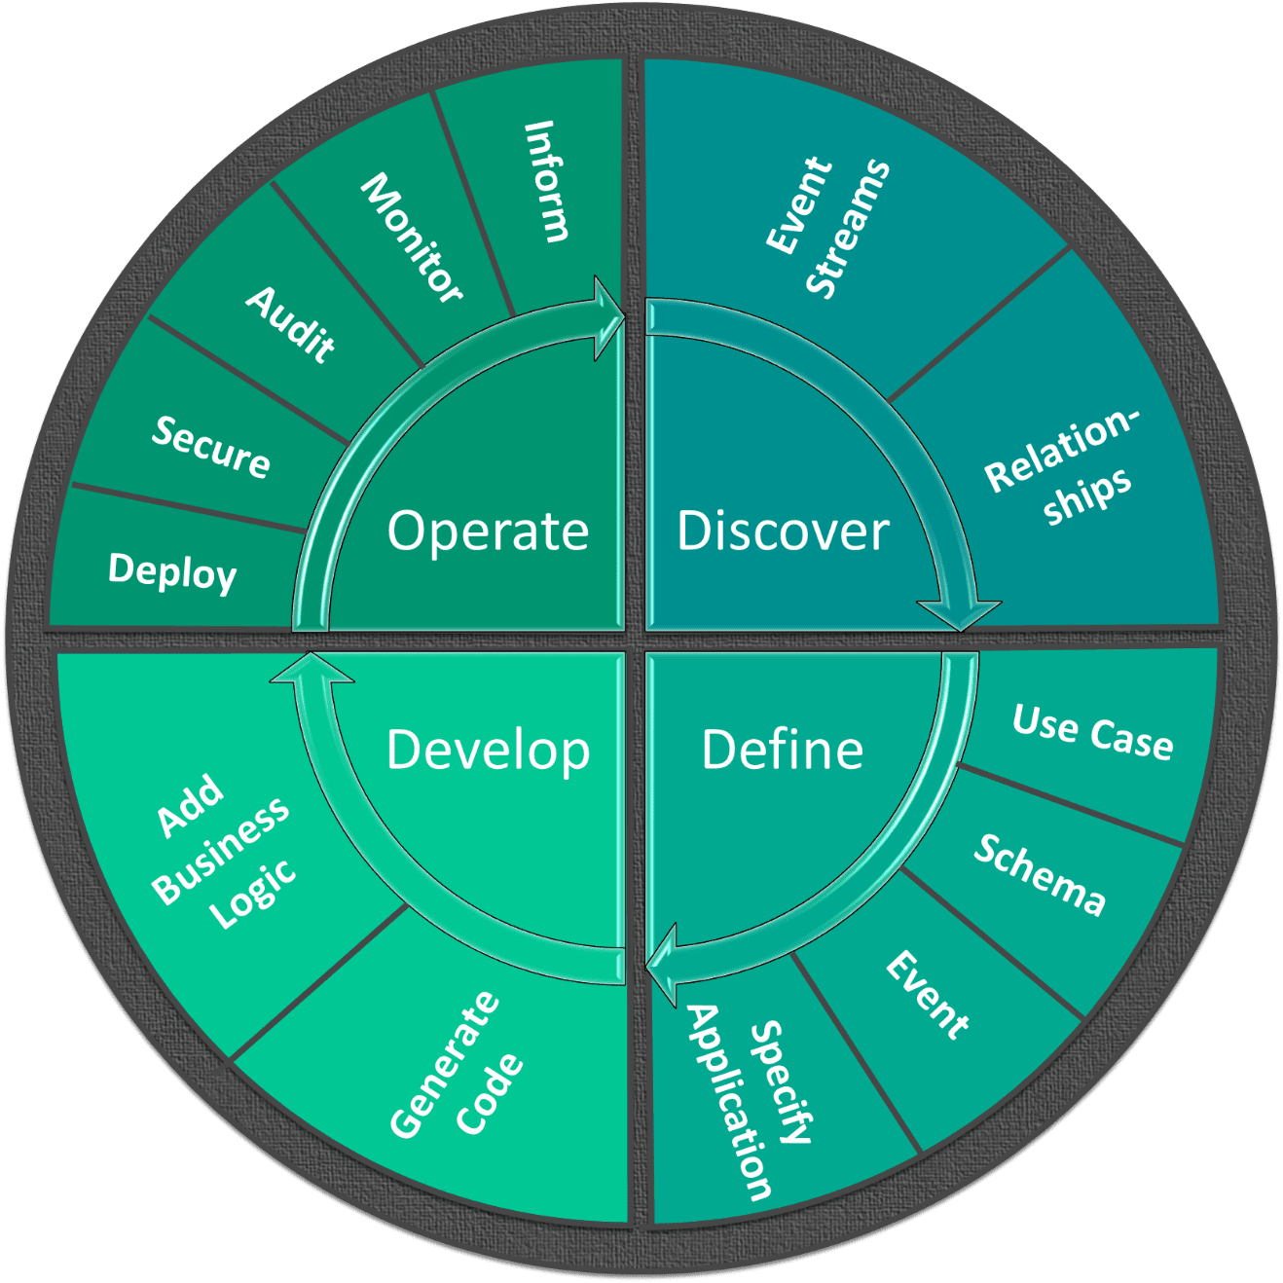
Figure 2 Event Cycle (Wolff, Jarodzka and Boshuizen, 2020)

Application to the Event
The activities of the Crossroads of Culture planning phase involve securing of Hyde Park as the location of the event, creation of layout map and the final timetable for cultural performances, hiring of personnel and volunteers to man the event among others. This is because the management of logistics will organise everything ranging from catering services to the concession, sound systems, and security (Wang, 2020). The implementation phase will emphasise the organisation’s objective in ensuring that the event is carried out as planned. Events such as drama performances, workshops, and art shows, will go on as scheduled; management of the events will ensure that the flow of the event is good and take care of the guests’ welfare and interest (Ameen et al., 2021).
EMBOK model applied to the "Crossroads of Culture" event in a concise table format:
EMBOK Model Area | Application to "Crossroads of Culture" Event
Scope | Focuses on promoting cultural diversity through performances, workshops, and exhibitions.
Time | Five-day event with a defined schedule, including cultural lectures, performances, and workshops, ensuring timely planning and execution.
Cost | £113,000 expenditure (venue, staff, catering) balanced by £145,000 income (ticket sales, merchandise, sponsorship).
Quality | High standards for performances, workshops, catering, and post-event evaluations to improve future events.
Human Resources | Includes logistics, security, volunteers, and cultural representatives, ensuring smooth operations and guest satisfaction.

When the event is over, an evaluation of the satisfaction level of the attendees of the event will be done through questionnaires. It will look into the aspect of financial revenue achieved by the team from the event as well as the effectiveness of how it was marketed and vice versa on the members of the targeted group in the society (van Zelst et al., 2020). This stage will provide organisers with key insights on what was successful and what should not be done in future multicultural events hence helping the organisers improve on the process.

Event Concept

Delegate Experience
The “Crossroad of Culture” is full of numerous definite activities in which all participants can participate to engage with different cultural activities. The audiences will be privileged to watch live music, traditional dances, and theatrical performances from the cultural groups (Thier, Mason and Mattice, 2023). Furthermore, the workshop will involve participants into practical activities including food preparation which are typical to certain cultures, making cultural complements and movement demonstrations that are characteristic of particular cultures. A revitalised art gallery, fashion show and history relevant and engaging experiences will also enhance learners’ knowledge concerning cross-cultural practises.

Itinerary
The event lasts five days and for each day, the event starts right from 10 in the morning in the morning down to 9 in the evening (Tan and Zhu, 2022). The thematic of the morning session will be cultural lectures and dissemination; the latter part of the day will be devoted to performances and exhibiton. At 2 p.m. all people can attend and take part in some of the facilitated activities like cooking or crafting (Alhazmi and Kaufmann, 2022). This will be followed by range of cultural events, including live band and authentic programmes of dances and performances, fashion show splits the evening in the evening. An early afternoon will consist of special sessions for the schools and educational groups where the stress will be on culturally related activities (Singh et al., 2021).

Event Design
The design of this type of event is very oriented toward creating an environment that can help people discover cultural differences. The design of the floor space adopting various ethnic-related themes and subsectors that provide areas for sale of foods and drinks, artwork, and acrobat performances. This design can promote people’s free movements and their transitions between various events when they are enjoying cultural performances at a certain point in time (Singh et al., 2020).

Sensory Engagement
The accompanying audio and visual programmes of different traditional music pieces, the costumes, artwork pieces, and lovely scents of various foods carefully prepare by attendees will please participants. Such sensory means, along with various interactive, help to encourage the people to experience multiculturalism in some or other way (Sillmann et al., 2021).

Aim and Objectives of the Meeting/Event
The major goal of the “Crossroads of Culture” is to raise awareness and sensitisation of the European values, non-discrimination, tolerance and multiculturalism within the framework of the Structure of the European Union, targeting aim of a range of activities (Seraphin, 2020).
In order to set achieve this goal, the event will be structured to meet the following specific goals:
- Specific: Raise cultural awareness by 30% among attendees, fostering greater understanding and appreciation for diverse cultures (Aldao et al., 2021).
- Measurable: Achieve a total of 10,000 attendees over the five-day event, with a wide demographic representation.
- Achievable: Secure over 50 sponsors and partners to ensure financial support and collaboration, including local and global cultural organisations (Russotto et al., 2021).
- Relevant: Ensure that at least 80% of attendees actively participate in cultural learning activities such as workshops, performances, and interactive exhibitions.
- Time-Bound: Complete the planning and organisation of the event three months before its commencement, allowing sufficient time for promotion and coordination.
These objectives will help in maintaining the purpose of the event while running the event in line with the appreciations of cultural diversity (Ritchie and Jiang, 2021).

Event Management

Required Skills and Resources
Management of the event “Crossroads of Culture” will involve operational, planning and marketing skills to be able to organise for the event. Specific activity skills like training in co-ordinating an event, managing resources such as hiring equipment and catering services and how to handle risks that might arise in the course of the event. The care must be sensitive in hosting and receiving the guests, meeting safety measures, coordinating activities such as feeding and transportation of guests amongst others (Ratten, 2020).
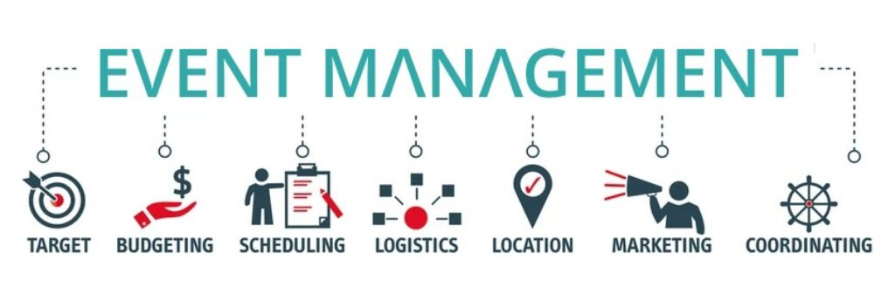
Figure 3 Required Skills and Resources (Park and Jones, 2021)
Some of the risks that will require management include; weather incidences and insecurity which may affect the set schedules of an event. Other related skills include planning skills that are of significant importance in the event. Preventing awareness will be achieved by among the targeted population using marketing tools namely the electronic media including, social media, and emails (Puspita and Pranoto, 2021). The event will also be aimed at seeking partnering with cultural organisations, businesses, and sponsors. It will also be effective in targeting a variety of different cultures for the attendees to increase the sense of an inclusive event.

Resource Allocation and Team Structure
Logistics entails establishing and acquiring the resources for a business which includes the financial resources to use in funding the business, human resources which is the people required for implementing the strategies of the business, and the other resources such as the venue, suppliers, and equipment (Park and Jones, 2021). All the necessary expenses such as rental of venue, foods and drinks, decorations and costs that will be incurred in compensating the employees will be factored in a detailed manner while preparing the budget (Alam, Wei and Wahid, 2020). Apart from entertainment crew, other people whom shall be hired will include event organisers, culture bearers, security personnel, as well as volunteers. The location of the event shall be booked well in advance and arrangements for its requirements such as food, equipment, and materials will also be procured from appropriate vendors (Pandey and Kumari, 2021).

Event Budget

Expenditure Breakdown
Expense | Cost (£)
Venue Booking | 35,000
Decorations | 25,000
Staff Management | 15,000
Food and Catering | 20,000
Marketing and Promotion | 10,000
Miscellaneous | 8,000
Total Expenditure | 113,000

Income Generation
Revenue Source | Income (£)
Ticket Sales | 50,000
Merchandise | 70,000
Sponsorship | 25,000
Total Income | 145,000

Financial Discussion
The expenditure breakdown here details the main overhead expense that are related to the ”Crossroads of Culture’ programme. The highest expense of £35,000 goes to venue booking, which is important to set the event, Hyde Park, as one of the most famous parks in London (Olivera et al., 2021). Next come decorations and staff related costs which amounts to £25,000 for the creation of an environment that meets the overall theme of the event and £15,000 for hiring staff to manage the event. The food and catering costs shall be £20,000; this is due to the kind of world class food that shall be served. £10,000 is spent on marketing and promotion, which includes online advertising, usage of influencers, and visible advertisements (Madi Odeh et al., 2021).

Industry Trends/Issues/Impacts

Current Trends in Event Management
The changes observed in the events industry in recent years include hybrid events, sustainability, and awareness of diversity. It is easier to organise such events and can cover a large number of participants owing to the fact that it incorporates both live and online participation. Sustainability in the event management entails the environmental conservation steps in ways that entail the conservation of energy, materials, and high impacts (Li et al., 2023).
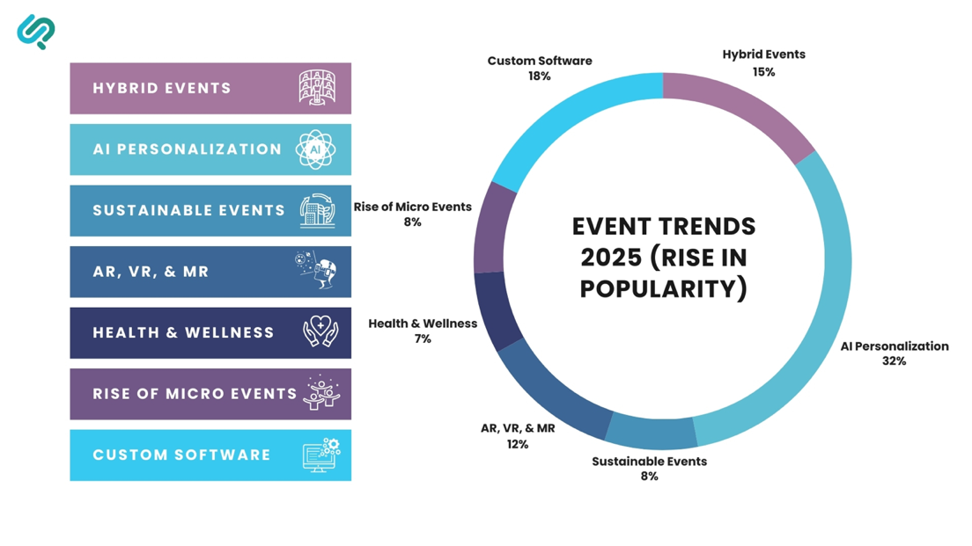
Figure 4 Current Trends in Event Management (Kaur et al., 2021)

Industry Impacts on Multicultural Event Planning
These concerns are considered highly topical concerning multicultural events as, for instance, “Crossroads of Culture,” which is supposed to be fully inclusive. It creates opportunities for this audience to contribute remotely through Hybrid formats to be incorporated in case of physical inability to attend the event (Khang et al., 2022). Eco-responsibility of every event has become the order of the day because this is today’s world where conservation of the resources is highly valued.

Event Adaptation to Trends
The openness to the industry dynamics of the “Crossroads of Culture” event is rendered by the latter’s adherence to such trends as the usage of environmentally friendly materials, encouragement of reusable items, and reduction of wastes. There will also be organised with a view of ensuring that it can accommodate everyone who may be attending including those with disabilities (Kaur et al., 2021). Live streaming of performances and use of other tools for hosting workshops will also be incorporated into the event to ensure that more people are able to participate due to social distance restrictions.

Situational and Cultural Considerations

Situational Factors
The following are some of the situational aspects that need to be taken into consideration when planning the “Crossroads of Culture” event. This involves political factors that may affect the event, economic factors that may affect the event, legal factors that may affect the event and the social factors that may affect the event (He et al., 2020). In its political perspective, the support of the local administration and the policymakers to get proper permission to organise the event and their cooperation to organise the event as per the goals and objectives of the particular locality.
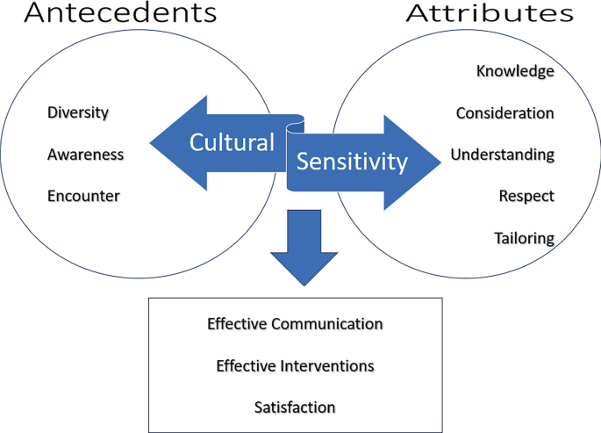
Figure 5 Situational factors and culture (Eldridge et al., 2022)
In an economic perspective, it should have effect on the progression of the economy through tourism; the event should be sited in Hyde Park. However, some of the costs may be an issue for instance charges like booking of the hall or hiring staff (Granadillo, Zarzosa and Diaz, 2021). Culturally, consumer concern for multicultural and diverse events is on the increase, as was described in a survey conducted by the UK Events Industry Board in 2021 outlining that 61% of people attended diversity-centred events. There are several likely issues that may arise and they include security given that the event is expected to attract a large congregation of people (Fancourt et al., 2021).

Cultural Considerations
From a cultural angle, it must respect diversity by the show embracing instead of assimilating culture. The cultural aspect must be respected in order to avoid stereotyping or disrespecting a particular culture to ensure it is depicted as it is. This is crucial for the cultural representation due to the fact that misinterpretation might prejudice and lead to incorrect portrayal of cultural diversity in the event (Eldridge et al., 2022).

Application of Business Analysis Tools

SWOT Analysis
- Strengths: Event has historical and cultural background, and therefore, finds favourable response across the communities that signifies a healthy start for the event. The variation is expressive enough to attract a large clientèle and a variety of events (Day, Tamatea and Geia, 2021).
- Weaknesses: Several potentially unfavourable circumstances include high costs entailing the provision of logistical, staffing and venue booking services. Also, the aspects of security related to crowd control and the use of public areas such as the Hyde park may pose some risk.
- Opportunities: The event does not exclude coverage by media and cibur could take advantage and build international cultural exchange (Corrales-Estrada et al., 2021). However, it opens up a lot of growth potential considering people today are more inclined towards events which support Diversity.
- Threats: Political instabilities or a change in the government political decisions may deny permission to hold an event. Further, the Covid-19 effects could still be an issue of concern since restrictions might affect so many things including large assemblies (Chowdhury, Khan and Dhar, 2021).

PESTLE Analysis
- Political: The government grants can also contribute to funding and support for permits of the event, in coherence with the government’s general objective of promoting multiculturalism.
- Economic: The event will be having the capability to earn ticket sales of £50000; merchandise stands at £70000; and standing from sponsors £ 25000 and thus supporting the economy (Chen, Wang and Tang, 2022).
- Social: Event attendees are today pushing for event events than are diverse and this means that the events have a higher engagement level.
- Technological: Extended use of social media and event applications will be effective in promotion of events and to organise the events for better satisfaction of the attendees (Byrnes, 2022).
- Legal: Compliance with event permits, health,and safety precautions, and restrictions related to COVID-19 are crucial to the success of an event.
- Environmental: Reduction of wastage and proper use of environmentally friendly products is reasonably acceptable since the organisation aims to embrace environmental friendly practises as is the current global trend (Buhalis, Leung and Lin, 2023).

SOAR Model
- Strengths: The event is bolstered by deep community engagement and strong cultural representation, providing a platform for diverse voices.
- Opportunities: Global tourism growth and potential educational collaborations offer new avenues for expansion and awareness (Bowdin et al., 2023).
- Aspirations: The goal is to increase cultural awareness and promote inclusivity, ensuring all attendees feel represented.
- Results: The event aims to leave a long-term social impact, fostering community cohesion and strengthening cultural understanding (Bhaskara and Filimonau, 2021).
Such an analysis helps actually place the event in a position where it is prepared to overcome hurdles, leverage opportunities and inclusively capture a polymorphous audience (Aulia et al., 2023).

Conclusion
The Crossroads of Culture is an event through which people from all around the world are encouraged to come and showcase their culture and facilitate integration of cultural diverse people in the society as well as interaction and sharing of cultural practises. The event will educate the participants through performances, workshops, and exhibitions as the aim is to respect other cultures and share similar feelings and that are important. On both the local and international levels, the participants of the event should have the purpose to raise awareness of cultures and improve the social inclusion. Based on the characteristics of Advanced Workshop planning and alignment with contemporary issues diversity and sustainability, the event has all the necessary conditions for success and further development.

Reference List
Alam, Md.M., Wei, H. and Wahid, A.N.M. (2020). COVID‐19 outbreak and sectoral performance of the australian stock market: An event study analysis. Australian Economic Papers, 60(3), pp.482–495. doi:https://doi.org/10.1111/1467-8454.12215.
Aldao, C., Blasco, D., Poch Espallargas, M. and Palou Rubio, S. (2021). Modelling the crisis management and impacts of 21st century disruptive events in tourism: the case of the COVID-19 pandemic. Tourism Review, 76(4), pp.929–941. doi:https://doi.org/10.1108/tr-07-2020-0297.
Alhazmi, A.A. and Kaufmann, A. (2022). Phenomenological Qualitative Methods Applied to the Analysis of Cross-Cultural Experience in Novel Educational Social Contexts. Frontiers in Psychology, [online] 13(1). doi:https://doi.org/10.3389/fpsyg.2022.785134.
Ameen, N., Tarhini, A., Shah, M.H., Madichie, N., Paul, J. and Choudrie, J. (2021). Keeping customers’ data secure: A cross-cultural study of cybersecurity compliance among the Gen-Mobile workforce. Computers in Human Behavior, [online] 114, p.106531. doi:https://doi.org/10.1016/j.chb.2020.106531.
Askitas, N., Tatsiramos, K. and Verheyden, B. (2021). Estimating worldwide effects of non-pharmaceutical interventions on COVID-19 incidence and population mobility patterns using a multiple-event study. Scientific Reports, 11(1). doi:https://doi.org/10.1038/s41598-021-81442-x.
Aulia, I.N., Soelton, M., Hanafiah, A., Thoullon, M.S., Paijan, P., Karyatun, S. and Saratian, E.T.P. (2023). ENTREPRENEURIAL PLANNING STRATEGY AT MERUYA UTARA-KEMBANGAN-JAKARTA. ICCD, [online] 5(1), pp.121–128. doi:https://doi.org/10.33068/iccd.v5i1.571.
Bhaskara, G.I. and Filimonau, V. (2021). The COVID-19 pandemic and organisational learning for disaster planning and management: A perspective of tourism businesses from a destination prone to consecutive disasters. Journal of Hospitality and Tourism Management, 46, pp.364–375. doi:https://doi.org/10.1016/j.jhtm.2021.01.011.
Bowdin, G., McDonnell, I., Harris, R., O’Toole, W., Allen, J. and Leo Kenneth Jago (2023). Events Management. Routledge. doi:https://doi.org/10.4324/9781003044963.
Buhalis, D., Leung, D. and Lin, M. (2023). Metaverse as a disruptive technology revolutionising tourism management and marketing. Tourism Management, [online] 97(104724), p.104724. doi:https://doi.org/10.1016/j.tourman.2023.104724.
Byrnes, W.J. (2022). Management and the Arts. doi:https://doi.org/10.4324/9781003030287.
Chen, J., Wang, C. and Tang, Y. (2022). Knowledge Mapping of Volunteer Motivation: A Bibliometric Analysis and Cross-Cultural Comparative Study. Frontiers in Psychology, 13. doi:https://doi.org/10.3389/fpsyg.2022.883150.
Chowdhury, E.K., Khan, I.I. and Dhar, B.K. (2021). Catastrophic impact of Covid‐19 on the global stock markets and economic activities. Business and Society Review, 127(2). doi:https://doi.org/10.1111/basr.12219.
Corrales-Estrada, A.M., Gómez-Santos, L.L., Bernal-Torres, C.A. and Rodriguez-López, J.E. (2021). Sustainability and Resilience Organizational Capabilities to Enhance Business Continuity Management: a Literature Review. Sustainability, [online] 13(15), p.8196. doi:https://doi.org/10.3390/su13158196.
Day, A., Tamatea, A. and Geia, L. (2021). Cross-cultural practice frameworks in correctional settings. Aggression and Violent Behavior, p.101674. doi:https://doi.org/10.1016/j.avb.2021.101674.
Eldridge, N., Wang, Y., Metersky, M., Eckenrode, S., Mathew, J., Sonnenfeld, N., Perdue-Puli, J., Hunt, D., Brady, P.J., McGann, P., Grace, E., Rodrick, D., Drye, E. and Krumholz, H.M. (2022). Trends in Adverse Event Rates in Hospitalized Patients, 2010-2019. JAMA, 328(2), p.173. doi:https://doi.org/10.1001/jama.2022.9600.
Fancourt, D., Aughterson, H., Finn, S., Walker, E. and Steptoe, A. (2021). How leisure activities affect health: A narrative review and multi-level theoretical framework of mechanisms of action. The Lancet Psychiatry, 8(4), pp.329–339. doi:https://doi.org/10.1016/s2215-0366(20)30384-9.
Granadillo, G.G., Zarzosa, S.G. and Diaz, R. (2021). Security Information and Event Management (SIEM): Analysis, Trends, and Usage in Critical Infrastructures. Sensors, [online] 21(14), p.4759. doi:https://doi.org/10.3390/s21144759.
He, J., Mao, Y., Morrison, A.M. and Coca-Stefaniak, J.A. (2020). On being warm and friendly: the effect of socially responsible human resource management on employee fears of the threats of COVID-19. International Journal of Contemporary Hospitality Management, ahead-of-print(ahead-of-print). doi:https://doi.org/10.1108/ijchm-04-2020-0300.
Kaur, R., Dutta, S., Charan, J., Bhardwaj, P., Tandon, A., Yadav, D., Islam, S. and Haque, M. (2021). Cardiovascular Adverse Events Reported from COVID-19 Vaccines: A Study Based on WHO Database. International Journal of General Medicine, [online] Volume 14, pp.3909–3927. doi:https://doi.org/10.2147/ijgm.s324349.
Khang, A., Vladimir Hahanov, Gardashova Latafat Abbas and Vugar Abdullayev Hajimahmud (2022). Cyber-Physical-Social System and İncident Management. CRC Press eBooks, pp.21–35. doi:https://doi.org/10.1201/9781003252542-2.
Li, B., Zhang, Y., Chen, L., Wang, J., Pu, F., Yang, J., Li, C. and Liu, Z. (2023). MIMIC-IT: Multi-Modal In-Context Instruction Tuning. [online] arXiv.org. Available at: https://arxiv.org/abs/2306.05425 [Accessed 18 Feb. 2025].
Madi Odeh, R.B.S., Obeidat, B.Y., Jaradat, M.O., Masa’deh, R. and Alshurideh, M.T. (2021). The transformational leadership role in achieving organizational resilience through adaptive cultures: the case of Dubai service sector. International Journal of Productivity and Performance Management, 72(2), pp.440–468.
Olivera, P.A., Zuily, S., Kotze, P.G., Regnault, V., Al Awadhi, S., Bossuyt, P., Gearry, R.B., Ghosh, S., Kobayashi, T., Lacolley, P., Louis, E., Magro, F., Ng, S.C., Papa, A., Raine, T., Teixeira, F.V., Rubin, D.T., Danese, S. and Peyrin-Biroulet, L. (2021). International consensus on the prevention of venous and arterial thrombotic events in patients with inflammatory bowel disease. Nature Reviews Gastroenterology & Hepatology, [online] 18(12), pp.857–873. doi:https://doi.org/10.1038/s41575-021-00492-8.
Pandey, D.K. and Kumari, V. (2021). Event study on the reaction of the developed and emerging stock markets to the 2019-nCoV outbreak. International Review of Economics & Finance, [online] 71, pp.467–483. doi:https://doi.org/10.1016/j.iref.2020.09.014.
Park, M. and Jones, T. (2021). Going Virtual: The Impact of COVID-19 on Internships in Tourism, Events, and Hospitality Education. Journal of Hospitality & Tourism Education, 33(3), pp.1–18. doi:https://doi.org/10.1080/10963758.2021.1907198.
Puspita, D. and Pranoto, B.E. (2021). The attitude of Japanese newspapers in narrating disaster events: Appraisal in critical discourse study. Studies in English Language and Education, 8(2), pp.796–817. doi:https://doi.org/10.24815/siele.v8i2.18368.
Ratten, V. (2020). Coronavirus (COVID-19) and entrepreneurship: Cultural, lifestyle and societal changes. Journal of Entrepreneurship in Emerging Economies, 13(4). doi:https://doi.org/10.1108/jeee-06-2020-0163.
Ritchie, B.W. and Jiang, Y. (2021). Risk, crisis and disaster management in hospitality and tourism: a comparative review. International Journal of Contemporary Hospitality Management, ahead-of-print(ahead-of-print). doi:https://doi.org/10.1108/ijchm-12-2020-1480.
Russotto, V., Myatra, S.N., Laffey, J.G., Tassistro, E., Antolini, L., Bauer, P., Lascarrou, J.B., Szuldrzynski, K., Camporota, L., Pelosi, P., Sorbello, M., Higgs, A., Greif, R., Putensen, C., Agvald-Öhman, C., Chalkias, A., Bokums, K., Brewster, D., Rossi, E. and Fumagalli, R. (2021). Intubation Practices and Adverse Peri-intubation Events in Critically Ill Patients From 29 Countries. JAMA, 325(12), p.1164. doi:https://doi.org/10.1001/jama.2021.1727.
Seraphin, H. (2020). COVID-19: an Opportunity to Review Existing Grounded Theories in Event Studies. Journal of Convention & Event Tourism, 22(1), pp.1–33.
Sillmann, J., Shepherd, T.G., van den Hurk, B., Hazeleger, W., Martius, O., Slingo, J. and Zscheischler, J. (2021). Event‐Based Storylines to Address Climate Risk. Earth’s Future, 9(2). doi:https://doi.org/10.1029/2020ef001783.
Singh, B., Dhall, R., Narang, S. and Rawat, S. (2020). The Outbreak of COVID-19 and Stock Market Responses: An Event Study and Panel Data Analysis for G-20 Countries. Global Business Review, p.097215092095727. doi:https://doi.org/10.1177/0972150920957274.
Singh, S., McNab, C., Olson, R.M., Bristol, N., Nolan, C., Bergstrøm, E., Bartos, M., Mabuchi, S., Panjabi, R., Karan, A., Abdalla, S.M., Bonk, M., Jamieson, M., Werner, G.K., Nordström, A., Legido-Quigley, H. and Phelan, A. (2021). How an Outbreak Became a Pandemic: A Chronological Analysis of Crucial Junctures and International Obligations in the Early Months of the COVID-19 Pandemic. The Lancet, [online] 398(10316), pp.2109–2124. doi:https://doi.org/10.1016/S0140-6736(21)01897-3.
Tan, Y. and Zhu, Z. (2022). The effect of ESG rating events on corporate green innovation in China: The mediating role of financial constraints and managers’ environmental awareness. Technology in Society, 68, p.101906.
Thier, M., Mason, D.P. and Mattice, B. (2023). Experiential learning… remotely: Study abroad, global citizenship and NGO management. Higher education quarterly. doi:https://doi.org/10.1111/hequ.12485.
van Zelst, S.J., Mannhardt, F., de Leoni, M. and Koschmider, A. (2020). Event abstraction in process mining: literature review and taxonomy. Granular Computing. doi:https://doi.org/10.1007/s41066-020-00226-2.
Wang, Q. (2020). The Cultural Foundation of Human Memory. Annual Review of Psychology, 72(1), pp.151–179. doi:https://doi.org/10.1146/annurev-psych-070920-023638.
Wolff, C.E., Jarodzka, H. and Boshuizen, H.P.A. (2020). Classroom Management Scripts: a Theoretical Model Contrasting Expert and Novice Teachers’ Knowledge and Awareness of Classroom Events. Educational Psychology Review, [online] 33(1). doi:https://doi.org/10.1007/s10648-020-09542-0.
Wong, I.A., Penny, K., Huang, G.I. and Qi, S. (2022). Green event directed pro- environmental behavior: an application of goal systems theory. Routledge eBooks, pp.210–231. doi:https://doi.org/10.4324/9781003314295-12.
Ziakas, V. (2020). Leveraging Sport Events for Tourism Development: the Event Portfolio Perspective. Journal of Global Sport Management, 8(1), pp.1–30. doi:https://doi.org/10.1080/24704067.2020.1731700.

