Module: Financial Management for the Hotel Industry
Module code: BMIH5007
Assignment Title: Business Report - Comparison of Two Hospitality Organisations
Nicusor Florin Mistode
2246469
Word count: 2181
Tutor: Ernest Wavei

I confirm that I have not used any AI tools in the research and creation of this assignment. I confirm that I have not presented any AI generated materials as my own work. I confirm I have copies of my drafts, notes, and other resources I used, which I may be asked to provide in evidence.

Executive Summary
The report is about a comparison of two hotel brands based on their financial management strategies and practices whose names are Shangri-La and Premier Inn. The key findings of the report include revenues of Shangri-La being significantly higher in all of the years. This can be evidenced based on the revenue of Shangri-La being $2,141,790 thousand (£1,752,616 thousand) compared to Premier Inn’s revenue of £1,210,000 thousand in the same year. On the other hand, Premier Inn has a higher market share in the UK in comparison to Shangri-La that has a huge competitive advantage in the global market. The force for good is a part of the ESG framework of Premier Inn compared to Shangri-La’s Triple S strategy. Therefore, the recommendations for Premier Inn are to focus on guest-centric strategies to exceed guests’ expectations.

Table of Contents
Introduction 5
1.Total Revenue 5
2.Market Position 8
3.Growth Potential 9
4.Financial Commitment to CSR (Corporate Social Responsibility) 10
Conclusion 11
Recommendations 12
Reference List 13
Appendices 17
Appendix 1 - Financial statements of Premier inn 17
Appendix 2 - Financial statements of Shangri-la hotels 19

Introduction
For monitoring the financial performance, the performance reports are produced by the accountant to the managers who use these reports for making financial decisions (Drury, 2021). The aim of the assignment is to make a comparison of two hospitality organisations which are Premier Inn and Shangri-La hotels. The overview will compare the total revenue earned by two hotels including their revenue trends, sources and the factors that drive the growth in revenue. The next section will highlight the market position of the two organisations based on factors such as customer demographics, market share and brand position. An evaluation of the growth potential of two hotels and financial commitments of each organisation towards the CSR practices are to be highlighted.

1.Total Revenue
Revenue trends and costs generated by each organisation

Figure 1: Revenue Comparison of Premier Inn and Shangri-La Hotels
(Source: Self-created)
The revenue earned by Premier Inn increased from £1,210,000 thousand in 2023 to £1,357,054 thousand in 2024. The upward trend was also observed in the revenue figures increasing from £249,627 thousand in 2021 to £772,806 thousand in 2022 (Gov, 2025). As opined by Seal et al. (2018), managers require the cost data for the preparation of the financial reports, budgets and making streamlined decisions. In comparison, the revenue of Shangri-La hotels increased from $1,241,049 thousand (£1,015,631 thousand) in 2021 to $1,462,145 thousand (£1,196,466 thousand) in 2022 (Shangrila, 2022). These figures further increased to $2,141,790 thousand (£1,752,616 thousand) in 2023 (Shangrila, 2023). There is a similar trend in the revenues indicating that it has been increasing for the organisation in the last few years.

Figure 2: Cost Comparison of Premier Inn and Shangri-La Hotels
(Source: Self-created)
The total costs of Premier Inn increased from £542,413 thousand in 2021 to £735,194 thousand in 2022 and kept rising to £941,870 thousand (Gov, 2025). In comparison, costs of Shangri-La hotels in 2021 were observed at $4,080,620 thousand (£3,343,884 thousand) which significantly increased to $6,029,902 thousand (£4,943,555 thousand) in 2022 (Shangrila, 2022). These costs reduced to $2,272,982 thousand (£1,862,606 thousand) in 2023 (Shangrila, 2023).

Sources of revenue
The source of revenue of premier inn includes room bookings which happens to be their direct source of revenue. The software used by Premier Inn usually matches rate to demand. Premier Inn Hotels also generates revenue from food and beverages and their mobile applications. Gao (2024) stated some examples of revenues generated within hospitality organisations that include dynamic pricing through the hotel software and keeping a streamlined procedure for booking. In comparison, the source of revenue for Shangri-La hotels is the room occupation where the revenue typically comes out from the guests. It also includes the services of food and beverage and the income from events and meetings. Corresponding to the above views, Asshofi et al. (2023) indicated that hotel revenue is usually generated by selling rooms and any other accommodations to the guests. Some contemporary examples related to generation of revenue from hotel’s operations are food and beverage services, partnering with the local businesses, hosting entertainment events and renting out the amenities.
Factors driving the growth of revenue
The factors that have been beneficial in driving the revenue growth in the operations of Premier Inn are guest satisfaction, economic conditions improving the trends in travel and hotel bookings and easy check-ins of the organisation. The revenue recognition principle indicates that revenue received for the services or goods needs to be recorded on that amount which is expected to be received (Wild and Shaw, 2019). In the hospitality industry, guest satisfaction is one of the most important elements which also helps in generating profits (Walker, 2017). In comparison, Shangri-La hotels enhanced their revenue due to the improvement in performance in different countries. The company was also strongly committed to the standards of quality that are often going above and beyond for meeting the needs of the guests. As evidence, the company has played a crucial role in creating a memorable family experience for the multi-generational travellers to provide them with proper services (Shangrila, 2025).

2.Market Position
Market share
Premier Inn is one of the biggest hotel brands in the UK that usually comprises 12% of the entire hotel market in the UK (Whitebread, 2023). This was enhanced based on the tourism recovery plan provided by Premier inn in collaboratively working with the private sector for implementing its plan based on the accommodation requirements. On the other hand, Shangri-La has a market share of £19.58 billion which makes Shangri-La one of the most valuable organisations not only in the UK but also in the global perspective.
Customer demographics
Customer demographics for an organisation are represented as the statistical data that is useful in providing a description of the characteristics of the customers for a specific business (Manyanga et al., 2022). The market segmentation followed by Premier Inn Hotels includes the demographic segmentation. This comprises targeting both males and females aged 25 to 34. Similarly, the business travellers carry much more importance than the leisure travellers who are responsible for spending around 3 times on an average basis. Every hospitality organisation is responsible for defining their market segments and the sub segments in a different manner (Tranter et al., 2014). In comparison, Shangri-La hotels have different customers that mainly consist of people belonging from different nationalities, gender and ages. The company usually targets both the upper- and middle-class leisure travellers and families.
Brand perception
The theory of brand perception provides an explanation regarding the thoughts, beliefs and feelings of the consumers towards the brand. The brand perception of Premier Inn includes priming its guests a good night sleep. The brand awareness of Premier Inn in the UK market is observed to be at 93%. (Statista, 2023). From the views of Ramadhani and Mujayana (2022), brand perception is an important element for companies since it can result in the enhancement of sales, customer loyalty and an overall brand equity. In comparison, Shangri-La hotels’ brand perception is mainly known for the creation of a sense of belonging for the guests. The brand usually strives for helping the guests in the realisation of their own moments in the delivery of genuine experience (Shangrila, 2025). Shangri-La hotels are also known for its heartfelt care, nature-oriented design and the introduction of culinary and cultural experiences.

3.Growth Potential
Expansion strategies
The expansion strategy of Premier Inn is strongly aligned with the company’s Vertically Integrated model that is beneficial in combining the ownership of its property and enhancing the hotel operations (Whitbread, 2025). Premier Inn is also expanding into the German market with the help of acquisitions, leases and new builds. The company also built their first Hotel at Frankfurt in 2016 which is a 210-bed hotel (Premierinn, 2019). In comparison, Shangri-La hotels implemented mergers and acquisitions for expanding its business that includes its partnership with the Taj Hotel. The company also followed the international expansion strategy that includes opening hotels at Shanghai, London, Kunming, Shenzhen and Jeddah.
Market opportunities
The expansion opportunities of Premier Inn include international expansion, conversion of restaurants into hotel rooms and expansion of digital partnerships. As an example, the company is expanding its digital partnership. It includes making use of digital tools for driving the overall demand and giving the boost to overall revenue. Market opportunity includes conducting an analysis of the market conditions, demands of the customers and determining the potential profit for growth and development (Rosário and Dias, 2023). Aligning with international expansion, the neoclassical growth theory indicates that expansion to countries with a lower per capita income might experience growth in the economy (Rumanzi et al., 2021). This can help Premier Inn to gain a comparative advantage and any other practices related to free trade.
In comparison, the market opportunities for Shangri-La hotels includes expansion into newer markets. For gathering opportunities for market growth and development is to improve the guest experience. This involves launching an application for the guests for providing feedback and gathering relevant information. Also, communication can be improved with the help of campaign advertising and being engaged with the target customers much more efficiently. Aligning with the endogenous growth theory, it relates to the aspect that human capital is useful for organisations to act as a medium for economic growth due to serving a fundamental input in the process of production (Zhang et al., 2024). This can also help Shangri-La to adapt to any fluctuations and changes taking place in the market by adhering to continuous innovation and growth.
Potential barriers to growth
Some of the potential barriers of growth for hotels while operating in the markets are economies of scale, regulatory barriers, economic barriers, cost barriers, the costs of capital and predatory pricing. For instance, Premier Inn can most likely face challenges like shortage of staff and geopolitical instability. As of 2024, around 7.4% of the total businesses in the UK has experienced shortage of staff (Statista, 2024). This is also interrelated to the economic challenges that might be observed for Premier Inn to expand into the global markets. In comparison, Shangri-La hotels have been experiencing competitive threats, challenges of expanding into newer markets, challenges of expanding into high-wage economies and poaching of staff. Some other barriers also include regulatory challenges while expanding into the global markets. Aligning Hofstede's cultural dimension, South Asian countries have a collectivist culture compared to countries like the UK and USA which have an individualistic culture. This also resulted in the values being difficult to apply for Shangri-La in non-Asian markets.

4.Financial Commitment to CSR (Corporate Social Responsibility)
In terms of financial commitment to the CSR practices, Premier Inn has been responsible for donating surplus food to the communities and working efficiently in reaching the net zero goals. This is a part of their “Force for Good” initiative by working on reaching net zero carbon in providing support to Great Ormond Street Hospital (GOSH) (Premierinn, 2025). The ESG report of Premier Inn includes a reduction of 52.5% in scope 1 and 2 carbon intensity from the base year and 99% of operational wastes diverted from the landfill (Whitebread, 2023). According to the opinion of Ahmad et al. (2024), a strong CSR strategy can be useful in not only creating a good corporate image but is also useful in bringing value to the organisation based upon the financial benefits. Aligning with the Triple Bottom Line theory, the environmental impact of Premier Inn includes efficient utilisation of resources that also helps them to ethically and responsibly earn profits by serving the people, that is, the communities.
In comparison, the financial commitment to CSR practices by Shangri-La Hotels includes being committed towards economic, environmental and social responsibilities. The ESG strategy of Shangri-La hotels includes the Triple S strategy (Stay, Savour and Shine) that highlights sustainability elements in numerous aspects for the business and its operations. The sustainable stay of the organisation includes building a well-designed interior environment by uplifting the satisfaction of the guests. The sustainability aspect of shine follows the “supplier code of conduct” and “responsible sourcing policy” (Shangrila, 2025). This indicates an empowerment of the stakeholders, supporting the local communities and nurturing the planet.

Conclusion
From the assignment, it is observed that the sources of revenue for Premier Inn and Shangri-La are room bookings, usage of software and generating revenue from food and beverages. Shangri-La’s brand perception mainly includes creating a welcoming atmosphere for the guests whereas Premier Inn promises its guests a good night sleep. However, the barriers faced by Premier Inn are more likely concerned towards shortage of staff whereas Shangri-La hotels have been facing issues related to cultural diversity. The CSR strategies of Shangri-La hotels is aligned towards the Triple S Strategy whereas Premier Inn’s strategies includes being a force for good. Therefore, Premier Inn can focus on providing streamlined customer experience to expand further in global markets. Shangri-La needs to understand the cultural barriers and provide customised services.

Recommendations
For Premier Inn Hotels
It is recommended for Premier Inn to implement guest-oriented strategies such as personalised marketing campaigns, further loyalty programmes and sustainable travel practices for both meeting and exceeding the expectations of the guests. A hotel can implement personalised strategies for marketing through the help of guest data for tailoring any messages of marketing that are based on the preferences of the individuals (Bardukova, 2023). Sustainable travel practices can be implemented by hotels in the conservation of energy, reduction of waste and promotion of eco-friendly practices.
For Shangri-La Hotels
It is recommended for Shangri-La hotels to enhance its market share in both the UK and in the global market. Market share of hotels can be enhanced by bringing improvements to customer engagement, improvements towards the operational efficiency and improving the quality of services (Nangpiire et al., 2022). Shangri-La hotels need to focus on exceptional services by giving top priority to address guest concerns, implement loyalty programmes and collect guest feedback. For mitigating cultural barriers, it is recommended for Shangri-La Hotels in understanding the cultural differences of numerous employees, respecting those differences and providing customised services. Also, the staff needs to undergo training regarding diversity and inclusive policies for helping to be encouraged towards multilingualism.

Reference List
Ahmad, N., Ahmad, A. and Siddique, I. (2024) ‘Beyond self‐interest: how altruistic values and human emotions drive brand advocacy in hospitality consumers through corporate social responsibility.’ Corporate Social Responsibility and Environmental Management, 31(3), pp.2439-2453. doi: 10.1002/csr.2701
Asshofi, I.U.A., Putri, M.A., Saputra, R.D. and Wijayanti, A. (2023) ‘Analysis of room rates setting in hotel daily operations.’ Journal of Gastro Tourism, 1(1), pp.35-42. doi: https://shmpublisher.com/index.php/jogasto/article/view/127
Bardukova, L. (2023) ‘Navigating the hospitality horizon: current trends and strategies for customer attraction and retention in the hotel industry.’ Economics and computer science, 2, pp.88-103.
Drury, C. (2021) Management and Cost Accounting. 11th Edition. London, Prentice Hall.
Gao, J. (2024) ‘Optimizing hotel revenue management through dynamic pricing algorithms and data analysis.’ Journal of Computational Methods in Science and Engineering, p.14727978241298467. doi: https://doi.org/10.1177/14727978241298467
Gov (2025) PREMIER INN HOTELS LIMITED [Online] Available at: <https://find-and-update.company-information.service.gov.uk/company/05137608/filing-history> (Accessed on 22 February 2025)
Manyanga, W., Makanyeza, C. and Muranda, Z. (2022) ‘The effect of customer experience, customer satisfaction and word of mouth intention on customer loyalty: The moderating role of consumer demographics.’ Cogent Business & Management, 9(1), p.2082015. doi: https://doi.org/10.1080/23311975.2022.2082015
Nangpiire, C., Silva, J. and Alves, H. (2022) Customer engagement and value co-creation/destruction: The internal fostering and hindering factors and actors in the tourist/hotel experience. Journal of Research in Interactive Marketing, 16(2), pp.173-188. doi: https://doi.org/10.1108/JRIM-05-2020-0104
Premierinn (2019) Whitbread opens second hotel in Germany Available at: <https://www.premierinn.com/gb/en/news/2019/whitbread-opens-second-hotel-in-germany.html> (Accessed on 12 February 2025)
Premierinn (2025) We're a Force for Good Available at: <https://www.premierinn.com/gb/en/why/force-for-good.html> (Accessed on 12 February 2025)
Ramadhani, I. and Mujayana, M. (2022) ‘Brand equity and strategies to win business competition.’ Journal of Applied Management and Business, 3(1), pp.20-25. doi: doi.org/10.37802/jamb.v3i1.245
Rosário, A.T. and Dias, J.C. (2023) ‘How has data-driven marketing evolved: Challenges and opportunities with emerging technologies.’ International Journal of Information Management Data Insights, 3(2), p.100203. doi: https://doi.org/10.1016/j.jjimei.2023.100203
Rumanzi, P.I., Turyareeba, D., Kaberuka, W., Mbabazize, R.N. and Ainomugisha, P. (2021) ‘Uganda’s growth determinants: a test of the relevance of the neoclassical growth theory.’ Modern Economy, 12(1), pp.107-139. doi: https://doi.org/10.4236/me.2021.121006
Seal, W., Rohde, C., Garrison, R. and Noreen, E. (2018) Management Accounting, 6e. McGraw-Hill Education (UK).
Shangrila (2022) Annual Report 2022 Available at: <https://sitecore-cd.shangri-la.com/-/media/Project/Shangri-La-Group/Investor/Files/Public-Disclosures/Latest-Top-Publications/e0069_230418_AR.pdf> (Accessed on 12 February 2025)
Shangrila (2023) Annual Report 2023 Available at: <https://sitecore-cd.shangri-la.com/-/media/Project/Shangri-La-Group/Investor/Files/Public-Disclosures/Latest-Top-Publications/2023_Annual_Report_E.pdf> (Accessed on 12 February 2025)
Shangrila (2025) Family Experiences Available at: <https://www.shangri-la.com/group/our-businesses/family-experiences> (Accessed on 12 February 2025)
Shangrila (2025) Hotels and Resorts Available at: <https://www.shangri-la.com/group/our-businesses/hotels-and-resorts#:~:text=Whether%20it%20is%20through%20its,and%20delivering%20memorable%20experiences%20with> (Accessed on 12 February 2025)
Shangrila (2025) Shine Available at: <https://www.shangri-la.com/group/sustainability/shine/> (Accessed on 12 February 2025)
Statista (2023) Premier Inn brand awareness, usage, popularity, loyalty, and buzz among hotel customers in the UK in 2022 Available at: <https://www.statista.com/forecasts/1335699/premier-inn-hotels-brand-profile-in-the-uk> (Accessed on 12 February 2025)
Tranter, K., Stuart-Hill, T. and Parker, J. (2014) Introduction to Revenue Management for the Hospitality Industry. London, Pearson.
Walker, J. (2017) Introduction to Hospitality. 7th Edition. Harlow, Pearson.
Whitbread (2025) Our business model and strategy Available at: <https://www.whitbread.co.uk/about-us/our-business-model/#:~:text=Our%20vertically%20integrated%20model%2C%20which,return%20on%20capital%20for%20shareholders> (Accessed on 12 February 2025)
Whitebread (2023) Environmental, Social and Governance Report 2022/23 Available at: <https://cdn.whitbread.co.uk/media/2023/07/Whitbread_ESG_Report_2022.pdf> (Accessed on 12 February 2025)
Whitebread (2023) The Economic Impact of Premier Inn Hotels Available at: <https://cdn.whitbread.co.uk/media/2023/08/The-Economic-Impact-of-Premier-Inn-hotels_2022-study_final.pdf> (Accessed on 12 February 2025)
Wild, J. and Shaw, K. (2019) Fundamental Accounting Principles. 24th Edition. New York. McGraw Hill.
Zhang, Y., Zhao, W. and Liu, H. (2024) ‘Effect of Digital Transformation in Sports Companies on Green Innovation: Evidence from Listed Companies in China.’ Sustainability, 16(19), p.8346. doi: https://doi.org/10.3390/su16198346

Appendices

Appendix 1 - Financial statements of Premier inn
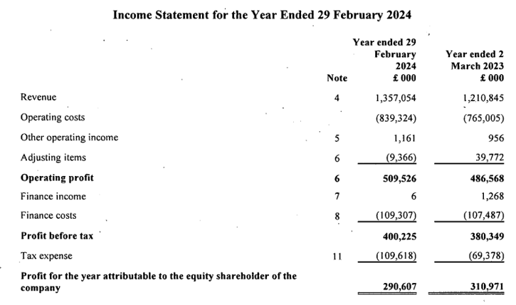
Figure 1: Income Statement of Premier Inn as of 29th February 2024
(Source: Gov, 2025)
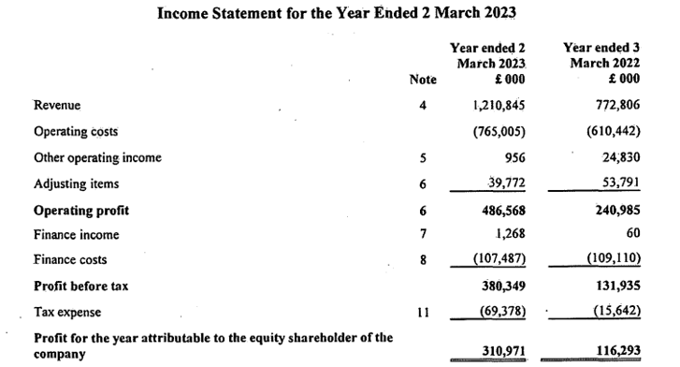
Figure 2: Income Statement of Premier Inn as of 29th February 2023
(Source: Gov, 2025)

Appendix 2 - Financial statements of Shangri-la hotels
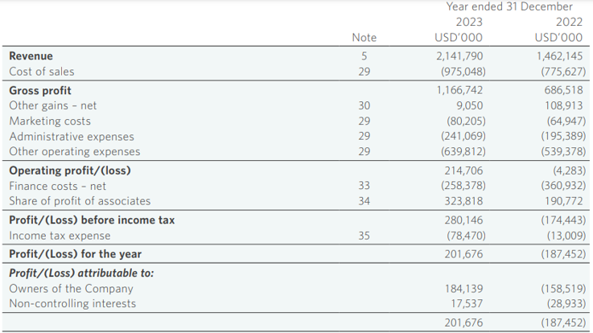
Figure 3: Income Statement of Shangri-La Hotels as of 2023
(Source: Shangrila, 2023)
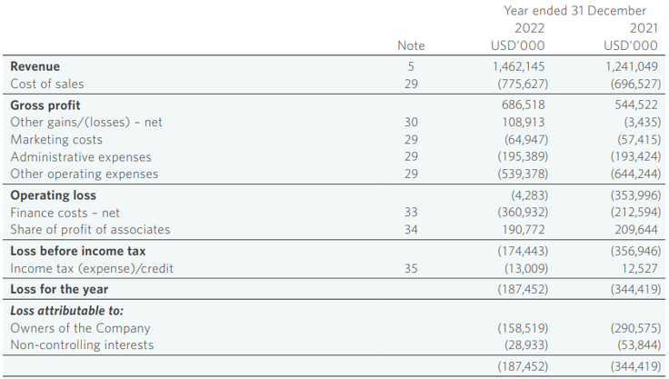
Figure 4: Income Statement of Shangri-La Hotels as of 2022
(Source: Shangri-la, 2022)

