Planning and Delivering an International Meeting/Event

“Equality, Diversity and Inclusion within Industry”

WomenLift in Leadership Live Event

Student name: Constantin-Daniel Andronache
Student number: 2222788
Module title: International Meetings Management
Module code: BMIH6007
Lecturer’s name: Christopher Wilkin
Date: 28/02/2025

AI Acknowledgement:
I confirm that I have not used any AI tools in the research and creation of this assignment. I confirm that I have not presented any AI generated materials as my own work. I confirm I have copies of my drafts, notes, and other resources I used, which I may be asked to provide in evidence.

Table of Contents
1 Introduction 3
1.1 The Event Description 3
1.2 Background 4
2 The Event Cycle 4
2.1 Definition 4
2.2 WomenLift in Leadership Live 2025's Event Cycle 5
3 Event Concept 6
3.1 Itinerary 6
3.2 Attendee Journey Map 7
3.3 Theme and Styling 8
3.4 Location and Venue 8
4 Aim and Objectives of the Event 9
4.1 Aim 9
4.2 Objectives 9
5 Event Management 9
5.1 Skills Requirements 9
5.2 Recourse Requirement 10
5.3 Marketing Activities 11
6 Event Budget 11
6.1 Budget Estimation 11
6.2 Revenue Projection 12
7 Industry Trends/Issues/Impacts 12
8 Situational and Cultural Considerations 13
9 Reference List 14

Introduction
The report critically outlines the relevant strategic planning and delivery of the considerations of the WomenLift in Leadership Live 2025 event, focusing on theoretical and practical issues that will ensure the event is a resounding success. The content of this report will strongly build and develop the information that was covered on the event feasibility plan, providing a strategic focus that the event management can use to achieve the acute specifics of the event and link it to the potential delivery of the event (Getz and Page, 2019). The strategic planning and delivery report will provide a detailed description and background of the event, its event cycle, event concept, aim and objectives of the event, event management resource requirements, budget, key issues/trends that could impact the event, and situational and cultural considerations.

The Event Description
The proposed event is WomenLift in Leadership Live 2025, a DEI event targeting the tourism and hospitality industry. The event aims to lift women into leadership positions in this industry because men dominate those positions despite the majority of the employees being women (Dashper, 2020; Marneros, Papageorgiou and Efstathiades, 2020). WomenLift in Leadership Live 2025 will be a full-day hybrid event that will combine both virtual and in-person attendance in order to reach as many people as possible in the target industry. Virtual attendance will be achieved by live streaming (Brown, 2021; Simons, 2019; Bajpai et al., 2022) through a YouTube link for the whole event, and important sections such as key speaker sessions will also be streamed on select media outlets like CNN, MSNBC, Sky News, and BBC News. The purpose of the event is to address the issues of gender gap in leadership positions in the hospitality industry. It will advocate for equality in leadership, highlight the current state of inequality in leadership in the hospitality industry, and sensitise hiring managers and leaders on how they can leverage diversity hiring to fill the gender gap in leadership.

Background
Gender equality is essential in fostering inclusive growth across the tourism and hospitality sectors. While gender equality has taken significant steps towards gender equality, the tourism and hospitality industry still grapples with gender inequality in leadership positions (Dashper, 2020). The hospitality industry is vast, comprising hotels, restaurants, tourism, and related services that thrive on diversity and inclusivity. Yet, the available statistics reveal a vast gender gap in leadership roles, where women make up a mere 8.8 per cent of the leadership roles despite making up 70% of the industry's workforce (Uppal, 2024). This leaves women to hold the less influential and least paid positions in the industry, leading to gender inequality not only in leadership but also in income despite having the same skills and capabilities that their male counterparts possess.
Therefore, empowering women in the industry through the WomenLift in Leadership Live 2025 event is not merely about social justice but also a strategic move that will unlock untapped talent pools. The event will also allow hospitality to leverage gender equality to enhance performance by offering a more diverse range of ideas, approaches, and perspectives on human resource policies (Bosch et al., 2018). The enhanced gender equality will also increase employee morale, retention, and satisfaction (this will inherently increase productivity and reduce turnover costs). Besides closing the gender equality gap in leadership positions, the WomenLift in Leadership Live 2025 will ensure that female employees in the hospitality industry feel valued, respected, and empowered in their roles, making them invaluable assets to their organisations in delivering excellence and customer satisfaction.

The Event Cycle

Definition
An event cycle refers to the complete process of planning, executing, and evaluating an event. The cycles encompass all the stages of the event, from its initial concept to post-event analysis. An event management cycle is vital to the WomenLift in Leadership Live 2025 event because it will enhance the event planning and execution by providing distinct phases with specific tasks to execute. It will allow room for the event's post-evaluation to highlight weaknesses and areas of improvement that can be addressed for continuous improvement or corporate learning. Thus, it provides a systemic approach that makes event management effortless and successful.

WomenLift in Leadership Live 2025's Event Cycle
The chosen event cycle for the WomenLift in Leadership Live 2025 event is the Five Stage Event Cycle (Kaunisto, 2021). This cycle has five steps: plan, organiser, measure, analyse, and share.
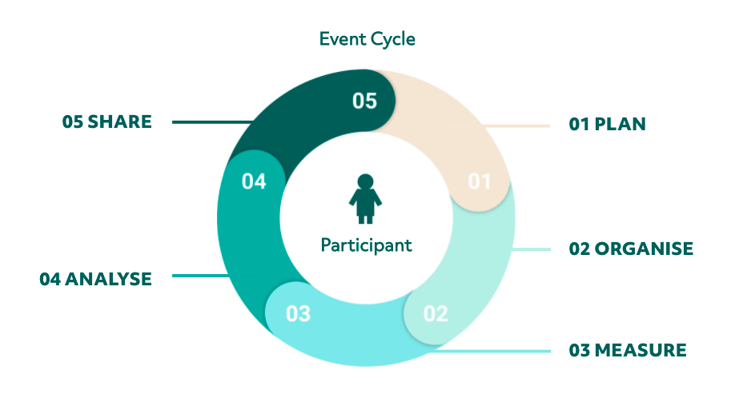
Figure 1: Five Stage Event Cycle (Source - Kaunisto (2021)

The plan cycle will review events from the event feasibility analysis and refine goals and targets for the WomenLift in Leadership Live 2025 event. The planning phase will also help the event identify the ideal participants for the event, set realistic goals, and set a realistic budget for the event based on the venue or live streaming channels chosen, the speakers, content, and event structure. Other activities in the plan will include searching for DEI or other hospitality industry sponsors, securing the venue and a date, envisioning sales, creating an event website, and promoting the event to the target audience.
The event phase will entail organising, tracking and handling all the paperwork needed, hiring adequate staff, providing attendees with a smooth and memorable experience, checking in on attendees' experience, networking with key guests, and closing the event. The third phase is the measure phase of how the event faired and its ability to deliver on its aim, objectives, and customer experience. The measure events will collect feedback from the audience and support staff on their experience, what they liked about the WomenLift in Leadership Live 2025 event, what they did not like, and what recommendations they would like to see in future gender equality in leadership DEI events, track the event ROI and revenue, and analyse the outcomes and goals of the events. The final step is sharing, where the event management will document and share the event outcomes and action points on how the event management can improve their event management in future events.

Event Concept

Itinerary
The event will start with an opening ceremony, which will act as an icebreaker and allow the attendees to get acquainted with each other, get comfortable, and familiarise themselves with the venue. The opening ceremony will include opening speeches and key announcements that can help enhance the attendees' experience at the event. This ceremony will include icebreaking activities such as trivia, dancing, and teambuilding activities. The session will be followed by a brief music session to give the attendees time to settle in, get ready for the main event, and interact with leaders from different brands, sponsors, and activist groups. The live music will carry on to the lunch hour, which will be followed by all other speakers who will be scheduled to address the issues of gender inequality in leadership positions in the tourism industry before handing over to the key speaker. The evening events will focus on allowing the attendees to interact with each other, interact with other employees from leading companies in the industry through exhibitions, purchase DEI and gender diversity hire materials, and be entertained to further improve their overall event experience.
Itinerary Summary
Item | Time
Opening Ceremony | 9:00 AM – 10:45 AM
Live Music | 11:00 AM – 1:00 PM
Lunch (Free food and drink) | 1:00 PM – 1:45 PM
Other Speakers and Presentations | 1:45 PM – 3:00 PM
Key Speaker | 3:00 PM – 4:00 PM
Afternoon Tea Break (free snacks and drinks) | 4:30 PM – 5:00 PM
Exhibitor Product Displays | 5:00 PM – 7:00 PM
Dancers and Live Performances | 7:00 PM – 8:00 PM
Socialising and Networking | 8:00 PM – 10:00 PM
Closing Dinner Party and Entertainment | 10:15 PM – 11:00 PM

Attendee Journey Map
The attendee experience will be organised into three touchpoints, including pre-event, during the event, and post-event. The prevention will include grabbing the attendees' attention through event marketing, setting up the live streaming platforms, deploying event resources for the event, and starting attendee engagement to commence the event. During the event, the actions that will shape the attendee journey and experience will be facilitating conversions, speeches and entertainment, monitoring the event, and managing content sessions. The post-event will collect and review attendee's feedback, interpret audience behaviours and sentiments, and review event data.
Provide Feedback
Mingle
Push Notifications
Explore Event Venue
Grab Attention Through marketing

Buy Ticket or Register for Streaming
Download event Content

Engagement Activities
Connect with other attendees

Figure 2: Attendee Journey Map for the WomenLift in Leadership Live 2025

Theme and Styling
The event colour and decoration colour palette will include a mixture of emerald green and deep teal to represent growth, balance and ambition. These will be supplemented by warm rose decorations to add a touch of femininity and inclusion because the event aims to promote women's inclusion in leadership positions. The venue entrance will have golden archways with flowers and the event name in emerald green. The seating arrangement will have a mix of round tables, networking loungers, and theatre arrangements to suit different sessions.

Location and Venue
The chosen venue for the WomenLift in Leadership Live 2025 event is The International Convention Centre (ICC), Birmingham, UK. This Venue is available for most of March and April of 2025. ICC Birmingham was chosen for the event because it has ample public transport access and parking for those who want to come with personal vehicles. It has a state-of-the-art audio-visual infrastructure and equipment that will help the event deliver a great customer experience to the attendees and stream the event content through select live streaming platforms (ICC Birmingham, 2024). ICC Birmingham has good accessibility for people with disability, with wheelchair-friendly design and hearing aid technologies. This venue has large halls that can accommodate thousands of attendees to the event – the venue has 10 conference halls, each with a capacity of up to 3000 delegates (ICC Birmingham, 2024). This venue is close to a large number of moderate to high-quality hotels, which will ensure that all attendees have access to accommodation prior to and after the event.

Aim and Objectives of the Event

Aim
The aim of the WomenLift in Leadership Live 2025 event is to address the gender gap in leadership in the hospitality industry.

Objectives
The events SMART objectives are:
- To educate at least 2000 participants on the benefits of embracing gender equality in leadership within the hospitality industry before May 2025.
- To highlight the challenges of implementing DEI initiatives/policies in leadership recruitment in hospitality and how to overcome them.
- To increase gender equality in leadership in the hospitality industry by 20% by 2030.

Event Management

Skills Requirements
The management team will need to hire and coordinate an event team that will be staff with different specialisations and skill sets. The event will need an onsite team during the material day to help facilitate different event activities. The onsite team will include audio-visual technicians, IT specialists, desk staff, hospitality and catering personnel, and security personnel. All the individuals in the project team will be expected to demonstrate the following communication skills.
Organisation skills: the team will require strong organisation skills to ensure a seamless and smooth experience for the attendees. This organisation will help with the proper execution of travel logistics, handling contractual details, and planning and executing every aspect of the event.
Communication skills: communication skills will help the project team with its coordination by eliminating misunderstandings, facilitating problem-solving, and ensuring everyone in the team is aligned with the project objectives and aims.
Time management skills: the team will need time management skills to effortlessly balance and execute all the events tasks without compromising on punctuality or quality. This skill will also help with managing and executing the events schedule.
Attention to detail: this skill will ensure the event plan is well executed to achieve the desired outcome and deliver an excellent experience to its attendees.
Problem-solving skills: the team members need to demonstrate critical thinking, creativity, and adaptability to quickly handle any challenges that might arise when planning the event or during its execution.

Recourse Requirement
The key resources that the WomenLift in Leadership Live 2025 event will need include catering, audio-visual equipment and IT technologies, parking and accessibilities, and human resources. The event will need catering resources to help serve food and drink during lunch, tea breaks, and dinner to the attendees. The catering resources will primarily include food and drink, cups, plates, bowls, and cutlery. The event will need audio-visual technology and IT technology, such as cameras and microphones, to record and stream the event for those who will be attending the event virtually. The audio-visual content will also be used to enhance the experience for those in attendance. The venue will also need to have parking and accessibility to ensure that the participants have ample parking, easy access, EV charging points for electric vehicles, and bike racks for those who choose to cycle to the venue. Last, the event will need human resources (staff and personnel) to carry out the different functions and activities.

Marketing Activities
The event aims to generate revenue through sponsorships and ticket sales. Thus, the event must generate enough traffic to attract high attendance and win sponsorships (Harb et al., 2019; Hulland and Houston, 2020). In order to achieve great results in generating ticket sales and winning sponsorships, the event will use marketing channels that have high reach and impact. The event will build an event website for selling tickets and showing the brands of the event sponsors who will sponsor the event (these brands will also be shared with other marketing content/messages). The social media campaigns will allow the event marketing team to reach many people at once because social media has billions of users (Evans, Bratton and McKee, 2021; Allen, Harris and Jago, 2022). Social media can also be used to drive engagement using hashtags that can be made by abbreviating the event name (for example, #WomeLift2025). The event will also seek out partnerships from reputable brands in the hospitality sector, like Hyatt, Marriot International, and InterContinental Hotels Group, to benefit from their publicity and vast audiences (Cornwell, 2020; Jensen and Cornwell, 2021).

Event Budget

Budget Estimation
Expense | Estimated Budget Cost
Venue Hire | £10, 000
Catering | £8, 000
Equipment | £7, 500
Key Speakers' fees | £15, 000
Staff and Logistics | £10, 000
Other | £5, 000
Total Estimated Expenses | £145, 500

Revenue Projection
Revenue Source | Projected Revenue
VIP Ticket Sales (@£50.00) | £10, 000
Regular Ticket Sales (£@25.00) | £50, 000
Sponsorships | £100, 000
Exhibitor Booths (@£2,500.00) | £7, 500
Donations | £30, 000
Total Revenue | £197, 500

Industry Trends/Issues/Impacts
The key trends in the event industries include personalisation at scale, data activation, the use of unique venues, and the use of technology to support accessibility. Akinsowon (2025) reports that the event industry has seen an increase in personalisation at scale, where event managers use networking recommendations, session recommendations, and personalised event summaries to enhance the event experience. The event industry has seen an increased use of data to refine attendee touchpoints and make informed decisions when planning their events (Akinsowon, 2025). The event industry has also witnessed an increased demand for unique venues to attract attendees. These unique venues include choosing art galleries, museums, and event cruise ships over traditional event venues like halls, hotels, and convention centres.
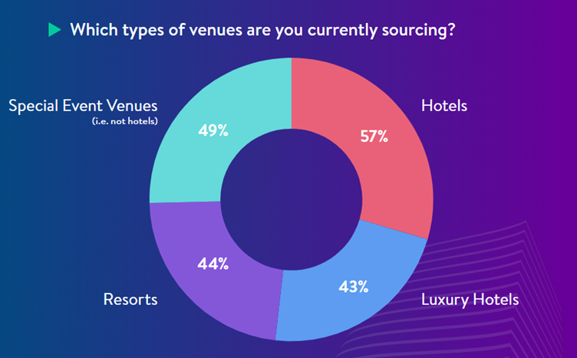
Figure 3: The Growing Popularity of Unique Venues (Source - Akinsowon, 2025).
Therefore, there is an increased use of technology to support best accessibility practices to ensure that people who experience any sort of disability have great experience in events. This is particularly significant because it is estimated that 16% of the world's population experiences disability (WHO, 2024). Technology is used to design venues, increase accessibility, and add assistive features to events, such as real-time captioning and sign language interpretation.

Situational and Cultural Considerations
The situational analysis for the event was conducted using a SWOT analysis. This analysis aimed to highlight the event's strengths and opportunities in tackling gender inequality and social issues and highlights threats and weaknesses that the event team should address to enhance its success.

Reference List
Akinsowon, V. (2025) Nine Event Trends that Will Shape 2025. Accessed at: https://www.cvent.com/en/blog/events/event-trends (Accessed on: 08 February 2025).
Allen, J., Harris, R. and Jago, L. (2022) Festival & special event management. John Wiley & Sons.
Bajpai, V., Hohlfeld, O., Crowcroft, J., Keshav, S., Schulzrinne, H., Ott, J., Ferlin, S., Carle, G., Hines, A. and Raake, A. (2022) Recommendations for designing hybrid conferences. ACM SIGCOMM Computer Communication Review, 52(2), pp.63-69.
Bosch, M.J., Las Heras, M., Russo, M., Rofcanin, Y. and Grau, M.G. (2018) How context matters: The relationship between family supportive supervisor behaviours and motivation to work moderated by gender inequality. Journal of Business Research, 82, pp.46-55.
Bowdin, G.A., Allen, J., Harris, R., Jago, L., O'Toole, W. and McDonnell, I. (2023) Events management. Routledge.
Brown, T. (2021) The future of events will be hybrid. Crisis management and recovery for events: Impacts and strategies, pp.142-164.
Cornwell, T.B. (2020) Sponsorship in marketing: Effective partnerships in sports, arts and events. Routledge.
Dashper, K. (2020) Mentoring for gender equality: Supporting female leaders in the hospitality industry. International Journal of Hospitality Management, 88, p.102397.
Evans, D., Bratton, S. and McKee, J. (2021) Social media marketing. AG Printing & Publishing.
Getz, D. and Page, S.J. (2019) Event studies: Theory, research and policy for planned events. Routledge.
Harb, A.A., Fowler, D., Chang, H.J., Blum, S.C. and Alakaleek, W. (2019) social media as a marketing tool for events. Journal of Hospitality and Tourism Technology, 10(1), pp.28-44.
Hulland, J. and Houston, M.B. (2020) Why systematic review papers and meta-analyses matter: An introduction to the special issue on generalisations in marketing. Journal of the Academy of Marketing Science, 48, pp.351-359.
Huseynli, N. (2022) Econometric analysis of the relationship between tourism revenues, inflation and economic growth: The case of Morocco and South Africa. African Journal of Hospitality, Tourism and Leisure, 11(1), pp.135-146.
Hyun, M. and Soebbing, B.P. (2023) Determinants of ticket prices in the secondary ticket market and the effects of COVID-19: empirical evidence from NBA ticket price data analytics. Sport, Business and Management: An International Journal, 13(4), pp.489-505.
ICC Birmingham (2024) About Us. Welcome to the ICC. Accessed at: https://www.theicc.co.uk/about-us/ (Accessed on: 08 February 2025).
Jensen, J.A. and Cornwell, T.B. (2021) Assessing the dissolution of horizontal marketing relationships: The case of corporate sponsorship of sport. Journal of Business Research, 124, pp.790-799.
Kaunisto, A. (2024) Introducing the Event Cycle – The core of Event Success Management. Accessed at: https://www.lyyti.com/en/blog/introducing-the-event-cycle-the-core-of-event-success-management (Accessed on: 08 February 2025).
Marneros, S., Papageorgiou, G. and Efstathiades, A. (2020) Identifying key success competencies for the hospitality industry: The perspectives of professionals. Journal of Teaching in Travel & Tourism, 20(4), pp.237-261.
Simons, I. (2019) Events and online interaction: The construction of hybrid event communities. Leisure Studies, 38(2), pp.145-159.
Uppal, R. (2024) Gender Equality can generate more employment opportunities in the hospitality sector. Accessed at: source link. (Accessed on: 01 February 2025).

