Programme control

Construction Management

ACBA6000

Jacob Passmore

1706871

Contents
What is a Gantt Chart? 3
Key Parts in Gantt Charts 3
Critical Path for the Gantt Chart on the New Library 4
Issues in Performance 6
Delay Analysis Techniques 6
As Planned 6
As Built 7
Window Analysis 7
Time Impact Analysis 7
Scenario 2 8
Direct Costs 8
Indirect Costs 8
Reducing the superstructure time 9
Plan View of Site Plan 10

What is a Gantt Chart?

Gantt charts is a horizontal bar chart which, over time, visually represents a project schedule. Current Gantt charts usually gives you the status of every role in the project, as well as who is responsible for it.

Key Parts in Gantt Charts

- Task List – Flows vertically down the left of the Gantt chart so that it defines project work and that it can be classified and sub grouped.

- Timeline – Goes across the top of the Gantt chart horizontally, this shows the months, weeks, days, and years.

- Dateline – Vertical line indicating the current date on the Gantt chart.

- Bars – Markers that are horizontal on the right-hand side of the Gantt chart that indicates tasks, the progress, duration, start and end dates.

- Progress – Shows how far the job is and can be shown by percentage complete and/or bar shading.

- Resources Allocated – Shows the person or people in charge of completing the task.

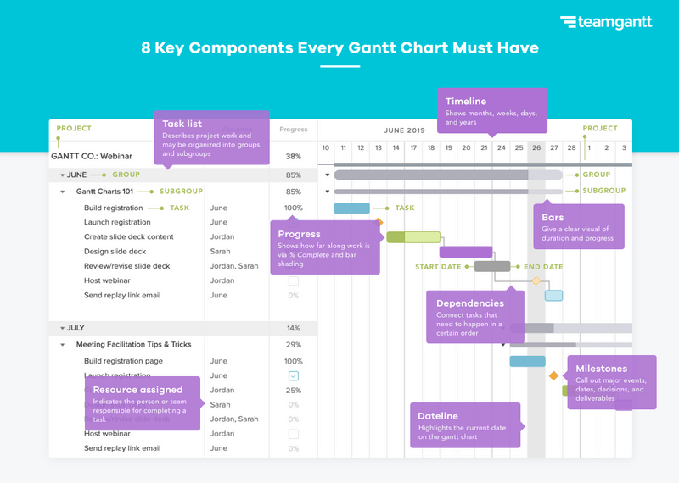

Fig 1

Critical Path for the Gantt Chart on the New Library
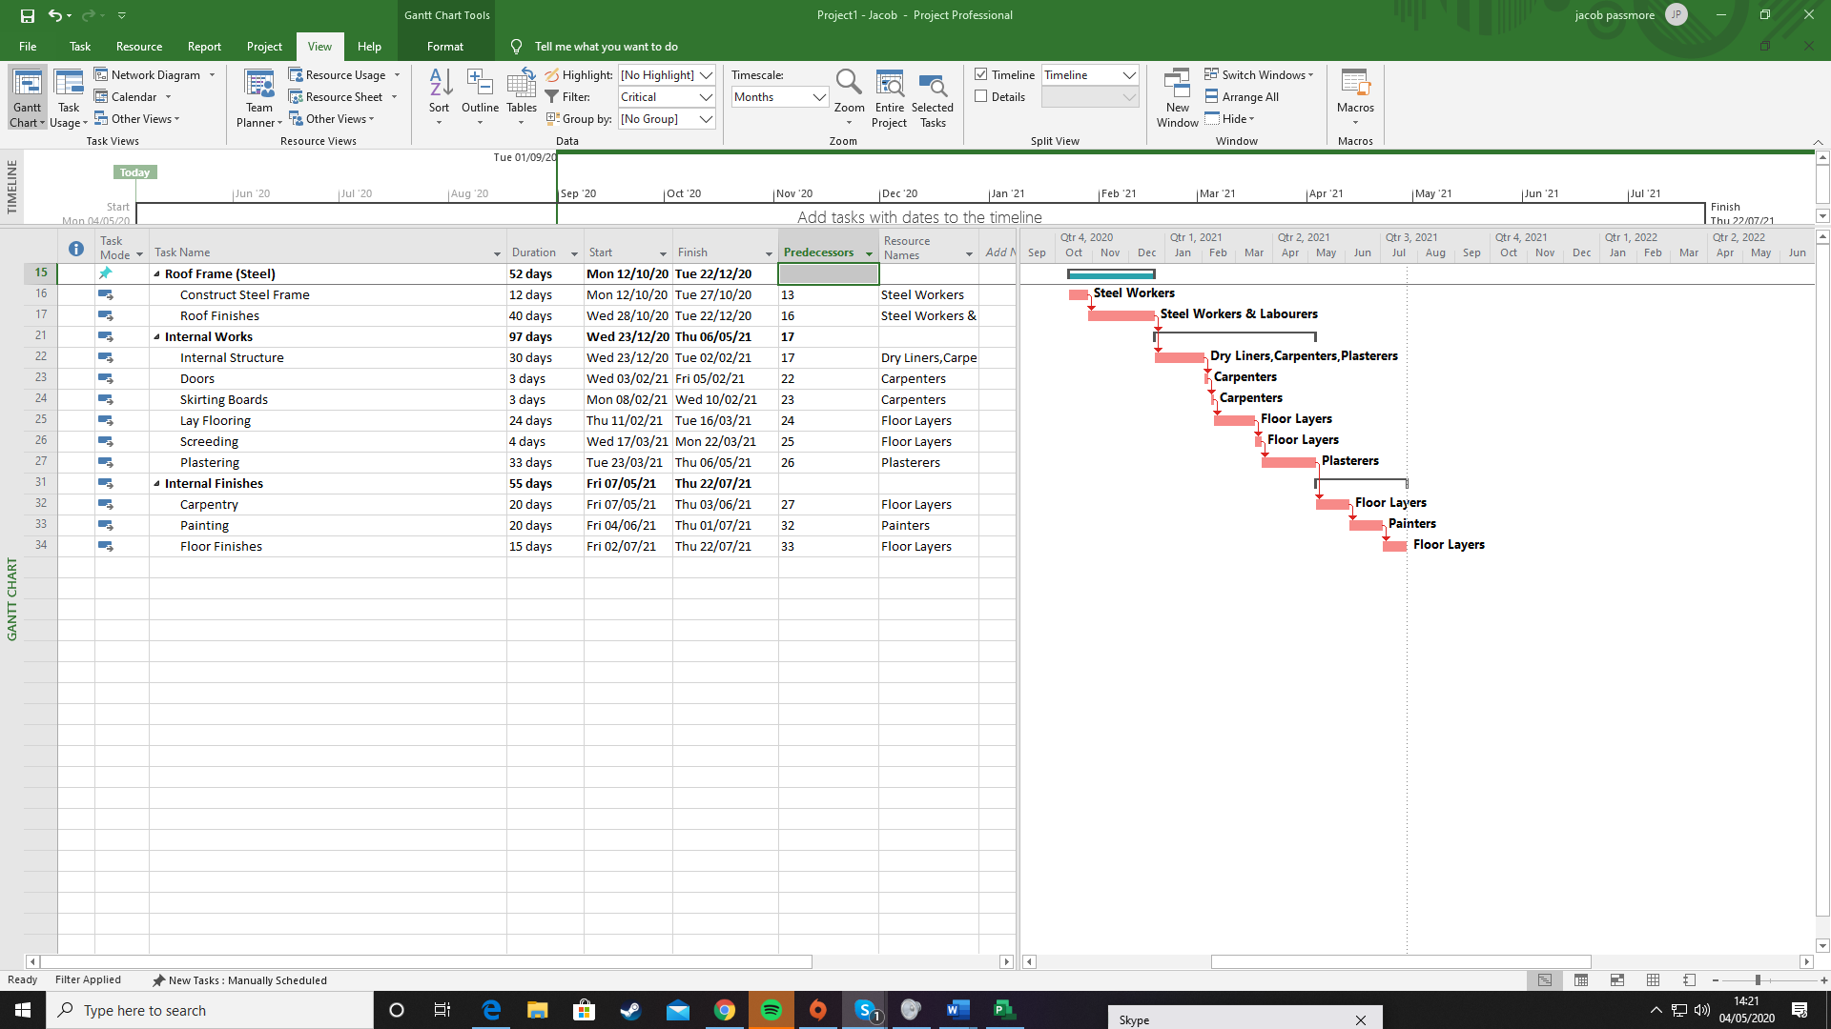

Fig 2

Critical paths help companies define series of tasks that have to be done before the project can be finished, and in some situations a task needs to be done before the next task can start. If a task cannot be completed on time, then the project would take much longer to the same degree.

The critical path on for the new library, shown in figure 2 and 3, shows that the roof frame, internal works and internal finishes are the critical path.
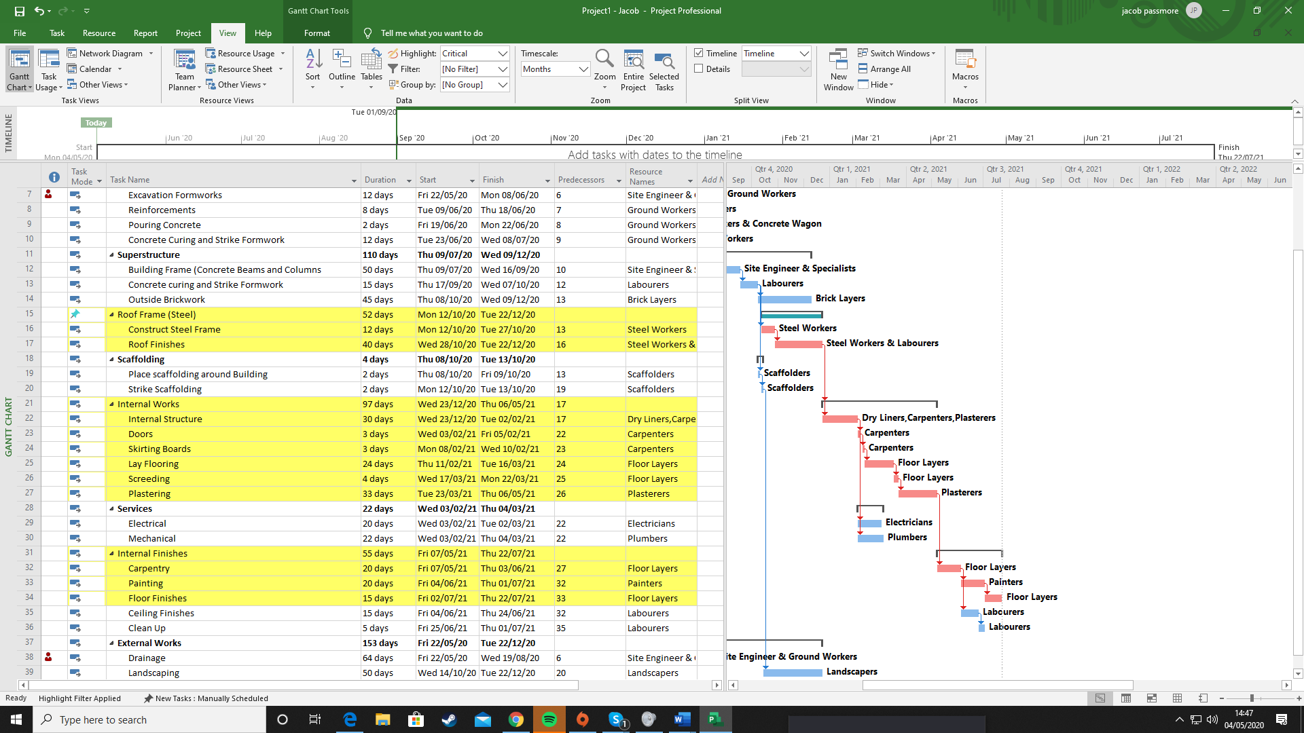

Fig 3

Issues in Performance

When issues in productivity occur in the project, it is important that the project manager informs the client about these problems as signed by both client and contractor, the contractor has a duty to complete the project on or before the completion date, if not then the contractor may suffer a deduction of liquidated and ascertained damage from his contract payment.
When working with delays there can be different types, these are:
- Delay Events
- Culpable Delay
- Non-Culpable Delay
When delay does happen there is someone at fault, when it’s the contractors fault its down to poor quality of workmanship, inadequate planning, under resourcing of site operations and accidents and incidents on the site. When the client is at fault its because of incomplete designs at commencement on site, delays in the flow of design information, variations and changes in the scopes of works and discrepancies in the contract documents. Sometimes, it’s no one’s fault, these are when unforeseen physical conditions occur, site labour affects like strikes, fires or other accidents and bad weather.

Delay Analysis Techniques

As Planned

It illustrates how the project is postponed (step by step) each interruption is applied to the as-planned programme. Every time delay affects the overall project. Just such impacts are considered for excusable delays.
The system involves only delays owing to one party. The gap in the ending with the complete delay indicates the other party's liability. From the point of view of the Contractor: consider only non-excusable delays The point of view of the Client: consider only excusable delays

As Built

Close to the previous one but it uses the As-built network instead of as-planned. The related delays are taken away for one party. The resulting work-end is removed from the actual. From the point of view of the contractor: just consider the point of view of the customer for excusable delays: just consider the non-excusable delays

Window Analysis

The overall length of the project is split into many time spans (windows, or snapshots). Each time period is evaluated separately. Delays are added during this time, and works are eventually finished relative to planned.

Time Impact Analysis

Related to the previous one, but now it relies on a single failure or failure case The timetable is revised at this point of delay and the result is evaluated to determine a new date of completion. Active methodology as it analyses delays using real time

Scenario 2

“The client needs to bring the project in according to the original completion date, which is 2 weeks earlier than the programme you have produced. What suggestions could you make to the client to achieve this”

Reducing the time of the project by two weeks does seem good but overall, it will cost more money, these include:

- More labourers
- More gangs
- More hours or days working which can include weekends and maybe more pay like time and half or double pay
- More equipment and plant
- More materials

There are two types of costs, these are direct and indirect costs. Direct costs only increase when the resources increase and the indirect costs increase when the project duration increases.

Direct Costs

- Labour costs
- Plant costs
- Material costs
- Sub-contractor costs
- Recovery of profit

Indirect Costs

- Preliminaries
- Supervision
- Head office expenses

To reduce the time on the project, increasing the number of labourers and gangs would help out substantially, but doing this increases the direct costs. Many construction efficiency errors are normally made in the stage of planning, time must be spent in good use before the project begins so figures equipment, materials and information can be collected, doing this would be the best way to avoid delays and cost increases.

Measuring success is a great incentive tool for staff, partially when bonuses are attached, improving communication with workers helps making it that much more effective in terms of improving efficiency and production.

Ordering materials before use and storing them offsite or even on site will help to reduce time as there may be problems later on and ordered materials might not be able to arrive. For example, outside brickwork starts on October 8th 2020, so if the bricks were ordered at the beginning of the project it then gives the client and project manager some ease and no risk of delay of the bricks.

Reducing the superstructure time

Stated on the Gantt chart, the superstructure takes 110 days to complete, with 50 days of constructing the building frame, 15 days on concrete curing and the removal of the formwork and 45 days on the outside brickwork. If there was an increase of labourers and gangs working on the building frame and more days allocated to this, it would reduce time input but as known, costs would increase, as there would be more people working the concrete consumption for the works would also increase, informing the concrete firm before hand is vital in order to obtain more concrete wagons as the concrete firm may be fully booked them extra days of pouring concrete.

As mentioned in this, if the bricks were ordered earlier in the stage process, no potential delays could arise, increasing brick layers and equipment in this area would also help in the reduction on time.

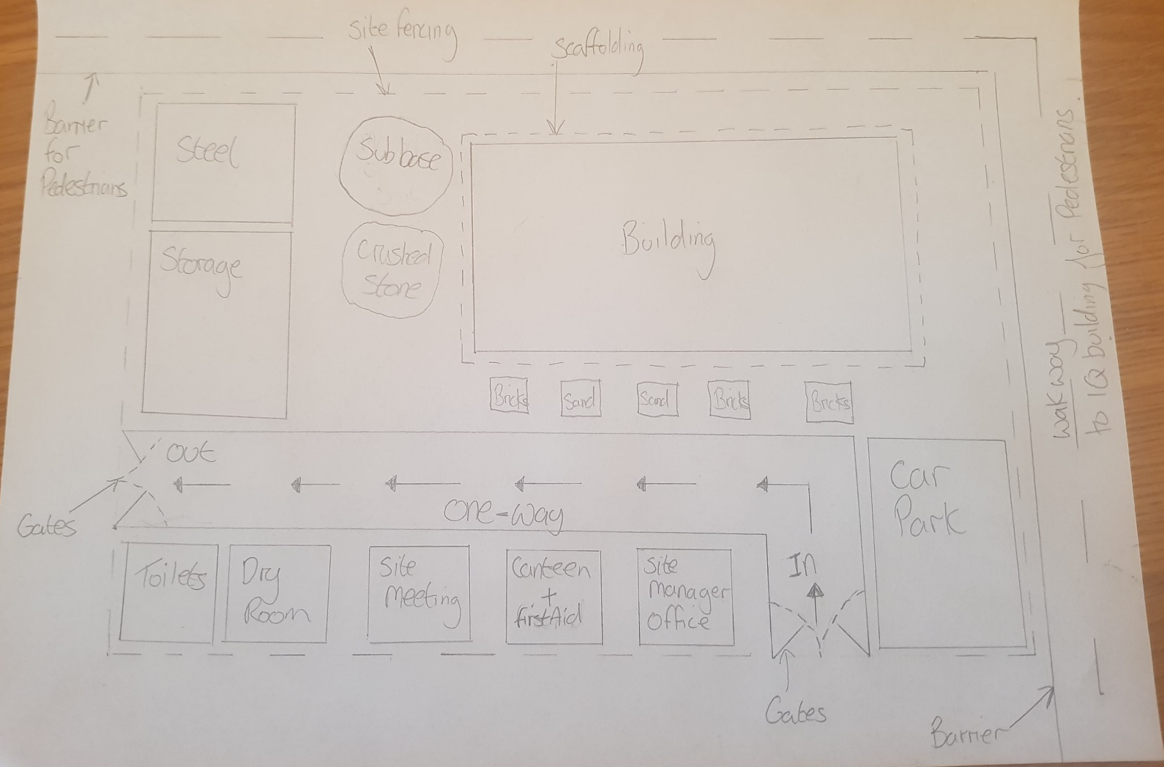

Plan View of Site Plan

Fig 4

