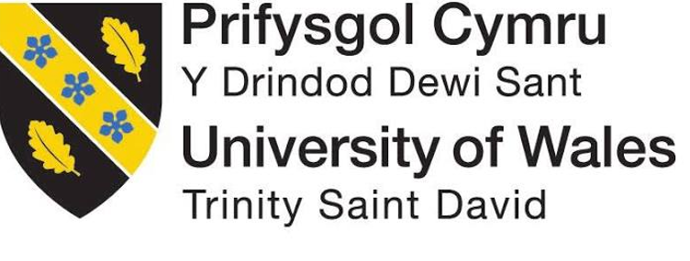

TETIANA DEL MONDO
Programme | Certificate in Higher Education Business Skills for the Workplace
Module Title | Enterprise and Entrepreneurship
Module Code | LCLM4006
Assignment Title | Task 1: Individual Written Business Plan
Student Name | Tetiana Kryvoruchko
Student Number | 2524771
Lecturer’s Name | Bohdan Kovalov
Business Plan | TETIANA DEL MONDO

Executive Summary
TETIANA DEL MONDO (TDM) is a proposed UK research-led education and human-development enterprise. It will transform original cultural field research into individual sessions, group programmes and organisational learning. Its proposed USP combines first-hand research with a five-stage method connecting inquiry to practical action; this distinction has not yet been validated commercially. Initial customers are internationally minded adults aged 35–55 navigating transitions, with small and medium-sized organisations as a prospective B2B segment. Research-led Instagram, Threads and Facebook content will support B2C discovery, while LinkedIn, professional events and direct relationships will support B2B outreach. The proposed start-up funding package is £4,000: a planned £1,000 founder contribution and a £3,000 Start Up Loan application. Neither amount is currently available or approved. The first-month cash forecast is therefore conditional on funding being received; paid pilots and customer interviews will test demand before expansion.

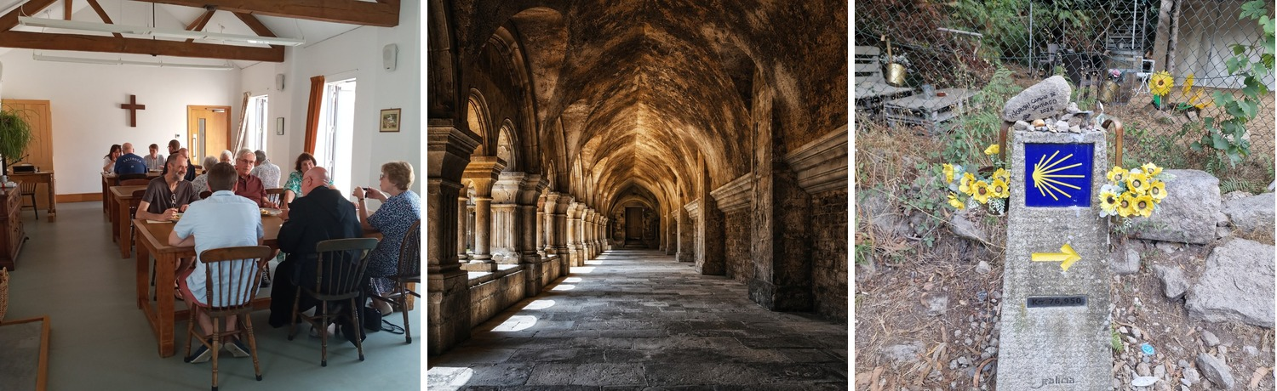
Figure 1. Cultural heritage, shared experience and personal journeys. Source: author-supplied photographs (2026).

Table of Contents
1. Overview of the Business Idea………………………………………………………… 4
2. Market Research………………………………………………………………………... 6
3. Marketing Communications……………………………………………………………. 7
4. Financials………………………………………………………………………………… 8
5. Reference List…………………………………………………………………………… 10

1. Overview of the Business Idea
TDM addresses a practical challenge: people and organisations seeking new perspectives often encounter either generic motivational content or specialised cultural education with limited application to decisions and behaviour. The proposed company combines encounters with people, places, histories and ideas with structured inquiry and action. Its working method is Encounter, Inquiry, Perspective, Application and Action. HUMAN POTENTIAL examines how capability develops; WHAT REMAINS? explores the enduring consequences of human action. These research platforms support a broader company portfolio rather than separate businesses. TDM's proposed advantage is the systematic translation of first-hand research into documented, reusable learning formats. Following the feasibility-testing logic of Barringer and Ireland (2019), this proposed differentiation must be tested through paid pilots and comparison with existing offers; it is not yet a proven competitive advantage.

Market Opportunity and Customer Segmentation
Market validation will separate interest from purchase: twenty semi-structured interviews will test the problem, two paid group pilots will test price and attendance, and five B2B discovery conversations will test procurement requirements. These samples are exploratory and cannot establish market-wide demand. The Department for Culture, Media and Sport (2026) found 62% physical heritage engagement in England in 2025/26, rising to 64–67% among people aged 35–54. This indicates potential cultural relevance, not willingness to pay. The Department for Education (2025) found that 59% of UK employers provided training in 2024, spending £53 billion compared with £59 billion in 2022 at constant prices. This establishes aggregate training expenditure, not the addressable market for TDM or demand for its specific services. TDM will initially target internationally minded adults aged 35–55 navigating transitions, SMEs requiring leadership development and, selectively, cultural institutions with longer procurement cycles. Segments and prices will be revised if paid pilot results contradict assumptions. The commercial opportunity is therefore a testable niche rather than a quantified market share. Interview recruitment should include people outside the founder’s existing audience to reduce selection bias; asking about previous purchases and requesting deposits is stronger evidence than stated enthusiasm. The primary B2C profile is an adult aged 35–55 in the West Midlands or online, curious about history and personal development, with discretionary spending and a preference for small-group learning. This is a proposed customer profile, not a measured demographic finding. B2B buyers are SME owners or people managers seeking a distinctive, evidence-informed team experience.

Legal Structure and Management
A private company limited by shares is proposed because it separates company liabilities from the founder's personal affairs in most circumstances, supports contracting and offers a structure for future collaborators. Compared with sole trading, it involves greater reporting and administrative obligations. GOV.UK (n.d.) outlines the steps for forming a limited company; the proposed structure is chosen for contracting and future intellectual-property development. The choice of a conventional limited company rather than a community interest company is a strategic proposal, not a claim established by that guidance. The founder will lead research, partnerships and product development, supported by specialist contractors. Contracts must clarify IP ownership, safeguarding where relevant, insurance and data responsibilities. Incorporation and permitted working activity will be checked against applicable immigration conditions before trading. A general partnership is less suitable for a single-owner launch and ordinarily shares responsibilities between partners. Unlike a CIC, the proposed Ltd retains commercial flexibility while incorporating community benefit through paid local partnerships and measurable learning outcomes. The founder is the sole proposed director and shareholder; research, venue delivery and specialist facilitation will be contracted as needed.

Social and Environmental Responsibility
TDM aims to broaden access to cultural learning and support purposeful action while paying local contributors fairly. Collavo (2023) discusses social entrepreneurship and impact measurement. TDM therefore treats its intended social outcomes as hypotheses, not demonstrated impacts. Participants will define an initial objective, record immediate learning and report after 30 days whether an agreed action occurred. Aggregated, consent-based findings will inform refinement; satisfaction alone will not be treated as behavioural impact. Existing venues, digital materials, local contributors and public transport where practicable should limit infrastructure and travel demands without justifying carbon-neutral claims. Bocken et al. (2016) discuss resource efficiency within circular business models; their manufacturing-focused framework is used only as a conceptual prompt, not evidence that TDM is a circular business.

2. Market Research
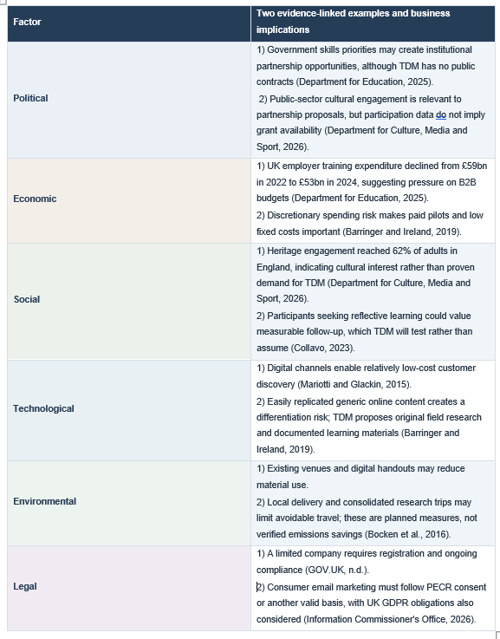

Competition and Market Structure
The School of Life combines philosophy, culture and workplace learning, demonstrating that interdisciplinary reflection is not inherently distinctive. Its workplace workshops are a direct comparator (The School of Life, n.d.); conventional coaching, leadership seminars and corporate training are substitutes. TDM will compete through documented field research, a coherent learning method and modular products rather than price alone. Its disadvantages include limited brand recognition, unvalidated outcomes and founder dependence. Delivery manuals and contractor training may reduce that dependence. Competitor testing will compare published prices, duration, customer promises and observable outcome evidence. TDM will not claim a legally proprietary method without establishing ownership and defensibility. The closest teaching-model classification is monopolistic competition: several providers offer related but differentiated services. This is a reasoned classification, not a measured concentration study. Monopoly and oligopoly do not describe the evidenced competitive alternatives.

3. Marketing Communications
Audience | Discovery | Conversion
Individuals 35–55 | Instagram · Threads · Facebook | Introductory session → paid programme
SMEs / institutions | LinkedIn · talks · direct outreach | Discovery call → paid pilot / contract
Direct marketing will be planned around PECR and UK GDPR requirements (Information Commissioner's Office, 2026). The acquisition pathway is research and fieldwork, original editorial content, audience trust, introductory engagement, paid delivery and referral. Instagram, Threads and Facebook will support B2C discovery; LinkedIn, speaking and direct relationship-building will support B2B sales. An owned website and permission-based consumer email list will reduce dependence on social algorithms. TDM will test separate B2C and B2B acquisition channels using qualified enquiries, conversion to payment, repeat purchase, referrals and acquisition cost, rather than treating follower growth as demand. B2B outreach is planned from month one, with a hypothetical first contract in month five; TDM currently has no corporate customers. Marketing messages will avoid unsupported therapeutic or transformational guarantees. The initial marketing focus will be LinkedIn for B2B relationships and Instagram for B2C storytelling; other channels will be secondary and evaluated against conversion, avoiding resource dispersion.

Implementation and Risk
In months one to three, TDM will conduct twenty customer interviews, deliver initial paid individual sessions and test one paid group. A second group is planned for month four, subject to demand. Five B2B discovery conversations and two proposal requests are future targets; no corporate clients or contracts are confirmed. Each pilot will record attendance, price acceptance, conversion, direct costs and a 30-day action-based follow-up. At day 90, management will retain, adapt or discontinue offers based on evidence. Principal risks include low paid conversion, underfilled groups, founder dependence and delayed organisational payments. Controls include staged spending, upfront payment where appropriate, contractor documentation and a cash reserve. Barringer and Ireland (2019) discuss feasibility and new-venture viability. For illustration, seven B2B sales at a 20% conversion rate require 35 qualified opportunities; at 10%, 70. These rates are unvalidated. Licensing will be considered only after repeat purchases, documented outcomes and delivery capacity beyond the founder.

4. Financials
Mariotti and Glackin (2015) discuss start-up, fixed and variable costs and cash-flow planning. TDM proposes a £4,000 funding package comprising a £1,000 planned founder contribution and a £3,000 Start Up Loan application. Neither source is confirmed or currently available. A Start Up Loan is personally repayable and does not constitute sales revenue. Month 1 assumes £300 collected from two individual sessions, £1,200 in one-off set-up payments, £400 in operating payments and £10 in direct costs. If both funding sources arrive in Month 1, total cash in is £4,300 and cash out before debt service is £1,610. The forecast reserves £61 for an illustrative loan instalment, approximately consistent with a £3,000 loan amortised over 60 months at an assumed 7.5% annual interest rate (about £60.11 per month). This is a scenario, not a lender quote or verified first-payment date. Including the rounded-up reserve, total cash out is £1,671 and closing cash £2,629. If neither funding source is received, no loan repayment arises; the same £300 in hypothetical sales against £1,610 of other expenditure would create a £1,310 shortfall. Expenditure must be deferred or financing secured before commitments are made. No B2B contracts, grants or institutional receipts are confirmed. A separate rolling liquidity forecast and staged expenditure will support control (Barrow, Barrow and Brown, 2021).

Month 1 Cash Flow Forecast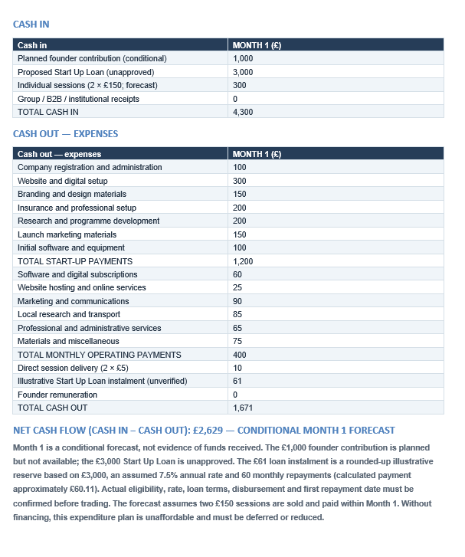

5. Reference List
Barringer, B.R. and Ireland, R.D. (2019) Entrepreneurship: Successfully Launching New Ventures. 6th edn. Pearson.
Barrow, C., Barrow, P. and Brown, R. (2021) The Business Plan Workbook: A Step-by-Step Guide to Creating and Developing a Successful Business. 10th edn. London: Kogan Page.
Bocken, N.M.P., de Pauw, I., Bakker, C. and van der Grinten, B. (2016) ‘Product design and business model strategies for a circular economy’, Journal of Industrial and Production Engineering, 33(5), pp. 308–320. doi:10.1080/21681015.2016.1172124.
Collavo, T. (2023) Foundations of Social Entrepreneurship: Theory, Practical Tools and Skills. Routledge.
Department for Culture, Media and Sport (2026) Community and Engagement Survey 2025/26: heritage report (revised 16 September 2026). Available at: https://www.gov.uk/government/statistics/community-and-engagement-survey-202526-heritage/community-and-engagement-survey-202526-heritage-report (Accessed: 12 October 2026).
Department for Education (2025) Employer Skills Survey 2024. Available at: https://explore-education-statistics.service.gov.uk/find-statistics/employer-skills-survey/2024 (Accessed: 12 October 2026).
GOV.UK (n.d.) Set up a limited company: step by step. Available at: https://www.gov.uk/set-up-limited-company (Accessed: 12 October 2026).
Information Commissioner's Office (2026) Guidance on direct marketing using electronic mail. Available at: https://ico.org.uk/for-organisations/direct-marketing-and-privacy-and-electronic-communications/guidance-on-direct-marketing-using-electronic-mail/ (Accessed: 12 October 2026).
Mariotti, S. and Glackin, C. (2015) Entrepreneurship: Starting and Operating a Small Business. 4th edn, Global edn. Harlow: Pearson Education.
The School of Life (n.d.) What We Offer. Available at: https://www.theschooloflife.com/at-work/what-we-offer/ (Accessed: 12 October 2026).

