
Ethical Considerations in Ancient Philosophy and the Evolution of Capitalism
Towards Business 2.0

November 9, 2023
University of Wales trinity saint david
SALVATORE RICCOBONO
2108906

Contents

Executive Summary…………………………………………………………………………………………………………………..2
Introduction……………………………………………………………………………………………………………………………..3
Ancient Philosophical Foundations…………………………………………………………………………….……………..4
Adam Smith's Vision of Capitalism………………………………………………………………………………….……..5-6
Careless exploitation …………………………………………………………………………………………………...….……6-7
The proposition: Business 2.0………………………………………………………………………………………..……7-8-9
Conclusion………………………………………………………………………………………………………………….…….…….10
References………………………………………………………………………………………………………………………….…..11

Executive Summary

The report explores the interplay between ancient philosophical ethics and modern capitalism, underscoring a profound shift from timeless moral principles to profit-centric business practices. It highlights the vision of Business 2.0 as a promising alternative, promoting ethical, sustainable, and stakeholder-centric approaches that prioritize community well-being alongside profit.
The report begins by emphasizing the enduring influence of ancient philosophers, such as Plato, Socrates, and Aristotle, on moral principles and virtues. It outlines how their ethical insights continue to resonate in contemporary society, providing a strong foundation for ethical living and governance. In contrast, the exposition delves into modern capitalism's evolution, diverging from the ethical tenets of ancient philosophers. Adam Smith's vision, encapsulated in the "Invisible Hand" concept, has led to profit often taking precedence over ethical considerations, resulting in ethical challenges like income inequality, environmental degradation, and exploitative labour practices.
The report introduces the concept of Business 2.0 as a solution to these ethical challenges, advocating for a reorientation of business practices. Business 2.0 promotes a stakeholder-centric approach, ethical leadership, sustainability, corporate social responsibility, transparency, and accountability. In the concluding section, this text emphasizes the vital role of technological innovating business theories in bridging the gap between ancient ethical wisdom and contemporary capitalism. It envisions a more just and equitable future where businesses align with timeless ethical values, contributing to societal well-being while recognizing the broader impact of their operations.
Overall, the report offers an ethical alternative and sustainable practise, therefore, it envisions businesses prioritizing community well-being alongside profit, fostering transparency and accountability. The concept of Business 2.0 offers a promising way to harmonize ancient ethical values with contemporary capitalism, contributing to a more just and equitable society.

1. Introduction
The ethical considerations of ancient philosophers such as Plato, Aristotle and Socrates have had a profound and enduring influence on human thought and behaviour. Their timeless ideas regarding morality, virtue, and justice remain relevant even in our contemporary society.
In contrast, modern capitalism and globalization in the last centuries have presented a significant departure from the ethical foundations laid out by these ancient thinkers. Adam Smith, considered the father of modern economics, envisioned a capitalism where self-interest and competition would unintentionally contribute to the welfare of society through his concept of the "Invisible Hand" (Smith, 1776). However, our present-day reality often prioritizes profit over ethical considerations, giving rise to numerous ethical issues.
Over the past three decades, capitalism and globalization have brought about a host of ethical challenges. These include income inequality, environmental degradation, exploitative labour practices, and a focus on short-term profits at the expense of long-term sustainability (Stiglitz, 2012). Multinational corporations, in their pursuit of profit, sometimes engage in tax avoidance, exacerbating economic disparities and depriving governments of resources needed for social welfare programs (Contractor, 2016).
This growing tension between enduring ethical principles and the ethical issues spawned by contemporary capitalism and globalization underscores the need for a re-evaluation of our economic and global systems. It prompts us to consider how we can navigate the complexities of a globalized world while maintaining a strong ethical foundation, drawing from the timeless wisdom of ancient philosophy to address the moral dilemmas of our modern age.
Moreover, it introduces the prototypical concept of Business 2.0, which is an agglomerate of modern theories capable of working linked one to another as a means to improve communities without exploiting other territories.

2. Ancient Philosophical Foundations
Plato, the eminent ancient Greek philosopher, underscored the fundamental role of ethical considerations in the establishment of a just society. In his seminal work, "The Republic," Plato expounded on the idea that governance should be in the hands of philosophers, individuals uniquely equipped with wisdom and virtue, essential attributes for ethical leadership (Plato, 360 B.C.E.). Plato further posited that genuine happiness could be achieved by individuals through the pursuit of justice, wisdom, and courage, providing a profound philosophical foundation for ethical living and just governance.

Socratic Ethics: Socrates, Plato's mentor, is renowned for his Socratic method, which aimed at self-examination and the pursuit of truth and wisdom. Socrates emphasized the importance of questioning one's actions and beliefs, as well as engaging in ethical discussions. He believed that true wisdom is in ‘knowing that you know nothing’ (Plato, 2000), which fosters humility and self-awareness.

Aristotelian Virtue Ethics: Aristotle introduced the concept of virtue ethics, which focuses on moral character. According to Aristotle, the path to ethical living lies in cultivating virtues like courage, temperance, and justice. Virtuous actions lead to a virtuous life, and a virtuous life, in turn, contributes to eudaimonia, or human flourishing (Gottlieb, 2009).
Consider the hypothetical perspective of three prominent ancient philosophers—Plato, Socrates, and Aristotle—in response to the prevalent greed observed within contemporary multibillionaire companies. Envision an entrepreneur who embodies the wisdom and courage as espoused by Plato, complemented by managers characterized by Socratic humility and self-awareness. This amalgamation of virtues is aligned with an Aristotelian notion of virtuous organization where the primary intent extends beyond profit-seeking, encompassing the concept of human flourishing.

In this imagined scenario, we contemplate how these philosophical principles might be harnessed as an alternative approach to the prevailing capitalist economy. Such an approach seeks to offer a more ethically grounded and humane model of business, in contrast to the relentless pursuit of profit that characterizes the current corporate landscape. It reflects the aspiration of various contemporary theories to introduce a new paradigm that prioritizes not only economic gains but also the holistic well-being of individuals and society as a whole.

3. Adam Smith's Vision of Capitalism

Adam Smith, the ‘creator’ of the modern economics, envisioned capitalism as a system driven by self-interest and competition, where individual pursuit of profit would ultimately benefit society. In his seminal work, "The Wealth of Nations," Smith introduced the concept of the "Invisible Hand," which posits that individuals, in their pursuit of self-interest, unintentionally contribute to the welfare of society. This vision of capitalism was based on the assumption that markets are self-regulating and would naturally lead to economic and social progress (Brown, 2001).

3.1 The Divergence from Adam Smith's Vision

Contemporary capitalism, however, has often deviated from Adam Smith's original vision. Today, profit-maximization often takes precedence over ethical considerations and social welfare. An example of this kind is hidden into leisure travels, behind the grandeur of a huge cruise ship it is veiled a catastrophic result that affects the oceans, in fact according to the magazine Marine insight a large passenger cruise ship can consume around 235 to 250 MT of fuel per day which translates to 8,323 litre per hour (Sinha, 2021).
As shown in the graph below the consumption strongly depend on the speed and the mass of the ship taken into account:
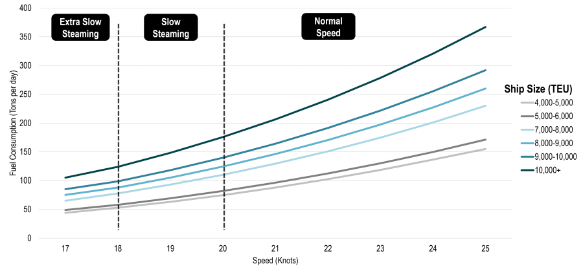Fuel Consumption by Containership Size and Speed (Notteboom, 2009).
An illustrative instance of unethical conduct pertains to the technology industry's practice of introducing new product models without substantial technological advancements. This pattern necessitates a constant demand for metals and minerals, frequently obtained from nations where labour conditions are subpar, and territorial exploitation is permitted. (Stone, 2021).
Several are factors contribute to this departure from Smith's vision, among them Short-Termism is the tendency businesses have on often prioritize short-term profits over long-term sustainability, neglecting the potential harm to society and the environment. Furthermore, capitalism has resulted in significant income inequality, with a small portion of the population amassing immense wealth, while many struggle to meet their basic needs. Based on an economic research the wealth of the 50 richest families in UK has surpassed the wealth of the poorest 50% of the population in UK (Bylines, 2023).
Some corporations engage in exploitative practices, such as low-wage labour, environmental degradation, and unethical supply chain management. As reported in many investigations, from the 90’s progressively more clothing brands have decided to transfer their manufactories in deprived countries creating huge sweatshops building that lack care about their employees nor the environment around them (Birch, 2000).
4. Careless exploitation
Nestlé, the Swiss-based food giant, pledged in 2010 to use only deforestation-free raw materials within a decade. However, recent data reveals that 30% of the palm oil it uses cannot be verified as deforestation-free. Nestlé recorded over 1,000 cases of deforestation per day in 2019, with significant impacts on rainforests, biodiversity, and labour conditions. The company has not named the suppliers behind the deforestation, creating concerns about the sourcing of its palm oil. Investigations have also linked Nestlé to environmental and human rights issues in various countries, challenging the company's commitment to sustainable sourcing (www.rainforest-rescue.org, 2020).
A conducted study has revealed variations in the geographical characteristics within certain regions Papua New Guinea with respect to the palm plantation camps used by the Nestle Corporation.
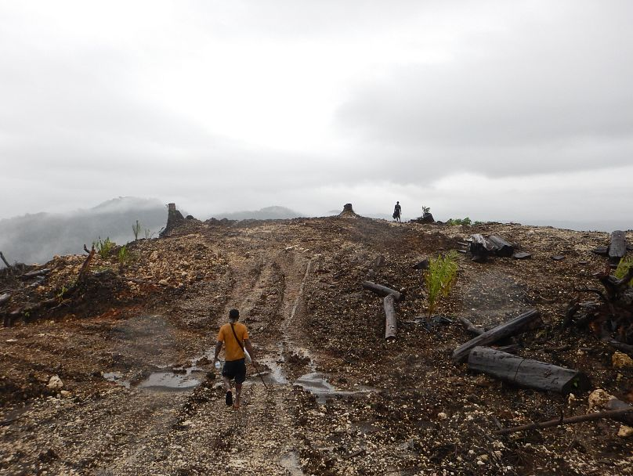 (Limb, 2021)

5. The proposition: Business 2.0

In response to the shortcomings of contemporary capitalism, the concept of Business 2.0 seeks to reorient the focus of businesses toward a more ethical and sustainable model. Business 2.0 wants to represent the connubium of modern economic theory integrated into the fundament of the capitalistic theory. it represents a paradigm shift in the way companies operate.
Stakeholder-Centric Approach is emphasized in the Business 2.0 model, the priority lies in the interests of all stakeholders, encompassing employees, customers, the community, and the environment. Business leaders operating within this framework are driven by ethical principles, leading to decisions that carefully assess their societal and environmental impacts. Following Edward Freeman’s principles stated on his book ‘Stakeholder theory’ (Freeman, 1984).
Patagonia, the outdoor clothing and gear company, puts a strong emphasis on environmental sustainability through practices like using recycled materials and donating profits to environmental causes. It prioritizes fair labour practices within its supply chain and maintains transparency in its operations, sharing information openly. Patagonia's social and environmental activism reflects its dedication to broader issues like climate change and social justice. The production of high-quality, long-lasting products further underscores its stakeholder-focused approach, encouraging sustainability. Patagonia serves as a prominent example of a company that balances the interests of various stakeholders beyond shareholders (O’Rourke, 2017).
Ethical Leadership: Business leaders are guided by ethical principles, making decisions that consider their impact on society and the environment. Ethical leadership has become an admired topic in recent times, it substantially consists on moral person and moral manager affecting the market they live in. It is safe to say that to allow the enhancement of leadership ethical behaviour is fundamental a surrounding high-value market moral standing (Sen, 2009).
Studies on this regard show how the more a leader performs in a way that followers perceive to be good ethical leader behaviour, the more a leader is trusted (van den Akker, 2009).

5.1. Sustainability with the Doughnut Economics: Sustainable practices, such as reducing carbon footprints, ethical sourcing, and waste reduction, are integral to this vision. Businesses should prioritize and actively manage their impact on the immediate environment in which they operate.
The "Doughnut Economics" framework, as introduced by economist Kate Raworth in 2017 offers a novel perspective on sustainable development. The central idea is represented by a doughnut-shaped model that defines two key boundaries. The inner boundary marks the minimum standards for human well-being, including access to clean water, food, and education. Beyond this boundary lies the potential for deprivation. The outer boundary, in contrast, signifies the ecological limits of the planet, covering concerns like climate change and resource depletion. Overshooting this boundary leads to environmental degradation. The goal is to operate within the "doughnut," striking a balance between meeting the essential needs of all whiles respecting planetary boundaries. This approach emphasizes regenerative and distributive economic design, local and global well-being, diversity in economic activities, the circular economy, and redefining success beyond GDP growth, fostering a holistic and sustainable approach to economic prosperity (Raworth, 2017).

5.2. Corporate Social Responsibility: Companies are expected to give back to the communities in which they operate, supporting local development and addressing societal challenges. In this regards Squarepeg, a Coffee shop that operates in Swansea, is an outstanding example. Supplied only from local businesses and farms, Squarepeg approaches their idea of business in a very socially responsible way. In fact, this reality, located in city of Swansea, “thinks there’s a better way to live your life and be part of society… Different is better, different is new and exciting”. Furthermore, this controversial business claims and display all the suppliers it trades with and states in its website that the company “gives its profit away, does not compromise in quality and believes everyone matters” (www.squarepeg.org.uk, 2015)

5.3. Transparency and Accountability: Transparency and accountability are paramount, with companies being open about their practices and accountable for their actions. This behaviour builds trust and credibility, safeguards reputation, and fosters positive relationships with stakeholders. Compliance with legal and regulatory requirements is easier to maintain. Ethical and sustainable practices often emerge, attracting like-minded customers and enabling innovation. Furthermore, transparency encourages companies to attract and retain top talent. This approach can provide a competitive edge, ensuring long-term sustainability while shunning short-term gains that may harm a company's future (Albu, 2019).

5.4. Improving Communities Without Exploitation

Business 2.0 seeks to improve communities without exploiting other territories by aligning business objectives with social and environmental responsibility. It promotes practices that foster community development and well-being without causing harm to other regions.
Key strategies include firstly local engagement, where businesses actively engage with local communities, fostering partnerships and supporting local initiatives, showing a beneficial impact even in peripheral regions (Bürcher, 2017). This, in turn, can lead to increased customer loyalty, positive word-of-mouth, and a more favourable public image, which can be advantageous for long-term success and profitability. Secondly prioritizing Fair Trade and Ethical Sourcing helps to ensure that their operations do not harm other regions or exploit labour. Operate in accordance with fair trade regulations that ensure an equitable marketplace for all is the basement of this concept. Oxfam fair trade, charitable trading initiative, establishes sustainable partnerships with small-scale producers, fostering long-term relationships built on trust and mutual benefit. In this comprehensive approach, Oxfam Fair Trade seeks to create a fair and ethical trading environment that not only benefits producers but also aligns with our values of social and environmental responsibility (www.oxfamfairtrade.be, 2023).
Ultimately, a pillar model that would enhance the value of the communities is Circular Economy (CE), designed to minimize waste and resource consumption. It emphasizes recycling, reusing, and extending the lifespan of products, reducing environmental impact, and promoting long-term resource efficiency (Blomsma, 2017). A study conducted during the period 2008-2017 on the EU market strengthens the thesis that supports CE as growth inductor. The paper underscores that the CE framework is influenced by several key factors, including resource efficiency, the allocation of labour towards environmental conservation efforts, the recycling rates of municipal waste, and the utilization of renewable energy sources. This growth model of the economy, built with a connubium of collaboration principals, was “valid and accurately specified” adding value to the model of the theory (Busu, 2019).
6. Conclusion
In conclusion, the ethical wisdom of ancient philosophers such as Plato, Socrates, and Aristotle have provided a steadfast foundation for understanding moral principles and virtues. Their enduring insights continue to resonate in our contemporary world, offering invaluable guidance for ethical living and governance. However, the capitalist system, as envisioned by Adam Smith, has evolved into one where profit often overshadows ethical considerations, resulting in adverse consequences for society. This departure from the ethical principles outlined by ancient philosophers has given rise to issues like income inequality, environmental degradation, and exploitative labour practices.
The concept of Business 2.0 represents a promising path forward, offering a blueprint for businesses to reorient their practices towards ethical, sustainable, and stakeholder-centric approaches. By embracing Business 2.0, companies can prioritize not only profitability but also the well-being of the communities they serve. This paradigm recognizes that the purpose of business should extend beyond generating profit; it should also encompass meeting the needs of the community and contributing to its betterment. As society grapples with the tension between ancient ethical values and the exigencies of modern capitalism, the Business 2.0 model offers a way to reconcile these conflicting forces. By doing so, we can strive for a more just and equitable future, where businesses play a pivotal role in improving communities without exploitation. In aligning with the timeless ethical values advocated by ancient philosophers, Business 2.0 presents an opportunity to harmonize profit with ethical considerations, contributing to a more ethical, sustainable, and equitable society.

References
Albu, O. B. &. F. M., 2019. Organizational Transparency: Conceptualizations, Conditions, and Consequences.. Business & Society, Volume 58, pp. 268-297.
Birch, S., 2000. Sweat and Tears. The Guardian.
Blomsma, F. B. G., 2017. The emergence of circular economy: a new framing, s.l.: J. Ind. Ecol..
Brown, P. L. H., 2001. Capitalism and Social Progress: The Future of Society in a Global Economy. New York: Palgrave.
Bürcher, S., 2017. Regional engagement of locally anchored firms and its influence on socio-economic development in two peripheral regions over time. Entrepreneurship & Regional Development, 29(7), pp. 692-714 .
Busu, M., 2019. Adopting Circular Economy at the European Union Level and Its Impact on Economic Growth, Bucharest: Bucharest University of Economics Studies.
Bylines, E. A., 2023. eastangliabylines.co.uk. [Online]
Available at: https://eastangliabylines.co.uk/wealth-inequality-soaring/
[Accessed 26 october 2023].
Contractor, F. J., 2016. Tax Avoidance by Multinational Companies: Methods, Policies, and Ethics, New Jersey: Rutgers Business Review.
Freeman, R. E., 1984. Strategic management: A stakeholder approach. Boston: Pitman: Cambridge University Press.
Gottlieb, P., 2009. The Virtue of Aristotle's Ethics. Cambridge: University of Wisconsin–Madison.
Limb, L., 2021. Nestlé and Kellogg’s linked to shocking palm oil abuse in Papua New Guinea. [Online]
Available at: https://www.euronews.com/green/2021/10/08/nestle-kellogg-s-linked-to-shocking-palm-oil-abuses-in-papua-new-guinea
[Accessed 31 october 2023].
Notteboom, T. a. P. C., 2009. Fuel surcharge practices of container shipping lines: Is it about cost recovery or revenue making?, Copenhagen: Proceedings of the 2009 International Association of Maritime Economists (IAME) Conference.
O’Rourke, D. S. R., 2017. Patagonia: Driving Sustainable Innovation by Embracing Tensions, s.l.: California Management Review.
Plato, 2000. Apology. Indianapolis: Hackett Publishing Company.
Plato, 360 B.C.E.. The Republic. s.l.:s.n.
Raworth, K., 2017. Doughnut Economics: Seven Ways to Think Like a 21st-Century Economist. Oxford: Oxford University Press.
Sen, A., 2009. The Moral Standing of the Market. Social Philosophy and Policy. 2 ed. s.l.:Cambridge University Press.
Sinha, S., 2021. MarineInsight. [Online]
Available at: https://www.marineinsight.com/know-more/how-much-fuel-does-a-cruise-ship-use/
[Accessed 25 october 2023].
Smith, A., 1776. The wealth of nations. London: W. strahan and T. Cadell.
Stiglitz, J. E., 2012. The Price of Inequality: How Today’s Divided Society Endangers Our Future. s.l.:W. W. Norton & Company.
Stone, M., 2021. https://www.technologyreview.com/. [Online]
Available at: https://www.technologyreview.com/
[Accessed 25 october 2023].
van den Akker, L. H. L. L. K., 2009. Ethical leadership and trust: It's all about meeting expectations, Amsterdam: International Journal of Leadership Studies.
www.oxfamfairtrade.be, 2023. WHY BUY FAIR TRADE FROM OXFAM?. [Online]
Available at: https://www.oxfamfairtrade.be/en/impact/
[Accessed 6 November 2023].
www.rainforest-rescue.org, 2020. Fact check: Nestlé palm oil is not sustainable. [Online]
Available at: https://www.rainforest-rescue.org/topics/palm-oil/nestle
[Accessed 30 October 2023].
www.squarepeg.org.uk, 2015. Square Peg: PROFITS, QUALITY & LOVE. [Online]
Available at: https://www.squarepeg.org.uk/
[Accessed 4 novermber 2023].

