DISERTATION(LCBB6000)
SUPERVISOR:DR.TAYE OSADIYA
STUDENT NAME:ION DULUMAN
STUDENT ID:1917721

SUSTAINABLE BUSINESS PRACTISES PRIORITISING PEOPLE'S HEALTH IN HYDRATION SECTOR

Acknowledgement
I would want to express my gratitude to my supervisor, _____, for providing me with consistent assistance and direction throughout the whole of this project. I would like to extend my gratitude to the following individuals for their assistance with our study endeavour. I would want to extend my gratitude to _______, without whom I would not have been able to finish this study.
Abstract
A water system is considered sustainable if it can meet the needs of the population now without compromising its ability to do so in the near future. In the framework of sustainable development, it is probable that it will not be feasible to physically restrict the amount of water that is used by water systems; yet, there are some applications of water that have traditionally been necessary. Such innovations as waterless toilets and vehicle washes, for instance, contribute to the maintenance of a constant water supply and lessen the impact of drought. The benefits of a dependable water supply to the economy, society, and the environment need to be the primary motivating factor behind water use. If there is a scarcity of resources, there may be rivalry between these interests; for instance, the demand for more water to serve a growing population in an urban area may come into conflict with the wants of farmers in rural areas. A dependable water supply is necessary for a variety of human endeavours, including agriculture, sustenance, industrial activity, and domestic requirements. When there are several stakeholders participating in finding the most effective approach to manage water resources, we refer to this process as integrated water resource management. In order to effectively manage integrated water resources, it is essential to have a consistent supply of water that will not get depleted. The potential for long-term survival of a water system is influenced by a wide variety of factors, some of which include environment, society, and economics. The mission of the United Nations' "Sustainable Water for All" initiative is to make sure that people all around the world have access to potable water that is free from contaminants. Even though its current output is only slightly higher than the average that can be obtained through optimal agricultural management, rain-fed agriculture is the most common type of agricultural production on a global scale. This is despite the fact that its current output is only slightly higher than the average. despite the fact that its production right now is just slightly higher than the average for the whole country. The global agricultural output has to grow by 60 percent by the year 2050, while the production in developing countries needs to rise by 100 percent over the same time.

Table of Contents
Chapter 1: Introduction 4
1.0 Background 4
1.1 Rationale 4
1.2 Aims 5
1.3 Objectives 5
1.4 Research question 5
Chapter 2: Literature review 6
2.0 Introduction 6
2.1 Sustainable water management practices 6
2.2 Sustainable development initiatives 7
2.3 Water management in agriculture 9
2.4 ‌Hydrological systems and sustainable water management 10
2.5 Characteristics of sustainable water management practices 11
2.6 Importance of sustainable water management practices 12
2.7 Advantages and disadvantages of sustainable approaches in water industry 14
2.8 Challenges faced by businesses to integrate sustainability in business operation 16
2.9 Conclusion 17
Chapter 3: Research methodology 18
3.1 Research strategy 18
3.2 Research approach 19
3.3 Research philosophy 19
3.4 Data collection 20
3.5 Data analysis 20
Chapter 4: Results 21
Chapter 5: Findings and discussion 24
Chapter 6: Conclusion 25
6.1 Conclusion 25
6.2 Recommendations 26
Reference 27

Chapter 1: Introduction

1.0 Background
A water system is considered sustainable if it can satisfy the needs of the current demand without compromising its ability to satisfy the needs of the future demand. In the context of sustainable development, water systems may not be able to physically manage the amount of water that is consumed, but these water systems do include systems in which water consumption has traditionally been necessary. The use of waterless toilets and car washes, for instance, contributes to the reduction of water shortages and the provision of a dependable water supply.
Consuming water should be done so with the intention of securing the economic, social, and environmental benefits that come along with a sustainable water supply. If there is a scarcity of resources, these goals may come into competition with one another; for instance, the need for water to support a growing urban population may compete with the needs of farmers in rural areas. Water is used for a variety of purposes, including agriculture, survival, industrial activities, and domestic demands. Integrated water resource management is the process of bringing together various stakeholders to determine how water should be administered in the most effective manner. One component of integrated water resource management is a sustainable water supply. The sustainability of a water system throughout time is contingent on a variety of factors, including the environment, society, and the economy.
The availability of freshwater resources is unfortunately restricted and unevenly distributed across the surface of the earth. Approximately half of the world's lakes may be found in Canada. A significant portion of the earth's surface water is currently unfit for human consumption because it has been tainted by contamination brought on by a wide variety of human activities. Therefore, therapy options are required to be considered.

1.1 Rationale
To ensure that ethical choices are made to protect future generations, sustainable practises are essential. Planning, developing, and managing water resources need a risk-based approach. New changes must be implemented to enhance water supply quality in order to promote water supply and management. Environmental, natural resource, and legislative entities must all have their functions analysed. Businesses in the United Kingdom must follow rules set by law, such as the Water Industry Act of 1991. Changes are being made to both the drinking water rules and the government's water strategy, which encourages economic activity and investment, in order to improve the water systems' ability to withstand disruptions.

1.2 Aims
It has been seen that effective maintaining of health and wellbeing of the people is one of the most effective factors within the hydration sector. Along with this, it has also been seen that the lack of sufficient health and safety in health and wellbeing have the potential to affect people. Keeping this fact in mind, the research aims to analyse the sustainable business practices prioritising people's health in the hydration sector. Along with this, the research aims to analyse to analyse the factors that needs to be maintained to enhance sustainability and wellbeing within the hydration sector.

1.3 Objectives
- To understand importance of sustainable business practices in hydration sector
- To identify factors that affect people’s health in water management practices.
- To recognize impact of sustainable practices to maintain quality of water resources and people’s health in UK.
- To analyse challenges faced by businesses adopting sustainability in hydration sector in UK.
- To recommend an effective strategy for implementing sustainable practices in hydration sector in UK.

1.4 Research question
- What is importance of sustainable business practices in hydration sector?
- What are major factors that affect people’s health and water management practices?
- What is impact of sustainable approaches on quality of water resources and people’s health?
- What are challenges faced by businesses adopting sustainability in hydration sector in UK?
- What are effective strategies to be implemented to improve integration of sustainable practices in hydration sector in UK?

Chapter 2: Literature review

2.0 Introduction
The ecological catastrophe that has been unfolding on a global scale over the course of the past few decades has become a significant barrier to the expansion of sustainable economies. When their effects on the surrounding environment were taken into account, sustainable development programmes were found to be wanting. The exhaustion of natural resources has reached a tipping point, and a great number of significant ecosystems are on the verge of being destroyed as a result. In order to protect the life-supporting systems of the planet, future frameworks for sustainable development need to be based on a growing understanding of global planetary boundaries. These boundaries must be respected in order to ensure the planet's continued habitability.

2.1 Sustainable water management practices
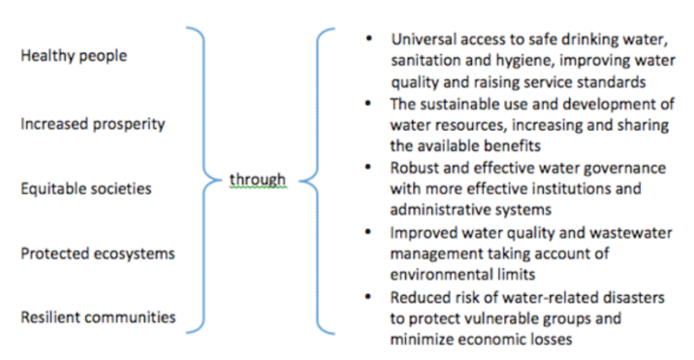
Figure: The water Goals
Source: Water and sustainable development (2022)
According to Ossewaarde and Ossewaarde-Lowtoo (2020), water is crucial to the success of any plan for sustainable development, as it is required for a robust economy, the maintenance of thriving ecosystems, and the continuation of life. It is necessary in order to improve people's health, well-being, and productivity, as well as to lessen the impact of disease on the global population. It is essential for the production and maintenance of a number of things that are to the advantage of people. Because it serves as the fundamental connector between the climate system, human society, and the natural environment, water is an extremely important component of climate change adaptation. Because water is essential to human life, it is imperative that one does everything in our power to preserve this finite and essential resource. If it is not managed in an efficient manner, then it cannot be considered renewable. More than two-thirds of the world's population will live in water-scarce regions by the year 2025 (Ungureanu, Vlăduț and Voicu, 2020).

2.2 Sustainable development initiatives
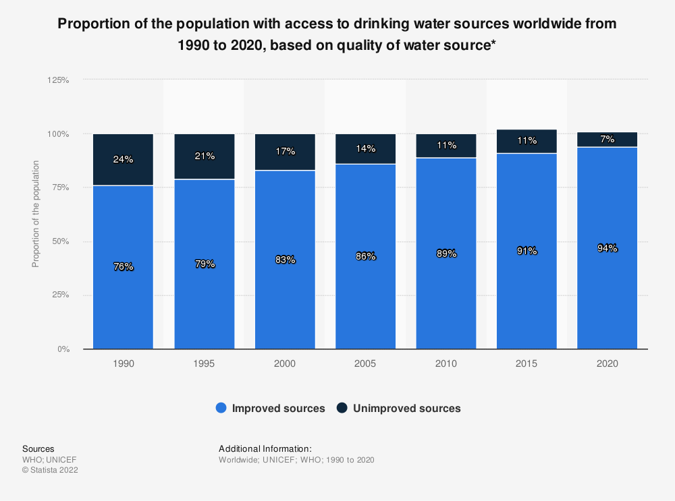
Figure: The percentage of the world's population with access to potable water, broken down by water source quality, from 1990 to 2020
Source: Statista (2020)
The General Assembly of the United Nations (2022) passed a resolution in July 2010 that "recognised the right to safe and clean drinking water and sanitation as an essential human right for the enjoyment of life and all human rights". This right was described as "an essential human right for the enjoyment of life and all human rights”. The sanitation MDG target is of much greater concern given that more than one billion people still engage in open defecation. According to the current state of affairs, by the target date approximately 500 million people will not have access to sanitary sanitation. At the Rio+20 Conference in 2012, participants had the opportunity to evaluate the sustainable development initiatives that had been implemented over the previous 20 years (Tomislav, 2018). The conference's final document, titled "The Vision We Want," outlined a number of approaches that could be taken to accomplish this objective. The provision of resources, the creation of new technologies, and the training of new employees were among these. The Millennium Development Goals, which have a deadline of 2015 to be completed, have prompted a worldwide evaluation of potential future projects that aim to create a more sustainable world (Del Campo, Gazzola and Onyango, 2020). When it came to water and development, the MDG framework fell short, both in terms of addressing all of the current concerns and of properly recognising the interconnections between them. This was true for both aspects.
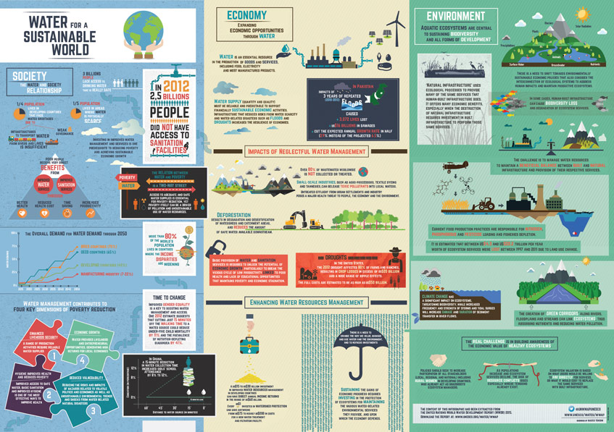
Figure: Trends for waste streams in US municipal waste output
Source: Water and sustainable development (2022)

2.3 Water management in agriculture
The goal of the United Nations initiative known as "Sustainable Water for All" is to guarantee that everyone on the planet has access to clean drinking water. According to Pérez-Blanco, Hrast-Essenfelder and Perry (2020), up to 70 percent of a country's total freshwater withdrawals are used for agriculture, and that is the case in most countries. Even though its current output is only slightly higher than the average that is feasible with ideal agricultural management, rain-fed agriculture is the most common method of agricultural production on a global scale. This is despite the fact that its current output is only slightly higher than the average. The global agricultural output needs to increase by sixty percent by the year 2050, and by one hundred percent in developing countries (Islam and Karim, 2019). The manufacturing and energy sectors together consume twenty percent of the available water on the planet. Agriculture consumes the vast majority of freshwater withdrawals in less developed nations, while industry consumes a much larger amount in more developed nations. Less developed nations also use a larger percentage of their freshwater withdrawals for agriculture. The manufacturing industry is confronted with a number of challenges as it works toward its goal of striking a balance between the demands of sustainable production and the more conventional idea of mass production in industrial settings. One of the most important challenges involves maintaining the viability of globalisation and figuring out how to bring the benefits of industrialization to people all over the world without exhausting the world's supplies of freshwater or other natural resources. Only 10% of the total water demand comes from homes and businesses in the residential sector (Woetzel, Pinner and Samandari, 2020). It is anticipated that more than two thirds of the world's 9 billion inhabitants will reside in urban areas by the year 2050, which is an increase from the current percentage of fifty percent. Because of this rise, a greater number of people will choose to live in slums, which usually have deplorable living conditions, including a lack of adequate water and sanitation facilities. The majority of these changes will take place in developing countries, which are less prepared to deal with rapid shifts in the environment. According to Di Baldassarre et al. (2019), the expansion of urban areas will have a close relationship to the development of water resources for promoting economic growth, social equality, and environmental sustainability.
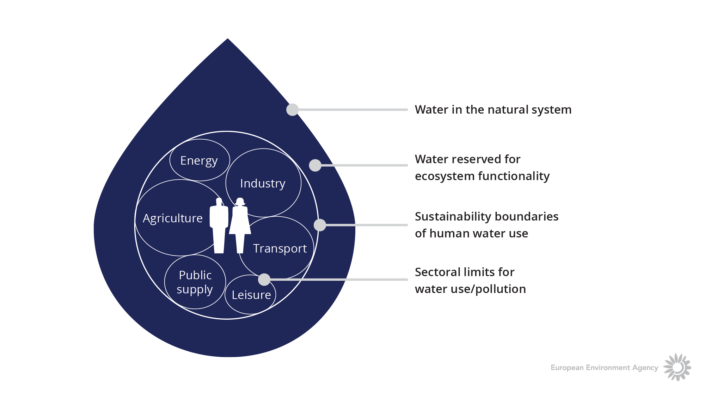

Figure: Sustainable water management
Source: ‌Hydrological systems and sustainable water management 2015

2.4 ‌Hydrological systems and sustainable water management
More than 1.7 billion people depend on the ecosystems and the services that they provide, both of which are in danger because of the fact that water consumption in river basins is higher than the amount that can be recharged (Abbasov, Karimov and Jafarova, 2022). Because of rising numbers of people and progress made economically, it is anticipated that the demand for water on a global scale will increase by a factor of fifty-five percent by the year 2050. If current consumption rates remain the same, by the year 2025, it is possible that two-thirds of the world's population will live in countries where water is scarce. According to the World Health Organization (WHO), countries that did not meet the Millennium Development Goals in this area lost an average of 1.5% of their GDP due to inadequate water and sanitation facilities. These countries also had lower life expectancies. According to some estimates, more than 80 percent of wastewater is discharged without first being treated. The greatest toll on society and the economy is taken by natural disasters that are caused by water. According to Kaur (2022), since the first Rio Earth Summit was held in 1992, natural disasters such as floods, droughts, and storms have affected an estimated 4.2 billion people (which is equivalent to 95% of all disaster victims) and cost an estimated 1.3 trillion USD (which is equivalent to 63% of all disaster damages).

2.5 Characteristics of sustainable water management practices

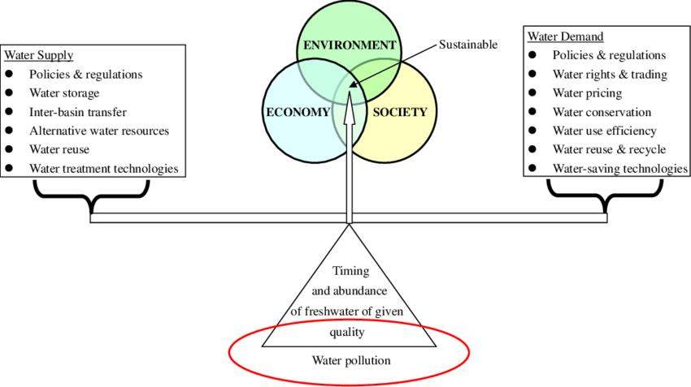
Figure: Sustainable water resource management
Sources: Cheng et al. (2022)
A nation is considered to have sustainable water if it is able to satisfy all of its own water requirements, regardless of whether those requirements are for agricultural, municipal, or industrial use. In addition, it demonstrates that despite the effects of climate change, such as drought and flood resilience, there will not be any significant changes to the water supply. For water to be deemed sustainable, there needs to be an economic equilibrium between supply and demand, and there needs to be optimization of water distribution. In the same vein, conventional methods of water treatment and alternative forms of energy can be integrated into a single system to fulfil the dual goals of water sustainability and energy neutrality. According to Stenzel et al (2021), the term "sustainable water management" refers to a practice in which present water needs are satisfied without jeopardising the ability of future generations to do the same. A holistic and interdisciplinary approach is required for effectively addressing the myriad of intricate problems that arise in the course of water management, including those pertaining to the environment, economy, society, and landscape aesthetics.
With a water cycle that is sustainable, one will be able to meet the water and wastewater needs of both our present generation and the generations to come in an equitable manner. The Environmental Protection Agency (2022) in the United States suggests that this could be accomplished through careful planning for water and wastewater systems, with the objective of better supervising the operations and infrastructure of those systems in order to ensure the long-term health of the communities that those systems serve.
The operation and maintenance of long-term infrastructure, as well as the development of long-term planning horizons, are often the responsibility of water utilities. Over time, the probable rewards and expenses associated with certain financial decisions mount up. According to the EPA's Sustainability Policy, all drinking water and wastewater systems are required to engage in "strong and comprehensive" planning. This is done to ensure that improvements in water infrastructure are cost-effective over the long term, make efficient use of resources, and are in line with other important community goals.

2.6 Importance of sustainable water management practices
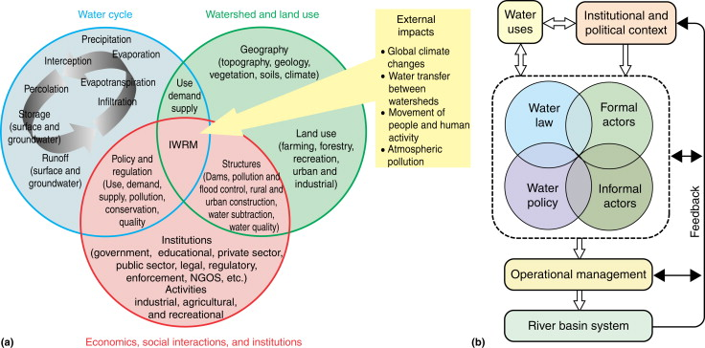
Figure: Integrated water resource management
Source: ‌Abell et al. (2009)
On Earth, water is a limited resource that is in short supply. As the need for water continues to grow, there will be an increasing urgency in the requirement to reduce water use in order to protect the availability of freshwater. Initiatives geared toward sustainable development are primarily reliant on efficient water management. Egypt's water supply is coming under increased strain because of the country's deteriorating energy crisis, resource deficit, and problems with the Renaissance Dam (Elbasiouny and Elbehiry, 2020). Some of these factors include population growth and the effects of climate change. Water management strategy is the only method that can provide a long-term solution to these problems. Two of the approaches that can help make this a reality are water conservation and making intelligent use of water technologies.
According to Yu, Josey, Bingham, and Lee (2020), the human body is approximately the same proportion of water as the globe, which is around two-thirds of the way through the water cycle. Water is essential to human life, yet it also has the potential to be a devastating force. Conflict in the future will be ignited more by struggle over water resources than it will be over oil reserves. Water scarcity is a big problem that is currently being faced all over the world. Water has lately been identified as one of the resources that will present the greatest challenges in the future because its availability will soon be severely limited. In the context of sustainable development, meeting present demands means not jeopardising the ability of future generations to do the same thing; therefore, sustainable water management should contribute favourably to the achievement of these aims.
According to Koop (2019), the goal of sustainable water management is to organise and maximise the performance of the numerous moving pieces that make up the water management system. This objective can be accomplished through the use of a variety of strategies, including water storage, water recycling, and water conservation. Overconsumption by people has the potential to put everything out of kilter in the natural world, despite the fact that the mechanisms of eco-systems in nature keep everything in a state of delicate balance. The foundation of sustainable water management is the reduction of water use through the implementation of improved water efficiency technologies and the changing of social behaviour.
The provision of drinking water, the running of taps and water fountains in common areas such as cafeterias and science labs, as well as for landscaping and watering outdoor play areas and playgrounds, all require a significant amount of water on a daily basis. Other uses of water in schools include climate control (heating and cooling), flushing toilets, providing heating and cooling, providing drinking water, flushing toilets, and providing drinking water. Because of the planned school construction programme and the central role schools play in our community in encouraging students to conserve water during the growth phase, it is imperative that sustainable water management be promoted within schools in addition to the environmental awareness and education provided by the school in support of sustainability. Schools play a central role in our community in motivating students to conserve water during the growth phase (EL-Nwsany, Maarouf and Abd el-Aal, 2019).

2.7 Advantages and disadvantages of sustainable approaches in water industry
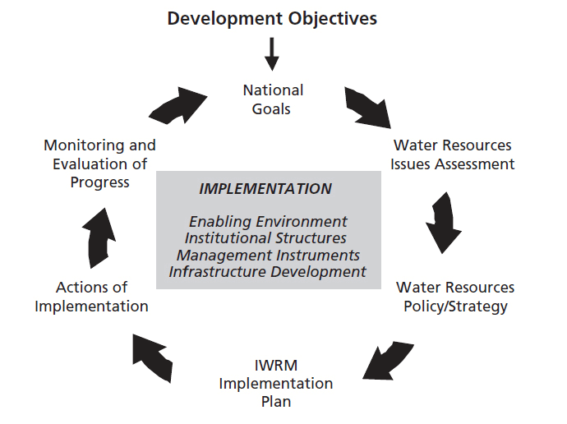
Figure: Water resource management objectives
Source: ‌Integrated Water Resources Management (IWRM) | International Decade for Action ‘Water for Life’ 2005-2015 (2015)
The distribution of freshwater across the surface of the planet is, sadly marked by a substantial lack of fairness in important parts of the world. Canada is home to around fifty percent of the total lakes found in the planet (Smith et al. 2019). In addition, the inadmissibility of this water for human consumption can be attributed to the pollution of a sizeable proportion of the surface water on the planet, which was brought about by a wide range of activities carried out by humans. Because of this, it is necessary to participate in therapeutic operations.
For example, dams are frequently utilised as a means of accumulating and storing water for use later. Dams are advantageous structures for a number of reasons, including the generation of hydroelectric power, the storage of water, the management of flooding, the redistribution of water, and the facilitation of navigation. If they are built properly, dams have the ability to help ensure a steady supply of water for many years to come. This is provided, of course, that the dams be built correctly. During the process of design, it is necessary to take into account a variety of aspects of the site. Some of these aspects include, but are not limited to wetlands, water tables, human impacts, ecological impacts (including impacts on wildlife), relocation compensation, historical and future peak flood flows caused by climate change, and other factors. Large-scale building projects of dams pose a number of potential hazards to the natural world, including the eradication of natural habitats, the obstruction of fish migration, the modification of water flow and quality, and the uprooting of local communities (Best, 2019). In order to study the building's long-term implications on the environment, economics, and society in the surrounding area, it is important to conduct an analysis of the building's impact on sustainability. Groundwater is an exceptionally significant resource for human use because of the fact that it accounts for more than half of the world's freshwater supply (Richards et al. 2021. When considering the extraction of groundwater, it is essential to keep the bigger picture in mind because the repercussions of this development may not become apparent for a number of years. Keeping this in mind will help ensure that no important details are overlooked. It is essential to incorporate groundwater supplies into urban drainage systems that are friendly to the environment as well as into efficient land use planning.

2.8 Challenges faced by businesses to integrate sustainability in business operation
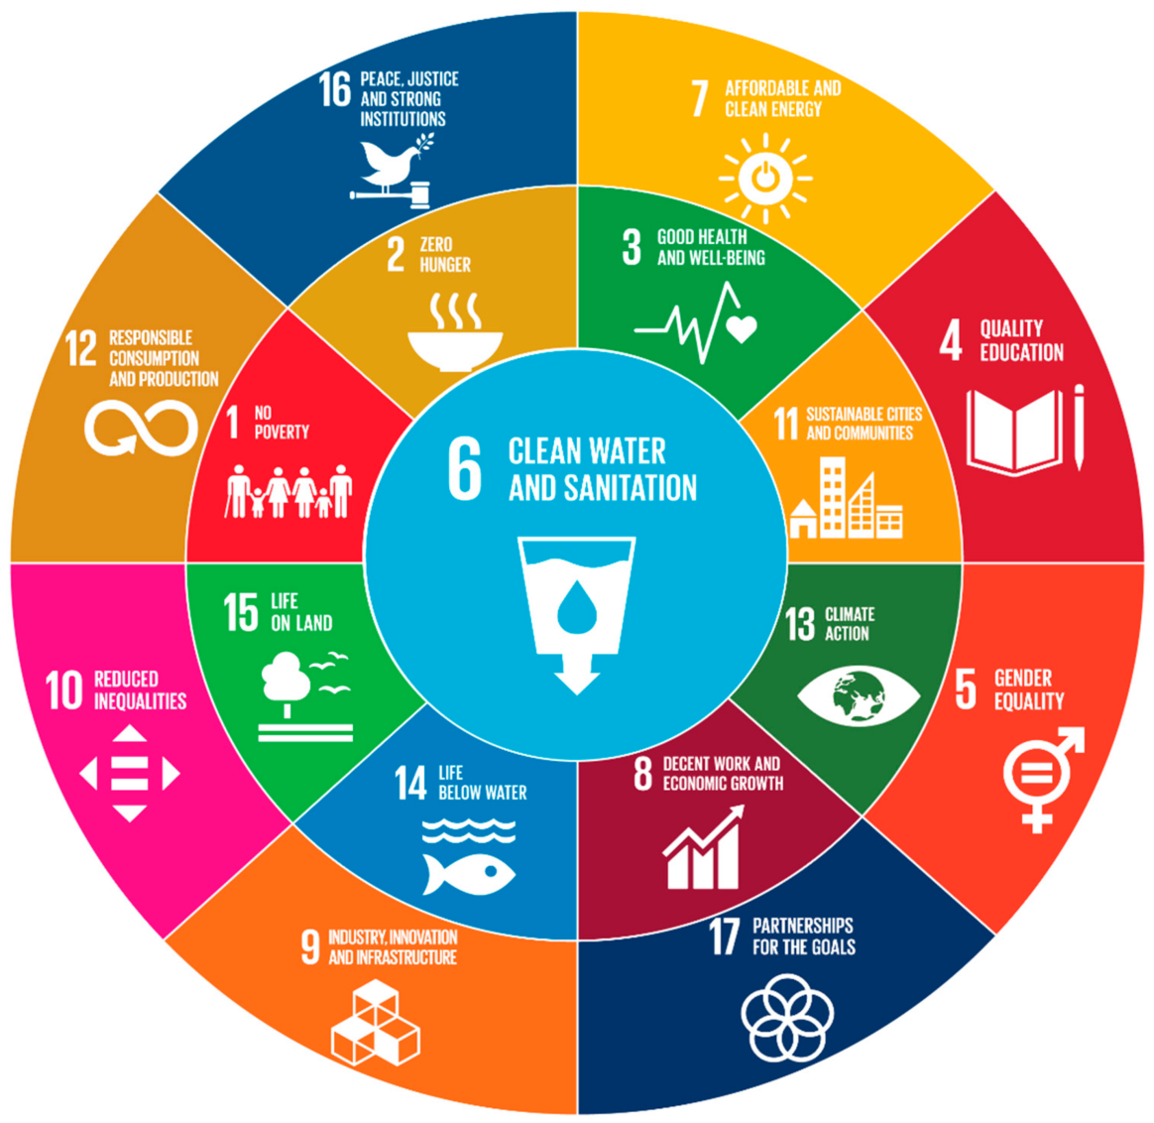
Figure: Challenges in water resource management
Source: ‌van Leeuwen et al. (2019)
Recently, the subject of sustainability has been brought to the forefront of conversations among people of varying ages and socioeconomic backgrounds. Even during the height of the COVID-19 pandemic, the majority of people still believe that addressing the climate crisis is just as essential, and they are convinced that the inevitable economic recovery will not come at the expense of protecting the environment. Even the vast financial stimulus programmes that governments are offering to help the economy recover have long-term viability as one of their primary goals. For instance, the European Commission's corona recovery package, which is worth 750 billion euros, makes allusions to main topics of the European Green Deal and expands upon several of the European Green Deal's initiatives encouraging carbon neutrality, the circular economy, and sustainable financing (European Commission, 2022). Several of the government's stimulus packages put an emphasis on protecting the environment and remaining environmentally responsible. A national recovery plan in Germany has been allocated a budget of €50 billion, which will be used to fund environmentally conscious breakthroughs such as digitalization, as well as environmentally friendly technology such as hydrogen and e-mobility infrastructure, as well as low-carbon buildings. According to Mardon et al. (2019), policies that are responsible for the environment and the resuscitation of the economy are not incompatible goals; the American Recovery and Reinvestment Act allots $90 billion to sustainable projects to demonstrate this point.

2.9 Conclusion
The "new infrastructure development plan" in China is supporting large investments on green infrastructure, including addressing electric transport and renewable energy sources. Because of the considerable impetus they provide for long-term change, businesses need to determine how these shifts will affect both their current and future growth. Change can serve as the incentive for an organisation to transform, which can lead to new economic prospects if the appropriate management and tactics are put into place. Companies can gain an advantage over their rivals by moving quickly and making sure, they are well prepared.

Chapter 3: Research methodology
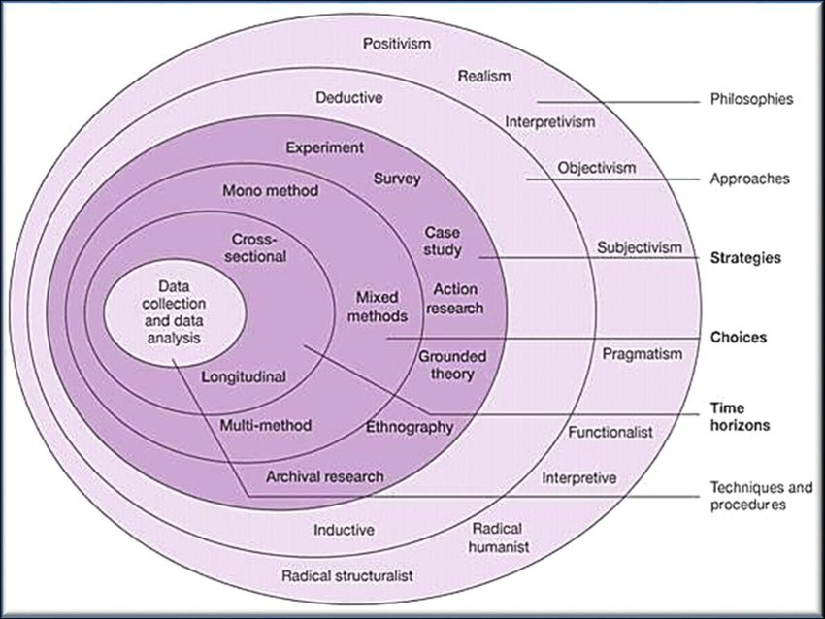
Figure: Research onion
Source: Temitope Omotayo and Udayangani Kulatunga (2015)

3.1 Research strategy
In the case of the concerned research, an effective mix method will be used. An investigation known as a mixed-methods study is one that makes use of both qualitative and quantitative research approaches. The collection and examination of qualitative and quantitative data helps researchers achieve a more comprehensive understanding of a phenomenon and provide answers to research questions. Mixed-methods research is based on the presumption that the combined advantages of the various research approaches will be superior to those offered by any one data source (Dawadi, Shrestha and Giri, 2021). To compare and contrast results and broaden the scope of their evidence, researchers frequently employ a methodology known as mixed methods, which draws from both qualitative and quantitative research approaches.

3.2 Research approach
In this research, an effective deductive research approach will be used. In order to use a deductive strategy, one must first develop a hypothesis in light of the previous research and then plan an experiment to put that hypothesis to the test. In other words, the deductive method requires two steps. Cramer-Petersen, Christensen and Ahmed-Kristensen (2019) stated that "deductive reasoning includes reasoning from the particular to the universal. In any circumstance in which a specific theory or case example appears to imply a causal relationship or link, it is highly likely that the theory or example is right. In order to determine whether or not this relationship remains true in more general circumstances, it may be possible to apply a procedure known as deductive reasoning. It is possible to employ hypotheses that are derived from the statements of the theory in order to provide an explanation of the deductive approach. To restate, deductive reasoning is the process of drawing conclusions based on hypotheses that have been proven true in the past. Deductive inquiry seeks to determine the extent to which a theory or phenomenon that has already been established can be applied to the issue at hand. This is the end goal of deductive inquiry. According to Cramer-Petersen, Christensen, and Ahmed-Kristensen (2019), "the deductive approach follows the route of logic more closely. The train of thought begins with a theory, and then it transitions into a different hypothesis. In addition, inductive reasoning is characterised as making a leap from the specific to the general, whereas deductive reasoning takes the opposite approach, starts with the general, and works its way back to the specific. To put it another way, hypotheses are developed and tested over the course of deductive research, but not during an inductive study.

3.3 Research philosophy
In the situation of the investigation at hand, the research philosophy of effective positivism is put into practise. The only kind of data that positivists consider to be trustworthy are those that are derived from empirical research, such as the outcomes of scientific methods like observation and measurement. In positivist investigations, the job of the researcher is reduced to nothing more than the collection of data and the impartial assessment of that data (Carminati, 2018). To put it another way, the researcher is an objective observer who, in order to provide an accurate assessment, sets her own beliefs and preconceptions to one side. Investigations of this nature typically produce measurable outcomes, which are then made available for review by the public. The domains of science and statistics provide the positivist philosophical framework with an empirical basis. For a considerable amount of time, many who work in the academic fields of management and business have regarded this approach as the strategy that best represents best practises. It is possible to say that positivism is consistent with the central premise of empiricist theory, which states, "Human experience is the source of knowledge." Empiricist views revolve around the concept that "human experience is the source of knowledge." This perspective considers the universe to be made up of separate, observable elements and events, the interactions between which are clear-cut and foreseeable. In this perspective, the universe is also referred to as a "microcosm”.
When conducting positivist research, inductive procedures are utilised, but when conducting positivist research, deductive methodologies are utilised. Towers et al. (2020) states that deductive procedures are more likely to be utilised in phenomenological research than inductive ones. In contrast to positivism, which insists that scientists pay attention to only the empirical facts, phenomenology lays a larger emphasis on interpretation and takes into account the characteristics that are related to human nature.

3.4 Data collection
Effective primary data collection method is used for the concerned study. It can be seen that the use of effective primary data collection methods can enhance the quality of the study (Johnson, Adkins, and Chauvin, 2020). 30 participants will be effectively surveyed using close ended questions to retrieve an effective number of data for the study.

3.5 Data analysis
It can be seen that an effective statistical data analysis method is used for the research. The process of using statistical analysis to find patterns and trends in data is known as "data mining" (Mughal, 2018). It is a technique for ensuring that the numerical analysis of data does not contain any trace of even the remotest possibility of an error. The accumulation of research interpretations, the construction of statistical models, and the coordination of surveys and studies are all significantly aided by this technique.
Statistical analysis is what produces the data, which in turn helps with decision-making and assists organisations in developing future forecasts based on trends that have been observed in the past. The process of collecting and analysing data in order to discover and depict patterns and trends is known as statistical analysis. Statistical analysis is the process of deriving meaningful information from data, and it involves working with numbers. Businesses and other organisations use statistical analysis.

Chapter 4: Results
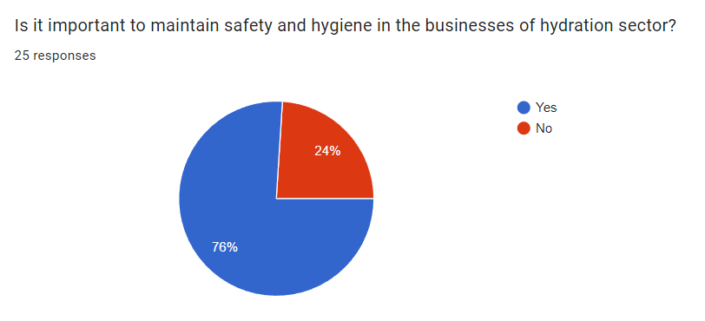
The majority of the participants have stated that it is highly important to maintain the health and safety of the hydration sector to enhance sustainability. It has been seen that the incorporation of effective health and safety procedures is needed for the development of the hydration section. Workers in the water industry may have to operate wastewater treatment facilities, conduct quality checks at outlying pumping stations and reservoirs, or keep an eye on water metres. Working alone with high voltage materials, contaminated or dangerous water, harmful chemicals, and toxic gases can be deadly.
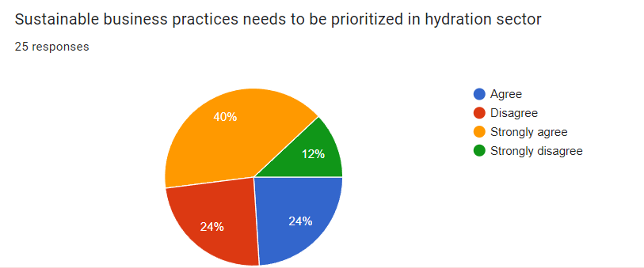
Based on the data of the survey, this fact has been seen that 40% of the participants have strongly agreed to the fact that sustainable business practices need to be prioritised in hydration sector. There is a need for creative solutions to water industry problems because those problems are notoriously difficult to handle. There are many potential solutions to this problem, one of which is the development of innovative, environmentally friendly water treatment technologies. However, in order to make these technologies more widely applicable, changes will also need to be made to the economic structures of metropolitan areas. This article places a primary emphasis on the significance of environmentally responsible business models in easing the path to technological advancements such as the proliferation of decentralised systems for enhancing the water quality and supply in metropolitan areas. Participation from the business sector may prove useful in overcoming the limitations and challenges of putting these strategies into practise and achieving sustainability. This was accomplished through the completion of the study. According to the findings of the study, corporate strategies and close integration with customers may assist boost consumers' acceptance of decentralised systems as well as their perceived risk and trust in these systems. In addition, the close collaboration among the actors makes for easier and more effective administration of the system.
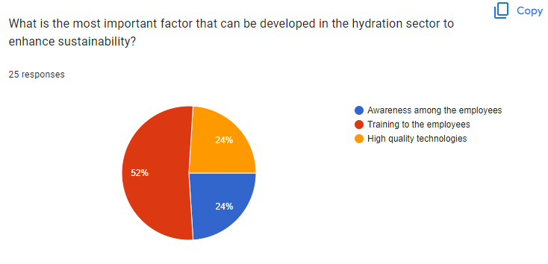
The majority of the employees stated that training the employees is a significant factor in the development of sustainability of the hydration sector. Training the employees can have an effective development in understand the need of as well as the actions that are needed for the development of the same.
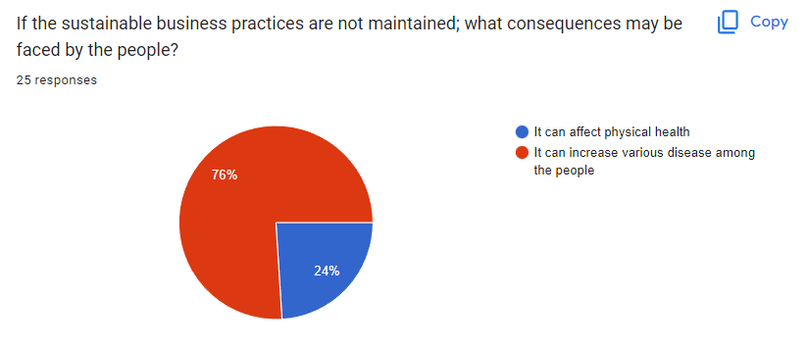
The majority of the participants have stated that the lack of sustainability in the hydration sector can have severe impacts on the human health. It has been observed that lack of sustainability in the hydration business can cause various diseases among the people.

Chapter 5: Findings and discussion
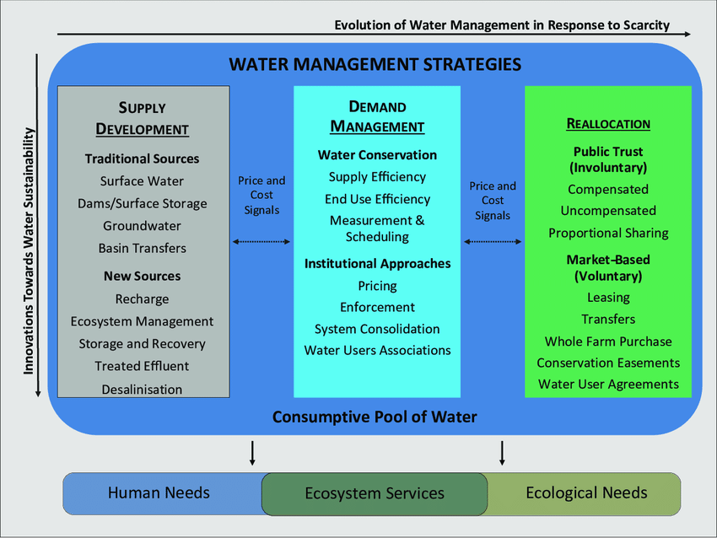
Figure: Water resource management strategies
Source: ‌Aylward, Pilz and Sanchez (2016)
Rainwater collection is one of the most environmentally friendly methods of obtaining water since, in contrast to the extraction of surface water and groundwater, there are naturally occurring impediments to the process, and the water can be consumed as soon as it is collected. Correct installation and maintenance of rainwater collecting systems are required in order to ensure efficient water collection, the avoidance of water contamination, and the implementation of environmentally responsible treatment processes in the event that water is found to be contaminated. At the point of usage, there is a wide selection of different ways for the purification of drinking water, each of which comes with its own individual set of positives and negatives. Some of the methods include flocculation and chlorination, while others include solar treatment, boiling, filtering, and chlorination. Other methods include chlorination and flocculation. The level of unpredictability and the number of competing demands for land usage make it such that collecting rainwater is most helpful when used in conjunction with other methods of providing sustainably sourced water.

Chapter 6: Conclusion

6.1 Conclusion
It is hoped that reclaimed water, which refers to water that has been reused after having been utilised for human purposes, would become an important source of water in the end. With the help of this technique, significant water sources, such as surface water and groundwater, can have some of the pressure lifted off them. Distributed options include the use of micro porous membranes and grey water recycling systems as two examples. Before recycled water can be used for anything, it must first undergo a specific kind of treatment that cannot be skipped. Because grey water and backwater are used for distinct purposes, it is frequently preferable to keep the two types of water distinct from one another. Greywater, which comes from things like doing the laundry, contrasts with the blackwater that, comes from human waste. This indicates that there are characteristics that are unique to each of the two categories of waste. The process of desalination can be used to supply sufficient quantities of water to regions that are short on freshwater, such as small island republics. The process of reverse osmosis is a typical method for desalinating water; but, due to the quantity of energy that it consumes, its application is limited in scope. The cost of desalinating water is around $0.81 USD per cubic metre, but the cost of water derived from alternate sources is $0.16 USD per cubic metre. Desalination using equipment that is both efficient and fuelled by renewable energy sources would make this supply source more reliable. Because more energy is needed for the desalination process to function, the costs associated with it are now ultimately borne by customers in the form of increased pricing for the product. Both the chemicals that are used to purify the water and the brine that is discharged from desalination facilities have the potential to have a negative impact on marine life as well as to contribute to an increase for pollution in the water. The twenty-first century saw the beginning of businesses promoting and selling drinkable water that was packed in bottles. There are some regions of the world where the only source of water that is certain to be safe for human consumption is bottled water.

6.2 Recommendations
Dams are capable of providing a wide variety of benefits, including, but not limited to, the generation of electricity, the provision of water, the irrigation of land, the prevention of flooding, the diversion of water, and the facilitation of navigation. According to Moran et al. (2018), dams have the potential to contribute to the maintenance of a sustainable water supply if they are designed and built correctly. It is important to take into consideration not only the peak flood flows but also seismic faults, soil permeability, slope stability and erosion, silting, wetlands, water table, human implications, ecological ramifications, resettlement compensation, and any other site characteristics. Large-scale dam construction projects can pose a number of potential challenges to ecological and economic sustainability, including interruptions to natural habitats, fish migration, water flow and quality, and the economic impact of relocating local populations. An analysis of how the project will affect several aspects of society, including the economy and the environment, is required for a sustainability impact assessment.

Reference
Abbasov, R., Karimov, R. and Jafarova, N., (2022). Ecosystem and Socioeconomic Values of Clean Water. In Ecosystem Services in Azerbaijan (pp. 71-121). Springer, Cham. Available at: https://link.springer.com/chapter/10.1007/978-3-031-08770-7_3 [Accessed on 30th November 2022]
‌Abell, R, Blanch, S, Revenga, C & Thieme, M 2009, ‘Conservation of Aquatic Ecosystems’, Encyclopedia of Inland Waters, pp. 249–258, viewed 30 November 2022, <https://www.sciencedirect.com/topics/agricultural-and-biological-sciences/integrated-water-resources-management>.
‌Aylward, B, Pilz, D and Sanchez, L 2016, Political Economy of Water Markets in the Western United States, ResearchGate, unknown, viewed 30 November 2022, <https://www.researchgate.net/publication/318010004_Political_Economy_of_Water_Markets_in_the_Western_United_States>.
Best, J., (2019). Anthropogenic stresses on the world’s big rivers. Nature Geoscience, 12(1), pp.7-21. Available at: http://www.vncold.vn/Modules/CMS/Upload/13/Water/190508/AnthropogenicStresses.pdf [Accessed on 30th November 2022]
Carminati, L., (2018). Generalizability in qualitative research: A tale of two traditions. Qualitative health research, 28(13), pp.2094-2101. Available at: http://www.opmexperts.com/s/Generalizability-in-Qualitative-Research-Carminati-lgbr.pdf [Accessed on 30th November 2022]
‌Cheng, H, Hu, Y, Cheng, H & Hu, Y 2022, Climatic Change Improving China’s water resources management for better adaptation to climate change, ResearchGate, unknown, viewed 30 November 2022, <https://www.researchgate.net/publication/267386446_Climatic_Change_Improving_China’s_water_resources_management_for_better_adaptation_to_climate_change>.
Cramer-Petersen, C.L., Christensen, B.T. and Ahmed-Kristensen, S., (2019). Empirically analysing design reasoning patterns: Abductive-deductive reasoning patterns dominate design idea generation. Design Studies, 60, pp.39-70. Available at: https://researchonline.rca.ac.uk/3726/1/2019DesignstudiesCPBCSAK.pdf [Accessed on 30th November 2022]
Cramer-Petersen, C.L., Christensen, B.T. and Ahmed-Kristensen, S., (2019). Empirically analysing design reasoning patterns: Abductive-deductive reasoning patterns dominate design idea generation. Design Studies, 60, pp.39-70. Available at: https://researchonline.rca.ac.uk/3726/1/2019DesignstudiesCPBCSAK.pdf [Accessed on 30th November 2022]
Dawadi, S., Shrestha, S. and Giri, R.A., (2021). Mixed-methods research: A discussion on its types, challenges, and criticisms. Online Submission, 2(2), pp.25-36. Available at: https://files.eric.ed.gov/fulltext/ED611786.pdf [Accessed on 30th November 2022]
Del Campo, A.G., Gazzola, P. and Onyango, V., (2020). The mutualism of strategic environmental assessment and sustainable development goals. Environmental Impact Assessment Review, 82, p.106383. Available at: https://www.sciencedirect.com/science/article/pii/S0195925519305128 [Accessed on 30th November 2022]
Di Baldassarre, G., Sivapalan, M., Rusca, M., Cudennec, C., Garcia, M., Kreibich, H., Konar, M., Mondino, E., Mård, J., Pande, S. and Sanderson, M.R., (2019). Sociohydrology: scientific challenges in addressing the sustainable development goals. Water Resources Research, 55(8), pp.6327-6355. Available at: https://agupubs.onlinelibrary.wiley.com/doi/pdfdirect/10.1029/2018WR023901 [Accessed on 30th November 2022]
Elbasiouny, H. and Elbehiry, F., (2020). Rice production in Egypt: the challenges of climate change and water deficiency. In Climate change impacts on agriculture and food security in Egypt (pp. 295-319). Springer, Cham. Available at: https://www.researchgate.net/profile/Heba-Elbasiouny/publication/340516277_Rice_Production_in_Egypt_The_Challenges_of_Climate_Change_and_Water_Deficiency/links/5fa3b8ed458515157bec0513/Rice-Production-in-Egypt-The-Challenges-of-Climate-Change-and-Water-Deficiency.pdf [Accessed on 30th November 2022]
EL-Nwsany, R.I., Maarouf, I. and Abd el-Aal, W., (2019). Water management as a vital factor for a sustainable school. Alexandria Engineering Journal, 58(1), pp.303-313. Available at: https://www.sciencedirect.com/science/article/pii/S1110016818302424 [Accessed on 30th November 2022]
European Commission, official website 2022, European Commission, viewed 30 November 2022, <https://ec.europa.eu/info/index_en>.
General Assembly of the United Nations (2022), Un.org, viewed 30 November 2022, <https://www.un.org/en/ga/#:~:text=The%20UN%20General%20Assembly%20(UNGA,Charter%20of%20the%20United%20Nations.>.
‌Hydrological systems and sustainable water management 2015, European Environment Agency, viewed 30 November 2022, <https://www.eea.europa.eu/soer/2015/europe/hydrological-systems>.
‌Integrated Water Resources Management (IWRM) | International Decade for Action ‘Water for Life’ 2005-2015 2015, Un.org, viewed 30 November 2022, <https://www.un.org/waterforlifedecade/iwrm.shtml>.
Islam, S.M.F. and Karim, Z., (2019). World’s demand for food and water: The consequences of climate change. Desalination-challenges and opportunities, pp.57-84. Available at: https://www.intechopen.com/chapters/66882 [Accessed on 30th November 2022]
Johnson, J.L., Adkins, D. and Chauvin, S., (2020). A review of the quality indicators of rigor in qualitative research. American journal of pharmaceutical education, 84(1). Available at: https://www.ajpe.org/content/ajpe/84/1/7120.full.pdf [Accessed on 30th November 2022]
Kaur, G., (2022). Economic Growth, Climate Crisis and Natural Disasters. IMPRI Impact and Policy Research Institute. Available at: https://www.google.co.in/books/edition/Economic_Growth_Climate_Crisis_and_Natur/EV1qEAAAQBAJ?hl=en&gbpv=1&dq=Since+the+first+Rio+Earth+Summit+was+held+in+1992,+natural+disasters+such+as+floods,+droughts,+and+storms+have+impacted+an+estimated+4.2+billion+people+(which+is+equivalent+to+95%25+of+all+disaster+victims)+and+cost+an+estimated+1.3+trillion+USD+ [Accessed on 30th November 2022]
Koop, S.H.A., (2019). Towards water-wise cities: Global assessment of water management and governance capacities (Doctoral dissertation, Utrecht University). Available at: https://dspace.library.uu.nl/bitstream/handle/1874/378386/2-proefschrifts.h.a.koop.pdf?sequence=1%26isAllowed=y [Accessed on 30th November 2022]
Mardon, A., Singh, J., Jean-Marie, N., George, M.E., Tang, M., Patel, A., Bilal, H., Bhagentsang, D., Raza, N., Habtemikael, M. and Schuler, M., HUMAN SPACEFLIGHT. Available at: https://www.researchgate.net/profile/A-Mardon/publication/356695811_Human_Spaceflight/links/61a80f04aade5b1bf5f8bb01/Human-Spaceflight.pdf [Accessed on 30th November 2022]
Moran, E.F., Lopez, M.C., Moore, N., Müller, N. and Hyndman, D.W., (2018). Sustainable hydropower in the 21st century. Proceedings of the National Academy of Sciences, 115(47), pp.11891-11898. Available at: https://www.pnas.org/doi/full/10.1073/pnas.1809426115 [Accessed on 30th November 2022]
Mughal, M.J.H., (2018). Data mining: Web data mining techniques, tools and algorithms: An overview. International Journal of Advanced Computer Science and Applications, 9(6). Available at: https://www.academia.edu/download/72044463/Paper_30-Data_Mining_Web_Data_Mining_Techniques.pdf [Accessed on 30th November 2022]
Ossewaarde, M. and Ossewaarde-Lowtoo, R., (2020). The EU’s green deal: a third alternative to green growth and degrowth?. Sustainability, 12(23), p.9825. Available at: https://www.mdpi.com/2071-1050/12/23/9825/pdf
Pérez-Blanco, C.D., Hrast-Essenfelder, A. and Perry, C., 2020. Irrigation technology and water conservation: A review of the theory and evidence. Review of Environmental Economics and Policy. Available at: https://www.journals.uchicago.edu/doi/full/10.1093/reep/reaa004 [Accessed on 30th November 2022]
Quality of the world’s drinking water supply 2020 | Statista (2020), Statista, Statista, viewed 30 November 2022, <https://www.statista.com/statistics/278656/quality-of-the-global-drinking-water-supply/>.
Richards, S., Rao, L., Connelly, S., Raj, A., Raveendran, L., Shirin, S., Jamwal, P. and Helliwell, R., (2021). Sustainable water resources through harvesting rainwater and the effectiveness of a low-cost water treatment. Journal of Environmental Management, 286, p.112223. Available at: https://eprints.gla.ac.uk/240832/2/240832.pdf [Accessed on 30th November 2022]
Rosa, L., Chiarelli, D.D., Rulli, M.C., Dell’Angelo, J. and D’Odorico, P., 2020. Global agricultural economic water scarcity. Science Advances, 6(18), p.eaaz6031. Available at: https://www.science.org/doi/full/10.1126/sciadv.aaz6031 [Accessed on 30th November 2022]
Smith, R.B., Bass, B., Sawyer, D., Depew, D. and Watson, S.B., (2019). Estimating the economic costs of algal blooms in the Canadian Lake Erie Basin. Harmful Algae, 87, p.101624. Available at: https://www.sciencedirect.com/science/article/abs/pii/S1568988319300915 [Accessed on 30th November 2022]
Stenzel, F., Greve, P., Lucht, W., Tramberend, S., Wada, Y. and Gerten, D., 2021. Irrigation of biomass plantations may globally increase water stress more than climate change. Nature communications, 12(1), pp.1-9. Available at: https://www.nature.com/articles/s41467-021-21640-3 [Accessed on 30th November 2022]
Temitope Omotayo and Udayangani Kulatunga 2015, The research methodology for the development of a kaizen costing framework suitable for indigenous..., ResearchGate, unknown, viewed 30 November 2022, <https://www.researchgate.net/publication/301864348_The_research_methodology_for_the_development_of_a_kaizen_costing_framework_suitable_for_indigenous_construction_firms_in_Lagos_Nigeria>.
Tomislav, K., 2018. The concept of sustainable development: From its beginning to the contemporary issues. Zagreb International Review of Economics & Business, 21(1), pp.67-94. Available at: https://hrcak.srce.hr/file/295780 [Accessed on 30th November 2022]
Towers, N., Abushaikha, I., Ritchie, J. and Holter, A., (2020). The impact of phenomenological methodology development in supply chain management research. Supply Chain Management: An International Journal, 25(4), pp.443-456. Available at: https://eprints.glos.ac.uk/7756/1/7756%20Towers%20%282019%29The%20Impact%20Of%20Phenomenological%20Methodology%20Development.pdf [Accessed on 30th November 2022]
U.S. Environmental Protection Agency | US EPA (2022), US EPA, viewed 30 November 2022, <https://www.epa.gov/>.
Ungureanu, N., Vlăduț, V. and Voicu, G., (2020). Water scarcity and wastewater reuse in crop irrigation. Sustainability, 12(21), p.9055. Available at: https://www.mdpi.com/2071-1050/12/21/9055/pdf [Accessed on 30th November 2022]
‌van Leeuwen, K, Hofman, J, Driessen, P and Frijns, J 2019, ‘The Challenges of Water Management and Governance in Cities’, Water, vol. 11, no. 6, p. 1180, viewed 30 November 2022, <https://www.mdpi.com/2073-4441/11/6/1180/htm>.
Water and sustainable development | International Decade for Action ‘Water for Life’ 2005-2015 (2015), Un.org, viewed 30 November 2022, <https://www.un.org/waterforlifedecade/water_and_sustainable_development.shtml>.
Woetzel, J., Pinner, D. and Samandari, H., (2020). Climate risk and response: Physical hazards and socioeconomic impacts. Available at: http://dln.jaipuria.ac.in:8080/jspui/bitstream/123456789/10843/1/MGI_Climate%20Risk_Case%20Studies_Florida_May2020.pdf [Accessed on 30th November 2022]
World 2018, Millennium Development Goals (MDGs), Who.int, World Health Organization: WHO, viewed 30 November 2022, <https://www.who.int/news-room/fact-sheets/detail/millennium-development-goals-(mdgs)>.
Yu, L., Josey, S.A., Bingham, F.M. and Lee, T., 2020. Intensification of the global water cycle and evidence from ocean salinity: A synthesis review. Annals of the New York Academy of Sciences, 1472(1), pp.76-94. Available at: https://nora.nerc.ac.uk/id/eprint/528935/1/YuWaterCycle20.pdf [Accessed on 30th November 2022]

