

REPORT ON LUNG CANCER AS A PUBLIC HEALTH ISSUE

Student Name: Rajneesh Sinha
Student ID: 2514106
Programme: Certificate of Higher Education Skills for the Workplace (Health and Social Care)
Module Title: Introduction to Public Health
Module Code: LCHS4008
Assignment Title: Assessment 2 – Report on a Health Issue (Lung Cancer)
Lecturer Name: Jolly Nwankwo
Submission Date: 21 April 2026
Word Count: 1447

Table of Contents
Introduction 3
1. Measurement and Monitoring of Lung Cancer 3
2. Control of Lung Cancer 4
3. Consequences of Lung Cancer on the Community 5
4. Health and Social Care Support Services 6
Conclusion 7
References 7

Introduction
Lung cancer is malignant disease that is characterised by the uncontrolled proliferation of abnormal cells in the lungs and can spread to other body parts. The typical symptoms are cough that is persistent, chest pain, breathlessness and unexplainable weight loss. The severity of cancer-related deaths in the world indicates the severity of the issue as a worldwide health concern (Corby et al., 2024).
Lung cancer is estimated to cause 32,800 deaths annually and is about 13 percent of the total number of new cancer cases in the United Kingdom (Cancer Research UK, 2024). Even through the development of medical technology, the rate of survival has been low especially because of late diagnosis. The large number of patients is diagnosed at an advanced stage, which decreases the effectiveness of treatment and raises the cost of healthcare (NHS England, 2024).
Thus, it is necessary to comprehend the measurement, control, and management of lung cancer to enhance the overall health outcomes of the population and decrease its burden.

1. Measurement and Monitoring of Lung Cancer
Pulmonary cancer measurement and monitoring are vital in determining trends, risk assessment, and influencing the interventions in the health of the population. Incidence, prevalence, and mortality rates are some of the most commonly used epidemiological tools to comprehend the magnitude and distribution of the disease (Corby et al., 2024). NHS England and other national cancer registries and organisations in the UK have been collecting and analysing data to monitor disease patterns and patient outcomes in the UK in a systematic manner.
The utilization of national cancer audits is one of the major monitoring methods. The National Lung Cancer Audit offers comprehensive information about diagnosis, treatment, and survival rates, which allows medical workers to assess the effectiveness of the services and enhance the work with patients (HQIP, 2025). To provide an illustration, there was an increase in the rate of early-stage diagnoses (stage 1 and 2) in England to 36.7%, which is a positive development in early diagnosis (HQIP, 2025).
Screening programmes can also be vital in observing lung cancer. The NHS Targeted Lung Health Check programme involves CT scans, which have low doses, to identify the high-risk group especially smokers and detect the cancer at an earlier stage. It has been demonstrated that more than 76% of the cancer detected on the basis of this programme is detected early, which has a significant impact on survival (NHS England, 2024).
Figure 1: Lung cancer screening and early detection pathway (NHS England, 2024)
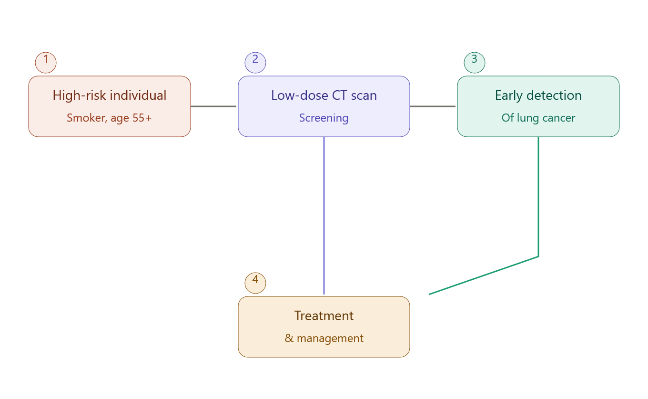
“As illustrated in Figure 1, early screening through CT scans enables timely detection and treatment, significantly improving survival outcomes (NHS England, 2024).”
The importance of these monitoring strategies is that they help to detect early, organize the resources, and make evidence-based policy decisions that can decrease mortality rates and enhance the health of the population.

2. Control of Lung Cancer
Prevention, early diagnosis, and effective treatment is a combination of measures that are necessary to control lung cancer. The prevention is mainly aimed at limiting exposure to risk (mostly smoking) and smoking is the number one cause of lung cancer. Smoking cessation programmes, taxation of tobacco, and awareness campaigns have also helped to reduce the level of smoking in the UK (Corby et al., 2024).
Another important area of disease control is early diagnosis. Early detection rates have been greatly enhanced through screening programmes e.g. NHS Targeted Lung Health Check. The patients who are diagnosed at an early age have a 20 times higher likelihood of surviving at least five years than those who are diagnosed later (NHS England, 2024). This shows the significance of early intervention in enhancing survival.
Some of the treatment options used in managing lung cancer are surgery, chemotherapy, radiotherapy, targeted therapy and immunotherapy. Recent progress in personalised medicine has been used to tailor treatments to specific patients as per genetic influences to increase effectiveness and minimise side effects (UK Lung Cancer Coalition, 2024). Nevertheless, along with these developments, the survival rates in the UK are still lower than in certain other developed nations, which is mostly attributable to the late diagnosis and disparities in access to healthcare (UK Lung Cancer Coalition, 2023).
Another important measure in controlling lung cancer is the public health policies. National cancer plans are intended to decrease the occurrence and enhance the survival by detecting it at an early stage and offering better treatment channels. Still, socioeconomic inequalities remain a challenge and people in poorer regions are more prone to lung cancer and have worse survival rates (University of Oxford, 2024).
On the whole, this has been achieved, but more efforts are still needed to enhance prevention, early detection, and equal access to care.

3. Consequences of Lung Cancer on the Community
The impacts of lung cancer are far reaching, impacting on individuals, families and the society at large. The disease has devastating physical manifestations, disability and mortality. In the UK, the survival rate is low in the long run, with about 11 percent of patients living more than a decade, illustrating the severity of the illness (Cancer Research UK, 2024)
Figure 2: Comparison of lung cancer deaths with other cancer deaths in the UK (Cancer Research UK, 2024)
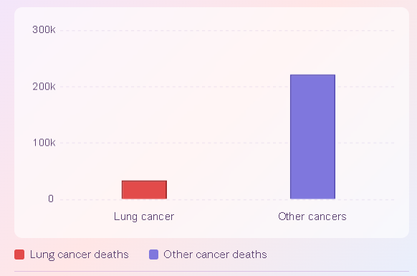
“As shown in Figure 2, lung cancer contributes a substantial proportion of cancer-related deaths in the UK, demonstrating its severe impact on population health (Cancer Research UK, 2024).”
Lung cancer can affect mental health in a considerable way psychologically. The life-threatening nature of the disease usually causes patients to develop anxiety, depression, and emotional distress. Family and caregivers are also involved and they too turn stressed and burdened when giving support.
Lung cancer can lead to isolation and poor quality of life, socially. A lot of patients cannot work or engage in social activities anymore and this can result in a loss of independence and dependence on family members or healthcare provision. Lung cancer has a heavy economic cost to healthcare systems and the economy in general. Diagnosis, treatment and long-term care are expensive, and the loss of productivity caused by illness or early death also affect the society (Alcaraz et al., 2023).
Also, disparities in the lung cancer outcome point to deeper social problems. It has been revealed that people in deprived communities are more prone to lung cancer and are less likely to live, which is a manifestation of differences in healthcare access and risk exposure (University of Oxford, 2024).
These multidimensional impacts demonstrate that lung cancer is not only a medical issue but also a significant social and economic challenge.

4. Health and Social Care Support Services
Health and social care services are important in helping those who have lung cancer. The NHS in UK offers extensive care, such as diagnostic services, specialist care, and palliative care. The team comprised of doctors, nurses, and oncologists (among other healthcare professionals) collaborates to provide patient-centred care (NHS England, 2024).
Services that are community-based are also critical in the provision of support to patients who are not in a hospital. These are home care services, rehabilitation programmes and support groups that assist the individuals to cope with symptoms and quality of life. Palliative care should be integrated early so as to be able to manage the symptoms and offer emotional support especially to the patients with advanced disease.
Another critical element of care is mental health support. The psychological therapies and counselling services assist the patients and their families to overcome the emotional difficulties with the lung cancer. This holistic strategy treats the physical and mental needs and enhances the overall wellbeing.
The health care providers are also instrumental in carrying out practical interventions. These involve encouraging early screening, teaching patients about risk factors and lifestyle modification, including smoking cessation. High-risk population-based public health campaigns play a crucial role in the formation of awareness and the enhancement of the rates of early diagnoses (UK Lung Cancer Coalition, 2024).

Conclusion
To sum up, lung cancer is a significant concern of the population with both global and national consequences. Good measurement and monitoring systems are critical in terms of comprehending disease trends and interventions. Although the prevention measures, early detection, and the development of treatment procedures have contributed to the improvement of the situation, issues like late diagnosis and healthcare disparities remain.
The effects of lung cancer are not only physical, but also psychological, social and economic stability. This underscores the importance of effective health and social care services to assist affected persons and communities.
Further work on the public health policy, early detection programmes, and equal access to healthcare services is needed to decrease the burden of lung cancer. With these challenges, healthcare systems will be able to increase the survival rate and the quality of life of victims of this condition.

References
Alcaraz, A. et al. (2023) Lung Cancer in Argentina: A Modelling Study of Disease and Economic Burden. Available at: https://arxiv.org/abs/2310.06999
Cancer Research UK (2024) Lung cancer statistics. Available at: https://www.cancerresearchuk.org/health-professional/cancer-statistics/statistics-by-cancer-type/lung-cancer
Corby, G. et al. (2024) Incidence, prevalence, and survival of lung cancer in the UK. Available at: https://pubmed.ncbi.nlm.nih.gov/39430337/
HQIP (2025) National Lung Cancer Audit Report. Available at: https://www.hqip.org.uk/resource/nlca-2023/
NHS England (2024) Targeted Lung Health Check Programme. Available at: https://www.england.nhs.uk/2024/11/thousands-of-cancers-caught-early-through-nhs-lung-checks/
UK Lung Cancer Coalition (2024) Improving Lung Cancer Outcomes. Available at: https://www.uklcc.org.uk
UK Lung Cancer Coalition (2023) About Lung Cancer. Available at: https://www.uklcc.org.uk/about-lung-cancer
University of Oxford (2024) Lung cancer inequalities study. Available at: https://www.ox.ac.uk/news/2024-11-08-largest-ever-uk-study-reveals-stark-ethnic-and-social-inequalities-lung-cancer

