
HR Effectiveness Measurement-TATA CONSULTING SERVICES

Word count:4051

S.NO | STUDENT NAME | STUDENT ID
1 | SUHAIB VELLIYATH | 2215786
2 | ANNA MARIA JOSE | 2216778
3 | NABHAN PUZHAKKATIL | 2215386
4 | RIMPAL YADAV | 2132837

Table of Contents

1.Introduction 2
2.Aims and Objectives 2
3.Tata consulting services(tcs) 4
4.Policies and procedures of the organisation 5
5.HR Effectiveness and Measurement 6
6.Why Should HR Effectiveness Measure 6
7.Why It Is Important To Measure HR Effectiveness 7
8.The Indicators of HR Effectiveness 8
9.Characteristic of an effective HR professional. 9
10.HRM Issues Faced By Tata Consultancy Services 9
11.IHRM issues in Tata Consultancy Services 11
12.Critical Analysis Of The Issues (HRM & IHRM) 12
13.Theoretical Perspectives of HRM Effective Measurement with Fombrun Model of HRM 12
14.Theoretical Perspectives of IHRM Effective Measurement with Guest Model of IHRM 13
15.Conclusion 15
16.References 16

1.Introduction
In this presentation, we are going to see the definition of human resource management and the “International Human Resource Management” challenges of Tata Consultancy Services (TCS). Human resource management (HRM) plays a critical role in supporting and developing employees, creating a positive work environment, and ultimately enhancing the competitive advantage of an organization. The HR department is responsible for a wide range of functions, including recruitment, training, compensation, talent management, workplace safety, and compliance (Jabbar, 2021). This provides insight into the difficulties TCS faced when managing its staff, especially related to hiring and the availability of qualified local talent. These difficulties are looked at in the context of TCS's international operations, where the business works in numerous nations with distinct cultural, legal, and economic situations. The work also highlights TCS's approach to international human resource management (IHRM) and how it deals with the difficulties of managing a multicultural and international workforce (TCS., 2021). This project report intends to offer insights into TCS's HRM practices and how it handles the difficulties associated with finding and hiring qualified local personnel. The research also emphasises the significance of IHRM in the current globalised economy and how businesses can successfully navigate the difficulties of managing a multinational workforce.

2.Aims and Objectives
This presentation aims to identify and analyse the staffing-related human resource management (HRM) and international human resource management (IHRM) challenges faced by Tata Consultancy Services (TCS), which is a leading Indian multinational company operating in various countries across the world (Salaria and Uppal, 2020). The difficulties in HRM connected to staff and recruitment are one of the main areas of focus. With consideration for the cultural, legal, and economic settings of these regions, the presentation will focus on how TCS is able to recruit, keep, and build a qualified workforce in various nations. The difficulties associated with finding qualified local personnel and the talent shortage in the global labour market will also be explored (Rao, S., & Rao, 2018). The presentation will also look at TCS's strategy for IHRM, which entails managing a multicultural and international workforce in accordance with a shared set of core principles. There will be a discussion of the difficulties in managing a global workforce, including cross-cultural communication and coordination, as well as methods for overcoming these difficulties.
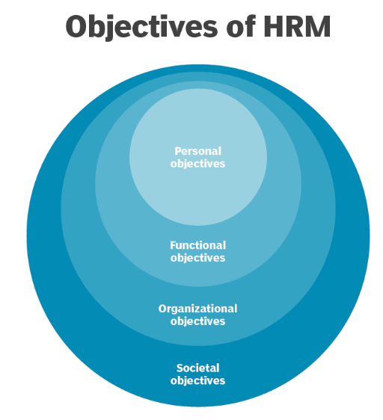
Figure 1, source: (Chai and Sutner, 2023)
The main objectives of TCS HRM are.
- Identify the recruitment and skill-development process of Tata Consultancy Services: This project report aims to provide an overview of the recruitment and skill-development process of TCS. It will examine how TCS attracts and selects candidates, and how it develops the skills of its employees to enhance their performance (Tata Consulting Services, 2021).
- Identify the recruitment and skill-development process of Tata Consultancy Services: This project report aims to provide an overview of the recruitment and skill-development process of TCS. It will examine how TCS attracts and selects candidates, and how it develops the skills of its employees to enhance their performance (Singh, P., & Singh, 2020).
- Identify the recruitment and skill-development process of Tata Consultancy Services: This project report aims to provide an overview of the recruitment and skill-development process of TCS (Hussain, A., & Usman, 2021). It will examine how TCS attracts and selects candidates, and how it develops the skills of its employees to enhance their performance.
- Identify the recruitment and skill-development process of Tata Consultancy Services: This project report aims to provide an overview of the recruitment and skill-development process of TCS (Yaseen, M., & Hussain, 2021). It will examine how TCS attracts and selects candidates, and how it develops the skills of its employees to enhance their performance.

3.TATA CONSULTING SERVICES(TCS)
Tata Consultancy Services (TCS) is a leading Indian multinational company that provides a range of IT and consultancy services to clients globally. Headquartered in Mumbai, India, TCS operates in more than 150 locations across 46 countries, with a workforce of over 60,000 employees as of 2022 (Tcs.com., 2023). The company's core services include IT consulting, business solutions, and digital ecosystems, with a focus on delivering innovative solutions to its clients.
Since its founding in 1968, TCS has been a leader in the Indian IT sector. Tata Sons, one of the biggest commercial conglomerates in India, formed the corporation, which has developed quickly to rank among the biggest providers of IT services globally. The success of TCS can be ascribed to its emphasis on innovation, client-centred strategy, and dedication to quality. The company has consistently delivered strong financial performance, with revenues of approximately 26 billion dollars in the year 2022. TCS achieved impressive annual sales of 1.91 trillion rupees in the year 2022, which is the highest in the last seven years (Statista, 2022). The company has also been recognized for its sustainability practices and has been included in the Dow Jones Sustainability World Index for the sixth consecutive year in 2022 (Tcs.com., 2023).

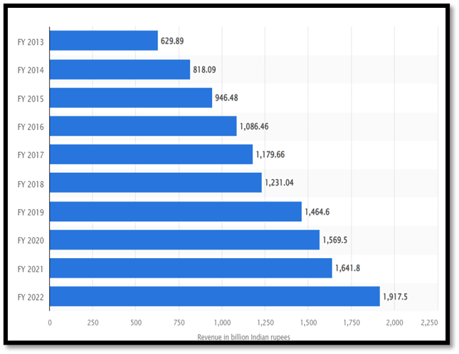
Figure 2, source: (Statista, 2022)
TCS competes with competitive international IT services firms like Accenture, Cognizant Technology Solutions, Infosys, and Wipro Limited in a market that is highly competitive. However, the company has managed to preserve its competitive edge because of its solid brand recognition, creative solutions, and focus on client happiness. To keep ahead of the curve and maintain its position as a leader in the industry, TCS has also made significant investments in research & development.

4.Policies and procedures of the organisation
TCS's HR department plays a crucial role in ensuring that the company has the human resources it needs to accomplish its goals. The HR department is in charge of creating rules and practices for hiring, training, and developing new personnel. It also emphasises creating a compensation plan to keep and inspire workers, and it makes use of technology to streamline HR procedures (Tien, C.-C., Chiu, Y.-C., & Liu, 2021). TCS has implemented a number of policies to guarantee adherence to rules and laws regarding the protection of employee data and unlawful discrimination. The company's dedication to upholding a moral and welcoming workplace is reflected in these rules (Tcs, 2023).
- Recruitment and hiring policies:
TCS has built a comprehensive hiring and recruitment process that involves conducting interviews, background checks, and skill assessments to determine which applicants are the most qualified for the position. The business also has a diversity and inclusion policy to guarantee that it doesn't discriminate against workers based on their colour, gender, religion, or sexual orientation and that it recruits people from a variety of backgrounds.
- Employee training and development policies:
Through different initiatives like in-person training, online learning, and career development possibilities for development inside the company, TCS prioritises the training and development of its employees.
- Data protection strategy:
TCS ensures the security of customer data through a strong data protection strategy, complying with GDPR and CCPA regulations, and having a data breach response plan data (TCS, 2021).
- Unlawful discrimination policies:
TCS has policies to prevent unlawful discrimination against its employees and job applicants. It prohibits discrimination on the basis of any protected characteristic and has a zero-tolerance policy for harassment (TCS, 2023).

5.HR Effectiveness and Measurement
Any successful organisation must have an effective HR department. In order to make sure that the company has the best talent on staff, it requires evaluating the effectiveness of the HR department's operations and decisions. Highly effective HR teams are essential to a company's success, and HR leaders are involved in guiding all corporate decisions. A strong human resources department makes certain that the business has qualified staff members who support its goals (Sher, M., Singh, R., & Shukla, 2021). It can be used as an illustration of how a well-designed and implemented onboarding strategy can assist a business in attracting top talent and skilled employees, thus improving the competitive advantages of the business. Additionally, an efficient HR department boosts output, which boosts the company's revenue. The effectiveness of the HR policies and processes, employee retention, engagement, and training and development programmes are all ways to evaluate the HR team's performance. To ensure that an organisation stays competitive and inventive, and accomplishes its goals, a highly effective HR team is crucial (Huselid, 1995).

6.Why Should HR Effectiveness Measure
HR metrics are used by companies to measure the effectiveness of their HR departments. These metrics help organizations evaluate the success of their HR strategies, processes, and initiatives, and make data-driven decisions to improve their HR practices.
- Effective HR measurement helps companies identify areas for improvement, track progress towards goals, and make informed decisions about HR investments. For instance, if a company has a high turnover rate, it can use HR metrics to determine the underlying causes and create plans to increase employee retention. Similarly to this, HR metrics can be used to assess the efficiency of the hiring process and pinpoint areas for development if a company's recruiting efforts are not yielding the expected results (Pandita, 2016).
- It helps companies in coordinating their HR operations with strategic goals. Companies can track HR metrics like employee engagement, productivity, and absenteeism to see how HR practices affect company results (Deloitte, 2017). Using this data, HR strategies that complement the broader aims and objectives of the company can be developed.
- Successful HR measurement keeps companies competitive. Companies can discover areas where they are falling behind their competitors and create plans to catch up by comparing their HR performance to industry benchmarks. In order to maintain a competitive advantage in the current business environment, it is essential for organisations to be able to attract and keep top people (Society for Human Resource Management, 2017).
Overall, effective HR measurement is essential for companies to optimize their HR practices and achieve business success. By measuring HR performance, companies can identify areas for improvement, align HR practices with business objectives, and stay competitive in today's rapidly changing business environment.

7.Why It Is Important To Measure HR Effectiveness
Measuring HR effectiveness is crucial for organizations to determine how well their HR function is performing and to improve their overall business performance. One of the key metrics that organizations use to measure HR effectiveness is the cost and quality of hire metrics. The cost of hire metric measures the cost incurred by the organization to recruit and hire new employees. The quality of hire metric measures the effectiveness of the recruitment process by evaluating the performance of new hires after they are onboarded (Tien, C. F., & Tien, 2021).
The cost of hire metric can be used to identify areas of improvement in the recruitment process, such as reducing recruitment costs or optimizing recruitment channels. The quality of hire metric can help organizations identify which recruitment channels are most effective in sourcing high-quality candidates and which recruitment sources are not effective. By using both cost and quality of hire metrics, organizations can evaluate the effectiveness of their recruitment process and make informed decisions about how to optimize it.
According to a study by LinkedIn, the cost of hire varies depending on the recruitment source, with employee referrals being the most cost-effective source of hire, followed by social media and job boards. The study also found that the quality of hire metric is strongly linked to employee retention and job performance (LinkedIn Talent Solutions., 2018). By measuring the quality of hire metric, organizations can identify the recruitment sources that provide the most productive and long-term hires.

8.The Indicators of HR Effectiveness
A company's HR department automates time-consuming administrative activities, enabling them to play increasingly crucial roles in the organisation.
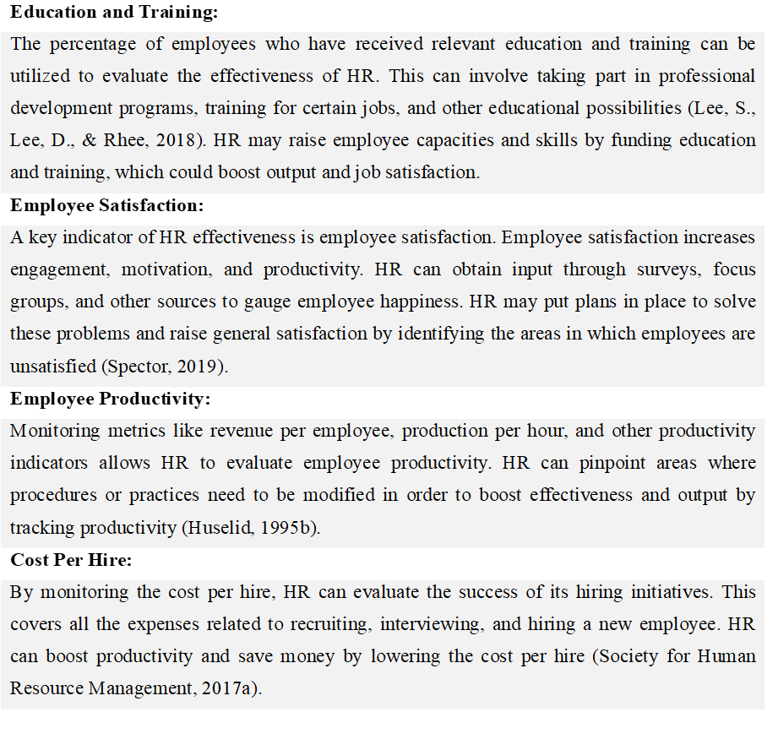

9.Characteristic of an effective HR professional.
An effective human resource professional possesses a combination of both technical and soft skills. Technical skills include knowledge of HR laws and regulations, data analysis, and HR technology systems. Soft skills include communication, leadership, empathy, and emotional intelligence (Bulla, D. N., & Scott, 1994). Effective HR professionals are also strategic thinkers, able to align HR initiatives with business objectives. They place a high priority on employee satisfaction, engagement, and development. They can deal with change and ambiguity because they are adaptive. Additionally, they uphold confidentiality in delicate HR concerns and are ethical. To stay relevant in the always-changing HR world, they also continually learn and grow as individuals. they are continuously learning and developing themselves to stay current in the ever-evolving HR landscape (Becker, B. E., & Huselid, 2006).
Some important skills for an effective HR professional are.
- Decision making
- Problem-solving
- Organised
- Multi-tasking
- Communication skill

10.HRM Issues Faced By Tata Consultancy Services
Tata Consultancy Services (TCS) is one of the largest global IT services and consulting companies. One of the significant HRM issues faced by TCS is the high attrition rate of its employees. Attrition refers to the rate at which employees leave the company voluntarily or involuntarily. TCS has been struggling with high attrition rates for the past few years, which has impacted its growth and profitability.
In the case of TCS, the high attrition rate of 19.7% in the first quarter of 2022-2023, which is a 23% increase from the previous quarter, is a cause for concern. This high rate of attrition can lead to increased costs due to the need to recruit and train new employees, as well as decreased productivity and revenue (businesstoday.in, 2023). high attrition rates can result in profit margin pressure and cost overloads. To address this issue, TCS and other IT companies in India may need to implement strategies to retain their employees, such as offering better compensation and benefits packages, providing opportunities for career growth and development, and improving the work-life balance of employees (Pallathadka et al., 2021), additionally, the global pandemic has further complicated the situation, as TCS and other companies are facing challenges in finding adequate resources and knowledge in the field of IT amidst the lockdown. To address these challenges, TCS and other companies may need to consider remote work options, investing in employee upskilling and reskilling programs, and leveraging technology to enhance communication and collaboration among employees (The Economic Times, 2020).
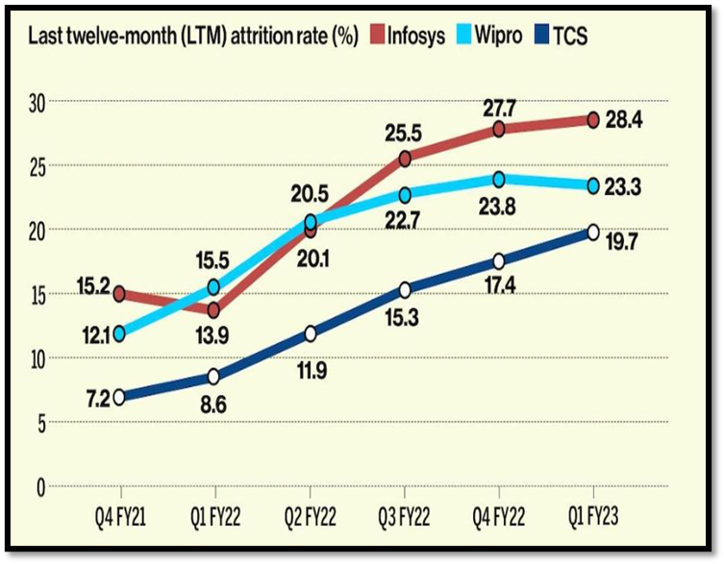
figure 3, source:(businesstoday.in, 2023)
The availability of skilled workers in the IT sector is essential to increase productivity since trained workers have the training and expertise to do their jobs well. However, the process of hiring staff and providing them with the training they need to develop these talents can be expensive. It is more difficult for huge organisations like TCS to locate people with the necessary skill set as a result of the rise of multiple start-up companies in India and the growing rivalry for talented workers.
Hindustan Times reports that as of 2022, TCS will be one of India's top IT firms, with a 35% female workforce. Women's empowerment is admirable, but recruitment shows that there is still a long way to go until gender equality is achieved (Hindustan Times., 2023). Finding qualified workers with the required abilities and tackling the gender gap are two challenges TCS must overcome. The business has taken action to close this gap by supporting diversity and inclusion initiatives, offering chances for women's training and development, and developing policies and programmes that accommodate the needs of working mothers (TCS, 2022).

11.IHRM issues in Tata Consultancy Services
One of the top providers of IT services globally, Tata Consultancy Services (TCS), has been accused of discriminatory hiring procedures in the US. During the hiring process, the corporation is alleged to have favoured South Asian and Indian applicants over non-South Asian and non-Indian applicants (Majumdar, 2023). Due to the preferential treatment given to Indian and South Asian applicants with visas, even when equally qualified US citizens are available, the lawsuit filed by the company highlights the challenges faced by the company in areas such as hiring, staffing, promotion decisions, termination, and benching. This demonstrates the discriminatory hiring practices used by TCS. The company's reputation and efforts to promote diversity and inclusion are both negatively impacted by this issue, in addition to harming the prospects of qualified US citizens. Legal repercussions and harm to the company's brand reputation may result from such discriminatory practices, which could have a negative effect on its business operations. TCS, in collaboration with the "Business in the Community (BITC) Race Equality Campaign," has announced a full-time commitment to ethnic minority communities in order to address this issue. The company's commitment to fostering international HR practices that support equal opportunities for all qualified applicants, regardless of their nationality or ethnic background, is reflected in this initiative (Tcs.com, 2021).
One of the primary challenges that TCS is currently facing is addressing the preference of the GenZ population towards remote work. According to Lo (2023), 83% of the GenZ population prefers to work from home, which has been found to increase productivity by 75% (H. Lo, 2023). This trend is not unique to TCS and is reflective of a global shift towards a remote work model. The statistics also show that 69% of women employees prefer to work from home, which presents an opportunity for TCS to address gender diversity issues in the workplace (Hughes, R., & Baldwin, 2021). However, it also poses a challenge for TCS to recruit skilled local labour who are willing to come to the office and travel to on-site locations. This could be attributed to several factors, including the preference for a better work-life balance and the high cost of living in certain areas. TCS needs to adapt its HRM practices to cater to the needs of its employees. The company can consider implementing flexible work arrangements, which would allow employees to work from home for a few days a week while coming to the office for the remaining days. TCS could also consider implementing virtual collaboration tools that would enable employees to work together remotely. These measures would help TCS attract skilled local labour while also catering to the needs of its employees.

12.Critical Analysis Of The Issues (HRM & IHRM)
Employee attrition is one of the HRM issues TCS is dealing with, and it is caused by the rising salary competition from the nation's proliferating IT firms (Verma, A., & Venkatesan, 2021). To ensure that its employees are competitive in the market, TCS must review its compensation plan in light of this. Additionally, TCS must concentrate on giving its employees adequate training and development opportunities in order to keep them with the business. The gender gap in the IT workforce is another HRM issue TCS is dealing with. Even though there is a focus on closing the gender gap, women tend to have lower levels of education and specialise in IT nationally, which furthers the availability and skill gap for women (Saini, N., & Mahapatra, 2019). To attract and keep female employees while ensuring they have equal opportunities for professional advancement, TCS must take proactive measures.
In terms of IHRM, TCS faces challenges in international recruitment selection, with legal cases filed stating that local people are not being hired, whereas Indian and South Asian candidates gain preference (Business Today, 2022). This highlights the need for TCS to ensure that its recruitment and selection processes are unbiased and based on merit rather than ethnicity or nationality. Moreover, TCS needs to focus on building a diverse workforce that reflects the local communities it operates in. TCS also faces challenges in recruiting talent that is willing to work in onshore locations due to the preference of GenZ over productivity (L. Lo, 2023). This requires TCS to revisit its work policies and provide flexible work arrangements to attract talent that values work-life balance.

13.Theoretical Perspectives of HRM Effective Measurement with Fombrun Model of HRM
Businesses must implement specific Key Performance Indicators that enable an understanding of the efficacy of the adopted strategies in order to improve the robustness of HRM measures from the perspective of employee recruitment and availability. The Fombrun Model of HRM is a theoretical perspective that focuses on aligning HR practices with organizational goals to create a competitive advantage (Fombrun, C., Tichy, N. M., & Devanna, 1984). One of the key aspects of the model is measuring the effectiveness of HR practices through various metrics.
- Employee Net Promoter Score (eNPS): which measures the probability that workers will endorse the company as a place to work. This metric is significant because it shows the level of engagement and satisfaction among employees, both of which are essential for an organisation's success (Branham, 2005).
- New hire performance: which measures how well the company's hiring and selection procedures are working. This metric evaluates new hires' performance during the first few months of employment and aids in pinpointing areas where the recruitment and selection process can be strengthened (Breaugh, 2008).
- Quality of hire: This evaluates the hiring process's overall effectiveness. This metric assesses new hires' performance over a longer period of time and aids in evaluating the effectiveness of the company's recruitment efforts (Collins, 2018).
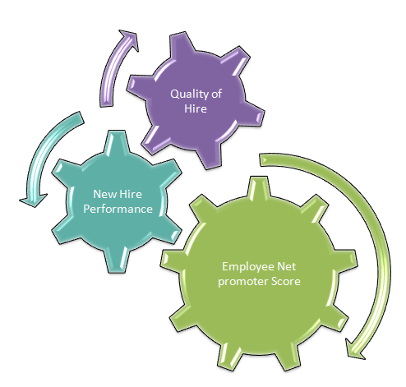
Figure 4, source: self-prepared

14.Theoretical Perspectives of IHRM Effective Measurement with Guest Model of IHRM
The Guest Model of IHRM is a theoretical framework developed by David Guest in 1997 to understand the relationship between HRM practices, HR outcomes, and organizational performance. The model emphasizes the importance of a strategic and integrated approach to managing human resources in global organizations.
HRM strategies consist of four main elements.
- HRM practices: An organisation uses various strategies to efficiently manage its human resources. Recruitment and selection, training and development, performance management, and compensation and benefits are some of these procedures. The Guest Model emphasises how crucial it is to match HRM practises with organisational strategic goals in order to improve HR outcomes (Purcell, J., Kinnie, N., Hutchinson, S., Rayton, B., & Swart, 2003).
- HR Outcomes: it cites the influence of HRM procedures on staff members' attitudes and actions. These results include the growth of human capital within the organisation as well as employee satisfaction, commitment, and engagement. The Guest Model emphasises the significance of tracking these results because they serve as important gauges of how well HRM procedures are working (Guest, 2017).
- Behavioural Outcomes: It is the impact of HRM practices on employee behaviour, including job performance, absenteeism, and turnover. The Guest Model suggests that HRM practices should be designed to enhance employee motivation and engagement, which can lead to improved behavioural outcomes (Guest, 1997).
- Financial Outcomes: HRM practices on the overall performance and financial results of the organization. The Guest Model suggests that effective HRM practices can lead to improved performance outcomes, such as increased productivity, quality, and innovation (Budhwar, P. S., & Debrah, 2013). Additionally, effective HRM practices can lead to improved financial outcomes, such as increased profitability, revenue growth, and return on investment.

15.Conclusion
With an effective HR strategy that takes into account the needs of the organization, TCS has established itself as a top IT company in India. TCS has put in place an efficient HR policy that takes into account the need for hiring professionals within the organisation. In any organization, the qualities of the HR team play a significant role in how effective HR policies are. Even after putting in place a number of measures, TCS still has trouble finding enough workers, particularly to close the gender gap and reduce the attrition rate. The challenges faced by IHRM include discrimination in the hiring process abroad and finding workers willing to relocate abroad.
TCS's effective HR policy has played a crucial role in the success of the organization. The recruitment of professionals based on their skills and expertise has enabled TCS to provide innovative and effective solutions to its clients. However, finding the right talent is an ongoing challenge for TCS, especially in reducing the gender gap and attrition rate. TCS needs to focus on diversity and inclusion in its recruitment process to address these challenges. In any organization, the qualities of the HR team determine how effective the HR policies are. The HR team should be equipped with the necessary knowledge and abilities to create and implement efficient policies that support the strategic objectives of the company. TCS can invest in training its HR team to make sure they have the necessary expertise to handle the challenges the company faces.
TCS should continue to focus on its HR policies to attract and retain top talent. Additionally, TCS needs to address the challenges faced in finding the right talent and improving diversity and inclusion in its recruitment process. By doing so, TCS can further strengthen its position as one of the leading IT firms in India

16.References
Becker, B. E., & Huselid, M.A. (2006) ‘Strategic Human Resources Management: Where do we go from here?’, Journal of Management, 32(6), pp. 898–925.
Branham, L. (2005) ‘Keeping the people who keep you in business: 24 ways to hang on to your most valuable talent’, New York: American Management Association. [Preprint].
Breaugh, J.A. (2008) ‘Employee recruitment, selection, and assessment: Contemporary issues for theory and practice.’, Psychology Press. [Preprint].
Budhwar, P. S., & Debrah, Y.A. (2013) ‘human resource management in developing countries’, Routledge [Preprint].
Bulla, D. N., & Scott, P.M. (1994) ‘Managing human resources for competitive advantage: A review and research agenda.’, The International Journal of Human Resource Management, 5(3), pp. 687–720. Available at: https://doi.org/10.1080/09585199400000063.
Business Today (2022) ‘TCS faces a lawsuit by an ex-US employee for “favouring Indians, South Asians”: Report’, Business Today [Preprint]. Available at: businesstoday.in/latest/corporate/story/tcs-faces-a-lawsuit-by-an-ex-us-employee-for-favouring-indians-south-asians-report-356073-2022-12-12.
businesstoday.in (2023) ‘Why Infosys , TCS , Wipro , and other Indian IT giants are facing record-high attrition rates’, pp. 1–4.
Chai, W. and Sutner, S. (2023) ‘human resource management (HRM)’, pp. 1–8.
Collins, B. (2018) ‘Measuring the Quality of Hire’. Available at: https://www.hrexchangenetwork.com/hr-talent-management/articles/measuring-the-quality-of-hire-0.
Deloitte (2017) ‘Global Human Capital Trends 2017’. Available at: https://www2.deloitte.com/global/en/pages/human-capital/articles/introduction-human-capital-trends.html.
Fombrun, C., Tichy, N. M., & Devanna, M.A. (1984) ‘Strategic human resource management’, John Wiley & Sons. [Preprint].
Guest, D.E. (1997) ‘Human resource management and performance: a review and research agenda’, International journal of human resource management, 8(3), pp. 263–276.
Guest, D.E. (2017) ‘Human resource management and performance: still searching for some answers’, Human Resource Management Journal, 27(1), pp. 1–15.
Hindustan Times. (2023) ‘TCS is the Only IT Firm with a 35% Women Workforce.’
Hughes, R., & Baldwin, M. (2021) ‘Precarious and flexible work in the platform economy: A gendered analysis’, European Journal of Industrial Relations, 27(1), pp. 49–64.
Huselid, M.A. (1995) ‘The impact of human resource management practices on turnover, productivity, and corporate financial performance’, Academy of management journal, 38(3), pp. 635-672.
Hussain, A., & Usman, M. (2021) ‘A Review of Recruitment and Selection Process in Tata Consultancy Services’, International Journal of Social Sciences and Management Research, 2(2), pp. 12–19.
LinkedIn Talent Solutions. (2018) ‘Global recruiting trends 2018’. Available at: https://business.linkedin.com/content/dam/business/talent-solutions/global/en_us/c/pdfs/Global-Recruiting-Trends-2018_EN-US.pdf.
Lo, H. (2023) ‘Candidates’ modification of global perspectives via international student teaching: A case study’, Cogent Education, 10(1), p. 2184028. Available at: https://doi.org/10.1080/2331186X.2023.2184028.
Lo, L. (2023) ‘TCS faces challenge recruiting talent willing to work onshore’, HR Dive. [Preprint].
Majumdar, R. (2023) ‘US lawsuit accuses TCS of favouring Indian and South Asian candidates’, pp. 1–10.
Pallathadka, H. et al. (2021) ‘Attrition in software companies: Reason and measures’, Materials Today: Proceedings, 51. Available at: https://doi.org/10.1016/j.matpr.2021.05.596.
Pandita, D. (2016) A Study on Measuring the Effectiveness of Human Resources in Organizations. Available at: https://doi.org/10.13140/RG.2.2.36586.62406.
Purcell, J., Kinnie, N., Hutchinson, S., Rayton, B., & Swart, J. (2003) ‘Understanding the people and performance link: Unlocking the black box’, London: Chartered Institute of Personnel and Development. [Preprint].
Rao, S., & Rao, T. (2018) ‘Staffing-related human resource management challenges and opportunities for Indian multinational companies’, Global Journal of Flexible Systems Management, 19(2), pp. 159–167.
Saini, N., & Mahapatra, S.S. (2019) ‘Women in Indian IT sector: Challenges and opportunities’, Journal of Management and Change, 36(2), pp. 117–127.
Salaria, B. and Uppal, S. (2020) Tata Consultancy Services Ltd. Company Analysis. Available at: https://doi.org/10.13140/RG.2.2.18230.93767.
Sher, M., Singh, R., & Shukla, A. (2021) ‘The role of HR in shaping strategic decision making.’, Journal of Human Resources Management and Labor Studies, 9(1), pp. 1-12.
Singh, P., & Singh, S. (2020) ‘Skill Development Initiatives for Employees and Its Impact on Organisational Performance: A Study of Tata Consultancy Services’, International Journal of Knowledge Management and Practices, 8(4), pp. 67–75.
Society for Human Resource Management (2017) ‘The use of HR metrics: Considerations for talent management.’
Statista (2022) ‘Tata Consultancy Services - annual revenue 2014-2022’. Available at: https://www.statista.com/statistics/491356/tata-consultancy-services-annual-revenue/.
Tata Consulting Services (2021) ‘Recruitment’. Available at: https://www.tcs.com/careers/recruitment.
Tcs.com. (2023) ‘Tata Consultancy Services - Consulting, Business Solutions, Digital Ecosystems’. Available at: https://www.tcs.com/about-us.
Tcs.com (2021) ‘tcs joins call to take action on racism in the work place by endorsing bitc ’s race at work charter’, pp. 1–8.
Tcs (2023) ‘HR Services’. Available at: https://www.tcs.com/hr-services.
TCS (2021) ‘Data Privacy and Protection’. Available at: https://www.tcs.com/about-us/data-privacy-protection.
TCS (2022) ‘Diversity and Inclusion’. Available at: https://www.tcs.com/diversity-and-inclusion.
TCS (2023) ‘“Diversity & Inclusion Policy.”’ Available at: https://www.tcs.com/diversity-and-inclusion-policy.
The Economic Times (2020) ‘TCS hiring plans may see impact as COVID-19 hits business’.
Tien, C.-C., Chiu, Y.-C., & Liu, C.-L. (2021) ‘The impacts of human resource management practices on employee performance in Taiwan’s high-tech industries’, Journal of Business Research, 134, pp. 42–50.
Tien, C. F., & Tien, C.L. (2021) ‘Analyzing recruitment performance using HR metrics: A data mining approach.’, Human Resource Management Review, 31(1). Available at: https://doi.org/100707.
Verma, A., & Venkatesan, V. (2021) ‘Impact of mushrooming IT firms on the employee attrition rate of TCS in India’, Journal of Management Development, 40(7), pp. 614–630.
Yaseen, M., & Hussain, A. (2021) ‘Challenges of HRM Practices in Multinational Corporations: A Study of Tata Consultancy Services’, Journal of Business and Management, 23(1), pp. 1–14.




