University of Wales Trinity Saint David

Effective team working
BMSW 4002
Individual Report

By

Zita Melinda Racz
2011317

Lecturer: Timothy Hopkins

27.08.2021

Table of Contents
Section 1: Introduction 3
Section 2; Models of communication 3
2.1 Shannon and Weaver (1948) 3
2.2. Schramm (1954) 4
2.3 Berlo SMCR model (1960-1964) 4
Section 3; Communication skills 6
3.1 Verbal- both oral (spoken) and written, choice of words, tone, pitch [para-verbal] 6
3.2 Non-verbal -body language, posture, gesture, tone, signals 6
3.3 Listening- active listening- empathetic listening 7
Tools and approaches to support and link skills 7
Conclusion 8

Effective team working

Section 1: Introduction
Communication is the mutual exchange of messages from the sender to the receiver. Communication in an organization means a continuous stream of information between two or more individuals for example management to employees then employees to customers. Feedback is one of the most essential parts of communication in organizations and must follow a system of communicating with the next individual. The main importance of communication in the workplace it helps managers and employees to actually perform their responsibilities and jobs. That means the communication is the beginning for planning with their staff on how to achieve their goals. Communication also encourages motivation by explaining and informing employees on the tasks that need to be done and how long they will take (Doyle, 2018, p.2018).
On the other hand, they are effects of poor communication between employees and can cause conflict in the organization. Conflicts will not only exist in the workplace but can extend to customers and ends up damaging the image of the company. Tensions will arise among work relationships and can lead to poor organization results and low self-esteem in the workplace (Doyle, 2018, p.2018). Examples of conflicts in the workplace include between workers and management, co-worker conflicts and employee to customer. This report will show how communication issues affect businesses/ organizations in general and use a case study to relate it to my workplace situation.

Section 2; Models of communication

2.1 Shannon and Weaver (1948)
In, this model of communication, follows an easy system of communication where the sender sends a message through encoding then it is decoded at the end of the receiver. Although noise is a barrier in communication that could change the meaning of the message. The model deals with concepts for example sender, transmitter, noise, transmission channel, receiver, information destination, encoding and decoding. For example, in the case study most of Anonymous job relies on verbal and visual communication when using telephones, conferences, meetings via video calls face to face. The problem arises when Anonymous has issues with service providers, with bed signals, downtime that are important, but they do again until message is clear. According to the Shannon- Weaver model of communication, messages between Anonymous and the clients are one-sided due to bed signals which affects the result of messages.
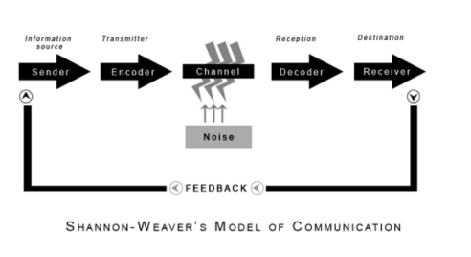

2.2. Schramm (1954)
In this model, the information does not have a meaning unless it is put in a form that can be understood by other individuals. Therefore, encoding is the main role in this model of communication because it undertakes communication by changing it in the right content. It will be up to the receiver of the message to interpret and understand what it wants to communicate. In the Schramm model decoding and encoding are the most important aspects that ensure effective communication between two people. Schramm also highlighted that communication is not complete until the sender of the messages can get a response from the person who received the message. In case an individual shared his thoughts with a colleague in the workplace and he/she did not respond shows that the communication was not complete. In this model, communication is a two-way procedure between two parties the first and second parties (Wahyuni, Masih & Rejeki, 2018, p. 012111).
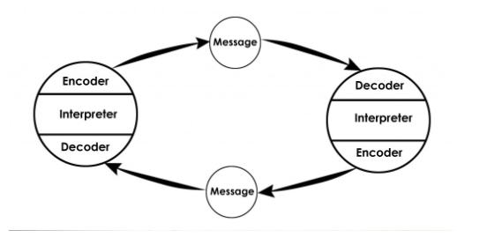

For example, according to the case study Anonymous does not receive any feedback from her colleagues because they use slangs in communicating. Anonymous has issues with her colleagues because it makes her work harder. Therefore, anonymous has to purposely get feedback from her colleagues to confirm the meaning of the original message.

2.3 Berlo SMCR model (1960-1964)
Berlo’s model of communication represents the simplest form of communication between individuals and is the same model as Shannon and Weaver model of communication. His model describes 3 main aspects of communication for example speaker, the message and the individual who receive the message. The one who receives the message decides how to explain or et the meaning of the message. Berlo argues that every communication process can be influenced by many factors according to the particular features. According to this model, in the case study Anonymous frequently asks for feedback from her colleagues to see how she can improve communication between them. This is a sign that the sender of the message must receive her/ his feedback.
First, the sender is the source of the message who creates and sends to the receiver. This is the start of the message/ communication procedure and is the person who codes the message. Factors that influence this mode of communication includes attitudes, communication skills, social systems, knowledge, and culture (Wahyuni, Masih & Rejeki, 2018, p. 012111).

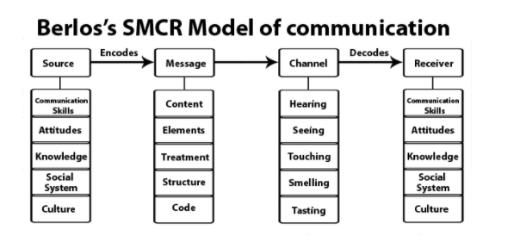
Secondly, the message is the actual package of meaning for the information sent to the receiver from the sender. For example, can be sent in many forms like speech, audio, texts and other media. In the case study, the message from Anonymous and clients was portrayed in audio form that is face to face interaction using video conference calls. So that the clients understand the nature of the message with sensible accuracy. Factors that influence a message include content, treatment, elements, structure and code (Wahyuni, Masih & Rejeki, 2018, p. 012111).
Thirdly, Channel is the method used to guide/ refer to the message. The medium should be able to pick sensory schemes of the receiver and may involve sound, vision, touch or taste, smell and so on. Channels of communication involve tools like the internet, phones, television and they are transmitting information via sound and visions. This is all involved with the human senses and how they react, feel, smell, taste and touch the message. (Crawford, 2016, pp.131-50).
Lastly, the receiver is the final individual to receive the message. Two factors can influence the quality of the message received that is noise and distortion or loss. Noise disrupts the message and the source from where the point is coming from. Internal noise is the state of the communication process in case the receiver is distracted or not feeling well. Sometimes distortion occurs when a receiver selectively chooses words of the messages being portrayed (McWhirter, 2016, pp.757-780).
The difference between the three models of communication is in the Linear model communication takes a straight-line approach leaving no space for immediate feedback. While the Schramm (1954) model of communication allows for the feedback component when the sender's message is received by the receiver and the receiver also give feedback to the sender. Berlo SMCR model (1960-1964) portrays that every communicator in the process can either be a receiver or sender of the message. Mainly because this model is more commonly used in analysing different cultural factors of how people will feel, taste or receive the message (McWhirter, 2016, pp.757-780).
On the other hand, the similarities that the models of communication have is they all have a systematic depiction of the procedure that will help to comprehend how communication works till the end. They also display a general perspective on how communication is broken down from simple form to complex form and keeps order in the components. To a bigger extent, they all encourage stereotyping and traditional thinking to ignore some aspects of errors in human communication. Furthermore, all these models of communication are used by businesses, organizations and companies to substitute the way they communicate, evaluate their circumstances and explore different options in the workplace. Lastly, all the are used accurately and precisely interpret the messages (Wang, Pauleen & Zhang, 2016, pp.4-14).

Section 3; Communication skills
These skills are needed by every individual and are an act to transfer information from one person to another. Skills are informed of verbal or vocal form, Non-verbal and body language (listening, active and empathetic listening).

3.1 Verbal- both oral (spoken) and written, choice of words, tone, pitch [para-verbal]
Verbal communication is transferring messages in form of words, tone, pitch and so on. Whereby, tone and pitch are levels of formality used to convey significant subtexts to the individual receiving the message. Tone changes according to the situation whether calm or stressful environment. For example, the tone portrayed by the manager during the meeting could have shown the level of seriousness of the message he intended to give the employees. Pitch is the ability for emotions to come to play when an individual is speaking. When one is upset, angry or frustrated is likely to convey to the listener a strong emotion which is not a good thing however sometimes individuals can control their emotions which cannot affect communication.
Written communication is significantly important because it helps individuals working in remote areas to work. Written communication can also be misjudged by the reader due to the choice of words used whether in an unpleasant way or know that a person had a bad day. For example, in the case study, anonymous uses mostly written communication like letters, emails and memos to interact with clients. Cnsidering the it is a London Corporation that carries out large projects anonymous finds written communication fast and cheap.

3.2 Non-verbal -body language, posture, gesture, tone, signals
Non-verbal communication mainly includes the physical aspects of a messenger like facial expressions, posture and so on. Posture refers to the way a person is seated or standing, the angle, or are they relaxed or seated in an open posture which shows the level of engagement. Crossing arms and leaning back on a seat portrays another type of message to both the listener and speaker. Gestures largely depend on the country of origin of both the sender and receiver of messages. A gentle touch between a manager and employees shows that symbol of encouragement while a strong handshake shows supremacy. Signals are the same as eye contact and are good to maintain direct eye contact and shows that someone is being attentive or truthful/ untruthful. It can show that interest too while connecting with the speaker conveying the message in another aspect in shows that you are a sincere and honest person (Pearson, et al, 2017, (p. 416). In the case study, Anonymous knows that she is an influential figure in therefore she maintains a professional demeanor throughout. Her professional demeanor can be able to reflect to her clients how serious she is while handling her job. Furthermore, anonymous is good at modifying her body language, changing her body posture, upholding focus and interest to ensure her clients are at ease or comfort to ask necessary questions.

3.3 Listening- active listening- empathetic listening
Listening is the ability to validate and express emotions as a way of maintenance and building relationships among employees. Listening has two types empathetic listening and active listening. Empathetic listening is the process of responding attentively to the contribution of others during conversations. It is a form of encouraging and supports to the other person instead of criticising them. Qualities of a good empathetic listener include compassion, wisdom, trustworthiness, do not judge, being patient, responsive and engage their presence to listen to others. For example, Anonymous is an empathetic listener who clearly understands her clients concerns and adapts her nature to accommodate them and make them feel she is puts herself in their shoes.
Active listening is the skill to focus fully on the speaker, comprehend their message and respond appropriately. Most times active listeners use non-verbal and verbal techniques to listen to the speaker for example in a case study Anonymous listens attentively during face to face interactions. Active listening is important in the workplace because it helps to build solids connections among colleagues where they will be contented sharing information. It also builds a sense of trust when an individual can speak without any judgements and interruptions they will be able to confide in those who listen actively. How one can become an active listener is by asking open-ended questions to gather more information on what is shared. Secondly, one can ask paraphrase to make sure that the message of the speaker has been fully understood and will be able to illuminate unclear information (Coffelt & Smith, 2020, pp.365-384.

Tools and approaches to support and link skills
Some tools and approaches can support and link the skills explained above to understand how communication can be effectively made in a business organization.
1. S.O.L.E.R is also another form of non-verbal communication representing sit squarely, open posture, lean toward eye contact and relax. It is used by businesses to educate and train employees to mind about their body language and can give a therapeutic space to employees in the workplace (Coffelt & Smith, 2020, pp.365-384.
2. Proxemics / Kinesics; these are classified as a form of non-verbal communication through using distance, space, touch and body posture in a business organization. To illustrate, space is used to distance employees in their workspaces which is common so that they can have their way to accomplish their tasks. Gestures and facial are used to regulate how individuals interpret situations in the workplace. In the case study, Anonymous maintains a professional demeanour (Coffelt & Smith, 2020, pp.365-384
3. Personal awareness – K.E.Y.S. Self-awareness is the ability to have a distinct understanding of your thoughts, personalities, behaviours and emotions, It permits the communicator and receiver of information to understand how you have affected the way they perceive and how you manage responses to make them feel important in the workplace. For example, Anonymous is aware about the level of influence she is at her workplace (Coffelt & Smith, 2020, pp.365-384).

Conclusion
Communication skills are important in every individual’s life and can be used to judge them in the type of culture or society, workplace or organization that they will work in. The model of communication can be used depending on how a sender tends to convey a message to their receivers.

References
Coffelt, T.A. and Smith, F.L., 2020. Exemplary and Unacceptable Workplace Communication Skills. Business and Professional Communication Quarterly, 83(4), pp.365-384.
Doyle, A., 2018. Communication skills for workplace success. Retrieved November, 19, p.2018.
Crawford, V.P., 2016. New directions for modelling strategic behaviour: Game-theoretic models of communication, coordination, and cooperation in economic relationships. Journal of Economic Perspectives, 30(4), pp.131-50.
McWhirter, G., 2016. Behavioural deception and formal models of communication. The British Journal for the Philosophy of Science, 67(3), pp.757-780.
Pearson, J.C., Nelson, P.E., Titsworth, S. and Harter, L., 2017. Human communication (p. 416). McGraw-Hill Education.
Wahyuni, L.M., Masih, I.K. and Rejeki, I.M., 2018. Communication skill attributes needed for vocational education enter the workplace. In Journal of Physics: Conference Series (Vol. 953, No. 1, p. 012111). IOP Publishing.
Wang, W.Y., Pauleen, D.J. and Zhang, T., 2016. How social media applications affect B2B communication and improve business performance in SMEs. Industrial Marketing Management, 54, pp.4-14.

