Pathway Project 1
Student name: Firon Miah
Student ID: 1605 305
Lecturer Name: Miguel Martins
Module Code: EMPL4013

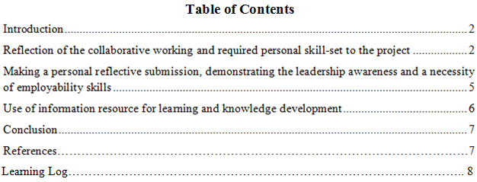

Introduction
When doing any group work, there are many considerations to be addressed to ensure the group work can be done efficiently. These are efficient time management and interpersonal communication. A wide range of theories explains how to manage time and use it effectively. There is also some theory to explain how to communicate with the group members to make all the group members to participate.
Time management
Time management is the process of evaluating, planning and exercising tasks to control the time that is spent on specific activities to increase efficiency and productivity (Julie, 2004). It ensures a greater output from a given input in less time. It provides a person with a choice that it can manage the activities with their own time and expectation.
80/20-time management theory specifies that 80% of job or output is done in 20% of time and effort (Larson and Gray, 2013). Now, it is a question that how to manage such 20% of the time to achieve the greater 80% of the job. In doing so several tasks should be taken, for example, frequently evaluating tasks, assessing the goals continually, determining the prime time that will be used to do the job, and identifying and eliminating the destructions.
During the preparation of the presentation under the topic, we started slowly at the beginning of the time considering that we have much amount of time in our hand. Then, we slowly started collecting our information that we needed for our presentation. We boosted our work when our final date of submission was near. So, it can be said that our 80% of work is done at the 20% of the time before final submission.
The pickle jar theory is one of the most important time management theory which specifies that a person first determines which tasks are useful and which tasks are not useful (Meredith and Mantel 2011). By doing so it will be easy to set up the daily priorities that should be performed and plan different tasks in such a way that the tasks are completed within the time
We know that the area we selected for our presentation is a wide and vast area and there is a wide range of information in this area. But we cannot cover all these things as we have limited time. So first we have to identify which is the most relevant areas for our presentation topic and we have access to this information. After that, we selected which topics should be presented first to make the presentation more appealing. After selecting and organizing the topics, then we divided the topics among the group members and then collected the information. Then, we prepared our presentation.
POSEC method is another time management method that stands for prioritizing, organizing, streamlining, economizing, and contributing. The first phase of this method prioritises the tasks that are relevant for accomplishing goals. It can be organized on the basis of task importance. On the basis of task, priority time should be allocated. In the second phase of this method, the task is organizing and coordinating the group member’s tasks efficiently. The main task in this phase is to structure the group member’s goals and tasks. In the third phase of streamlining, the work tasks that take much time and member’s effort should be automated and can be performed collectively. Economizing is doing the tasks in such a way that will skip some tasks that is not needed urgently. The contributing phase outlines that it should be given the attention the tasks that will make a difference which can be observed in the longer period of time but not immediately.
For the preparation of our presentation, firstly we make the list of tasks that should be completed. Then we divided our organized tasks to the group members. We have collectively done the work that needs our collective effort and then have completed all the tasks for coordinating the groups, dividing tasks, collecting information and others that will affect our presentation preparation.
Interpersonal communication
The system theory is mainly based on the interdependence that originated from the interaction among group members and shares common types of problems (Beebe et al., 2000). So this approach outlines a way to understand how the interpersonal and individual relationship with other influences the group as a whole (Trenholm and Jensen, 2013)). That is the mutual influence among group members. It puts an attention of achieving the goal from group participation. For this reason, the approach focuses on the interpersonal communication as an important mechanism in the group performance rather than specific principles.
During our presentation preparation, understood that it will not be done within the specified time if the work is not done collectively. So we discussed that mutual participation is the most important. To make individual participation more effectively we used online services, for example WhatsApp.
The politeness theory suggests that the interaction between different persons should be done through using politeness strategies so that a person’s own and others identity can be efficiently managed (David, 2001). There are three assumptions of politeness theory. Firstly, an individual is concerned in maintaining his or her own identity or face. Secondly, the theory assumes that people are goal oriented and rational in achieving goals. So, their goals are task oriented and directed to maintain his or her identity. Thirdly, though peoples’ tasks are goal oriented and maintaining his or her face or identity, these tasks threaten others’ identity or face.
During communication with the group members, we have taken all the decision collectively and we have taken the opinions of each of the members. We did not leave any scope for the members to dominate in the group discussion. As a result, each of the members is motivated to do their jobs.
Social exchange theory is usually used how to maintain a relationship with others. It is a board approach how to develop and continue a personal relationship with others (Neil, 2006). The theory assumes that a person looks and maintain a relationship for benefits. During the engagement, the relationship ends when there will be not benefits received or cost is greater than benefit (Raymond, 2008). So the social exchange theory follows some assumptions. Firstly, a personal relationship is a function of cost and benefit and every person wants to maximize his or her benefits during the personal engagement. Secondly, people maximize benefits by lessening costs. Thirdly, during personal engagement people always thinks of himself first then others.
Our collaborative work maintains the interest of all the group members. As a result, all the group members participated in the greater extent that they will be benefited from the group participation.
Delegation
Delegation theory explains that managers provide some authority to its employees while performing specific tasks and the employees are accountable to the manager for their responsibilities (Armstrong, 2006). When the employees receive some authority to do something he always tries to use his or her potential to get maximum output because he thinks that he is accountable for doing so.
As I mentioned above that we first decided out tasks that would be covered. Then, we divided the group tasks equally to all the members on their preference. It was the responsibility of the group members to collect data from the authentic source and arrange it accordingly. So the topics that were presented by the group members were the responsibility of that member.
As we know that presently the participative leadership is used in the most organization in the tourism sectors because the opinions of the staffs are accounted here, it has some limitations that it slows down the decision making and has different security issues. When the leadership style is participative it takes too much time to take a decision as the staffs’ opinion is taken, assessed and then decisions are taken (Robbins et al., 2011). There is a security issue arises because the decision-making process in this approach includes may participants. If the information is lacked, there will be a problem in developing strategies.
Sustainability means conducting business activities and uses its profits for the sustainable development or at least the activities of the business do not harm environment and society as a whole (Mowforth and Munt, 2015). So the company should aware and organize its activities in such a way that it does not harmful to the environment and none of the stakeholders are affected.
A person has rights and responsibilities as a member of this world rather than as a citizen of a nation. This means that the person should not prefer only the interest of its own country, he also considers the interests of others which is called in boarder term as humanity. So, as a member of a global community such person or a company should consider the betterment of world after his or her own nation. So, a global citizen plays an active role in the community that he belongs to and works with others to make the world as a better place and sustainable.
Employment skills are needed for being fit for particular jobs. There is a wide range of employment skills needed in the jobs such as communication and interpersonal skills, problem-solving skills, organizational skills, team working, and negotiation skills (Herarsy et al, 2007).
In the preparation of the presentation, we found several advantages of the selected topics in the tourism sector. For example, Leadership ensures a group of people to work in a certain way. It is a process of motivating people. But if the leadership is in the wrong hand, the effort becomes aimless. The companies in the tourism industry such as Travelodge need appropriate leadership to improve its service quality. Because the employees need the motivation to work in a certain way and it comes from the top management. As a result, it will be easy for the management to take decisions if the company follows participative leadership. From the presentation, it can be also said that the companies in the tourism industry also put their effort on the sustainability. By doing this Travelodge can ensure legitimacy to the society. If the company does not adopt any activities regarding sustainability, their quality of work remains questionable. So, ensuring sustainable development will increase service quality for example if Travelodge uses recycled water for the bath, the customer thinks that their service is not harmful to the society. Participation in the different community activities or sponsoring different community development program will increase positive imprecision towards the community people. People will know that the company is doing good for the community in various aspects from the newspaper. By involving community participation, the company can ensure clean and healthy environment, increasing the reputation destination for ensuring a clean environment, and the industry will be sustainable for the long term. If the companies in the tourism sectors ensure good environment and adopt sustainability programs, the responsibility as a global citizenship will be ensured. Good sustainable development in the tourism sector will increase the employment generation and special skills will be developed that will provide the industry a competitive advantage over other industry as the industry is attracted by many people.

Conclusion
I have learned several good things regarding the above issues, there are some challenges we faced that are lack of understanding, limited access to the information and problem in organizing data. I have learned several things like entrepreneurship, leadership and ensuring sustainability as a global citizenship. So, to conduct group work efficiently time management and interpersonal communication should be focused on greater participation.

References
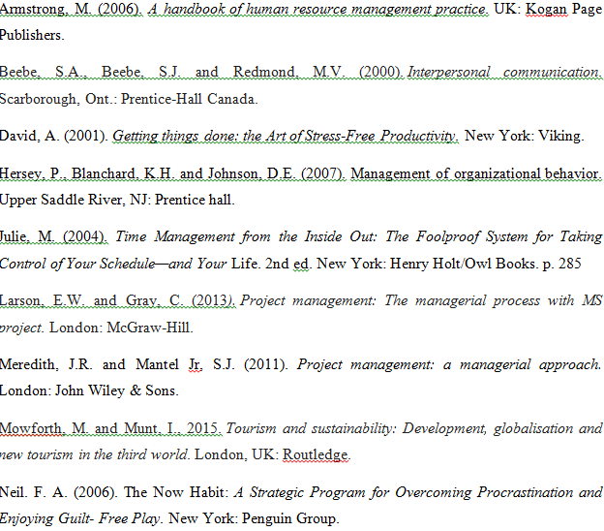

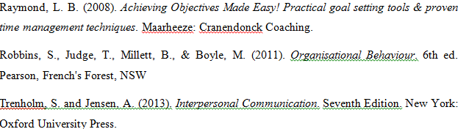

Learning Log
- How did you work together?
I collected data individually and cross checked each of the data so that the information is valid as much as possible. I and my team members analyze and research together so that all the relevant information can be included. Then, I prepare my presentation part.
- Who did what?
In the presentation all of the parts are divided equally. My part was introduction and meaning of global citizen in the sustainability of globalization.
- What went wrong?
I have lack of understanding as well as it was difficult to reach to gather appropriate information.
- What went well?
Despite several problems, I was able to finish our presentation and all of the group members are satisfied.
- Did you meet often enough?
Yes, I have participated all the group gathering that was organized for gathering data and preparation of presentation.
- Did you use Skype or other online meeting platform?
Yes, I used WhatsApp for communication with the group members for discussion.
- Did that work well?
Yes, those medium was effective and work well for maintaining distant communication among the group members.
- Did you have technical problems in meeting online?
No, I have no technical problems in meeting online.
- Did some group members refuse to meet online?
As all the members were very gentle and did not refuse to meet online.
- How did you overcome this?
No problem was in meeting online so no issue of overcoming.
- Did someone not pull their weight?
No. everybody was serious and participative in the group activities.
- Did you discuss this with them as a group?
No. Because there is no such issue to discuss.
- Did you resolve this problem satisfactorily?
There were no problems to be resolved.
- How did you divide the work between you?
First, we divided all of the topics equally and then, each of the members willingly chose their interested topics
- Was it fairly shared out?
Everyone had the opportunity to choose their topics. So it was fairly shared out.
- What have you learned by doing this?
I have learn how to participate, effectively personal communication and different decision making within group.
- Did you enjoy the process?
Yes, I enjoyed the process.
- Why did you enjoy it?
I enjoyed because I have learned may things such as participation, communication, decision making and doing tasks using own knowledge etc.
- Did you dislike the process?
No, I did not dislike the process.
- Why did you dislike it?
There was no issue to dislike the process.
- How could it have been improved?
Through collaborative effort and active participation in various process.

