
Geodemographic analysis using gis software
Level 5 Assessment

Geographical Information Systems
Module Code: ACCB5027
Student ID: 2311568
Nate Fox

Contents
Introduction 3
GIS & Thematic Mapping 4
Data & Methodology 5
Results & Analysis 6
Wales MSOA Base Map 6
Income Deprivation across Welsh MSOA 7
Educational Attainment across Welsh MSOAs 8
BMI across Welsh MSOAs 9
General Health Outcomes across Welsh MSOAs 10
Disability Rates across Welsh MSOAs 11
GP Surgery Locations across Wales 12
Suicide Rates across Welsh MSOAs 13
Income Deprivation and GP Surgery Locations across Wales 14
General Health Outcomes and GP Surgery Locations across Wales 15
Overall Analysis and Conclusion 17
References 18
Appendix 19

Introduction

This study uses Geographical Information Systems (GIS) to explore patterns of deprivation and health across Wales at the Middle Super Output Area (MSOA) level. By combining different types of data, including income, education, lifestyle behaviours, general health, disability rates, and GP surgery locations, the aim is to understand how these factors vary across different areas.
The main aim of this study is to investigate whether areas with lower income levels also experience poorer health outcomes, such as higher obesity rates, worse general health, and higher levels of disability. A second aim is to look at whether GP surgeries are in the areas where they are most needed. This helps to highlight any possible inequalities in both health outcomes and access to healthcare services.
Wales is used as the case study because there is a good availability of data at the MSOA level, which allows for more detailed analysis. GIS is used to create maps that show these patterns clearly, making it easier to compare different areas. Overall, this study aims to provide a better understanding of how deprivation and health are linked across Wales, and whether services are distributed fairly.

GIS & Thematic Mapping

Geographical Information Systems (GIS) are tools used to store, manage and analyse data that is linked to specific locations. They allow different types of information to be layered onto a map, making it easier to identify patterns and relationships [1] that may not be obvious when looking at data in tables alone. In this study, GIS is used to combine multiple datasets, such as income, education and health, to explore how these factors vary across different areas of Wales.
A key feature of GIS is the use of thematic maps. These maps are designed to show a particular theme or variable, such as income levels or health outcomes. In this study, choropleth maps [2] are used, where areas are shaded using different colours to represent values. For example, darker colours may represent higher levels of deprivation, while lighter colours represent lower levels. This makes it easier to quickly compare different regions and identify trends.
The use of GIS and thematic mapping is important because it allows complex data to be presented in a clear and visual way. Rather than interpreting large datasets, users can understand patterns through the map itself. This is particularly useful when analysing inequalities, as spatial patterns can highlight areas that may require further attention or resources. Overall, GIS acts as a powerful tool for turning data into meaningful insights that support decision-making.
The use of colour gradients helps the maps to be interpreted more easily. In several of the maps, red is used to show areas with higher levels of concern, such as deprivation, poor health or disability, while green or lighter colours show lower values. This makes the maps easier to understand because the reader can quickly identify areas that may require attention. Clear legends, titles and consistent map layouts also help to communicate the data effectively to both technical and non-technical audiences.

Data & Methodology

This study uses a range of publicly available datasets to explore patterns of deprivation and health across Wales. Most of the data was collected at Middle Super Output Area (MSOA) level, which allows for detailed comparison between different areas. The datasets used include income deprivation and educational attainment data from the Office for National Statistics (ONS) [3], as well as health-related data such as general health, disability, and suicide statistics. Information on GP surgery locations was also included to analyse the distribution of healthcare services.
However, not all the datasets were originally available at the same geographical level. In particular, the physical activity and BMI datasets were provided at a different statistical geography. To ensure consistency across the analysis, data processing techniques were applied to align these datasets to the MSOA level. This allowed all variables to be compared on the same spatial scale, improving the accuracy and reliability of the analysis.
The GIS software QGIS [4] was used to build and analyse the spatial data. Each dataset was imported as a separate layer and joined to the MSOA boundary layer using a common geographic identifier. Choropleth mapping techniques were used to visualise the data, with colour gradients representing different value ranges. In addition, point data was used to map GP surgery locations using latitude and longitude coordinates. These methods allowed for clear visual comparison between different variables and supported the identification of spatial patterns across Wales.
To support transparency and demonstrate the process undertaken, two types of visual outputs are included within this report. The figures presented within the main body of the report are taken from the final map layout exported from QGIS as PDF files, providing a clear and professional representation of the spatial analysis. In addition, supplementary screenshots showing the full QGIS interface during the development process are included with the appendix. These provide further evidence of the GIS workflow, including data loading, layer management, and map construction.

Results & Analysis

This section presents the results of the spatial analysis carried out using GIS. A series of thematic maps are used to explore patterns of deprivation, health outcomes, and the distribution of healthcare services across Wales. Each map focuses on a different variable, allowing comparisons to be made between areas and helping to identify any spatial relationships between income, education, lifestyle behaviours, and health.
The analysis begins with a base map of Wales at MSOA level, followed by a series of choropleth maps showing income deprivation, educational attainment, BMI, general health, and disability rates. A final map displays the locations of GP surgeries to assess whether healthcare services are distributed in areas of greatest need. Together, these maps provide a visual overview of how socio-economic factors and health outcomes are linked across Wales.

Wales MSOA Base Map

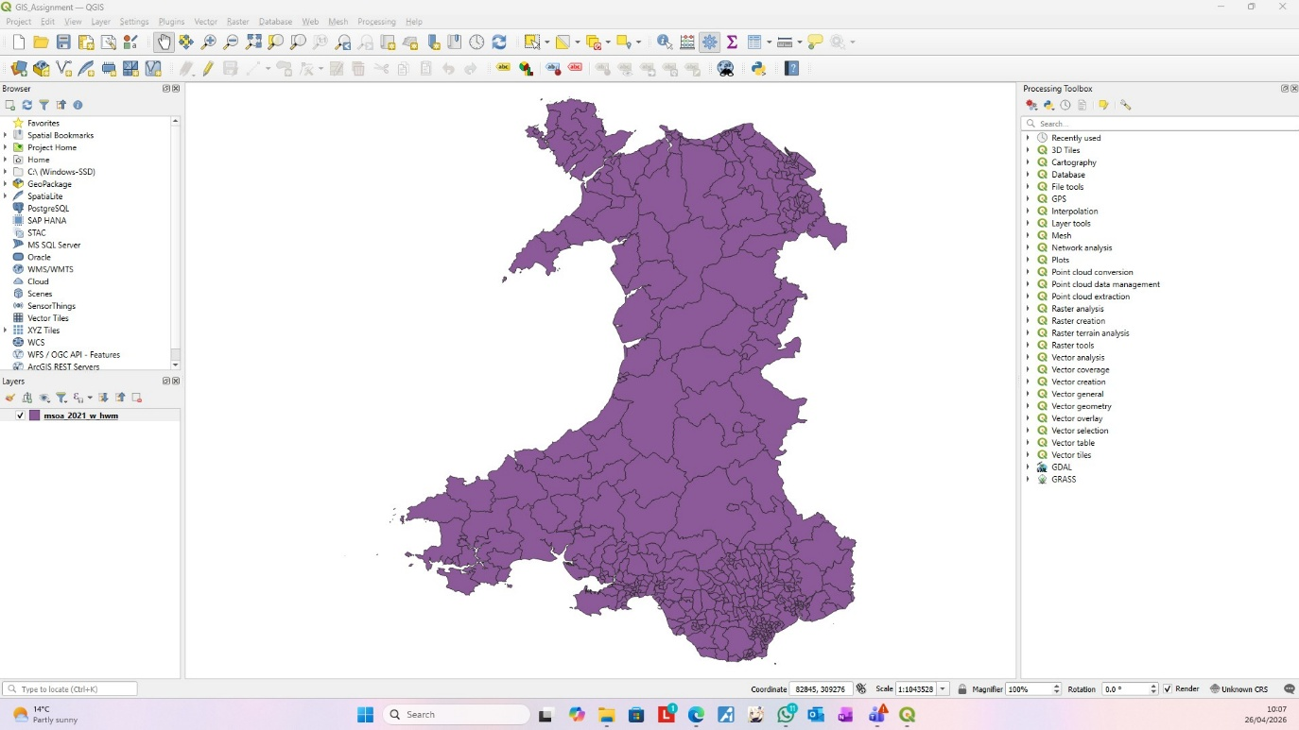
Figure 1 - Wales MSOA Base Map – GIS Workspace Screenshot
Figure 1 presents the base map of Wales divided into Middle Super Output Areas (MSOAs), which act as the main spatial units used throughout this study. These areas provide a consistent geographical framework that allows different datasets to be mapped and compared across Wales.
Although this map does not display any specific variables, it is important as it forms the foundation for all subsequent analysis. Each dataset used in the study is linked to these MSOA boundaries, ensuring that comparisons between income, education, health, and service provision are made on the same spatial scale. This helps to maintain consistency and allows patterns observed in later maps to be interpreted more reliably.

Income Deprivation across Welsh MSOA

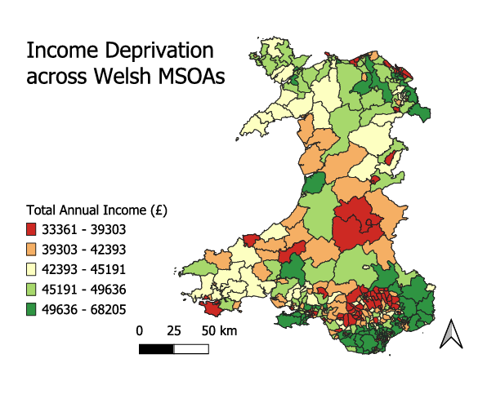
Figure 2 - Income Deprivation across Welsh MSOAs
Figure 2 illustrates the distribution of total annual household income across Welsh MSOAs. A clear spatial pattern is visible, with lower income areas (shown in red) concentrated mainly in South Wales, particularly within the South Wales Valleys. In contrast, higher income areas (shown in green) are more commonly found in parts of North Wales and along certain coastal regions.
This pattern highlights a noticeable geographical divide in income levels across Wales, with more deprived areas often clustered in historically industrial regions. These findings provide an important basis for further analysis, as they can be compared with subsequent maps to explore whether lower income levels are associated with poorer health outcomes and lifestyle factors.
The map presented in Figure 2 is taken from the final layout exported from QGIS, while a full screenshot of the GIS workspace used to produce this map is provided in the appendix for reference (see Appendix A).

Educational Attainment across Welsh MSOAs

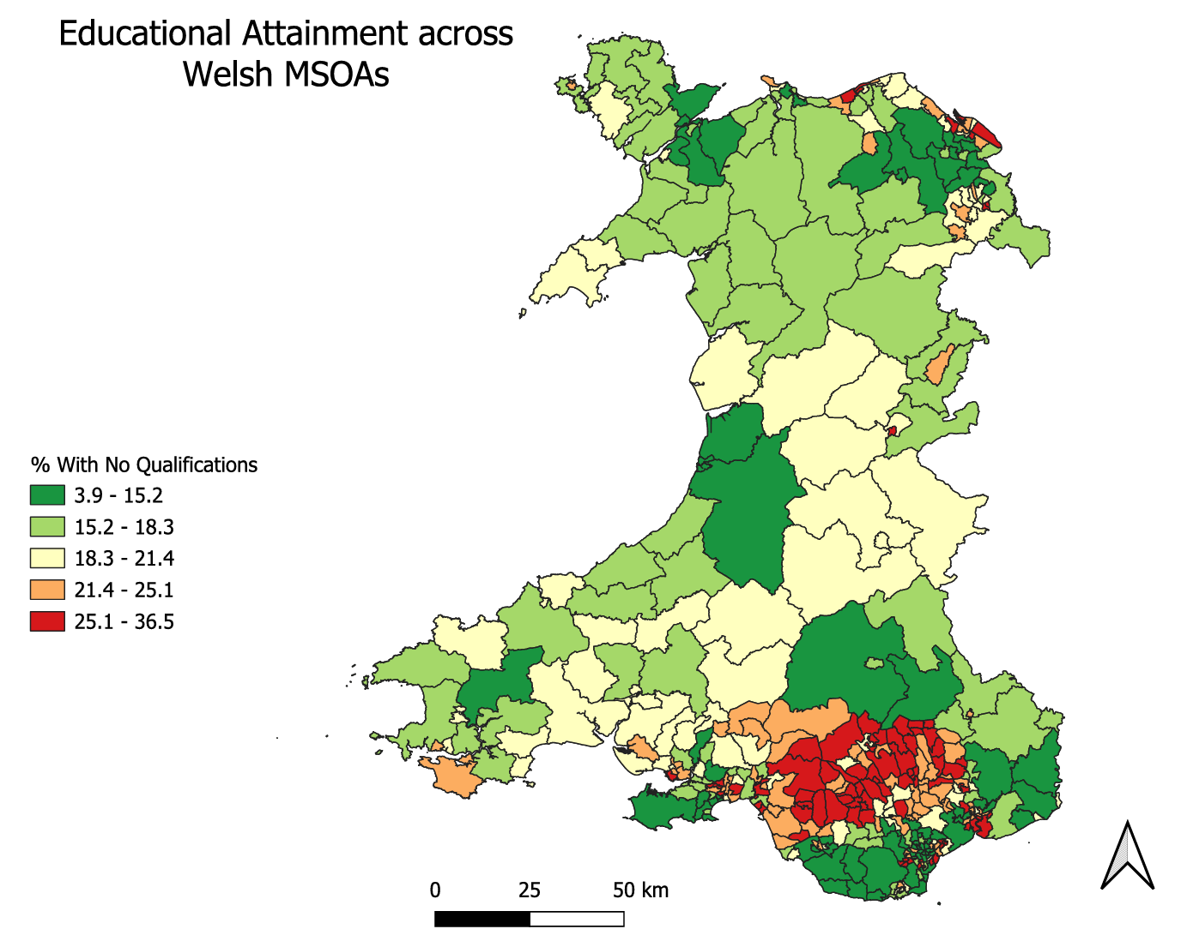
Figure 3 - Educational Attainment across Welsh MSOAs

Figure 3 shows the percentage of individuals with no formal qualifications across Welsh MSOAs. A clear spatial pattern can be observed, with higher percentages (shown in red) concentrated in parts of South Wales, particularly within the South Wales Valleys. In contrast, lower percentages (shown in green), indicating higher levels of educational attainment, are more commonly found in parts of North Wales and some coastal areas.
This distribution closely mirrors the patterns observed in Figure 2 for income deprivation, suggesting a strong relationship between lower income levels and lower educational attainment. Areas with higher proportions of individuals without qualifications may face greater socio-economic challenges, which can contribute to wider inequalities across regions.
The map presented in Figure 3 is taken from the final QGIS layout, while a full screenshot of the GIS workspace used to produce this map is included in the appendix for reference (see Appendix B).

BMI across Welsh MSOAs

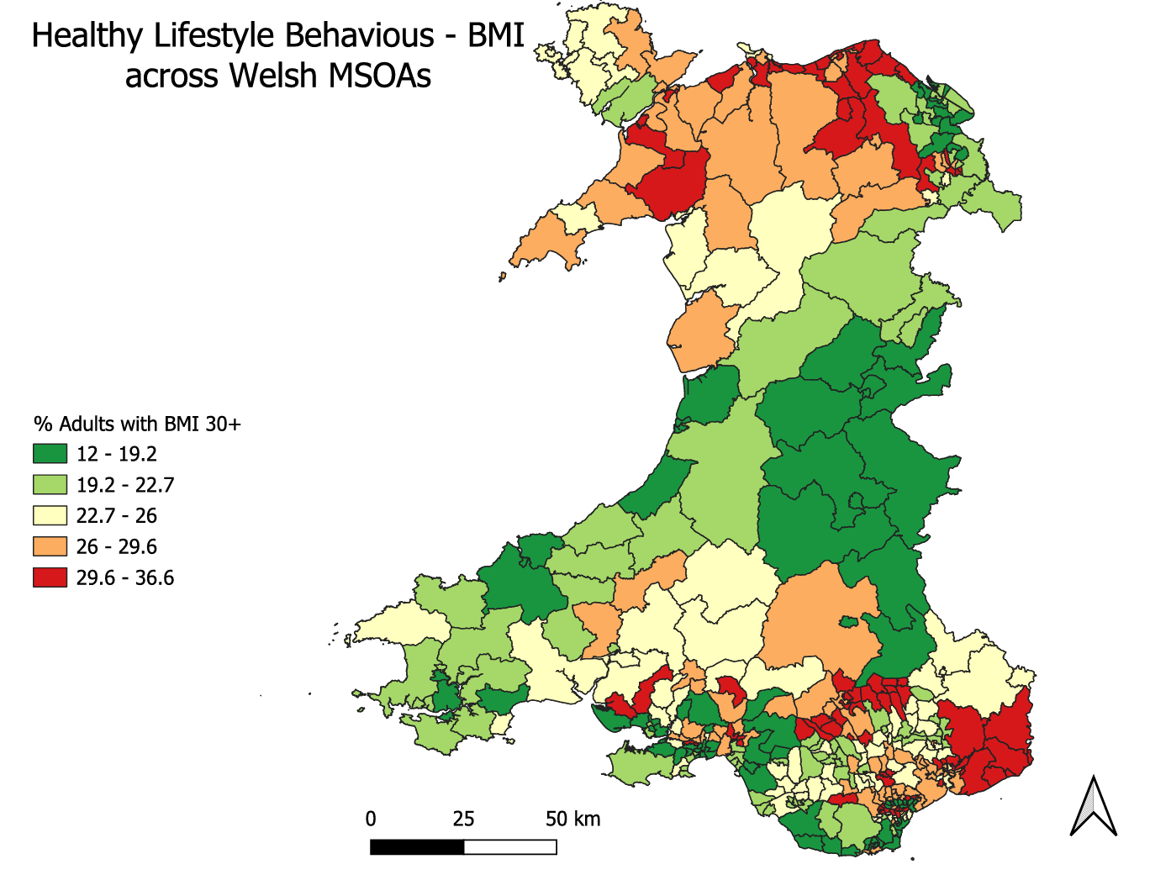
Figure 4 - BMI across Welsh MSOAs

Figure 4 presents the percentage of adults with a Body Mass Index (BMI) of 30 or above across Welsh MSOAs. In this map, higher percentages of obesity are shown in red, while lower percentages are shown in green. A clear spatial pattern can be observed, with a higher obesity level appearing more frequently in parts of North Wales and some rural areas, whereas lower levels are visible in sections of South Wales.
This suggests that obesity may be influenced by additional factors beyond income alone, such as lifestyle behaviours, access to services, or rural characteristics. While some overlap exists, the distribution of obesity does not align perfectly with areas of income deprivation, suggesting that lifestyle behaviours may be influenced by a wider range of factors beyond income alone. However, certain areas still show a relationship, indicating that socio-economic conditions may contribute to differences in health behaviours.
The map presented in Figure 4 is taken from the final QGIS layout, while a full screenshot of the GIS workspace used to produce this map is included in the appendix for reference (see Appendix C).

General Health Outcomes across Welsh MSOAs

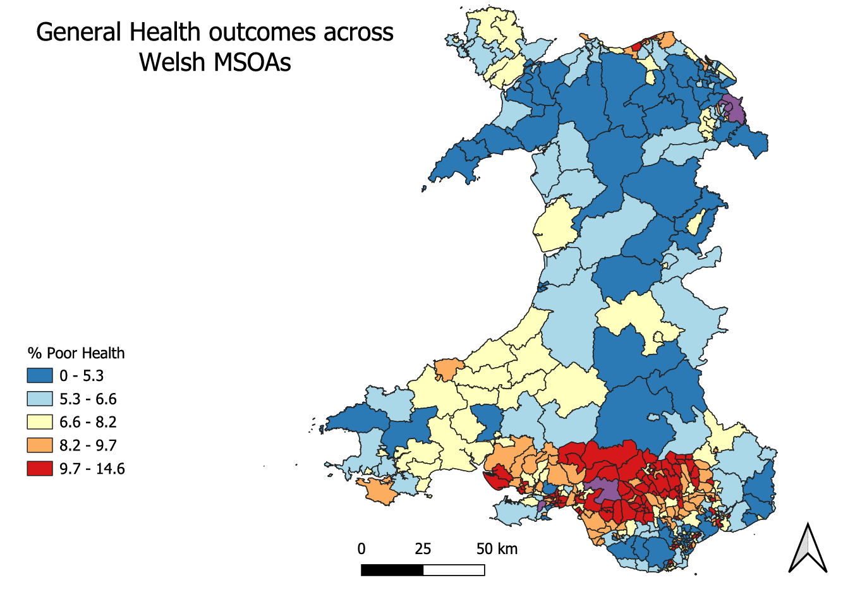
Figure 5 - General Health Outcomes across Welsh MSOAs

Figure 5 shows the percentage of individuals reporting poor health across Welsh MSOAs. In this map, higher percentages of poor health are represented by warmer colours, particularly red, while lower percentages are shown in cooler blue tones. A clear spatial pattern can be observed, with higher levels of poor health concentrated in South Wales, especially within the South Wales Valleys and surrounding urban areas.
This distribution closely reflects patterns seen in income deprivation and educational attainment. Areas that were previously identified as having lower income and lower levels of educational attainment also tend to report poorer health outcomes. This strengthens the evidence of a relationship between socio-economic conditions and health, suggesting that deprivation may play a significant role in influencing overall wellbeing.
The map presented in Figure 5 is taken from the final QGIS layout, while a full screenshot of the GIS workspace used to produce this map is included in the appendix for reference (see Appendix D).

Disability Rates across Welsh MSOAs

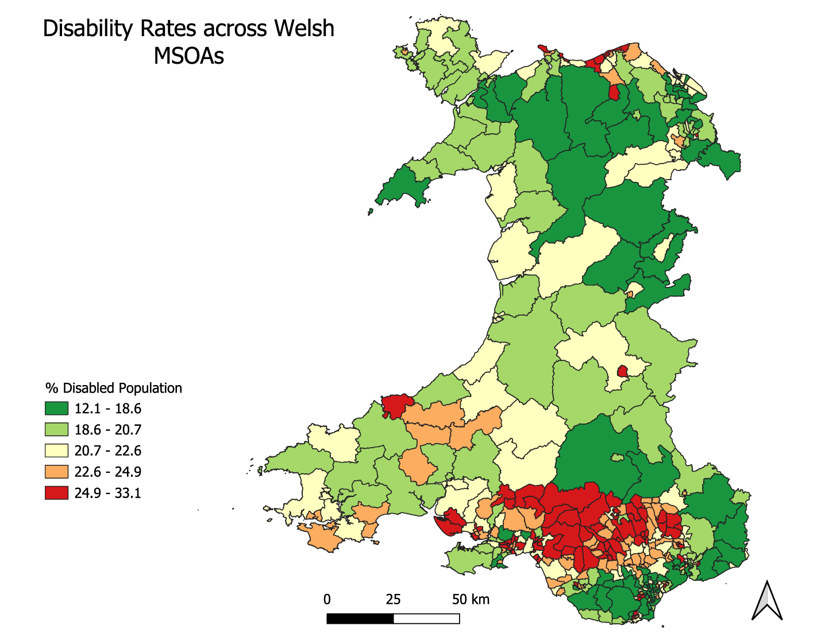
Figure 6 - Disability Rates across Welsh MSOAs

Figure 6 presents the percentage of the population reporting a disability across Welsh MSOAs. Higher percentages are shown in warmer colours, particularly red, while lower percentages are represented by green tones. The map shows a clear concentration of higher disability rates in South Wales, especially across the South Wales Valleys.
This spatial pattern is very similar to those observed in income deprivation, educational attainment, and general health outcomes. Areas with higher levels of deprivation and poorer health also tend to have a higher proportion of individuals reporting disabilities. This suggests a strong link between socio-economic disadvantage and long-term health conditions, highlighting how inequalities can impact multiple aspects of people’s lives.
The map presented in Figure 6 is taken from the final QGIS layout, while a full screenshot of the GIS workspace used to produce this map is included in the appendix for reference (see Appendix E).

GP Surgery Locations across Wales

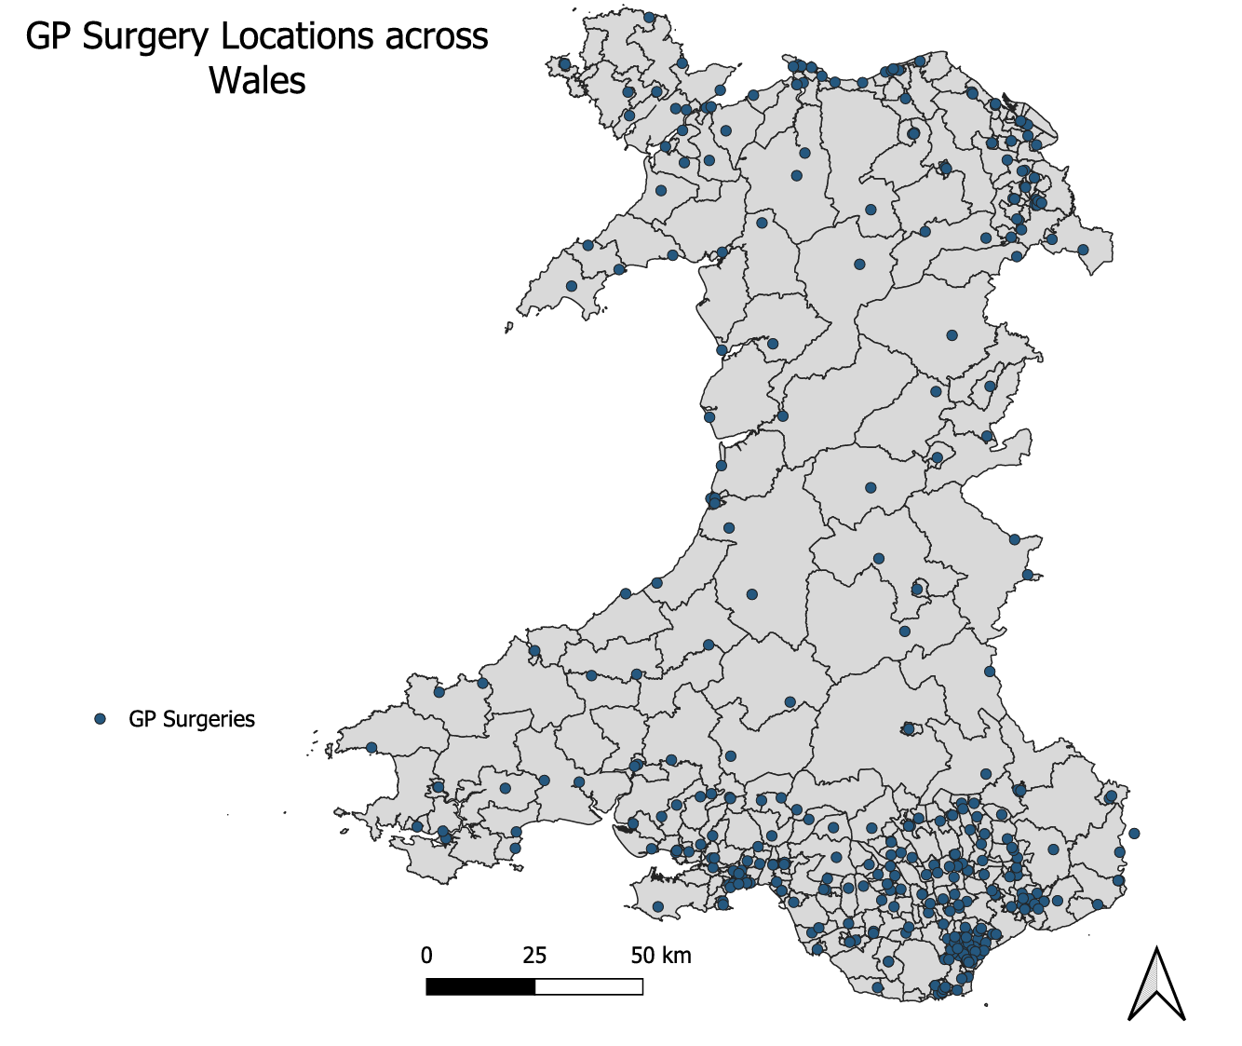
Figure 7 - GP Surgery Locations across Wales

Figure 7 shows the distribution of GP surgery locations across Wales. Each point represents a GP surgery, with a higher concentration of services clearly visible in South Wales, particularly around major urban areas such as Cardiff, Newport, and Swansea. In contrast, more rural and less densely populated areas, especially in Mid and North Wales, show a much lower density of GP locations.
This spatial pattern broadly reflects population distribution, with more healthcare services located in areas of high population density. However, when compared with previous maps showing higher levels of deprivation, poor health outcomes, and disability in parts of South Wales, the concentration of GP surgeries in these areas may indicate a greater demand for healthcare services. At the same time, the more limited distribution of GP surgeries in rural areas may suggest potential challenges in access to healthcare for those populations.
The map presented in Figure 7 is taken from the final QGIS layout, while a full screenshot of the GIS workspace used to produce this map is included in the appendix for reference (see Appendix F).

Suicide Rates across Welsh MSOAs

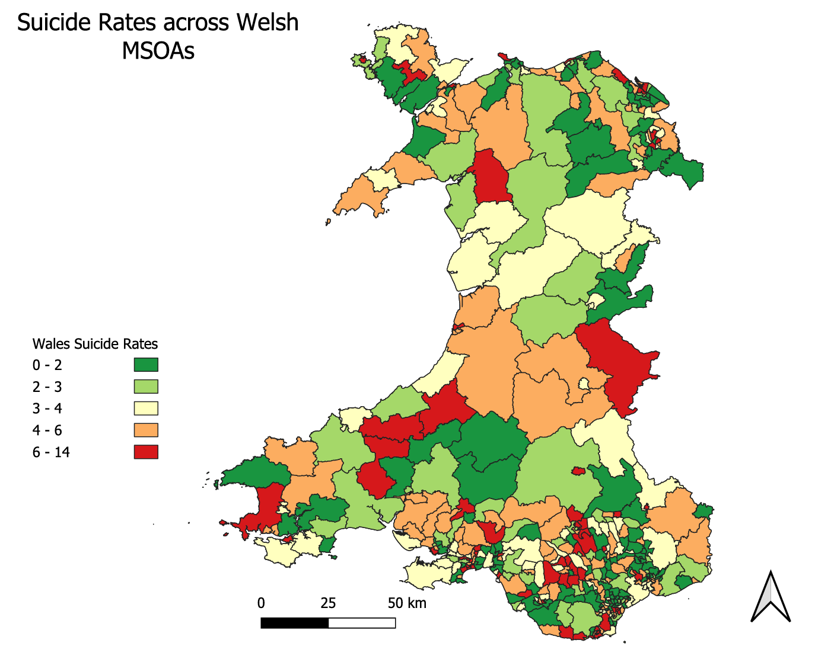
Figure 8 - Suicide Rates across Welsh MSOAs
Figure 8 presents the number of recorded suicide deaths per MSOA across Wales. The map reveals a varied spatial distribution, with no single region showing a consistently high concentration of cases. Areas recording higher numbers of deaths (shown in red, representing 6-14 deaths per MSOA) are scattered across South and North Wales, while areas shown in green represent MSOAs with the lowest recorded numbers (0-2 deaths).
Suicide data should be interpreted with caution, as the relatively small numbers at MSOA level mean individual cases can significantly influence the overall pattern. However, when considered alongside indicators such as income, deprivation and poor health outcomes, the data may suggest that socio-economic factors contribute to vulnerability in certain communities.
The map presented in Figure 8 is taken from the final QGIS layout, while a full screenshot of the GIS workspace used to produce this map is included in the appendix for reference (see Appendix G).

Income Deprivation and GP Surgery Locations across Wales

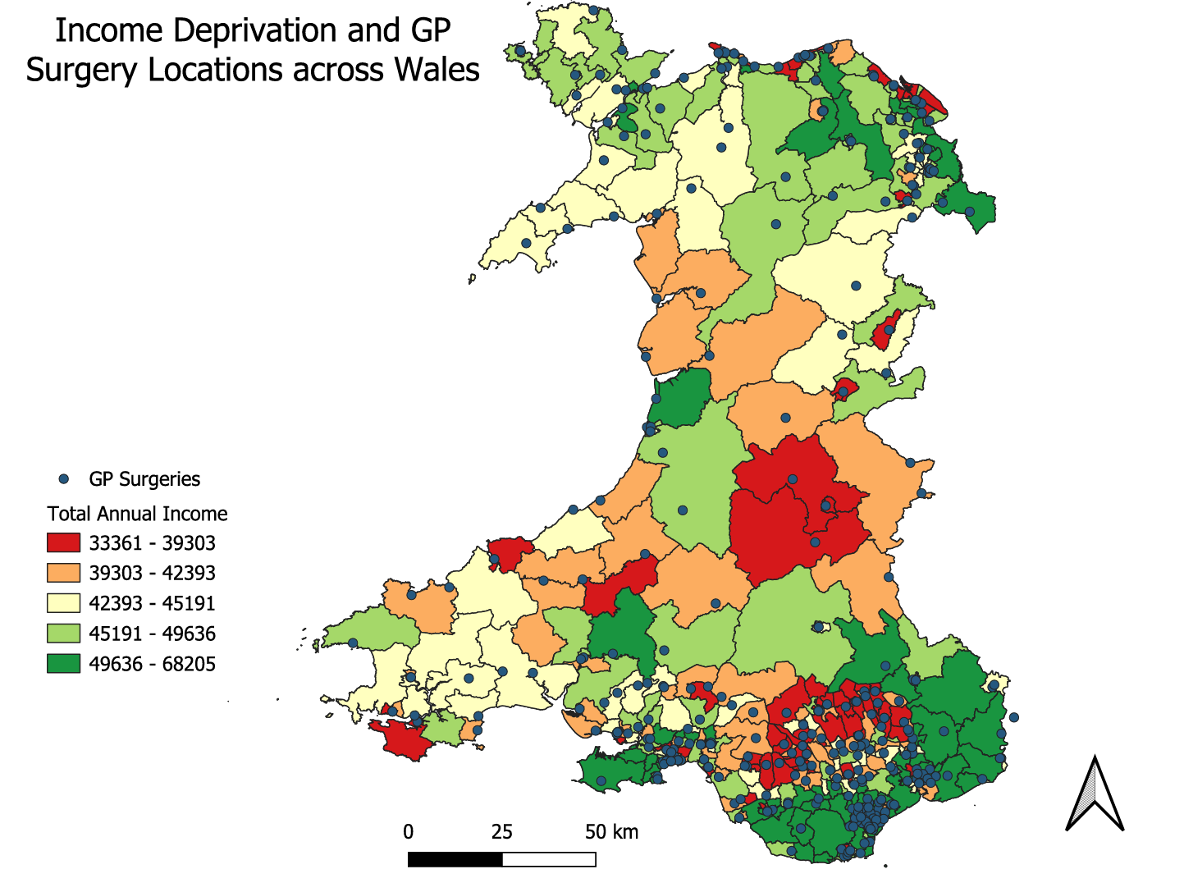
Figure 9 - Income Deprivation and GP Surgery Locations across Wales
Figure 9 represents an overlay of income deprivation and GP surgery locations across Wales. This map directly addresses the secondary research question of whether primary care services are distributed in areas of greatest need. The blue points representing GP surgeries are clearly concentrated in South Wales, particularly around the urban areas of Cardiff, Newport and Swansea, while these areas do contain some of the most deprived MSOAs, a large cluster of GP surgeries is also visible in wealthier green areas along the south coast.
Notably, several of the most deprived areas shown in red, particularly in Mid Wales and parts of South Wales Valleys, have very few GP surgeries nearby. This suggests a potential mismatch between healthcare need and service provision in certain areas, where high levels of income deprivation are not matched by an equivalent concentration of primary care service. This raises important questions around healthcare accessibility and equity across Wales.
The map presented in Figure 9 is taken from the final QGIS layout, while a full screenshot of the GIS workspace used to produce this map is included in the appendix for reference (see Appendix H).

General Health Outcomes and GP Surgery Locations across Wales

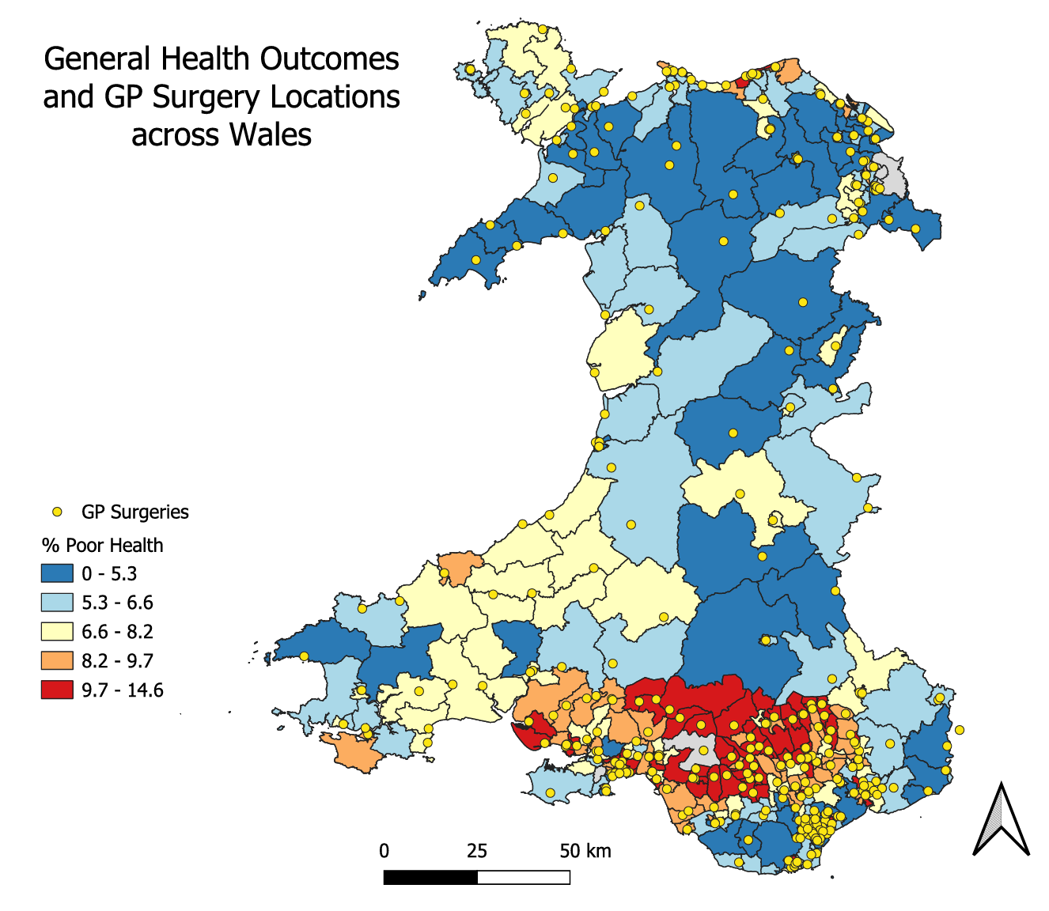
Figure 10 - General Health Outcomes and GP Surgery Locations across Wales
Figure 10 presents an overlay of general health outcomes and GP surgery locations across Wales. The map clearly shows that the highest concentrations of GP surgeries are in South Wales, particularly in and around the areas showing the worst health outcomes, represented in red and orange. This suggests that in urban areas of South Wales, healthcare provision does broadly align with areas of greatest health need.
However, a closer examination reveals that many GP surgeries in the south are clustered in a relatively small geographic area, potentially placing pressure on services in these communities. In contrast, large areas of Mid and North Wales show very few GP surgery locations despite some areas recording moderate to poor health outcomes. This raises concerns about healthcare accessibility in more rural communities, where residents may face significant travel distances to access primary care services.
Overall, this map provides the strongest evidence in support of the study’s secondary research question, suggesting that while GP services are broadly located in areas of need, significant gaps remain, particularly in rural Wales.
The map presented in Figure 10 is taken from the final QGIS layout, while a full screenshot of the GIS workspace used to produce this map is included in the appendix for reference (see Appendix I).

Overall Analysis and Conclusion

This report has explored a range of socio-economic and health-related datasets across Welsh MSOAs using GIS mapping techniques. By visualising income deprivation, educational attainment, BMI, general health outcomes, disability rates, suicide rates, and GP surgery locations, clear spatial patterns have emerged across Wales. Two overlay maps were also produced to directly address the study’s secondary research question regarding the distribution of healthcare services.
Across multiple datasets, a consistent pattern can be observed, particularly in South Wales. Areas such as South Wales Valleys repeatedly show higher levels of income deprivation, lower educational attainment, higher proportions of adults with a BMI over 30, poorer health outcomes, and higher disability rates. This suggests a strong relationship between socio-economic disadvantage and negative health outcomes, where communities experiencing deprivation are more likely to face a range of health-related challenges [5].
The suicide map adds a further dimension to this analysis. Although suicide data must be interpreted with caution due to the small numbers involved at MSOA level, certain areas recording higher numbers of deaths also correspond with areas of greater deprivation. This suggests that mental health and wellbeing may also be influenced by socio-economic conditions, reinforcing the broader pattern observed across the other datasets.
In contrast, many areas in Mid and North Wales tend to show more positive outcomes across these indicators, with lower levels of deprivation and better overall health. However, these areas are often more rural, and the GP surgery maps highlight a lower density of healthcare services in these regions. This suggests that while health outcomes may be better overall, access to services may still present challenges due to distance and availability.
The two overlay maps presented in Figures 9 and 10 provide the most direct evidence in response to the secondary research question. When GP surgery locations are overlaid against both income deprivation and general health outcomes, services are broadly concentrated in urban South Wales, where demand is highest. However, significant gaps remain in rural Mid and North Wales, where some areas show moderate health needs but very limited healthcare provision. This raises important questions around healthcare equity and accessibility across Wales.
It is also important to acknowledge limitations within the data. While most datasets were available at MSOA level, some, such as BMI and physical activity, were originally provided at a different geographical level. These were adapted to align with MSOA boundaries for consistency, which may introduce some level of approximation. Additionally, the use of aggregated data means that individual-level variation is not captured, and patterns should be interpreted with this in mind.
Overall, the use of QGIS mapping has proven highly effective in identifying spatial patterns and relationships between socio-economic factors and health outcomes. The findings highlight clear inequalities across Wales, particularly in South Wales, and emphasise the importance of targeting interventions and resource allocation to address these disparities. These findings demonstrate the value of GIS as a decision-making tool, enabling organisations to identify high-need areas and allocate resources more effectively.
It should also be noted that generative AI was used to assist in the manipulation and reformatting of certain datasets, including BMI and physical activity, to ensure compatibility with the MSOA geographical framework used throughout this study.

References

[1] P.A. Longley, M.F. Goodchild, D.J. Maguire and D.W. Rhind, Geographic Information Science and Systems, 4th ed. Hoboken: Wiley,2015.
[2] T.A. Slocum, R.B. McMaster, F.C. Kessler and H.H. Howard, Thematic Cartography and Geovisualization, 3rd ed. Upper Saddle River: Pearson, 2009.
[3] Office for National Statistics, “MSOA Level Household Income Estimates,” ONS, 2023, [Online]. Available: https://www.ons.gov.uk. [Accessed: 26 April 2026].
[4] QGIS Development Team, “QGIS Geographic Information System,” Open Source Geospatial Foundation, 2024. [Online]. Available: https://www.qgis.org. [Accessed: 26 April 2026]
[5] M.Marmot, Fair Society, Healthy Lives: The Marmot review. London: UCL Institute of Health Equity, 2010. [Online]. Available: https://www.instituteofhealthequity.org/resources-reports/fair-society-healthy-lives-the-marmot-review. [Accessed:26 April 2026]

Appendix

Appendix A – Income Deprivation across Welsh MSOAs – GIS Workspace Screenshot:
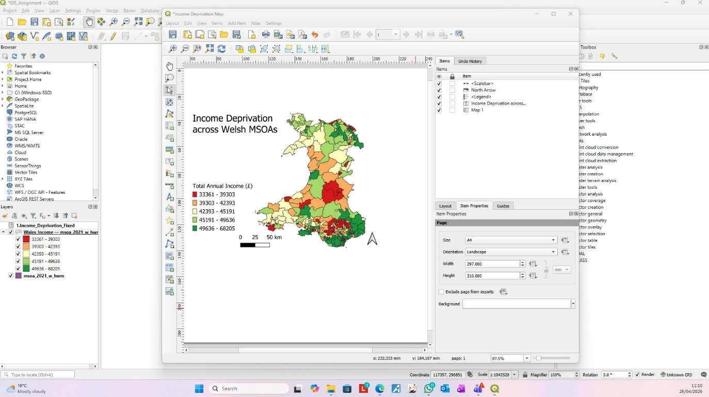

Appendix B – Educational Attainment across Welsh MSOAs – GIS Workspace Screenshot:
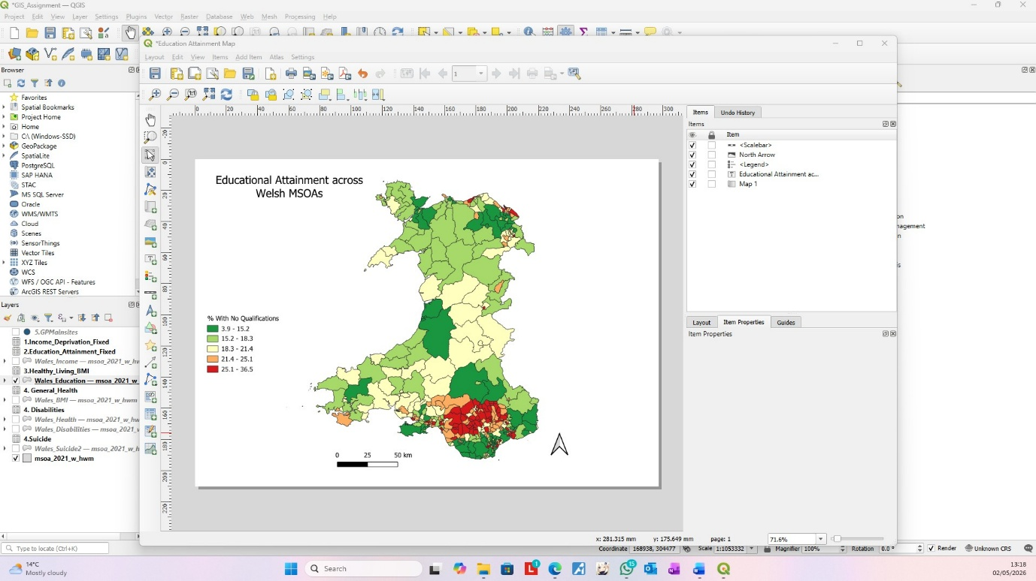

Appendix C – BMI across Welsh MSOAs – GIS Workspace Screenshot:
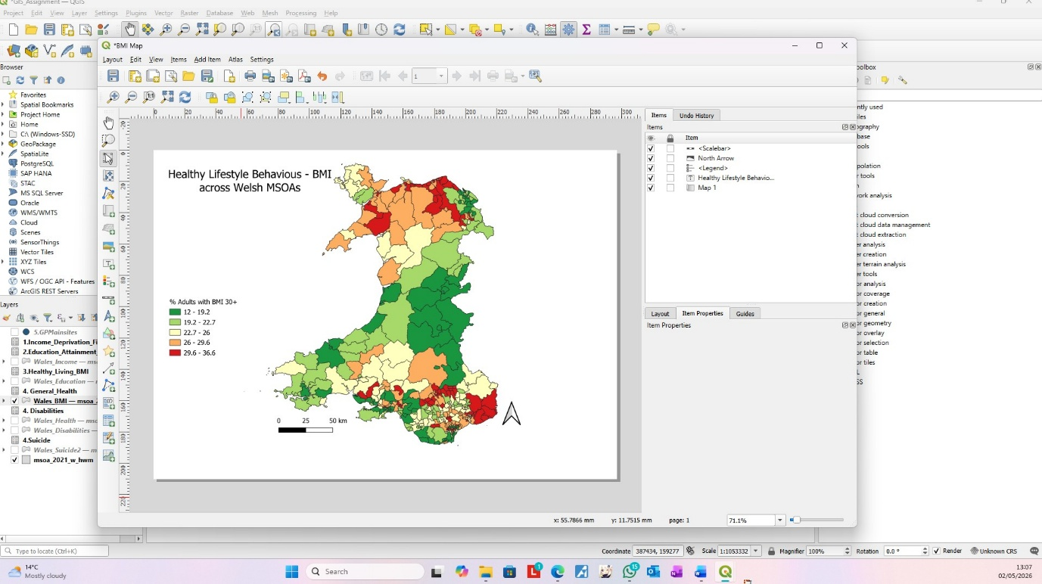

Appendix D – General Health Outcomes across Welsh MSOA – GIS Workspace Screenshot:
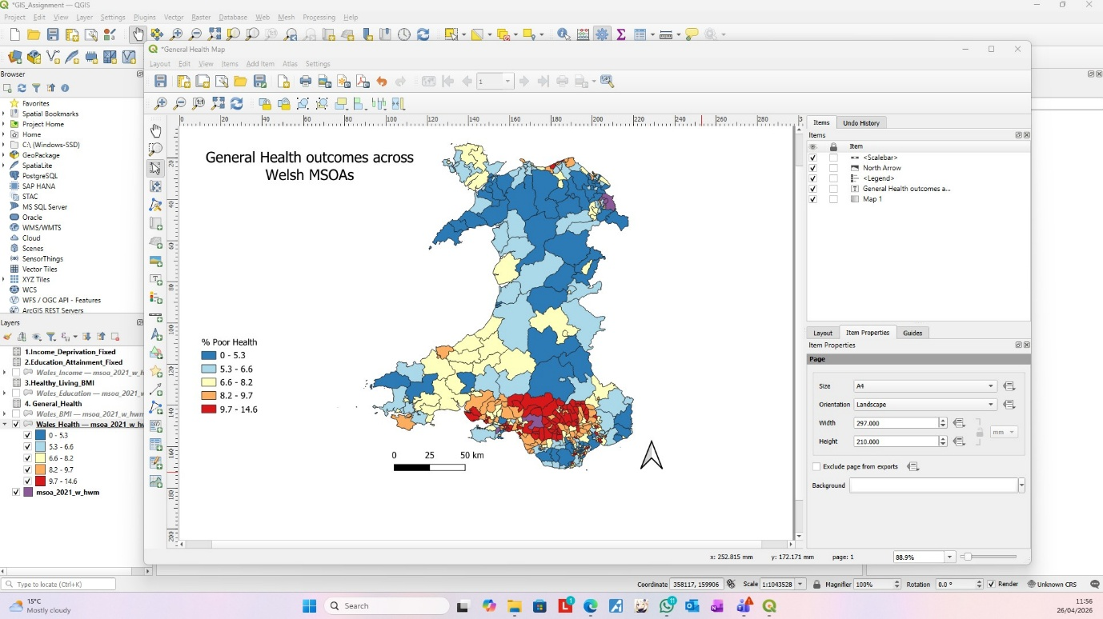

Appendix E – Disability Rates across Welsh MSOAs – GIS Workspace Screenshot:
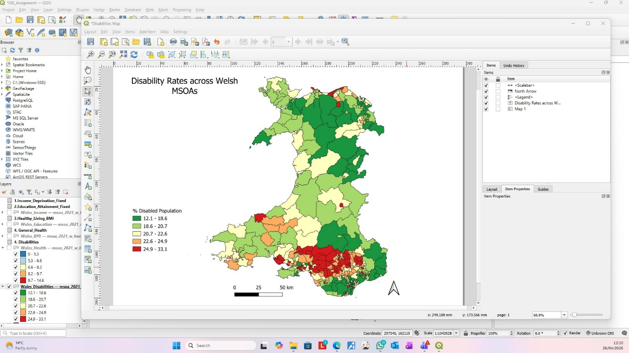

Appendix F – GP Surgery Locations across Wales – GIS Workspace Screenshot:
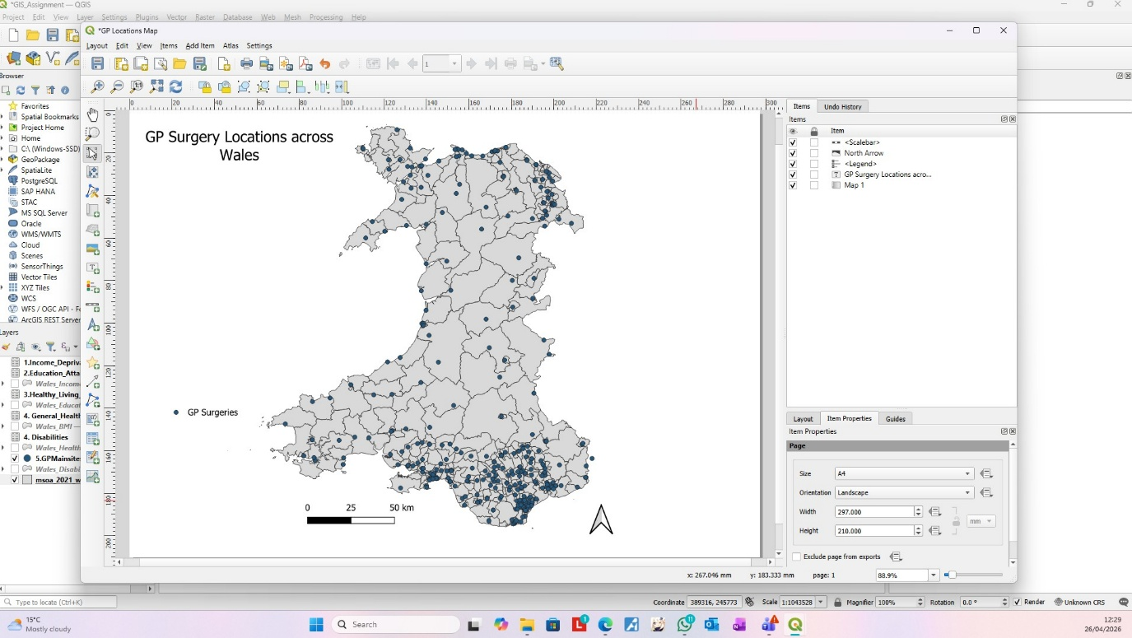

Appendix G – Suicide rates across Welsh MSOAs – GIS Workspace Screenshot:
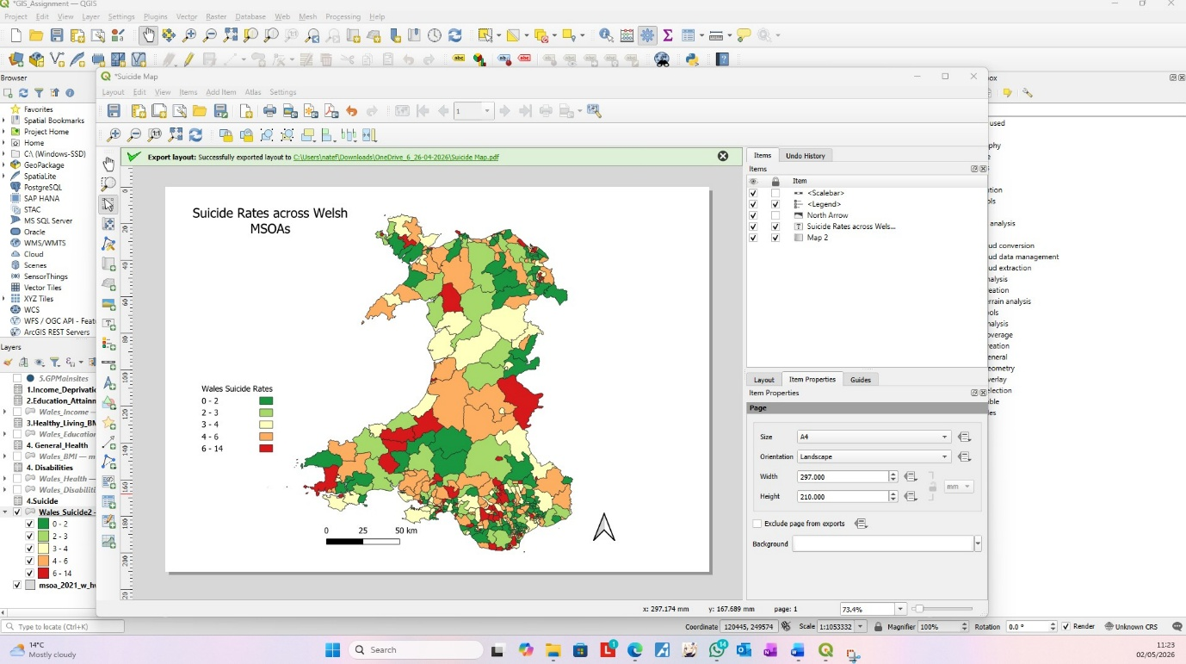

Appendix H – Income Deprivation and GP surgery locations across Wales – GIS Workspace Screenshot:
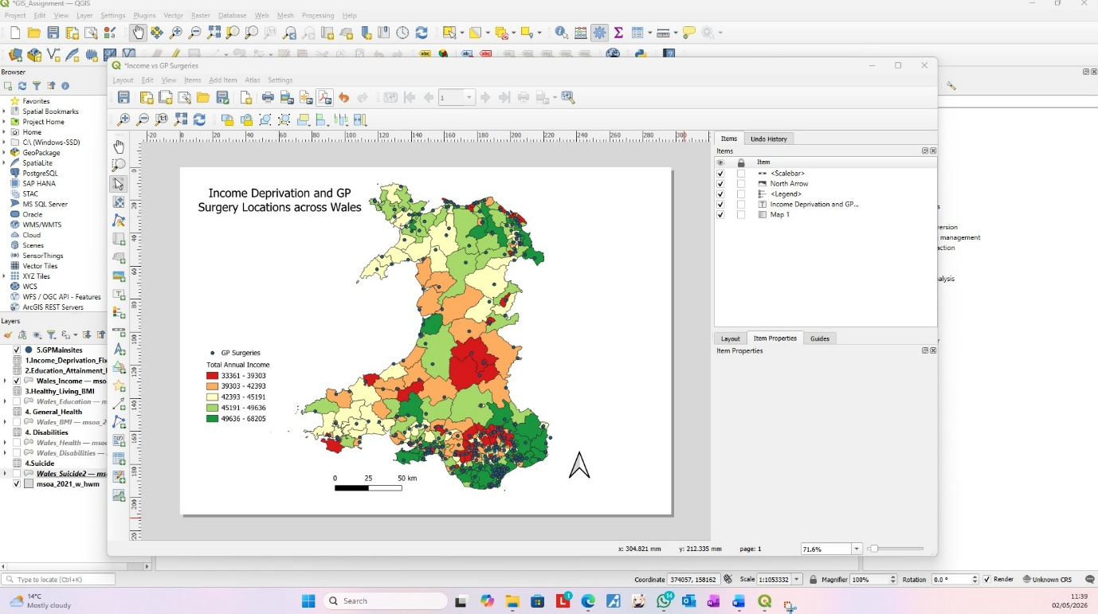

Appendix I – General Health Outcomes and GP Surgery Locations across Wales – GIS Workspace Screenshot:


