

Motorcycle Traction Control
for
Dr Owen Williams

Written as a Journal Paper for the “Journal of Automobile Engineering” by SAGE Publications, following the Manuscript Submission Guidelines (SAGE Publications, 2016) and SAGE UK Style Guide (SAGE Publications, 2011).

10/01/2018

Alexander Thaddaeus Przibylla (P144999) Module: M6X00412

The Mechanisms and Complexities of the Dynamic Handling of the Competition Motorcycle

Alexander Przibylla
Faculty of Manufacturing and Engineering, University of Wales Trinity Saint David, Swansea, UK

Abstract
The control of modern and high-performance motorcycles is a challenging task and this paper focuses on the electronic control strategies developed for making production motorcycles safer and competition motorcycles faster, by allowing for the full potential of their very high power outputs to be utilised within the limiting laws of physics. It explains the methods used at world championship level of racing based on data analysis and explains the underlying motorcycle dynamics that require the implementation of mathematical models in conjunction with sophisticated sensor technology. Furthermore, it gives an insight into the development and complexity of these models, as well as the current state of the art technology for the most advanced prototype motorcycles built to date.

Introduction
The governing vehicle dynamics behind two-wheeled motorcycles are highly complex and the stability of single-track vehicles like such is dependent on numerous factors that are affecting each other on a great scale. With the development of motorcycle engines capable of ever more extreme power outputs, resulting in previously unseen and continuously increasing power-to-weight-ratios that are unique to production sports bikes and prototype motorcycles in particular, which are built for operating and competing at the very limit of the performance achievable and controllable by even the most skilled riders in the world, who are racing at world championship level like in the MotoGP, not just the design of suitable motorcycle chassis, brakes or tyres for example has been the focus over recent years. It also introduced the necessity to develop and implement highly sophisticated sensors and electronic control strategies in order to increase the safety of production motorcycles and to get the very most out of competition prototypes. Whereas control systems for meeting safety requirements for roadgoing motorcycles, like Anti-Lock Brake Systems (ABS) and simple Traction Control Systems (TCS), using basic technology and relying on the main Electronic Control Unit (ECU), have been in use on production motorcycles for a long time, the dynamic electronic control of competition motorcycles is far more advanced and requiring a lot more effort, which means that highly complex strategies of engine management for example have to be developed and are being implemented with additional ECUs that are getting set up by engineers, who are relying on data acquisition and mathematical models for motorcycle dynamics, as well as the results of experimental testing, to do so (Vetr, et al., 2009).

Under Braking
Unlike most production motorcycles, competition motorcycles are usually not equipped with ABS, as the rider is required to decelerate the motorcycle as late and as quickly as physically possible, to take the given corner at the highest possible speed for the desired radius of the turn and the ideal lean angle of the motorcycle, without the motorcycle doing a forward flip around the axis of the front wheel spindle, due to its geometry and the occurring weight transfer, or the contact patch of the front tyre losing grip with the tarmac of the race track, which the rider needs highly developed skills and precise feedback from the motorcycle for. Since the ABS is designed to interfere with the riders braking input applied through the front and rear brake lever and takes over as soon as a pre-defined amount of tyre slippage is detected, with applying maximum braking up until the point at which the dangerous tyre slippage is getting picked up by the sensors again, resulting in a repeat of this process, such a technology would highly affect the feedback from the motorcycle to the rider and its stability quite negatively by unsettling it due to the ABS abruptly and repeatedly applying the brakes in a pulse-like manner whenever the motorcycle is close to the limit of the available grip whilst being decelerated. However, there are other electronic aids for the rider that control the behaviour of the motorcycle when under braking. Data for Tech3’s Yamaha M1 MotoGP bike from 2007 suggests that during that time, due to a risk of the rear wheel locking up when the rider re-engages the clutch after downshifting, the amount of engine speed deceleration, when the clutch is being pulled in by the rider for shifting down the gears, is controlled by the electronics of the fly-by-wire system slightly opening the throttle bodies responsible for the amount of air that is being sucked into the engine, which results in the crankshaft speed dropping controllably and down to a stable and pre-defined level that is being maintained until the clutch slip decreases again and the throttle opening is no longer based around that but now controlled by the measured difference in wheel speeds, i.e. wheel slip, as shown in Figure 1 (Anon., 2007). This wheel slip is the consequence of the momentum from the rear wheel accelerating the engine again when the clutch is being re-engaged and therefore the rear wheel and gear box losing rotational energy and decelerating with a proportionally equal amount that they are accelerating the engine by, especially when the rear wheel has got minimum or no contact with the ground. The throttle bodies are then gradually being closed again by the electronics and eventually returning to match the actual throttle input of the rider, which in this case would be zero as the motorcycle is under braking, until the wheel slip has almost disappeared (Anon., 2007).
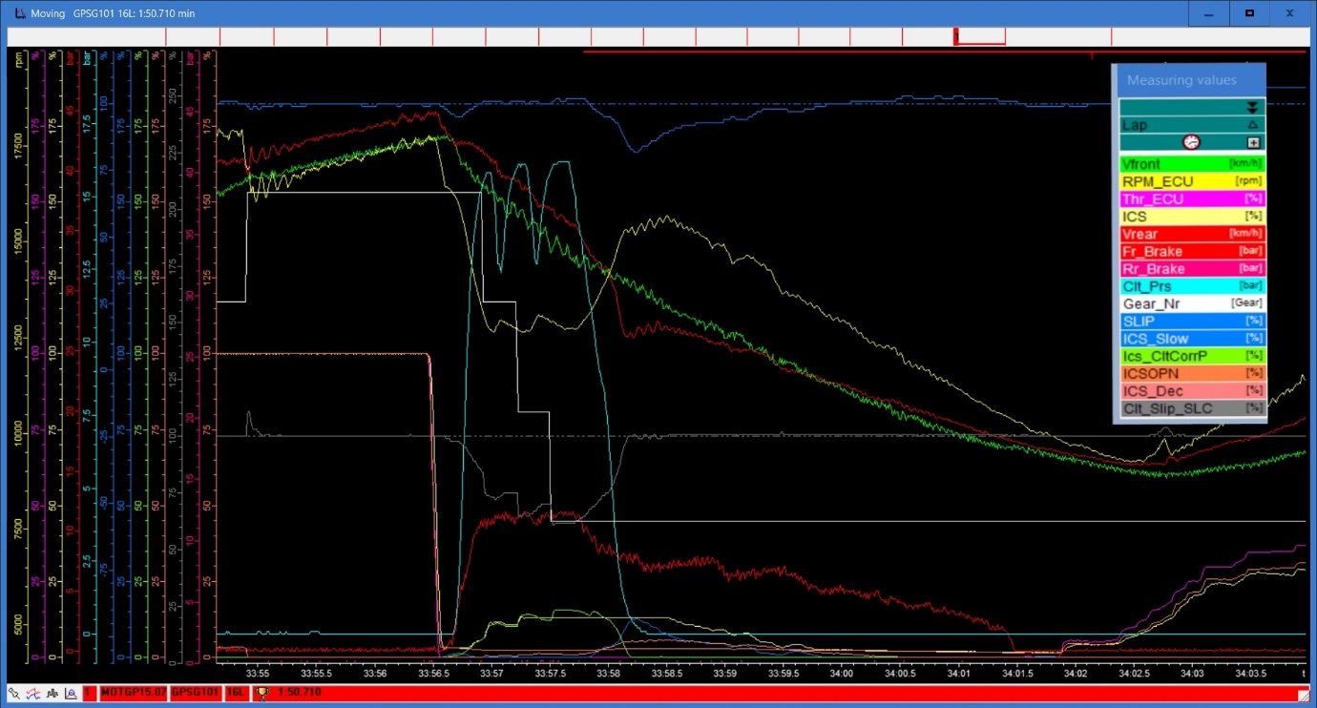
Figure 1. Selection of data traces from “2D Dataset for Factory Yamaha M1 from MotoGP Championship Round 15 Race at Motegi Circuit” for a braking scenario (“V”: Wheel Speed, “RPM”: Engine Speed, “Thr”: Throttle, “ICS”: Intake Control System, “Clt”: Clutch)
Nowadays, the manual use of the clutch is no longer required during downshifts, as the invention and wide use of seamless gearboxes allows for very quick gear changes without losing drive to the rear wheel (Spalding, 2017). Generally, in seamless gearboxes the next gear is selected whilst the current gear is still engaged and after both gears have been engaged simultaneously for a few milliseconds, the gearbox deselects the previous gear when the new one has been mechanically accelerated, whilst very precise ignition cuts and electronically managed throttle body adjustments smoothen out a sudden change in load, as the energy from changing crankshaft speeds compensates the cuts in power, to prevent unwanted upset of the motorcycle (Spalding, 2017).

Mid-Corner and Straight-Line Acceleration
In motorcycle racing, the acceleration phase usually starts just before or with the motorcycle hitting the apex of a turn on the line chosen by its rider around any given corner and is therefore introduced at very high, if not maximum possible lean angles of the motorcycle. This is when TCS sets in and really enables the rider to get the maximum performance from a motorcycle that has engine characteristics which are difficult to control, with a high power output and lean running due to strict fuel limitations in the MotoGP, that can then be accelerated at the very physical limit of grip available at the contact patch of the rear tyre without crashing, should the ECU pick up sensor readings that signal the requirement of intervention based on pre-defined parameters for safety and performance targets (Anon., 2007). The general aim of the TCS is to control and reduce the torque that is being delivered to the rear wheel in order to keep the rear tyre from losing more traction than is desired for the highest possible acceleration at any given lean angle of the motorcycle, ideally even before it is being produced by the engine and having to then be counteracted again (Spalding, 2017). A series of different strategies allow the ECU to reduce engine torque, where each strategy sets a target torque reduction and, should intervention be required, the ECU will select the strategy that offers the highest torque reduction, however all the strategies work in parallel at all times and, if the chosen approach proves to be insufficient based on current information that the ECU is constantly being supplied with, i.e. the situation may have changed and yet more intervention is required, faster or more aggressive TCS strategies can be selected (Spalding, 2017). Methods for the ECU to reduce engine torque are the reduction of ignition advance from its pre-defined and very accurate base map, cutting the ignition in certain cylinders completely and electronically reducing the throttle opening for the desired torque delivery at each throttle grip position and engine speed, where the speed of intervention is considered highest for retarding the ignition advance and slowest for altering the amount of throttle opening (Spalding, 2017). The TCS strategies described are ultimately used to reduce or prevent wheelies and rear wheel slip, if necessary even simultaneously (Spalding, 2017). Therefore, the ECU constantly monitors the readings from sensors on the motorcycle, including Inertial Measurement Units (IMU), which are devices that include a collection of advanced sensors like accelerometers and gyroscopes that measure linear accelerations and rotational speeds, from which it calculates the attitude of the motorcycle, i.e. pitch, yaw and lean, as well as their rates of change, and assesses how quickly and aggressively an intervention should be introduced, depending on the rate at which the sensor readings approach pre-set target numbers and by how much they might be breaching these limits, however it is always ensuring an intervention proportional to the arising problem (Spalding, 2017). These limits, as well as torque maps based on ignition timing and electronic throttle opening with respect to the manual rider inputs, must be defined and implemented in the ECUs by the engineers of the race teams and the following chapters will cover and explain the methods of how this is achieved in detail. The data traces for the Yamaha M1 from 2007 shown in Figure 2 reveal that retarding the ignition timing is mostly used for fine adjustments of the engine torque output, for example to curb beginning rear wheel slip, and that altering the throttle opening, but especially cutting the ignition temporarily, is a more drastic measure to avoid or counteract excessive speeding up of the rear wheel and wheelieing of the motorcycle (Anon., 2007). In addition to the obvious correlation between the graphs of measured torque with the activation and effect of the electronic control systems, by looking at the air/fuel ratio of the different cylinders, it can be seen that the ignition cut is not synchronous in all cylinders, but changing cylinder in a particular order (Anon., 2007). The dataset also suggests that, whilst retarding ignition timing or cutting the ignition completely is used as a TCS strategies and to provide the rider with the ideal amount of torque at all times, retarding the ignition, or sometimes cutting it as well, is also essential under upshifting, where the rider does not need to use the clutch and can keep the throttle wide open when shifting up through the gearbox, because, since the ignition timing is being retarded massively but with decreasing magnitude the higher the velocity and gear number selected, the gearbox is being relieved from engine torque enough for the next gear to slot in as smoothly and quickly as possible, as shown in Figure 2 (Anon., 2007). In addition, retarding the ignition advance helps to avoid unwanted jerking, i.e. pitching of the motorcycle, as the slop in the gearbox is taken up during upshifts (Spalding, 2017).
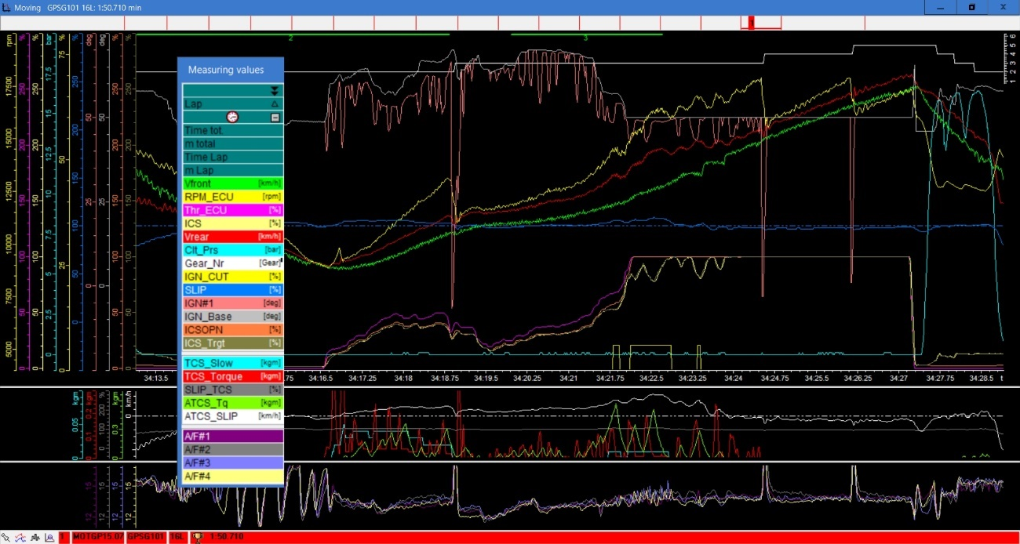
Figure 2. Selection of data traces from “2D Dataset for Factory Yamaha M1 from MotoGP Championship Round 15 Race at Motegi Circuit” for an acceleration scenario (“IGN”: Ignition, “A/F”: Air/Fuel-Ratio)

Limiting Dynamics
The complexity of motorcycle dynamics requires the implementation of physical and mathematical models to define the ideal torque output for maximum performance of a competition motorcycle at any given point on a race track and under any given set of circumstances, with the objective being its capability of using the maximum traction available, whilst avoiding abrupt behaviour, loss of grip and lift-offs from the ground that could compromise the ability of the motorcycle to achieve its fastest acceleration possible. Conventional TCS use detection of front wheel lift-offs from the ground, where the front wheel is decelerating because it is no longer being driven, and wheel slip as the result of a loss of traction of the rear tyre with the ground by sensing differences in wheel speeds, but estimations for the limit of traction are inaccurate and therefore insufficient, if they are not based on ECU control setups as well, which serve the purpose of avoiding abrupt behaviour and hunting phenomena due to a delay in response that would ultimately mean an ineffective use of the high power output available from competition motorcycles (Akitsu, 2012). With the relatively recent development and improvement of technology like electronically controlled throttle bodies and improved attitude sensors, i.e. inertia platforms, the torque output of motorcycle engines can be ever more precisely controlled and race teams have been able to develop control setups for wheelie- and traction-limited acceleration aimed at controlling and reducing the torque delivered to the rear wheel based on dynamical models that offer far more accurate calculations for the estimation of dynamic limits under any given circumstances and are therefore predefining the highest possible acceleration for the motorcycle at all times (Akitsu, 2012). From Honda Racing Corporation’s approach, in contrast to a static and therefore simplified model that can be used to calculate the driving force at the rear wheel contact patch when the load on the front wheel becomes zero based on static geometry parameters only, an accurate dynamic model for calculating wheelie-limited acceleration of a MotoGP bike has to include the inertia forces of every part of the motorcycle, since it is accelerating and decelerating very quickly, the changes in dimensional specifications that result from the constant change in attitude of the motorcycle and the effect of the drag acting on the motorcycle due to it achieving very high speeds, which for example means taking into account the influence of the motorcycle turning, its rolling and pitching motions, as well as aerodynamics (Akitsu, 2012). Whilst suitable equations for use with further derivation can be found in literature on motorcycle dynamics, for example in Vittore Cossalter’s book “Motorcycle Dynamics” (Cossalter, 2006), most dynamically changing values need to be determined by using sensor readings like suspension travel, for determining the dynamic height of the centre of gravity and dynamically changing wheelbase, or the angular acceleration from pitching, angular pitch velocity, angular roll velocity, centrifugal force from turning and the total aerodynamic lift, based on the coefficient of lift that can be determined with the help of wind tunnel testing or Computational Fluid Dynamics (CFD) analysis and is also essential for calculating the dynamically changing load on the front wheel, for determining the dynamic vehicle mass as a result of inertia forces (Akitsu, 2012). To include the overall resistance to motion, the drag, rolling resistance, wheel inertia torque, tyre cornering resistance, the angular pitch velocity torque, and the resistance due to the gradient of the ground are considered (Akitsu, 2012). From all of this, the target driving force at the contact patch of the rear wheel is calculated, summing up the wheelie-limited acceleration force and the resistance force, and, by calculating the inertia of the rotating parts inside the engine, considering the rear wheel rotation radius and the reduction ratio, the target driving torque at the rear wheel contact patch is converted to the equivalent target engine torque output at the crankshaft (Akitsu, 2012). Actual testing of this model implemented in the ECU and controlling the torque delivered by the engine done by HRC has shown that the wheelie angle can be limited to 1.6° and is about 60% more controlled with the model described above in comparison to conventional methods (Akitsu, 2012). HRC’s traction-limited acceleration model is based around the coefficient of friction of the tarmac and the slip limit of the rear tyre, which changes significantly with the vertical load on and the lateral force at the rear wheel contact patch (Akitsu, 2012). The model is estimating the friction coefficient and vertical load on the rear wheel contact patch based on the concept of a friction ellipse, sensor readings for rear suspension spring load, the (anti-)squat ratio based on the motorcycle geometry, as well as figures for the rear suspension damping force and more (Akitsu, 2012). A friction ellipse, or friction circle, is the concept of a circle described by the vector of maximum force available at the contact patch of the rear tyre within an x-y-coordinate system, where the x-axis describes the lateral force and the y-axis the longitudinal force acting on the contact patch (Cocco, 1999). Since the maximum friction force available at the road surface for any given load and friction conditions is given by the product of the vertical load on the rear wheel contact patch and the friction coefficient of the surface, which is also the radius of the friction circle, the maximum force available at the contact patch is constant (Cocco, 1999). This means that the sum of the squares of lateral and longitudinal forces on the contact patch of the tyre is always constant in a friction ellipse and that the traction force and lateral force can constantly be calculated by the ECU, where the force that can be transferred by the tyre in lateral and longitudinal direction is dependent on the dynamically changing variables vertical force on the rear tyre, slip in longitudinal direction, side-slip angle and roll angle of the motorcycle (Vetr, et al., 2009). The friction coefficient is estimated to an accuracy that allows for the target traction at any given lean angle of the motorcycle to be converted to a target torque output at the crankshaft and to be achieved even outside the area for which it can be calculated within the friction ellipse (Akitsu, 2012). The traction-limited acceleration model is designed in a way that it does not interfere with the wheelie-limited acceleration model up to a certain lean angle, so that both can be run together and take over from each other depending on which model is required (Akitsu, 2012). Testing of the traction-limited acceleration model done by HRC has shown that it suppressed the yaw rate fluctuations of the motorcycle by about 55% and keeps the traction used by the motorcycle much closer to the calculated limit of traction, if compared to conventional TCS that operate based on wheel slip detection (Akitsu, 2012). Kawasaki uses a slightly different traction-limited acceleration model for the TCS on their production motorcycles, which has been simplified from the version that was originally developed for prototype racing in MotoGP due to the necessity of being able to run it on the main ECU of their production motorcycles, rather than on a separate and additional one, by reducing the number of measured inputs required, like the lean angle or pitch of the motorcycle, and therefore reducing the processing power required for solving the model (Masuda & Matsuda, 2011). However, their prototype TCS also works on the basis of an estimated tyre friction performance, which is constantly being re-calculated from sensor readings within the dynamic model, but the torque control is achieved by a method of comparing the actual engine torque output to the calculated limit, hence it may be operating rather reactive still (Masuda & Matsuda, 2011). Other mathematical and physical models for electronic stability control and TCS have been developed and offer good explanations of the governing vehicle dynamics, but their actual implementation and use in competition motorcycles is indeterminate, as they are purely theoretical and, instead of working with sensor readings, based on simplifying assumptions and motorcycle simulators, see (Massaro, et al., 2010), (Corno, et al., 2012), (Tanelli, et al., 2009), (Vetr, et al., 2009). Whilst traction-limited acceleration can be calculated from the dynamic models and ensured using different electronic control strategies, a crash as a result of the motorcycle entering a turn with a velocity that eventually causes the required lateral force to exceed the maximum lateral force available from the grip at the contact patches of the tyres with the lean angle of the motorcycle increasing cannot be prevented by any ECU, regardless of the model used (Vetr, et al., 2009).

The Status Quo
The development and use of electronic control strategies, including very accurate torque maps, i.e. ignition timing advance and electronic throttle opening maps, based on the desired engine torque output calculated by using the models described above, at world championship level of prototype racing started around the year 2007 and received major attention by the big factory teams, which had managed to get ahead of privateer teams to such an extent by 2015 that the regulations for the MotoGP where altered and the most sophisticated technologies banned by the organisers, who from then on only allowed their teams to use the same and unified, however less advanced electronic control systems in order to limit the costs of electronically controlling the motorcycles and evening out the field of competitors again (Spalding, 2017). Whilst some electronic control systems where able to calculate the exact position of the motorcycle and learn how much wheel spin was being generated by the applied throttle opening at any given lean angle and point on the circuit, which allowed them to constantly improve and adapt to changing conditions of the track and the available grip from deteriorating tyres, the controlled ECU only allows pre-set and invariable maps for TCS and the torque output of the engine via maps for electronic throttle opening and ignition timing advance to be implemented, however allowing riders to switch between the maps using buttons on the handlebars and giving teams the opportunity to split the race track up into a maximum of 25 sectors, using the time-keeping transponders of the circuits and the measured distance covered by the motorcycle after passing them instead of GPS, for which different mapping in each gear and sector is possible (Spalding, 2017). For operating the throttle bodies, the ECU allows to distinguish between two groups of butterflies and, because it is more effective to achieve a given torque output with a bigger throttle opening of one throttle body instead of a smaller opening on several, the electronic throttle opening on in-line 4 cylinder engines is usually controlled by splitting them into groups of two or one group of three throttle bodies plus an individually controlled one (Spalding, 2017). On cars the adaptive technology used for electronically controlled throttle bodies is mostly based on PID sliding mode controllers, which offer high robustness and precise control, but the demands for fly-by-wire on motorcycles could barely be met this way, because the throttle response differs too much from the accuracy provided with mechanically operated throttle bodies and is therefore insufficient for motorcycle riding requires the fastest response possible under initial and continuous operation (Abe, et al., 2009). In 2009 Honda therefore changed the existing high-speed response equation for their adaptive sliding mode controllers and added a hysteresis property correction equation for the throttle body drive-train to achieve throttle response characteristics almost equivalent to the near instantaneous response of mechanically controlled throttle bodies (Abe, et al., 2009). This way, the fly-by-wire system offers the same operation feeling as a mechanically controlled throttle, after the high-speed response time was improved by 0.02 s to match the equivalent response time of mechanically controlled throttle bodies and the response time for minute operations was improved from 0.04 s with the conventional system to 0.01 s with the new algorithm, which also ensures minimal overshoot (Abe, et al., 2009). Regarding the technology and level of sophistication of TCS used on modern production motorcycles, a patent issued by the Honda Motor Corporation from 2015 indicates the following (Honda Motor Co. Ltd., 2015). On top of measuring the wheel slip rate, the TCS is able to detect the change in vehicle attitude to eliminate a delay of action whilst minimising the prediction time for subsequent states compared to conventional systems by relying on an engine driving force controller, which calculates and enforces a target slip ratio based on sensor readings of the driving and driven wheel speed, the transmission gear selected, throttle valve opening in relation to throttle grip opening and attitude of the motorcycle with accelerometers, depending on the throttle opening degree and bank angle (Honda Motor Co. Ltd., 2015). It converts the target slip ratio to a target torque output via a target torque setting unit that uses sliding mode control to enhance the resistance to disturbance and operation speed for reducing the engine torque output to match the target slip ratio with the real slip ratio by adjusting the throttle valve opening degree and ignition timing of the engine based on a target slip map that is saved in the memory of the engine driving force controller in a rewritable manner, which allows for the TCS to be programmed to suit the individual preferences of the owner (Honda Motor Co. Ltd., 2015). In addition, torque output limitations can be changed and applied based on the measured lateral G acceleration and front suspensions stroke, hence whilst cornering, and if desired, the torque output limitation for wheelieing can be set for different pitch angles, since the driven wheel comes off the ground (Honda Motor Co. Ltd., 2015).

Conclusion
The characteristics of modern, high-performance motorcycles have been described, as well as the governing dynamics that give rise to the necessity for implementation of electronic control strategies, as to that the highly complex methods for determining the physical limits and ensuring their lower deviation developed for competition motorcycles and the basic technologies used on production motorcycles have been explained.

References
- Abe, T. et al., 2009. Research of Electronically Controlled Throttle System for Large Motorcycles - Honda R&D Co., Ltd.. SAE International, 2009-01-1047(0148-7191), p. 7.
- Akitsu, Y., 2012. Research on Engine Torque Control with Acceleration Performance for MotoGP Class Racing Motorcycles - Honda Racing Corporation. SAE International, JSAE 20129123(SAE 2012-32-0123), p. 9.
- Anon., 2007. 2D Dataset for Factory Yamaha M1 from MotoGP Championship Round 15 Race at Motegi Circuit. Motegi, Japan: s.n.
- Cocco, G., 1999. How and Why: Motorcycle Design and Technology. 4. ed. Milan, Italy: Giorgio Nada Editore.
- Corno, M. et al., 2012. Control-Oriented Modeling of Motorcycle Dynamics - 16th IFAC Symposium on System Identification. Brussels, Belgium, The International Federation of Automatic Control.
- Cossalter, V., 2006. Motorcycle Dynamics. 2nd ed. Milton Keynes, England, Great Britain: Lightning Source UK Ltd..
- Honda Motor Co. Ltd., 2015. Patent Issued for Traction Control Device and Method for a Motorcycle. Atlanta, USA, Patent No. 8958968.
- Massaro, M., Lot, R. & Cossalter, V., 2010. On engine-to-slip modelling for motorcycle traction control design. Proc. IMechE Vol. 225 Part D: J. Automobile Engineering, Issue 09544070JAUTO1575, p. 13.
- Masuda, Y. & Matsuda, Y., 2011. Stability Control of Motorcycle - Kawasaki Heavy Industries Ltd.. SAE International, JSAE 20119558(SAE 2011-32-0558), p. 6.
- SAGE Publications, 2011. SAGE UK Style Guide. [Online]
Available at: https://uk.sagepub.com/sites/default/files/sage_uk_style_guide_short.pdf
[Accessed 8 January 2018].
- SAGE Publications, 2016. Manuscript Submission Guidelines: Proceedings of the Institution of Mechanical Engineers, Part D: Journal of Automobile Engineering. [Online]
Available at: https://uk.sagepub.com/en-gb/eur/journal/proceedings-institution-mechanical-engineers-part-d-journal-automobile-engineering#submission-guidelines
[Accessed 8 January 2018].
- Spalding, N., 2017. MotoGP Technology. 3rd ed. Llandysul, Wales, Great Britain: Phoebus Apollo Publishing Ltd..
- Tanelli, M. et al., 2009. Traction Control for Ride-by-Wire Sport Motorcycles: A Second-Order Sliding Mode Approach. IEEE Transactions on Industrial Electronics, Vol. 59(No. 9), p. 10.
- Vetr, M., Hirsch, M. & Del Re, L., 2009. Curve Safe Traction Control for Racing Motorcycles. SAE International, 2009-01-1020(0148-7191), p. 8.

