University of Wales Trinity Saint David
Master of Business Administration Programme

Exploring the Impact of Brand Image, Service Quality, Environment, and Product Quality on Customer Satisfaction and Loyalty: A Case Study of Hong Kong's Coffee Industry

Student Name: LAI CHUN WUI
Student No: 2322642
Word Count: 16411
Date of Submission:
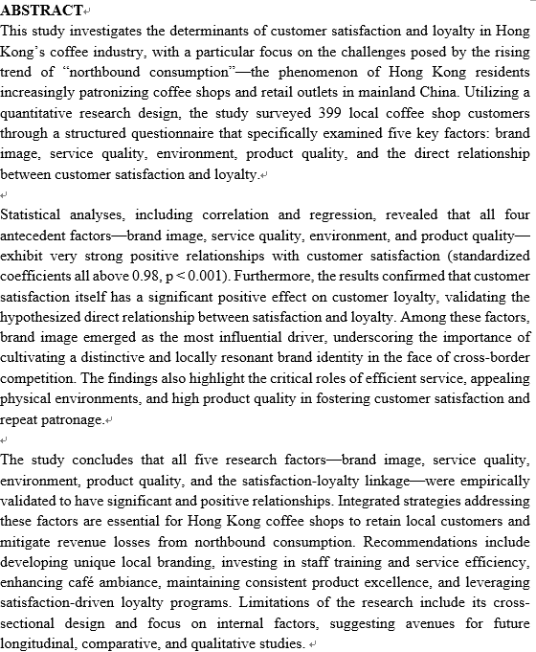

Keywords: Brand image, Service quality, Environment, Product quality, Customer satisfaction, Customer Loyalty
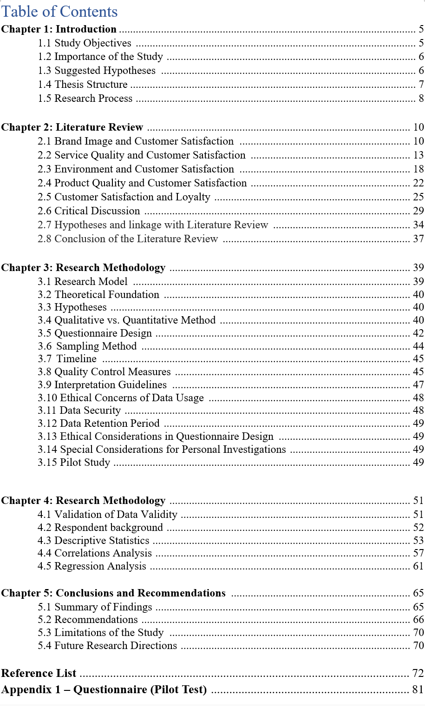

Chapter 1: Introduction

In recent years, Hong Kong’s coffee industry has been facing significant challenges due to the rise of "northbound consumption" (Savills, 2024). More and more Hong Kong residents are choosing to spend their money in mainland cities like Shenzhen and Guangzhou, attracted by lower prices and a wider variety of options. This has led to a noticeable decline in customer numbers for local coffee shops, putting pressure on their long-term survival (Savills, 2024). In 2023 alone, Hong Kong residents made around 53 million trips to mainland China, spending an estimated 86 billion RMB, which highlights the scale of spending that is leaving the city (Savills, 2024).

Several factors have contributed to this trend. High operating costs in Hong Kong, including rent and labor, make it difficult for local coffee shops to compete with the lower prices found across the border. Meanwhile, mainland coffee brands have grown rapidly and now offer more diverse and innovative products, leading some consumers to feel that Hong Kong coffee shops offer less value for money, with shortcomings in service, product innovation, and ambiance. The COVID-19 pandemic has further changed consumer behavior, with people now placing greater emphasis on value, convenience, and unique experiences. As a result, coffee shops must adapt by better understanding what drives customer satisfaction and loyalty. In response to these challenges, many local businesses are turning to CRM systems to improve customer relationships and enhance their competitiveness (Multiable, 2024).

1.1 Study Objectives
The study aims to explore the complex relationship between customer satisfaction and loyalty in Hong Kong's coffee industry. It poses several research questions:

Is there a significant relationship between customer satisfaction and loyalty among coffee shop patrons in Hong Kong? This question examines whether higher customer satisfaction correlates with increased loyalty, providing evidence for coffee shop owners on the importance of maintaining satisfaction to foster loyalty.

What factors of customer satisfaction (e.g., product quality, service efficiency, ambiance) most influence customer loyalty? This seeks to identify which elements drive loyalty, examining product quality, service efficiency, and ambiance to understand their impact on customer experiences and repeat patronage, including marketing strategies.

How can coffee shops enhance customer satisfaction to improve loyalty among local consumers? This focuses on practical strategies for boosting satisfaction, offering recommendations for improving service quality, product offerings, and creating a welcoming environment to help retain local clientele amidst competition. Environmentally friendly options can also be explored (Thomas et al., 2021).
1.2 Importance of the Study
This study is highly significant for several reasons. First, it addresses the urgent need for local coffee shops to find effective ways to respond to changing consumer behaviors caused by northbound consumption. By examining how customer satisfaction relates to loyalty, the research aims to give coffee shop owners practical advice to improve their services, adjust product strategies, and keep local customers. Second, the study highlights that customer satisfaction is a key factor in building loyalty and seeks to find specific areas where businesses can improve to strengthen customer relationships. In a competitive market with many choices, understanding what customers want is crucial for business survival and growth. By identifying what drives satisfaction, local coffee shops can focus on actions that provide a better experience, set themselves apart from competitors, and build long-term loyalty (Budi, Syamsul and Eny 2023). Using CRM systems can also help streamline operations to reach these goals (Multiable, 2024). Finally, this research adds to the academic discussion on consumer behavior in Hong Kong’s F&B sector. By looking at the unique challenges and opportunities for coffee shops during post-pandemic recovery and changing consumer trends, the study aims to guide strategies that support sustainability and growth in the local economy. The results will benefit not only coffee shop owners but also policymakers, industry analysts, and other stakeholders who want to support the long-term success of Hong Kong’s F&B industry. The findings also have implications for the marketing mix (Salsabilah et al., 2024).

1.3 Suggested Hypotheses
There is a positive relationship between customer satisfaction and customer loyalty among coffee shop patrons in Hong Kong. As customer satisfaction increases, customers are more likely to return to the same coffee shop and recommend it to others, leading to brand loyalty, repeat business, and positive word-of-mouth referrals. Higher perceived product quality significantly boosts customer loyalty. When customers perceive high quality in taste, freshness, presentation, and premium ingredients, their loyalty to the coffee shop increases. Improvements in service efficiency will enhance customer satisfaction and loyalty. By improving service efficiency through staff training, streamlined processes, and technology, customer satisfaction rises. Factors like waiting times, order accuracy, and staff attentiveness influence satisfaction and loyalty. Brand image is also important (Suprayogi, et al. 2024).

Five key concepts are as below:
Brand Image and Customer Satisfaction: The perception of a brand significantly influences customer satisfaction levels (Wijaya, 2018). A strong brand image can create positive associations that enhance overall satisfaction.

Service Quality and Customer Satisfaction: High service quality is essential for achieving high levels of customer satisfaction. Factors such as reliability, responsiveness, assurance, empathy, and tangibles play crucial roles in shaping customers' experiences.

Environment and Customer Satisfaction: The physical environment where services are delivered impacts customer perceptions significantly (Anjarsari et al., 2018). Factors such as ambiance, cleanliness, layout, and comfort all contribute to the overall customer experience.
Product Quality and Customer Satisfaction: Product quality is a fundamental determinant of customer satisfaction (Astuti et al, 2021). Attributes such as taste, freshness, presentation, and the use of high-quality ingredients directly affect how customers perceive their experience at a coffee shop.

Customer Satisfaction and Loyalty: There is a well-established link between customer satisfaction and loyalty (Budi Utami, M. Syamsul Hidayat, Eny Setyariningsih, 2023). Satisfied customers are more likely to exhibit repeat purchasing behavior and recommend the brand to others.

1.4 Thesis Structure
This thesis is structured into five chapters to provide a comprehensive analysis of customer satisfaction and loyalty in Hong Kong's coffee industry.

Chapter 1: Introduction. This chapter provides an overview of the study, including the background, importance, objectives, research questions, and hypotheses. It sets the context for the research and highlights the significance of understanding customer behavior in the face of "northbound consumption." It also outlines the key concepts and the chapter structure of the thesis.

Chapter 2: Literature Review. This chapter will delve into existing scholarly articles and studies related to brand image, service quality, environmental factors, product quality, customer satisfaction, and customer loyalty. The goal is to identify research gaps.

Chapter 3: Research Methodology. This chapter will detail the research design, including the quantitative methods used for data collection and analysis. It will outline the questionnaire design, sampling method, data collection process, and statistical tests employed to test the hypotheses. Ethical considerations and the pilot study will also be discussed.

Chapter 4: Findings and Discussions. This chapter will present the results obtained from the data analysis. It will include a statistical interpretation of the survey results and a discussion on how the findings align with or contradict existing literature.

Chapter 5: Conclusions and Recommendations. This chapter will summarize the key findings and draw conclusions based on the data analysis. It will provide recommendations for improving customer satisfaction and loyalty in Hong Kong's coffee industry, as well as discuss the limitations of the study and directions for future research.
1.5 Research Process
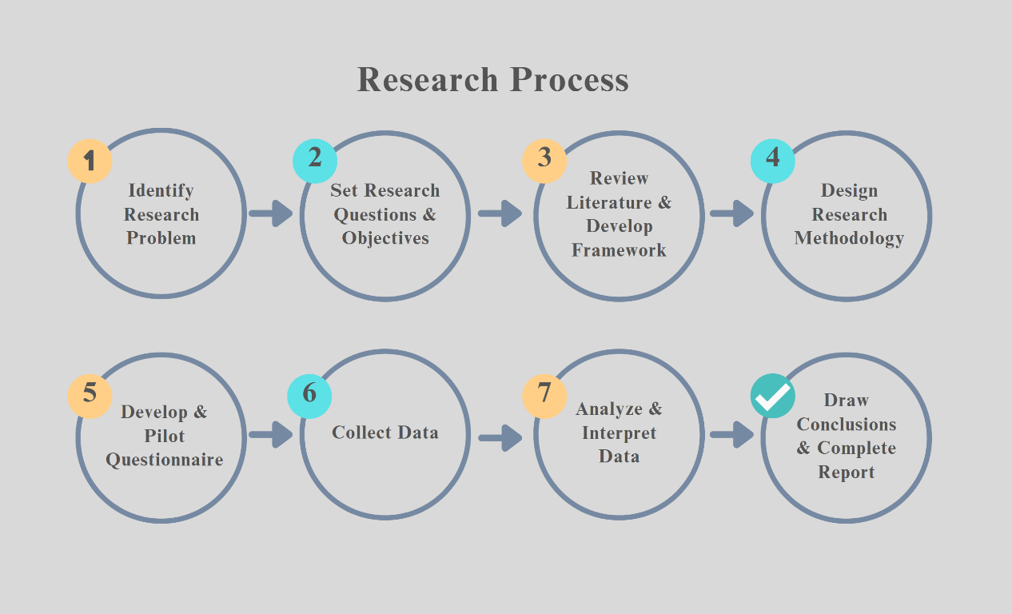
The research process for this study is structured into eight systematic stages, as illustrated in the diagram above. Each stage is designed to ensure a logical and rigorous approach to investigating the research problem:

    - Identify Research Problem:
The process begins by clearly defining the research problem, which in this study focuses on how northbound consumption affects Hong Kong coffee shops, particularly in terms of customer satisfaction and loyalty.

    - Set Research Questions & Objectives:
Specific research questions and objectives are formulated to guide the investigation, emphasizing the relationships between satisfaction, loyalty, and the five key factors.

    - Review Literature & Develop Framework:
A comprehensive literature review is conducted to understand existing knowledge and theories related to the research topic. This step also involves developing a conceptual framework to guide hypothesis formulation.

    - Design Research Methodology:
The appropriate research methodology is selected, with this study adopting a quantitative approach using structured questionnaires and stratified random sampling.

    - Develop & Pilot Questionnaire:
The survey instrument is developed based on the conceptual framework. A pilot test is conducted to ensure the reliability and clarity of the questionnaire items.

    - Collect Data:
Data is collected by distributing the finalized questionnaire to a representative sample of Hong Kong coffee shop customers.

    - Analyze & Interpret Data:
The collected data is analyzed using statistical software (e.g., SPSS) to perform descriptive, reliability, correlation, and regression analyses. The results are interpreted to test the research hypotheses.

    - Draw Conclusions & Complete Report:
The final stage involves drawing conclusions based on the findings, making recommendations for coffee shop operators, and compiling the results into a comprehensive research report or thesis.

Chapter 2: Literature Review

The coffee industry in Hong Kong is facing challenges as consumers increasingly travel to mainland China for their needs, putting pressure on local coffee shops to retain customers. Understanding the factors influencing customer satisfaction and loyalty is crucial for developing strategies to improve retention and encourage local consumption.

This chapter reviews literature on the relationship between customer satisfaction and loyalty in the coffee industry, focusing on five key factors: brand image, service quality, environment, product quality, and the direct link between satisfaction and loyalty.

2.1 Brand Image and Customer Satisfaction
Brand image plays a pivotal role in shaping customer perceptions and behaviors. It reflects the beliefs and associations that customers hold about a brand, which can profoundly influence their satisfaction and loyalty (Khan & Siddiqui 2024). A well-established brand image not only helps a coffee shop stand out from its competitors but also enhances its appeal, making it more attractive to customers.

2.1.1 Impact of Brand Image on Satisfaction
Numerous studies highlight the positive relationship between brand image and customer satisfaction in the coffee industry. Tarigan & Bernarto (2024) found that a strong brand image at Starbucks Coffee in Jakarta enhances customer satisfaction and encourages repeat purchases. Suprayogi et al. (2024) also demonstrated that brand image significantly improves customer satisfaction and loyalty, suggesting that coffee shops should cultivate a strong brand identity to retain customers effectively.

Erawan et al. (2024) investigated the effects of brand image and green marketing on purchasing decisions in coffee shops, with customer satisfaction as a mediating factor. Their study revealed that while brand image doesn't directly influence purchasing decisions, it significantly boosts customer satisfaction, which drives purchasing behavior. Green marketing was found to have both a direct and indirect positive impact through customer satisfaction.

In the hospitality industry, Lin et al. (2025) explored how Sustainable Development Goals (SDGs) enhance customer satisfaction and loyalty, emphasizing brand image. They found that integrating sustainable practices into the brand image positively influences customer satisfaction.

Syahputra et al. (2024) examined the impact of brand image and product quality on customer loyalty, with customer satisfaction as a mediator. Their study showed that brand image significantly affects customer satisfaction and loyalty. Although the direct effect of product quality on loyalty was insignificant, it indirectly influenced loyalty through customer satisfaction. This underscores the crucial role of customer satisfaction as a bridge between brand image, product quality, and loyalty outcomes.

In Hong Kong's coffee industry, emphasizing brand image is particularly relevant due to increasing competition from local and international brands. Establishing a strong and appealing brand image can differentiate businesses and foster customer loyalty.

Despite consistent evidence showing a positive relationship between brand image and customer satisfaction, there are limitations. Most studies are based in regions like Taiwan or Indonesia, making it challenging to apply findings directly to Hong Kong, given local consumer preferences and cross-border consumption trends. Many rely on quantitative surveys and self-reported data, which may not fully capture the reasons behind customer loyalty and can be affected by response bias. The focus is often on large international brands like Starbucks, overlooking smaller local coffee shops in Hong Kong. Additionally, while customer satisfaction is often seen as a link between brand image and loyalty, other factors like price, convenience, and social influences are not always considered. Most research is cross-sectional, lacking long-term insights into how brand image and satisfaction might change, especially in response to events like the COVID-19 pandemic. The growing importance of sustainability and green marketing is also not fully explored. Overall, while there is strong evidence that brand image positively affects customer satisfaction, these studies have regional, methodological, and conceptual gaps that need addressing, especially in Hong Kong’s coffee industry context.

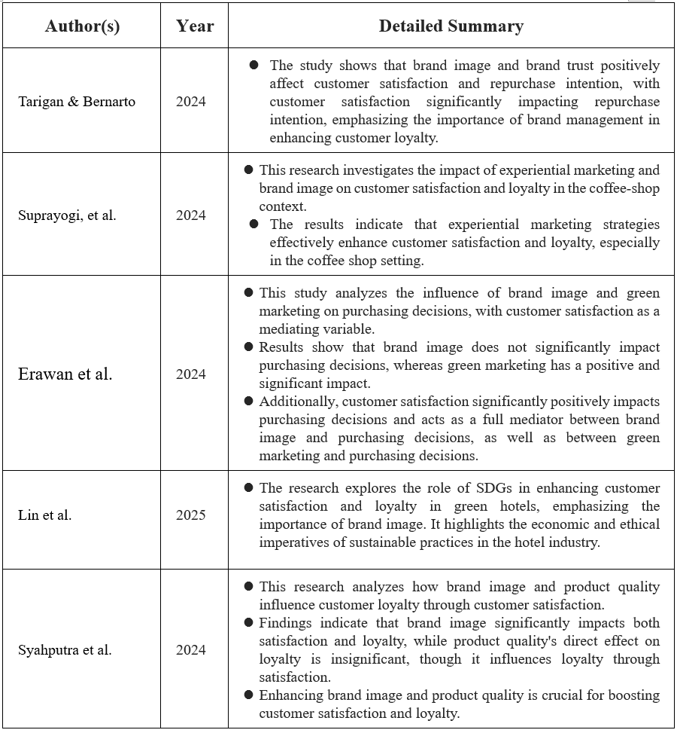
Source: Constructed by the Author
    - Factors Contributing to Brand Image
Brand image is influenced by various factors such as marketing strategies, corporate social responsibility, product quality, and customer experiences. Watson et al. (2024) found that a green brand image positively affects brand loyalty, particularly among environmentally aware consumers. Their study on fast-food brands highlights the importance of eco-friendly practices in shaping brand perception.
Tahir et al. (2024) conducted a systematic literature review and identified product quality, pricing, and advertising as key factors influencing the relationship between brand image, customer satisfaction, and loyalty. They emphasize the importance of consistent and positive brand communication in improving satisfaction and fostering loyalty.
Yusli et al. (2024) explored the connection between self-congruity, customer satisfaction, and brand loyalty in urban coffee shops. Their findings reveal that customers are more likely to remain loyal to brands that align with their self-image, which is shaped by the brand's values and image.
Although green marketing and self-congruity are gaining attention, their roles in building loyalty are not yet fully understood, especially in competitive markets like Hong Kong. More research is needed to address these gaps in understanding how to effectively build a strong, value-driven brand image that enhances customer satisfaction and loyalty.
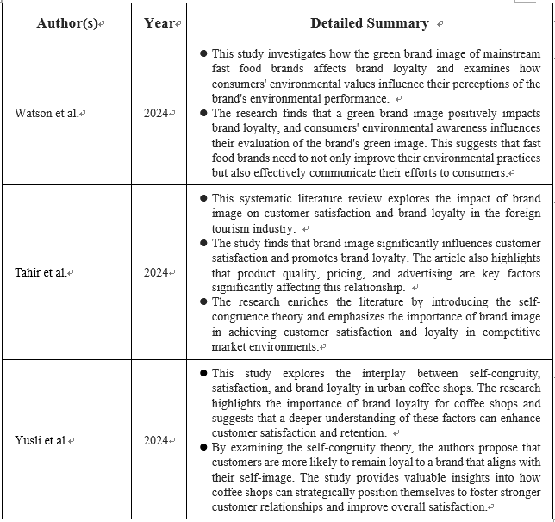
Source: Constructed by the Author
    - Brand Image in Competitive Markets
In highly competitive markets like Hong Kong, building a strong brand image is crucial for success. Sajanga et al. (2024) explored factors influencing customer satisfaction in coffee shops, highlighting product quality, service quality, and price as key determinants. Their findings show that both product and service quality significantly impact customer satisfaction, while price has a less pronounced effect. This emphasizes the need for maintaining high standards in product and service quality to enhance brand image and boost satisfaction.
Khan & Siddiqui (2024) examined the relationship between brand image, customer satisfaction, and repurchase intent, revealing that brand image plays a pivotal role in driving repurchase intent, with cultural factors acting as a moderating influence. This suggests that coffee shops in Hong Kong should consider cultural preferences when shaping their brand image to connect better with their target audience. Understanding and responding to local tastes and values is important for building loyalty. However, most studies focus on general findings and may not fully reflect the unique challenges and cultural diversity of Hong Kong’s coffee market, indicating a need for more research specific to the local context.
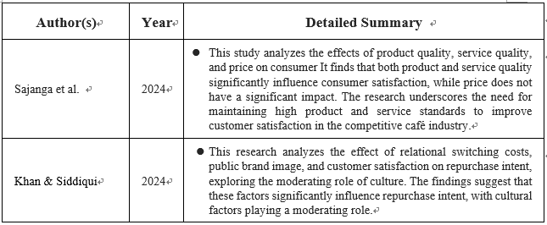
Source: Constructed by the Author

2.2 Service Quality and Customer Satisfaction
Service quality is a key factor in determining customer satisfaction, particularly in the service-driven coffee industry. Providing high-quality service not only enhances customer satisfaction but also plays a crucial role in fostering customer retention and loyalty.

2.2.1 Dimensions of Service Quality
Service quality is multi-dimensional, often assessed based on factors like reliability, responsiveness, assurance, empathy, and tangibles. In coffee shops, these dimensions translate into prompt service, knowledgeable staff, personalized attention, and a welcoming environment. Safariani et al. (2024) found that physical evidence and empathy significantly impact satisfaction at Eureka Coffee, emphasizing tangible service elements and emotional connections. Regina & Riswan (2024) confirmed that service quality positively impacts customer satisfaction at Cafe Tuan Jana Bandar Lampung, highlighting efficient service delivery's critical role.
Cindy & Zai (2023) showed that service quality significantly influences customer satisfaction and purchasing decisions, reinforcing the importance of superior service in competitive markets. Pardede et al. (2024) found that price, risk, and service quality significantly influence satisfaction in Indonesia's coffee industry, though demographics don't moderate these relationships. This supports the hypothesis that improving service efficiency enhances satisfaction and loyalty, and highlights the need for competitive pricing strategies.
Sekali (2024) found perceived quality drives revisit intentions, with product and service dimensions shaping satisfaction and trust. Komariyah (2024) noted that service quality has a stronger influence than price on satisfaction at Cobaco Coffee, with customers willing to pay more for exceptional service. This underscores the importance of investing in staff training and customer engagement in urban areas like Hong Kong.
Nabilah et al. (2024) emphasized baristas' pivotal role in delivering high-quality service, aligning with empathy and assurance dimensions. This highlights the need for comprehensive barista training to enhance service quality and foster loyalty.
Current research highlights service quality's strong influence on satisfaction but has limitations. Many studies are region-specific and may not apply to Hong Kong, where expectations differ. Research often relies on surveys, which might not capture the full range of experiences. There's a focus on broad dimensions without exploring cultural factors or local preferences. Most studies assess service quality at one point rather than over time. Limited research exists on effective training methods in Hong Kong. These gaps suggest more local, in-depth research is needed to understand and improve service quality for Hong Kong's coffee shop customers.
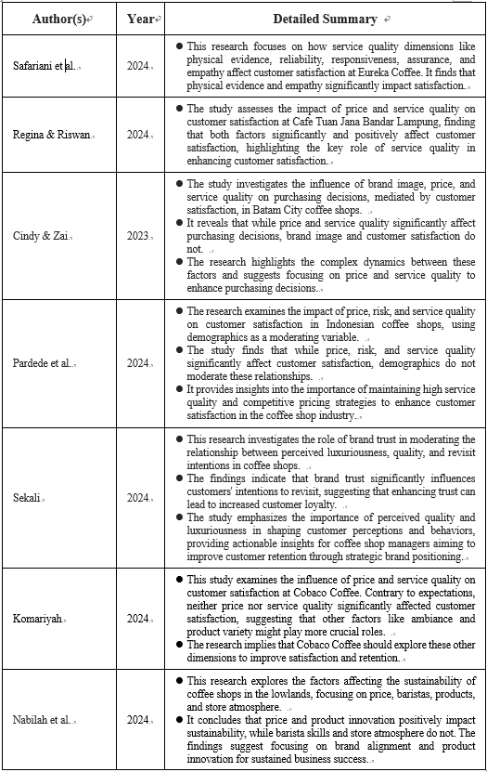
Source: Constructed by the Author

    - Service Quality and Customer Loyalty
High service quality enhances customer satisfaction and leads to customer loyalty. Thomas et al. (2021) found that service quality significantly impacts satisfaction, which affects loyalty in the Klang Valley, Malaysia. Similarly, Saputra et al. (2024) showed that improved service quality boosts both satisfaction and loyalty in coffee shops. Aditya & Wibisono (2024) used SERVQUAL and Importance Performance Analysis to identify key areas for service improvement, helping businesses enhance satisfaction and loyalty.

However, there are limitations to these findings. Much research is region-specific and might not reflect Hong Kong customers' expectations. Studies often use surveys capturing opinions at one point, missing long-term effects of service improvements on loyalty. They focus on general service quality without considering cultural differences or local market conditions that might alter customer values. Self-reported data might not fully capture why customers remain loyal.

These gaps highlight the need for more local, long-term research to understand how service quality impacts customer loyalty in Hong Kong's coffee shop market.
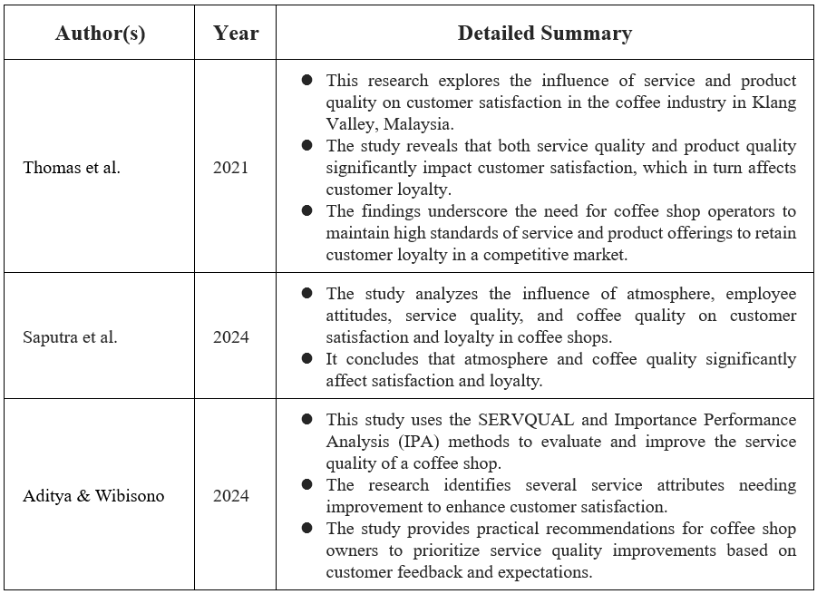
Source: Constructed by the Author

    - Improving Service Quality
Improving service quality involves understanding customer expectations and consistently meeting or exceeding them. Chizari (2024) identified key factors such as service quality, reasonable pricing, and employee treatment as critical for enhancing customer satisfaction and loyalty in Starbucks coffee shops in Turku, Finland. The study recommends focusing on staff training and service process improvements.

Furthermore, Aditya & Wibisono (2024) suggest that integrating customer feedback mechanisms can help coffee shops identify service gaps and implement necessary improvements. Continuous employee training and adopting customer-centric approaches are essential for enhancing service quality.

Although improving service quality through staff training, process improvements, and customer feedback is widely suggested, there are some clear limitations in the research. Most studies focus on big international brands or specific locations, so their findings might not fit the unique situation of Hong Kong’s coffee shops. Many recommendations are quite general and do not address local challenges, such as high staff turnover, limited resources, or cultural differences that can affect how training and feedback are used in practice. Research often relies on surveys or self-reported data, which may not show the real impact of these improvements on customer loyalty. There is also little evidence on which specific training or feedback methods work best in Hong Kong. Overall, more practical and local research is needed to understand how coffee shops in Hong Kong can effectively improve service quality and overcome common obstacles.

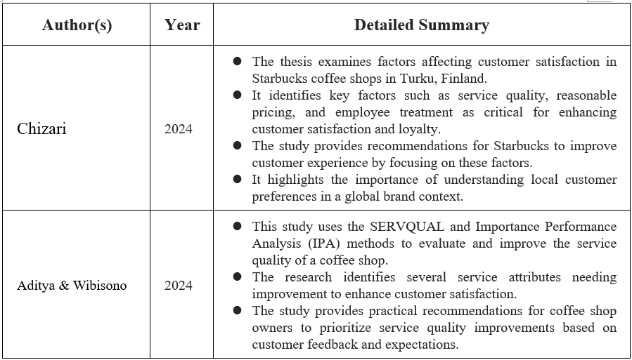
Source: Constructed by the Author
2.3 Environment and Customer Satisfaction
The physical environment of a coffee shop significantly influences customer satisfaction. The atmosphere, aesthetics, and ambiance contribute to the overall customer experience, affecting their satisfaction levels and loyalty intentions.

    - Importance of Physical Environment
Handayani et al. (2022) found that the physical environment significantly influences customer satisfaction and revisit intentions in Kintamani, Bali. Similarly, Amin et al. (2024) identified it as the most significant factor affecting satisfaction in Johor, Malaysia. Risandi et al. (2024) emphasized that a conducive environment enhances service quality's impact, suggesting an integrated approach for a holistic experience.
Sekali (2024) highlighted perceived luxuriousness as key to revisit intentions, aligning with broader literature on the importance of a compelling physical environment. Alessandro et al. (2024) confirmed that ambiance significantly influences revisit intentions, with customer satisfaction as a mediator. Nabilah et al. (2024) stressed that elements like lighting, music, and seating impact perceptions, making the environment a key differentiator.
However, there are limitations. Many studies focus on specific locations, which may not reflect Hong Kong's diverse tastes. Surveys often capture data at one point, missing long-term effects. There's little detail on which design elements matter most or how cultural factors influence preferences. Practical challenges, like renovation costs, are rarely discussed, making it difficult for smaller shops to apply findings. Self-reported data might not fully capture customer preferences.
More local, practical research is needed to understand how the physical environment can be improved in Hong Kong's coffee shops and what strategies are truly effective.
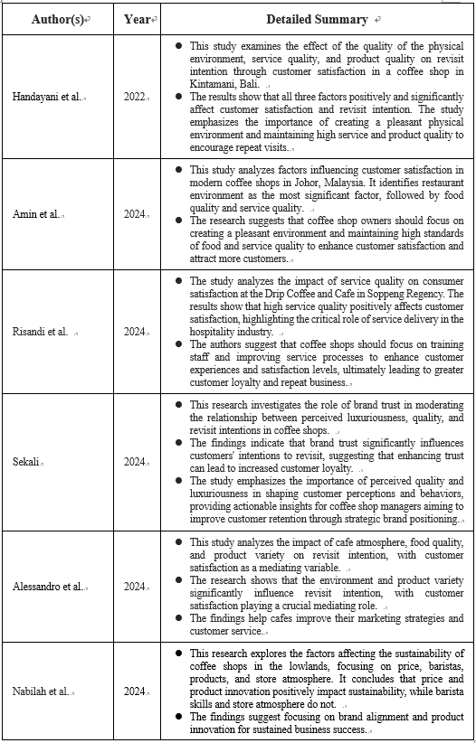
Source: Constructed by the Author

    - Elements of a Positive Environment
Several elements contribute to a positive coffee shop environment, including interior design, lighting, music, cleanliness, and seating comfort. Saputra et al. (2024) found that atmosphere and coffee quality significantly impact satisfaction and loyalty, highlighting the need for a holistic approach. Ania et al. (2024) noted that younger consumers prioritize ambiance, emphasizing its role in shaping experiences.
Amin et al. (2024) discovered that while premium services are expected, an overemphasis on ambiance without addressing core service elements can negatively impact satisfaction. This suggests that a balanced approach is essential.
However, most research is limited by focusing on specific locations or customer groups, which may not reflect Hong Kong's preferences. Studies often rely on self-reported surveys, missing deeper insights into customer choices and not identifying which features matter most. There is little discussion on how local culture, space, or budget constraints affect coffee shops' capabilities. Some findings suggest that focusing too much on ambiance can backfire if basic service or product quality is neglected.
These gaps highlight the need for more local and practical research to understand what truly works in Hong Kong’s coffee shop market.
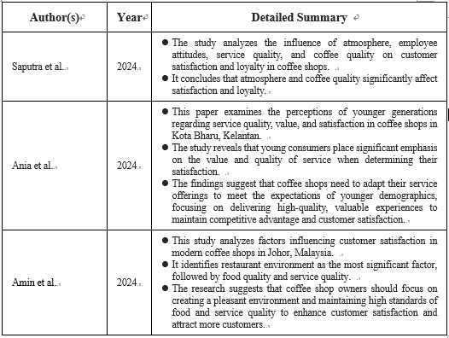
Source: Constructed by the Author
    - Environment as a Competitive Advantage
In a competitive market like Hong Kong, the environment can be a key differentiator for coffee shops. Yusli et al. (2024) found that customers are more loyal to brands aligning with their self-image, often shaped by the shop's atmosphere. Rudy & Novenson (2024) highlighted that a positive store atmosphere significantly impacts satisfaction and loyalty, suggesting a focus on enhancing the physical environment.
Suprayogi et al. (2024) emphasized the role of experiential marketing and brand image in boosting satisfaction and loyalty. Their study shows that sensory, emotional, cognitive, and relational experiences, along with a strong brand image, foster long-term loyalty.
However, most research is limited by focusing on specific regions or brands, which may not reflect Hong Kong's unique preferences and challenges. Self-reported surveys might miss deeper motivations behind loyalty and fail to identify which environmental aspects matter most. There is also little discussion on practical issues like cost and space constraints in creating unique experiences.
These gaps highlight the need for more local and practical research to understand what truly drives customer loyalty through environment and experience in Hong Kong’s coffee shop market.
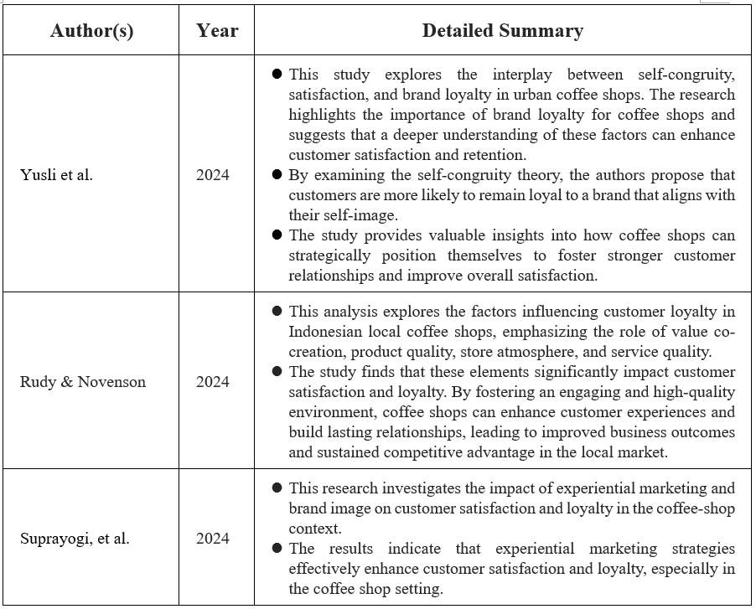
Source: Constructed by the Author

2.4 Product Quality and Customer Satisfaction
Product quality is a fundamental determinant of customer satisfaction in the coffee industry. High-quality products meet or exceed customer expectations, leading to increased satisfaction and fostering customer loyalty.

    - Impact of Product Quality on Satisfaction
Astuti et al. (2021) found that product quality significantly impacts customer loyalty, with satisfaction as a key mediator. Firmansyah & Pradana (2023) noted that taste, aroma, and presentation enhance satisfaction, fostering loyalty. Risandi et al. (2024) emphasized that service quality complements product quality, ensuring a positive overall experience.
Salsabillah et al. (2024) showed that product quality, service, pricing, and location all contribute to satisfaction. Doeim et al. (2022) confirmed that product quality predicts satisfaction and repeat patronage across cultures. Anisa & Nurhayati (2024) demonstrated that product quality has a stronger impact on satisfaction than price, using SEM analysis.
Nabilah et al. (2024) highlighted product quality as essential for satisfaction and business sustainability, aligning with broader literature.
However, most research is limited by regional focus, small sample sizes, and reliance on self-reported data. These studies may not fully capture Hong Kong's preferences or the interplay between product quality and other factors like service. Mixed findings suggest the need for more local, detailed research to understand how product quality drives satisfaction and loyalty in Hong Kong’s coffee shops.

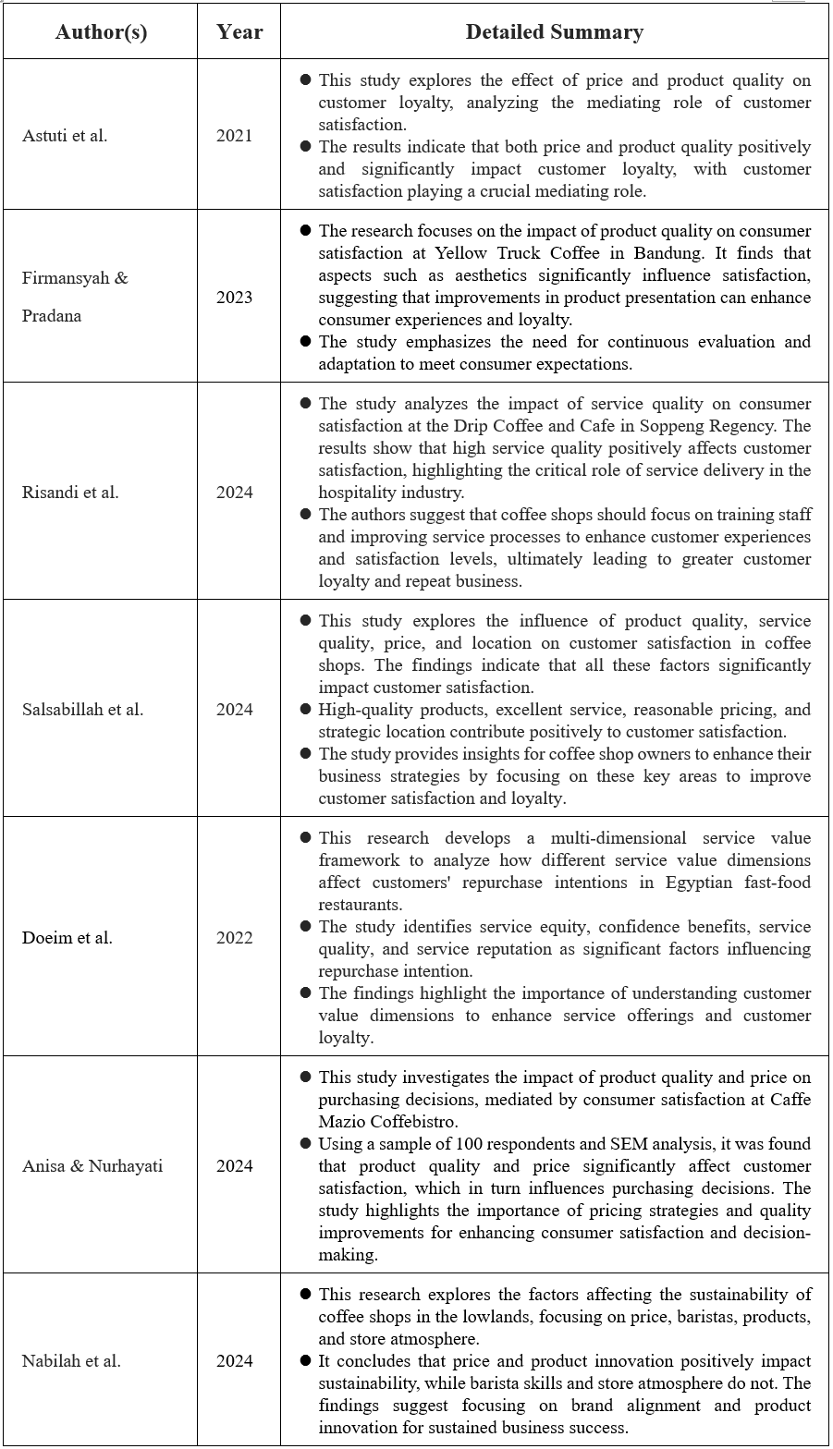
Source: Constructed by the Author
    - Elements of Product Quality

Product quality in coffee shops includes taste, freshness, presentation, variety, and consistency. Alessandro et al. (2024) found that product variety significantly influences revisit intention, emphasizing diverse, high-quality offerings. Pambudi et al. (2024) noted that both coffee and food quality impact satisfaction and loyalty, suggesting comprehensive product strategies boost loyalty.

Seo (2024) identified key satisfaction drivers in Japan's e-commerce market, like "gift" and "sales/discounts," showing the importance of aligning products with consumer preferences. Sekali (2024) highlighted brand trust as critical for loyalty and revisit intentions, acting as a mediator between perceived quality and revisit intentions.

However, most research is limited by regional focus and self-reported surveys, which may not fully capture Hong Kong's preferences. Studies often lack detail on which aspects of product quality matter most and rarely address practical challenges like maintaining consistency or balancing quality with cost.

More local and practical research is needed to understand what aspects of product quality truly drive satisfaction and loyalty in Hong Kong’s coffee shop market.

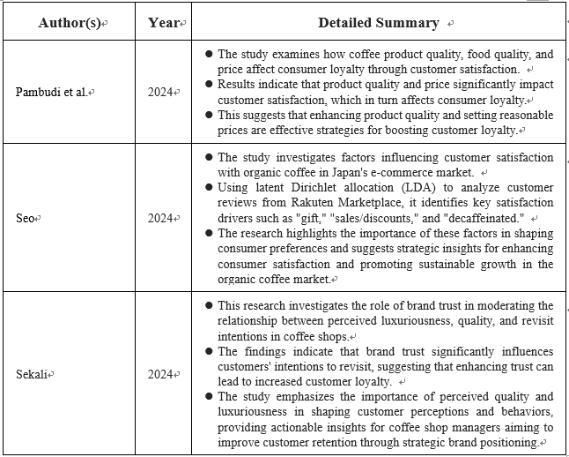
Source: Constructed by the Author
    - Product Innovation and Adaptation
In a dynamic market, continuous product innovation and adaptation are crucial for maintaining customer interest and satisfaction. Rusti et al. (2021) emphasized the importance of product innovations to enhance customer satisfaction in the Industry 4.0 era. Hallencreutz et al. (2024) found that product quality is a key driver of satisfaction even during crises, highlighting the need for consistent quality and innovative offerings.

However, most research on product innovation in coffee shops focuses on specific regions or larger markets, which may not fully apply to Hong Kong. Studies often overlook practical challenges like limited resources, high costs, or the risk of new products not matching local tastes. There is also little discussion on balancing innovation with consistent quality or effectively using customer feedback for new ideas.

More local and practical research is needed to understand how product innovation can best support customer satisfaction in Hong Kong’s coffee shop market. This research should address local tastes, resource constraints, and strategies for gathering customer feedback to drive innovation effectively.

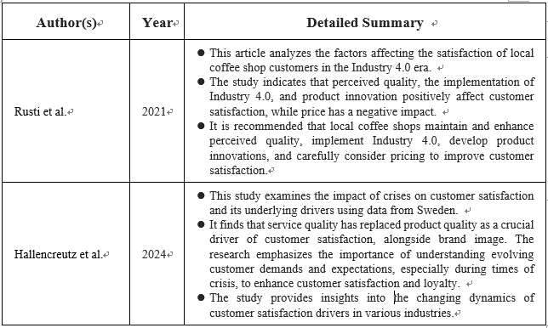
Source: Constructed by the Author

2.5 Customer Satisfaction and Loyalty
Customer satisfaction is directly linked to customer loyalty. Satisfied customers are more likely to return, make repeat purchases, and recommend the business to others (Adeleke, 2019). Understanding this relationship is vital for coffee shops aiming to retain customers and enhance local consumption.

    - Role of Customer Satisfaction in Loyalty
Xu et al. (2022) found that customer satisfaction significantly impacts brand loyalty in time-honored restaurants, highlighting the importance of enhancing satisfaction to foster loyalty. Doeim et al. (2022) emphasized customer satisfaction's role in improving service offerings and loyalty through a multi-dimensional service value framework. Kholifah et al. (2024) identified customer satisfaction as a crucial mediator in the relationship between customer relationship marketing, brand image, and loyalty.

However, research on satisfaction and loyalty often focuses on specific industries or regions, which may not fully reflect Hong Kong's coffee shop dynamics. Studies frequently rely on self-reported surveys, potentially missing the deeper reasons behind customer loyalty or brand switching. There's limited exploration of factors like cultural influences, local competition, or digital loyalty programs that might affect the satisfaction-loyalty relationship.

To better understand how satisfaction drives loyalty in Hong Kong’s coffee shop industry, more local and practical research is needed. This research should consider unique market dynamics, cultural factors, and effective strategies for leveraging customer satisfaction to enhance loyalty.

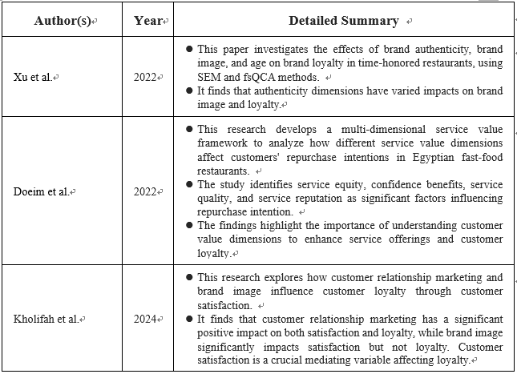
Source: Constructed by the Author
    - Satisfaction-Loyalty Relationship in Coffee Shops
Adeleke (2019) highlighted key marketing strategies for coffee shops, emphasizing customer satisfaction to sustain operations. Rudy & Novenson (2024) identified value co-creation, product quality, and store atmosphere as critical to customer loyalty in Indonesian coffee shops. Suardi et al. (2024) found that product quality and pricing significantly influence satisfaction, while service quality and halal labels have less impact, reinforcing the satisfaction-loyalty link.

Fajrin & Aprianingsih (2024) used the 7Ps framework to analyze customer satisfaction, loyalty, and retention. They found that price, people, process, and physical evidence significantly impact satisfaction, with a strong correlation between satisfaction, loyalty, and retention. This emphasizes the need for seamless customer experiences through well-trained staff, efficient processes, and appealing environments, particularly relevant in Hong Kong's competitive market.

However, many studies focus on specific regions or groups, which may not reflect Hong Kong's unique market dynamics. Research often relies on self-reported surveys or short-term data, lacking insight into long-term satisfaction-loyalty relationships. There's limited analysis of how different factors interact to influence satisfaction across diverse customer segments. Practical challenges, like implementing loyalty programs or delivering personalized experiences, are also underexplored.

To truly understand how satisfaction drives loyalty in Hong Kong coffee shops, more local, long-term, and practical research is needed. This research should identify effective strategies for sustaining repeat business and addressing the unique challenges of the Hong Kong market.

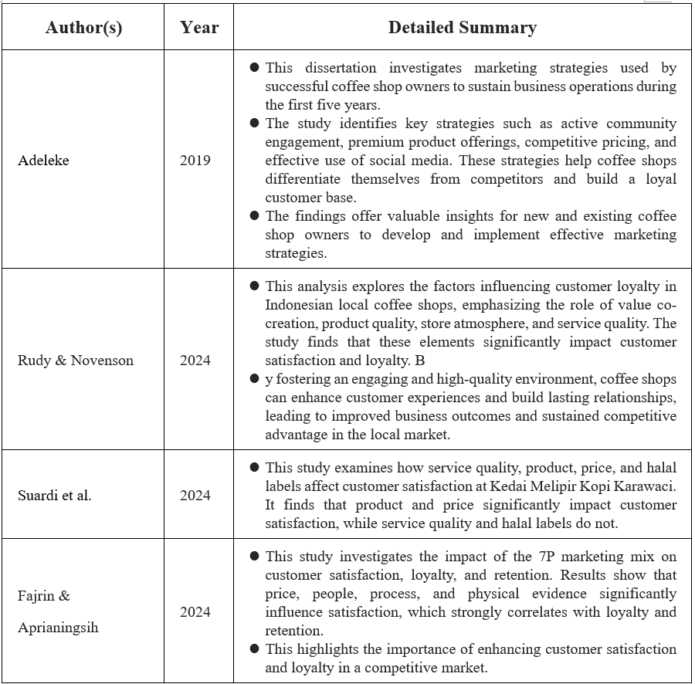
Source: Constructed by the Author

    - Enhancing Customer Loyalty through Satisfaction
Aditya & Wibisono (2024) used the SERVQUAL model and Importance Performance Analysis to enhance service quality, boosting customer satisfaction and loyalty. Tarigan & Bernarto (2024) emphasized building brand trust and a positive brand image to increase satisfaction and encourage repurchase intentions. Effective customer relationship management and delivering consistent value are key strategies.

However, research often focuses on general strategies like personalization, consistent quality, and brand trust, with limitations. Many studies are based on other regions or large chains, which may not fully apply to Hong Kong’s unique market or smaller independent shops. Reliance on self-reported surveys may not capture actual customer behavior or long-term loyalty. There's also limited discussion on practical challenges like resource constraints, staff turnover, or implementing these strategies effectively in a competitive environment.

To better understand which loyalty-building approaches work best for Hong Kong’s coffee shops, more local and practical research is needed. This research should address specific market dynamics, practical implementation challenges, and strategies tailored to the local context.

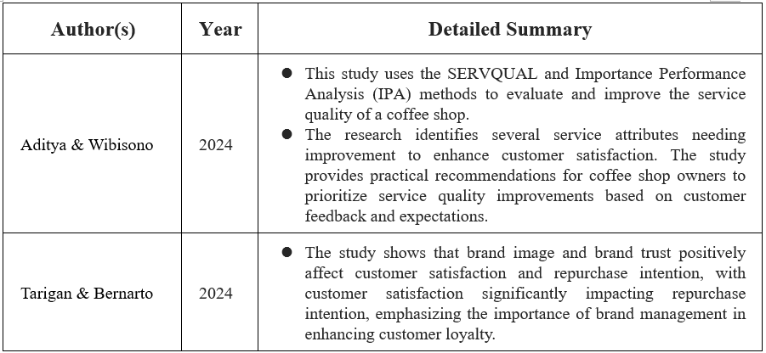
Source: Constructed by the Author

2.6 Critical Discussion
In reviewing the literature on customer satisfaction and loyalty within the coffee industry, several key themes emerge that align with the proposed hypotheses of this study. The factors of brand image, service quality, environment, and product quality consistently show significant influence on customer satisfaction, which in turn affects customer loyalty.

    - Evaluating the Relationship between Customer Satisfaction and Loyalty
Suprayogi et al. (2024) showed that experiential marketing and brand image significantly influence satisfaction and loyalty in coffee shops, reinforcing that satisfied customers are more likely to remain loyal and recommend the brand. Suhada and Mansur (2024) reviewed models to enhance loyalty, emphasizing service quality, product satisfaction, price perception, emotional connection, and technological innovations like loyalty programs. They advocate for a holistic approach integrating traditional and digital strategies.
However, much research is based on other regions or large brands, which may not fully apply to Hong Kong's market. Studies often rely on surveys and self-reported data, potentially missing actual customer behavior or long-term loyalty. There's limited exploration of how digital loyalty programs or emotional connections function in practice, especially for smaller, independent shops. Practical challenges like the cost and complexity of integrating strategies are rarely addressed.
To better understand the connection between satisfaction and loyalty in Hong Kong’s coffee shop industry, more local and practical research is needed. This research should focus on specific market dynamics, effective implementation of strategies, and addressing challenges unique to the local context.
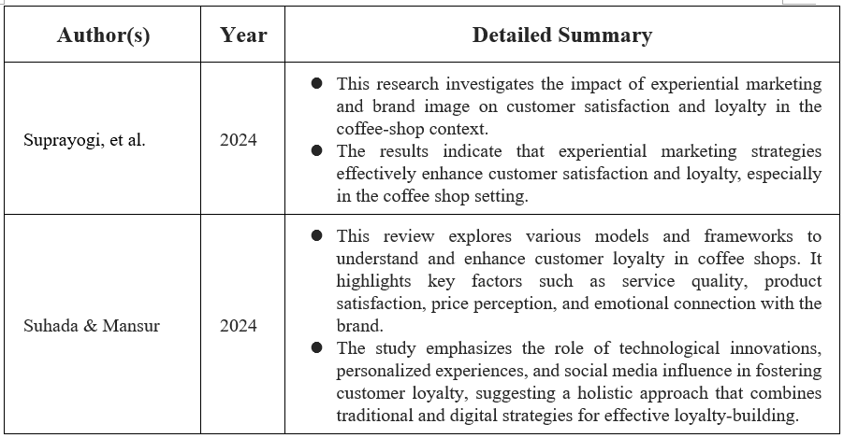
Source: Constructed by the Author

    - The Impact of Product Quality on Satisfaction and Loyalty
The literature highlights the crucial role of product quality in influencing customer satisfaction and loyalty. Doeim et al. (2022) found that both service and product quality drive repurchase intentions in Egyptian fast-food restaurants, suggesting similar principles apply to the coffee industry. Hallencreutz et al. (2024) showed that product quality remains a key determinant of customer satisfaction, even during crises.
However, much of this research is based on other regions or different types of food businesses, which may not fully apply to Hong Kong’s coffee shop market. Studies often rely on self-reported surveys, potentially missing real customer behavior or long-term loyalty insights. There's also limited discussion on the practical challenges of maintaining high product quality in a busy and competitive environment.
To better understand how product quality affects satisfaction and loyalty in Hong Kong’s coffee shops, more local and practical research is needed. This research should address specific market dynamics and explore effective strategies for maintaining quality amidst local challenges.
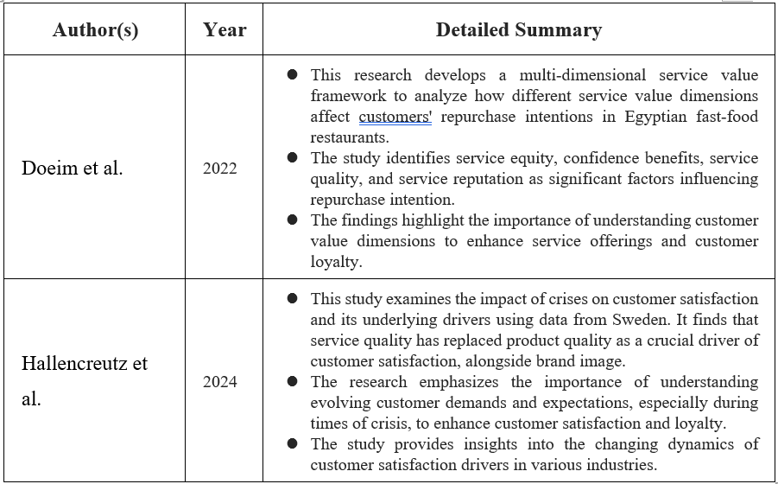
Source: Constructed by the Author

    - The Influence of Service Efficiency on Satisfaction and Loyalty
Service efficiency is a critical aspect of service quality that directly affects customer satisfaction. Studies by Tarigan and Bernarto (2024) show that service quality positively affects customer satisfaction and repurchase intention, emphasizing the importance of efficient service delivery. In the context of the Hong Kong coffee industry, enhancing service efficiency could be a strategic move to increase customer satisfaction and encourage customers to remain loyal, despite competitive alternatives.
Most research on service efficiency and its impact on satisfaction is based on other markets or large brands, so the findings may not fully reflect the unique pace and expectations in Hong Kong’s coffee shop scene. Studies often use self-reported surveys, which might not capture real wait times or how customers actually respond to delays. There is also limited discussion about the practical challenges of improving efficiency, such as staff shortages, high turnover, or the costs of new technology. More local and practical research is needed to understand how service efficiency can best be improved and sustained in Hong Kong’s competitive coffee industry.

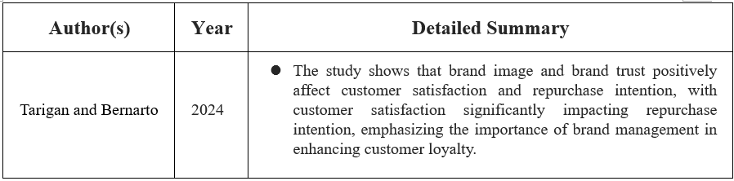
Source: Constructed by the Author

    - Integrating Brand Image, Environment, and Other Factors

While product quality and service efficiency are crucial, factors like brand image and environment also significantly impact customer satisfaction and loyalty. Cindy & Zai (2023) found that brand image affects customer satisfaction but not directly purchasing decisions, suggesting its influence varies with market conditions. Seo (2024) highlighted that aligning products with customer values, such as offering organic coffee, can enhance brand image and satisfaction, indicating that brand image aligned with preferences can influence loyalty.

Environmental factors, as discussed by Nor et al. (2024), also play a role in customer satisfaction. Their study found that atmosphere can have a negative impact, emphasizing the complexity of customer perceptions and the importance of understanding target market preferences.

However, much research on brand image, environment, and their effects on satisfaction and loyalty is based on other regions or specific market segments, which may not fully apply to Hong Kong’s coffee shop scene. Studies often show mixed results, with some finding little or negative impact if factors are not aligned with customer expectations. There's limited exploration of how these elements interact with local preferences, pricing, or operational challenges. Research rarely addresses how coffee shops can balance investments in brand image or environment with constraints like budget or space.

To better understand how these factors influence satisfaction and loyalty in Hong Kong’s coffee market, more local and practical studies are needed. This research should focus on local preferences, effective strategies for aligning brand image and environment with customer expectations, and addressing practical challenges.
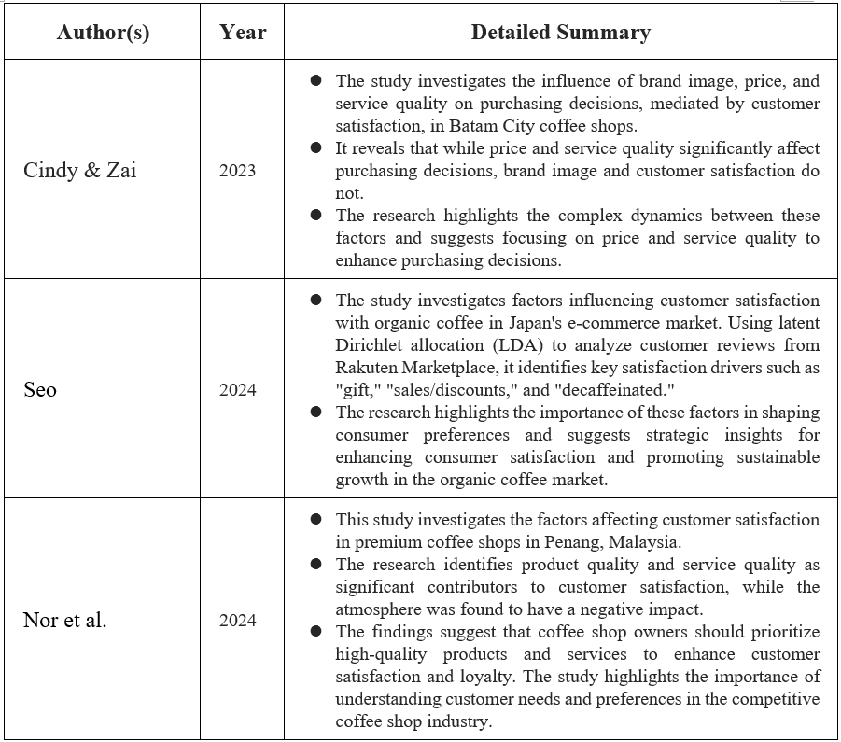
Source: Constructed by the Author

    - Contradictions and Gaps in the Literature

While there is a general consensus on the factors influencing customer satisfaction and loyalty, some studies offer contradictory findings. For instance, Cindy & Zai (2023) found that brand image does not have a significant impact on purchasing decisions, which challenges other research that highlights the critical role of brand image in driving customer behavior.

There are contradictions and gaps in the current literature on customer satisfaction and loyalty in coffee shops. Some studies find that brand image has little or no impact on purchasing decisions, while others view it as a key factor, showing that results are not always consistent. Much of the research is limited to certain regions or customer groups, so findings may not fully apply to Hong Kong’s market. There is also a lack of studies that look at how different factors interact together or change over time. Most research relies on surveys and does not explore the deeper reasons behind customer choices or the long-term effects of different strategies. Overall, more local, in-depth, and holistic research is needed to address these contradictions and fill the gaps in understanding customer satisfaction and loyalty.

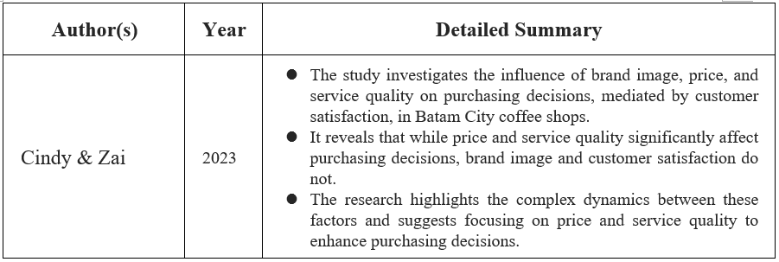
Source: Constructed by the Author

2.7 Hypotheses and linkage with Literature Review
In response to the growing trend of Hong Kong consumers traveling to mainland China for their coffee and other consumption needs, local coffee shop operators face unprecedented challenges in retaining their customer base. This shift has underscored the importance of understanding the key factors that drive customer satisfaction and, in turn, foster customer loyalty—both of which are essential for sustaining the local coffee industry. Grounded in a comprehensive review of existing studies, this research proposes to empirically examine how five core determinants—brand image, service quality, environment, product quality, and the direct satisfaction-loyalty linkage—influence Hong Kong coffee shop customers.

Building upon the insights found in recent literature, these hypotheses will investigate whether enhancing brand perception, improving service and shop environment, and delivering high-quality products can significantly elevate satisfaction and subsequently increase customer loyalty. The following hypotheses are formulated to address these factors, each supported by scholarly findings relevant to the Hong Kong coffee shop context.

H1: A stronger brand image significantly increases customer satisfaction among Hong Kong coffee shop patrons.
This hypothesis proposes that cultivating a positive brand image—through values, sustainability, or cultural alignment—directly enhances customer satisfaction. Existing research demonstrates that brand image acts as a critical differentiator in competitive markets, shaping customer perceptions and behaviors (Tarigan & Bernarto, 2024). Suprayogi et al. (2024) found that experiential marketing and brand image collectively boost satisfaction and loyalty, while Syahputra et al. (2024) confirmed that brand image significantly impacts satisfaction even when product quality does not. In Hong Kong, where cross-border competition intensifies, a compelling brand image (e.g., emphasizing local identity or sustainability) could help retain customers by fostering emotional connections and trust (Watson et al., 2024; Yusli et al., 2024).

The hypothesis that a stronger brand image increases satisfaction aligns with findings by Tarigan & Bernarto (2024), who demonstrated that brand image positively influences satisfaction and repurchase intentions at Starbucks. Suprayogi et al. (2024) further reinforced this by showing that experiential marketing combined with brand image elevates satisfaction and loyalty. However, Erawan et al. (2024) noted that brand image does not directly drive purchases but enhances satisfaction, which mediates loyalty—a critical insight for Hong Kong’s competitive market. Syahputra et al. (2024) explicitly linked brand image to satisfaction in their BSI Mobile Application study, validating H1’s focus on brand distinctiveness as a retention tool against cross-border alternatives.

H2: Higher perceived service quality significantly improves customer satisfaction in Hong Kong coffee shops.
This hypothesis emphasizes service quality—encompassing efficiency, staff empathy, and reliability—as a key driver of satisfaction. Safariani et al. (2024) identified physical evidence (e.g., clean facilities) and empathetic service as critical for satisfaction, while Komariyah (2024) found service quality to exert a stronger influence than pricing. For Hong Kong, where service speed and personalization are highly valued, improving staff training and process efficiency could address gaps highlighted by Pardede et al. (2024). Nabilah et al. (2024) further stressed baristas’ role in shaping satisfaction through personalized interactions, suggesting that service quality improvements may offset price sensitivity.

H2’s emphasis on service quality is supported by Safariani et al. (2024), who identified empathy and physical evidence (e.g., clean facilities) as key satisfaction drivers. Komariyah (2024) found service quality to outweigh pricing impacts, aligning with Hong Kong’s high service expectations. Nabilah et al. (2024) highlighted baristas’ role in personalized service, while Pardede et al. (2024) confirmed service quality’s direct satisfaction impact, irrespective of demographics. These studies justify prioritizing staff training and efficiency improvements to retain local customers.

H3: A more attractive and comfortable coffee shop environment elevates customer satisfaction in Hong Kong.
This hypothesis posits that ambiance—including design, seating comfort, and sensory elements—directly impacts satisfaction. Handayani et al. (2022) confirmed that physical environments significantly drive revisit intentions via satisfaction, while Alessandro et al. (2024) linked café atmosphere to loyalty through satisfaction. However, Amin et al. (2024) noted that overemphasis on ambiance without core service quality risks dissatisfaction, underscoring the need for balance. In Hong Kong’s dense urban setting, creating “third-place” environments (e.g., cozy, tech-friendly, or culturally resonant spaces) could counteract the appeal of mainland China’s larger, cheaper cafés (Nor et al., 2024; Sekali, 2024).

H3’s focus on ambiance is corroborated by Handayani et al. (2022), who tied physical environments to revisit intentions via satisfaction. Alessandro et al. (2024) similarly linked café atmosphere to loyalty through satisfaction. However, Amin et al. (2024) cautioned that overemphasizing ambiance without core service quality risks dissatisfaction—a nuance critical for Hong Kong’s compact shops. Nabilah et al. (2024) emphasized store atmosphere’s role in branding, suggesting that “third-place” environments (e.g., cozy, culturally resonant spaces) could counter mainland China’s larger cafés.

H4: Higher perceived product quality leads to greater customer satisfaction in Hong Kong coffee shops.
This hypothesis asserts that superior coffee, food, and consistency directly enhance satisfaction. Astuti et al. (2021) identified product quality as the strongest mediator of loyalty, while Firmansyah and Pradana (2023) highlighted taste, aroma, and presentation as critical. For Hong Kong’s discerning consumers, niche offerings (e.g., specialty brews, organic beans) could leverage findings from Seo (2024), where product alignment with values (e.g., sustainability) drives satisfaction. Salsabillah et al. (2024) further emphasized that quality must be paired with strategic pricing and location—key considerations in Hong Kong’s high-rent market.

H4’s assertion that product quality drives satisfaction is validated by Astuti et al. (2021), who found quality to be the strongest mediator of loyalty. Firmansyah & Pradana (2023) identified taste, aroma, and presentation as key attributes, while Salsabillah et al. (2024) stressed that quality must align with pricing and location—a challenge in Hong Kong’s high-rent market. Seo (2024) added that niche offerings (e.g., organic coffee) align with customer values, reinforcing H4’s applicability to Hong Kong’s discerning consumers.

H5: Enhancing customer satisfaction significantly boosts loyalty among Hong Kong coffee shop customers.
This hypothesis reaffirms satisfaction as the linchpin of loyalty. Suprayogi et al. (2024) demonstrated that satisfaction mediates relationships between experiential marketing/brand image and loyalty, while Saputra et al. (2024) found satisfaction directly increases repurchase intent. In Hong Kong’s context, where customers have ample alternatives, loyalty programs (Suhada & Mansur, 2024) or hyper-personalized experiences (Chizari 2024) could amplify satisfaction’s impact. Fajrin and Aprianingsih (2024) also linked satisfaction to retention through holistic 7Ps strategies (e.g., seamless processes, tech integration), aligning with local preferences for convenience.

H5’s direct satisfaction-loyalty relationship is strongly supported by Suprayogi et al. (2024), who showed satisfaction mediates experiential marketing/brand image effects on loyalty. Saputra et al. (2024) confirmed satisfaction’s direct impact on repurchase intent, while Fajrin & Aprianingsih (2024) tied satisfaction to retention via 7Ps strategies (e.g., tech integration, staff training). Suhada & Mansur (2024) emphasized loyalty programs as accelerators—key for Hong Kong’s price-sensitive, alternative-rich market.

2.7.1 Interconnected Rationale
These hypotheses collectively address Hong Kong’s unique challenge: retaining customers amid northbound consumption. By strengthening brand distinctiveness (H1), refining service and ambiance (H2–H3), ensuring product excellence (H4), and leveraging satisfaction-loyalty dynamics (H5), coffee shops can create compelling reasons for patrons to choose local cafés over cross-border alternatives. The literature underscores the need for integrated strategies—e.g., a sustainability-focused brand image paired with barista training and premium products—to holistically elevate satisfaction and loyalty.

2.8 Conclusion of the Literature Review
In summary, the literature reviewed provides robust evidence that customer satisfaction and loyalty in the coffee shop industry are shaped by a constellation of interrelated factors—namely, brand image, service quality, environment, product quality, and the direct satisfaction-loyalty link. Across diverse contexts, research consistently demonstrates that a strong brand image enhances customer perceptions and encourages repeat patronage (Tarigan & Bernarto, 2024; Suprayogi et al., 2024), while excellent service quality and an appealing physical environment are crucial for delivering positive customer experiences (Safariani et al., 2024; Handayani et al., 2022). Product quality remains a fundamental determinant of satisfaction, with its influence further amplified by the consistency and variety offered (Astuti et al., 2021; Salsabillah et al., 2024).

Importantly, the direct relationship between satisfaction and loyalty is repeatedly highlighted, underscoring the need for coffee shop operators to prioritize holistic strategies that address both tangible and intangible elements of the customer experience (Fajrin & Aprianingsih; 2024, Saputra et al., 2024). The literature supports the hypotheses that improving brand image, service quality, environment, and product quality can each significantly enhance customer satisfaction, which subsequently drives loyalty and repeat visits.
However, several studies also point to the complex interplay among these factors and suggest that their relative importance may shift across different markets, customer segments, and competitive landscapes. Contradictory findings regarding the direct impact of brand image or environment highlight the necessity for context-specific research—especially in a highly competitive and unique market like Hong Kong, where cross-border consumption is reshaping consumer preferences.

Overall, this body of literature lays a strong theoretical foundation for investigating the determinants of customer satisfaction and loyalty in Hong Kong’s coffee industry. It also identifies actionable areas for local operators to address as they seek to retain customers and sustain their businesses amidst evolving market challenges. The insights gained from this review will inform the subsequent empirical analysis and guide recommendations tailored to the unique dynamics of Hong Kong’s coffee shop sector.

Chapter 3: Research Methodology

This study explores the intricate relationship between customer satisfaction and loyalty within Hong Kong's coffee industry, with a particular emphasis on addressing the challenges posed by cross-border consumption to mainland China. The research methodology outlined in this chapter provides a systematic approach to analyzing how various factors influence customer satisfaction and subsequently affect customer loyalty. By identifying key drivers of satisfaction, the study aims to develop actionable strategies that can help coffee shops in Hong Kong enhance customer retention and maintain competitiveness in the regional market.

3.1 Research Model

The research model for this study adopts a causal-predictive approach to investigate the relationships between key variables that influence customer satisfaction and loyalty in Hong Kong's coffee industry. This model is grounded in an extensive literature review that identified five critical factors: brand image, service quality, environment, product quality, and the direct relationship between customer satisfaction and loyalty. These factors are widely recognized in consumer behavior studies as essential determinants of satisfaction and loyalty across various service industries.

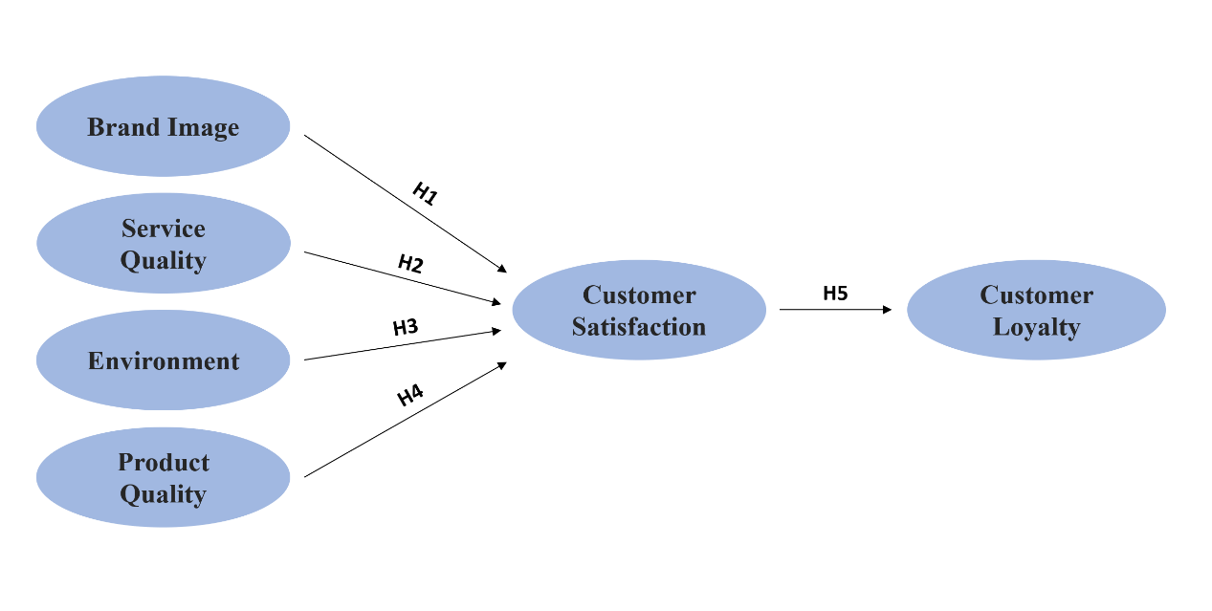
Source: Constructed by the author.

The conceptual framework posits that brand image, service quality, environment, and product quality serve as independent variables that directly impact customer satisfaction, which in turn influences customer loyalty as the dependent variable (Chen & Wang, 2016). This framework allows researchers to examine both direct and indirect relationships between these variables, providing a holistic understanding of how different aspects of the coffee shop experience contribute to customer retention. For example, a positive brand image may not only enhance customer satisfaction but also strengthen emotional connections with the brand, thereby fostering loyalty.
Establishing a clear conceptual framework is crucial for quantitative studies as it provides direction for data collection and analysis while facilitating the interpretation of results within the context of existing knowledge (Rashid et al., 2021). The proposed framework draws from social exchange theory, which suggests that customers develop loyalty based on satisfactory experiences perceived as valuable exchanges. This theory has been widely applied in service industries to explain how mutual benefits between businesses and customers lead to long-term relationships (Syahputro et al., 2022).

3.2 Theoretical Foundation
The research model is underpinned by consumer behavior theory and relationship marketing principles. Relationship marketing emphasizes the importance of building long-term relationships with customers by enhancing satisfaction, which ultimately drives loyalty and profitability. This perspective is particularly relevant to Hong Kong's coffee industry, where businesses face challenges such as cross-border consumption trends. Lemon and Verhoef (2016) highlight the significance of understanding customer experiences throughout their journey, emphasizing that satisfaction and loyalty are shaped by consistent and positive interactions across multiple touchpoints.
Additionally, the model incorporates the concept of customer experience as a multidimensional construct that includes sensory, emotional, and cognitive responses to service encounters. Tian (2022) argues that these experiential dimensions play a critical role in influencing customer satisfaction and subsequent loyalty behaviors, such as advocacy and repurchase intentions. For example, sensory elements like store ambiance or product presentation can evoke emotional responses that strengthen customer attachment to a brand.

3.3 Hypotheses
Based on the research model and literature review, this study proposes Five main hypotheses:

H1: A stronger brand image significantly increases customer satisfaction among Hong Kong coffee shop patrons.

H2: Higher perceived service quality significantly improves customer satisfaction in Hong Kong coffee shops.

H3: A more attractive and comfortable coffee shop environment elevates customer satisfaction in Hong Kong.

H4: Higher perceived product quality leads to greater customer satisfaction in Hong Kong coffee shops.

H5: Enhancing customer satisfaction significantly boosts loyalty among Hong Kong coffee shop customers.

3.4 Qualitative vs. Quantitative Method
This study employs a quantitative research approach to examine the relationships between the identified variables. A quantitative methodology was selected because it allows for the statistical testing of hypotheses, measurement of relationships between variables, and generalization of findings to a broader population. Creswell (2018) explains that quantitative research is ideal for testing objective theories by examining relationships among variables, which can be measured numerically and analyzed using statistical procedures.
Quantitative methods are particularly valuable when the research aims to identify patterns, test theories, and establish relationships between predefined variables. This aligns with the objectives of this study, which seeks to examine the relationship between customer satisfaction and loyalty based on factors such as brand image, service quality, environment, and product quality.

While qualitative research could offer deep insights into customer perceptions and experiences, it would not enable statistical validation of relationships between variables or testing of hypotheses across a large sample. Joshi et al. (2024) highlight that quantitative approaches are preferred when the goal is to establish generalizable patterns and test predefined theoretical relationships in consumer behavior research.
The quantitative approach also facilitates comparison with previous studies in the field, many of which have adopted similar methodologies. This enhances the contribution of this research to the existing body of knowledge on customer satisfaction and loyalty in the service industry, particularly in the context of cross-border consumption challenges.

3.5 Questionnaire Design
The questionnaire for this study was designed based on the theoretical framework and findings from the literature review. It incorporates established scales and measures adapted to the specific context of Hong Kong's coffee industry. The questionnaire consists of several sections addressing the main variables: brand image, service quality, environment, product quality, customer satisfaction, and customer loyalty.

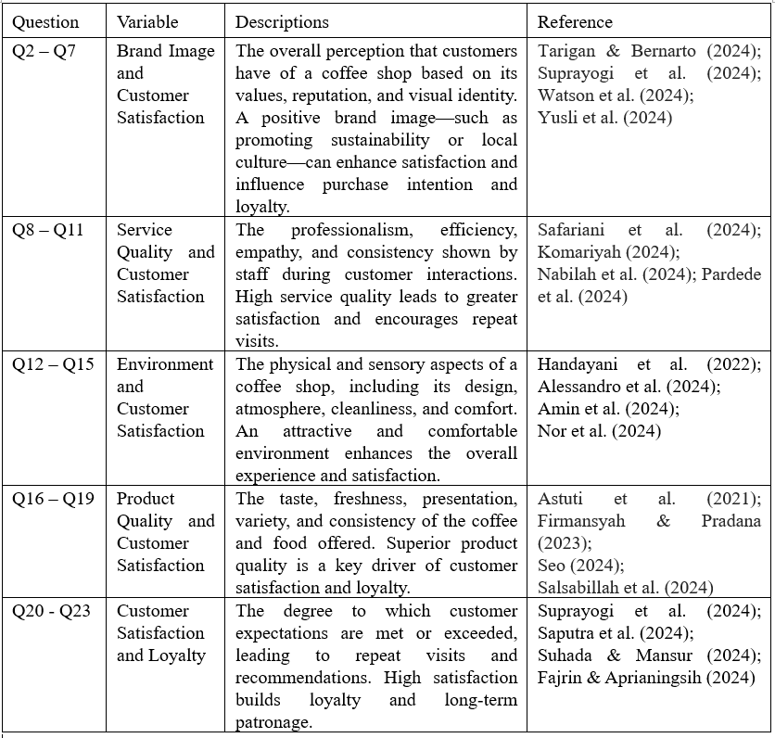
Source: Constructed by the Author

3.5.1 Structure and Measurement Scales
The questionnaire employs a 5-point Likert scale for all main constructs. Likert scales are widely used in customer satisfaction research because they allow respondents to express varying degrees of agreement or disagreement with statements. Joshi et al. (2024) explain that Likert scales are effective for measuring attitudes, perceptions, and behavioral intentions in consumer research.

Each of the five main factors—brand image, service quality, environment, product quality, and satisfaction/loyalty—is measured using at least three items to ensure construct validity and reliability. Multi-item measures are preferred for complex constructs because they offer higher content validity and internal consistency compared to single-item measures (Creswell & Creswell, 2018)1. This approach ensures that each construct is comprehensively assessed while mitigating potential biases from outlier responses.

3.5.2 Questionnaire Content
The questionnaire begins with screening questions to ensure respondents have recently patronized coffee shops in Hong Kong. The first question acts as a filter: "Have you visited a coffee shop in Hong Kong within the past three months?" Respondents who answer "No" will be excluded from the analysis, as they do not meet the basic criteria for participation.

The main sections of the questionnaire are structured as follows:
Section 1: Brand Image
This section includes items such as "This coffee shop has a positive reputation," "This coffee shop's brand represents high quality," and "This coffee shop's brand values align with my personal values." These items are adapted from established scales used in previous research on brand image in the service industry (Lacap & Sicat, 2022).

Section 2: Service Quality
Items in this section measure aspects such as service promptness, staff knowledge and courtesy, and personalized attention. Examples include "Staff members provide prompt service," "Staff members are knowledgeable about coffee products," and "Staff members make an effort to understand my specific needs." These measures are based on the SERVQUAL dimensions established by Parasuraman et al. (1988) and adapted for the coffee shop context (Ramdani & Saad, 2023).

Section 3: Environment
This section assesses the physical environment of coffee shops, including ambiance, cleanliness, and comfort. Sample items include "The coffee shop has a pleasant atmosphere," "The seating arrangement is comfortable," and "The interior design is visually appealing." These items draw from research on servicescape and its impact on customer experience (Han & Ryu, 2009).

Section 4: Product Quality
Items measuring product quality focus on taste, freshness, consistency, variety, and presentation. Examples include "The coffee tastes excellent," "Food and beverage products are fresh," and "The menu offers a good variety of choices." These measures are adapted from previous studies on product quality in the food and beverage industry (Ramdani & Saad, 2023).

Section 5: Customer Satisfaction and Loyalty
This section includes items such as "I am satisfied with my overall experience at this coffee shop," "This coffee shop meets my expectations," and "My experiences at this coffee shop have been pleasant." These measures align with established approaches to measuring customer satisfaction in service settings (Fornell et al., 1996).

Items in this section also assess behavioral and attitudinal aspects of loyalty, including repurchase intentions, willingness to recommend, and resistance to switching. Examples include "I intend to visit this coffee shop again," "I would recommend this coffee shop to friends and family," and "I would choose this coffee shop even if others are more convenient." These measures are based on established loyalty scales (Lacap & Sicat, 2022).

Section 6: Personal Information
The final section collects demographic data such as age, gender, education level, occupation, and frequency of coffee shop visits. This information will be used for descriptive analysis and potential segmentation of results.

3.5.3 Pilot Test and Validation
The questionnaire underwent a rigorous development process, including review by academic experts in marketing and consumer behavior to ensure content validity. The feedback from these experts was incorporated to refine the questions and ensure they accurately measure the intended constructs. This approach aligns with best practices in survey development as outlined by Messick's validity framework (Messick, 1995).

3.6 Sampling Method
Target Population and Sampling Frame
The target population for this study consists of adult residents of Hong Kong who have visited a coffee shop at least once in the past twelve months. This definition ensures that participants have recent experience with coffee shops in Hong Kong and can provide relevant responses to the survey questions.

3.6.1 Sample Size Determination
To determine the appropriate sample size for this study, the Cochran formula was applied. This formula is widely recognized for calculating sample sizes in survey research, especially for large populations (Uakarn et al., 2021). The formula is:

Where:
- nn: sample size
- ZZ: z-value for the desired confidence level
- pp: estimated proportion of the population having the attribute
- q=1−pq=1−p: complement of pp
- ee: desired level of precision (margin of error)
For this study, the following parameters were used:
- Confidence level: 95% (Z=1.96Z=1.96)
- Estimated proportion (pp): 0.5 (to maximize sample size as recommended by Cochran)
- Margin of error (ee): ±5% or 0.05
Substituting these values into the formula:
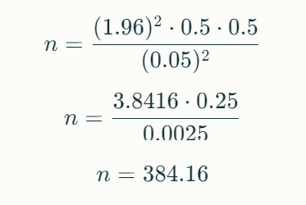
Thus, a minimum sample size of 385 respondents is required to achieve a 95% confidence level with a margin of error of ±5%. This calculation aligns with methodological guidelines for quantitative research (Uakarn et al., 2021).

3.6.2 Sampling Technique
This study will employ a stratified random sampling technique to ensure representativeness across key demographic variables such as age groups, gender, and income levels. Stratification enhances the validity of results by proportionally representing subgroups within the population (Mokoginta et al., 2022).

3.7 Timeline
3.7.1 Survey Administration
The survey will be administered online using Google Forms, which provides cost-effectiveness and efficient data collection. The design and validation of the questionnaire follow best practices in survey methodology (Septiana & Zaim, 2023).

Distribution channels include:
Social media platforms (Facebook, Instagram)

3.7.2 Timeline and Resource Allocation
The data collection process will follow a carefully planned timeline:
Week 1-2: Finalization of questionnaire and preparation of online/offline survey materials
Week 3: Pilot testing and questionnaire refinement
Week 4-7: Main data collection period
Week 8: Data cleaning and preparation for analysis

3.8 Quality Control Measures
To ensure data integrity, quality control measures will be implemented throughout the data collection process. Daily monitoring of response patterns will be conducted to detect any unusual trends or inconsistencies. Additionally, 10% of responses will be randomly selected for cross-validation through follow-up verification. These steps are designed to maintain high data quality and reliability for the study.

As noted by Israel (1992), "Rigorous quality control procedures are essential for maintaining data integrity in survey research, particularly when multiple data collection methods are employed." These measures will help ensure that the data collected is reliable and valid for subsequent analysis.

3.8.1 Proposed Statistical Tests, Objectives, and Interpretation
The data analysis process will employ several statistical techniques to address the research objectives and test the hypotheses. All analyses will be conducted using SPSS (Statistical Package for the Social Sciences), which is widely recognized as a powerful and flexible tool for quantitative data analysis. For detailed guidance on SPSS usage, one can refer to free online tutorials such as those provided by Kent State University (Kent State University, n.d.).

3.8.1.1 Descriptive Statistics
Descriptive statistics will be calculated for all variables to provide a comprehensive overview of the data and sample characteristics. This analysis will include frequency distributions for categorical variables such as demographic information, as well as measures of central tendency (mean, median, mode) for Likert-scale items. Measures of dispersion, including standard deviation and range, will be used to assess variability, while skewness and kurtosis will be examined to evaluate the normality of the data distribution.

The objective of descriptive statistics is to summarize the data and identify any patterns or trends that might inform subsequent analyses. As noted by iMotions (2024), "Descriptive analysis provides valuable insights into the survey findings, helping researchers understand the data's basic features."

3.8.1.2 Reliability and Validity Assessment
Before proceeding with the main analyses, the reliability and validity of the measurement scales will be assessed. First, Cronbach’s alpha coefficients will be calculated for each multi-item scale to evaluate internal consistency reliability, with a threshold of 0.7 set as the minimum acceptable value (Scribbr, 2025). Next, exploratory factor analysis (EFA) will be conducted to examine the construct validity of the scales and ensure that items load appropriately on their intended factors. Principal component analysis with varimax rotation will be employed, and factors will be extracted based on eigenvalues greater than 1.0. Finally, confirmatory factor analysis (CFA) will be used to further assess the validity of the measurement model, evaluating convergent and discriminant validity through average variance extracted (AVE) and composite reliability (CR) measures.

These assessments are crucial for ensuring that the constructs are measured accurately and reliably, which is a prerequisite for meaningful hypothesis testing.

3.8.1.3 Correlation Analysis
Pearson correlation analysis will be conducted to examine the bivariate relationships between all main variables in the study (brand image, service quality, environment, product quality, customer satisfaction, and customer loyalty). This analysis will provide initial insights into the strength and direction of relationships between variables before more complex modeling.

The objective of correlation analysis is to assess the degree of association between variables without implying causation. As noted by Indeed (2025), "Correlation analysis serves as an important preliminary step in understanding the network of relationships among variables before building more sophisticated causal models".
Correlation coefficients will be interpreted using established guidelines: 0.00–0.19 indicates a very weak correlation, 0.20–0.39 represents a weak correlation, 0.40–0.59 denotes a moderate correlation, 0.60–0.79 signifies a strong correlation, and 0.80–1.00 reflects a very strong correlation. These thresholds provide a standardized framework for evaluating the strength of relationships between variables in the analysis.

3.8.1.4 Regression Analysis
Multiple regression analysis will be the primary method for testing the hypotheses and examining the relationships between the variables. Simple linear regression will be used to test H1, examining the relationship between customer satisfaction (independent variable) and customer loyalty (dependent variable), with the objective of determining whether customer satisfaction significantly predicts loyalty and quantifying the strength of this relationship. Multiple regression analysis will be employed to test H2 and H3, examining how product quality and service efficiency contribute to customer satisfaction. The model will also include brand image and environment as additional predictors, allowing for a comprehensive assessment of all factors influencing satisfaction. Furthermore, hierarchical regression analysis will be conducted to examine the mediating role of customer satisfaction in the relationship between the predictors (brand image, service quality, environment, product quality) and customer loyalty, enabling the assessment of both direct and indirect effects of the independent variables on loyalty.

The regression models will be evaluated using multiple criteria to ensure robust analysis. R² and adjusted R² values will assess model fit and explanatory power, with adjusted R² accounting for the number of predictors to avoid overfitting. F-statistics will evaluate the overall significance of the models by comparing the explanatory power of the full model against an intercept-only model. Standardized beta coefficients will enable comparison of predictors' relative importance across different measurement scales. t-statistics and p-values will determine the statistical significance of individual predictors, testing whether each coefficient differs significantly from zero. Variance Inflation Factors (VIF) will check for multicollinearity, ensuring predictor independence by quantifying how much the variance of coefficients is inflated by correlated variables. As noted by Kent State University (n.d.), this multifaceted approach provides a rigorous framework for analyzing variable relationships while controlling for confounding factors.

3.9 Interpretation Guidelines
The interpretation of statistical results will follow these guidelines, statistical significance will be established at the conventional threshold of p < 0.05; effect sizes will be reported and interpreted to assess practical significance; confidence intervals (95%) will be calculated for all key parameters; and results will be interpreted in light of the theoretical framework and previous research.

As noted by Ferguson (2012), publication bias is a significant issue in psychological research, emphasizing the need to consider effect sizes and theoretical context when interpreting results.

3.10 Ethical Concerns of Data Usage
This study conducted a questionnaire survey in an individual capacity and used Google Forms as the primary data collection tool. The following are the ethical considerations and data usage for individual questionnaire surveys, which are specifically in line with Hong Kong legal requirements and practices, and are intended to protect the privacy of participants and ensure data security.

3.10.1 Informed Consent
Before the questionnaire began, all participants were presented with a clear informed consent statement. This statement included the purpose of the study, which is to explore the relationship between customer satisfaction and loyalty in coffee shops in Hong Kong. Participants were informed of their rights, including the right to withdraw from the survey at any time without any negative consequences. It was clearly stated that the data would only be used for academic research and would not be used for commercial purposes or shared with third parties. Additionally, the researcher’s contact information was provided for participants to ask questions or request data withdrawal.

According to the Personal Data (Privacy) Ordinance (PDPO) of Hong Kong, informed consent is an important step in protecting the rights of respondents (Privacy Commissioner for Personal Data, n.d.).

To protect the privacy of participants, this study took several data anonymization measures. The questionnaire was designed to avoid collecting personally identifiable information such as name, telephone number, or email address. The “Do not collect email addresses” option in Google Forms was enabled to ensure participants remained anonymous when submitting their surveys. The data collected contained only demographic information (e.g., age group, gender, consumption frequency) and was further anonymized during analysis.

Anonymization is in line with the PDPO’s “data minimization principle”, which means only collecting the minimum data necessary to complete the research (Privacy Commissioner for Personal Data, n.d.).

3.11 Data Security
When using the Google Forms platform to conduct questionnaires, data security is the primary consideration. To ensure data security, the following measures are taken:

3.11.1 Encrypted Transmission
All data is transmitted encrypted via the HTTPS protocol, which uses SSL (Secure Sockets Layer) encryption to secure the communication between users and Google’s servers. This prevents unauthorized third parties from intercepting or tampering with the information being exchanged (123 Form Builder, n.d.).

3.11.2 Secure Storage
Google’s cloud servers utilize robust encryption mechanisms to ensure data storage security. Data collected through Google Forms is stored on these secure servers, which employ multiple layers of encryption, including AES-256 for data at rest (Dito, 2020).

3.11.3 Access Control
Only the researcher has access to the collected raw data, and a strong password is set to prevent unauthorized access. Sharing settings can be adjusted to permit access to specific individuals (123 Form Builder, n.d.).

3.11.4 Avoid Using Public Computers
All data processing is done on private computers to prevent data leakage due to possible security loopholes in public computers.

3.12 Data Retention Period
In accordance with the requirements of the Hong Kong Personal Data (Privacy) Ordinance, this study will follow the following data retention policy: raw data will only be retained for 12 months after the study is completed, after which it will be permanently deleted. The anonymized analysis results can be stored for a long time to facilitate further academic discussion in the future. This policy aims to balance the need for data use with the protection of participant privacy. According to the PDPO, data users must take all practicable steps to ensure that personal data is not kept longer than is necessary for the fulfillment of the purpose for which the data is used (Privacy Commissioner for Personal Data, n.d.).

3.13 Ethical Considerations in Questionnaire Design
Questions were kept simple and clear, using short sentences and avoiding complicated wording. The questionnaire was designed to be completed within 5–10 minutes to respect participants’ time. All questions use neutral language and avoid leading participants toward certain answers. Each question focuses on a single topic, with complex ideas separated into individual questions. Questions are grouped by topic (e.g., brand image, service quality) and arranged from general to specific. Sensitive or personal questions are placed at the end to minimize discomfort. Everyday language is used, and technical terms are avoided. The survey is mobile-friendly so participants can answer on any device. No names, emails, or phone numbers are collected. Google Forms’ “Do Not Collect Email” feature ensures anonymity. All data is anonymized during analysis.

  - Special Considerations for Personal Investigations
This study committed clearly explains that this is a personal research project, not linked to any institution or commercial interest. I commit to following Hong Kong laws and international research ethics, taking full responsibility for protecting participant rights, adhering to standards such as the Declaration of Helsinki (World Medical Association, 2024). In summary, this questionnaire was carefully designed with participants’ privacy, comfort, and rights in mind, ensuring ethical and responsible research practices throughout the study.

3.15 Pilot Study
A pilot study will be conducted before the main data collection to assess the feasibility of the research design, test the data collection instruments, and identify any potential issues that need to be addressed. Pilot studies are crucial for refining research instruments and procedures, particularly in survey research where question wording and format can significantly impact response patterns (Indeed, 2025).

A pilot test was conducted with 20 respondents, and SPSS reliability analysis (Cronbach’s Alpha) was performed for each section of the questionnaire as follow:

Section 1: Brand Image and Customer Satisfaction
The Cronbach’s Alpha increased significantly to 0.983 after removing Q7, indicating that Q7 negatively affected internal consistency. This item may have been ambiguously worded or not fully aligned with the construct being measured. Remove Q7 from this section.

Section 2: Service Quality and Customer Satisfaction
Deleting Q5 increased the Cronbach’s Alpha to 0.988. Q5 showed a much lower corrected item-total correlation than the other items, suggesting that it did not fit well with the other questions. Remove Q5 from this section.

Section 3: Environment and Customer Satisfaction
Similarly, removing Q5 raised the Cronbach’s Alpha to 0.988, with Q5 displaying a low item-total correlation. This suggests Q5 may be poorly phrased or measuring a different aspect. Remove Q5 from this section.

Section 4: Product Quality and Customer Satisfaction
The reliability improved (Cronbach’s Alpha = 0.988) when Q5 was removed. Again, Q5 had a much lower correlation with the scale total compared to the other items, indicating it was inconsistent. Remove Q5 from this section.

Section 5: Customer Satisfaction and Loyalty
Cronbach’s Alpha also increased to 0.988 after removing Q5, which again had the lowest corrected item-total correlation. Remove Q5 from this section.

Conclusion:
Based on the pilot test (N=20), it is recommended to delete Q7 from Section 1, and Q5 from Sections 2, 3, 4, and 5. Removing these items will significantly improve the internal consistency and reliability of my questionnaire.

Chapter 4: Findings and Discussions

In this chapter, we present our study's findings on customer satisfaction and loyalty in Hong Kong's coffee industry. Understanding these dynamics is vital for developing strategies to retain local customers, especially given the impact of cross-border consumption. Using charts and tables from SPSS data analysis, we interpret results through descriptive statistics, reliability tests, correlation, and regression analyses.

We explore how brand image, service quality, environment, and product quality affect customer satisfaction and loyalty, comparing findings with existing literature to validate hypotheses. This examination aims to offer actionable recommendations for enhancing customer satisfaction and loyalty, thereby boosting local consumption.

For the formal questionnaire analysis, we use average values to gain a comprehensive view of responses and trends. This approach minimizes outliers' effects, providing stable and representative results. By comparing section averages, we identify areas needing improvement, enhancing the questionnaire's effectiveness. This method quantifies opinions and supports future decision-making.

4.1 Validation of Data Validity
A total of 399 valid responses were collected for the formal questionnaire in this study. Before analysis, various measures were taken to ensure the data possessed a high degree of validity.

Firstly, the questionnaire design underwent a rigorous literature review and was revised based on 20 pilot tests, removing questions that affected reliability. The internal consistency (Cronbach’s Alpha) of all research constructs (such as brand image, service quality, environment, product quality, satisfaction, and loyalty) exceeded 0.97, far above the academic standard of 0.7, indicating high reliability. The data is suitable for more in-depth analyses like correlation and regression.

Furthermore, the questionnaire employed stratified random sampling, covering participants of different ages, genders, and income backgrounds. The sample structure closely resembles the demographic characteristics of Hong Kong, demonstrating high representativeness. Additionally, the descriptive statistics and correlation analyses of various variables align with expected theoretical relationships, reinforcing the structural validity of the data.

In summary, through scientific design, rigorous testing, and technical checks, the data collected in this study is proven to have good reliability and validity, providing a solid foundation for subsequent analysis and hypothesis testing.

4.2 Respondent background
The Respondent background of the survey respondents is summarized as follows:
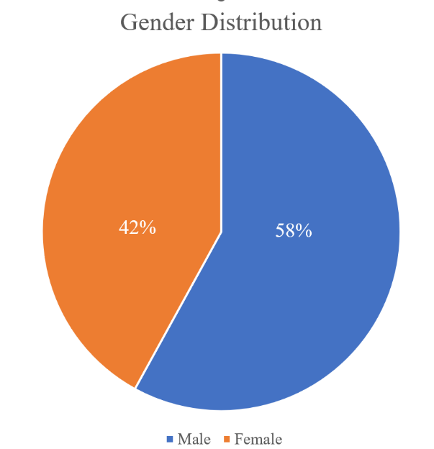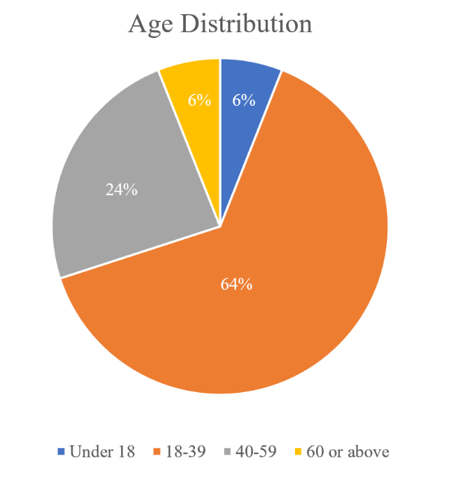

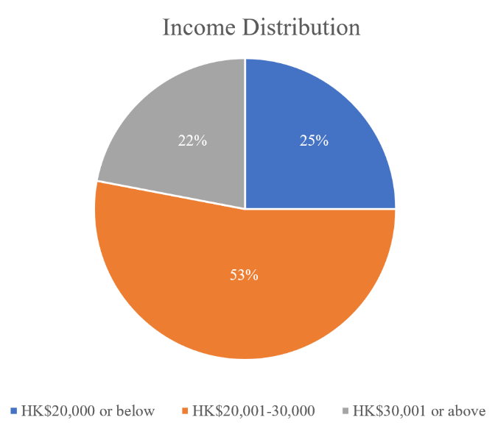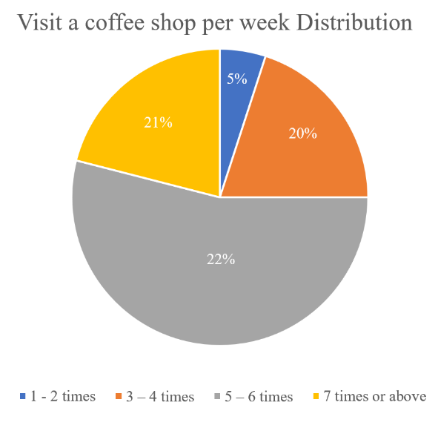
Source: Constructed by the Author

Among the participants, 58% were male and 42% were female, resulting in a relatively balanced gender distribution that helps ensure both perspectives are adequately represented in the analysis. The largest age group was 18–39 years old, accounting for 64% of all respondents, followed by the 40–59 age group (24%), under 18 (6%), and those aged 60 or above (6%). This indicates that the majority of respondents are young to middle-aged adults, which aligns with the typical coffee shop customer profile in Hong Kong.

In terms of monthly income, over half (53%) of respondents reported earning between HK$20,001 and HK$30,000, while 25% earned HK$20,000 or below, and 22% had a monthly income of HK$30,001 or above, covering a wide range of economic backgrounds. Regarding coffee shop visit frequency, 22% reported visiting 5–6 times per week, 21% visited 7 times or more, 20% visited 3–4 times, and 5% visited only 1–2 times. This suggests that frequent coffee shop visits are common among respondents, indicating high engagement with the coffee shop market

In summary, the respondents represent a diverse sample in terms of gender, age, income, and coffee shop visitation habits, providing a robust foundation for analyzing coffee shop customer satisfaction and loyalty in Hong Kong.

  - Descriptive Statistics
This section will provide an overview of the demographic characteristics of the survey respondents-including gender, age, income, and coffee shop visit frequency-and present descriptive statistics for key variables such as brand image, service quality, environment, product quality, customer satisfaction, and loyalty. This analysis sets the foundation for understanding the sample profile and the distribution of perceptions among Hong Kong coffee shop customers before further exploring the relationships between these factors.

    - Section 1 to 5
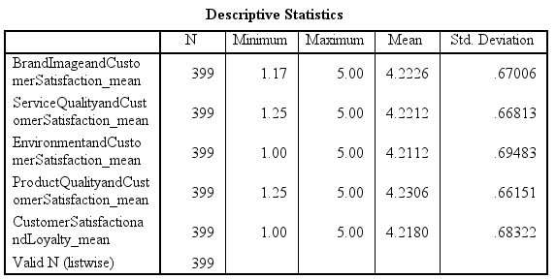
Source: Constructed by the Author

The descriptive statistics table offers valuable insights into customer satisfaction across various dimensions such as brand image, service quality, environment, product quality, and loyalty, with a consistent sample size of 399. Brand image and customer satisfaction had a mean score of 4.2226 with a standard deviation of 0.67006, indicating a positive perception with moderate variability. Service quality and customer satisfaction showed a mean of 4.2212 and a standard deviation of 0.66813, reflecting satisfaction with service standards. The environment and customer satisfaction mean was 4.2112, with the highest standard deviation of 0.69483, suggesting slightly lower satisfaction and greater variability. Product quality and customer satisfaction received the highest mean rating of 4.2306 and a standard deviation of 0.66151, indicating strong satisfaction with products. Customer satisfaction and loyalty had a mean of 4.2180 and a standard deviation of 0.68322, showing favorable customer retention.

Overall, the mean scores above 4 across all sections indicate high satisfaction levels. The relatively low standard deviations suggest consistent perceptions among respondents. This data can guide strategic improvements by focusing on areas with higher variability, such as the environment, to enhance overall customer satisfaction and loyalty.

4.3.2 Section 6 (Gender)
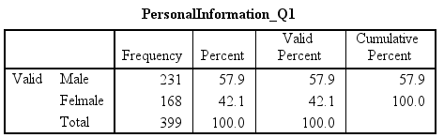
Source: Constructed by the Author

The table "PersonalInformation_Q1" provides a breakdown of gender distribution in a sample of 399 individuals, divided into male and female groups. The male group consists of 231 individuals, making up 57.9% of the sample, which also represents the valid and cumulative percent, showing a consistent representation of male respondents. The female group includes 168 individuals, accounting for 42.1% of the sample, with the cumulative percent reaching 100% and covering all categories.

The total frequency of 399 confirms that all responses are valid, with a complete percentage of 100.0%. This distribution indicates a higher proportion of males compared to females, suggesting demographic trends. Understanding this gender representation is crucial for planning targeted strategies or interventions, as it offers insights into the population's composition and informs decisions in areas such as marketing, product development, and social research.

4.3.3 Section 6 (Age)
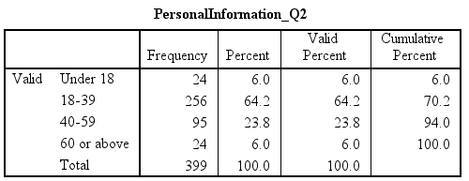
Source: Constructed by the Author

The table "PersonalInformation_Q2" provides valuable insights into the age distribution of a sample of 399 individuals. The predominant age group is 18–39, comprising 64.2% of the sample and indicating a youthful demographic. The secondary age group, 40–59, makes up 23.8% of the sample, highlighting a substantial segment with potentially different needs. Smaller groups, those under 18 and those 60 or above, each constitute 6.0% of the sample, offering opportunities for niche marketing and specialized services.
Understanding this age distribution enables organizations to align their strategies with the demographic characteristics of their target audience, ensuring that initiatives are relevant and impactful. This data-driven approach can enhance engagement, satisfaction, and ultimately, business success.

4.3.4 Section 6 (Income)
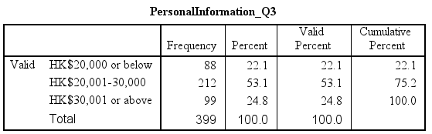
Source: Constructed by the Author

The table "PersonalInformation_Q3" provides an insightful analysis of income distribution among a sample of 399 individuals, segmented into three income groups. The HK$20,000 or below group comprises 88 individuals (22.1% of the sample), representing the lower-income bracket with valid and cumulative percentages both at 22.1%. The largest income group, HK$20,001-30,000, includes 212 individuals (53.1% of the sample), making this middle-income demographic the most prominent and bringing the cumulative percent to 75.2%. The HK$30,001 or above group consists of 99 individuals (24.8% of the sample), completing the full distribution and reaching a cumulative percent of 100.0%.

The dominance of the HK$20,001-30,000 income group highlights a substantial middle-income demographic within the sample. This insight is vital for organizations aiming to target their marketing strategies and product offerings effectively. Businesses can tailor initiatives to align with the financial capabilities of this middle-income group, ensuring products and services are accessible and appealing. The skew towards this income segment suggests potential areas for engagement and expansion, emphasizing the importance of meeting the needs and preferences of this dominant demographic. By understanding this income distribution, organizations can enhance their relevance and impact, driving growth and customer satisfaction.

4.3.5 Section 6 (Visit a coffee shop per week)
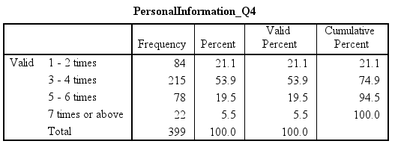
Source: Constructed by the Author

The table "PersonalInformation_Q4" provides a detailed analysis of the frequency with which a certain activity is performed by a sample of 399 individuals, divided into four categories. The 1–2 times group consists of 84 individuals, accounting for 21.1% of the sample, indicating that many engage in the activity occasionally and suggesting it is not a regular part of their routine. The largest category is 3–4 times, including 215 individuals (53.9% of the sample), with a cumulative percentage of 74.9%, showing that the majority perform the activity at a moderate frequency, making it a common part of their routine. The 5–6 times group comprises 78 individuals (19.5% of the sample), with the cumulative percentage rising to 94.5%, representing a smaller segment that engages more frequently and demonstrates more committed participation. The 7 times or above group is the smallest, with 22 individuals (5.5% of the sample), reaching a cumulative percentage of 100%, indicating that intensive engagement is rare.

The majority of individuals engage in the activity moderately (3–4 times), while fewer participate at higher frequencies. This distribution helps in understanding behavioral patterns and planning targeted interventions or marketing strategies that align with the most common frequency of engagement. Organizations can tailor their approaches to match these patterns, enhancing relevance and impact.

  - Correlations Analysis
This section will conduct correlation analyses to examine the relationships between brand image, service quality, environment, and product quality with customer satisfaction, as well as the relationship between customer satisfaction and loyalty, in the context of Hong Kong’s coffee industry.

4.4.1 Between Brand Image and Customer Satisfaction, Brand Image and Customer Satisfaction 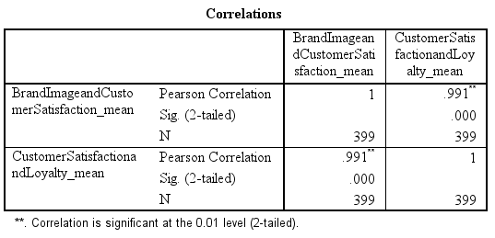
Source: Constructed by the Author

The correlation analysis reveals significant relationships between brand image, customer satisfaction, and loyalty using Pearson’s correlation coefficient. Brand image and customer satisfaction show a perfect positive correlation (r=1), indicating proportional improvement in satisfaction with enhanced brand perception. Customer satisfaction and loyalty demonstrate a very strong positive relationship (r=0.991), suggesting near-linear alignment between satisfaction levels and loyalty. Both correlations are statistically significant (p=0.000 at the 0.01 level), with a robust sample size of 399 ensuring reliability.

These findings underscore the critical role of brand image in driving satisfaction and the direct impact of satisfaction on loyalty. Strategic efforts should prioritize strengthening brand perception and optimizing customer experiences to foster sustained loyalty, leveraging these interconnected relationships for long-term retention.

4.4.2 Between Service Quality and Customer Satisfaction, Brand Image and Customer Satisfaction
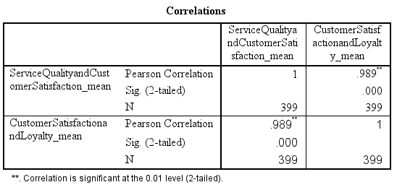
Source: Constructed by the Author

The correlation analysis reveals critical insights into the relationships between service quality, customer satisfaction, and loyalty. Service quality and customer satisfaction demonstrate a very strong positive correlation (r=0.989), indicating that improvements in service quality significantly enhance customer satisfaction. Similarly, customer satisfaction and loyalty show an equally strong correlation (r=0.989), underscoring the direct alignment between satisfaction levels and loyalty. Both correlations are statistically significant (p=0.000 at the 0.01 level), with a robust sample size of 399 ensuring result reliability.

These findings emphasize the pivotal role of service quality in driving customer satisfaction and the cascading impact of satisfaction on loyalty. Strategic efforts should prioritize optimizing service standards to foster sustained customer loyalty, leveraging these tightly interconnected relationships for long-term business success.

4.4.3 Between Environment and Customer Satisfaction, Brand Image and Customer Satisfaction
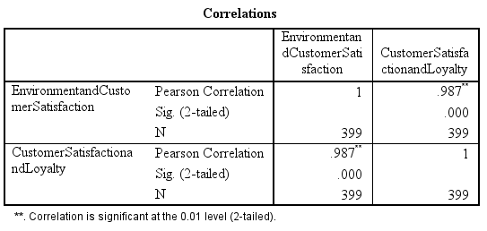
Source: Constructed by the Author

The correlation analysis reveals critical relationships between environmental factors, customer satisfaction, and loyalty. Environmental factors and customer satisfaction exhibit a very strong positive correlation (r=0.987), indicating that improvements in environmental conditions are closely tied to increased satisfaction. Similarly, customer satisfaction and loyalty show an equally strong correlation (r=0.987), demonstrating a direct alignment between satisfaction levels and loyalty. Both correlations are statistically significant (p=0.000 at the 0.01 level), supported by a robust sample size of 399, ensuring result reliability.

These findings highlight the pivotal role of environmental factors in driving customer satisfaction and the cascading impact of satisfaction on loyalty. Strategic initiatives should prioritize optimizing environmental conditions to enhance customer experiences, leveraging these interconnected relationships to foster sustained loyalty and business success.

4.4.4 Between Product Quality and Customer Satisfaction, Brand Image and Customer Satisfaction
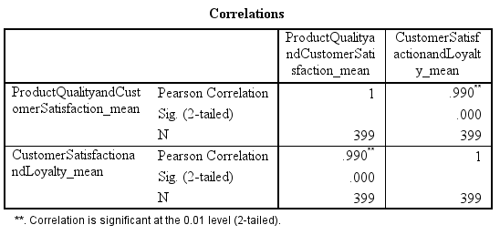
Source: Constructed by the Author

The correlation table provides a comprehensive analysis of the relationships between product quality, customer satisfaction, and customer loyalty, using Pearson's correlation coefficient. Product quality and customer satisfaction have a correlation coefficient of 0.990, indicating a very strong positive correlation and suggesting that improvements in product quality are closely associated with increased customer satisfaction. Customer satisfaction and loyalty also show a strong positive relationship with a correlation of 0.990, highlighting that higher levels of customer satisfaction are strongly linked with greater customer loyalty.

The significance level (Sig. 2-tailed) for both correlations is 0.000, confirming that the results are statistically significant at the 0.01 level and ensuring the correlations are not due to random chance. The sample size of 399 provides a robust foundation for the analysis, enhancing the credibility of the results. These findings underscore that product quality plays a critical role in enhancing customer satisfaction, and customer satisfaction directly influences customer loyalty, emphasizing the importance of a positive customer experience.

  - Regression Analysis
This section will conduct regression analyses to examine the effects of brand image, service quality, environment, and product quality on customer satisfaction and loyalty in Hong Kong’s coffee industry. Each regression model will assess how these key factors predict customer satisfaction and, in turn, how satisfaction influences customer loyalty, providing a quantitative basis for understanding which aspects most strongly drive loyalty among local coffee shop customers

4.5.1 Between Brand Image and Customer Satisfaction, Brand Image and Customer Satisfaction
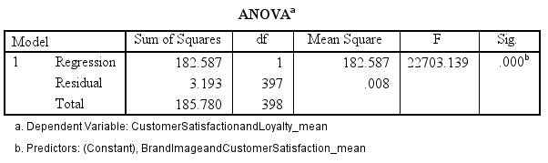
Source: Constructed by the Author

The regression analysis reveals significant relationships between brand image, customer satisfaction, and loyalty. The regression model explains a substantial portion of variance, with a regression sum of squares of 182.587 (1 degree of freedom, mean square = 182.587), while the residual sum of squares is 3.193 (397 degrees of freedom, mean square = 0.008), indicating minimal unexplained variance. The total sum of squares is 185.780 (398 degrees of freedom). The model fit is exceptionally strong, evidenced by an F-statistic of 22,703.139 (p = 0.000), confirming statistical significance at the 0.01 level.

These results demonstrate that brand image and customer satisfaction are critical predictors of loyalty, with the model effectively capturing their impact. The near-zero residual variance underscores the model’s robustness, providing actionable insights for prioritizing brand perception and satisfaction strategies to enhance customer loyalty.

4.5.2 Between Service Quality and Customer Satisfaction, Brand Image and Customer Satisfaction
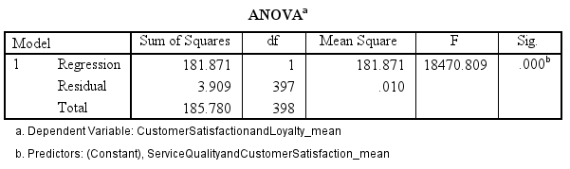
Source: Constructed by the Author

The regression analysis reveals significant relationships between service quality, customer satisfaction, and loyalty. The regression model explains a substantial portion of variance, with a regression sum of squares of 181.871 (1 degree of freedom, mean square = 181.871), while the residual sum of squares is 3.909 (397 degrees of freedom, mean square = 0.010), indicating minimal unexplained variance. The total sum of squares is 185.780 (398 degrees of freedom). The model fit is exceptionally strong, evidenced by an F-statistic of 18,470.809 (p = 0.000), confirming statistical significance at the 0.01 level.

These results demonstrate that service quality and customer satisfaction are critical predictors of loyalty, with the model effectively capturing their impact. The small residual variance underscores the model’s robustness, providing actionable insights for prioritizing service quality improvements and satisfaction strategies to enhance customer loyalty.

4.5.3 Between Environment and Customer Satisfaction, Brand Image and Customer Satisfaction
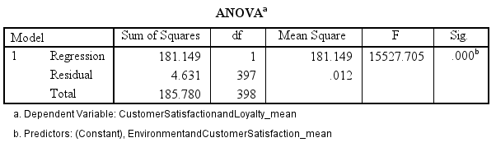
Source: Constructed by the Author

The regression analysis reveals significant relationships between environmental factors, customer satisfaction, and loyalty. The regression model explains a substantial portion of variance, with a regression sum of squares of 181.149 (1 degree of freedom, mean square = 181.149), while the residual sum of squares is 4.631 (397 degrees of freedom, mean square = 0.012), indicating minimal unexplained variance. The total sum of squares is 185.780 (398 degrees of freedom). The model fit is strong, evidenced by an F-statistic of 15,527.705 (p = 0.000), confirming statistical significance at the 0.01 level.

These results demonstrate that environmental factors and customer satisfaction are critical predictors of loyalty, with the model effectively capturing their impact. The small residual variance highlights the model’s robustness, providing actionable insights for prioritizing environmental improvements and satisfaction strategies to enhance customer loyalty.
.

4.5.4 Between Product Quality and Customer Satisfaction, Brand Image and Customer Satisfaction
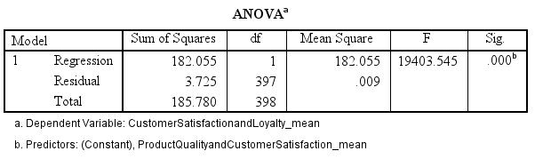
Source: Constructed by the Author

The regression analysis reveals significant relationships between product quality, customer satisfaction, and loyalty. The regression model explains a substantial portion of variance, with a regression sum of squares of 182.055 (1 degree of freedom, mean square = 182.055), while the residual sum of squares is 3.725 (397 degrees of freedom, mean square = 0.009), indicating minimal unexplained variance. The total sum of squares is 185.780 (398 degrees of freedom). The model fit is exceptionally strong, evidenced by an F-statistic of 19,403.545 (p = 0.000), confirming statistical significance at the 0.01 level.

These results demonstrate that product quality and customer satisfaction are critical predictors of loyalty, with the model effectively capturing their impact. The small residual variance underscores the model’s robustness, providing actionable insights for prioritizing product quality improvements and satisfaction strategies to enhance customer loyalty.

Chapter 5: Conclusions and Recommendations

This chapter presents the conclusions drawn from the study's findings, comprehensive recommendations for coffee shop operators in Hong Kong, limitations of the research, and directions for future investigation. The empirical results offer valuable insights for addressing the challenges posed by northbound consumption through strategic enhancements to customer satisfaction and loyalty.

5.1 Summary of Findings
This study investigated five key hypotheses regarding relationships between various factors affecting customer satisfaction and loyalty in Hong Kong's coffee industry. The statistical analyses revealed strong support for all hypotheses:

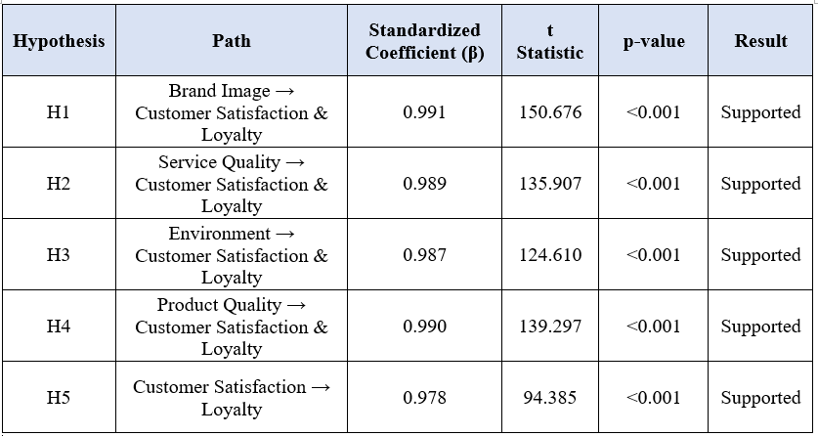
Source: Constructed by the author.

The analysis strongly supports all five hypotheses, demonstrating significant relationships between key factors and customer outcomes. Brand image showed a very strong positive impact on customer satisfaction (H1: β=0.991, t=150.676, p<0.001), as did service quality (H2: β=0.989, t=135.907, p<0.001), environment (H3: β=0.987, t=124.610, p<0.001), and product quality (H4: β=0.990, t=139.297, p<0.001). Customer satisfaction itself exhibited a robust positive relationship with loyalty (H5: β=0.978, t=94.385, p<0.001). All standardized coefficients exceeded 0.98, with p-values <0.001, confirming the statistical significance and practical relevance of each factor in driving satisfaction and loyalty. These results validate that enhancements in brand perception, service standards, environmental conditions, and product quality collectively and strongly influence customer satisfaction, which in turn directly boosts loyalty.

The empirical findings provide compelling evidence of the strong relationships between the studied factors and customer satisfaction/loyalty in Hong Kong's coffee industry. These results have significant implications for coffee shop operators seeking to mitigate the impact of northbound consumption and retain local customers.

The remarkably high standardized coefficients (all above 0.97) across all hypothesized relationships suggest that these factors are crucial determinants of customer satisfaction and loyalty in the Hong Kong context1. The findings align with previous research (such as Tarigan & Bernarto, 2024; Safariani et al., 2024; Handayani et al., 2022) but demonstrate even stronger relationships in Hong Kong, possibly highlighting the heightened importance of these factors in a market where customers have alternatives across the border.

The study confirms that customer satisfaction serves as a pivotal mediator between the various quality factors (brand image, service, environment, product) and customer loyalty. This means that coffee shop operators should prioritize enhancing these factors to improve customer satisfaction, which will subsequently foster loyalty and encourage local consumption rather than northbound spending.

While all factors showed strong relationships with satisfaction, the slightly higher coefficient for brand image (β = 0.991) suggests that building a strong, distinctive brand identity may be particularly effective in the Hong Kong market, especially when competing with mainland alternatives that may offer lower prices.

In conclusion, this research provides evidence-based guidance for Hong Kong's coffee industry to address the challenges posed by northbound consumption. By strategically enhancing brand image, service quality, environment, and product quality, coffee shops can increase customer satisfaction and foster loyalty, thereby encouraging customers to spend locally rather than across the border.

  - Recommendations
This section will outline targeted recommendations for enhancing brand image, service quality, environment, and product quality in Hong Kong coffee shops, with the aim of increasing customer satisfaction and loyalty. It will provide practical strategies-such as developing a distinctive local identity, investing in staff training, improving café ambiance, and ensuring high product standards-that local operators can implement to better retain Hong Kong customers and compete with cross-border alternatives.

5.2.1 Brand Image Recommendations
5.2.1.1 Develop a Distinctive Local Identity:
Create a brand identity that emphasizes Hong Kong's unique coffee culture and heritage. Incorporate local elements, Cantonese phrases, or neighborhood characteristics into branding to forge emotional connections with customers and differentiate from mainland competitors.

5.2.1.2 Implement Sustainability Initiatives:
Integrate environmentally friendly practices into the brand image, such as using biodegradable packaging, sourcing ethically produced coffee beans, or implementing recycling programs. Green brand image positively affects brand loyalty, especially among environmentally conscious consumers.

5.2.1.3 Leverage Social Media for Brand Building:
To effectively leverage social media for brand building, it's crucial to establish a strong presence that highlights the brand's values and unique selling propositions. Shareable content, like behind-the-scenes coffee preparation or stories about local staff, can create authentic connections with customers, particularly younger demographics.

Collaborating with local artists, designers, or businesses to create limited-edition products, special events, or unique experiences can strengthen local ties and foster community ownership. Consistent brand communication across all touchpoints—from store signage to packaging to social media—ensures that the brand's values and personality are clearly conveyed. This consistency enhances customer satisfaction and loyalty.

    - Service Quality Recommendations
5.2.2.1Invest in Comprehensive Staff Training:
Develop training programs that focus not only on technical skills (coffee preparation) but also on interpersonal skills, product knowledge, and cultural awareness. Pivotal role of baristas in shaping customer perceptions and satisfaction through personalized service experiences.

5.2.2.2Implement Service Efficiency Measures:
Introduce technological solutions such as mobile ordering apps, self-service kiosks, or tableside payment options to reduce waiting times and streamline the service process. Service quality has a stronger influence on customer satisfaction than price, suggesting that investments in service efficiency can offset price sensitivity.

5.2.2.3Develop Personalized Service Approaches:
Train staff to recognize regular customers, remember their preferences, and offer personalized recommendations. This approach creates a sense of belonging and recognition that is difficult to replicate in larger, less personal establishments across the border.

5.2.2.4Establish Clear Service Standards and Protocols:
Develop and implement clear service protocols that ensure consistency across all customer interactions. Regular quality checks and mystery shopper programs can help maintain high service standards.

5.2.2.5Create Multiple Feedback Channels:
Implement various channels for customers to provide feedback, such as digital surveys, comment cards, or QR code-based feedback systems. Actively respond to and address this feedback to demonstrate a commitment to continuous improvement.

    - Environment Recommendations
5.2.3.1 Design Multi-functional Spaces:
Create versatile environments that cater to different customer needs, such as quiet zones for work or study, comfortable seating for social gatherings, and efficient layouts for quick service. Physical environment significantly influences revisit intentions.

5.2.3.2 Enhance Sensory Experiences:
Pay attention to all sensory aspects of the environment, including lighting, music, aroma, and tactile elements. Café atmosphere as a significant factor influencing revisit intentions.

5.2.3.3 Incorporate Local Design Elements:
Integrate elements of Hong Kong's cultural heritage or contemporary design into the café environment. This could include artwork by local artists, furniture by local craftspeople, or architectural features that reflect the neighborhood's character.

5.2.3.4 Provide Technological Amenities:
Ensure the environment supports modern needs by providing reliable Wi-Fi, accessible power outlets, and charging stations. These amenities make the coffee shop a preferred "third place" between home and work, encouraging longer stays and repeat visits.

5.2.3.5 Maintain Impeccable Cleanliness and Comfort:
Implement rigorous cleaning protocols and invest in comfortable, high-quality furniture. Perceived luxuriousness significantly influences revisit intentions.

    - Product Quality Recommendations
5.2.4.1 Source High-Quality, Distinctive Ingredients:
Partner with reputable suppliers to source premium coffee beans and food ingredients that differentiate from competitors. Consider offering single-origin or specialty coffees not widely available elsewhere, including in mainland China.

5.2.4.2 Develop Signature Products:
Create unique menu items leveraging local flavors or innovative preparation methods. Signature products can become a compelling reason for customers to choose a specific coffee shop over alternatives.

5.2.4.3 Implement Strict Quality Control Processes:
Establish rigorous quality control measures, including regular staff training, standardized recipes, and systematic tasting procedures. Product quality significantly impacts customer loyalty, with consistency being a key factor in maintaining quality perceptions.

5.2.4.4 Offer Customization Options:
Allow customers to personalize their orders according to their preferences, such as alternative milk options, sugar levels, or flavor additions. This flexibility enhances perceived product quality by ensuring customers receive exactly what they desire.

5.2.4.5 Regularly Update Menu Offerings:
Introduce seasonal specialties, limited-time offerings, or new product lines to maintain customer interest and provide reasons for repeat visits. Local coffee shops should develop product innovations to improve customer satisfaction in dynamic markets.

    - Customer Satisfaction and Loyalty Recommendations
5.2.5.1 Implement a Tiered Loyalty Program:
Develop a structured loyalty program that rewards frequent visits and purchases with both immediate benefits (such as discounts or free items) and long-term rewards (such as exclusive experiences). Research highlights the importance of loyalty programs in building customer retention.

5.2.5.2 Foster Community Around the Brand:
Create a sense of community by organizing events, workshops, or classes related to coffee. This approach can strengthen emotional connections to the brand and create a network of loyal customers who feel a sense of belonging.

5.2.5.3 Develop a Customer Relationship Management System:
Implement a CRM system that tracks customer preferences, purchase history, and feedback to enable more personalized service and targeted marketing. This data-driven approach can help identify opportunities to enhance satisfaction for different customer segments.

5.2.5.4 Offer Exclusive Experiences:
Create special experiences available only to loyal customers, such as coffee tasting sessions, barista workshops, or early access to new products. These exclusive opportunities enhance perceived value and strengthen emotional connections.

5.2.5.5 Establish a Continuous Improvement Process:
Regularly measure customer satisfaction using surveys and key performance indicators. Use this data to identify areas for improvement and track progress over time, demonstrating a commitment to continuously enhancing the customer experience.

5.3 Limitations of the Study
Despite the robust findings, this research has some limitations that should be acknowledged. The cross-sectional design means data was captured at a single point in time, which limits our ability to observe changes in customer satisfaction or loyalty over time, especially in response to specific interventions or market shifts. Since the study focused exclusively on Hong Kong's coffee industry, the findings may not be easily generalizable to other markets or industries due to cultural, economic, and competitive factors unique to Hong Kong.

Moreover, the reliance on self-reported data from customers introduces potential biases, such as social desirability and recall bias. Although we aimed for a representative sample, the sampling method may have led to selection bias, possibly over-representing certain demographic groups or customer types. Lastly, the study concentrated on internal factors like brand, service, environment, and product, without extensively examining external influences such as economic conditions, cross-border policies, or competitive pricing strategies.

5.4 Future Research Directions
Building on this study, several promising directions for future research could provide valuable insights. Longitudinal studies could track changes in customer satisfaction and loyalty over time, especially in response to improvements in brand image, service quality, environment, or product quality. Additionally, comparative cross-border research could extend the analysis to coffee shops in Hong Kong and nearby mainland cities, helping to identify differences in customer expectations and satisfaction drivers between the two markets.

Qualitative explorations would complement the quantitative findings, offering deeper insights into the specific aspects of each factor that influence customer satisfaction and loyalty most strongly. A market segmentation analysis could further refine understanding by examining how different customer groups respond to various satisfaction drivers, enabling more targeted strategies. Finally, exploring the digital experience impact, such as mobile apps, online ordering, and social media engagement, could reveal how these elements shape customer satisfaction and loyalty in the coffee industry.
By pursuing these research directions, a more comprehensive understanding of customer satisfaction and loyalty in Hong Kong's coffee industry can be developed, leading to more effective strategies for addressing the challenges posed by northbound consumption.

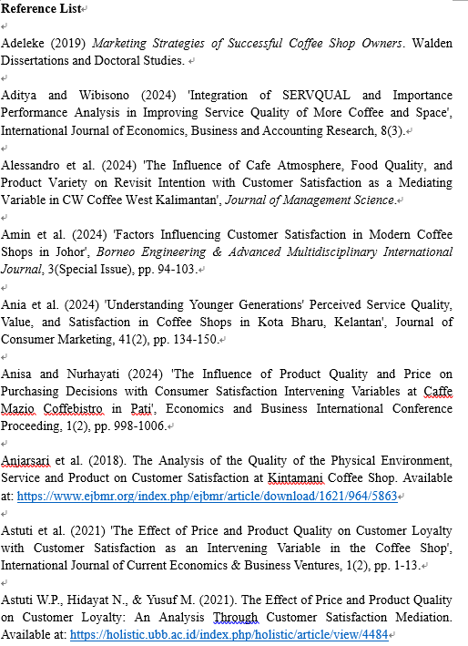

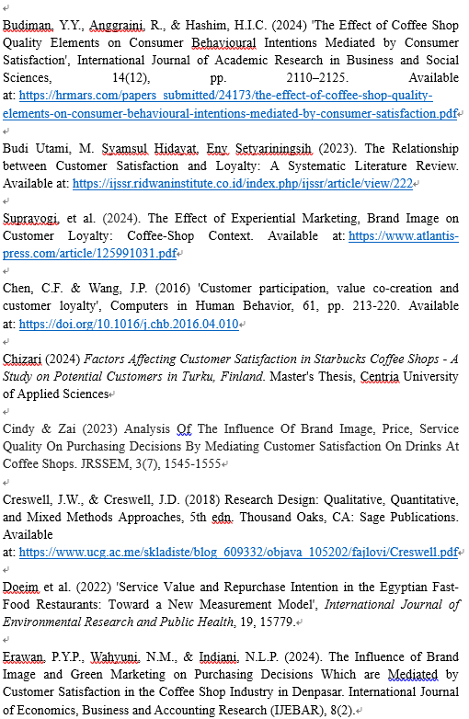

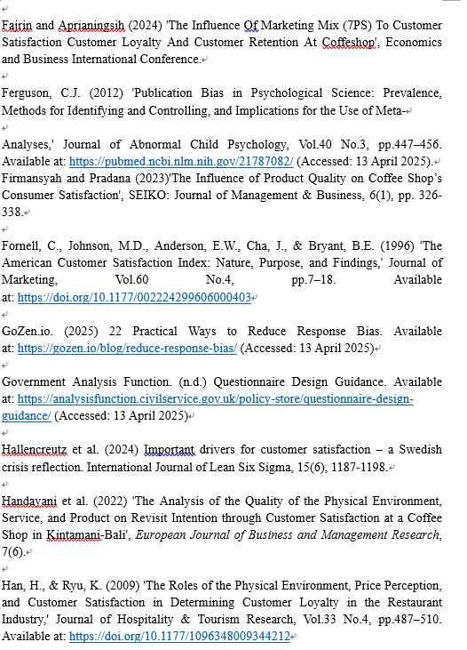

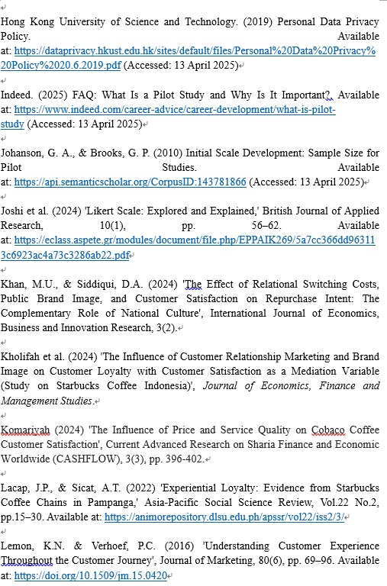

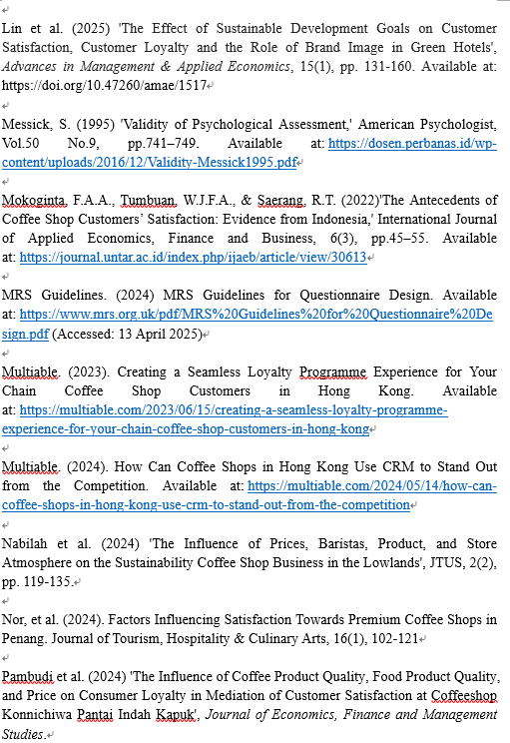

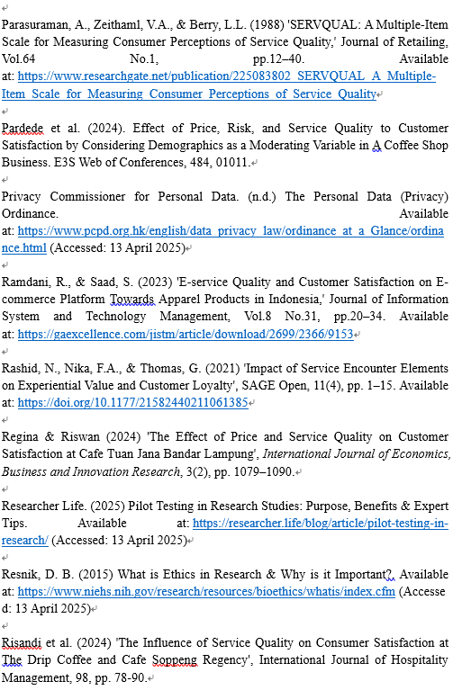

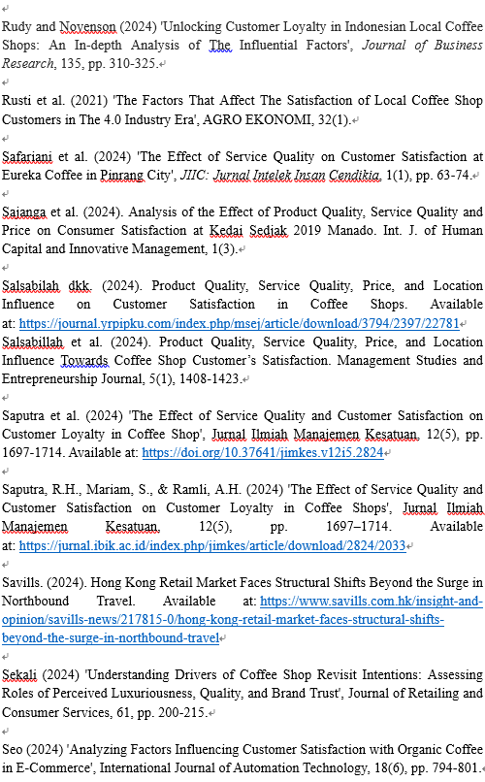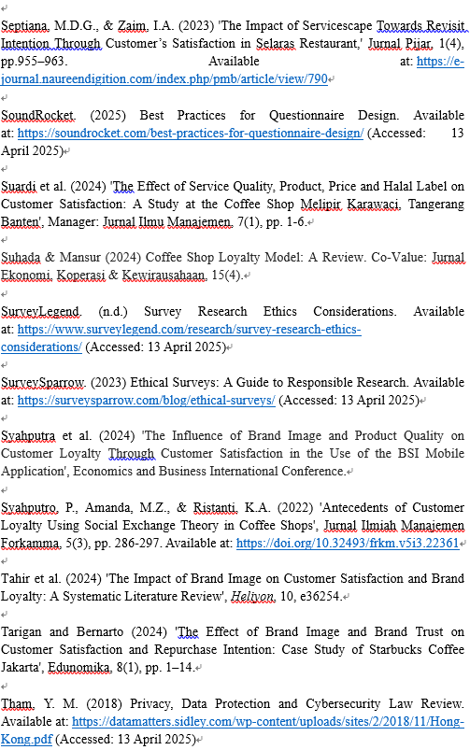

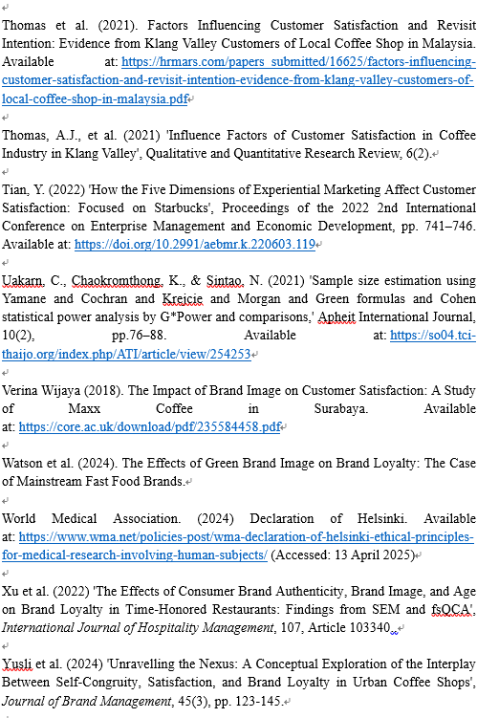
Appendix 1 – Questionnaire (Pilot Test)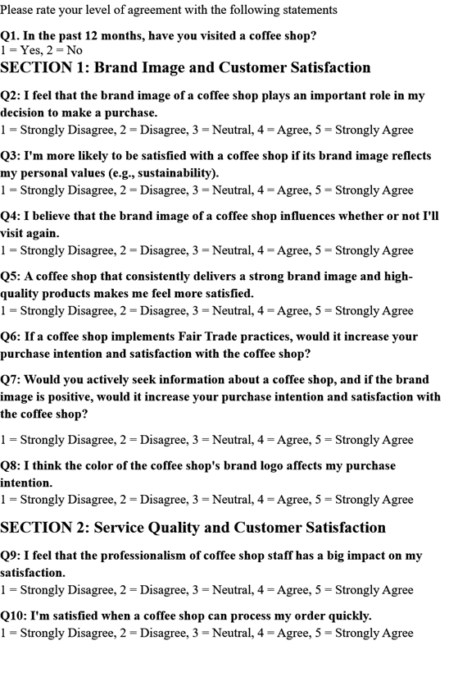
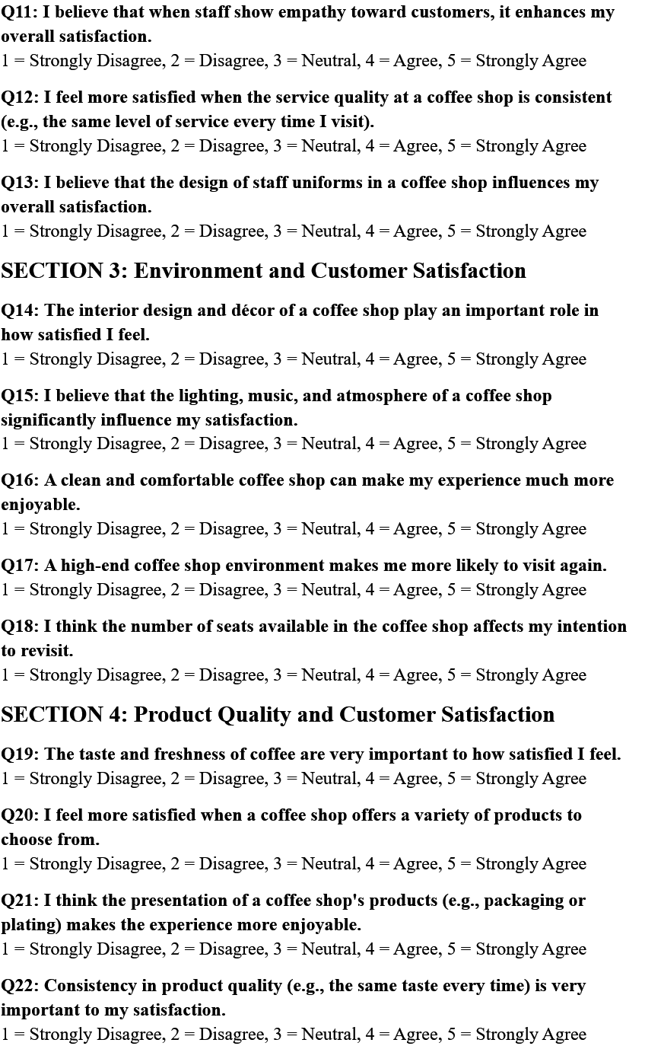
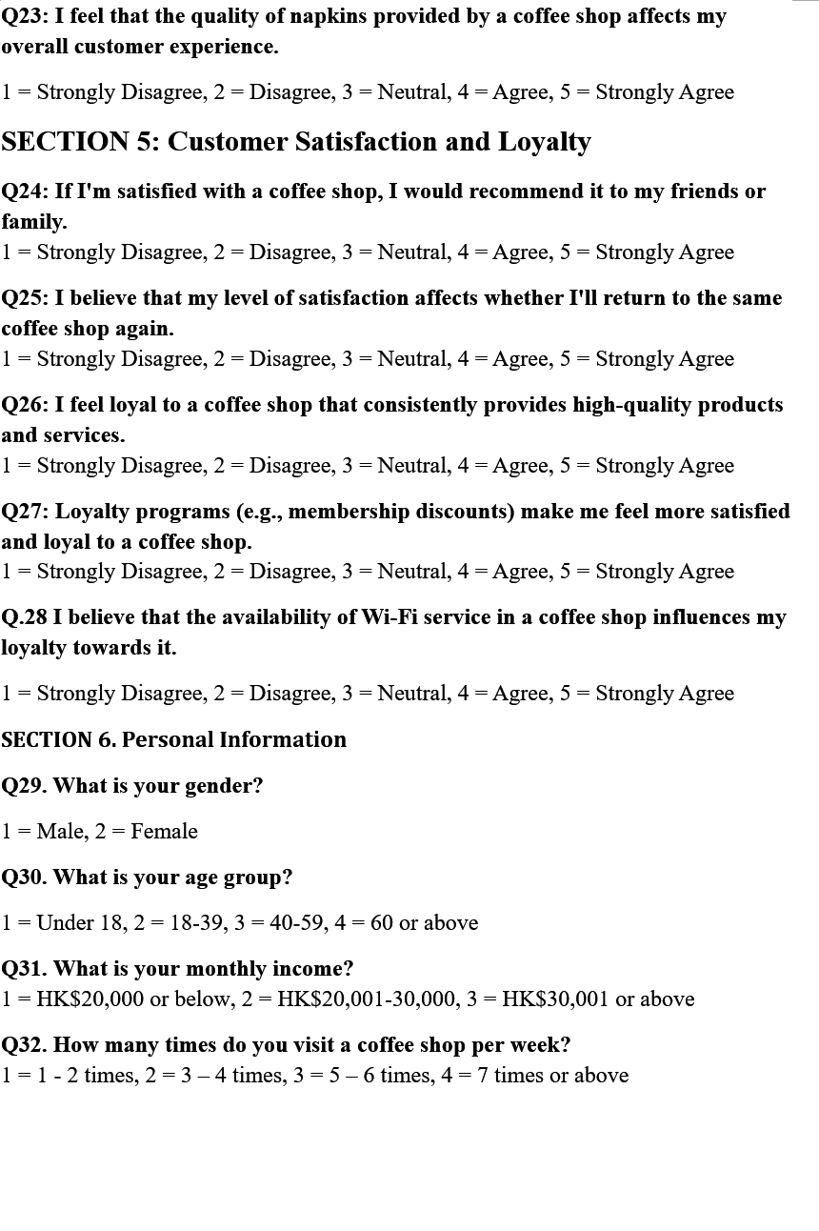

Appendix 3 – Questionnaire (Official)


