Workplace Culture and its impact on Organisational Efficiency
Module code: BMSW 5005
Lecturer: Dr Eric Osei
Student Name: Md Shahidur Rahman
Student ID: 1709339

Executive Summary
This report analyses the internal and external environment of Cinnamon Spice Indian restaurant, and culture and structure affect the efficiency of the organisation. Porter five forces, McKinney’s 7s and Cultural Wed analyse in this report. Ethical stance of the organisation, Cinnamon Spice Indian Restaurant shown by serving half portion and using leftover ingredients first can reduce food waste. Cinnamon Spice should enhance socialization for retaining its Culture.

Contents
Executive Summary 2
Contents 3
Introduction 4
What is the organisation? 5
External analysis 5
Figure1: The Porter Five Forces 5
Supplier Power 6
Buyer Power 6
The threat of new entry 7
Treat of Substitute 7
Rivalry among existing competitor 7
Internal Analysis 7
Figure 2: McKinney’s 7s frame tools 8
Strategy 8
Structure 8
Figure 3: Cinnamon Spice Structure 9
System 9
Shared Value 9
Style 9
Staff 10
Skills 10
Ethical stance 10
Organization Culture 11
Figure 4: The Culture Web 11
Recommendations 12
Conclusion 12
References 13

Introduction
This report will define what is the organisation and its culture will cultivate journals and researches conducted on that topic. This report will examine Cinnamon Spice (an Indian Restaurant), based in Telford, Oakengates. Every business has an internal and external environment, the internal environment is tangible, however, it can influence by its external environment. If the minimum wage gone up and if business revenue is the same, the organisation cannot employ the same number of employees and therefore the organisation will employ a few fewer employees as it is not feasible for them.

What is the organisation?
An Organisation often stars or born when there is a need for something or something that will make life easy. These needs are identified by entrepreneurs and they start their organisation by themselves or with a group of people. Cambridge dictionary defines the organisation as “ a group of people who work together in an organized way for a shared purpose” (Dictionary.cambridge.org, 2019). Organisation itself has no structure or culture, structure and culture begin from the founder of the organisation, founder’s mission, vision and value form the culture and structure of the organisation

External analysis
We will use Porter 5 forces to analyse the external environment and how it impacts on the competitiveness of the organisation that we have chosen.

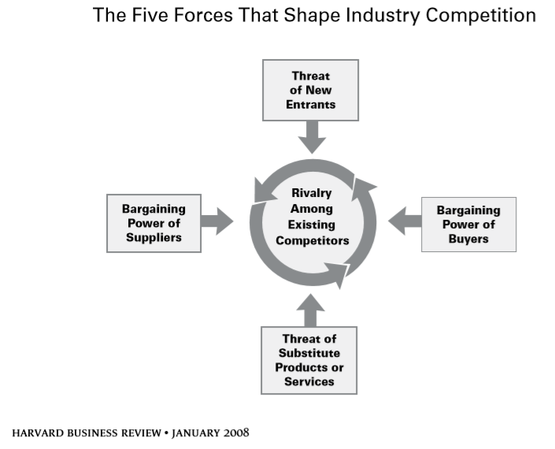

Figure1: The Porter Five Forces
Source: Adapted from Harvard business review, (2008, p.27).
Porter 5 forces invented by young economist Michael E, Porter started a revelation in the strategic field with having assistance from Jan Rivkin who is Harvard Business School Professor and Joan Magretta who was working with Porter for a long-time (Porter, 2008). Competition in the market is not coincident or bad luck (Porter, 1989). Awareness of what is happening in the external environment can help managers better ways of operating their organisation.
They are is two threat and two power and existing competition, we will try to discuss each element of Porters five completive forces and evaluate how the external environment influence culture and efficiency of Cinnamon Spice. These five competitive forces determine organisation profitability (Porter, 2008). Porter’s five comparative forces are,
1. Competitive Rivalry is how many rivals or similar organisation are alike.
2. Supplier Power is if few suppliers available they will lead the price, so supplier will decide how much to charge for goods.
3. Buyer Power is if the demand is less and production is more, that can give buyer burgling power and it can affect organisation profitability

4. Threat of Substitute, its means if similar product or service available for less price, for example, Apple iPhone and Samsung Android, the phone has a similar faction but Samsung is a substitute product for iPhone.

5. Threat of New Entry, mean how high is a barrier to enter the market, it can be a financial or legal barrier (government legislation).
(Porter, 2008).

Supplier Power
Supplier is an important stakeholder for an organisation, for restaurant to produce its product they have to use raw material and its human capital, suppler provide raw materials and cost of raw material determine organisation culture, if the raw material is not up to the stander (fresh) employees can demotivate employees and they will not feel that what there doing is important, employees should buy the best possible product so that employees can proud of what they do.
There are many suppliers in curry industry, among them there is few big organization and they are, East End Foods, East End best known for their spices and curry trade depend on spices, East End ground their spices in the UK so that aroma of the spices stays (Eastendfoods.co.uk, 2019).East End foods is environmentally friendly as they will make sure their farmers not using accessing comical to grow their crops. When Cinnamon Spice buy spices from Est End foods, employees will be morally inspired to do well within the organisation, having such a culture of buying environmentally friendly supplier makes, employees efficient. For spice, the supplier has power. On other grocery and raw material (chicken, meat) supplier has low power, because too many supplier’s delivery raw materials as such as Euro Foods, Giro Foods Ltd.

Buyer Power
They are is 46 Indian curry houses in Telford (Tripadvisor.co.uk, 2019). Buyer power is high in Telford, the consumer can get their curry delivered from 46 curry house in Telford, Cinnamon Spice differentiate their product by innovating new dish and allowing customers to buy curry even in half portion rather than buying full portion, it is feasible for customers to buy curry from Cinnamon Spice (Cinnamonspicetakeaway.com, 2019)

The threat of new entry
Curry trade does not need big capital to open, therefor anyone can open a curry house, but the operational cost is high. The restaurant chef is retired and curry industry having difficulty to fill their gap because cooking curry needs dedication, it is hard to get chef from abroad. One of the Immigration rules in Britain is that non-EU chefs must earn a minimum of £29,570 after all expenses (CHAUDHURI, 2016). Short of staff will eliminate the threat of the new entrance.

Treat of Substitute
The threat of substitutes is, similar products available for a cheaper price with a similar performance or better performance with the same price. Retail store stock curry, a similar product to what Cinnamon Spice is selling.
Almost all the curry house in Britain has the same traditional curry on their menu. A big organisation like Asda has Indian foods, especially curry, but in Asda, they have chilled foods and foods that Cinnamon Spice sale is hot and more personalize foods, where a consumer can choose any vegetable or meat to add on their dish, Cinnamon Spice cook foods how customer like it. Customers can cook curry by following YouTube videos instruction, so the threat of substitute is high, and this can determine business profitability.

Rivalry among existing competitor

In order to have competitive advantage organisation must update their knowledge resource (Harrison and Leitch, 2000). Cinnamon Spice has a digital database where they store all the data and process data based on their needs. Having knowledge culture in place improve employees’ productivities, for example, we have a day to day sale data and weekly sale data as well as monthly sale data, by processing the data we can find out what day is the busy day and can make employees timetable accordingly.

Internal Analysis
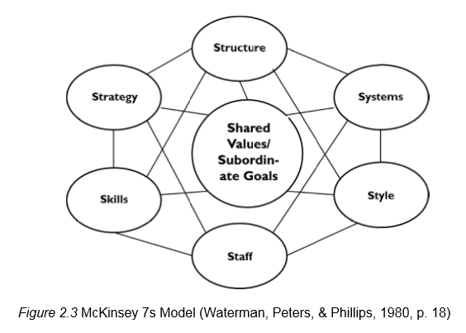

Figure 2: McKinney’s 7s frame tools
Source: Adapted from Waterman, Peters and Phillips, (1980).

We will conduct an analysis of the internal environment of Cinnamon Spice to identify the comitative and weaknesses of the organisation. We will McKinney’s 7s frame tools for the analysis.
McKinsey's 7S framework is a model for analysing the internal environment of an organisation and it is more focused on people who are internally responsible for their organisation effective or not. McKinsey's 7S focuses on 7 aspects that determine organisation success and they are as follows, strategy, structure, systems, shared values, style, staff and skills (SINGH, 2013).

Strategy

Strategies are what takes an organisation one position to another, a strategy is finding a unique way of doing things (Ansoff, 1965). Cinnamon Spice strategy is to employ 1 extra driver all the time, so if one regular driver fails to turn at work, one extra driver can deliver the foods and maintain customer expected delivery time.

Structure

The structure is how employee’s responsibility divided and employees know who is responsible for what (Pascale, and Athos, 1981).
Cinnamon Spice structure is a hierarchical functional structure, as a business owner, it is not possible for one person to deal with all the staff, therefore Cinnamon Spice has structure so that every employee knows whom they should report to. Because the owner is present at work all the time it is easy to communicate by all member of staff with the owner. This structure make Cinnamon Spice culture as a communicating culture, if communication is not broken efficiency of the organisation will be good.

because they can speak to the owner himself before taking any critical decision.

Figure 3: Cinnamon Spice Structure

System
The procedure employees use for daily activities is call System (Pascale, and Athos, 1981). Epos system is in use in Cinnamon Spice, Epos system need software and hardware to operate, the Epos system makes no human error in calculation and time efficiency is upmost. Having an Epos system give customer better expression about the restaurant culture, because customer trust is high because the epos system does not make any mistake in calculation and it's faster than doing manually. Staff spend more time with the customer and building a connective culture with the customer.

Shared Value

Shared values are the core value of the organisation, shared value consists of; vision, mission, and values of the organisation or employees (Pascale, and Athos, 1981). Cinnamon Spice has an unwritten Value statement, however, from founder attitude toward the organisation can determine the value stamen of the organisation. As employees and employers in curry trade belief they sale, their culture which is their foods are their pride. If an organisation does not have strong value, employees follow their own value which is not necessarily alien with organizational value (Martins and Terblanche, 2003).

Style

Leaders are who influence, guide, the inspiration for followers, leadership is also the art of motivation for a group of people toward a common goal (Patnaik, 2011). Traditionally businesses were influenced by the military-style of management and culture, where the upper level will instruct how the task should be done and the lower-level worker will follow the guideline given by the manager, without putting their interpretation of the task (SINGH, 2013). Leadership style in Cinnamon Spice is a democratic leadership style, where team leaders will ask a team member for their opinion before making any big decision. Democratic leadership style shows employees that their opinion is important. The benefits of democratic leadership employees tend to be more creative and innovative (DEBELL, 2019).

Staff
Staff is people or employees of the organisation, the organisation has a responsibility toward their human capital (Pascale, and Athos, 1981). The people, their backgrounds and competencies; how the organization recruits, selects, trains, socializes, manages the careers and promotes employee recruitment and talent management is vital for the organisation (SINGH, 2013). On recruiting process organization advertise the job with the description of job role, what candidate believes, the value on curry trade determine hiring process. by asking relevant question managers can identify candidate competency alien with curry trade culture or not. Employees' growth and future career motivate employees (Purcell and Boxai, 2003). So that employees feel good about and they work for longer, the organisation enjoys their knowledge asset in the form of their employees.

Skills
Skills are how skillful employees is, specialism on something like technology (Pascale, and Athos, 1981). Having a compassionate approach toward employees will inspire a compassionate attitude toward the employer (Rosenberg 2003). In Cinnamon Spice culture is to treat each other with respect and dignity, having such culture motivate the employees to do well in the workplace if respect is centre of any culture can have great bonding for employees to colleagues and that can be seen by customer by observing employees attitude toward their colleagues.

Ethical stance
The human is the founder of organisation, organisation did not form its self, owner has to decide what is right or rang the behalf of the organisation (Kitson, and Campbell, 1996). Waste foods have an impact globally, waste foods reach a significant figure, one-third of the witch produce for human consumption is lost or wasted globally, which is 1.3 billion tons of foods every (Vilariño, Franco and Quarrington, 2017). the term ‘food loss’ often comes up in the literature sometimes, the terms ‘food loss’ and ‘food waste’ are used interchangeably (Beretta et al., 2013). Foods lost are foods that originally produced for human consumption gone to none foods or wasted in the manufacturing level (Beretta et al., 2013). Food waste is a consumer-level retail or restaurant (Ali Mekouar, 2017).
In Cinnamon Spice foods are prepare daily, rotate stoke (use old stoke first) and have appropriate storage facilities. Serving the right portion is also help reducing food waste or lost, develop country kitchen contributes a vast amount of food waste (Quested et al., 2013). It has shown on literature by providing safe food storage facilities, appropriate foods portion, and donating extra foods witch may expire soon can reduce food waste (Lipinski et al., 2013; HLPE, 2014; Koester, 2014). Corporate ethical stand motivates the internal environment of the organisation by pointing out to employees, what we do is good for the community. Providing support for school donation for local school and charity activity is the norm for Cinnamon Spice.

Organization Culture
Organizational culture has four functions and they are, gives members a sense of identity, increases their commitment, reinforces organisational values, and serves as a control mechanism for shaping behavior (Atkinson, 1990; Nelson & Quick, 2011; Marcoulides & Heck, 1993; Schein, 1992; Schein, 2011). Culture is an important element in an organisation and lives of stakeholders, culture is going around in the form of belief, value, tradition and help the organisation reach its goal (Patnaik, 2011). For comparing the culture of Cinnamon Spice to Bangla Pride Johnson’s Cultural Web will be used for that purpose. Johnson’s Cultural Web is a theoretical model for study culture in an organisation (Johnson,1992). Johnson has identified six cultural elements as follows (MCDONAL and FOSTER, 2013).
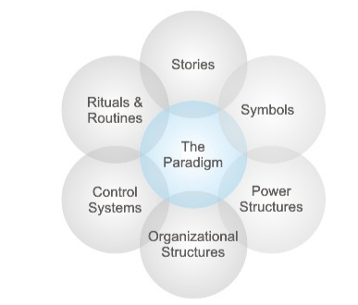

Figure 4: The Culture Web
Source: Adapted from (Mindcontrol101.com, 2019).

- Power structure: who has the authority, who has decision making power.
- Organizational structure: who is contributing what.
- Control system: what technology or procedure used for doing a task.
- Stories: people talking about a past event.
- Rituals and routine: daily routine what is expected to do as normal.
- Symbols: dress code, formal or informal and company logo.
Scholes and Johnson (2001, p. 306)
Having a Bangladeshi oriented background both organisations attract employees from that region because it has similarities with their personality, they’re for it attract Bangladeshi people to work within their organisation (Judge &Cable, 1997). Bangladeshi owner does not encourage to employ a female chef and front house staff. Cinnamon spice does employ female staff for the kitchen as well as the front house. Paying employees wage on time, make the culture strong and employees’ efficiency because employees don’t have to worry about their wage so that they can concentrate on work. Cinnamon spice has a rich story, the owner had a restaurant in the same town, and he had a problem with his partners and that why he bought a restaurant 4 to 5 miles away. Bangla pride, on the other hand, he bought the restaurant in Telford but live in Birmingham. Bangla Pride has Theory X on their management style, theory X is, high supervision theory, where employees are kept in high supervision and really centralisation (McGregor, 1960).

Recommendations
If Cinnamon Spice develops a culture where employees share their ideas at ease and without any fear, an organisation can implement their strategies easily and the process will become a mindset rather than complicated (Bhatti, Zaheer, and Rehman, 2011). Organization culture alien with a personality of an individual, what their own belief, value determine their culture As stated by Oswick, Lowe, & Jones (1996). Cinnamon Spice promotes open discussion, having a secret can have an ill-effect on organisation, a secret can travel like grapevine (Bacal 2004). Cinnamon Spice management is as of theory Y, theory Y is that management has the belief that people want to work and can take responsibility (McGregor, 1960). Cinnamon Spice must work on retaining their culture by socialization and be learning organisation, a learning organisation continues the learning process and keep learning throughout its life and get smarter and smarter (HITT, 1995). According to government law employees under the age of 25 get less minimum wage, doing the same work and get paid less because of this, it can affect organisation efficiency (GOV.UK.,2019). Yes it is law and organisation can pay less to employees under the age of 25 but if Cinnamon Spice pay according to task regardless of their age, employees morale will increase.

Conclusion
Organisation efficiency depends on their culture and structure, for having a healthy culture organisation must have adequate structure, employees must know who is responsible for what and pay employees according to their task difficulty. Internal and external environments of the organisation determine their profitability if the internal environment is effective and the external environment is not, then it will be very difficult for organisation sustainability. Now technology can benefit organisation communication by using smartphones and the internet and decision-making process is not as lengthy (Singh, 2013).

References
- Ali Mekouar, M. (2017). 15. Food and Agriculture Organization of the United Nations (FAO). Yearbook of International Environmental Law, 28, pp.506-520.
- Ansoff, I. (1965). Corporate Strategy. London: McGraw-Hill.
- Atkinson, P. (1990). Creating Cultural Change. The TQM Magazine, 2(1).
- Bacal, R. (2004). Organizational Conflict-The Good, the Bad, and the Ugly. Journalfor Quality & Participation, 27(2), 21-22
- Beretta, C., Stoessel, F., Baier, U. and Hellweg, S., 2013. Quantifying food losses and the potential for reduction in Switzerland. Waste management, 33(3), pp.764-773.
- Bhatti, W.A., Zaheer, A. and Rehman, K.U., 2011. The effect of knowledge management practices on organizational performance: A conceptual study. African Journal of business management, 5(7), pp.2847-2853.
- Boyle, S. (2007). ImpactofChanges in Organizational Structure on Selected Key Performance Indicators for Cultural Organizations. International Journal of Cultural Policy, Vol. 13 (3), pp.319-334.
- CHAUDHURI, S., 2016, Jun 02. U.K. Curry Industry Battles for 'Brexit' as EU Debate Gets Spicy; Curry-house owners argue that mass immigration from EU is jeopardizing future of U.K.'s national dish. Wall Street Journal (Online).
- Cinnamonspicetakeaway.com. (2019). Cinnamon Spice | Cinnamon Spice, Telford, Telford, Takeaway Order Online. [online] Available at: https://cinnamonspicetakeaway.com/ [Accessed 25 Oct. 2019].
- DEBELL, JAN, CDA,M.S., B.S., 2019. Democratic Leadership. Dental Assistant, 88(2), pp. 6-7.
- Dictionary.cambridge.org. (2019). ORGANIZATION | meaning in the Cambridge English Dictionary. [online] Available at: https://dictionary.cambridge.org/dictionary/english/organization [Accessed 18 Oct. 2019].
- Eastendfoods.co.uk. (2019). East End. [online] Available at: https://eastendfoods.co.uk/ [Accessed 25 Oct. 2019].
- GOV.UK. (2019). National Minimum Wage and National Living Wage rates. [online] Available at: https://www.gov.uk/national-minimum-wage-rates [Accessed 3 Nov. 2019].
- Harrison, R.T. and Leitch, C.M., 2000. Learning and organization in the knowledge‐based information economy: initial findings from a participatory action research case study. British Journal of Management, 11(2), pp.103-119.
- HITT, W.D., 1995. The learning organization: Some reflections on organizational renewal. Leadership & Organization Development Journal, 16(8), pp. 17.
- Johnson, G., 1992. Managing strategic change—strategy, culture and action. Long range planning, 25(1), pp.28-36.
- Judge, T. & Cable, D., 1997. Applicant personality, organizational culture, and organization attraction. Personnel Psychology, 50(2), pp.359–394.
- Kitson, A. and Campbell, R., 1996. The ethical organisation. In The ethical organisation (pp. 97-117). Palgrave, London.
- Koester, U., 2014. Food loss and waste as an economic and policy problem. Intereconomics, 49(6), pp.348-354.
- LEWIS, P., 2019, Jan 26. How I saved £650 for half an hour's work: ON THE MONEY. Financial Times, 7. ISSN 03071766.
- Lipinski, B., Hanson, C., Lomax, J., Kitinoja, L., Waite, R. and Searchinger, T., 2013. Reducing food loss and waste. World Resources Institute Working Paper, pp.1-40.
- Losses, H.F., 2014. Waste in the Context of Sustainable Food Systems. A Report by the High Level Panel of Experts on Food Security and Nutrition of the Committee on World Food Security, pp.1-6.
- Martins, E. and Terblanche, F. (2003) "Building Organisational Culture that Stimulates Creativity and Innovation", European Journal of Innovation Management, Vol. 6 (1), 64-74.
- MCDONALD, S. and FOSTER, R.A., 2013. The Use of Johnson's Cultural Web to Improve Understanding of Organisational Culture: A Critical Review. International Journal of Management, 30(4), pp. 340-354.
- McGregor, D., 1960. Theory X and theory Y. Organization theory, 358, p.374.
- Mindcontrol101.com. (2019). [online] Available at: http://mindcontrol101.com/pdfs/The_Culture_Web.pdf [Accessed 4 Nov. 2019].
- Mitro ff, I.I. (1998). Smart Thinking for Crazy Times: The Art of Solving the Right Problems. San Francisco: Berrett-Koehler.
- Pascale, R.T. and Athos, A.G., 1981. The art of Japanese management. Business Horizons, 24(6), pp.83-85.
- Patnaik, J., 2011. ORGANIZATIONAL CULTURE: THE KEY TO EFFECTIVE LEADERSHIP AND WORK MOTIVATION. Social Science International, 27(1), pp.79–94.
- Porter, M.E., 1989. How competitive forces shape strategy. In Readings in strategic management (pp. 133-143). Palgrave, London.
- Porter, M.E., 2008. The five competitive forces that shape strategy. Harvard business review, 86(1), pp.25-40.
- Purcell, J. and Boxai, P. (2003). Strategy and Human Resource Management (Management, Work and Organisations). UK: Palgrave Macmillan.
- Quested, T.E., Marsh, E., Stunell, D. and Parry, A.D., 2013. Spaghetti soup: The complex world of food waste behaviours. Resources, Conservation and Recycling, 79, pp.43-51.
- Rosenberg, M. (2003). Nonviolent Communication: A Language of Life. Encinitas, CA: Puddle Dancer Press.
- Schein, E.H., 2011. Commentary from Edgar H. Schein on “Complexity and Safety” by Rosa Antonia Carrillo. Journal of Safety Research, 42(4), p.301.
- Scholes, K. and Johnson, G. eds., 2001. Exploring public sector strategy. Pearson Education.
- SINGH, A., 2013. A Study of Role of McKinsey's 7S Framework in Achieving Organizational Excellence. Organization Development Journal, 31(3), pp. 39-50.
- Tripadvisor.co.uk. (2019). THE 10 BEST Indian Restaurants in Telford, Updated October 2019 - TripAdvisor. [online] Available at: https://www.tripadvisor.co.uk/Restaurants-g187050-c24-Telford_Shropshire_England.html#EATERY_OVERVIEW_BOX [Accessed 25 Oct. 2019].
- Vilariño, M.V., Franco, C. and Quarrington, C., 2017. Food loss and waste reduction as an integral part of a circular economy. Frontiers in environmental science, 5, p.21.
- Waterman Jr, R.H., Peters, T.J. and Phillips, J.R., 1980. Structure is not organization. Business horizons, 23(3), pp.14-26.

